James Cawte (2313853)

Work based group project

Contents
Table of Figures 2
Table of Tables 2
1.0 – Introduction 3
1.1 – Situation Brief 3
1.2 – Scope 3
1.3 – Areas of Responsibility 4
1.4 – Collaboration 4
2.0 – Systems Engineering 5
2.1 – Requirements 5
2.2 – Rationalized Requirements 5
2.3 – Required Functionality 7
2.4 – Design QFD 1 8
2.5 – Function Means Analysis 10
2.6 – Functional Metrics 10
2.7 – FMEA 11
2.8 – System Pugh 11
2.9 – QFD 2 12
2.10 – P Diagram 14
2.11 – What Why 14
2.12 – Manufacturing 15
3.0 – Trials & Evaluation Safety 16
4.0 – Reflection 17
References 18
ANNEX A - FMA 19
ANNEX B – Functional Metrics 20
ANNEX C – FMEA 21

Table of Figures
Figure 1 – Pairwise comparison of requirements 6
Figure 2 – Bar Chart illustrating importance of each requirement 7
Figure 3 – QFD 1 9
Figure 4 – QFD 1 Functional Importances 10
Figure 5 – FMA 10
Figure 6 – Functional Metrics Analysis 11
Figure 7 – System Pugh 12
Figure 8 – QFD 2 12
Figure 9 – Feature Importances 13
Figure 10 - P Diagram (GPR) 14
Figure 11 – “What Why” (GPR) 14

Table of Tables
Table 1 – Areas of Responsibility 3
Table 2 – Table linking non-functional requirements to functional requirements 8

1.0 – Introduction

1.1 – Situation Brief
Medical relief supplies require transportation through a valley known to be a minefield. Alternate routes which would avoid this minefield are too lengthy for the time sensitive mission. Any use of large air vehicles to transport would be countered by man portable air defence systems. The only land vehicles made available for this mission are Land Rovers and Toyota pickup trucks. A pre-existing solution (Python) has been ruled out due to perceived bullet vulnerability. There is a lack of capability to transport heavy vehicles. The solution must clear, mark and remove mines to produce a safe pathway through the valley which can be used repeatedly by both humanitarian missions and locals.
The munitions expected are the OZM-72 (a Russian bounding mine) and the M15 (anti-tank mine). The OZM-72 is an anti-infantry measure which when triggered will bounce 1 metre into the air sending a fan of shrapnel at chest height propelled by about 660 grams of TNT. This mine is lethal to approximately 25 metres and causes serious injuries up to 50 [1]. The OZM-72 is usually set up with a tripwire to trigger and is very sensitive however it can also be configured to use seismic sensors or pressure. The M15 anti-tank mine is much larger being 330mm across. It is also much less sensitive requiring at least 160kg of pressure to initiate. These mines can be fitted either with tilt switches or pressure sensors [2]. The fill is 10000g of composition B (RDX/TNT). All mines encountered in the operation may be in poor condition having remained in place for long periods of time. There is also the possibility of anti-tamper devices installed to prevent clearance. Lastly, there is no guarantee that these examples will be all that is encountered in the operation.

1.2 – Scope
The scope of the operation will be deployment from a base in proximity to the minefield. The system will consider methods of transport, operators and personnel. The system does not include any convoy vehicles other than those that play a direct or supporting role in the clearance of mines.

1.3 – Areas of Responsibility
The team working on this project were divided into roles relevant to their profession. This meant all parties were able to apply knowledge from their workplace to provide the best possible solution.
Table 1 – Areas of Responsibility
Name | Role
William Critchley | Research & Development
Shaun Malone | Test & Evaluation
Theo Dunning | Manufacture
Arron Simpson | Breakdown & Disposal
James Cawte | Test & Evaluation Safety
Euan Kelly | Manufacturing Safety
Caspar Thurston-Smith | Operational Safety

1.4 – Collaboration
Once the roles had been assigned, communication channels between all members of the group were established. These took the form of a Microsoft Teams working area to collate information. This also allowed for a live version of the project file to be kept and worked on simultaneously by all members. This eliminated the issue of multiple versions of the same document being used with inconsistent information which may have not been up to date. As well as the Teams area, a mobile messaging group was set up so that quick questions could be asked to the whole group at any time to get an answer and continue with work without having to organise and meet up. It was decided that out of university block meetings should take place to review progress on the group work.

2.0 – Systems Engineering

2.1 – Requirements
The first stage was to get a set of non-functional system requirements. These were decided as a group in person with all members contributing. The requirements decided on were as follows:
The system shall detect buried or surface-laid mines typical of legacy and improvised mine threats.
The system shall render detected mines safe by removal, destruction, or permanent disabling.
The system shall be transportable and operable using light vehicles (Land Rover, Hi-Lux, or equivalent).
The system shall clearly mark mines cleared lanes and boundaries in a way visible to follow-on with light wheeled vehicles
The system shall function in high dust, sand, heat, and vibration conditions without degradation of performance.
The system shall clear the required route length within a time window compatible with urgent medical convoy movement.
The system shall limit blast, fragmentation, and collateral damage within the confined pass.
In the event of malfunction, the system shall default to a safe condition without creating additional hazards.
The system shall be designed to enable safe, compliant breakdown and disposal of all system components, including explosive payloads, electronic subsystems and structural elements in accordance with applicable environmental, explosive safety, and hazardous waste regulations at end of life.

2.2 – Rationalized Requirements
Once selected, the non-functional system requirements were subjected to a pairwise comparison to establish the most important goal for the system. In a pairwise comparison, each requirement is compared with every other requirement and given a weighting determining the preference to achieve one requirement over the other. The pairwise comparison was undertaken with all members of the group present. The process was a subject of immense discussion, and the ratings were repeatedly re-evaluated.
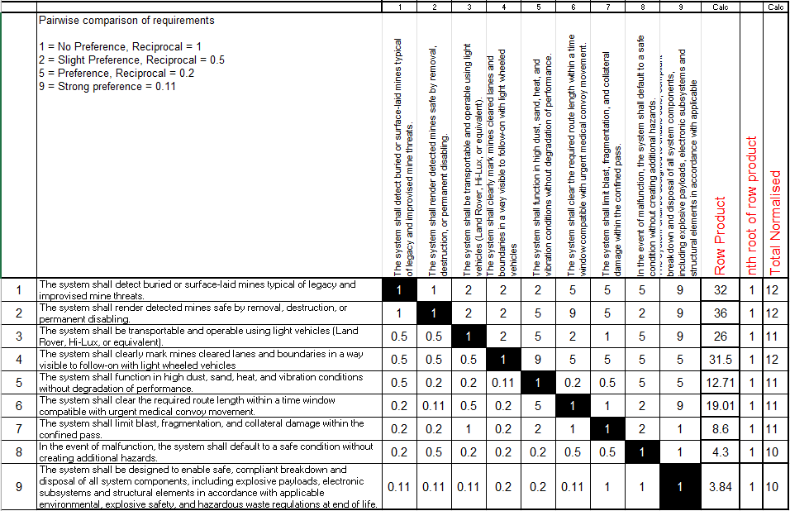
Figure 1 – Pairwise comparison of requirements

Figure 2 – Bar Chart illustrating importance of each requirement
Figure 2 shows the preference given to each of the non-functional system requirements. In this project, “the ability for the system to render detected mines safe by removal, destruction, or permanent disabling” has been decided as the most critical requirement.

2.3 – Required Functionality
Following the non-functional requirements, each requirement was expanded into functional requirements by group agreement. At level 1 these are simple functional requirements detailing what the system must do to achieve all non-functional requirements. At level 2 these provide more granularity on the tasks the system must be capable of allowing for a more informed decision when progressing through the function means analysis.
Table 2 – Table linking non-functional requirements to functional requirements
LEVEL 1 | LEVEL 2
Deploy Clearance Capability | Load off to light Vehicle
Deploy Clearance Capability | Move to clearance start point
Deploy Clearance Capability | Online systems and sensors
Deploy Clearance Capability | Establish exclusion zone
Detect Explosive Hazard | Surface detection
Detect Explosive Hazard | Subsurface detection
Detect Explosive Hazard | Noise filtering (rocks, clutter etc)
Detect Explosive Hazard | Geo-reference detection location
Assess and Decide | Correlate sensor inputs
Assess and Decide | Assign confidence level
Assess and Decide | Select neutralisation method
Neutralise or Removal | Mechanical disturbance / actuation
Neutralise or Removal | Controlled detonation
Neutralise or Removal | Extraction or displacement
Verify Clearance | Post clearance scan
Verify Clearance | Record cleared area
Mark Cleared Route | Define lane width and limits
Mark Cleared Route | Deploy physical markers
Mark Cleared Route | Deploy visual markers (day / night)
Enable Convoy Transit | Lead vehicle convoy
Enable Convoy Transit | Clearance interiority monitoring
Enable Convoy Transit | Halt / warn if anomaly detected
Recover and redeploy | Safe stowage of equipment
Recover and redeploy | Relocate to next identified area
Render Safe or Dispose of System | Deactivation and Neutralisation
Render Safe or Dispose of System | Isolation and Containment
Render Safe or Dispose of System | Dismantling and Disassembly
Render Safe or Dispose of System | Documentation and Certification

2.4 – Design QFD 1
Quality Function Deployment (QFD) 1 takes the non-functional system requirements weighted by their importance from the rationalised requirements pairwise comparison and compares how much each functional requirement achieves it. A critical interaction is marked with a 9, a moderate interaction with a 3 and a slight interaction with a 1. This calculates the function which is most critical to fulfilling the requirements.
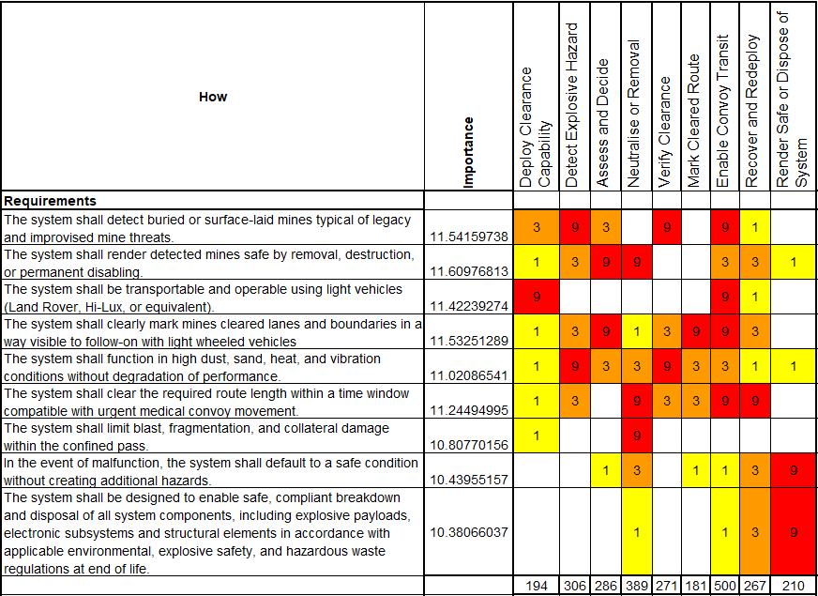
Figure 3 – QFD 1

Figure 4 – QFD 1 Functional Importances

2.5 – Function Means Analysis
The purpose of the function means analysis is to come up with a variety of methods to achieve each function and then narrow them down until a suitable solution remains.
A function means analysis was undertaken as a group discussion to gain a wide variety of concepts and appropriately decide solutions.
Figure 5 – FMA
Past this point in the process, the team split to complete work directly relating to the areas of responsibility.

2.6 – Functional Metrics
The functional metrics analysis was carried out by Shaun Malone and James Cawte being responsible for trials and evaluation and trials and evaluation safety respectively. A series of trials were decided upon through an iterative process until the result adequately tested every requirement.
Figure 6 – Functional Metrics Analysis

2.7 – FMEA
In order to assess the dangers posed in each trial, a Failure Modes Effects Analysis (FMEA) was conducted [ANNEX C – FMEA] to decide the trials most likely to pose risk to personnel involved. For each trial, the 5 failure modes were considered for cause and effects. This was then scored on Severity, Likelihood and Ease of Detection. These values were then multiplied together to provide a final score for each failure. If this score exceeded a threshold of 300 then additional safety mitigations/controls were conceptualised to get the trial to a tolerable state.

2.8 – System Pugh
To assess how the selected system compares to the widely used Python, 3 options were compared on a basis how well they achieved each requirement compared to Python. A solution with many positives indicated that, for this situation, Python would be an inferior option.
Figure 7 – System Pugh

2.9 – QFD 2
QFD 2 was completed as a group. It showed how well each component of the selected solution contributed to the functional requirements.
Figure 8 – QFD 2
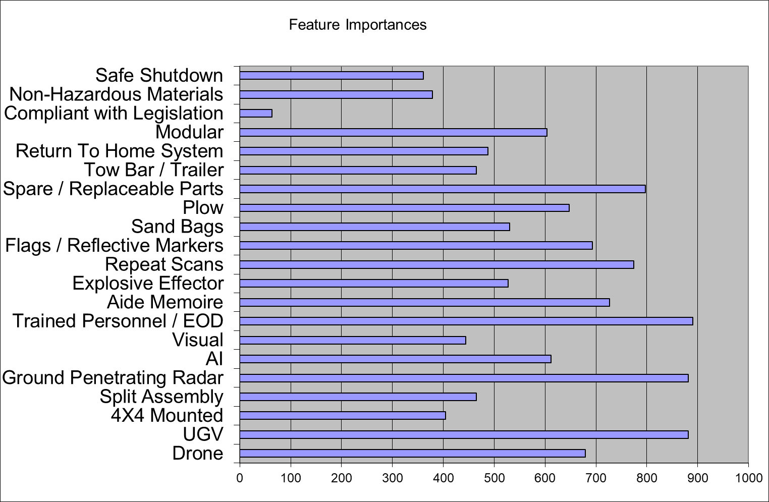
Figure 9 – Feature Importances
The result of QFD 2 was that trained personnel are the most critical feature of the system followed by the ground penetrating radar.

2.10 – P Diagram
A P Diagram was produced to collate all the noises affecting the function of one of the most critical parts of the system (the ground penetrating radar). The external noises included environmental factors such as dust and depth of mines. One example of unit-to-unit noise was differences in component quality. Deterioration noises included the power source draining and general wear and tear. All these factors would impact the command input providing a ground profile.
Figure 10 - P Diagram (GPR)

2.11 – What Why
A what why table was created for the ground penetrating radar component of the system as it was the second most important according to QFD 2. The noises from the P Diagram were compared with the controls implemented to determine if any noises were uncontrolled/unmitigated. The only noise that was not reduced was the age of the mines. This can not be impacted by any measure but may have an impact on the ability of the system to detect reliably (if the mines are degraded past what would be expected).
Figure 11 – “What Why” (GPR)

2.12 – Manufacturing
Theo Dunning and Euan Kelly undertook the manufacturing stages of the project. Firstly, manufacturing requirements were developed as a basis for the manufacturing QFD 1. This organised the manufacturing requirements into a hierarchy. Next, a function means analysis was carried out for the manufacturing stages and the selected methods were put into the manufacturing QFD 2. This provided the most important stage of the manufacturing process being the hand packed explosive. A process Pugh was filled out comparing other manufacturing systems to the proposed. QFD 3 was then undertaken to compare the methods of manufacture with each component and assign relationships 1, 3, or 9. This proved that manual assembly was the most applied process in the creation of the charges. A manufacturing P diagram identified the noises and available controls. Examples include temperature and lighting as external noises, lack of training as unit-to-unit noise, and fatigue as a deterioration. Controls included a sterile work environment and clear operating procedures. “What Why” tables then provided the link between the noises and controls showing that training is the most crucial control. QFD 4 compared the process controls with each process step.
Manufacturing was informed about the nature of the trials planned so that the products produced would be suitable and able to pass. Group coconscious lead to only the explosive disruptor being manufactured due to the majority of the system being comprised of off the shelf equipment that would be more trouble to make than buy.

3.0 – Trials & Evaluation Safety
General trials safety would be in accordance with The Health and Safety at Work Act 1974 [3] and Explosives Regulations 2014 [4]. Each test site will have its own safety regime to adhere to.
Any trial which was able to have the energetic material removed did. This brings the risk and difficulty of conducting these trials down. If trialling explosives, then it must be done on a range.
The FMEA provided a shortlist of trial failures which would need additional mitigation. The highest scoring failure was on the identification training trial. This was for an intermittent failure where the system is unable to consistently identify the threat leading to potential false positives or more serious false negatives. The mitigations to this were to not use real ordnance in the trial until potentially the very end of identification training. By this point the software should be consistently identifying the threats. The next highest scoring failure was in the firing test against a munition. This failure was unexpected initiation of either charger or target munition. This cannot be mitigated by removing the energetics due to the trial testing the effectiveness against a live target. Since a sudden unexpected initiation is very unlikely all that can be done past standard explosives handling practices is to have first aiders on site with trauma kits and a robust plan to get the casualty to a suitable medical facility.

4.0 – Reflection
The requirements for the system do not specify any safety requirements. The oversight to implement a requirement detailing that it must achieve its purpose safely shows there was a failure to consider safety at the early stages. However, the team had 3 people each working on a specific area of safety rather than 1 overarching safety responsible individual. This could have led to each focusing in on their specific area and not considering the system as a whole. There was good interaction between the Trials & Evaluation safety and the occupational safety as much of the framework used to make the trials safe would apply in real use. The process is iterative and as nothing has been created yet, safety requirements can be implemented with relative ease.
Due to time constraints, noise factors were only considered for a single part of the system. A more comprehensive investigation into all noises for all components could provide trends of noises which show up frequently which would make the systems vulnerabilities known at which point it can be mitigated or controlled into a more robust system. The controls implemented for the GPR may benefit other components as well, but this cannot be substantiated unless the process is completed.

References

[1] | V. Jokic, “OZM-72 anti-personnel fragmentation mine,” 2011. [Online]. Available: https://nolandmines.com/Mines/OZM-72_bounding_AP_mine.pdf. [Accessed 02 05 2026].
[2] | B. Seddon, “EXPLOSIVE ORDNANCE GUIDE FOR UKRAINE,” GICHD, 2025, p. 31.
[3] | “Health and Safety at Work etc. Act 1974,” The National Archives, [Online]. Available: https://www.legislation.gov.uk/ukpga/1974/37/contents.
[4] | “The Explosives Regulations 2014,” The National Archives, 2015. [Online]. Available: https://www.legislation.gov.uk/uksi/2014/1638. [Accessed 2 4 2026].

ANNEX A - FMA

ANNEX B – Functional Metrics

ANNEX C – FMEA

For a larger image see ANNEX A - FMA
For a larger image see ANNEX B – Functional Metrics
1. No function 2. Too much function 3. Not enough function 4. Intermittent function 5. Unexpected function

