

Ordinance, Munitions and Explosives

Academic Year 2024 - 2025

Jack Burden

Rate of Reaction Lab Report

This thesis is submitted in partial fulfilment of the requirements for the HNC of OME
(NB. Remove if the degree award is based solely on examination of the thesis)

© UWTSD 2024. All rights reserved. No part of this publication may be reproduced without the written permission of the copyright owner.

Academic integrity declaration
I declare that:
- the thesis submitted has been written by me alone.
- the thesis submitted has not been previously submitted to this university or any other.
- that all content, including primary and/or secondary data, is true to the best of my knowledge.
- that all quotations and references have been duly acknowledged according to the requirements of academic research.
I understand that to knowingly submit work in violation of the above statement will be considered by examiners as academic misconduct.

Abstract
This Lab report explores the effects the concentration of Hydrochloric acid (HCl), the temperature of HCl and the surface area of Magnesium ribbon has on the rate of reaction of Magnesium. The theory behind rate of reaction is discussed as well as the importance of Kinetics within the Ordinance, Munitions and Explosives industry.

Introduction

Purpose of the experiments
The aim of the experiments was to determine which dependant variable increases the rate of reaction the greatest. This was done by having 7 separate experiments, each changing a dependant variable and observing the outcome. 3 of these experiments were related to the concentration of Hydrochloric acid, another 3 of these were related to the temperature of Hydrochloric acid and the final test was related to the surface area of the Magnesium ribbon.

Hypothesis
The hypothesis made prior to the practical’s was that temperature would effect the rate of reaction the most. This conclusion was made due to heat being a major factor in reactions such as detonation or combustion. The rate of reactions of both detonation and combustion is high compared to that of a reaction like iron rusting.

Variables
The experiments rely solely on changing different dependant variables and observing how these variables effect the rate of reaction. The dependent variables were: manipulating the concentration of Hydrochloric acid, increasing the temperature of the Hydrochloric acid and witnessing the effect of the surface area of the Magnesium ribbon. The independent variables vary for each test. For the concentration of Hydrochloric acid and the temperature of the Hydrochloric acid: the mass and the surface area of the Magnesium ribbon was not changed. For the surface area of the Magnesium ribbon: the concentration of Hydrochloric acid was not changed. For all experiments the control variable was the volume of acid (20mL). This was not changed as it had the potential to skew the results.

Theory

Basic concepts and equations
Rate of reaction is the speed at which the reactants convent into products. Rate of reaction can be visualized by two graphs, the amount of reactant used against time or the amount of product formed against time. These graphs are the kinetic profile of a certain reactant. There are multiple factors that can effect the rate of reaction: the concentration of the reactant, the temperature of the reaction, the particle size of a solid and the presence of a catalyst. When each of these factors are increased, in theory, the rate of reaction should increase. The equation used to work out the rate of reaction is:
$$Rate of reaction= \frac{Change of concentration}{change of time}$$
After the kinetic profile of a reactant is plotted, the average rate of reaction can be calculated by calculating the gradient of a tangent between t = 0 and t = t1. Alternatively, an instantaneous rate of reaction at a certain time can be determined. This is done by taking a tangent through a point on the graph and working out the gradient.
For these experiments, the equation used to work out the rate of reaction at t = 0, t = t1 and the average is:
$$Rate of reaction= \frac{Change of volume of Hydrogen}{Change of time}$$

2.2 Importance of Kinetics in OME
Explosives within the Ordinance, Munitions and Explosives industry rely on the activation energy ($E_{a}$) of an explosive substance. The activation energy is the energy required to break the bonds between the molecules. Another factor that effects explosive substances is the critical temperature. Critical temperature can be described as “the lowest constant surface temperature at which a specific material of a specific size and shape will self heat catastrophically. The critical temperature is related to the size, shape, chemical, and physical properties of a specific material.” [1]. The Arrhenius equation uses both the temperature and the activation energy to determine the rate constant (K) of a material.
$$The Arrhenius equation: K=Ae^{-\frac{E_{a}}{RT}}$$
“The rate constant is defined as the proportionality constant, which explains the relationship between the molar concentration of the reactants and the rate of a chemical reaction.” [2]. The temperature directly effects the rate constant. If the activation energy is equal to 0 and $e^{-\frac{E_{a}}{RT}}$ is equal to 1 then all the colliding molecules react. If the activation energy divided by the gas constant multiplied by the temperature is less than 1, then most molecules will not react. As the temperature of an explosive substance reaches the critical temperature the rate of reaction and the rate constant increase.

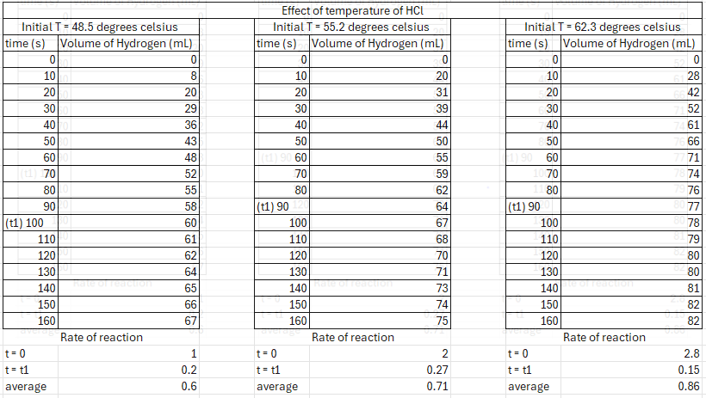
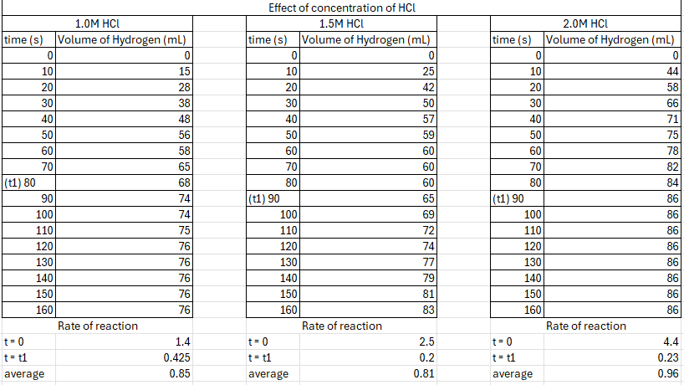
Results and Calculations
Table 4, Table 5, Table 6
Table 1, Table 2, Table 3

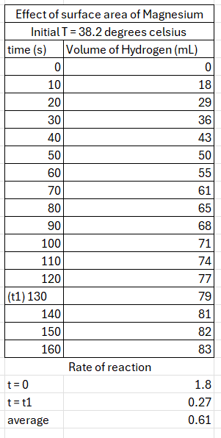
Table 7
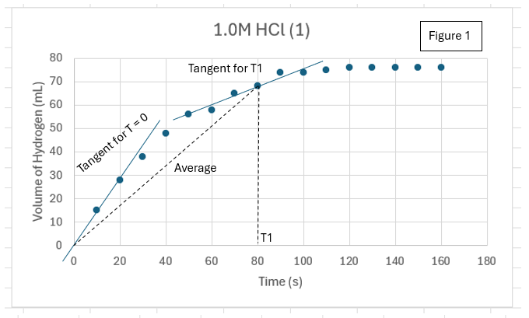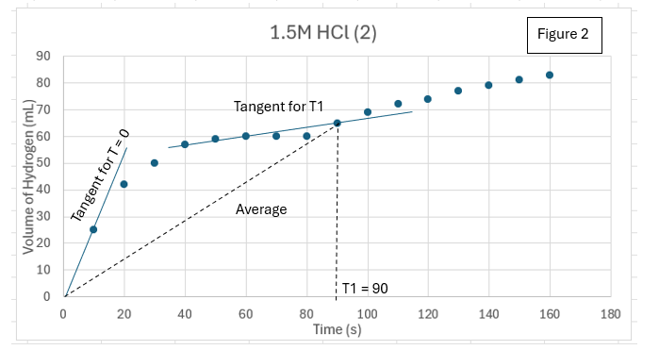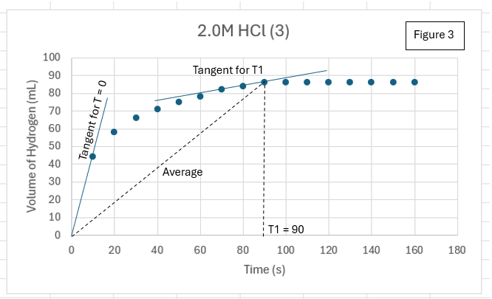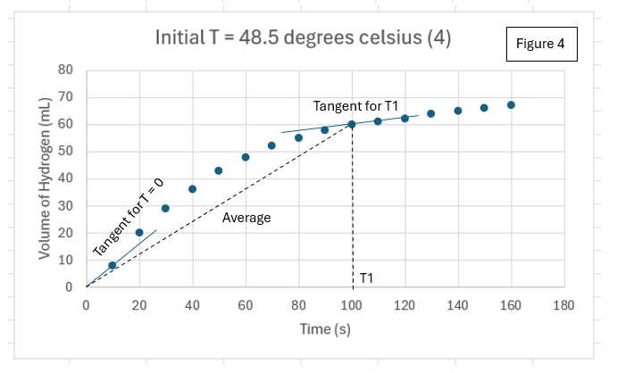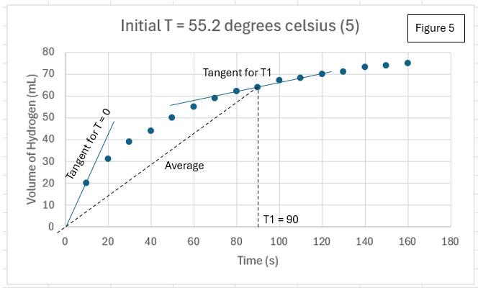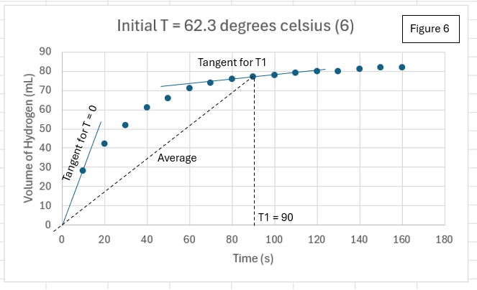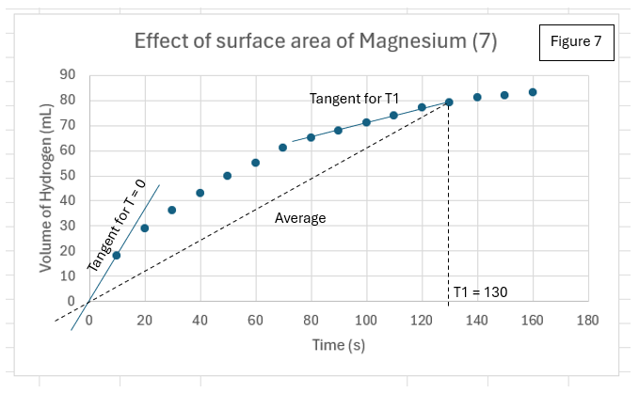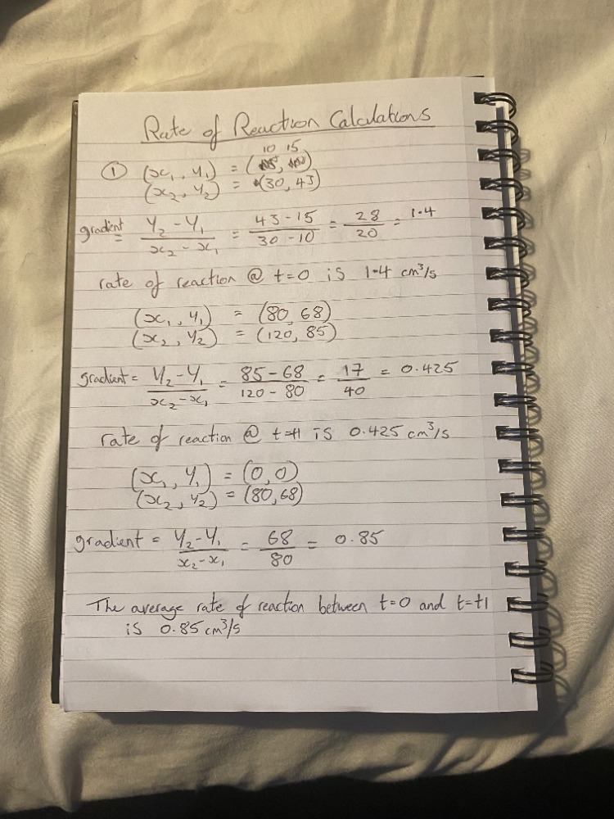
Figure 8
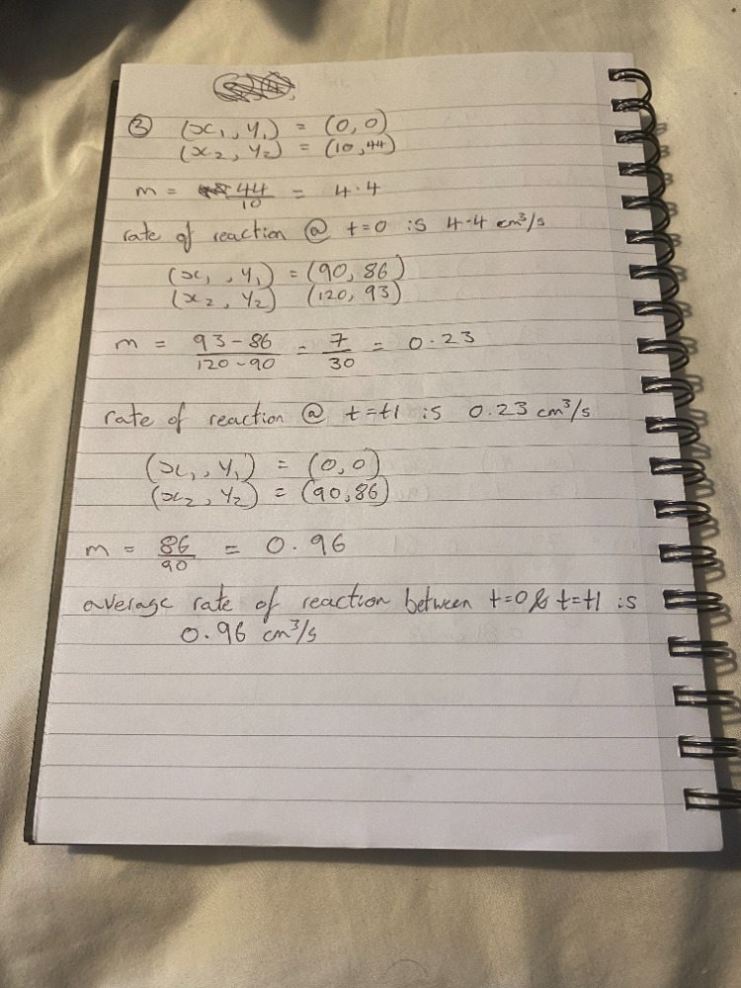
Figure 9
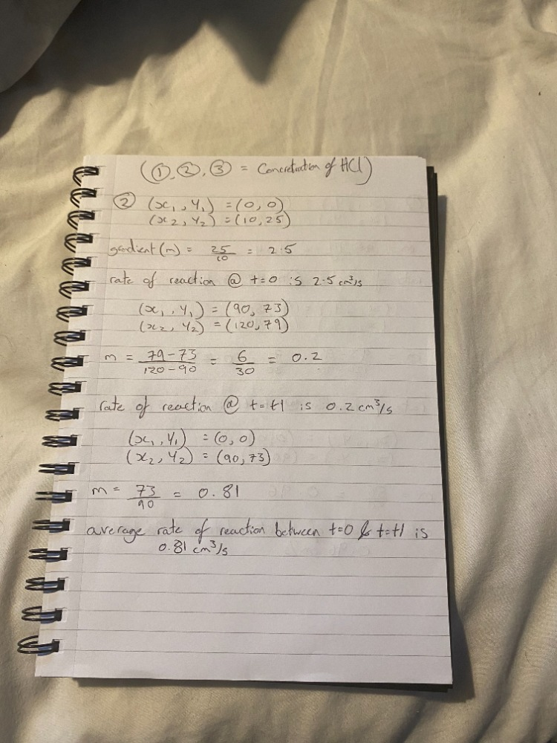
Figure 10
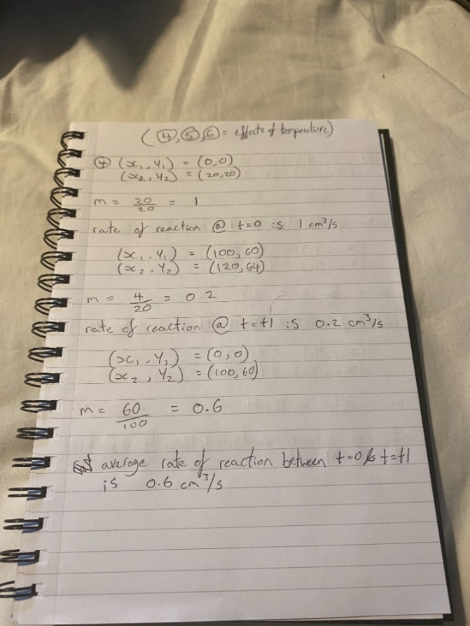
Figure 11
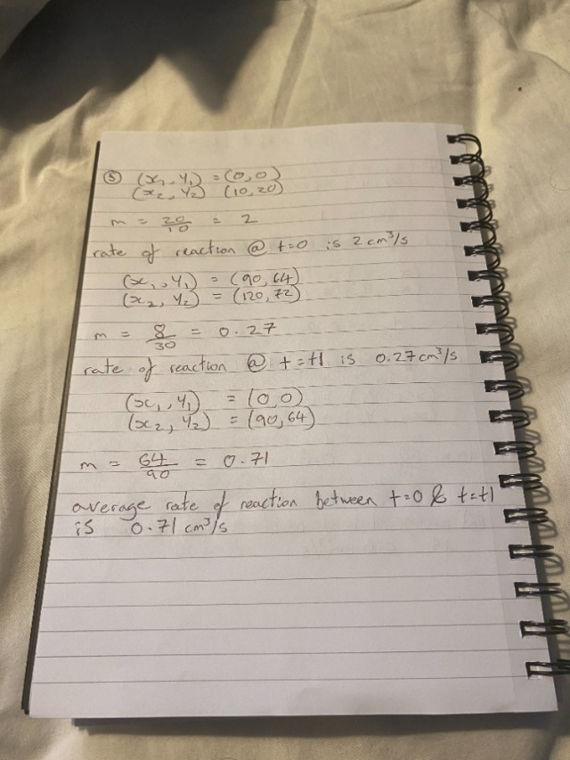
Figure 12
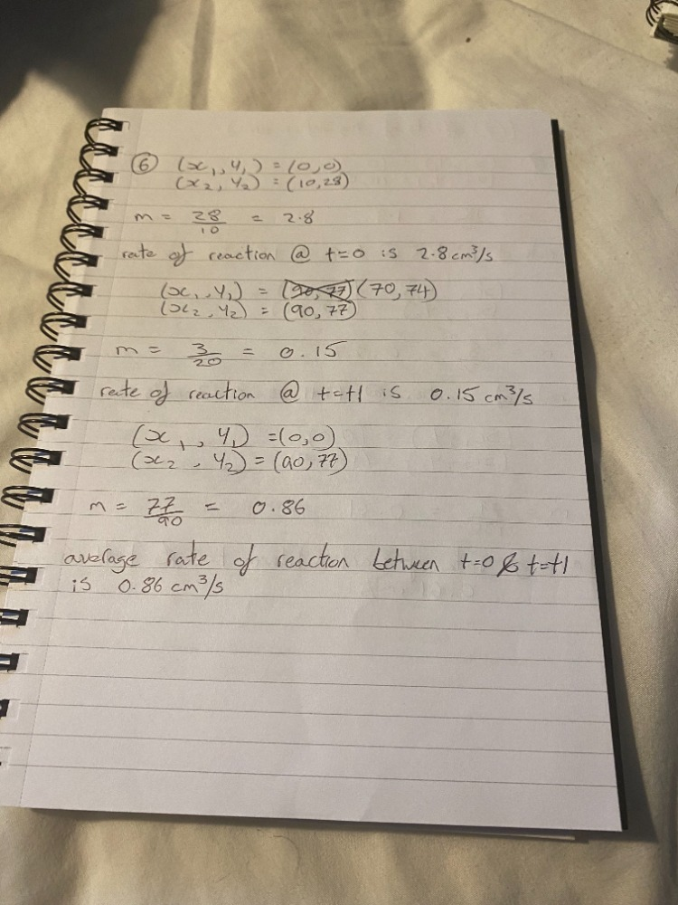
Figure 13
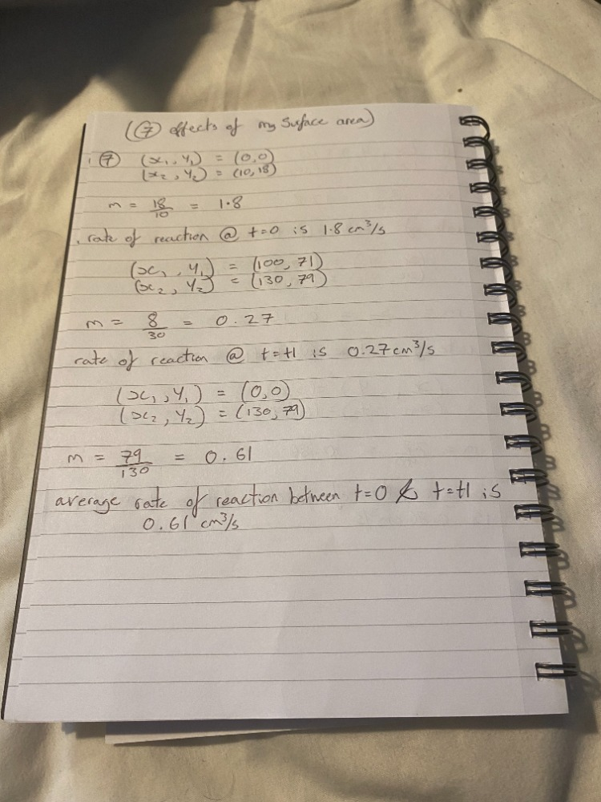
Figure 14

Discussion
There are two different methods to calculate rate of reaction: measuring the quantity of reactants used against time or measuring the quantity of products formed against time. Within these experiments, the latter was chosen.
When comparing the rate of reactions at t = 0 for all experiments, it is clear that 2.0 Moles of Hydrochloric acid had the highest value at 4.4 ${cm}^{3}/s$. This can be seen in figure 9. The conclusion that can be made from these observations is that the concentration of acid significantly effects the rate of reaction at the beginning of the process.
The value for t = t1 in each test is different. T1 has been taken to be the closest time to which the products formed begin to stagnate. The rate of reactions calculated determined that 1.0 Mole of Hydrochloric acid has the highest rate at this time at 0.425 ${cm}^{3}/s$, as seen in figure 8.
Finally, the average rate of reaction for each experiment has been compared. The average has been calculated by taking a tangent between t = 0 and t = t1 for each graph and then working out the gradient of said tangent. The test with the highest average rate of reaction was 2.0 Moles of Hydrochloric acid at 0.96 ${cm}^{3}/s$, as seen in figure 9.
Overall, it is evident that the concentration of acid has the greatest effect on the rate of reaction. In comparison to the hypothesis, the temperature of the acid made no significant increase in the rate of reaction. Experimental errors that could have occurred when undergoing each test could be that not all of the acid was at a higher temperature when heating up the test tube in the water bath. As seen in Figure 2, the rate of reaction started to stagnate and then began increasing again. This was because the Magnesium ribbon was not fully submerged in the acid resulting in skewed results.

Conclusion
After reviewing the results obtained during these experiments, it is evident that the concentration of Hydrochloric acid had the greatest effect on the rate of reaction of Magnesium. Future studies should be focused on concentrations of acid that are greater than 2.0 Moles. This is so it can be determined if there is a concentration that maximises the rate of reaction of Magnesium. This could also show whether an instantaneous reaction of Magnesium to Hydrogen is possible, if it is, could the energy released be harnessed into a practical explosive?

References
[1] Raymond N. Rogers, Joan L. Rogers. “Explosives science”. Place of publication: Los Alamos, NM. Page no: 14. Revised 2004.
[2] Prof. Lisa Jardine-Wright, Prof. Mark Warner. “isaac physics” [online]. Available: https://isaacphysics.org/concepts/cc_rates#:~:text=The%20rate%20constant%20k%20is,rate%20of%20a%20chemical%20reaction. (accessed on 23/11/2024)

Appendices
- The chemicals and equipment used during these experiments are listed below:
- Magnesium ribbon cut into 4cm length and weighed
- Magnesium powder (same mass as ribbon)
- Hydrochloric acid (2.0 M and 1.0 M)
- Deionised water
- Long test tube with arm
- Gas syringe
- Rubber bung and delivery tube to fit the test tube
- 2 large beakers for the water bath and reaction mixture waste
- Pipette and pipette filler
- 2 clamp stands
- 6 test tubes and test tube holder
- Graduated cylinder
- Thermometer
- Ring stand, Bunsen burner
- Graph paper

- The PPE worn during this experiment consisted of a Lab coat, safety goggles and gloves.

- The following is an explanation of each of the 3 procedures undertaken during this report:

Effect of HCl concentration on the speed of ${\text{H}}_{2}$ gas evolution
- Prepare three 20mL solutions of HCl each with different concentrations, 2.0 M, 1.5 M and 1.0 M respectively.
- Pour the HCl solution with the lowest concentration into the test tube with arm.
- Add a 4cm strip of Magnesium ribbon to the test tube, quickly replacing the bung and starting the stopwatch.
- Record the volume of Hydrogen gas given off at 10 second intervals. Continue timing until no more Hydrogen is given off.
- Once the reaction is complete, discard the mixture into the waste beaker.
- Measure the temperature of the 1.0 M HCl.
- Repeat the same test for the other two concentrations of HCl.

Effect of temperature on the speed of ${\text{H}}_{2}$ gas evolution
- Set up a water bath. Heat the water bath over the Bunsen burner till the temperature of water increases to 10 Degrees Celsius above the initial temperature of 1 M HCl recorded in the previous test.
- In a graduated cylinder measure 20mL of 1.0 M HCl into three test tubes.
- Place the 1st test tube into the water bath and wait until the temperature of the acid reaches the temperature of the water in the water bath.
- Quickly transfer the warm HCl into the tube with the arm, put 4cm piece of Magnesium ribbon into the test tube and quickly replace the bung and start the stopwatch.
- Continue timing until no more Hydrogen is given off.
- Once the reaction is complete, discard the mixture into the waste beaker.
- Repeat the same test for two more temperatures.

Effect of the surface area of Magnesium on the speed of ${\text{H}}_{2}$ gas evolution
- Use the graduated cylinder to transfer 20mL of 1 M HCl at room temperature into the test tube with arm.
- Quickly add Magnesium powder into the test tube, replacing the bung and starting the stopwatch.
- Continue timing until no more Hydrogen is given off.
- Once the reaction is complete, discard the mixture into the waste.

