

A Study of Automotive Automatic Lighting and Parking Aid

By
Luke Andersen

Supervisor: Dr Gary L Jones

Project submitted as part of the requirements for the award of
BEng (Hons) Electrical and Electronics Engineering

May 2022

Acknowledgement
I would firstly like to thank my supervisor Dr Gary L Jones, for his dedicated support, encouragement and guidance throughout this project. Furthermore I would like to thank the University Trinity Saint David for the collaborative effort in ensuring all facilities and equipment were made available to myself throughout the Project. I would also like to thank my girlfriend Samantha Williams, for her continued support and inspiration throughout a challenging year.
Finally, I would like to express my gratitude and appreciation for my fellow class mates whose energy and support has been one of the many driving factors during the completion of the project.

Declaration
I, Luke Andersen declare that I am the sole author of this Project; that all references cited have been consulted; that I have conducted all work of which this is a record, and that the finished work lies within the prescribed word limits.
This work has not previously been accepted as part of any other degree submission.

Date: 01/05/2022

Form of consent
I Luke Andersen hereby consent that my Project, submitted in candidature for the B.Sc.(Hons) Computing (stream)degree, if successful, may be made available for inter-library loan or photocopying (subject to the law of copyright), and that the title and abstract may be made available to outside organisations

Date: 01/05/2022

Abstract
As there is an increasing number of cars on the road and forever ongoing road works which the public encounter every day, there are many distractions that can cause a lapse in concentration whilst driving. The external features of a car can help minimise the distractions whilst driving, thus helping improve safety whilst driving. An assessment has been completed regarding the usage of a microcontroller for exterior features of an automobile. This paper will identify if using a microcontroller is a suitable method to operate parking aid and automatic headlights. Research was carried out to take a look into the relevant existing systems and the sensors that follow each design. An analysis of each systems sensors was completed, followed by a report to ensure the correct selection of sensors can meet the design aims set out. The programmes Proteus and CCS were used to create and design the system which operates the parking aid and automatic headlights. The system was designed and tested on breadboards demonstrating that the microcontroller could successfully implement parking aid and automatic headlights flawlessly. Future recommendations would focus on a different microcontroller selected within the system as various features could have been added to the system to improve the number of functions.

Table of Contents
1. Introduction 1
1.1 Automotive Automatic Functions 1
1.1.1 Automatic Headlights 1
1.1.2 Parking Sensors 1
1.2 Aims and Objectives 2
2. Planning 2
2.1 Project Breakdown 3
2.2 Project Timing Plans 3
2.2.1 Timing Plan 1 4
2.2.2 Timing Plan 2 4
2.2.3 Timing Plan 3 5
3. Research Methodology 6
3.1.1 Philosophy 6
3.1.2 Approach 7
3.1.3 Strategy 7
3.1.4 Choice 8
3.1.5 Time horizon 8
3.1.6 Techniques and procedures 8
4. Research 9
4.1 Existing systems 9
4.1.1 Automatic Headlight Systems 9
4.1.1.1 Magideal 1 Car Automatic Headlight Smart Control Kit 9
4.1.1.2 Banggood Auto Headlight Sensor & Control Switch 10
4.1.1.3 VendinPlus Car Automatic Headlight Control Kit 10
4.1.1.4 Vanstyle Auto Headlight Switch & Module 11
4.1.1.5 Comparison of Existing Automatic Headlight Systems 11
4.1.2 Parking Sensors 12
4.1.2.1 Ultrasonic Sensor Systems 12
4.1.2.1.1 COCAR Backup System 12
4.1.2.1.2 VALEO Parking Sensors Kit 13
4.1.2.1.3 BRIGADE BS-4000W Sensor Kit 13
4.1.2.1.4 STEELMATE PTS800EX Parking Sensors 14
4.1.2.1.5 Comparison of Ultrasonic Sensor Parking Systems 14
4.1.2.2 Radar Sensor Systems 15
4.1.2.2.1 BRANDMOTION RDBS-1500 Radar System 15
4.1.2.2.2 VALEO Monitoring System 15
4.1.2.2.3 Crimestopper BSD-754 16
4.1.2.2.4 Motor Mods Radar System 16
4.1.2.2.5 Comparison of Radar Sensor Systems 17
4.1.2.3 Electromagnetic Sensor Systems 17
4.1.2.3.1 EPS-Dual 4.0 18
4.1.2.3.2 Parking Dynamics PD1-Rear 18
4.1.2.3.3 Smart Star Sensor 18
4.1.2.3.4 Hawk HA-EMS02 19
4.1.2.3.5 Comparison of Electromagnetic Sensor Systems 19
4.2 Sensor Selection 20
4.2.1 Sunlight Brightness Sensor 20
4.2.1.1 Light Dependant Resistors 21
4.2.2 Distance Measuring Sensor 22
4.2.2.1 Ultrasonic Sensors 23
5. Design 24
5.1 Brief 24
5.2 Microcontroller Selection 24
5.3 Component Selection 26
5.3.1 Yellow LED 26
5.3.2 Red LED 26
5.3.3 Green LED 26
5.3.4 Push Button Switch 27
5.3.5 Slide Switch 27
5.3.6 Resistor Kit 27
5.3.7 LCD Screen 28
5.3.8 BC108 Transistor 28
5.3.9 Relay 28
5.3.10 Breadboard 29
5.4 Costing 29
5.5 Operational Functions 29
5.5.1 Automatic Headlights 29
5.5.2 Parking Sensors 30
5.6 Block Diagram 30
5.7 Flow Chart 31
5.8 Proteus Design 31
5.8.1 Full Schematic Design 32
5.8.2 PIC16F886 Schematic 33
5.8.3 Switches and LDR Sensor Schematic 34
5.8.4 Activation LEDs & Ultrasonic Sensor Schematic 34
5.8.5 Headlights LED Schematic 35
5.8.6 LCD Screen 35
5.9 Coding 35
5.9.1 Section 1 36
5.9.2 Section 2 37
5.9.3 Section 3 38
5.9.4 Section 4 39
5.9.5 Section 5 40
5.10 Final Build 41
6. Evaluation & Analysis 42
6.1 Lux Level Survey 42
6.1.1 Lux Level Survey Results 43
6.2 Coding Simulation 44
6.2.1 Reverse Activation Simulation 44
6.2.1.1 Analysis of Reverse Activation Simulation 45
6.2.2 Manually Activated Yellow LED Simulation 47
6.2.2.1 Analysis of the Manually Activated Yellow LED Simulation 48
6.2.3 Automatically Activated Yellow LED Simulation 48
6.2.3.1 Analysis of the Automatic Activation of the Yellow LED Simulation 49
6.2.4 Evaluation of Proteus Simulation 51
6.3 Headlights Tests 52
6.3.1 Test 1 – Manual Activation and Deactivation of Headlights 52
6.3.2 Test 2 – Automatic Activation of Headlights 52
6.3.3 Test 3 – Automatic Deactivation of Headlights 53
6.3.4 Analysis of Headlights tests 53
6.4 Ultrasonic Sensor Tests 53
6.4.1 Test 1 – Ultrasonic Sensor 53
6.4.2 Test 2 – Ultrasonic Sensor 53
6.4.3 Analysis of Ultrasonic Sensor Tests 54
6.5 Initial Build Problems 54
7. Conclusion 55
7.1 Future Recommendations 55
7.1.1 System On/Off Buttons 55
7.1.2 External Lighting 55
7.1.3 Bleeper 56
7.1.4 Blind Spot Detection 56
8. Reflection 56
References 58

Figure 1: Timing Plan 1 4
Figure 2: Timing Plan 2 4
Figure 3: Timing Plan 3 5
Figure 4: Research Methodology Onion 6
Figure 5: MagiDeal 1 Headlight kit 9
Figure 6: Banggood Auto Headlight System 10
Figure 7: VendinPlus Headlight System 10
Figure 8: Vanstyle Auto Headlight System 10
Figure 9: Cocar Backup System 12
Figure 10: Valeo Sensors Kit 12
Figure 11: Brigade BS-4000W Sensor Kit 13
Figure 12: Steelmate PTS800EX Parking Sensors 13
Figure 13: Brandmotion RDBS-1500 Radar System 14
Figure 14: Valeo Monitoring System 14
Figure 15: Crimestopper BSD-754 15
Figure 16: Motor Mods Radar System 15
Figure 17: EPS-Dual 4.0 16
Figure 18: Parking Dynamics PD1-Rear 17
Figure 19: Smart Star Sensor 17
Figure 20: Hawk HA-ESMS02 17
Figure 21: Block Diagram 28
Figure 22: System Flow Chart 29
Figure 23: Proteus Components 30
Figure 24: Full Schematic of Proteus Design 30
Figure 25: PIC16F886 31
Figure 26: PIC16F886 Pin Diagram 31
Figure 27: Switches and LDR Sensor 32
Figure 28: LEDs and Ultrasonic Sensor 32
Figure 29: Headlights LED 33
Figure 30: LCD Screen 33
Figure 31: Main.h source code 34
Figure 32: Coding - Section 1 35
Figure 33: Coding - Section 2 36
Figure 34: Coding - Section 3 37
Figure 35: Coding - Section 4 38
Figure 36: Coding – Section 5 39
Figure 37: Final Build 40
Figure 38: Survey Form 41
Figure 39: Completed Survey Forms 41
Figure 40: Reverse Activated – 100cm 43
Figure 41: Reverse Activated – 140cm 44
Figure 42: Reverse Activated – 20cm 45
Figure 43: Manually Activated Yellow LED 46
Figure 44: Automatically Activated Yellow LED 47
Figure 45: Automatically Activated Yellow LED 48
Figure 46: Automatic Deactivation of Yellow LED 49
Figure 47: Final Simulation 50
Figure 48: Initial Build 52

Table 1: Project Breakdown 3
Table 2: Comparison of automatic headlight systems 11
Table 3: Comparison of ultrasonic parking sensor systems 14
Table 4: Comparison of radar sensor parking systems 17
Table 5: Comparison of electromagnetic sensor parking systems 19
Table 6: Comparison of sunlight brightness sensors 20
Table 7: Comparison of light dependant resistors 21
Table 8: Costing - LDR Sensor 21
Table 9: Comparison of distance measuring sensors 22
Table 10: Comparison of ultrasonic sensors 23
Table 11: Costing - Ultrasonic Sensor 23
Table 12: Costing - PIC16F886 25
Table 13: Costing - Yellow LED 26
Table 14: Costing - Red LED 26
Table 15: Costing - Green LED 26
Table 16: Costing - Push Button Switch 27
Table 17: Costing - Slide Switch 27
Table 18: Costing - Resistor Kit 27
Table 19: Costing - LCD Screen 28
Table 20: Costing - BC108 Transistor 28
Table 21: Costing – Relay 28
Table 22: Costing – Breadboard 29
Table 23: Table of Costs 29

Introduction

1.1 Automotive Automatic Functions
Automatic functions within the automotive industry is becoming very common; manufactures are including several types of automatic features within their cars. Automatic features can vary from headlights activating when a specific level of darkness has been reached, but a more advanced automatic feature which has been implemented into the majority of models is parking aid.
Parking aid is where parking sensors calculate the distance an object is from the car, this data is then used to replicate the distance on a display and/or a bleeper. Automatic features can also limit the distractions whilst driving as the drivers full focus would be on the road, rather than trying to activate the car’s lights, wipers or any other function within the car. Automotive manufactures around the globe are investing a significant amount of money and time in developing and improving all types of automatic features within automobiles.

1.1.1 Automatic Headlights
The very first implementation of automatic headlights was the Twilight Sentinel device, which was first used in 1955 on General Motors Cars . It was a device that automatically turned the exterior cars lights on and off. It used a dash mounted photoelectric eye which sensed day and night, whilst activated the lights accordingly. The sensitivity and headlight deactivation could be adjusted with the touch of a dial. [1] The automatic operation of headlights is an extremely common feature used in all cars today.
Cars have a multi-operational switch where the headlights can be switched on manually, or they can be activated automatically. If the switch is turned to the automatic option a photoelectric sensor, which is located on either the dash or windscreen of the car, reads the level of light. Once the level of light is read, it compares the value to a pre-defined level which is programmed in to the car’s computer during manufacturing. If the level of light is lower than the pre-determined level a signal is sent to the car’s computer which then initiates the headlights. As the multi-operational switch is left in automatic, the photoelectric sensor is continuously reading the level of light. If the level of light exceeds the pre-determined level then the headlights will deactivated until the level of light drops below the pre-determined value.

1.1.2 Parking Sensors
Parking sensors first found their way into mass-marketing in 2003 but are now one of the most common features of a car in today’s market. It was the Toyota Prius which was the first commonly available car to feature sensors on its bumpers. [2]
As parking sensors have become a basic necessity in cars, they are an integral part of the automatic features within an automobile. Parking sensors most commonly feature on the rear of a car, but they can also appear on front and rear. To activate parking sensors when driving a car the reverse gear is initiated or another point of activation is if the car reaches a slow speed. The value of speed is dependent on what the manufacturer programmes within the cars computer. Once the parking sensors are activated a bleeper and/or display indicates how far away an object is from the car. A bleeper will gradually get faster the closer an object gets to the car whilst parking, whereas the display will signify how far away the object is by using a graphic. To deactivate the parking sensors, reverse is disengaged or the car exceeds the pre-defined speed of activation.
This report will look at automatic headlights and parking aid within an automobile along with the sensor technology used to operate these features. A breakdown of the systems design will follow, along with testing to prove the system operates accurately.

1.2 Aims and Objectives
The purpose of this project is to identify if a microcontroller can be used to implement the use of automatic features within an automobile. Accordingly, the two features identified below are the design aims of the project:-
- Rear and front parking sensors
- Automatic headlights
The above features have been selected given they are basic necessities that commonly feature in newly manufactured cars, and as a result, they should work flawlessly.
The objectives that are to be achieved during the operation of the system are outlined below:-
- The activation point for the parking aid to operate is when the reverse gear has been initiated
- The Headlights have to be activated once a specific level of darkness has been reached
- The Headlights must be able to activate manually
- The distance an object is from the system must be replicated via a display

Planning
Within this chapter, the planning of the entire project will be defined, along with a breakdown of timing plans and revised timing plans. Timing plans help plan ahead, as it is possible to become proactive and foresee future issues that may come forth throughout the project. These obstacles can arise from anywhere, therefore it is important to allocate enough time to deal with any ‘road blocks’ along the way. Planning ahead will also aid with successfully completing the projects aims and objectives.

2.1 Project Breakdown
Table 1 is a breakdown of the project and it’s allocated time of completion.
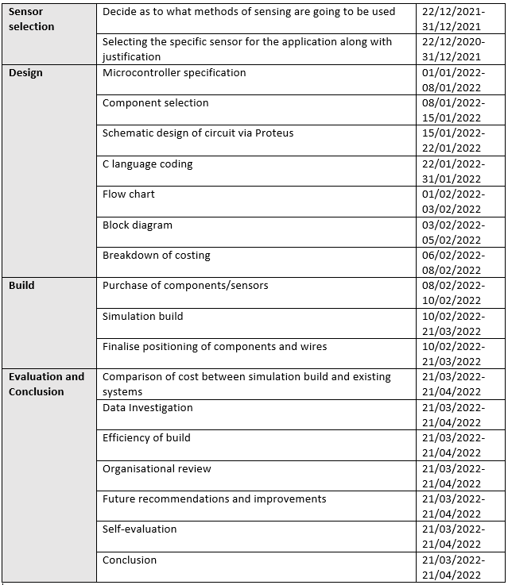
Table 1: Project Breakdown

2.2 Project Timing Plans
Throughout this project various timing plans were created and followed. The initial timing plan along with two more revised plans are present. It was important to revise the timing plans throughout the project as problems can arise. Revised plans should factor in the problems occurred and update the timing and completion of each task.

2.2.1 Timing Plan 1
As shown below in Figure 1, the initial timing plan for the project was created in September 2021. It includes primary tasks along with a set date they should be completed. The green blocks indicate the length at which each task should take.
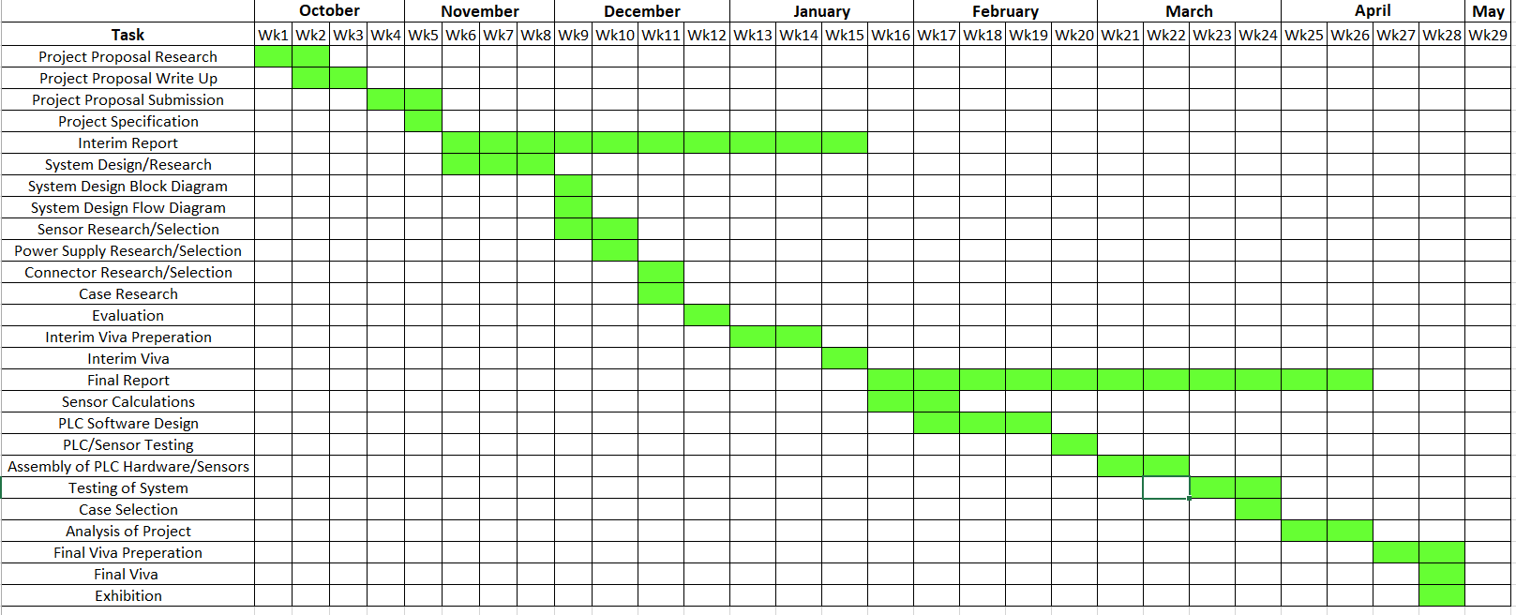
Figure 1: Timing Plan 1

2.2.2 Timing Plan 2
At the half way stage of the project, the second week of January, the original timing plan was revised and amendments were made according to the time it took to complete each task, as well as a revision of future tasks and the time available to complete them. Timing Plan 2 is shown below in Figure 2.
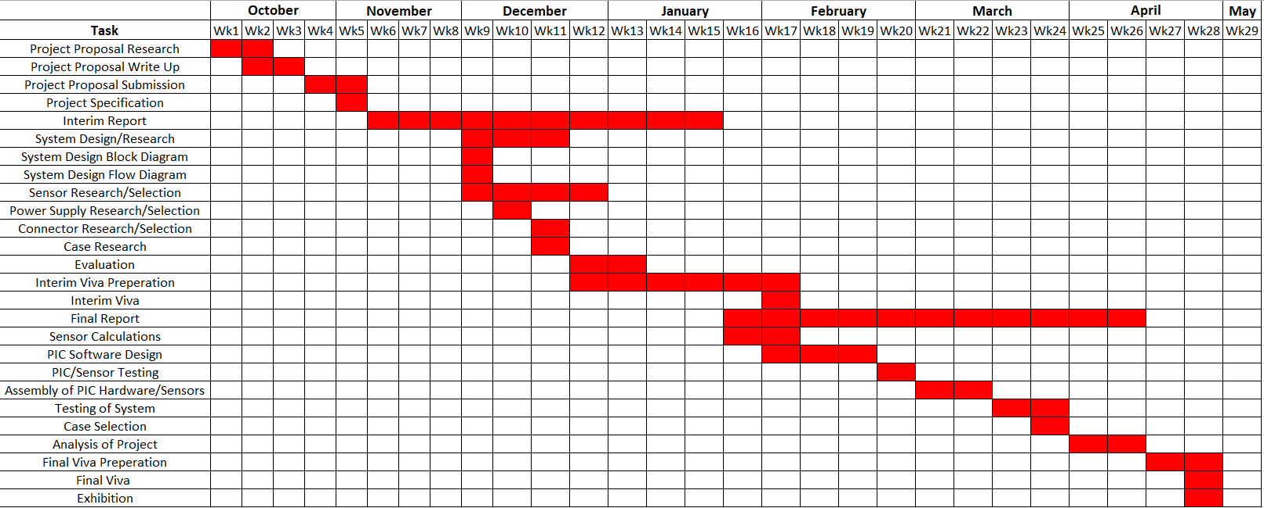
Figure 2: Timing Plan 2
In comparison to the initial timing plan, the following changes were made:-
- PIC Software Design & PIC testing changed from PLC due to design limitations.
- System Design/Research was moved forward due to work commitments.
- Sensor Research was extended by two weeks.
- Evaluation took an extra week.
- Interim viva presentation pushed forward to February due to the above circumstances.
Moving forward from Timing Plan 2, productivity had to increase in order to complete the final report by the latest, week 26.

2.2.3 Timing Plan 3
A third revision was taken during the second week of March as shown in Figure 3. This was created to revise recent tasks and to also make amendments according to the time taken to complete the most recent tasks.
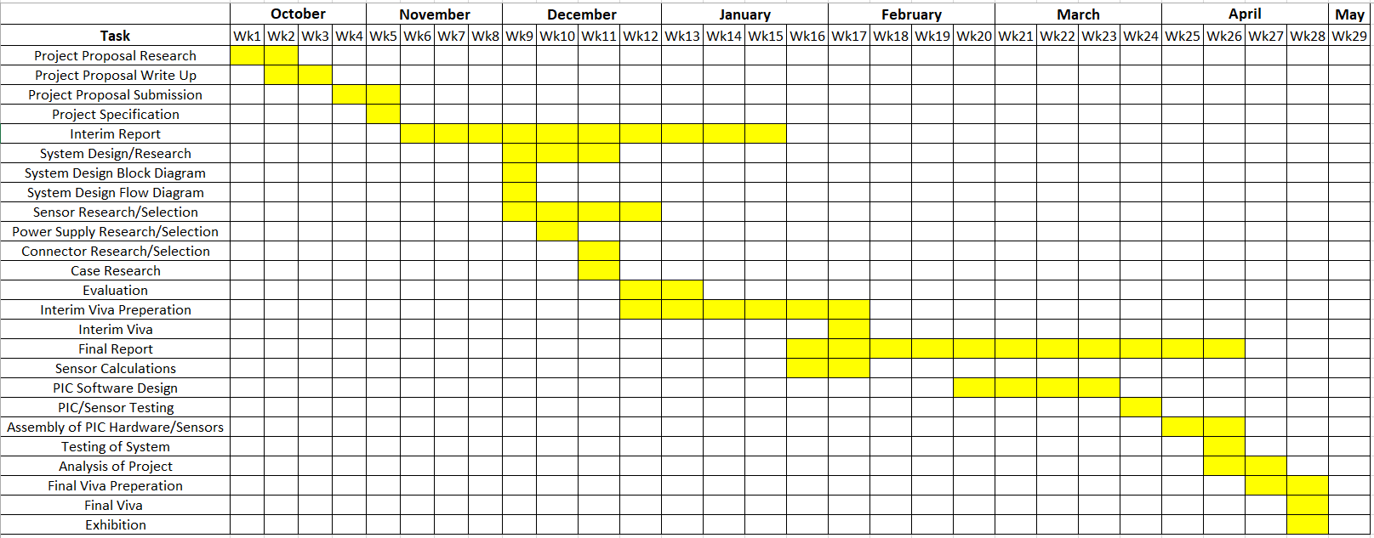
Figure 3: Timing Plan 3
In comparison to Timing Plan 2, the following changes were made:-
- PIC Software design was extended by 4 weeks, this was due to work commitments.
- PIC/Sensor testing was pushed forward 4 weeks due to the extension of PIC Software design.
- Assembly of PIC Hardware/Sensors was also pushed forward by a total of 1 week.
- Testing of System was pushed forward 1 week and only took a single week to complete, in comparison to the 2 weeks which was planned within Timing Plan 2.
- Analysis of the project was pushed forward by one week.
A final timing plan will be revised once the remaining tasks of the project have been completed. This will be completed and analysed within the Final Viva.

Research Methodology
Before partaking in any research driven project, it is vital that a clear methodology is in place. Research methodology is how a researcher systematically designs a study, to ensure valid and reliable results that address the research aims and objectives. [3] The research onion model, which is shown in Figure 4, was created to illustrate ways that different elements involved in research can be examined to develop the final research design. The reasoning behind the name ‘research onion’ is because of the six main layers that it consists of, which is shown in Figure 4. The six layers must be peeled back one at a time as the research methodology is developed.
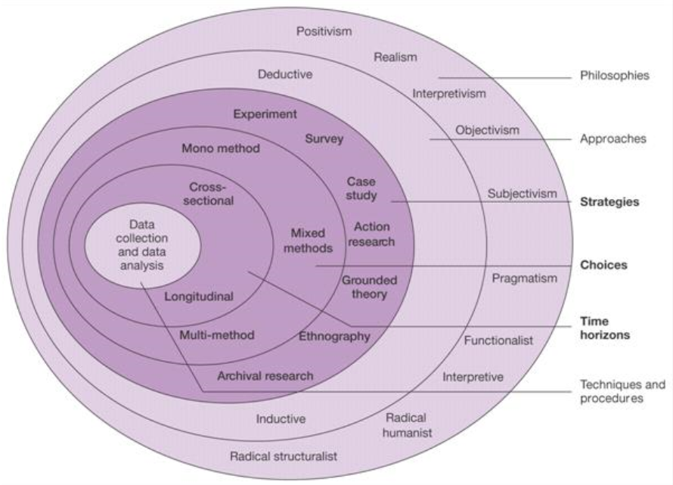
Figure 4: Research Methodology Onion [4]

The six layers of the onion, starting from the outside layer are:-
- Philosophies
- Approaches
- Strategies
- Choices
- Time horizons
- Techniques and procedures

3.1.1 Philosophy
Although the philosophy layer shown within Figure 4 contains ten sections, there are three main sections, these are:-
- Positivism
- Interpretivism
- Pragmatism

Positivism is the knowledge that exists outside of what is being studied, this cannot include any personal viewpoints, which can only be done objectively. It is theoretical point of view which concentrates on social facts, scientific and quantitative data and due to this, a Positivism philosophy is to be used and that the knowledge can be acquired through research, which is based on measurements and observation. If something is not true or false it would be dismissed as it no longer holds ground. One key advantage of using a positivism approach is that is that the method is objective and reliable. [3] [5]

3.1.2 Approach
The two sections for approach are as followed:-
- Deductive
- Inductive
Inductive research approaches involve generating theories from research. Unlike Inductive approaches, Deductive approaches begin with a theory and then aim to build on it through extended research. [3] Throughout this project all research will be gathered from proven theories and existing products, this will help identify their purpose for use within the project. As a result of this, a Deductive approach will be taken. Using a Deductive research approach, this supports the generation and flexibility of any theory used. [6] One disadvantage of using an Deductive approach is that if observations are incorrect, the research would end up in incorrect conclusions, so it is vital that all research throughout the project is carried out thoroughly.

3.1.3 Strategy
There are seven types of research strategies within this layer of the onion, they are as followed:-
- Experiment
- Survey
- Case study
- Action research
- Grounded theory
- Ethnography
- Archival research
Experimental research is the strategy that will be used for this project in order to create a functioning system that uses a microcontroller to control automatic headlights and a parking aid. Using an Experimental research strategy, gives a higher level of control, as factors that may affect the overall results can be controlled. This could be something as simple as sensor positioning.

3.1.4 Choice
The three options for research choice are:-
- Mono method
- Mixed method
- Multi method
The Mono method means that only one data type is used, that being either qualitative or quantitative data type. To make use of both quantitative and qualitative data, Mixed method would be the correct approach. Lastly, with the Multi method research choice, a use of a wider range of approaches is what differentiates it from the other two choices. It uses more than just one quantitative and one qualitative approach. [3] As there will only be one data type method used within this project’s research, the Mono method choice will be used.

Time horizon
The two tie horizon types are as follows:-
- Cross-sectional
- Longitudinal
The Cross-sectional time horizon is used when all gathered data is collected at a single point in time, whereas longitudinal data is repeated over a prolonged period of time, this could be months, quarters or even years. [7] As this is a university project which can only be completed during term times, a Cross-sectional time horizon will be used.

Techniques and procedures
The final layer of the onion consists of data collecting and analysis. At this stage of the onion it is to be decided whether primary or secondary data is to be collected. Primary data is the type of data to be collected directly from a data source without having to go through any existing sources. Whereas secondary data has been collected in the past by someone else but has been made available for others to use. [8]
Within this project a combined use of primary and secondary data collection exists. The secondary data that will be collected is via the sensor research, where information and data will be collected from sensor suppliers and manufacturers. The primary data will be implemented throughout the project where tests and recorded data will be obtained.
An advantage of using secondary data is that it’s easily accessible compared to primary data and it is also available on different platforms for a little to no cost at all. Primary data can become more expensive than secondary, which hinders the chance of obtaining any data at all, so it is vital to ensure that the testing process of my chosen sensors will be affordable where necessary. If affordable, primary data can become an extremely reliable and an accurate source of data. A disadvantage of secondary data is that it may not be authentic and reliable, to overcome this, all collected data and statistics must come from reliable sources. [8]

Research
The research chapter uses the selected methods highlighted in Chapter 3. Existing products and sensor technology are compared and contrasted within this chapter. Below each table a conclusion is included, explaining the preferred choice of either the existing systems or sensor technology.

Existing systems
This section compares existing systems which are available to purchase on today’s market, whilst outlining the key features of each system possesses.
In the tables below, a variety of different types of existing systems are identified. The preferred system of the four compared is highlighted in green, along with a justification as to why they were chosen.

Automatic Headlight Systems
Automatic headlights is a feature that is included in almost all newly manufactured cars. The technology has been around since 1955 and since then, has been included as one of the most basic features that are included within a car. As the technology has slightly progressed for this feature, it has allowed aftermarket manufacturers to create a simple ‘plug in and play’ type of device which is available to purchase on various platforms. ‘Plug in and play’ systems require the computer system of the car to adapt to hardware changes with minimal intervention. The following devices listed below are available to purchase on today’s market.

4.1.1.1 Magideal 1 Car Automatic Headlight Smart Control Kit
This automatic lighting system includes a simplistic on/off switch that operates at the press of a single button. The systems supply voltage is 10V - 18V and it costs a total of £41.99. It is a very basic design where it only operates the dipped beam function. [9]
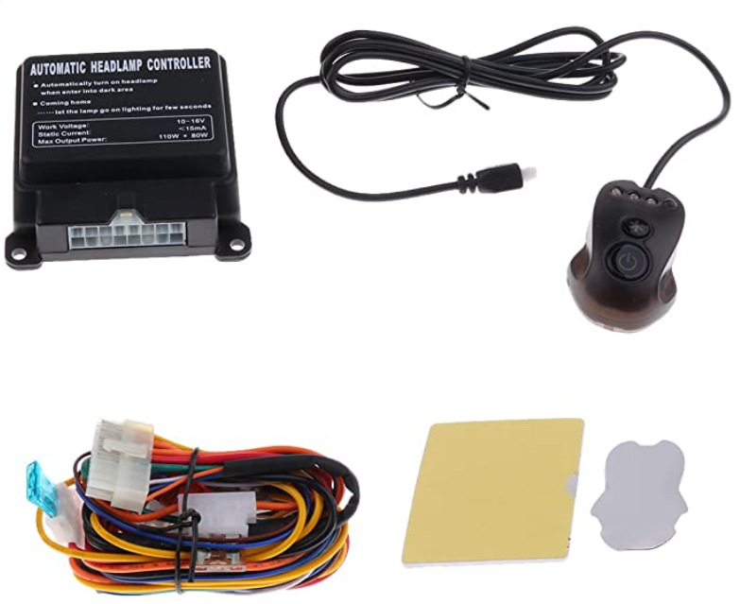
Figure 5: MagiDeal 1 Headlight kit [9]

4.1.1.2 Banggood Auto Headlight Sensor & Control Switch
This relatively cheap automatic headlight sensor and control switch costs just £24.00. The control switch offers a range of simple settings along with the addition of manual activation of the front and rear fog lights. This control system has an easy to use operational switch which requires no drilling to fit into the console. [10]
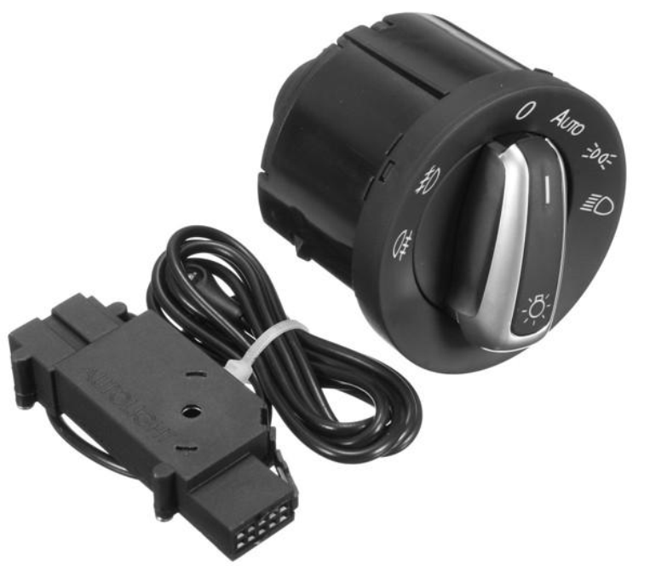
Figure 6: Banggood Auto Headlight System [10]

4.1.1.3 VendinPlus Car Automatic Headlight Control Kit
The VendinPlus control kit as shown in Figure 7 requires a supply voltage of 12V and has a single switch operation to enable the dipped beam function within the headlights. It costs just £29.99 and includes all pieces of kit needed for a simple and easy installation. [11]
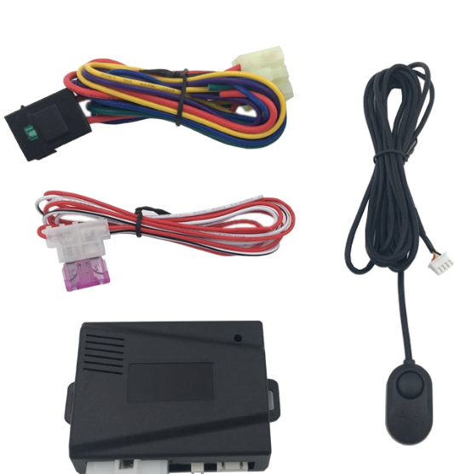
Figure 7: VendinPlus Headlight System [11]

4.1.1.4 Vanstyle Auto Headlight Switch & Module
Vanstyle’s auto headlight module includes all fixings as shown in Figure 8 and is of great quality. The system allows the user to operate the rear and front fog lights, as well as the automatic function for dipped beam and side lights. Unfortunately the module costs a relatively expensive £59.99 and the light monitoring sensor is not supplied with the system. [12]
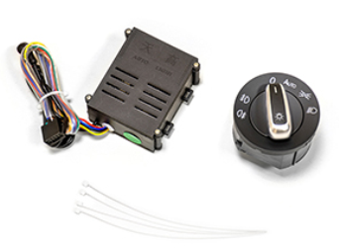
Figure 8: Vanstyle Auto Headlight System [12]

4.1.1.5 Comparison of Existing Automatic Headlight Systems
Table 2 is a comparison of the existing automatic headlight.
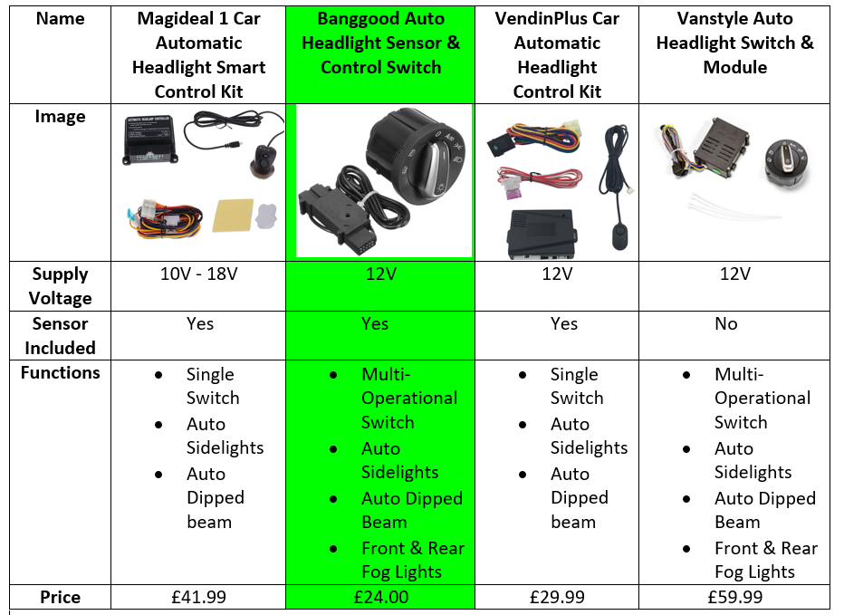
Table 2: Comparison of automatic headlight systems [9] [10] [11] [12]
The preferred choice of automatic lighting system is the Banggood Auto System. The reasoning behind this choice is due to the multi-operational switch and the relatively cheap purchase price of £24.00, the system also includes the sensor which detects the level of brightness.

Parking Sensors
Parking sensors are a feature which have only been included in mass produced cars since 2003, where they were first featured in a Toyota Prius. [13] Parking sensors are an automated feature which have been developed to work flawlessly and have gone from a costly extra, to a very basic feature that is included on nearly all newly manufactured cars. Chapter 4.2 takes a look into the various types of aftermarket parking sensor systems that are available to purchase on today’s market. The products listed below are not products that are featured on newly manufactured cars, but are aftermarket products.

4.1.2.1 Ultrasonic Sensor Systems
Ultrasonic sensors are one of the most commonly used type of sensors within parking aid. Ultrasonic sensor technology functions through the production of sound waves. The sound waves detect any objects or vehicles within close proximity. Normally a bleeper noise is produced when the car approaches another object or vehicle. The bleeper becomes more frequent the closer the car gets to an object. [2] An advantage of ultrasonic sensoring systems is that they are able to function in the dark, unlike proximity sensors that use light or cameras. Dark environments have no effect on an ultrasonic sensors ability, which is vital for parking aids on a car.

4.1.2.1.1 COCAR Backup System
This ultrasonic system includes four sensors (for rear of the car) as shown in Figure 9. It also has a sound bleeper for when objects are close and it comes with an LED distance display. The range of the detection is between 30cm – 200cm and the sensors have an enclosure rating of IP67. [14]
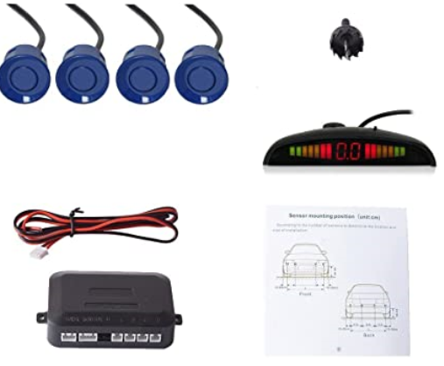
Figure 9: Cocar Backup System [14]

4.1.2.1.2 VALEO Parking Sensors Kit
This parking sensor kit only includes four ultrasonic sensors but is relatively cheap, costing just £65.50. As shown in Figure 10 it does not include any display and the sensors enclosure rating is IP67. The ultrasonic sensors have a range of detection up to 170cm. [15]
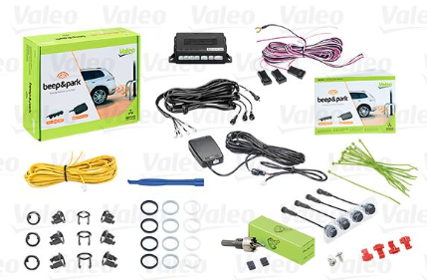
Figure 10: Valeo Sensors Kit [15]

4.1.2.1.3 BRIGADE BS-4000W Sensor Kit
This expensive ultrasonic sensor kit costs £243.11 and includes eight ultrasonic sensors, as shown in Figure 11. The range of detection is between 60cm – 250cm and the sensors have an enclosure rating of IP68. The system includes a bleeper and an LCD distance display screen. [16]
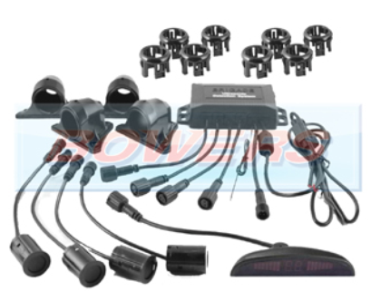
Figure 11: Brigade BS-4000W Sensor Kit [16]

4.1.2.1.4 STEELMATE PTS800EX Parking Sensors
The Steelmate PTS800EX Includes a total of eight ultrasonic sensors, four for the front bumper of the car and four for the rear bumper. Although it does not include a display unit it is compatible with a variety of visual displays. It comes with two bleepers, one sound is for the detection of the front of the car and there is a different sound for the rear. The sensors have an enclosure rating of IP68 and have two different detection ranges. The front sensors detect between 30cm – 100cm and the rear sensors 30cm – 250cm. [17]
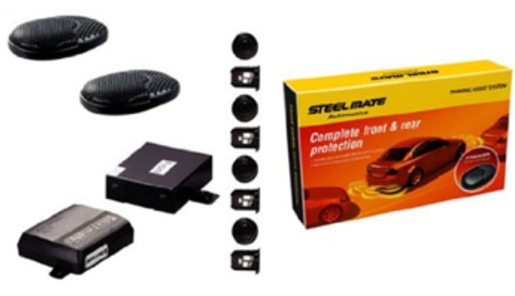
Figure 12: Steelmate PTS800EX Parking Sensors [17]

4.1.2.1.5 Comparison of Ultrasonic Sensor Parking Systems
Table 3 compares the four ultrasonic parking sensor systems.
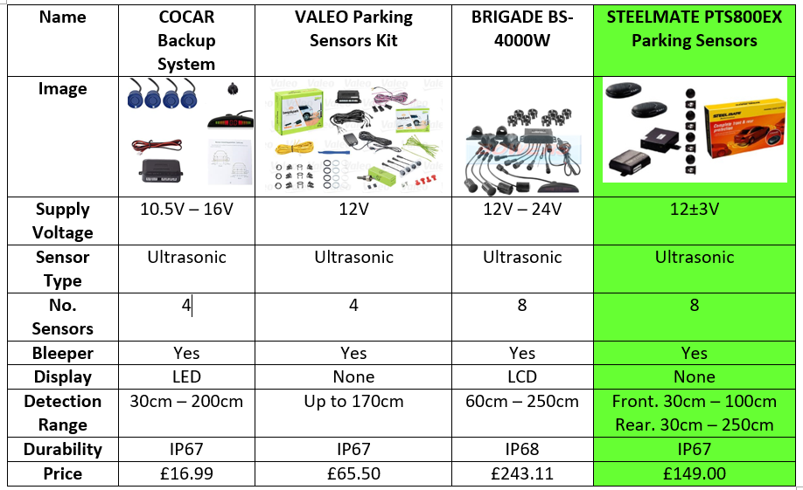
Table 3: Comparison of ultrasonic parking sensor systems [14] [15] [16] [17]
The preferred choice of ultrasonic parking sensors are the Steelmate PTS800EX as highlighted in green. This has been chosen as the favourite of the four systems because it offers double the amount of sensors as the Cocar Backup System and Valeo Parking Sensors. Although costing a slightly high £149.00, it is still more cost effective than the Bridgade BS-4000W.

4.1.2.2 Radar Sensor Systems
After extensive research of radar sensor technology, it was established that the sensoring technology was used commonly for blind spot detection within cars, rather than parking aid. Upon recent times radar sensors have also been integrated into aiding with lane change assistance and collision mitigation. It is clear to see that radar sensors are an integral part of advanced driver assistance systems within the modern day car. These assistance features are only recently being introduced into newly manufactured cars and come at a costly extra.
Radar sensors use radio waves to detect how far away an object or car is. To do this, the radar sensor emits a concentrated radio wave and listens for any echo. [18] One advantage of Radar Sensor Systems used for blind spot detection is that the radar technology can tell the difference between stationery and moving target, without this feature the blind spot detection would activate constantly as it would be detecting all stationary object.
The systems below are aftermarket radar sensor systems, which are available to purchase on various platforms.

4.1.2.2.1 BRANDMOTION RDBS-1500 Radar System
This blind spot detection system has two radar sensors which can detect up to 12 metres . The sensors have an enclosure rating of IP68. The system includes two LED warning lights. As shown in Figure 13 the system contains a bleeper to notify the driver and costs a extortionate £581.14. [19]
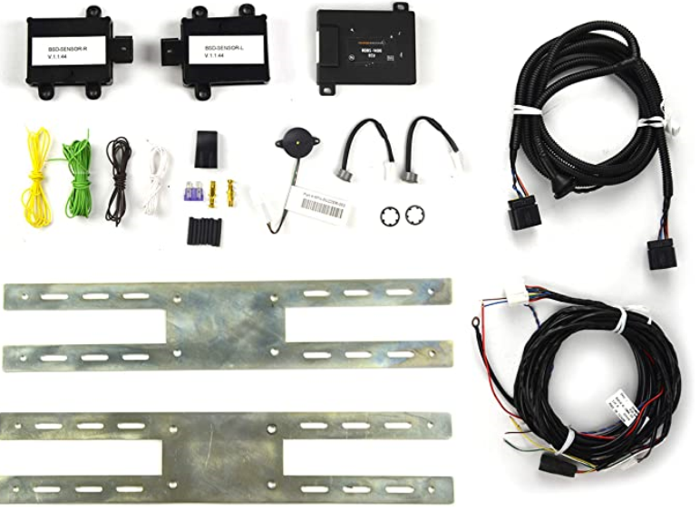
Figure 13: Brandmotion RDBS-1500 Radar System [19]

4.1.2.2.2 VALEO Monitoring System
This radar system was found on Amazon costing £126.62, it features two radar sensors, two LED indicators and also a bleeper. Valeo state that the detection range of each radar sensor can be up to 5 metres and that they are rated IP68. [20] [21]
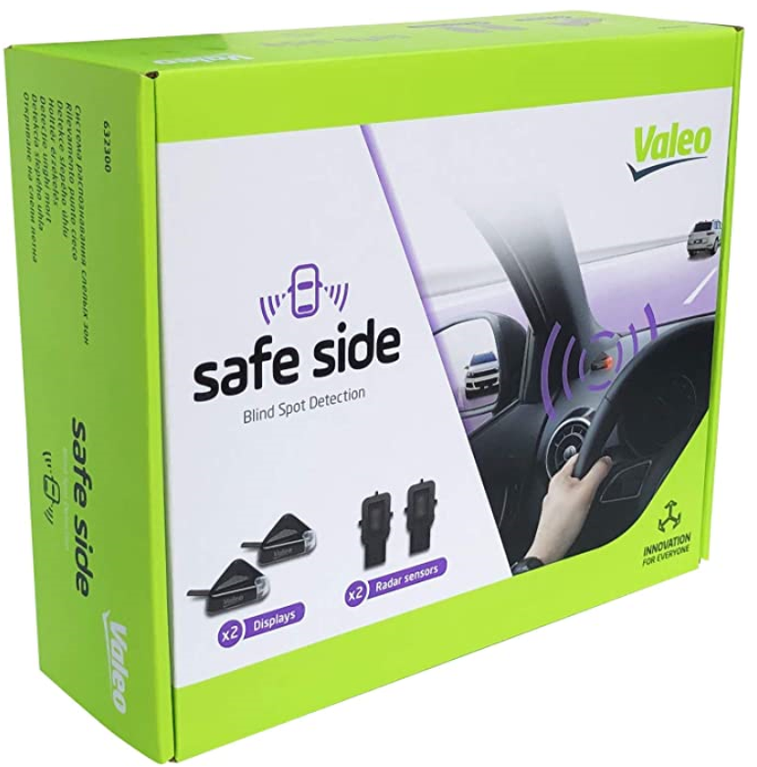
Figure 14: Valeo Monitoring System [20]

4.1.2.2.3 Crimestopper BSD-754
This blind spot radar system incorporates four radar sensors and two LED indicators which illuminate on warning. Along with the two LEDs, a bleeper activates as a warning signal. The Crimestopper BSD-754 has an additional two sensors included which are fitted at the front of the vehicle, the front sensors communicate with the main unit to not trigger once the rear sensors pick up an object. The system operates at 12V and costs $117.99. The total range of the sensors is 4 metres and have an enclosure rating of IP67. [22]
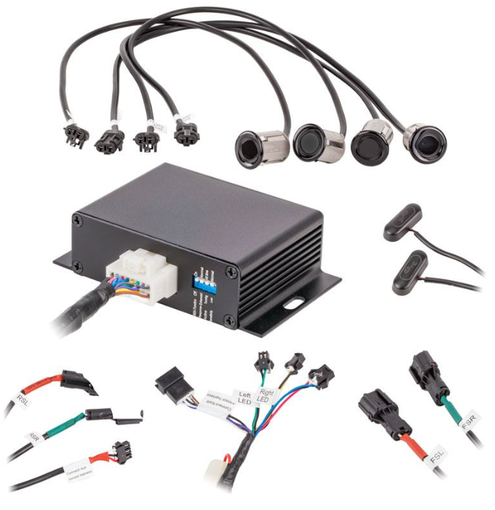
Figure 15: Crimestopper BSD-754 [22]

4.1.2.2.4 Motor Mods Radar System
The Motor Mods radar system contains two IP67 rated radar sensors that operate at 12V and have a detection range of up to 15 metres. Two LED indicators and a bleeper are included in the system but the price was not given due to the make and model of the car having an impact on the total price. [23]
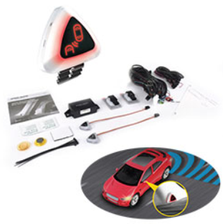
Figure 16: Motor Mods Radar System [23]

4.1.2.2.5 Comparison of Radar Sensor Systems
Table 4 compares the four existing radar sensor systems.
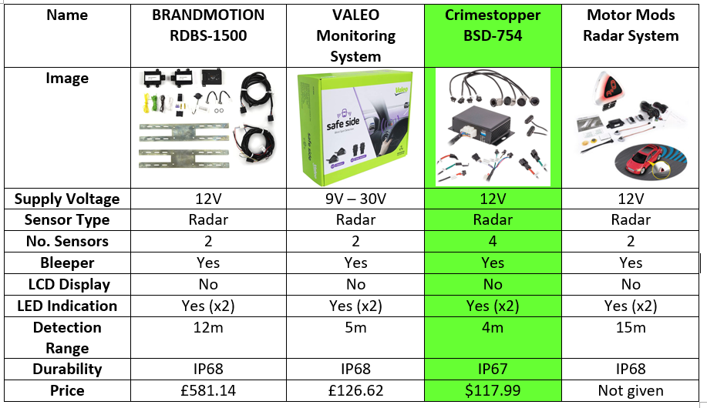
Table 4: Comparison of radar sensor parking systems [19] [20] [21] [22] [23]
After careful consideration the preferred choice of the four radar sensor systems is the Crimestopper BSD-754. This system was the preferred choice not only because of its low cost but it’s total of four sensors is double that of any of the other systems. It has a detection range of 5 metres which is a sufficient range of detection.

4.1.2.3 Electromagnetic Sensor Systems
Much like ultrasonic sensors, electromagnetic parking sensors work by emitting a wave, then timing how long it takes to return. One key difference between electromagnetic sensors and ultrasonic sensors is that visually, you will not spot an electromagnetic parking sensor as they are generally placed behind the rear bumper, hidden from view. Where ultrasonic sensors emit a sound wave, electromagnetic sensors emit a radio wave. The radio wave will bounce off an object and return to the sensor, the change in frequency is used to calculate the distance from the sensor to the object. [24] One advantage of Electromagnetic Sensor Systems used for parking aid is that the sensor is situated behind the plastic bumper of the car, and unlike ultrasonic sensors, it requires no drilling of holes or painting.

4.1.2.3.1 EPS-Dual 4.0
The Parking Dynamics PD-1 Rear parking system contains just one electromagnetic sensor which has a detection range of up to 80cm. Although there is no display a bleeper is integrated into the system to signify how close an object is to the sensor. The supply voltage for the system is 9.5V – 18V and costs £47.95. [25]
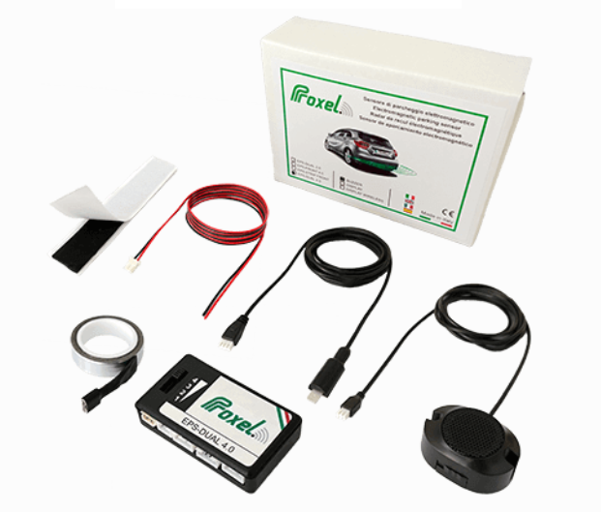
Figure 17: EPS-Dual 4.0 [25]

4.1.2.3.2 Parking Dynamics PD1-Rear
The Parking Dynamics PD1-Rear system requires a supply voltage of 12V and contains a single electromagnetic sensor. The electromagnetic sensor has a detection range of up to 80cm and the system contains a bleeper, but no detection display. At the time of this report the system was out of stock and therefore no price was listed.
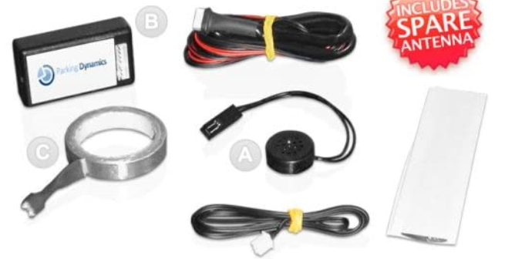
Figure 18: Parking Dynamics PD1-Rear [26]

4.1.2.3.3 Smart Star Sensor
The Smart Star Sensor system has a detection range of 0.3m – 2.5m and contains a bleeper to signify how close an object is from the electromagnetic sensor. The system requires a 12V supply and costs just £26.99.
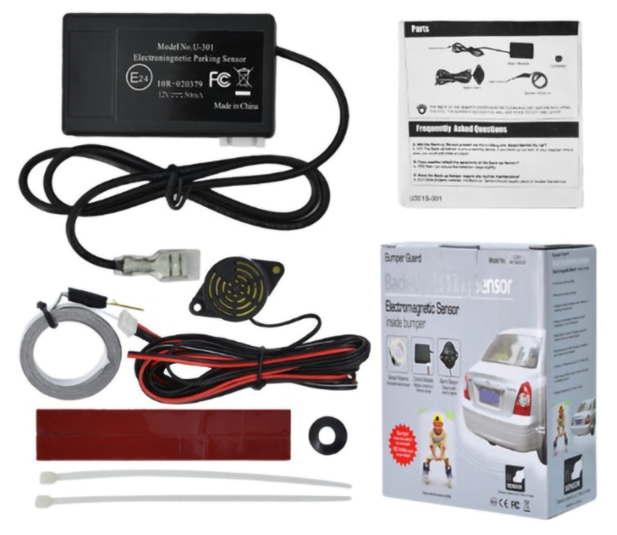
Figure 19: Smart Star Sensor [27]

4.1.2.3.4 Hawk HA-EMS02
The Hawk HA-EMS02 system has a detection range of up to 70cm and contains a bleeper. The system costs just £29.99 and requires 12V supply. [28]
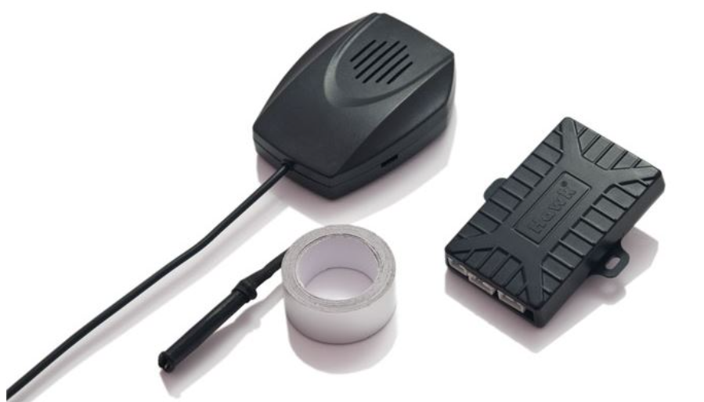
Figure 20: Hawk HA-ESMS02 [28]

4.1.2.3.5 Comparison of Electromagnetic Sensor Systems
Table 5 compares the electromagnetic sensoring systems.
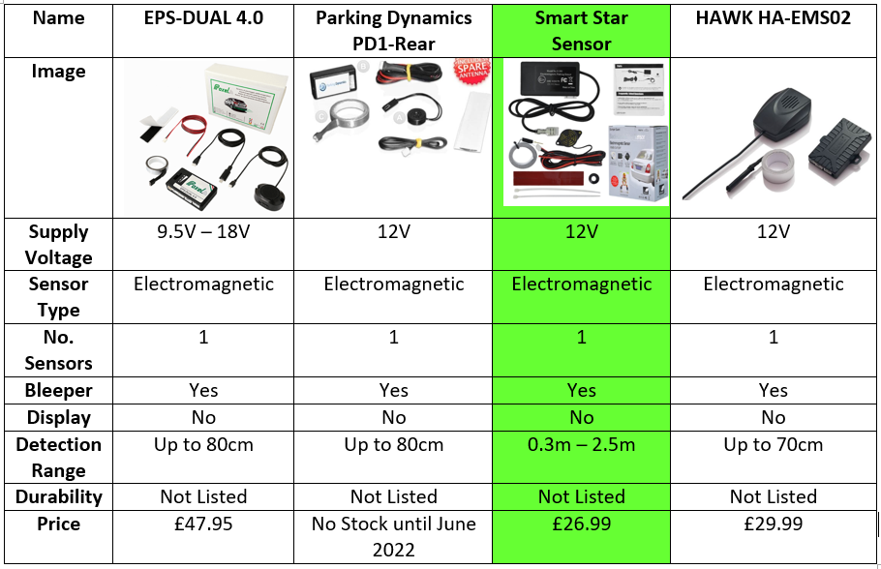
Table 5: Comparison of electromagnetic sensor parking systems [25] [26] [27] [28]
After comparing the four electromagnetic parking sensors, the preferred choice is the Smart Star Sensor system. This is the favourable choice as its detection range is double that of the other three systems. It is also the cheapest of the four.

4.2 Sensor Selection
This chapter compares and contrasts different types of sensor technologies that are able to measure the two variables within the project, sunlight brightness and distance. The brightness will need to be read to activate the headlights once a specific level of brightness has been reached. The distance an object is from the system will need to be measured within the parking aid function, to notify the user how far away an object is.
The tables within this section contain critical information which aid in the decision to select the most appropriate sensor. It is vital that the correct sensor technology is chosen as the variables to be measured need an accurate reading in order for the system to be successful in its operation.

4.2.1 Sunlight Brightness Sensor
Table 6 compares three different types of sensor technology that is able to measure sunlight brightness.
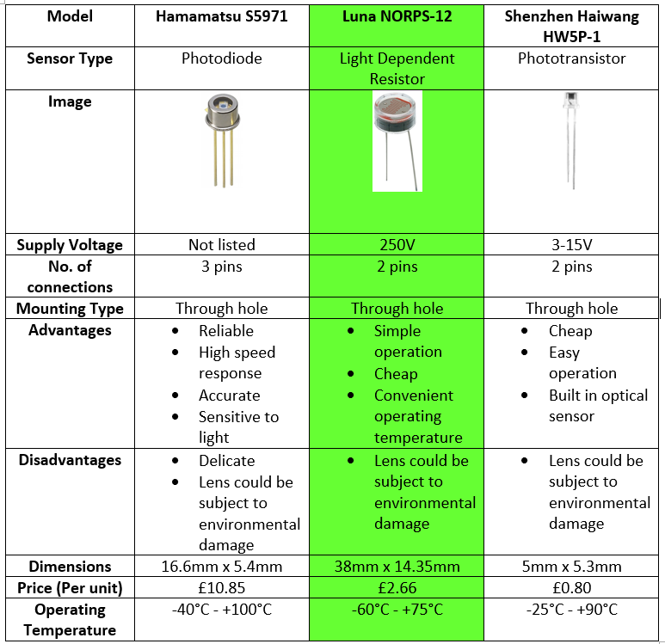
Table 6: Comparison of sunlight brightness sensors [29] [30] [31]
The sensor technology that was selected for further research was the light dependant resistor. The reason as to why light dependant resistor was chosen, was because it has a very simplistic operation, and is also very affordable.

4.2.1.1 Light Dependant Resistors
Table 7 compares three different types of light dependant resistors.
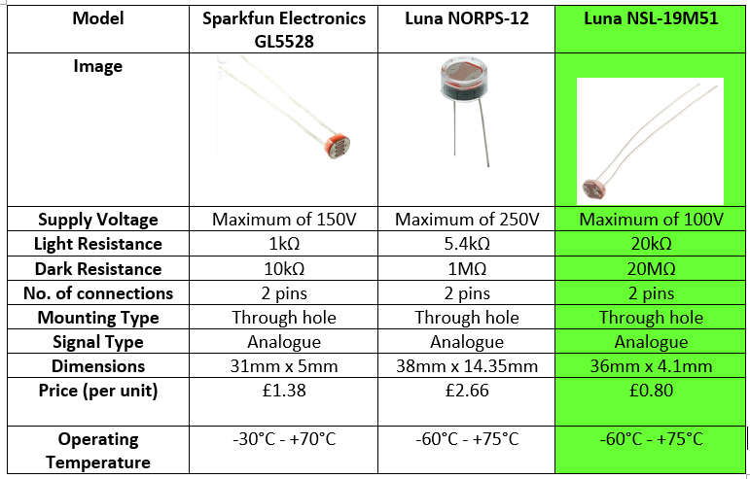
Table 7: Comparison of light dependant resistors [32] [30] [33] [34]
The chosen sensor to measure sunlight brightness was the Luna NSL-19M51. The Luna NSL-19M51 is the cheapest of the three LDRs and has an excellent light and dark resistance range. It is also extremely cost effective.
At the time of this report due to the ongoing events with COVID-19, delivery times on all components varied depending on stock. The Luna NORPS-12 was ordered via RS Components as this was the only LDR of the three which was in stock. It would be delivered in a suitable timeframe for the project to be completed and because of the varying stock quantities a total of four sensors were ordered. Although just one LDR was required for the design, three more were ordered in the event the original sensor would break or become faulty.
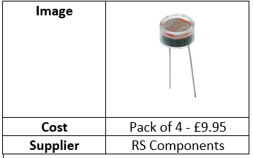
Table 8: Costing - LDR Sensor [35]

4.2.2 Distance Measuring Sensor
Table 9 compares three different sensor technologies that are capable of measuring distance. One of the sensor technologies were to be used for parking aid within the system.
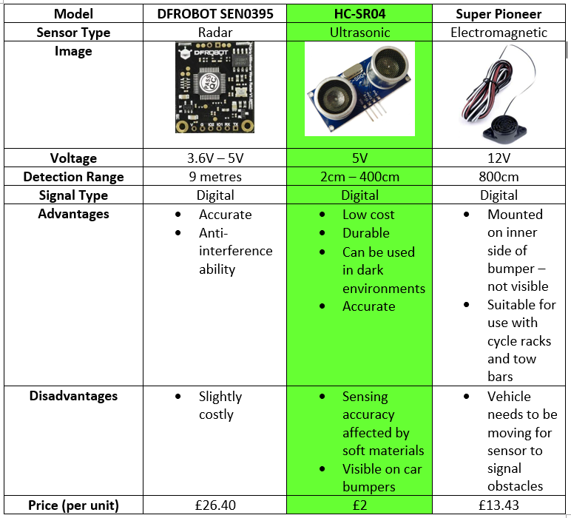
Table 9: Comparison of distance measuring sensors [36] [37] [38]
The chosen sensor technology to measure distance was the ultrasonic sensor technology. After extensive research it was clear that the ultrasonic sensor technology would outperform radar and electromagnetic. Radar sensors have a limited field of vision, which would cause a delay in detection of vehicles/objects when parking, which is why this sensor technology was not chosen. In order for the Electromagnetic sensor to work when parking, the car needs to be stopped in order to gain a detection reading, which is not suitable for the function of the parking aid. The main reason why the ultrasonic sensor was chosen was because it is extremely durable and could be used within dark environments. The detection range and cost is adequate for the task at hand.

4.2.2.1 Ultrasonic Sensors
The ultrasonic sensor will be used as parking aid within the system by detecting objects which are situated within the detection range and radius of the sensor. Ultrasonic sensors have the capability to work whilst stationary, like electromagnetic sensors, but also work whilst moving. They use sound waves to detect objects that are situated in front of the sensor. The sensor will pulsate the sound in a high frequency, which then reflects off nearby objects. The receiver of the sensor can catch the reflected waves, and then calculate the distance to the detected objects. Table 10 compares three different ultrasonic sensors.
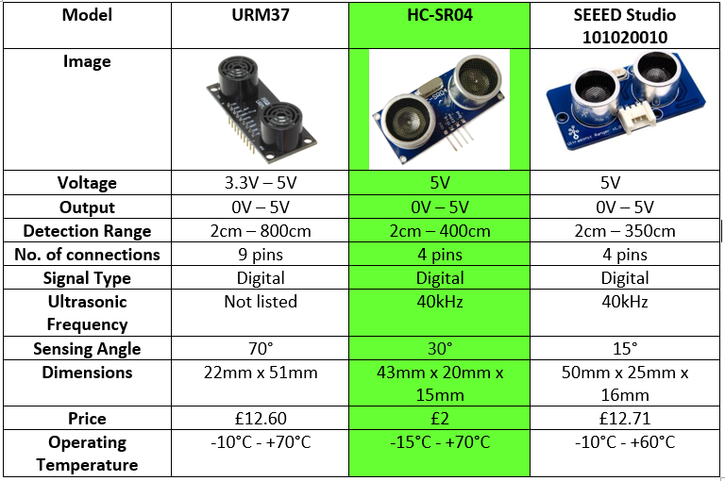
Table 10: Comparison of ultrasonic sensors [39] [40] [41]
After comparing the three ultrasonic, the favoured choice is the HC-SR04. This sensor was chosen due to its extremely affordable price. Although the remaining two sensors featured excellent detection ranges, the 2cm – 400cm detection range of the HC-SR04 is an adequate range of detection. The price tag of the HC-SR04 makes it the most cost effective choice of the three. Four HC-SR04 ultrasonic distance sensors were purchased via RS Components, although one sensor would be needed for the system to function, a further three were purchased in case any were faulty or were to break.
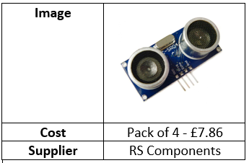
Table 11: Costing - Ultrasonic Sensor [42]

Design
The following chapter looks into the decisions made when designing the system, and will also look at the implementation of the components used. Each stage of the design and how the system operates is explained within this chapter. Costs of the components will also be outlined.

5.1 Brief
The two design aims of the project were to create a microcontroller based system which would operate two of the following:-
- Front and rear parking sensors
- Automatic headlights
The concept of this idea was used to create a simulation. As the product would be replicated via an in person and virtual simulation, only one ultrasonic sensor was used for the design of parking aid, acting as a rear parking sensor, and a yellow LED would replicate the headlights.

5.2 Microcontroller Selection
To select what microcontroller would be used, a specification which outlines the key aspects of the design must be generated. The specification allowed differentiation of each microcontroller which was available to purchase. Highlighting the different aspects each microcontroller preserve is key to identifying the correct selection. If the correct microcontroller is not selected, issues may occur further down the project, such as an insufficient amount of pins on the microcontroller. The microcontroller specification is as follows:-
- 3 Analogue Inputs
- 4 Digital Inputs
- 4 Digital Outputs
- 7 Pins for LCD – 4 data, 3 setup
- RS232
- 2 Debug

Pins needed:-
Total Pins = 24 pins + Power and Ground (4 pins) = 28 pins.
Whilst the total number of pins had be calculated, Microchip.com was then used to select criteria which mirrors the specification to find the correct microcontroller suitable for the system. Microchip.com allows parameters to be set when selecting the criteria of the microcontroller.

Factoring in the microcontroller specification, the following parameters were set when searching for a suitable microcontroller:-
- Minimum Programme Memory – 4KB
- Minimum Ram – 273 bytes
- Pin Count – Max 40, Minimum – 27
- Minimum ADC Channels – 3
- Max Res (ADC) – 16, Minimum – 8
- Internal Oscillator 16Mhz or above
- 1 Uart

After selecting these parameters a small quantity of microcontrollers fitted the specification. Normally, the most suitable microcontroller would be selected in terms of its capabilities and features, but due to the ongoing COVD-19 events, there is a worldwide component shortage which has a substantial effect on delivery times for microcontrollers around the globe. The microcontrollers that were in contention to be selected, were ones which could be delivered in a suitable time frame.
After an investigation into how long each microcontroller would take to be delivered, the only available PIC which had a suitable delivery date and cost was the PIC16F886. Although just one microcontroller is needed for the system to function, a quantity of five were ordered in the event that any were faulty or would fail further along the project. It was important to order spares due to poor delivery times. If a single microcontroller was ordered and became faulty, the timeframe in which the project could be completed would decrease substantially. The microcontrollers were ordered from RS Components as shown below in Table 12.
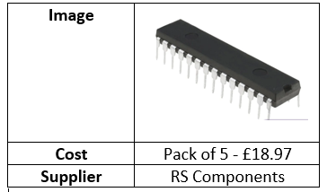
Table 12: Costing - PIC16F886 [43]

5.3 Component Selection
This chapter considers components necessary for the system to function successfully. A picture of the product along with its price is listed below.

5.3.1 Yellow LED
This yellow LED is used for the simulation of the headlights.
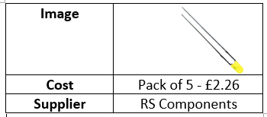
Table 13: Costing - Yellow LED [44]

5.3.2 Red LED
The red LED is used for an indication that the reverse gear is engaged.
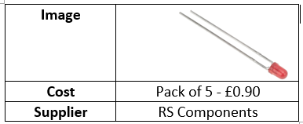
Table 14: Costing - Red LED [45]

5.3.3 Green LED
The green LED is used to indicate if the headlights are active.
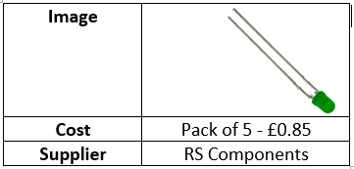
Table 15: Costing - Green LED [46]

5.3.4 Push Button Switch
The push button switch controls the manual activation and manual deactivation of the headlights.
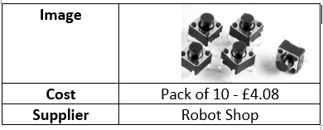
Table 16: Costing - Push Button Switch [47]

5.3.5 Slide Switch
The slide switch will operate the ‘in reverse’ function, which can activate or deactivate the reverse gear simulation.
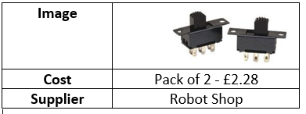
Table 17: Costing - Slide Switch [48]

5.3.6 Resistor Kit
The resistor kit contains a set of 610 resistors.
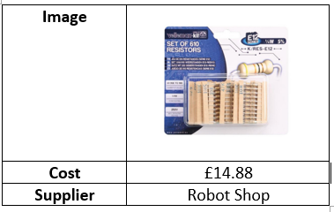
Table 18: Costing - Resistor Kit [49]

5.3.7 LCD Screen
The LCD Screen is used to display details of the brightness value and distance an object is from the ultrasonic sensor.
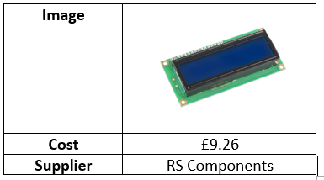
Table 19: Costing - LCD Screen [50]

5.3.8 BC108 Transistor
The transistor is used within the headlight circuit, it is connected to the yellow LED.
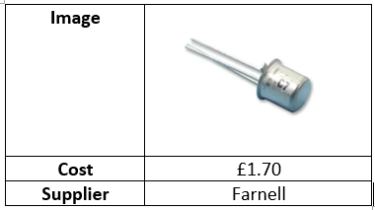
Table 20: Costing - BC108 Transistor [51]

5.3.9 Relay
The relay is used within the headlight circuit, it will be used to switch the yellow LED on and off.
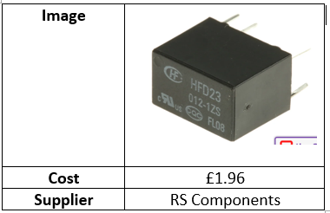
Table 21: Costing – Relay [52]

5.3.10 Breadboard
The breadboard is used to build and test the circuitry of the design.
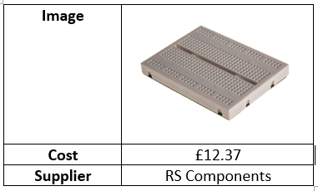
Table 22: Costing – Breadboard [53]

5.4 Costing
Within Table 23 all components needed for the systems final build are listed. Fortunately, the university were able to provide a lot of the components, these components are highlighted in yellow.
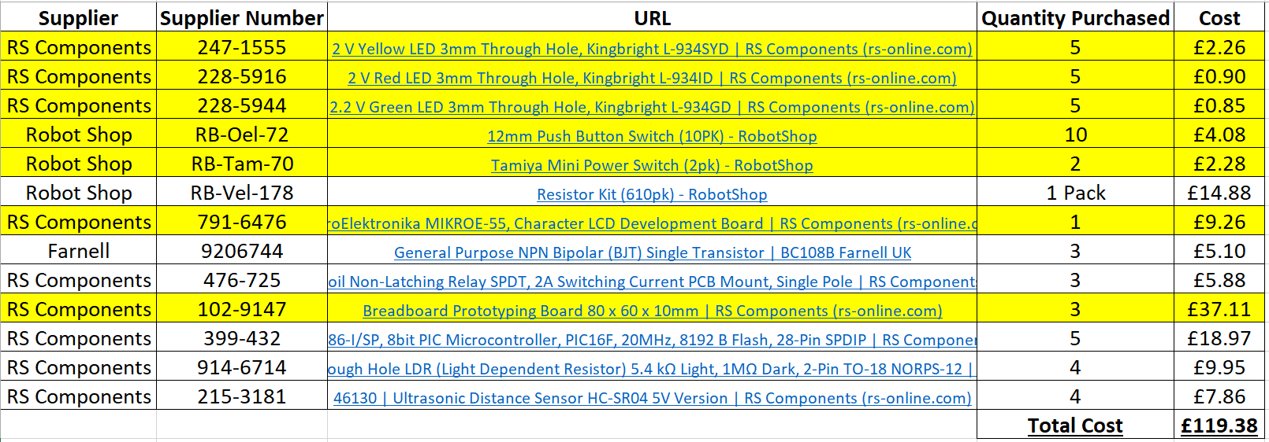
Table 23: Table of Costs

5.5 Operational Functions
The following section looks at the two main working functions of the system, along with their operational processes, how they will be simulated, how they will be activated and what happens when they are activated.

5.5.1 Automatic Headlights
As previously mentioned, the headlight function is simulated via a yellow LED. The operation of the yellow LED within the system is activated via two routes. The first being a push button switch which manually activates the yellow LED.
The other route of activation was that when the light dependant resistor (LDR) reads the brightness level to be less than 220, the yellow LED will activate. Once the brightness level is 220 or greater, the yellow LED will deactivate. The brightness level of 220 was a pre-defined value which was calculated by conducting a survey. The survey process and results are detailed in Chapter 6.1.
A green LED was included in the system to activate alongside the yellow LED. This was to simulate a warning light that appears on the dashboard of a car when the headlights are active, notifying the driver that the headlights are active.

5.5.2 Parking Sensors
The operation of the ultrasonic parking sensor within the system is activated via a slide switch. The switch simulates the reverse gear of the car being initiated. Once reverse is initiated a red LED will also activate. The red LED signifies that the car has been put into the reverse gear which is what would be shown on the dashboard or screen of a car. Once in the reverse gear a sets of XX’s will appear on the LCD screen, this is the indication of how far away an object is from the sensor. Each set of XX will equal a distance of 20cm, therefore if any object is 19cm or less, 0 XX’s will appear on the LCD screen. When the slide switch has been activated the message ‘Reverse’ will be present. A simulation was run via Proteus to prove each set of XX is equal to 20cm along with an in-person testing process. These simulations and tests are outlined within Chapter 6.

5.6 Block Diagram
Figure 21 shows the block diagram of the system.
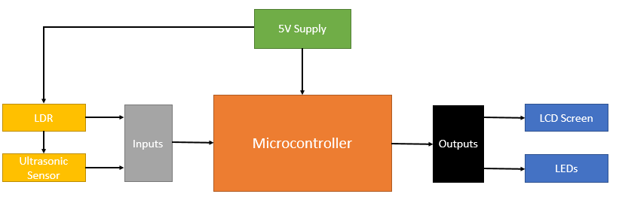
Figure 21: Block Diagram

5.7 Flow Chart
The systems flow chart is shown below in Figure 22.
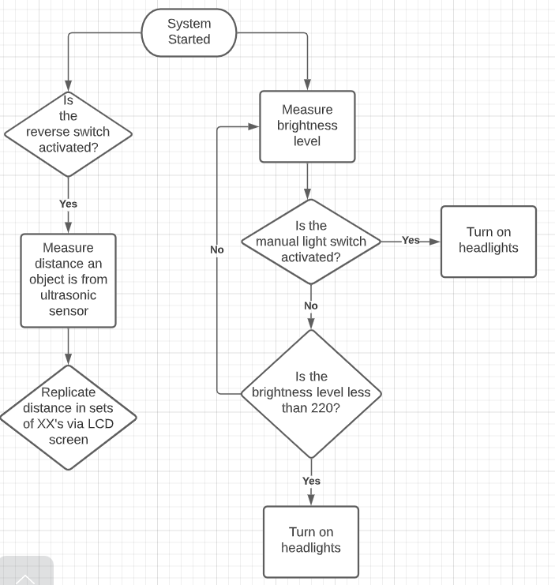
Figure 22: System Flow Chart

5.8 Proteus Design
Before conducting the schematic design of the system via Proteus, it was important to list the initial components needed to create the schematic, these were as followed:-
- PIC16F886
- LCD Screen
- Slide Switch
- Push Button Switch
- 3 10k Ohms Resistors
- 3 250 Ohms Resistors
- 1 220 Ohms Resistor
- 1 LDR Sensor
- 1 Ultrasonic Sensor
- 1 Green LED
- 1 Yellow LED
- 1 Red LED
- 1 Relay
- 1 BC108 Transistor

Once listed, they were added to the components tab via Proteus, as shown below in Figure 23, this was to ensure easy access when designing the system.
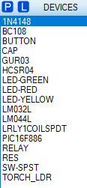
Figure 23: Proteus Components

5.8.1 Full Schematic Design
The full schematic of the Proteus design is shown below in Figure 24. Proteus was an excellent method to create a virtual schematic of the system, as it had of all components necessary to replicate a real life build of the system. Proteus would initially be used to create the circuitry along with the addition of supplying the PIC16F886 with its input and output connections.
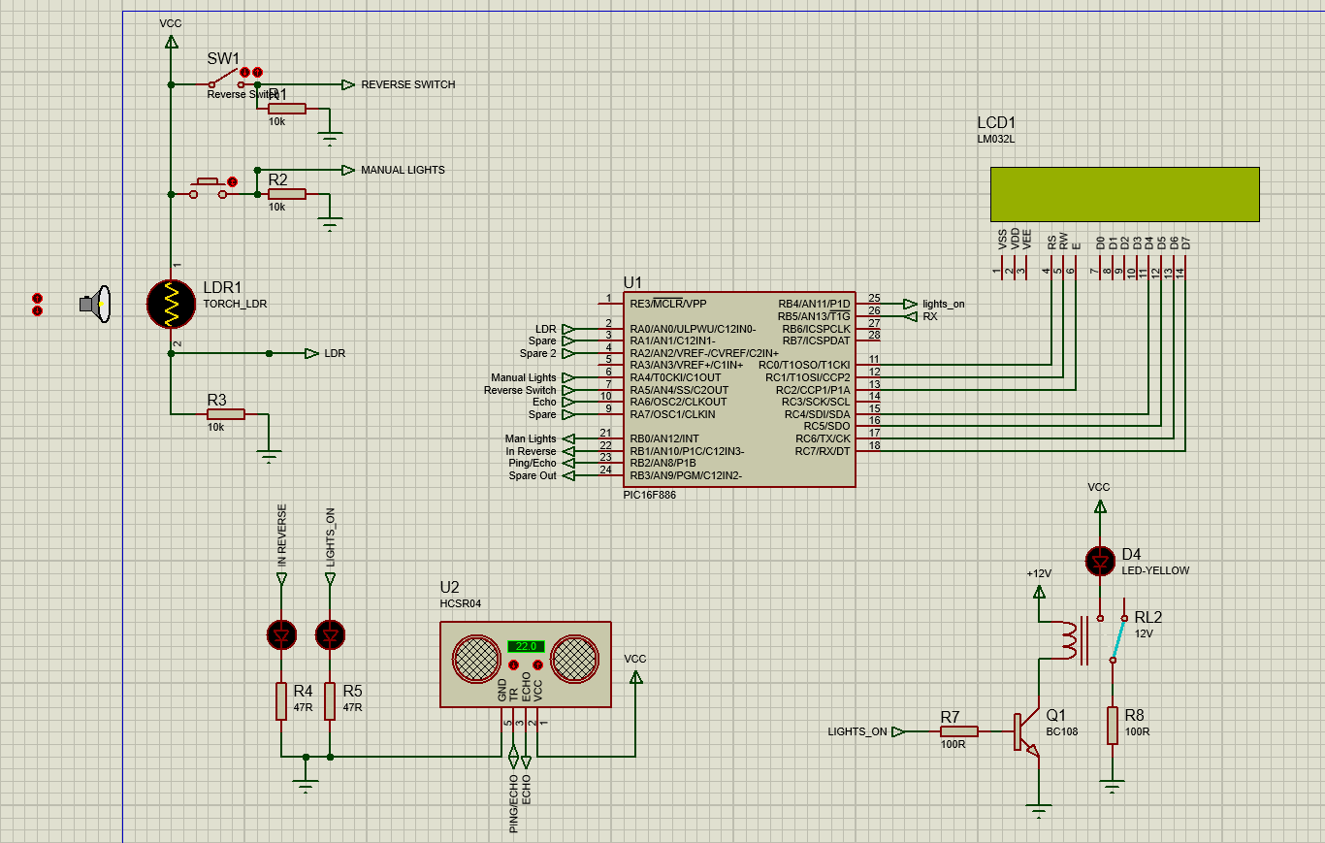
Figure 24: Full Schematic of Proteus Design

5.8.2 PIC16F886 Schematic
Figure 25 shows the PIC16F886 with its inputs and outputs connections. The inputs are labelled via pins 2-10, and the output pins 21-25. Within the input pins there are two pins spare, labelled spare and spare 2. It was important when referring to the microcontrollers specification that there would be spare pins, as not all initial designs are successful and further altercations may of needed to happen. There is also a spare output pin which is labelled spare out, as shown on pin 24.
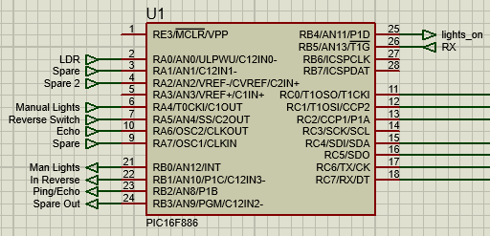
Figure 25: PIC16F886
When building the physical system, it was apparent that the layout of the pins for the PIC16F886 were different on Proteus, when compared to the PICs datasheet. The pin diagram from the PICs data sheet shows the correct orientation of the pins as shown below in Figure 26.
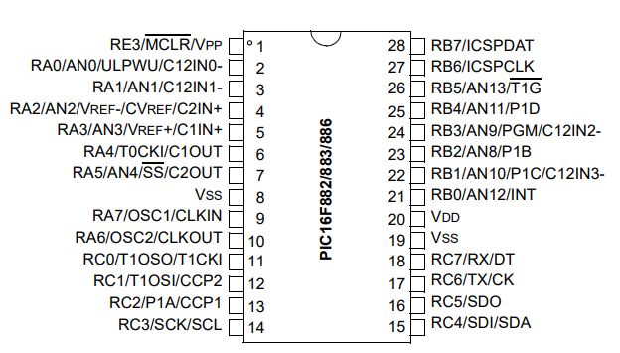
Figure 26: PIC16F886 Pin Diagram [54]
Whilst referring to the Proteus schematic when making the physical connections from the PIC to the components, it was important to also refer to the pin diagram to ensure the correct connections were made.

5.8.3 Switches and LDR Sensor Schematic
As shown in Figure 27 both switches and the LDR (Light Dependant Resistor) require VVC, which is 5V. Both switches and the LDR require a 10k Ohms resistor to ensure a defined state is present at the microcontroller’s input, otherwise the input could be left floating. The switches and LDR sensor also require a connection to ground to ensure safety.
The circuit that contains the slide switch labelled SW1 connects to pin 7 on the PIC, this circuit is the circuit that simulates ‘in reverse.’ The push button circuit connects to pin 6 on the microcontroller, this circuit manually activates the headlights (yellow LED). The LDR circuit connects to pin 2 on the microcontroller.
Two different types of switches were used in the design so that the user can easily differentiate between manually switching the headlights on, and initiating the reverse gear.
The LDR component also features a torch on Proteus, the torch can increase or decrease brightness levels when running a simulation.
Figure 27: Switches and LDR Sensor

5.8.4 Activation LEDs & Ultrasonic Sensor Schematic
Figure 28 shows the ultrasonic sensor is connected to VCC and is supplied via the sensors pin 1. Ground is connected to pin 4 and the ping is connected from the sensors pin 3 to the PICs pin 23.The echo is connected from the sensors pin 2 to the PICs pin 10. The red LED is connected to the input of ‘In Reverse’ and the green LED is connected to the input of ‘Lights_On.’
When ‘in reverse’ has been activated via the slide switch the red LED, which is connected to the resistor R4, will activate. If at any time the yellow LED activated, the green LED connected to resistor R5 will activate. A resistor was connected to each of the LEDs to protect them, as each resistor will limit the amount of current passed through each LED.
Figure 28: LEDs and Ultrasonic Sensor

5.8.5 Headlights LED Schematic
The yellow LED requires VCC and is also connected to a relay. The coil of the relay is connected to 12V and a BC108 transistor as shown in Figure 29. The transistor is included within this circuit to allow fast switching of electrical signals.
Figure 29: Headlights LED

5.8.6 LCD Screen
The LCD screen is connected directly to the PIC and VSS/VDD. The LCD Screen will display information regarding the distance an object is from the ultrasonic sensor, the ambient brightness value and also warning the user that the system is on.
Figure 30: LCD Screen

5.9 Coding
Once the schematic design of the system had been completed in Proteus, the next step was to create coding that would operate the components that were used in the Proteus design. This section of the report will look at the code written along with a description of each section of the code and its functions. Written in green, adjacent to the coding, is a short description of each line of code.
The coding was written under the source code tab within Proteus. The software CCS was used to create a new source code file which contains specific header files. As shown below in Figure 31, the main.h file is included along with its statements.
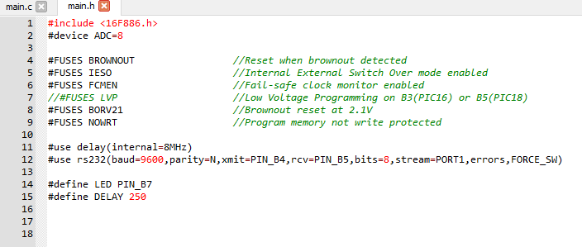
Figure 31: Main.h source code

5.9.1 Section 1
Lines 8-14 define the pins on the PIC that are used for the LCD screen, as shown in Figure 32. Line 17 starts the definition ‘set_lights,’ whilst line 18 starts the definition ‘lights.’
Between lines 22-24 sub routines of the programme are being defined. The routine ‘ping’ that is stated on line 22 is when an ultrasonic sound wave is sent out from the ultrasonic sensor to the nearest object, and the ‘echo’ as stated on line 23, will be the return pulse. The ‘calc’ is where the length of the pulse is going to be calculated to find its length, the length of the pulse is how far away the object is from the ultrasonic sensor. These sub routines will take place further along in the programme.
Lines 27-32 are declaring global variable definitions, where the integer values for man and ldr are 0. Line 31 states that the actual value of the distance an object is from the ultrasonic sensor will be stored. The main function is called on Line 34 whilst the ADC ports are set up within lines 39-40.
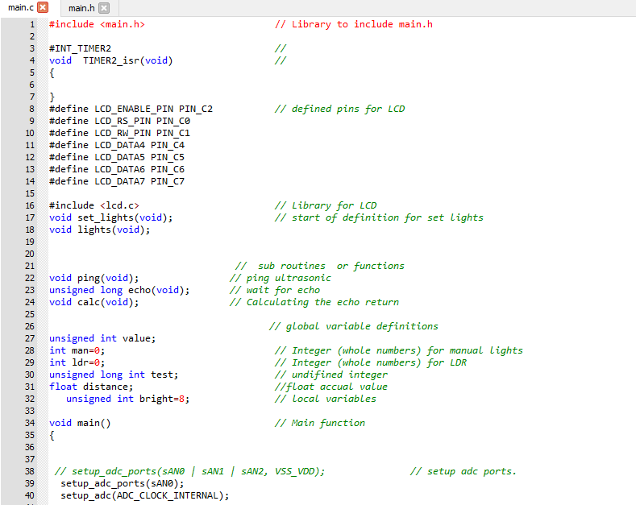
Figure 32: Coding - Section 1

5.9.2 Section 2
‘q’ is declared as a variable whilst ‘lig=0’ and ‘rev=0’ are also declared as variables by using ‘unsigned int’ data command as shown between lines 49-50 in Figure 33. ‘lig’ is short for lights and ‘rev’ is short for reverse. The LCD is initialised, and the message ‘System On’ appears on the LCD screen for 2 seconds. This is a safety feature to make the user aware that the system is live. Once the 2 seconds is up, the LCD screen clears the message. This process is outlined between lines 55-60. A looping statement whilst true is used, as shown on line 63, to execute statements shown in Figure 34, unless specified conditions are met.
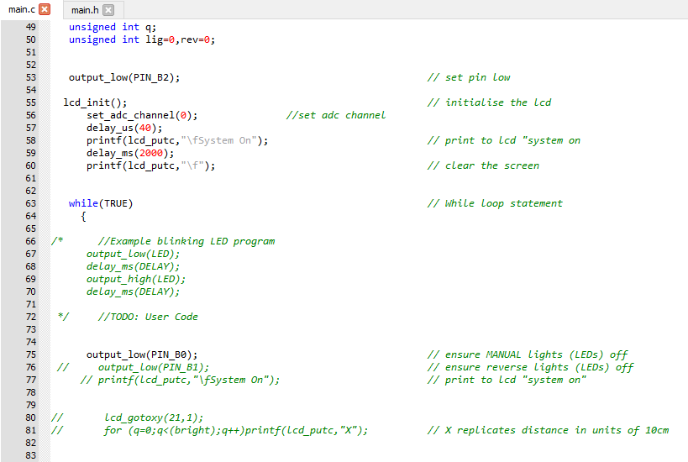
Figure 33: Coding - Section 2

5.9.3 Section 3
As stated within Section 2, a looping statement whilst true has been activated for the following section. If the reverse switch has been activated the system simulates the reverse gear being activated, then the message ‘Reverse’ will appear on the LCD screen, signifying to the user that reverse is activated. As the reverse gear has been activated the function ping is called, which is where the ultrasonic sound wave is sent from the ultrasonic sensor. The echo function is called which is where the return pulse is produced from the reflected signal received. The following processes are written between lines 87-105.
If the reverse switch is not activated, in a normally open state, then the LCD screen replicates the level of brightness read by the LDR. Along with a value of brightness, the LCD will also display the message ‘Ambient,’ along with its brightness level. This is to signify the brightness level to the user. 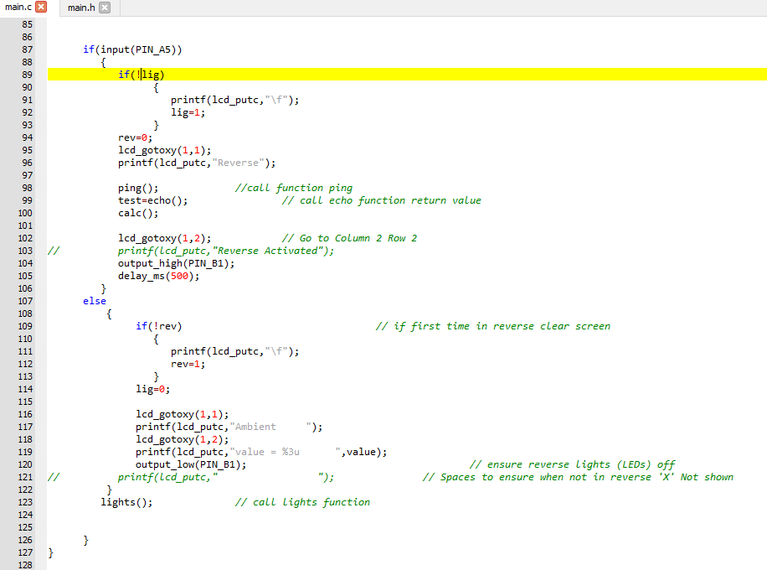
Figure 34: Coding - Section 3

5.9.4 Section 4
The lights function is called and if the manual light push button switch is pressed once, then the yellow LED will activate. As the yellow LED is activated, the green LED is also activated, notifying the user that the headlights would be active. This process is written between lines 138-142. Lines 145-147 set and read the ADC channel. If the value read at the LDR is less than 220 then the set_lights function is called as shown between lines 149-152. The value 220 was a pre-determined value of brightness. Chapter 6.1 looks at how the pre-determined brightness value was calculated.
Line 156 calls the definition set_lights. If the PICs pin B4 output is high then the yellow LED and headlights on indication (green LED) activate, whereas if the output for pin B4 is low then both the yellow LED and green LED stay off as shown between lines156-168
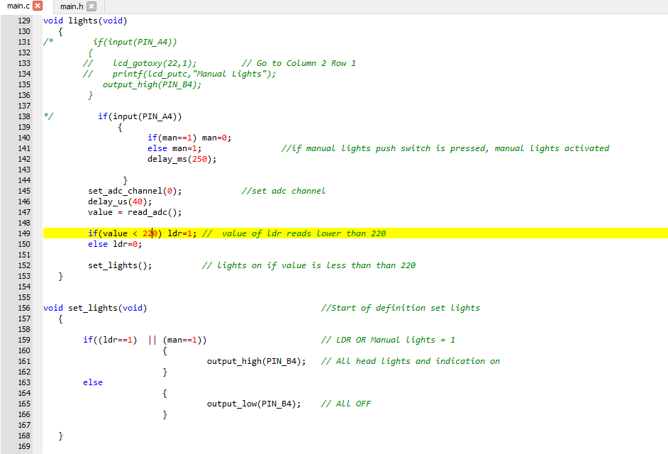
Figure 35: Coding - Section 4

5.9.5 Section 5
As shown on line 171 within Figure 36, the definition ‘calc’ is called. The defintion ‘calc’ divides the calculated distance of the pulse produced by the ultrasonic sensor when by 11.59. This calculation will give a value for the distance an object is from the ultrasonic sensor in cms. Once the distance an object is from the ultrasonic sensor is calculated into cms, it is replicated via sets of XX’s on the LCD screen. The LCD screen produces 1 set of ‘XX’ every 20cm.
If an object is 100cm from the ultrasonic sensor then the amount of XX’s that will appear on the LCD screen is, ‘XX XX XX XX XX XX.’
If an object is 65cm away from the ultrasonic sensor, the message ‘XX XX XX’ will appear.
It was important to breakup the XX’s to make the message comprehensible whilst parking. The process written can be seen between lines 171-185 within Figure 34. The XX’s and the message ‘Reverse’ disappear when reverse is disengaged.
The definition ‘ping’ is called on line 187 where pin B2 is set to high, which sends out the ping of the ultrasonic sensor, as shown on line 189. Line 190 activates a delay of 10μs as in the datasheet of the ultrasonic sensor, it states that a 10μs pulse is required to record the time taken for the echo to be received. Line 191 will then stop the pulse by setting the PICs pin B2 pin low.

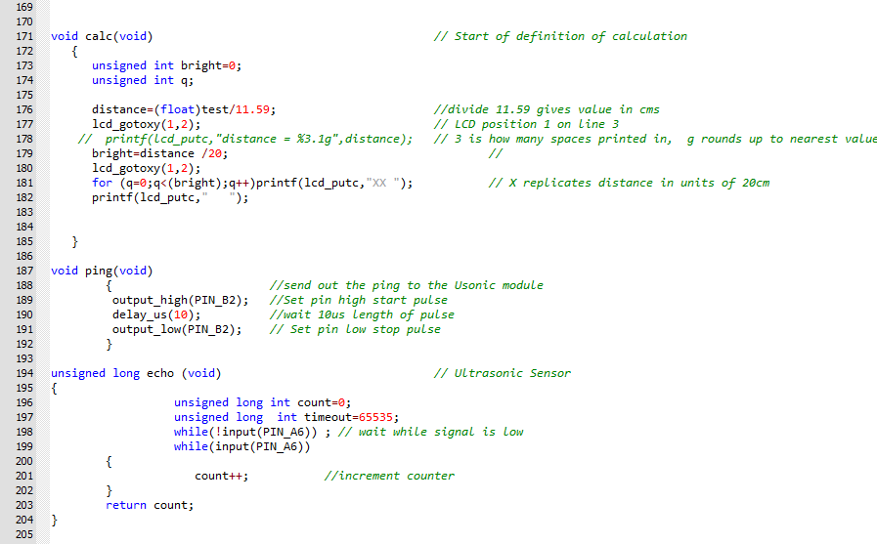
Figure 36: Coding – Section 5

5.10 Final Build
The schematic design created on Proteus was followed closely and replicated via a breadboard design as shown in Figure 37.
The orange wires used are for the incoming supply, which is connected to VAR. VAR is connected via an integrated board supply which is controlled by the software LJ Create. The VAR supply voltage is 5V, therefore the breadboard has a supply voltage of 5V. The red wire within the system is connected to 12V which supplies the coil of the relay. The black wires are used for connections to ground. The remaining wires which are various colours are used for input/output/signal connections.
It was important to place the microcontroller in the correct orientation, as the PIC required the wires to be connected to the correct pins otherwise the system would not work. If the PIC was placed into the breadboard in the incorrect orientation, it would not receive a 5V supply, which is why it was important to refer to the PICs datasheet.
The breadboard used was very advantageous in terms of time management as the connection between each wire and component required no soldering, which saved a considerable amount of time.
It was vital that the LDR and ultrasonic sensor were not obstructed by any components/wires/objects as this could potentially falsify their readings. The ultrasonic sensor was bent back slightly whilst the LDR required no adjusting.
Variable resistors were included into the final build, as the LCD screen had a backlight. The variable resistors required a connection VCC and the LCD screen. The brightness level of the screen and it’s backlight could be adjusted via the variable resistors.
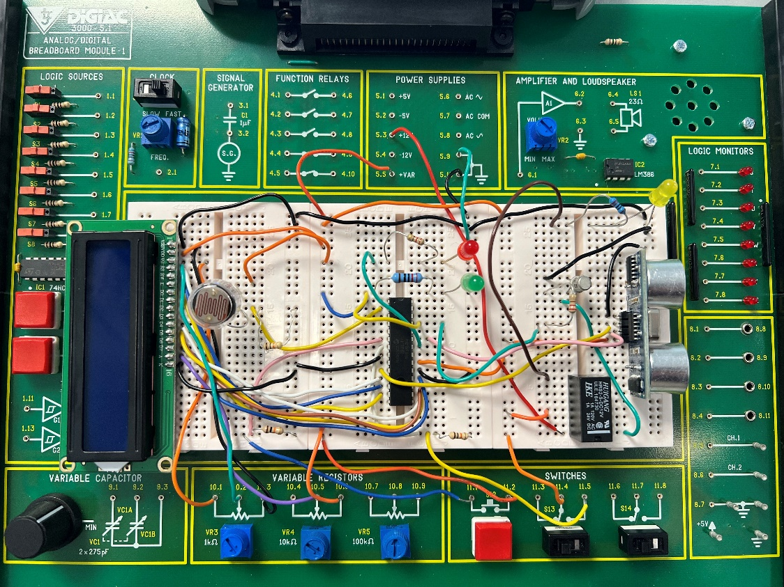
Figure 37: Final Build
A video was conducted to talk about each component within the final build and some of their uses.
Video link: https://youtu.be/Y0ckH1-UsQI

Evaluation & Analysis
This chapter reviews the collected information from the simulation operated on Proteus and the in person testing. The chapter also determines if aspects of the project have been successful or unsuccessful.

6.1 Lux Level Survey
As mentioned within the Chapter 5.5.1 the pre-determined brightness value to activate the automatic headlights was stated to be less than 220. In order to gain this value a survey was conducted with five experienced drivers.
The purpose of the survey was to ask the experienced drivers at what level of light do they deem appropriate for the activation of the headlights in their car. To do this, they all had to fill out the survey form leaving the adjacent box to ‘Lux Level Chosen’ blank. The survey form is found in Figure 38. A light meter was used to read the level of light in Lux.
Once the form was filled out, each driver stood outside around evening time. As the survey was completed during the month of May, the evening time is when it starts to get dark. Ensuring there was nothing above the light meter to obstruct the light, the recordings began.
When the driver taking the survey deemed it dark enough for the activation of their headlights, the lux level from the light meter was read and then recorded within the Lux Level Chosen section of the form.

Figure 38: Survey Form

6.1.1 Lux Level Survey Results
Once the drivers had completed the survey, their forms and data were recorded. The completed forms are shown below in Figure 39.
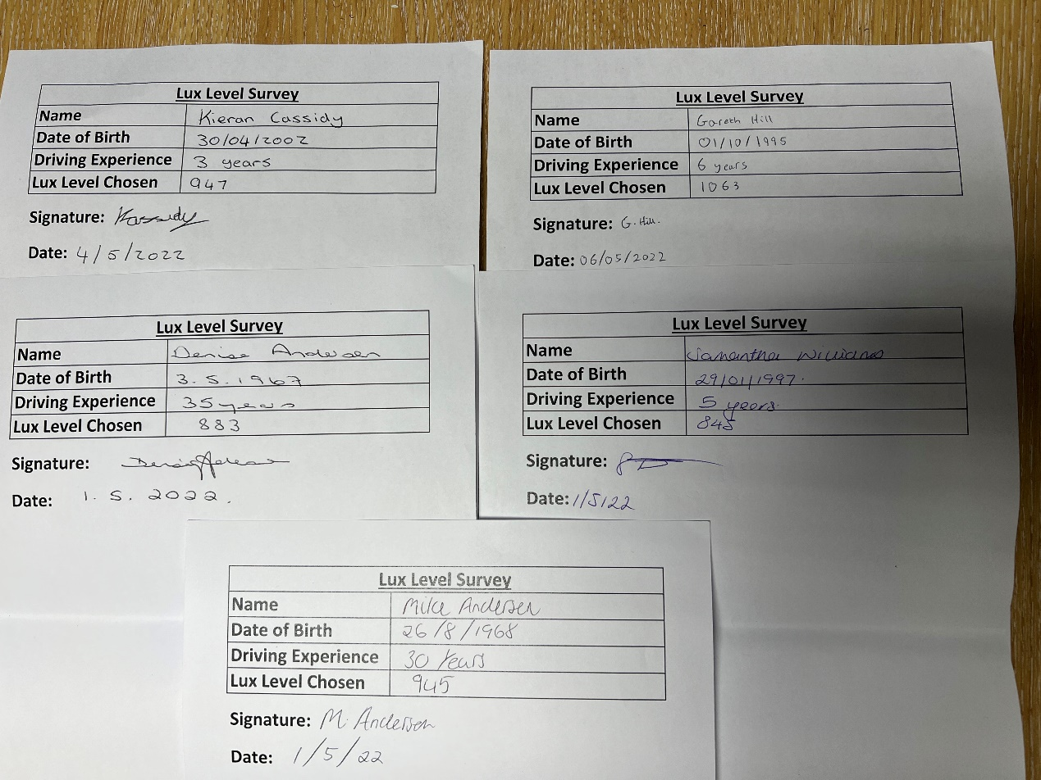
Figure 39: Completed Survey Forms
It was important to gain a lux level of five different drivers as it is a matter of personal opinion as to when they thought the headlights should be activated. The rationale for selecting five participates was to gain a variety of opinions. As shown in Figure 39 the resultant lux levels chosen showed no major anomaly’s.
The average lux level from the five drivers results were calculated, as this was going to be the lux level of activation for the automatic headlights. The equation used to calculate the average lux level from the results is shown below.
$$\frac{Total levels of lux}{Number of drivers}=Average lux level$$

$$\left(\frac{1063+947+945+848+883}{5}\right)=Average lux level$$

$$\frac{4927}{5}=Average lux level$$

$$937=Average lux level$$
As the average level of lux was 937, this was implemented into the automatic headlights function.
The light meter was used once more, as 937 lux needed to be recreated. Within a classroom in the university the level of light at 937 lux was recreated. Lowering light levels within the class room consisted of shutting the blinds and decreasing the light until 937 lux was reached.
Once the lux level 937 was reached, the system was switched on and the brightness value which is read via the LDR, was recorded. The value which was recorded from the LCD screen was 220. This was used as the pre-determined value that activates the headlights. If the brightness value read by the LDR is less than 220, then the yellow LED will automatically activate. If the brightness value were 220 or greater, then the yellow LED would deactivate.

6.2 Coding Simulation
This section looks at how the coding was implemented within the schematic on Proteus. A simulation of the system was run to test the theory behind the code that was written. An advantage of using the Proteus simulation is that the code can be edited at any time, which helps make small or large modifications if needed. It also gives a clear indication as to what components or circuitry are not functioning correctly.

6.2.1 Reverse Activation Simulation
Figure 40 shows the reverse function via a simulation on Proteus. The slide switch which operates the reverse gear is activated within the following simulation and shows the message ‘Reverse’ on the LCD screen. As the reverse gear has been engaged the red LED is active, which simulates the reverse gear being shown as active on a car’s dashboard or display screen.
As the car is in reverse, the ultrasonic sensor is now active and it takes reoccurring readings until the reverse gear is disengaged. Once the reverse switch is returned to open, the red LED will deactivate, showing that the car is no longer in the reverse gear.
Each set of ‘XX’ that appears on the LCD screen replicates 20cm, the LCD screen would only show measurements in sequences of 20cm. 20cm was used per XX for accuracy and detailed measuring. To test the theory out via a simulation in Proteus a distance is set on the ultrasonic sensor, this distance is shown below within Figure 40.
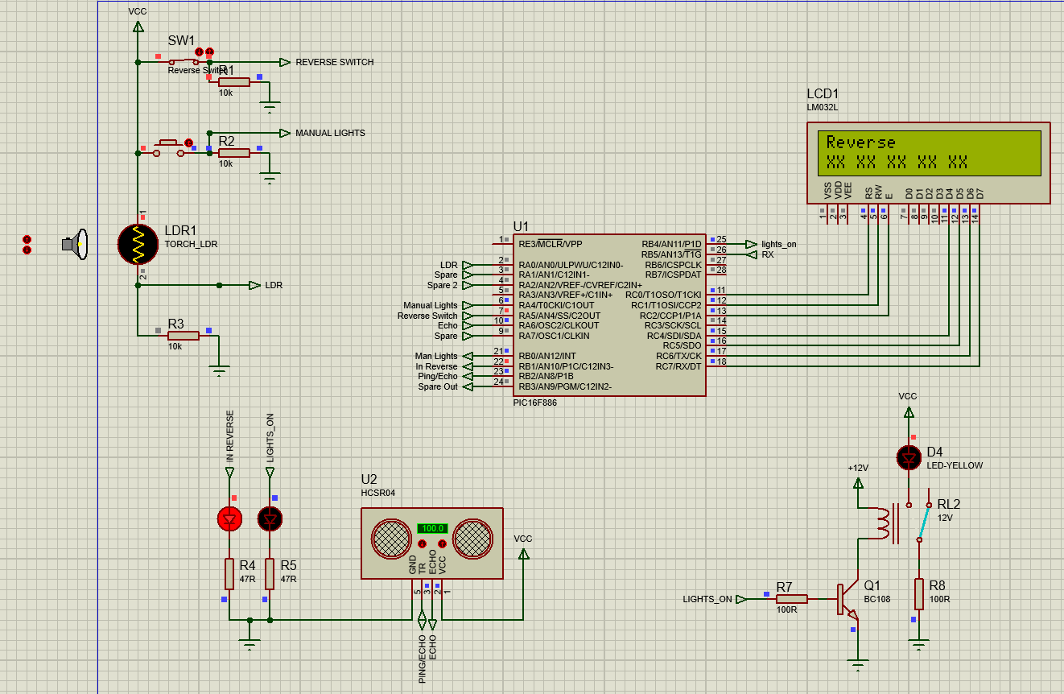
Figure 40: Reverse Activated – 100cm

6.2.1.1 Analysis of Reverse Activation Simulation
To prove that the theory behind the coding works successfully for detecting an object via the ultrasonic sensor, a distance of 100cm was set at the ultrasonic sensor. This distance replicates an object that is 100cm away from the ultrasonic sensor.
The theory behind the code was proven to be successful as 100cm is set on the ultrasonic sensor whilst five sets of XX’s appear on the LCD screen, as shown in Figure 40. As each set of XX replicates 20cm the following equation was used to calculate the total length replicated on the LCD screen:-

$$Total sets of {XX}^{'}s on the LCD Screen ×20cm=Distance replicated \\ 5 ×20cm=100cm$$

This result proves the theory behind the code is successful.
This simulation was repeated to prove the theory behind the coding once more. On the second simulation the distance set on the ultrasonic sensor was 140cm as shown below in Figure 41. There were 7 sets of XX’s visual on the LCD screen, the equation used to calculate if it was calculating the distance correctly was:-

$$Total sets of {XX}^{'}s on the LCD Screen ×20cm=Distance replicated$$
$$7 ×20cm=140cm$$

The theory behind the code was again proven to be successful as the amount of XX’s replicated on the LCD screen were seven, whilst the distance set on the ultrasonic sensor was 140cm.
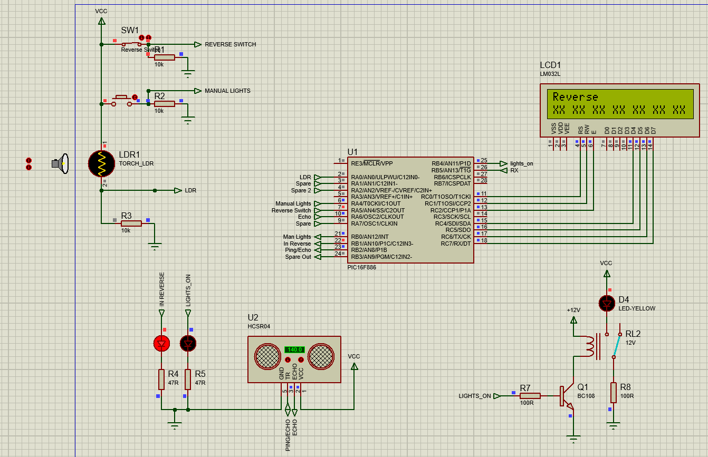
Figure 41: Reverse Activated – 140cm
A third and final simulation was run to ensure the theory behind the coding was correct. The distance set at the ultrasonic sensor this time was 20cm, as shown in Figure 42. The equation to calculate the amount of XX’s and what it replicates is shown below:-

$$Total sets of {XX}^{'}s on the LCD Screen ×20cm=Distance replicated$$
$$1×20cm=20cm$$

The final simulation proves that the theory behind the coding was successful as the ultrasonic sensor could replicate the distance an object was from it via set of XX’s replicated on the LCD screen.
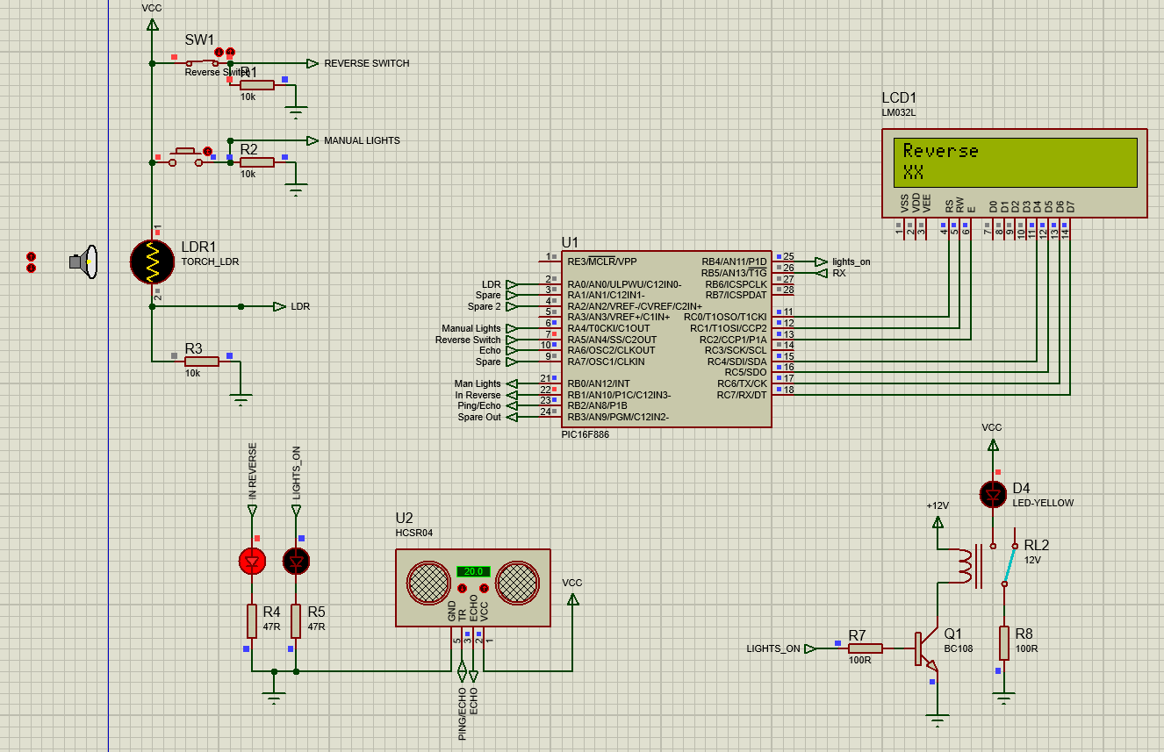
Figure 42: Reverse Activated – 20cm

6.2.2 Manually Activated Yellow LED Simulation
When the push button switch that operates the headlights is pressed once, it will activate the headlights, which is replicated as a single yellow LED, as shown in Figure 43.
When the yellow LED is active, the green LED is also active, which indicates to the user that the headlights are operational. By pressing the push button switch once more, the relay will return to its normally open state, therefore deactivating the yellow LED and green LED. A is run simulation within Proteus to find out if the theory behind the coding is correct.
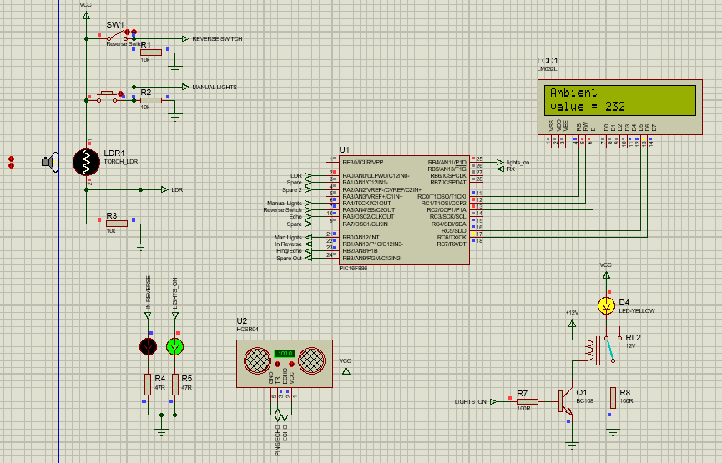
Figure 43: Manually Activated Yellow LED

6.2.2.1 Analysis of the Manually Activated Yellow LED Simulation
The simulation was run and was successful as when the push button switch was pressed, the relay was switched to a closed circuit, activating the yellow LED. As the yellow LED was active, the green LED activated to signify the headlights were active. Once both LEDs were active the push button was pressed once more to deactivate the yellow LED, which was a success. Due to the button manual activating and deactivating the yellow LED, the theory behind the coding was deemed successful.

6.2.3 Automatically Activated Yellow LED Simulation
The yellow LED is activated automatically when the light dependant resistor reads a brightness value of less than 220. Once the level of brightness is less than 220 the relay will switch from normally open to a closed circuit, which activates the yellow LED, as shown in Figure 44. If the brightness level increases to 220 or greater, the yellow LED deactivates as the relay returns to its normally open state.
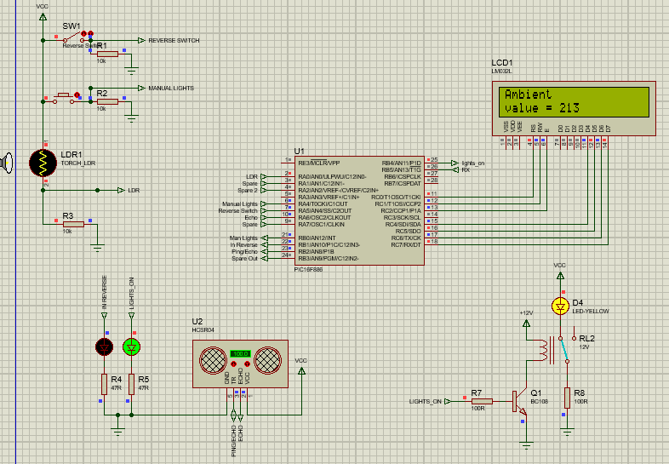
Figure 44: Automatically Activated Yellow LED

6.2.3.1 Analysis of the Automatic Activation of the Yellow LED Simulation
As shown in Figure 44, when the yellow LED is activated, the green LED also turns on, to notify the user the headlights would be operational. The brightness level is that of 213, which is less than the pre-determined value of 220. The yellow LED can only be switched off when manually activated because if headlights are activated automatically it is due to the level of light being low enough for activation.
A repeat of the simulation followed but this time the brightness level was changed to 23. As shown below on Figure 45 the value of brightness is 23. The second simulation was a success as the yellow and green LED automatically activated.
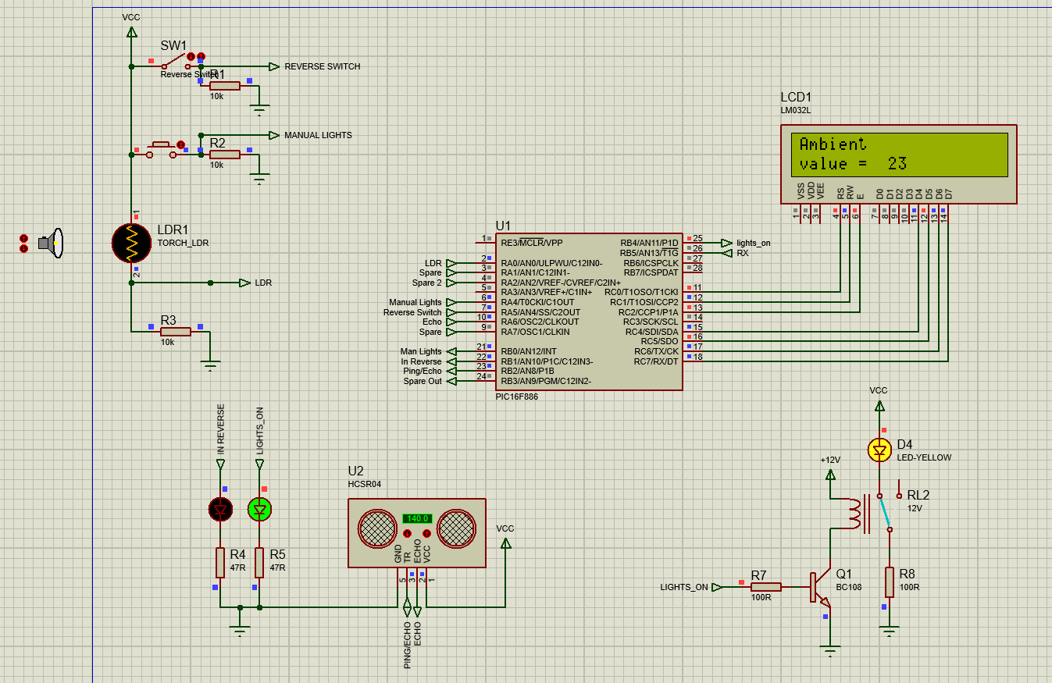
Figure 45: Automatically Activated Yellow LED

A third and finally simulation was run to find out if the yellow LED would automatically deactivate if the brightness level was to increase and exceed the pre-determined value of 220. Using the torch function as part of the LDR, the brightness level was increased to 232. The simulation was a success as the yellow and green both LED deactivated. This can be seen below in Figure 46.
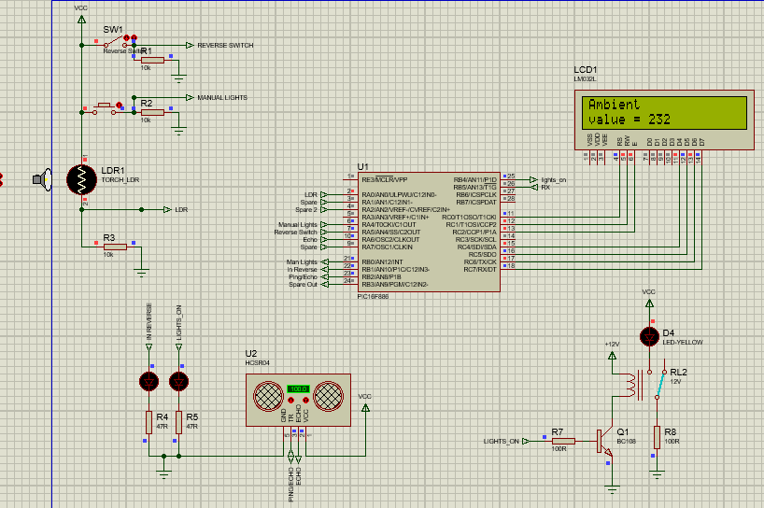
Figure 46: Automatic Deactivation of Yellow LED

6.2.4 Evaluation of Proteus Simulation
Overall the simulations that were run were a success. The simulations were run to test and analyse the theory behind the coding created. The programme written was replicated on the schematic of the Proteus design to see if the components functioned correctly. As previously stated within the analysis of each simulation, the two design aims were to create parking aid and automatic headlights, both worked successfully via the simulation.
Below within Figure 47 a simulation was run to ensure whilst the automatic headlights are activated, the parking aid can operate at the same time.
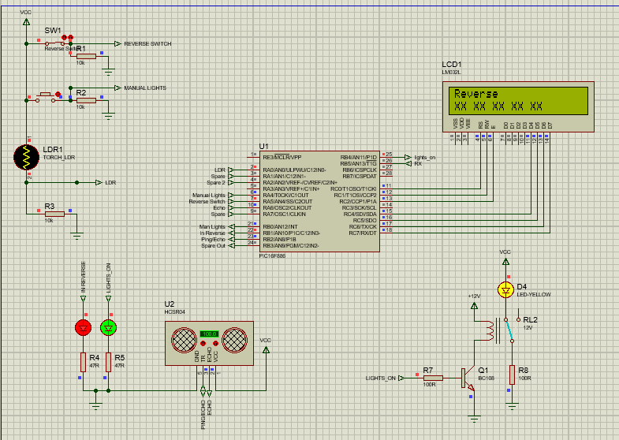
Figure 47: Final Simulation
As the system worked via the simulations and no further modifications were needed, the software MPLAB IPE and a PicKit were used to programme the microcontroller.

6.3 Headlights Tests
To test the activation of the headlights the system had to be set up in the correct environment. The LDR was free from any obstruction of light. The tests conducted were to find out if the yellow LED would activate automatically and manually, whilst also deactivating manually and automatically.

6.3.1 Test 1 – Manual Activation and Deactivation of Headlights
The first test conducted was to test the manual operation of the yellow LED. The system was switched on and the push button switch, which operates the manual activation and deactivation of the yellow LED, was pressed to see if it worked.
Test 1 video link: https://youtu.be/e07WEU7LI8s

6.3.2 Test 2 – Automatic Activation of Headlights
The second test conducted was to ensure that the yellow LED could automatically activate. The system was tested within a classroom in the university, where the blinds were raised to allow sunlight to enter the room. As the rooms brightness value was exceeding the 220 value, the yellow LED was not active. The test conducted was to gradually decrease the brightness within the classroom until it was at a brightness value of 219 or less, which would activate the yellow LED automatically.
Test 2 video link: https://youtu.be/8D27NjWNM1Y

6.3.3 Test 3 – Automatic Deactivation of Headlights
The third and final test was to ensure the successful deactivation of the yellow LED once the brightness level was at 220 or greater. The blinds within the classroom were shut, to create a dark environment, where the brightness value was less than 220. The brightness levels were gradually increased by opening the blinds until the brightness value exceeded 220, which would deactivate the yellow LED automatically.
Test 3 video link: https://youtu.be/mZKgB1ojMrI

6.3.4 Analysis of Headlights tests
The three tests were deemed successful as the push button switch could manually activate and deactivate the yellow LED. Once the brightness value of 220 was met and exceeded, the yellow LED would deactivate. If the brightness value dropped below 220, it would successfully activate the yellow LED. Whilst activating and deactivating the yellow LED, the green LED, which was used to warn the user than the headlights are on. The three tests determined that the design aim set out in Chapter 1.2 of functioning automatic headlights had been met.

6.4 Ultrasonic Sensor Tests
Before testing the ultrasonic sensor the positioning of the sensor was important, as it would be easy to manipulate the resulting distance if any object was within its detection radius/range. The sensor was bent slightly back so it would not detect the body of the board it was placed on.
To identify if the ultrasonic sensor could accurately measure how far away an object was from the sensor and display it in sets of XX’s on the LCD screen, two tests were completed. A solid box was used as the object whilst placing a measuring tape alongside it to accurately determine the distance the box was from the sensor.

6.4.1 Test 1 – Ultrasonic Sensor
In the first test the box started at a distance of 10cm away from the ultrasonic sensor. Whilst examining the LCD screen, the box was moved along the measuring tape, stopping at various distances, until 100cm was reached. The purpose of this test was to prove that the parking aid function could work and the calculation of the distance an object is from the ultrasonic sensor could be replicated in sets of XX’s equivalent to 20cm per set.
Test 1 video link: https://youtu.be/iAhHLYZUoQY

6.4.2 Test 2 – Ultrasonic Sensor
The second test was a repeat of the first test, but the box started at 100cm and the distance was gradually decreased until it was less than 20cm.
Test 2 video link: https://youtu.be/VN-0neOIUk8

6.4.3 Analysis of Ultrasonic Sensor Tests
The two tests conducted proved that the system was able to measure the distance an object is from the ultrasonic sensor and replicate it in sets of XX’s via the LCD screen. It was difficult to include the entire measuring tape and the LCD screen in the video to show exactly when another set of XX’s were present but the system managed to replicate the sets of XX’s accordingly.
The objective set out in Chapter 1.2 was to activate the parking aid via the initiation of the reverse gear, this objective has been met as the slide switch simulates the reverse gear being activated.

As shown in the video below, the operation of the ultrasonic sensor and the automatic headlights can function together at the same time. This was an important aspect of the design as the headlights and parking aid are both used in the dark, therefore they should both be able to operate at the same time.
Video link: https://youtu.be/hNtr6KfzWU8

6.5 Initial Build Problems
When building the system on the breadboard, one problem which occurred was the length of the wires connected to the components and microcontroller. The length of the wires made it difficult to see if the correct connections had been made from the microcontroller to the components on the breadboard. As shown below in Figure 48 the length of the wires were too long which caused a congested breadboard.
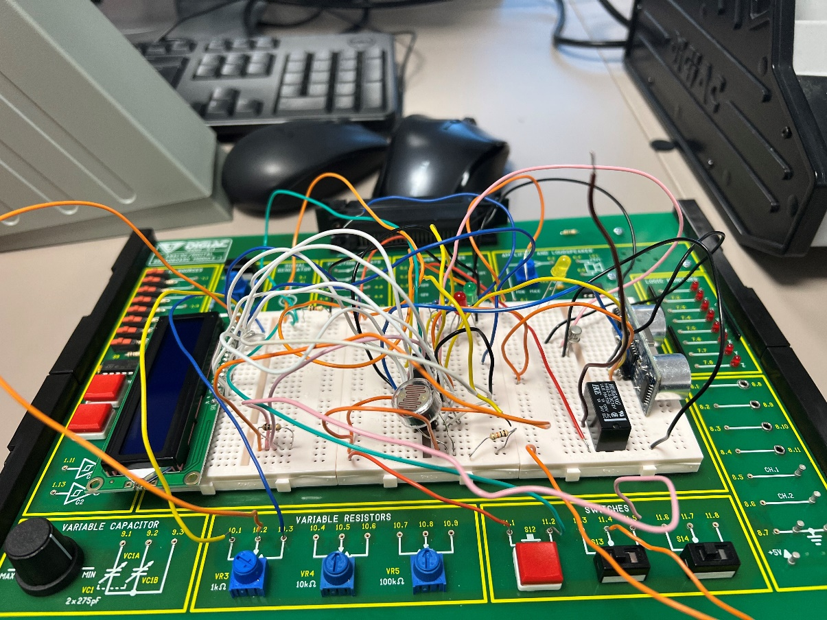
Figure 48: Initial Build
All wires were removed from the breadboard and cut to an appropriate length, as if a problem occurred within the system, it would be difficult to troubleshoot. The final build where the wires were cut to an appropriate length can be found within Figure 37.

Conclusion
The aim of this project was to identify if a microcontroller could be used to implement the design aims set out in Chapter 1.2. It was evident that a microcontroller could be successfully used to assist parking aid and automatic headlights within an automobile. The theory used to create the system was inspired from the research of existing sensor technology that is available to purchase on today’s market. The results which were attained from the testing in Chapter 6 proved that the theory was correct as the system operated successfully. The results of the tests also indicate that the use of a microcontroller could be used to meet the design aims. Furthermore, the initial project plan was to use a PLC to meet the two design aims. After further research it was found that a PLC would not be quick enough to cope with the ultrasonic sensors demand. On this basis a microcontroller was chosen, given it had the capabilities to implement an ultrasonic sensor within the system.
The objectives set out in Chapter 1.2 were met, as the automatic headlights and parking aid operated in the desired ways of activation. The testing of the parking aid and automatic headlights were in a controlled environment, which was a university classroom. Further testing could have been added where the system would have been taken outside to test the automatic headlights function. Taking the system outside would of added an uncontrollable lighting environment where the brightness value would fluctuate and the operation of the automatic headlights would be solely dependant on the surrounding level of light.

7.1 Future Recommendations
Although the project was a success and was able to successfully achieve the design aims, improvements could be made to further advance the system. This chapter looks at future recommendations that could be included within the system. Depending on how many of the following recommendations would be implemented, a new microcontroller would need to be selected if there were to be an increase in pins required.

7.1.1 System On/Off Buttons
One aspect which was not included in the design of the system was an on/off button. This would replicate the ignition of a car, as when the ‘on’ button is active, it simulates the car’s ignition being on, whilst the ‘off’ button would simulate the ignition being off. The only functions which would be operational whether the on/off switch is active, would be the external lighting, as all external lighting can be operated whilst the ignition of the car is off. This is due to safety reasons, as if a car was to break down at night and the engine would need to be shut off, all light functions would have to be operational in order for other drivers to be able to see the broken down car.

7.1.2 External Lighting
There are various external lighting functions on a car that are essential safety features which were not included within this project. The external lighting functions which are persistently used on a daily basis within a car are reverse lights, brake lights and indicators.
The reverse lights could be included within the ‘in reverse’ circuitry, as when reverse is activated via the slide switch a single white LED could replicate the reverse lights being active.
The indicator function could be replicated via two orange LEDs. A three way slide switch would be introduced into the design. When the switch is in the middle position neither LEDs would operate. When the position of the switch is moved to the left, it would activate the orange LED that represents the left side of the cars indication. If the position of the switch was moved to the right, it would operate the orange LED that represents the right hand side of the cars indication.
A single push button switch could be included in the design to operate a pink LED, which would simulate the activation of brake lights. The addition of these three external lighting features would increase the amount of safety features within the car.

7.1.3 Bleeper
The ultrasonic sensor and the LCD screen combine to create a fully functioning parking aid function that replicates the distance an object is from the ultrasonic sensor in the form of XXs. To further improve the parking aid function, a bleeper could be incorporated into the system. The bleeper would indicate how far an object is by using an audible ‘bleep,’ the ‘bleep’ would get increasingly faster the closer the object gets to the ultrasonic sensor. As shown in Chapter 4.2 a bleeper is commonly included in aftermarket ultrasonic parking aid systems. The inclusion of the bleeper would give the parking aid system an additional feature, which would enable the user to park without having to rely on just visual aid.

7.1.4 Blind Spot Detection
As stated in Chapter 4.1.2.2 it was found through research that radar sensors within automobiles were used primarily for blind spot detection. Blind spot detection is where radar sensors are mounted either on the rear bumper or side mirrors of a car. The radar sensors detect vehicles in the adjacent lane and an audible or visual warning will notify the driver. Blind spot detection would offer an additional safety feature which requires very little manual input. If blind spot detection was added to the current system, an additional breadboard would have to be purchased as there is very little room on the three breadboards used in the system. If the radar sensor were to be placed on one of the current three breadboards then the area in which it detects may become obstructed, which would give false readings.
One radar sensor would be used for the simulation of the design and the placement would have to be well prepared as nothing should interfere within its detection radius, otherwise it would give a consistent false reading of detection. A red LED would be introduced into the system, notifying the user when an object appears within a blind spot.

Reflection
During my initial research into potential project ideas, I attempted to base my ideas on work related designs that I have been made aware of during my employment. I also tried to implement my own personal interests on how certain aspects of a car work. As parking sensors have become a basic necessity within cars, it made myself wonder how it’s possible to detect objects so quickly, and reiterate the distance back to a bleeper or display screen within the car. I thought that this would be an excellent base point for the project. I also wanted to include a simplistic feature of a car, this was why I decided automatic headlights. Automatic headlights seemed like it was a relatively new feature to be included in cars. Upon my discovery within my research, the automatic headlights technology had been around for many years. This was when I combined both ideas I had, and created a project plan to fit.
Initially I ran into my first problem shortly after the project proposal was submitted, where I found that a PLC could not be used due to its characteristics, the PLC was too slow to run the ultrasonic sensor. The PLC was not be able to calculate the length of the pulse sent out from the ultrasonic sensor to the nearest object. I was slightly disappointed by this as I thoroughly enjoyed the PLC module studied earlier on in the year, but looked forward to the challenge ahead using a microcontroller.
I felt the two design aims set out were achievable in the time frame given, but wish I had added more simplistic features to replicate a car’s functions as outlined in Chapter 7.1. After setting the design aims I began the literature review and sensor technology research. I gathered the relevant information and data and learnt a lot regarding how each sensor technology worked. The ultrasonic sensor technology was particularly interesting as I knew that these types of sensors were featured commonly on newly manufactured cars.
Despite starting the project off strongly and completing a small portion of the research, I fell behind in regards to the research and design aspect of the project due to work commitments. Working away from home disrupted my timing plan that I was following closely, due to this I had to extend the sensor research and my design by a couple of weeks. This could have been avoided had I factored in that timing plans won’t always go to plan. Due to the extension on the research, other tasks of my project got delay. Due to this I had to dedicate a lot more of my free time to get back on track. Although working away from home was something not in my control, I felt that my time management could of been improved slightly. This was where I revised my timing plan and allocated more time to each of the remaining tasks. When I made changes to the timing plan I factored in that things may not always go to plan.
The designing of the system via Proteus was an aspect of the project I thoroughly enjoyed, this is where I managed to replicate my ideas on paper into a virtual simulation. It was rewarding to see the components working via a simulation as the code written was proven to be successful.
One key aspect of the project I realised I had to improve on was time management, I decided to order the components for my final design earlier than required. This was due to the impact that was going on around the world due to effects of COVID-19. There had been component shortages worldwide and due to this, I decided to find stock of all components and ordered them as soon as possible. I was relieved to have done this as when I was following my microcontroller specification there was only one suitable microcontroller available to purchase which would be delivered in a suitable time frame for completion of the project.
Incorporating my Proteus design into real life proved slightly difficult. Due to an unforeseen programming error, I could not get power to the PIC when it was connected to VCC. Although it took some time to trouble shoot, the error encountered was due to a software issue within CCS.
Overall, I am pleased with the outcome of the project and I feel proud of the final product. There were a few issues which cropped up along the way in this project, but I am proud of myself for staying calm and handling them in the correct manner. The issues which cropped up allowed me to test myself and put myself out of my comfort zone, and due to this I have learnt so much about myself. I feel like I am coming away from this project with so many more skills and qualities that I can apply to everyday life.

References

[1] | M. Bumbeck, “Hagerty,” 21 June 2016. [Online]. Available: https://www.hagerty.com/media/archived/photonic-technology/. [Accessed 29 December 2021].
[2] | Ageas, “Parking tech explained: from sensors to cars that do it all,” 3 September 2020. [Online]. Available: https://www.ageas.co.uk/solved/your-car/parking-tech-explained-from-sensors-to-cars-that-do-it-all/. [Accessed 29 December 2021].
[3] | D. J. (. &. K. W. (PhD), “GradCoach.com,” GradCoach, June 2020. [Online]. Available: https://gradcoach.com/what-is-research-methodology/. [Accessed 20 February 2022].
[4] | The WritePass Journal, “The WritePass Journal,” 2021. [Online]. Available: https://writepass.com/journal/research-onion/. [Accessed 20 February 2022].
[5] | Bartleby Research, “Bartleby Research,” 2021. [Online]. Available: https://www.bartleby.com/essay/Examine-the-Advantages-and-Disadvantages-of-Using-F34RW7RSZL4Q. [Accessed 20 February 2022].
[6] | Warwick, “Warwick Education Studies,” 6 June 2016. [Online]. Available: https://warwick.ac.uk/fac/soc/ces/research/current/socialtheory/maps/when/. [Accessed 20 February 2022].
[7] | 15 Writers, “15Writers,” 2020. [Online]. Available: https://15writers.com/research-onion/. [Accessed 20 February 2022].
[8] | Formplus Blog, “Formplus Blog,” 11 August 2021. [Online]. Available: https://www.formpl.us/blog/primary-secondary-data. [Accessed 20 February 2022].
[9] | Amazon, “Amazon Car Parts,” MagiDeal, 4 January 2022. [Online]. Available: https://www.amazon.co.uk/MagiDeal-Automatic-Headlight-Control-Universal/dp/B0745VR3Z5. [Accessed 4 January 2022].
[10] | Banggood, “Sensors & Switches,” Banggood, 4 January 2022. [Online]. Available: https://uk.banggood.com/Control-Switch-Auto-Headlight-Sensor-for-Volkswagen-Golf-MK6-Jetta-MK5-Tiguan-p-1072292.html?utm_source=googleshopping&utm_medium=cpc_organic&gmcCountry=GB&utm_content=minha&utm_campaign=minha-gbg-en-pc&currency=GBP&cur_warehouse=C. [Accessed 4 January 2022].
[11] | VendinPlus, “VendinPlus,” VendinPlus, 4 January 2022. [Online]. Available: https://www.vendinplus.com/products/us-fast-delivery-12v-car-automatic-headlight-control-kit?variant=39728447815858&currency=GBP&utm_medium=product_sync&utm_source=google&utm_content=sag_organic&utm_campaign=sag_organic. [Accessed 2022 January 2022].
[12] | VanStyle, “VanStyle Auto Headlight,” 4 January 2022. [Online]. Available: https://www.vanstyle.co.uk/van/auto-headlight-switch-module-transporter-caravelle-p-5886.html?utm_source=google&utm_medium=googleshopping&utm_campaign=googlebase. [Accessed 4 January 2022].
[13] | Ageas, “Ageas,” 3 September 2020. [Online]. Available: https://www.ageas.co.uk/solved/your-car/parking-tech-explained-from-sensors-to-cars-that-do-it-all/. [Accessed 31 March 2022].
[14] | Amazon, “Amazon Electronics,” COCAR, 6 January 2022. [Online]. Available: https://www.amazon.co.uk/Vehicle-Reverse-Parking-Distance-Detection/dp/B01BML59NS/ref=sr_1_1_sspa?crid=L4PB229N19FS&keywords=Car%2BParking%2Bultrasonic%2BSensors&qid=1641403272&sprefix=car%2Bparking%2Bultrasonic%2Bsensors%2Caps%2C82&sr=8-1-spons&spLa=ZW5j. [Accessed 6 January 2022].
[15] | BuyCarParts.co.uk, “BuyCarParts.co.uk,” VALEO, 6 January 2022. [Online]. Available: https://www.buycarparts.co.uk/valeo/12781066. [Accessed 6 January 2022 ].
[16] | BOWERS, “BowersPartsOnline,” Brigade, 6 January 2022. [Online]. Available: https://www.bowerspartsonline.co.uk/brands/brigade-electronics/brigade-bs4000w-backscan-12v24v-ultrasonic-reverse-parking-4x-sensor-detection-systemkit. [Accessed 6 January 2022].
[17] | Amazon, “Amazon.co.uk,” Steelmate, 6 January 2022. [Online]. Available: https://www.amazon.co.uk/Steelmate-PTS800EX-Front-Sensors-Buzzer/dp/B005NABQMI. [Accessed 6 January 2022].
[18] | T. Harris, “How stuff works,” 8 February 2021. [Online]. Available: https://auto.howstuffworks.com/radar-detector.htm. [Accessed 12 April 2022].
[19] | Amazon, “Amazon Car Body Parts,” Brandmotion, 6 January 2022. [Online]. Available: https://www.amazon.co.uk/Brandmotion-RDBS-1500-Radar-Blind-System/dp/B07GDV24FK. [Accessed 6 January 2022].
[20] | Amazon, “Amazon Car Electronics,” Valeo, 7 January 2022. [Online]. Available: https://www.amazon.co.uk/Valeo-632300-Turning-Assistant-Elastic/dp/B084BKQ14V. [Accessed 7 January 2022].
[21] | Valeo, “ValeoService,” Valeo, 7 January 2022. [Online]. Available: https://www.valeoservice.co.uk/en-uk/passenger-car/driving-and-parking-assistance-uk/safe-side-blind-spot-detection-system-valeo. [Accessed 7 January 2022].
[22] | Quality Mobile Video, “QMV,” Crimestopper, 10 January 2022. [Online]. Available: https://www.qualitymobilevideo.com/bsd-754.html. [Accessed 10 January 2022].
[23] | Motor Mods, “MotorMods.co.uk,” Motor Mods, 11 January 2022. [Online]. Available: http://www.motormods.co.uk/blind_spot_monitor.html. [Accessed 11 January 2022].
[24] | P. Maric, “Car Expert,” 2021. [Online]. Available: https://www.carexpert.com.au/car-reviews/how-do-parking-sensors-work-radar-and-remote-parking-technology-explained. [Accessed 13 April 2022].
[25] | Proxel, “Proxel,” April 2022. [Online]. Available: https://www.proxel.com/en/models/rear-parking-sensor/electromagnetic-eps-dual-4-0.html. [Accessed 13 April 2022].
[26] | Amazon, Parking Dynamics, 2022. [Online]. Available: https://www.amazon.co.uk/Electromagnetic-Parking-Sensor-No-Holes/dp/B0023S5BK6. [Accessed 13 April 2022].
[27] | Grandado, Smart Star, 2022. [Online]. Available: https://gbr.grandado.com/products/electromagnetic-induction-parking-sensor-system-without-drilling-and-reversing-anti-collision-parking-sensor-without-probe?gclid=EAIaIQobChMIu-eS95mR9wIVuYFQBh05hQVeEAQYAiABEgI9F_D_BwE&variant=UHJvZHVjdFZhcmlhbnQ6NDA3MjA3. [Accessed 13 April 2022].
[28] | Hawk Alarms, 2022. [Online]. Available: https://www.hawkcaralarm.com/catalog/no-holes-invisible-in-bumper-electromagnetic-parking-sensors-kit. [Accessed 13 April 2022].
[29] | RS Components , “RS Displays,” Hamamatsu, 12 January 2022. [Online]. Available: https://uk.rs-online.com/web/p/photodiodes/1247158. [Accessed 12 January 2022].
[30] | Edu Lab, “Edu Lab,” Luna, 12 January 2022. [Online]. Available: https://edulab.com/product/norps-12-ldr/. [Accessed 12 January 2022].
[31] | The Pi Hut, “The Pi Hut Photo Transistor Light Sensor,” Shenzhen Haiwang, 12 January 2022. [Online]. Available: https://thepihut.com/products/photo-transistor-light-sensor?variant=27740141521&currency=GBP&utm_medium=product_sync&utm_source=google&utm_content=sag_organic&utm_campaign=sag_organic. [Accessed 12 January 2022].
[32] | Robot Shop, “RobotShop.com,” Sparkfun Electronics, 12 January 2022. [Online]. Available: https://www.robotshop.com/uk/mini-photocell-light-sensor.html. [Accessed 12 January 2022].
[33] | RS Components, “RS LDR,” Luna Optoelectronics, 12 January 2022. [Online]. Available: https://uk.rs-online.com/web/p/ldr-light-dependent-resistors/9146714. [Accessed 12 January 2022].
[34] | RS Components, “RS LDRs,” Luna, 12 January 2022. [Online]. Available: https://uk.rs-online.com/web/p/ldr-light-dependent-resistors/9146710. [Accessed 12 January 2022].
[35] | RS Components, “RS Components,” 2022. [Online]. Available: https://uk.rs-online.com/web/p/ldr-light-dependent-resistors/9146714/?relevancy-data=7365617263685F636173636164655F6F726465723D31267365617263685F696E746572666163655F6E616D653D4931384E53656172636847656E65726963267365617263685F6C616E67756167655F757365643D65. [Accessed 22 April 2022].
[36] | ThePiHut, “ThePiHut,” DFROBOT, 13 January 2022. [Online]. Available: https://thepihut.com/products/mmwave-radar-human-presence-detection?variant=40183087333571&currency=GBP&utm_medium=product_sync&utm_source=google&utm_content=sag_organic&utm_campaign=sag_organic. [Accessed 13 January 2022].
[37] | The Pi Hut, “ThePiHut,” The Pi Hut, 13 January 2022. [Online]. Available: https://thepihut.com/products/ultrasonic-distance-sensor-hcsr04?variant=1054704288&currency=GBP&utm_medium=product_sync&utm_source=google&utm_content=sag_organic&utm_campaign=sag_organic. [Accessed 13 January 2022].
[38] | Ebay, “Ebay,” Ebay, 13 January 2022. [Online]. Available: https://www.ebay.co.uk/itm/125079001552?chn=ps&mkevt=1&mkcid=28. [Accessed 13 January 2022].
[39] | The PiHut, Fermion, 2022. [Online]. Available: https://thepihut.com/products/urm37-v4-0-ultrasonic-sensor-for-arduino-raspberry-pi?variant=27740999825&currency=GBP&utm_medium=product_sync&utm_source=google&utm_content=sag_organic&utm_campaign=sag_organic&gclid=EAIaIQobChMIlNLsn6WR9wIVkt_tCh3zIAEPEAQYA. [Accessed 13 April 2022].
[40] | The Pi Hut., 2022. [Online]. Available: https://thepihut.com/products/ultrasonic-distance-sensor-hcsr04?variant=1054704288&currency=GBP&utm_medium=product_sync&utm_source=google&utm_content=sag_organic&utm_campaign=sag_organic. [Accessed 13 April 2022].
[41] | Conrad, SEED Studio, 2022. [Online]. Available: https://www.conrad.com/p/seeed-studio-101020010-ultrasonic-range-finder-1-pcs-1369546?WT.srch=1&vat=true&utm_source=google&utm_medium=organic&utm_campaign=shopping. [Accessed 13 April 2022].
[42] | RS Components, “RS Components,” 2022. [Online]. Available: https://uk.rs-online.com/web/p/bbc-micro-bit-add-ons/2153181?sra=pstk. [Accessed 22 April 2022].
[43] | RS Components, “RS Componets,” 2022. [Online]. Available: https://uk.rs-online.com/web/p/microcontrollers/0399432. [Accessed 22 April 2022].
[44] | RS Components, 2022. [Online]. Available: https://uk.rs-online.com/web/p/leds/2471555. [Accessed 21 April 2022].
[45] | RS Components, “RS Components,” 2022. [Online]. Available: https://uk.rs-online.com/web/p/leds/2285916. [Accessed 21 April 2022].
[46] | RS Components, “RS Components,” 2022. [Online]. Available: https://uk.rs-online.com/web/p/leds/2285944. [Accessed 21 April 2022].
[47] | Robot Shop, “Robot Shop,” 2022. [Online]. Available: https://www.robotshop.com/uk/12mm-push-button-switch-10pk.html. [Accessed 21 April 2022].
[48] | Robot Shop, “Robot Shop,” 2022. [Online]. Available: https://www.robotshop.com/uk/tamiya-mini-power-switch-2pk.html. [Accessed 21 April 2022].
[49] | Robot Shop, “Robot Shop,” 2022. [Online]. Available: https://www.robotshop.com/uk/resistor-kit-610pk.html. [Accessed 21 April 2022].
[50] | RS Components, “RS Components,” 2022. [Online]. Available: https://uk.rs-online.com/web/p/display-development-tools/7916476?cm_mmc=UK-PLA-DS3A-_-google-_-CSS_UK_EN_Raspberry_Pi_%26_Arduino_%26_Development_Tools_Whoop-_-Display+Development+Tools_Whoop_OMNISerpNov-_-7916476&matchtype=&aud-772940708159:pla-477731620. [Accessed 21 April 2022].
[51] | Farnell, “Farnell,” 2022. [Online]. Available: https://uk.farnell.com/multicomp/bc108b/transistor-npn-to-18/dp/9206744?gclid=EAIaIQobChMIju_u4-ul9wIVhu3tCh2okAx7EAQYAyABEgJHcfD_BwE&mckv=_dc|pcrid|565740995228|plid||kword||match||slid||product|9206744|pgrid|130059224773|ptaid|pla-1643724294623|&CMP=KNC. [Accessed 21 April 2022].
[52] | RS Components, “RS Components,” 2022. [Online]. Available: https://uk.rs-online.com/web/p/non-latching-relays/0476725?cm_mmc=UK-PLA-DS3A-_-google-_-CSS_UK_EN_Relays_Whoop-_-Non-Latching+Relays_Whoop-_-476725&matchtype=&pla-304787064700&gclid=EAIaIQobChMIzv6C19in9wIVxbTtCh0HlwPmEAQYASABEgLMO_D_BwE&gclsrc=aw.ds. [Accessed 22 April 2022].
[53] | RS Components, “RS Components,” 2022. [Online]. Available: https://uk.rs-online.com/web/p/breadboards/1029147. [Accessed 22 April 2022].
[54] | Microchip.com, 2022. [Online]. Available: https://ww1.microchip.com/downloads/en/DeviceDoc/40001291H.pdf. [Accessed 10 May 2022].

