MORDEN MANUFACTURING TECHNOLOGY

ROBOTICS & AUTOMATION / INDUSTRY 4.0
September 2

STUDENT DETAILS:
ID: 2015736
Module:ACMA 4010
Word count:

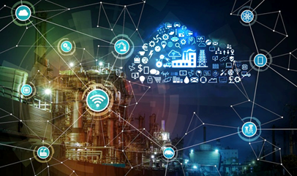
REPORT

Contents and page numbers

List of Tables and Figures | 3 - 4
Introduction | 5
What is smart factory  - Smart factories and what they produce | 6
Advancements in manufacturing  - Examples and uses of 4.0 technology used in smart factories  -sensors  -cloud computing  -big data analysis  -industrial internet off things (IIOT) | 7 - 8
Benefits of smart factories  - Improve product safety and quality  - Delightful customer experiences  - Environmental and social benefits  - Profitability | 9
Limitations of smart factories  - Safety between humans and robot collaboration  - Multilingualism  - Cyber security  - Need for high skilled labour | 10
Smart factory history | 11
Conclusion | 12
References | 13

List Of Figures and Tables

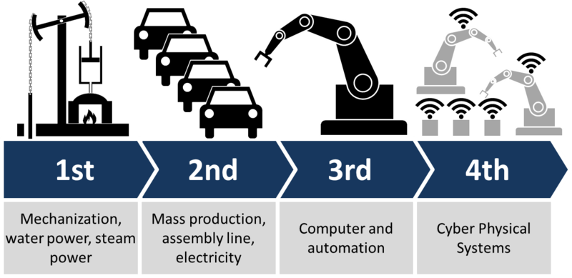
(thumbor.forbes, 2021)

this figure is showing the advancement of the manufacturing revolution from the first industrial revolution to industry 4.0 and how technology has improved.

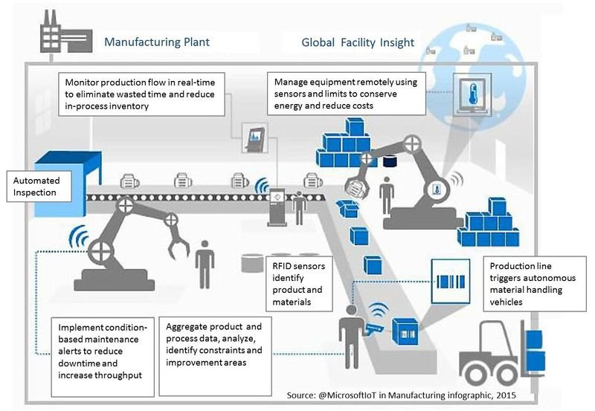
(researchgate.net, 2021)

this shows data and product flow in a smart factory, and how human employees are co-working with technology from industry 4.0. such as RFID tags which hold information about the product.

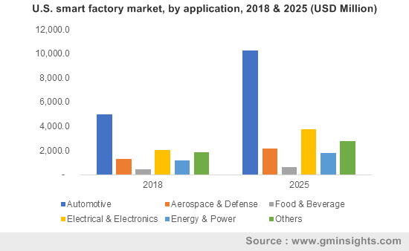
(Gminsights.com [online], 2021)

this graph is showing the US application of industry 4.0 technology which in terms increase the productivity of products.

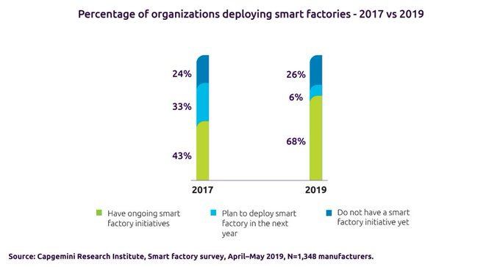 (twimg.com, 2021)

this shows manufacturers are investing heavily in smart factories. So, it shows that it must be the way forward in the future.

Introduction

This report will talk about smart factory principles and look into how its implementation of industry 4.0 technology, is having an impact on the manufacturing industry. It will contain explanations and detailed accounts of what a smart factory is; and how industry 4.0 technology is used in these facilities to achieve desired outcomes. The report also goes on to briefly mention some smart factories and what they produce. A discussion will also be made surrounding advancements to manufacturing technology, and Examples and uses of 4.0 technology in smart factories. The benefits and limitations of smart factories are also included in this report giving a brief outlook of the advantages and disadvantages of implementing smart factories. The history of smart factories shall also be reviewed extensively; and the direction in which the implementation of smart factories globally will follow in the next 20-year future.



(Redirect Notice, 2021)

What is a smart factory?

A smart factory is commonly described as a digitalized shop floor that shares and collects data such as a product's colour. This is done continuously, through production systems, connected machines, and devices (What Is A Smart Factory And What It Means For You), 2021).
Using information obtained from data optimizing devices, it is possible to improve manufacturing processes, proactively address issues and respond to new demands.

Smart factories can monitor every part of the production process, starting from manufacturing tools, through the entire distribution process, and to individual operators on the shop floor. This is achieved by connecting the physical and digital world (The factory of the future is smart, connected and already here | ABB, 2021).
This has been made possible due to various technology such as industrial internet of things (IIOT), artificial intelligence (AI), cloud computing and big data analytics, and many more.

Technology used in smart factories:

In Smart factories or Smart manufacturing; modern automation and robotics systems is used. It arises from the fourth industrial revolution; also known as industry 4.0. Industry 4.0 could be described as a method of using information and communication technology; to gain intelligent networking of processes and machines within an industry (Siemens Electronic Equipment Factory in Amberg - The Digital Factory, 2021).

Smart factories and what they produce:

- ABB Ability TM in Heidelberg, Germany; It produces miniature smart circuit breakers. This is made possible with robots which are all connected and monitored to the industrial internet. Using this technology, ensures optimum performance and increased productivity.

- FESTO Factory in Scharnhausen, Germany; produces valves terminals, valves, and electronics; made in very high volumes and within a short period. An example of automated equipment used in this facility is the heat-able spraying system; it applies special grease accurately and safely by using spray nozzles. (Festo.com. 2021)

- Siemens Factory in Amberg, Germany is credited for building industrial automation equipment. These are achieved by factory efficiency, by using groundbreaking technology such as cloud solution, artificial intelligence (AI), and industrial Edge computing (Services et al., 2021).

Advancements to manufacturing technology

The fourth revolution is being brought about due to the contribution of several factors; Such as politics, world-wide market demands, and economics. These may revolutionise the way manufacturing is done, by using technology innovations, such as:

- big data analytics
- artificial intelligence (AI)
- sensors
- advanced robotics
- cloud computing

These technologies co-exist in manufacturing today and are being advanced upon daily. The industry aims to achieve collective innovative ideas; by interlinking the virtual and physical aspects of manufacturing concepts (The Nine Pillars of Industry 4.0 - Technological Advancements, 2021).

Examples and uses of 4.0 technology used in smart factories

Sensors:

These are attached to devices and machines with the sole aim to collect distinct data points during specific periods of the manufacturing process (Brand, 2021); such as smart sensors being attached to the frame of an induction motor to measure key parameters such as temperature and vibration.

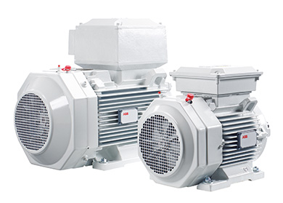

(Www07.abb.com, 2021)

Cloud computing:

This technology enables smart factories to process, store and share data easily whilst being cost-effective. It enables interconnection devices and machines on the store floor to benefit from faster uploading times for data (What is cloud computing? A beginner’s guide | Microsoft Azure, 2021).
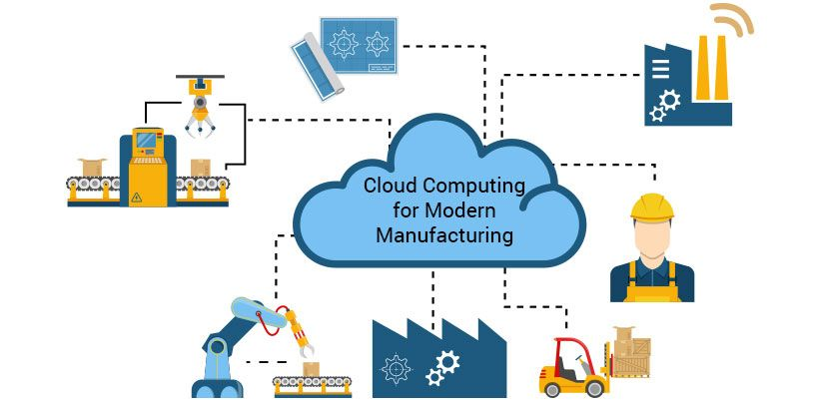

(i.pinimg.com,2021)

Big Data Analytics:

It is used to provide an insight into how efficient the production process is in underperforming systems and which matrices to focus on by accumulating data over some time. By using big data, it is easy to see error patterns, which intern enables smart factories to predict quality assurance of produced products efficiently (Wittenbur, 2021).
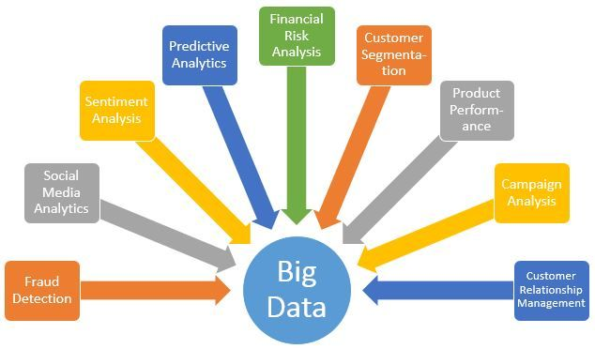

(big data, 2021)

Industrial Internet of Things (IIOT):

These are instruments used on identifying ways to improve manufacturing processes. Industrial Internet Of Things are machines interconnected devices that are linked by data communication systems.

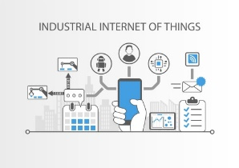

(Foptiware.com,2021)
Benefits of smart factories

- Improved product safety and quality: this is achieved through the implementation of industry 4.0 technology. This is used for quality testing, throughout different stages of the production process.

- Delightful customer experiences: This is done using computing and automation technologies from industry 4.0. This gives customers the chance to directly or indirectly interact with the company. By doing so, the customer will be able to access more information such as trucking a product during production line and customizing products, giving the customer more power and control.

- Environmental and social benefits: With the implementation of 4.0. technology, smart factories will help reduce greenhouse emissions. This will be done by using efficient methods in reducing physical transportation, waste, and carbon footprint by vertical integration.

- Profitability: Smart factories use cyber-physical systems which is one of its main concepts. It requires a huge initial investment to implement and substantial maintenance cost to run. However, it is profitable in the short and long term as it will help open new opportunities to serve larger markets.



(Benefits, 2021)

Limitations of smart factories

- Safety between human and robot collaboration: Cobot is an example of a useful robot, as it performs specialized tasks whilst physically interacting and coordinating with humans in the workplace. However, it is extremely important to take into consideration when it comes to the safety and occupational health of employees working on site.

- Multilingualism: smart manufacturing systems should be able to interpret any instruction in human language either by text format or by voice. Functions such as, converting language effectively into machine language; making It easy to achieve the desired operation.

- Cybersecurity: This is a feature which helps to reduce the exposure of cyber-security issues such as shut down by cyber-attacks, data protection, manipulation, product protection and many more.

- Need for highly skilled labour: To use the technology implemented in smart factories employees will need special training as well as being multi-skilled. Some of the skills expected of the employee are technical skills, coding skills, media skills, understanding IT security, and many more. To train existing employees to acquire such skills will be expensive and also difficult to find employees with these skills.

Smart factory history

The term smart manufacturing was first mentioned in 2006 at a national science foundation workshop. The was workshop was on cyberinfrastructure based in the USA (A Brief History of Smart Manufacturing, 2021). During this period cyberinfrastructure was a term being used in the context of implementing new applications. This was a method of combining the power of data exchanges through networks; that aggregate information; regarding different facilities, including locations, advances in data modelling, and computational power.

During this period German engineers were working on a similar project independently called smart factory. These factories were later renamed Industry 4.0.
Germany's main focus was cyber-physical systems; whilst the national science foundation objective on smart manufacturing; focused on highly connected information-driven manufacturing.

In 2010, fifty industry leaders were gathered by the Smart Manufacturing Leadership Coalition (SMLC) in a workshop. This gathering was brought about with the sole aim to advance the development of the infrastructure needed to achieve the full potential of smart manufacturing.
During the meeting, organized by the SMLC, it was acknowledged that there would be challenges in achieving the full potential status of manufacturing in areas such as usability, affordability, protection of proprietary data, customer integration, interoperability, and cyber security. (Implementing 21st Century Smart Manufacturing DRAFT Workshop Summary Report, 2021)

In 2014 German engineers/ manufacturers released a standardization roadmap version 1.0. which was published. (German Standardization Roadmap Industrie 4.0, 2021)
They stressed that standardization was the key to the success of industry 4.0. initiative. The document noted the importance of:

- Integration of technical processes and business processes
- Extensive use of the internet
- Digital mapping and virtualization of the real world
- Integration of data-enabled smart products with production systems
The German expert’s initiative was soon followed by other countries that were in similar industries. This took place between 2010 and 2016 widely in the U.S, where manufacturers began to integrate technologies such as:

- Cloud and edge computing
- Big data processing and predictive analytics capabilities
- Industrial internet of things (IIOT)
- Enterprise integrating and API management platforms
- Smart machines and collaborative robotics and A2A and B2B standards for multi-vendor interoperability.
In today’s smart factory industry, manufactures are making vast commitments in terms of investing towards its implementation. This is evident based on the increase of the global smart manufacturing platform market size throughout the past years since its introduction till date.

According to Smart Manufacturing Platform Market, the global smart manufacturing platform size is estimated to grow from USD 5.8 billion in 2021 to USD 13.3 billion by 2026. Judging by using this information, it is can be estimated that smart factories will continue to have a great impact on manufacturing in many years to come.

The smart factory may have the biggest impact in the next 20 years within manufacturing because it uses latest technology such as sensors, artificial intelligence (AI), and cloud computing. These technologies are essential within the development of manufacturing products. Companies such as Siemens, ABB, and FESTOS have all implemented these features and have improved greatly in productivity and manufacturing processes (A State of Art Review, 2021).

Implementation of technology used in smart factories requires large investments. Smart factory systems can be quite costly for smaller companies however, as time goes on it shall become more accessible and affordable (Things to Consider when Designing and Operating a Smart Factory, 2021) The smart factory conversion cost shall drop in the future making it easier for factories to obtain the use of features needed in the industry.

The introduction of 5G will enable factories to manage vast quantities of data by allowing faster data transfers, lower latency, and better edge computing. 5G shall also make it more affordable to build robots that are more movement accessible and compact. They will be able to make decisions more quickly than humans. (Smart Factories: The Role IoT in the Future of Manufacturing | Operator by Hologram, 2021

conclusion

In conclusion, smart factories will offer us the chance to enter the world of highly skilled production and beneficial technology usage. It will be possible to increase customer choice, efficiency, productivity, and create employment within many industries. The Smart Manufacturing Platform Market seems to show no intention of slowing down in terms of innovative production and is continually adapting to the latest technology such as 5G. Therefore, these factors suggest that it will have the biggest impact in the next 20 years (How will smart factories influence the future of manufacturing? - PES Media, 2021).

LIST OF REFERENCES

1. Manufacturing Operations Management Talk. 2021. A Brief History of Smart Manufacturing. [online] Available at: <https://www.manufacturing-operations-management.com/manufacturing/2021/06/a-brief-history-of-smart-manufacturing.html> [Accessed 2 August 2021].

2. 2021. [image] Available at: <https://i.pinimg.com/originals/ac/19/fd/ac19fdcb791d7ab5d99645c35cac0380.jpg> [Accessed 9 August 2021].

3. Festo.com. 2021. [online] Available at: <https://www.festo.com/net/SupportPortal/Files/378243/Festo_Technology-plant_Scharnhausen_en.pdf> [Accessed 5 August 2021].

4. R.search.yahoo.com. 2021. [online] Available at: <https://r.search.yahoo.com/_ylt=AwrJ7Y5zoiNhHy8A2EKe3olQ;_ylu=c2VjA3NyBHNsawNpbWcEb2lkAzU0NjE5ODMwYzFjZDc4OTZkZmNjZjFjZDU2MTc0NjI3BGdwb3MDMTkzBGl0A2Jpbmc-/RV=2/RE=1629754099/RO=11/RU=https%3a%2f%2ffaet.it%2fit%2fnovita%2friparazione-e-manutenzione%2fnuovo-prodotto-abb-ability-smart-sensor%2f/RK=2/RS=1ukRJhH1CayWL53eU4gyUmnc5Oc-> [Accessed 23 August 2021]. ( ABB PICTURE SENSOR )

5. ResearchGate. 2021. (PDF) Challenges, Opportunities and Future Directions of Smart Manufacturing: A State of Art Review. [online] Available at: <https://www.researchgate.net/publication/341069796_Challenges_Opportunities_and_Future_Directions_of_Smart_Manufacturing_A_State_of_Art_Review> [Accessed 23 August 2021].

6. 2021. big data. [image] Available at: <https://i.pinimg.com/736x/14/64/95/1464957d29339fb1aa3ef77d3a22e6d1--data-analytics-big-data.jpg> [Accessed 23 August 2021].

7. Brand, S., 2021. The Role of Smart Sensors in Manufacturing. [online] Cmtc.com. Available at: <https://www.cmtc.com/blog/the-new-role-of-sensors-in-manufacturing> [Accessed 5 August 2021].

8. 2021. German Standardization Roadmap Industrie 4.0. [ebook] Available at: <https://www.din.de/resource/blob/65354/1bed7e8d800cd4712d7d1786584a7a3a/roadmap-i4-0-e-data.pdf> [Accessed 13 August 2021].

9. 2021. Implementing 21st Century Smart Manufacturing DRAFT Workshop Summary Report. [online] Available at: <https://www.controlglobal.com/assets/11WPpdf/110621_SMLC-smart-manufacturing.pdf> [Accessed 23 August 2021].

10. 2021. Industrial Internet of Things. [image] Available at: <https://www.google.com/url?sa=i&url=https%3A%2F%2Foptiware.com%2Fblog%2Fwhat-is-industrial-internet-of-things-iiot-and-why-is-it-important-in-manufacturing%2F&psig=AOvVaw0Kp7ipCXRaU8wfili78gR9&ust=1629207392769000&source=images&cd=vfe&ved=0CAsQjRxqFwoTCODGzKTUtfICFQAAAAAdAAAAABAJ> [Accessed 23 August 2021].

11. 2021. INDUSTRY 4.0, INTERNET OF THINGS. [image] Available at: <https://thumbor.forbes.com/thumbor/960x0/https%3A%2F%2Fblogs-images.forbes.com%2Fbernardmarr%2Ffiles%2F2016%2F03%2FIndustry_4.0.jpg> [Accessed 23 August 2021].

12. Market, S., 2021. Smart Manufacturing Platform Market by type, Application, Industry | COVID-19 Impact Analysis | MarketsandMarkets™. [online] Marketsandmarkets.com. Available at: <https://www.marketsandmarkets.com/Market-Reports/smart-manufacturing-platform-market-66129711.html> [Accessed 4 August 2021].

13. Services, P., Solutions, M., Careers, J., us, A., Fairs, E., Relations, I., Areas, T., Technologies, R. and Machines, C., 2021. Digital transformation: Leading by example. [online] siemens.com Global Website. Available at: <https://new.siemens.com/global/en/company/stories/industry/electronics-digitalenterprise-futuretechnologies.html> [Accessed 23 August 2021].

14. Plattform-i40.de. 2021. Siemens Electronic Equipment Factory in Amberg - The Digital Factory. [online] Available at: <https://www.plattform-i40.de/PI40/Redaktion/EN/Use-Cases/076-siemens-electronic-equipment-factory-in-amberg-the-digital-factory/article-siemens-electronic-equipment-factory-in-amberg-the-digital-factory.html> [Accessed 3 August 2021].

15. Hologram.io. 2021. Smart Factories: The Role IoT in the Future of Manufacturing | Operator by Hologram. [online] Available at: <https://www.hologram.io/blog/smart-factories#why> [Accessed 23 August 2021].

16. News. 2021. The factory of the future is smart, connected and already here | ABB. [online] Available at: <https://new.abb.com/news/detail/2176/the-factory-of-the-future-is-smart-connected-and-already-here> [Accessed 23 August 2021].

17. Tulip. 2021. What Is A Smart Factory? (And What It Means For You). [online] Available at: <https://tulip.co/glossary/what-is-a-smart-factory-and-what-it-means-for-you/> [Accessed 1 August 2021].

18. Wittenbur, I., 2021. Big Data in Smart Manufacturing. [online] Blog.datumize.com. Available at: <https://blog.datumize.com/big-data-in-smart-manufacturing> [Accessed 23 August 2021].

19. 2021. [image] Available at: <https://www.researchgate.net/profile/Amita-Singh-7/publication/327884684/figure/fig1/AS:675054727725056@1537956997009/Shows-an-example-of-product-and-data-flow-in-a-Smart-Factory-Product-carries-RFID-tag.jpg> [Accessed 24 August 2021].

20. 2021. [Blog] Available at: <https://blog.datumize.com/big-data-in-smart-manufacturing> [Accessed 24 August 2021].

21. Gminsights.com. 2021. [online] Available at: <https://www.gminsights.com/assets/img/smart-factory-market.png> [Accessed 24 August 2021].

22. Google.com. 2021. Redirect Notice. [online] Available at: <https://www.google.com/url?sa=i&url=https%3A%2F%2Fwww.bbva.com%2Fen%2Finnovation-and-collaboration-go-hand-hand-digital-economy%2F&psig=AOvVaw1rf7osI_Z4A37AdBaSES3i&ust=1629913014270000&source=images&cd=vfe&ved=0CAgQjRxqFwoTCKCNh-mYyvICFQAAAAAdAAAAABAY> [Accessed 27 August 2021].

23. 2021. [image] Available at: <https://i.pinimg.com/originals/ac/19/fd/ac19fdcb791d7ab5d99645c35cac0380.jpg> [Accessed 27 August 2021].

24. 2021. [image] Available at: <https://www.google.com/url?sa=i&url=https%3A%2F%2Foptiware.com%2Fblog%2Fwhat-is-industrial-internet-of-things-iiot-and-why-is-it-important-in-manufacturing%2F&psig=AOvVaw0Kp7ipCXRaU8wfili78gR9&ust=1629207392769000&source=images&cd=vfe&ved=0CAsQjRxqFwoTCODGzKTUtfICFQAAAAAdAAAAABAJ> [Accessed 27 August 2021].

25. Www07.abb.com. 2021. [online] Available at: <https://www07.abb.com/images/librariesprovider100/default-album/smart_sensor_for_motors_single.jpg?sfvrsn=6b967c14_1> [Accessed 27 August 2021].

26. Polestarsolutions. 2021. The Nine Pillars of Industry 4.0 - Technological Advancements. [online] Available at: <https://polestarllp.com/what-is-industry-40-and-its-nine-technology-pillars> [Accessed 27 August 2021].

27. Cleverism. 2021. Things to Consider when Designing and Operating a Smart Factory. [online] Available at: <https://www.cleverism.com/things-consider-designing-operating-smart-factory/> [Accessed 27 August 2021].

28. Taylor & Francis. 2021. Pros and cons of implementing Industry 4.0 for the organizations: a review and synthesis of evidence. [online] Available at: <https://www.tandfonline.com/doi/full/10.1080/21693277.2020.1781705> [Accessed 31 August 2021].

29. 2021. [online] Available at: <https://www.capgemini.com/wp-content/uploads/2019/11/Report-%E2%80%93-Smart-Factories.pdf> [Accessed 31 August 2021].

30. Hal.archives-ouvertes.fr. 2021. [online] Available at: <https://hal.archives-ouvertes.fr/hal-03054284/document> [Accessed 31 August 2021].

