ENGINEERING DESIGN PROJECT REFLECTION

BEng Engineering
Engineering Design

BILAL MOHAMED AHMED


Contents

1. INTRODUCTION 2
2. Group working dynamic & Time Management 3
3. Design & Performance 3
4. Evaluation 3

1. INTRODUCTION
In this report I will always speak in summary of the process carried out in the last weeks for the assembly and design of our line launcher as well as my participation and ideas contributed.

2. Group working dynamic & Time Management
Group work in general has been very scarce at certain times, such as in the assembly and design of the pieces. Due to the low cooperation, delays are caused and this in turn makes our way of organizing our time not accurate. Thus, having less room for improvement.

3. Design & Performance
The line launcher has gone through many stages, the first idea proposed by one of the team members was a trebuchet, but due to the complicity and the time necessary in its assembly, but due to the short time available, another Team member presented a design that would be simpler and cheaper (this would help us invest less time and money). This design had several stages, but the idea remained firm.
Day 1. We proceed with the assembly and once finished during the tests carried out this design gave good results but one of the pieces always ended up breaking. (This is the basic model where day by day we were implementing improvements)
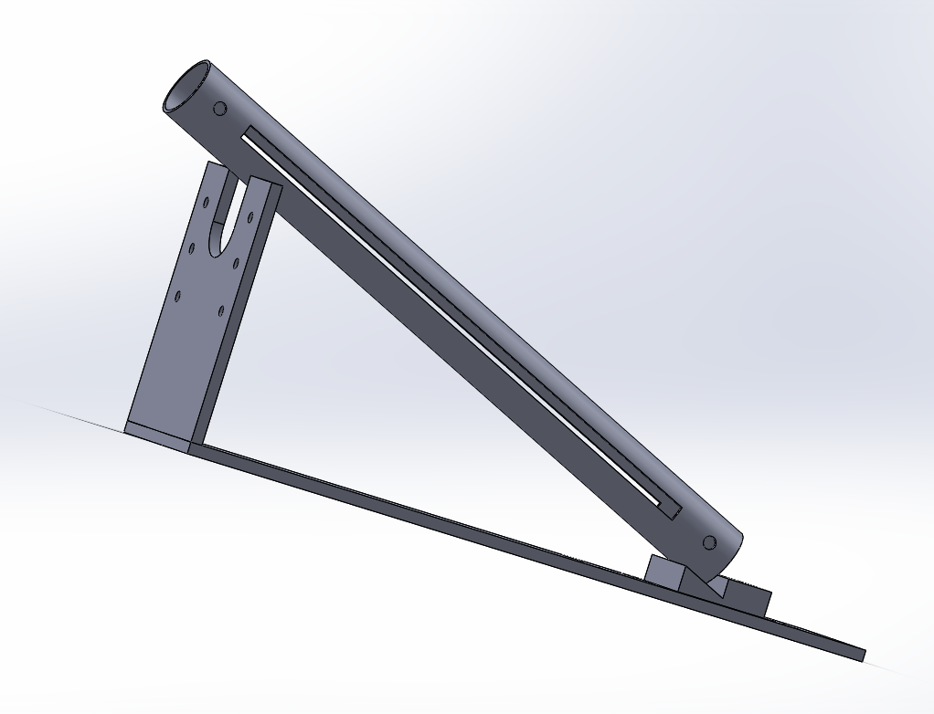
Figure 1. Day 1

Day 2. We changed the part that was always damaged by a more rigid one that solved the problem and we also added a part that allowed us to have different linear angles (we achieved an angle up to 30C). In the previous tests we threw a paper ball but when we threw the original ball we realized that it caused some friction with the tube and causing the ball not to come out.
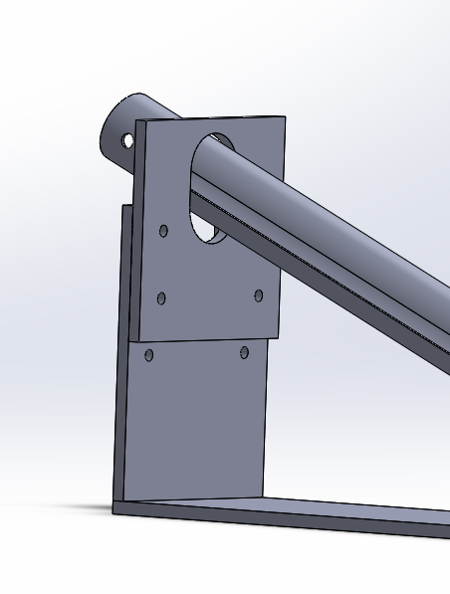
Figure 2. Day 2
Day 3. A piece is designed that will be implemented inside the tube and helps us to avoid friction when we throw the ball. One of the pieces is modified and we obtain different lateral angles. The line launcher works but it is very imprecise. (A lateral angle of up to 15C is achieved). In addition, a launch mechanism is implemented.
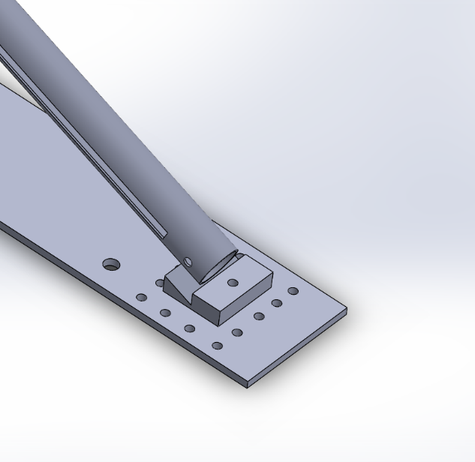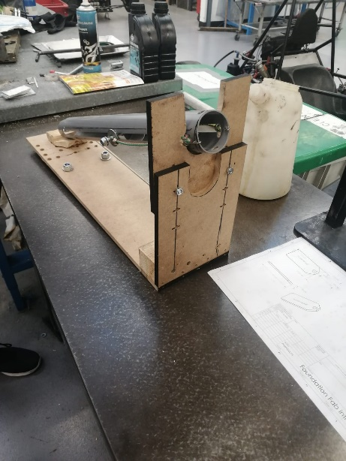
Figure 3. DAY 3

Day 4. The objective is to improve the launcher performance. For this, a new shorter tube was created, and the elastic bands have been replaced by stronger and more resistant springs. With these changes we get a more stable line launcher with better durability.

4. Evaluation
In general, there are many things that I and the team could have done to make this project much better. Our group dynamics have been null in many moments, as well as the organization of time. To improve this, I must try harder and I must motivate the team more to do things as soon as possible and not leave them at the last moment, not always everything goes as you wish and having some time remaining can help you on many occasions. On the other hand, I consider that you must take charge at certain times and create something, you don't necessarily have to wait for other members.
Moreover, the design and creation of the pieces, honestly in the first 2/3 days only one member of the team was always motivated and much of our design is by him (Sam). I try to help as much as possible in the first 3 days to have the launcher ready. Even so, I think that I could have contributed more.
During the process I learned a lot the use of many tools and ways to create the desired pieces. On day 4th. I felt more comfortable with the handling of the tools and I was able to create new parts that significantly improved performance.
In general, I am 50% satisfied and the basic ideas learned for next time are; 1. Organize my time better. 2. Motivate the team members more. 3. Do more tests

