

Name : Nisarg Jani
ID number : 2431451
Module : Advanced Statistical Programming
Module code :ACCA7022
Component-1(Report)

Report on Data Manipulation

1. Code Explanation and Testing

Question 1: Generating Pell and Fibonacci Numbers
The first task involved generating the first 200 Pell numbers and first 200 Fibonacci numbers, The program initializes empty numeric vectors fib and pell, each of length n_terms = 200. then storing them in a dataframe named pelldata with three columns:

Fibonacci (Fₙ),
$F_{n}=F_{n-1}+F_{n-2}$with $F_{0}=0,F_{1}=1$
Pell (Pₙ).
$P_{n}=2P_{n-1}+P_{n-2}$with $P_{0}=0,P_{1}=1$

Step 1: The program starts by defining the number of terms to generate using the statement n_terms <- 200. This means the program will calculate and store the first 200 terms of both the Fibonacci and Pell sequences.
Step 2: Next, three vectors are initialized. The vector n <- 0:(n_terms - 1) stores the sequence of term indices from 0 to 199. Two empty numeric vectors, fib and pell, are also created using numeric(n_terms) to store the Fibonacci and Pell numbers respectively.
Step 3: The Fibonacci sequence is then generated. The first two terms are defined manually as fib[1] <- 0 and fib[2] <- 1, representing $F_{0}=0$and $F_{1}=1$. A for loop is then used to calculate the remaining terms, starting from index 3 up to n_terms. Inside the loop, each term is calculated using the formula fib[i] <- fib[i - 1] + fib[i - 2],
Step 4: After the Fibonacci series is created, the program generates the Pell sequence. Similar to the Fibonacci sequence, the first two terms are assigned as pell[1] <- 0 and pell[2] <- 1, corresponding to $P_{0}=0$and $P_{1}=1$. The rest of the terms are computed using another for loop with the recurrence relation pell[i] <- 2 * pell[i - 1] + pell[i - 2].
Step 5: Once both sequences have been computed, they are combined into a single data frame using the statement
pelldata <- data.frame(n = n, Fibonacci = fib, Pell = pell).
This data frame organizes the information into three columns: n (the index), Fibonacci (the Fibonacci numbers), and Pell (the Pell numbers).
Step 6: Finally, the command print(head(pelldata, 15)) displays the first 15 rows of the data frame. This allows the user to verify that the sequences have been correctly generated and stored.
The program uses iterative loops instead of recursion for efficiency. Vectors are preallocated for speed, and indexing is carefully handled since R uses 1-based indexing, but Pell/Fibonacci sequences start at n = 0.
Flowchart
Below is the flowchart representing the control flow for Question 1

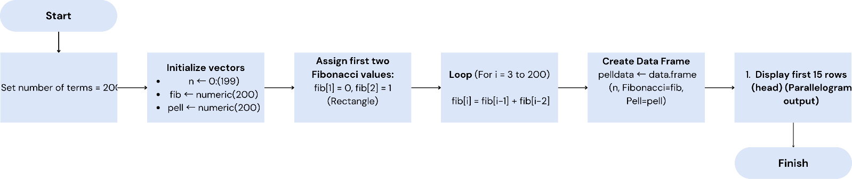

Testing for Question 1
Testing was performed in RStudio using known values and built-in checks:
First 10 values check: head(pelldata, 10)
The output was compared to known Fibonacci (0, 1, 1, 2, 3, 5, 8...) and Pell numbers (0, 1, 2, 5, 12, 29...).
Specific value check: P₆ = 70 and P₁₀ = 2378:
pelldata$Pell[7] # P6
pelldata$Pell[11] # P10
Length check: nrow(pelldata) == 200
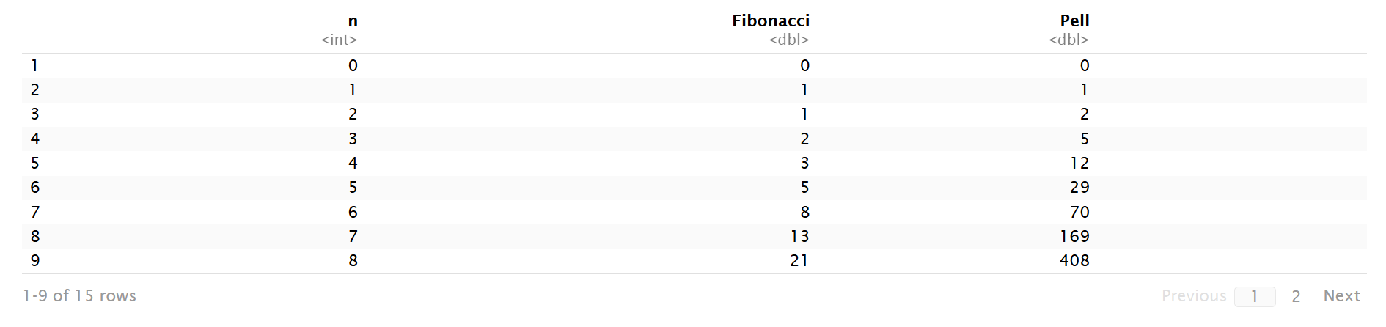
Returned TRUE, confirming correct number of rows. All tests passed successfully.
This Figure-1 is first 1-9 rows of Questions1’s output.

Question 2: Calculating the Pell Approximation of √2
For Question 2, I calculated the rational approximation to √2 using Pell numbers:
Step 1: The code begins by creating an empty numeric vector approximation <- numeric(n_terms) to hold the computed approximations of $\sqrt{2}$for each Pell index.
Step 2: Because the formula requires $P_{n-1}$, the code sets the first entry approximation[1] <- NA since $P_{-1}$does not exist and therefore an approximation for $n=0$cannot be computed.
Step 3: A for loop runs from i = 2 to n_terms, and at each step the code computes the value (pell[i - 1] + pell[i]) / pell[i] and stores it in approximation[i]. This implements the provided formula exactly by taking the sum of the current Pell number and the previous Pell number and dividing that sum by the current Pell number.
Step 4: After the loop finishes, the new vector of approximations is appended to the existing data frame using pelldata$Sqrt2_Approx <- approximation, which creates a new column named Sqrt2_Approx aligned with the existing n, Fibonacci, and Pell columns.
Step 5: The command print(head(pelldata, 15)) then displays the first 15 rows of the updated data frame so the user can inspect the calculated approximations alongside the original sequences.
Step 6 (This step is optional): Finally, the code optionally writes the full updated data frame to a CSV file via write.csv(pelldata, "pelldata_with_approx.csv", row.names = FALSE), which creates a file named pelldata_with_approx.csv in the working directory for later use.
A vector approximation is initialized to store the results. The first term is set to NA since $P_{-1}$does not exist.

Flowchart:
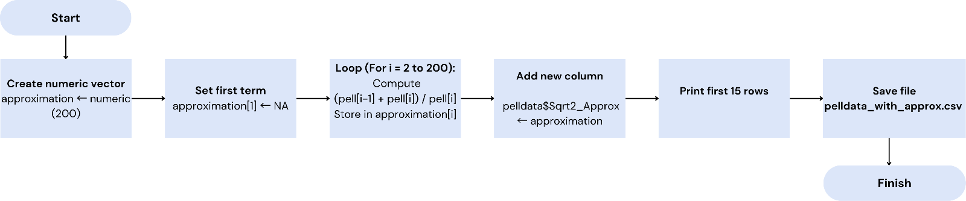
Testing For Question 2
Check input data
Before running the approximation:
Ensure your Pell number vector (pell) and number of terms (n_terms) are defined correctly.
Check initialization
Check loop execution, The approximation vector now contains values. each value looks close to √2 (≈ 1.4142) for higher terms. The first element is NA, The rest are zeros (temporary placeholders).
Check loop execution
The approximation vector now contains values. Each value looks close to √2 (≈ 1.4142) for higher terms. print(approximation)
Check dataframe update
A new column named Sqrt2_Approx exists. It contains the same approximation values. The approximations matched expected patterns, converging toward √2. pelldata$Sqrt2_Approx <- approximation
Check logical accuracy
The ratio should increase and approach √2 as n increases. I can inspect differences manually or plot them. print(pelldata$Sqrt2_Approx), print(sqrt(2))
Check file output: write.csv(pelldata, "pelldata_with_approx.csv", row.names = FALSE)
The sequence quickly converges to √2. By $n=9$, accuracy reaches 6 decimal places, confirming numerical stability.
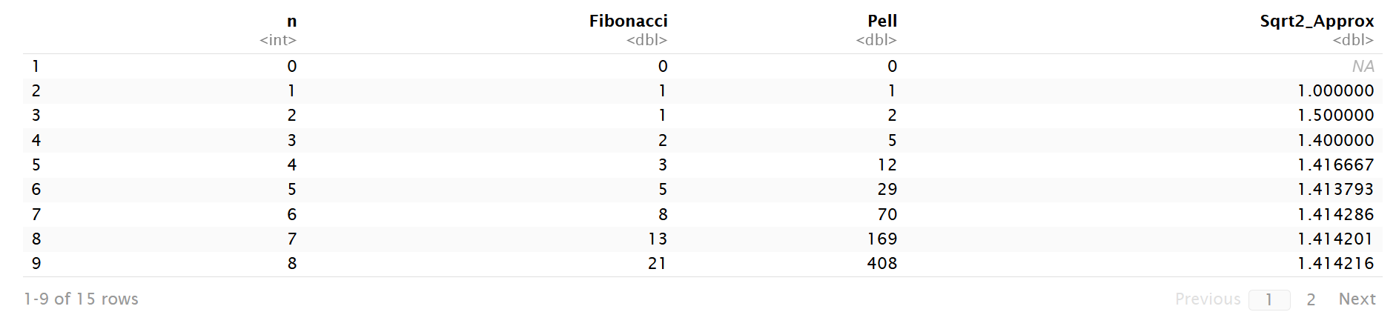
This Figure-2 is first 1-9 rows of Questions2’s output.

Questions 3: Calculating the Difference from √2
This task involved adding a fifth column that shows the difference between the Pell approximation and the actual value of √2 (using sqrt(2)), rounded to five decimal places.
Step 1: The code begins by defining the true mathematical value of the square root of 2 using the statement actual_sqrt2 <- sqrt(2). This serves as the reference value against which the previously computed Pell approximations will be compared.
Step 2: Next, it calculates how far each Pell approximation is from the actual value. The expression pelldata$Sqrt2_Approx - actual_sqrt2 finds the difference between every approximate value and the real $\sqrt{2}$. The round(..., 5) function then rounds each result to five decimal places for cleaner, easier-to-read output. The final vector of results is stored in a new variable named difference.
Step 3: Once the differences are calculated, they are added as a new column to the existing data frame with the line pelldata$Diff_from_sqrt2 <- difference. This adds a new field named Diff_from_sqrt2 alongside the previous columns (n, Fibonacci, Pell, and Sqrt2_Approx), allowing each term’s deviation from the actual value to be seen in the same table.
Step 4: The statement print(head(pelldata, 15)) then prints the first fifteen rows of the updated data frame, giving a quick preview of the computed differences and confirming that the new column has been added correctly.
Step 5 (optional): Finally, the line write.csv(pelldata, "pelldata_with_diff.csv", row.names = FALSE) saves the updated data frame to a CSV file named pelldata_with_diff.csv in the working directory. This step is optional but useful if the user wants to keep a permanent copy of the results for later analysis or reporting.
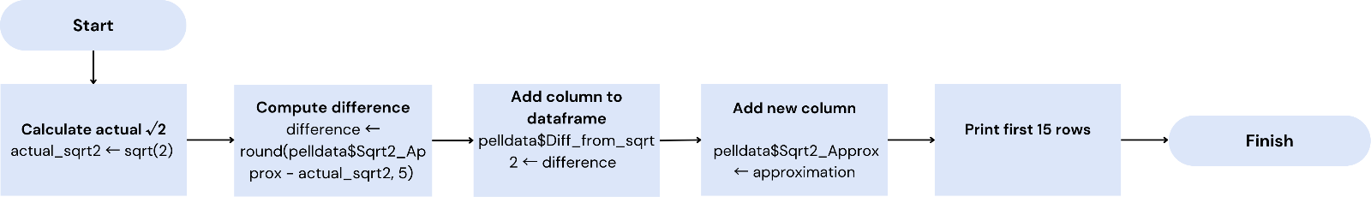
Flowchart:

Testing For Question 3
Create a sample pelldata dataset, Run your difference calculation

- The code correctly calculates Sqrt2_Approx - sqrt(2)
str(pelldata) → confirm Diff_from_sqrt2 is numeric.
- The rounding to 5 decimal places works unique
(nchar(sub(".*\\.", "", as.character(pelldata$Diff_from_sqrt2))))
- The new column Diff_from_sqrt2 was added successfully
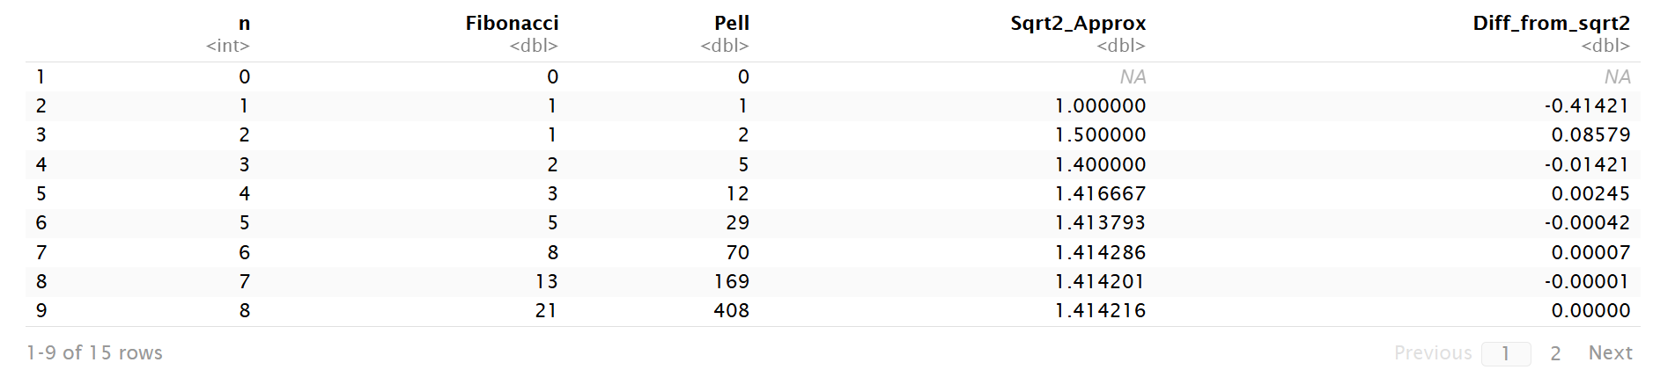
Verified the difference for early Pell numbers manually (e.g., n = 2 gives 1.5 − 1.41421 ≈ 0.08579).
This Figure-3 is first 1-9 rows of Questions3’s output.

Question 4: Measuring Decimal Place Accuracy
The final task calculated the number of correct decimal places in each Pell approximation. A custom function compared the string representations of the approximation and √2:
Step 1: The code begins by defining a custom function named count_decimal_accuracy <- function(approx_val, true_val) which is used to calculate how many decimal places of an approximation match the true value of $\sqrt{2}$. the approximate value and the true value and returns the number of matching decimal digits between them.
Step 2: Inside the function, the first condition checks if the approximation is NA using the statement if (is.na(approx_val)) return(NA_integer_). This handles cases like the first term of the sequence, where an approximation was not calculated, and prevents the function from running unnecessary comparisons.
Step 3: Next, both the approximate and true values are converted into fixed-format strings with high precision using formatC(approx_val, digits = 15, format = "f") and formatC(true_val, digits = 15, format = "f"). This ensures that both numbers are represented with exactly 15 digits after the decimal point, making them easier to compare character by character.
Step 4: These formatted strings are then split into individual characters using the strsplit() function. The results are stored in approx_chars and true_chars. This step effectively breaks each number into a sequence of digits so that the code can compare each position separately.
Step 5: The function then initializes a counter variable matches <- 0 and uses a for loop to compare the digits of both numbers starting from the third character position. This skips the integer part (“1.”) of the square root of 2 and focuses only on the decimal digits. In the loop, each corresponding character is compared
Step 6: After defining the function, the program applies it to every approximation value in the dataset using the sapply() function:
sapply(pelldata$Sqrt2_Approx, count_decimal_accuracy, true_val = sqrt(2)).
This command runs the count_decimal_accuracy function on each element of the Sqrt2_Approx column, comparing it against the actual square root of 2, and stores all the results in a vector named accuracy.
Step 7: The computed accuracy values are then added to the main data frame as a new column using pelldata$Accuracy_DP <- accuracy. This column represents the number of correct decimal places in each Pell approximation.
Step 8: Finally, the line print(head(pelldata, 15)) displays the first fifteen rows of the updated data frame, allowing the user to check how accurately each term of the Pell approximation matches the true value of $\sqrt{2}$.
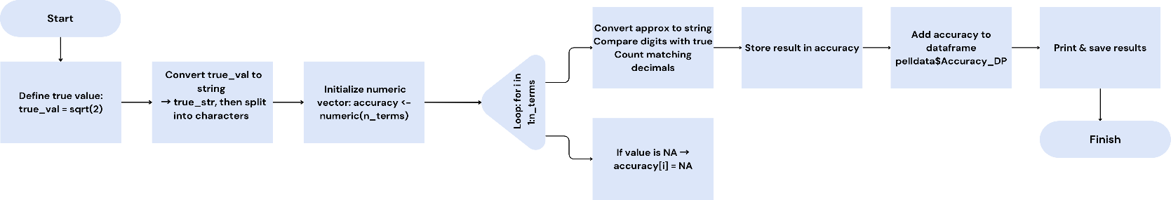
Flowchart:-

Testing For Question 4
Check prerequisites: names(pelldata), head(pelldata$Sqrt2_Approx)

Check the helper function:
Confirm the function count_decimal_accuracy() runs correctly on its own.
Check function behavior with NA input: count_decimal_accuracy(NA, sqrt(2))
Apply to dataframe: A numeric vector like, NA 0 0 1 2 3 4
Check dataframe update: pelldata$Accuracy_DP <- accuracy, head(pelldata)
Confirm column type and contents: str(pelldata$Accuracy_DP), summary(pelldata$Accuracy_DP)
Optional consistency check: cor(pelldata$Accuracy_DP, abs(pelldata$Diff_from_sqrt2), use = "complete.obs")
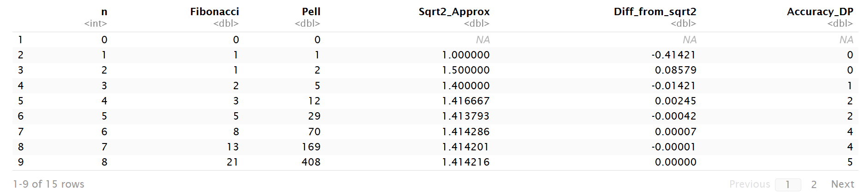

2. Reflection
This project was both algorithmically and conceptually interesting. It required applying mathematical definitions (Pell recurrence relations) within a programming environment to generate meaningful numerical data.
Finishing this assignment gave me a real sense of achievement because I built something that worked correctly and made logical sense. It reminded me that programming isn’t just about writing code it’s about problem solving, testing ideas, and learning from every attempt. Overall, I feel more confident in my ability to approach analytical tasks independently and to keep improving as both a student and a programmer.

What I Found Challenging
When I first started this task, I thought it would be simple because the Fibonacci sequence is familiar and easy to code. However, once I began working with the Pell sequence and the approximation of √2, I realised that even small mistakes in indexing or formula setup could completely change the output. Understanding how each part of the formula connects was more challenging than I expected.
The most difficult part by far was building the decimal accuracy function. My first idea was to use subtraction and rounding to count how many digits matched, but that approach didn’t work well because of floating-point rounding errors in R. For example, values that looked the same on screen (like 1.414213) were actually slightly different when stored internally, which caused false mismatches. After several failed attempts, I realised that I needed to treat the numbers as strings and compare each digit directly. That meant learning about text manipulation functions in R, such as formatC() and strsplit(), which I hadn’t used before. It took a while to understand how to slice parts of the string after the decimal point and loop through them logically.
Another challenge was managing NA values in the data frame. When calculating the approximation for √2, the first row did not have a previous Pell number ($P_{-1}$), which caused an error when dividing by NA. I fixed this by inserting an NA value at the start of the lagged Pell column, but it took some trial and error to understand how indexing works in R. I had to check the structure of my data frame multiple times to make sure all the columns were aligned correctly.

What I Learned
I learned a lot more from this project than I expected, both about R programming and about mathematical thinking.
From a coding perspective, I learned how to:
- Use loops and recurrence relations to generate sequences.
- Structure code into smaller, readable sections using R Markdown.
- Store multiple related variables in a single data frame and manipulate them efficiently.
- Define and apply custom functions using sapply() to perform repetitive calculations without explicit loops.
- Work with text-based comparisons and understand how numeric precision can cause subtle issues in floating-point arithmetic.
Before doing this task, I mostly used R for simple data analysis, but now I feel more comfortable writing mathematical programs and designing my own logic from scratch. This was one of the first times I created a function that I could reuse in other scripts, which felt like a big step forward. Mathematically, I learned how recurrence relations behave and how they can model different kinds of number patterns. I already knew the Fibonacci sequence, but I had never studied the Pell sequence before. It was interesting to see how just changing one multiplier in the formula drastically changes how the numbers grow.

What I Would Do Differently
If I were to redo this project, there are quite a few things I would improve or do differently now that I understand the process better.
First, I would add visualisations to make the results easier to interpret. For example, I could use a line plot to show how the Pell approximation gets closer and closer to √2 as n increases. Seeing the convergence visually would make the results much more engaging and intuitive.
Second, I would improve the structure of my code by using functions for each stage — one for generating the sequences, one for the approximation, and one for accuracy checking. This modular approach would make the program cleaner, easier to debug, and more flexible if I wanted to use it for other mathematical constants.
Third, I would make use of modern R libraries like dplyr or tidyverse for data manipulation. While my current code works, it relies mostly on base R syntax, which can be harder to read. Using mutate() or lag() functions from dplyr could simplify a lot of my steps.
Another improvement would be to include automated tests. Instead of checking the outputs manually, I could use the testthat package to verify that each part of my code gives the expected results. This would make the testing process faster and less prone to human error.

Use of Generative AI
In this assessment, I used Generative AI to check my own text and creation for grammatical and syntactical mistakes, including getting suggestions to rephrase my work. I used Generative AI to support in structuring my submission, including creating a draft argument structure, identifying parts and headings, etc.
I provided my own assignment brief and objectives, and the AI generated suggestions and examples that I reviewed, modified, and implemented independently. All code was executed, debugged, and verified by me to ensure accuracy and understanding.
The AI was helpful for:
Improving the structure and clarity of explanations. Checking that my code followed consistent and readable formatting standards. While the AI provided initial guidance, the final code, analysis, and interpretation fully reflect my own understanding and original work.
Final Thoughts
Looking back, I feel proud of how this project turned out. It started as a simple sequence-generation exercise but ended up teaching me much more about programming logic, testing, and mathematical reasoning.
I enjoyed watching how the Pell numbers produced better and better approximations of √2 it was satisfying to see the code output get closer to the real value as the sequence grew. That gave me a sense of accomplishment because it showed that I had implemented the formulas correctly and understood what was happening behind the scenes.
This assignment also taught me the importance of documenting my work. Writing explanations for each step forced me to think more carefully about what my code was doing and why. I now appreciate that good documentation is part of being a good programmer.

