12/15/2025
Assessment
Portfolio Report on Contemporary Software Applications for Business


Student Name: JOANNA GRABOWSKA
Student ID: 2511424

Module NaMe: Software solutions for business
STUDENT NAME: JOANNA GRABOWSKA
Module Code: ACCA 4026
Lecturer: AMITAVE BANIK
Trinity saint david University of Wales (London Campus)

Table of Contents
Introduction 2
Main Body 3
Task 1 3
e-Commerce Website builders/software solutions 3
Task 2 6
Mind-map of Contemporary Software Applications 6
Task 3 9
Office Applications for Creating, Storing, Presenting, and Analysing Data 9
a. 9
b. 13
Task 4 17
Communication and Collaboration applications 17
a. 17
b. 19
Conclusion 23
References 24

Introduction
With the current digital era, companies are very dependent on original software applications to increase productivity, efficiency as well as connectivity. Technology allows organisations to conduct important functions in the e-commerce platforms through office and collaboration solutions. This report discusses a variety of software programs that aid the modern business, such as e-commerce platforms like Shopify and Wix, digital mind-mapping systems to plan creatively, and Microsoft office software to document, analyse data, and present it. It also considers communication and teamwork channels such as Microsoft Teams and OneDrive, which have transformed teamwork in both the hybrid and remote location. This paper notes down the advantages, and constraints of these tools in the actual business situations, especially in the automation of processes and the flow of information. In general, the report underlines that the development of integrated digital solutions is the cornerstone of effective business management, which helps to make informed decisions, be scalable, and competitive in the changing global market.

Benefits and Features of Modern E-Commerce Solutions

Task 1

e-Commerce Website builders/software solutions
The contemporary digital economy has enhanced the application of e-commerce sites to help businesses, both large and small, to access the global markets, administer sales, and incorporate payment gateways without having to engage in any sophisticated programming inputs. Such website builders come with pre-finished templates, web hosting services, analytics platforms and security to assist organisations to maintain a professional online presence. Among the most popular of them are Shopify and Wix eCommerce, as accessibility and a wide range of features have made them widely used.
Shopify
Shopify is a prominent cloud-based e-commerce system that makes the establishment and operation of online stores fast and easy. It provides a user-friendly interface, which enables one to customise websites using drag-and-drop features with no technical skills. Its main characteristics are a safe payment using Shopify Payments, selling on various channels via social media (Facebook, Instagram, TikTok), inventory control, and embedded analytics. Scalability is also offered by Shopify, and it can fit both small start-ups and large business ventures [1].
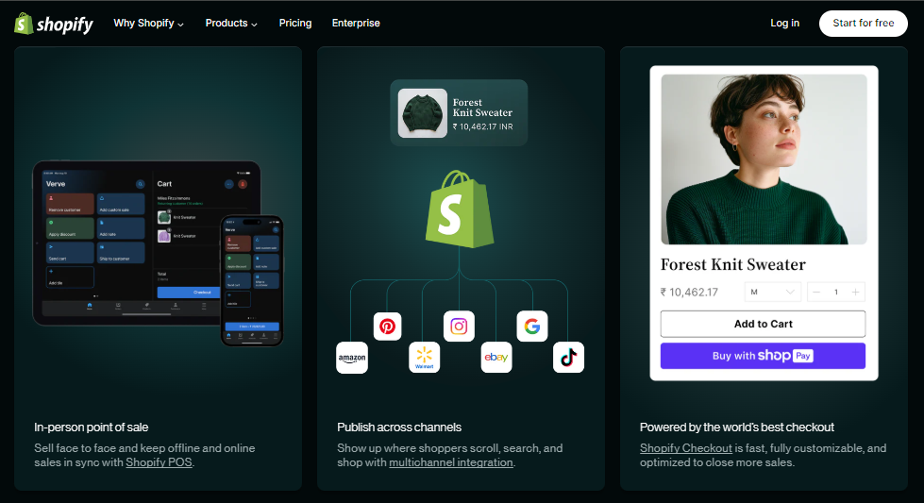
Figure 1. Shopify
Benefits:
The most remarkable feature of Shopify is its ecosystem 1-in-one services, which include web hosting, security with an SSL and automatic updates. It has more than 100 payment gateways and 24/7 customer support. App Store has thousands of plug-ins to promote marketing automation, SEO optimisation and accounting, allowing the businesses to easily expand functionality.
Limitations:
Although there are its strengths, the subscription fee and transaction fee of signing up at Shopify can prove expensive to small businesses. Proprietary code is somewhat limited to customisation, and designers who desire control over the depth of design are limited. Companies that use plug-ins extensively might have to spend on extra maintenance and compatibility problems.
Wix eCommerce
Wix has also developed into a powerful online shopping system that could be used by entrepreneurs and SMEs. It gives over 500 templates, drag and drop editing, as well as built-in tools for order management, product galleries and safe payments. Wix eCommerce also has AI-based design features (Wix ADI), which are known to automatically create website layouts according to the name and address input and are user-friendly [2].
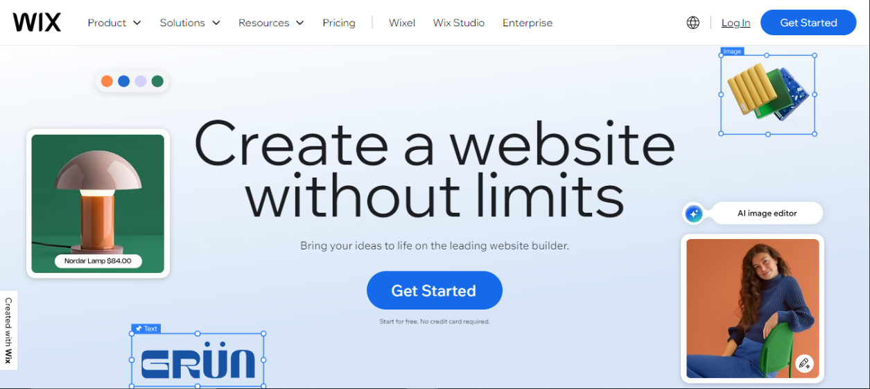
Figure 2. Wix
Benefits:
Wix eCommerce is valued because of its flexibility in design according to the needs of users. Companies are able to develop highly graphical websites having custom animations and media incorporation. The site will provide SEO Wiz, which is a search engine optimisation tool and Wix Analytics, which is a performance monitoring tool. The prices are affordable, and they offer web hosting and domain management, plus SSL certificates, which make the business conduct easier.
Limitations:
The Wix eCommerce, however, is not as scalable as Shopify. It may slow down with an increase in the number of products, and it does not offer the same range of third-party integrations. Payment gateways are also limited, and when a template is chosen, it may take significant modifications to the design to create them.
Comparative Evaluation
Both these platforms give power to non-technical users, but depending on the size of the business, they are not suitable. Shopify would be the best fit when a company needs a full-fledged growth-focused solution with a multi-channel sales solution, whereas Wix eCommerce would address the needs of the small retailer and creative professionals who need less attractive design and a lower price tag. Both accommodate key e-commerce domains, including reliable payments, responsive design, and analytics, which expresses how the software-as-a-service (SaaS) platforms facilitate entrepreneurship online.
Conclusion
In short, modern e-commerce website creators such as Shopify and Wix eCommerce have changed the online retail sector by offering secure at low-cost solutions, and scalable system solutions. They do away with technical barriers, improve the customer reach, as well as enable businesses to adapt very fast to the market requirements. The choice between the two lies in the size of the organisation, design requirements and expansion goals.

Task 2

Mind-map of Contemporary Software Applications
(a) Description and Benefits of Mind Mapping in Business
Mind mapping is a graphical method by which information is arranged around a central concept to assist individuals and teams in the strategy of capturing, linking, and structuring ideas in a logical manner. It was popularised by Tony Buzan, who described it as a diagrammatic process of organising thoughts into branches, colours, and keywords, in the way the human brain naturally processes information. Applications of mind maps are mainly applied in the business environment in brainstorming, project planning, knowledge management as well and problem-solving. The use of mind mapping can also make people more creative and clearer, which is one of the key advantages of this process. It allows the representation of information on a non-linear basis, which means that it challenges the participant to recognise connections between concepts that would be overlooked in a linear system of notetaking. To give an example, a mind map can be used when managers are strategizing a new marketing strategy to be applied by them, so they can visualise customer demographics, promotional channels, budgets to be used, and the schedules [3].
Mind maps can also be used to engage in good decision-making since they enable teams to divide more intricate issues into manageable units. This model enhances a better understanding, memorisation, and coordination at meetings or strategic discussions. Productivity and efficiency in solving problems are greater in employees who use visual mapping tools than in employees who use traditional note formats. Technologically, maps can be collaborated on in real-time and integrated with cloud storage features using digital mind mapping software like XMind, MindMeister, and Miro, and sent into project management systems. These applications combine the visual thinking and digital working process marvelously and work perfectly well in both hybrid and remote workplaces.
(b) Mind Map of Contemporary Software Applications
The mind map below illustrates the modern-day software applications that are widely used to facilitate day-to-day business activities. These tools will be categorised into functional units as productivity services, communication services, collaboration services, financial management services and customer relation services.
Mind Map Diagram
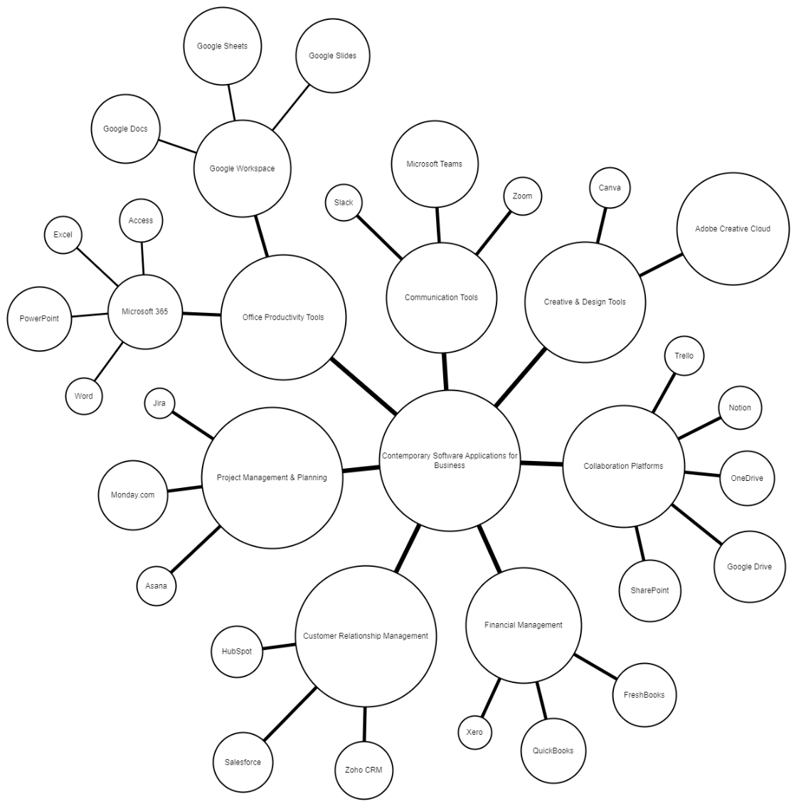
Figure 3. Mind map

Explanation
The software systems illustrated on this mind map show how different programmes can streamline companies' operations. For example, Microsoft 365 is useful for improved productivity and documentation, Teams and SharePoint are helpful in real-time workplace collaboration, financial systems like QuickBooks automate invoicing and reporting, and the use of CRM systems like Salesforce gives the ability to sustain and service relationships with customers and their campaigns. By connecting in a centralised system, it provides an interwoven network of functions in their digital solutions that are communicative, effective and can assist with data on the decision-making process, which is much needed for modern business. This map is available for businesses to speak to when looking to choose or incorporate the software to best suit their operational needs [4].
Conclusion
Mind mapping is not only a structured way of offering information but also helps in better understanding and cross-departmental collaboration. Through visual mapping of software applications within major business processes, organisations can detect digital gaps, eliminate duplicate services and optimise the processes to guarantee better performance and competitiveness.

Task 3

Office Applications for Creating, Storing, Presenting, and Analysing Data
The organisations of today are greatly relying on digital tools to manage their daily functions effectively. The role of office Applications in this digital environment is to allow employees to develop documents, interpret information, share information, and systematically save them. One of the most popular suites of software is Microsoft Office 365 and Google Workspace, which have integrated applications that are effective at improving productivity, collaboration and data management. The given task is dedicated to four key applications of the Microsoft Office suite, including Word, Excel, PowerPoint, and Access, with an underscoring of their key features, advantages, and drawbacks and a practical demonstration of the chosen business-specific functions.

a.
1. Microsoft Word
Microsoft Word is among the most frequent word processing software programs, and these can be used to create, edit, and format professional documents. It is an inseparable part of Microsoft 365 and a necessary application to prepare letters, proposals, meta-reports, and manuals in business. It has an easy-to-use interface with a ribbon menu dividing the tools into rational groups like Home, Insert, and references [5].
Major Features:
Word also has many features of document formatting like styles, templates and themes and this way documentation is all branded across the company. Such advanced functions as mail merge, which automatises writing personalised letters or emails using a data source, and track changes, which makes reviewing documents and collaborating easier, can be found. It can be combined with OneDrive so that it facilitates co-authoring in the most real-time manner, when the work can be co-edited by one or more users located at various points.
Benefits:
Word has the major benefit of being versatile, useful for a simple memo or a complicated and multi-section report consisting of tables, graphs and citations. Word is used by businesses to ensure uniformity of formatting and also facilitates communications with its clients. The fact that spell check, grammar check, and language translators are all included makes written communication professional. Besides this, compatibility with Microsoft Teams will enable the sharing of documents instantly in workspaces.
Limitations:
Although Word is mighty, it can usually be quite resource-intensive and slow when it has to deal with very large files with embedded images or charts. However, issues of file compatibility may also arise when exchanging files with people of another software version or operating system. One more restriction is that some more sophisticated functions demand a paid subscription to Microsoft 365.
2. Microsoft Excel
Microsoft Excel is a spreadsheet tool that is used in data organisation, computation, and analysis. It allows the user to do mathematical operations, visual charts, and complex formulae. Excel has found its way into being an important tool in the world of finance, logistical work, and data analysis because it has the capability of handling large volumes of data [6].
Major Features:
Excel has numerous formulas and functions available, like SUM, AVERAGE, IF, VLOOKup, and PivotTables that assist a user in analysing data within a very short time. The large tables can be summarised by the use of PivotTables, whereas the charts (bar, pie, line) can be used to represent data and make a decision. Conditional formatting is also offered in Excel and visually highlights a trend in data.
Excel has a significant strength in terms of analysing its data. As an illustration, tools such as Goal Seek and What-If Analysis are useful in predicting the result of the business. Real-time business intelligence reporting and dashboards are made possible through integration with Power BI.
Benefits:
Excel provides a balance between simplicity and high analytical capabilities. Its grid-based system enables one to store and manipulate data without programming skills. It is utilised in business to do budgeting, financial modelling, sales reporting, and performance analysis. The fact that it browses with the cloud storage promotes access and shareability of spreadsheets by teams.
Limitations:
Even though it has its merits, Excel is susceptible to human error, particularly when one is involved with manual data entry. A spreadsheet may turn problematic because it is difficult to work with in situations where the datasets increase and cause version control problems. In addition, incorrect data validation could result in incorrect outcomes that will affect business decisions. Excel also does not have the automation and the scaling of specific database systems.
3. Microsoft PowerPoint
Microsoft PowerPoint is a presentation application that is used to create slideshows to be used during a meeting, lecture, and also in training companies. It allows the production of presentations that are attractive and interactive and convey the information [7].
Major Features:
PowerPoint has many templates and design themes, which make the creation of the slide easier. Its SmartArt tools, Animations, and Transitions feature makes the presentation interesting, and its Slide Master feature ensures that the slides are uniformly formatted. Neither does it conflict with Excel and Word- in fact, one can directly import charts or tables used in those programs into presentations. Presenter View, Presenter View assists the speakers to see notes, showing the slides to the audience, without showing them, in order to deliver in a more professional manner.
Benefits:
PowerPoint helps improve communications by using visual storytelling. It is used by businesses in summarising reports, presenting project proposals, and providing training materials. The software can be used to integrate multimedia (images, video, audio) so that it can suit various learning styles. It is integrated with Microsoft Teams, providing the possibility of live presentations during virtual meetings.
Limitations:
The drawback of PowerPoint is that there is the possibility of information overload in case slides are congested with text or graphics. Excessive intake of animations can be distracting to the audience. In addition, the efficiency of a presentation is related mostly to the design skills of a user. The sizes of files may also become bigger when several media elements are embedded.
4. Microsoft Access
Microsoft Access is a database management application that is utilised in storing, managing and analysing structured data. It is more user-friendly than complex database systems such as MySQL or Oracle because it combines the features of a relational database with a user-friendly graphical interface [8].
Major Features:
Access will enable the user to form tables, queries, forms and reports and form a relational database. Tables can be connected with the help of unique keys to the data, then organised. It also has query tools like Structured Query Language (SQL) through which certain data can be retrieved. This is because the form builder is used to design easy interfaces to input data and enable automatic generation of reports to be analysed.
Benefits:
Small and medium-sized businesses that require a centralised data repository without the complexity or cost associated with an enterprise can access it. It closely fits together with Excel and Outlook, and it has an import/export data facility. The Access visual design features enable users who have little knowledge of code to create database applications that can be used to track customer orders, employee or inventory information.
Limitations:
Scalability brings about limited access, which works best with smaller datasets and not very many simultaneous users. Enterprise-oriented database management is usually favoured by large organisations that use SQL Server or Oracle.
Comparative Discussion
Comparing these four applications, one can see that Microsoft Word and PowerPoint are oriented toward the creation and presentation of content, as Excel and Access are directed at the analysis and control of data. They create a single ecosystem that facilitates every process of business documentation and decision-making.
A business report may be prepared in Word, backed up by the data analysis by use of Excel, delivered by a PowerPoint presentation, but underpinned by a database of customers that can be managed by use of Access. This is one of the most powerful benefits of Microsoft Office, as it enables the transfer of data, as well as the integration of working processes and enhances efficiency and productivity.
The cooperation with cloud services (OneDrive and SharePoint) allows version control and collaborative editing, which is needed in contemporary hybrid workplaces. Although there are alternative software packages like Google Workspace and LibreOffice, Microsoft Office is the most widespread package because it has the best features, enterprise compatibility, and is familiar to professionals.

b.
In order to illustrate the usability of office software in real life, two capabilities of two separate programs were tried: Mail Merge in Microsoft Word and VLOOKUP in Microsoft Excel. The tools are commonly utilised in business where they are used to communicate and analyse data.
1. Mail Merge in Microsoft Word
The Mail Merge feature serves to automatically prepare several personalised documents (letters, invoices, email messages, etc.) by combining a template document with a data source (e.g., an Excel file with names and addresses). This comes in handy, especially in marketing or communicating with clients.
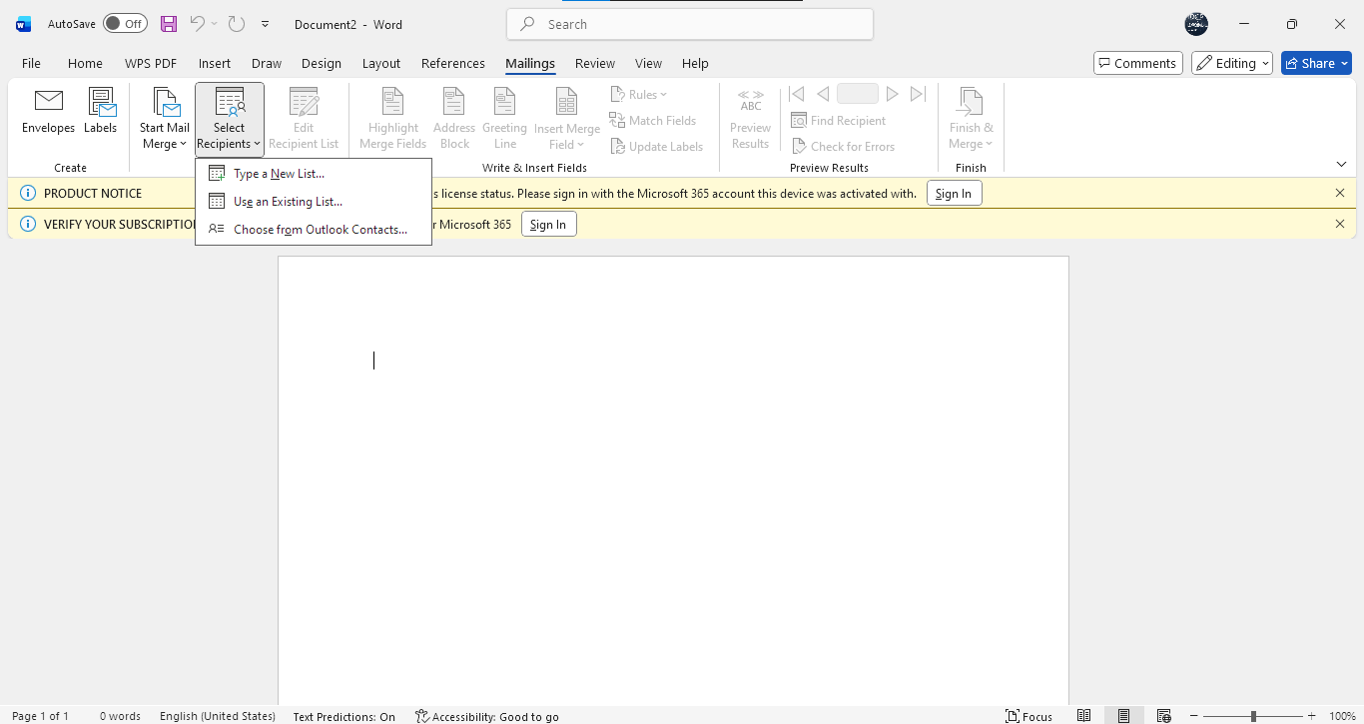
Figure 4. Word Document with Dropdown
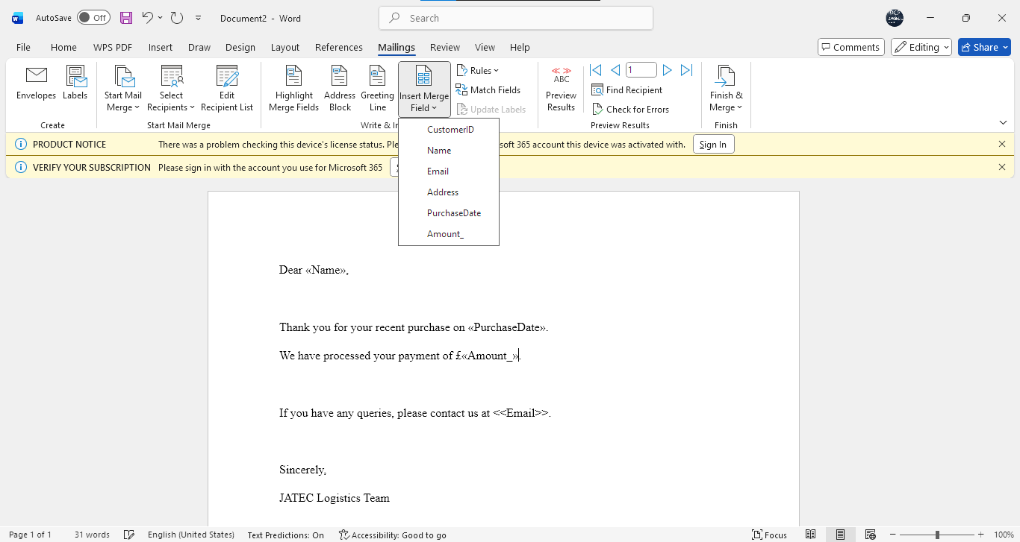
Figure 5. Mail Merge
Business Use Example:
An example of a logistics firm is given in which Mail Merge can be utilised to send monthly payment information to a group of customers. This is time-saving and ensures personalised and consistent communication with hundreds of records.
Advantages:
Mail Merge will cut down on the manual editing and reduce the mistakes in client correspondence. It also guarantees personalised and professional communication and preservation of the consistency of formatting and branding.
Limitations:
Malfunctions in the source of data (e.g., some fields are not found or are incorrectly formatted) can lead to inconsistencies in the final letters. Using Mail Merge requires some preparation, which can be time-consuming for those who are not experienced.
2. VLOOKUP Function in Microsoft Excel
VLOOKUP (Vertical Lookup) is among the most useful functions in Excel that allows one to search and retrieve data in an enormous table. It is often applied in sales, human resources, and accounting departments to find and retrieve certain information as per a key value.
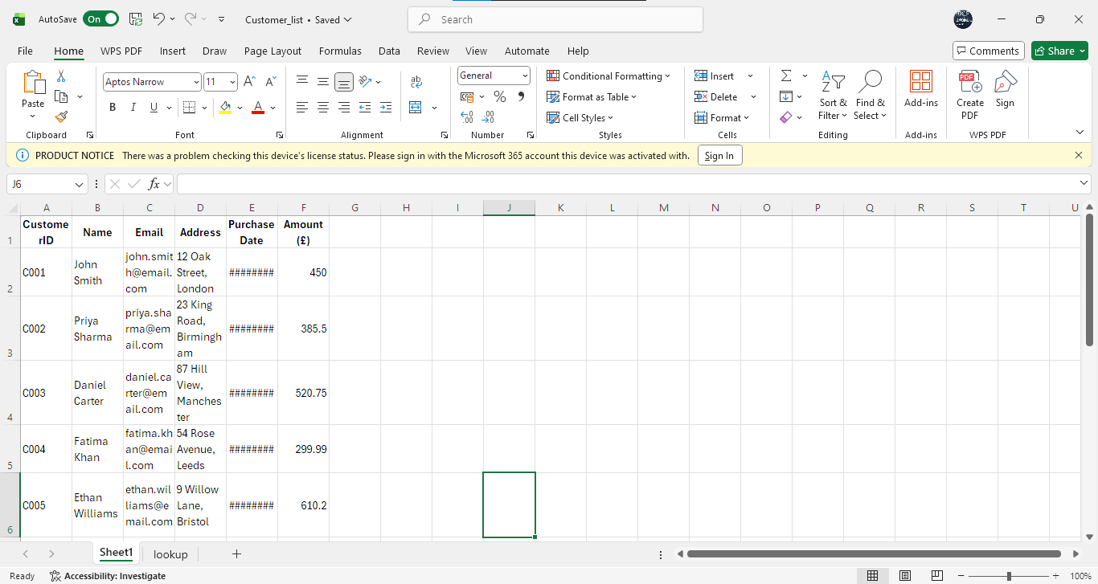
Figure 6. Excel
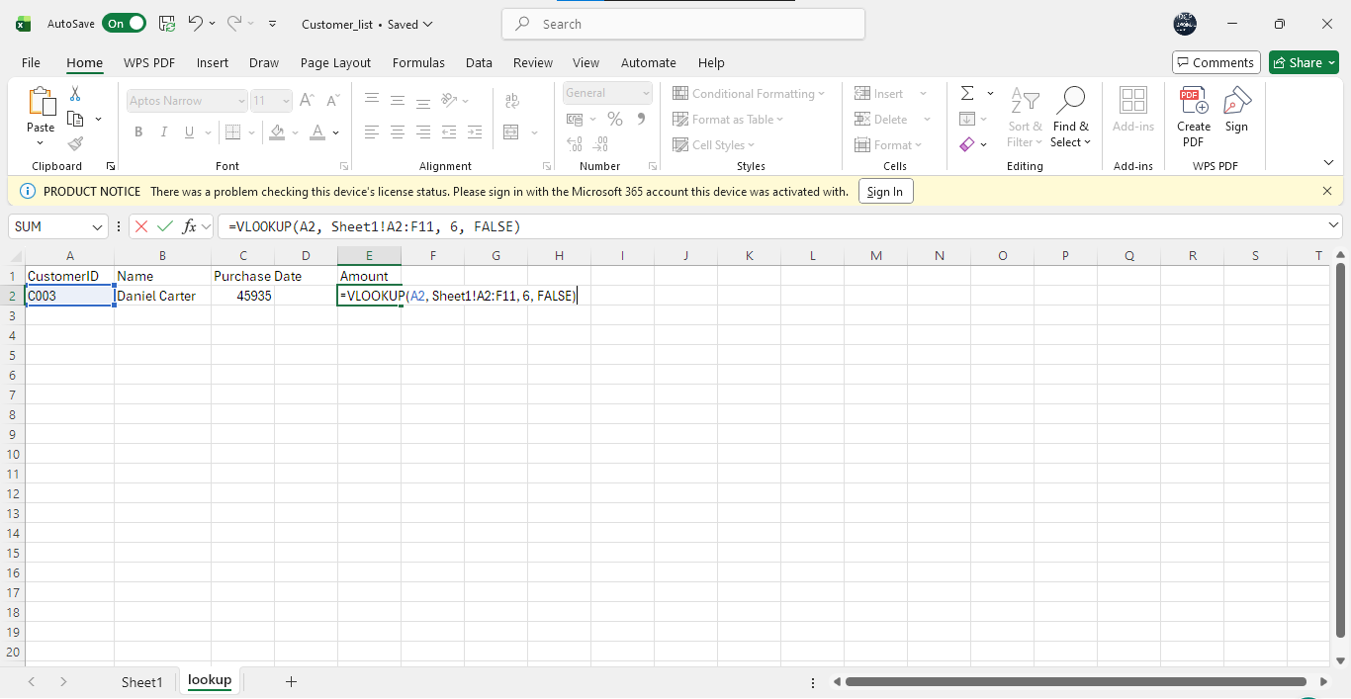
Figure 7. VLOOKUP Use
Business Use Example:
VLOOKUP in an accounting department may help accelerate the process of contracting information and saving time in crossing invoice numbers and product databases to call up price or stock information.
Advantages:
By removing manual searches, VLOOKUP is able to increase the effectiveness of data analysis. It guarantees the consistency of data and is best in the case of massive data. It also incorporates other formulaic ones to give sophisticated automation.
Limitations:
VLOOKUP has the capability of a horizontal and left-to-right search only. The formula can break down in case the data structure is changed. In more complex queries, the business can use the INDEX-MATCH combination or look up advanced data using Power Query.
Practical Significance
The Mail Merge, as well as VLOOKUP, are more illustrations of how office programs can automate everyday business functions. Mail Merge will automate communication with customers and VLOOKUP will automate data retrieval - both of which increase efficiency and accuracy. With the help of these tools, a business will decrease the load on administering it, increase the quality of working with data, and ensure consistency in the work of the business.
Conclusion
The digital basis of business documentation and analysis is made up of Microsoft Word, Excel, PowerPoint and Access. They allow users to make, save, display, and analyse information efficiently, which is in line with the demands of the data-driven business world. Word, PowerPoint facilitate communication and presentation, and Excel and Access enable analysis and database. The real-life examples of Mail Merge and VLOOKUP also show how practical these tools are in terms of automating repetitive work and preventing errors in data.

Task 4
In the modern, new digital-first work setting, communication and collaboration products play a key role in keeping the business productive, particularly when it is in a hybrid and remote workplace. Such software applications eliminate the geographical barriers, enhance teamwork, and decision-making. This assignment compares one of the current communication technologies (Microsoft Teams) with one of the collaboration technologies (OneDrive), a pair of applications that are components of a single Microsoft 365 technology.

Communication and Collaboration applications
a.
1. Microsoft Teams (Communication Application)
Microsoft Teams is an integrated platform of communication technology that allows instant messaging, video conferencing, and document-sharing applications in one digital workspace. It is a work-centralised communication hub that enables connecting to the Microsoft 365 suite of applications, including Outlook, SharePoint, and OneNote [9].
Key Features:
Teams also has chat-based communication with an individual and group message feature. The chat interface is such that users can share files, pictures and hyperlinks in real-time. The Video Conferencing feature provides HD as well as screen sharing/ virtual background, which is suitable when hosting meetings and training. Teams is also based on Microsoft Planner and Calendar, and users can schedule a meeting in Teams and allocate tasks.
Benefits:
The centralised communication model is the key benefit of Microsoft Teams since the staff can chat, call, meet, and work together without using more than one software. It promotes hybrid work with the ability to communicate remotely and the inclusion of global teams. Organisations operating with Teams have up to 25% more efficient collaboration as they are not as dependent on email and make decisions faster. The advantage is also its enterprise-level security as Teams meets the requirements of ISO 27001 (GDPR) of Microsoft. Secrecy of information transmitted and at rest is possible since data is encrypted and can be applied in companies dealing with sensitive information.
Limitations:
Teams, however, may be resource-intensive and therefore may use a lot of bandwidth as long as the video calls are on. The notification system is overwhelming to some users, particularly when there are many channels that are active in large organisations. This will introduce new users to a learning curve when using its advanced features. Microsoft Teams offers a solid system of communication that contributes to better productivity and helps to build a unified culture of the workplace, particularly during digital transformation.
2. Microsoft OneDrive (Collaboration Application)
OneDrive is an online file storage and exchange tool helping to share documents in real-time and collaboratively complete them by Microsoft. It enables users to save a file safely on the cloud, visit it on different devices, and share it with their co-workers with restricted accessibility [10].
Key Features:
OneDrive will provide cloud-based storage with versioning, such that files are stored there to be reused or restored whenever needed. The device updates are automatically synchronised throughout the system, allowing a user to edit him or herself offline and then resynchronise upon returning to the internet. Its feature of sharing permission enables users to select the level of access, i.e. view-only, edit, or comment, which guarantees the security of data and its further control.
Benefits:
The key advantage of OneDrive is the smooth collaborative platform, which allows its users to collaborate within the team and work with the same file without disagreements or versioning issues. The files get automatically uploaded to the cloud, eliminating the chances of losing data through hardware failure. The system has an automated version history, whereby older versions of documents can be retrieved when the need arises. OneDrive is also able to improve cooperation inside the company through the ability to get documents wherever an employee is and whenever needed. Using one cloud-based collaboration of OneDrive, among other tools, the workflow has become 40% more agile in companies that have switched to this type of technology.
Limitations:
A limitation is that the performance of OneDrive is dependent on the connectivity of the internet; the lack of bandwidth can slow down uploads or synchronisation. The site offers high-level encryption for security; the user needs to be very cautious with the permissions they set to avoid unauthorised users. Big organisations could also have difficulties with storage management, especially when managing a large quantity of multimedia files.
Comparative Overview
Microsoft Teams and OneDrive are both beneficial to productivity in an organisation, albeit in a complementary manner. Teams is used to work on communication and coordination, and OneDrive enables one to manage the content and collaborate. Teams allows team members to make decisions fast with the help of meetings as well as chat, but OneDrive provides teams with the means of supporting their decisions with secure storage of documents and effortless sharing of files. The two develop an integrated ecosystem in Microsoft 365 that makes it possible to work together on ideas from the execution.
b.
To illustrate the real usage of these tools, a feature of the tools, one, Meeting Scheduling and chat in Microsoft Teams and the other, File Sharing and Real-Time Collaboration in OneDrive, was tried. Screenshots and instructions are as follows.
1. Microsoft Teams- Organising a Meeting and Chat Exchange


Figure 8. Teams

Figure 9. New Chat
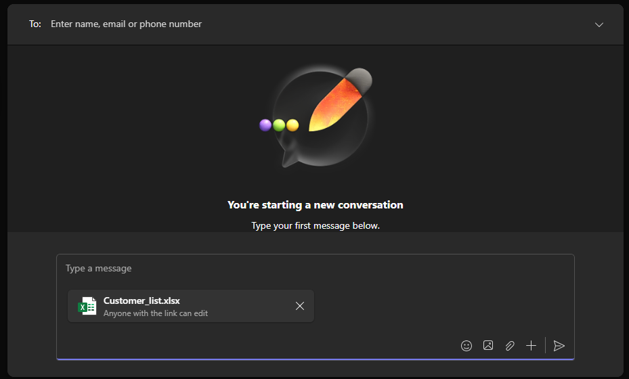
Figure 10. Attaching a Document in Chat
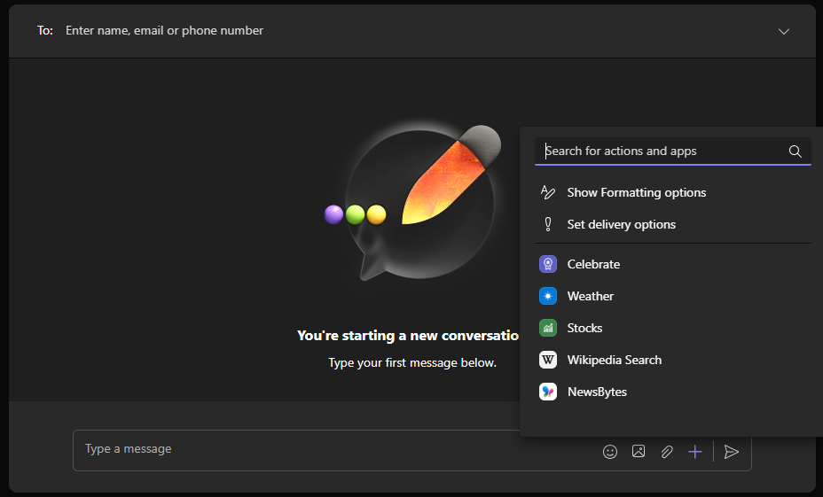
Figure 11. More Options
Business Use Example:
Teams’ meetings may be utilised in a logistics company to hold weekly updates on the operations. Team leads can discuss performance dashboards (built in Excel), distribute tasks even in the chat, and breakfast on performance evaluations and route planning, which makes them accountable and continuous.
Advantages:
This aspect eases communication and lowers email traffic, and all conversations and documents are stored at a single point.
Limitations:
Video calls require a good bandwidth, and people accessing the internet at low speeds can experience issues with or sound quality.
2. Microsoft OneDrive -File Share and Real-time collaboration.
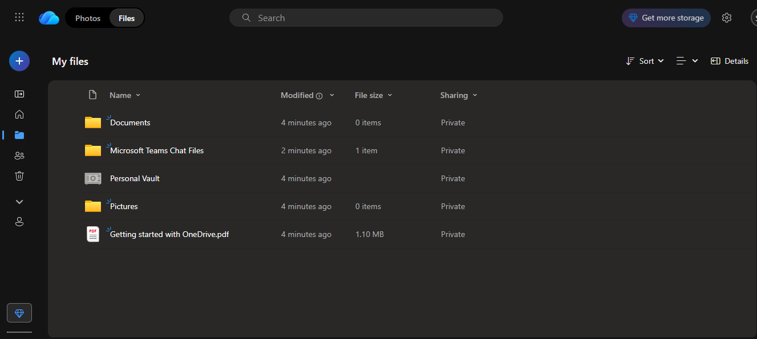
Figure 12. OneDrive
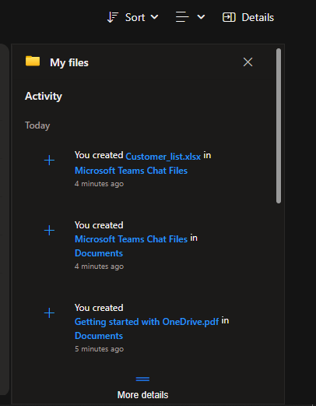
Figure 13. OneDrive Activity
Business Use Example:
The transport company (JATEC) can utilise OneDrive to ensure that the employees collaborate to keep the data relating to the delivery schedules and the fleet in Excel files. The drivers and the operations manager can also update records and have the latest information received by the various stakeholders.
Advantages:
This characteristic promotes teamwork and removes the misunderstanding regarding various versions of the file. It ensures homogeneity and data clarity.
Limitations:
Internet connectivity leads to delays in updating information, and unwanted links shared with the general population may be devastating to the dissemination of information unless adequately addressed.

Conclusion
In conclusion, the integration of software solutions in the operation of business ventures has transformed the way organisations engage and collaborate and also deliver services. As the comparison of such platforms as Shopify, Wix, Microsoft Office Suite, Teams, and OneDrive reveals, online tools can facilitate efficiency, automation, and innovation. These types of technologies simplify the tasks of processing, presentation, communication with the customers, real-time teamwork and, therefore, help the firms to work more strategically. Despite the weaknesses of both software, their combination is a complete business success in the digital world. According to the report, flexibility and training are critical in order to realise the potential of these tools. As the companies continue to digitalise, the possibility of choice and application of the proper software is among the main competitive advantages. Lastly, technology not only enables businesses to work more efficiently, but it also allows businesses to remain flexible in the dynamic business world and be viable in their development.

References
[1] T. Akhtar, Website Platform Selection for Online Shop, 2021. [Online]. Available: https://www.theseus.fi/bitstream/handle/10024/411922/Website%20Platform%20Selection%20for%20Online%20Shop.pdf?sequence=2
[2] A. T. Cahyadi, N. Miftahudin, N. S. Islahiyah, F. D. Yulianti, and B. N. H. Masturah, “Design of Website for Business Enterprises Using a Website Creation Application,” Visualita, 2022. [Online]. Available: https://ojs.unikom.ac.id/index.php/visualita/article/download/6562/2999
[3] T. Buzan, Mind Map Mastery: The Complete Guide to Learning and Using the Most Powerful Thinking Tool in the Universe, Jaico Publishing House, 2024. [Online]. Available: https://books.google.com/books?hl=en&lr=&id=5VUWEQAAQBAJ&oi=fnd&pg=PT7&dq=mind+mapping+technique&ots=gvc8XRs9cp&sig=xtidTbNKWM0n4XDPMxYn2hdxO3c
[4] M. Ramayah and H. B. A. Jaleel, “Mind-Mapping Tool to Enhance Application of Economic Knowledge for Hybrid Learning,” in Innovating Education for a Better Tomorrow, p. 480, 2022. [Online]. Available: https://www.researchgate.net/profile/Muhamad-Hassim/publication/365423420_Infographics_in_Teaching_and_Learning_An_Attention_Grabber/links/63abb66b097c7832ca6fc575/Infographics-in-Teaching-and-Learning-An-Attention-Grabber.pdf#page=497
[5] C. Rapp, T. Heilmann, and O. Kruse, “Beyond MS Word: Alternatives and Developments,” in Digital Writing Technologies in Higher Education: Theory, Research, and Practice, Cham: Springer International Publishing, 2023, pp. 33–47. [Online]. Available: https://link.springer.com/content/pdf/10.1007/978-3-031-36033-6_3.pdf
[6] C. M. Cabrera and J. Pentang, “Development of an Offline Computer-Based Assessment Tool in Statistics and Probability Utilising MS PowerPoint and MS Excel,” 2023. [Online]. Available: https://philpapers.org/archive/CABDOA.pdf
[7] E. C. Nwangwu, P. Obichukwu, A. U. Uzuagu, and C. B. Omeh, “Development of an Interactive PowerPoint Presentation Design Training Package,” The International Journal of Technologies in Learning, vol. 28, no. 2, p. 39, 2021. [Online]. Available: https://www.researchgate.net/profile/Christian-Omeh/publication/352756747_Development_of_an_Interactive_PowerPoint_Presentation_Design_Training_Package_IPPDTP_for_Lecturers_of_Tertiary_Institutions/links/61dd3263323a2268f997fb75/Development-of-an-Interactive-PowerPoint-Presentation-Design-Training-Package-IPPDTP-for-Lecturers-of-Tertiary-Institutions.pdf
[8] A. Azcorra, Lightning Guide to Databases with Microsoft Access and SQL: A Practical Guide to Database Design with Microsoft Access and SQL, Arturo Azcorra-Saloña, 2021. [Online]. Available: https://dspace.networks.imdea.org/bitstream/handle/20.500.12761/1506/Lightning_Guide_v_1_0_Preview.pdf?sequence=2&isAllowed=y
[9] T. V. M. Yen and N. T. U. Nhi, “The Practice of Online English Teaching and Learning with Microsoft Teams: From Students’ View,” AsiaCALL Online Journal, vol. 12, no. 2, pp. 51–57, 2021. [Online]. Available: https://asiacall.info/acoj/index.php/journal/article/download/41/20
[10] S. R. Mohamad and N. Hussin, “The Usage of Microsoft OneDrive among the Professional College Staff,” Journal of Information and Knowledge Management (JIKM), vol. 11, no. 1, pp. 84–94, 2021. [Online]. Available: https://ir.uitm.edu.my/id/eprint/65495/1/65495.pdf

