

Program: Master of Business Administration
Module Name: International Business Concepts
Module Code: LCMB7034
LVMH's International Market Entry Strategy for Ethiopia: A Critical Evaluation of Market Attractiveness, OLI Advantages and Entry Mode

Lecturer: Akshay Narayanan, Mansoob Murshed
Student Name: Ayush Alpeshbhai Navdiya
Student ID: 2530961

Table of Contents
Section 1 3
1. Organisational Classification and Global Strategy 3
2. Macro-Environmental Appraisal and Market Attractiveness 4
2.1 Introduction to the Ethiopian Market 4
2.2 Political Environment and Implications for LVMH 4
2.3 Economic Environment and Luxury Market Potential 6
2.4 Legal and Regulatory Environment 9
2.5 Cultural and Consumer Environment 10
2.6 Market Attractiveness: Opportunities and Risks 11
2.7 Applying Dunning's Eclectic Paradigm (OLI) 12
2.8 OLI Synthesis and Implications for Market Entry 13
2.9 Overall Market Attractiveness and Strategic Implications 14
3. Entry Mode Strategy and Strategic Synthesis 14
3.1 Historical Entry Modes Used by LVMH 14
3.2 Evaluation of LVMH's Dominant Entry Mode 15
3.3 Suitability for Ethiopia 15
3.4 Recommended Entry Strategy for LVMH in Ethiopia 16
3.5 Strategic Synthesis and Final Recommendation 17
Section 2 — Reflective Account 18
4.1 Description 18
4.2 Feelings 18
4.3 Evaluation 18
4.4 Analysis 19
4.5 Conclusion 19
4.6 Action Plan 20
References 21

Section 1

1. Organisational Classification and Global Strategy
Strategic Categorization
Louis Vuitton Moët Hennessy (LVMH) can be described as pursuing a transnational strategy according to the Bartlett and Ghoshal (1989) framework, combining a high level of global integration with a high level of local responsiveness. It has 75 Maisons, each with its own creative identity and entrepreneurial autonomy within a shared Group platform. This allows LVMH to transfer expertise in brand management, retail, craftsmanship, digitalisation and customer experience across international markets while retaining flexibility. This strategic fit is particularly appropriate for luxury markets because global consistency is essential for maintaining brand prestige, while local adaptation enables individual Maisons to respond to cultural differences, purchasing behaviour, tourism and consumer expectations (Tsega et al., 2022). However, the model also creates coordination challenges because greater Maison autonomy can result in duplication of resources and make Group-wide integration more difficult. Therefore, while decentralisation provides flexibility, LVMH must actively manage it to maintain effective control over quality, distribution and brand equity.
Global Configuration
LVMH operates in 81 countries and has 6,283 stores across its 75 Maisons as of 31 December 2025. In 2025, the Group generated €80.8 billion in revenue, highlighting the scale of its geographically diversified business model. The Fashion and Leather Goods segment is highly internationalised, generating €37.77 billion in revenue in 2025, with 35% generated in Asia excluding Japan, 18% in the United States and 10% in other markets. This geographical diversification reduces dependence on individual economies and enables LVMH to capture growth across both mature and emerging markets.
LVMH's configuration strengthens its competitive advantage through control of key stages of the luxury value chain. Its directly operated boutiques support consistent brand presentation, customer experience and retail-margin protection, while its extensive manufacturing and craftsmanship networks support quality, authenticity and scarcity (Deng, 2025). The Group's scale also facilitates knowledge sharing and investment in digitalisation and international marketing while allowing individual Maisons to maintain distinctive identities. Geographical diversification and entrepreneurial agility are therefore important foundations of LVMH's global competitive position.
This configuration suggests a cautious approach to expansion into Ethiopia rather than immediate large-scale investment. LVMH's international expertise could support market entry through selective retailing or partnerships before establishing a substantial physical presence. Such an approach would allow the company to test market demand, develop local knowledge and limit capital exposure while protecting brand exclusivity and control. Overall, the transnational model provides LVMH with the flexibility to explore the Ethiopian market while maintaining a consistent global luxury brand proposition (Zhang and Donzé, 2024). For Louis Vuitton, an asset-light Ethiopian pilot combining digital engagement with a carefully selected premium retail partner could generate valuable local market knowledge before any commitment to wholly owned stores.

2. Macro-Environmental Appraisal and Market Attractiveness

2.1 Introduction to the Ethiopian Market
Ethiopia is a potentially promising, but difficult to get into, emerging market for LVMH due to its high population, emerging economy, and growing urban customer base. Addis Ababa is particularly topical as it is the political, business and international centre of the country and, thus, the most viable to open in the first place in the luxury-market segment. Growth of the number of middle-income buyers in Ethiopia and increased contact with foreign brands creates the possibility of a long-term demand for high-quality goods (Bai et al. 2026). However, the economic instability, exchange risks, uncertainty about the legislative framework and poor luxury retailing facilities should also mitigate this opportunity. Therefore, Ethiopia cannot be measured in terms of its growth potential, but rather by whether the institutional and market environment is able to support the high-end positioning, brand management and long-term global approach of LVMH.

2.2 Political Environment and Implications for LVMH
The politically asymmetric opportunity to LVMH is Ethiopia: the government is opening up the economy to foreign investments more, and institutional and security risks remain elevated. Ethiopia has a huge population of over 120 million, two-thirds of whom are under 30, and therefore, the country provides a huge consumer base in the long term (U.S. Department of Commerce, 2024a). More importantly to LVMH, the government has of late shifted towards more involvement of the private sector. The formal market-access environment is greatly improved with the introduction of such a directive as No. 1001/2024 that opened the retail, wholesale, import and export sectors to foreign investors in 2024 (U.S. Department of Commerce, 2024b). This gives LVMH a chance to have a direct presence as opposed to being structurally reliant on a domestic intermediary.
Nonetheless, execution risk is not removed through formal liberalisation. In Ethiopia, political and regional insecurity is still being experienced; there are complaints of bureaucratic delays in businesses, inconsistent enforcement of regulations and logistical challenges. According to the U.S. Department of Commerce, the political instability and ethnic conflict are the elements that discouraged FDI, and businesses are still experiencing administrative inefficiencies and a lack of foreign exchange (U.S. Department of Commerce, 2024a). These limitations are especially relevant to a luxury company since the competitive edge of LVMH relies on the consistency of the availability of products, the managed retailing conditions and the uniformity of customer experience, and not merely on the presence of a big population.
The political factors, which have a direct strategic influence, are various:
- FDI Liberalisation: Opening of retail and permitting foreign investors to invest would help in making strategic decisions by LVMH and strengthening the argument of experimentation in the market.
- Administrative barriers: licensing, customs and government procedures can increase the entry cost by delaying the transit of the high-value imported products (Bai et al. 2022).
- Security risk: Addis Ababa should be the base of an initial operation due to a lack of regional stability to roll out the project nationwide; it will provide a higher degree of control and reduce geographic risk.
- Policy uncertainty: Reforms still going on generate potential upside, although the process of implementing them is less predictable than in developed luxury markets.
Critical judgement: The political situation in Ethiopia is thus to be considered as conditionally attractive as opposed to being inherently attractive. Liberalisation creates a real first-mover advantage, although mass investment is not proportional to the existing market opportunity due to security, institutional and administrative uncertainty. The entry of light-asset staging would allow LVMH to enjoy the benefits of reform at a lower political risk and would also allow it to inject more of its commitment in case institutional conditions improve.

2.3 Economic Environment and Luxury Market Potential
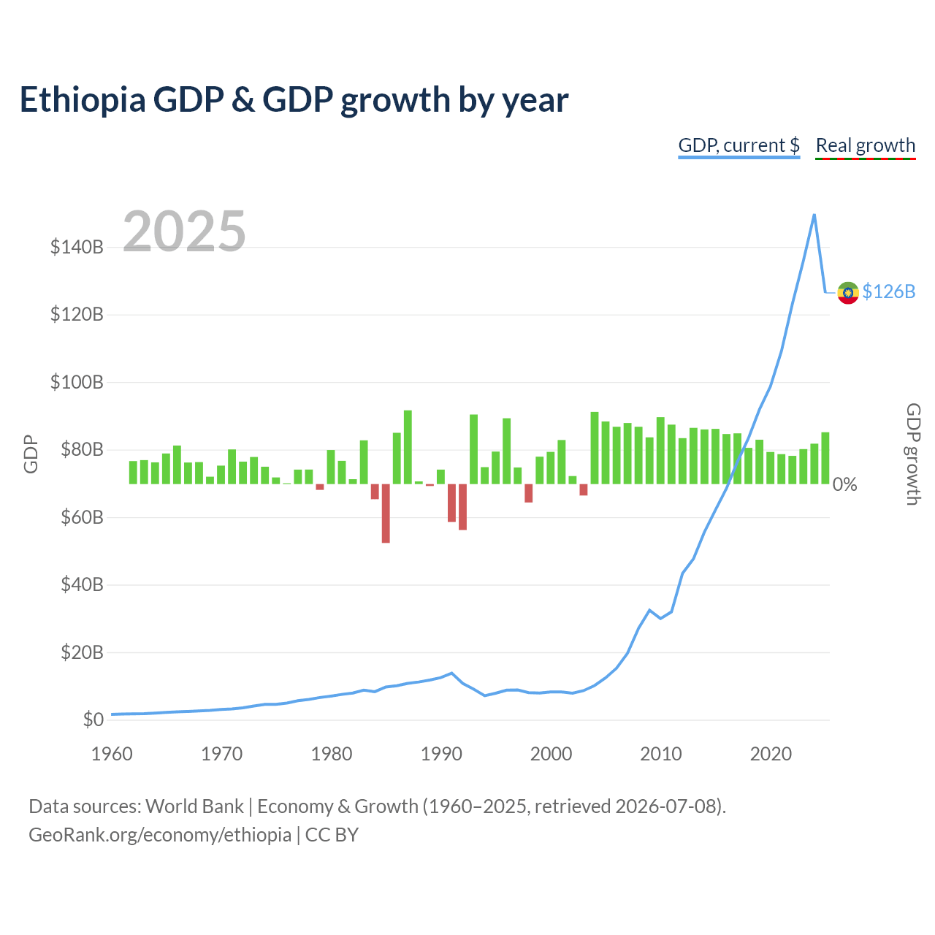
Figure 1: Ethiopia's GDP Growth and GDP per Capita, 2015–2025
(Source: World Bank, 2026)
Ethiopia has good long term growth opportunities and poor short term purchasing power, which poses a fundamental conflict to LVMH. In 2025, the economy was growing at a rate of 9.8 percent and GDP was approximated at US126.4 billion. However, its GDP per capita was US$932.7, demonstrating that despite the high rate of aggregate development, people have not yet achieved the same purchasing power as the developed luxury markets (World Bank, 2026).
Indicator | Latest position | Implication for LVMH
GDP growth | 9.8% (2025) | Strong long-term market potential
GDP per capita | US$932.7 (2025) | Limited mass luxury affordability
Inflation | 11.8% projected 2026 | Pressures discretionary spending
FX reserves | 2.2 months of imports projected 2025/26 | Potential import/payment constraint
Birr/USD | 136 at June 2025 | Significant currency risk
Table 1: Key Economic Indicators Relevant to LVMH
(Source: World Bank (2026); IMF (2026).)
The economic expansion in this way provides a big market-development opportunity, particularly the urbanisation and the shift of business in Addis Ababa, with the potential of generating geographically oriented demand among high-income consumers, expatriates, business travellers and tourists. Nevertheless, the high number of people cannot be compared to a high luxury market by LVMH (Li, 2027). Ethiopia is still a low-income economy, so, at least in the short term, the market that can be addressed with such a product like Louis Vuitton is most likely to be small and focused among high-income earners.
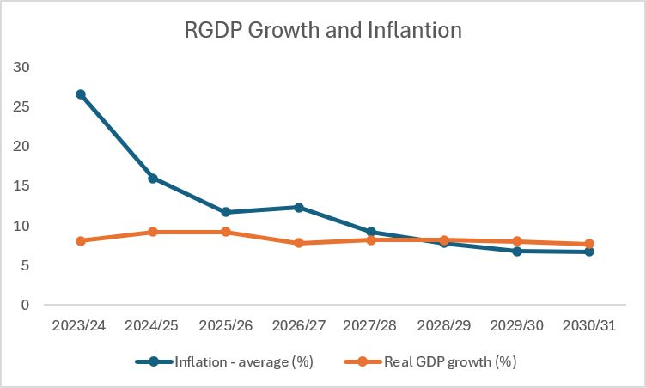
Figure 2: Ethiopia's inflation rate to decline below GDP growth rate
(Source: linkedin.com, 2026)
The most important limiting factor is macroeconomic instability. Although inflation has been on a downward trend, it is still high, and the IMF anticipates that the average consumer-price inflation will be 11.8% in 2026 (IMF, 2026). More to the point, in June 2024, and June 2025, the value of the birr dropped to 57 and 136, respectively, which greatly increased the cost of imported luxury items in the domestic currency (IMF, 2026). This presents a two-fold issue since the imported goods are now even more expensive in addition to the reality that the actual discretionary income of consumers is also stretched due to inflation.
The availability of foreign exchange is on the rise after Ethiopia disbanded its exchange-rate reforms, but it is still strategically pertinent. IMF documents indicate that reserves are merely about 2.2 months of imports, limiting how far LVMH would go to remain committed to an old-fashioned import-intensive retailing approach (IMF, 2026).
Critical judgement: Ethiopia ought thus to be considered as a long-run alternative and not a luxury market that can be scaled at the moment. The strong expansion of GDP and the development of high-income demand justify market experimentation, but the low level of per-capita income and inflation and currency risk would make major initial investment economically untimely (Seitz, 2025). This justifies the planned staged, asset-lite entry by LVMH, first in Addis Ababa, to focus on the top-income and internationally connected consumers, instead of seeking a national expansion.

2.4 Legal and Regulatory Environment
The regulatory environment in Ethiopia is a major plus for formal market access, yet foreign luxury retailers still have the chance of being affected by implementation risks. The most recent wave of investment reforms has been the opening up of the previously closed-off sectors to foreign investors. Most importantly, foreign investment in retail trade was liberalized in 2025 having a minimum paid-up capital of US 2.5 million. This makes the viability of a direct LVMH operation much more viable, but the cost of entry in terms of capital is relatively high to join a market the luxury demand of which cannot be anticipated.
Particularly relevant are several regulatory issues:
- Foreign ownership/ foreign investment: LVMH has the potential to create a foreign-owned business but investment licenses, capital registration and industry specifications impose administrative burdens (Gomez-Trujillo et al. 2026). This is biased towards a staged commitment as opposed to large-scale investment.
- Import and customs control: Luxury products are going to be imported predominantly, and customs and tariffs and documentation would be a strategic factor. Slow delivery or high import prices can affect the supply of products and increase their prices, which will damage the well-regulated retail proposition of LVMH.
- Taxation: VAT, customs duties and other taxes can play a major role in determining the end price of the imported luxury products. This is particularly true in an occasion where the purchasing power of consumers is already low.
- Intellectual property and trademarks: The protection of Louis Vuitton trademarks, designs and brand image is a strategic necessity since the value of luxury is based on authenticity and rarity (Zhang and Donzé, 2025). The leniency in the enforcement would imply increased exposure to imitations and illegal distribution.
- Online regulation: Consumer-protection requirements and the new e-commerce regulation would be required to be accommodated within a model of any digital sales or customer engagement. Thus, the digital expansion can not be capable of replicating the current-market LVMH practices unless there are regulatory reforms.
- Profit remittance and foreign exchange: LVMH would also be at the cost of the Ethiopian foreign-exchange system. Although the investment environment has been improved by undertaking reforms, conversion of local revenues into foreign currency and repatriation of returns can also be viewed as having critical implications to a foreign-owned retailer.
Critical judgement: Ethiopia is improving its regulatory trend towards being more appealing, but institutionally challenging. The opening of retail offers a real possibility to LVMH; however, capital requirements, exposure to imports, taxation, IP protection, and foreign-exchange risk increase the cost and risk of direct investment. Thus, regulation encourages entering the market, although not a massive investment.

2.5 Cultural and Consumer Environment
The Ethiopian cultural milieu possesses a discriminating chance of posh consumption and not a broad mass-market prospect. Strong community, family, and social relationships impact Ethiopian consumers, and that means that luxury buying can go beyond functional value to identity, social recognition and prestige. The symbolic value of a brand such as Louis Vuitton can be reinforced in the case of LVMH but the comparatively small affluent segment of the population urges the belief that prestige positioning must be highly sensitive and not expect that the large population of Ethiopia can be a large luxury market.
Some of the cultural and consumer factors to consider are:
- Luxury and status consumption: Luxury items can be used as conspicuous representations of status and success. This might well resonate with the placement of LVMH in terms of scarcity and prestige (Reff, 2025). Nevertheless, the conspicuous branding should be accompanied by culturally appropriate communication as excessive westernisation can lead to the loss of authenticity.
- New wealthy customers: This will cover the most pertinent group of wealthy Ethiopian professionals, entrepreneurs, diaspora-related consumers, diplomats, expatriates and internationally exposed younger consumers.
- Cultural adaptation: LVMH should maintain its global brand codes but needs to alter the communication, events and customer engagement to fit the Ethiopian cultural expectations. Sensitivity in product communication, promotional activities and seasonal campaigns also needs sensitivity on religious and cultural diversity.
- Strategic location of Addis Ababa: Addis Ababa provides the most optimal starting point for internationally connected consumers, businesses, diplomatic missions and tourism (Liu and Bai, 2022). This aids in maintaining an urban, but not national, implementation and reduces the complexity of culture and operation in early growth.
- Digital impact: Ethiopia has a digital penetration that is significant but relatively minor, with the number of social-media users equaling 28.6 million identities in January 2025 and internet users amounting to 28.6 million identities in January 2025 (DataReportal, 2025).
Critical judgement: The cultural context helps LVMH to position itself as a global luxury brand, albeit only when it is coupled with certain local responsiveness. This is not to localise the identity of Louis Vuitton to its maximum extent, but to continue to remain exclusive across the globe and modify targeting, communication, partnerships and customer experiences to the newly affluent young demographic of Addis Ababa. This strengthens the argument of an asset-light pilot prior to making a permanent commitment to a flagship presence.

2.6 Market Attractiveness: Opportunities and Risks
Ethiopia is one of the countries that provides long-term commercial potential opportunities to LVMH, but is not attractive in the short term. First-movers' opportunity owing to its emerging affluent segment, urbanisation, tourist activities and comparatively low luxury competition (Yalcinkaya and Griffith, 2025). In the short term, however, currency limitations, inflation, and political, legal, and regulatory issues, and incomplete luxury infrastructure development limit scalability.
Opportunities | Risks
Emerging affluent consumer segment | Limited current luxury-market size
Long-term economic growth | Inflation and reduced purchasing power
Urbanisation centred on Addis Ababa | Foreign-exchange and currency risk
International tourism and business activity | Political and security uncertainty
Limited established luxury retail presence | Import and regulatory barriers
Potential first-mover advantage | Limited premium retail infrastructure
Table 2: Key Opportunities and Risks for LVMH in Ethiopia
LVMH is interested in testing Ethiopia's market, but not yet interested enough to commit significant capital investment. LVMH could gain the fruits of the new appetite in Addis Ababa at a much lower risk of economic and political turmoil through a gradual “asset light” process.

2.7 Applying Dunning's Eclectic Paradigm (OLI)

2.7.1 Ownership Advantages (O)
Ethiopia is blessed with a considerable number of special privileges which LVMH can acquire. This portfolio will have more than 6000 stores worldwide in 2026, with financial resources in excess of €80.8bn, meaning they will have developed good marketing expertise, financial resources and scale (LVMH, 2026). Furthermore, as one of the most distinguished brands in the world and with vast knowledge in craftsmanship, it is hard to be copied by local companies. In this specific case, the luxury relevance of these assets is particularly important in Ethiopia, as it will be more important than price competitiveness in the luxury demand. Ownership power is not enough to compensate for low purchasing power, however.

2.7.2 Location Advantages (L)
Ethiopia's long-term demand base is 135.5 million people and the GDP growth in 2025 can be as high as 9.8% (World Bank 2026). Most of the international-oriented consumers and tourism/business activities are located in Addis Ababa. Furthermore, Ethiopia's US$ 932.7 GDP per capita also makes it lacking in terms of depth in the short-term luxury market. Political uncertainty and restrictions on currency and infrastructure thus reduce the current value of site benefit (Wings, 2026). It is now time to increase the market, and not just enlarge the scale.

2.7.3 Internalisation Advantages (I)
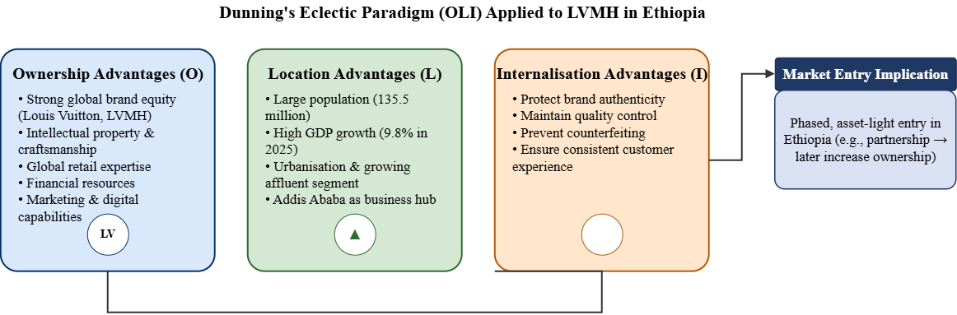
Figure 3: Dunning's OLI Framework Applied to LVMH's Potential Entry into Ethiopia
Internalisation continues to play pivotal roles as LVMH is committed to safeguarding the value of its luxury brands, its craftsmanship, product authenticity and the controlled customer experience, which are crucial to understanding the luxury value. In addition, direct control will help protect against counterfeiting and maintain the proprietary right. Wholly owned operations involve greater capital investment, management commitment and exposure to the risks encountered in Ethiopia, however (Sahm, 2025). Thus, the OLI analysis result is a basis for selective internalisation: leave market access and operational learning to a controlled local partner; keep control over brand-critical activities until the initial period to enable further operational learning.

2.8 OLI Synthesis and Implications for Market Entry
The OLI analysis indicates that the competitiveness of LVMH is excellent, while the market is not very developed in Ethiopia. Emergent Location advantages are provided in Ethiopia by urbanisation, high purchasing power and growth prospects in the business, while LVMH's Ownership advantages are based on its IP ownership, craftsmanship, brand strength and retailing.
- Ownership: Strong and transferable.
- Location: Very competitive due to currency, political and infrastructure risk.
- Internalisation: This is useful to brand protection but not cost-effective for the current situation.
It is therefore still too early for full internalisation (Zhang and Donzé, 2024). A controlled asset-light entry can help maintain key internalisation benefits for LVMH and reduce risk, as it directly focuses on the evaluation of the entry mode in Section 3.

2.9 Overall Market Attractiveness and Strategic Implications
Ethiopia's market is a luxury market and the country is playing an early game; it is still hiding a big opportunity for LVMH because of the huge potential of the business. It is also well positioned in a longer-term perspective as it has a GDP growth towards 2025 of 98%, a population of 135M, and a GDP per capita range that is very narrow 933 USD, it has high immediate purchasing power (Jin, 2024).
- Short term: High economic and currency / regulatory pressures.
- Long term: Affluenza of the customer, urbanisation, new development fields.
- Success conditions: Addis Ababa focus, good brand protection, sourcing assurance and currency-risk management.
Therefore, it is preferable to step-wise develop a market, rather than to become part of a big market entry. This asset-light solution, through the chosen strategic partner, would enable LVMH to measure the market's interest rate and sales at specific moments and when market conditions are favourable, push to the home market, supporting awareness creation and keeping the momentum only taking the plunge when the market conditions and market share requirements are favourable.

3. Entry Mode Strategy and Strategic Synthesis

3.1 Historical Entry Modes Used by LVMH
Independence was an LVMH strategy for a long time focused on control and flexibility in terms of internationalisation; depending upon the market, LVMH decides to internationalise through full ownership, membership in an acquisition, or selective partnership. Wholly owned boutiques are more significant for Louis Vuitton because of the brand's control over the presentation, the price and the product's authenticity, hence the quality of the customer's experience. The control over distribution generates value for the brand; this is a key factor in the luxury-based competition.
LVMH have used acquisitions to speed up their international growth by gaining new brands, improved capabilities, and access to markets. However, the use of capital and the complexity of integration may lead to risks, particularly on the strategic level of keeping the entrepreneurial independence of each Maison (Lindner and Puck, 2025). Lower resource commitment and higher levels of local knowledge available with partnerships and joint ventures, and less managerial control, with the risk of compromising brand consistency. Overall, the company knows that investments in LVMH companies favor a high-control entry when there is sufficient market potential, and that partnerships are favoured in uncertain situations. In Ethiopia, however, the approach must be properly tailored to the emerging luxury tourism market in Africa.

3.2 Evaluation of LVMH's Dominant Entry Mode
A wholly owned boutique is a good strategy, as luxury value is determined by how the presentation, pricing and customer experience are controlled. Its usefulness is dependent on the maturity of the market and the degree of risk, though.
- Control: Greater flexibility when it comes to control over pricing, inventory, and retail standards.
- Brand protection: Maintains the exclusivity, authenticity and IP of Louis Vuitton.
- Customer experience: Provides uniformity in service and the highest quality customer image (Schlegelmilch, 2022).
- Resource commitment: Needs a significant investment of capital, management and infrastructure.
- Financial exposure: LVMH's exposure is direct to the currency market, political risk, and demand risk.
An appropriate strategy in Ethiopia's volatile and still not long-developed luxury segment is to avoid the investment intensity and risk exposure of high control; yet high control is necessary to maintain LVMH's competitive advantages. A lower commitment mode, hence a better strategic fit, therefore.

3.3 Suitability for Ethiopia
LVMH's traditional high-control system provides the best brand protection but is by no means the best to start in the lower-risk political, currency and market-development environment as that of Ethiopia. A "strategic partnership" or "selective retailing" arrangement is a better approach to the balanced relationship between control and flexibility.
Factor | Option A: Wholly Owned Store | Option B: Strategic Partnership / Selective Retailing
Political risk | High exposure | Shared/reduced exposure
Financial risk | High | Lower
Operational risk | LVMH bears most risk | Shared with partner
Control | Very high | Moderate
Flexibility | Low | High
Investment | Substantial | Relatively limited
Brand protection | Strong | Requires strict contractual controls
Local knowledge | Limited initially | Stronger
Table 3: Comparison of Entry Modes for LVMH in Ethiopia
Fully-owned control means greater commitment and commitment than the luxury demand for Ethiopia. At the same time, a partnership does lead to a loss of autonomy, and local knowledge and reduced exposure and market flexibility are obtained (Udomkit, 2026). Thus, a premium partner carefully selected for its canniness, if LVMH can maintain control of the standards, the quality of the prices and the quality of the customer experience, should be the best initial strategic match so far.

3.4 Recommended Entry Strategy for LVMH in Ethiopia
Changes are expected over the long term, and a gradual, asset-light exposure is suggested for LVMH, with a full-boutique exposure only planned after the financial and political risk of this exposure proves to be beneficial. The steps must be done in a progressive way:
- Digital market testing: Test digital channels and targeted campaigns for three different metrics: awareness, engagement and potential demand amongst high-income consumers in Addis Ababa.
- Strategic retail partnership: Identify a trustworthy local high-end retailer who is knowledgeable about the luxury, tourism and wealthier consumers of Ethiopia (Giuliani, 2023).
- Limited Louis Vuitton presence: Implement a controlled product range, or select retail shops and format, adhering to LVMH requirements with regard to global pricing, the handling of the stock, and the brand.
- Market-demand assessment: To assess sales, customer specifications and repeat purchasing and operational risk before committing to an increase.
- Dedicated boutique: Only develop a dedicated boutique if there is an ongoing demand, the foreign exchange situation is stable, the infrastructure is right, and the regulations are suitable.

3.5 Strategic Synthesis and Final Recommendation
According to the analysis, LVMH's transnational approach, ownership advantages and global retail experience are a convincing basis for entering Ethiopia. The low purchasing power per capita, volatility of the currency, political uncertainty, regulatory restrictions and limited depth in the luxury market, however, offset the country's high rate of economic growth. The OLI analysis hence suggests a significant Ownership advantage, a developing, yet limited Location advantage and an Intermediate Internalisation advantage (Li and Shaheer, 2024). This does not mean that LVMH needs to immediately incorporate a top-tier boutique.
LVMH should instead open sure-footedly into the market with a suitable and profitable channel for retailing champagne along with a well-thought-out contractual agreement that ensures the brand's presence, price-point and the experience of its customers. The need for luxury has to be constant in the long term, exchange rates have to be stable, the political climate has to have favourable elements, and the infrastructure needs to be stable before they can go into a purpose-built Louis Vuitton store.

Section 2 — Reflective Account

4.1 Description
For this assignment, I took a look at the LVMH opportunity for expansion in Ethiopia and studied the decision to introduce Ethiopia as an international market. I took a look at LVMH's global strategy and geographic setup before analysing the political, economic, legal and cultural landscape in Ethiopia. Next, I used Dunning's OLI framework to link together strengths that LVMH has with conditions in Ethiopia. My research was based on academic literature as well as recent data from credible sources such as LVMH, the World Bank, the IMF, the U.S. Department of Commerce and DataReportal. I also ran comparison analysis of different entry points prior to building a ‘phased' asset-light recommendation. This way I was able to relate the theoretical concepts to real-world business decisions for an international market.

4.2 Feelings
Originally I was going to attempt analysing LVMH in the luxury segment, but it was a very big and global company, and overseas! However, when I researched some of these details about Ethiopia, I was not quite certain because there were lots of new market conditions, political, economic, and legal, in an emerging markets country with new luxury markets. It was particularly difficult to find reliable and timely information, especially forms of information related to the country, but not specifically related to luxury retail (Solberg and Huse, 2024). The opportunity that economic development clearly existed in Ethiopia was clear, but on further research I saw the domino effect that inflation and currency fluctuation, both in value and stability, affected the purchasing power of the people. The thought was not now to enter but to judiciously choose an entry point.
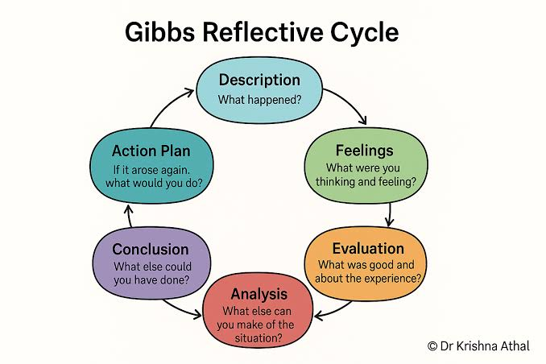
Figure 4: Gibbs Reflective Cycle
(Source: drkrishnaathal.com, 2026)

4.3 Evaluation
Some of my own techniques seemed to be successful, especially when using academic theory with existing secondary data. The transnational approach, as suggested by Bartlett and Ghoshal and the OLI approach, as offered by Dunning, enabled me to shift from descriptive to structured strategic thought in preparing my argument. Ethiopia has also been assessed by comparing political, economic, legal and cultural aspects, which helped to have a balanced view of the attractiveness of Ethiopia. Sourcing information from an unfamiliar emerging market was, however, challenging as some data was sometimes too general or oriented toward the investment market, or was old. One drawback was the lack of luxury-consumption data for Ethiopia, forcing the placing of assumptions on general economic indicators. However, combining information from authoritative institutional resources with academic scholarship helped support the analysis and minimise the need to make assumptions without support.

4.4 Analysis
The field of academic thinking in the formation of a theory of transformation was the principal reason to move away from the descriptive analysis of the country and towards a strategic analysis. In excluding the tension of global integration versus local responsiveness, I gained new insights into understanding LVMH's transnational strategy, which was clearly made apparent through Bartlett-Ghoshal's framework. It came particularly in handy in shaping Louis Vuitton's territory as a global exclusive and the ability of LVMH to change according to Ethiopia's customers. Another perspective was presented in Dunning's OLI framework, as a connection was made regarding Ethiopia's location advantages and the internalisation costs, with the help of LVMH ownership advantages (Schlegelmilch, 2026). Theories relating to entry Mode Selection, Risk, Risk-Resource commitment and Risk-Resource Control were conceptualized using the concepts of international business into a practical suggestion. More importantly, these facts informed my initial sense of how appealing Ethiopia was for luxury products; GDP growth of 9.8% seemed very positive, but the lack of GDP per capita, inflation, currency volatility and regulatory uncertainty were put on my table. This resulted in being more cautious and taking a measured step-in approach.

4.5 Conclusion
With this assignment, I came to realize that one thing which just being able to see potential in the international market was not enough for this company to succeed. I am able to use concepts, empirical information, and strategic insight effectively when evaluating uncertain markets. The way of thinking has changed from just looking at ‘going into a market' to the understanding of risk, time, control, flexibility and market success. In the Ethiopian case, the growth rate was good despite major structural barriers. Therefore, now that I know, entering the international game is a step-by-step strategic process, and each step of the commitment of investment should be proportionate to market conditions.

4.6 Action Plan
I would create a more systematic evidence collection for future research, starting with the specific research questions and criteria for selecting the sources. I would look at more recent peer-reviewed journals, government reports, and reports from international organisations, being careful to consider the date, methodology and credibility of secondary sources. I would also gather quantitative indicators, organizing them in a structured form, before taking on the written analysis, so that I could make stronger comparisons and draw fewer inferences. I would find my critical analysis to be enhanced by stating an alternate explanation and/or entry method, instead of mostly my preferred one. In a professional setting, I will use these skills in making decisions about international business, integrating evidence with theory, risk assessment and strategic judgement to inform recommendations regarding investment actions.

References
Bai, H., He, W., Shi, J., McColl, J. and Moore, C., 2022. Parenting advantages of emerging market multinationals (EMNCs) in luxury fashion retailing. International Journal of Retail & Distribution Management, 50(1), pp.1-17.
Bai, H., McBride, L. and Shi, J., 2026. Opportunities and challenges in emerging markets for luxury fashion brands. Dynamic Fashion Marketing: Internationalisation, Sustainability and Technology.
DataReportal (2025) Digital 2025: Ethiopia. Available at: https://datareportal.com/reports/digital-2025-ethiopia (Accessed: 11 August 2026).
Deng, K., 2025. Capital Structure Optimization of Beauty Brands in International Market Expansion: The Integration of Financing Options and Market Entry Strategies. In SHS Web of Conferences (Vol. 218, p. 01024). EDP Sciences. https://www.shs-conferences.org/articles/shsconf/abs/2025/09/shsconf_icdde2025_01024/shsconf_icdde2025_01024.html
Giuliani, M., 2023. Towards a new approach to measuring the internationalization degree of wine companies in China: the Internationalization Assessment Framework.
Gomez-Trujillo, A.M., Buriticá Henao, D.C., Arroyo, B., Bonilla-Calle, D. and Mesa Bedoya, J.C., 2026. Affordable Luxury from the Global South: Monastery’s Path to Internationalization. Latin American Business Review, pp.1-20.
International Monetary Fund (IMF) (2026) The Federal Democratic Republic of Ethiopia: Fourth Review Under the Extended Credit Facility Arrangement. Available at: https://www.elibrary.imf.org/view/journals/002/2026/020/article-A001 (Accessed: 1 June 2026).
Jin, B.E., 2024. Global fashion business: international retailing, marketing, and merchandising. Bloomsbury Publishing.
Li, S. and Shaheer, N., 2024. Global strategy: A market creation approach. SAGE Publications.
Li, Y., 2027. Miniso's Lifestyle Retail Internationalization: A Chinese Lifestyle Brand's International Journey. In Cases on Chinese Brands’ Globalization Strategies (pp. 267-290). IGI Global Scientific Publishing.
Lindner, T. and Puck, J., 2025. International business: mastering strategic challenges in the 21st century. SAGE Publications Limited.
linkedin.com, 2026, Ethiopia's inflation rate to decline below GDP growth rate by 2030, Available at: https://www.linkedin.com/posts/amare-fentaye-farise-75b66b111_the-figures-are-from-international-monetary-activity-7486432539381886976-yTcT, (Accessed: 11 August 2026).
Liu, H. and Bai, H., 2022, September. Examining the Glocalised Marketing Strategies of Luxury Fashion Retailers in China. In Colloquium on European Research in Retailing Book of Proceedings (pp. 181-189). University of Zagreb.
LVMH (2026) Key figures. Available at: https://www.lvmh.com/investors/key-figures (Accessed: 11 August 2026).
Reff, A.M., 2025. Ami Paris in Southeast Asia: strategic market entry and growth opportunities in Indonesia.
Sahm, C.E., 2025. AMI Paris in southeast Asia: strategic market entry and growth opportunities in Thailand.
Schlegelmilch, B.B., 2022. Global marketing strategy. Springer International Publishing.
Schlegelmilch, B.B., 2026. Globale Marketingstrategien. Springer Books.
Seitz, C.J., 2025. AMI Paris in southeast Asia: Strategic Market Entry and Growth Opportunities in Malaysia.
Solberg, C.A. and Huse, H., 2024. Strategic international marketing: strategy development and implementation. Taylor & Francis.
Tsega, T.T., Thoben, K.D., Rao, D.N. and Haile, B., 2022. Leather and textile industries-strategic sectors for Ethiopia to gain capability of manufacturing for global market competitiveness: a literature review. Ethiopian Journal of Science and Technology, 15(1), pp.9-30. https://www.academia.edu/download/115779743/206990.pdf
U.S. Department of Commerce (2024a) Ethiopia – Investment Climate Statement. International Trade Administration. Available at: https://www.trade.gov/country-commercial-guides/ethiopia-investment-climate-statement-0 (Accessed: 11 August 2026).
U.S. Department of Commerce (2024b) Ethiopia Opens 32 Sectors to Foreign Participation. International Trade Administration. Available at: https://www.trade.gov/market-intelligence/ethiopia-opens-32-sectors-foreign-participation (Accessed: 11 August 2026).
Udomkit, N., 2026. International Trade Essentials: An Integrated Approach Across Business, Economics, and Law. Taylor & Francis.
World Bank (2026) Ethiopia – Data and Country Overview. Available at: https://data.worldbank.org/country/ethiopia (Accessed: 1 June 2026).
World Bank (2026) Ethiopia – Data. Available at: https://data.worldbank.org/country/ethiopia (Accessed: 11 August 2026).
Yalcinkaya, G. and Griffith, D.A., 2025. The disruptive effects of changes in institutional distance on global marketing.
Zhang, J. and Donzé, P.Y., 2024. The internationalisation of Chinese apparel companies.
Zhang, J. and Donzé, P.Y., 2024. The internationalisation of Chinese apparel companies. http://www2.econ.osaka-u.ac.jp/econ_society/dp/2405.pdf
Zhang, J. and Donzé, P.Y., 2025. The internationalisation of Chinese apparel companies, 1990–2020. Business History, pp.1-21.

