Electronics 2
ACDA6001

Design Of An Unsigned Two Number Uneven Parallel Multiplier & The Design of a FSM In Hardware and VHDL
Luke Andersen - 1603319

Contents
Task 1 3
Binary Multipliers 3
Braun Multiplier 3
Booth’s Multiplier 3
Wallace Tree Multiplier 3
Array Multiplier 4
Comparison of Multipliers 4
Binary Multipliers Conclusion 5
12x4 Multiplier 5
VHDL 5
Half Adder Design 5
Half Adder VHDL 6
Half Adder Test Bench 6
Full Adder Design 8
Full Adder VHDL 8
Full Adder Test Bench 9
Line 0 VHDL 11
Line 0 Test Bench 13
Line X VHDL 17
Line X Test Bench 19
Multiplier 12x4 Full 26
Multiplier 12x4 Test Bench 28
Task2 32
FSM 32
Next State Tables 33
Karnaugh Maps 35
Discrete Gate Solution Final Design 36
FSM VHDL 38
FSM Test Bench 39
Bibliography 41

Task 1

Binary Multipliers
A binary multiplier is a combinational logic circuit which is used in digital systems to perform multiplication of two binary numbers. In binary multiplication of each long number is multiplied by a single digit – 0 or 1. In order to multiply two binary numbers the multiplication comes down to calculating partial products, shifting them left, and then adding them together, through binary addition. (Reegan, 2012)
An example of four different types of binary multipliers is identified below.

Braun Multiplier
A Braun Multiplier is a very basic parallel multiplier which is generally referred to as a ‘carry save array’ multiplier. The architecture of the Braun Multiplier mainly consists of adders and also ‘AND’ gates. (Thakur, 2012)
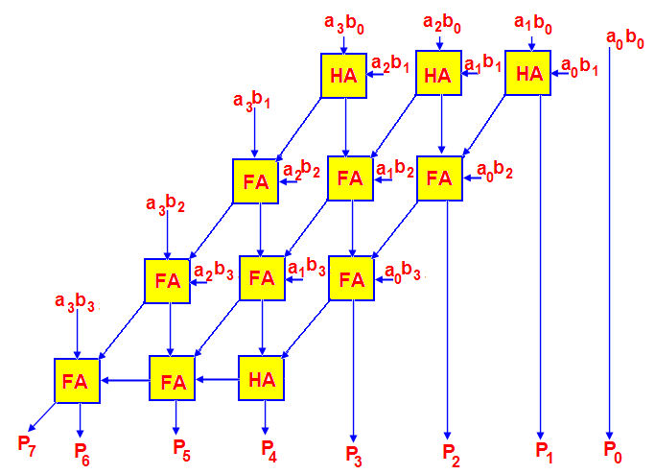
Figure 1. Braun Multiplier (B, 2021)

Booth’s Multiplier
Booth’s is a multiplication algorithm which multiplies two signed binary numbers in two’s complement notation. The multiplication algorithm can be applied by repeatedly adding one of two predetermined values ‘A’ and ‘S’ to the product ‘P’, then performing a rightward arithmetic shift on A. (Gudhimetla, 2017)
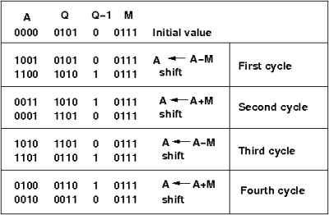
Figure 2. Booth’s Multiplier (Virtual Labs, 2021)

Wallace Tree Multiplier
The Wallace Tree multiplier is an effective parallel multiplier. The very first step of the Wallace Tree multiplier is to multiply each bit of one number by each bit of the other, this results in n ² bits. Once the following step is completed, the resulting bits are then reduced to two numbers. The two numbers are then fed into an adder in order to obtain the final product. (Bansal, 2014)
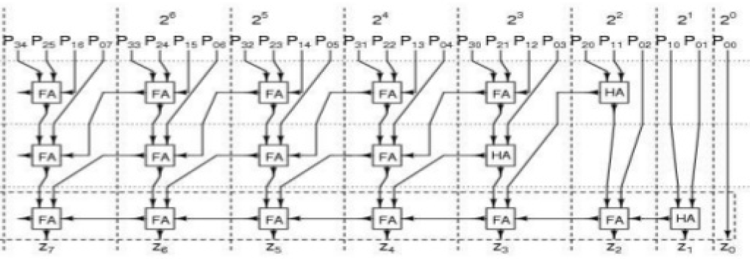
Figure 3. Wallace Tree Multiplier (P, 2018)

Array Multiplier
The array multiplier is a digital circuit used to multiply two binary numbers, where various half adders and full adders are used. In order to form a number of product terms, an array of AND gates are used which are then fed into the adder array. One at a time, the bits of the multiplier are checked and product is then formed with the usage of add and shift operations. (GeeksforGeeks, 2019)
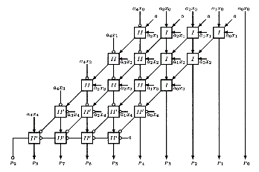
Figure 4. Array Multiplier (Shaown, 2021)

Comparison of Multipliers
Table 1 differentiates the pros and cons of each binary multiplier.
Type of Multiplier | Braun | Booth’s | Wallace Tree | Array
Pros | - A basic parallel multiplier.  - Suitable for only un signed numbers. | - Low power consumption | - Small delay.  - Higher speed – smaller area.  - Low power consumption | - Minimum complexity for less number of bits.  - Regular structure – easy to layout and small in size.
Cons | - Suitable for 16 bit – or less  - Power consumption can be high – resulting in delays. | - An increase in radix number – results in it becoming cumbersome.  - Complex layout | - It has a irregular layout which complicates the task of coming up with an efficient layout. | - High power consumption– resulting in delays.  - An increase in complexity results in an increase in delay.  - Slow speed for a wide multiplier.
Picture
Table 1. (Gudhimetla, 2017) (Salehan, 2007) (Ijirset, 2015) (Mishra, 2018) (Anon., 2019)

Binary Multipliers Conclusion
After looking at the pros and cons in Table, 1 my conclusion is that the best multiplier is the Wallace Tree. Although the Wallace Tree has an irregular layout which complicates the task of coming up with an efficient layout, it has a high speed with small delay making it an efficient multiplier. Both Wallace Tree and Booth’s multiplier contain a lower power consumption but, the Wallace Tree outshines Booth’s due to its speed and minimal delay.

12x4 Multiplier

VHDL
VHDL is an international IEEE standard specification language which is used by industry all over the world, it is used for describing digital hardware. VHDL is a mechanism for digital design and enables hardware modelling from the gate to system level. (© 2021 Cadence Design Systems, Inc, 2021) One additional benefit gained from the use of VHDL is that it allows for better design management and also provides technology independence. An example of providing technology independence is that, if you were to write a half adder to run on a PAL then it would also run on a FPGA, you would not have to rewrite the code.

Half Adder Design
A crucial part of parallel multipliers is the half adder. The half adder is an arithmetic circuit that adds two numbers and produces a sum bit and a carry bit. It consists of two inputs (A & B) and two outputs (Sum & Carry). The inputs add two numbers together and produces a sum bit and a carry bit as the outputs. (© 2020 CircuitsToday, 2020) A half adder is designed by connecting one XOR gate and one AND gate as shown in Figure 5.
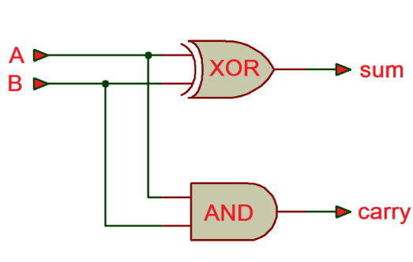
Figure 5. (Bhatt, 2021)
The half adder is only capable of adding two inputs, if the input to the half adder was to have a carry, then it would be neglected and would only add the A and B bits. As this means the binary addition process is incomplete, it gives it the name half adder. Table 2 is a representation of the half adder truth table.
Inputs |  | Outputs
A | B | Sum | Carry
0 | 0 | 0 | 0
0 | 1 | 1 | 0
1 | 0 | 1 | 0
1 | 1 | 0 | 1
Table 2.

Half Adder VHDL
The very first step I took when creating a half adder was to name a new project file ‘HalfAdder,’ after this I would then add a source, which was a VHDL module. As shown in Figure 6 I set the entity of the program by setting the inputs as ‘A’ and ‘B’ and then set the outputs as ‘Sum’ and ‘Carry,’ this can be proven by looking at Lines 32-37.
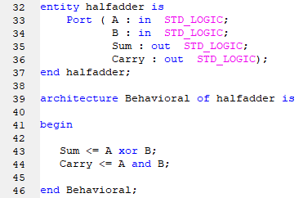
Figure 6.
Architecture of the body describes an implementation of an entity. The next step of the program was to implement the entity by assigning ‘Sum’ to A or B and the ‘Carry’ to A and B. This represents the design of the half adder which is replicated in Figure 5 and is shown between Lines 41 – 46 of Figure 6. The <= symbol which is present on line 43 – 44 is the symbol that is used to assign the Sum and the Carry. Once this step was completed, a design tool ‘Synthesize’ was used to ensure there were no errors or warnings within the program.

Half Adder Test Bench
After the program had been successfully synthesised, a test bench must be created in order to simulate the VHDL logic. A test bench will ensure that the operation is successfully working. A new source was added to the Half Adder, and it was that of a VHDL test bench, as shown working in Figure 7. Lines 52-54 set the inputs to ‘0.’
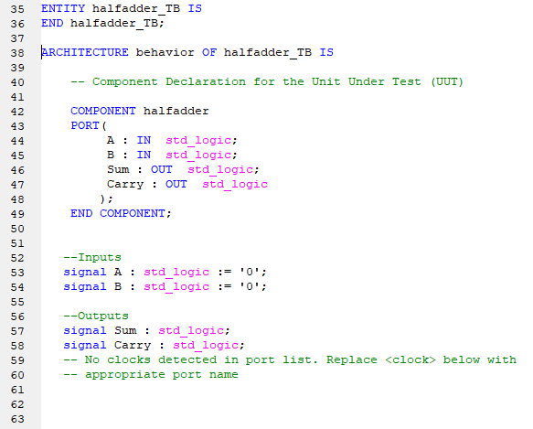
Figure 7.

As there are two inputs, there will be two stimulus processes, which are shown in Figure 8. A is assigned not A and Process 1 which is named Stim_Proc0 states that input A will pulse every 10ns. A will pulse to a ‘1’ and after 10ns back to ‘0’. Process 2 which is called Stim_Proc1 states that B will pulse every 20ns, allowing B to pulse to a ‘1’ and back to a ‘0’ every 20ns.
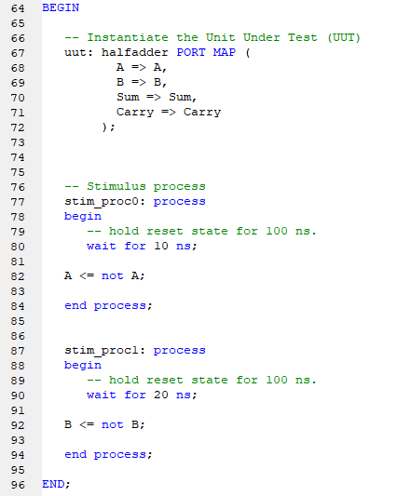
Figure 8.

The next step is to carry out a Behavioral Syntax Check to ensure no errors or warnings appear within the program. Once successful, a simulation of the test bench creates a graph, which is shown in Figure 9.
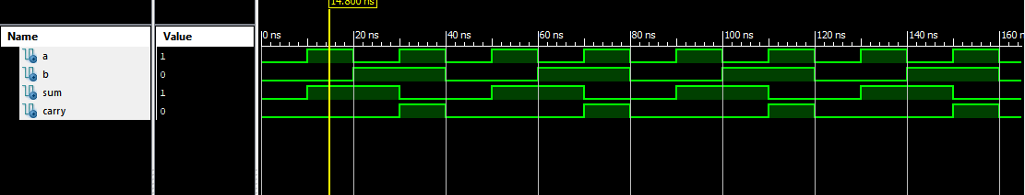
Figure 9.
As shown in Figure 9 when input A is 1 and input B is 0, then the output Sum is 1 whilst the output Carry is 0.
Another example showing that the Half Adder works successfully is shown below in Figure 10. When input A and input B equal 1, then the output Sum equals 0 and the output Carry equals 1.
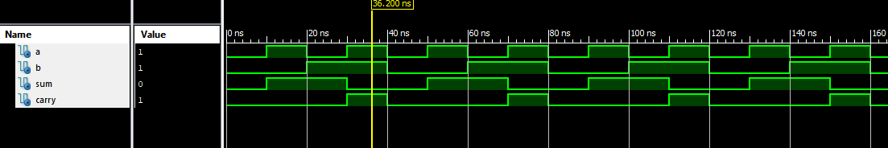
Figure 10.

Full Adder Design
Just like the half adder, the full adder has a crucial part to play in parallel multipliers. The full adder adds three inputs and produces two outputs. The inputs consist of ‘A’, ‘B’ and ‘Cin’, while the outputs consists of ‘Sum’ and ‘Carry.’ The full adder logic is designed to take up to eight inputs together to create a byte wide adder and cascade the carry bit from one adder to another. (GeeksforGeeks, 2019) The design of a full adder consists of two XOR gates and two AND gates as shown in Figure 11.
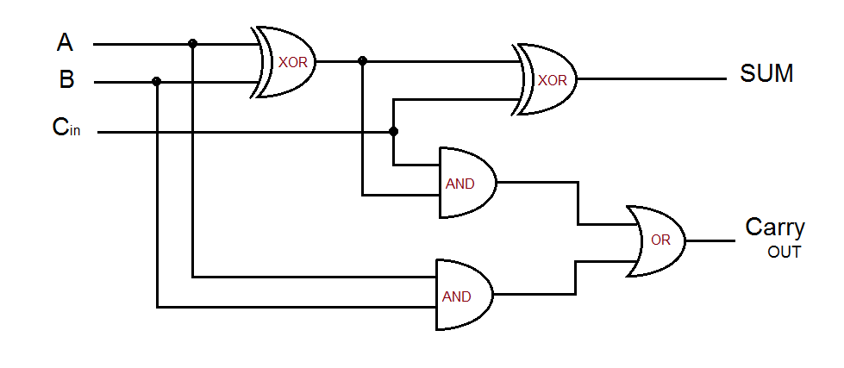
Figure 11. (theoryCIRCUIT ©, 2021)

The full adder is capable of carrying from a previous half or full adder. Normally the half adder is used at the beginning of a typical parallel multiplier, as it only uses two inputs and there are no carries to begin with. The full adder is utilised to deal with any potential carries. Table 3 is a representation of a Full Adder Truth Table.
Inputs |  |  | Outputs
A | B | Cin | Sum | Carry
0 | 0 | 0 | 0 | 0
0 | 0 | 1 | 1 | 0
0 | 1 | 0 | 1 | 0
0 | 1 | 1 | 0 | 1
1 | 0 | 0 | 1 | 0
1 | 0 | 1 | 0 | 1
1 | 1 | 0 | 0 | 1
1 | 1 | 1 | 1 | 1
Table 3.

Full Adder VHDL
A similar process to the half adder, a new project was created but this time, with the name ‘Fulladder.’ A new source was added, which is a VHDL module. As shown in Figure 12 the inputs were set at A, B and C, and the outputs set at Sum and Carry – this is shown within Lines 32-38. The intermediate signals are outlined between Lines 40-44. Now that the intermediate signals were set, they had to be assigned, this is apparent between Lines 46-55. Following the process of the half adder, a Synthesize check takes place to ensure there are no errors or warnings.
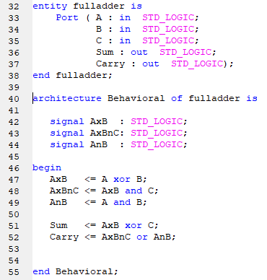
Figure 12.

Full Adder Test Bench
After the program has successfully been synthesised, a Full Adder Test Bench is created to simulate the VHDL logic. Lines 53-56 set the inputs to ‘0’ as shown in Figure 13.
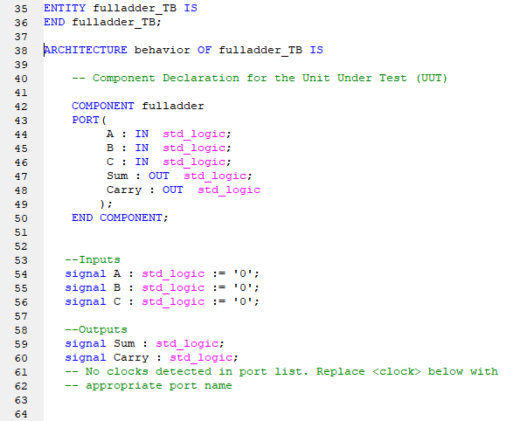
Figure 13.

The commands of the inputs A,B and C are shown in Figure 14 where three stimulus processes take place to determine whether the full adder program was successful. Stim_proc states that A will pulse every 10ns, while Stim_proc1 states that B will pulse every 20ns. Finally C will pulse every 40ns, meaning that for every time C pulses, A would have pulsed four times more and B would have pulsed two times more.
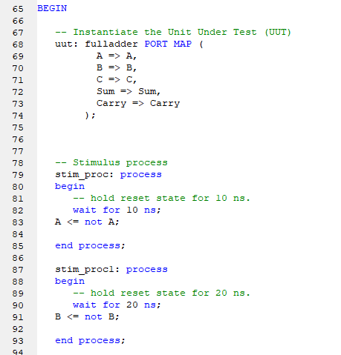
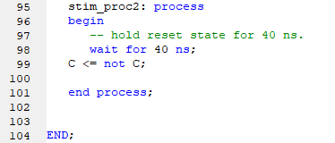
Figure 14.

The next step is to carry out a Behavioral Syntax Check to ensure no errors or warnings appear within the program. Once successful, a simulation of the test bench creates a graph, which is shown in Figure 15.
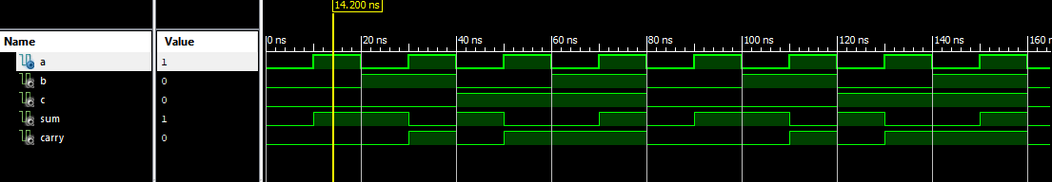
Figure 15.
Figure 15 shows the results that when the input A is one and inputs B and C are zero, the Sum is equal to one and the Carry zero.

More results of the full adder test bench is shown below, in Figure 16.
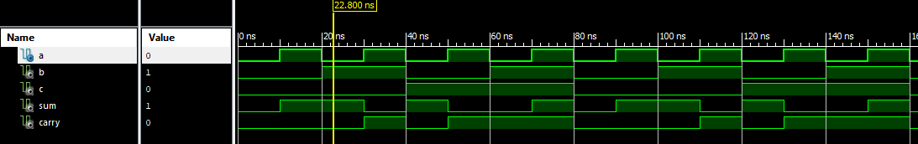
Figure 16.
The results in Figure 16 show that when the input of A and C is zero and the input of B is one, the Sum is equal to one and the Carry zero.

Figure 17 shows the results that when inputs A and B are equal to one and C is equal to 0, the Sum equals 0 and the Carry equals 1.
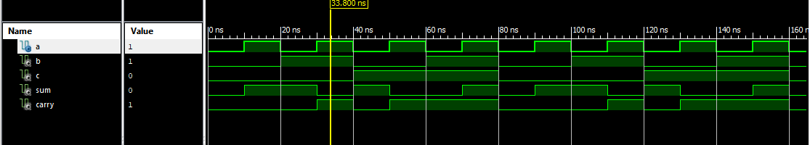
Figure 17.

The results in Figure 18 show that when input A is equal to one and inputs B and C equal 0, the output Sum equals 0 and the output of Carry is equal to 1.
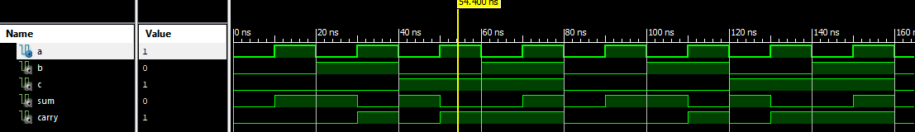
Figure 18.

Line 0 VHDL
Line 0 is the first line in the 12x4 multiplier and the inputs are assigned A0-A11 and B which are represented in Figure 19 between Lines 32-45. The outputs of Q0-Q11 are assigned between Lines 46-58.
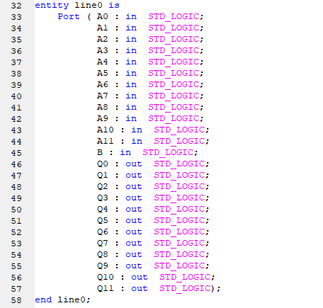
Figure 19.
The input B is the multiplier and as you can see by Figure 20 B runs straight through all the A inputs.
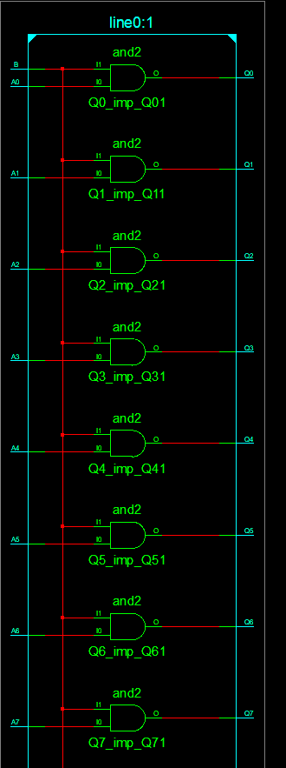
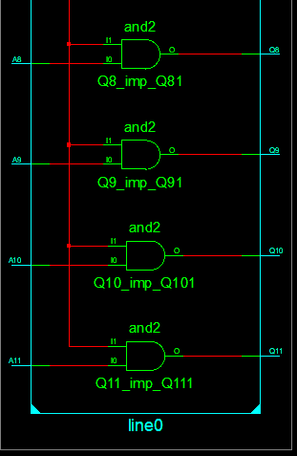
Figure 20.
The outputs within line 0 Q0-Q11 are assigned to the following inputs A0-A11 and B, as shown in Figure 21.
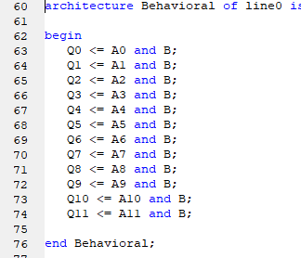
Figure 21.

Line 0 Test Bench
In the line 0 test bench, the aim was to create simulations with the stimulus process. By creating stimulus processes I wanted to see if there were any patterned errors coming up. This is why it is important to go through each stimulus process. To start the program, the inputs were set at A0-A11 and B, and the outputs Q0-Q11 as shown between Lines 35-69 in Figure 22.
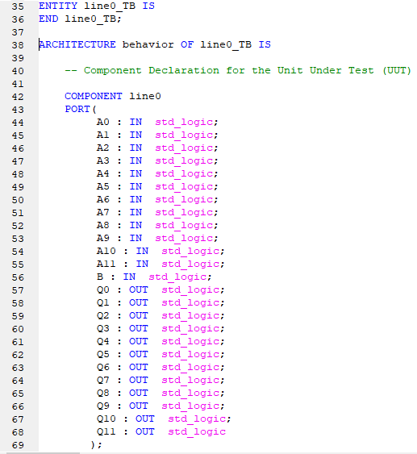
Figure 22.
As shown in Figure 23 the inputs are set at 0 and the output signals set.
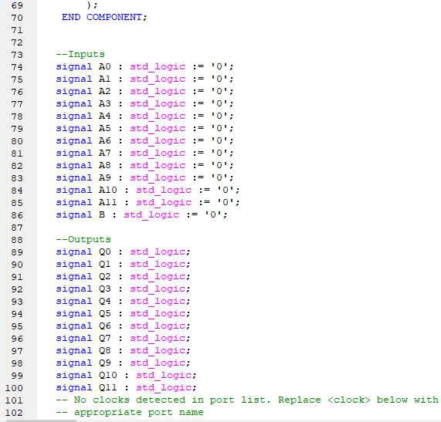
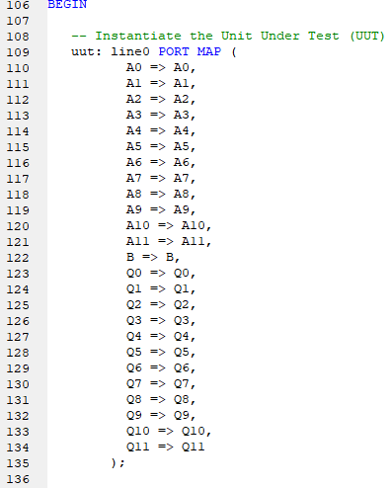
Figure 23.

Line 0 port mapping of the inputs and outputs are shown in Lines 106-134 below in Figure 24.
Figure 24.
Below is Figure 25 where line 0’s test bench stimulus processes are written. By looking at Stim_proc it is clear to see that every 10ns A0 will flip to 1, then 10ns later will flip back to 0. A1 in Stim_proc2 follows the same procedure but with a slight change, it flips every 20ns. The same procedure continues into Stim_Proc3 – Stim_Proc12 (inputs A2-A11) where the pulse time doubles every stimulus procedure.

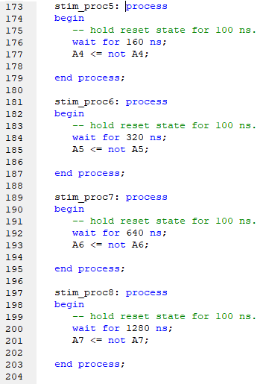
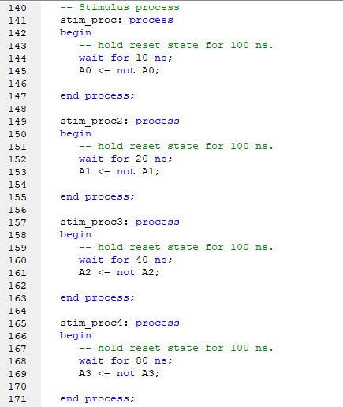
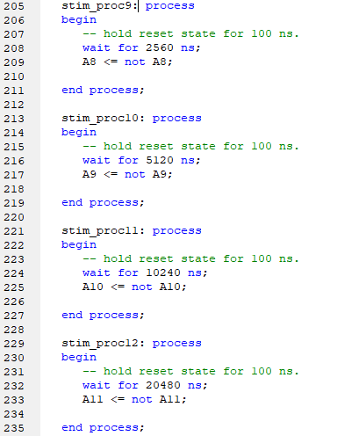
Figure 25.
Stim_Proc13’s pulse time doubles that of Stim_Proc12’s but the input is B, as shown in Figure 26.
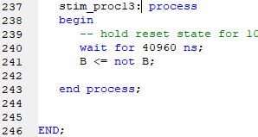
Figure 26.

Once the stimulus processes have been written out correctly a behavioural syntax check takes place to ensure the program is correct and then we simulate to get the test bench graph, as shown in Figure 27.
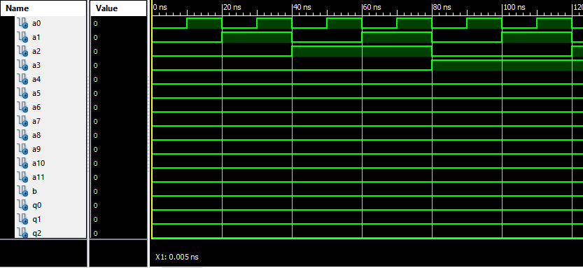
Figure 27.
The reason as to why stimulus process is important is because we are exercising all of the inputs and will be able to look at the outputs from them as reflected in Figure 27. The reason why stimulus processes double in time is to ensure they all line up, making it easily visible – this is proven in Figure 27. Making the graph visible enables the user to clearly see what is happening at what point.

As shown in Figure 28, whatever input A is, when B is one, output Q will always be the same. Figure 28 shows that input A is equal to 744, input B is equal to 1 and output Q is equal to 744.
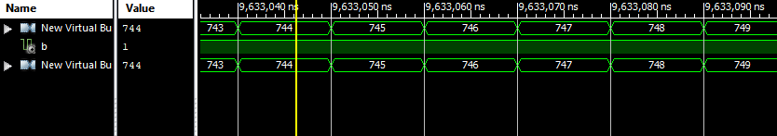
Figure 28.

Line X VHDL
The inputs are set at A0-A11, B1 and P1-P12, while the outputs are sets at Q1-Q13, as shown in Lines32-72.
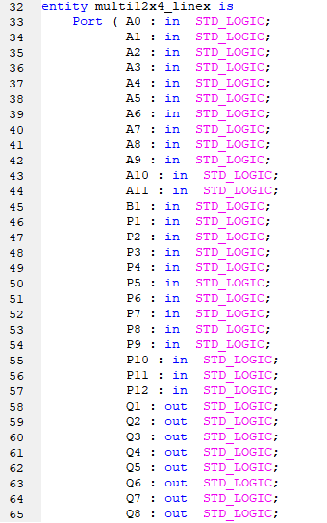
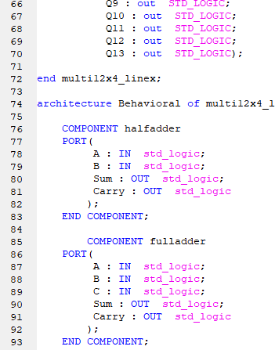
Figure 29.
Signals S0-S11 and C1-C11 are internal signals which have been set between Lines 95-119 in Figure 30.

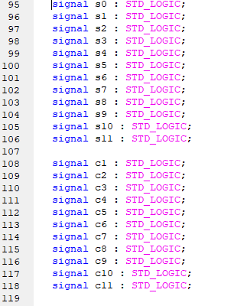
Figure 30.

As shown in Figure 31, S0 is assigned to A0 and B which is already proven in the AND gate logic sequence.
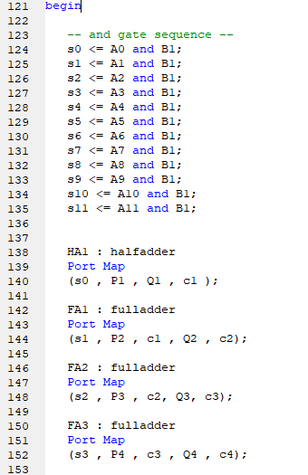
Figure 31.
Figure 31 and Figure 32 both show the half adder and full adder being mapped into the program.
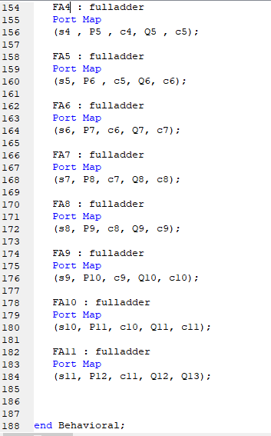
Figure 32.

Line X Test Bench
The line x test bench has A0-A11, B1 and P1-P12 inputs set and Q1-13 as outputs set, as shown in Lines 35-83 of Figure 33 and Figure 34.
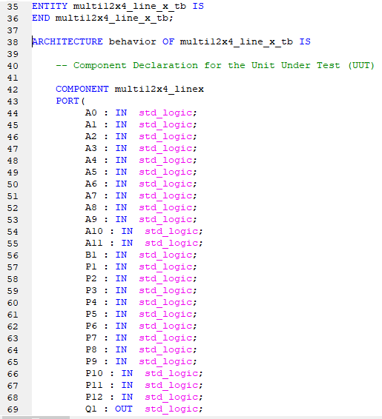
Figure 33.
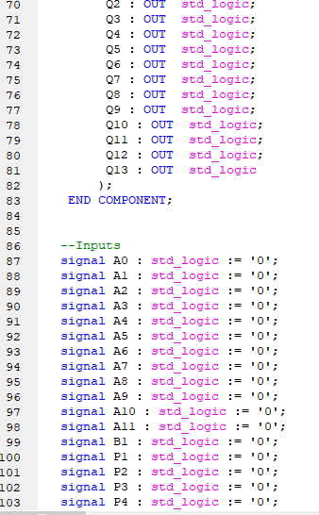
Figure 34.
Signal inputs of A0-A11, B1 and P1-P12 are set at 0, as shown on Figure 34 and Figure 35, Lines 86-111. Q1-Q13 are set as signal outputs as shown on Lines 113-126.
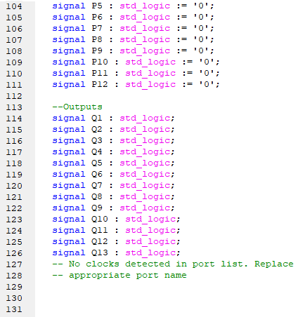
Figure 35.
Line x port mapping is shown on Figure 36.
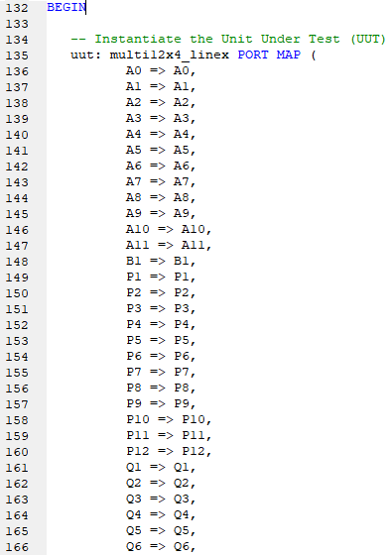
Figure 36.
The stimulus process takes place for line x on Figure 37 and Figure 38, Figure 39 and Figure 40, Lines 179-406.
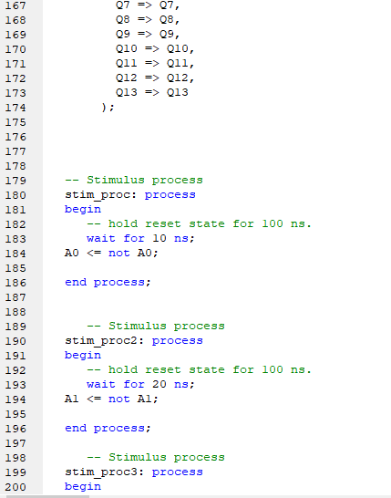
Figure 37
Figure 37, Figure 38, Figure 39 and Figure 40 contain the Stimulus process for Line X test bench. As already stated in the Line 0 test bench, the same procedure will apply to Line x’s stimulus processes, where the pulse time of each input will double after every new stimulus process. This can be found from Lines 189-406.

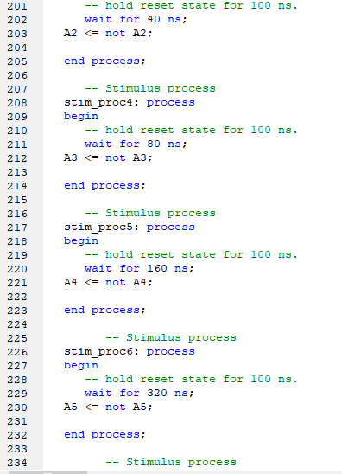
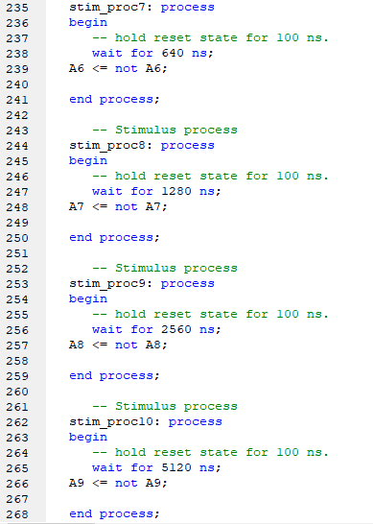
Figure 38.
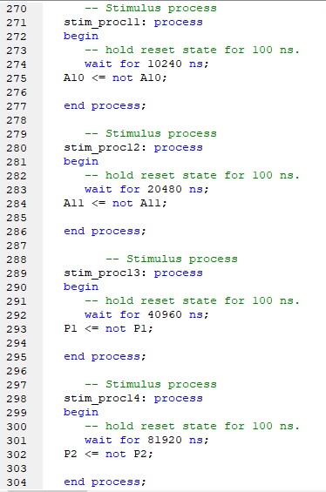
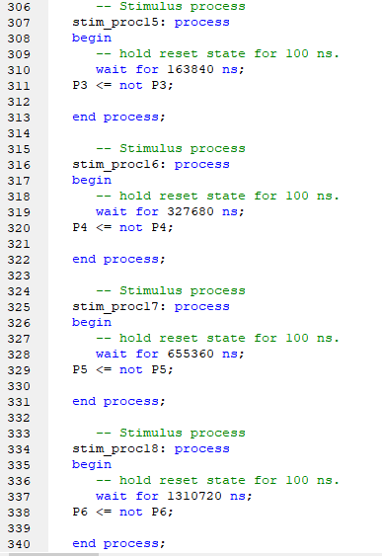
Figure 39.
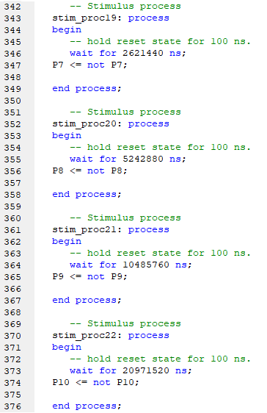
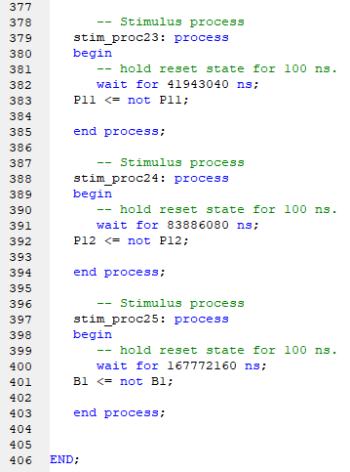
Figure 40.
Once the stimulus processes have been written out correctly a behavioural syntax check takes place to ensure the program is correct and then we simulate to get the test bench graph, as shown in Figure 41. The graph reads correctly, showing that when input B is set to one, input A + P = Q. Figure 41 reads - A equals 2404, B equals 1, P equals 155 and Q equals 2559.
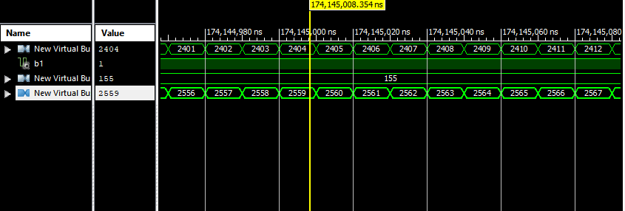
Figure 41.

Figure 42 again proves the test bench successful as it reads, A = 89, B1 =1, P = 1538 and Q = 1627
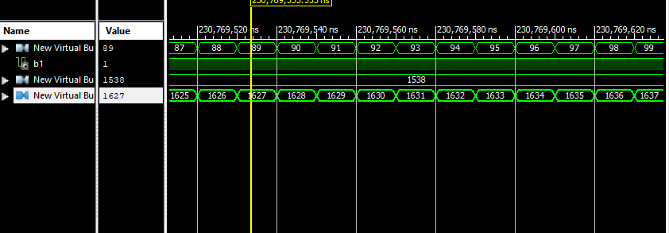
Figure 42.

Figure 43 shows that the test bench is working successfully as when B is set at 0, P and Q should equal the same. Figure 43 shows A = 250, B = 0, P = 1 and Q = 1.
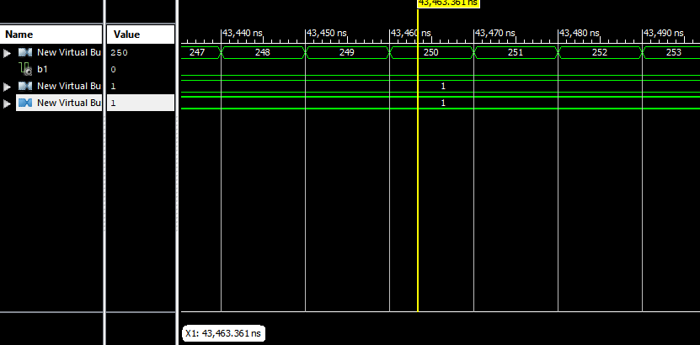
Figure 43.

Multiplier 12x4 Full
Figure 44 shows that A0-A11 and B0-B3 are set as the inputs and that Q0-15 are set as the outputs.
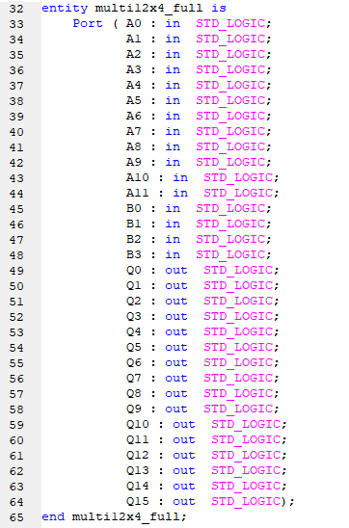
Figure 44.
Figure 45 shows that the architecture of Line 0’s VHDL has been brought in.
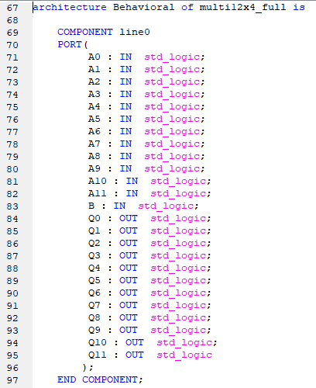
Figure 45.
Figure 46 and Figure 47 shows that architecture of Line X’s VHDL has also been brought in, this can be seen between Lines 99-140.
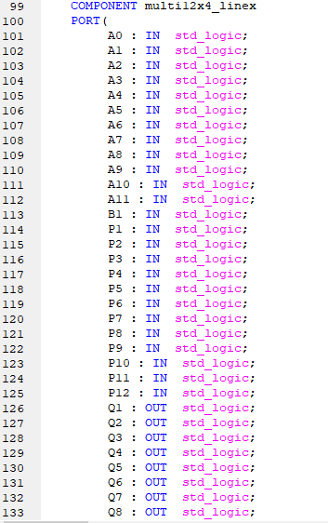
Figure 46.
The only intermediate signals that we have are present in Figure 47 and Figure 48 between Lines 142-178.
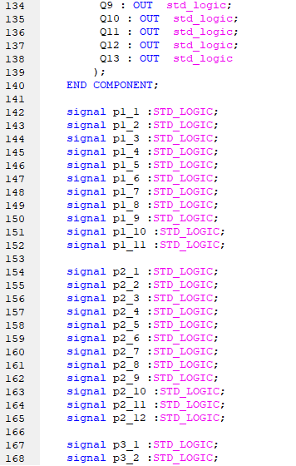
Figure 47.
In Figure 48 port maps Line 0 and reuses its components along with the intermediate signals. Within the VHDL we are declaring that the signals go between the lines. When port mapping (Lines 182-201) it is very important that the inputs and outputs are in order. In Line1 : Line0 all the A’s are multiplied by B0 and the output of that line is Q0. These can be referred to on Lines 184-186.
Whereas Line 1 : Line 0 multiplies the A’s by B0, Line2 : Multi12x4_linex multiplies them by B1. Furthermore, on Line2 : Multi12x4_linex, p2_1 – p2_12 is used as well as p1_1 – p1_11 as it is now line 2. The output Q0 also drops out where Q1 becomes the output.
The same rules apply for Line 3 : Multi12x4_Linex where the inputs, outputs and signals change. The input changes from B1 to B2, the output changes from Q1 to Q2 and the signals change from p2_1 – p2_12 to also p3_1 – p3_12.
Line 4 : Multi12x4_linex carries out the remaining numbers.

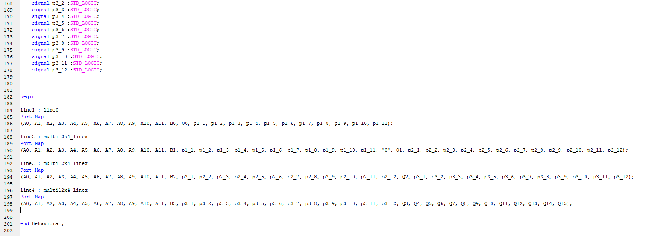
Figure 48.

Multiplier 12x4 Test Bench
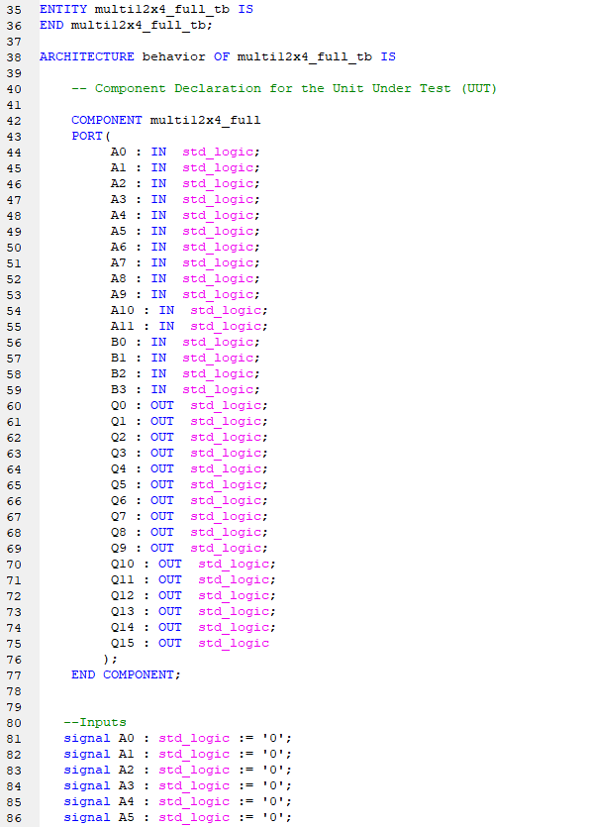
The inputs are assigned A0-A11 and B0-B3, and the outputs are assigned Q0-Q15 as shown in Figure 49 Lines 35-77. The inputs are set at 0 as shown in Lines 81- 96.

Figure 49.

The inputs are set at 0, as shown in Figure 49 and Figure 50 between Lines 80-96.

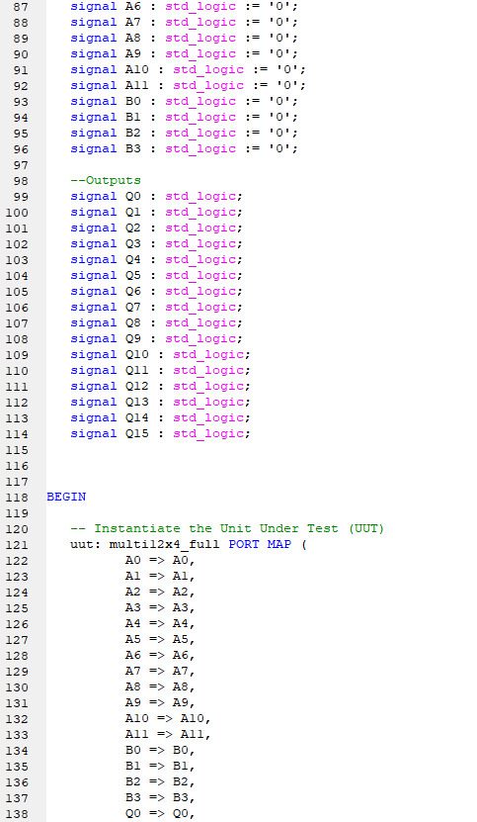
Figure 50.
The 12x4 multiplier full test bench stimulus process is shown on Figure 51 and Figure 52 between Lines 159-272. The same procedure follows as usual, where the pulse time doubles after every process. The inputs used were A0-A11 and B0-B3.
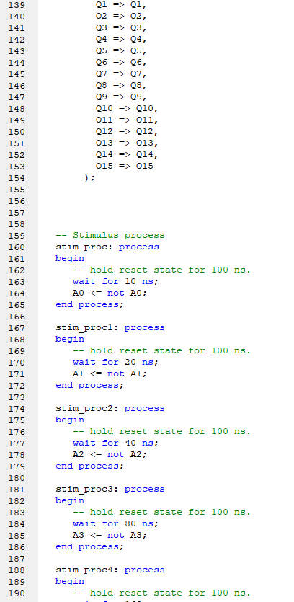
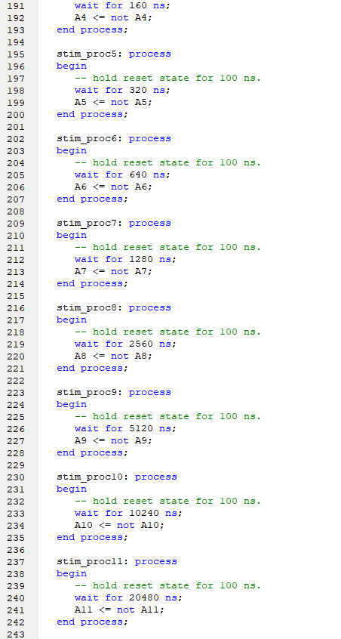
Figure 51.
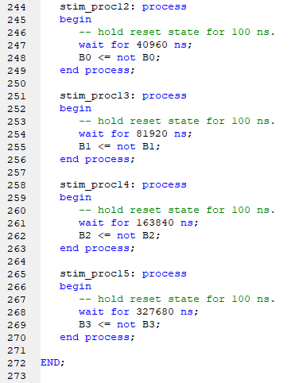
Figure 52.

Once the stimulus processes have been written out correctly a behavioural syntax check takes place to ensure the program is correct and that there are no errors or warnings. Then a simulation takes place in order to get the test bench graph, as shown below in Figure 53. The graph proves that the value of X multiplied by the value of B, will equal Q. This is shown below as, A = 40, B=1 and Q=40.

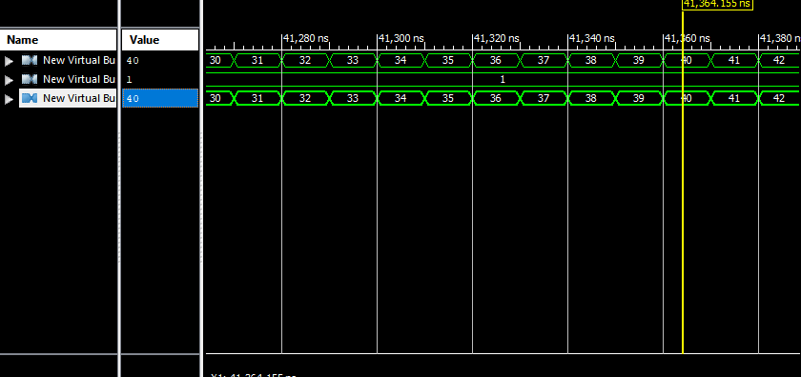
Figure 53
The multiplier has successfully worked as you can see in Figure 54, A = 2765 and B = 2. 2765 multiplied by 2 gives an answer of 5570, which is the value of Q.
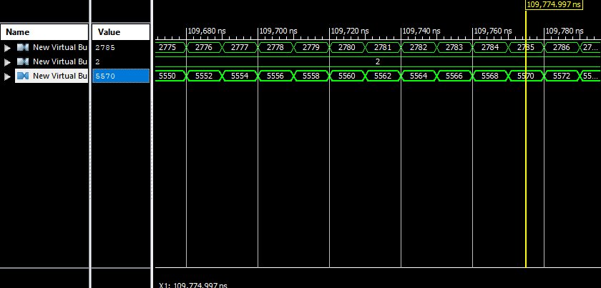
Figure 54

Figure 55 is more evidence that the 12x4 multiplier works efficiently and successfully as A = 3686, B=8 and Q=29488.
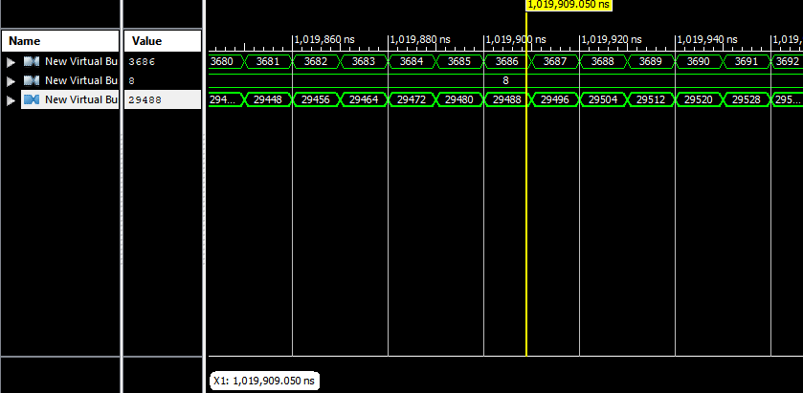
Figure 55.

Task2

FSM
The objective of Task 2 was to design, simulate and synthesise the FSM described by the state diagram as shown in Figure 56. The task was to design, simulate and synthesise both a VHDL and also a discrete gate solution.
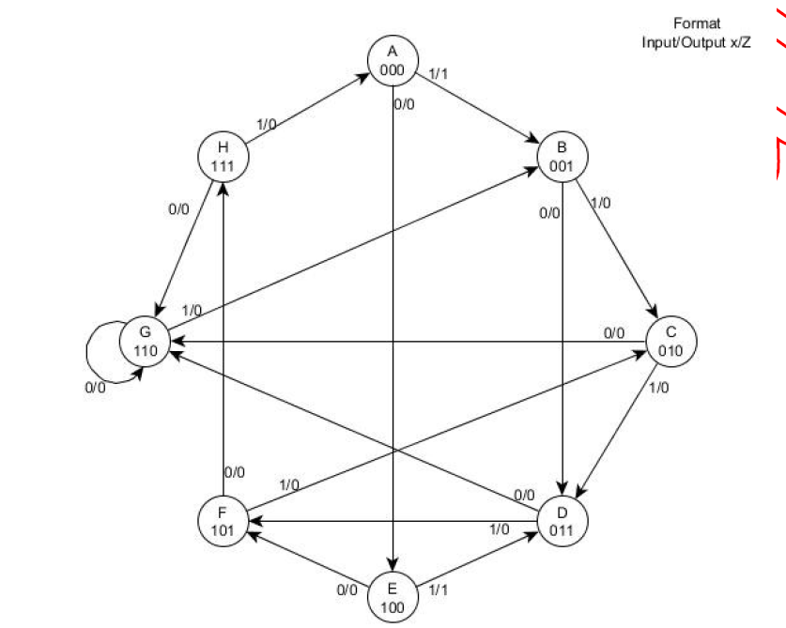
Figure 56.

Next State Tables
States 1 – 8 represent each binary number within the FSM of A – H as shown in Figure 56. As A’s binary number is 000, that is the number used for State 1. As this is the present state, this rule follows every letter within the FSM as shown in yellow within Table 4. For example, D = 011, in Table 4 it is evident that State 4 = 011. As each state within the FSM can have either an input of X=1 or X=0 this is replicated in red within Table 4 by each state having a possible of two types of inputs.
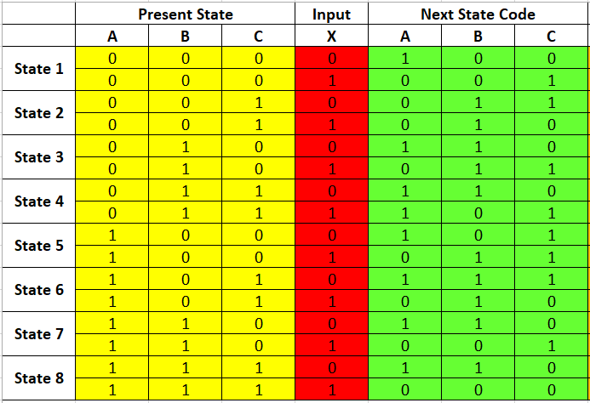
Table 4.
Following the present states binary number and also the input of X, a next state code is created by following the path to its next letter/binary number. For example, state 1 = A within the FSM, has a binary number of 000 and when it’s input X = 0, you can see that within Figure 56 it paths to E (100), which is stated in Table 5. If A was to have an input of X = 1, then it would follow the route to B (001). The next state code is highlighted in green.
Table 5.
Table 6 includes the Output of each state, as shown in Figure 56.
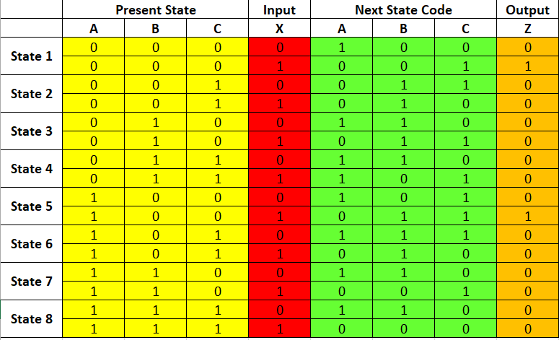
Table 6.

Karnaugh Maps
Karnaugh Maps is a method to simplify Boolean’s algebra expressions used to reduce the need for extensive calculations by taking advantage of humans’ pattern-recognition capability. The Karnaugh maps on Table 7, Table 8 and Table 9 are all grid like representations of the truth table outlined in Table 6. The Karnaugh maps are another way of representing what is in a truth table.
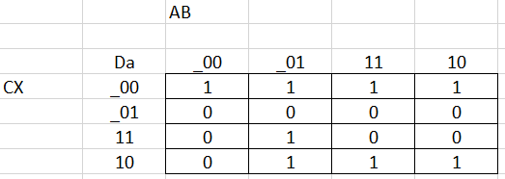
Table 7.

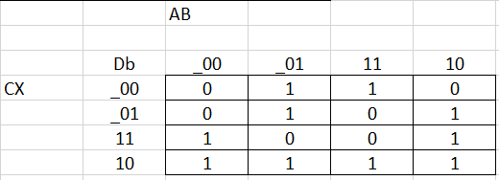
Table 8.

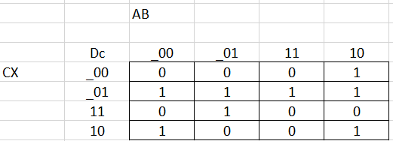
Table9.

Karnaugh maps are designed so that any two adjacent cells in the map differ by a change in only one variable. It is always a change of one variable at any time when you cross a horizontal or vertical cell boundary. Karnaugh map simplification of Boolean algebra make heavy used of adjacency. An adjacent cell which is where a cell is directly to the side or top or bottom of another. An exemption from this rules is that if the adjacent cell is the opposite edge of the table, be it top to bottom or left to right, this is evident within Table 12. Terms may only be grouped by 2,4,6,8 etc. As shown in Table 10, Table 11 and Table 12 the final functions are attached below each table.
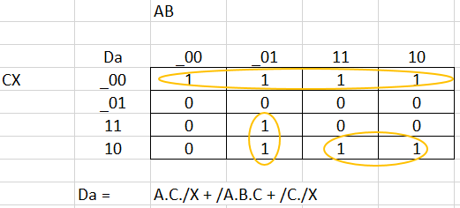
Table 10.

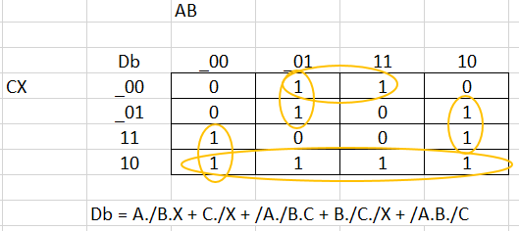
Table 11.

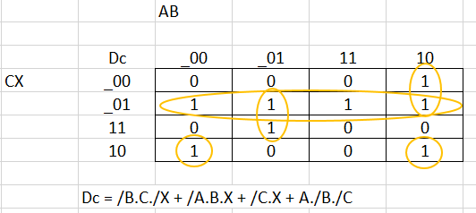
Table 12.

Discrete Gate Solution Final Design
Figure 57 consists of 3 AND gates, 1 OR gate and 1 DTFF. The inputs of the AND gates replicate the final function of the Karnaugh Map Da, which is shown in Table 10.
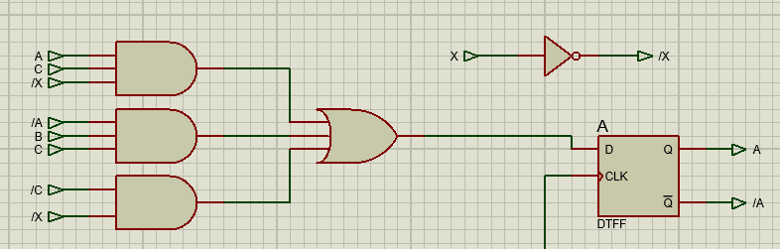
Figure 57.
Figure 58 consists of 5 AND gates, 1 OR gate and 1 DTFF. The inputs of the AND gates replicate the final function of the Karnaugh Map Db, which is shown in Table 11.
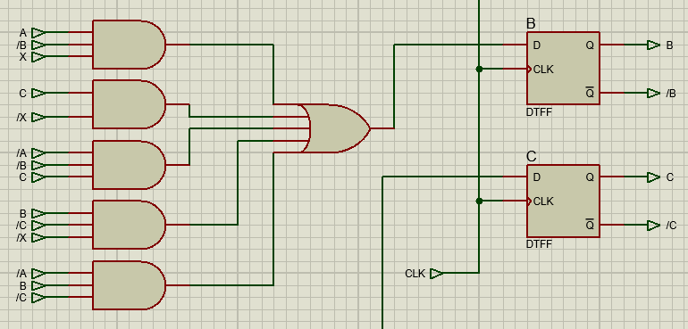
Figure 58.

Figure 59 consists of 4 AND gates, 1 OR gate and 1 DTFF. The inputs of the AND gates replicate the final function of the Karnaugh Map Dc, which is shown in Table 12.
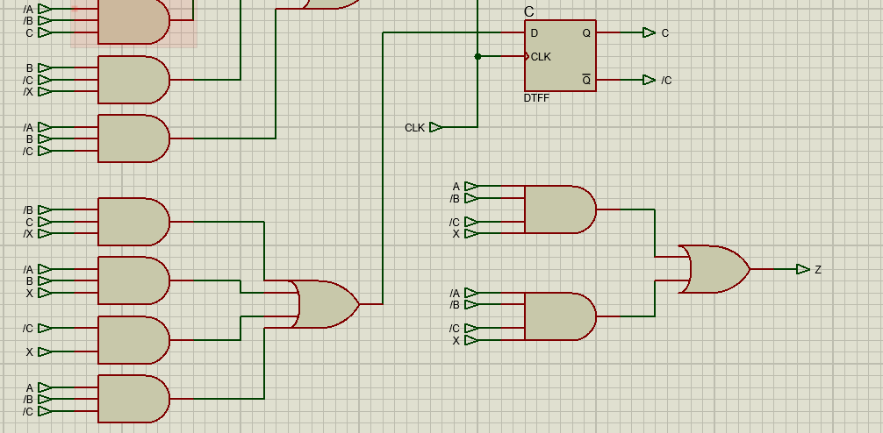
Figure 59.
Figure 60 is the full schematic including all AND, OR gates connected to A, B and C. You can also see the output Z contains the final function of the Karnaugh map in Table 13. As shown in Figure 60, all of the DTFF’s clocks are connected together.
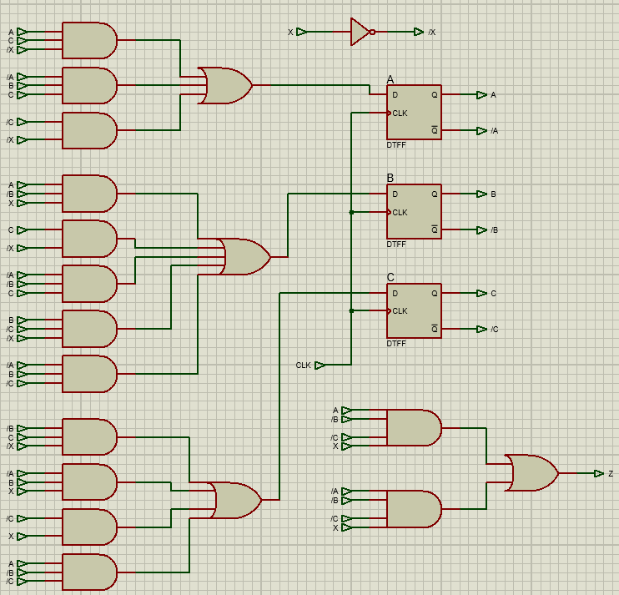
Figure 60.

FSM VHDL
The VHDL for the FSM between lines 47-60 shows that when the input X = 0 what the next state will be. An example of this is that when state A’s input = 0, then it’s next State would be E as shown in Figure 61, Line51. The output of Z is also stated in the program as Z assigned 0 or 1.
When the input of X = 1 the next state is shown between lines 61-72. On line 70 you can see that when on State H and the input of X = 1, the next state would be A.
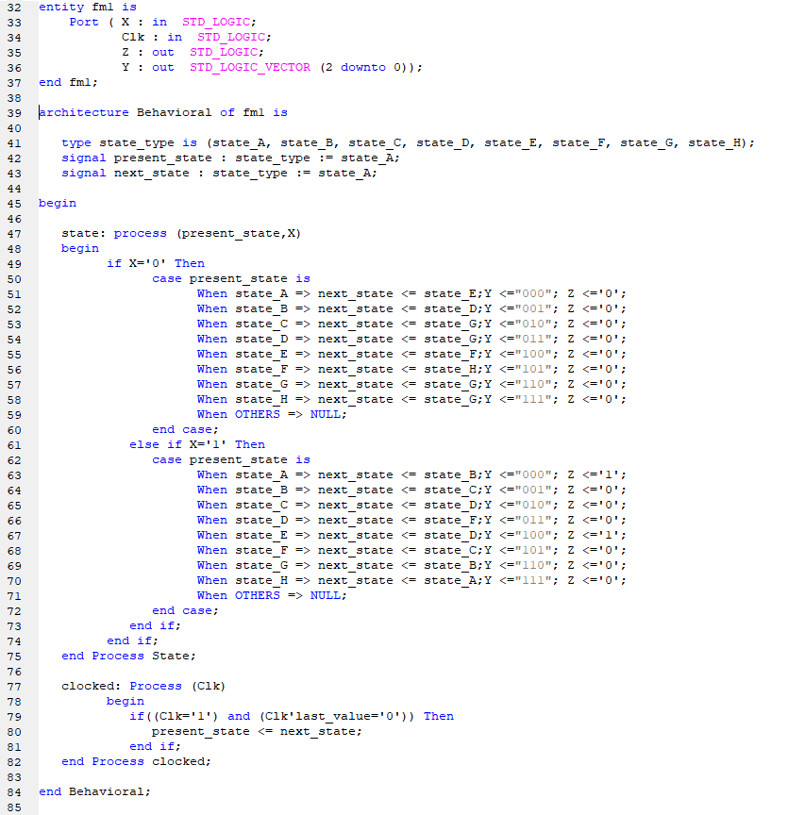
Figure 61.

FSM Test Bench
The test bench consist of two inputs X and Clk, and two outputs Z and Y as shown between lines 42-49.
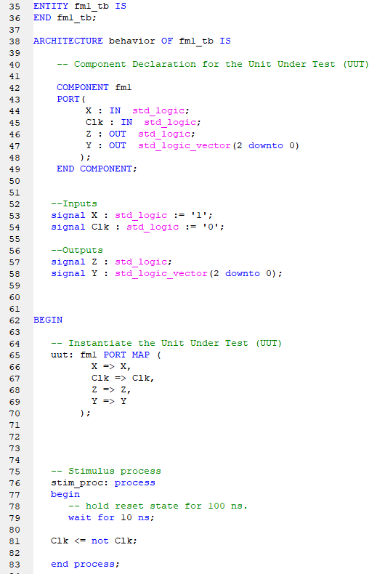
Figure 62.
Stimulus process 1 has the input X set to either 1 or 0 as shown in Figure 63. My design was to test and visit every state by ensuring the input takes it to the correct state. 20ns is how long it takes to get to a single state, if 40ns was used then it would be able to reach two states. For example, referring back to Figure 56 you can see that when at state 3 and the input of X = 1, it moves to state 5. This is also the case within my test bench as shown in Lines 94-97.
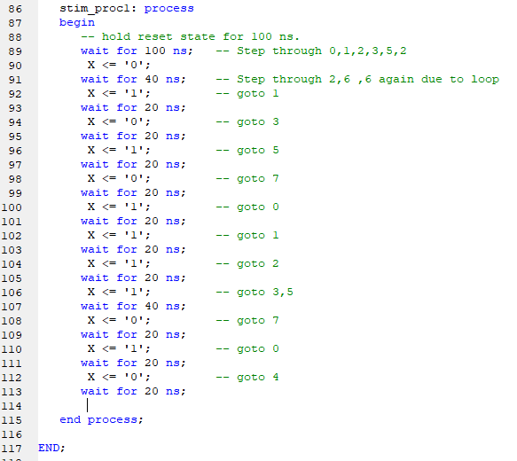
Figure 63.

Figure 64 proves that the stim_proc1 works successfully as you can see that the output Y follows the Step through guide, which is between lines 87-117 in Figure 63. Every time a new Clk starts, the state changes to how it is written in Figure 63.
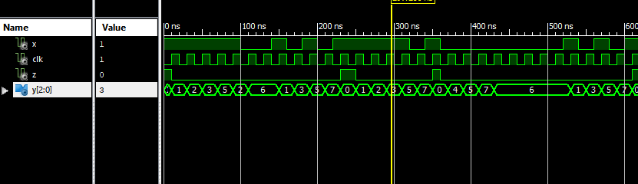
Figure 64.

Bibliography
© 2020 CircuitsToday, 2020. circuitstoday. [Online]
Available at: https://www.circuitstoday.com/half-adder
[Accessed 3 May 2021].
© 2021 Cadence Design Systems, Inc, 2021. resources.pcb. [Online]
Available at: https://resources.pcb.cadence.com/blog/2020-hardware-description-languages-vhdl-vs-verilog-and-their-functional-uses
[Accessed 3 may 2021].
Anon., 2019. GeeksforGeeks. [Online]
Available at: https://www.geeksforgeeks.org/array-multiplier-in-digital-logic/
[Accessed 2 May 2021].
Bansal, H., 2014. core. [Online]
Available at: https://core.ac.uk/download/pdf/234643291.pdf
[Accessed 2 May 2021].
Bhatt, A., 2021. engineersgarage. [Online]
Available at: https://www.engineersgarage.com/vhdl/vhdl-tutorial-10-designing-half-and-full-adder-circuits/
[Accessed 3 May 2021].
B, S., 2021. researchgate. [Online]
Available at: http://vlabs.iitkgp.ernet.in/coa/exp7/index.html
[Accessed 3 May 2021].
GeeksforGeeks, 2019. GeekforGeeks. [Online]
Available at: https://www.geeksforgeeks.org/array-multiplier-in-digital-logic/
[Accessed 2 May 2021].
GeeksforGeeks, 2019. GeekforGeeks. [Online]
Available at: https://www.geeksforgeeks.org/full-adder-in-digital-logic/
[Accessed 3 May 2021 ].
Gudhimetla, M., 2017. Digitalxplore. [Online]
Available at: https://www.digitalxplore.org/up_proc/pdf/315-150546881948-53.pdf
[Accessed 28 April 2021].
Ijirset, 2015. Ijirset. [Online]
Available at: http://www.ijirset.com/upload/2015/january/52_Performance.pdf
[Accessed 28 April 2021].
Mishra, P., 2018. ijarse. [Online]
Available at: http://www.ijarse.com/images/fullpdf/1523964041_IIMT19.pdf
[Accessed 28 April 2021].
P, A. J. R., 2018. Ijirset. [Online]
Available at: http://www.ijirset.com/upload/2018/rtcsit/RTCSIT-77.pdf
[Accessed 3 May 2021].
Reegan, R., 2012. exploringbinary. [Online]
Available at: https://www.exploringbinary.com/binary-multiplication/
[Accessed 2 May 2021].
Salehan, N., 2007. dspace.unimap. [Online]
Available at: http://dspace.unimap.edu.my/bitstream/handle/123456789/1934/Literature%20review.pdf?sequence=4
[Accessed 28 April 2021].
Shaown, 2021. stackoverflow. [Online]
Available at: https://stackoverflow.com/questions/60474960/signed-array-multiplier-in-verilog?form=MY01SV&OCID=MY01SV
[Accessed 3 may 2021].
Thakur, M. M., 2012. ijser. [Online]
Available at: https://www.ijser.org/paper/Design-of-Braun-Multiplier-with-Kogge-Stone-Adder-Its-Implementation-on-FPGA.html
[Accessed 02 May 2021].
theoryCIRCUIT ©, 2021. theorycircuit. [Online]
Available at: https://theorycircuit.com/full-adder-circuit-diagram/
[Accessed 3 May 2021].
Virtual Labs, 2021. vlabs. [Online]
Available at: http://vlabs.iitkgp.ernet.in/coa/exp7/index.html
[Accessed 3 May 2021].

