

Assignment Title: Assessment component 1: Individual report
Report Title: Comparative Analysis of Toyota's International Market Entry Strategy and Marketing Mix: Evidence from Japan and the United Kingdom

Student Name: B M A RAHMAN
Student ID: 2526730

Programme: Master of Business Administration
Module Name: International Marketing: Principles and Practices
Module Code: LCMB7026

Lecturer’s Name: Dr Tola Odugbesan
Work Count: 5373

Submission Date: 13 August, 2026

Acknowledgement of AI Tool Use
I acknowledge using AI tools for purposes of permitted research, explanation, proofreading as outlined in the Guidelines for Using AI in Research at the UWTSD (February 2026).
ChatGPT (https://chatgpt.com/) was used to support research, explain strategic management concepts and frameworks, and proofread the assignment.
Perplexity AI (https://www.perplexity.ai/) and Google Gemini (https://gemini.google.com/) were used to support research and understanding of BYD, the European EV market and relevant strategic issues.
Grammarly (https://www.grammarly.com/) was used for grammar, spelling, clarity and proofreading.
QuillBot (https://quillbot.com/) was used to improve the wording and readability of selected passages.
I certify that I have not submitted AI-generated content as my own work. I know that the content of this assignment, any analysis, arguments and conclusions are the ultimate responsibility of me.

Table of Contents
Section 1 5
1. Introduction 5
2. Comparative Market Analysis 6
2.1 Comparative PESTEL Analysis of Japan and the United Kingdom 6
Critical Discussion 7
Political Factors 7
Economic Factors 7
Social Factors 8
Technological Factors 8
Environmental Factors 8
Legal Factors 9
2.2 Comparative Cultural Analysis Using Hofstede's Cultural Dimensions 11
Critical Synthesis 12
3. Comparative Analysis of Toyota's Segmentation, Targeting and Positioning (STP) 13
Critical Evaluation 14
4. Comparative Analysis of Toyota's International Marketing Mix (7Ps) 15
4.1 Product Strategy 16
4.2 Price Strategy 17
4.3 Place (Distribution) Strategy 17
4.4 Promotion Strategy 18
4.5 People Strategy 19
4.6 Process Strategy 19
4.7 Physical Evidence 20
5. Analysis of Toyota's Market Entry Strategy in the United Kingdom 20
6. Evaluation of Ethical Issues Related to Toyota's Marketing Mix in the United Kingdom 21
7. Strategic Recommendations for Toyota's International Marketing Strategy 23
Section 2: Reflective Account 25
1. Reflective Learning Abstract 25
2. Description 25
3. Feelings 26
4. Evaluation 26
5. Analysis 27
6. Conclusion 27
7. Action Plan 27
References 29

Table 1: Comparative Analysis of Hofstede's Cultural Dimensions 11
Table 2: Comparative STP Strategy 14
Table 3: Comparative Marketing Mix Overview 15

Figure 1: Toyota's Global Operations: Japan (Home Market) and the United Kingdom (Host Market). 6
Figure 2:Macro Environment 6
Figure 3: Comparative PESTEL Summary of Japan and the UK. 10
Figure 4 : Comparison of Hofstede's Cultural Dimensions: Japan and the United Kingdom. 11
Figure 5: Comparative Hofstede Culture Dimensions: Japan Vs United Kingdom 12
Figure 6: Toyota's Strategic STP Process in International Marketing 14
Figure 7: Gibbs Reflective Cycle 25

Section 1

1. Introduction
Toyota Motor Corporation is one of the biggest automotive manufacturers in the world and has built a strong international presence by striving for continuous innovation, operational excellence and strategic expansion in the market. Established in Japan in 1937, Toyota is a global brand that operates in over 170 countries and regions, selling a wide range of passenger vehicles, commercial vehicles, hybrid electric vehicles (HEVs) and battery electric vehicles (BEVs).
The political, economic, socio-cultural, technological, environmental and legal scenarios are diverse in different countries, leading to a complexity in international marketing (Hollensen, 2020). Therefore, it is the responsibility of multinational companies to decide how to make their marketing plans or decisions uniform or to customize them to the local market characteristics (Cateora, Gilly and Graham, 2020). This is the challenge that Toyota faces: to have a uniform global brand image while adjusting the various aspects of the marketing mix to the preferences, regulations and competition of each country.

The report compares the marketing strategy of Toyota company in Japan (home market) with the U.K., an important market with an already highly developed automotive sector and growing demand for sustainable mobility solutions. The analysis starts with the macro-environmental analysis using PESTEL methodology and then moves on to the socio-cultural differences using Hofstede's cultural dimensions. It then discusses the segmentation, targeting and positioning (STP) strategy of Toyota along with the international marketing mix (7Ps), examines how Toyota marketed into the UK, identifies ethical problems of Toyota's marketing, and provides strategic recommendations to enhance Toyota's marketing performance in the international markets.

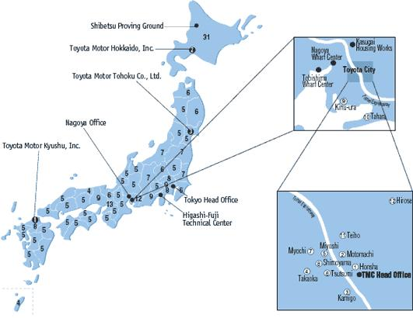
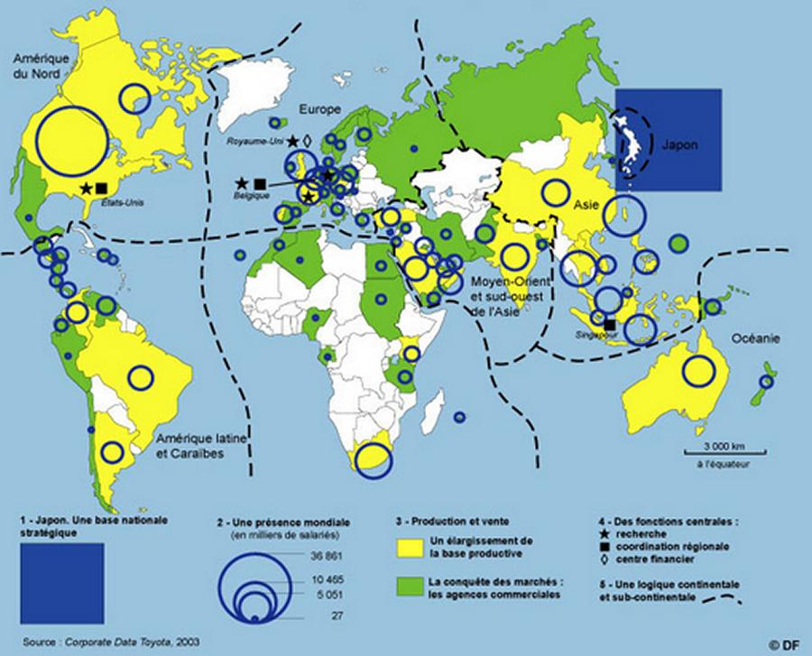
Figure 1: Toyota's Global Operations: Japan (Home Market) and the United Kingdom (Host Market).
Source: Adapted from Toyota Motor Corporation (2025).

2. Comparative Market Analysis

2.1 Comparative PESTEL Analysis of Japan and the United Kingdom
Figure 2:Macro Environment
Macro-environmental factors can impact on the international marketing environment by affecting the way an organisation makes decisions, how consumers act, and the competitive environment (Hollensen, 2020; Cateora, Gilly and Graham, 2020). PESTEL is a structured way to assess the political, economic, socio-cultural, technological, environmental and legal environment that impacts business operations in various countries (Kotler, Keller and Chernev, 2022; Johnson et al., 2020).

Critical Discussion

Political Factors
The political stability of Japan and the UK is conducive to long-term investment and foreign business activities (OECD, 2024; World Bank, 2024). But there are not many similarities in the kind of government intervention. Japan has traditionally promoted industrial innovation, efficiency and export competitiveness of its automobile industry through policies (OECD, 2024). Since the UK left to leave the EU, in contrast, there had been significant changes in its political landscape, particularly in relation to customs, supply chain and regulatory changes for UK manufacturers producing abroad (UK Government, 2024).
Therefore, the marketing strategy of Toyota in the UK should be well-integrated with the changing trade policy and the respective industrial policies to remain competitive.

Economic Factors
While both nations have high income, modern economies, the nature of markets in the two nations is very different (World Bank, 2024; OECD, 2024). Japan is a developed automotive market with low population growth where ageing population has led to relatively stable demand for vehicles (World Bank, 2024). The UK market, on the other hand, is a very competitive market with inflationary pressures, rising interest and cost-of-living concerns that impact consumer purchasing behaviour in the recent past (OECD, 2024).
Such economic disparities have a direct impact on the pricing and product policies of Toyota (Kotler, Keller and Chernev, 2022). In Japan, there is a strong emphasis on reliability and fuel efficiency, rather than the competitive edge in prices, and technological innovation is also a significant consumer preference. However, in the UK, financing options, promotional offers and value for money has grown more significant because of the growing sensitivity of consumers on prices (Toyota Motor Corporation, 2025; Toyota UK, 2025). Hence, it is essential for Toyota to change its pricing policy in order to keep its high-quality image as a premium brand.

Social Factors
One of the most influential factors of international marketing success is socio-cultural characteristics (Hollensen, 2020). In general, Japanese society is more collectivist in values, longer term in relationships and more product, reliable, and continuous improvement in culture. In contrast, British consumers are more individualistic, are more concerned with personal lifestyle, convenience and sustainability (Hofstede, Hofstede and Minkov, 2010; Hofstede Insights, 2024).
The differences are significant and have a big impact on Toyota's communication strategy (Keegan and Green, 2020). In Japan, marketing campaigns often highlight the quality of their products, their reliability and the reputation of their company, while in the UK, the focus is now more on environmental issues, technological innovation and personal mobility options (Toyota Motor Corporation, 2025; Toyota UK, 2025).

Technological Factors
Japan continues to be one of the global hotspots for automotive research and development, especially in the areas of hybrid technology, robotics, and manufacturing innovation (Toyota Motor Corporation, 2025).
In contrast, the UK has put a huge amount of money into the development of digital infrastructure, connected mobility, the charging networks for EVs, and so on (UK Government, 2024). This setting will allow Toyota to take a more comprehensive approach to digital marketing, online vehicle sales sites and the connected customer services available for customers in the UK (Toyota UK, 2025).
The technological differences highlight the fact that innovation is not just about products, but also about how the customer is engaged and how the service is delivered digitally, necessitating a change in Toyota's products and marketing channels.

Environmental Factors
In both countries environmental sustainability has been strategically placed as a priority, but with varying regulatory focus (OECD, 2024). While the United Kingdom has set ambitious targets and policies to transition to battery electric vehicles and maintain its progress toward net zero (UK Government, 2024), Japan is continuing to advance low-emission technology and hydrogen innovation (Toyota Motor Corporation, 2025). Also, the role of the institutional environment in enhancing environmental sustainability is highlighted by the findings of Odugbesan et al. (2021) which revealed that the relationship between institutional and regulatory factors and carbon productivity is significant. This implies that the institutional framework is important not only because of consumer demand and corporate efforts toward environmental sustainability, but because of its quality and effectiveness.
All these environmental pressures have had a tremendous effect on the product portfolio as well as on the marketing communications of Toyota (Leonidou, Katsikeas and Morgan, 2022). The hybrid vehicle is the focus of Toyota's global strategy, but the new environmental rules in the UK will necessitate a more focus on battery electric vehicles and sustainability messages (Toyota Motor Corporation, 2025; UK Government, 2024).

Legal Factors
Compliance with the law is essential for Toyota's global business (Johnson et al., 2020). Safety and consumer protection laws are in place and strict in both countries, but the UK has more stringent emissions regulations and compliance requirements after Brexit (UK Government, 2024).
Not adhering to these legal frameworks may cause Toyota's reputation and consumer confidence to be harmed (Freeman, 1984). Hence, the decision to legalise reflects not only a legal requirement, but also a marketing strategy for Toyota's international marketing (Kotler, Keller and Chernev, 2022).

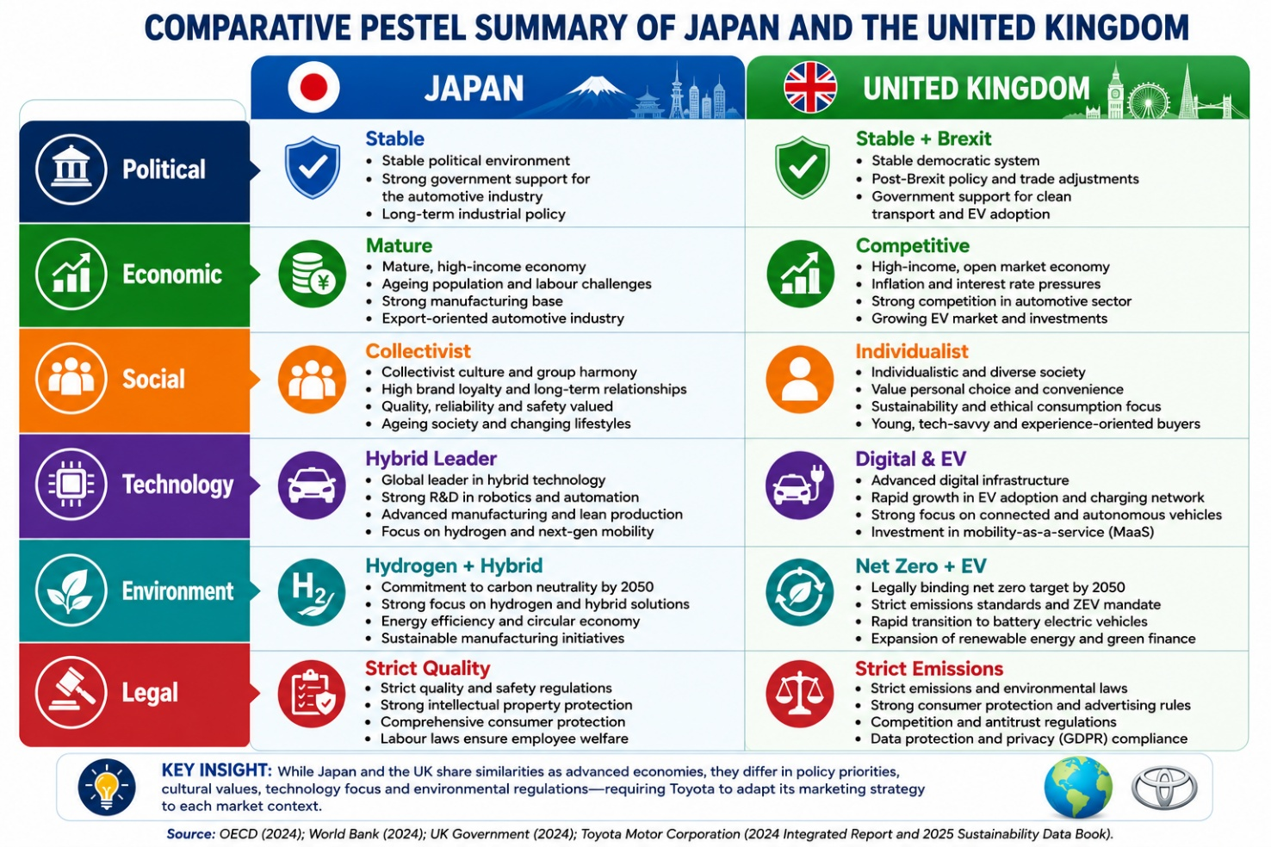
Source: Author's own illustration based on OECD (2024), World Bank (2024), UK Government (2024), Toyota Motor Corporation (2025).
Figure 3: Comparative PESTEL Summary of Japan and the UK.

2.2 Comparative Cultural Analysis Using Hofstede's Cultural Dimensions
Consumer behaviour and international marketing strategies are strongly influenced by culture, as it affects one's values, attitudes, buying choices and communication preferences (Hollensen, 2020; Cateora, Gilly and Graham, 2020).
Consumers' expectations, communication, purchasing behaviour, and brand perceptions vary significantly between the Japanese and the British market, making an understanding of these differences critical to Toyota (Hofstede Insights, 2024; Toyota Motor Corporation, 2025).
Figure 4 : Comparison of Hofstede's Cultural Dimensions: Japan and the United Kingdom.
Source: Adapted from Hofstede Insights and Hofstede, Hofstede and Minkov (2010).
Table 1: Comparative Analysis of Hofstede's Cultural Dimensions
Cultural Dimension | Japan | United Kingdom | Marketing Implication for Toyota
Power Distance | Moderate | Relatively low | More consultative customer interactions in the UK
Individualism | Lower (more group-oriented) | Very high | UK advertising emphasises personal lifestyle and choice; Japan stresses reliability and social value
Masculinity | Very high | High | Performance and achievement appeal in both markets, but expressed differently
Uncertainty Avoidance | Very high | Lower | Japanese consumers seek detailed information and proven quality; UK consumers are more open to innovation
Long-Term Orientation | Very high | Moderate | Japan values durability and long-term ownership; UK consumers increasingly focus on technology and sustainability
Indulgence | Lower | Higher | UK marketing uses emotional and lifestyle appeals more extensively
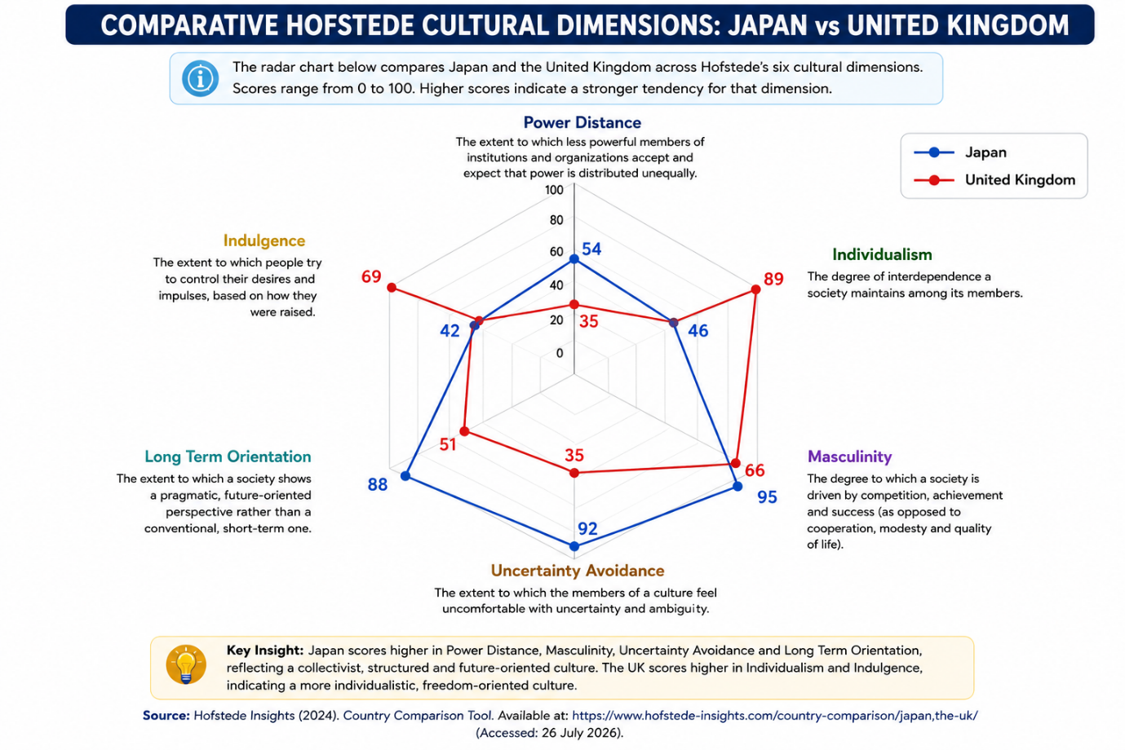
Source: Author's own compilation based on Hofstede, Hofstede and Minkov (2010) and Hofstede Insights.
Figure 5: Comparative Hofstede Culture Dimensions: Japan Vs United Kingdom
Source: Adapted from Hofstede Insights (2024) Country Comparison Tool.

Critical Synthesis
The Hofstede's analysis shows that there is a vast difference between Japan and the United Kingdom with regard to the four dimensions of culture, namely individualism, uncertainty avoidance, long-term orientation, and indulgence (Hofstede Insights, 2024). The differences affect the expectations of consumers, communication preferences and purchasing behavior, which makes it necessary for Toyota to fine-tune aspects of its international marketing strategy, while keeping its brand image constant throughout the world (Hollensen, 2020). Toyota is not aiming at full standardisation in its approach to global marketing, but is successfully integrating global and local responsiveness. Toyota does not aim for total standardisation in its approach to global marketing but is able to integrate global and local responsiveness, highlighting the strategic role of cultural intelligence in global marketing (Douglas and Craig, 2011; Toyota Motor Corporation, 2025).

3. Comparative Analysis of Toyota's Segmentation, Targeting and Positioning (STP)
Strategic marketing is built on Segmentation, Targeting, and Positioning (STP), which helps companies find groups of customers with whom they are successful, prioritize marketing resources, and craft value propositions that appeal to a target group. In international marketing, however, STP decisions are far more complicated due to the differences in the world of customers, culture, purchasing power, and competition between countries (Hollensen, 2020; Cateora, Gilly and Graham, 2020). Therefore, the decision of whether to use a global or local marketing strategy for multinational businesses depends on the characteristics of the local market.
Toyota aims to optimize its product development by incorporating locally relevant adaptations, such as those based on cultural preferences and economic environments, while maintaining a global core set of values in its product development, including quality, reliability, and innovation (Toyota Motor Corporation, 2025; Hollensen, 2020). Toyota's practice of how it integrates with the global market while retaining responsiveness to local market needs to build its competitive advantage can be illustrated through comparison with the United Kingdom (UK) (Douglas and Craig, 2011).
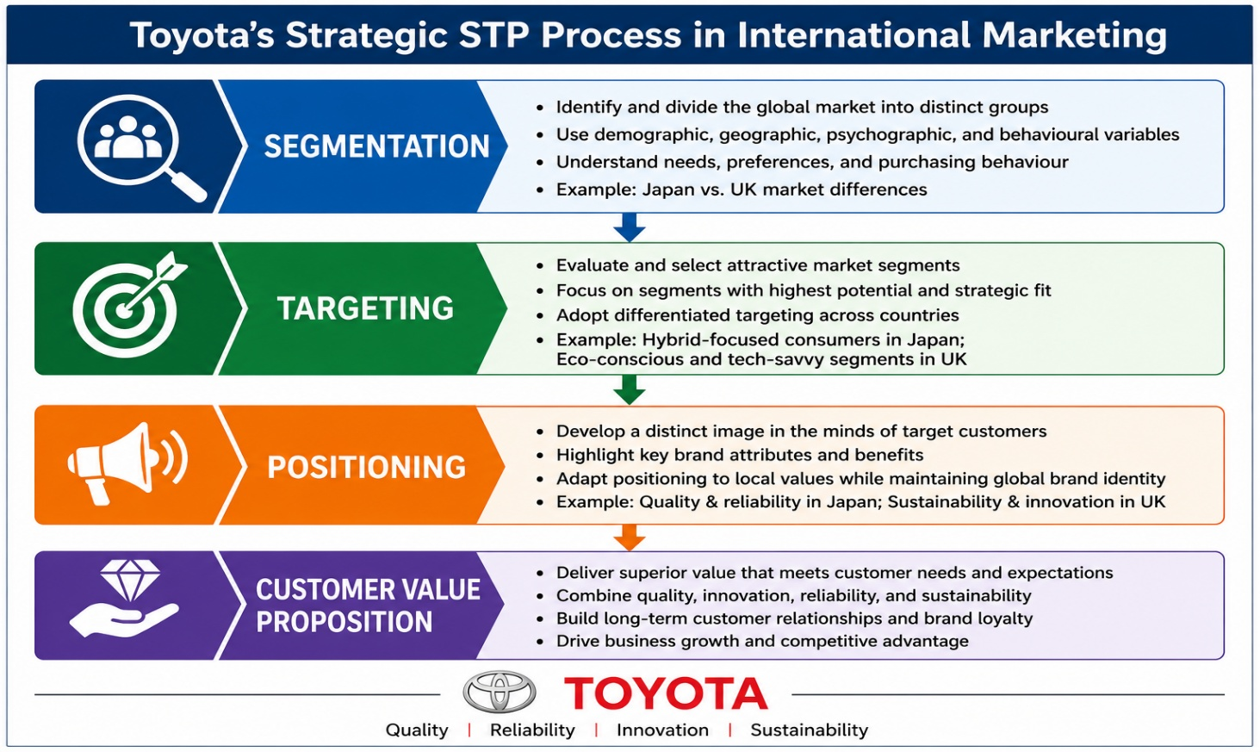
Figure 6: Toyota's Strategic STP Process in International Marketing
Source: Adapted from Kotler, Keller and Chernev (2022)
Table 2: Comparative STP Strategy
Element | Japan | United Kingdom | Critical Evaluation
Segmentation | Ageing population, families, environmentally conscious drivers | Young professionals, families, fleet buyers, EV adopters | Market characteristics require different segmentation priorities.
Targeting | Hybrid users, long-term owners, reliability seekers | Hybrid/EV users, urban commuters, business customers | UK targeting is more diversified due to competitive market conditions.
Positioning | Reliability, quality, technological excellence | Innovation, sustainability, reliability | Core positioning is consistent but communication is locally adapted.

Critical Evaluation
STP strategy of Toyota is one example of how the continuum of standardization and adaptation is used in international marketing (Keegan and Green, 2020). The brand standardisation of the company's core position helps to increase its brand equity at a global level, improves customer confidence and creates economies of scale (Levitt, 1983). At the same time, the ability to adjust segmentation and targeting will allow Toyota to do the same in response to variations in demographic makeup, preference, environmental consciousness and buying habits (Hollensen, 2020).
There is, however, a danger with adaptation that it undermines the global brand identity and a danger with standardisation that it makes it less relevant locally (Douglas and Craig, 2011). Toyota's current approach to business provides an interesting balance between these competing interests and will help it remain competitive both domestically and internationally. However, segmentation and positioning strategies should be constantly adapted to meet fast changing consumer expectations, especially in the field of digital mobility and electric vehicles to maintain the competitive edge over the long term.

4. Comparative Analysis of Toyota's International Marketing Mix (7Ps)
The extended marketing mix (7Ps) is an overall framework used to assess the adaptation of marketing strategies by multinational organisations in the international markets (Booms and Bitner, 1981; Kotler, Keller and Chernev, 2022). Although Toyota's reputation for quality, innovation and reliability is globally recognised, the marketing mix that is implemented varies between Japan and the United Kingdom, as a result of differences in consumer preferences, economic conditions, cultural values, competitive environment and regulations among the two markets (Toyota Motor Corporation, 2025; Keegan and Green, 2020).
Table 3: Comparative Marketing Mix Overview
Marketing Mix | Japan | United Kingdom | Degree of Adaptation
Product | Hybrid-focused, compact vehicles, kei-car partnerships | Hybrid, SUVs, increasing EV portfolio | Moderate
Price | Value and long-term ownership | Competitive pricing with finance options | High
Place | Extensive dealership network | Dealerships plus stronger online integration | Moderate
Promotion | Quality, reliability, corporate heritage | Sustainability, innovation, digital campaigns | High
People | Relationship-focused service | Customer experience and personalised support | Moderate
Process | Traditional plus digital services | Digital purchasing and after-sales integration | Moderate
Physical Evidence | Premium showroom quality | Modern sustainable dealership environment | Low
Source: Author's own compilation based on Toyota Motor Corporation (2025), Toyota UK (2025), and Kotler, Keller and Chernev (2022).

4.1 Product Strategy
Product is the key component of Toyota's global marketing plan. Toyota has a range of compact cars, hybrid electric vehicles, luxury models and commercial vehicles to meet the varying demands of Japanese consumers. Fuel efficiency, technological reliability, compactness (appropriate for urban environment) and long life (durability) are generally important attributes to Japanese consumers (Hofstede, Hofstede and Minkov, 2010; Toyota Motor Corporation, 2025). Hence the use of hybrid technology is still playing a vital role in Toyota's product approach in the home market.
By contrast, Toyota's product focus in the United Kingdom has been shifting towards hybrid and battery electric vehicles as well as family-appealing, more utilitarian, and more comfortable SUVs to reflect the trends of consumer preferences and government policies on low emission travel (Toyota UK, 2025; UK Government, 2024). Environmental knowledge, environmental concern and perceived consumption values also have an influence on consumer reactions towards environmental products. These factors are significant consumers' intention towards environmentally friendly products, as reported by Odugbesan, Aghazadeh and Abdullahi (2021). This serves as a good starting point to understanding why Toyota is making greater strides to electrify their vehicles. As the growing demand for mobility that is environmentally friendly, Toyota is continuing to increase its range of electrified vehicles.

4.2 Price Strategy
Toyota uses value-based pricing with the factors of market competition, purchasing power, taxation and consumer perceptions of quality taken into account (Kotler, Keller and Chernev, 2022). Hereafter, the price varies from Japan to UK.
The long-term cost of ownership, durability, fuel efficiency, and resale value are typically the key factors consumers consider when purchasing vehicles in Japan (Toyota Motor Corporation, 2025). Consequently, Toyota does not compete on the basis of discounting, but through beating the competition in terms of value.
In contrast, the UK car market is very competitive, and there is greater emphasis on the financial option, leasing, green car incentives (UK Government), and promotional pricing (UK Government) by customers (UK Government). Toyota thus supports its high-quality marketing with flexible financing options, warranty schemes and seasonal promotional offers (Toyota UK, 2025).
These pricing disparities show that Toyota keeps the value proposition the same around the world but pricing structures and mechanisms need to be adapted to local market conditions (Hollensen, 2020).

4.3 Place (Distribution) Strategy
Toyota has a wide network of dealerships both in Japan and the UK to ensure as much market penetration as possible and customer accessibility (Toyota Motor Corporation, 2025). However, different distribution strategies are evident for various stages in the digital transformation process.
Japan has a fully developed dealership network and a long history of dealer/customer relationships. One to one communication and follow-up service continue to be a major aspect to the customer service.
The United Kingdom also has a long-established dealership network; but things have changed with digital transformation in the buying process. Consumers are now spending more time online researching cars, using digital tools to specify their desired vehicles, booking test drives and arranging finance prior to visiting dealerships (Toyota UK, 2025). As a result, Toyota has enhanced its omnichannel approach by seamlessly bridging the gap between brick-and-mortar dealerships and digital customer engagement initiatives.
It shows that the Toyota's place strategy has shifted from physical distribution to an omnichannel strategy to cater for consumer behaviour change.

4.4 Promotion Strategy
Toyota's brand identity is consistent worldwide with a focus on quality, innovation, reliability and sustainability, but they tailor promotion messages to the local value system of their consumers (Toyota Motor Corporation, 2025).
The Japanese focus on promoting craftsmanship, engineering, safety and reliability, and long-term use. The corporate heritage and the quality of Toyota's product still play a significant part in the company's communication.
On the other hand, UK-led promotional campaigns are more and more centered on the environmental sustainability of the product, hybrid leadership, electric mobility and digital innovation. Toyota also uses digital ads, social media, influencers, and sustainability-focused marketing campaigns in their initiatives to reach consumers with a strong environmental focus (Toyota UK, 2025).
The differences highlight the effect of the cultural values found in the Hofstede analysis (Hofstede and Hofstede and Minkov, 2010). Japanese consumers value the messages focussed on trust and quality, while UK consumers are paying more attention to innovation, sustainability and lifestyle value. Toyota thus readjusts its promotional approach without compromising its basic global brand (Douglas and Craig, 2011).

4.5 People Strategy
In addition to the customers, employees, dealership personnel, and customer service representatives are also important components of the four P's as they directly impact the customer satisfaction and the perception of your brand (Booms and Bitner, 1981; Kotler, Keller and Chernev, 2022).
The people strategy at Toyota UK, however, focuses more on making it easy, accessible and consultative for customers. There is also a rise in the use of digital tools by sales advisers to help them to configure the vehicle, facilitate finance deals and provide after-sales services, which is a reflection of the expectations of consumers of speed and flexibility (Toyota UK, 2025). In addition, employees at dealerships have the training to discuss new technology, including hybrids and electric cars and explain them to customers to help them make informed choices.
Toyota Motor Corporation (2025) reports that employee development is consistently implemented around the world and that Toyota's customer service is consistent. It is this interplay between universal business principles and culturally sensitive service provision that allows Toyota to build customer connections in a variety of global markets (Keegan & Green, 2020).

4.6 Process Strategy
Toyota has dedicated a lot of effort to process innovation in Japan and the UK (Toyota Motor Corporation, 2025). Toyota's famous philosophy of production and quality control continues to be a major factor in the Japanese purchasing process, which remains based on close relationship between the customer and the dealership. Long term customer loyalty is maintained through after-sales services and scheduled maintenance services, as well as warranty programmes.
The United Kingdom is an example of a region that has progressed further in digital transformation along Toyota's customer journey. Customers are increasingly conducting research on cars online, making comparisons on financing options, booking test drives digitally and communicating with dealerships online (Toyota UK, 2025). For this reason, Toyota has introduced digital capabilities into sales, booking and the management of customer relationships, providing an omnichannel communication system that brings the dealerships into a digital world.
Such disparities show that Toyota changes operational processes to meet the shifting needs of customers and maintains the same quality standards on a worldwide basis (Hollensen, 2020). This adaptability can help the company enhance customer service and ensure smooth operations in various global markets.

4.7 Physical Evidence
Physical evidence is the tangible aspects that are used to assess service quality and brand credibility (Booms and Bitner, 1981).
Toyota has a consistent brand image across the UK and Japan, so that customers can easily identify the brand and know that it is known for quality, professionalism and innovation (Toyota Motor Corporation, 2025). Consumers' confidence in both markets is boosted by the modern layout of showrooms, uniform corporate branding and well organised service centres.
However, the way physical evidence is presented can be different in each case. The idea of precision, efficiency and hospitality is a strong one with Japanese dealerships according to Hofstede, Hofstede and Minkov (2010), which is in line with the Japanese culture expectations of professionalism and customer care. To increase the message of sustainability, the introduction of EV charging stations and digital display technologies that help customers make more sustainable choices is becoming more commonplace at UK dealerships (Toyota UK, 2025).
The differences illustrate that these aspects in the service experience not only impact on service quality but also on Toyota's positioning in various international markets (Keegan and Green, 2020).

5. Analysis of Toyota's Market Entry Strategy in the United Kingdom
The choice of market entry strategy is a very important decision as it affects market control, risk of investment and competitive advantage in the future. Theories in international marketing suggest that the key modes for entry into foreign markets include exporting, licensing, franchising, joint ventures, strategic alliances and foreign direct investment. Foreign Direct Investment (FDI) (Hollensen, 2020).
The company first came into the United Kingdom via exports from Japan, enabling them to assess the demand for their products in the UK with reduced financial risk. But for Toyota, exposure to exporting, exchange rate fluctuations, import tariffs, and longer delivery times. This demand became too great to be met by exporting alone, therefore.
Toyota later went all out with a Foreign Direct Investment (FDI) policy, setting up manufacturing plants in Burnaston, Derbyshire and Deeside, North Wales (Toyota Manufacturing UK, 2025). Local production lowered logistics costs, increased supply chain response, increased regulatory compliance, and allowed for quickening the response to customer needs in the European market. It also helped to build Toyota's reputation and show that they care about the UK economy and regional jobs.
Notwithstanding these advantages, it was a FDI that would involve a significant capital outlay and greater risk of political and economic uncertainties. Brexit also presented challenges in the area of customs procedures, labour mobility and supply chain management, necessitating Toyota's adaptation of their operations (UK Government, 2024).
Theoretically, wholly owned FDI gave Toyota more control over manufacturing quality, technology and brand reputation than exporting or licensing or joint ventures would have allowed (Hollensen, 2020; Liker, 2004). Overall, Toyota's shift from exports to FDI reflects a long-term strategy aimed at maintaining competitiveness, ensuring that the company can manage its operations effectively while remaining responsive to market demands.

6. Evaluation of Ethical Issues Related to Toyota's Marketing Mix in the United Kingdom
In the context of international marketing, ethical considerations have become a key element of the success of organisations, and they are increasingly being expected to have social responsibility, environmental responsibility and transparency in their operations (Kotler, Keller and Chernev, 2022; Schlegelmilch, 2022). The main dilemma for Toyota in the UK is how to sell hybrid cars as fully electric cars become more popular.
Toyota is a long-established leader in the field of hybrid technology, and it has been actively marketing hybrid cars as a more environmentally friendly option than petrol- or diesel-powered cars (Toyota Motor Corporation, 2025). While hybrids help to cut fuel usage and carbon emissions, some have questioned the ongoing use of hybrid technology as a method to slow the shift towards battery electric vehicles (BEVs), which emit zero tailpipe pollutants (International Energy Agency, 2024). As such, Toyota is open to scrutiny from an ethical perspective around its product strategy's ability to contribute towards the UK's net zero goals (UK Government, 2024).
In promotion, also ethical questions arise. Any marketing communications regarding hybrid vehicles as environmentally friendly vehicles must clearly articulate the benefits and limitations of the vehicles. Otherwise, there is a risk of being accused as greenwashing, that is, providing misleading information on sustainability (Delmas and Burbano, 2011). Similarly, Odugbesan and Aghazadeh (2025) find that perceived greenwashing can lead to loss of trust and engagement, underscoring the need for transparency and real commitment of the organization to sustainability. To counter this, Toyota has been expanding its BEV and H2 vehicle lineup and has been beefing up its sustainability communication and carbon neutral manufacturing efforts (Toyota Motor Corporation, 2025).
Ethics also impact upon Toyota's people and physical evidence strategies. Dealership staff needs to be well informed about emissions, battery technologies and government incentives, and dealerships are now starting to include sustainability measures into their vehicles, and electric vehicle charging infrastructure (Toyota UK, 2025).
Stakeholders' viewpoints must be considered when Toyota is balancing the needs of customers, shareholders, employees, governments, suppliers and society (Freeman, 1984). The Triple Bottom Line also highlights the need to consider the economic, environmental and social aspects (Elkington, 1997). Toyota has improved their Sustainability approach as a whole, but communication of information to the market transparently and increased investment in zero emissions technologies will still be vital to sustaining stakeholder trust and ethical approach to the UK automotive market.

7. Strategic Recommendations for Toyota's International Marketing Strategy
From the above comparative analysis, it can be seen that Toyota has managed to have a balance between global standardization and local adaptation. However, it is necessary to continuously improve its international marketing strategy in response to the changing needs of consumers and the digital transformation and increasingly rigorous environmental regulations.
The first announcement is to boost the range of battery electric vehicles (BEVs) available in the UK. The first is for Toyota to speed up its BEV expansion in the UK. The company is dominant in the hybrid segment, but with the increase in demand for ZEVs and government decarbonisation policies, it needs to have a more robust portfolio of BEVs. Greater investment in battery technology, partnerships with charging infrastructure, and a more resilient supply chain would boost Toyota's competitiveness and sustainability.
Second, Toyota needs to invest more in digital marketing at the local level and enhance the use of artificial intelligence, personalised marketing, virtual vehicle demos and local data in customer relationship management to build a more effective marketing team. Marketing messages need to be culturally relevant and should focus on UK sustainability and innovation, while continuing to emphasize UK reliability and value in Japan.
Third, Toyota can further demonstrate transparency in communicating about sustainability by providing measurable environmental performance, such as lifecycle emissions, carbon-neutral manufacturing programs and independently verified sustainability results. This would help to minimise the chance of greenwashing and build stakeholder confidence.
Fourth, Toyota should continue to promote its education initiatives about hybrid, plug-in hybrid, all-electric and hydrogen fuel-cell technologies to customers in dealerships and online. Smart customers will be more receptive to new mobility offerings and build loyalty to the brand.
Last but not least, Toyota should pursue strategic collaboration with the government, technology companies, renewable energy companies and charging station organizations to better speed up the innovation of sustainable mobility. These recommendations combined would bring Toyota's competitiveness up to scratch whilst maintaining its reputation for quality, reliability and constant improvements so that Toyota can maintain a balance between global efficiency and local responsiveness.

Section 2: Reflective Account
Figure 7: Gibbs Reflective Cycle

1. Reflective Learning Abstract
This is a reflection on my learning journey whilst developing the international marketing report involving the Japanese operations and the United Kingdom of Toyota. I reflect on the nature of research using Gibbs' Reflective Cycle (1988) in order to critically analyse the knowledge and skills acquired, strengths and weaknesses observed and outline actions that will help my future professional development. Reflection is an integral part of postgraduate education as it promotes the process of making links between theory and practice, fosters critical thinking and allows for continuous development (Gibbs, 1988).

2. Description
I hope that by preparing this report, I can use the theories of international marketing to the working of Toyota in Japan and the United Kingdom. The research utilized academic literature, company reports, government publications, and industry sources to analyze the impact of the macro-environmental conditions, cultural differences, market entry strategies and marketing mix decisions on international business performance.
The structured approach was followed by using PESTEL, Hofstede's Cultural Dimensions, STP, the extended marketing mix (7Ps) and market entry theories to compare the strategies of Toyota between both countries. The findings were then integrated with ethical issues and strategic recommendations developed. The report did not describe the activities of Toyota; it was about critically analysing the reasons for some differences in marketing strategies between international markets (Gibbs, 1988; Hollensen, 2020).

3. Feelings
At first, I thought that the task would be mainly comparing the products and promotional activities of Toyota. The literature showed that international marketing is not only about promotion as it involves political, economic, cultural, technological, ethical and sustainability aspects (Keegan and Green, 2020).
The challenge in integrating multiple theories without repetition as well as shifting from description to analysis was also difficult. As I carried out research, my confidence got higher because I became more comfortable in linking academic theories to actual business decisions and more of an understanding on the importance of consistency and adaptation on the local level (Moon, 2004).

4. Evaluation
A strength of the research process was the selection of a range of different and credible sources, such as academic journals, Toyota's reports and government publications, to support the quality of evidence. A comparison between Japan and the United Kingdom also revealed that international marketing strategies could not be generalized due to the fact that cultural values, consumer expectations and the regulatory environments are widely divergent.
The availability of up-to-date information, however, was hindered by some reports from commercial markets being unavailable, and by marketing strategies being so quick to change that the information provided was not always current. Furthermore, while Hofstede's model provided a rich in-depth analysis of culture, a single model might give an incomplete picture of consumer behavior. These constraints strengthened the need to critically analyse evidence from various sources (Hofstede, Hofstede and Minkov, 2010; Gibbs, 1988).

5. Analysis
This assignment helped me greatly to understand the international marketing as an integrated strategic field of marketing. PESTEL has shown the importance of external factors of a business and Hofstede's framework has explained how culture is related to communication and positioning. The study also helped me to gain a better understanding of the importance of weighing market opportunities against potential operational risks, as this was a key aspect in Toyota's decision to enter the market (Hollensen, 2020).
Beyond this, the study of ethical issues revealed that, besides profitability, transparency, sustainability and stakeholder responsibility are crucial for an effective international marketing. It expanded my knowledge of the strategic function of marketing in responsible business management and sharpened my analysis and decision-making abilities (Freeman, 1984; Kotler, Keller and Chernev, 2022).

6. Conclusion
This assignment helped in strengthening my knowledge of the application of international marketing theories to real-life situations. Gained more confidence in comparative market analysis, strategic evaluation, and using academic literature and organisational evidence. It also helped to strengthen the critical thinking skills and evidence-based decision making and constant adaptation to the ever-changing global market conditions (Gibbs, 1988).

7. Action Plan
This reflection has pinpointed a number of areas for further development. I plan to examine several theoretical approaches instead of using one approach in-depth, and improve the weightage of using quantitative market data to assist strategic decision making. In addition, I will also gain more knowledge in digital marketing analytics, artificial intelligence and sustainability reporting, as these are gaining relevance in international marketing (Kotler, Keller and Chernev, 2022).
Last, but not least, I will strive to enhance my academic writing, accessing a broader variety of peer-reviewed literature and more balanced critical arguments. These activities will help me to become a reflective practitioner and enhance my power to make informed strategic decisions in international business environments (Moon, 2004).

References
Beugelsdijk, S. and Welzel, C. (2018) ‘Dimensions and dynamics of national culture: Synthesizing Hofstede with Inglehart’, Journal of Cross-Cultural Psychology, 49(10), pp. 1469–1505.
Booms, B.H. and Bitner, M.J. (1981) ‘Marketing strategies and organisation structures for service firms’, in Donnelly, J.H. and George, W.R. (eds.) Marketing of Services. Chicago: American Marketing Association, pp. 47–51.
Delmas, M.A. and Burbano, V.C. (2011) ‘The drivers of greenwashing’, California Management Review, 54(1), pp. 64–87.
Douglas, S.P. and Craig, C.S. (2011) ‘Convergence and divergence: Developing a semiglobal marketing strategy’, Journal of International Marketing, 19(1), pp. 82–101.
Elkington, J. (1997) Cannibals with Forks: The Triple Bottom Line of 21st Century Business. Oxford: Capstone.
Freeman, R.E. (1984) Strategic Management: A Stakeholder Approach. Boston, MA: Pitman.
Gibbs, G. (1988) Learning by Doing: A Guide to Teaching and Learning Methods. Oxford: Oxford Polytechnic.
Hofstede, G., Hofstede, G.J. and Minkov, M. (2010) Cultures and Organizations: Software of the Mind: Intercultural Cooperation and Its Importance for Survival. 3rd edn. New York: McGraw-Hill.
Hollensen, S. (2020) Global Marketing. 8th edn. Harlow: Pearson.
International Energy Agency (2024) Global EV Outlook 2024. Paris: International Energy Agency. Available at: https://www.iea.org/reports/global-ev-outlook-2024 (Accessed: 26 July 2026).
Keegan, W.J. and Green, M.C. (2020) Global Marketing. 10th edn. Harlow: Pearson.
Kolb, D.A. (1984) Experiential Learning: Experience as the Source of Learning and Development. Englewood Cliffs, NJ: Prentice Hall.
Kotler, P., Keller, K.L. and Chernev, A. (2022) Marketing Management. 16th Global edn. Harlow: Pearson.
Levitt, T. (1983) ‘The globalization of markets’, Harvard Business Review, 61(3), pp. 92–102.
Liker, J.K. (2004) The Toyota Way: 14 Management Principles from the World's Greatest Manufacturer. New York: McGraw-Hill.
Moon, J.A. (2004) A Handbook of Reflective and Experiential Learning: Theory and Practice. London: RoutledgeFalmer.
Odugbesan, J.A., Aghazadeh, S. and Abdullahi, M. (2021) ‘Perceived environmental concern, knowledge, and intention to visit green hotels: Do perceived consumption values matter?’, Pakistan Journal of Commerce and Social Sciences, 15(2), pp. 240-264.
Odugbesan, J.A. and Aghazadeh, S. (2025) ‘Environmental support or just greenwashing? Understanding the impact of university sustainability programs on students’ eco-behaviours in Turkey’, Innovative Higher Education, 50(5), pp. 1461-1485. doi: 10.1007/s10755-025-09818-9.
Odugbesan, J.A., Rjoub, H., Ifediora, C.U. and Iloka, C.B. (2021) ‘Do financial regulations matters for sustainable green economy: evidence from Turkey’, Environmental Science and Pollution Research, 28(40), pp. 56642-56657. doi: 10.1007/s11356-021-14645-4.
OECD (2024) OECD Economic Surveys: United Kingdom 2024. Paris: OECD Publishing. Available at: https://www.oecd.org/content/dam/oecd/en/publications/reports/2024/09/oecd-economic-surveys-united-kingdom-2024_82b39666/709e70b8-en.pdf (Accessed: 26 July 2026).
Schlegelmilch, B.B. (2022) Marketing Ethics: An International Perspective. Cham: Springer.
Toyota Manufacturing UK (2025) Toyota Manufacturing UK. Available at: https://www.toyotauk.com (Accessed: 26 July 2026).
Toyota Motor Corporation (2025) Toyota Integrated Report 2025. Available at: https://global.toyota/pages/global_toyota/ir/library/annual/2025_001_integrated_en.pdf? (Accessed: 26 July 2026).
Toyota UK (2025) Toyota UK. Available at: https://www.toyota.co.uk (Accessed: 26 July 2026).
UK Government (2024) Zero Emission Vehicle (ZEV) Mandate Guidance. Available at: https://www.gov.uk/government/publications/vehicle-emissions-trading-schemes-vets-final-compliance-information-2024 (Accessed: 26 July 2026).
World Bank (2024) World Development Indicators. Available at: https://data.worldbank.org (Accessed: 26 July 2026).

