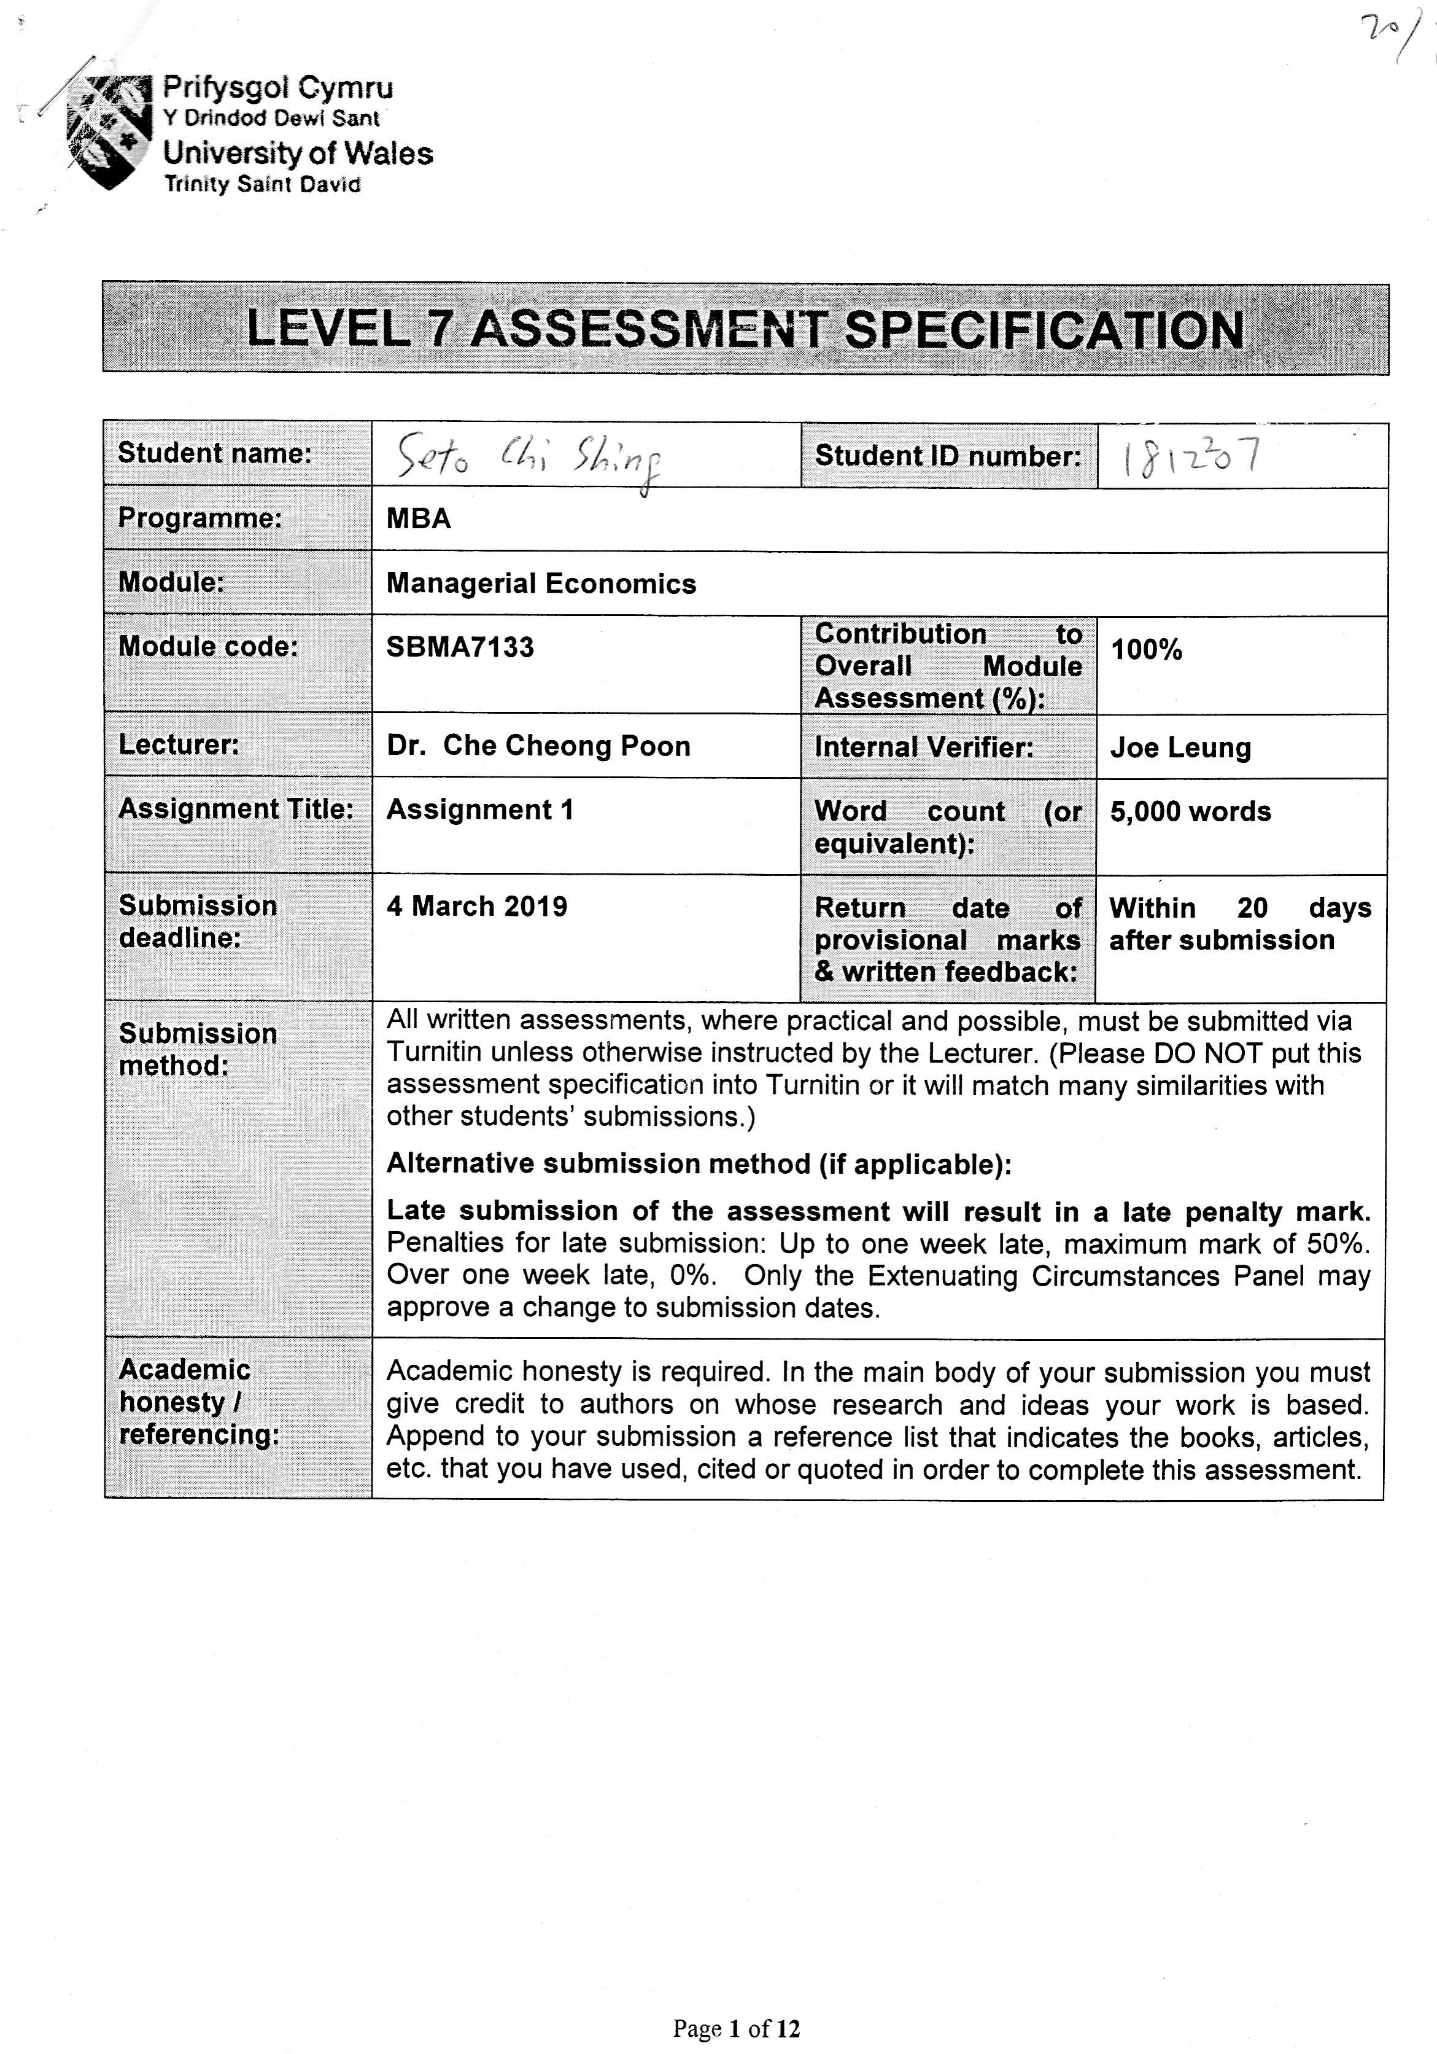

Table of Contents

 |  |  |  |  |  | Page
1 | Introduction |  |  |  |  | 1
 | 1.1 | The company’s product/service portfolio
 | 1.2 | The market for this product/service
2 | Case study design and planning |  |  |  |  | 5
 | 2.1 |  | Objectives and research questions
 | 2.2 |  | Quantitative/quality data collection method
 | 2.3 |  | Quantitative/quality data analysis method
3 | Analysis and discussion |  |  |  |  | 6
 | 3.1 |  |  |  | The price discrimination technique used by the company.
 | 3.2 |  |  |  | An evaluation of the price discrimination technique used by the company
4 | Conclusion and recommendation |  |  |  |  | 11
 | 4.1 |  |  | Conclusion
 | 4.2 |  |  | Recommendation
References |  |  |  |  |  | 12
Appendice |  |  |  |  |  | 13

- Introduction

  - The company’s product or service portfolio

The name of the company for the project is Dream Cruise. The name of the Cruise for the project is World Dream.

The following is the Dream Cruise company service portfolio:

Genting Dream with the total length 335 meters and 150,000 ton vessel provides 1,674 cabins
able to carry 3,352 guests and 2,000 crew members.
With over 70% of staterooms containing private balconies and more than 100 connecting rooms that will
ensure that family and larger group vacations have never been more convenient.
Foodies with delight in over 35 restaurant and bar concepts capturing the flavours of Asia and the world.
And a 610-metre wraparound promenade will allow for dramatic sea-side dining and lounging from sunrise to sunset.
In additional, a plethora of past times including pools, six water slides, play rooms, rock climbing wall, mahjong room and mini golf.
A full complement of health and well-being facilities will further enhance the guest experience including state of the art Asian and Western Spas,
A beauty salon, barbershop and health club.

  - The market for the this product/service

The Cruise business in Hong Kong is perfect competition and perfect elastic demand.
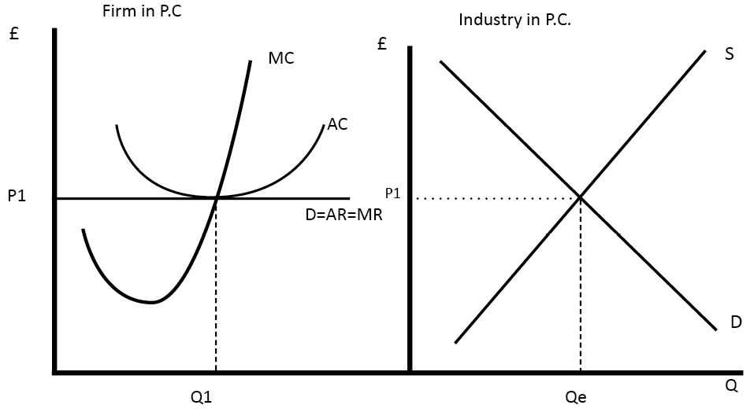

The target group of cruise tourism is no longer limited to retirees or family travelers. More and more cruise companies are renovating passenger ships, adding new and interesting leisure and entertainment facilities to attract young customers with colorful and fun sea journeys. In addition, the number of days of the voyage is also diversified, and the new short-term itinerary is suitable for passengers who have only a few days of holidays. In addition, the source market for cruise tourism is also changing. Statistics from the International Cruise Association show that the annual growth rate of Asian cruise tourism is as high as 8-9%, so Asian travelers have become a new target for cruise companies.

To tie in with the opening of the new cruise terminal, the HKTB has actively negotiated cooperation programs with major ports in Asia. In 2013, the HKTB signed a cooperation agreement with the Taiwan Tourism Bureau to promote the addition of two Hong Kong-based cruises to the Royal Caribbean International Cruise. Subsequently, at the "Miami Cruise Expo" in March 2014, the HKTB and the Taiwan Tourism Bureau announced the establishment of the "Asian Cruise Project" to support cruise companies in marketing and development of cruise tourism products to encourage further development including Hong Kong. And the Asian route to Taiwan. In addition, a number of ports including Hainan, Okinawa, Kagoshima, and the Philippines joined the "Asian Cruise Project" to enhance the confidence of cruise companies in developing the East Asian cruise market.

In the consumer market, the HKTB has promoted Hong Kong as a cruise holiday destination through various channels. The activities include co-organizing the "Cruise Holiday Expo", launching a regional marketing campaign for consumers, and focusing on the promotion of cruise tourism at the annual "Hong Kong International Travel Fair" and various overseas exhibitions.

In the market, cruise products including Hong Kong are constantly being launched. Travelers choose to travel to Hong Kong by cruise, so they can enjoy Hong Kong and enjoy the bustling scenery on both sides of the Victoria Harbor.

- Case study design and planning

  - Objectives and research question

To analyze the price discrimination techniques and its impact on Genting Cruise Lines Dream Cruises performance.

  - Qualitative data collection method

The sampling method of the qualitative data collection method is open ended and less structured protocols.
The tools of the qualitative data collection method is depend on interactive interview.
The result of the qualitative data collection method is produce results that give meaning, experience and views.
For this project is to get the data from Cruise tour catalogue.

  - Qualitative data analysis method

Analyzing Qualitative Data
Qualitative data analysis works a little differently from quantitative data, primarily because qualitative data is made up of words, observations, images, and even symbols. Deriving absolute meaning from such data is nearly impossible; hence, it is mostly used for exploratory research. While in quantitative research there is a clear distinction between the data preparation and data analysis stage, analysis for qualitative research often begins as soon as the data is available.
Data Preparation and Basic Data Analysis
Analysis and preparation happen in parallel and include the following steps:
1. Getting familiar with the data: Since most qualitative data is just words, the researcher should start by reading the data several times to get familiar with it and start looking for basic observations or patterns. This also includes transcribing the data.
2. Revisiting research objectives: Here, the researcher revisits the research objective and identifies the questions that can be answered through the collected data.
3. Developing a framework: Also known as coding or indexing, here the researcher identifies broad ideas, concepts, behaviors, or phrases and assigns codes to them. For example, coding age, gender, socio-economic status, and even concepts such as the positive or negative response to a question. Coding is helpful in structuring and labeling the data.
4. Identifying patterns and connections: Once the data is coded, the research can start identifying themes, looking for the most common responses to questions, identifying data or patterns that can answer research questions, and finding areas that can be explored further.

- Analysis and discussion

  - The price discrimination technique used by the company

* Price discrimination
* General concept of price discrimination
* “In pure price discrimination, seller will charge the buyer the absolute maximum price that he is willing to pay. Companies use price discrimination in order to make the most revenue possible from every customer. It is also describing the practice of selling identical goods or services at different prices from the same provider. This allows the producer to capture more of the total surplus by selling to consumers at prices close to their maximum willingness to pay. Although the cost of producing the products is the same, the seller has the ability to increase the price based on various criteria, consumer financial status, product demand, etc. Within commerce, there are specific criteria that must be met in order for price discrimination to occur, such as market power, recognition of difference in demand and ability to prevent arbitration or resale of product. In short, the purpose of price discrimination is to capture the market’s consumer surplus and generate the most revenue possible for a good. Usually, it is the result of unique characteristics of products or industry which may have some discretion over product pricing.”
Boundless Economics - LumenLearning (2019) Price Discrimination
Available at: http://www.courses.lumenlearning.com
(Accessed: 27-Feb-2019)

In the below, we are going to study on three types of price discrimination by observing some of their samples. Finally, we shall examine our focus case study, cruise industry, and analyze on its unique price discrimination characteristics.

First degree
First degree price discrimination
Charging whatever the market will bear
The purpose of price discrimination is to capture the market’s consumer surplus and generate the most revenue possible for a good. The monopoly seller of a good or service must know the absolute maximum price that every consumer is willing to pay and charge each customer that exact amount. This allows the seller to obtain the highest revenue possible.
“This first type of product pricing is based on the sellers ability to determine exactly how much each and every customer is willing to pay for a good. Different consumers have different preferences and levels of purchasing power and thus the amount they would be willing to pay for a good often exceeds a single competitive price. This difference between what a consumer is willing to pay and the price actually paid is known, of course, as consumers surplus. Thus a firm engaging in first degree price discrimination is attempting to extract all the consumers surplus from its customers as profits.”
Douglas A. Ruby (2003) Price Discrimination ,
Available at: http://www.digitaleconomist.org
(Assessed: 27-Feb-2019)

Sample
First degree price discrimination usually happen when the product or service becomes monopoly in the market. When consumer cannot find alternatives or other alike in the market, plus there is other attractive elements provided, they will be attracted and drawn to this target and willing to pay to fight for it. In most of the cases, consumers are paying for fame and reputation and desperate need. Take car industry as an example, when a car company has built up its high end image and reputation, car lovers will be drawn to purchase the newest model no matter how high is the price. Another similar example is the iPhone products of Apple Store. The phone is one of the highest among the market. Once the image and trend is built up, customers eagerly long for the newest version and pay for their vanity. In China, medical and education is the two most needed and profitable area. A well famed doctor can, of course, do price discrimination. Parents also have hot fever in their children education. Number one school usually only accepts neighborhood application, thus promoting top school area property price discrimination. Rugby Sevens in Hong Kong is another ticket fight for worldwide rugby fans for its fame, despite of the price. Last but not least, the trend of limited edition products are also the pursuing targets for uncountable youngsters. Price of online bidding on limited edition products? You name it. This is the magic of first degree price discrimination.

Cruise industry vs First degree price discrimination
Is Cruise industry doing First degree price discrimination? The answer is obvious. As aforementioned, the characteristics of First degree price discrimination count heavily on its uniqueness and fame, resulting in monopoly. For Cruise industry, there seems to be no very outstandingly monopoly cruise, which can claim unique and leading role in the industry. On the contrary, the cruise companies look more or less the same and the content seems similar between one another. In terms of size, cruises have standard size. For room, food, shopping and entertainments, the existing cruise in the marketing are offering more or less the same commercial choice. One may be stronger in this area and the other may be better in that area. No single cruise boat comes up as unique and outstanding. The only difference can be on the course of voyage. However, likewise, cruise boat seem to be some standard routes among those hot countries. Furthermore, to get on a cruise boat itself is not a worldwide prime trend. It used to be more high class and a symbol of wealth when cruise industry first emerged as a travelling choice. With the rapid growth on cruise operators and spread of market, nowadays, cruise does not represent a high end identity. As the price is getting lowered, more customers of all range can afford the price and share the cruise experience, cruise industry is unable to operate as any one of the above mentioned product / services and attract customers ‘to fight for a cruise ticket’. As a cruise boat, there is difficult to attract customers by ‘new version’. There is no desperate need for customers to be on board of a cruise boat. The cruise tickets are obviously not on ‘limited edition’. Most importantly, there is no magic of fame and vanity after a cruise boat holidays nowadays. Without all these basic pull and push factors, no one will fight for a cruise ticket and bid up the ticket price, thus it is not surprising that current Cruise industry is not in a position to do First degree price discrimination. But the Cruise market is the company is not monopoly seller of a good or service. The existing market has so many Cruise companies such as Dream Cruises, Star Cruises, etc. ,so it is not a First degree of price discrimination.

Second degree
Second degree price discrimination
Quantitative discounts or versioning
“In second degree price discrimination, price varies according to quantity demanded. Larger quantities are available at a lower unit price. This is particularly widespread in sales to industrial customers, where bulk buyers enjoy higher discounts.
Additionally to second degree price discrimination, sellers are not able to differentiate between different types of consumers. Thus, the suppliers will provide incentives for the consumers to differentiate themselves according to preference, which is done by quantity "discounts", or non-linear pricing. This allows the supplier to set different prices to the different groups and capture a larger portion of the total market surplus.”
Michael R. Baye (2010) ‘Pricing tragedies for Firms with Market Power’, Managerial Economics and Business Strategy, 7th ed., pp. 404.

Sample
Second degree price discrimination happens when price is lower due to bulky purchase. It is very common in manufacturing industry between wholesale and retail customers. Every industry has its own specific reasons on the price cut. Take printing industry as an example, the price of printing name card and brochure decreases in accordance with the increasing printing quantity. To initiative one printing operation involving the bulky printing machine, there are unavoidable basic costs both on manpower and material consumption. Therefore, bulky printing with higher revenue is always welcome and encouraged. Other industry such as telecommunication and use of energy is also charged less for higher consumption. By observing the price list of telecommunication company and energy consumption bills, we see the decrease on price occurring when there is increase on usage. Such behavior of attracting bulky quantity on a lowering price is the second type of price discrimination on seizing higher revenue.

Cruise industry vs Second degree price discrimination
Can Cruise industry perform the Second degree price discrimination? The answer is also obvious. The characteristics of Second degree price discrimination is to push up revenue by attracting bulky quantity consumption. According to the current cruise industry, it is more a common trend of retail customers. Some customers do come as a group but it is far from the definition of bulky quantity. The sales strategy of cruise boat is more on its content on the boat and selling points. For tourism industry, we rarely hear the discounts on a 20-people group. Tour or cruise are instead a combination of various retailed customers, forming into a tour or cruise passengers. There is no attraction point of bulky quantity consumption behavior by being on a cruise. Therefore, the Second degree price discrimination strategy is rarely used in Cruise industry.The Cruise ticket price does not vary according to quantity demanded, so it is not a Second degree of price discrimination.

Third degree
Third degree price discrimination
Separate markets and customer groups
“The final type of price discrimination is commonly practiced by firms that recognize that the demand for their product differs systematically across consumers in different demographic groups. In these instances firms can profit by charging different groups of consumers different prices for the same product. For example, it is common for stores to offer ‘student discounts’ and for hotels and restaurants to Ofer ‘senior citizen discounts’. These practices effectively mean that students and senior citizens pay less for some goods than do other consumers. One might think that these pricing strategies are instituted to benefit students and senior citizens, but there is a more compelling reason: to increase the firm’s profits.”
Michael R. Baye (2010) ‘Pricing tragedies for Firms with Market Power’, Managerial Economics and Business Strategy, 7th ed., pp. 404-405.

Sample
Third degree price discrimination is characterized by differentiating the customer groups and charged differently for the purpose of maximizing the revenue. This type of price discrimination is different from the previous two that there is no need for fame or monopoly, nor there is any encouragement on bulky quantity purchase. The revenue increase is achieved simply by single out the groups and charge accordingly. Such commercial conduct is even openly acknowledged by the customers and widely accepted. For instance, air fare is a commonly known business using this price discrimination approach. The air fare is differentiated between direct flight, indirect flight, day flight, night flight, first class and economy class with all different charges. Textbook and pharmaceutical industry is another example, with the same book content, we will find different price in advanced countries and low cost countries, whilst drugs price is following the same format. Subsequently, there is a worldwide university charging their school fee by categorizing the students’ country of origin and presenting school fee for Country A, Country B and Country C according to the wealth level. There are also categorization on customers by single out their location and price discrimination is being applied. The residents in Discovery Bay, Hong Kong and Clifford Estates, Guangzhou, China are sharing similar characteristics of residing in remote area, inconvenient to commute outside. One is located on a big island, whilst the other is located in a traffic congestion zone which is far and difficult to reach. They both become a community by themselves and residents intend to stay within the housing estates. Merchants naturally provide all sorts of basic needs for life and the commercial activities happen more and more within the housing estates. With this circumstances, these single out remote residents become the target of Third degree price discrimination. Due to convenience and time consideration, the customers are willing and used to this commercial behavior.

Cruise industry vs Third degree price discrimination
Further to the above, cruise industry does not belong to the First nor Second degree price discrimination. There are sufficient information showing that cruise industry belongs to the Third degree price discrimination. It means the passengers on the cruise are being categorized by different criteria. The cruise subsequently is charging differently based on these different categories with different prices. Such price difference is determined not by the nationality, country location or customer location, but by the pure preference and personal choice of customers, meaning a single customer does not carry any specific characteristics for making such choice. It is the marketing and commercial intention of the cruise, categorizing the criteria and specification of the room, providing a list of choice to customers and they are choosing whatever suits their preference. With the same room specification, the price varies due to different factors according to the discounts and selling points set out by the company. Therefore, it is a free will with fair ground on the customer side. Not like some of the above examples, some of the customers are passively restricted to receive Third degree price discrimination. Having said that, there may be certain conditions leading to the choice of cruise customers. However, they still retain the free will of opting to join or not according to their circumstances. To summarize, the pattern of Third degree price discrimination offered by the cruise industry is not based on the urge and need of the customers. It is an approach of providing more marketing choices, providing discounts and attraction points to customers, as a result, increasing the revenue of the cruise. The Cruise ticket price does charging a different price to different consumer groups, so it is Third degree of price discrimination.
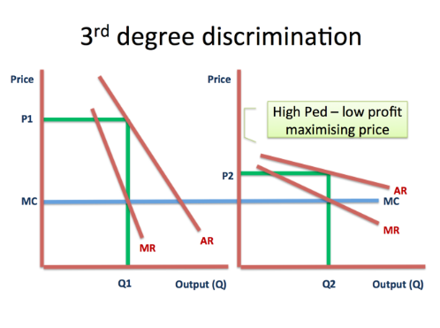
MR = MC
Where MR (marginal revenue), MC (marginal cost), P (price), E (elacticity)

P = { |E| / ( 1- |E| ) } x MC

3.2 An evaluation of the price discrimination technique used by the company

Let’s take a close look at the approach of the price design of the cruise and analyze how Third degree price discrimination is being applied and brings in higher revenue.

Please refer to the blue highlighted figures in first 3 pricelists from the below for case study.
(Pricelist code: HTTP8 / HTTP18 / HTTP38)

World Dream, operated by Cruises center, Hong Thai Travel
Ocean-view stateroom
The room price list for this cruise is categorized into certain criteria. There is an original price of an ocean-view stateroom on the new year day of HK$4,370. Meanwhile, a New Year special offer is being provided at a rate of HK$2,693. With this nearly half price attraction and holiday peak season, the cruise has a high chance absorbing a high increase of customers with this price cut and choice of offer date. Other than the new year offer on 8-Feb-2019, the cruise is also offering other price cut attraction during the month from Feb to Mar 2019. The original price during this period for the same ocean-view stateroom is HK$2,910, however, the cruise is providing promotion offers and give price cut. For example, if there are 3 to 4 passengers sharing the same room, using the maximum capacity of the room, the room price will be lowered to HK$2,183. Another attraction point for customer is Birthday special offer during this period. The birthday person will receive a price cut to HK$2,040 for the same room. During the month of Feb and Mar, the original room rate is HK$6,840. There is a discount of Winter special offer and the price of the same room is being cut down to HK$5,130. During the month from Jan to Mar, the cruise also provides Birthday special offer for the same room at a rate of HK$4,790. By categorizing all these criteria and customers are given various discounts, more customers are being attracted and Third degree price discrimination is being used to enhance the total revenue.

4 | Conclusion and recommendation

4.1 | Conclusion

By observing the First degree, Second degree and Third degree price discrimination, we understand that such application is commonly applied in the current commercial world and a guarantee for increased revenue. The provider is to be carefully consider their approach and gain the highest return by applying the most appropriate price discrimination according to their product nature. For our focus case study, Cruise industry, the current approach with the operator is Third degree price discrimination, which is considered to be mild and reserved. With our recommendation and suggestion, cruise industry has room to grow into a more bright and shining industry by applying all three price discrimination approach and inputting with more unique and monopolistic elements. Price discrimination is proved to be a useful and practical tool for enhancing company profit when being applied appropriately.
4.2 | Recommendation

By observing the price set, discount offer and category type, we see clearly that the cruise is using marketing strategy and giving discount, in order to attract customers. By setting out different price at different time and different conditions, such as high season, low season, departure date, winter offer, early bird offer and birthday offer, the cruise successful distinguish different customer group and charge at different price. By doing so, customers are drawn more to the proposed price set. It turns into a successful Third degree price discrimination model.

However, no matter how many offers were being given, it is still the single mono skill of discounts and one type of price discrimination. Customers are undoubtedly drawn more due to the price offer, but it is not an outstanding attraction or excitement or urge for customers. Plus, the pattern of the cruise is maintained in a casual retail sale format and it does not become a fight for the cruise participation. Discount is given and customers enjoy a little. The increase of revenue is not yet at a peak as if could.

By observation the precious two types of price discrimination, revenue is absorbed to the highest that the market can bear with a bulky quantity of customers. If we can mold the three types of price discrimination together, the cruise can receive the highest and long lasting revenue ever.

Considering the First degree price discrimination, customers have an eager urge to fight for the product or ticket due to fame or limited supply. The other prerequite is such product or service is a monopoly and they cannot find an alternatives. For cruise industry, there is no single cruise that has come top in the industry. Therefore, it is the marketing technique and content provided to create an uniquely un-replacement cruise. The hardware is there already. The cruise operator can enter high end software to attract specific high end class of customers. Not only the content and services provided cannot be commercial and usual as every other cruise, expertise needs to be placed in the cruise. The operator can consider a theme for each cruise. For example, global networking opportunity for businessman, jewellery industry, designer, medical or education sector groups. There can be even mix between different customer groups. In that way, customers not only come for holidays, they will gain precious reward by joining this cruise. Furthermore, due to the specification of class and gathering of professionals, the fame and reputation including content and services is to be upgraded naturally. With this setting, customers will start to eager and wait and fight for a cruise ticket. In this sense, First degree price discrimination can be applied subsequently.

Not only the cruise operator can put First degree price discrimination for a unique cruise, the Second degree price discrimination will come along naturally. If the cruise is to be advertised globally for worldwide professionals and expertise on certain field, those international organization will tend to send representatives or teams to join such cruise. By provide group discount, those bulky quantity high end customer groups will be absorbed and they have a tendency to repeat their attendance annually. As such, stable wholesale revenue will be guarantee through Second degree price discrimination.

With the First degree and Second degree price discrimination secured, the cruise operator can easily implement the Third degree price discrimination together. Categorizing customers into sub group and encourage their consumer behavior at a lower rate but higher quantity and revenue input.

To conclude, cruise industry is one of the unique industry that can apply all three degree price discrimination together for a tremendous increase on revenue with good fame and monopoly. The operator just need to put in more creative ideas and market friendly elements.

References

- Baye, Michael R. and Prine Jeffrey T. (2017) Managerial Economics And Business Strategy. 9th edition. McGraw-Hill/Irwin

- Brickley, J.A., Smith, C W and Zimmerman, J.L (2007) Managerial Economics and Organization Architecture. 4th edition, Mcgraw-Hill.

- Dul.J., and Hak, T.(2007) Case Study Methodology in Business Research. Routledge.

- Hirschey, M (2016) Managerial economics. Cengage Learning.

- Perloff, J M and Brander, J A (2017) Managerial Economics and Strategy. Person.

- Samuelson, W F and Marks S G (2010) Managerial Economics, 6th Edition, John Wiley & Sons.

- Samuelson, W F and Marks, S G (2011) Managerial Economics, Study Guide. London: John Wiley & Sons.

- Solman, J and Hinde, K (2012) Economics for Business. London: FT/Prentice Hall.

Price discrimination through refund contracts in airlines

International Journal of Industrial Organization, May 2014, Vol.34, pp.1-8

Price Discrimination and the Cruise Line Industry: Implications for Market Definition, Competition, and Consumer Welfare

International Journal of the Economics of Business, 01 February 2008, Vol.15(1), p.1-25

Optimal cruise-liner passenger cabin pricing policy

European Journal of Operational Research. 11/25/91, Vol. 55 Issue 2, p136-147. 12p. 3

Travel Agency: Hong Thai Travel
Cruises company name: CRUISES center
Cruise name: World Dream世界夢號
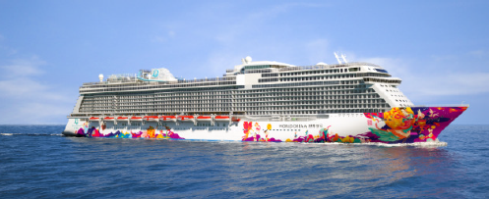
code | Room type | Birthday special offer  Feb-Mar 19 | 3-4 passengers in a room  Feb-Mar 19 | Original price  Feb-Mar 19 | New year special offer 8/2/2019 | Original price  8/2/2019 | Maximum number of passenger
HTT1 | Palace villa |  |  | HK$22430 |  | HK$33640 | 4-6
HTT2 | Palace penthouse |  |  | HK$15700 |  | HK$21310 | 4
HTT3 | Palace deluxe suite |  |  | HK$6390 |  | HK$9310 | 4
HTT4 | Palace suite |  |  | HK$5270 |  | HK$7960 | 4
HTT5 | Palace suite |  |  | HK$5270 |  | HK$7960 | 4-6
HTT6 | Balcony deluxe stateroom | HK$2670 | HK$2858 | HK$3810 | HK$3615 | HK$5830 | 3
HTT7 | Balcony stateroom | HK$2440 | HK$2610 | HK$3480 | HK$3360 | HK$5490 | 3
HTT8 | Ocean-view stateroom | HK$2040 | HK$2183 | HK$2910 | HK$2693 | HK$4370 | 3
HTT9 | Interior stateroom | HK$1570 | HK$1680 | HK$2240 | HK$2100 | HK$3590 | 2
Port charge: HK$410
Service charge: HK$300 (stateroom), HK$240(non-stateroom)

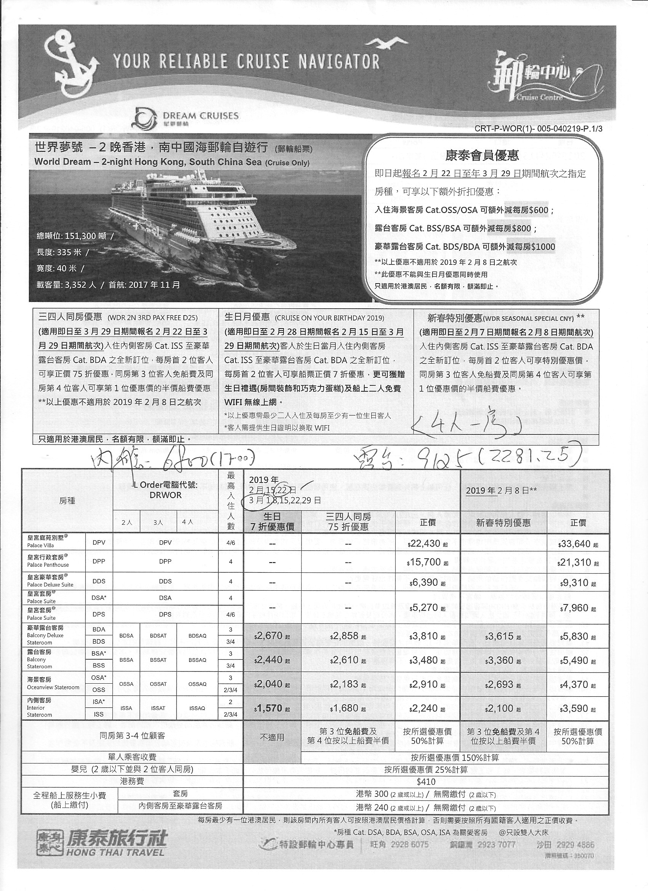
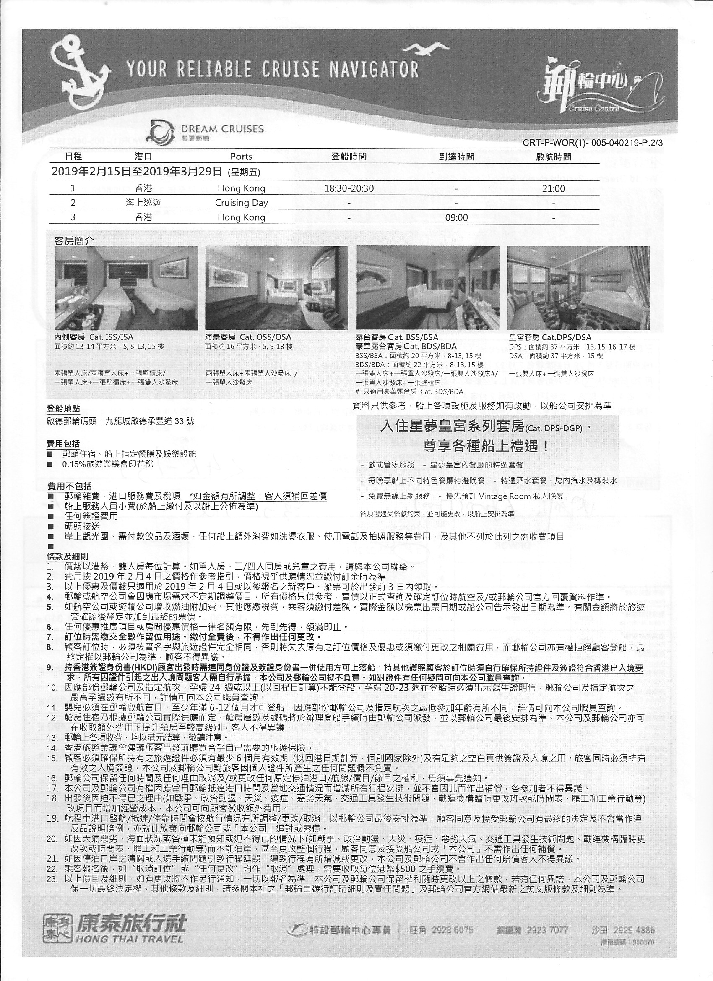
Travel Agency: Hong Thai Travel
Cruises company name: CRUISES center
Cruise name: World Dream世界夢號
code | Room type | Birthday special offer  Mar Jan 2019 | Winter special offer  Feb-Mar 2019 | Original price  Feb-Mar 2019 | Birthday special offer  Jul Aug 2019 | Original price  Jul Aug 2019 | Original price  29/9/2019 | Maximum number of passenger
HTT11 | Palace villa |  |  | HK$48670 |  | HK$48670 | HK$48670 | 4-6
HTT12 | Palace penthouse |  |  | HK$39250 |  | HK$39250 | HK$39250 | 4
HTT13 | Palace deluxe suite |  |  | HK$24790 |  | HK$24790 | HK$24790 | 4
HTT14 | Palace suite |  |  | HK$14920 |  | HK$14920 | HK$14920 | 4
HTT15 | Palace suite |  |  | HK$14920 |  | HK$14920 | HK$14920 | 4-6
HTT16 | Balcony deluxe stateroom | HK$5740 | HK$6150 | HK$8190 | HK$7310 | HK$10430 | HK$12450 | 3
HTT17 | Balcony stateroom | HK$5500 | HK$5130 | HK$7850 | HK$7070 | HK$10100 | HK$12110 | 3
HTT18 | Ocean-view stateroom | HK$4790 | HK$5130 | HK$6840 | HK$5980 | HK$8530 | HK$10210 | 3
HTT19 | Interior stateroom | HK$3930 | HK$5610 | HK$5610 | HK$4720 | HK$6730 | HK$9090 | 2
Port charge: HK$410
Service charge: HK$300 (stateroom), HK$240(non-stateroom)

Travel Agency: Hong Thai Travel
Cruises company name: CRUISES center
Cruise name: World Dream世界夢號
code | Room type |  | Winter special offer  Feb-Mar 1,8,15,22 Mar2020 | Original price  Feb-Mar 1,8,15,22 Mar2020 |  |  |  | Maximum number of passenger
HTT31 | Palace villa |  |  | HK$48670 |  |  |  | 4-6
HTT32 | Palace penthouse |  |  | HK$39250 |  |  |  | 4
HTT33 | Palace deluxe suite |  |  | HK$24790 |  |  |  | 4
HTT34 | Palace suite |  |  | HK$14920 |  |  |  | 4
HTT35 | Palace suite |  |  | HK$14920 |  |  |  | 4-6
HTT36 | Balcony deluxe stateroom |  | HK$6150 | HK$8190 |  |  |  | 3
HTT37 | Balcony stateroom |  | HK$5130 | HK$7850 |  |  |  | 3
HTT38 | Ocean-view stateroom |  | HK$5130 | HK$6840 |  |  |  | 3
HTT39 | Interior stateroom |  | HK$5610 | HK$5610 |  |  |  | 2
Port charge: HK$1559
Service charge: HK$300 (stateroom), HK$240(non-stateroom)



