Hotel Placement – Managing Hotel Administration
Department Focus: Reception and Bar Operations
Module No: BMIH6004 - Student Learning Log
Student Name: Cristina Petrache
Student no: 2234360
Lecturers: Daniel Payne, Jessica Newport, Kathryn Roberts
Date of submission: 14/11/2025

AI Declaration:
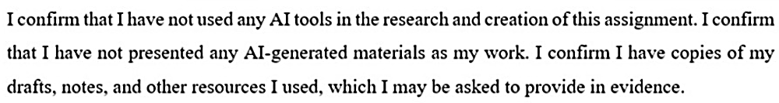

Table of Contents
1 Introduction 3
2 Gibbs’ Reflective Model 4
2.1 Description 4
2.2 Feelings 5
2.3 Evaluation 5
2.4 Analysis 6
2.5 Conclusion of Reflection 6
2.6 Action Plan 7
2.7 Conclusion and Development plan. 7
3 References 8

Introduction
I am now on a ten-week placement at The Cheltenham Chase Hotel, which is part of the QHotelsColumn at Gloucestershire. It is a four-star hotel that offers a wide range of services and facilities, such as a bar and reception, event and conference rooms, a spa, a leisure club, and accommodation. I was placed on 29 September 2025 and work two days a week in the Reception Department, where I assist and learn under the supervision of Harriet and Sandra. My responsibilities include handling guest check-ins and check-outs, managing room reservations, and supporting the smooth operation of the front desk. The Reflective Cycle of Gibbs has been used in this report. The model provides a systematic approach that includes 6 steps, which are description, feelings, evaluation, analysis, conclusion, and plan of action (Adeani et al., 2020). This reflection has the aim of critically analysing my development as a professional over the course of the placement, and it has the aim of demonstrating the development of my skills since the Level 4 to where I am currently in my studies.

Gibbs’ Reflective Model
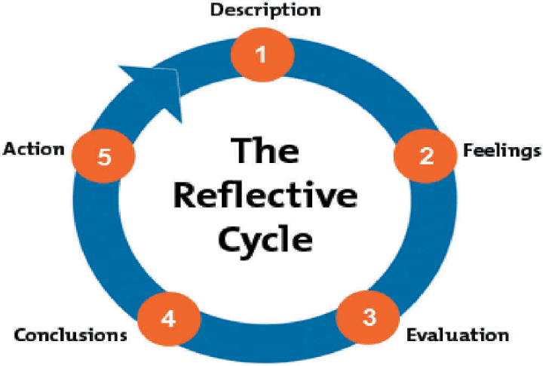
Figure 1 Gibbs' Reflective Cycle
Source: Ahmed (2019)

Description
In the first two weeks of my engagement in the reception desk, Harriet and Sandra gave me extensive training on how the guest check-in and check-out works. One evening on a very busy Friday, a situation of a double-booking arose in the reservation system. Moreover, I was also tasked with the management of the booking platform and ensuring that there were clear channels of communication with the guests as well as internal stakeholders. The incident enlightened the Level 4 experiential learning undertaken at a boutique hotel restaurant where I gained expertise on service etiquette and collaborative techniques in work. These cumulative experiences have enabled me to get accustomed to the increased and faster operational environment at Cheltenham Chase. Since the hospitality sector of the United Kingdom employs around 1.83 million people, it requires a strong coordination, effective operations, and managerial control of the industry (Baum et al., 2023). This incident confirmed the importance of leadership, top-tier communication, and adaptability as far as hospitality management is concerned.

Feelings
At first, I was nervous about adapting to the Reception’s fast-paced environment and mastering the Property Management System (PMS) within a short time. During my first shift, several guests arrived at once, and I felt overwhelmed. However, Harriet supported me in prioritising tasks and maintaining composure, which helped build my confidence in handling pressure. I knew that emotions had a potential to affect my performance. A guest's compliment that I was attentive encouraged me to keep providing good service. According to Goleman's Emotional Intelligence Theory, hospitality requires self-awareness and emotional control. It has been observed that emotional intelligence is as important as technical ability in customer-facing roles, improving hospitality workers' performance, job satisfaction, and service quality (Zhu et al., 2022). I can perform better and stay in control during long shifts by learning how to handle pressure.

Evaluation
My experience was associated with a number of positive results and the areas of development that can be identified. On the positive side, I have improved my communication and team work skills especially when under pressure. Working with the Reception team improved my time-management and communication skills (Felce, 2019). I also appreciated the way Harriet and Sandra motivated the team through positive feedback. However, I noticed that I still need to develop assertive communication, particularly when managing multiple guest queries during peak check-in times. At times my hesitation resulted in order delays. When I was thinking of the Level 4 module Customer Experience Management, I remembered that I had heard about SERVQUAL model that emphasises reliability and responsiveness in service quality. The theory needs one to think fast and to be confident, which are qualities that I am still developing as I apply it in real life. Moreover, studies have shown that communication problems have been one of the most common operational problems quoted by 47% of hospitality workers (Wood, 2013). This firsthand experience has made me acutely aware that effective communication and prompt communication are what is at the foundation of a satisfied customer and a well running operation.

Analysis
2.4 Analysis
There are academic theories that fit into my developmental path analytically. Kolb Experiential Learning Cycle argues that the concept of learning can involve actual experience, reflective observation, abstract conceptualisation, and active experimentation (Cheung & Delavega, 2024). This cycle is reinforced every time I rotate in Cheltenham Chase, specifically, having to deal with guest queries and special requests in Reception helped me become more detail-oriented and able to foresee guest needs. Empirical studies show that the hotels, where the employees are more engaged, attain higher quality of service and customer satisfaction (Silva, 2025). Cheltenham Chase proved the fact that motivated groups were able to cope with peak periods better.
During the Level 4 course in Hospitality Human Resource Management, I studied the Two-Factor Theory of Herzberg who distinguishes between hygiene factors and motivation including recognition. Practically, this idea was reflected in the Reception briefing sessions during which Harriet would praise employees and create a positive and encouraging environment. Work placements also enhance the technical skills, as well (Haag, 2013). The knowledge of property management system (PMS) broadened my perspective on the fact that technology is the basis of efficient guest management, proper billing, and flowed check-in processes. A significant number of hotels depend on the use of integrated IT systems, which makes technical expertise a prerequisite to achieve operational efficiency (Wynn, 2023). The frequent utilization of said systems increases accuracy, speed, and financial and administrative understanding of hotels (Jawabreh, 2022).

Conclusion of Reflection
In consideration t of these experiences, I can state that my placement at the Cheltenham Chase has been both challenging and growthful. The experience has strengthened my understanding of teamwork, leadership, and communication within the Reception Department. Relative to the work that I did at Level 4, I have developed a sense of independence and confidence in handling guest interactions or complicated scenarios. The reflective cycle proposed by Gibbs has allowed the systematic analysis of the experiences, recognition of the lessons, and development of the strategies to work on them. I have, therefore, developed high levels of self-awareness, emotional stability and active problem solving. According to a recent study, job readiness is also improved by 30% with the help of structured reflective learning, which proves the professional worth of using reflective cycles in work-based learning (Felce, 2019).

Action Plan
In order to continue on my advancement, I have outlined three main goals. To begin with, I am determined to develop the skill of assertive communication by watching the styles of management communication and engaging in dialogues with clarity when faced with a situation of high pressure of service provision. Second, to increase technical expertise in property management systems (PMS) and financial platforms, which are regarded as critical skills in future supervisory roles, I would also seek extra training opportunities offered by the administration department of the hotel. Third, I will continue to use Gibbs Reflective Cycle as a systematic self-reflection tool and keep reflective journal where I document my lessons and progress after every rotation. According to the CIPD Learning Report, the hospitality careers show that constant professional growth increases the chances of promotion by 27% (Preko and Anyigba, 2024).

Conclusion and Development plan.
The reflection represents an example of how the systematic implementation of the Reflective Cycle created by Gibbs helped me shift understanding to a competence level. The rotation at The Cheltenham Chase Hotel has further enhanced my understanding of interdepartmental cooperation towards guest services provision of high quality. Comparing it to my Level 4 experience, it is possible to note a clear development in professional skills in leadership acumen, emotional intelligence, and operational capability. The combination of the learning theories experiential cycle by Kolb, hierarchy of needs by Maslow and concept of motivation-hygiene by Herzberg has enriched my critical interpretation of hotel management.

References
Ahmed, M. (2019) Gibbs’ reflective cycle [figure]. In: Students' reflective journaling: an impactful strategy that informs instructional practices in an EFL writing university context in Qatar. Available at: https://www.researchgate.net/figure/Gibbs-reflective-cycle_fig1_341090108 (Accessed: 8 October 2025)
ASET (2017) Good Practice Guide for Workbased and Placement Learning in Higher Education. Sheffield: ASET. Available at: https://www.asetonline.org/wp-content/uploads/2024/04/ASET-Good-Practice-Guide-Work-based-and-Placement-Learning.pdf
Baum, T., Mooney, S., Robinson, R. and Solnet, D. (2023) Work, Wages and Employment in the UK’s Hospitality Sector. ReWAGE Evidence Paper. University of Warwick. Available at: https://warwick.ac.uk/fac/soc/ier/rewage/publications/employment_in_uk_hospitality_-evidence_paper-_formatted_edited.pdf (Accessed: 8 October 2025)
Cheung, R. and Delavega, E. (2024) ‘Experiential Learning in Mental Health Diversion: an interprofessional experiential learning opportunity grounded in Kolb’s Learning Theory’, Journal of Experiential Learning and Teaching, Available at: https://www.tandfonline.com/doi/full/10.1080/26408066.2024.2444316 (Accessed: 8 October 2025)
Felce, A. (2019) ‘Managing the quality of higher education in apprenticeships’, Higher Education, Skills and Work-Based Learning, 9(2), pp. 141–148. https://www.emerald.com/heswbl/article-abstract/9/2/141/94620/Managing-the-quality-of-higher-education-in?redirectedFrom=fulltext
Haag, E. (2013) Internship Guide: Work Placements Step by Step. 1st edn. The Hague: Eleven International Publishing. https://research.rug.nl/en/publications/internship-guide-work-placements-step-by-step-2
Jawabreh, O. (2022) ‘The strategic deployment of information systems attributes, resources and capabilities: evidence from Jordanian hotels’, Information Systems Management, 39(4), pp. 255-272. Available at: https://digitalcommons.aaru.edu.jo/cgi/viewcontent.cgi?article=1426&context=isl (Accessed: 31 October 2025).
Preko, A., and Anyigba, H. (2024) The tourism and hospitality career progression pathway. International Hospitality Review, 38(1), 54-80. https://www.emerald.com/insight/content/doi/10.1108/IHR-02-2022-0005/full/pdf
Silva, S. (2025) ‘How Human Resources Management Practices Affect Service Quality in Hotels: The Role of Employee Motivation’, Proceedings of the International Conference on Tourism Research and Innovation, pp. 1–14. Available at: https://papers.academic-conferences.org/index.php/ictr/article/download/2140/3125/12437 (Accessed: 8 October 2025)
Wood, R. C. (2013) Key Concepts in Hospitality Management. London: SAGE Publications Ltd. Available via Sage Knowledge preview: https://sk.sagepub.com/dict/mono/preview/key-concepts-in-hospitality-management.pdf
Wynn, M. G. (2023) “Digitalisation and IT Strategy in the Hospitality Industry”, [Journal name/publisher if available]. Available at: https://eprints.glos.ac.uk/13238/8/13238%20WYNN%20Martin%20%282023%29%20Digitalisation%20and%20IT%20strategy%20article.pdf (Accessed: 8 October 2025)
Zhu, D., Doan, T., Kanjanakan, P. and Kim, P. B. (2022) ‘The impact of emotional intelligence on hospitality employees’ work outcomes: A systematic and meta-analytical review’, Journal of Hospitality Marketing and Management, 31(3), pp. 326–347. Available at: https://researchportal.northumbria.ac.uk/files/90399104/Final_version.pdf (Accessed: 8 October 2025)

