Mobile Application Development II
  - Lecture 4 Lab Tutorial Exercise

The Quiz App Part I

Objectives
In today’s exercise, you will create an app that uses the Model-View-Controller (MVC) design pattern. Additionally the app will have two activities that communicate with each other (Part II).

Exercise 1: Getting Started
- Create a new project for today.
- Add a new empty activity to it called QuizActivity or whatever you want.

Exercise 2: Creating the Model
- The model holds the application’s data and business logic. Their sole purpose is storing and managing data. In Android apps, the models are typically the custom classes you create.
- The model for this exercise is the Question class, which represents a single question in the quiz question bank.
- Create a new class in your project called Question.
- Each question has two pieces of data:
  - The question text
  - The question answer (true or false)
Add the following two member variables to store this information.
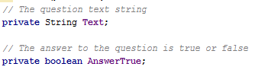
- Next add a constructor method to initialise the member fields when a new question object is created.
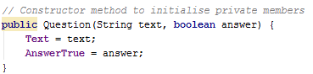
- Next, you need to create a set of getter and setter methods. Android can generate these for you. Right-click just after the constructor method, and in the popup window, select Getter and select the two fields in the following window that displays (you can select multiple fields at time)
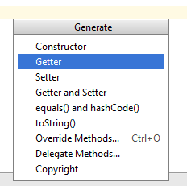
- Repeat the last step to generate the Setter methods too.

Exercise 3: Creating the View
- The view is the layout – what the user sees. You will use a linear layout to display the view objects in a linear fashion.

String Resources for the Layout
- The layout requires a couple of string resources. Open up the string resources file
- Add the following string resources. Feel free to use your own string label values.
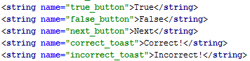

The Layout File
- Open up the activity layout XML file.
- Change the default layout from relative to linear as shown.
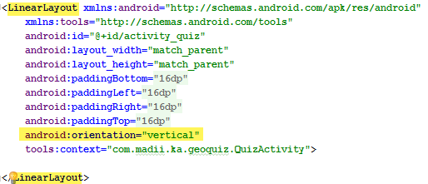

The Question Text View Object
- For the default text view adding to the layout, make the following changes:
  - Remove the default android:text attribute
  - Set the Android ID:
  - Set the padding (android:padding) to 24dp (device independent sizing, it is advisable to use dp units and not fixed pixel (px) units)
  - Layout width and height: wrap content

The True and False Buttons
- Next add two buttons:
True Button
  - Android ID: true_button
  - Layout width and height: wrap content
  - Android text: true button string resource
False Button
  - Android ID: false_button
  - Layout width and height: wrap content
  - Android text: false button string resource
- If you preview your layout using the Design view tab at the bottom of the page, you will find that everything is in a linear fashion. You do, however, want the True and False buttons displayed side-by-side.
- Return to the text view and insert another linear layout, just after the Text View object.
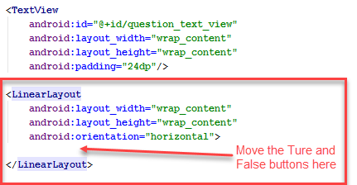
- Move the two buttons to the position shown.
- Have a preview using the Design view.

The Next Button
- Next, add another button after the linear layout that contains the True and False buttons with the following properties:
  - Android ID: next_button
  - Layout width and height: wrap content
  - Android text: next button string resource

Exercise 4: Creating the Controller
- Controllers tie the model and the view together. They contain the “application logic”. They respond to the view events and update the view accordingly from the model. In Android apps, controllers are typically Activities, Fragments or Services.
- For this exercise, the controller is the QuizActivity or whatever your single activity is called. Open it up so you can add some application logic to it.

Getting Access to the Layout View Objects
- First, you will add some variables to store and reference the different view objects on the layout as the controller needs to:
  - Listen for the different button click events
  - Update the Text View object accordingly
The variables need to have global scope so they are accessible to all methods in the activity – add as highlighted. If prompted, accept the imports (otherwise you will need to import android.widget.Button and android.widget.TextView).
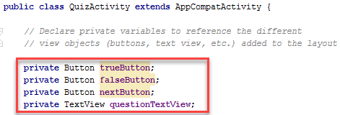
- Recall that the onCreate method executes when the activity first starts and it is a useful place for initialisation. Use the findViewById() method to initialise the view object variables as shown:
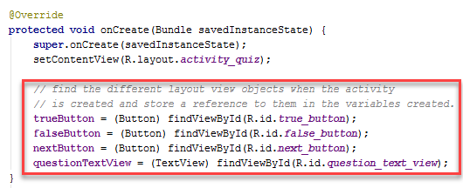

Creating the Button Click Event Listeners
- You need to create event listener methods for each of the buttons. Add these after the onCreate() method. The first one is shown below. Don’t forget the semi-colon at the end and don’t worry about the logic just yet.
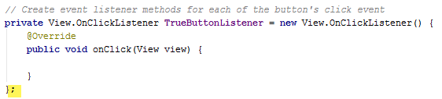
- If you have not done so already, also add listeners for the False and Next buttons.
- Next, you need to bind (link) each of the event listener methods to the corresponding button. You use the set
- Return to the create method and add the following in the onCreate() method after initialising the view object variables.
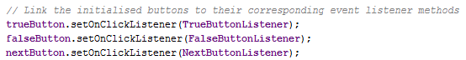

Retrieving the Questions
- One of the responsibilities of the controller is to manage the display and flow of data between the model and the view, so it needs to read the data and sometimes send updates.
- You will create another variable with global scope that will store the data, an array collection of question objects.
- Return to the top of the class and add the following array object variable definition (Ashely, you can copy the comments ).
// Variable to store quiz questions
// It will get the quiz questions and
// answers from a string array resource and load them
// into an array object called questionBank in the activity
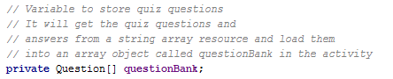

The Questions
- You need a set of True/False questions to display and store these as a string array resource. You can Google: Quiz questions true or false. I have taken mine from: http://www.quiz-zone.co.uk/quizrounds/020317trueorfalse/answers.html.
- Open up the strings resources file.
- Add your chosen questions, but please note the following:
  - You need to add the questions and corresponding answer in the following format (i.e. separated by the pipe “|” character). I have highlighted the first few in yellow.
Question text …|Answer
  - If your question text contains any special characters (e.g. single or double quotes), you will need to escape them using the back slash “\” character. See examples highlighted in orange.
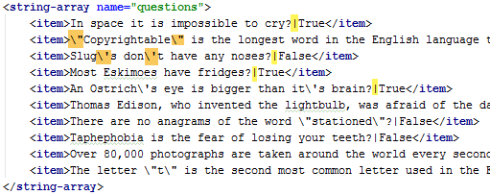

Loading the Questions
- Return to the activity.
- You will create a separate method to load up the questions.
- Create a new method at the end of the activity class called loadQuestions with a return type of void (method does not return anything).
- Retrieve the array items in the string array resource into a temporary string array variable, questions.
// Get the questions string array resource
- Next get the number of questions using the array object’s length property
// Get the number of questions from the length property
- Initialise the global question bank array object to receive the question items.
// Initialise the questionBank array object to receive the array items
- Next you need to loop through each of the string resource array items (temporarily stored in the questions array) and parse the items into Question model objects.
// Loop through the questions array and parse out the question and answer
// The question and answer are stored in the format "Question|Answer" (i.e. separated by | character)
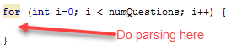

- Recall that each question and answer is stored as Question text…|Answer, i.e. separated using the pipe “|” character. You will use the string’s split method to split the string based on this character. The result is an array object with:
  - Question at index zero [0]
  - Answer at index one [1]
// Use the string split method to split the current question string based on the "|" character
// The question will be item 0, and the answer will be item 1
// Add the current question to the question bank array object
- That’s all for the loadQuestions method, but you need to call the method in the onCreate() method.

Updating the View with the Current Question
- The controller (activity) needs to update the view with the current question to display.
- As all the questions are stored in the questionBank array object, an index is needed to point to the question of interest (array items are accessed via index numbers).
- Return to the top of the class and add another global variable called currentIndex of type integer (int) and initialise it to a value of zero.

The Update Question Method
- Next, create a new method called updateQuestion with a return type of void
- Retrieve the current question to display based on the value of the current index variable.
- Update the text view object in the layout accordingly. The question’s text can be read using the getText accessor method.
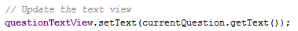
- That’s all for the updateQuestion method, but you need to call the method in the onCreate() method, after calling loadQuestions so the layout shows the first question when the layout is initially created.

Toggling between Questions – Clicking Next
- You want the layout to go through the questions as the user clicks the next button. The event listener for the button has already been created, you just need to add the logic to it.
- Locate the Next Button Listener. The following will be added to its onClick method.
  - You essentially want to increase the current index by 1 and when it gets to the last question, set it back to 0.
  - You can use an If … Then … Else statement
  - Alternatively, you can use the modulus operator (%). It divides number 1 by number 2 and returns the remainder. For example:
    - 0 % 10 = 0
    - 1 % 10 = 1
    - …
    - 11 % 10 = 1
  - Use whichever method you prefer, the modulus operator method is shown.

// Increments the currentIndex by 1 and returns to 1 when it reaches the last number
// The modulus operator (returns remainder of division) is used to make it start back at one. Divides number 1 by number 2 and returns the remainder
// e.g. 0 % 10 = 0, 1 % 10 = 1, 2 % 10 = 2 ... 10 % 10 = 0, 11 % 10 = 1
- Call the updateQuestion method to update the view with the new current question.
- Challenge Exercise: How about adding a previous button? Make sure you test the button and confirm that it is working.

Checking the Answers Selected
- When the user clicks the True or False buttons you want to check if the answer is correct.
- Create a new method called checkAnswer with a return type of void, but should accept a single Boolean parameter called userPressedTrue representing which answer option was selected by the user.
- This method will compare the selected answer with the question’s actual answer (retrieved from isAnswerTrue accessor method)
- Retrieve the current question’s answer into a Boolean variable using the question’s isAnswerTrue accessor method.
- Based on the answer selected, the app will display a toast mesaage (simple feedback about an operation in a popup). You have already created the toast messages in the string resources file. Create a variable that will retrieve the required toast string resource ID.
// Variable to store the toast string resource id
// based on whether the answer is correct or not
- Next, check the answer selected against the actual answer and set the toast message resource id to display.
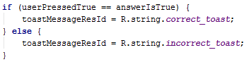
- Display the toast. The syntax is:
  - Context – the current activity (referenced using the “this” keyword)
  - Text – the text to display
  - Duration - for how long
- That’s all for the Check Answer button.
- Locate the True Button Listener and call the checkAnswer method from its click method with the correct Boolean parameter value.
- Do the same for the False Button Listener.
- Finally, save your changes and test your app.

Exercise 5: Using Image Icons
- In this exercise, you will replace the Next and Previous button text with image icons.
- Images in Android are stored in the the app\src\main\res\drawable folders, but you probably want to provide different images for different device capabilities/configurations. To do this you create folders named in the format: <resource_type_name>-<config-qualifier> and add the resource for that configuration to the corresponding folder. So for drawables, for example, you could have drawables-hdpi, drawables-ldpi, etc. for different screen pixel densities. Obviously, you are duplicating images and increasing the app size. This app is small, so it is okay, but note that there is an alternative approach.
- Download the drawable.zip folder available on Moodle.
- Extract the contents to your app’s res folder (..\app\src\main\res).
- Return to Android Studio and if you expand the res drawable folder, you should have something similar to the following (4 different versions of the arrow icons are available).
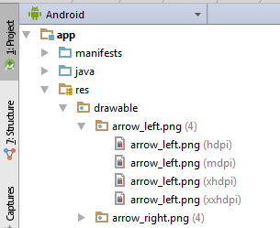
- Resources added to the drawable folder are automatically added to R.java and you can access the resources:
  - From your layout using @drawable/resource_id (the resource_id is the name of the image)
  - From your activity code using R.drawable.resource_id
- Open up your layout file and make the following highlighted change to the next button.
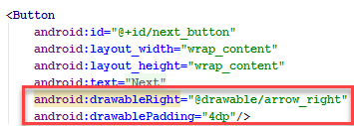
- Do the same for your previous button.
- How about replacing the button with a proper image button, show it shows only the icons?
  - In the layout file,
    - Replace the Button with an ImageButton view object
    - Add an android:src attribute pointed at the image resource
    - Add an adroid:contentDescription attribute and set this to the string resource
    - Get rid of the android text, drawableLeft and drawablePadding attributes.
    - Do the same for the Next Button
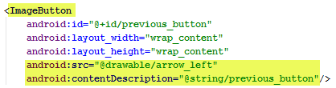
  - In the Activity file, you will need to update all references to a Button object for these two buttons to an ImageButton object instead.
- Did it work?
- Hmmm, but there is a bug in the app.
- Run the app and navigate to the second or third question. Now rotate your device. What happens?
  - The problem is because when you rotate your device, your activity essentially restarts (gets destroyed and recreated) and we have not actually told it to save its state information yet (hopefully you can recall all this from lecture 2 when we discussed the activity lifecycle).

Exercise 6: Creating a Landscape Layout
- You need to create a different layout for Landscape orientation.
- Right-click on the res folder in your project directory and select New Android resource directory.
  - In the first window, choose layout as the Resource type and set the qualifier type to Orientation.
  - In the second window, set the Screen Orientation direction to Landscape for the UI mode.
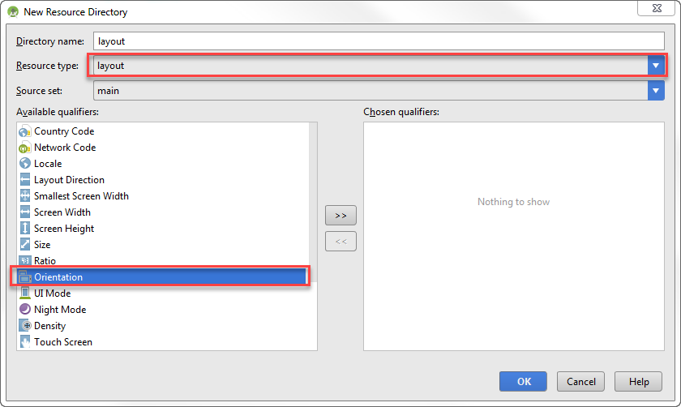
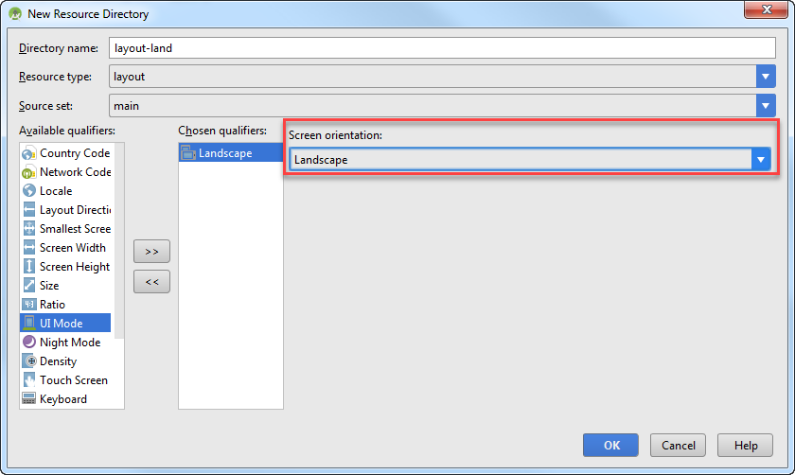
- Right-click on the existing activity layout file in the res folder and select Refactor Copy. In the window that pops up, click the button with the ellipsis (…) to select what folder to copy to.
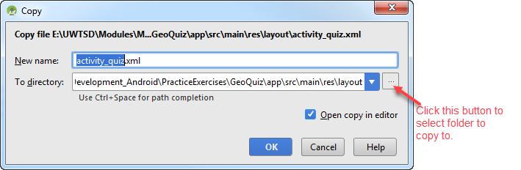
- Copy the file to the alternate resource directory layout-land.
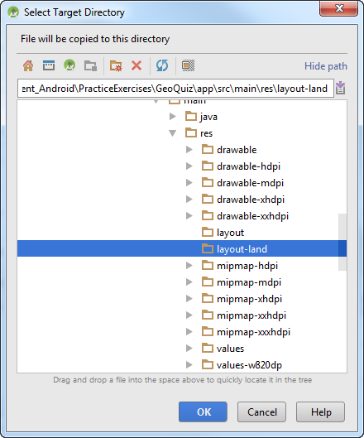

- Make the following changes
  - Outermost (parent) linear layout – replace with a frame layout as shown
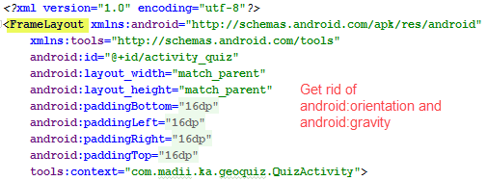
  - 1st Nested Linear Layout (containing True and False buttons), add the following highlighted line
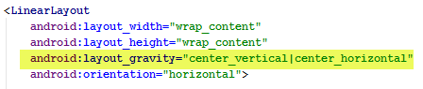
  - 2nd Nested Linear Layout (containing Next and Previous buttons), add the following. You can try bottom|center instead, for example – use the option you prefer. The idea is to have the buttons in a different position, so it is more obvious when the layout changes.
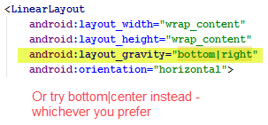
- Test to see if it works, but the bug still persists.

Exercise 7: Saving Activity State
- Recall from Lecture 2 that activity state information is saved as “a Bundle” of name-value pairs and is:
  - Saved using onSaveInstanceState()
  - Restored using either onCreate or onRestoreInstanceState()
- Return to your activity code file.
- The state information we want to preserve is the CurrentIndex, which indicates the current question the user is on.
- You will add a constant variables to store a key name that will be used for the name part of the name-value pairs added to the activity state information bundle.
- Add the following declarations just below the declarations for the different view objects.
// Constant to store key name for state information

Saving State - Implementing OnSaveInstanceState
- To implement the OnSaveInstanceState, you need to override the activity’s default OnSaveInstanceState method, because we want to add to its default behaviour.
- Add the following to override the method.
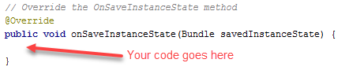
- Next, even though you are overriding the default onSaveInstanceState method, you do not want to lose the default behaviour. You still need to run the default OnSaveInstanceState method and you do this using the super prefix followed by a dot (.) and then the method you are overriding. This ensures that the inherited class method’s code will run first. Add the following.
// Call the inherited overridden method first
// (the Activity class default onSaveInstanceState method)
- Now, you can add your own implementation.
- All you want to do is save the current index which is an integer value to the savedInstanceState bundle parameter passed to the method. It is an integer value, so you use the putInt method.
// Add the state information to add to the Bundle.
// The bundle is the savedInstanceState parameter passed to the method
// The current index is an integer value, so we use the putInt method

Restoring the Saved State – Using the OnCreate Method
- As we already have the onCreate method in our activity, we will use that method to restore the saved state.
- All you need to do is check if the savedInstanceState bundle is not null and if it is not, retrieve your saved state information using the key name used to save it.
- Locate your onCreate method and just before the updateQuestion() method is called – this should be the last action in this method, following the call to loadQuestions, add the following:
// Check if state information has been saved and
// if yes, retrieve the current index from it
// If it does not find the saved state information, make it default to zero
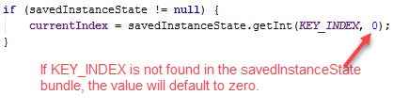
- Test your app. Does it work.
- Phew! Finally, that’s all for today

Adapted from Android Programming: The Big Nerd Ranch Guide The quiz questions used in the exercise instructions are from http://www.quiz-zone.co.uk/quizrounds/020317trueorfalse/answers.html

