Surveying Problems

Module code
ACBA4002

Prepared for
A.Abraham and H. Williams

Submission
November 2023

Created by
Lloyd Wilson

Question 1.

- 1.465m

- 2.179m

- 3.975m

- 0.820m

- 1.502m

Question 2.

Back Sight | Intermediate | Fore Sight | Height of Collimation | Reduced Level | Remarks
1.850 |  |  | 51.850 | 50.000 | BM
1.720 |  | 1.500 | 52.070 | 50.350 | A
 | 1.640 |  |  | 50.430 | B
 | 1.590 |  |  | 50.480 | C
2.100 |  | 1.550 | 52.620 | 50.520 | D
 |  | 1.240 |  | 51.380 | E

- 50 + 1.85 = 51.850

- 50.350 + 1.720 = 52.070

- 51.850 – 1.500 = 50.350

- 52.070 – 1.640 = 50.430

- 52.070 – 50.480 = 1.590

- 52.620 – 50.520 = 2.100

- 52.070 – 1.550 = 50.520

- 52.620 – 1.240 = 51.380

Question 3.

3.1 Area calculation process

Point A 100E 200N
Point B 200E 300N
Point C 350E 225N
Point D 325E 125N
Point E 175E 50N

Area A = 150 x 75 /2 = 5625
Area B = 100 x 100 /2 = 5000
Area C = 150 x 75 /2 = 5625
Area D = 100 x 25 /2 = 1250
Area E = 150 x 75 /2 = 5625
Small box = 25 x 75 = 1875

Add all the triangle and small square areas together.
5625 + 5000 + 5625 + 1250 + 5625 + 1875 = 25000

Large box (overall area) = 250 x 250 = 62500

Take away the triangle and small square from the large square box to find the area.
62500 – 25000

Area = 37500

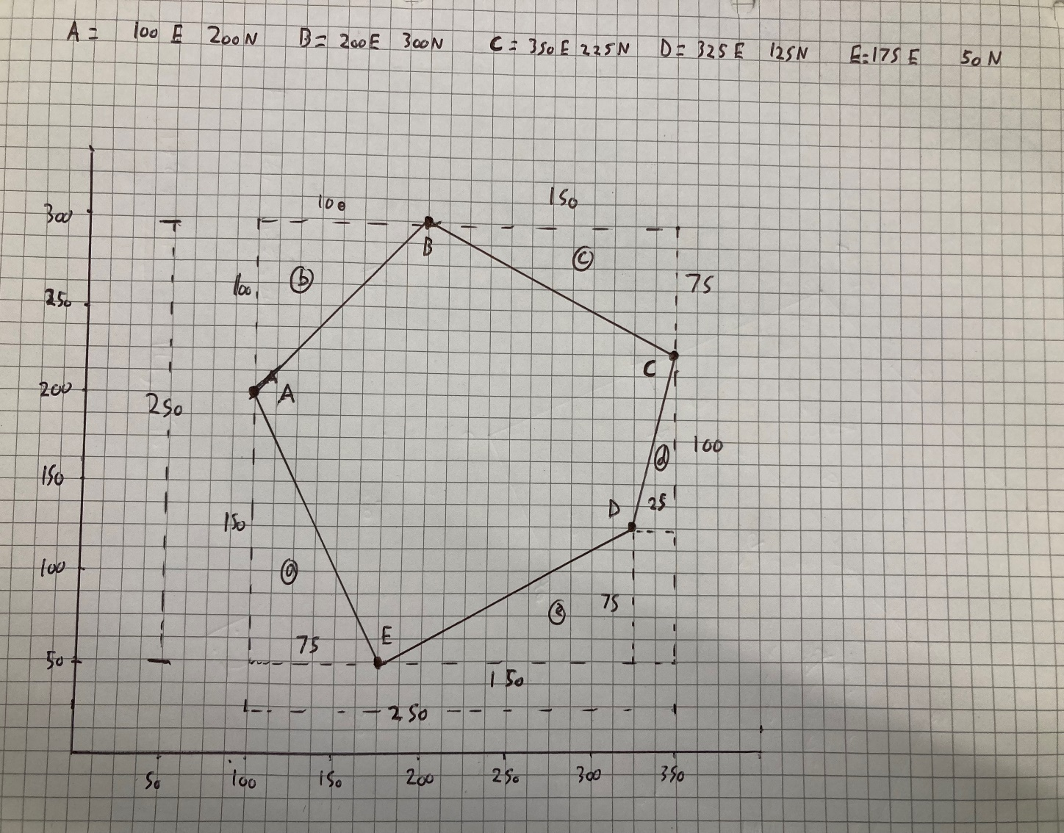
Source: Lloyd Wilson 19/11/2023
3.2 Perimeter

Points | Easting  (X) | Northing  (Y)
A | 100 | 200
B | 200 | 300
= | 100 | 100
B | 200 | 300
C | 350 | 225
= | 150 | 75
C | 350 | 225
D | 325 | 125
= | 25 | 100
D | 325 | 125
E | 175 | 50
= | 150 | 75
E | 175 | 50
A | 100 | 200
= | 75 | 150

A-B:
Pol(100,100)
r = 141.4213562

B-C:
Pol(75,150)
r = 167.7050983

C-D:
Pol(25,100)
r = 103.0776406

D-E:
Pol(150,75)
r = 167.7050983

E-A:
Pol(75,150)
r = 167.7050983

141.4213562 + 167.7050983 + 103.0776406 + 167.7050983 + 167.7050983

Perimeter = 747.6142917
Perimeter =747.614

Question 4

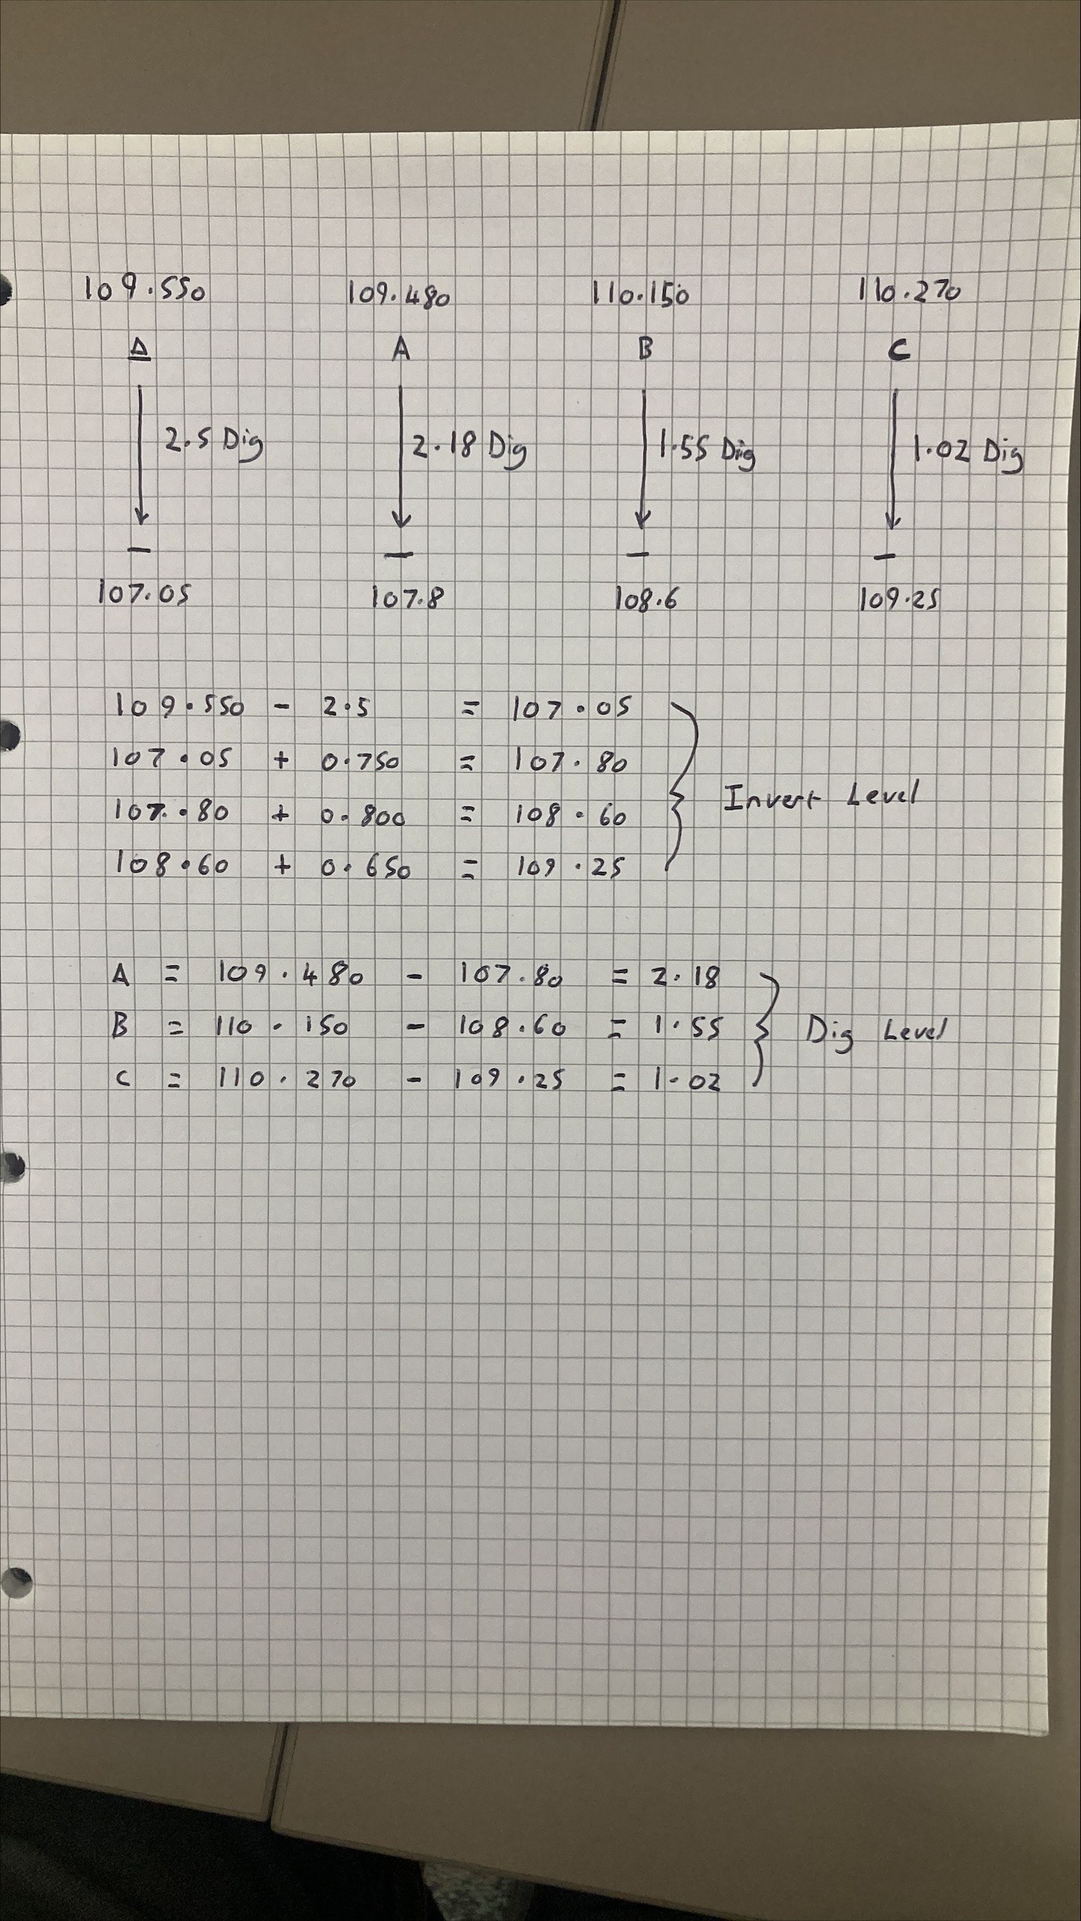
Source: Lloyd wilson 20/11/2023

Question 5

An Auto Level is a type of surveying implement that is used in surveying raise and falls in the landscape or on building sites. The equipment is used by being placed on top of a tripod and looking down the lens to a chain person using a staff. The Auto level must be levelled on the tripod by using the adjustment dials by visually centring the bubble to precisely set it level. The lens can also be adjusted using the focus dial and the chain person can rock the staff back and forth to identify the exact height to be recorded manually into a handbook or tablet device. The auto level is securely placed into the carrier box that is cushioned with foam to prevent any damage in storage or transport to locations of use.

