

Car Park

Module: Object Oriented Programming
Name: Zhiqiang Geng
Student ID: 2200520
Date:2023 .04.22

Catalog
1. An overview of object-oriented programming 4
1.1 data abstraction 4
1.2 encapsulation 5
1.3 Inheritance 5
1.3.1 class-to-class relationships 5
1.4 polymorphism 6
1.4.1 polymorphic implementation 6
1.5 memory layout and virtual function related content 7
1.5.1 C++ program memory layout 7
1.5.2 virtual function 8
2. Realization of parking lot management system 9
2.1 overall route 9
2.2 Implementation of IDReader 11
2.2.3 The overall structure of IDReader 12
2.2.4 IDType class and its derived classes 12
2.2.5 Why do fictitious functions of base classes need to be declared virtual? 13
2.2.6 IDReader class 13
2.2.7 The storage structure of the derived class of IDReader 14
2.2.8 Derived class of IDReader - IDNumberplateReader 15
2.2.9 Derived class of IDReader - IDCardReader 15
2.3 Realization of barriers 16
2.3.1 Barrier base class 17
2.4 Implementation of the log system 18
2.5 CarPark implementation 18
2.5.1 Functional interface exposed to the outside 18
2.5.2 polymorphic implementation 19
2.5.3 CarPark::readInfo() 20
2.5.3 The flow into and out of the parking lot 21
2.5.3 Procedure for leaving the parking lot 21
3. Summary 22
Reference 23

An overview of object-oriented programming
First of all, object-oriented programming has the following core ideas: data abstraction, inheritance, encapsulation and dynamic binding. In general, the core ideas are mutually influencing and interlocking, that is, using these four core ideas at the same time to complete C++ object-oriented programming.
If you want to describe object-oriented programming in C++ in one sentence, it is: through data abstraction (implementation class), you can separate the interface of the class from the implementation; using inheritance, you can define similar types and model their similar relationships; Using dynamic binding, you can ignore the difference of similar types to a certain extent, so that you can use their objects in a uniform way.
In the concept of object-oriented programming, four basic concepts have to be mentioned, namely: object, class, message, and method.
Classes are divided according to the commonality of objects. Classes are the abstraction and description of objects, and are unified descriptions of similar characteristics of multiple objects with common attributes and operations.
Objects are real and can be tangible or abstract. An object is an entity that describes objective things and is a basic unit of a system. An object is composed of a set of attributes and services that operate on this set of attributes. A class is an object after instantiation.
A method is an action an object performs when it receives a message.
Among them, the message refers to the communication and request tasks between objects. It is worth noting that the objects for message communication can be of the same class or of different classes.

data abstraction
The meaning of data abstraction in C++ object-oriented programming is mainly to abstract objects with similar attributes and similar behaviors into a class (the content of instantiation is involved here, which can be simply divided into static and dynamic). Of course, in the end, these so-called objects with similar behavior and attributes need to be instantiated through classes. And a class can be regarded as an abstraction, which mainly focuses on objects related to objects and the objects that users of this class are concerned about, thus ignoring some properties that users do not care about while also protecting some members of the class ( This involves access control and inherited protection levels).

encapsulation
Data encapsulation is also an important concept of C++ object-oriented programming. Encapsulation is an important concept of object-oriented programming. It is a mechanism to hide the data of an object or method, abstract the data, and only expose the operation interface to the user while hiding the specific implementation details. , the purpose of encapsulation is to eliminate various problems caused by the separation of data and operations in traditional structural methods, improve the reusability and maintainability of programs, and reduce the difficulty and complexity of program development.
C++ supports encapsulation through classes. Any class with public and private members can be used as an instance of data encapsulation and data abstraction. Usually, we create a class and define the members of this class as private members. This is done to hide The properties of this class, so as to achieve the purpose of encapsulation.

Inheritance
Inheritance saves programmers a lot of time while keeping code canonical and concise. In C++, you can inherit only one base class or multiple base classes. If a derived class has more than one base class, it uses multiple inheritance. Here are two keywords of C++: derived classes (subclasses) and base classes (parent classes).
Inheritance is the creation of a new class on the basis of an existing one. Existing classes are called "base classes" or "parent classes", and newly created classes are called "derived classes" or "subclasses".
Inheritance mechanism is the most important means for object-oriented programming to make code reusable. It allows programmers to extend and add functionality while maintaining the original class characteristics. Inheritance presents the hierarchy of object-oriented programming and reflects the cognitive process from simple to complex. The reuse we touched before is function reuse, and inheritance is class design level reuse.

class-to-class relationships
The has-A inclusion relationship is used to describe that a class is composed of multiple component classes, and the implementation of the has-A relationship is represented by the member attributes of the class, that is, the member attributes of a class are another defined class;
use-A, one class uses another class, communicates with each other through member functions between classes, defines friends or realizes it by passing parameters;
IS-A, inheritance relationship, the relationship is transitive;

polymorphism
It is to send the same message to different objects, and different objects will have different behaviors (that is, methods) when they receive it. That is, an interface can implement multiple methods.
The essential difference between polymorphism and non-polymorphism is whether the function address is bound early or late. If the function is called, the calling address of the function can be determined during the compilation of the compiler, and the code is generated, which is static, that is, the address is bound early. And if the address of the function call cannot be determined during the compiler, it needs to be determined at runtime, which is late binding.

polymorphic implementation
In fact, polymorphism generally refers to polymorphism implemented by inheritance and virtual functions. For overloading, the actual principle is that when the compiler generates a symbol table for a function
Overloading is just a language feature, it has nothing to do with polymorphism, and it has nothing to do with object-oriented, but this is a new rule added in C++, so it belongs to C++, so if you have to say heavy If loading is a kind of polymorphism, then it can be said: Polymorphism can be divided into static polymorphism and dynamic polymorphism.
① Static polymorphism: In fact, it is overloading, because static polymorphism means that which function to call is determined at compile time, and is determined according to the parameter list;
②Dynamic polymorphism: It is realized by rewriting the virtual function of the parent class by the subclass, because it is a function that is decided to be called during operation, so it is called dynamic polymorphism.
Under normal circumstances, when we do not distinguish between the two, the polymorphism we refer to refers to dynamic polymorphism.
The realization of dynamic polymorphism is related to virtual function table and virtual function pointer.

memory layout and virtual function related content
Because important concepts such as the way of C++ object instantiation and dynamic binding are related to the memory distribution and virtual functions of C++, so here is a separate section to introduce it.

C++ program memory layout
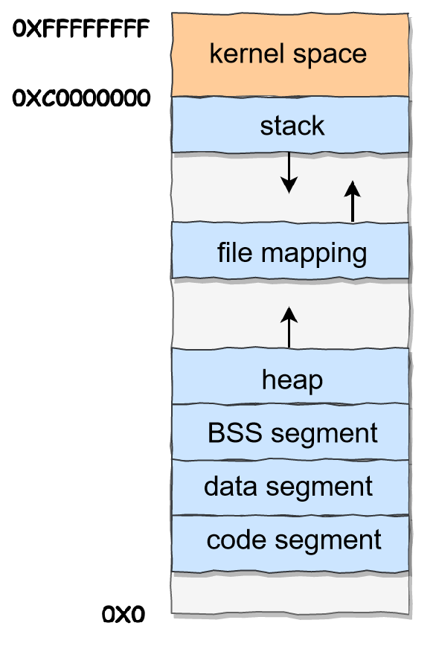
If a 32-bit system is taken as an example, the memory distribution is roughly as follows:
Figure 1 Memory distribution in a 32-bit system
From this picture, you can see that user space memory has 6 different memory segments from low to high:
• Code segments, including binary executable code;
• Data segment, including initialized static constants and global variables;
• BSS segment, including uninitialized static variables and global variables;
• Heap segments, including dynamically allocated memory, grow upwards from low addresses;
•The file mapping segment, including dynamic library, shared memory, etc., grows upwards from the low address (related to hardware and kernel version (opens new window));
• Stack segment, including local variables and the context of function calls, etc. The stack size is fixed, typically 8 MB. Of course, the system also provides parameters so that we can customize the size;
As can be seen from the memory layout in the figure above, there is still a section of memory space (gray part) below the code segment. This area is the "reserved area". The reason why there is a reserved area is because in most systems, we It is considered that an address with a relatively small value is not a legal address. For example, we usually assign invalid pointers to NULL in C code. Therefore, there will be an inaccessible memory reserved area here to prevent the program from reading or writing data at some small memory addresses due to bugs, which will cause the program to run away.
Among the seven memory segments, the memory of the heap and file mapping segments is allocated dynamically. For example, using the new keyword in C++ and malloc() or mmap() in the C standard library, you can dynamically allocate memory in the heap and file mapping segments, respectively.

1.5.2 virtual function
The appearance of polymorphism in C++, add the virtual keyword before the function of the base class, rewrite the function in the derived class, and the corresponding function will be called according to the actual type of the object at runtime. If the object type is a derived class, the function of the derived class is called, and if it is a base class, the function of the base class is called.
In fact, when a class contains a virtual function, the compiler will generate a virtual function table for the class to save the address of the virtual function in the class. Similarly, the derived class inherits the base class, and the derived class itself Of course, there must be virtual functions, so the compiler will also generate its own virtual function table for derived classes. When we define a derived class object, the compiler detects that the type has a virtual function, so it generates a virtual function pointer for the derived class object, pointing to the virtual function table of the type, and the initialization of the virtual function pointer is done in the constructor.
In the future, if there is a pointer of the base class type pointing to the derived class, then when the virtual function is called, it will find the address of the virtual function according to the virtual function table pointer of the real object pointed to, and then the derived class can be called The virtual functions in the virtual function table of the class implement polymorphism in this way.

Realization of parking lot management system
Project background: Designing a parking lot for a company, in consideration of safety, mainly requires these key contents: barrier, IDReader, full sign at the entrance of the parking lot, and log system.
Among them, the barrier class is used to handle the rise and fall of the two barriers at the entrance and exit, and the barrier class also needs to handle the toll system. IDReader needs to process three kinds of information at the same time, namely IDCard, IDBarcode, and IDNumberPlate. Full sign signs are required to indicate whether there are still vacancies in the parking lot. The log system is used to record every entry and exit of the parking lot and related failures.

overall route
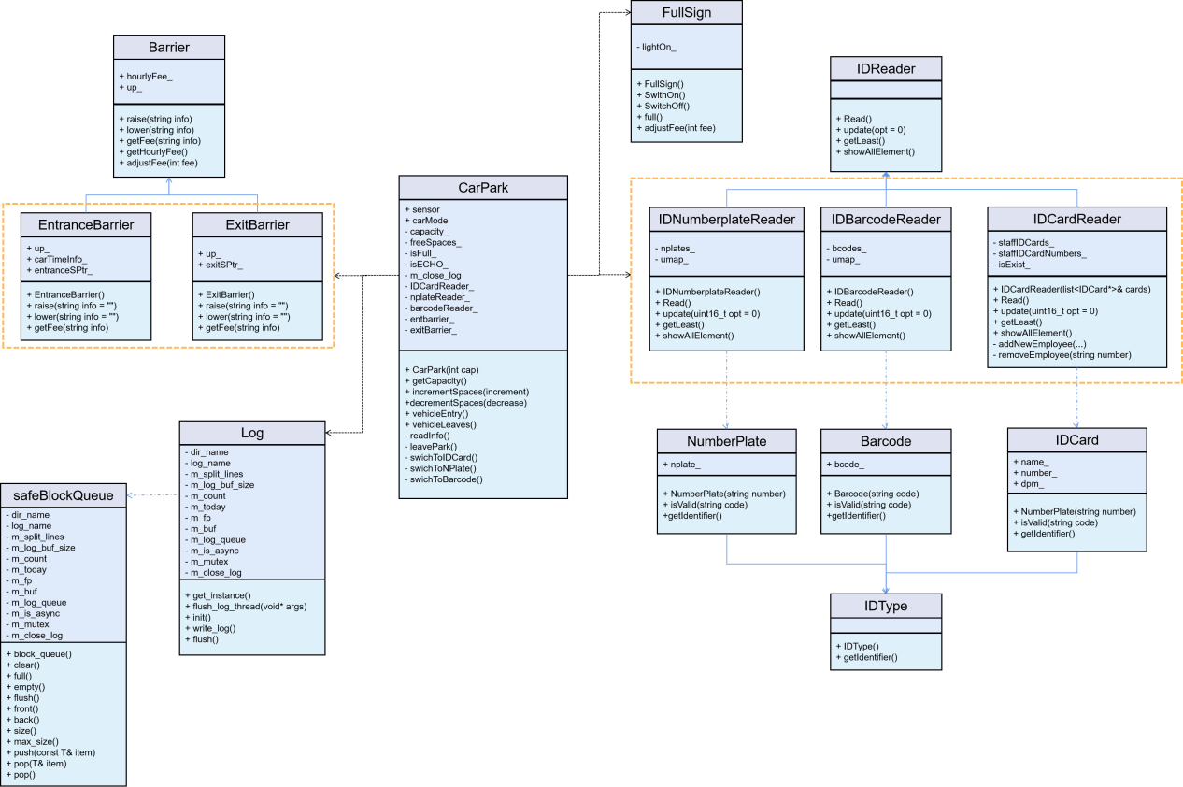
In addition to several basic requirements mentioned in the requirements, this article also adds a charging system for outsiders (the system is free for employees) and a logging system to improve the overall function.
Figure 2 overall class diagram
First look at the overall file division. Figure 2 is the tree diagram of the overall parking lot management system. It can be seen that it is mainly divided into the above-mentioned modules: Barrier, IDReader, FullSign, Log, etc. The overall code tree diagram is shown in Figure 3 below.
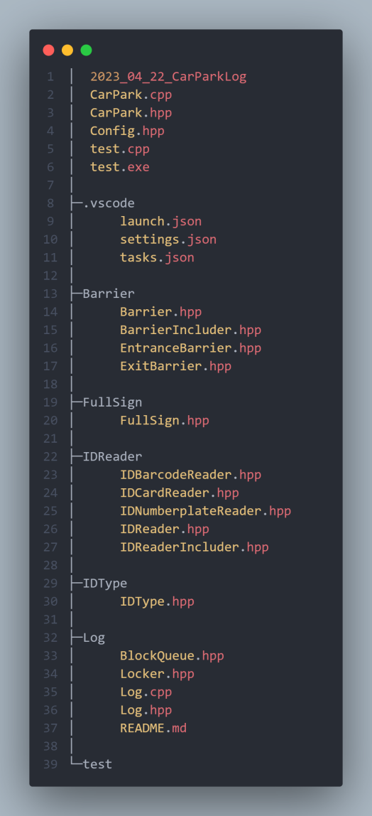
Figure 3 The overall tree diagram of the code
These modules and the final system to be implemented are dependent, that is, they all work for the CarPark class, so these classes and the CarPark class are a one-way dependency.

Implementation of IDReader
The IDReader here mainly realizes the following functions, that is, the reading of three kinds of information:
①Store, read and verify the employee ID card
② Store, read and verify the Number Plate of the foreign vehicle
③ Store, read and verify the Barcode of foreign vehicles
Mainly use a base class - IDReader class, and three derived classes - IDNumberplateReader class, IDBarcodeReader class, IDCardReader class to complete the storage, reading and verification of the above three information.
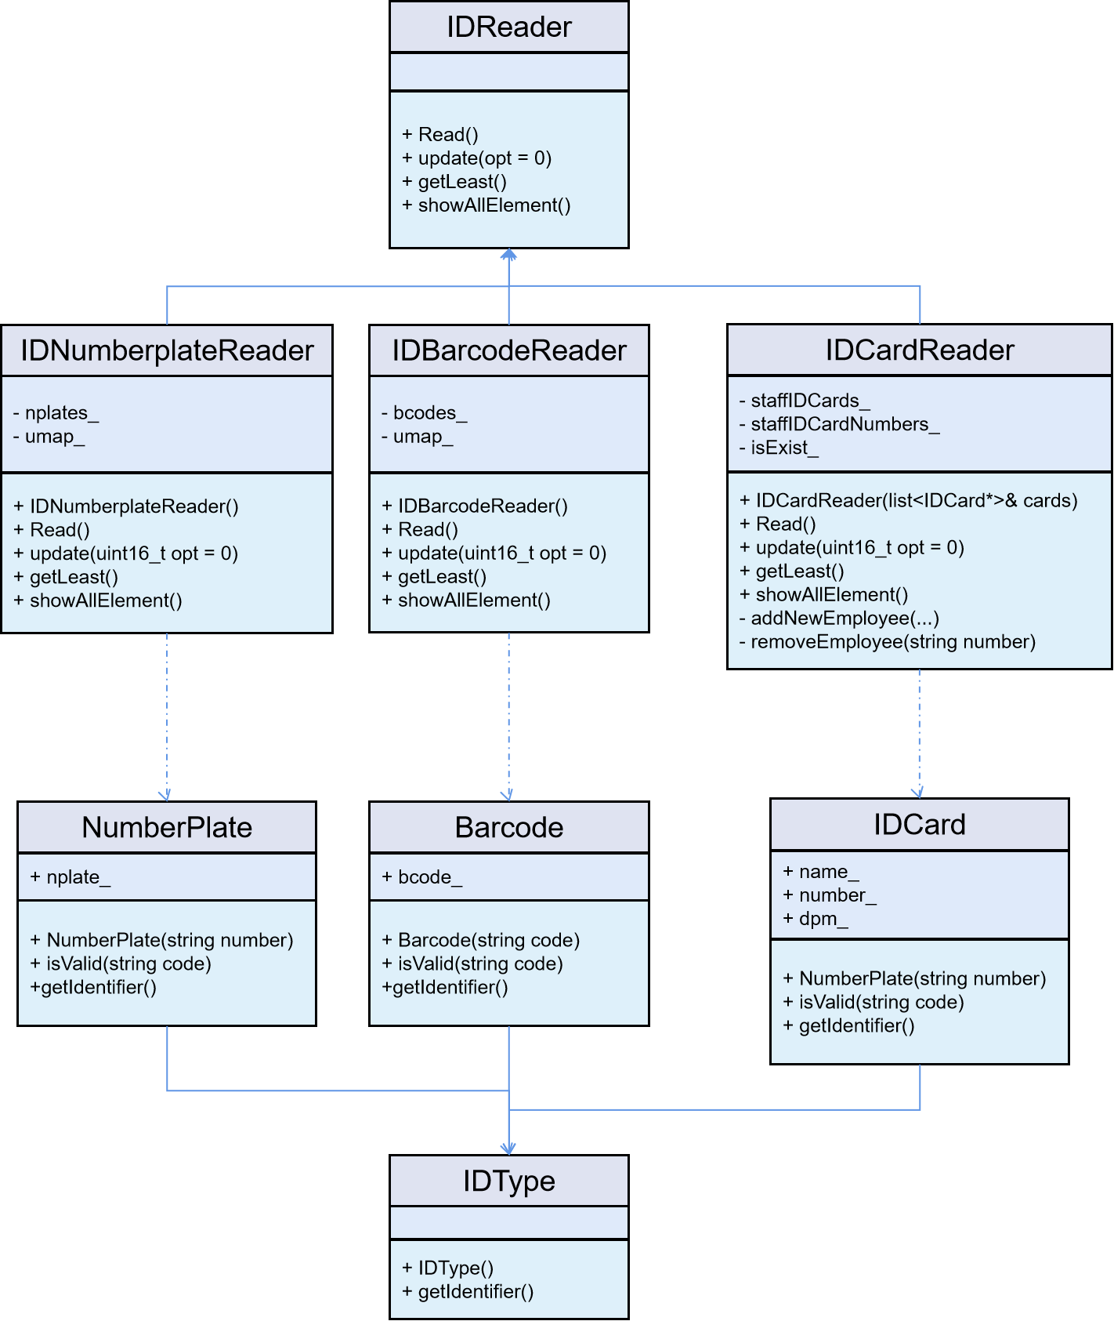
Figure 4 IDReader overall class diagram

2.2.3 The overall structure of IDReader
First look at the overall structure of IDReader. Figure 4 is an overall class diagram showing related class descriptions. It can be seen that this article encapsulates Number Plate, Barcode and IDCard respectively. Let these three IDTypes be used as dependencies of IDNumberplateReader, IDBarcodeReader, and IDCardReader to assist in the construction of IDReader.
The following introduces the IDType class and its derived classes and the IDReader class and its derived classes respectively.

2.2.4 IDType class and its derived classes
IDType is a base class, it does not have any member variables, only a member function getIdentifier(), this member function is a pure virtual function, the function is to obtain the corresponding type of vehicle identification code or employee identification code, the function declaration is as follows.
virtual string getIdentifier() = 0;
A class with a pure virtual function is an abstract class and cannot be instantiated, and this is exactly what we want for the following reasons:
In fact, the emergence of pure virtual functions is to allow inheritance to occur in a variety of situations:
① Sometimes we want derived classes to only inherit the interface of member functions.
② Sometimes we want the derived class to inherit both the interface of the member function and the implementation of the member function, and the member function can be rewritten in the derived class to achieve polymorphism
③ Sometimes we hope that the derived class cannot override the default implementation when inheriting the member function interface and implementation.
In fact, the purpose of declaring a pure virtual function is to let the derived class only inherit the interface of the function, and the derived class must provide an implementation of this pure virtual function, otherwise the class containing the pure virtual function will be abstract class and cannot be instantiated.
Its three derived classes, Number Plate, Barcode, and IDCard all rewrite the virtual function getIdentifier(). Of course, this is necessary, because if these subclasses do not rewrite the pure virtual function of the base class, then these subclasses It will also become an abstract class and cannot be instantiated.
Secondly, Number Plate, Barcode and IDCard also respectively realize the function of information verification.
It can be seen that no member variables are stored in the base class IDType, but its three derived classes have different member variables, so we need to declare the destructor of the base class as a virtual function. The specific reason we Explained in the next section.

2.2.5 Why do fictitious functions of base classes need to be declared virtual?
Intuitively speaking: it is to reduce the possibility of memory leaks. For example, a pointer of a base class points to an object of a derived class. When it is ready to be destroyed after use, if the destructor of the base class is not defined as a virtual function, the compiler will consider it based on the pointer type The type of the current object is the base class, call the destructor of the base class (the function address of the destructor of the object has long been bound as the destructor of the base class), only execute the destructor of the base class, dispatch The content of the raw class will not be destructed, resulting in memory leaks.
If the destructor of the base class is defined as a virtual function, then the compiler can execute the destructor of the derived class according to the actual object, and then execute the destructor of the base class to successfully release the memory.
A question is raised again: When a derived class rewrites a destructor, does it need to have the same name as the destructor of the base class?
The answer is no, because if the destructor of the base class is a virtual function, the destructor of the derived class can only be defined at this time, regardless of whether the virtual keyword is added, it will be rewritten with the destructor of the base class, although the base class Different from the name of the derived class, it seems to violate the above-mentioned three forms of polymorphism, but it is not at the beginning, because the compiler has done special processing on the name of the destructor, and the name of the destructor after compilation is unified If it is processed into destruct, it meets the conditions of polymorphic rewriting after processing, because the function name is the same at this time.

2.2.6 IDReader class
The IDReader class mainly implements several functions to complete the functions of information storage, reading and verification. Among them, the Read() function is mainly used to process information at the entrance and exit, and the processing flow is as follows: ① Verify the validity of the Number Plate or Barcode or IDCard; ② Read the information; ③ Store the read information as the corresponding in the storage structure. These functions are pure virtual functions, so the IDReader class is also an abstract class and cannot be instantiated. The function signature is as follows.
virtual bool Read() = 0;
virtual string update(uint16_t opt = 0) = 0;
virtual void* getLeast() = 0;
virtual void showAllElement() = 0;
virtual ~IDReader() = default;
Then, IDNumberplateReader, IDBarcodeReader, and IDCardReader respectively rewrite these functions to basically meet the requirements of the overall IDReader.
Because IDNumberplateReader and IDBarcodeReader are similar, only IDNumberplateReader and IDCardReader are observed here.

2.2.7 The storage structure of the derived class of IDReader
After we enter the vehicle or employee information, we need to store it. The choice of the storage structure here is very important, because on the one hand, we need to ensure that the query of relevant information is fast, and on the other hand, we need to ensure that the relevant information is deleted quickly. So the data structure commonly used in the LRU algorithm-hash linked list is used here. The reasons are as follows:
The hash table is fast to look up, but the data has no fixed order; the linked list has an order, and the insertion and deletion are fast, but the search is slow. So combine them to form a new data structure: Hash linked list LinkedHashMap.
For a certain key, we can quickly locate the node in the linked list through the hash table, so as to obtain the corresponding linked list node pointer.
At the same time, the linked list obviously supports fast insertion and deletion at any position, just change the pointer. It's just that the traditional linked list can't quickly access the elements at a certain position according to the index, but needs to traverse from the beginning, and here it can be accessed directly with the help of a hash table。
The structure of LinkedHashMap is shown in Figure 5.
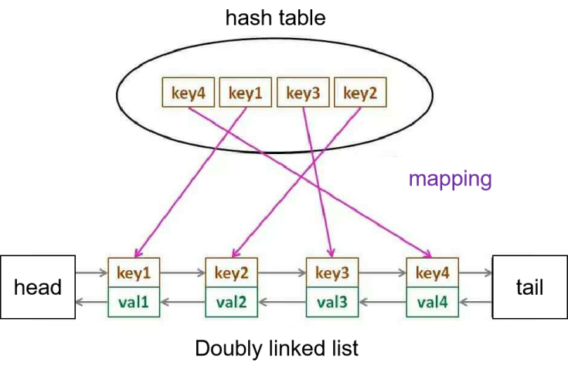
Figure 5 Structure of LinkedHashMap

2.2.8 Derived class of IDReader - IDNumberplateReader
This class mainly has two member variables: list<NumberPlate*> nplates_, used to store the license plate numbers of all vehicles currently in the parking lot. unordered_map<string, NumberPlate*> umap_, a hash table, the value is the index of NumberPlate in nplates_, the key is the license plate number, and nplates_ form a hash list to support fast query and deletion.
First look at the IDNumberplateReader class, which is mainly used to read and delete the Number plate of vehicles entering and leaving the parking lot. The following steps are mainly implemented in the function Read():
① Obtain the Number plate of the vehicle and perform verification. If the verification fails, return false directly, and then hand it over to CarPark for processing.
② Find out whether the Number plate of the current vehicle already exists. Although this does not seem to exist in real life, this is mainly to prevent system error records.
③ Put relevant information into nplates_ and umap_.
In the function update(), the deletion of corresponding information is mainly realized, and the general steps are as follows:
① Check whether nplates_ is empty to determine whether there are any vehicles recorded with Number Plate in the current parking lot.
② Check whether the current vehicle is not in the parking lot. This operation is also to prevent errors in system records.
Remove the record for the current vehicle from nplates_ and umap_.

2.2.9 Derived class of IDReader - IDCardReader
There are many differences between IDCardReader and IDNumberplateReader. On the one hand, it is because of the data usage of internal employees. The following function signatures are given.
addNewEmployee(string name, string number, DEPARTMENT dpm)
removeEmployee(string number)
The member variables are also different, they are staffIDCards_, staffIDCardNumbers_, isExist_, and their functions are: store the ID cards of all employees currently in the parking lot, the key is the card number of the ID card, the value is the pointer of the ID card, whether the employee's vehicle is In the parking lot.
Therefore, when IDCardReader processes Read() and update(), it does not need to enter and delete information, but only needs to process isExist_, and then perform relevant verification and error-proof processing.
At the same time, IDCardReader also supports the addition and deletion of employees in update(). Due to space issues, the relevant codes are not displayed too much in the paper.

Realization of barriers
Similar to IDReader, Barrier uses a base class and two derived classes to complete related functions. The overall class diagram is shown in Figure 6 below.
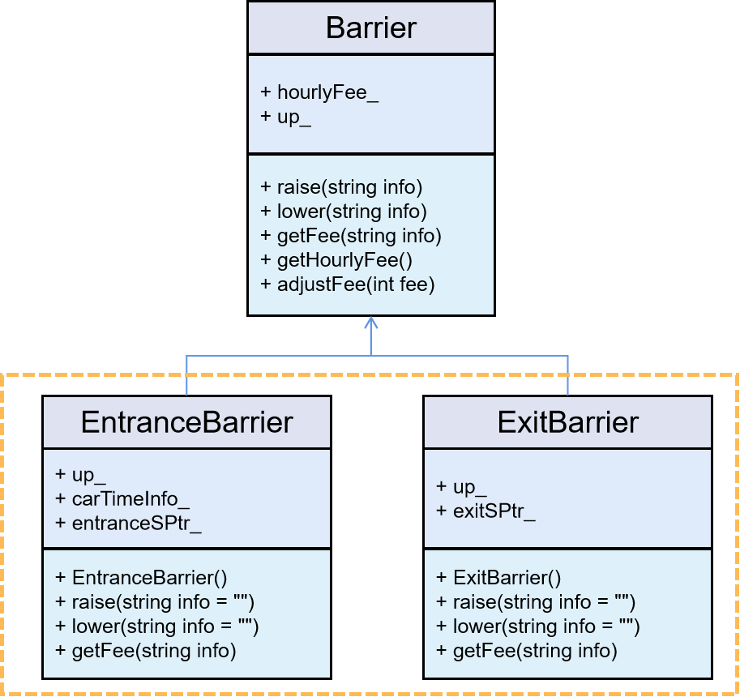
Figure 6 Barrier overall class diagram

Barrier base class
The base class function related function signature is as follows:
virtual void raise(string info) {}
virtual void lower(string info) {}
virtual uint32_t getFee(string info) {return 0;}
uint32_t getHourlyFee() {... ...}
bool adjustFee(int fee) {... ...}
It can be seen that because we need to use related functions in the base class, we do not talk about setting Barrier as an abstract class here.
The two derived classes are EntranceBarrier and ExitBarrier, which respectively represent the barrier at the entrance and the barrier at the exit. The two are also responsible for the billing of foreign vehicles. They each have a member variable entranceSPtr_ and exitSPtr_. This member variable points to the shared smart pointer of vehicle entry and exit time. There are two such smart pointers, one at the entrance and one at the exit. The statement is as follows
unordered_map<string, pair<clock_t, clock_t>>* entranceSPtr_;
unordered_map<string, pair<clock_t, clock_t>>* exitSPtr_;
Because the two need to coordinate and handle the billing work of outsiders, these two member variables point to the same hash table carTimeInfo_, and the variables are declared as follows.
static unordered_map<string, pair<clock_t, clock_t>> carTimeInfo_;
It can be seen that this is a static variable, because we want all objects to share this time information table, and because the two classes share a hash table, we need to declare ExitBarrier as a friend class of EntranceBarrier.
class EntranceBarrier : public Barrier {
friend class ExitBarrier; ...}
Due to the limited space, the rest will not be repeated.

Implementation of the log system
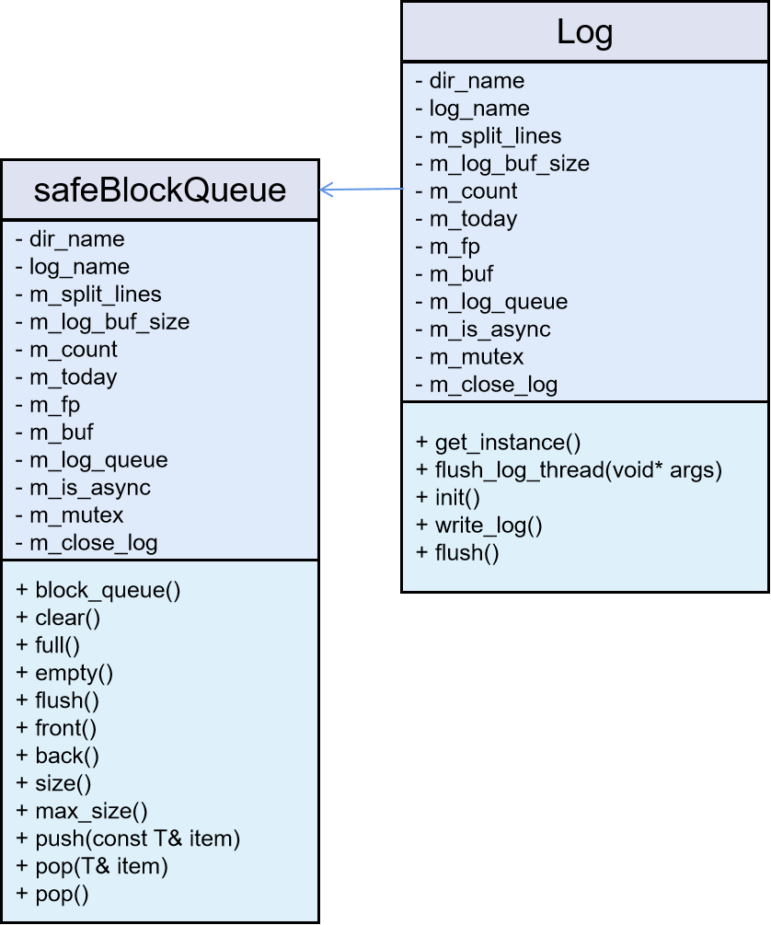
As shown below, the log system class diagram is written asynchronously using a blocked queue.
Figure 7 Log system class diagram

CarPark implementation
CarPark may need to fully utilize and coordinate the previous IDReader (including IDType), Barrier, FullSign and log systems to complete the design of the overall parking lot management system. Among them, IDReader completes the extraction, storage, verification and deletion of information, and then returns it to the readInfo() function of CarPark for subsequent processing; on the one hand, Barrier needs to be responsible for the management of vehicle access barriers, and on the other hand, it needs to charge foreign vehicles Processing; FullSign is mainly responsible for warning that there are no more vacancies in the parking lot; and the log system can record the entry and exit of vehicles and some error operation information for a long time

Functional interface exposed to the outside
In order to prevent operators from modifying and destroying the internal information of the parking lot management system, the CarPark class hides many details from the outside. The figure below shows the relevant member functions and member variables of CarPark.

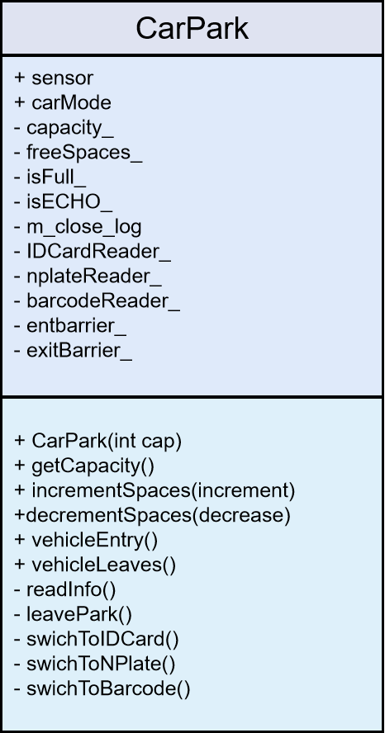
Figure 8 CarPark's related member functions and member variables
It can be seen that most of the member variables and nearly half of the member functions are declared as private, which can protect the internal information of the class very well, and also make the user's operation more convenient, so that only the user needs to use the part of the .

polymorphic implementation
This part mainly introduces the use of dynamic binding, and mainly explains the use of IDReader pointers to dynamically bind IDNumberplateReader, IDBarcodeReader, and IDCardReader object information.
The dependency of IDReader is IDType, and the two cooperate to realize the dynamic binding of CarPark.
As mentioned in the previous part of the introduction of the principle, C++ mainly relies on inheritance and virtual functions to achieve polymorphism, which refers to the realization of the virtual function of the parent class by rewriting the subclass, and then decides to call the function during runtime.
Because when the derived class inherits the base class, it will automatically generate the part of the base class, and then rewrite the virtual function of the base class. At the same time, the derived class will share a virtual function table with its direct base class, so if there is a base class The pointer points to the object of the derived class, then the compiler will find the address of the virtual function according to the virtual function table of the real object, and then complete the dynamic binding. Figure 9 below shows the memory distribution of the IDCardReader object, and IDNumberplateReader and IDBarcodeReader have similar structures.

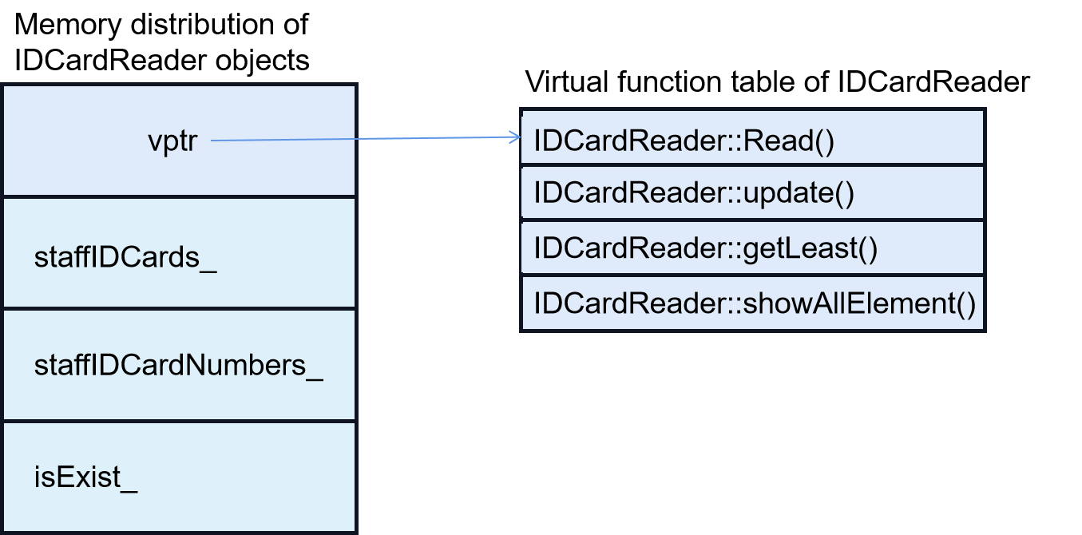
Figure 9 Memory distribution of IDCardReader object
Of course, there are similar structures in the derived classes of IDType and Barrier, so that dynamic binding at runtime can be realized. However, it is worth mentioning that what is implemented in this article is single inheritance, and multiple inheritance is not implemented.
If there is multiple inheritance, the memory distribution of derived class objects will also be quite different. Simply put, the order of base classes in the derived list determines the memory distribution of the base class's content in the derived class. The address of the first base class in the derived list is the same as that of the derived class, and the end of the memory is the member of the derived class itself.

2.5.3 CarPark::readInfo()
The dependency of IDReader is IDType, and the two cooperate to realize the dynamic binding of CarPark. There are mainly several processes here to complete the reading of information, and finally return an IDType* type pointer, and then use the current carMode to convert and operate the response.
The readInfo() process is as follows:
①The IDReader base class pointer sensor dynamically searches the Read() function of the currently bound object in the virtual function table at runtime, and if the reading is successful, it will enter the next step, otherwise it will record an error.
②Similarly, the IDReader base class pointer sensor dynamically looks for the getLeast() function of the currently bound object in the virtual function table at runtime, so as to obtain the corresponding IDType* type pointer.
③To determine the current carMode, if it is an employee, directly open the Barrier at the entrance, that is, entbarrier_, if it is an outsider, it is necessary to perform the corresponding pre-charging time recording work.
④Record related logs and information, and execute related information output at the same time.

2.5.3 The flow into and out of the parking lot
Entering the parking lot is mainly accomplished by the vehicleEntry() function, which is shown in Figure 11 below.

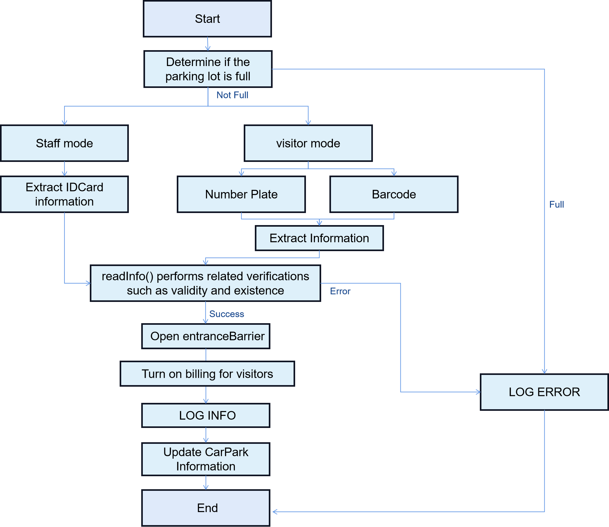
Figure 11 vehicleEntry flow chart

Procedure for leaving the parking lot
Entering the parking lot is mainly done through the vehicleLeaves() function, and the general process is shown in Figure 12 below. The general flow of the vehicle leaving the parking lot is similar to the entry flow, but the functions used in it are different, resulting in some differences in the intermediate process, such as information erasure and parking fee settlement.
It can be seen that for employees, the parking lot is free, and the employee information will not be dynamically updated unless there is a mandatory addition or deletion by the administrator. However, the billing system will be implemented for the parking lot of foreign vehicles, and there are two modes of Number Plate and Barcode, and the parking lot will dynamically update the information of foreign vehicles instead of long-term storage.
The log system used here can also always record the entry and exit of employee vehicles in and out of the parking lot and the entry and exit of foreign vehicles. At the same time, it can record some error situations, such as access denial and repeated entry.

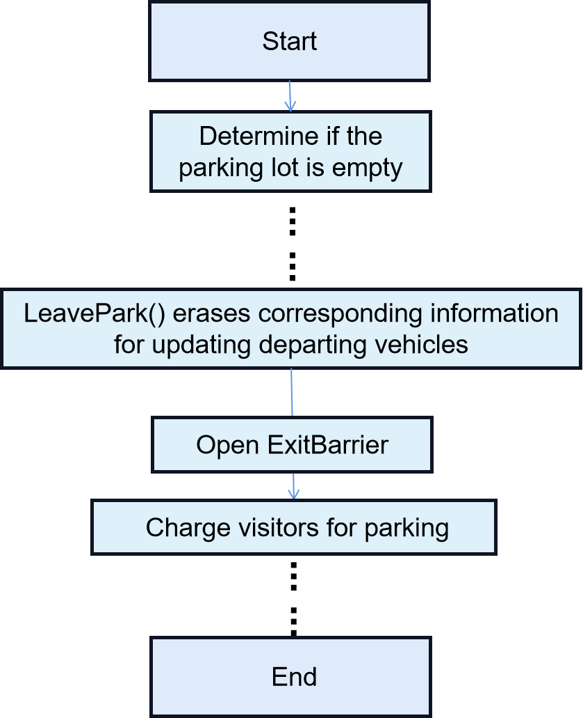
Figure 12 vehicleLeaves flow chart

Summary
Through this coursework, I successfully learned the method of object-oriented programming, and deepened my understanding of concepts such as dynamic binding and virtual function table. At the same time, a set of parking lot management system was successfully designed, making full use of the three characteristics of C++ object-oriented programming: encapsulation, inheritance, and polymorphism. After testing, the system works well.

Reference
- Fen Juqiang, Fan Jiang, Han Fang. Design and implementation of intelligent parking lot management system based on data fusion [J]. Journal of Jiujiang University (Natural Science Edition), 2022,37 (01): 45-49.DOI:10.19717/j.cnki.jjun.2022.01.010..
- Jiang Xiaojing, Xie Xiangxin, Hang Yiliu, Sun Jingyu. Design and Implementation of Community Self-service Parking Lot Management System[J]. Wireless Internet Technology, 2020,17(21):35-36
- Chen Dongmei, Bolian parking lot management system [abbreviation: Bolian parking lot client] V1.0. Gansu Province, Lanzhou Beikeweituo Technology Co., Ltd., 2020-11-18
- Du Qing, Xie Fang, Li Chunying, Wang Danhua. C++ Object-Oriented Programming Course [M]. People's Posts and Telecommunications Press:, 201701.272.
- Yan Han, Lu Jianfeng, Zhong Yi. New Standard C++ Programming [M]. Nanjing Southeast University Press:, 201808.472
- Liu Xinzhe, Liu Ling, Wang Chao, Li Jingna, Li Aihua, Chen Zuxian. Learning C/C++ from Defects[M]. People's Posts and Telecommunications Press:, 201309.182
- Xiong Qingyu, Wen Junhao, Lei Yueming, Tan Huixin, Zeng Jun, Yang Zhengyi. Case Study of Software Engineering Training Project Ⅲ [M]. Chongqing University Press: National Demonstration Software College Software Engineering Training Series Course, 201604.256

