Cloud computing

Alexandru Balasa
1814696

Table of Contents
Introduction 3
1. Literature review 4
1.1 Background of the cloud computing 4
2. Knowledge and understanding of the subject 5
2.1 Characteristics and benefits of the cloud Computing 5
3. Analysis 7
3.1 Service model and real world services 7
4. Practical assignment and deployment 9
4.1 Deployment models 9
4.2 Explanation of virtualisation 11
4.3 Migration strategies of the cloud computing 12
5. Skills for professional practice 14
5.1 Concerns of security 14
5.2 Implementation process of SaaS 15
Conclusion 17
Reference list 18

Introduction
Cloud Computing is one of the most effective systems for the organisations which are updating their information technology infrastructure in two more effective one. Cloud computing is referring to the process of delivering computing services including servers, storage, video database, networking, software analytics and intelligence. It is one of the most effective ways to have innovation and flexibility in the organisation to perform the activities related to business. Cloud computing can be very effective to the organisation in order to reduce the cost of the operation and to increase the efficiency of the resources. In other words cloud computing can be stated as the on demand availability of computer system resources in the organisation to increase the efficiency of the business process. With the help of cloud computing system it is possible to link many organisations into one cloud computing system to perform the activities with maximum efficiency and having collaboration. In this report, required factors of cloud computing will be analysed and evaluated for the organisation London bikes ltd.

1. Literature review
In present days every organisation is expanding their business in the internet; therefore it is important for the organisation to have appropriate information technology infrastructure and stable networking system to perform business activities with maximum efficiency. Cloud computing can be effective for the organisation to provide many beneficial services in order to conduct the business process in well manner. Therefore it is very important for the organisation to implement the cloud computing services in order to perform the activities in best possible way and to manage the important factors in proper way.

Background of the cloud computing
System of cloud computing services can be divided into two major factors, which are public cloud and virtualised pool of resources. Public cloud is one of the most important tools for the business organisation to have multi cloud approaches. Virtualised cloud services are also very effective for the organisation to control the activities of computers, networking services on the request of the customer or clients (Stergiou et al., 2018). Public cloud is most used among the customers of the organisation to have new and updated capability without investing in the hardware or software. Public cloud can be playing significant role in any business process to manage the activities with maximum efficiency. It is also very effective to reduce the workload of the employees in order to have perfect condition of working in the organisation.
The concept of the cloud computing was originally developed in the year of 1955, through the different parts of the artificial intelligence. It was developed as the concept of sharing files between the users in order to have maximum efficiency in the operational activities in the organisations. The use of cloud based technologies started and developed in the mid part of the year of 1960. With the system known as the ARPANET, the digitalisation of the resources has been started. Since then the cloud based technologies are started to develop its strength in the different parts of the business process.
The system of cloud computing can be divided into three major parts and all these parts are very important for the organisation to perform the activities of business in proper way. Three parts of the cloud computing are very important for different organisations and for different requirements.
Software as a service (SaaS) is one of the most effective public cloud systems of all time and it is accessed by the different kinds of browsers. Software as a service model is very effective for the organisation to have efficiency in the system like ERP suits, Oracle and SAP. it is very efficient for the customers also in order to provide facilities like own modification system.
Infrastructure as a service (IaaS) is also one of the most important tools for the organisation to manage several parts of the information technology infrastructure. This type of public cloud provides effective facility in storage services, computing services and networking services. Advantages of infrastructure as a service are high scalable database, virtual private networks, big data analytics, developer tools, machine learning and application monitoring.
Platform as a service (PaaS) is another form of public cloud services which is the effective in the areas of developers for the organisation. It is effective for the developers to provide techniques, processes and API to generate acceleration in the development, testing and to deploy the application of cloud computing in the organisation (Varghese, and Buyya, 2018).
These are the effective parts of the cloud computing systems which are very important for the organisations in different areas. Therefore organisation like London bikes is focusing on the software as service to improve and increase they are productivity in the respective market.

2. Knowledge and understanding of the subject
Cloud computing is one of the most important part of the business process in present days. It is the responsibility of the organisations which are having errors in the business process, must be implementing the cloud based services to increase the efficiency of the business process. Public cloud based services is one of the most effective systems to be implemented in the organisation to have many beneficial services in the respective areas.

2.1 Characteristics and benefits of the cloud computing
Cloud computing has many effective benefits which are very important for the organisation in order to conduct the business processes in respective areas. Benefits of the cloud computing services are,
- Cost
System of cloud computing is very effective to eliminate the capital expenses of buying or implementing new hardware and software to run the process of business (Marinescu, 2017). It is also reducing the cost of managing infrastructure of information technology in the organisations.
- Speed
It is one of the most important facilities of the cloud based services that it is increasing the speed of operations in different parts of the business. Also the sources can be accessed and used in proper way with the help of cloud computing services.
- Productivity
Cloud computing services are basically implemented in the organisation to increase the productivity to have maximum profit in the respective areas of business. Information technology management of the organisation gets many facilities regarding hardware setup, software patching and other important services with the help of cloud computing system (Hurwitz and Kirsch, 2020).
- Performance
Cloud computing systems are very effective to update the applications of business to provide fast and effective services. Therefore it is resulting in an improvement of performance of the organisation in the respective area of business. It is including reduced network latency, reduced cost of economics and improved performance of the employees.
- Reliability
Computing services is reliable to the organisations which are using it effectively. Some of the services including backup, the disaster recovery, business continuity and reduction of overall cost increase the efficiency of the business process for any organisation (Li et al., 2018).
These are the benefits which will be having to the London bikes if they implement the cloud computing services in proper way and use it with maximum efficiency.
There are also several characteristics of cloud computing services which are very effective to the organisation.
- Cloud computing services are very effective to provide agility to the performance of the organisation.
- It is also providing freedom to the employees to manage devices and locations of the organisation.
- Maintenance of the cloud computing services is easier to perform.
- Organisations which use cloud based system can be having improved scalability and elasticity in the organisational activities (Yang et al., 2017).
- Security can be very tight if the cloud based system is maintained in proper way.
These are the characteristics of cloud based system which any organisation can have if the implementation of the system is effective.

3. Analysis

3.1 Service model and real world services
Service models of the cloud computing systems is very effective to provide essential services and can be considered as everything as a service. Service models of the cloud based systems are very efficient to improve the performance of organisational operations. There are several service models which place significant role in the organisation to perform the activities that are related to business.
- Infrastructure as a service (IaaS)
Infrastructure as a service is referring to the process of providing services regarding high level API and important network infrastructures. Infrastructure as a service is one of the most effective part of the public cloud based system to provide efficiency in the physical computing resources, location, data partitioning, security and backup. Infrastructure as a service is one of the most important operational cloud system which provide effective support to the virtual machines and requirements of the business process (Subramanian and Jeyaraj, 2018). It is also effective to improve the efficiency of the resources including disc image library, block storage, object storage, firewalls, load balancers, virtual local area network and to the software applications.
- Platform as a service (PaaS)
Platform as a service is referring to the process of providing effective facilities to the respective customers of the organisation using programming languages, libraries, services and tools of the service provider. It is also preventing the access of consumers to manage or control the infrastructure of the organisation including network, server, operating system and storage (Almorsy et al., 2016). In many cases of the organisational context, platform as a service is used as a delivery models of the effective information. One of the best thing about platform as a service is, it increases the integration capabilities of the organisation to enable customers to manage the flow of integration.
- Software as a service (SaaS)
The most important part of the cloud based system or the cloud computing is the, software as a service. SaaS is one of the most important service models of the cloud computing system to provide access to the application, software and database of the organisation. Software as a service provides effective facilities to the organisational employees and to the consumers to access the database from any browser having proper security (Messerli et al., 2017). It is also called as on-demand software, and can be playing significant role in case of managing the database and application of the respective areas. With the help of software as a service the cost of the operational program gets reduced and it also decreases the cost of implementing new hardware and software to perform the same activities. It is also capable of preventing the access of an authorised person in the respective area of cloud computing (Palos-Sanchez et al., 2017). London bike is a small medium enterprise which is updating their website to have more efficient services in the business process. Therefore it is very important for the organisation to implement the systems of software as a service effectively to perform the activities in well manner.
- Function as a service (FaaS)
Function as a service is also an effective service model of the cloud computing system which is hosting the remote procedure to perform different activities (Pop, 2016). It is including server-less computing and other important parts of the computing services and it also can interchange the functions when needed.
These are the service models of the cloud computing system which an organisation can implement to have more effective services in the business process. In case of London bikes, they are focusing on the software as a service to improve their website in order to attract more number of customers to their business.
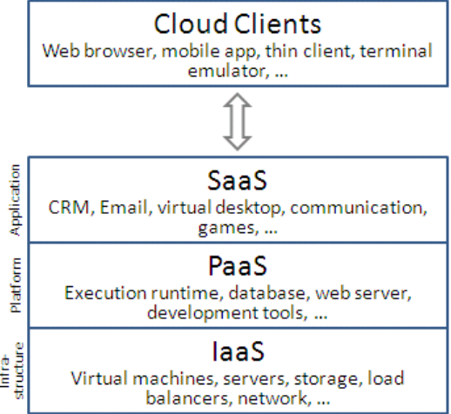

Figure 1: Service model
Source: (Vázquez-Poletti et al., 2017)

4. Practical assignment and deployment

4.1 Deployment models
Deployment models are important parts of the cloud computing systems which are used in the organisational context to provide effectiveness in the operations or activities. There are many important deployment models, which are very effective to deploy the cloud computing services in the organisations.
- Private cloud
Private cloud is referring to the infrastructure which is used and accessed by single person for single organisation. It can be managed by the employees of the organisation or by some third party and it can be controlled internally and externally. Private cloud projects are one of the most complex projects and prospective organisation must be taking significant decision about converting the system into private use the resources in efficient way (Dašić et al., 2016). Therefore it is the responsibility of the management of the organisation to provide effective decision-making information in order to have the private cloud. Private cloud is very effective for the organisation to improve the efficiency of the business process but in several areas there are many issues regarding securities and vulnerabilities.
- Public cloud
Public cloud is one of the most important types of cloud computing system which is used in the many organisations to control their activities and operations of business. Public cloud is referring to the process of sharing several clouds computing system with the help of same network. Public cloud system is also available for the public to use and control the activities in it. Public cloud is better than the private cloud if compared in the security and sustainability of the system (Stavrinides and Karatza, 2016). Public cloud is very effective to provide efficient applications, storage and resources which are very helpful to the business process. There were many public cloud providers which gives different facilities to the respective users, to manage the activities in proper way.
- Hybrid cloud
Hybrid cloud is considered as the combination of public and private cloud computing system. It is very effective to the organisation in order to provide on premises resources in case of conducting the business process. Hybrid cloud computing system he is also having the services of community based cloud computing systems which is very effective to the organisation to have. Some of the facilities of hybrid cloud are aggregation, integration and customisation with other cloud services. It is also very effective to manage and control the data centre and to provide effective information to the IT technologies to perform the analysis programme in well manner.
These are the three major deployment models of the cloud computing system to be used in the organisational context. London bikes Ltd is an organisation which is having business on bicycles and they are improving their website to have efficiency in the business process. Primarily they are focusing on the software as a service to increase their business efficiency. Therefore deploying cloud computing service in the organisation will be effective for the business process and to manage the customers (Bhardwaj et al., 2018). In this context, deployment model such as public cloud can be playing significant role if implemented in proper way. Organisation like London bikes should be implementing the public cloud system in the organisation to provide effective facilities to their respective customers. With the help of public cloud system customers of the London bike can manage their database in proper way and they can have effective information regarding business process. It is also effective for the management of London by to control requirements and demands of their customers to provide effective facilities.
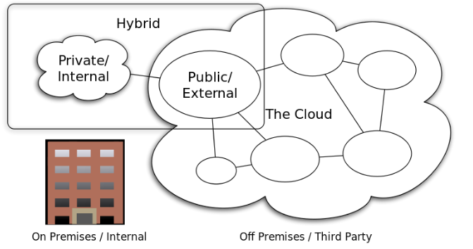

Figure 2: Deployment model
Source: (Alam, 2020)

4.2 Explanation of virtualisation
Virtualisation is very important part of the cloud computing services to help the organisation in order to manage and control the activities related to business. Virtualisation is referring to the process of capability of managing multiple operating system in the single set of hardware to increase the efficiency of cloud computing. There are also different layers, which plays effective role in the cloud computing and virtualisation to be working together in any organisation. Virtualisation can be divided into different parts for any cloud computing and those are,
- Network virtualisation
It is about the combination of resources and network to split the bandwidth in two different channels to perform with maximum efficiency. These different channels are assigned to different servers or devices in the organisation to help in the business process (Jain, and Choudhary, 2016). Virtualisation of network is very effective to divide the technologies into different parts to reduce the complexity in the workplace.
- Storage virtualisation
It is about connecting several interconnected storage into one single stimulated storage device to manage the storage related activities in proper way. It is one of the best techniques to be used in the cloud computing services in case of backup, archiving and to recover data from any sources. It is the responsibility of the developers to hardware and software to make hybrid system in order to perform this kind of activities.
- Server virtualisation
This is about hiding the resources of server to have efficiency in the business process. It works on the physical servers to hide the identity, numbers, operating systems and processors. It is very effective to reduce the management of complex services resources and to have efficiency in the services (Modi, and Acha, 2017). This type of system is used in the sharing and utilising of resources in the business process.
- Data virtualisation
It is referring to the process of developing virtualisation of the techniques to manage data in the organisation in order to increase the efficiency of the process. London bike is an organisation who is trying to increase their business process and they should be implementing virtualisation of the data management system to have maximum profit in the respective market.
- Desktop virtualisation
This is one of the most effective ways to bring virtualisation in the system. It is very effective than other techniques as it emulates workstation load better than a server. London bike should be updating their desktops in order to have efficiency in the process of managing data centres.
- Application visualisation
Software virtualisation in the cloud computing is one of the most efficient way to provide support to the organisation. In this process the application can be performing more efficiently to perform the business related activities (Le et al., 2018). It is the responsibility of the management of London bike to virtualise the application in order to increase the efficiency.
This is how the cloud computing can be work with virtual systems to provide efficiency in the business activities in the organisation.

4.3 Migration strategies of the cloud computing
Migration strategies of the cloud are referring to the process of developing the platform of the organisation into on-premises architecture to have several benefits in the business process. It is one of the best ways to prioritise the migrate application before commencing any project. Migration strategy for the cloud is performed through several stages, and all the stages are very important to be focused by the developer.
- Planning the migration
It is very important for the organisation to have an effective plan of the migration process and effective reasons to migrate the system. Therefore to have effective migration procedure for it is important for the organisation like London bike to calculate the requirements of cloud server in order to control the application resources.
- Choosing the cloud and environment
In this context it is important to choose appropriate model to implement the process of migration. There are several models which are very effective for the migration of cloud. It is also depending on the structure of the system including public cloud, hybrid cloud, private cloud and multi cloud (Alzahrani, 2016). Depending on the structures London bike should be choosing appropriate model which will be accomplishing the project in proper way.
- Migration of the application and data
Organisation like London bike must be planning the process of migration considering the backup and recovery factors. It is important to keep effective applications and information as backup in order to be used in the process of business after the migration of cloud.
- Validating post-move success
It is also important for the organisation to collect the evidence of successful accomplishment of the migration project. Therefore London bike should be comparing the condition of their organisation after migration of clouds and before the migration process (Alam, 2020)
. It will be effective to have appropriate evidence of successful accomplishment of the migration of cloud and also the factors which are still affecting the system.
These are the stages through which any kind of migration is performed on the cloud computing systems.
Migration strategies
There are various types of migration models which are used as a strategy in the process of migration the cloud computing system. They are also called the 6 Rs of the migration.
- Re-hosting
- Re-platforming
- Repurchasing
- Refactoring
- Retiring
- Retaining
These are the strategies which are used in the migration process of cloud computing system in any organisation.
Migration model
Cloud migration is very effective to maintain the data related matters with maximum efficiency and it is needed to be managed in perfect way to have expected result in the organisational process and operations. In order to have maximum efficiency in the business process of the organisation like London Bike, there are several steps which are needed to be followed in perfect way. The steps of the migration models are very important for the business process of the London Bike.

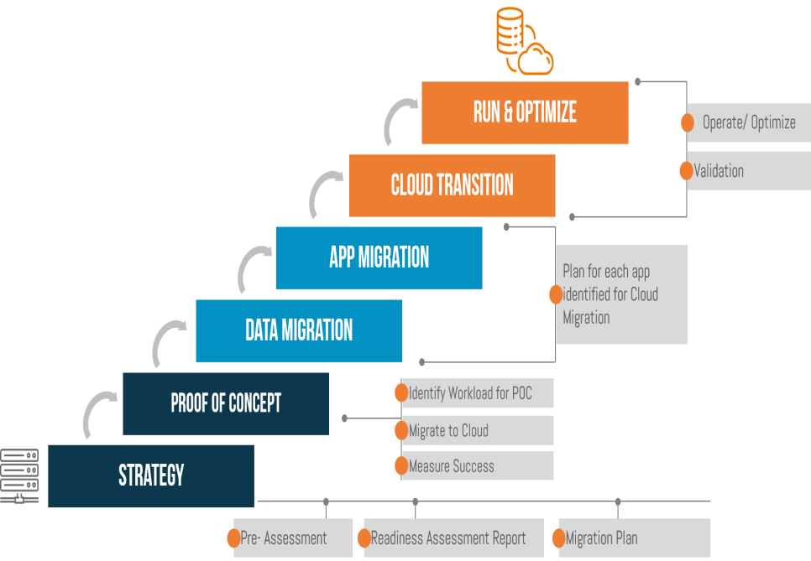

Figure 3: Migration model for cloud based systems

5. Skills for professional practice
Cloud computing system is one of the most effective systems to be used in the business process in many organisations. It is very effective to provide many benefits in the process of business in the respective areas. One of the most important things about cloud computing systems is, it is very important to have experts in the organisation which are having cloud computing system. It is not possible for the every employee in the organisation to manage the cloud computing therefore respective experts and experience person should be hired by the organisation to control the cloud based systems in perfect way.

5.1 Concerns of security
Security of the cloud computing system is one of the most important matters for the organisation which are having the cloud based system to control the business process. London bike is an organisation which is trying to update their information technology infrastructure into cloud-based system to perform the business related activities in more efficient way. They are focusing on the software as a service to improve the information technology of the organisation. Therefore it is very important to focus on the security of the cloud based system to prevent the potential risk to take place. Several security factors, which must be focused by the organisation, are,
- Data loss
In present days the cyber crime has increased in large scale, it is very important for the organisation to implement the cloud based system with proper security to prevent the loss of data (Vázquez-Poletti et al., 2017). London bike is an organisation which is updating their website to be used in the business process which is why it is important for the organisation to improve the security of the website in order to prevent the loss of important data of the organisation and the customer.
- Malware Infections
London bike is a business organisation therefore the website they are using, has many important data stored. It is important for the organisation to have effective security programs to prevent the cyber attacks including malware infections. It will be very bad for the organisation if the website is infected with the malware infection which will lead to many conflicts in the cloud computing.
- Legal and compliance issues
In present days governments are very concerned with the cyber crimes, as there are several rules and regulations are prescribed by the respective government to prevent the illegal and unethical work related to cyber (Pop, 2016). For the organisations which are having cloud computing system should be following all the rules and regulations to have effective security in to prevent the cyber-attacks.
These are the security concerns for the organisation London bike to plan the security designs in appropriate way.
Security control mechanism
Security control is one of the most important parts of the management of the cloud based systems and there are several mechanisms by which the control of the security of the cloud based systems will be very effective to the organisation in different parts of the business.
The mechanisms are,
- Perfect authentication in the cloud based systems
- Confidentiality in the cloud based technologies
- Access control in the cloud computing
- Maintaining the authorisation in the cloud computing
- Wireless access control; of the data in the cloud based systems

5.2 Implementation process of SaaS
Implementation of the software as a service is one of the complex processes to be performed in any organisation. There are several models of SaaS, which are very effective to be used in case of implementation. 3 major things that should be included in every SaaS model are,
- Multitenant architecture
- Customisation
- Accessibility
Implementation process of SaaS includes several stages which are,
Understanding the business requirement
It is important for the organisation like London bike understand the requirements of the business in different parts to implement the software as a service.
Identification of the team
London bike should be identifying the employees, who will be hired to perform the activities to implement the software as a service (Dašić et al., 2016).
Designing a scalable infrastructure
It is very important for the organisation London bike; build the appropriate infrastructure which will be holding the SaaS. Infrastructure must be having,
- Data centre
- Network infrastructure
- Hardware
- Backup and monitoring tools
Bandwidth requirement and hosting facility
It is important for the organisation to have connectivity to the public server. Connectivity factors including bandwidth and networking technologies must be identified and checked to be used in the implementation process.
Deployment of the SaaS delivery infrastructure
After the development of the infrastructure it is important to declare the software as service components.
Preparing a customer support centre
As the business of London bike is customer oriented, therefore it is important to develop a customer support centre which will be helping respective customers.
Documentation
It is important for the organisation to document all the important information and strategies which are used in the implementation process.
These are the steps of implementation process of software as a service.

Conclusion
Cloud computing is one of the most important parts of the business process if the system is implemented in proper way. Organisations which are having business functions must be implementing the cloud based systems to perform the business activities with maximum efficiency. There are many factors related to cloud computing system therefore it is important for the organisations to focus on all the factors to have cloud computing system without errors. There are also many beneficial services of the cloud based systems which are very effective to the business process. Three major parts of the service model of cloud computing system, SaaS, PaaS and IaaS are very important to the organisation to have. Implementation process of the cloud based system is very important for the organisation to be performed in perfect way. It is important for the organisation to have effective measure of security in order to prevent the cyber attacks in different places.

Reference list
Alam, T., 2020. Cloud Computing and its role in the Information Technology. IAIC Transactions on Sustainable Digital Innovation (ITSDI), 1(2), pp.108-115.
Almorsy, M., Grundy, J. and Müller, I., 2016. An analysis of the cloud computing security problem. arXiv preprint arXiv:1609.01107.
Alzahrani, H., 2016. A brief survey of cloud computing. Global Journal of Computer Science and Technology.
Bhardwaj, T., Kumar, M. and Sharma, S.C., 2018. Megh: a private cloud provisioning various IaaS and SaaS. In Soft Computing: Theories and Applications (pp. 485-494). Springer, Singapore.
Dašić, P., Dašić, J. and Crvenković, B., 2016. Service models for cloud computing: Search as a service (SaaS). International Journal of Engineering and Technology (IJET), 8(5), pp.2366-2373.
Hurwitz, J.S. and Kirsch, D., 2020. Cloud computing for dummies. John Wiley & Sons.
Jain, N. and Choudhary, S., 2016, March. Overview of virtualization in cloud computing. In 2016 Symposium on Colossal Data Analysis and Networking (CDAN) (pp. 1-4). IEEE.
Le, D.N., Kumar, R., Nguyen, G.N. and Chatterjee, J.M., 2018. Cloud computing and virtualization. John Wiley & Sons.
Li, P., Li, J., Huang, Z., Gao, C.Z., Chen, W.B. and Chen, K., 2018. Privacy-preserving outsourced classification in cloud computing. Cluster Computing, 21(1), pp.277-286.
Marinescu, D.C., 2017. Cloud computing: theory and practice. Morgan Kaufmann.
Messerli, A.J., Voccio, P. and Hincher, J.C., Rackspace US Inc, 2017. Multi-level cloud computing system. U.S. Patent 9,563,480.
Modi, C.N. and Acha, K., 2017. Virtualization layer security challenges and intrusion detection/prevention systems in cloud computing: a comprehensive review. the Journal of Supercomputing, 73(3), pp.1192-1234.
Palos-Sanchez, P.R., Arenas-Marquez, F.J. and Aguayo-Camacho, M., 2017. Cloud computing (SaaS) adoption as a strategic technology: Results of an empirical study. Mobile Information Systems, 2017.
Pop, D., 2016. Machine learning and cloud computing: Survey of distributed and saas solutions. arXiv preprint arXiv:1603.08767.
Stavrinides, G.L. and Karatza, H.D., 2016, June. Scheduling different types of applications in a saas cloud. In Proceedings of the 6th International Symposium on Business Modeling and Software Design (BMSD’16) (pp. 144-151).
Stergiou, C., Psannis, K.E., Kim, B.G. and Gupta, B., 2018. Secure integration of IoT and cloud computing. Future Generation Computer Systems, 78, pp.964-975.
Subramanian, N. and Jeyaraj, A., 2018. Recent security challenges in cloud computing. Computers & Electrical Engineering, 71, pp.28-42.
Varghese, B. and Buyya, R., 2018. Next generation cloud computing: New trends and research directions. Future Generation Computer Systems, 79, pp.849-861.
Vázquez-Poletti, J.L., Moreno-Vozmediano, R., Han, R., Wang, W. and Llorente, I.M., 2017. SaaS enabled admission control for MCMC simulation in cloud computing infrastructures. Computer Physics Communications, 211, pp.88-97.
Yang, C., Huang, Q., Li, Z., Liu, K. and Hu, F., 2017. Big Data and cloud computing: innovation opportunities and challenges. International Journal of Digital Earth, 10(1), pp.13-53.

