Coaching and Mentoring Skills in the Workplace
Samsul Alom
Student No. 1605851
BMSK6005_L

Table of Contents
Introduction 3
Purpose of coaching and mentoring skills in the workplace. Similarities and Differences in coaching and mentoring activities 3
Benefits of Developing Individuals’ Workplace Effectiveness Based on the GROW Model of Coaching and Mentoring 9
Knowledge, skills, attitude, and behaviours required by an active coach or mentor 14
Conclusion 20
References 21

List of Figures
Figure 1: The purpose of Coaching Skill in Workplace 4
Figure 2: Purpose for Mentoring Skills in Workplace 5
Figure 3: Similarities of Coaching and Mentoring 6
Figure 4: Dissimilarities in Coaching and Mentoring 7
Figure 5: Summary of Comparison 8
Figure 6: Collaboration of Coaching and Mentoring 9
Figure 7: Grow Model for Coaching and Mentoring 10
Figure 8: The GROW model for coaching and mentoring in the Co-op 12
Figure 9: Requirements for Mentor and Coaching 14
Figure 10: Knowledge required for Coaching and Mentoring 15
Figure 11: Skills Required for Coaching 16
Figure 12: Skills required for Mentoring 18
Figure 13: Attitude and behaviour required for coaching and Mentoring 19

Introduction
In the ever-growing modern business world, the necessity of skilled human resource is increasing more than ever. The essential skilled human resources can improve organizations efficiency and productivity. However, human resources if trained and developed can also contribute to creating competitive advantages for any organizations(Conan, 2019). The co-operative group is one of the successful retail businesses in the UK. The flourishing business organization was found in 1844 in the Manchester of United Kingdom. The giant organization has around 100 subsidiaries globally. The organization goes by the name co-op and has a huge employee base of approximately 72,000 worldwide. The co-operative group has their footsteps in the retail, finance, education, social and wholesale industries(PoklepovićPeričić, 2015). Besides this, the co-operative group is also indulging in the business of insurance and funeral care. By shading light on the selected retail organization (The Co-Operative Group) a model of coaching and mentoring is defined and analyzed. The benefits of employees in co-op workplace are also discussed in this portion. In the final portion of the report essential skills, qualities, knowledge, attitude and behaviors required for a mentor or coach are discussed.

Purpose of coaching and mentoring skills in the workplace. Similarities and Differences in coaching and mentoring activities
Organizations indulge in various activities such as coaching, counselling, career counselling and mentoring. The Co-operative Group focuses on coaching and mentoring for improving various skills and capability of its employees(Alessandra, 2017). The following discussion focuses on the purposes of coaching and mentoring. Besides the similarities and dissimilarities are also discussed in her
The purposes of coaching and mentoring skills are many. But eventually, they all lead to the benefit of the workplace. These purposes also improve the professional qualification of employees. Coaching is concerned about tapping the hidden potentiality of employees. This improves the overall working capacity of employees. When the employee can handle any task it ultimately creates job satisfaction and reduces turnover(Witherspoon, 2013). Coaching skill improves the confidence and self-belief of an employee. This promotes both efficiency and effectiveness of respective jobs. However, the improved effectiveness helps Co-op to attain their annual goals perfectly. Also, this contributes to developing professionalism. Another purpose of coaching skill is to improve the analytical ability of any employee. As the analytical power is furnished throughout the various career-building exercise the Co-op gets skilled human resources. This ultimately enhances the reputation and growth of Co-op as the employees get more efficient in problem-solving. Therefore it brings fluency in problem-solving within Co-op.

Figure 1: The purpose of Coaching Skill in Workplace
Source:(Morton, 2015)
Coaching Skills of employees opens a various opportunity for growth both personal and professional. At the management level of Co-op, coaching is one of the major or handling employees. The purpose of coaching of Co-op, therefore, is to enable the employees and managers of through various short term programs. So that they can understand and attain the goals and objectives set. Another purpose of coaching is to develop operational efficiency(Pyatt, 2015). The Co-op needs skills such as time management, problem-solving, resilience among their employees. However, these qualifications require guidance for operating at their best. A large amount of tactical and analytical skill is the main target of coaching within the Co-op. Apart from that, another purpose of coaching skills is to improve the communication system within the organisation. The Co-op focuses on building communication system throughout effective coaching so that no employee feels left out. Also, organisational citizenship improving is a target for coaching skills.

Figure 2: Purpose for Mentoring Skills in the Workplace
Source: (Pardey, 2015)
Mentoring Skill is often referred to as the transformation of knowledge and experience. Unlike coaching, this is a more informal approach and requires less set of skills and styles. The mentors of Co-op usually guide the employees to do what they have accomplished in the past. Therefore the purpose is to consult about the requirements and guidance to achieve similar goals. In the workplace, mentoring is concerned about motivating employee. The purpose of a mentor is to motivate so that the employee can achieve their goal through Existing potentiality. This improves the chain of command within the organization (Robbinson, 2018).
Another purpose of Mentoring Skill is to stimulate the thinking capacity of the employee. Mentors help the employee to think out of the box, which in the long run helps co-op in innovative strategy making. Another purpose of Mentoring is to support through ups and downs of career lifetime. This promotes organizational culture and brotherhood within Co-op. The organizational culture is improved throughout various activities of mentoring. Apart from these, the Co-op uses mentoring for succession planning. They train an employee for a key position throughout the various mentoring program. This improves the recruitment capacity of co-op and reduces the overall cost of time and money(Paul and Susannah, 2016). Co-op is mentoring for planning Career Development of employees. Therefore another purpose of Co-op mentoring is playing the role of career consultant within the organization. The purpose of both coaching and mentoring skill is directed toward the achievement of goals and strategies of Co-op.
Coaching and Mentoring are two separate types of programs offered to employees. They are quite similar in some fields. The purpose of both coaching and mentoring is to driving the employee toward success. Both of these managerial practices help employee realise their hidden potential and work together toward improving productivity(Kodwani, 2017). However, both of these practices also focuses on organisational growth such as Co-Op productivity and profitability. Therefore the purpose of both coaching and mentoring is similar while achieving a strategic goal.

Figure 3: Similarities of Coaching and Mentoring
Source: (Robbinson, 2018)
The role of both coach and mentor is like a teacher or consultant. The mentors and coach of Co-op identify the potentiality and weakness of employees. They work together to improve their hidden potential. Also in some cases, the coach or mentor pose as learning or thinking partner along with the mentee or coachee (Reddick, 2016). They share the role of teacher-student in most of the cases. Another Similarity of Coaching and mentoring is the relationship between coach, mentor and employee. In most of the cases, the mentor and coach are supportive and less critic while providing their services. The coach tries to bring out the hidden potentiality of employees while the mentor shows the way of attaining and achieving a preset target(Hudson, 2015). The Co-op mentors and coach are always supportive listeners and active in providing guidelines. They believe it is the best way of improving both organisational and employee performance. The relationship among mentor, coach and employee is built on trust, respect and recognition for hard work. Therefore the employee and mentors or coaches share the same value.
Even though coaching and mentoring are quite similar there are some basic differences in these two management practices. The core difference is that coaching is more elaborate and requires bringing hidden potentiality to attain and promote both personal and professional growth. On the contrary, mentoring requires showing the employee the path of success that the mentor has accomplished already. Co-op selects their mentors and coaches based on a particular set of skills, knowledge, attitude and behaviour required for the particular job(Thomas and Qiu, 2012). Another difference between coaching and mentoring is the process. In coaching, the coach asks several questions to be specific about the knowledge, potential skills and aspirations of cochere or employee. The coach provides tailored instructions as per the necessity of the employee. On the contrary, the mentor simply tells the experiences, shares his knowledge about the path of accomplishment. He can show the way to success his way. Unlike coach the mentor plays a role of mutual thinker and plays a supportive role.
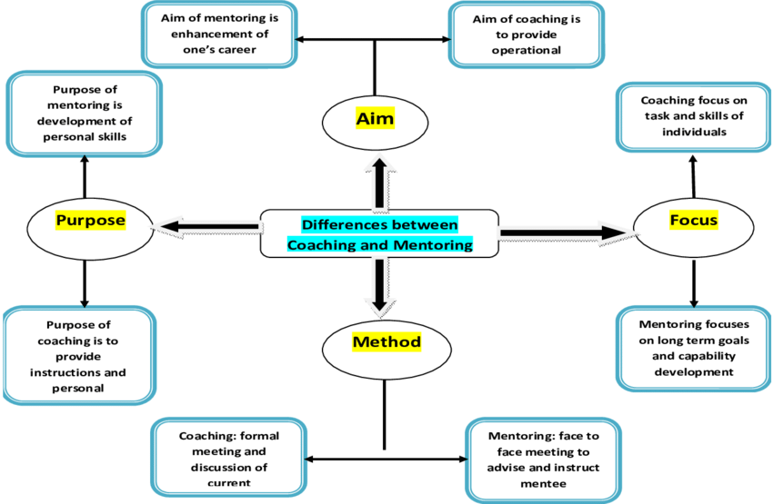
Figure 4: Dissimilarities in Coaching and Mentoring
Source: (Patt, 2016)
The focus of a mentor is to provide a solution for long term goals and developing gradually. On the contrary, the goal of a coach is to enable employee in the short term but sure skills. The focus is to improve the skill set in the current issue. Unlike mentoring the coaching is focused for a short period. The method of Coaching is more formal and requires structured meeting and feedback sessions. In these meetings, the position and improvement of employees are discussed (Cotrufo, 2019). On the contrary, mentoring meetings are more informal. Mentor usually provides instructions and shares experiences with the employee. In here, he motivates and inspires employee through sharing experiences achievement. Also, informal ad hoc meetings often take place as per the requirements of the employee. The target of the coach is to enhance the operational performance of an organisation. Therefore the relation is more formal and may not be entirely for the betterment of employee. On the other hand, the mentor's target is to gain accomplishment through improving the career development plan of an employee. This makes a more respectful and informal relationship between mentor and employees.
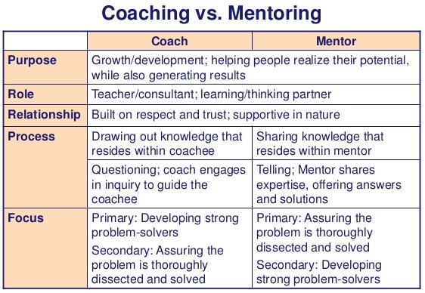
Figure 5: Summary of Comparison
Source: (Thomas and Qiu, 2012)
Another difference is the learning. Learning in coaching is mainly focused on the abilities in coaching (Pardey, 2015). Coaches of co-op identify skill lacking and work to improve them. On the contrary, in mentoring learning is focused on the behaviour and attitude of both mentor and employees. The co-op uses these differences to assign coaches or mentors as per requirements of organisational needs.Managers take various steps toward improving human resources such as training, development programs, coaching and mentoring etc. The coaching and mentoring programs are carried out by the majority of retail businesses in the UK. These particular management practices help employee realize their goals and set career plans.

Benefits of Developing Individuals’ Workplace Effectiveness Based on the GROW Model of Coaching and Mentoring
For coaching or mentoring several models can be used. For example- GROW Model, ACHIEVE Model, STEPPPA Model, OSCAR Model, and CLEAR Model. Each model has its significance to develop individuals' workplace efficiently. Among these models, the GROW model is discussed in this paper below.
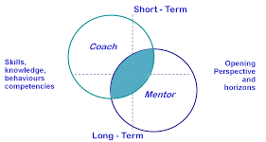
Figure 6: Collaboration of Coaching and Mentoring
Source: (Conan, 2019)
The GROW model is undoubtedly the most widely-utilized coaching and mentoring model not only in the UK but also throughout the world. GROW stands for Goal, Reality, Opportunity, Will/Wrap-up/What next/Way forward. It is a modest 4 steps model for organizing mentoring and coaching sessions. It can be integrated into managerial and leadership practices to maintain competency, improvement, and efficiency of internal coaching and to ensure a superior return on asset (Thomas and Qiu, 2012). It skeletons a methodical and systematic agenda between mentor and employees in the Co-operative Group for problem-solving and goal-setting. A critical evaluation of this model to develop individuals’ workplace is discussed here. This coaching model helps the mentees to formulate superior choices, resolve difficulties, acquire innovative expertise, and growth in their professions.
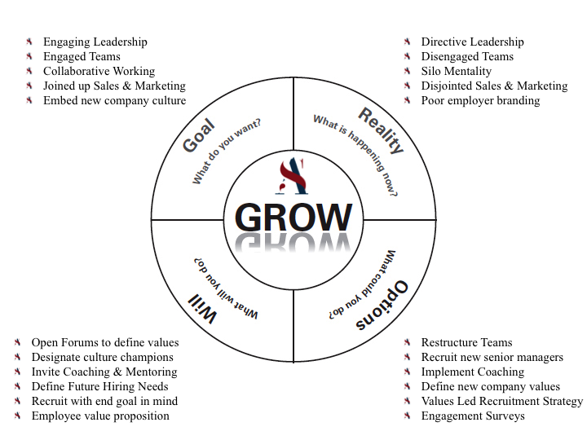
Figure 7: Grow Model for Coaching and Mentoring
Source: (Irby, 2012)
Establish the Goal: The first stage of the GROW coaching model is Goal. Establishment of goal along with consequences, precise path and purposes must have to be discussed in this stage by the mentors or coaches. The goal must be SMART (Specific, Measurable, Accurate, Realistic and Timely) in nature. The goal should also be motivating, optimistic, and stimulating to maximize the productivity of the overall organization(Morton, 2015). It also indicates the requirement of the HR and their capabilities to accomplish that goal. It also helps to clarify the organization's vision and focus, introduce self-discipline: generate new potentiality, manage time and accomplish tasks based on priority. For controlling and monitoring of the staffs of the Co-operative Group formulation of the goal is very important. On the other hand, the downsides of this stage could be accomplishment addiction, mystical starvation, identity misperception, and excessively ambitious attitude of the mentors or employees of the firm. This model ensures greater productivity, responsibility, and accountability of the entire team which leads to a healthy working environment within the company (Pardey, 2015). For example- The Co-operative Group wants to intensify its revenue by 10% by December 31, 2018, is the establishment of goal.
Examine the Current Reality: The second stage of the GROW model is Reality. Considering the current situation and describing the present reality it the most important issue in any coaching session. It is quite hard to solve any problem or move forward without evaluating the current situation or without considering the exact starting point. The appropriate evaluation of reality leads the coaching session to reach goal efficiently (Alexander, 2016). With the help of different approaches and techniques both mentee and coach sketch and discuss the existing reality to measure employees' condition before providing a solution. In this phase SWOT (Strength, Weakness, Opportunity, and Threat) analysis is conducted to evaluate the overall situation. Proper evaluation of reality offers appropriate direction, clarity in decision making, controlling the surroundings with confidence as well as focus on important issues.
It also helps to motivate the employees and enhance job satisfaction in the Co-operative Group. On the other hand, without proper calculation of current situation provide inappropriate directions and reduce the productivity and performance of the overall company. Improved level of communication throughout the management team and good interpersonal relationship are also the positive sides of this approach which promotes the effectiveness of the atmosphere of the workplace. For example- the current reality of The Co-operative Group is its current revenue is £9.5 billion in 2017 and the firm wants to reach £10.45 by the end of 2018 where the firm has more than 7,000 outlets and 70,000 employees along with more than 4.6 million active members.
Explore the Options/ Opportunity: The next stage is all about made alternative options to reach the goal of the coaching session determined in the first stage. The options should be based on the current reality to maximize the output and ensure the fruitfulness of the coaching session. This stage helps the employees and mentors of the Co-operative Group to create a shield for any kind of obstacles to reach the goal efficiently(Barnson, 2014).
In this third stage, a wide range of choices including proposals from the client are put-forward and conferred. After studying all the possible alternatives, the mentor or coach must have to introduce a common ground of option considering client’s inclusive situation. It reduces the degree of risk and ensures cost efficiency to reach the goal. After this stage, both mentor and employees of the Co-operative Group will be certain about some options and actions with less vagueness to overcome the current situation. Though it is a lengthy and complicated process to evaluate different alternatives, it ensures higher potentiality of return form performance(Patt, 2016). For example- an exploration of options includes increasing the number of active members in 2018 along with the improvement in marketing strategy and campaigns as well as promotion, expansion of the partnership network with Nisa Retail Limited, The Manx Co-operative Society Limited, etc. Training for employees is also an option. After the evolution of each alternatives' pros and cons, the mentor must have to take actions.
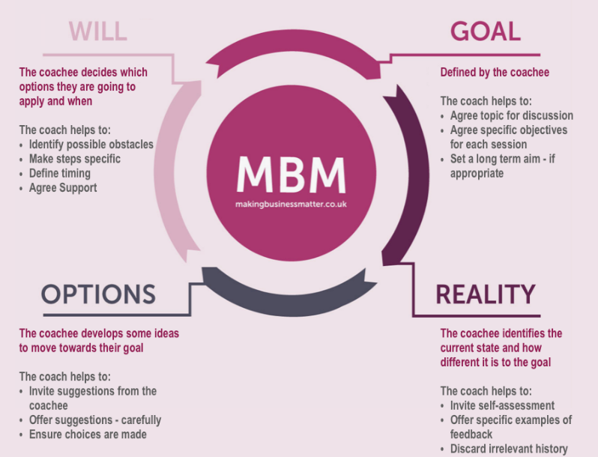
Figure 8: The GROW model for coaching and mentoring in the Co-op
Source: (Kodwani, 2017)
Establish the Will/Wrap-up/What next? /Way Forward: The last and final stage of the GROW model is Will in which the commitment of the team to a precise set of actions to reach the goal efficiently. In this stage, the mentor or coach must have to help the employees of the Co-operative Group to inaugurate their will and lift their degree of motivation. This stage indicates proper guidelines and a deadline to accomplish specific tasks(Morton, 2015). Any possible difficulties which can be encountered during the procedure are recognized and succeeding resolutions are measured together with a framework of the essential support throughout. It ensures accountability among the team and offers different approaches to reach the goal smoothly. Both the mentee and mentor must have to be flexible during the whole procedure, and aims/arrangements may need alteration to respond to both optimistic and negative incidents. Though it hinders the degree of freedom and innovation of the mentee or employee, it offers guidelines and proper instruction to them(Cotrufo, 2019). This stage helps the mentor to control and manage the entire team and lead them to reach the goal perfectly. For example- A detailed and precise milestones and timelines are set to accomplish the target. After that review of performance in every month will ensure the achievement of the goal.
Benefits of GROW model for developing individuals’ workplace effectiveness
The practice of GROW model in coaching session along with organized inquiries widens the degree of responsibility, awareness, and accountability in the workplace which will promote the individuals’ workplace efficiency(Pardey, 2015). This model also helps to cultivate the applied techniques and proactive attitude of the mentees in the workplace which assists to accomplish objectives and overcome complications. The well-organized coaching practices and framework helps individuals to unlock their true potentiality with a magnitude of sufficient self-confidence, rewards, and incentives. This model drives the management team to a specific and attainable goal which results in job satisfaction among the employees the Co-operative Group by motivating them. GROW coaching model enriches workplace culture and facilitates HR and talent management of any company with efficiency(Reddick, 2016). Application of SMART, SWOT tools in this GROW model results in reliability and confidence and ensures the effectiveness of an individual's workplace. As GROW model is simple and most common it can be practised to discover and design for a bulky number of diverse goals. It helps to make quick and reliable decisions regarding any obstacles.

Knowledge, skills, attitude, and behaviours required by an active coach or mentor
In some of contexts coaching is different form mentoring. But both the functions can be accomplished based on some core knowledge, skills, and expertise in attitudes and behaviour. For a sound and effective work environment, the knowledge of a coach or mentor is very significant. Some of these are mentioned very briefly on this paper.
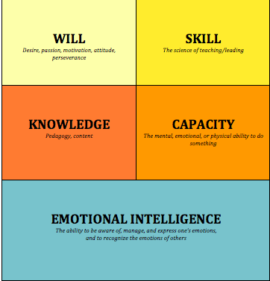
Figure 9: Requirements for Mentor and Coaching
Source: (PoklepovićPeričić, 2015)
Knowledge of coach or mentor regarding a specific area is very important for the establishment of any sound work environment. Generally, coaches must have to maintain three categories of knowledge including professional, interpersonal and intrapersonal knowledge. A mentor should have experience and expertise and ability to teach and learn as his professional knowledge. Experience helps the coaches to relate and encounterthe challenges of the work environment in The Co-operative Group(Hudson, 2015). On the other hand, it helps to build faith and trust of employees toward their mentors which promote sound workplace. For conducting different training programs for their employee coaches must have to ensure proper knowledge on the ability to teach and learn. It ensures the quality of employees and turns the human resources as human capital within The Co-operative Group.

Figure 10: Knowledge required for Coaching and Mentoring
Source: (Irby, 2012)
Intrapersonal knowledge is about understanding coaches or mentors by himself. It helps a coach recognize his core values, advance coaching aptitudes and endure a coaching profession. Self-awareness is one of the vital key points of intrapersonal knowledge. It motivates the coaches and increases the degree of responsibility and accountability among the coaches in the Co-operative Group. On the other hand, without any self-awareness and only for rational purpose coaching profession results in an unhealthy workplace. Reflection is a regular process in the coach in the Co-operative Group which introduce the coach with new best alternatives solution of any problem. For quality coaching, practical reflection and critical reflection are mostly used(Kodwani, 2017). Both methods are practised by the coach in solving any problem or tackle any situation in the workplace. This reflection process helps the coach to generate quick decisions among probable best alternatives, maintain quality and competitive advantages of the firm. The main drawback of these approaches is it takes huge time even for a simple problem to reflect solution. Continuous improvement is another vital intrapersonal knowledge of coaching. Though coaches have to be confident they must have to be enough humble to learn something new. It helps the coach to constantly identify different aspects of coaching that can be improved(Patt, 2016). It promotes strong learning and support networks for the employees as well as coach in the workplace of the Co-operative Group.
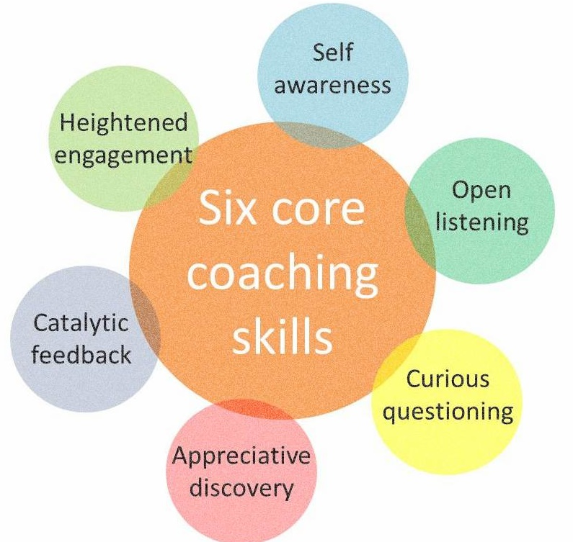
Figure 11: Skills Required for Coaching
Source: (Barnson, 2014)
Coaches must have to cultivate the interpersonal knowledge in which emotional intelligence is very crucial. Emotional intelligence includes observing, understanding, managing and using employees’ emotion to confirm the right option for the employees in the workplace. It provides the appropriate guideline about the management of employees in different stages and helps to motivate the employees(Paul and Susannah, 2016). Otherwise, the employee turnover rate will be very high. Transformational leadership is another vital point of interpersonal knowledge. In this process, coaches emphasize shared and distributive leadership and responsibilities among employees. It helps to generate self-confidence and self-motivationamong the employees and form solidity or collective efficacy. It ensures a good relationship between employees and mentors(Sinclair, 2016). It exterminates the performance of the Co-operative Group when the responsibilities are distributed among inappropriate people.
In the Co-operative Group coaches and mentors are considered as a crucial part of the management of that company. Being a coach or a mentor of the Co-operative Group is not an easy job where more than 80,000 employees are working. A perfect combination and blending of personal and professional qualities are very important for any coach or mentor(Robbinson, 2018). Skills and these abilities that are required for an effective coach or mentor for the sound workplace are outlined below this script.
Rapport building refers to the interpersonal skill of a coach through which a proper degree of understanding between coach and learner can be ensured. To educate the employees about the company's standard and memorandum, this skill is practised. It helps to maximize the outcome of the Co-operative Group from the coaching session. This skill also helps the coach to be people-oriented and ensures a comfortable workplace and reduce the level of conflicts and confusions. Appropriate listening and looking ability is a very crucial skill in a coaching session(Witherspoon, 2013). Listening ability includes verbal and visual cues to understand by the coach. On the other part looking ability measures the level of emotion and commitment of employees and working atmosphere of that particular company. It motivates the employees by establishing two-sided communication and responding to employees’ queries properly. Best alternatives can be generated with this approach though it is a lengthy process with a probability of interruptions during the session.

Figure 12: Skills required for Mentoring
Source: (Sinclair, 2016)
The ability to empathize is the critical skill of coach in the Co-operative Group. Empathy refers to experience the sense of the other person’s emotional conditions(Sinclair, 2016).It helps the coach to receive the employees on their terms and drive them with motivation toward the company's goal with sufficient rewards. Sound work atmosphere, Employee motivation, job satisfaction, productivity, and profitability are the main outcomes of this practice. Empathy also increases the degree of trust and respect for the coach or mentors. Leadership skill is one of the most important skills of mentors. A mentor should have the skill to lead his team toward the company's goal(Pyatt, 2015). To direct the workforce of the Co-operative Group toward a single goal the coach or mentor must have to pose the leadership skill. It ensures accountability, delegation, and empowerment in different stages of management. It helps the coach to guide the beginner in goal setting and accomplishment.
Catalytic feedback is another important skill of a coach or mentor which is practised in every sphere of the coaching session in the Co-operative Group. A coach must have the skill to offer observational and non-judgmental feedback about the employees' actions and magnitudes. Proper feedback improves the performance of employees, maximizes their productivity and motivates them. It also assists to open up new opportunities and viewpoints(PoklepovićPeričić, 2015). Coaching is an approach to interpret the goal of the Co-operative Group. For this reason, the coach or mentor must have the ability to stimulate clear, precise and expressively engaging goals form the coaching session. In both formal and informal way, a coach can drive and motivate employees toward the firm's goal and maximize their productivity. This skill is most important to inaugurate realistic objectives and design appropriate action plans. The ability to question effectively and wisely is a significant skill of a coach or mentor in the Co-operative Group. Appropriate use of questioning techniques and intellectual open-ended questions inspires the employees to elaborate more(Alessandra, 2017). It increases the person’s level of consciousness and exemplifies the consequences of diversified approaches to coaching techniques. It can promote sincere attention and apprehension toward the employees.

Figure 13: Attitude and behaviour required for coaching and mentoring
Source: (Alexander, 2016)
Coaching and Mentoring profession requires involvement in open and wide range conversation among huge people. For this purpose, communication skill is also very significant in coaching or mentoring. For easily transfer of massages, giving feedbacks and direct the employees toward the goal of the Co-operative Group a coach must have to be expert in communication. It ensures the productivity and profitability of the coaching session and firm(Conan, 2019). The motivation of employees and reduction of conflicts and employee turnover is positive outcomes of this practice. A coach or mentor must have the skill to motivate and inspire the employees throughout the operational level of the Co-operative Group. It promotes job satisfaction, reduces employee turnover rate and enhances the productivity of the overall company. It also ensures the sound workplace as well as job security among employees and management.

Conclusion
Coaching and Mentoring are two of the main motivational factors when it comes to enhancing employee skills in the workplace. However, there positioning and hard work has already brought result. In an annual report of the co-op, it was concluded that the employee effectiveness and job satisfaction increased by 29% after taking the coaching in hand. However, the organization believes they still have miles to go with coaching and mentoring.Management of Co-op has been taken various strategy for the implementation of coaching and mentoring properly. However, it has been confirmed that using the models for coaching and mentoring has proven to be more effective. Among the many benefits, co-op believes the GROW model is creating a better workplace environment through building skills, respect and organizational satisfaction. Besides the implementation and benefits Co-op keeps in mind the suitability of coaches and mentors. The skills, knowledge and attitude make them appropriate for their job.

References
Alessandra, A. (2017). Coaching. [Place of publication not identified]: Team Publications & Worldwide Center for Organizational Development.
Alexander, C. (2016). Workplace Information-Forcing: Constitutionality and Effectiveness. American Business Law Journal, 53(3), pp.487-536.
Barnson, S. (2014). The Authentic Coaching Model: A Grounded Theory of Coaching. International Sport Coaching Journal, 1(2), pp.61-74.
Conan, J. (2019). Elements of Effective Practice for Mentoring™ - MENTOR. [online] Mentoring.org. Available at: https://www.mentoring.org/program-resources/elements-of-effective-practice-for-mentoring/ [Accessed 19 Jul. 2019].
Cotrufo, M. (2019). Effective Mentoring. CSA News, 64(2), p.22.
Hudson, P. (2015). Mentors Report on Their Own Mentoring Practices. Australian Journal of Teacher Education, 35(7).
Irby, B. (2012). Editor’s Overview: From Mentoring Synergy to Synergistic Mentoring. Mentoring & Tutoring: Partnership in Learning, 20(2), pp.175-179.
Kodwani, A. (2017). Decoding training effectiveness: the role of organisational factors. Journal of Workplace Learning, 29(3), pp.200-216.
Morton, A. (2015). Mentoring. York: Learning and Teaching Support Network.
Pardey, D. (2015). Coaching. 16th ed. Oxford: Elsevier.
Patt, T. (2016). Interpersonal and organizational approaches to effective mentoring. Mentoring & Tutoring: Partnership in Learning, 14(2), pp.135-136.
Paul, P. and Susannah, P. (2016). Aspire Project - an integrated wellness coaching model facilitated by an online coaching technology. Frontiers in Public Health, 4.
PoklepovićPeričić, T. (2015). Understanding wider environmental influences on mentoring: Towards an ecological model of mentoring in academic medicine. ActaMedicaAcademica, 44(1), pp.83-86.
Pyatt, G. (2015). Training and implementing a peer mentoring strategy. Mentoring & Tutoring: Partnership in Learning, 10(2), pp.171-177.
Reddick, R. (2016). Intersecting Identities: Mentoring Contributions and Challenges for Black Faculty Mentoring Black Undergraduates. Mentoring & Tutoring: Partnership in Learning, 19(3), pp.319-346.
Robbinson, A. (2018). Strategy to improve knowledge, attitude, and skill toward mentoring and coaching. International Journal of Social Sciences and Humanities.
Sinclair, C. (2016). Mentoring Online about Mentoring: Possibilities and practice. Mentoring & Tutoring: Partnership in Learning, 11(1), pp.79-94.
Thomas, H. and Qiu, T. (2012). Work‐related continuing education and training: participation and effectiveness. Journal of Workplace Learning, 24(3), pp.157-176.
Witherspoon, H. (2013). Stress Management Program Improving Worker Health and Operational Effectiveness: A Case Study. Workplace Health & Safety, 61(3), pp.134-134.

