Marketing plan written for

Holiday Inn Edinburgh

Student Name: Cristina Maria Radu

Student ID number: 2214729

Marketing Essentials BMIH4005

Lecturer: Ruth Taylor -Davies

Contents
Introduction 3
Situation Analysis 3
Competitiveness in the market 4
Holiday Inn’s B2B relationships, partnerships and franchises 4
Objectives 5
Strategy 5
Tactics: Marketing Mix 6
Action: Gantt Chart 7
Control: Unique Selling Proposition (USP) 7
Conclusion 8
References 9
Appendices 10

Introduction
This marketing plan is prepared for Holiday Inn Edinburgh to let marketing managers in the hotel implement the plan effectively to attract new customers introducing new services that Holiday Inn Edinburgh yet to ensure at its fullest namely digital payment methods and online booking and cancellation amid this ongoing global economic recession in the post-COVID market. Despite being situated in excellent location, providing superb services and atmosphere, this hotel fails to retain its growth up. With the application of SWOT, 4Ps of marketing, and PESTLE for both micro and macro-economic factors, an effective marketing plan will be provided for Holiday Inn Edinburgh.

Situation Analysis

SWOT analysis for Holiday Inn Edinburgh
Strengths  Strong brand recognition;  Excellent services especially having experienced workforce; and  More than 1200 hotels globally. | Weaknesses  Limited market share; and  Still expanding in emerging markets.
Opportunities  Development of tourism industry especially after relaxation of lockdowns; and  Growing number of millenniums around the world (Oldroyd, 2001) | Threats  Global recession in the post-COVID market  Increasing operational costs following sky-rocketing price inflation; and  Intense competition from Hyatt, Marriot and Ramada Inn.

Customers: Segmentation and Targeting
In case of segmentation, people visit for many reasons but for Holiday Inn hotel those who seek a comfortable environment to get away from the day-to-day life.
The target market based on the segmentation are corporates, families from home and abroad. As per innovative marketing plan to attract new customers, it will target growing number of millennials community. Mostly the budget hotel tries to ensure that mid-range earning people can afford this hotel to have a relax and just be thyself environment (Shapiro, 2014).

Competitiveness in the market
To analyse competitiveness of Holiday Inn in Edinburgh, here Porter’s five forces analysis incorporated-
Industry Rivalry | Higher revenues at lowest possible costs;  Strong brand loyalty; and  Growing sales revenue.
Threat of New Entrants | Adding new services and products;  Enjoying economies of scale i.e., low fixed cost per unit; and  Large volume investments in research and development.
Bargaining Power of Suppliers | Maintaining strong supply chain relationships with multiple suppliers; and  Reliance on various sources of services, raw materials (Smith & Zook, 2020).
Bargaining Power of Buyers | Loyal customer base; and  Widespread presence in the market and addition of new products and services.
Threats of substitute products or services | Mostly service oriented thank to experienced workforce; and  Fulfilment of core needs of clients.

Holiday Inn’s B2B relationships, partnerships and franchises
As part of strategic partnership in 2016, Holiday Inn partnered with two small businesses – Sword & Plough and Perfect 10 (Morrison, 2016). Before partnering with them, Holiday Inn researched more than three hundred companies. Moreover, it also allows franchise of its own name maintaining standards that Holiday Inns ensure.
PESTEL to analyse macro-environment
Political factors | Government restrictions on the use of fuel and gas.  Increased tariffs and import duties on luxury items; and  Rising income tax to curb inflation.
Economic factors | Increased policy interest rates (Ayman and Kaya, 2020).  Mounting inflationary pressure in fuel, oil and food market; and Increasing rate of unemployment.
Social Factors | Growing number of millennials.  Afraid of being COVID affected; and  Increased savings attitude experiencing financial hardship.
Technological Factors | Adoption of digital payment systems; and  Efficient and cost savings technologies.
Environmental Factors | Recycling and waste management.  Launching on eco-friendly or green products; and  Use of renewable energy.
Legal Factors | Laws related to consumer protection and e-commerce.  Health and safety; and  Data protection.

Objectives
Aim of the Marketing Plan: Increase number of customers by 10% in Q1 in 2023.
Specific: Increasing number of customers introducing new services that Holiday Inn Edinburgh yet to ensure at its fullest namely digital payment methods and online booking and cancellation.
Measurable: Clearly defined the target to increase by 10%.
Achievable: Launching hotel rooms at low costs with basic amenities but not luxury following the growing number of millennials who prefer site-seeing rather than enjoying in-house facilities and using Google’s Local SEO.
Relevant: relevant with the goal of attracting new customers
Time-bound: Limited to Q1 in 2023.

Strategy

In this era of technological advancements, every competing hotel in the industry tries to incorporate updated services and products (Kotler et al, 2020). The value proposition of Holiday Inn is to deliver the most efficient services in terms of booking, payment, and availing services. Following Bowman’s strategy clock, it will focus on focused differentiation strategy as mentioned above target customers are corporates, families having mid-range income. Digital marketing platforms will be used to communicate and deliver the message to potential customers. Targeting mid-range customers, Holiday Inn will be able to provide efficient services, comfortable environment to make customers stress-free with an affordable budget, which will affect its positioning positively.

Tactics: Marketing Mix
Product
In hotel industry, service is the difference-maker (Kotler, 1984). That is why Holiday Inn always tries to ensure their best services. Holiday Inn Edinburgh provides 24-hour front-desk and housekeeping, free internet access, laundry, non-smoking and smoking zone, contactless check-in and out to avoid contamination. Moreover, it ensures staffs wear PPE, cleanliness and disinfection, provides free hand sanitizer, avails individually wrapped food options anytime. As part of marketing plan to attract new customers, this hotel can attract customers by introducing new services that Holiday Inn Edinburgh yet to ensure at its fullest namely digital payment methods and online booking and cancellation. It can attract new customers by launching hotel rooms at low costs with basic amenities but not luxury following the growing number of millennials who prefer site-seeing rather than enjoying in-house facilities
Place (Distribution)
Holiday Inn in Edinburgh city is in the heart of the city centre. One can easily visit this hotel by road or air. People from different cities or countries can land in Edinburgh city and then travel to the hotel easily (Bowie et al, 2017). This is the ideal accommodation for tourists around the world who want to enjoy and explore the idiosyncrasy of Edinburgh city.
Price
Some people trade-off price with quality (Morrison, 2016). Our target customers may not seek luxuries but will not compromise a minimum standard for price. Focusing on mid-range customers, Holiday Inn always follows cost-plus pricing strategy. This strategy enables Holiday Inn to offer competing services comparatively at a lower price in this area. Depending on the benefits, room size and services required, Holiday Inn provides variety in price points which is displayed in websites, hotel receptions.
Promotion
Among different promotion mid elements, Holiday Inn still focuses on advertisements on newspaper, sponsorship, television media only whereas competing hotels mostly depend on digital marketing platforms (Fletcher, 1990). For this, Hotel Inn needs to bring changes in promotion strategy. It can use social media platforms like Facebook, Twitter, YouTube, etc. to reach millions around the world with a minimum cost and efforts. Moreover, it can go for discount offer in special seasons not compromising with quality and services. Holiday Inn can also focus on public relations. It can invite celebrities in the world to stay in the hotel for free. It will have a positive impact in the market. Using Google’s Search Engine Optimization (SEO), specially, local SEO, Hotel Holiday Inn can reach customers who seek hotel nearby places. Moreover, asking customer’s reviews in social media pages or company websites can be a wonderful way to help new customers to make wise decisions.

Action: Gantt Chart
Gantt charts are highly sued in project planning to certain deadlines and allocate resources for each task to be accomplished to complete the project within deadline (Diamond and Pintel, 1991). Here is the Gantt chart for conducting the marketing plan-
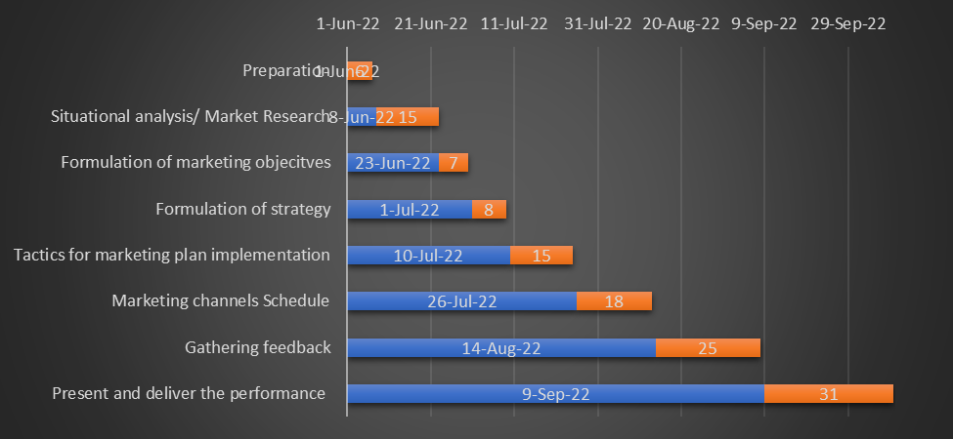

In case of marketing channels schedule, the prime concern was to communicate with target community to make them aware of services and products offered by Holiday Inn in Edinburgh which might help them to make informed decision to choose a hotel. Among paid, free, traditional and digital marketing channels, digital marketing channel is now used mostly to communicate millions around the world easily (Chaffey and Ellis-Chadwick, 2022). Top giants now adopt digital marketing. People are no longer confined to television or newspapers. That is why adopting digital distribution channels is justifiable.

Control: Unique Selling Proposition (USP)

The Unique selling proposition (USP) is the specific feature that makes a business differentiate from others in the market (Jobber and Ellis-Chadwick, 2020). It helps a business to be unique and remain competitive in the market. Holiday Inn having strong brand recognition, focused customer group, global presence with 1200 hotels and experienced workforce can enjoy USP to remain competitive in the market. In case of Holiday Inn, success can be measured in terms of percentage of customers increased in the next quarter as set target for Q1 in 2023. Besides a rise in profit can also be considered as success parameter but positive attitudes towards the brand is optimum because it has long term impacts on the performance of the business.

Conclusion
In this marketing plan of introducing new services that Holiday Inn Edinburgh yet to ensure at its fullest namely digital payment methods and online booking and cancellation it is obvious that aim is to increase the number of customers in Q1 next year, but it is not that easy to attain as stated above. Mostly, with mounting fuel, oil and food prices, people around the world are facing fiscal crisis, which may, in turn, cause financial recession. Adopting Fintech may face challenges from existing employees as they are not acquainted with this one and often customers may fail to have easy access with this (Gursoy, et al, 2023). Customers data protection is necessary. Initially it might be difficult to reach target audiences too using digital platform. But to cope up with these challenges-
- Holiday Inn can focus on renewable energy sources and develop own supply chain for food production and process to serve in its hotels to avoid inflationary pressure in the market.
- Holiday Inn can train its existing employees to use Fintech adopted.
- Payment systems, apps need to be developed in such a way that is easy to use - customers can feel safe and simple.
- Adopting block chain applications, Holiday Inn can avoid security risk of customer data (Ghauri, 2014).

References
Ayman, U. and Kaya, A.K. (2020) Promotion and Marketing Communications. London, UK: IntechOpen.
Bowie,D. Buttle,F. Brookes,M & Mariussen,A (2017), Hospitality Marketing. Third ed, Routledge, London
Chaffey, D. and Ellis-Chadwick, F. (2022) Digital Marketing. Harlow, England: Pearson.
Diamond, J. and Pintel, G. (1991) Principles of Marketing. Englewood Cliffs, NJ u.a: Prentice Hall.
Fletcher, K. (1990) Marketing Management & Information Technology. New York: Prentice-Hall International.
Ghauri, P N (2014) International Marketing, 4th Ed, McGraw Hill, London
Gursoy, D., Bowie, D. and Buttle, F. (2023) Hospitality marketing: Principles and practice. Abingdon, Oxon: Routledge.
Jobber, D. and Ellis-Chadwick, F. (2020) Principles and practice of Marketing / David Jobber and Fiona Ellis-Chadwick. Maidenhead: McGraw-Hill Higher Education.
Kotler, P., Armstrong, G., Harris, L. and He, H., 2020. Principles of marketing. 8th European ed, London: Pearson Education Limited.
Kotler, P. (1984) Marketing essentials. Englewood cliffs, n. j.
Morrison, K. (2016) “The targeting of the Holiday Inn,” Sarajevo’s Holiday Inn on the Frontline of Politics and War, pp. 193–202. Available at: https://doi.org/10.1057/978-1-137-57718-4_11.
Oldroyd, M. (2001) Marketing environment. Oxford: Butterworth-Heinemann.
Shapiro, B.P. (2014) The marketing mix. Boston, MA: Distributed by the Pub. Division, Harvard Business School.
Smith PR & Zook ZE (2020) Marketing Communications. 7th ed, Kogan Page, London

Appendices
Slide 01
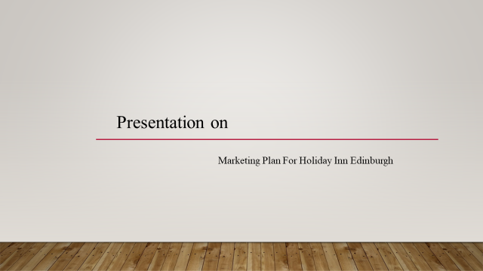

Slide 02
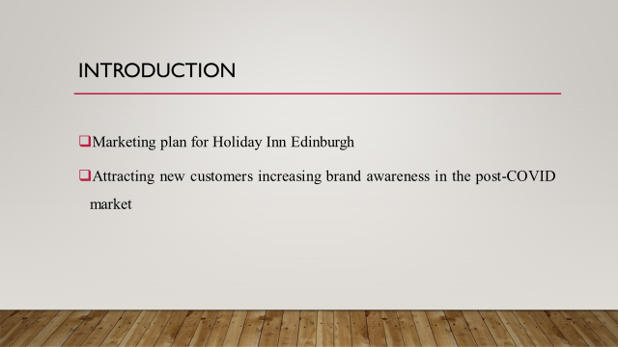

Slide 03
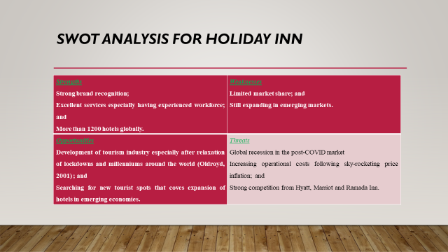
Slide o4
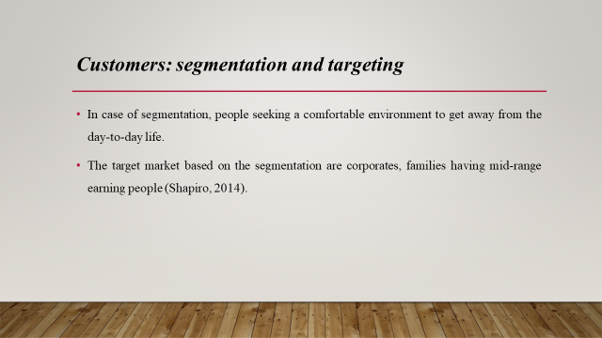

Slide 05
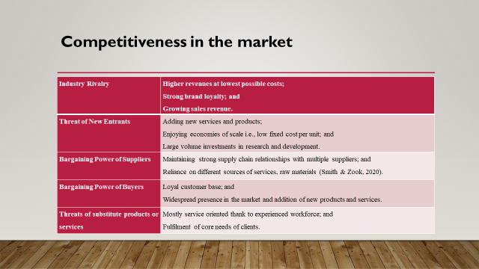

Slide 06
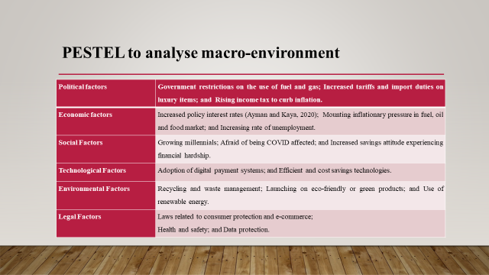

Slide 07
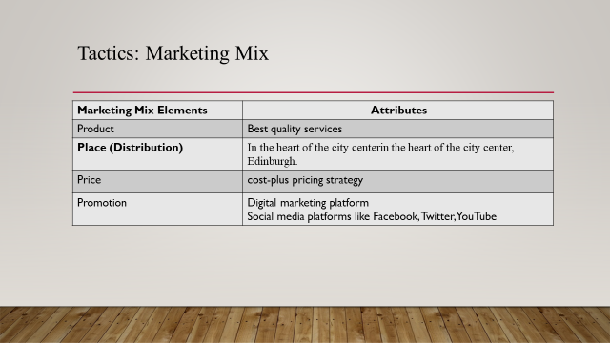

Slide 08
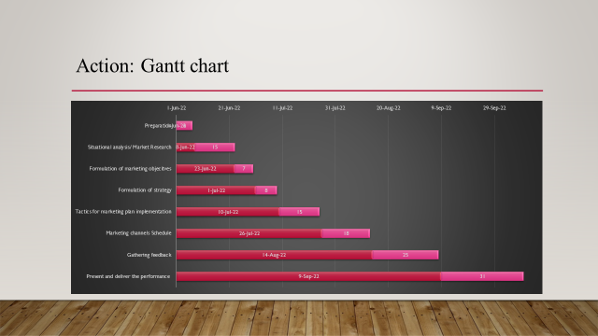

Slide 09
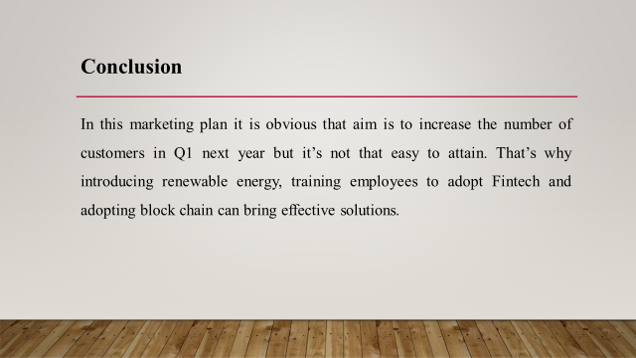

Slide 10


