Mikolaj Michalski (1900885)
1900885@student.uwtsd.ac.uk
Networking And Cybersecurity

Changemakers: Creativity and value creation
Assignment 1: E-Portfolio

Table of Contents
1. E-Portfolio 2
2. Task 1 – Mind map 3
3. Task 2 – Image Based Video Presentation 4
4. Task 3 – Video presentation 5
5. Task 4 – Academic Poster 6
References 7

E-Portfolio
Link: https://mikolay102.wixsite.com/my-site


Task 1 – Mind map
Link: https://mikolay102.wixsite.com/my-site/unit-1-1
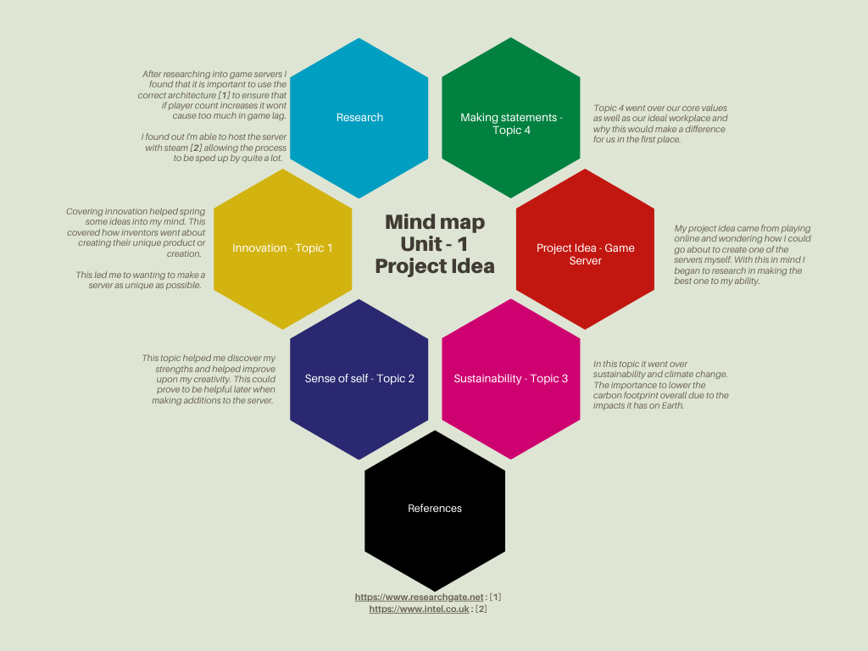
References: [1] , [2]

Task 2 – Image Based Video Presentation
Link: https://mikolay102.wixsite.com/my-site/unit-2
YouTube: https://youtu.be/9_5ii3ijo_8
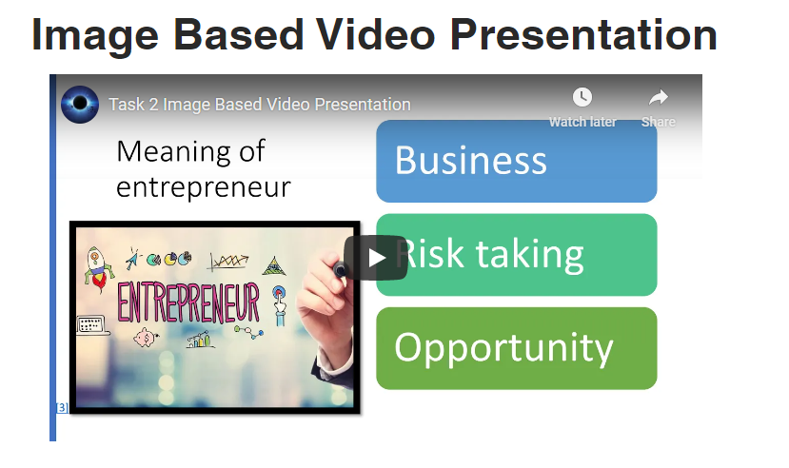

References: [3], [4], [5], [6]

Task 3 – Video presentation
Link: https://mikolay102.wixsite.com/my-site/unit-3
YouTube: https://youtu.be/CDoZ_O6FYYo
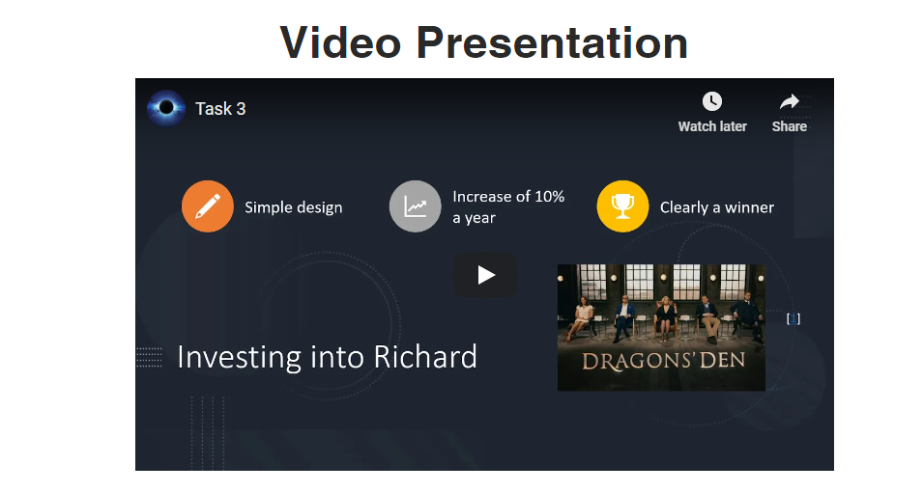
References: [7], [8], [9], [10], [11]

Task 4 – Academic Poster
Link: https://mikolay102.wixsite.com/my-site/unit-4
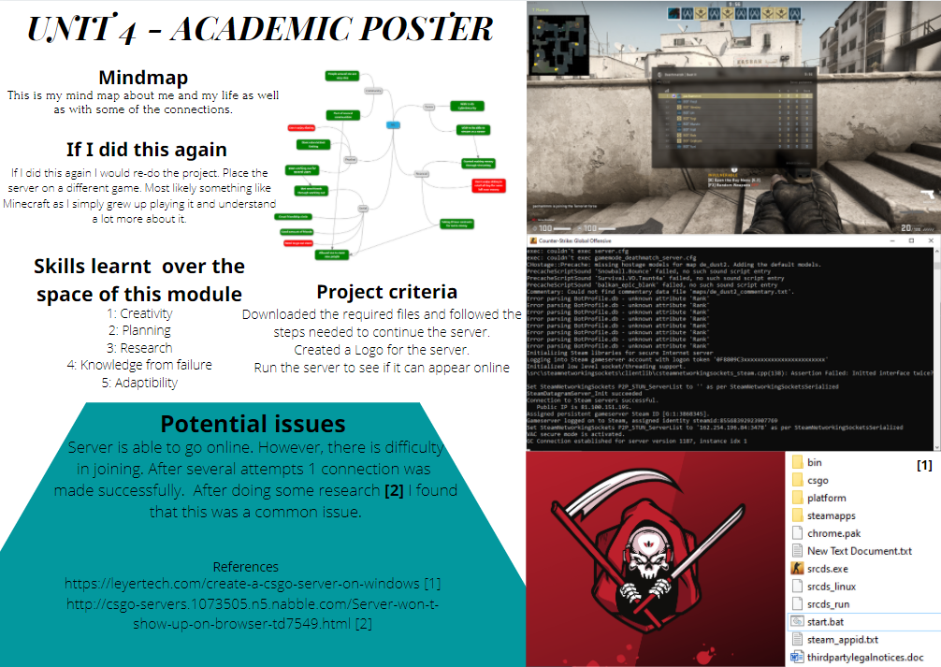

References: [12], [13]

References

[1] | A. C.-C. Hsu and C.-C. J. Kuo, “On the Design of Multiplayer Online Video Game Systems,” Proceedings of SPIE - The International Society for Optical Engineering, 2003.
[2] | “How to set up a dedicated game server,” Intel, [Online]. Available: https://www.intel.co.uk/content/www/uk/en/gaming/resources/game-server.html. [Accessed 25 Novemeber 2020].
[3] | S. Cao, “Elon Musk Says Putting AI Chip in Your Brain Will Be as Simple as Lasik,” OBSERVER, 14 11 2019. [Online]. Available: https://observer.com/2019/11/elon-musk-neuralink-ai-brain-chip-podcast-update/.
[4] | E. McCallum, J. Ratto-Nielsen and M. Bacigalupo, January 2019. [Online]. Available: https://ec.europa.eu/jrc/sites/jrcsh/files/workshop_format_inspired_by_entrecomp.pdf. [Accessed Novemeber 2020].
[5] | L. Farrell, “The Best Time In History To Become An Entrepreneur,” The Farrell Company, 21 August 2018. [Online]. Available: https://mcgrawhillprofessionalbusinessblog.com/2018/08/21/the-best-time-in-history-to-become-an-entrepreneur/. [Accessed November 2020].
[6] | G. Quadrio, A. Bujari, C. E. Palazzi, D. Ronzani, D. Maggiorini and L. A. Ripamonti, “Network analysis of the steam in-home streaming game system: poster,” in Poster: Network Analysis of the Steam In-Home Streaming Game System, 2016.
[7] | B. Simmons, “4 tips for making it out the Dragons’ Den alive,” 13 February 2019. [Online]. Available: https://boostcapital.co.uk/blog/4-tips-for-making-it-out-the-dragons-den-alive/. [Accessed November 2020].
[8] | M. Michalski, Task 2 Image Based Video Presentation, Swansea, 2020.
[9] | L. B. Marshal, The Public Speaker, 26 September 2011. [Online]. Available: https://www.quickanddirtytips.com/business-career/public-speaking/how-to-make-a-speech-memorable.
[10] | G. Quadrio, A. Bujari, C. E. Palazzi, D. Ronzani, D. Maggiorini and L. A. Ripamonti, “Network analysis of the steam in-home streaming game system: poster,” 2016.
[11] | Steam, [Online]. Available: https://steamcommunity.com/dev/managegameservers.
[12] | Leyer, “Create a CS:GO Server on Windows,” 12 July 2018. [Online]. Available: https://leyertech.com/create-a-csgo-server-on-windows/. [Accessed November 2020].
[13] | N. wav, Server won't show up on browser, 2014.

