Table of Contents
  Assessment 1  USER REQUIREMENTS AND PROTOTYPE | Date: 28.11.2025  Ana Chicaiza Asimbaya (2115194)  Module: Usability Engineering (ACCB6017) University of Wales Trinity Saint David London Campus

Introduction 2
Audience Profiles and Experience Objectives 3
Research Design, Instruments, and Synthesis 4
Interaction Framework and Usability Rationale 5
Wireframe Narrative and Information Architecture 6-7
Formative Evaluation and Analytical Findings 8
Conclusion 9
References 10

Introduction
This report presents the conception and early validation of a mobile-first, three-player deduction game entitled UWTSD: Signal Lost. It replaces the traditional murder mystery with a non-violent, time-bounded campus incident: the student radio station's transmitter has failed just before a live community broadcast. The team must restore transmission within a short session by triangulating partial clues distributed across university locations and systems. The design goal is to retain the cognitive pleasures of inference and coordination while aligning with an inclusive, light-toned academic context. The artefact at this stage is a low-fidelity prototype that expresses information architecture, interaction flows, and accessibility semantics suitable for rapid iteration.
A usability engineering frame that privileges evidence-based decisions, measurable goals, and progressive refinement inform the approach taken in this project. Three evidence-backed personas drive complementary roles in the cooperative design. A mixed-methods study elicited needs and constraints, and the findings were translated into an interaction framework based on the current state of standards and literature with respect to interaction principles, presentation of information, and inclusive patterns [1], [2], [3], [4]. The report documents the research approach, the rationale guiding layout and behavior, a wireframe narrative spanning core states of the application, and findings from a formative evaluation whose participants were mapped to the personas. It concludes with a synthesis of the lessons learned and a plan for high-fidelity prototyping.

Audience Profiles and Experience Objectives

Three personas anchor the design, each corresponding with a role that surfaces distinct information streams. The objective is to achieve complementarity without redundancy, such that each player's perspective is necessary yet not sufficient on its own. Roles are embedded in the university context and deliberately avoid trope-laden crime narratives.
The first persona is Arjun Rao, a 21-year-old undergraduate in Media Production stationed at the Swansea campus. Arjun is fluent in smartphone interaction and audiovisual tooling but impatient with extensive configuration. He values immediate comprehension, clear affordances, and prompt feedback coupling. The role assigned to Arjun is Signal Tech, whose interface presents equipment status readouts and error codes from virtualized transmitter modules. Usability expectations stress visibility of system status, reversibility of actions, and low memory load by means of externalized logs that comply with known principles of interaction [1], [6].
The second persona represents a 39-year-old senior lecturer in Education at the Carmarthen campus, Bethany Clarke, who regularly coordinates student projects. Bethany sees the game as structured teamwork and reflection. She will be playing the role of Coordinator, concerned with timelines, task orchestration, and the cross-checking of actions taken by the team. For this, she needs to have traceability, predictable mappings between controls and outcomes and a means to reconcile discrepancies across streams. The interface should thus surface a coherent sequence of events and allow for efficient comparison and undo, behaviors strongly associated with effectiveness and reliability quality-in-use characteristics [2], [9].
The third persona is Milan Petrovic, 27 years old, master's student in Inclusive Design, partially sighted and using magnification and a screen reader to navigate digital systems. Milan represents an important access perspective and is given the role Field Scout with an abstracted campus map with added environmental cues and access limitations. He needs content to be perceivable, focus order to be unambiguous, accessible names for controls to be descriptive, input modality to be flexible and non-speech audio to have captions, while semantics are to be consistent for use by assistive technologies [3], [4]. The design turns these constraints into first-order considerations rather than late-stage compliance tasks.
Across personas, convergent experience objectives emerge. The session should start immediately, boiling the premise down to a single sentence and letting players act within seconds. Information should be glanceable, not buried in nested controls. The system should offload memory via an always-available shared log recording decisions and evidence provenance. Sessions should fit naturally into campus rhythms, lasting eight to twelve minutes, with a soft timer and a pause-resume capability [7].

Research Design, Instruments, and Synthesis
The research strategy aimed at grounding design choices in mixed evidence, with respect for early-phase constraints. The plan combined semi-structured interviews, a short survey, and a mini focus conversation. Ethics approval was obtained through the School process; participation was voluntary, with informed consent and anonymized data handling.
Nine semi-structured interviews (approximately 15–20 minutes) explored attitudes to short-form cooperative play, tolerance for complexity, device preferences and accessibility expectations. Participants spanned undergraduates, academic staff and professional services roles. Interviews were audio-recorded with permission and analyzed via reflexive thematic analysis. Three themes dominated the corpus. First, participants wanted “instant legibility” at entry, with a single clear call to action. Second, mobile access was strongly preferred, with a desire for clear focus indicators and legible contrast. Third, cooperation was valued only if it were genuine; participants expressed frustration with designs in which “teamwork” was cosmetic rather than functionally necessary.
A short online survey (n = 36) reinforced these findings. Seventy-nine percent of the respondents preferred sessions less than fifteen minutes. Seventy-two percent considered "clear visual contrast and text size options" very important, while sixty-five percent did so for the "ability to undo or revisit steps". Free text comments underscored avoiding "UI mazes" and making orientation cues available without having to toggle through menus. Results have been used to prioritize requirements via a light-weight Lean UX framing to connect outcomes, assumptions, and tests into an iterative loop [8].
A three-participant focus conversation developed the triadic role model. Participants endorsed asymmetric information: the Signal Tech should see module statuses and diagnostics codes; the Coordinator should control task sequencing and verify that steps align temporally; the Field Scout should bring spatial constraints and access hints from the campus. The discussion also steered tone from crisis to challenge: restoring a broadcast feels urgent and meaningful without invoking fear. It was now time to translate these insights into acceptance criteria mapped to relevant standards for interaction, presentation of information, and accessible semantics [1], [2], [3], [4]. This baseline set of requirements classified the following as essentials: perceivability, operability, undo, explicit state visibility, and shared logging; included as high-value options were reduced-motion mode, captions by default, and role-specific onboarding; desirable options included avatar customization and thematic transitions.

Interaction Framework and Usability Rationale
The interaction framework follows five constraints: mobile-first ergonomics, explicit state visibility, low memory load, robust accessibility semantics, and short-session pacing. These jointly instantiate usability as the degree to which specified users can achieve goals with effectiveness, efficiency, and satisfaction in a defined context, as articulated in contemporary standards [1], [2].
System status visibility is maintained through nonintrusive multimodal cues. A timer indicates remaining time. A team indicator signals whose action was last committed. Presentation principles regarding perceivability and no text contrast [2] guided the use of color and shape redundancies rather than color alone for module statuses. Feedback latency was tuned to not break action chaining, and explicit confirmation was elicited for destructive actions. The interface establishes predictable mappings between controls and outcomes, and a back/undo affordance that is stable across states.
This externalities information, reducing memory load. A common Event Log records clues, actions, timestamps and origins. Each role has a private note pane and can publish selectively to the shared log. The log supports filtering by origin type and sorting by time. Decisions are surfaced as linkages between items, rather than overwritten values, preserving traceability for the group and supporting post-hoc reflection. Metrics that matter at this fidelity include time-to-first-action, successful publication of a clue, and correct link creation between items, all measurable during formative evaluation [9].
Accessibility semantics and presentation are engineered across layers: interactive elements expose accessible names and roles, the focus order tracks visual order, visible focus indicators meet contrast thresholds, all non-speech audio cues have captions and can be muted, and a reduced-motion mode respects platform preferences [3, 4]. Labels avoid jargon and error messages communicate actions users can take rather than codes alone. The design references both standards and large-scale patterns libraries to encourage familiarity and reduce friction during adoption [10, 11].
Pacing is calibrated to campus realities: sessions target eight to twelve minutes with a soft timer and pause-resume to cope with interruption. The end state is a Debrief that relates performance to strategy, showing where the team's synthesis succeeded or failed. The intent is instructional rather than punitive, aligned with research in game user experience emphasizing clear mental models and feedback loops supporting mastery [5], [7].

Wireframe Narrative and Information Architecture
Five states make up the wireframe set: Lobby, Role Briefing, Campus Panel, Clue View and Event Log/Debrief. The narrative below describes their information architecture and behavioral intent.
The Lobby is intentionally sparse. The title appears, accompanied by a one-line premise: “Your team has eight minutes to restore the campus broadcast; each of you sees different clues.” One prominent control begins the session; secondary affordances include a concise “How it works” and “Settings”. At the footer, status text indicates whether all players have connected. The visual hierarchy is sharp: one obvious path forward, two quiet alternatives. Contrast meets recommended thresholds for text and interactive graphics, while controls surface descriptive names for assistive technologies [2], [3].
The Role Briefing is personal and minimal. Arjun as Signal Tech sees a diagnostic panel with two module tiles and an example of tapping to expand an error code; the micro-brief reads, "Open a module, read the code, share relevant entries." Bethany as Coordinator sees a clean timeline with a draggable marker and a sample of flagging a mismatch; the micro-brief reads, "Align events and flag anomalies." Milan as Field Scout sees a schematic campus map with large target areas and sample path toggles; the micro-brief reads, "Mark accessible routes; propose likely paths." Each briefing uses one example interaction to teach the core affordance. All controls remain operable by touch and keyboard, with clear focus cues and aria-friendly names [3], [4].
The Campus Panel represents the common summarizing system and setting. A compact top bar reveals the countdown and a team activity indicator. The remainder of the screen contains a two-column layout: a card stack with role-specific widgets on the left and a quick-access strip to the Event Log on the right. The Field Scout is able to reveal access hints on locations, the Signal Tech to open module tiles for states and code copy, and the Coordinator to overlay a simple run book. Entry to a location or the opening of a module is accompanied by a short, consistent transition that conveys causality without impeding chaining of the actions. Labels and icons use shape cues so that meaning is not borne solely by color [2].
The Clue View is different for each role but follows a common template: one central artefact, three or fewer primary actions, and immediate, reversible feedback. For Signal Tech, the artefact is a module error panel with brief description and "Share to Log" control; the player can annotate with a short label, such as "Overheat near Atrium, 11:58". For the Coordinator, the artefact is a time band showing recent actions and system events, with an overlay toggle to compare streams; anomalies may be flagged and unflagged. For the Field Scout, the artefact is a simplified route map; proposed paths appear as thick lines with clear focus outlines and can be added to the shared log. Across roles, captions accompany non-speech audio feedback; focus movement is predictable; and explicit undo avoids destructive surprises [3], [4].
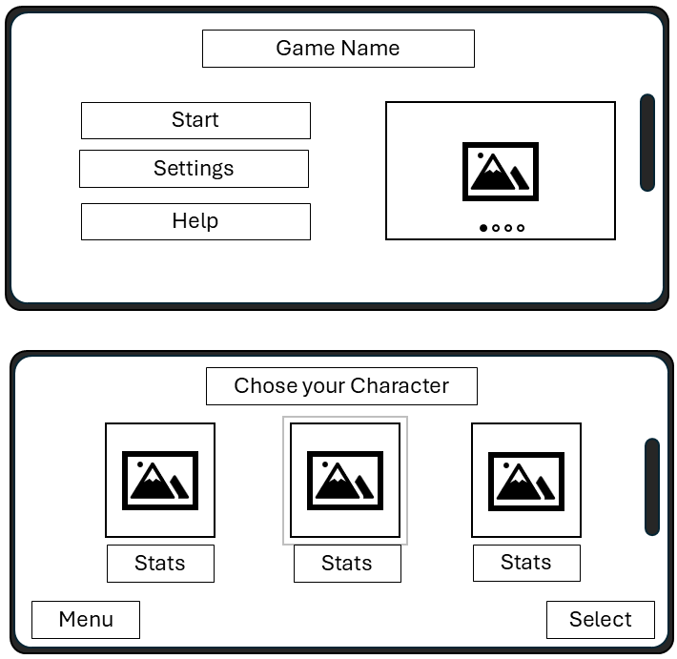
The Event Log externalizes memory and structures synthesis. Entries appear chronologically with badges indicating origin (Tech, Timeline, Route). Selecting an entry reveals a concise detail pane and a “Link with…” affordance to connect two items into a hypothesis. Links never erase original items; they add semantic structure visible to the group. The log supports filtering and sorting and includes a prominent “Resolve” control that submits a final synthesis when the team believes they have restored the broadcast path. When the timer expires or the team resolves, the Debrief appears, mapping correct and incorrect links and suggesting how an additional clue might have improved confidence. The presentation values clarity and legibility over ornament, following presentation principles in current standards [2].
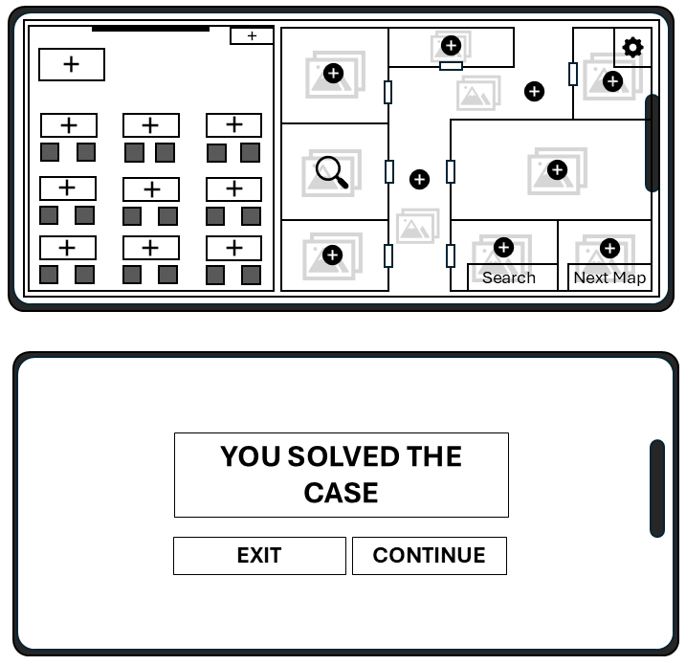

Formative Evaluation and Analytical Findings
A formative evaluation considered whether the prototype embodied the intended principles and satisfied persona-derived requirements. The six participants, two mapped to each persona, completed a think-aloud walkthrough of the clickable low-fidelity artefact. Sessions took approximately twenty-five minutes and captured behavioral measures—task success, time-to-first-action, link creation errors—and attitudinal responses. The procedure followed recognized recommendations for combining behavioral and subjective data, and for rapid iteration based on findings [8], [9].
Task success on core flows was high. All participants reached their first meaningful action in under thirty seconds, suggesting that the single-sentence premise and dominant start control gave adequate orientation. Role-specific affordances were internalized quickly. The Signal Tech participants opened modules and shared diagnostic entries without hesitation. The Coordinator participants successfully overlaid streams and flagged anomalies; one participant requested a tooltip explaining how flags propagate to the log — this will be added. The Field Scout participants navigated the schematic map and proposed routes; both praised the clarity of large targets and focus outlines.
Accessibility observations identified and confirmed several decisions, while surfacing actionable refinements. Focus order followed visible order; interactive elements were named descriptively; non-speech audio had captions. Two issues were highlighted. First, the audible cue for "entry shared" sounded similar to the one for "entry linked," creating the potential for confusion; distinct tones and richer captions will be provided. Second, the hit area for the "Link with…" affordance abutted the scroll region on small viewports, leading to occasional accidental drags; increasing the size of targets and their spacing aligns with both ergonomic and presentation guidance [2], [3].
The analysis indicates that explicit state visibility, externalized memory, and predictable mappings together reduced cognitive overhead and supported effective collaboration, results that align with the norms on interaction and presentation concerns [1], [2]. Quantitative measures—fast time-to-first-action and low link error rates—triangulate with attitudinal data to support the current direction. Remaining issues cluster around distinguishability of non-speech audio cues, target spacing near scroll regions, and explanatory microcopy in the Coordinator overlay, all tractable within the next iteration.

Conclusion
UWTSD: Signal Lost strengthens the module brief through a collaborative approach that neither incorporates nor even hints at violence and keeps the essential analytic components of the mystery intact. The three-role format provides valuable collaboration through the distribution of different streams. Design and functionality are strong on usability, mobile first, and meet the latest accessibility and usability guidelines, addressed in [1], [2], [3], [4], [6], [7], [8], [9], [10], [11].

Formative evaluation validates major assumptions and pinpoints feasible changes. The completed work demonstrates the ability of recognition-first layouts, reversible actions, and an external event log to provide a readable and enjoyable experience in the face of typical limitations. The path forward includes the development of a high-fidelity prototype that, despite increased semantic and media richness, keeps the disciplined simplicity intact. The proposed work includes the implementation of reduced motion and caption defaults, touch target separation near scrollable areas, and the use of caption pairs for non-speech audio signals. Time-to-FIA, link attempts, and mis-tap recoveries on the prototype shall be instrumented in order to enable scientific evaluations. A larger-scale test shall compare those using the shared event log with those who do not, in keeping with the hypothesis that externalizing memory provides improved accuracy and enjoyment. In the process, the aim of the proposed work, and the fulfillment of the UWTSD spirit, is the development of a useful and enjoyable system.

References
[1] ISO 9241-110:2020, Ergonomics of human-system interaction—Interaction principles. Geneva, Switzerland: International Organization for Standardization, 2020.
[2] ISO 9241-112:2020, Ergonomics of human-system interaction—Principles for the presentation of information. Geneva, Switzerland: International Organization for Standardization, 2020.
[3] W3C, Web Content Accessibility Guidelines (WCAG) 2.2. World Wide Web Consortium Recommendation, Oct. 2023.
[4] W3C, Accessible Rich Internet Applications (WAI-ARIA) 1.2. World Wide Web Consortium Recommendation, Dec. 2023.
[5] C. Hodent, The Gamer’s Brain: How Neuroscience and UX Can Impact Video Game Design, 2nd ed. Boca Raton, FL, USA: CRC Press, 2020.
[6] J. Tidwell, C. Irwin, and A. Hoekman, Designing Interfaces, 3rd ed. Sebastopol, CA, USA: O’Reilly Media, 2020.
[7] P. Desmet and A. F. Sears, “Designing for positive user emotions: A contemporary framework,” Behav. Inf. Technol., vol. 41, no. 12, pp. 2519–2536, 2022.
[8] J. Gothelf and J. Seiden, Lean UX, 3rd ed. Sebastopol, CA, USA: O’Reilly Media, 2021.
[9] J. Sauro and J. R. Lewis, Quantifying the User Experience: Practical Statistics for User Research, 2nd ed., updated reprint. Cambridge, MA, USA: Morgan Kaufmann, 2022.
[10] Microsoft, Inclusive Design Toolkit (v3). Redmond, WA, USA: Microsoft Corporation, 2020.
[11] Google, Material Design 3 Guidelines. Mountain View, CA, USA: Google LLC, 2022.

