Task 1

Summary of essential skills for study and employment.

During this term ,I am starting realize how much important are some of the skills that we talked about during the module Learning in the Digital Era .
Some of these such us Time Management and critical thinking ,I believe they will be very important for my Career and for my Studies.


Time Management
Time management refers to the way I organize and prioritize task during my journey.
Studying and working is the proper example how Time management can help me get through my daily activities.
By doing To-do List ,set Goals ,achievements and prioritize what’s require more attention from me ,it helping me a lot in preparing at the moment my Assessment
and work. But mostly it will help me in my future career based on creating Software project and the time is the key[1] [2] [3] [4].

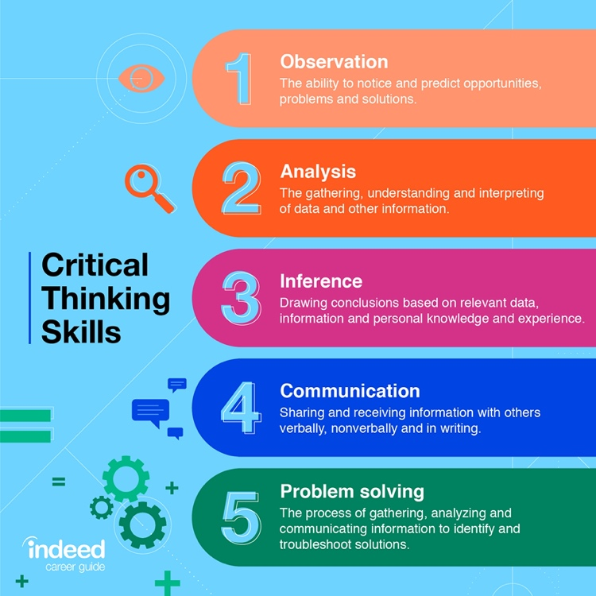

Critical thinking
Critical thinking is the act of analyse data to understand an article thoroughly. This process usually includes collecting more information and data, and asking myself question about it ,so it can help me realize how much truly are the information that I am reading, and in this case, it will help me in my career and study to make sure that after analysing data I could not only identify the problem but develop and execute solution [5] [6] .

Reference:

[1] Mind Tools Content Team, “What Is Time Management?Working Smarter to Enhance Productivity,” Mindtools, 2009. https://www.mindtools.com/pages/article/newHTE_00.htm (accessed Apr. 20, 2021).
[2] P. Forsyth, Successful Time Management, 3rd Edition. London Kogan Page, 2013, pp. 1–5.
[3] L. McNeely, “10 Tips for Mastering Time Management at Work | Lucidchart Blog,” Lucidchart, Apr. 11, 2017. https://www.lucidchart.com/blog/time-management-at-work (accessed Apr. 20, 2021).
[4] T. C. Schumann, “StackPath,” Dentistryiq, Jun. 16, 2014. https://www.dentistryiq.com/dentistry/endodontics/article/16360105/top-10-ways-for-effective-time-management-for-the-dental-executive (accessed Apr. 20, 2021).
[5] Indeed Editorial Team, “What’s the Importance of Critical Thinking in the Workplace?,” Indeed Career Guide, Feb. 23, 2021. https://www.indeed.com/career-advice/career-development/importance-of-critical-thinking (accessed Apr. 20, 2021).
[6] Indeed Editorial Team, “Critical Thinking Skills: Definitions and Examples | Indeed.com,” Indeed, Mar. 18, 2021. https://www.indeed.com/career-advice/career-development/critical-thinking-skills (accessed Apr. 20, 2021).
‌

