applied programmable logic controllers (acda6000) rEPORT
Factory Control report
By Greg Dickson (2204524)

Introduction
This report will contain information on the programming logic controls, ladder logic code for a conveyor belt and sorting factory system and the 3D design of the factory sorting system.
Programmable logic controllers (PLCs) are the devices which are used to program machinery to do a specific task or react to an event if a variable triggers it. PLCs used in a wide variety of applications in industry, PLCs can be used within applications of production, packaging and heating control systems. [1]
The PLCs can be programmed using ladder logic code. Ladder logic programming is a way of programming a PLC using a visual illustration of programming code. The ladder logic can be used to power certain systems on during a certain time or when a certain condition is met through various means such as sensor inputs or numerical values are met. [2]
PLC’s can be simulated to work within a virtual environment, this can be achieved by using a program such as Factory I/O. This allows an engineer designing a PLC system to have an environment in which the PLC system can be created and fixed if any faults are found.
Literature review
Name | Rs Pro Logic module  110 – 240V ac supply [3] | Siemens Logo! 8.4 12V dc, 24V dc supply [4] | Schneider Electric Zelio Logic Series Module 24V dc [5] | Omron CK3E Series Logic Controller [6]
Image | 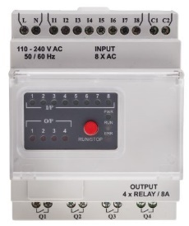 | 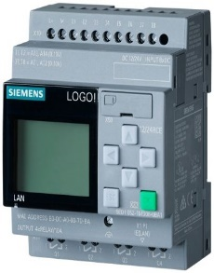 | 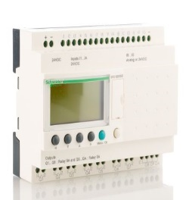 | 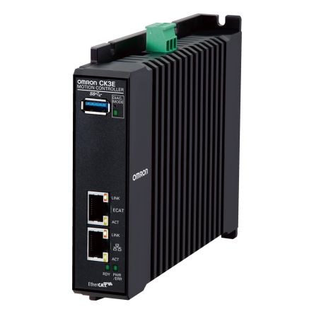
Price | £103.20 | £156 | £335.38 | £6,678
Pros | 8 Inputs  relatively inexpensive  Works between 110 to 240V | 8 inputs, works in 12v to 24v DC  easy to program | 16 Inputs and 10 outputs  24V DC supplied voltage | Ethernet and USB input and output  very compact
Cons | 4 outputs  digital input only  can only take higher voltages | 4 outputs  can be considered more expensive | More expensive  can be limited with  communication protocols | Very expensive  can be considered  very extreme for simple tasks  very limited I/O ports for the price

PLCS (Programable logic controllers) can have a broad range of applications within industry some include industries such as the manufacturing and automobile industry where PLCS are able to provide data at a very reliable level, they are very quick at processing any commands given to them and they are easy to implement into an industrial application. [7]
Not all PLC’s are created with the same specs, some are used for less intense operations and some are used for more intense operations. This use of the PLC will depend on what PLC will be required for a certain task create a working system and have an expected output. There are a variety of PLCs available to purchase, some which are much cheaper and come with less features such as programming types, input and output ports and the type of signal the PLC can receive and transmit. PLCs which cost more will have more features usually on them, such as easier programming operations, more input and output slots on the PLC, a more compact design for the PLC to fit inside and better mounting systems such as a DIN Rail.

The PLC’s listed above will have different uses depending on the task or operation they are being used for.
The RS Pro Logic module will be a very basic PLC, some of the pros of using this PLC is the ability to have eight inputs put into it, allowing the device to take a variety of commands when certain events have taken place and to process them into an output. It is relatively inexpensive to purchase, allowing the PLC to be bought multiple times and be used for a relatively low-cost solution. It also works on 110v to 240v allowing it to be used on regular mains voltage supply without the need for a transformer to alter the voltage supplied to it.
There are some cons with the RS Pro Logic module, such as it only has four outputs. This will leave it very limited to how many output commands it can send out which might require more than one to do one task effectively. It can also only take the higher voltages when most PLCs work on a lower DC voltage such as 12v supplied.

The Siemens Logo! 8.4 PLC is a slightly more advanced PLC compared to the RS PLC. The Siemens PLC is also able to take advantage of eight inputs, it can work within 12v to 24 DC voltage input which is more of a normal voltage supply. It is also an easy PLC to program leading to it not needing to have much downtime is a program is being created for it and will be easier to train an engineer to program the PLC.
There are some negative points about the PLC, it only has four outputs like the RS PLC, meaning it may not be able to complete a required task with the four outputs alone. This can lead to more of the PLCS needing to be purchased to be used to complete one task and with a higher cost, it might be considered inefficient.

The next PLC is the Schneider Electric Zelio, this PLC is more advanced again compared to the Siemens PLC. It has sixteen inputs allowing for a lot more inputs than the cheaper PLCs and it also has ten outputs, this could lead to less of a need to purchase more PLCs when this one PLC could complete the tasks with its input and output ports. It can be supplied with 24v DC voltage which other PLCs are able to use also. This PLC can also support digital and analogue inputs.
It does come with a few cons such as it is more expensive to purchase than the previous PLCS stated, with that in mind it could be considered unnecessary if there is only a basic task needing to be performed which a cheaper and less sophisticated PLC could do. It also can be limited with the communication protocols it is able to use in more advanced uses within industry, leading to it being used for less complex tasks.
Finally, the Omron CK3E PLC is a very sophisticated PLC. It has both Ethernet and USB input and output ports, allowing it to be used with most modern devices with more recent connectors. It also has a very slim and compact design, allowing it to be transported easily and mounted in very small, enclosed places.
This PLC does cost very large sum of money. It is very expensive compared to the latter PLCS discussed above, even at around twenty times the cost. It can also be considered being very extreme for most applications within industry, especially simple tasks. Finally, it also has a limited amount of input and output ports, leading it to being connected to a very limited number of devices into and from itself, this is a considerable con compared to the price it costs to purchase.

Flow Chart
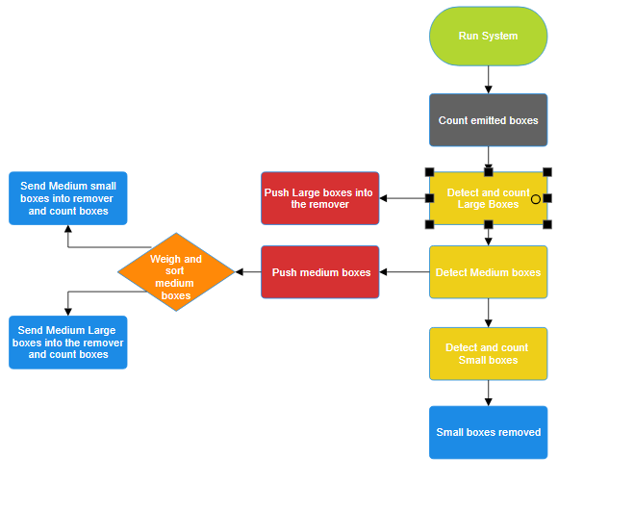

Factory I/O Design
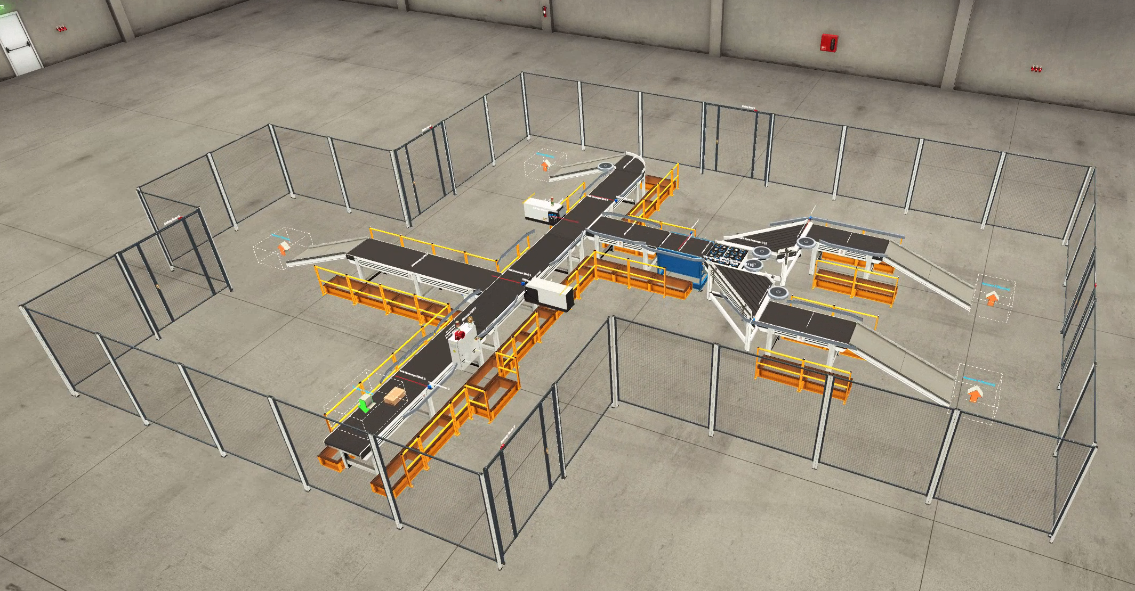

The above image is a capture of the 3D Factory I/O design. It contains a box emitter, sorters for large boxes, medium Small boxes, Medium Large Boxes and Small boxes. All if the boxes are counted as they leave the emitter and then recounted when they get to their destination at the box removers after being sorted.
It also features a warning light to show the system is on along with a siren. The stack lights positioned on either side of the conveyors will indicate if there are any warnings or errors which may be or may have occurred.

Alarm and warning strategy
The warning and alarms will be triggered when certain conditions are met.
Whilst the system is running functionally the ‘Green’ stack lights will be lit showing that there are no warning present within the system allowing it to run. These stack light will also be present within the Human machine interface (HMI) to give indication that they are working on there also.
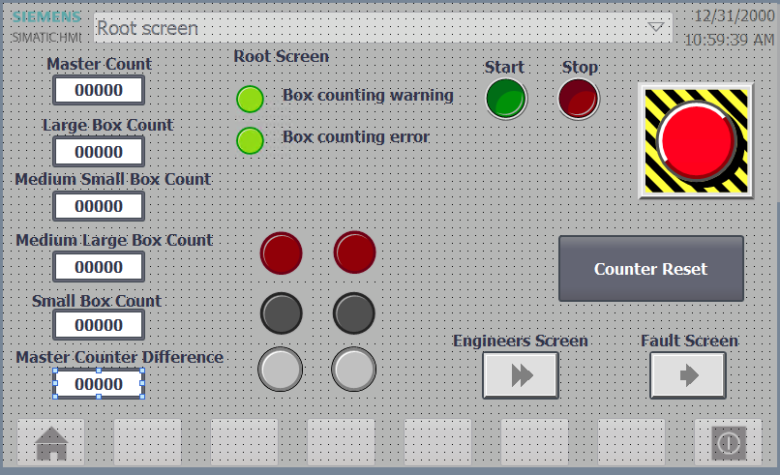
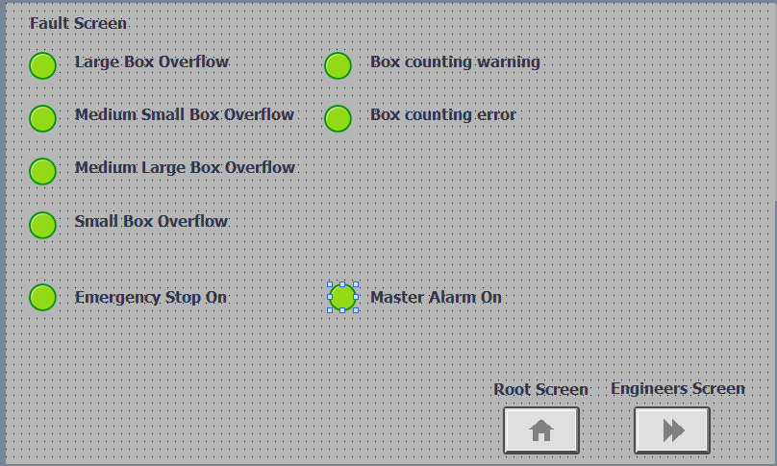
Once certain conditions are met of the boxes being counted from the emitter go over five from a comparison of all the boxes reaching their removal destinations, a yellow light will illuminate on the stack lights as well as a light on the HMI to display “Box counting warning”. This will give indication to the operators that there is a potential error about to occur so it should be investigated immediately.
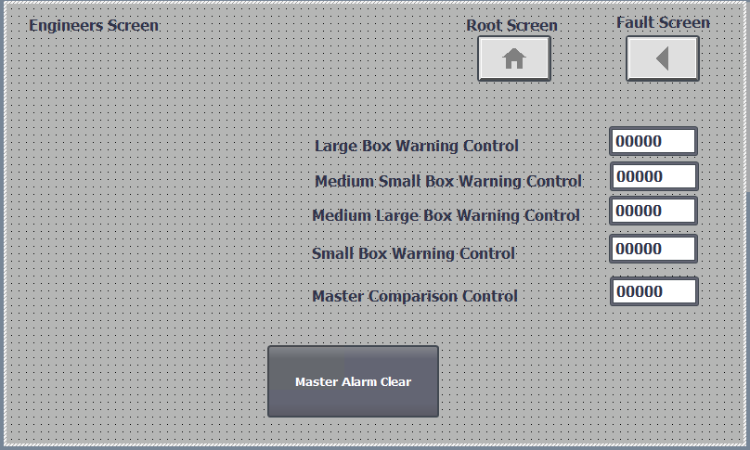
If the yellow light is still present and the warning as not been cleared physically and, on the HMI, any more of an increase on the comparison will trigger a full system shut down if it reaches ten and will set the master alarm. This will trigger the “Box counting error” light as well as the stack lights turning red to indicate that the error has occurred. This will need to be cleared by an engineering using the HMI engineer’s screen. Once the engineer has cleared the master alarm, the counter reset button on the root screen can be pressed to ensure that all the counts are reset to zero ensuring that the system can work from the start again without any errors.

Ladder Logic Program and brief of each rung
Network 1:


Network 2: Start and Stop for the system
This network contains the commands for the system to start working if a button is pressed. If the start button is pressed and the master alarm is not active, then the conveyer belt system will start to power on gradually. The stop button will also function as a way to power down the system, ensuring that the system stops as soon as it is pressed.


Network 3: System conveyer and warning systems start
This network will start the operations of the conveyer belts and warning systems. As soon as the "Run System" is started, a timer operation is initiated. After two seconds the siren alarm and Emergency warning light are started, with the timer lasting a few seconds and the warning light remains on for the duration that the system has power. As the first two seconds are progressed through the conveyor belts are initiated with a 500ms gap between each one to prevent inrush current from breaking the electrical systems within the devices.
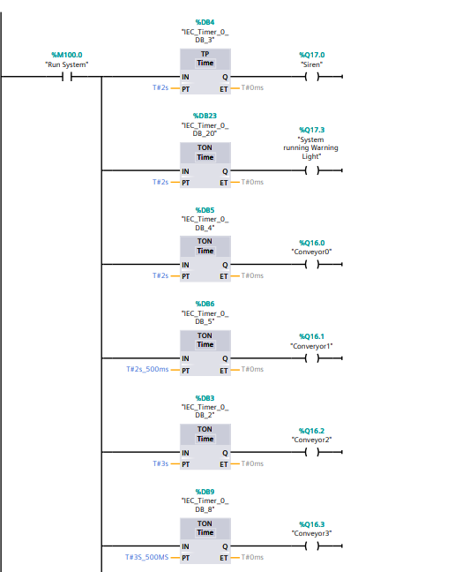
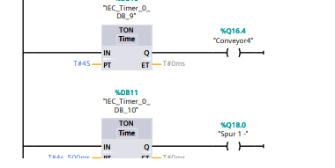
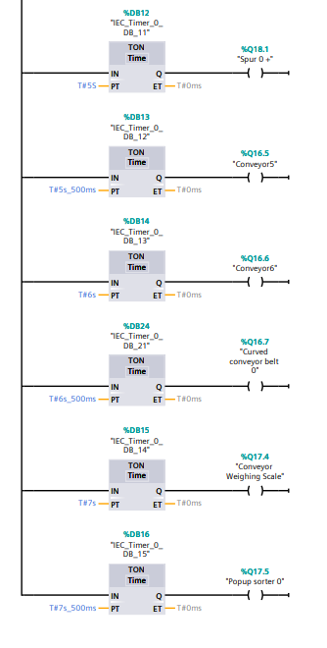

Network 4: Large Box Pusher
This network will enable the first sensor to detect a box is present as the correct height and wait for it to get in front of the pusher. The pusher will then push the box once the specified time has passed and push the box down an alternate conveyor to be sorted.
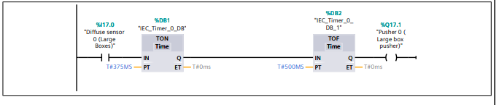

Network 5: Medium Box Pusher
The Medium Box pusher is controlled here, this will sense if a medium box has come into the sensors beam. If there is a box present the system will wait 650ms for the box to be in front of the pusher and then it will push the box towards the sorting conveyor.
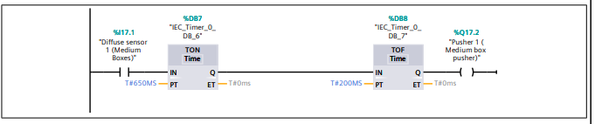

Network 6: Alarm set
This network will set the alarm if it notices that the system has set the alarm byte higher or lower than '0'. This byte will then engage the set on the 'Master Alarm' triggering the system to come to a complete standstill.


Network 7: Weighing Scale Conveyor Control
The weighing scale conveyor is controlled from this, it will wait to see if the system is running in which it will then check to see if the scale control is off, if these measures are met then the conveyor scale will start again.


Network 8: Weighing System Control
This network will control the weighing system movement. It will first detect if a box has been loaded onto the weighing scale in which it will set the "Scale Control" on. This will then wait for 700ms to give the box time to settle and ensure that false readings are not given. Once the 700ms are done it will then set the weighing scale to “Ready" which will enable the scale to take a weight reading from the box on it over a period of 700ms. Once the box has been weighed over the 700ms it will then reset both the "Ready" and "Scale Control" so it can read the next medium box loaded onto the weighing system.
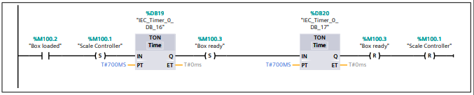

Network 9: Medium Box Weighing Scale Sensor
The medium boxes will be detected on the weighing scales through this network. It will first detect that a box is present and after 1ms it will enable the "Box Loaded" assignment to be turned on.


Network 10: Weighing system and Popup control
This network will control the direction of which the medium boxes will go. It will first sense that "Ready" has been set on, then it will wait 5ms to then acquire the medium boxes weight, from the medium boxes weight it will register the known weight of the medium box from which it will be able to sense if it is equal to or less than 4.5kgor if it is equal to or more than 4.6kg. Once the boxes weight has been sensed, the system will then send the box in a direction using the popup sorters depending on the weight sensed, ensuring that the correct direction is selected and set within the incorrect direction reset.
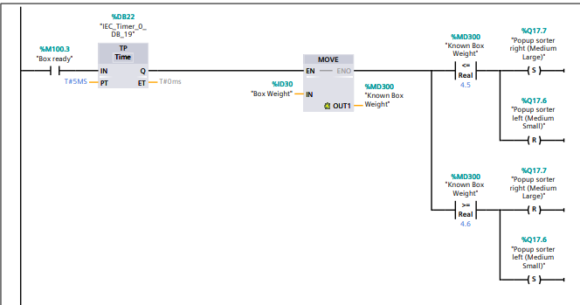

Network 11: Box weight to LCD
This small network will turn the "Known box weight" sensed by the weighing scales into a number on the LCD connected to the weighing scale conveyor.


Network 12: Emergency Stop Button system
The emergency stop is controlled through this network. The system will wait to see if the system is running and if the emergency stop button has been pressed. If the emergency stop button has been pressed, the system will enable the "Master Alarm" and set it to on.


Network 13: Master Box counter
This will count the amount of total boxes which the system has recorded going through the first sensor on the conveyors. If the system is running then the sensor at the start will sense each box which has passed it on the conveyor, from this it will record the amount of boxes it has registered going past it and send the amount to the HMI root screen with the counter. This network is able to be reset by the counter reset button on the root HMI screen.
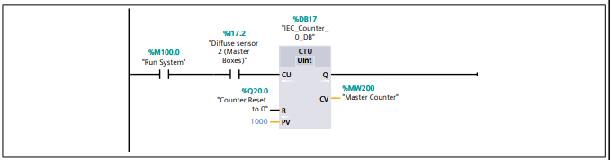

Network 14: Large box counter
The large box counter network will detect if the system is running and when the large box pusher is activated. From this it will record the amount of large boxes which have been pushed by the pusher. This network will be able to send out a signal if the large boxes are over a specific limit set by the counters in the engineer’s screen. If there is a detection of too many boxes, then the network will send a signal to the system to turn on a warning light for an overflow of the large boxes. This network is able to be reset by the counter reset button on the root HMI screen.
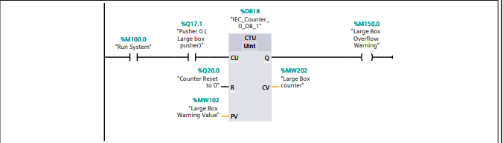

Network 15: Medium Small Box Counter
The Medium Small box counter network will first detect if the system is running. If the system is running then the diffuse sensor will detect how many boxes have gone past it, using this it will record the amount of boxes which have gone past the sensor and store the value. This network can also send out a signal if there is an overflow of boxes which have been sent out from it using the overflow value which can be set in the HMI engineer’s screen. If too many boxes are detected depending on the overflow value, a signal will be sent out to light a warning light in case there is a problem. This network can be reset using the counter reset button which is located on the HMI root screen.

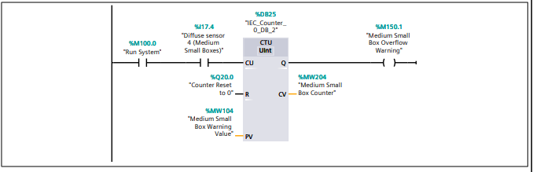

Network 16: Medium Large Box Counter
The Medium Large box counter network will first detect if the system is running. If it detects that the system is running then the diffuse sensor will detect how many boxes have gone past it, using this it will record the amount of boxes which have gone past the sensor and store the value and display it on the HMI root screen. This network can also send out a signal if there is an overflow of boxes which have been sent out from it using the overflow value which can be set in the HMI engineer’s screen. If too many boxes are detected depending on the overflow value, a signal will be sent out to light a warning light in case there is a problem. This network can be reset using the counter reset button which is located on the HMI root screen.
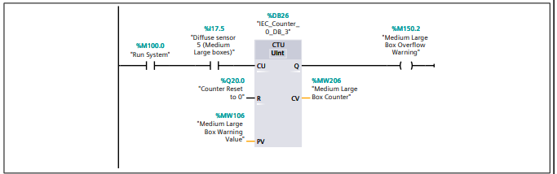

Network 17: Small Box counter
The small box counter network is detecting to see if the system is running firstly. If the system is detected as running, then the diffuse sensor on its conveyor will detect how many boxes have gone past the sensor and record the within the root screen on the HMI using a numerical display. This network is also able to send out a signal if there is an overflow of boxes depending on the value set for the overflow warning within the engineer’s screen on the HMI. If there is an overflow detected, then the network will send a signal out from itself to the system to indicate there is a warning and enable a warning light within the error screen of the HMI. This network also has the ability to be reset by using the counter reset button which can been found on the HMI root screen.
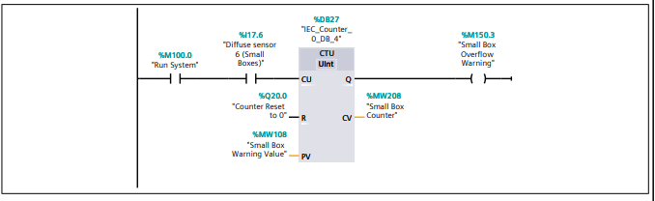

Network 18: Stack Lights system
The stack lights network will be able to detect if certain issues arise and enable a light depending on what type of issue is detected. If the system is running at normal operation with no errors or warnings detected, then the stack lights will be turned on to green. The network next has a measure to detect if a warning has been issued into the system from another network. If a warning has been found the stack lights will have a yellow light turned on to indicate to the supervisors of the system that a warning has been triggered and it needs to be monitored or it count turn into an error. The final measure that this network can display is the error warning, if this is triggered then the whole system has come to a stop with the red stack lights enabled. This error will not allow the system to be reenabled until investigated and in which the red stack lights will remain on until the error has been cleared and the system is functional once again.

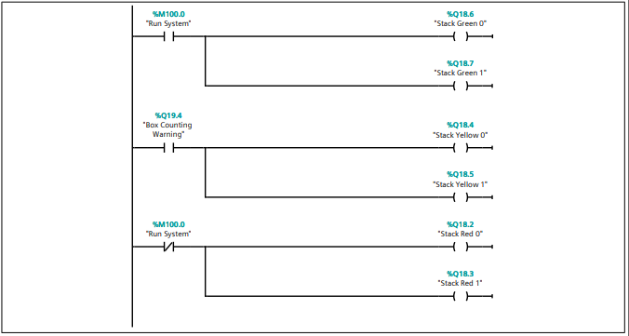

Network 19: Warning and Error checking system
The warning and error checking network is present to monitor if there are any conditions met which could cause a warning or error to happen. The network will first monitor the boxes which have been counted by the dedicated sensors or pushers, such as the small box counter, the medium small box counter, the medium large box counter and the small box counter. The counts which have been recorded from the individual box sensors will be added together to acquire a value which will be known as "Master counter comparison". The "Master counter comparison" will be used to compare the "Master counter" value from the start of the conveyor system from itself by subtracting the "Master counter comparison" from "Master counter". The difference between the two values will beknown as "Master counter difference" which will be used as a value to monitor if too many boxes are not taken for. If the system detects that the boxes have gone above a value or equal to a value of five or below or equal to a value of nine, the system will set the "Box counting Warning" allowing the error light and yellow stack lights to be turned on. If the system detects that the value has gone below or equal to four then the system will turn off the warning lights and remain with a green light on. If the system reaches a difference of ten or more, the network will trigger a "Box count error" and the error lights will turn on along with the red stack lights. This will also cause the system to stop immediately with no conveyors running and will require an engineer to reset the system using the "Master Alarm Clear" button within the Engineers screen on the HMI.

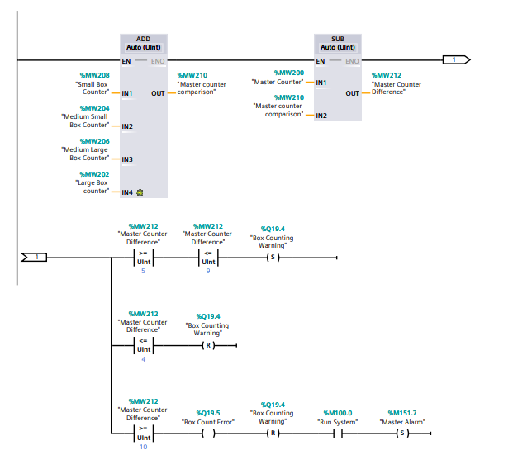

Discussion
The making of the Factory I/O 3D model and programming of the PLC’s went very well. The system runs as it was intended and programmed. It is capable of counting the correct amount of boxes, moving them to the necessary sorting area, it can display a warning if there is one and shut down the system if an error occurs.
There were some things which didn’t go quite as planned, there were limitations to the creation of the 3D model of the factory with the available models in the software. The PLC’s can also sometimes not react to the program which they have been programmed into and get stuck within a loop.
Overall PLCs are a very effective tool to use to power an industrial environment such as a factory conveyor belt system, which can be programmed to the specification needed to operate the system with additional devices attached to the PLCs.

Conclusion
PLC’s using ladder logic programming can be a very effective way to create an operational system. They can reduce the time needed to program a system and be a very cost-effective way to implement a programmed system without needing an actual computer within industry.
There are some limitations to PLCs with customising them how a user would want them and could be more expensive if the user doesn’t intend to use them as they are in industry.

Bibliography
https://uk.rs-online.com/web/content/discovery/ideas-and-advice/plcs-programmable-logic-controllers-guide [1] RScomponents 17th January 2023
https://blog.se.com/industry/machine-and-process-management/2022/08/05/ladder-logic-programming-a-detailed-insight/ [2] Schneider Electric 5th August 2022
https://uk.rs-online.com/web/p/plcs-programmable-logic-controllers/9176373 [3]
https://uk.rs-online.com/web/p/plcs-programmable-logic-controllers/2825512 [4]
https://uk.rs-online.com/web/p/plcs-programmable-logic-controllers/4684242 [5]
https://uk.rs-online.com/web/p/plcs-programmable-logic-controllers/2157334 [6]
https://blog.logicbus.com/plc-programmable-logic-controller-industrial-applications/ [7] Logicbus, 16TH November 2021

