Module: MANAGING PEOPLE
Module code: LCBB5004
Module Lecturer: Nishi Ramsurrun

Assignment Title: Assessment 2
Student Name: Boscanean Maria
Student ID: 2021937

Executive summary
This report has aimed at discussing the drivers and concept of employee engagement along with the factors that motivate the employees to work better. Moreover, this report highlights the tools required for measuring employee engagement within the organisation. In addition, effective strategies have been discussed in this report for increasing the level of employee engagement significantly.
Table of Contents
Introduction 4
Reviewing the drivers and concept of employee engagement 4
Evaluating the diagnostic tools in order to measure employee engagement 5
Constructing an employee value proposition from the previous analysis and ideas involving strategies to increase the level of employee engagement 7
Conclusion and recommendations 10
References 11

Introduction
Employee engagement is an important part of HRM that contributes to increasing the commitment of the employees to the organisation. Engaged employees are more likely to be productive and dedicated to their work which, in turn, helps to enhance the performance level significantly. As a result, employee engagement plays a major role in reducing employee turnover rate and maximising the overall profit growth of the organisation. Therefore, it is necessary to measure employee engagement and develop effective strategies to increase the involvement of the employees in the workplace. Accordingly, this report focuses on the employee engagement strategies based on the idea and analysis regarding employee engagement in the context of the given case scenario.

Reviewing the drivers and concept of the employee engagement
It is effectively important to understand the things that motivate the employees and also drive them to invest personally in their respective works to improve employee engagement. However, there are no "universal drivers" of employee engagement. Employee engagement can vary from any organization to another. Moreover, it can also vary from various employee groups within any single organization (Ahmed et al. 2018). Therefore, with time, drivers also can change because of external factors, it can also change. In “periods of rapid social, technological and economic change”, it is specifically helpful to return to the generals and recognize the factors which allow the people to focus more and perform their best work. Furthermore, though the technology along with the other present practices has changed the way how employees work, most of the "traditional drivers" of "employee engagement" have still remained the same as before. However, an upgrade perspective on employee engagement and people requires deep thinking of these particular drivers in a more customized way. There are a lot of factors that impact employee engagement; the factors include organizational culture, job function, industry, and career path.
Organizational culture- The culture of an organization encompasses the behaviours and values which shape the organization and exemplify "the way things get done around the organization" (Natrajan et al. 2019). Culture holds a critical effect on the “employee engagement drivers and levels”. Moreover, it can also be said that both the culture and engagement are affected by the management practices and the prevailing leadership in the organization.
Industry- According to some research, if the two managers of two different industries are asked about what drives the engagement of the employees in their industries, they can surely suggest two various lists. Like, "an employee at a non-profit rate” may require to get the work more meaningful (Milhem et al. 2019). Moreover, “an auto worker” can prioritize the safety of the workplace and “relationships with colleagues''. Therefore, like the culture of the organization, an “employee engagement" driver is affected by the industry where they are presently working.
Job function- Particular job function of an employee can impact greatly on what most motivates them. For a few of the employees, meaningful work is demonstrated as the "motivation in and of itself". The "meaning of work" is totally personal to every employee and also can be typical to measure. Employees that are motivated instantly with their work feel that they are delivering a broader food or are helping the organization to acquire the “long term goals”.
Career path- The progress to the future and career goals are other key factors that contribute to employee engagement. According to the views of De and Rodríguez, (2021), relying on the "career stage" of a specific employee who is currently surviving, can be motivated by multiple things. Like, "the employees who are in earlier stages” of their future careers can prioritize the strong leaders and the competitive compensation who can help them to improve their respective skills.

Evaluating the diagnostic tools in order to measure employee engagement
Employee Satisfaction Index (ESI)
ESI is considered an important tool for measuring employee engagement within an organisation in terms of determining whether the employers are satisfied with their work or not. According to the view of Veloso et al. (2021), ESI helps to provide proper information about the job satisfaction level of the employees. Based on the index, it can be stated that a closer value to 100 in the index indicates a higher satisfaction level of the employees across the organisation. Thus, by applying the ESI it can become easier for the HR leaders to retain top talent and improve the performance level of the existing employees.
Employee turnover rate
Employee engagement has a direct relation with employee turnover and retention within an organisation. As highlighted by Hadi and Ahmed (2018), the employee turnover rate indicates the ability of an organisation to retain the existing employees. Thus, the organisational leaders need to focus on measuring the employee turnover rate for increasing the effectiveness of the overall HR management within the company. Employee turnover rate can be measured by dividing the number of employees leaving in a particular time period by the average number of employees working in the organisation in the same period. Thus, the HR leaders can develop effective strategies for reducing turnover and increasing employee engagement with the organisation significantly.
Employee surveys and exit interviews
It is necessary to conduct employee surveys on a regular basis in order to collect feedback about the job satisfaction level of the employees. Employee surveys are considered the easiest and most cost-effective ways of measuring employee engagement. According to the comments of Winton and Palmer (2018), actionable employee surveys are very effective for increasing employee motivation and obtaining new ideas from the employees. Therefore, the HR leaders need to develop an effective survey questionnaire that includes three key metrics of employee engagement such as alignment, satisfaction and future orientation. In addition, exit interviews of the employees can also help the HR managers to understand the actual reasons behind the employees leaving the organisation. Thus, it can be effective to create more engaging strategies for increasing employee satisfaction and retention significantly.
Absenteeism rate
Lack of employee engagement can lead to maximising the absenteeism rate within the organisation. The average rate of employee absenteeism was 5.8 days per employee in the UK in 2020 (Statista.com. 2022). Therefore, it can be effective to consider the employee absenteeism rate to understand the impact of disengagement on increasing the absence rate across the organisation. Moreover, it can support the managers to address the specific needs of the employees regarding improving employee experience.
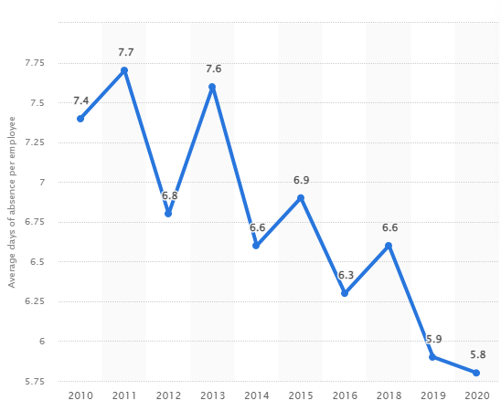
Figure 1: Employee absenteeism rate in the UK, 2020
(Source: Statista.com. 2022)
Employee NPS (Net Promoter Score)
Employee NPS are mainly used for measuring the level of satisfaction and loyalty of the employees towards the organisation. In order to calculate the employee NPS, it is required to subtract the detractors from the promoters and divide the results by the total number of employees (Sedlak, 2020). A positive score indicates that the employees are more likely to recommend others to the organisation. It means that the positive scores refer to a high level of employee engagement with the organisation.

Constructing an employee value proposition from the previous analysis and ideas involving strategies to increase the level of employee engagement
Employee value proposition
Employee value proposition (EVP) refers to the benefits received by the employees in return for adding value to the organisation. The employees are supposed to use their skills, knowledge and competencies to bring more value to the business. Therefore, the companies are likely to offer employee benefits such as compensation, flexible working, work-life balance and show respect to the employees to make them feel valued effectively. As per the opinion of Pawar (2020), EVP is important for attracting top talents and maximising employee retention across the organisation. In this regard, it can be said that the company needs to focus on increasing EVP with a view to maximising the effectiveness of the recruitment and hiring process in the company. In addition, it can also support the HR manager to boost employee morale in a significant manner.
Moreover, employee recognition programs play an important role in adding more value to employers. As per the view of Masri and Abubakr (2019), employee recognition programs are important in terms of boosting employee motivation. Besides, these programs are also very helpful for promoting work-life balance and flexible working practices among the employees which, in turn, contributes to increasing employee engagement with the work at a significant level. Based on the given case scenario, it can be noted that the company has already introduced remote working and flexible working practices for maximising employee engagement effectively. As a result, it can support the company to add more value to the existing employees so that they can work more productively and efficiently.
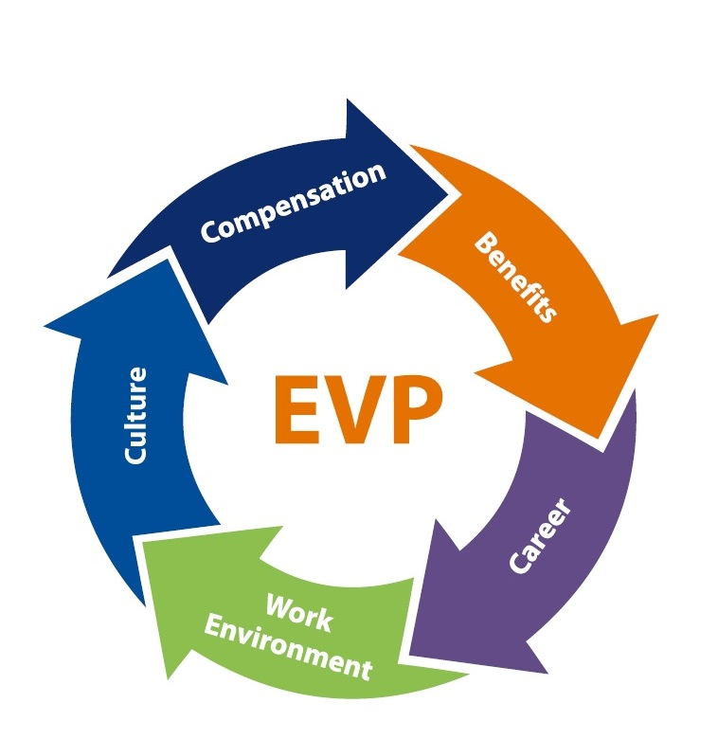
Figure 2: Employee value proposition
(Source: Pawar, 2020)
Strategies for increasing employee engagement
Promoting two-way communication
Communication plays an important role in building strong relations between employees and employers. Two-way communication enables the employees to share new ideas and provide feedback (Falco and Kleinhans 2018). As a result, it can contribute to maximising employee engagement with the company.
Increasing employee development
The company needs to focus on introducing effective training and development progress so that the employees can have a great opportunity to enhance their skill set and improve their performance level accordingly. As stated by Malik and Garg (2020), employee development supports the employees to acquire new skills. Therefore, the HR managers have the responsibility to identify the specific needs of the employees and ensure fair access to development opportunities.
Increasing effective cooperation
It is important to build strong corporations between different departments in order to conduct business activities smoothly. In turn, it can also help the company to reduce workplace conflicts and improve relationships among the employees. Moreover, the HR leaders can promote a collaborative working environment to increase employee engagement within the company effectively.
Promoting employee well-being
The HR managers have the duty to promote the health and well-being of the employees across the company. As per the study by Emre and De Spiegeleare (2021), work-life balance is important for increasing both the physical and mental well-being of the employees. Therefore, the HR managers need to focus on promoting flexible working and encourage the employees to maintain work-life balance for improving employee health. Besides, it is also vital to take effective actions to minimise accidents, injuries and violence in the workplace.
Offering fair pay and benefits
The HR managers need to emphasise maintaining transparency while offering rewards and benefits to the employees. It can be more effective to provide benefits according to the performance level of the employees in order to increase fairness and transparency in the reward management system. Thus, it can influence the employees to build trust in the organisation.
Designing clear and accessible HR policies
It is also essential to develop and implement strong HR policies to keep the employees engaged with the work more effectively. Thus, it can also support the HR managers to monitor and control the overall HRM system efficiently. In turn, it can contribute to increasing the involvement of the employees in their jobs.

Conclusion and recommendations
In conclusion, it can be summarised that employee engagement has a significant impact on the overall growth of the organisation. Employee engagement not only helps employee satisfaction but also supports increasing employee motivation to a great extent. In this regard, this report highlights the key drivers of employee engagement within an organisation. In addition, this report is also significant for identifying the tools that are used for measuring the level of employee engagement across the company. Consequently, it can help the GHR managers to develop effective strategies for increasing employee engagement with the organisation. Therefore, this report includes employee engagement strategies concerning a rise in the level of employee engagement.
Based on the above discussion, it can be recommended that the company needs focus on the quality of line management so that it can become easier to develop a stronger relationship with the employers. Moreover, HR managers need to consider the importance of diversity and inclusion in the workplace in order to create a harmonious working environment within the company. Thus, it can be possible to achieve the desired level of employee engagement within the company.

References
Ahmed, U., Shah, S.A., Qureshi, M.A., Shah, M.H. and Khuwaja, F.M. (2018). NURTURING INNOVATION PERFORMANCE THROUGH CORPORATE ENTREPRENEURSHIP: THE ODERATION OF EMPLOYEE ENGAGEMENT. Studies in Business & Economics, 13(2).
De-la-Calle-Durán, M.C. and Rodríguez-Sánchez, J.L. (2021). Employee engagement and wellbeing in times of COVID-19: a proposal of the 5Cs model. International Journal of Environmental Research and Public Health, 18(10), p.5470.
Emre, O. and De Spiegeleare, S. (2021). The role of work–life balance and autonomy in the relationship between commuting, employee commitment and well-being. The International Journal of Human Resource Management, 32(11), pp.2443-2467.
Falco, E. and Kleinhans, R. (2018). Beyond Information-Sharing. A Typology Of Government Challenges And Requirements For Two-Way Social Media Communication With Citizens. Electronic Journal of e-Government, 16(1), pp.pp32-45.
Hadi, N.U. and Ahmed, S. (2018). Role of employer branding dimensions on employee retention: Evidence from educational sector. Administrative sciences, 8(3), p.44.
Malik, P. and Garg, P. (2020). Learning organization and work engagement: The mediating role of employee resilience. The International Journal of Human Resource Management, 31(8), pp.1071-1094.
Masri, N.E. and Abubakr, S.U.L.I.M.A.N. (2019). Talent management, employee recognition and performance in the research institutions. Studies in Business & Economics, 14(1).
Milhem, M., Muda, H. and Ahmed, K. (2019). The effect of perceived transformational leadership style on employee engagement: The mediating effect of leader's emotional intelligence. Foundations of Management, 11(1), pp.33-42.
Natrajan, N.S., Sanjeev, R. and Singh, S.K. (2019). Achieving job performance from empowerment through the mediation of employee engagement: an empirical study. Independent Journal of Management & Production, 10(3), pp.1094-1105.
Pawar, A. (2020). Prognostic model for employer brand, talent attraction, and employee retention through employee value proposition. Journal of Applied Management and Investments, 9(3), pp.133-152.
Sedlak, P. (2020). Employee Net Promoter Score (eNPS) as a Single-item Measure of Employee Work Satisfaction An Empirical Evidence from Companies Operating in Poland. Contemporary Organisation and Management. Challenges and Trends, Michałkiewicz A. and Mierzejewska W.(eds), Wydawnictwo Uniwersytetu Łódzkiego, Łód, pp.347-357.
Statista.com. (2022). Average rate of absence per employee in the United Kingdom (UK) from 2010 to 2019. Available at: https://www.statista.com/statistics/1133778/employee-absence-rate-in-the-uk/#:~:text=In%202020%2C%20the%20average%20level,days%20per%20employee%20in%202013.[Accessed on: 04.04.2022]
Veloso, C.M., Sousa, B., Au-Yong-Oliveira, M. and Walter, C.E. (2021). Boosters of satisfaction, performance and employee loyalty: application to a recruitment and outsourcing information technology organization. Journal of Organizational Change Management.
Winton, S. and Palmer, S.N. (2018). It's about time: measuring the pulse of engagement. Strategic HR Review.

