University of Wales Trinity Saint David
School of Engineering



Development of The Mazda MX-5

Introduction to Automotive Engineering ACHA4009

Freddie Watkins
2107574
April 2022

Contents

1.0 Introduction 1
2.0 Impact of the Topics 2
2.1 Materials 2
2.2 Manufacturing Process 2
2.3 Emissions 2
2.4 Computational Methods as an Engineering Tool 3
2.5 Control Systems 3
2.6 Aerodynamics 4
2.7 Applying Calculus to Automotive Engineering 4
2.8 Hybrid Vehicles 4
3.0 Current State of the Industry 6
4.0 Conclusion 7
References 8
2.1 8
2.2 8
2.3 8
2.6 8
2.7 8

1.0 Introduction

In this assessment, we will be discussing and reviewing the design and manufacturing process of Mazda’s MX-5, analysing why specific choices were made, and why it is still a popular choice for enthusiasts to this day. The MX-5 (known as the ‘Miata’ in North America and the ‘Eunos Roadster’ in Japan) is a production car designed and made by Mazda from 1989 until present. There are four main iterations of the car over the years, however we will mostly be focusing on the first generation, also known as the *“NA” model (Figure 1).
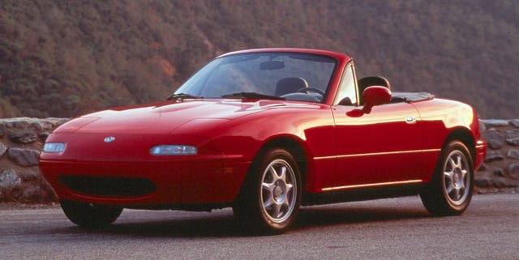
The fundamentals of the MX-5 have remained the same since the first generation and have proven to be very popular. The design elements that make this car so popular are, low mass, 2 seats, a front-mounted petrol engine, rear-wheel drive, even front-to-rear weight distribution, a low centre of gravity and a convertible roof. The MX-5 was designed for motoring enthusiasts and delivers a fun, “sporty” ride quality for a relatively low cost. When designing the first generation, Mazda used design elements from classic British roadsters, most notably the Lotus Elan.
Figure 1 - The First Generation of the Mazda MX-5
*Note that the term “NA” does not refer to the aspiration method of the car’s engine.

2.0 Impact of the Topics

2.1 Materials

Mazda primarily used steel for the main body/chassis of the car. This is because steel is a relatively high strength alloy with an ultimate tensile strength of 400-2000 MPA while still holding a low cost compared to other options (Tudor, K. 2022). Unfortunately, steel does have a lower strength to weight ratio compared to other options meaning that the overall mass of the vehicle is increased. Steel is also very vulnerable to rust, meaning that many MX-5’s started to develop corrosion around the rear wheel arches and rear sills early, as water was frequently trapped in these areas due to the cars water draining system.
Mazda also implemented aluminium into several areas of the car, these areas being the top end of the engine, the pistons, the transmissions bellhousing, the Power Plant Frame (PPF), and the bonnet. Aluminium was chosen for these areas of the vehicle due to its strength to weight ratio being much higher than steel (Tudor, K. 2022), meaning that the weight of the car can be decreased by using aluminium in these otherwise heavy areas. Using aluminium for the bonnet also improved weight distribution, as it reduced weight from the front of the car.

2.2 Manufacturing Process

Mazda used an assembly line process for the final assembly of components for the MX-5. This method was first used in the automotive industry by Henry Ford when producing the Ford Model T in 1913 (Tudor, K. 2022). This process allows for a much cheaper and more consistent mass production of a vehicle compared to having employees assemble each unit at a time, it is since wildly popular and used by most manufacturers to this day (Tudor, K. 2022).
When manufacturing large metal components for the MX-5 (chassis, engine block, transmission housing etc), Mazda opted to use casting as their primary method of manufacturing parts. This is because forging can be efficiently and consistently repeated on a mass production scale and has a lower cost compared to other methods such as forging (Tudor, K. 2022).
The interior parts of the car, such as the dashboard, centre console and door trims, are mostly made from moulded plastic. This was an obvious method for Mazda as it is very cheap, consistent, and durable. This process can however create a ‘cheap’ or ‘low-quality’ feel when inside the car.

2.3 Emissions

The original 1598cm^3 engine in the MX-5 produced an estimated 186g/km of CO2 emissions and averaged an efficiency of 7.8L/100km (36 miles/UK gallon) (Ultimate Specs, 2022), while the later 1839cm^3 engine produced an estimated 208g/km of CO2 emissions and hand an average fuel efficiency of 8.7L/100km (32 miles/UK gallon) (Ultimate Specs, 2022). In the UK, this puts these two variants of the MX-5 into vehicle tax groups J and K respectively.
Mazda used catalytic converters as part of the exhaust systems in order to reduce emissions, however the figures are still much higher than the modern standards are today meaning that it is likely these cars will become increasingly more expensive to own as the world moves to a more environmentally friendly place.

2.4 Computational Methods as an Engineering Tool

In recent years, computer-based engineering tools such as Computational Fluid Dynamics (CFD) and Computational Stress Analysis have become an industry standard when designing and manufacturing automotive components. These tools allow engineers to test and analyse different properties of a component before it is made, saving both time and money when manufacturing a vehicle. Unfortunately, such tools were in very early development at the time of the first MX-5, meaning that Mazda had limited access to computer-based tools, and the design process was both expensive and strenuous. Instead, Mazda’s designers and engineers tested many different prototypes and built down-scaled models of the car in order to manually measure the different properties of each design.

2.5 Control Systems

Electronic control systems have massively changed the automotive industry in recent years due to their potential to improve the user experience, as well as safety, fuel efficiency and other aspects of a vehicle. When Mazda were designing the first MX-5, a lot of this technology was still in development, however some of the main electronic control systems used are listed below.
- Electronic Fuel Injection
- Electronic Ignition Timing
- Electronic Control Unit (ECU)
- Gauges to indicate speed, RPM, Milage, Fuel, Oil Pressure and Engine Temperature
- Various warning lights
- OBD1 Diagnostic Interface
- Ignition Immobiliser (optional extra)
- Airbags (optional extra)
- Anti-Lock Braking System (optional extra)
- A plethora of sensors used to monitor various aspects of the vehicle (e.g., a Crankshaft Position Sensor to provide the ECU with live information)
These systems were implemented by Mazda to improve the reliability, user experience, and safety of the vehicle. At the time of production (1989), these features were very advanced for a car of the MX-5’s class. However, it still lacked many systems such as remote/central locking, GPS, parking sensors, electronic throttle body, traction control, digital display and many other features that are standard in modern vehicles. The above information has been acquired from person experience with multiple MX-5’s from this generation.

2.6 Aerodynamics

The aerodynamics of a vehicle refer to how it interacts with air while in motion, and how the vehicle can be altered to manipulate areas of high or low pressure to benefit performance (Tudor, T. 2022). In recent years, CFD (in conjunction with wind tunnels) has been the standard method for experimenting with aerodynamics, however this technology was unavailable during the design process for the MX-5 meaning this was a difficult task for Mazda. The goal for Mazda was to achieve a low drag co-efficient while maintaining suitable downforce for stability and grip for corners and high speeds. The published drag co-efficient of the vehicle is 0.38 (Lucas, 2015).
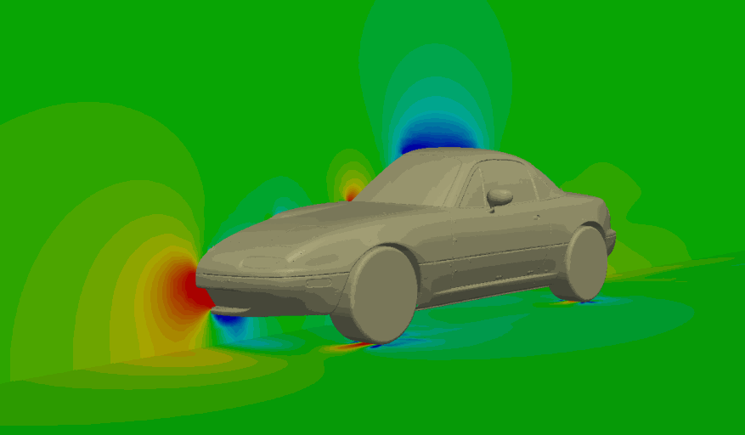
Figure 2 shows us a model of the MX-5 when tested using CFD and there are obvious areas of high and low pressure which likely impacts the vehicles performance. However, Mazda engineers had to consider that this car would have a convertible soft roof, as well as an optional ‘hard top’ roof and analyse how this would affect its aerodynamics. The car is also equipped with motorised ‘pop-up’ style headlights which affect the aerodynamics depending on their position.
Figure 2 - Mazda MX-5 (NA) CFD (Lucas, 2015)

2.7 Applying Calculus to Automotive Engineering

Mathematics is arguably the most crucial aspect to engineering and calculus is used in many stages of the design/manufacturing process of a vehicle. The term ‘calculus’ itself refers to the mathematical study of change, often over time. Differentiation and integration are included in this field also (Sutton, 2022). One example of when Mazda used calculus, is when the engineers designed the suspension damper system and need to decide on the best damping rate for that individual component. Engineers will generally aim for a ‘critically dampened’ result, meaning that the resistance of the damper is efficient as it can be without overshooting or undershooting (Sutton, 2022).

2.8 Hybrid Vehicles

The concept of hybrid vehicles has been around for many years now, and the idea is that a vehicle can be equipped with an internal combustion engine, alongside a battery and motor. This means that the engine can be used to charge the battery at its most efficient rate possible. This idea can be difficult to design however can massively reduce a vehicles emissions and improve their fuel economy. Mazda have successfully experimented with hybrid engines in recent years, including a hybrid rotary Wankel engine, however many find it unlikely that Mazda will be using this technology in an MX-5 model. This is because enthusiasts of this car tend to prefer the ‘authentic’ feel of a combustion engine powered vehicle.

3.0 Current State of the Industry

To this day, the early MX-5 models are still popular amongst enthusiasts, and Mazda are still producing the MX-5 in the form of its latest revision as of 2022. This shows that the fundamental design of the car is still very desirable. One of the reasons for the popularity of the first- and second-generation cars is the after-market support that allows for a huge range of upgrades and customization, as well as the cars infamous reliability.
Unfortunately, the first-generation MX-5 would be impossible to sell as a new vehicle in todays market. This is because the car is far behind meeting a multitude of safety, efficiency and emissions standards that brand new cars must meet. The latest generation MX-5 can meet these standards due to the advancement in technology since the early models were released.

4.0 Conclusion

In conclusion, Mazda did incredibly well to produce such a popular vehicle that still holds popularity over 30 years since its original release. This is likely because Mazda were able to identify a demand for a car like the MX-5 and execute the design and manufacturing of the car to come out with a product that delivers the best driving experience possible for its price.
Unfortunately, it is becoming increasingly difficult to find an original car in good condition in the UK market. This is due to the cars being very vulnerable to rusting quickly, as Mazda didn’t design the cars to stay well protected from the salt found on many British roads.

References

2.1
- Tudor, K. (2022) Introduction to Materials. Introduction to Automotive Engineering ACHA4009. University of Wales Trinity Saint David. 20th January 2022.

2.2
- Tudor, K. (2022) Automotive Manufacturing Processes. Introduction to Automotive Engineering ACHA4009. University of Wales Trinity Saint David. 3rd February 2022.

2.3
- Ultimate Specs (2022) Mazda MX 5 Miata (NA) 1.6i Specs. Available at: https://www.ultimatespecs.com/car-specs/Mazda/7593/Mazda-MX-5-Miata-(NA)-16i.html (Accessed: 24 April 2022)

- Ultimate Specs (2022) Mazda MX 5 Miata (NA) 1.8i Specs. Available at: https://www.ultimatespecs.com/car-specs/Mazda/7592/Mazda-MX-5-Miata-(NA)-18i.html (Accessed: 24 April 2022)

2.6
- Tudor, T. (2022) Introduction to Aerodynamics. Introduction to Automotive Engineering ACHA4009. University of Wales Trinity Saint David. 17th February 2022.

- Lucas, P. (2015) Air Dam or Splitter – A Closer Look. Available at: https://www.verus-engineering.com/blog/cfd-cases-4/air-dam-or-splitter-a-closer-look-12 (Accessed: 25 April 2022)

2.7
- Sutton, R. (2022) Applying Calculus to Automotive Systems. Introduction to Automotive Engineering ACHA4009. University of Wales Trinity Saint David. 25th March 2022.

