MSc Public Health and Social Care in Practice
Population Health and Digital Health Promotion
LCHS7007

Student Name: - Pratik saliya
Student ID: - 2413323
Module Name :- Population Health and Digital Health Promotion
Course Coad :- (LCHS7007 Population Health and Digital Health Promotion
Module Leader :- Dr Ping Wu

Table of Contents
Blog 1: The Impact of Telemedicine on Managing Chronic Diseases 4
Introduction 4
Why is this a concern? 4
Overview of the Existing Digital Technology – Telemedicine 5
How Telemedicine Works in Health Promotion? 5
Evidence of Impact 6
Critical Discussion on Impact 7
Advantages of Telemedicine 7
Disadvantages and Shortfalls 7
Addressing Shortfalls 8
Conclusion 9
Blog 2: Revolutionizing Mental Health Care with AI Chatbot "MindWell" 10
Introduction 10
Why is this a concern? 10
Your Digital Health Technology Design – "MindWell" 10
Key Features of MindWell: 10
Application in Health Promotion 11
Addressing Shortfalls 13
Conclusion 13
References 14
Task -2 Poster 15

Table of Figures
Figure 1: Challenges in Health Care Management 4
Figure 2: Telemedicine Role in Health Promotion 6
Figure 3: Digital Initiatives 9
Figure 4: Comprehensive Digital Mental Health Support with Mindwell 11
Figure 5: Mindwell Continuous Health Monitoring Cycle 12

Blog 1: The Impact of Telemedicine on Managing Chronic Diseases

Introduction
Globally, chronic conditions including diabetes, high blood pressure, and heart disease are the leading causes of morbidity and death (WHO, 2025). According to the WHO, the analysis estimated the 74% of deaths globally are caused by chronic illness, with diabetes also impacting more than 537 million individuals in 2021

Why is this a concern?
- Increased healthcare burden: Long-term treatment and ongoing monitoring are necessary for chronic illnesses (NIHCM, 2023).
- Limited access to healthcare: Timely access to healthcare is a problem for underprivileged communities and rural locations.
- Cost of management: The high expense of routine medical examinations and testing contributes to treatment non-adherence (SPH, 2025).
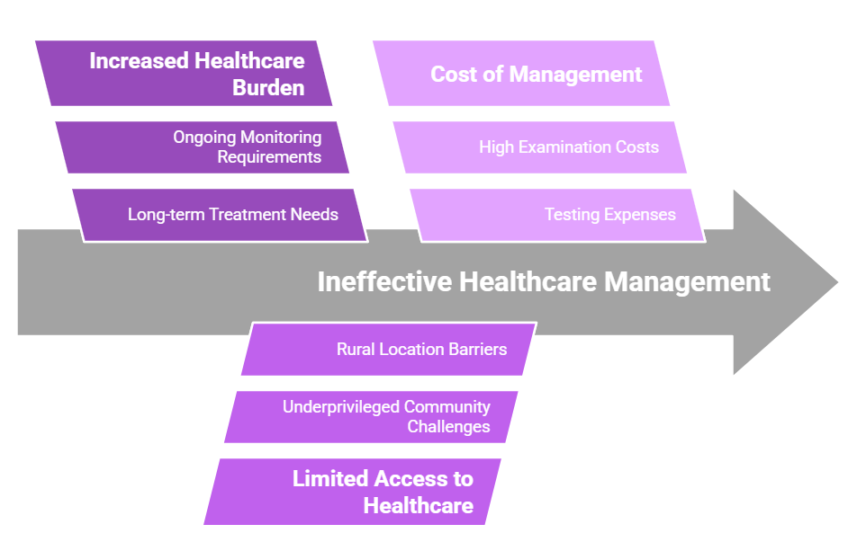
Figure 1: Challenges in Health Care Management
(Sources: Self Developed)

Overview of the Existing Digital Technology – Telemedicine
The can offer the digital prescription, virtual consultations and monitoring, telemedicine has revolutionized the healthcare sector. It fill the gap between the patients and healthcare the professionals by using the mobile applications, video chats and AI Powered platforms.

How Telemedicine Works in Health Promotion?
- Real-time virtual consultations: By using audio and video conversations, patients may consult clinicians in real time, eliminating the need for in-person visits.
- Remote monitoring: Apps and wearable technology provide doctors with real-time health data so they may provide preventative care.
- Digital prescriptions: By prescribing drugs and treatment regimens online, adherence is increased.
- Health education: AI-powered chatbots and applications offer nutrition advice, medication reminders, and lifestyle suggestions.
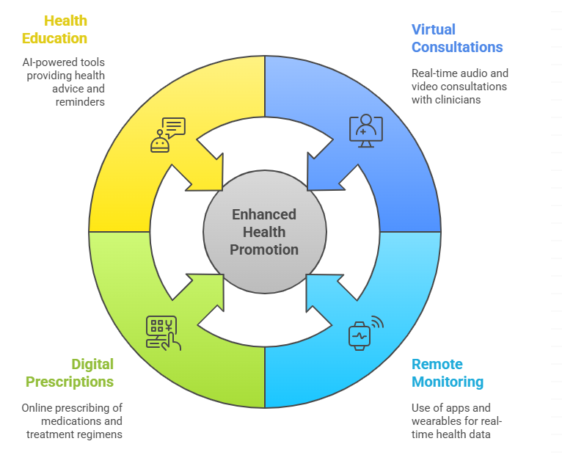
Figure 2: Telemedicine Role in Health Promotion
(Sources: Self Developed)

Evidence of Impact
- Improved patient outcomes: According to a research published in The Lancet in 2022, telemedicine helped diabetic patients avoid hospital readmissions by 35%.
- Higher engagement: Compared to in-person consultations, 80% of telemedicine users said that managing chronic diseases was simpler.
- Cost savings: According to a Harvard Medical School research, telemedicine often lowers medical expenses by $200 each visit (The Lancet Digital Health, 2022).

Critical Discussion on Impact

Advantages of Telemedicine
- Accessibility:
  - Provides access to isolated and rural locations with little medical facilities.
  - Shortens wait times for meetings with specialists.
- Cost-effectiveness:
  - Reduces travel and hospital visits.
  - Offers reasonably priced digital healthcare options.
- Engagement and convenience:
  - Personalized care plans and reminders are sent to patients through applications.
  - AI chatbots offer round-the-clock health advising assistance.
- Scalability:
  - Easily incorporated into global healthcare systems that are currently in place.

Disadvantages and Shortfalls
- Digital Divide:
  - Low-income populations have limited access to cellphones, the internet, and digital literacy.
- Data Privacy Concerns:
  - Online patient data is susceptible to cyberattacks.
  - Concerns about illegal access and data confidentiality.
- Usability Issues:
  - Non-techies and elderly patients have trouble navigating apps.
  - The absence of a human touch during online consultations.

Addressing Shortfalls
- Bridging the Digital Divide:
  - Government efforts to offer digital literacy and internet programs at reasonable prices.
  - Telemedicine kiosks are being installed in rural clinics.
- Enhancing Data Security:
  - More robust encryption and cybersecurity safeguards powered by AI.
  - Strict adherence to the GDPR and HIPAA data protection regulations (Ang, 2022).
- Improving Usability:
  - Voice-activated navigation for senior citizens.
  - AI-driven virtual assistants that offer detailed instructions on how to use telehealth systems.
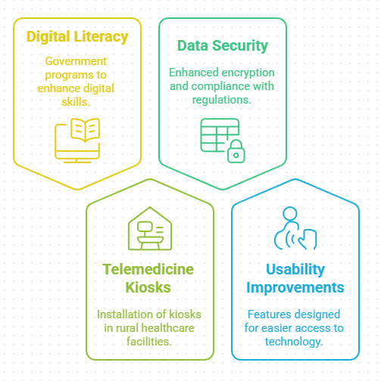
Figure 3: Digital Initiatives
(Sources: Self-Developed)

Conclusion
It has been concluded that the management of chronic diseases is being revolutionized by the telemedicine, which provide the scalable, accessible and reasonable priced healthcare options. The also faces the challenges such as a digital inequality and data privacy challenges, telemedicine can become the important factor of global health promotion with the ongoing advancement such as a technology, legislation and the education.

Blog 2: Revolutionizing Mental Health Care with AI Chatbot "MindWell"

Introduction
Anxiety and depression are two of the most common mental health conditions that contribute to disability globally. The World Health Organization claims that:
- One in four individuals worldwide will at some point in their lives deal with a mental health issue.
- More than 75% of people in low- and middle-income nations do not have access to mental health care (WHO, 2022).
- One of the main causes of death for people between the ages of 15 and 29 is suicide.

Why is this a concern?
- Limited access to treatment due to shortage of mental health experts, high cost, and stigma.
- Delayed intervention: A lot of people put off getting assistance until things get worse.
- An increase in stress and anxiety: Fast-paced lifestyles, social media, and financial strain can exacerbate mental health issues.

Your Digital Health Technology Design – "MindWell"
An AI-powered chatbot called MindWell was created to offer immediate, private, and easily accessible mental health assistance.

Key Features of MindWell:
- 24/7 AI Chat Support: Clients can communicate with a virtual therapist powered by AI at any time.
- Tools for Cognitive Behavioral Therapy (CBT): Provides self-help activities based on CBT methods.
- Mood Tracking & Analytics: This tool tracks user feelings by checking in every day and makes recommendations for treatments.
- Personalized Wellness Plans: Offers breathing techniques, journaling, and meditation.
- Emergency Assistance: Provides consumers with access to expert therapists and crisis hotlines when necessary (Zafar et al., 2024).
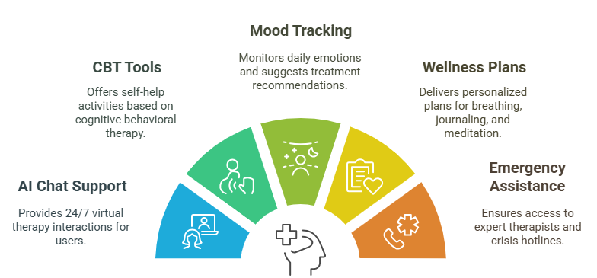
Figure 4: Comprehensive Digital Mental Health Support with Mindwell
(Sources: Self-Developed)

Application in Health Promotion
How does "MindWell" address mental health issues?
- Early intervention: AI-powered prompts assist in identifying anxiety and depression early on.
- Self-management: Individualized coping mechanisms are given to users according to their mental health patterns (RTOR, 2025).
- Dispelling stigma: Users may more easily seek assistance without worrying about being judged when they connect anonymously.
- Greater accessibility: A free smartphone app that makes mental health care accessible and inexpensive everywhere in the world.
Critical Discussion on Impact
Advantages of MindWell
- Innovation
  - Provides real-time, nonjudgmental assistance through AI-driven replies.
  - Analyzes heart rate and sleep habits by integrating with smart wearables.
- User Engagement
  - Daily mood tracking is encouraged by gamification aspects.
  - Push alerts urge users to take care of themselves and be aware.
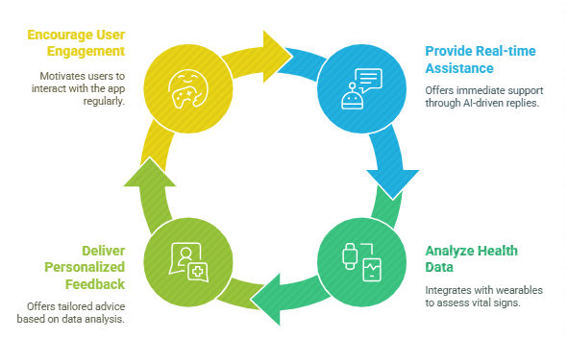
Figure 5: Mindwell Continuous Health Monitoring Cycle
(Sources: Self-Developed)
- Effectiveness
  - AI-driven cognitive behavioral therapy has been shown to lessen anxiety symptoms by 30–40%.
  - 70% of consumers reported improvements in their emotional well-being after a month, according to pilot study (Jiang et al., 2024).
Disadvantages & Shortfalls
- Cost & Accessibility
  - A paid membership may be necessary for advanced features (like therapist chat).
  - Access in low-income communities is limited since it requires a smartphone and internet.
- Digital Literacy
  - Some users might find it difficult to use the chatbot efficiently.
- Data Privacy Concerns
  - Cybersecurity threats may affect sensitive mental health data.
  - The possibility that AI will misread distress messages.

Addressing Shortfalls
- Improving Accessibility
  - Provide inexpensive premium plans and free basic services.
  - Create offline modes for people who don't have a lot of internet connectivity.
- Enhancing Digital Literacy
  - For novice users, offer detailed instructions..
  - Provide voice command capabilities to facilitate communication (PMC, 2025).
- Strengthening Data Security
  - Employ end-to-end encryption to safeguard user information..
  - To identify high-risk instances and refer them to experts, use AI-human hybrid monitoring..

Conclusion
By offering easily accessible, reasonably priced, and interesting digital assistance, MindWell has the potential to close the mental health gap. It has the potential to revolutionize mental health promotion by tackling privacy issues and internet accessibility, hence reducing stigma and promoting inclusivity in therapy.

References
Ang, A., 2022. Also, IVF clinic FertilTree is adopting an AI assistive tool for embryo selection by Embryonics. [Online] Available at https://www.healthcareitnews.com/news/asia/roundup-docty-setting-100-telehealth-kiosks-india-and-more-briefs
Jiang, M., Zhao, Q., Li, J., Wang, F., He, T., Cheng, X., Yang, B.X., Ho, G.W. and Fu, G., 2024. A Generic Review of Integrating Artificial Intelligence in Cognitive Behavioral Therapy. arXiv preprint arXiv:2407.19422. https://arxiv.org/pdf/2407.19422
NIHCM, 2023. Rural Health: Addressing Barriers to Care. [Online] Available at https://nihcm.org/publications/rural-health-addressing-barriers-to-care
PMC, 2025. Revolutionizing e-health: the transformative role of AI-powered hybrid chatbots in healthcare solutions. [Online] Available at https://pmc.ncbi.nlm.nih.gov/articles/PMC11865260/
RTOR, 2025. AI in Mental Health: Balancing Innovation with Caution in Virtual Services and Applications. [Online] Available at https://www.rtor.org/2025/02/10/ai-in-mental-health-balancing-innovation-with-caution-in-virtual-services-and-applications/
SPH, 2025. Chronic disease burden and future perceptions of financial control. [Online] Available at https://sph.umich.edu/news/2025posts/chronic-disease-burden-and-future-perceptions-of-financial-control.html
The Lancet Digital Health, 2022. Efficacy of telemedicine for the management of cardiovascular disease: a systematic review and meta-analysis. [Online] Available at https://www.thelancet.com/journals/landig/article/PIIS2589-7500%2822%2900124-8/fulltext
WHO, 2022. Mental disorders. [Online] Available at https://www.who.int/news-room/fact-sheets/detail/mental-disorders
WHO, 2025. Non-communicable diseases. [Online] Available at https://www.who.int/health-topics/noncommunicable-diseases
Zafar, F., Alam, L.F., Vivas, R.R., Wang, J., Whei, S.J., Mehmood, S., Sadeghzadegan, A., Lakkimsetti, M. and Nazir, Z., 2024. The role of artificial intelligence in identifying depression and anxiety: a comprehensive literature review. Cureus, 16(3). https://www.cureus.com/articles/233758-the-role-of-artificial-intelligence-in-identifying-depression-and-anxiety-a-comprehensive-literature-review.pdf

Task -2 Poster


