Exhibition Lighting.
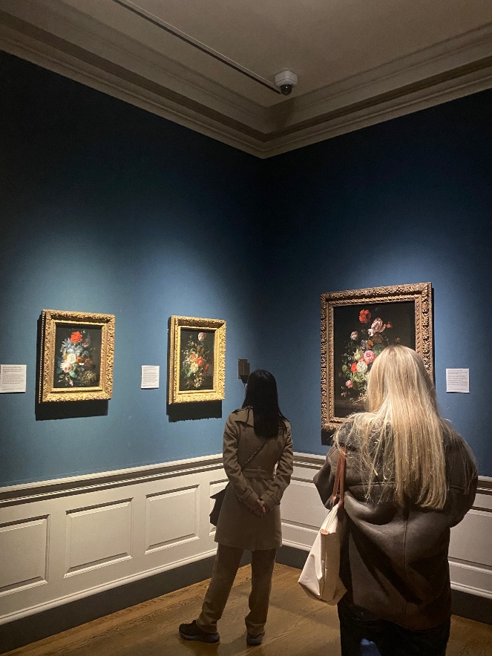
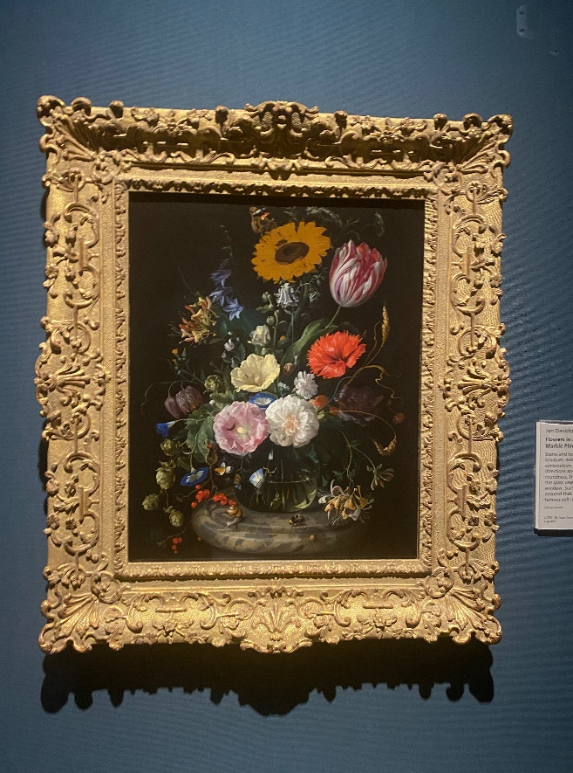
Exhibition 1: The National Gallery, London.
(Primary Sources)
These two images are photos that I had taken from one of the exhibitions contained in the National Gallery in London. There were many exhibitions in the Gallery but I really liked this exhibition in particular. This was the only part of the gallery where the walls were painted navy blue and were much darker compared to the rest of the building. This room consisted of plant and flower arrangement paintings. Many of the paintings that I had taken photos of were by the same artist Jan Davidsz de Heem, who is mainly a still life artist. The photo on the right is his piece ‘Flowers in a Glass Bottle on a Marble Plinth’. His paintings are similar in the sense that he makes similar flower arrangements but with different species of flowers. The majority of the time, the background in his paintings are dark, which brings out the vibrant colours that he uses in the painting. This helps a lot when lighting the piece because you can clearly see the detail in the colours used. The lighting that the Gallery used in these paintings are roof lights from the ceiling directed at the paintings.
I really like the contrast of these paintings. De Heem used oil paints to create these works and used a lot of black in his pieces which I believe has been really effective to show the detail and vibrancy in the paintings. There is a term in painting called tenebrism, which originated from the Italian term ‘tenebroso’ meaning the darkened and obscuring. According to the National Gallery website, this term is used to describe a certain type of painting in which significant details are contrasted with a predominantly dark setting (The National Gallery, 2016-2023). Black is always a hard colour to light in general but because of the amount of colour used in his piece, I believe the dark setting is really beneficial.
The photo on the left shows how effective these lights are when it comes to presenting the artwork. By using these lights, it shows the contrast of colours in the piece. The rest of the gallery did not include this type of lighting of the paintings; where the lights were closely directed at the artworks. So I wanted to show how much this type of lighting can be effective on a painting. When lighting an oil painting, it is important to remember that certain temperatures and light production can alter the durability and colour of an oil painting. After doing some research, I found that Museums and Galleries tend to use halogen lamps or UV bulbs that are around 5000k. Matt Fussell (2022) explains in his blog that 5000k is most ideal because it best mimics the sun, any degree higher may force the colours to turn a little warmer. According to the Guest User on their blog 1000 bulbs, halogen lamps are often used because of their crisp white light, Guest User (2021). This is why they are most commonly used in lighting galleries and museums. However, they are many disadvantages to using this light. For example, according to Guest User, these lights have a heavy energy cost in the form of heat. It costs much more to keep these lamps lit, Guest User (2021).
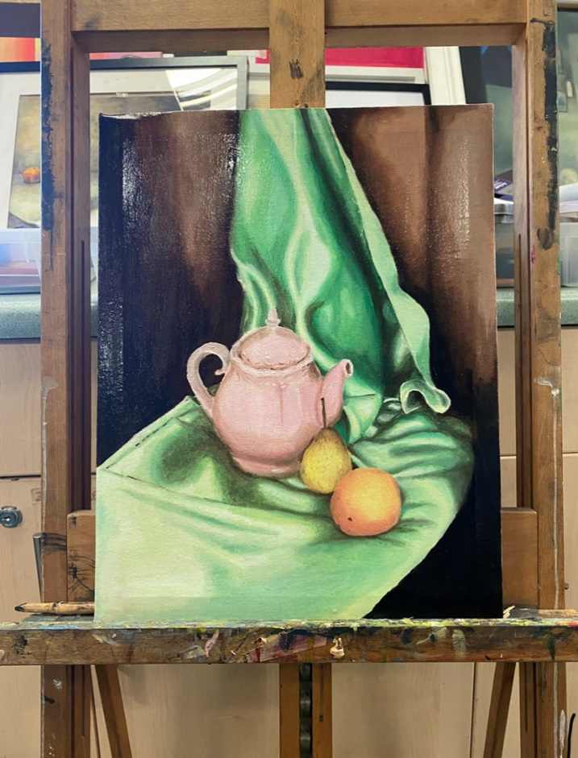
(Primary Source)
This is my example of this type of lighting, similar to the exhibition in the National Gallery, London. I used one of my still life oil paintings because there was a lot of contrast in this painting similar to the piece by artist Jan Davidsz de Heem. Where he used mainly darker colours in the background to make the vibrant colours more effective. I wanted to use this effect on my paintings. Instead of using the tenebrism technique, I tried not to use too much black in my painting but instead I used more brown and green rather than black. I think that this did help because I notice that the light has shown the different tones in the painting rather than just coming up as black. I put the painting up on an easel to present it but I used my phone torch to light the painting similar to the way the exhibition was lit in the Gallery.
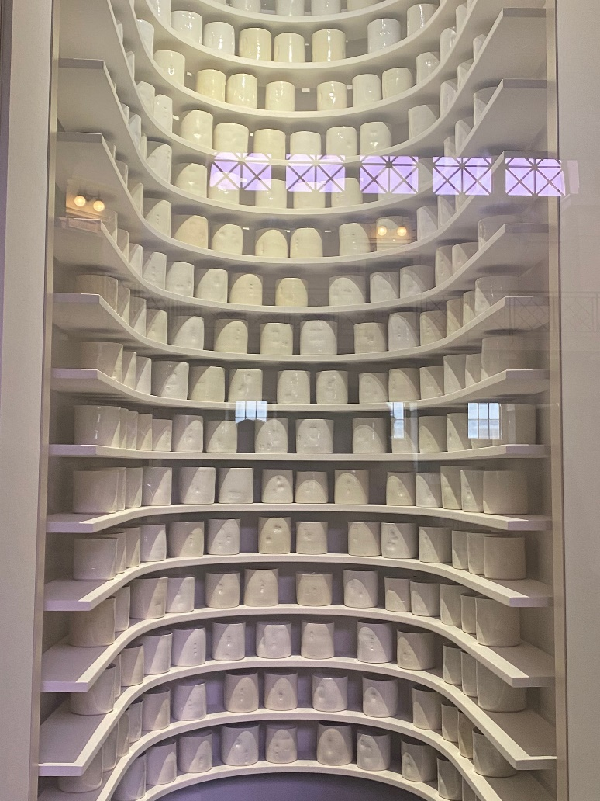
I believe that overall it was effective to the painting, However my phone torch was not strong enough compared to the museum lighting. However, I can see when the main light source is coming from in the photo. The natural sunlight was behind my painting coming from a window, so I thought that facing the painting away from direct sunlight then using a torch would give similar effect to the exhibition piece. Considering that I did use my phone torch to mimic this technique. I think that I was able to capture the contrast and detail in the painting similar to de Heem’s exhibited work. Where I did not use as much black in my painting as he did, I think that the painting itself shows a lot on contrast and you can see the intention of where the light falls in the painting.
Exhibition 2: The National Gallery, Cardiff.
(Primary Source)
This is a still life exhibition that contains many hand sculpted ceramic objects. I wanted to include this exhibition from the Cardiff museum because of the way the objects are lit. At the moment I have been looking at still life and when I saw this piece, I was really interested in the placement and lighting of the still life objects. This exhibition include many handmade ceramic cups all placed on rows of shelfs on top of each other. Because they are hand made, all of the cups are slightly different. You can see this by the way the light has reflected on the dents and marks on each cup. The exhibition was made to be asymmetrical from each other. You can see that the placement of the cups do not fall in line with the other rows. The reason that I liked this idea was because of that intended purpose.
I included this because I believe the lighting of the exhibition is very effective to the objects. It includes one singular sky light at the top which causes shadows to fall on all of the objects. This is how you can see the asymmetry and hand marks on each of the ceramic pieces. This is what makes the piece meaningful, because at first it looks like it is supposed to be perfect but when you look closer you can see the differences. Where they could have lit each individual sculpture, they just used one sky light for the whole piece. This has caused the top middle objects to be fully lit and the rest of the objects are either slightly shaded or completely shaded.
I like the way that this has shown shading throughout the exhibition, where the top is fully lit you can not see the marks made on the objects. But as you look further down, you can clearly see them. Going back to the idea that it looks as if it is supposed to be perfect at first but then you can see the different marks on each object. It looks as if it is intentional to the exhibition and the lighting used has really helped that idea
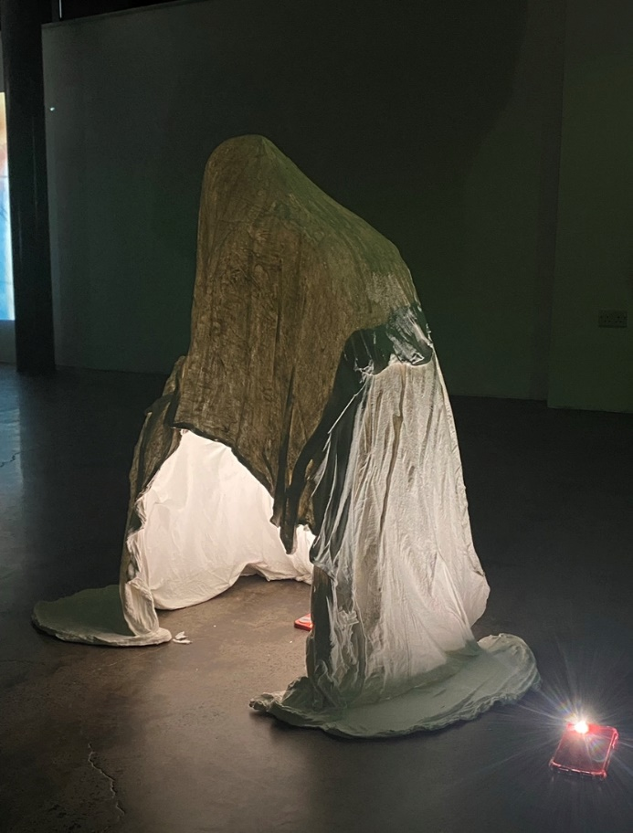
(Primary Source)
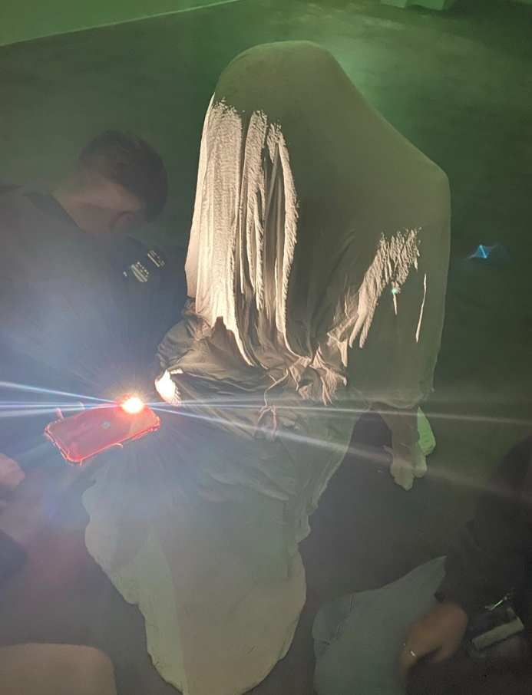
During our sessions at University, we have looked and experimented with how light can completely affect an object or an art piece. We used our space at Stwdio Griffiith to use the artworks made by other students to experiment lighting on. This photo is an example of what we did to one of the artworks in the Stwdio. Using what looks to be a sculpture of what would have been a piece of fabric draped over a kneeling person. We turned off the main lights in the room and then used two phone torches to light this plaster sculpture in different ways. It was a hollow sculpture so we experimented with this and tried to light it in different ways to change the perspectives. Shown in this photo, we put one of the phone torches underneath the sculpture then one just on the outside of the sculpture. We noticed that when the sculpture was not lit at all, you could not see the intended creases and where most of the plaster is formed on the sculpture. So we wanted to make use of the fact it was a hollow sculpture and put the light underneath to light up the inside of the sculpture.
This way you can see the where the material falls and where the most hollow parts of the sculpture. I believe that this was effective because not only can you see the shape of the students artwork but you can see the heaviest and hollow parts of the sculpture is. Similar to the exhibition piece that I had included from the National Gallery, Cardiff. Where the sculptures were lit to shown the dentures and hand made marks on the objects. We did something similar in that aspect, where you can clearly see the depth in the sculpture despite that it is completely hollow.
I included a second image of another example of how we lit the sculpture. Compared to the first example, this way of lighting gives more of a perspective to the students artwork. Rather than using a phone torch underneath to light up the inside of the hollow sculpture, we used one phone torch to light up the front of the sculpture. This way we obtain the same idea as the first example, where the intention was to highlight the depth and marks on the sculpture, but just from a different perspective. This way, it looks as if the face of the person in the fabric is looking down into his knees due to the placement of the light. We found this very effective when it came to recreating this idea because we were able to show something similar when using charcoal and pencil to draw the sculpture. We could draw the contrast shown in the photo because of the way it was lit.
To conclude, I have included two exhibitions that I believe the lighting has affect on. The lighting where the perspective is shown differently compared to if it was not lit by a gallery. I think both ways of lighting can be brought into my work more because I like that they have benefitted the look and outcome of the artworks. For example, when I lit my oil painting similar to the oil painting in the National Gallery in London, I found that the tones and detail were more prominent in the painting. I also included the second exhibition because of my interest in still life and I hope to use that idea more in my work. I think they way the lit and placed the exhibition from the National Gallery in Cardiff makes the piece much more interesting.

Bibliography.

Guest User (2021) Gallery And Museum Lighting
Available at: https://blog.1000bulbs.com/home/gallery-and-museum-lighting
(Accessed: 2nd January 2023)

Matt Fussell (2022) Lighting Your Art Studio
Available at: https://thevirtualinstructor.com/blog/lighting-your-art-studio
(Accessed: 2nd January 2023)

National Gallery (2016-2023) Tenebrism
https://www.natinalgallery.org.uk/paintings/glossary/tenebrism
(Accessed: 4th January 2023)

