

Global Business Environment
Assignment 2

Student Name: Bogdan Hodor
Student ID: 1917709

Table of Contents
Introduction 1
PART 1 2
Changes Taken Place in NHS due to COVID-19 2
New Product Portfolio and Strategy 5
Recruitment strategy, people and culture 7
Operational processes and systems 8
PART 2 8
The Sustainability of New Operational processes and systems 8
Conclusion 9
Recommendations 9
References 10

Introduction
The National Health Service (NHS) has been heavily affected by COVID-19. It has spread all over the UK in a short time. So, the demand for healthcare has increased drastically. Also, the demand for elective medical care and intensive care unit (ICU) has increased in a big number. The available supply of service has failed to meet that rapidly increasing demand. This situation led the NHS to the complete use of all the available medical resources of NHS hospitals, rearrangement of medical facilities, redesign of service structure, and hiring more staff. Besides, to fight this pandemic the NHS has been compelled to establish NHS field hospitals. Throughout this report, the changes in the NHS due to the coronavirus pandemic like the changes in service strategy, recruitment strategy, and the new operational process to face the pandemic are discussed along with the business frameworks.

PART 1

Changes Taken Place in NHS due to COVID-19
NHS is one of the four national healthcare systems in the United Kingdom that serves the people with medical services (Worthington, Britton, and Thompson, 2018). It provides health services to the residents and non-residents of the UK. The majority of medical services in England, including primary care, in-patient care, long-term healthcare, eye care, and dental care are provided by the NHS. When the COVID-19 outbreak occurred in the whole world, the NHS has faced a massive challenge to fight that pandemic. The past service policies and strategies became ineffective. On the other hand, the number of corona infected patients was increasing drastically. They started to come to the hospitals. The number of service seekers exceeded the capacity of NHS hospitals. Besides, the regular patients were admitted to the hospitals. The outspreading of the virus was increasing drastically as it is highly contagious. The death toll was also rising with a higher proportion. At that moment the whole country went into lockdown. A long time staying at home started to cause mental problems to the residents.
Many more patients were in critical condition. So, the demand for ICU beds also increased in a big number. All the previous records of ICU bed occupancy has broken. Because, the corona infected patients were at high death risk (Pattani, 2020). So, they needed intensive care. There was another big problem. The doctors and nurses needed to serve patients with direct physical contact. But, COVID-19 is a highly contagious virus. They were at high health risk. To keep safe the doctors and nurses, it became a must to provide personal protective equipment (PPE) which increased the service cost of medical authority.
The infected patients exceeded the capacity of medical beds and it was increasing continuously (Khan and Naushad, 2020). So, an immediate step was needed to admit that a huge amount of patients. To give medical care to an unexpected number of patients a big number of medical staff needed.
A huge number of people were seeking minor medical services from home via online platforms. To meet that NHS needed to set more doctors to help the people online. Also, it was needed to increase the server capacity so that people could get services without any trouble.
The invention of the vaccine has become a fire emergency for human civilization. So, NHS invested a big amount in the invention of the vaccine.
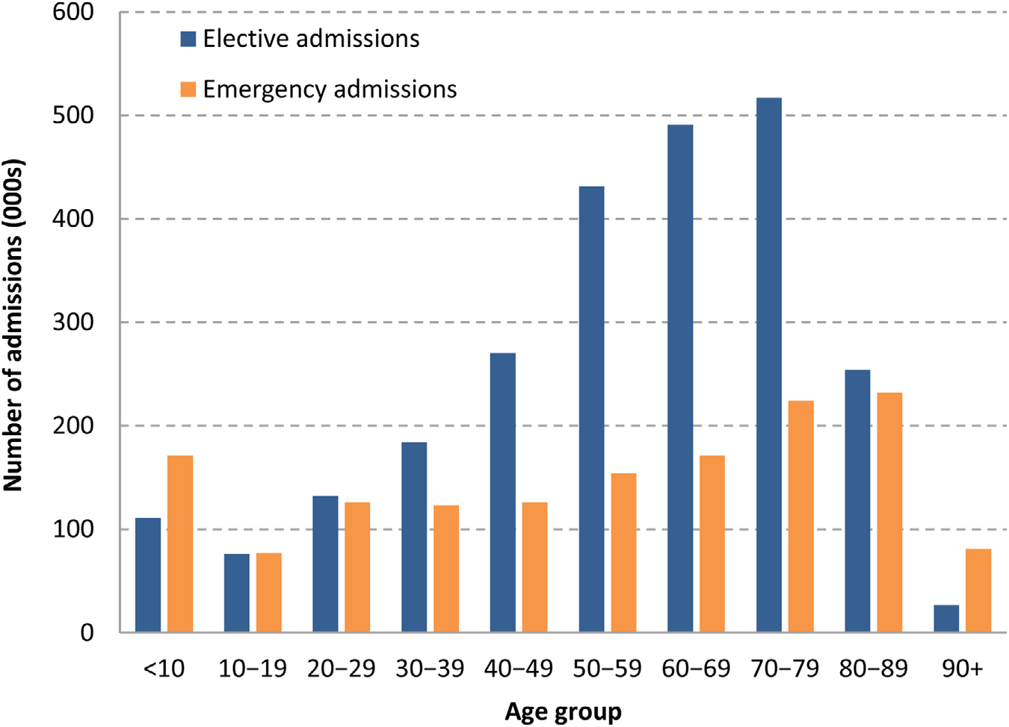
FIGURE 1
Number of elective and emergency admissions between April and June 2017,
By ten-year age group (Propper, Stoye and Zaranko, 2020)
PEST Analysis of the NHS in COVID-19
I will use PEST analysis which considers the Political, Economic, Sociocultural, and Technological factors affecting an organization to review the NHS’s current and future operational standings in this COVID-19 situation (Redmon, Mawhinney, and Johnson, 2019).
Political Factors
NHS can be affected by a political factor in this corona pandemic. That is the ability and expertise of the government to fight against this destructive pandemic (Dessler, 2020). The opposition parties always try to find out the weakness of the government. So, the government always tries to show the ability of them. Also, the international relations of the government affect the situation against the pandemic.
Economic Factors
Economic downturn
In this pandemic, the whole world has experienced a big economic downturn (Khan and Naushad, 2020). Of course, the United Kingdom was in no way immune to this economic setback, and this is something that has impacted the NHS. Because to continue the activities NHS needs funding.
Sociocultural factors
Aging population
A common phenomenon is that of an aging population. As healthcare facilities improved, the average age of populations is increasing. But the mortality rate of aged people is high in this corona pandemic. Because, they suffer from various kinds of diseases like Diabetes, high blood pressure, etc. As a result, the NHS facing an extra strain in this COVID-19 situation.
Technological Factors
Improved healthcare
In this modern century, almost all sectors are benefitted from new technologies. Medical services can be provided easily with modern technologies. The medical test equipment, patients’ data management, ventilator support, and other life-supporting technologies increased the service quality and ability of the medical system. Providing telemedicine service is possible only by using modern technologies. The NHS is affected by these technologies in providing services.

New Product Portfolio and Strategy
NHS needed to make a massive change in the service portfolio and strategy to fight the coronavirus pandemic. So, NHS has taken new strategies and created some new service policy. NHS established seven NHS Nightingale Hospital in a very short time to provide medical care to the huge infected patients. As we discussed earlier NHS faced a huge demand for medical care and medical bed and equipment (Yang and Ma, 2020). But space and available beds in the NHS medicals were insufficient to meet that demand. The admission of patients was 40 times more than usual. We can see this in Figure-2 graphically.
To meet the rapidly increased demand the NHS has established NHS Nightingale Hospital that made NHS able to serve the huge corona infected people (Propper, Stoye and Zaranko, 2020). These hospitals have increased the availability of medical beds and service equipment.
NHS brought back the recently retired medical staff and permitted the final year nursing students to join as staff. 7000 recently retired nurses return to their workplace within March 2020 and around 3000 final year nursing students were appointed as a nurse in the NHS hospitals (Williams, 2020). Besides, NHS reduced nurses to look after other regular patients and deploy them to look after the Coronavirus affected patients. The working time duration has increased for the doctors and nurses. As a result, they started facing health and mental pressure. A number of them are infected by the Coronavirus and some are suspected that they are infected (Hossain, 2020). So, they went to self-isolation and some others took leisure from the work. So, the need for doctors and nurses has increased in a greater proportion.
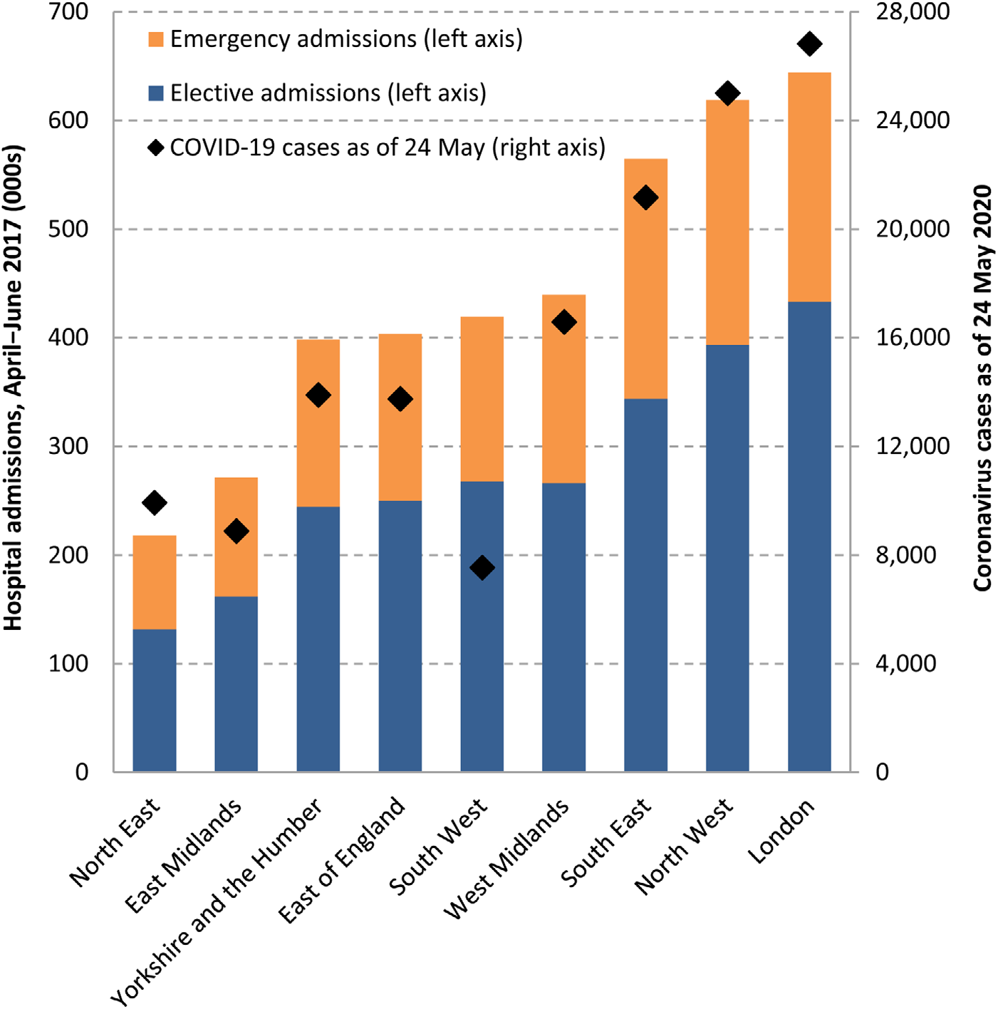
FIGURE 2: Total number of NHS elective and emergency admissions
by English region (Propper, Stoye and Zaranko, 2020)
For covering this situation, NHS has changed its recruitment procedure and requirements. It has allowed the final year nursing students to join as a nurse and the wiped out the age requirement. So, the retired nurses also joined as a nurse in their hospitals (Lundstrom, 2020).
NHS also changed the strategy of treating Non-COVID patients. They planned to discharge the patients who are medically fit. Also, the NHS reduced the number of surgery in a big number (Yang and Ma, 2020).
Telemedicine service was emphasized with the help of websites and apps. NHS started to provide remote consultation via NHS App, NHS website, and online video call. It reduced the regular patients’ pressure in hospitals (Propper, Stoye, and Zaranko, 2020).
Also, NHS reduced resources for the non-Corona virus patients and employ them to serve Corona patients. It transferred equipment and other resources from the non-Corona ward to the COVID ward and nightingale hospitals (Yang and Ma, 2020).
NHS invested a huge amount in the production of vaccines. Because the only vaccine can stop this pandemic. NHS conducted vaccine trials of Pfizer and BioNTech’s Vaccine to the required areas and people (Williams, 2020).

Recruitment strategy, people and culture
After the coronavirus outbreak, the NHS has changed the recruitment process and strategy quietly. NHS started an online platform based interview in hiring. Besides, NHS is allowing the fresh graduates with zero work experience to join as the medical staff. It allowed final year nursing students to join as a nurse. NHS shorten the recruitment process for the COVID-19 situation.
The work culture of NHS also changed in the post-pandemic situation. Before that NHS used to serve all the patients as per their need for treatment. They always follow the first come first serve rule. Also, they never discharge any patient before being completely fit. But in this corona pandemic, NHS prioritize the corona infected patients highly. They reduced the treatment of non-corona virus patients. Also, NHS transferred resources from other wards to the COVID-19 ward. They discharged patients when they become medically fit. The number of surgery was decreased highly in this situation. On the other hand, NHS increased the shifting time of the doctors and medical staff over their interest.
Incentives to the employees in the post COVID situation in NHS is changed. It pays the employees for their extra effort. Besides, NHS offers its employees various kinds of facilities like discounted taxi rides, discounted meal delivery, data deals, and activities for children and families. Employees are getting a discount of up to 75% in many outlets and transportation services. Also, their families are being benefitted from those offers.

Operational processes and systems
NHS has adapted a new operation process and incorporated new systems in the post COVID situation. Before the Coronavirus pandemic, NHS hospitals were providing health care services to the people of the UK (Propper, Stoye, and Zaranko, 2020). They provide emergency medical care, elective care, etc. Also, NHS hospitals gave attention to the patients as per their needs. But in the Corona pandemic situation NHS hospitals have given the top priority to the Corona infected patients. They prioritize their needs for regular patients. NHS discharged most of the regular patients when they are medically fit. Besides, they decreased the number of surgery (Yang and Ma, 2020). To serve the big number of Corona patients NHS established seven NHS Nightingale hospitals where only COVID infected can get healthcare services. NHS started to provide regular medical consultancy services via online and mobile applications so that the pressure of regular non-corona patients decreases in the hospitals.

PART 2

The Sustainability of New Operational processes and systems
These new operational processes and systems are very effective to fight the pandemic. The sudden increase of service-seeking people has covered up with these. These changes made the NHS able to face this type of situation in the future. The new processes are sustainable that NHS will be more confident to face any emergency and these will enable NHS to take proactive measures for the future. In this pandemic, NHS has taken some new operational processes which will be continued in the future and will make its future path easy. But in the long run, when the pandemic will end many of these systems will not work anymore. Then a contingency plan will be needed to come back into normal service processes.

Recommendations
The NHS has taken many emergency steps to fight the COVID-19 pandemic. But it seems the pandemic will not end soon. So, the NHS should take some permanent steps for this. NHS can increase the medical bed capacity. It will be effective for the long term. Besides, NHS should also increase the medical staff and doctors and train them properly. Though the NHS hired final year students in an emergency, they need to be trained properly so that they can serve properly in the long run. Also, the NHS should make a contingency plan for the post corona situation.

Conclusion
COVID-19 has fallen a severe effect on the National Health Services (NHS). The organization faced many challenges to control the situation. NHS has taken many steps to overcome this pandemic. NHS has changed its operation as per the needs of the people. It introduced a new service portfolio and strategy for coronavirus patients. To meet the rapidly increasing demand NHS has changed its recruitment process and hired a huge number of medical staff. Besides, the operational processes and strategies were updated by NHS as per the situation. It can be said that the NHS successfully faced the COVID-19 pandemic.

References
2017. Environment & Business. [London]: Department of Trade and Industry.
Bradley, K. and Clark, R., 2015. The Legal Environment. London: Holt, Rinehart & Winston.
Dessler, G., 2020. Human Resource Management. New York: Pearson.
Dew, P., 2016. Bahrain's Business Environment. London: GMB Pub.
Druckman, D., Singer, J. and Van Cott, H., 2016. Enhancing Organizational Performance. Washington, D.C.: National Academy Press.
Fernando, A., 2019. Business Environment. Chennai: Pearson.
GIACALONE, R., 2016. Handbook Of Workplace Spirituality And Organizational Performance. [Place of publication not identified]: TAYLOR & FRANCIS.
Hossain, A., 2020. Impacts of Global Pandemic Outbreak of Novel Coronavirus on Massive Humanity: A Data Analysis. Scholars Journal of Medical Case Reports, 08(05), pp.586-597.
Iacobucci, G., 2020. Covid-19: NHS will restart some paused services this week. BMJ, p.m1709.
Ivancevich, J. and Konopaske, R., 2017. Human Resource Management. New York: McGraw-Hill Irwin.
Khan, N. and Naushad, M., 2020. Effects of Corona Virus on the World Community. SSRN Electronic Journal,.
Lundstrom, K., 2020. Coronavirus Pandemic—Therapy and Vaccines. Biomedicines, 8(5), p.109.
Miller, B., 2016. Assessing Organizational Performance In Higher Education. San Francisco, Calif.: Jossey-Bass.
Pattani, S., 2020. An insight from a NHS Occupational Health Physician during COVID-19. Occupational Medicine,.
Propper, C., Stoye, G. and Zaranko, B., 2020. The Wider Impacts of the Coronavirus Pandemic on the NHS *. Fiscal Studies, 41(2), pp.345-356.
Redmon, W., Mawhinney, T. and Johnson, C., 2019. Handbook Of Organizational Performance. Hoboken: Taylor and Francis.
Williams, C., 2020. Impacts of the coronavirus pandemic on Europe's tourism industry: Addressing tourism enterprises and workers in the undeclared economy. International Journal of Tourism Research,.
Worthington, I., Britton, C. and Thompson, E., 2018. The Business Environment. Harlow, United Kingdom: Pearson Education Canada.
Yang, H. and Ma, J., 2020. How an Epidemic Outbreak Impacts Happiness: Factors that Worsen (vs. Protect) Emotional Well-being during the Coronavirus Pandemic. Psychiatry Research, 289, p.113045.

