

REPORT

Effective Team Working and Communication
Javier Portaro
Student number: 1906228
Module N°BMSW4002_LON

Acknowledgements:
I would like to thank my colleagues in uni, professors, and university staff to allow me to continue with my development and gave me all the guidance to reach the end of this first term. This work would not have been possible without the support of my family specially of my son's understanding of going to college and spending less time with him.

Contents
- Summary
- Introduction
- Types of communication

  - Verbal Communication
  - Non Verbal Communication
- Theories of communication
  - Shannon Weaver model of communication
  - Berlo’s model of communication
  - Schramm’s model of communication
- Conclusion
- Appendices

- Summary
This report focuses on all the information we received and exercises we did during the first term of this course; in this case I will use all I learnt to describe and explain about three article using different methodologies.

- Introduction
Teamwork
Teamwork is essential in many company projects in which the essence of the team shows that the sum of different talents at the individual level leads to success because true knowledge is shared with humility thanks to the feedback that arises from assertive dialogue and of mutual admiration. A team is made up of people working in the same direction respecting a concrete action plan and following the guidelines of a good leader who becomes the best example to follow and a reference for the members of that team. Teamwork brings great strengths since it is fortunate to have a co-worker who can help you in a difficult time: successes are shared as well as failures in the context of the team.
Teamwork in the workplace
It is very common to find this concept in companies, as these are different groups of people organized to meet specific common objectives. The goal of teamwork is to bring together a group of people with similar abilities, intelligences, ideas, and skills in order to perform different tasks to get better results. The ability to work together is an element that many leaders and recruiters value today, since they believe that relying on others and at the same time providing them with the best of you, is the key to easier reaching everything that you propose Finally, this practice helps to maximize the strengths of each team member, making the best of himself and complementing them with those of others. Along the same lines.
Organizations are made up of individuals, so everything that happens in them, from daily work to human relationships must be understood in terms of communication. This communication in the organization allows the relationship with others, learn to work, transmit business culture, lead teams, etc.

In every communication process, several elements can be distinguished:
- Message: What you want to communicate.
- Transmitter: It is the one that originates the message.
- Receiver: Message recipient.
- Channel: Medium or vehicle used for the message to reach the receiver.
- Codification: Process through which the issuer transforms his ideas and feelings into words.
- Decoding: The message recipient translates words into ideas and feelings.

HAPPY EMPLOYEES The importance of communication in organizations

Reference
https://www.forbes.com/sites/quora/2013/01/23/why-and-where-is-teamwork important/#39498386287a
- Types of communication
In every organization two forms of communication coexist: formal and informal. The first is given by the organization itself, which is the one who establishes the lines of communication. The second is spontaneous and arises whenever an individual need to communicate with another and there is no formal channel for it.

3.1 Verbal communication
Verbal communication is the interaction between two or more people, either orally or in writing. It is essential in any human relationship and, therefore, is present in daily life, for example, in interviews, letters, email, etc.
Although all species communicate, language itself is a purely human phenomenon that allows greater precision in the method of communication. Through verbal communication, knowledge, emotions, experiences, etc. can be transmitted.
It can be used to inform, investigate, and discuss all kinds of topics. It is vital for teaching and learning, as well as the formation of bonds and the building of relationships with other people. In a world where there is a constant bombardment of information, and great pressure to report everything with great speed, it is a great challenge to be able to transmit messages that reach everyone, and that are also credible
3.2 No Verbal communication
Nonverbal communication is a communication process through which a message is transmitted through gestures, signs, or signs; That is, without words. Gestures, body language, posture, facial expression, eye contact ... are some of the resources you use.

Nonverbal behaviour develops several functions in the socialization process:
- Define our identity.
- It shows the degree or ability we must relate.
- It helps to limit and understand the messages.
- It transmits emotions and feelings.
- It influences others and us.
Reference
https://degree.astate.edu/articles/undergraduate-studies/3-main-types-of-communication.aspx

- Theories of communication
Communication means transmitting ideas and thoughts in order to present them "in common" with another person. This involves the use of a shared communication code.
A code is a set of symbols and signs which must be shared by the protagonists of the process.
Thanks to the fact that a code is shared, messages are transmitted from person to person.
Generally thinking about language when talking about codes, but this is a much broader concept. In addition to verbal codes (oral and written), there are others such as gestures, movements of the face and body, those given by shape and colour (for example traffic signs) or music (where there are rules that mark a structure). Naturally, nonverbal codes, like language, vary according to different cultures.
Thus, it is affirmed that language is only one more mean. The tendency to identify it with the communication is a consequence of this being the most suitable means for the transmission of ideas.
If the concept of communication is considered from a broad sense, it refers to living beings that are related to their environment, but from the scientific language it will refer to beings related to each other and capable of expressing internal processes and situations, of making circumstances known or encourage other creatures to specific behaviours.

4.1 Shannon and Weaver Model of Communication

This model is specially designed to develop the effective communication between sender and receiver. Also, they find factors which affecting the communication process called “Noise”. At first the model was developed to improve the Technical communication. Later it is widely applied in the field of Communication.
The model deals with various concepts like Information source, transmitter, Noise, channel, message, receiver, channel, information destination, encode and decode.


Example
During a phone call when I was giving some instructions to my colleague about the parts he need to buy for the his car the background sound had the noise of a machines working, in this case the sound of the people working would be the noise that caused the wrong message.
4.2 Berlo’s Model of Communication
It corresponds to an individual or a group with an objective to communicate. Among them, five factors are identified: Communication skills the analytical ability of the source to know its purposes and its ability to encode messages that express its intention. Attitudes fidelity can be affected by the attitude of the source towards itself, the attitude towards the subject or message it tries to convey and the attitude towards the recipient. Knowledge is the level of knowledge that the source has regarding the subject of your message. Sociocultural system location of the source in a specific social and cultural context.

- ENCODER It is up to the person in charge of taking the ideas from the source and arranging them in a code.
- MESSAGE The purpose of the source expressed in some way. It considers the following elements: Code, Content and Treatment
- CHANNEL The medium, conduit or bearer or transmitter of the message. The fidelity of the communication will be greater if the appropriate channels for the message are chosen or if they are combined.
- DECODER It corresponds to what the message translates and gives it a form that is usable by the recipient.
RECEIVER The person or group of people who constitute the objective of the communication.

Example
During a service in the restaurant where I work after several months and after developing empathy and friendship.
The manager's instructions are only gestures when he need the staff to go faster and be more friendly. Just one gesture or one look is enough to understand what he needs from the team.
4.3 Schramm’s Model of Communication
This model addresses the process in which from this multiplicity of messages the receiver selects the ones that make the least effort to perceive their meaning and those that best represent the set of norms of the social group to which the recipient is a part.

In the study of the communication process that Schramm does is implicit, as we said, the concern about the study of the effects and part of the assumption that when an communication is issued an attempt is made in unison to predict its effects: the issuer makes a projection of the possible effects of your messages.

However, Schramm recognizes that the effects of communication are the result of several forces of which the communicator can only control one: to shape his message and decide when and where to transmit it. The remaining uncontrolled elements are the situation in which the communication is received and in which the response will take place; the personality of the recipient and; the norms and group relations of the receiver.

Finally, although Schramm's models follow Laswell’s and Shannon's models make new contributions. For example, feedback and the notion of the field of experience as that common memory that makes effective communication possible (the absence of this memory was one of the main criticisms of Shannon's model).

Even so, although Schramm acknowledges that the sender not only can transmit messages, it also does not go beyond which the process of producing the information remains a black box.

Reference
https://epgp.inflibnet.ac.in/epgpdata/uploads/epgp_content/library_and_information_science/knowledge_society/05._theories_and_models_of_communication/et/4305_et_et.pdf

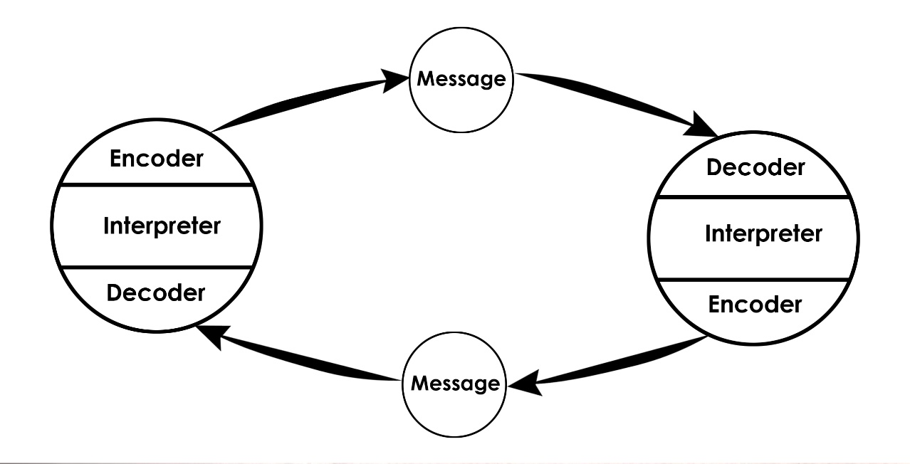
Example
In this case, an example in the workplace is when brainstorming is carried out and all participants are free to participate and contribute their best ideas in search of a common goal, the discussion is horizontal since all participants have the right to express oneself.
5.0 CONCLUSION
Communication in a organization is very important because you must be aware of how essential it is to provide a quality service for external and internal customers (staff).
Today times have changed when efforts were mostly dedicated to increasing sales and generating more profits.
Today it is important to manage business communication and value the human capital of a business first and seek to understand our consumers.
6.0 Appendices
In Class Exercises


