University of Wales Trinity Saint David
Module Name: Organisational Culture
Module Code: LCLM 5005
Student Name: Tauseef Ahmed
Student ID: 2331193
Lecturer: David Oyebisi
Organisational Culture at Toyota Motor Corporation


Table of Contents
1. Introduction 3
2. Toyota Motor Corporation Organisational Context. 3
2.1 Global Scale and Operational Complexity. 3
2.2 Organisational structure and Governance. 4
2.3 Pressures in the External Environment. 6
2.4 Toyota Cultural Significance in Organisational Culture. 7
3. Organisational Culture, Structure, and Decision Making. 7
3.1 The Cultural Levels of Schein and the Organisational Structure of Toyota. 7
3.2 Cultural Dimensions and Decision-Making Behaviour of Hofstede. 8
Table 1 Hofstede national culture scores for Japan and implications for Toyota 9
3.3 Cultural Types of Handy and Structural Dynamics of Toyota. 10
3.4 Critical Synthesis of Cultural Influence on Structure and Decision Making. 11
4. Leveraging organisational culture to adapt to external environmental influences 12
4.1 Expert forces Toyota needs to adjust to. 12
4.2 How Toyota’s culture enables adaptation through operational learning 12
4.3 Model based evaluation of the Toyota flexibility. 13
4.4 Critical analysis of culture as an adaptation means. 13
5. Organisational Culture as an Enabler or Block to Effective Operation. 14
5.1 Culture Factors to Empower Effectiveness 14
5.2 Cultural Factors as an Obstacle. 14
Recommendations 15
Conclusion 16
References 17

Introduction
Organisational culture has been well known to be a major influence on organisational structure, decision-making and performance. According to Mullins and Christy (2016), culture refers to the common values and practices that define how things are done in this place, determining motivation, control systems and organisational effectiveness in the more globalised world. Schein (2010) agrees with this by conceptualising the notion of culture as a multilayered notion that includes organisational values and underlying assumptions of behaviour present in organisations. Moreover, Hofstede et al. (2010) and Handy (1978) underline that the national and organisational culture trends influence managerial behaviour, coordination and leadership styles, yet Denison (1990) ties strong cultures to high performance in organisations.
The report is limited to Toyota Motor Corporation, which is among the largest automotive manufacturing companies in the world and has been able to hire over 375, 000 people in over 170 countries (Toyota Motor Corporation, 2025). Toyota has revenues of more than USD 312 billion in the 2024 financial year, which indicates its global presence and complexity of operations (Toyota Motor Corporation, 2025). It is often claimed that Toyota has managed to achieve its success due to its unique organisational culture and especially the ideals being embedded in the Toyota Way and Toyota Production System (Liker, 2004; Ohno, 1988). This report critically assesses the influence of the culture of Toyota on its structure and decision-making, ability to adapt to external forces, and organisational performance and gives evidence-based recommendations on how to improve the situation using available cultural frameworks.

2. Toyota Motor Corporation Organisational Context.

2.1 Global Scale and Operational Complexity.
One of the biggest automotive manufacturers in the world is Toyota Motor Corporation, which employs some 375,000 individuals and which functions in more than 170 countries and regions (Toyota Motor Corporation, 2025). The company also earned a revenue of USD 312 billion in the 2024 financial year, and this makes it the highest revenue-earning motor automotive company in the world. In the year 2023, Toyota also sold approximately 11.2 million cars in the world, making it the largest in the world in terms of car production.
Although this scale indicates a high market dominance, it also creates a lot of complexity in the organisation. The coordination, standardisation and control needed to manage the dispersed manufacturing plants, culturally diverse workforces and large supplier networks is high. This complexity adds to the need of the organisation to have a robust, integrated culture in order to ensure that the organisation achieves the same level of performance and organisational discipline in all its global operations.

2.2 Organisational structure and Governance.
Board oversight and control
Toyota Motor Corporation is governed by a structure that is aimed at enhancing oversight coupled with minimizing blind spots as a result of internal-group thinking. According to the Toyota corporate governance reporting, it has a total of 10 members on the Board of Directors, including 5 Outside Directors registered by the Tokyo Stock Exchange (Toyota Motor Corporation, 2025). The company also changed to a company with an Audit and Supervisory Committee, which entrenches audit control at the board level decision-making (Toyota Motor Corporation, 2025). Under the same governance structure, Toyota explains the formal assessment of board performance, which is conducted in the period between February and May 2025 and is focused on enhancing composition, functioning and oversight abilities (Toyota Motor Corporation, 2025).
Importantly, this organisation is an indication of more checks and representatives of stakeholders, yet more governing levels are introduced. Greater control and accountability can be enhanced by more control, but the fast strategy may require rapid decisions.
Independence mechanisms and committees.
Toyota has certain decision-making organs that minimise the chances of top-level managers dominating remuneration and appointments. Its governance reporting describes an Executive Compensation Meeting in which the majority of the members are Outside Directors and significant remuneration decisions are to be delegated to that body in a bid to enhance independence (Toyota Motor Corporation, 2025). The design of the Audit and Supervisory Committee is also present in the 20 F filing: the filing reports the presence of four members of the Audit and Supervisory Committee, three of whom are Outside Directors, with separate remuneration limits also approved by the shareholders meeting (Toyota Motor Corporation, 2025).
This is where it becomes uncomfortable: Toyota itself reports that, as a foreign private issuer, it is not expected to comply with some expectations of board independence, and does not have a board organ that consists solely of independent directors, as is expected under those NYSE rules (Toyota Motor Corporation, 2025). It is not necessarily a bad thing, but it is one of the real governance risk arguments you can criticize.
Operating structure: Executive management.
Toyota works operationally with a hybrid model, as it has its strategic direction and governance at the top level, and execution is distributed across key regions and functions. Toyota discloses that it also has a structured interaction between Outside Directors and executive management as well as requesting Outside Directors to significant gatherings like product and design choice forums to further expand oversight of the formal board plans (Toyota Motor Corporation, 2025). This facilitates consistency on scale but it introduces cost of coordinating. The greater the level of dependence of the system on consensus and formal decision paths, the greater the probability of slower strategic adjustment in the cases of a rapidly changing external environment.
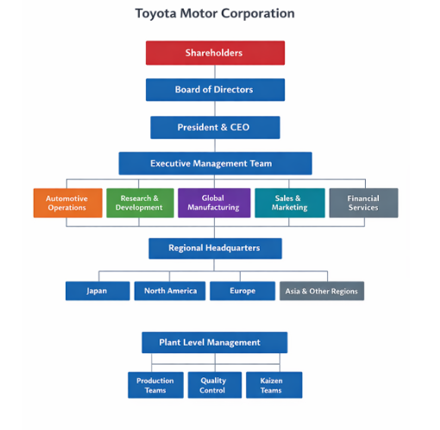
Figure 1 Organisational structure and Governance.

2.3 Pressures in the External Environment.
Toyota has a more competitive and volatile automotive environment to operate. The worldwide transition to electric vehicles (EVs) has accelerated, and EV sales are expected to reach approximately 18 percent of the annual total international car sales by 2023 (compared to 14 percent in 2022). In most of the key markets, governments are tightening up on the emissions regulations, which are pressuring the manufacturers to shift to non-traditional internal combustion engines.
Although Toyota has a robust hybrid vehicle lineup, critics have claimed the company has lagged behind some of its market competitors in adopting battery electric vehicles wholesale. Meanwhile, other companies like Tesla and some emerging Chinese manufacturers have become more competitive and are giving Toyota its customary popularity in terms of quality and low cost. Such pressures require quick innovation and strategic maneuverability, which challenge the capabilities and weaknesses of the existing cultural practices at Toyota.

2.4 Toyota Cultural Significance in Organisational Culture.
Being such a large international corporation with organised governance and chaotic external conditions, the organisational culture is used as a fundamental tool that ensures the consistency of the performance and orientation of the employees at Toyota. The focus on continuous improvement, discipline, teamwork and long-term thinking facilitates operational excellence and quality control in the case of geographically spread operations (Liker, 2004; Toyota Motor Corporation, 2024).
Nonetheless, even though this robust culture has led to efficiency and reliability in the past, it can also lead to organisational inertia. Entrenched emphasis on stability, risk aversion and incrementalism may hamper the responsiveness of Toyota to disruptive technological changes (Liker, 2004; Toyota Motor Corporation, 2024). Thus, the organisational environment at Toyota presents the advantages of an integrated performance culture and its possible limitations during the periods of the fast transformation of the industry.

3. Organisational Culture, Structure, and Decision Making.

3.1 The Cultural Levels of Schein and the Organisational Structure of Toyota.
The model by Schein (2010) describes the organisational culture as three levels being interdependent: artifacts, espoused values, and underlying assumptions. The company culture at Toyota is based on control, learning and continuous improvement and as such, visible artifacts like standardised work procedures, visual performance boards, team-based problem-solving meetings and quality checkpoints along the production lines reflect the culture. These artifacts are underpinned by espoused values that are incorporated in the Toyota Way, specifically, the concepts of continuous improvement and respect for people (Liker, 2004).
At the base level, the Toyota underlying assumptions are based on a belief that the success in the long term relies on the disciplined processes, shared responsibility and learning through errors. These assumptions of culture have a direct influence on the organisational structure of Toyota. It has a hybrid organisational design that concentrates strategic power and decentralises operations to regional units and plants (Toyota Motor Corporation, 2024). By permitting frontline employees to participate in gradual improvements, this design offers uniform world standards and, at the same time, permits incremental changes.
Most importantly, although the Schein model describes culture as a mechanism that creates structural stability, it also shows possibilities of rigidity. The ingrained beliefs regarding standardisation and risk management can be restrictive to structural adaptability to disruptive changes in the industry. Therefore, the structure of Toyota can be seen as a strength as well as a limitation of the culture.
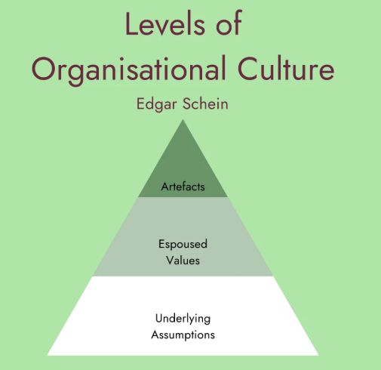
Figure 2 the Schein model

3.2 Cultural Dimensions and Decision-Making Behaviour of Hofstede.
Hofstede et al. (2010) highlight the role of national and organisational cultures when it comes to authority, collaboration and risk tolerance. The cultural background of Toyota in Japan indicates a relatively great extent of collectivism and uncertainty avoidance as opposed to most of the firms in the west. Toyota has the presence of collectivism in the form of team-based work systems, joint accountability towards quality results and problem-solving methods that are made by consensus.
This type of collectivism facilitates participative operational decision-making. There is an empowerment of employees who are allowed to halt production lines and raise quality issues, which depicts a show of trust and accountability (Liker and Hoseus, 2008). Nevertheless, the high uncertainty avoidance is expressed in the way Toyota takes as long as possible to conduct analyses, testing, and risk minimisation before major strategic decisions.
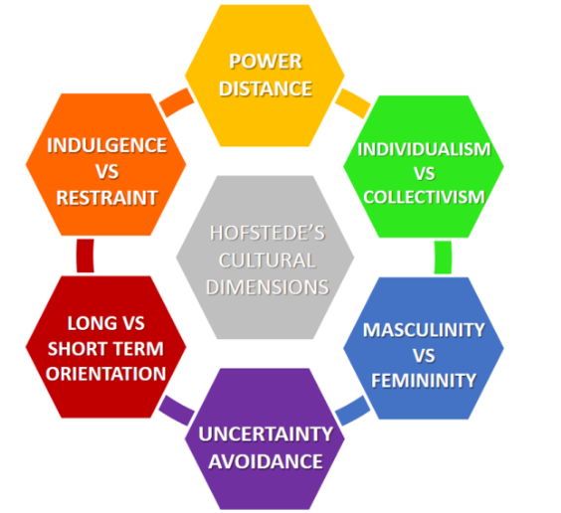
Figure 3 Hofstede et al. (2010)
Most importantly, this tendency within the culture favors reliability and quality yet slows down responsiveness. The relatively slow pace at which Toyota is entering fully electric vehicles, in contrast to competitors, indicates that the culture-based risk-aversion can limit fast innovation. This model by Hofstede thus describes the operational perfection of Toyota as well as the slower strategic flexibility.

Table 1 Hofstede national culture scores for Japan and implications for Toyota

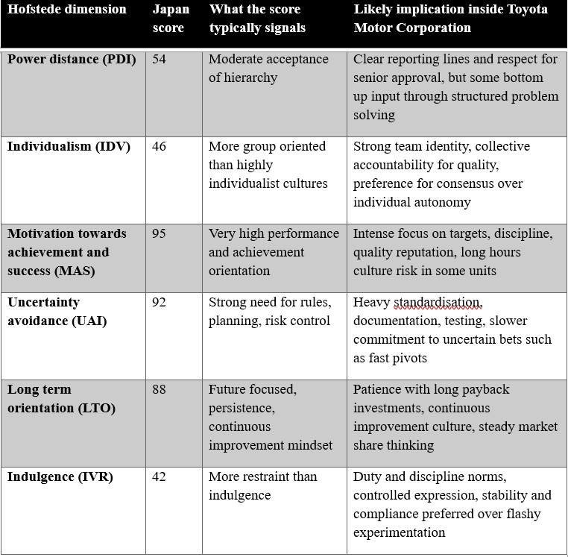

3.3 Cultural Types of Handy and Structural Dynamics of Toyota.
According to the cultural typology provided by Handy (1978), role culture, task culture, power culture and person culture are the common organisational forms. The Toyota structure is largely a mix of the role culture and task culture.
The role culture is manifested in the highly formalised processes, the defined job roles, the hierarchical reporting structure and the powerful governance practices that are influential in Toyota. This helps in consistency, predictability and control of the international activities. This cultural alignment to structure is essential in handling large scale manufacturing processes which generated more than11.2 million vehicles in 2023.
At the same time, the task culture also develops in cross functional teams tasked with solving problems, innovation and process improvement. These cross-functional teams are flexible in nature to meet certain operational challenges, which promotes the process of continuous improvement.
The role culture that dominates at the strategic levels can, however, suppress the force of the task culture in bringing radical change. Whereas task-oriented teams are effective in the achievement of efficiency at an incremental level, significant strategic realignments continue to go through the bureaucratic levels influenced by role culture. The culture predominant at Toyota is primarily role culture under the tutelage of task culture and small amounts of power culture at the centre of strategies and small amounts of person culture in non-specialist pockets (Handy, 1978).
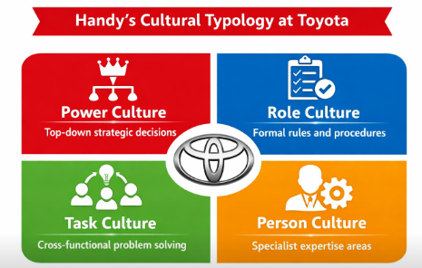
Figure 4 Cultural typology provided by Handy (1978)

3.4 Critical Synthesis of Cultural Influence on Structure and Decision Making.
The combination of Schein, Hofstede and Handy frameworks allows showing that the organisational culture at Toyota is imbued with its structural design and decision-making processes. The model by Schein describes how hybrid structures get institutionalised by underlying assumptions on discipline and learning. The dimensions developed by Hofstede explain why Toyota prefers group participation and risk management decisions. The cultural types of Handy show that there is predominance of formalised role type of culture and bits of flexible task type of culture.
This cultural fit has traditionally led to high operational performance, which is manifested in the fact that Toyota's revenues are above USD 312 billion in 2024 (Toyota Motor Corporation, 2025). However, high cultural coherence also brings about inertia. Strong cultures as Denison (1990) puts it, will increase efficiency but will not resist transformational change.
The cultural processes that guarantee quality and consistency in the case of Toyota might restrict speed, experimentation and responsiveness in a fast-moving car industry. As such, organisational culture plays a structural stabiliser role and strategic constraint role in that it influences decision making in a manner that promotes reliability but may limit innovation. The current culture in Toyota is role culture aided by task culture mostly, with little power culture in the strategic centre and small person culture.

4. Leveraging organisational culture to adapt to external environmental influences

4.1 Expert forces Toyota needs to adjust to.
Electrification, regulation, digitalisation, and new competition are changing the automotive industry. Electric car sales are almost 18 percent of the total car sales, which in 2023 is nearly 14 million cars compared to 14 percent in 2022, indicating that it is no longer a niche adoption (IEA, 2024). The adaptation challenge is evident in Toyota's own sales mix. A 2025 Toyota vehicle sale of 11.3 million vehicles in the global market with hybrids taking 42 percent and battery electric vehicles taking 1.9 percent of parent company sales suggest that Toyota is evolving more through hybrid-electrified vehicles than a battery electric pivot (Reuters, 2026). Firms that are constructed around battery electric platforms also contribute to the competitive pressure. In a segment with which Toyota had been relatively prudent, Tesla reported 1,808,581 deliveries in 2023, showing scale (Tesla, 2024).

4.2 How Toyota’s culture enables adaptation through operational learning
The most adaptive strength that Toyota possesses is not speed to imitate competitors, it is scale-disciplined learning. Based on the model proposed by Schein (2010), the artifacts of Toyota (e.g., standardised work, visual management and structured problem solving routines) can be used to indicate a culture in which performance gaps are perceived as system problems that should be solved, rather than individual failures. These artifacts support espoused principles relating to lifelong improvement and people respect (Liker, 2004; Liker and Hoseus, 2008), and this translates to a structure whereby plants and teams are at liberty to continually optimise the processes without necessarily having to undergo a redesign at the highest level. According to Spear and Bowen (1999), this is a management system in which work is structured in such a way that abnormalities are brought into the limelight very fast and transformed into organisational knowledge. This cultural trend assists Toyota to adjust to shocks in operations, quality risk and cost pressure with high reliability, which is important when the company is operating on a global level.

4.3 Model based evaluation of the Toyota flexibility.
Denison (1990) perception of culture connects effectiveness with such characteristics as involvement, consistency, adaptability and mission. Toyota seems structurally well where there is consistency and involvement since routines, standards, and joint problem solving have strong institutionalisation and are predictable to be followed in various regions. The probable limitation is the flexibility at the time when the environment should compensate the discontinuous change. The argument is not that Toyota is incapable of changing, but the fact that it tends to do so in gradual stages. This interpretation is justified by the 2025 sales mix: the Toyota is expanding hybrids as the safer way of adopting adaptations to the market when battery electric penetration is low compared to market momentum (Reuters, 2026).
The competing values framework by Cameron and Quinn (2011) also displays an explanation of this tension. The Toyota culture is largely associated with hierarchy orientation based on the control, standardisation, and process discipline, and clan orientation based on teamwork and collective responsibility. The two quadrants are good in terms of quality, cost and reliability, but they can underweight adhocracy, the one associated with speed and experimentation. This is important since the external information indicates the market is fast developing: with 18 percent share of the global electric sales in 2023 it represents a sharp technology diffusion curve, not a gradual change (IEA, 2024).

4.4 Critical analysis of culture as an adaptation means.
The culture of Toyota is quite evident in the context of adaptation in case the objective is the operational excellence, control of risk and scalable learning. It also provides Toyota with financial ability to invest during recessions. Toyota has reported sales revenues in its automotive segment of 41,264.266b yen and net income attributable to Toyota of 4,944.9b yen (as of FY 2024) thus demonstrating a strong performance that has the potential to finance strategic transitions (Toyota Motor Corporation, 2024). However, culture may also be a hindrance when adapting needs rapid adherence to un-certain technologies and business concepts. Hofstede et al. (2010) aids in explaining this as a controlled decision-making style due to uncertainty avoidance that safeguards reliability but retards radical action. In a recap, culture is utilised by Toyota to a great degree to enable it to adapt and survive on incremental levels, yet the same cultural framework can also inhibit speed and experimentation when the external environment requires the company to change speedily.

5. Organisational Culture as an Enabler or Block to Effective Operation.
5.1 Culture Factors to Empower Effectiveness.
The Toyota culture has high values of reliable operational practice and coordination of performances in its international operations. Applying the framework of Schein (2010), the visible routines like standardised work system, quality control board, and team problem solving in a structured way are deep assumptions about the discipline, collective responsibility, and learning as a continuous process.
The enabling effects are:
• Low faults and quality of products.
• Good employee participation in the improvement activities.
• Uniformity of standards at international plants.
• Cost control and process stability.
The model by Denison (1990) describes the effectiveness of Toyota in terms of high consistency and involvement that leads to predictable execution. It is displayed in financial performance since FY2024 revenues are over USD 312 billion and net income around 4.9 trillion yen (Toyota Motor Corporation, 2025).

5.2 Cultural Factors as an Obstacle.
Though Toyota has strengths in its operation, corporate culture can limit responsiveness in very dynamic environments.
The main limiting effects include:
- Consensus processes in sluggish strategic decision making.
- High-risk avoidance postpones disruptive innovation.
- Slowness of bureaucratic layers of governance.
- High emphasis on steady improvement as opposed to radical change.
According to Hofstede et al. (2010), this is expounded by the high uncertainty avoidance, which promotes indecisive decision-making. Domination of role culture by Handy (1978) strengthens formal procedures and approvals that may be rank and restrict flexibility.
The effect is manifested in the electrification of Toyota. Hybrids are expected to make up approximately 42 percent of Toyota vehicle sales in 2025, with battery electric vehicles being less than 2 percent, although EVs had reached 18 percent of the world's vehicle sales in 2023. This gives an indication of cultural favoring of safer, gradual adaptation as opposed to sudden change.

Recommendations
- Two-speed model of innovation and core operations.
Establish a fast-track governance path to EV and digital projects with reduced approval times and retain TPS controls of core production. KPI: time to invest in innovation projects; decrease by 30 percent. (Handy, 1978; Cameron and Quinn, 2011)
- Automate management information systems to make real-time decisions.
Adopt a single enterprise dashboard that connects safety, quality, cost, delivery and electrification milestones and has standardised definitions on the basis of regions. KPI: time on decision process between identification of an issue and executive action; goal of 25 percent decrease. (Schein, 2010; Spear and Bowen, 1999)
- Enhance psychological safety to reveal risks sooner.
Routine problems are formalised with rewards to raise problems, defend dissent and monitor critical issues closure. KPI: average response time to high severity issues; decrease by 20 percent. (Denison, 1990; Liker and Hoseus, 2008)
- Connection culture with measurable results.
Include culture associated indicators on leadership scorecards, but not just output targets. KPI list: time to make decisions, time to take countermeasures, cross functional team score. The future of the industry appears promising due to the presence of several legal frameworks. The existence of various legal frameworks supports the future of the industry as promising.

Conclusion
The organisational culture influences the organisational structure of Toyota, the way it is constructed, and its decision making. The hierarchical structure indicates strong bias toward strict control, well-defined roles, and repetitive patterns, a feature that contributes to uniform performance in a big global organisation. Operation level of decision making is highly evidence based and learning oriented which safeguards quality and dependability. Nonetheless, the cultural reasoning may slug strategic actions when the market requires quick experimentation and bold investment in case of uncertainty. There can be consensus building, a stratification of governance and a tendency towards incremental improvement, which slows down the pace of change even in the situation when the outside world is changing rapidly. In general, culture is an enabler of successful operations in the main operations of Toyota, and its obstacle in instances where rapid transformation is needed. The implication in practice is simple. Toyota needs to maintain its discipline of operations and intentionally establish accelerated channels of innovation decision and better information systems that reduce the gap between risks arising, executive concern and response. This will be the most realistic protection of reliability and enhance agility.

References
A. Tadesse Bogale and Y. A. Debela (2024) ‘Organizational culture: a systematic review’, Cogent Business and Management, 11(1), Article 2340129.
Assadej Vanichchinchai (2023) ‘The relationships between soft and hard factors of the Toyota Way: a sociotechnical perspective’, Operations Management Research, 16, pp. 768 to 779.
Charles Handy (1978) The Gods of Management: The Changing Work of Organisations. London: Souvenir Press.
Daniel R. Denison (1990) Corporate Culture and Organizational Effectiveness. New York: Wiley.
Edgar H. Schein (2010) Organizational Culture and Leadership. 4th edn. Hoboken, NJ: John Wiley and Sons.
Geert Hofstede, Gert Jan Hofstede and Michael Minkov (2010) Cultures and Organizations: Software of the Mind. 3rd edn. New York: McGraw Hill.
Jeffrey K. Liker (2004) The Toyota Way: 14 Management Principles from the World’s Greatest Manufacturer. New York: McGraw Hill.
Jeffrey K. Liker and Michael Hoseus (2008) Toyota Culture: The Heart and Soul of the Toyota Way. New York: McGraw Hill Professional.
Kim S. Cameron and Robert E. Quinn (2011) Diagnosing and Changing Organizational Culture: Based on the Competing Values Framework. 3rd edn. San Francisco, CA: Jossey Bass.
Laurie J. Mullins and Gill Christy (2016) Management and Organisational Behaviour. 11th edn. Harlow: Pearson Education Limited.
Mullins, L. and Christy, G. (2016). Management and Organisational Behaviour (11th ed.). Pearson Education Limited.
Steven J. Spear and H. Kent Bowen (1999) ‘Decoding the DNA of the Toyota Production System’, Harvard Business Review, September and October, pp. 96 to 106.
Taiichi Ohno (1988) Toyota Production System: Beyond Large Scale Production. Portland, OR: Productivity Press.
Toyota Motor Corporation (2024) Integrated Report 2024. Toyota City, Japan: Toyota Motor Corporation. Available at: Toyota Global Investor Relations website (Accessed: 4 February 2026).
Toyota Motor Corporation (2024) Sustainability Data Book 2024. Toyota City, Japan: Toyota Motor Corporation. Available at: Toyota Global Sustainability Report Library website (Accessed: 4 February 2026).
Toyota Motor Corporation (2025) Annual Report on Form 20 F for the fiscal year ended 31 March 2025. Toyota City, Japan: Toyota Motor Corporation. Available at: Toyota Global Investor Relations website (Accessed: 4 February 2026).
Toyota Motor Corporation (2025) Corporate Governance Report. Toyota City, Japan: Toyota Motor Corporation. Available at: Toyota Global Investor Relations website (Accessed: 4 February 2026).

