Construction Technology 2
Swansea Hotel New Build Report
ACBA5019
Charlie Gardner
Student Number - 2405435

Table of Contents
Introduction 2
Site Constraints and Environmental Conditions 2
Foundations 3
Mine Survey 6
Structural Frame 6
Building Envelope – Materials and Methods 7
External Walls 7
Roof Design 8
Glazing & Openings 9
Pre-Fabrication 9
Sustainability 10
Conclusion 10
References 11

Introduction
The following report has been prepared to support a proposed medium to high rise hotel development on a site located near Singleton Hospital in Swansea. The client on the proposed project has limited experience in construction and has therefore requested a detailed explanation regarding the construction decisions made when designing the proposed building. I will also outline the decisions made that would underpin the successful delivery of the building. The report focuses specifically on the selection of an appropriate structural frame and foundation system, the design and material choice for the building envelope, and the balance between prefabricated and traditional on-site construction methods.
The hotel is intended to be aesthetically pleasing whilst holding strong against the weather and ground conditions in Swansea, providing accommodation for visitors of the area, hospital users, and student for the nearby universities. The building must achieve high standards of safety, durability, comfort, and environmental performance while remaining economically viable. Throughout this report, I have considered design intent, structural strength, stability, fire safety, appearance of the hotel and the sustainability side of the project, ensuring that the proposed solutions are suitable for the long-term use of the hotel to withstand the expected footfall.

Site Constraints and Environmental Conditions
The proposed development site is located in Swansea close to the Singleton Hospital, Swansea is a coastal city in South Wales. When designing a building in this area the coastal conditional can have a significant influence on construction technology decisions Particularly in regards to the durability and weather resistance of the building. Swansea exhibits substantial average rainfall from 59mm (2.32") to 123mm (4.84") monthly. The frequency of rainfall days ranges between 13 and 20 days per month (Atlas, n.d.), due to the significant rainfall and windy conditions due to being on the coast this could be a concern for medium to high rise hotels as exposure increases with the height of the building.
In addition to the weather conditions the site being near the coast means that the air could contain high levels of salt corrode metals, erode building materials and damage finishes over time (Williams, 2025). This could mean careful consideration of using salt water resistant building materials for finish of the buildings exterior envelope to ensure durability over the building’s lifespan.
Swansea’s ground conditions usually consist of made-up ground over soft soils with weathered bedrock found at greater depths of borehole logs, these conditions can result in low bearing capacities with a risk of ground movement if shallow foundations are used. The presence of nearby hospital buildings also places constraints on construction activities, particularly in relation to noise, vibration, and site disruption.

Foundations
An investigation was conducted into the ground conditions for the project, a Borehole log shown below as image 1 was found that was produced from a site nearby. The borehole was drilled between 18th November 1999 to 19th November 1999 which gives us the makeup of the ground from surface to around 10 metres down. The borehole log shows the ground starts off with made ground comprising of concrete, and subbase for the first 0.3 metres. After this the ground is made up of blackish brown clay-like substance, slightly silty sand and fine to course gravel with occasional redbrick and many cobbles up until 1.5 metre.
From 1.5 meters down to 5 metres the ground is made up of medium dense becoming dense, dark greyish brown clay with subrounded gravel with many cobbles of sandstone. From 5 Metres and below the ground conditions are dense with no other explanation given until 8.45 metres down where it contains very dense dark greyish brown clay, silty sand and gravel with occasional cobbles and boulders, as the Borehole log does show any further ground conditions, I can only assume that this ground substance continues down further than the log suggests. The site is situated close to the coast which is probably the defining factor as to why there is sand present in the borehole log.

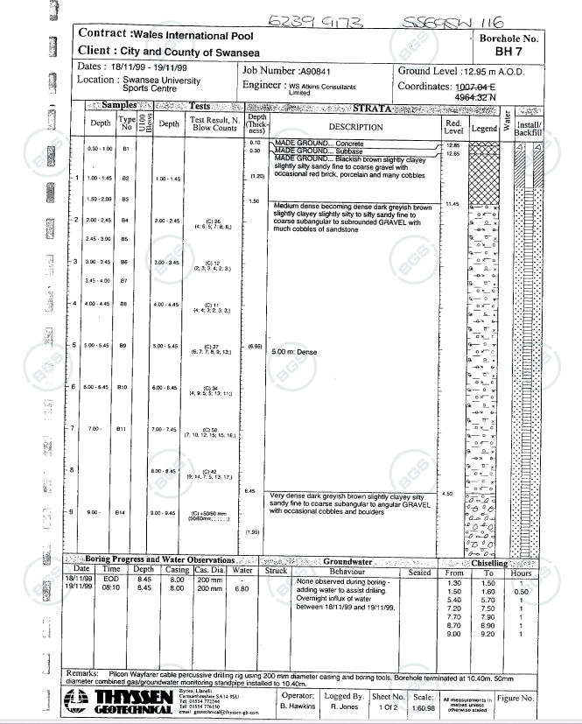
Image 1 - BGS ID: 370608 : BGS Reference: SS69SW116
Given the anticipated ground conditions and the scale of the proposed hotel, a deep foundation solution shows to be the most appropriate solution. Using shallow foundations such as strip or pad foundations are generally unsuitable for medium to high rise buildings these ground conditions. Instead, piled foundations provide a more suitable option due them being driven down to more solid ground conditions.
Pile foundations have a high load bearing capacity making them suitable for structure with heavy loads and challenging soil conditions, they can effectively control any settlement ensuring the structure remains solid and remains solid over time (Civil Today, n.d.). The type of pile foundation I recommend using is the cast in situ bored piles which is shown in image 2 below, as this will have less vibration for the surrounding building and with a hospital nearby it minimises the risk of disturbing this.
This foundation strategy offers excellent structural performance and long-term durability. It reduces the risk of ground movement and provides a robust base capable of supporting the significant vertical and lateral loads that come with a multi-storey hotel building.
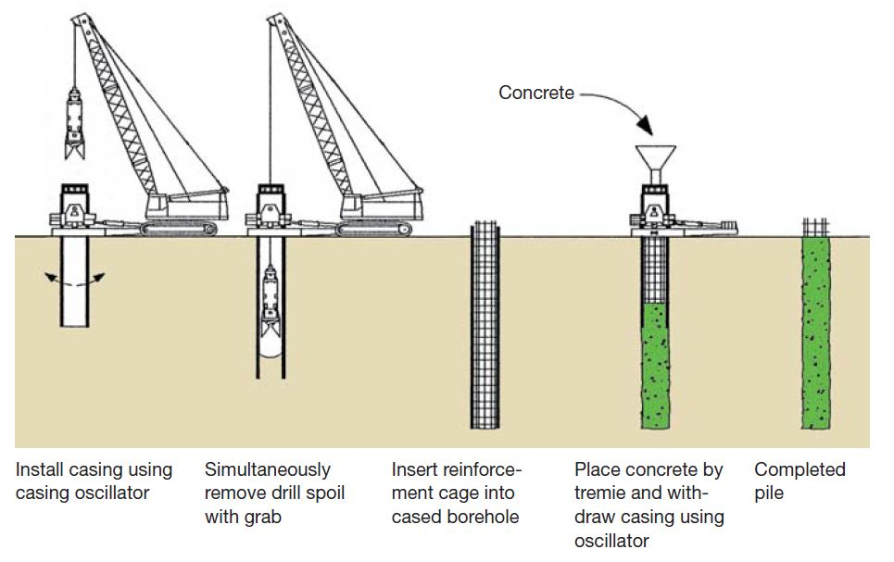
Image 2 - (The Constructor, 2022)

Mine Survey
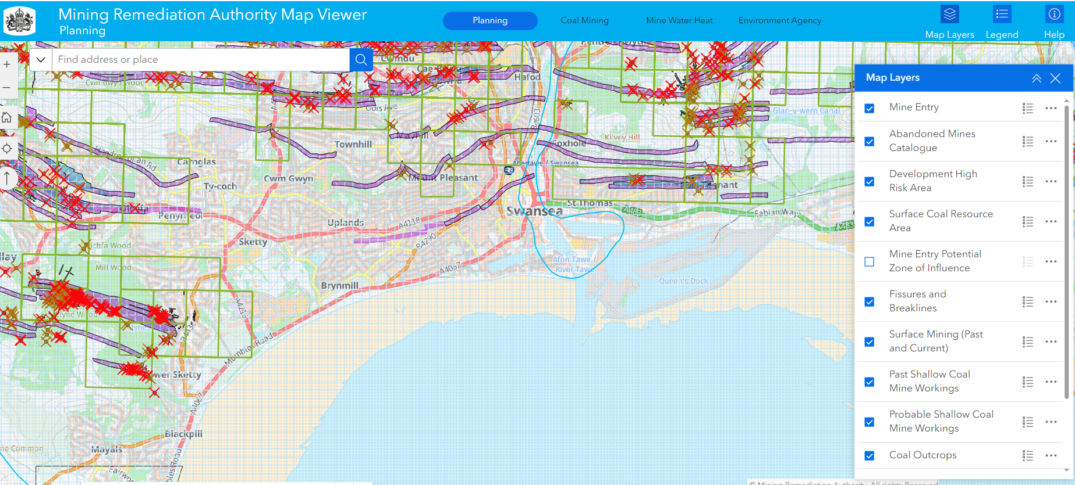
Image 3 by - Coal Authority (2021).
On researching abandoned mines, a search was completed on the mining remediation authority website, during the search I was unable to find any mines, current or old at the site, however during the search it shows multiple mine entries and abandoned mines surrounding the area, with this in mind there could be a possibility of mine routes underneath the site. Before any work on the project commences, I would recommend a more in-depth survey to be carried out ensure there are no mines below the site that would become a danger once work is underway.

Structural Frame
Several structural framing options were considered for the proposed hotel, including a structural steel frame, a reinforced concrete frame, and a hybrid system combining steel framing with a concrete core. After assessing these options against the project requirements and site constraints, a hybrid system combining steel framing with a concrete core and concrete roof/floor slabs has been selected as the most suitable solution.
The Hybrid system involves using a hot rolled steel frame which can be designed and fabricated off site. The steel frame will then be delivered to site and installed in a more timely manner, this reduces the onsite time and lowers risk of any health and safety incidents. A concrete core and slabs are installed once the steel frame has been constructed providing strength which results in a more durable and resilient structure (Wzhbuild.com, 2025) . The advantage of the concrete core and flooring slabs is that concrete has a high fire resistance (Concretecentre.com, 2019), if you also coat the steel frame in intumescent paint which can go up to a 90 minute fire resistance, this causes the paint to expand when exposed to heat and forms a protective layer around the steel (www.fusseyengineering.com, n.d.) then the medium to high rise building should be fire efficient in case of a fire.
The proposed hotel will also have a car park situated in the basement of the building, this will be enclosed with concrete slabs. The hotel will benefit from this as we will be able to build a bigger hotel or will not be restricted for the space for an external car pack.

Building Envelope – Materials and Methods
The building envelope is critical in protecting the structure from the external environments including weather conditions while also contributing to the building’s aesthetics, energy performance and the user’s comfort. For the proposed hotel in Swansea the envelope must resist wind driven rain, minimise heat loss and withstand long term exposure to the coastal environments including airborne salt.
Below I will be giving my recommendations for the materials and methods for the external walls, roof design, any opens & any glazing on the property.

External Walls
For the external walls the design I am recommending is an aluminium composite panels (ACP) cladding system as shown in image 4 below. This system consists of an outer layer of cladding which will be fixed to the structural frame via a fixings, with a ventilated cavity and insulation located behind the panels. The aluminium composite panels will act as a screen to protect the structure from any rainwater and winds with any moisture that penetrates being safely drained within the cavity. The cladding system offers excellent performance in wet and windy climates and reduces the risk of damp penetration, which is particularly important in a coastal city such as Swansea.
The aluminium cladding system offers resistance to corrosion and moisture, it prevents rust and degradation even in harsh coastal environments. The cladding can be procured in a range of colours for the aesthetic purposes, The durability and colour stability of PVDF-coated panels mean that repainting or major maintenance is rarely required. The cladding will retain its appearance for years to come (PRANCE, 2025).
The aluminium composite panels have a high melting point making it more resistant to heat and flames which helps with the buildings fire resistance and safety, along with this the cladding is light weight and easy to install making it a cost effective and sustainable material to use.
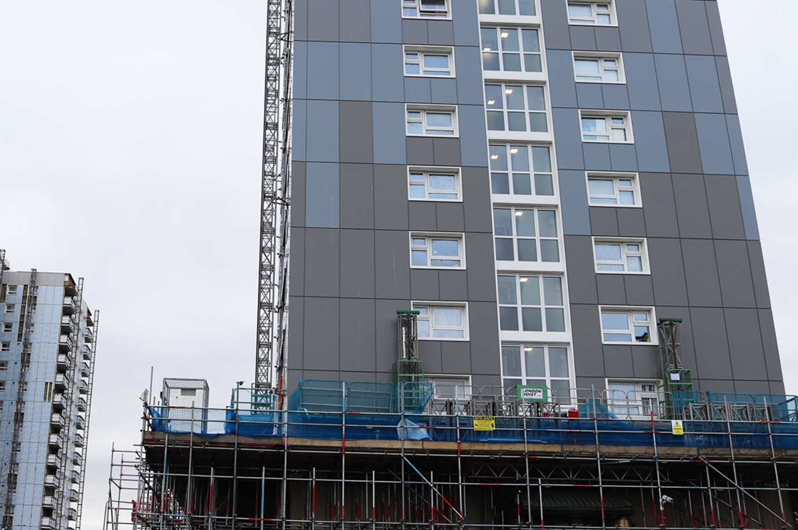
Image 4 - (Finish Facades, 2023)

Roof Design
For the roof design of the hotel, I have proposed a flat insulated roof. In this arrangement the insulation is located above the structural concrete roof slab, this will protect the structure from temperature fluctuations and reduces the risk of condensation. A high-performance waterproof membrane such as am EPDM rubber roof membrane which is a type of roofing system used in commercial construction since late 1960’s, it has a long service life and low material cost. This will sit on top of the roof structure to provide weather protection (EPDM Rubber Roofing, 2024).
The flat roof design will allow integration of sustainable technology including solar panels, air source heat pumps and rainwater harvesting systems. The roof can also be used for green roof areas, this can improve biodiversity and improve thermal performance (sales@livingroofsuk.co.uk, 2023).

Glazing & Openings
Windows and glazed elements must balance thermal performance, sun light exposure and resistance weather conditions. I propose using high-performance triple-glazed units with thermally broken aluminium frames. These systems offer excellent thermal insulation which dramatically reduces heat loss (staywarm, 2025) while remaining durable in a coastal environment. Triple glazed windows also provide better acoustic insulation which will be improve the hotel users stay. Recessing the windows within the facade helps to provide additional protection from driving rain and enhances the visual depth of the building elevation.

Pre-Fabrication
A combination of prefabricated elements and traditional on-site construction is recommended for this project. This hybrid approach allows the modern methods of construction to be used alongside new methods such as modular builds.
Prefabrication is suitable for repetitive elements such as precast floor and roof concrete slabs and facade panels. The cladding panels can also be measured and cut off site and installed directly on to the structure, however certain elements such as the reinforced concrete core, foundations, and structural frame, are better suited to in-situ construction. These components require integration with the specific site conditions and benefit from the flexibility offered by on-site casting.
This balanced approach reduces construction time, improves quality control and minimises disruption to the surrounding area, which is particularly important given the proximity of the site to a hospital.

Sustainability
With the use of structural steel and concrete for the buildings structure this can be sourced locally to reduce the projects emissions. The buildings envelope materials a high thermal performance which reduces heating and cooling demand, with the introduction of a HVAC system this will be used to regulate heat and air quality indoors to enable the building to run efficiently (Moor, 2023).
As mentioned earlier in the report, the flat roof allows room for renewable energy technology such as air source heat pump which is a sustainable way of heating the building and producing hot water, this combined with solar panels on the roof which will give sustainable electricity for the hotel.
Prefabrication of the concrete slabs and façade will reduce waste on site and will also reduce the carbon footprint of the project by not having to deliver as many materials to site and reduce worker travel due to the shorter duration of installation.
With the amount of rain that falls in Swansea during the year the hotel will have the space to facilitate rainwater harvesting with this a water meter would have to be fitted to see the benefit. The advantage of having this is that you will save maintenance costs by collecting the rainwater to be used for amenities such as toilets and sinks throughout the hotel (Richardson, 2019).

Conclusion
The report outlines the proposal for the construction of the Swansea hotel, it gives recommendations for the materials that will be used to combat the sites environmental challenges and ground conditions while meeting the client’s needs for hotel to be safe, durable and sustainable. A hybrid structure of a steel frame along with concrete core, floor and roof slabs will provide a solid structure.
The piled foundations will provide structural robustness and fire safety, while a high-performance cladded envelope protects against the harsh coastal climate. The use of prefabrication where appropriate improves build quality and programme certainty. Overall, the proposed approach represents a well-justified and practical solution for a medium to high-rise hotel development in Swansea that will have as little maintenance as possible over the building’s lifespan.

References
- Williams, S. (2025). Seaside Structures: Key Considerations for Building Near Coastal Areas - ELMENS. [online] ELMENS. Available at: https://www.elmens.com/business/environment/seaside-structures-key-considerations-for-building-near-coastal-areas/ [Accessed 12 Jan. 2026].
- Atlas, W. (n.d.). Yearly & Monthly weather - Swansea, United Kingdom. [online] Weather Atlas. Available at: https://www.weather-atlas.com/en/united-kingdom/swansea-climate.
- Image 1 - https://api.bgs.ac.uk/sobi-scans/v1/borehole/scans/items/370608
- Civil Today (n.d.). Advantages and Disadvantages of Pile Foundation - Civil Engineering. [online] civiltoday.com. Available at: https://civiltoday.com/geotechnical-engineering/foundation-engineering/deep-foundation/449-advantages-and-disadvantages-of-pile-foundation.
- Image 2 - The Constructor. (2022). Construction Techniques for Cast-in-Situ Reinforced Concrete Pile. [online] Available at: https://theconstructor.org/geotechnical/construction-techniques-cast-in-situ-reinforced-concrete-pile/568176/.
- Image 3 by - Coal Authority (2021). The Coal Authority Map Viewer. [online] Arcgis.com. Available at: https://datamine-cauk.hub.arcgis.com/
- Wzhbuild.com. (2025). Hybrid Steel-Concrete Structures. [online] Available at: https://www.wzhbuild.com/news/Hybrid-Steel-Concrete-Structures.html.
- Concretecentre.com. (2019). Fire resistance. [online] Available at: https://www.concretecentre.com/Performance-Sustainability-(1)/Fire-Resistance.aspx.
- www.fusseyengineering.com. (n.d.). What Is Intumescent Paint And When Should You Apply It To Your Steel? | Fussey Engineering. [online] Available at: https://www.fusseyengineering.com/article/what-is-intumescent-paint-and-when-should-you-apply-it-to-your-steel/.
- PRANCE (2025). ACP Cladding: The Ideal Solution for Modern Construction. [online] Prancebuilding.com. Available at: https://prancebuilding.com/w-acp-cladding-the-ultimate-guide-to-aluminum-composite-panel-facades.html [Accessed 12 Jan. 2026].
- EPDM Rubber Roofing. (2024). Benefits of Using EPDM Membranes for Roofing | EPDM Rubber Roofing. [online] Available at: https://epdmrubber.co.uk/blog/benefits-of-using-epdm-membranes-for-roofing/ [Accessed 12 Jan. 2026].
- sales@livingroofsuk.co.uk (2023). 9 Key Benefits Of Green Roofs - Living Roofs UK. [online] Living Roofs UK | Green Roof Specialists | Sedum & Wildflower Roofs. Available at: https://www.livingroofsuk.co.uk/benefits-of-green-roofs/.
- staywarm (2025). Are Triple Glazed Windows Worth It in the UK? An Honest 2025 Analysis. [online] Stay Warm Windows Ltd | Window Installers | Chesterfield, UK - If you’re after experienced and dedicated window installers in the Dronfield area, look no further than Stay Warm Windows. Call our team today. Available at: https://www.staywarmwindows.co.uk/are-triple-glazed-windows-worth-it-in-the-uk-an-honest-2025-analysis/.
- Moor, T. (2023). What Is HVAC? A Comprehensive Guide. [online] www.hvac.com. Available at: https://www.hvac.com/expert-advice/what-is-hvac/.
- Finish Facades. (2023). Aluminium Rainscreen Cladding System Explained. [online] Available at: https://www.finishfacades.co.uk/aluminium-rainscreen-cladding-system/.
- Richardson, J. (2019). Benefits of Rainwater Collection in the UK. [online] The Renewable Energy Hub. Available at: https://www.renewableenergyhub.co.uk/main/rainwater-harvesting-information/benefits-of-rainwater-collection.

‌

‌

