PESTEL ANALYSIS
To better understand the opportunities and challenges our business might face and to enable us to make wise decisions that will help it succeed in the market, we must assess the viability of our bakery by considering a variety of external factors that could have an impact on its operations. One useful framework for analyzing these factors is PESTEL analysis, which stands for Political, Economic, Sociocultural, Technological, Environmental, and Legal factors which we will describe next.
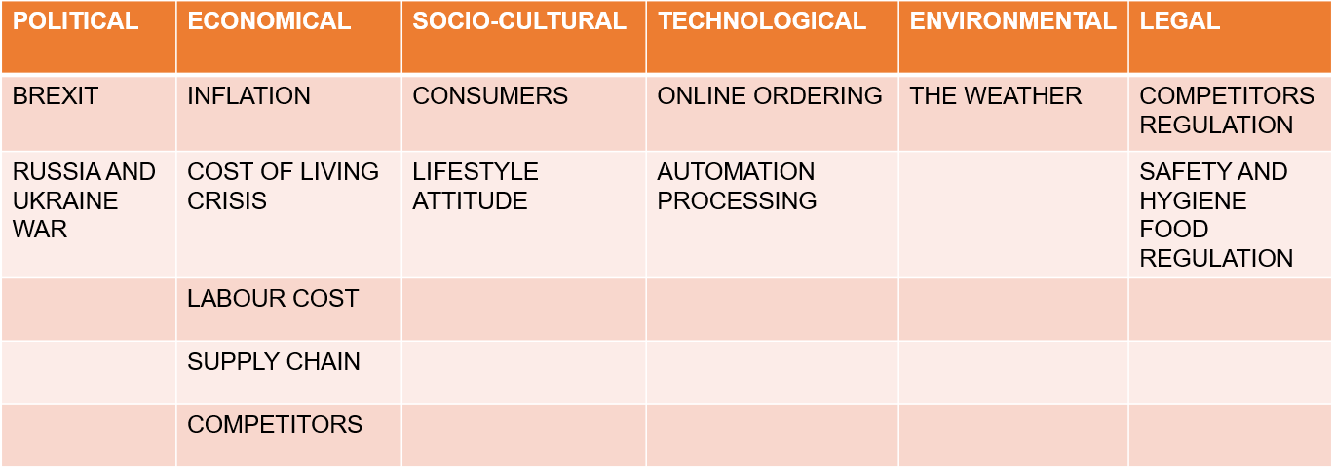
The ongoing conflict between Russia and Ukraine has had a severe impact on the economy, leading to rising costs of labor, ingredients, and services, including energy. The disruption caused by BREXIT has also affected imports and exports, leading to supply chain issues and inflation rates. These factors have contributed to a cost-of-living crisis and higher prices for final products, potentially reducing demand for baked goods and leading to a shift in consumer preferences toward lower-priced options.
As a small bakery, we may face challenging competition with larger bakeries with automated production processes. To expand our customer base and meet market demands, investing in technology is necessary, although this can be costly, making it difficult to produce larger volumes of bread at a competitive price while maintaining quality and profitability.
Environmental factors, such as weather, can also significantly impact the baking business, affecting the availability and sustainability of key ingredients such as wheat, sugar, and oil. Legal factors, including competitor and food safety regulations, are also essential to consider for growth and success in the bakery industry.
MARKETING MIX
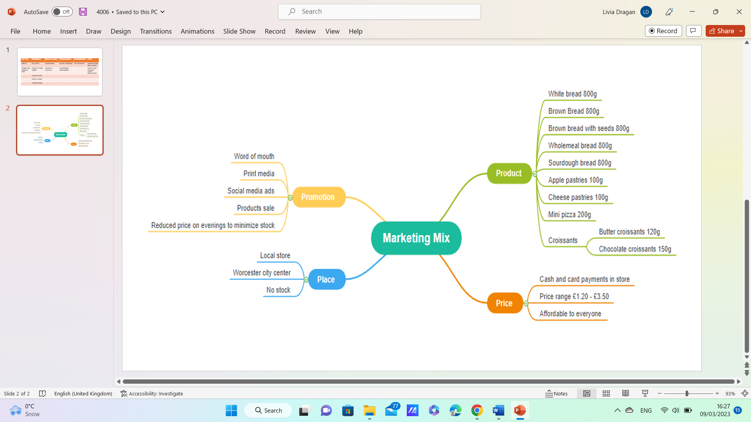
Now that we are aware of the factors outside the bakery's control, we can focus on creating a marketing mix using McCarthy’s (1960) marketing mix model that incorporates strategies for product development, pricing, promotion, and place to meet the customers’ needs. The marketing mix refers to the collection of marketing strategies employed by a company to achieve its marketing goals within its target market (Kotler, Ang, Leong, and Tan, 1999). To stay up to date with market trends and marketing methods, theories regarding marketing management and strategy must adapt and evolve over time (Goldsmith, 1999).
Product: We offer a variety of high-quality baked goods on an authentic recipe, including bread, pastries, and pizza as well as specialty items such as gluten-free or traditional Christmas cake to a wider range of customers. We use eco-friendly packaging to reduce our environmental impact and our bakery products comply with regulations for allergies and intolerances.
Price: The price of our bakery's products is competitive with other bakeries in the area, while still reflecting the quality of the ingredients used. We offer special deals and promotions to attract new customers and to make our product affordable to price-sensitive customers as well as to lower stock levels.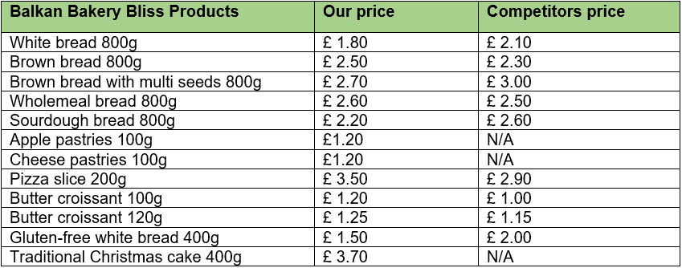
Promotion: For brand awareness, word-of-mouth promotion, and to encourage consumers to try our products, we use flyers and social media advertising, participate in local artisan food festivals, and give a 3 for 2 deal on Monday and Tuesday.
Place: The location of the bakery is in the city center, as foot traffic and high visibility are important drivers of sales. We also offer a comfortable and inviting atmosphere to encourage customers to try and enjoy our products.
References:
Goi, C.L., 2009. A review of marketing mix: 4Ps or more. International journal of marketing studies, 1(1), pp.2-15.
Goldsmith, R.E. (1999), The Personalised Marketplace: Beyond the 4Ps, Marketing Intelligence & Planning, Vol. 17, No. 4, pp. 178 - 185.
Kotler, P., Ang, S.H., Leong, S.M. and Tan, C.T. (1999), Marketing Management - An Asian Perspective, 2nd Ed., Prentice Hall.
McCarthy, E. J. (1960). Basic Marketing, A Managerial Approach. IL: Richard D. Irwin.

