

MODULE: Effective Teamwork and Communication
MODULE CODE: BMSW4002
LECTURER: Ejiro Esohwode
NAME: Henri William Rabeh
ID Number:2115861

TABLE OF CONTENTS
TABLE OF FIGURES 3
INTRODUCTION 4
MODELS OF COMMUNICATION 6
SHANNON AND WEAVER'S MODEL OF COMMUNICATION 6
SCHRAMM MODEL OF COMMUNICATION 8
BERLO’S MODEL OF COMMUNICATION 10
COMMUNICATION SKILLS 12
VERBAL 12
NON VERBAL 12
ACTIVE LISTENING 12
EMPATHETIC LISTENING 13
THE ADVANTAGES AND DISADVANTAGES OF COMMUNICATION THEORY 14
CONCLUSION 15
REFERENCES 16

TABLE OF FIGURES
Figure 1 Shannon and Weaver Model of communication 5
Figure 2 Schramm Model of communication 8
Figure 3 Berlo's model of communication 9

INTRODUCTION
This report is based on the topic, 'effective teamwork and communication'. The report will highlight the concepts and related aspects of the communication process. A detailed assessment of communication will be accomplished in the report. The discussion in the report will be supported by the models and theories of communication. To develop a better understanding of the communication process, the case studies will be discussed in the report. The objective of this report is to have a coherent and detailed understanding of the communication process.
COMMUNICATION
Communication can be defined as the practice of giving, sharing and receiving information and exchanging ideas. The practice of exchange of information can be facilitated by writing, speaking and another medium. It is defined as the two-way process that includes the involvement of sender, message, channel, receiver and feedback. Communication serves in all the areas and domains of personal and professional life (van der Vleuten et al., 2019).
It is very important in the world of work because it helps in leading working. Communication is applicable in all industries and all areas of working. To develop strong and effective relationships and teamwork in the business, Communication is essential. The productivity and overall profitability of the organization is been enhanced due to effective communication in the business, it is very important in the world of work to ensure the facilitation of communication (Tiferes and Bisantz, 2018).
morale and misunderstandings among people. The emergence of conflicts, misinformation and bottom line negativity are some of the major consequences that are the result of poor communication facilitation in the workplace (Tiferes and Bisantz, 2018).

MODELS OF COMMUNICATION

SHANNON AND WEAVER'S MODEL OF COMMUNICATION
The Shannon and Weaver model of communication is one of the most relevant and prominent models of communication. This model helps in assessing the process of communication. The key elements described in the Shannon and weaver theory are sender, Encoder, Channel, decoder and receiver (Kubota, 2019).
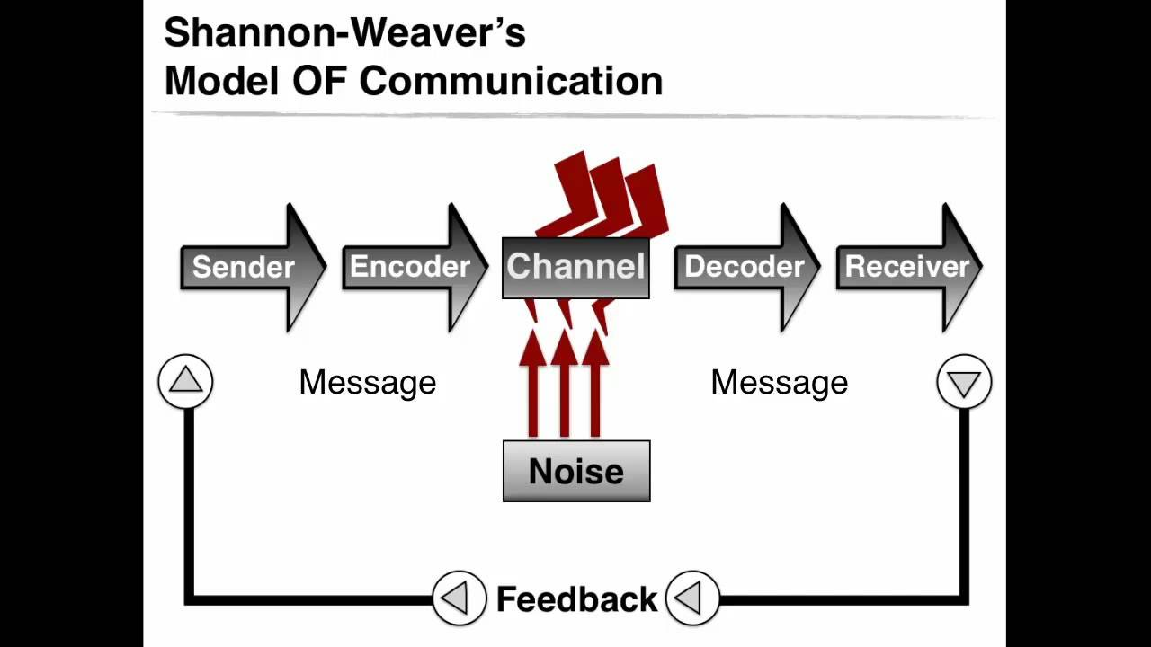
Figure 1 Shannon and Weaver Model of communication
Source: (Kubota, 2019)
The process involved in the Shannon and Weaver Model of communication includes as sender or originator who selects the desired message. The encoder transmits the desired message with the signals. The encoders use a channel or medium to send the message which is been received by the decoder who converts the signals into the message. In the end, the message is received by the receiver. In this process of communication Noise or barriers are also involved in the channels process (Kubota, 2019). The concept of noise or barriers in the communication process was introduced in this model. The model was proposed in the year 1948, and at that time the sources of barriers were less, so introducing the Noise as the Missing time due to disruption. By assessing the time and situation of the year of introduction of the model it can be depicted that Shannon and Weaver were thinking of the Physical barriers and Noise only. With the evolution of models and technology, the different types of barriers were been analyzed. The physical barriers include environmental disturbances, People, distractions etc. (Altun and Anwar, 2021).
To avoid the misunderstandings created due to Noise, the assessment and root cause of the noise are required to identify. The model suggests that misunderstanding in the communication process can be avoided by the identification and elimination of the cause of the noise. By eliminating the noise in the communication process, misunderstanding can be reduced. By prioritizing the listening process more than active speaking, noise and misunderstanding can be reduced to a great extent (Cargill, 2019).
The implementation of the Shannon and Weaver model can be assessed by the example of a case study of Maria and Pedro. The misunderstanding created between Maria and Pedro is an example of the introduction of noise in the communication process. The lack of focus and interest is the barrier to communication and misunderstandings had emerged. One of the key causes of the misunderstanding with the word, Chicken and Kitchen with Maria and Pedro is due to preconceived ideas. The preconceived idea of Pedro about Maria being in the Kitchen led to the interference of his willingness to hear her. The case study explains the Shannon and Weaver Model by explaining Noise factors in communication. Maria being the sender encodes the message to bring Chicken, and used their Mobile Phone as a channel to transmit the message. Pedro is the receiver who decodes the message but due to the interference of Noise in the process, the desired message is not been delivered to Pedro who is the receiver.
My colleague at work in the middle of the break made a lot of noise which created disruption and made the speech of the manager who was in the opposite room inaudible which ended up creating misunderstandings, which is an example of noise in the workplace.

SCHRAMM MODEL OF COMMUNICATION
Proposed in 1954 by Wilbur Schramm is one of the prominent model communications which includes Feedback as an essential element of the communication process. The key difference between the Shannon and Weaver model of communication and the Schramm Model is that in the Schramm model, feedback is the key element of the communication process, while it is lacking in the Shannon and Weaver Model of communication (Kastberg, 2022). Due to the presence of the Feedback element, the Schramm model is more relativity comprehensive than the Shannon and Weaver Model of communication. The active participation of both sender and receiver is involved in the Schramm Model of communication which is lacking in the Shannon and Weaver Model.
It is a circular model and involves source, receiver, message and Feedback as the key elements, and other essential principles of communication. In this circler model of communication, the sender and receiver are the same person and interchange the acts based on the situation.
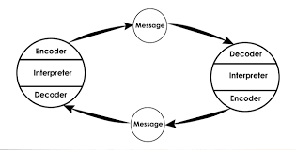
Figure 2 Schramm Model of communication
Source: ( https://qsstudy.com )
According to this model, in the communication process, there is an Encoder or sender who sends the message and is delivered to the receiver. The receiver acts as a decoder while receiving the message and interprets the meaning of the message. Based on the understanding of the message feedback is been created by the receiver, which is encoded and delivered to the sender (Cargill, 2019). In the process of getting feedback, the sender acts as a receiver and decoders the feedback. In this way, the circular process of Communication is completed according to the Schramm Model of communication.
Feedback is essential in reducing the interferences and bringing efficacy to the communication process. Feedback helps in facilitating effective and healthy communication flow. The Schramm Model of communication suggests that interference and misunderstanding can be reduced by facilitating feedback and the effectiveness of the communication process can be enhanced to a great extent (Elleström, 2018). The example of the Case study of Maria and Pedro is the guide that suggests that in absence of feedback misunderstanding is created. If Pedro could have ensured the message by providing feedback, then the scope of misunderstanding of Chicken and Kitchen be could have reduced.
In the workplace, the feedback from the manager will improve the work of the staff and the lack of feedback will bring repeating mistake.

BERLO’S MODEL OF COMMUNICATION
Berlo’s model of communication is also known as the SMCR model of communication which depicts that the sender, Message, Channel and receiver are the key elements of the communication process.

Figure 3 Berlo's model of communication
Source: (Bergman, 2019)
According to this model, the efficient communication process is directed by the collective implementation of the factors associated with basic elements of communication. Communication skills, attitude, Knowledge, social system and culture are the key aspects that are required to be possessed by the source and receiver to facilitate an effective communication process. The identification of selective content, elements, treatment, structure and code is essential for formatting the message (Mitra et al., 2020). Berlo’s model of communication suggests that the five senses are the channel by which the message is been received. Hearing, seeing, touching, smelling and tasting are the key methods of receiving the message (Bergman, 2019).
In a case study of Villagers and professors, the communication skills and knowledge of social systems and culture were lacking in Professor's attitude. The lack of selective content for forming the message has caused poor communication and thus it results in damaging the house of the Professor. The lack of knowledge among the receiver or Villagers is also the factor that results in bringing negative consequences of a poor communication process.

COMMUNICATION SKILLS
To facilitate an effective communication process, certain skills are required to develop. The communication process can be established and can be made effective by adding certain personality skills to the practice. The Key communication skills are:

VERBAL
Verbal communication skills are the set of practices that helps in bringing effectiveness to the communication process by the use of language. The active listing and choice of words, tone and pitch are the key aspects of verbal communication skills (Bergman, 2019). The smoother pitch, comforting tone and languages are the key verbal communication skills that are used by Chief to communicate with Mark. The Choice of language helps Chief in Comforting Mark.

NON VERBAL
Gestures, expressions and body languages are the elements of non-verbal communication skills. Rather than words, in non-verbal communication skills, the effective communication process is accomplished by using actions and sending cues (Ali, 2018). Based on the assessment of the body language and gestures portrayed by Mark in front of the chief, such as losing the tie and sitting with cross legs, he has faced a negative response from the Chief.

ACTIVE LISTENING
Active listening is one of the most powerful and important communication skills. It helps in obtaining complete information and helps in learning. It depicts the personality of the listener and influences the speaker positively. By reducing the distractions such as using the Phone in between the conversation and speaking in between, active listening can be accomplished (van der Vleuten et al., 2019).

EMPATHETIC LISTENING
Empathy is one of the most essential communication skills that help in building a strong and influencing relationship between speaker and listener. It develops trust and resolves conflicts (Chen, 2022). The assessment of the case study of Max suggests that the multitasking and not being emphatic to someone might create the worst situations. Max must have use empathetic approach in the communication process and by responding to the feelings and emotions of the Tamara, the negative outcomes could have avoided. It is one of the most important skill that is useful in business to manage the relationship with customer. The effective listening helps in all the domains of life and working (Wahyuni, 2018).

THE ADVANTAGES AND DISADVANTAGES OF COMMUNICATION THEORY
There are certain advantages and disadvantages are associated with Communication theories.
ADVANTAGES
The advantages of communication theories are that it provides the knowledge and ability to assess and understand human interaction. The advantages of communication theories are that it helps in guiding and directing people's behaviour. The development of essential knowledge and skills for facilitating effective communication is the advantage of Communication theories (Kristjánsson et al., 2020).
DISADVANTAGES
Based on the assessment it is been abstracted that there is no single theory that defines and depicts the communication process completely. The disadvantages of the communication theories are that it restricts the free flow of communication (Kačerauskas and Mickūnas, 2020). The various ways of human interaction and communication are not been included in the communication theories which is a major drawback. The technological and other evaluation changes may not be involved in the communication process which is a disadvantage of the communication theories (Kristjánsson et al., 2020).

CONCLUSION
The report is based on effective teamwork and communication. The assessment of the key aspects of Communication is included in the report. The report includes a detailed assessment of the Communication, barriers and poor communication. To support the discussion, models and case studies are discussed in the report. The analysis of communication skills and the advantages and disadvantages of communication theories is attached to the report. The Objective of the report is to provide knowledge of the communication process.

REFERENCES
Ali, M. (2018). Communication skills 3: non-verbal communication. Nursing times, 114(2), pp.41-42.
Bergman, M. (2019). Towards a Pragmatistic Perspective on Models of Communication. Models of Communication: Theoretical and Philosophical Approaches, pp.47-63.
Cargill, S.S. (2019). How do we really communicate? Challenging the assumptions behind informed consent interventions. Ethics & human research, 41(4), pp.23-30.
Elleström, L. (2018). A medium-centered model of communication. Semiotica, 2018(224), pp.269-293.
Https://qsstudy
Kastberg, P. (2022). Modelling Knowledge Communication as Co-Actional Communication. In Perspectives on Knowledge Communication: Concepts and Settings. Routledge.
Kristjánsson, H., Chiribella, G., Salek, S., Ebler, D. and Wilson, M. (2020). Resource theories of communication. New Journal of Physics, 22(7), p.073014.
Kubota, M. (2019). What is “Communication”?―Beyond the Shannon & Weaver’s Model―. International Journal, 13(1), pp.54-65.
Tiferes, J. and Bisantz, A.M. (2018)
van der Vleuten, C., van den Eertwegh, V. and Giroldi, E. (2019). Assessment of communication skills. Patient Education and Counseling, 102(11), pp.2110-2113.

