

Analysis of energy consumption in one room. Calculations for heating, cooling, lighting and power. Define solutions to reduce energy consumption and cost.

Mark Jones

Assignment 2
School: Built Environment
Subject: Energy efficiency in a building
Hand In date: 21st may 2019
Lecturer: Juan A Ferriz-papi
2019

Contents

Introduction 3
Methodology 4
Appliances 4
Heating 4
Lighting 5
Results and discussion 6
How often the room is being used 6
Recommendations 6
Solar/thermal panels 7
Lights 7
Upgrades 7
Insulating 7
Thermal imaging 7
Use of Natural light 7
Sensors 8
Renewable energy Schemes 8
Heat loss 8
Summary 8
References 9
Picture references 9
Appendixes 9
Appendix 1 9
Appendix 2 11
Appendix 3 12
Appendix 4 15
Appendix 5 19
Appendix 6 20
Appendix 7 21
Appendix 8 22
Appendix 9 23
Appendix 10 24
Appendix 11 25
Appendix 12 25

Introduction

This report will analyse the energy consumption of a particular room in the Business campus, the aim of this report is to describe all the types of energy consumers in the room and calculate the amount of energy they produce over the period of one year. The room that was surveyed for our previous report was AS306, the room’s measurements and appliances were recorded. This report will continue to study AS306 providing a further inspection and calculations for the amount of heat and electricity produced. The calculations for the consumers will be outlined, describing how much heating and lighting the room consumes over one academic year excluding all holidays, this will give an actual estimate of energy consumption, recommendation and solutions to reduce the energy consumption, carbon footprint and cost will be described.

Methodology

An interview will be the first activity that will take place, I will arrange an interview with the Maintenance workers at the business campus and the interview will take place to find out certain questions about the proposed room being surveyed See appendix 1 for question list and answers. Once all the data for energy consumption in the room is surveyed, the next step is to calculate the energy being consumed in the room. The Heating for the room will need to be calculated, this will be done by working out the total area of the building and room, meaning a percentage will to be found to work out how much the room produces compared to the whole building. A set of plans was provided therefore each wall will be measured to give an actual estimate of consumption. The lighting will then need to be calculated by Working out the lumen’s method and room index, (this calculation was previously given to us) this will determine if the luminaires in the room is compatible, each lamp will be recorded to work out the total luminance in the room. The next step is to calculate all the wattages of the devices recorded in the room from the previous report (appendix 2). Once the total amount of electricity being consumed for that room is found by adding all the wattages together from all different consumers, the overall energy consumptions for electricity and heating will be stated. The amount of days the room is in use will need to be found to work out the energy consumed over one academic year. Once all these steps are completed recommendations and solution on how the building/ room can be made more efficient will be added, these recommendations will be made using the internet, books and previous experiences I’ve had on site.

How often the room is in use

There are two semesters within the academic year.
Semester 1 starts:
September 24th – December 14th 11
(Christmas break)
January 7th – January 11th 1 week
Semester 2 starts:
28th January – 5th April 9 weeks
29th April – 8th May 1 week
Excluding all the holidays there are 22 weeks in total.
As you can see in appendix 3, there is a time table of the week for the room AS306. In total throughout the week the room is used for 38.5 hours in Semester 1, as Semester 1 is 12 weeks long the total number of hours would be 462 hours.
Appendix 4 shows the timetable for Semester 2, the total number of hours is 42.5 as there is a total of 10 weeks in semester two the total number of hours the room is in use for is 425.
There room is in use for a total of 887 hours per academic year.

Appliances

All the appliances that consume electricity or Gas (radiators, computers, lights etc.) are listed in appendix 2, the wattage/voltage and sizes of the appliances are also noted.
The total wattage of all the appliances in the room is added up to 1.360 kW per hour, this is applied to the total amount of hours the room is in use for 887 hours as stated in the ‘how often the room is in use’ paragraph above, meaning the room produces 1206.32 kW over the year.
See appendix 2 for the calculations of the total wattage.

Heating

To work out the amount of heating being produced over one year, the total area of the building needs to be found. This is done by working out the total area of one floor then applying that to the total number of floors there are.
The total amount of heating being produced for the whole building is shown in appendix 5. After the area of the whole building is found the area of the proposed room needs to be worked out. Appendix 8 shows the calculations for working out the area of the building and room.
After room area is found, the percentage of how much heating the room produces compared to the whole building will need to be calculated, see appendix 12.
The total amount of gas being consumed is 246,480 kWh (see appendix 5), the total amount the room AS306 consumes is 1.42% meaning the room consumes 3500.016 kW every academic year.
Central heating (2019) states gas to heat a building on average is 4.5 pence per kWh which means that the room will cost 15750 pence per year which converts to £158.35 to heat AS306 per year.

Lighting

The amount and type of lights were found out in the first report completed (see appendix 2), after speaking to the care takers the type of lights was confirmed and the wattage/lumens of the bulbs were found.
The calculations for finding the lumens (Lumens methods) was completed see appendix 9, to work out the lumens the Room index was needed, the method for both calculations are shown in appendix 9. The caretakers stated that the bulbs are LED 36 Watt, 2720 lumens.
Appendix 6 shows a table of the reflectance of a room similar to AS306. The room has a white acoustic-tiled ceiling, Carpet floor with lightly painted walls, there is a table also shown in appendix 6 that converts the reflectance to find the room index. Once the room index was found I was able to work out the Utilization factor by applying it to the other table shown in appendix 6.
There are 4 lamps per luminaire, there are a total of 12 luminaires in the room:
36 watt lamp x 4 lamps = 144 watt per luminaire
There are 12 luminaires in the room meaning 144 watt x 12 luminaires = 1.728 kW per hour
887 hours per academic year = 1532.736 kW per year for lighting.

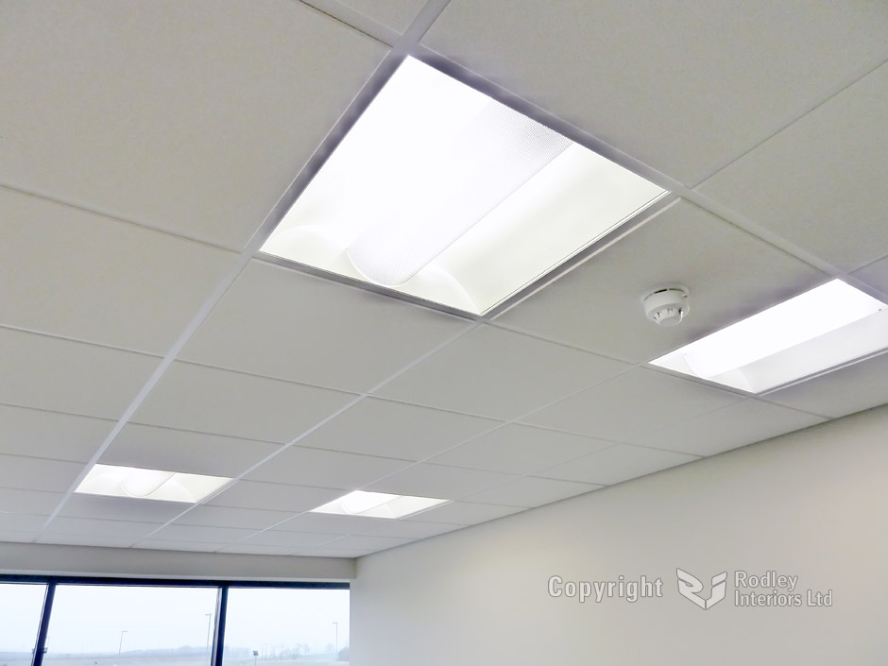
Sourced at Democraciaejustica (2018).

Results and discussion

The results show that for heating AS306 it would cost around £158.35 for a year, meaning the room produces 3500.016 kW a year. This amount was calculated by working out the total amount of heating the building consumed throughout the year.
The lighting calculations in appendix 9 states that the total luminance of the room is 7, as there are 12 luminaires in the room the luminance is compliant. The lamps are 36 Watt each, because there are 12 luminaires in the room the total wattage the room produces is 1.728 kW per hour, as there are 887 academic hours in the year the total amount of wattage produced over the year is 1532.736 kW for lighting.
The appliances wattages are all added up to have a total of 1.360 kW per hour, this information has been taken from appendix 2, The total wattage added to the total amount of hours in the academic year is 1206.32 kW.
See appendix 11, for a table of the complete amount of energy the room produces over an academic year, the table can be used to compare the room’s energy consumption against other rooms of the same or different buildings, the results from these calculations can be used to give the building/room a detailed energy saving report to reduce the amount of energy the building consumes in total throughout the year. Most of the energy that is being produces id electricity, meaning the best solution for energy saving would be to install solar panels.

Recommendations

There are a few changes that could be undertaken to make the building/proposed room more energy efficient, small changes will improve the buildings energy efficiency although to improve it drastically large, costly actions may need to take place.

Solar/thermal panels
Solar panels or solar thermal panels could be intergraded onto the roof of the building to supply some of the electricity or hot water needs, the building is large enough meaning nothing would obstruct the solar panels to prevent sunlight hitting them. They would not supply all the energy needs throughout the year as Swansea doesn’t see much sun through the winter although in summer most of its energy needs could be met, although they will supply a large amount, for the rest of the energy needs a backup boiler or electric heater can be used. Once installed they can reduce the amount of carbon footprint made by the building, reduce the amount the university must pay on energy bills and most solar panels are noticed by BREEAM when the building gets a BREEAM rating.
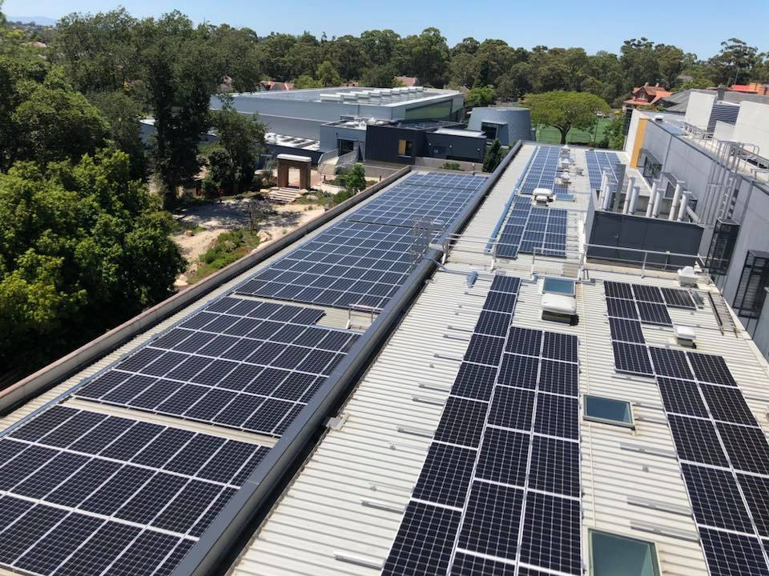
Solar Quotes Blog (2017)

Lights
All the lamps in the building/room can be change to more efficient lamps that consume less electricity, these lamps will cost more than ordinary, less efficient lamps although money will be saved in the long run.

Upgrades
Depending on the age and how sustainable the boiler system is, it could be upgraded for a newer more efficient one, upgrade appliances in the rooms for more efficient, energy saving appliances. Computers and monitors can be appliances that get upgraded for more energy saving versions (usually newer versions are more sustainable).

Insulating
Re insulate the walls in the building will make the rooms hold heat better, once all the walls in the building are insulted the heating won’t need to be on for as long, mainly for winter use although this will apply for summer months as well.

Thermal imaging
There are some thermal bridging points in the room as show in appendix 10, meaning some filling in around the windows could be done to prevent heat passing through these points.

Use of Natural light
Making the most of natural lighting will prevent the amount of artificial lighting needed in the room, keeping the window blinds open all the time will eliminate the need for artificial lighting.

Sensors
CSS (2017) describes that Installing sensors that turn lights and temperature on when someone enters a room can be a low-cost way of reducing the amount of energy wasted in a room, or it can be applied for the whole building. Most large buildings like the business campus have issues like people leaving the lights and heating on when it Is not needed, the sensors should reduced the amount of wasted energy.

Renewable energy Schemes
There are schemes set up in the UK to reward users of sustainable methods in commercial buildings, the rewards are usually a small income for every unit of energy produced through a renewable energy source. They are beneficial as the energy sourced can be used on the building and whatever isn’t used can be sold back to the grid for additional payments. Renewable Heat incentive (RHI) is an example of a government incentive to install solar PV or solar thermal as you are paid for every unit of renewable energy sourced.

Heat loss
A further survey of the room could be carried out to see if any windows or doors need to be upgraded, insulation could be added into the external wall to stop heat loss as most of internal heat is lost through the fabric of the building e.g. walls, door, windows, floors etc. “Around 75% of an industrial unit’s heat is lost through the building fabric” Carbontrust (2018).
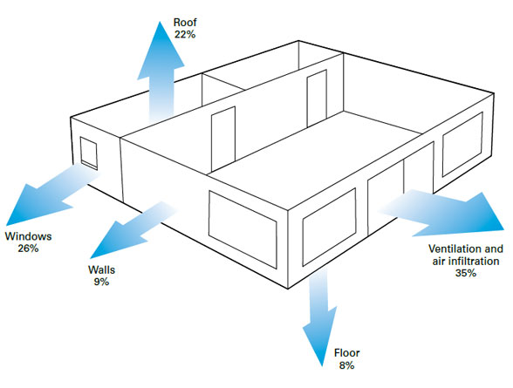
Carbontrust (2018).

Summary

The report was used to find the total energy consumption of the room AS306 in the business campus. A questionnaire was comprised to find out certain things about the proposed room (see appendix 1) the caretakers answered these questions meaning the calculations for finding the total energy consumption for lighting, heating and the devices in the room could be completed. The total amount of hours the room is in use was record by asking at the office in the business campus for a timetable, meaning the energy consumption was recorded throughout the whole academic year for the room. Once all energy consumptions were recorded then next part of the report was to recommend ways to improve the energy saving of the building, the main solution to improve its energy efficiency was solar panels, this will supply the building with most of its electricity needs. Small low-cost ways to reduce energy were recommended also, for example upgrade devices for more efficient ones and install sensors that turn lighting and heating on when the room is in use.

References

Carbontrust (2018). Buildings Energy Efficiency | Guides | Carbon Trust. [online] Available at: https://www.carbontrust.com/resources/guides/energy-efficiency/buildings-energy-efficiency/ [Accessed 26 Mar. 2019].
CentraHeating (2019). The Running Cost Of Central Heating: Controlling Your Heating Expenses. [online] Available at: https://www.centralheating-quotes.com/new-central-heating/running-cost-central-heating/ [Accessed 25 Mar. 2019].
CSS (2017). How to make your commercial building more energy efficient - CSS - Contracting Site Solutions. [online] Available at: https://contractingsite.com.au/improve-energy-efficiency/ [Accessed 26 Mar. 2019].
LRC (n.d.). Lighting Research Center | Education | Learning | Terminology | Reflectance. [online] Available at: https://www.lrc.rpi.edu/education/learning/terminology/reflectance.asp [Accessed 26 Mar. 2019].

Picture references
Democraciaejustica. (2018). Beautiful - Democraciaejustica. [online] Available at: https://democraciaejustica.org/tool.html#bGlnaHRpbmctc2Nob29scw== [Accessed 26 Mar. 2019].
Solar Quotes Blog. (2017). Do Solar Panels Installed On A Flat Roof Need Tilt Frames?. [online] Available at: https://www.solarquotes.com.au/blog/solar-panels-flat-roof/ [Accessed 28 Mar. 2019].

Appendixes

Appendix 1

Questions and answers of the interview:
- How often is the room used?
- What time is the room in use every day? (Time table)

Answer – A time table of the class room throughout the year was provided.

- What days is the building closed for holidays and inset days?

Answer - I was able to get the holidays and days off, from my lecturer.

- What activates take place in these rooms?
- Are they lecture rooms or are they used for different activities?

Answer -The room is strictly used for lecture rooms.

- How often the heating is on for this particular room?
- Is there a thermostat in each room to control heat?

Answer – There is a master thermostat at ground level that controls the heat for the whole building.

- If not, what temperature is the room kept at?

Answer – The room has an individual thermostat that can be adjusted to suit the occupant’s needs.

- How often are the lights on?
- Does the building use more natural lighting?

Answer – There are light switches that can be turned on and off in the room, meaning the lights are only on when the room is occupied. There are blinds on the windows so the occupants control the natural lighting In the room.

- What bulbs are used in the ceiling lights?

Answer – The bulbs used are LED 36-watt bulbs and there are 4 in each ceiling light, there are 12 ceiling lights in the room AS306.

Appendix 1, is the 4 questions I asked at the reception of the business campus, reception referred me to the care takers office where I got a response to each question in detail.

Appendix 2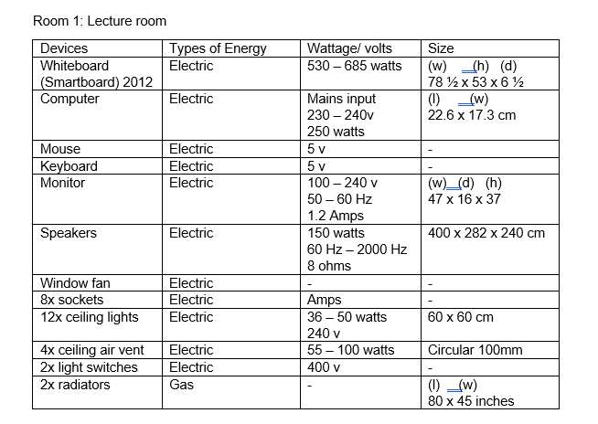
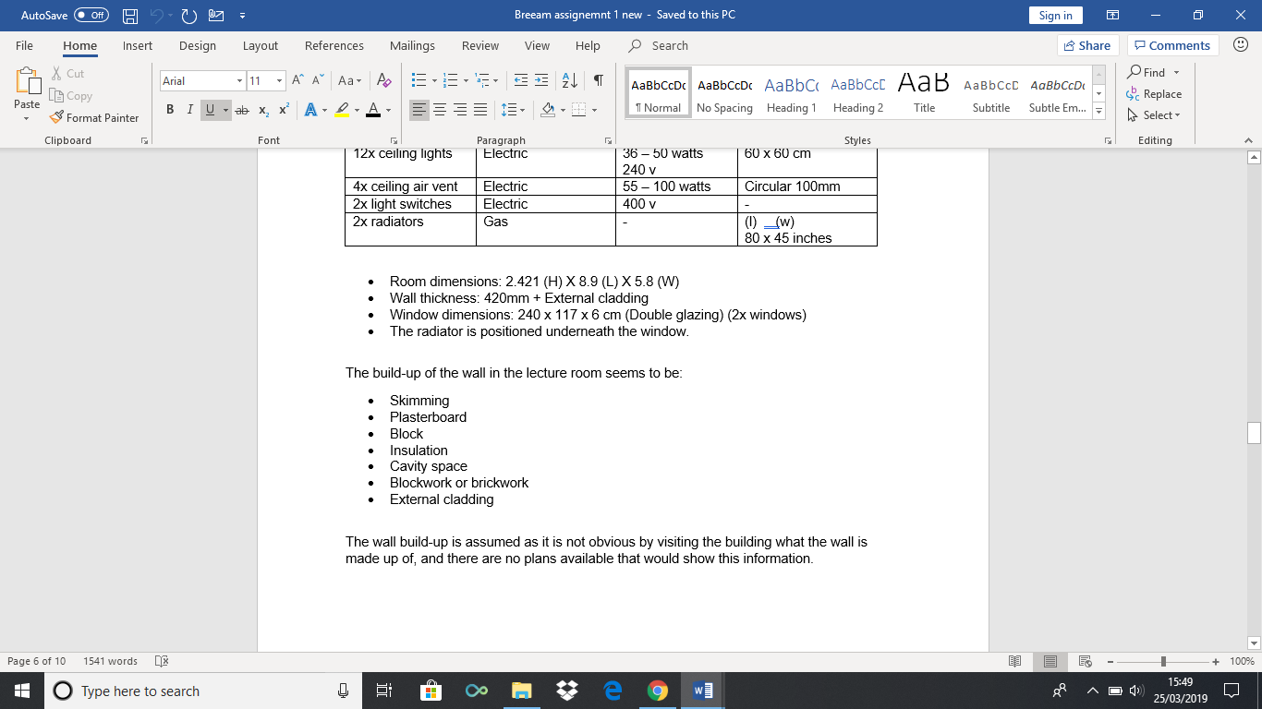
Appendix 2 shows what the lecture rooms dimensions are, what devices are in the room, the types of energy each device uses and the wattage of each device. The table was sourced from the previous report of the building.
To work out how much wattage the room’s appliances use all the wattages must be added together from the table above, this adds up to 1.360 kW, I then times it by the total hours the rooms is in use for, which is 887 = 1206.32 kW per academic year.

Appendix 3

As you can see in Appendix 3 the weekly time table is show for semester 1, which shows the room is in constant use apart from Sunday, this timetable will allow me to find out how often the room is used throughout the year. Finding out how often the room is in use will allow me to work out the total energy the room produces over one academic year.
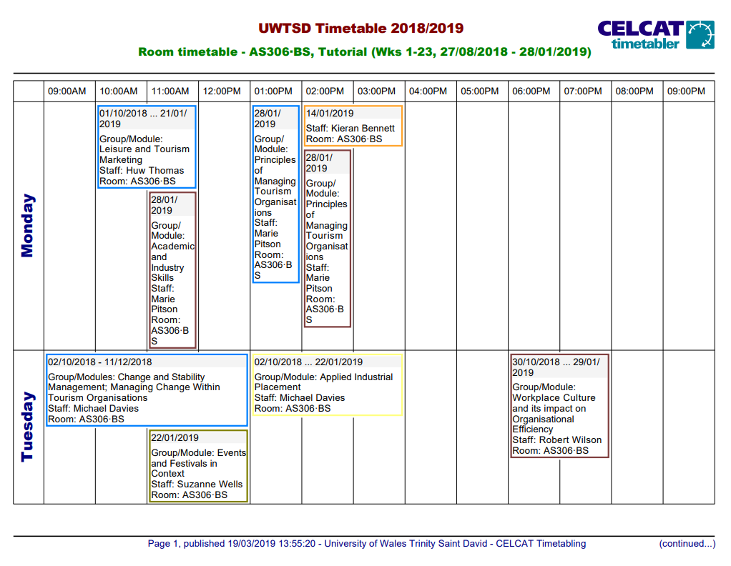

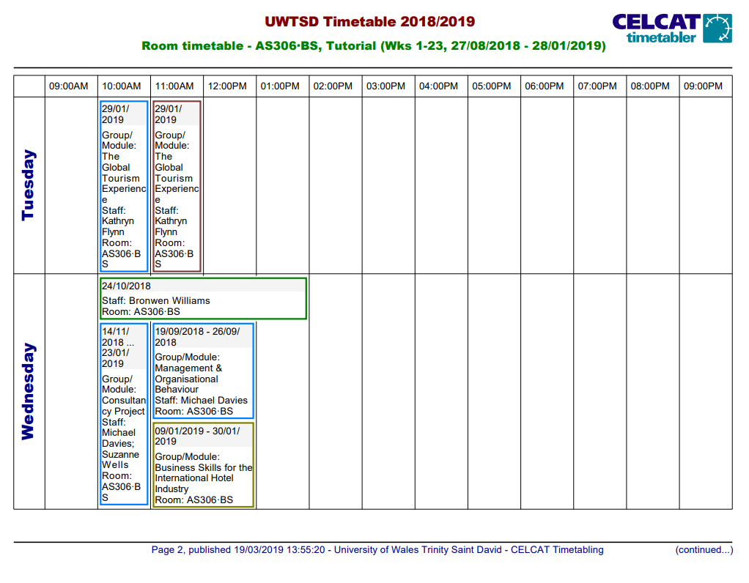
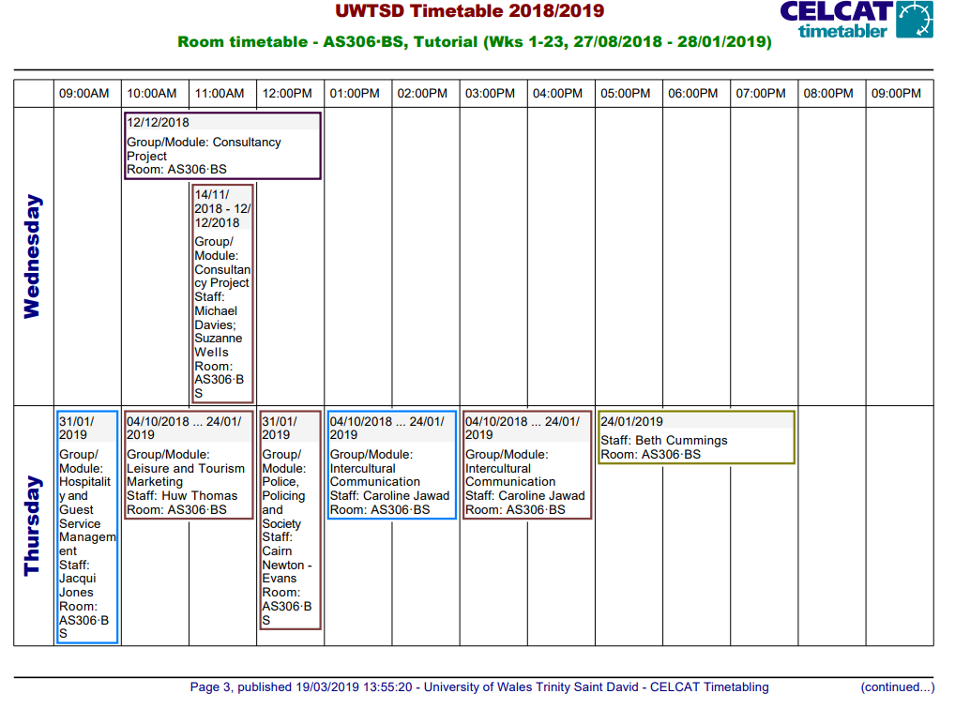
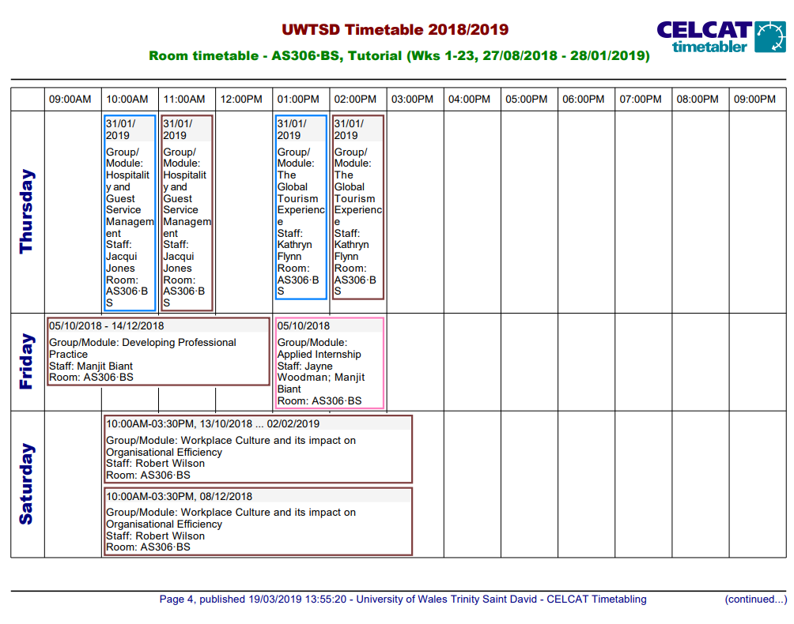

Appendix 4
Appendix 4 shows the weekly time table for semester 2, the time table shows that there are classes on Saturday which will need to be considered to find out the total lighting the room uses over one year.
There room is in use for a total of 887 hours per year.

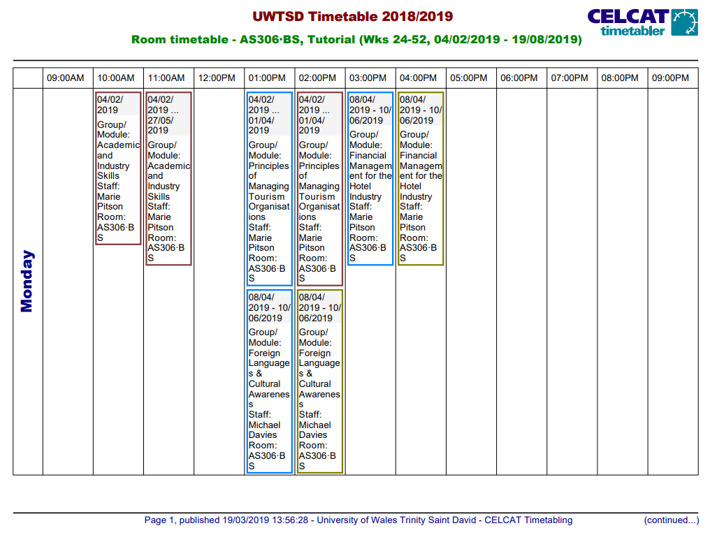
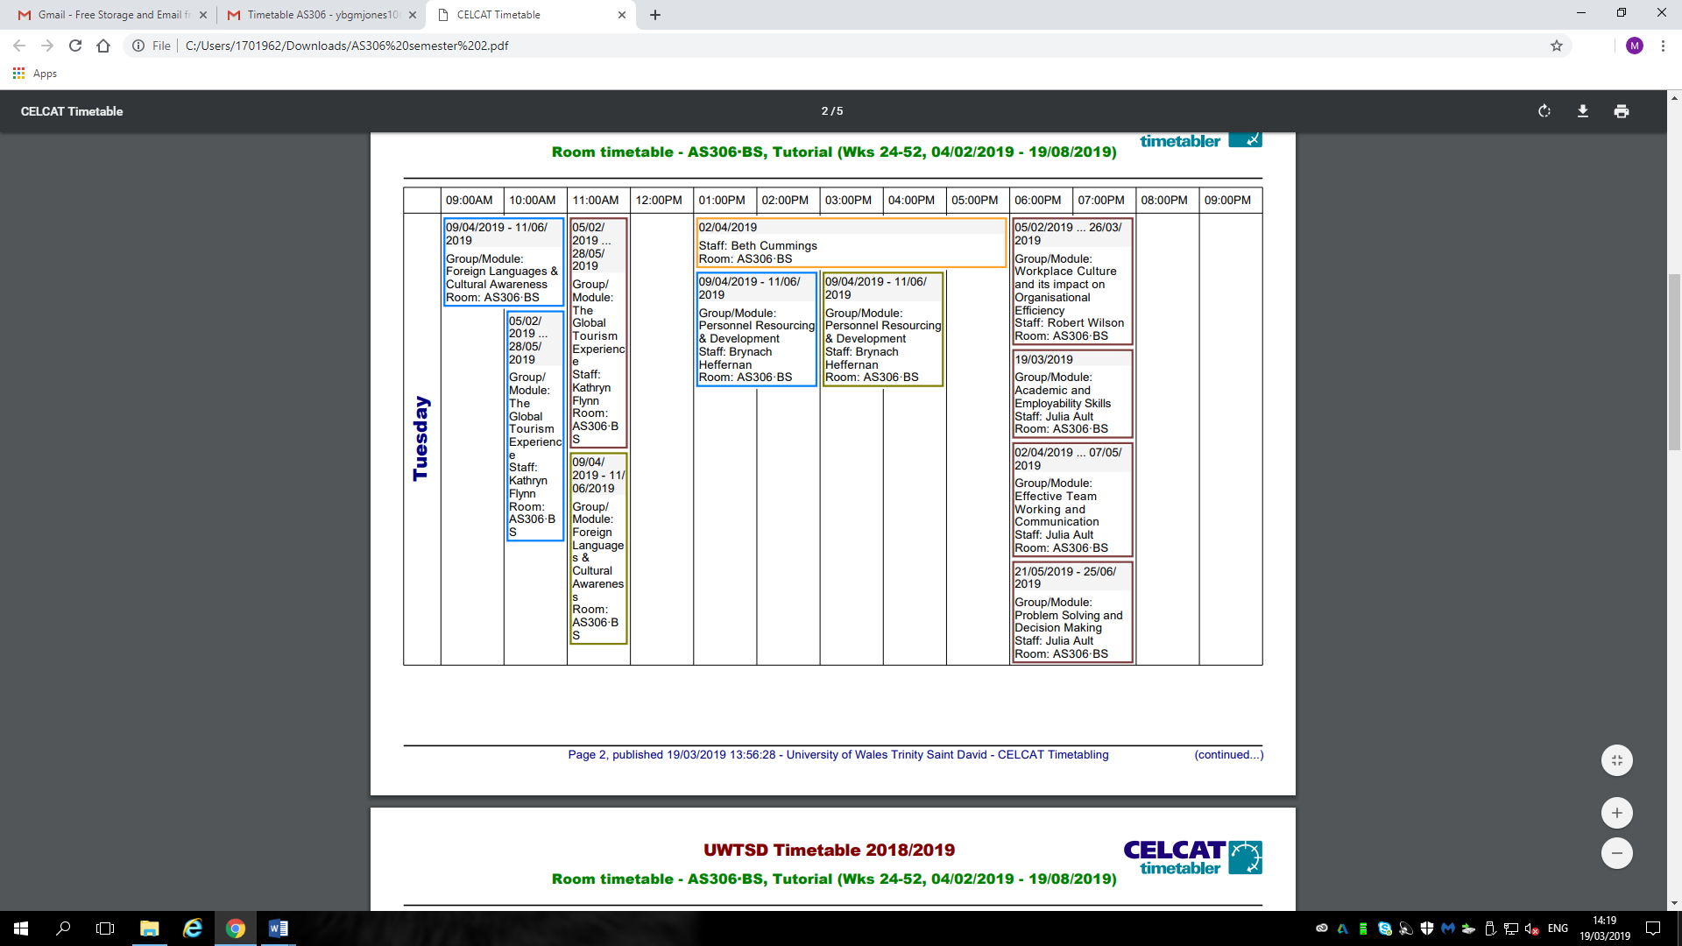
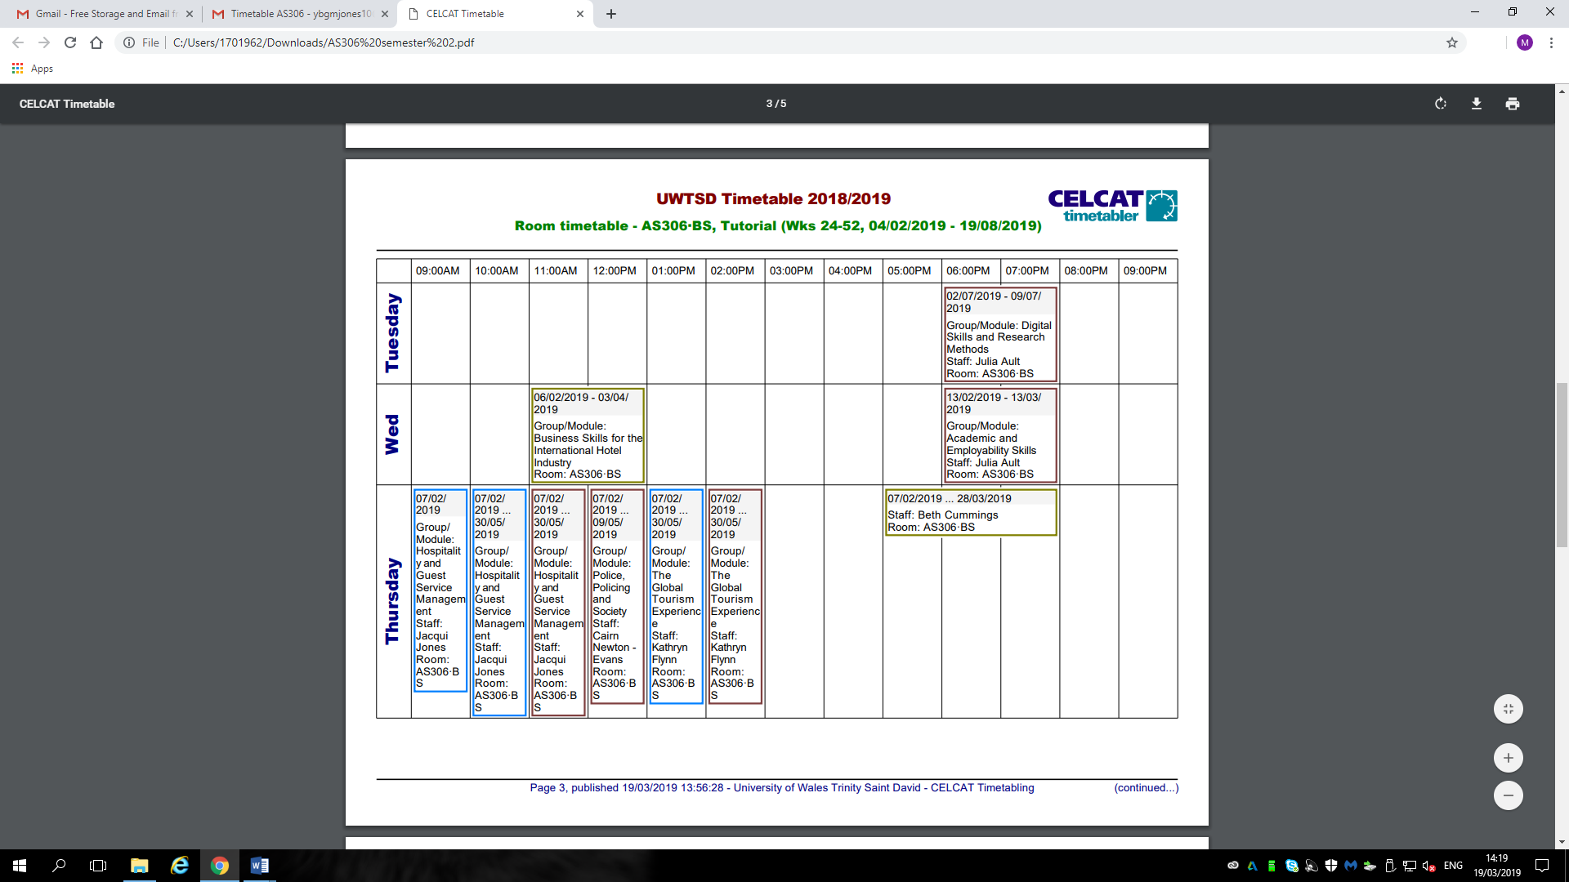

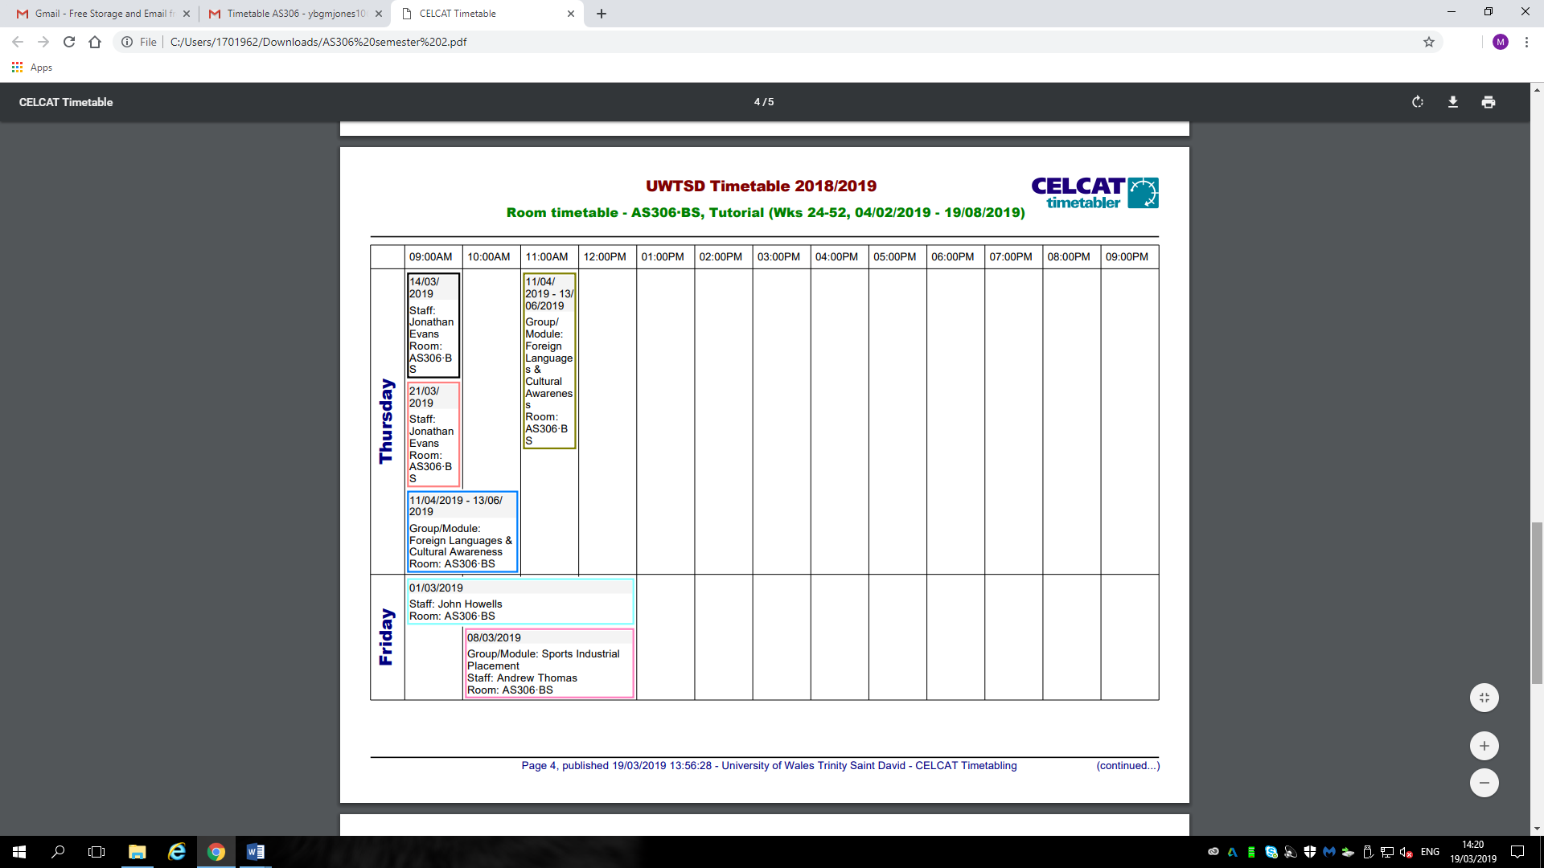

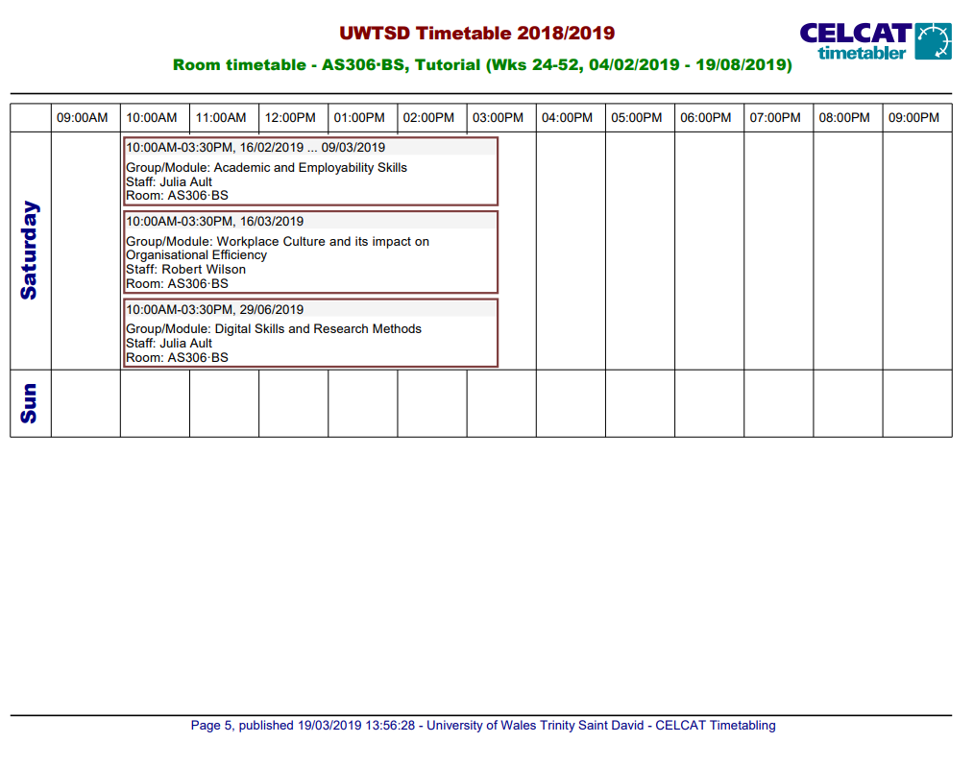

Appendix 5
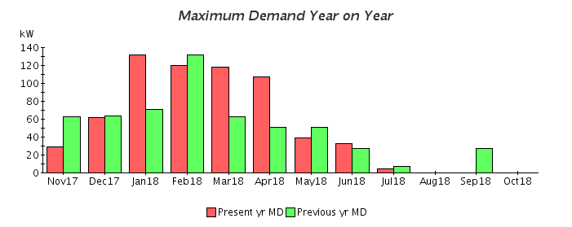
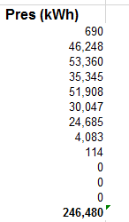

Appendix 5 shows the total amount of heat being consumed in the business campus over one year, this amount was needed to calculate the total amount the proposed room produces throughout the academic year. The average cost for the room was calculated from this, working out the percentage of the room compared to the whole building.

Appendix 6
Room Surface | Reflectance Value
white acoustic-tiled ceilings | 70 to 80%
light-colored walls | 40 to 60%
carpeting | 15 to 30%
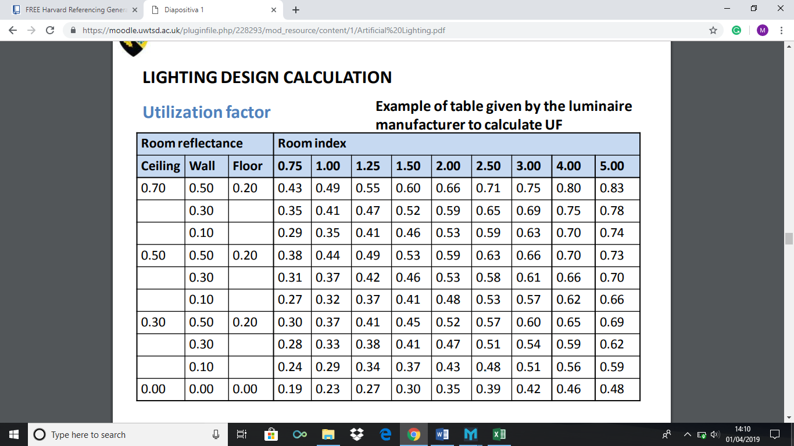
The calculation for the room index worked out to be 2.19, as this figure is between 2.00 and 2.50, the two figures were added together (0.66 + 0.71 = 1.37) this is then divided between 2 = 0.685. The reflectance for the ceiling is: 70 walls are: 50 and Floor is: 20, these figures were all taken from the reflectance’s shown in the tables above in appendix 6.

Appendix 7
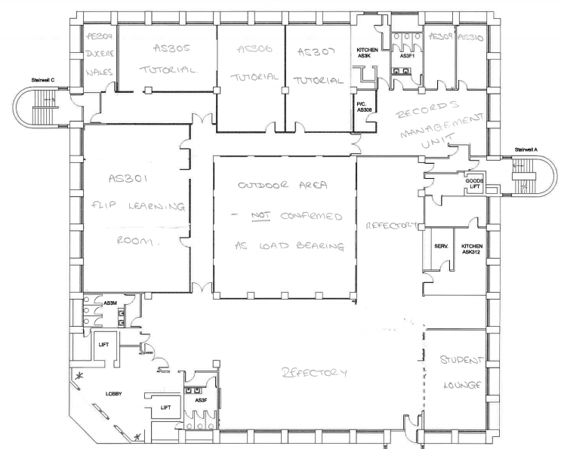

Assuming the scale of the drawings in appendix 7 is 1:200 the sizes of the building were recorded at 27m2, all other measurements were taken from the previous report as seen in appendix 2, this was needed to work out the area of the building.

Appendix 8
All the area calculations
For One floor
27m (L) x 27m (W) x 2.4 (H) 1749.6 m3
For whole building
x 5 floors = 8748m3
Room
8.9m x 5.8m x 2.4m = 123.888m3

Appendix 8 shows all the workings out for the building and room, I measured using a scale rules the sizes of all external walls and internal heights then times it by the total amount of floors which calculated the m3 for the whole building. I done the same for the proposed room which allowed me to work out a percentage for how much energy the room produces.

Appendix 9
The lighting calculations of the room
The lumens method
N= E x Area (m2) Room index = L x B
L x UF x MF Hwc (L + B)

E = 200 Lux
Area = 51.62m2
L = 12
Room index = 8.9 x 5.8 RM= 2.194 UF = 0.66
1.6 (8.9 + 5.8)
MF= 0.8
N = 200 x 51.62
2720 x 0.685 x 0.8
N = 6.9263
N = 7 luminaires

Appendix 9 shows all the workings out for the lighting in the room, these are calculated by finding how many lights are in the room then using the calculation as shown in the table above to find out the total luminance of each lamp, then adding that to the total amount of luminaires in the room. The total luminaries is 7 which is less than the amount of ceiling luminaires in the room (12) meaning it is compliant.

Appendix 10
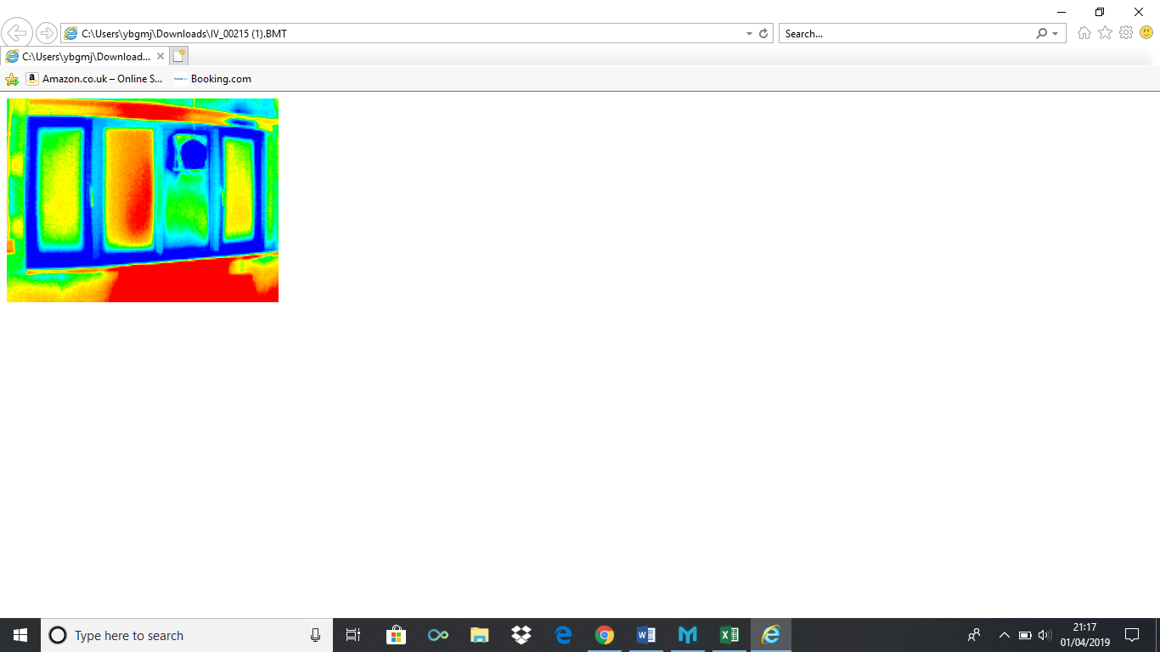
Appendixes 10: thermal imaging showing thermal bridging around the window, meaning filling in may be needed to prevent this issue.

Appendix 11
Table of results
Electricity (all devices) | Electricity (for lighting) | Heating (Gas)
1206.32 Kw | 1532.736 kW | 3500.016 Kw

The table above is the total amount of energy the building produces over one academic year. These are the results of all the calculation that were completed.

Appendix 12
Percentage of the room
As shown in appendix 8 the total m3 of the building is:
8748m3
The room worked out to be:
123.888m3
123.888 is 1.42 % of 8748m3.
As the building consumes 246,480 kWh throughout the year, the room will consume 3500.016 kW every academic year, as 1.42% of 246,480 = 3500.016 kW

The percentage is needed to work out how much heating the room consumes throughout the year compared to the whole building, appendix 12 shows the percentage of the room along with describing that the room consumes 3500.16 kW over the academic year.

