Kellie Morgan-Rowe ECAD6007

A critical evaluation of next teaching and learning steps focussing on a case study of an individual learner or group of learners, based on an observed critical incident.

Introduction

The title of this assignment is " a critical evaluation of next teaching and learning steps focussing on a case study of an individual learner or group of learners, based on an observed critical incident". A critical incident is an approach to learning proposed by theorist David Tripp, who defined a critical incident as any incident observed in the classroom that becomes critical by critically analysing it (Tripp, D. 2002). Once the critical incident has been analysed, the next steps in learning can be identified and an action plan can then be developed.

The purpose of this assignment was to identify a critical incident following observation of a case study of a group of learners in a learning environment. I then aim to critically evaluate this incident by researching the literature around the areas identified and to link my observations to the Four purposes of the curriculum (Donaldson, G. 2015). I will then discuss in further depth why the incident relates to one or more of these purposes. I will also be researching professional teaching standards and the curriculum reform in Wales. I will then critically evaluate this incident by focussing on specific areas of interest and researching the relevant literature. Upon evaluation of this reflective practice, I will then be able to identify the next steps for learning and identifying the role of critical reflection and discuss why this is important for my development as a teacher. Within this research I aim to make links with the professional teaching standards and the four purposes.

The role of critical reflection

Critical reflection in the context of teaching practice is a development of "critical thinking" whereby we as teachers analyse our practice, highlight any key areas of interest and then through researching the relevant literature, use our findings to inform future actions.

Stephen Brookfield is a philosopher who suggests that the path to becoming an effective practitioner involves critically reflecting on a practice or set of practices to make them work more effectively in order to achieve the desired outcomes for the learners (Brookfield, S. 1998). Within this theory Brookfield proposes that teachers should view the learning process through four lenses, 1) the autobiographical 2) the student's eye 3) our colleagues experiences 4) Theoretical literature. Thus, the first step is to reflect but you must then also consider other people’s experiences. These lenses link directly to the processes of self-reflection, student feedback, peer assessment and engaging with the literature. By considering the four lenses model whilst carrying out more in -depth reflection of an identified critical incident we are then able to gain a clearer idea of what happens and why.

Other models of reflective practice also exist such as Kolb’s reflective model. This model is referred to as experiential learning which suggests that it is our own experiences which are the driving force for review, analysis and evaluation of a practice. These new experiences then form the basis of the next cycle (the new "concrete experience"). (Kolb, D.A. 1984).

Kolb's model:

Kolb, D.A. (1984).

Gibbs proposes a different model again, which suggests the following stages are used in reflection: description, feelings, evaluation, analysis, conclusions and action plan. (Gibbs, G. 1988).
Thus, this model aims to prioritise reflections and highlight feelings in order that we don't make assumptions too quickly.

Gibb's model:

Gibbs, G. (1988).
Although there are clear differences in these proposed models of reflection the overarching common theme amongst them all is that teachers must be reflective, and this involves constantly adapting and changing their activities accordingly. This can be shown in the model below encompassing all models of reflection.

Reflective cycle:

Getting started with reflective practice-Cambridge international Education Teaching
and Learning Team.

The curriculum in Wales is currently undergoing a reform which advocates combining the standardised school-based curriculum with the development of skills and competencies required for learners to achieve success in this ever-changing world in which we live. Donaldson set out four purposes of the new curriculum. The four purposes are that all children and young people will be:
- Ambitious, capable learners who are ready to learn throughout their lives.
- Enterprising, creative contributors who are ready to play a full part in life and work.
- Ethical, informed citizens who are ready to be citizens of Wales and the world.
- Healthy, confident individuals who are ready to lead fulfilling lives as valued members of society (Donaldson, G.2015).

The practice of critical reflection aims to critically reflect on our experiences in order to fulfil
these four purposes.

Critical reflection plays a vital role in our developing teaching practice since it allows us as teachers to identify our strengths and weaknesses as well as allowing us to promote a positive learning environment. The practice of critical reflection provides the foundation for exemplary teaching.

Observation school and class context

The primary school in which I undertook my observations is an English medium community school catering for pupils aged 3 to 11 years of age. The school’s name is kept anonymous to comply with the BERA regulations (BERA 2018). The school is situated in a large housing estate consisting of mainly private housing in an affluent area of Bridgend County borough.

The school has a strong partnership with the community and local businesses and is well supported by a strong governing body. The school makes use of these positive relationships to enhance the learning of its pupils. The school currently has 582 pupils of mixed gender (48.6% boys and 51.4% girls) split up into 18 classes which include seven mixed age classes and a part-time nursery class. The average number of pupils per teacher is 25.6. Only 6% of the pupils are eligible for free school meals and 11% of pupils have been identified as having additional learning needs. Both figures are considerably lower than the national average. Most pupils are from a white British background and no pupils speak Welsh at home.

The school places a strong emphasis on physical activity and well-being and the
latest inspection report by Estyn rated the school as good with particularly strong communication skills and the overall behaviour of the pupils judged as exemplary (Estyn 2018).

The critical incident related to this assignment was observed in a morning Maths lesson in a year 6 class of 25 mixed gender pupils.

The critical Incident

The incident I observed was a learning strategy employed by the teacher in the lesson. The Area of Learning (AoLE) was mathematics, and it was the first lesson of the day. There were 25 children in the class of mixed gender sat in tables of 4 to 6 pupils per table all mixed ability. The area of maths that was being taught was rounding to tens and hundreds.

At the start of the lesson the teacher recapped on the previous lesson and the children were given a task to complete and share their answers by holding up their white boards. The teacher then checked that all pupils were engaged and understood the concepts. The teacher then gave the pupils a task to complete on their maths book monitors. The school use a learning strategy called a "spice-o-meter" whereby the children choose a level that they think is suitable for themselves based on their own understanding of the topic being covered. This had four levels of difficulty from easiest to hardest which were- medium, hot spicy and sizzling. The spice-o-meter indicates the level of challenge of the task, the spicier the task the more challenging it is.
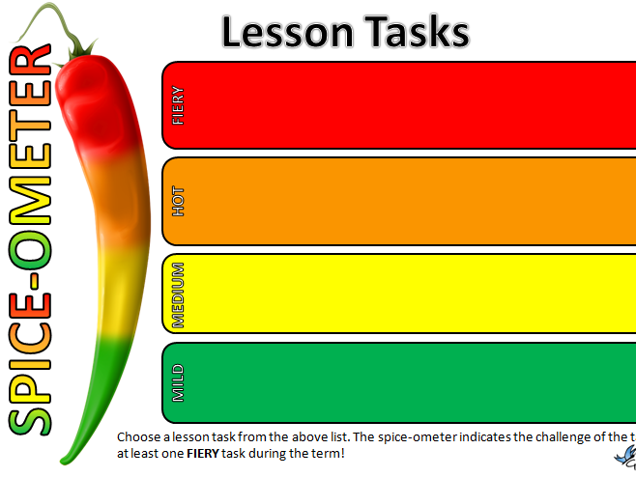
Tes resource-Presenting Differentiated Lesson Tasks.

The learners were allowed to choose which level they thought they were at and to then
complete the tasks for that level. Thus, this allowed for differentiated learning to take place amongst the different ranges of ability of the learners. They then marked their own work themselves and evaluated their progress on a traffic light system of self-assessment whereby red indicated they found it hard and green indicated they found the work easy.

They could then move up or down levels accordingly. Many of the children were finding the work easy and therefore after evaluating and reflecting on their own work based on these methods of self-assessment decided to move up to the higher level in order to challenge themselves. Alternatively, if any pupil was finding a particular level too difficult, they could then drop down until they had fully grasped the concepts and were confident enough to progress. Thus, the aspect of this lesson that was the critical incident was the self-assessment learning strategies employed. (Appendix 1)

This critical incident relates mainly to the four purposes of the curriculum, namely “creating ambitious, capable learners" setting themselves high standards and seeking to enjoy challenge, using number effectively in different contexts and understanding how to interpret data and mathematical concepts. There is also a link with the " enterprising, creative contributors who aim to connect and apply their knowledge, skills and ideas, identify and grasp opportunities and take measured risks. As the learners were given ample opportunity to collaborate with one another the inclusion parameter of the four purposes is being met as well as links to well-being via differentiated tasks building resilience and self-confidence.

This critical incident draws attention to assessment for learning strategies and encouraging learners to take charge of their own learning through self-reflection and self-evaluation which links to the professional teaching standards which support the four purposes namely refining teaching, through managing the learning environment, assessment and differentiation, as well as advancing learning via the teacher demonstrating a knowledge and understanding of the needs of all learners. I will be looking into these areas in further detail in the body of this assignment.

Literature Review

The critical incident I observed highlighted assessment for learning strategies, and this is what I am going to discuss in further detail. Assessment for learning (AFL) is defined as any assessment for which the priority in its design and practice is to serve the purpose of promoting pupil's learning. (Black et al 2004).

This definition was developed by the Assessment Reform Group (ARG) in the UK, which also stated that an assessment activity can help learning if it provides information to be used as feedback for teachers, and by their pupils in assessing themselves and each other in order to modify the learning activities. When this evidence is then used to adapt the teaching to meet the learners needs then the assessment becomes "formative". This is in comparison to the standard assessment based merely on scores and levels without the feedback and self-assessment processes.

Professor Dylan Williams is a professor of educational assessment who proposed that providing feedback at regular intervals enables the learners to achieve the highest levels of attainment whilst also allowing us as teachers to reflect on their practice as an ongoing process. (Black, P. 1998). Williams also claims that if assessment for learning is implemented effectively it will raise standards for all and reduce the spread. He states that this type of formative assessment can be split into three amin steps: 1) finding out what stage the learners are at, 2) where do the learners need to go next in terms of progress and 3) how do we get the learners to this next level.

Thus, assessment for learning is a short term, on-going feedback process which enables us as teachers to reflect on our experience and as result of this reflection, enables us to change planning as appropriate in order to develop further learning.

Dylan Williams references 5 key strategies that need to be implemented for formative assessment to be successful. (Williams, D., & Thompson, M 2007).

These are:
1.) clarifying, understanding and sharing learning intentions.
2.) engaging effective classroom discussions, tasks and activities that elicit evidence of
learning.
3.) providing feedback that moves learners forward.
4.) activating students as learning resources for one another.
5.) activating students as owners of their own learning.

Blooms taxonomy is a proposal developed by Professor Benjamin Bloom (Bloom, B.S.1969) which sets out a hierarchy of thought for the learners. The goal of using Blooms taxonomy is therefore to encourage student to build up from lower order thought process to encourage higher order thinking. Bloom proposed that these different levels of cognition require different methods of teaching and consequently assessment and therefore Blooms taxonomy allows for teachers to check that all levels have been assessed appropriately. Thus, there is a generic language which teachers can use to compare assessment methods and outcomes.

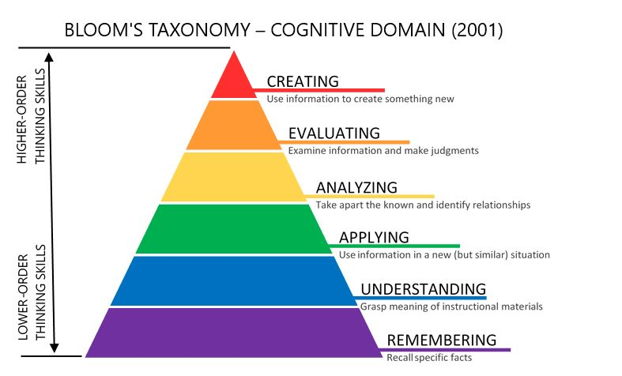
Krathwohl, D.R. (2002).

Therefore, if we link the "spice-o-meter" strategy to these theories, by the learners choosing
their own level of difficulty for the maths task they are clarifying, identifying and understanding the learning intentions, and are therefore effectively taking ownership of their learning. As they also mark each other’s work then they are fulfilling the providing resources for one another, following completion of the tasks and activities that tested their understanding. This is then deemed an effective formative assessment, and this indeed showed in my classroom observations.

The feedback that then ensued by the "traffic light system" of self-reflection is the driving force that moves the learners forward. Moving the learners up a level to further challenge themselves or down a level to reconsolidate knowledge.

The "spice-o-meter" assessment for learning strategy also allows for differentiation and inclusive learning to take place within the classroom as driven by the four purposes and the curriculum reform. Differentiation is a philosophy that involves providing all learners with a range of different avenues for understanding new information so that all students within a classroom can learn effectively regardless of differences in their ability. (Tomlinson, Carol. 2001).
Thus, in the spice-o-meter strategy, the learners were able to choose for themselves the level of ability they thought they were at in order to choose the appropriate task. On observation of this strategy in practice it was evident that overall, this was a very effective strategy for the learners to take control of their own learning with the differentiated tasks building resilience and confidence amongst the pupils.

Assessment for learning strategies are based on the constructivist theory of learning developed by theorist Jean Piaget who through studying his own children, suggests that human learning is constructed and based on a foundation of previous learning, and it is this previous learning which influences what new knowledge an individual will construct from the new learning experience (Phillips, 1995).

Piaget proposes that children should mainly focus on the process of learning rather than the final product of the learning, (i.e., formative versus summative assessment) and that the process of doing activities is the best way for children to learn. Piaget states therefore that the role of the teacher should be to facilitate the learning as opposed to direct tuition. Direct tuition with the focus on the end point ultimately takes away the constructivism aspect of learning as for a child to learn effectively he must construct his or her own learning themselves. The constructivist approach can be seen in the classroom whereby it is the responsibility of the teacher to create a collaborative environment using scaffolding techniques to respond to the learners’ achievements or lack of, by adjusting their input accordingly.

Lev Vygotsky (1978) is another constructivist theorist who offers a parallel view to Piaget's view of constructivism. He argues that although children do learn through social interactions, they require an adult or a "more knowledgeable other" (MKO) for example, a teacher to assist the child through the zone of proximal development via scaffolding technique. Scaffolding is ultimately levels of support given to a child by a more knowledgeable other to enable the child to progress and complete the task independently.

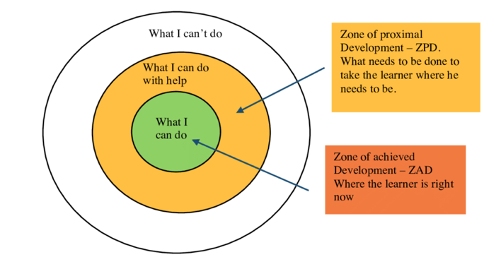

Lev Vygotsky (1978)

They are however, both in agreement that children should be actively, constructing their own knowledge rather than simply being taught (McCleod, S. 2022). This approach to learning meets the needs of the four purposes and curriculum reform, allowing learners to take ownership of their own learning which is shown to be of huge benefit to the pupils.

However as with any practice of learning there are limitations and in the case study, there were a small number of children who appeared to be finding the tasks too easy and completing them significantly faster than the rest of their cohorts. This then poses the question of are some learners lacking confidence in their ability or are indeed deliberately choosing the easier tasks. There is a link here to the well-being of the children as if the learners are constantly questioning their own ability or if a child chooses a level of learning that is too difficult for them this could have a detrimental effect on their confidence. Conversely however if a child chooses a lower level and then completes it with ease and can progress to the next level, this will then have a confidence boosting effect for the learner and consequently a positive effect on their well-being. As mentioned earlier this was not an effect that was evident in this case-study, however it is a factor that needs to be considered when using this form of assessment for learning, especially with regards to lower ability learners. Another limitation of this form of assessment is lack of structure which does not meet the needs of some pupils who require a highly structured learning environment in or order to be able to reach their full potential. For these pupils it is therefore an ineffective practice.

There are indeed a few education critics of differentiation such as Pashler, who states that 'the literature fails to provide adequate support for applying learning-style assessments in school settings".

In contrast to the formative assessment of learning discussed above which is based mainly on meaningful learning, summative assessment measures student progress as a means of assessing the learning using standardized tests and grading of the learners. This form of assessment has the advantage in that it provides structure, is more easily measurable and is less time consuming. It also overcomes difficulties associated with the formative assessment such as lack of confidence in the ability of the learners to choose an appropriate challenge level. However, this form of assessment provides no clear or effective feedback on the actual learning process itself and can encourage a "teach to the test" mindset to develop which is what the new curriculum reform and the four-purpose framework is aiming to discourage. In other words, it adversely narrows teachers’ visions to focus solely on obtaining grades and targets rather than the wider skills needed for learners to develop in society and the world of work.

Reflection/evaluation and next steps

After considering all the literature and observations, it is concluded that formative assessment is a more effective practice of assessing the learning of pupils in the classroom. The learners are taking ownership of their own learning and are given the opportunity to reflect on their own as well as peers work thus creating confident, creative individuals.

Differentiation of tasks within the classroom provides inclusion for all learners which enables them to collaborate at all levels. This is conforming with the four purposes and curriculum reform in Wales and the move away from the standardised "teach to test" methods and a drive towards more skill-based teaching.

The four-purpose statement by Donaldson (Donaldson, G. 2015) aims to create ambitious, capable learners who "set themselves high standards and seek and enjoy challenge, are questioning and enjoying solving problems, and are understanding how to interpret data and apply mathematical concepts". Another of the four purposes is to create enterprising, creative contributors who "identify and grasp opportunities, take measured risks, and give of their energy and skills so that other people will benefit". This study has clearly identified how the assessment for learning strategies has linked to these four purposes and contributed to the curriculum reform.

The assessment strategies also influence the well-being of the children through boosting self-confidence. Another of the four purposes is to create healthy, confident individuals who “are building their mental and emotional well-being by developing confidence, resilience and empathy”. Through the reflection and self-assessment of their own and their peer’s work the learners are fulfilling this purpose by fostering a growth mindset for the individuals.

By considering the four aspects of reflection discussed earlier that Brookfield proposed (i.e., the autobiographical lens, the learner lens, the peer lens, and the theoretical lens, we can fully make use of this reflective practice of formative assessment and learn from our experience in order to adjust and modify our teaching accordingly. (Brookfield, 1998). The outcome of which is then hopefully fully capable, confident children achieving the targets set out for them as well as producing highly informed teachers who have learnt from their practice.

It should be noted however that summative assessment does have its place in the learning environment, namely, to test understanding and provide academic records for school grading systems as well as providing an indicator of educator performance. A possible approach is therefore to use summative and formative assessment complimentary to each other, for example planning a test at the end of each formative assessment session.

There are several barriers to critical incident methodology such as the observation itself is a very subjective process and one observer might see things differently to another. There is also the possibility of a trend toward focussing on the negative aspects and some aspects may indeed be overlooked. All these considerations must be accounted for when reflecting on any learning practice.

In addition, we should be aware of the age and ability of the learners in the case study. This observation took part in a year 6 class and although the methods of assessment for learning appeared to work particularly well in this age group, this might not have been the case in a younger group of learners. Therefore, in order to make a more accurate evaluation of this practice perhaps the observations should also be conducted in a younger age group for example year 2, in addition to the learners in year 6 to give a more accurate representation of the effectiveness of this learning strategy. This therefore is a point of reference for future studies.

The next steps for me as teacher, is to take everything I have learnt in this study into the classroom with me and use it to effectively plan my teaching and create the desired outcomes amongst my learners. Whilst the strengths of this form of assessment significantly outweigh the limitations, it is paramount to remain aware of these and keep them in mind as I go through my teaching practice.

This assignment has highlighted to me the importance of reflection of any teaching practice strategies and the ability to become aware of limitations and the consideration of new techniques if necessary to develop as a teacher and move the learning forward.

Conclusion

The aim of this assignment was to observe and identify a variety of critical incidents in the classroom environment. After choosing one incident to highlight I was then able to focus on this is greater depth. I read and researched the literature and then subsequently discussed the importance and role of critical reflection as a development of critical thinking. The study highlighted the importance of reflecting and evaluating our practices in order to identify any strengths and weakness. The results of this can then be used to progress our teaching and create better learners. Several variations of reflective models were discussed and compared with the main conclusion being reached that the core theme of is the concept of the cycle of teaching, self-assessment, and reflection in order to inform and improve our next teaching steps

The critical incident identified was assessment for learning strategies and these were researched in greater depth. After comparing the various methods of assessment for learning I was able to conclude that the formative assessment for learning strategy I observed was in fact a very successful learning strategy producing good outcomes in the group of learners I was observing. it was however noted that other methods of assessment such as summative assessment do also have their place in teaching practice and a combination of the two methods is perhaps the best strategy to employ.

I can use this information to carry this forward in my teaching practice whilst remaining fully aware of its limitations. I also fulfilled further aims of the assignment I set out in that I have identified further ideas to study such as testing on several year groups.

So, in conclusion critical reflection is a very important tool that we as teachers can utilize in the classroom to improve our teaching practice, inform others and therefore produce the best possible outcomes for our learners.

References

Black, P. and William, D (1998). "Assessment and classroom learning". Assessment in education: principles, policy, and practice, 5(1), 7-74.

Black,P. and Harrison,C (2004). The nature and value of formative assessment

Appendices

OBSERVATION / FIELD NOTES

Record 1
Date and time, year group:
26/09/2022. 9.15am. Year 2
Where and When: Context of the observation – subject/AOLE, general classroom context
The AoLE was literacy and maths with the topic being dinosaurs. The class consisted of 25 children grouped in groups of 5/6. There was indoor work being carried out as well as an outdoor challenge area.

What happened: a detailed description of the critical incident (the more detail the better to refer to in your later work)

Two of the boys were very restless and misbehaving whilst sitting on the carpet watching a video. However, I observed that when they were doing structured work, they were very well behaved as they were focused on their tasks.

Their names were written on the board and as a punishment their "free choice" time was taken away from them. This strategy appeared to work well as it was only during their free time that they misbehaved, therefore this was limited.

Areas of possible exploration: what you think could be” under the hood” in these incidents? What avenues of research could you consider?

I could consider behaviour management, managing the learning environment and the theoretical underpinning of scaffolding as a pedagogical technique.

Notes: any details you can note (is it a busy environment, is it after lunch, are there lots of distractions, are directions made explicit - the more you can refer to the better here)

It was first thing in the morning, we do not know what had gone on before they arrived to school (e.g. were they hungry or tired)

Record 2
Date and time, year group:
26/09/2022. 1.15pm. Year 2.
Where and When: Context of the observation – subject/AOLE, general classroom context

The AoLE was Welsh. The lesson took place indoors. There were 30 children in the classroom with groups 5/6.

What happened: a detailed description of the critical incident (the more detail the better to refer to in your later work)
The class teacher was on a course so there was a TA in charge. On a Monday they have flexible seating options. The children have been told not to sit next to their best friends. However, with the teacher away the children ignored this and sat next to their friends. As a result, two boys who were told not to sit next to each other had to since there were no other seats available. These 2 boys were disruptive and arguing and did not finish their work. When the teacher returned she regrouped them next to their learning partners with a much better outcome.

Areas of possible exploration: what you think could be” under the hood” in these incidents? What avenues of research could you consider?
I would explore pedagogy-managing the learning environment and behaviour management

Notes: any details you can note (is it a busy environment, is it after lunch, are there lots of distractions, are directions made explicit - the more you can refer to the better here)

There were a lot of children in a small space, it was quite loud and hectic.

Record 3
Date and time, year group:
27/09/2022. 9.15am. Year 6
Where and When: Context of the observation – subject/AOLE, general classroom context

The AoLE was mathematics and numeracy. There were 25 children in the class in groups of 5/6.

What happened: a detailed description of the critical incident (the more detail the better to refer to in your later work)
I observed an assessment for learning strategy. The teacher used the chili challenge using the "spice-o-meter". The children chose a level to work at which they thought was suitable for them. They then assessed their own work using the traffic light system and moved up or down a level accordingly.

Areas of possible exploration: what you think could be” under the hood” in these incidents? What avenues of research could you consider?

I would research assessment for learning strategies and the pedagogical principle of refining teaching- managing the learning environment and advancing learning. Also, differentiation could be researched.

Notes: any details you can note (is it a busy environment, is it after lunch, are there lots of distractions, are directions made explicit - the more you can refer to the better here)
The class was more spacious and there was a quiet calm environment with no disruptions.

