

Programme: | Certificate of Higher Education in Skills for the Workplace
Assignment Title: | Digital Skills and Research Methods
Hand Out Date: | The 2nd Week of Term | Submissi on deadline: | Please refer to the assessments schedule published on Students’ Hall in Moodle and the Assessment Board on campus

Student name: Cristian Sturzu
Student ID: 1916726
Submission date: 10.05.2021

DIGITAL SKILLS AND RESEARCH METHODS

Executive summary
The virtual learning environment is one of the major ways of learning respective courses without having any complexities. In the present days, the essentiality of the VLE is very high as a large number of students are preferring it for the learning purpose. The following study focuses on the essential factors related to the VLE to have absolute idea on the process and to improve the process of learning. On the other hand, the primary and secondary data about the significance of the VLE has been given in the research to have proper view on the major facts. However, a proper conclusion along with the recommendation have been provided to understand the major areas. Additionally, in order to perform the primary data collection 30 numbers of students have been selected from the university so that the researcher can able to interpret the result.

Table of Contents
Introduction 3
Impact of the virtual learning environment 3
Data collection 4
Primary data collection 4
Secondary data collection 10
Discussion of findings 11
Conclusion and recommendation 12
Collusion 12
Recommendation 12
Reference list 13
Appendices 15

Introduction
The virtual learning environment is considered one of the greatest online-based platforms that offer students and professors digital solutions through which they can communicate with each other to conduct the learning sessions. The actual purpose of using the virtual learning environment is to avail a perfect condition through which any individual can be involved in the learning process with the guidance of experts. The following study sheds light on the different factors related to the virtual learning environment to gather ample amounts of information to enhance the knowledge base. Therefore the virtual learning environment is very beneficial for the students to have the appropriate opportunity of running respective courses

Impact of the virtual learning environment
Virtual learning environments have been very impactful for the students as well as teachers to avail a proper medium that will be enhanced in the educational learning process for the students. Impacts of the VLE on the students are,
- Improved flexibility: Using the VLE, any individual can have appropriate support in their learning process without having the difficulties of travelling a long distance (Goeser et al., 2018). The VLE provides a perfect online platform for the students to have proper guidance from the respective teachers from any location. In that way, the student becomes more flexible in the learning process without having any kind of difficulties.
- Access to the information: In the process of traditional learning students are required to be meeting the teachers to collect information regarding their courses. In that case, students who are not capable of meeting the teachers do not possess a greater strength in the learning of the respective materials (Huda et al., 2017). However, with the help of a virtual learning environment, any student can have access to the respective information from any location and anytime.
- Cost-effective: Sometimes the traditional learning process becomes expensive for the respective individual who is not capable of affording the cost. According to Oubahssi and Piau-Toffolon, (2018), using the virtual learning environment any individual can have the guidance of the respective professor using only a single device. In that way, the cost of education reduces on a large scale and it helps the students to grow in the respective area.

Data collection

Primary data collection
Question 1: I have complete knowledge of the working process of VLE?
Responses | Total number of respondents | Number of respondents | Percentage
Strongly agree | 30 | 15 | 50%
Agree | 30 | 11 | 17%
Neutral | 30 | 0 | 0%
Disagree | 30 | 3 | 10%
Strongly disagree | 30 | 1 | 3%

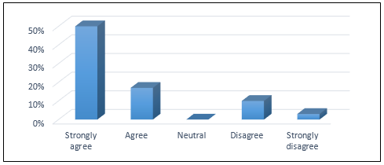
Figure 1: Response of the students
A virtual learning environment is one of the most effective ways to be used in the present days to have perfect support in the learning process without having major difficulties (Homola et al., 2017). According to the given information, a total of 67% of the students have agreed that they have proper knowledge regarding the process of using VLE to manage the learning process. Another total of 13% of the remaining participants has suggested that they have no proper information about the use of VLE in online education systems.
Question 2: Log-in gateway of the VLE is perfect?
Responses | Total number of respondents | Number of respondents | Percentage
Strongly agree | 30 | 7 | 23%
Agree | 30 | 10 | 33%
Neutral | 30 | 5 | 17%
Disagree | 30 | 5 | 17%
Strongly disagree | 30 | 3 | 10%

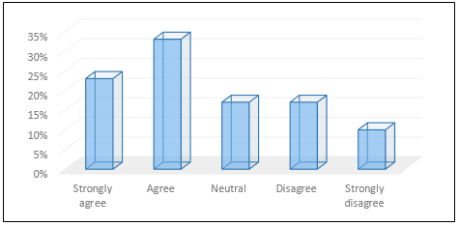
Figure 2: Response of the students
As the VLE is accessed through the online platform therefore it must have a login gateway through which the respective students can be accessing the required areas (Halili et al., 2018). Considering the purpose of the question a total of 66% of the selected students have agreed that the login gateway is perfect to use. Following that 17% of them have not provided any opinion regarding the question. However, a total of 27% of the respondents have disagreed with the fact that the online gateway of VLE works perfectly.
Question 3: Are the online classes beneficial for the students to improve their skills and knowledge on the respective courses?
Responses | Total number of respondents | Number of respondents | Percentage
Strongly agree | 30 | 5 | 16%
Agree | 30 | 18 | 60%
Neutral | 30 | 4 | 14%
Disagree | 30 | 3 | 10%
Strongly disagree | 30 | 0 | 0%

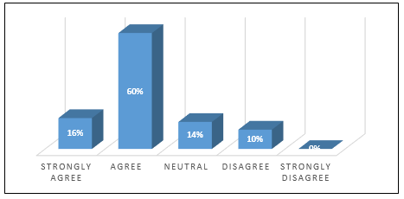
Figure 3: Response of the students
It has been observed that online classes are beneficial for the students who cannot afford to have the process of learning due to the distance of travel or other complexities. Considering the significance of the question 16% among the students have strongly agreed while 60% of them have a great following fact. However, 14% of them have been silent while providing an opinion considering the question. In that, a total of 10% of the students have disagreed that online classes can be beneficial for the students to provide educational support.
Question 4: Is the shared information in the VLE is simple to be accessed while required?
Responses | Total number of respondents | Number of respondents | Percentage
Strongly agree | 30 | 10 | 33%
Agree | 30 | 9 | 30%
Neutral | 30 | 5 | 17%
Disagree | 30 | 4 | 13%
Strongly disagree | 30 | 2 | 7%

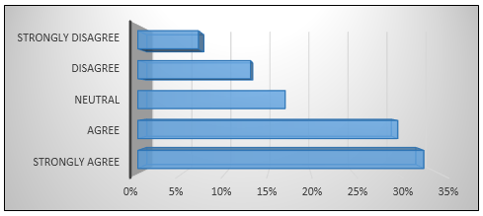
Figure 4: Response of the students
A virtual learning environment can be described as one of the most effective systems that contain essential information regarding the study courses of the respective students (Ali et al., 2017). Therefore having access to the VLE is very important for the students to extract the information that they need in the required time of learning. Considering the fact a total of 43% of the students have agreed and following them, 17% have stayed neutral in the process. On the other hand, a total of 20% of the remaining selected students have disagreed with the facts.
Question 5: Do the teachers are helpful in providing appropriate guidance for the students in the required time?
Responses | Total number of respondents | Number of respondents | Percentage
Strongly agree | 30 | 8 | 27%
Agree | 30 | 9 | 29%
Neutral | 30 | 3 | 10%
Disagree | 30 | 7 | 23%
Strongly disagree | 30 | 3 | 10%

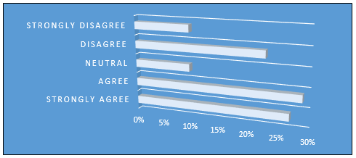
Figure 5: Response of the students
It has been observed that the teachers are very effective at providing support and guidance to the students when they require it or in the time of online classes (Reisoğlu et al., 2017). According to the participants, a total of 56% of the selected students have given their opinion that the teachers have been very proactive at providing support. However, 10% of the selected students have not spoken about it and following that a total of 33% of these selected students have not agreed with the following argument.
Question 6: Are the preferences of the online classes more than the traditional learning process?
Responses | Total number of respondents | Number of respondents | Percentage
Strongly agree | 30 | 4 | 13%
Agree | 30 | 7 | 23%
Neutral | 30 | 5 | 17%
Disagree | 30 | 8 | 27%
Strongly disagree | 30 | 6 | 20%

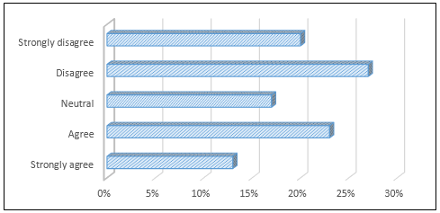
Figure 6: Response of the students
In the present days, online classes are preferred more than the traditional learning system as the outbreak of covid-19 has changed the educational systems on a large scale. Considering the fact a total of 36% of the selected respondents have supported the following argument while 17% among them have not provided any opinion. Apart from that, a total of 37% of the respondents have disagreed that online classes can be beneficial rather than the traditional learning methods.
Question 7: According to you, what is the most suitable system to be used to have perfect support in the VLE?
Responses | Total number of respondents | Number of respondents | Percentage
Laptop | 30 | 8 | 26%
Desktop | 30 | 5 | 17%
Smartphone | 30 | 6 | 20%
Others | 30 | 11 | 37%

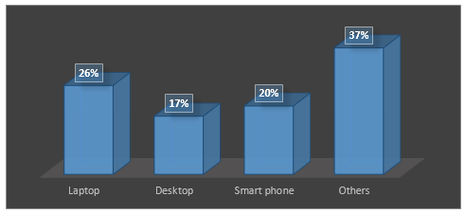
Figure 7: Response of the students
Having a perfect system enhances the process of online learning considering the access to the virtual learning environment for the respective students (Dung, 2020). 26% of the respondents have suggested that the laptop can be the most suitable device to be used while having online classes through the VLE. Knowing that 17% among them had given their opinion about the use of a desktop for the online classes however 20% of the selected students have supported the use of smartphones for having a learning process. On the other hand, another 37% of the selected students have given their opinion about other devices that can also be used in the process. Henceforth the suitability of the devices depends upon the uses for the respective individuals.

Secondary data collection
(For thematic analysis table: Refer to Appendix 2)
Theme 1: Influence of social media in the process of virtual learning environment
Technological innovation is very important for the improvement of the virtual learning environment as improved technologies provide greater advantages such as flexibility and diversity in the learning process. According to Gunawan et al., (2018), social media platforms are one of the most significant areas that are widely used by students in present days to communicate with other individuals. However, the medium of social media can be used in the process of online learning where the students can interrogate their respective teachers face-to-face regarding the learning process. Therefore the relation between the VLE and social media is very effective as the students are using both these systems in their learning process with the guidance of their respective teachers.
Theme 2: Inadequacies of current e-learning platform such as VLE
A virtual learning environment is considered one of the greatest ways of providing educational support to the students in the present days. In the words of Laeeq and Memon, (2018), some of the inadequacies have been found regarding the use of virtual learning environments and one of them is the design of the respective system. It has been observed that several students find it difficult to use the virtual learning environment systems for having support in the learning process. However, Kuzilek et al., (2018), in some of the cases teachers are not participating perfectly in the process of learning and the collaboration between the student and teacher is getting conflicted. In support of that, the major difficulties regarding the virtual learning environment should be reserved perfectly to improve the supported partition for the students to have a learning process.
Theme 3: Improvement of the student-teacher collaboration through VLE
VLE is very effective in ensuring appropriate opportunities for the students to work alongside the teachers to increase their skills and knowledge regarding the respective subject. According to Bani-Salameh et al., (2017), one of the major benefits of the virtual learning environment is to bring collaboration in the relation of student and teacher. The following process improves the interaction between the student and teacher which increases the value of learning for the respective students. However, the teachers should participate more in this process as they need to provide absolute guidance to their students to support them in the learning process.

Discussion of findings
From the assessment of collected information, it can be assumed that the VLE has become one of the most significant in the educational context that is widely adopted by the students in the present generation. Innovation in technologies has impacted the educational learning system for the students and the Teachers as online classes are becoming popular among the students. According to Goeser et al., (2018), online classes through the availability of VLE can be expressed as one of the greatest advantages to individuals who cannot afford traditional ways of learning. In support of that students are required to use a proper device that will provide them with the opportunity to access the VLE from which they can be extracting essential information that they need for their courses. However, Homola et al., (2017), suggested that an online learning system considering the VLE can be bringing a perfect collaboration in the relation between the student and teachers that will be enhancing the growth of the respective students perfectly. With respect to that, the virtual learning environment has been adopted by the students on a large scale and due to the present situation of a global pandemic; it is also helping a lot of individuals for improving the study related area.

Conclusion and recommendation

Conclusion
A virtual learning environment is very effective for the students to have an absolute chance of getting in contact with the respective teachers for the fulfillment of the learning process. There have been many advantages of the virtual learning environment as the students can have absolute support in getting information from any location without having difficulties travelling. However, the VLE is also helpful at increasing the collaboration between the students and teachers in case of having a successful learning environment. In some of the cases, different types of challenges can also be viewed, and one of the most important is the inefficient effectiveness of the respective teachers. Henceforth the teachers must be more effective at guiding the students to improve their skills in the respective area through the VLE.

Recommendation
The recommendations for the improvement of the virtual learning environment-related factors are,
- The user interface of the system should be improved and the accessibility must be increased for the students.
- The suitability of the device must be checked before using the virtual learning environment through the respective devices.
- Teachers and professors who are involved in the online learning process should be more active at guiding the respective students in the required time.
- The networking system that is used while accessing the VLE should be improved to have proper support in finding the respective information.

Reference list
Ali, D.F., Omar, M., Mokhtar, M., Ali, M., Suhairom, N., Abd Halim, N.D., Shukor, N.A. and Abdullah, Z., 2017. Enhancing students' mental rotation skills in engineering drawing by using a virtual learning environment. Man in India, 97(17), pp.161-170.
Bani-Salameh, H., Al-Gharaibeh, J., Jeffery, C. and Al-Sharif, Z.A., 2017. Collaborative education in a virtual learning environment. International Journal of Business Information Systems, 25(4), pp.474-489.
Dung, D.T.H., 2020. The advantages and disadvantages of virtual learning. IOSR Journal of Research & Method in Education, 10(3), pp.45-48.
Goeser, P.T., Hamza-Lup, F.G., Johnson, W.M. and Scharfer, D., 2018. VIEW: A virtual interactive web-based learning environment for engineering. arXiv preprint arXiv:1811.07463.
Gunawan, W., Kalensun, E.P. and Fajar, A.N., 2018, September. E-Learning through social media in the virtual learning environment. In IOP Conference Series: Materials Science and Engineering (Vol. 420, No. 1, p. 012110). IOP Publishing.
Halili, S.H., Rahman, N.H.A. and Razak, R.A., 2018. Traditional versus virtual learning: How engaged are the students in learning English literature. Indonesian Journal of Applied Linguistics, 8(1), pp.79-90.
Homola, M., Kubincová, Z., Kl'uka, J., Švolík, M., Darjanin, M. and Zapalač, P., 2017, July. Team workflow and peer review in a virtual learning environment. In 2017 16th International Conference on Information Technology Based Higher Education and Training (ITHET) (pp. 1-6). IEEE.
Huda, M., Haron, Z., Ripin, M.N., Hehsan, A. and Yaacob, A.B.C., 2017. Exploring innovative learning environment (ILE): big data era. International Journal of Applied Engineering Research, 12(17), pp.6678-6685.
Kuzilek, J., Vaclavek, J., Fuglik, V. and Zdrahal, Z., 2018, September. Student drop-out modelling using virtual learning environment behaviour data. In European conference on technology enhanced learning (pp. 166-171). Springer, Cham.
Laeeq, K. and Memon, Z.A., 2018. An Integrated Model to Enhance Virtual Learning Environments with Current Social Networking Perspective. International Journal of Emerging Technologies in Learning, 13(9).
Oubahssi, L. and Piau-Toffolon, C., 2018, March. Virtual Learning Environment Design in the Context of Orientation Skills Acquisition for LUSI Class. In CSEDU (1) (pp. 47-58).
Reisoğlu, I., Topu, B., Yılmaz, R., Yılmaz, T.K. and Göktaş, Y., 2017. 3D virtual learning environments in education: A meta-review. Asia Pacific Education Review, 18(1), pp.81-100.

Appendices
Appendix 1: Survey questions
I have complete knowledge of the systems of VLE?
- Strongly agree
- Agree
- Neutral
- Disagree
- Strongly disagree
Log-in gateway of the VLE is perfect?
- Strongly agree
- Agree
- Neutral
- Disagree
- Strongly disagree
Are the online classes beneficial for the students to improve their skills and knowledge on the respective subject?
- Strongly agree
- Agree
- Neutral
- Disagree
- Strongly disagree
Is the information that is shared in the VLE is simple to be accessed while required?
- Strongly agree
- Agree
- Neutral
- Disagree
- Strongly disagree
Do the teachers are helpful in providing appropriate guidance for the students in the required time?
- Strongly agree
- Agree
- Neutral
- Disagree
- Strongly disagree
Are the preferences of the online classes more than the traditional learning process?
- Strongly agree
- Agree
- Neutral
- Disagree
- Strongly disagree
According to you, what is the most suitable system to be used to have perfect support in the VLE?
- Laptop
- Desktop
- Smartphone
- Others

Appendix 2: Thematic table
Year | Author | Article | Theme
2018 | Gunawan, W., Kalensun, E.P. and Fajar, A.N., | September. E-Learning through social media in the virtual learning environment. | Influence of social media in the process of virtual learning environment
2018 | Laeeq, K. and Memon, Z.A., | An Integrated Model to Enhance Virtual Learning Environments with Current Social Networking Perspective | Inadequacies of current e-learning platform such as VLE
2017 | Bani-Salameh, H., Al-Gharaibeh, J., Jeffery, C. and Al-Sharif, Z.A., | Collaborative education in a virtual learning environment. | Improvement of the student teacher collaboration through VLE

