SONY Internationalization Strategic Choice Analysis

Xin Wang
1704354
Managing Internationally
SBUS6115
Contents
Executive Summary
1.0 Introduction
2.0 Strategic Choices
2.1 Entry mode
a) China
b) U.S.A.
2.2 Organisational Structure
a) China
b) U.S.A
2.3 Resource Allocation
a) China
b) U.S.A
References and Bibliography

Executive Summary
This report aims to:
Compare and contrast the strategies of entry modes, organisational structure and resource allocation that Sony Corp. have chosen to apply in China and U.S.A markets.
Explain the appropriateness and results of strategic application by researching these two market’s differences in political, economic and legal systems.

1.0 Introduction
The Sony Corp. was founded in 1946, which is considered a myth by one Japanese generation. Because it is the symbol of rapid growth and internationalization of Japanese enterprises after the Second World War(Wikipedia,2018). It is well-known that Steve Jobs was a big fan of Sony Corp. This legendary head of Apple studied Sony’s experience carefully and learned a lot from the company (Kitguru,2018).
It has been 35 years since Theodore Levitt first put forward the statement of globalization in 1983 (Harvard Business Review, 2018). With the trend towards greater economic, cultural, political and technological interdependence among national institutions and economies, most companies have entered overseas markets to cope with fierce international competition. (Quizlet,2018)
"Global localization" is always Sony Corp.’s starting point for global management.
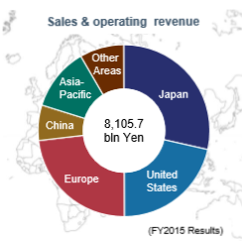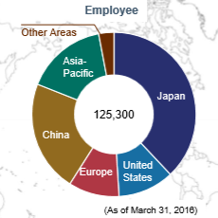
(Sony Global, 2018)
Sony Corp. has widely carried out R&D, manufacturing, sales and after-sales service in Japan, United States, Europe and Asia Pacific region including China. By 2016, the enterprise has 104 subsidiary companies (75 in overseas markets) and 125300 employees (Sony Global, 2018).

2.0 Strategic Choices
2.1 Entry mode
a) China
Sony Corp. began its business in China in 1978. They adopt multiple modes of entry in China market that include forming joint ventures, acquiring local firms and establishing new subsidiaries. Firstly, offices were set up in Beijing, Shanghai, Guangzhou and Chengdu. Thereafter, 6 large-scale manufacturing enterprises, 8 joint venture enterprises and 48 subsidiary companies were set up in the whole country. Products are made here and sold all over the world. Sony (China) Co., Ltd. was set up in Beijing in October 1996. It is a wholly-owned subsidiary that manages and coordinates Sony Corp.’s business activities in China (Sony China,2018).
Sony Corp. has expanded its investment and production in China and shifted the focus of production to mainland China since 2002. Hence, Sony Corp. business achieved rapid annual growth. By 2016, Sony Corp.’s electronic business in China had reached $5 billion with a total investment of more than $800 million (Pan, J.,2008).
Political and Legal factors:
- Chinese economic reform encouraged foreign investment
Since the reform and opening-up policy was introduced in 1978, the policies and practices of introducing foreign investment had undergone tremendous changes. In October 1986, the State Council issued the "Regulations on encouraging foreign investment” --For foreign-invested enterprises, especially those with advanced technology, would be given favourable treatment in taxes, land use fees, labour costs, profit distribution, external conditions of production and operation, etc.（Party Documents Research Office of the CPC Central Committee, 1986）. Moreover, after Deng Xiaoping's south tour speech in 1992, the pace of reform was accelerated. Relatively complete legal system was gradually being formed. These favourable policies laid political foundation for Sony Corp.'s investment in Chinese market(Liu,D., 2002).
- From joint venture to sole proprietorship
In July 1979, law on joint Chinese and foreign investment enterprises was passed and came into operation. Since that time, foreign investors can enter the Chinese market by joint venture entry mode.
However, it was not until 1986 that China promulgated the law of the People's Republic of Foreign-capital Enterprises to allow foreign investors to hold wholly owned foreign enterprise. It was with this policy that Sony Corp. was able to set up the regional headquarters in Beijing and change their view of China from manufacturing factory to sales market (SCIO,2018).
Economic factors:
- The economy downturn of Japan
Since the mid and late 1990s, affected by the financial crisis of Southeast Asian, many enterprises went bankrupt. The unemployment rate was high, Japanese economy entered a ten-year recession. To overcome challenges, Japanese enterprises had to migrate production lines. Due to the geographical and complementary advantages of industry, China had become the first choice for their international migration.
- Increasing economic strength and limitless prospect
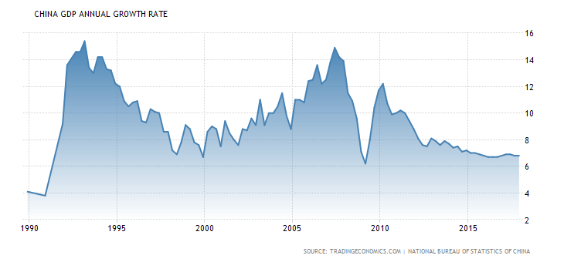
(China GDP by Trading Economics, 2018)
Along with the continually accelerated development of economic reform, the socialist market economy system was initially established, and the open economy had been formed. The productivity, comprehensive national strength and Gross Domestic Product were increasing annually. From 1978 to 2003, the average annual growth rate of China GDP was 9.4% (National Bureau of Statistics of China, 2018). In 1990s, Sony Corp. saw the limitless prospect of Chinese market and began to generate the localization strategy.
- Large market demand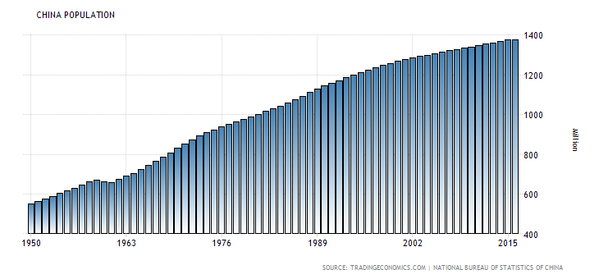
（China Population by Trading Economics, 2018）
China has huge market capacity and market demand. The population reached 9.6259 billion in 1978 (National Bureau of Statistics of China, 2018) and had soared in the next 30 years. 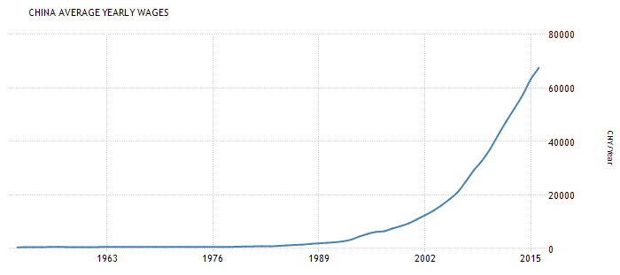
(China Average Yearly Wages, by Trading Economics, 2018)
Chinese consumption capacity and demand for digital products were becoming higher and higher with the increasing wages. Per capita income doubled from 1979 to 1990 and then doubled again in the 1990 (National Bureau of Statistics of China, 2018). To seize market opportunities, Sony Corp. was willing to spend resources and ability cultivating China market.
- Technological factors:
Sony Corp.'s electronic technology was in its heyday in 90s. There is no doubt that they have a monopoly advantage over China's backward electronic market.

b) U.S.A.
Sony adopts multiple modes of entry in United States market that include exporting, forming joint ventures, acquiring local firms and establishing new subsidiaries.
By 1960, the audio and electronic products Sony exported to the United States had generated more than half on its sales outside Japan. Morita, Sony Corp.’s founder, took an assertive stand to enter the market of United States. Firstly, they set up office in New York. Then in 1960, Sony Corporation of America was established to oversee Sony's marketing activities in the United States. Moreover, they became the first Japanese company to offer shares in the United States (Sony Global, 2018). They originally started off selling radios and television sets but have expanded broadly since then(Tiki-Toki,2018). 1968, CBS/Sony Records Inc., a 50-50 joint venture, established. It became a wholly-owned Sony subsidiary in January 1988.
Sony Corp. competed with American enterprises with aggressive low-price strategy. They penetrated into the American market and defeated a lot of American enterprises. Despite the frequent use of anti-dumping protection measures in the United States, they still occupied the market by cheaper products that with high quality.

Political and legal factors:
- predictable and transparent legal system, low taxes
For example, the internal revenue code (1986 version) stipulated a number of provisions that aimed at encouraging foreign investment. Some provisions allow a total reduction of the income tax on foreign investors (Cornell Law School,2018). Moreover, the approval procedures of foreign direct investment are as same as the local companies. Both are very favourable for Sony Corp. to enter American market.
- The United States provides a strong regime of intellectual property rights protection and enforcement (International trade administration,2018).
Economic factors:
- Huge consume market
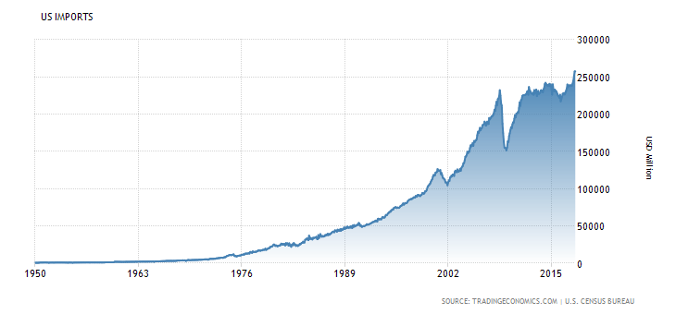
(US Imports, by Trading Economics ,2018)
Imports in the United States averaged 67377.32 USD Million from 1950 until 2018. Since 1976, the imports had been growing rapidly for 20 years.
- Large demand for electronic products
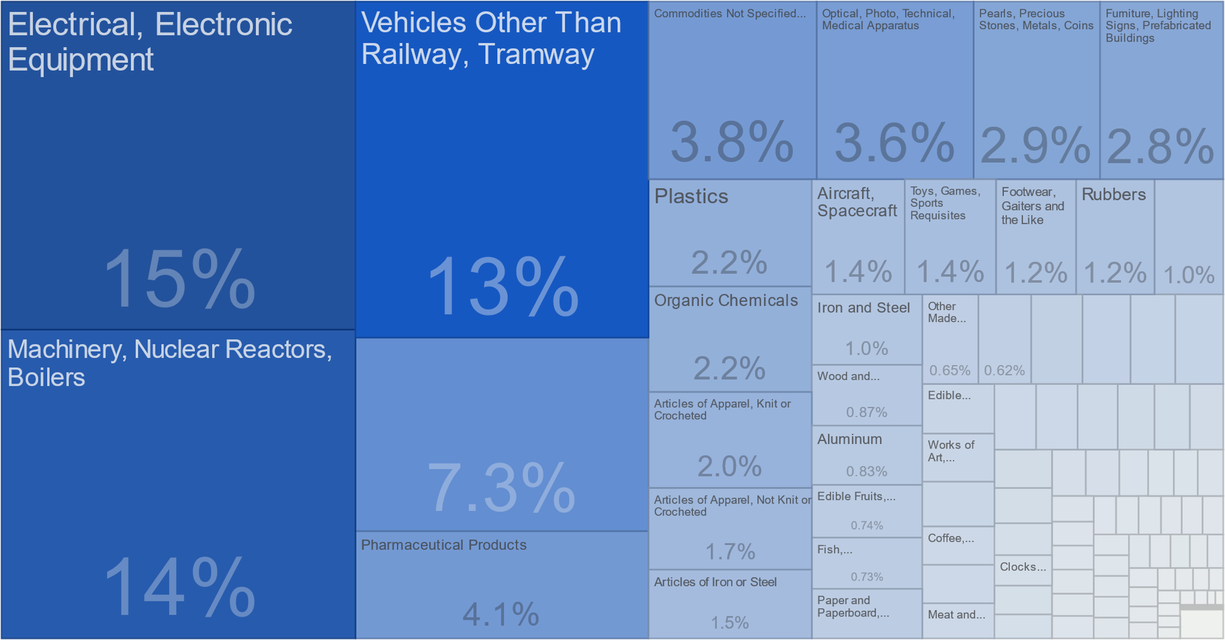
(Imports category, by Trading Economics, 2018)
As one of the most open countries in the world, the United States imports a large number of electronic products every year.
- High income
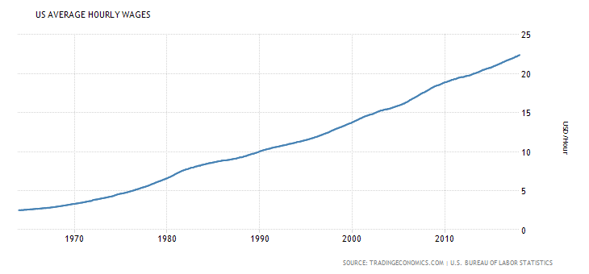
With strengthened mobility of goods, the price gap in different countries is becoming more and more narrow. As a result, purchasing power gap caused by the income gap is quite obvious.
- Social factors:
The United States is an immigrant country. Its population formed by different races, and people from different countries or regions, including whites, blacks, Asians and Pacific Islanders, Indians and so on. Different races have different cultural traditions and customs. The diversity of consume market is determined by the diverse American population.
- Technology factors
The United States is also the founder of major electronic products. The technology of television, air conditioner, VCR, DVD, computers and digital camera was created by Americans.

2.2 Organisational Structure
A. D. Chandler, a famous scholar of the United States, thought that strategies decided structures and structures followed strategies.
- Sony Corp.’s global strategy and centralized management model application in early stages
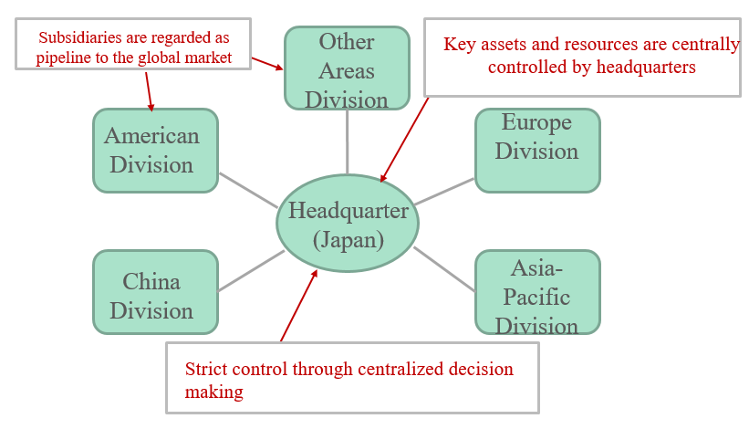
After the World War II, Japan had set up highly efficient and intensive factories. The competitive strategy of Japanese Multinationals focuses on cost advantage and product quality. Strict control of product development, procurement and manufacturing was carried out. Therefore, Sony Corp. applied an international strategy of centralized control and export oriented. Japanese culture also put emphasize on group behaviour and interpersonal harmony. As a result, Sony Corp. uses global strategy and centralized management in the early stages of entering China and American market (Zhou, W., Wu, X. and Youssef, A. B.,2017).
The global strategy tries to take standardized products and unified development strategy in all host country markets, control the decision-making power of competition strategy in the parent company, and make unified development strategy by the parent company.

- Decentralization process-transnational structure
To better adapt to global markets and improve strain capacity, at the end of 1993, Sony Corp. began to break the centralized control system of headquarters. Move part of headquarters' decision-making capacity down to subsidiaries. Since 2003, Sony Corp.’s organizational structure had gradually changed into transnational structure.
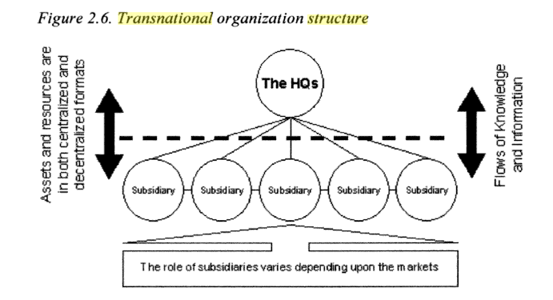
(Transnational organizational structure, Yi-chen Lan, 2005)
The transnational company seeks efficiency not for its own sake, but as a means to achieve global competitiveness. It acknowledges the importance of local responsiveness. It acknowledges the importance of local responsiveness, but as a tool for achieving flexibility in international operations (Yi-chen Lan, 2005).

the characteristics of Sony’s organizational structure:
- Function-based groups
This structural feature involves Sony’s business functions. For example, Research & Development functions are grouped together. The objective is to use the corporate structure to support functional efficiency and effectiveness. Sony has the following function-based groups in its organizational structure:
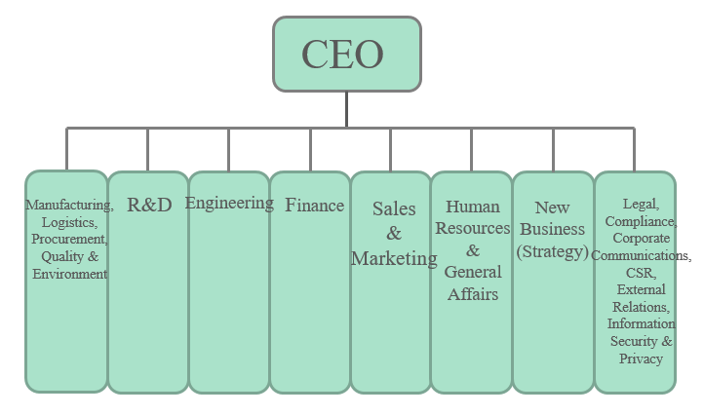
- Business Type Divisions
In its organizational structure, Sony maintains divisions based on business type or product type:
- Geographic Divisions
This structural characteristic is the least significant in Sony Corporation’s business. The company uses geographic divisions for finance, planning and strategic decision-making. For example, geographic divisions are used in financial reports. Sony uses the following geographic divisions:
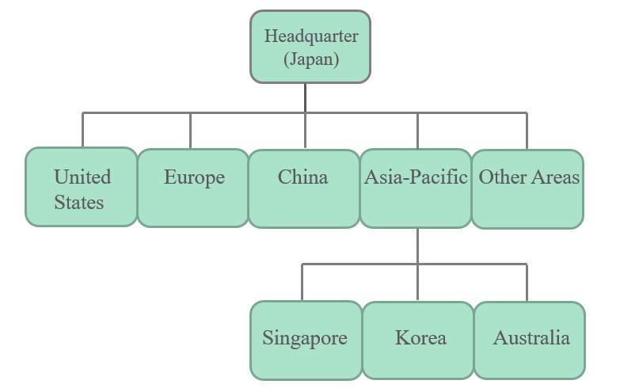

- Contrast and comparison
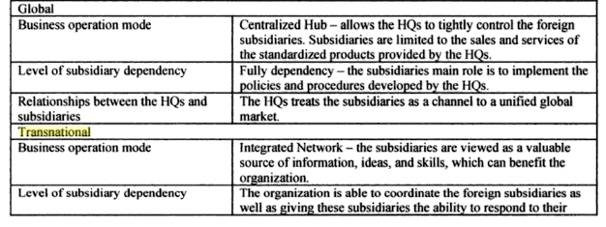

2.3 Resource Allocation
- The localization of human resources
On the one hand, SONY makes great efforts to develop local talents, on the other hand, they actively recruit local human resources. At the same time, they pay much attention to the internationalization.
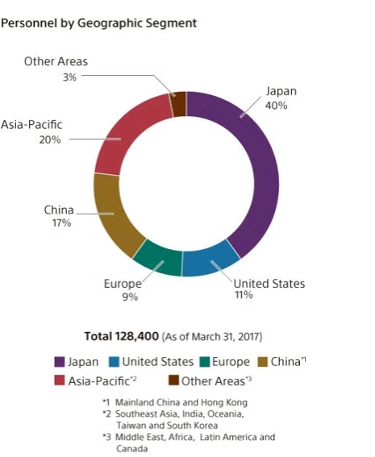
Breaking down employee numbers by geographical area, Japan accounted for roughly 40% of all Group employees as of March 31, 2017, while locations outside Japan accounted for the other 60%. The Asia-Pacific region accounted for 20%, followed by mainland China and Hong Kong (17%), the US (11%), Europe (9%), and other areas (3%)（Sony Global,2018）.

- Examples of Activities for Appointing Global Business Leaders around the World
To further grow Sony's businesses, the most important thing is to cultivate highly skilled and motivated employees from various fields and provide them with opportunities to make full use of their talents.
- Sony University was established in 2000 in the Shinagawa district of Tokyo. Its mission is to develop the people who will shape and lead management vision and strategy and build strong personal networks that facilitate Group management. The University offers short-term and long-term programs for cross-border, cross-regional, and cross-organizational development of the global leaders who will drive Sony's business forward.
For instance, potential business leaders from around the world participate in a six-month program that promotes friendly competition.
- Sony Outstanding Engineer Award
In fiscal 2003, Sony established the Sony Most Valuable Professional (MVP) Award to recognize Sony Group employees who have developed innovations that create new value for customers, and who have worked hard to solve advanced technical problems by applying specialized expertise and knowledge.
- Global Challenge Program
Sony Global Manufacturing & Operations Corporation (SGMO) has established its Global Challenge Program to enable its employees who have worked abroad to apply what they have learned after returning to Japan, thereby contributing to the development of SGMO. Under the program, SGMO sends employees to work at offices in another country to allow them to experience a different culture and become directly familiar with the dynamics of a workplace outside Japan. Each year, five employees working for SGMO are selected for a three-month program in the U.K. or Brazil.
- Reason analysis
Political factors:。
The implementation of localization of human resources can make Sony Corp. get more support from local governments.
Economic factors:
The implementation of localization can reduce their labour costs.
Social factors:
It is beneficial to open up the host countries’ markets. Local operators have a natural advantage in understanding of their own country’s operating environment.
It is easy to cross the internal cultural barriers. Local managers and their own employees grow up in the same context. So that it is easy to avoid various kinds of frictions caused by cultural differences.

References and Bibliography
Baike.com. (2018). 索尼公司_互动百科. [online] Available at: http://www.baike.com/wiki/索尼公司 [Accessed 20 Mar. 2018].
Chandler, A. (1976). Strategy and structure. Cambridge: M.I.T., pp.56-58.
Data.stats.gov.cn. (2018). 国家数据. [online] Available at: http://data.stats.gov.cn/search.htm?s=GDP1978-2003 [Accessed 20 Mar. 2018].
En.wikipedia.org. (2018). Sony. [online] Available at: https://en.wikipedia.org/wiki/Sony [Accessed 20 Mar. 2018].
Harvard Business Review. (2018). The Globalization of Markets. [online] Available at: https://hbr.org/1983/05/the-globalization-of-markets [Accessed 20 Mar. 2018].
LII / Legal Information Institute. (2018). 26 U.S. Code Subtitle A - Income Taxes. [online] Available at: https://www.law.cornell.edu/uscode/text/26/subtitle-A [Accessed 20 Mar. 2018].
Liu, D. (2002). Deng Xiaoping South Tour Speech And the cohesion of the Chinese nation. Shandong Social Science, (1003-4145), pp.11-17.
Pan, J. (2008). Sony Corp. Localization Strategy in China And Enlighten Chinese Corporation Research. MA. University of Lanzhou.
Quizlet. (2018). International Business: Ch.1 Flashcards | Quizlet. [online] Available at: https://quizlet.com/82161527/international-business-ch1-flash-cards/ [Accessed 20 Mar. 2018].
Scio.gov.cn. (2018). 首页>政府白皮书. [online] Available at: http://www.scio.gov.cn/zfbps/index.htm [Accessed 20 Mar. 2018].
Selection of the Twelfth People’s Congress. (1986). Beijing: People’s Publishing House, p.25.
Sony.com.cn. (2018). 关于索尼 - 索尼（Sony）中国网站. [online] Available at: http://www.sony.com.cn/aboutsony.htm [Accessed 20 Mar. 2018].
Sony.net. (2018). [online] Available at: https://www.sony.net/SonyInfo/CorporateInfo/data/sonysummary_en.pdf [Accessed 20 Mar. 2018].
Steve Jobs inspired some Sony products, a. (2018). Steve Jobs inspired some Sony products, and Sony inspired him - KitGuru. [online] KitGuru. Available at: https://www.kitguru.net/lifestyle/mobile/apple/anton-shilov/steve-jobs-inspired-some-sony-products-and-sony-inspired-him/ [Accessed 20 Mar. 2018].
Tiki-toki.com. (2018). Japanese Companies Entering the US Market. [online] Available at: http://www.tiki-toki.com/timeline/entry/75661/Japanese-Companies-Entering-the-US-Market/#vars!date=1960-07-26_03:35:31 [Accessed 20 Mar. 2018].
Trade.gov. (2018). Invest in America. [online] Available at: https://www.trade.gov/investamerica/index.asp [Accessed 20 Mar. 2018].
Turner, L. (1983). New theories of the multinational enterprise and Multinational enterprise and economic analysis. International Affairs, 59(3), pp.500-501.
Wang, Y. (2005). SONY Acquired Columbia Corp. IT Times Weekly, (1672-5247), pp.108-109.
Zaheer, S. and Nachum, L. (2011). Sense of place: From location resources to MNE locational capital. Global Strategy Journal, 1(1-2), pp.96-108.
Zhou, W., Wu, X. and Youssef, A. (2017). Organizational structure selection at early stages of enterprise internationalization. Management Review, 29, pp.116-126.

