
Coaching and Mentoring Skills for the Workplace
Written Reflection
Student: Cristian Dumitru – 2108821
Module Code: BMSW6105

Lecturer: Dennis Pepple
Executive Summary
Coaching and mentoring have been described in this report with a focus on the differences and uses of coaching and mentoring in the workplace. Along with this, the report has discussed the GROW model, by assessing the advantages and disadvantages of using it. Thus, realistic considerations have been offered based on the author’s formal and informal personal practice in coaching and mentoring processes. The report has also contained a critical evaluation of the theories, models, and literature with the successful implementation of coaching and mentoring.

Table of Contents
Introduction 3
Critical assessment of the determination of coaching and mentoring within a workplace 4
Define the main determinations for which coaching and mentoring can be used in the workshop 5
Critical analysis of a specific model of coaching 7
Mixed Methods Mentoring (MMM) Theory 10
Reflection on Practical 1: Coaching and Goal Setting 11
Gibbs Reflective Cycle 12
Reflection on Practical 2: Mentoring Journey and Feedback Provision 14
Conclusion 17
References 19

Introduction
The context aims to look at the significance of two closely related but different entities of coaching and mentoring in the working environment, with special emphasis on how they are defined and implemented. Stress has been laid on the appreciable aspect of the report which is a description of the GROW coaching model and real-life experiences in the areas of coaching and mentoring. This kind of report has reflective characteristics and therefore it uses the Gibbs Reflective Cycle to describe, realise, analyse, evaluate, and draw conclusions from these experiences. This report therefore seeks to draw attention to the importance of coaching as well as mentoring as a strategy for the development of human capital within organisations with a focus on learning as well as performance improvement.
Coaching and mentoring as two of the most important and popular processes in organisations have a primary focus on one person, who is an employee and contains the main potential for improvement and development within the organisation. Coaching can be short-term and long-term and often aims at helping an individual acquire new skills relevant to short-term and specific goals, thus using models such as GROW and MMM Theory. On the other hand, mentoring focuses on career and skill enhancement throughout the employee’s working life and entails knowledge exchange and rapport. The seven practices of exemplary coaching are understanding, listening, and being able to offer positive critical commentary. These concepts will be explained as well as some of the major theories and models like the GROW model and their relevance to organisations.

Critical assessment of the determination of coaching and mentoring within a workplace

Define the main determinations for which coaching and mentoring can be used in the workshop
Coaching
Enhancement of Skills: Coaching quintessence on enhancing the main specific capabilities or capabilities needed to generally meet many certain complications or to accomplish contemporary job responsibilities (Rivaldo and Nabella, 2023). In order to complete these aims, it regularly entails finding precise, achievable goals and contribution reassurance and feedback.
Enhancement of Performance: Coaches cooperate with many staff members to identify several areas of shortage in presentation and develop strategies of action to adjacent these major gaps. Regular feedback, presentation monitoring, and alterations are all part of the effective coaching procedure, which helps the staff members reach goals and intensification output (Ehrhardt and Ensher, 2021).
Goal Achievement: Employees can also accomplish both personal and professional goal lines with the assistance of effective coaching. This protection desires for mainly personal growth, meeting many project goals, and career progression.
Mentoring
Career Development: Long-term professional career growth and expansion are supported by mentoring. Counsellors support all of the mentees in circumnavigating their professional expeditions and offer counsel on their career choices and pathways.
Knowledge Transfer: Mentors communicate to several mentees their organisational information, involvement, and area of speciality (De Oliveira, 2023). This simplifies the transfer of significant knowledge and capabilities that are not frequently covered in official training sequences.
Personal Development: Self-awareness, leadership aptitudes, and personal effectiveness are all teg main areas of holistic expansion that are emphasised in effective mentoring. It motivates mentees to contemplate their compensations and shortcomings.
Comparison of Coaching and Mentoring
Focus and Scope:
Coaching: Targeting specific aptitudes, performance difficulties, or major short-term goals, coaching is frequently more concerted and short-term. It recurrently entails planned meetings with computable goals and a schedule (Rivaldo and Nabella, 2023).
Mentoring: The long-term, wide-ranging concentration of mentoring is on both personal and professional expansion. It entails unceasing, unendorsed coaching and support with a reduced focus on the precise, calculable results.
Relationship Dynamics
Coaching: A more endorsed, professional association with clearly well-defined duties is regularly encompassed in coaching. Although they may not exert themselves for the same business or have a lot of business information, the coach is talented in the coaching procedure.
Mentoring: Typically, mentoring involves a more casual, friendly association. Mentors are experienced specialists from the same corporation or sector who suggest information based on their personal qualified knowledge (Mullen and Klimaitis, 2021).
Objectives and Goals:
Coaching: The short-term, embattled goals of education include skill expansion and work presentation. Usually, a team is complicated in setting the purposes, and unvarying development reports are made.
Mentoring: The main goal lines of mentoring are individual expansion and extensive career expansion. Less assembly is used in the purposes, which modification over time in rejoinder to the mentee's requirements and goals (Smith et al., 2020).
Techniques and Strategies:
Coaching: Goal-setting, presentation intensive care, and response are just a few of the organised performances used in the coaching. Formal conferences and distinct action plans are commonly encompassed.
Mentoring: A more casual and informal method is used in mentoring. It necessitates having frequent, normally structured discussions to share involvements, give counsel, and offer sustenance.

Critical analysis of a specific model of coaching
An Explanation of the GROW Model
The acronym for the GROW model is as follows:
Goal: Require the envisioned result or purpose of the coaching meeting. In order to continue, the individual must be strong on their long- and short-term goalmouths (Grant, 2020).
Reality: Appraise the current conditions and understand the environment in which the impartiality will be skilful. Exploratory the confines and problems that happen now are part of this.
Options: Regulate possible methods and progressions of achievement to influence the unbiassed. This stage encourages ideation and also weighing dissimilar options.
Will: Determine the level of commitment to the particular course of achievement and the compulsory steps to put it into consequence. This involves finding detailed goals, due dates, and responsibility values (Mullen and Klimaitis, 2021).
Critical Analysis
Advantages of the GROW Model
Structured Framework: The GROW model suggests a systematic and transparent training technique that simplifies discussion organisation and assurances that all significant topics are enclosed. For beginner coaches or coaches who want a systematic method, this background can be especially helpful.
Goal Achievement: The GROW model helps coaches in important their goals exactly and generates the workable approaches by concentrating on goals, authenticity, selections, and will. Setting major goals and producing an action plan improves inspiration and offers a clear route ahead.
Encourages Self-Discovery: By influencing coaches to contemplate their own selections and explanations, the method inspires self-discovery and individual accountability. Greater possession of the significances and normally more long-lasting variations are the significance of this enablement (Garvey et al., 2021).
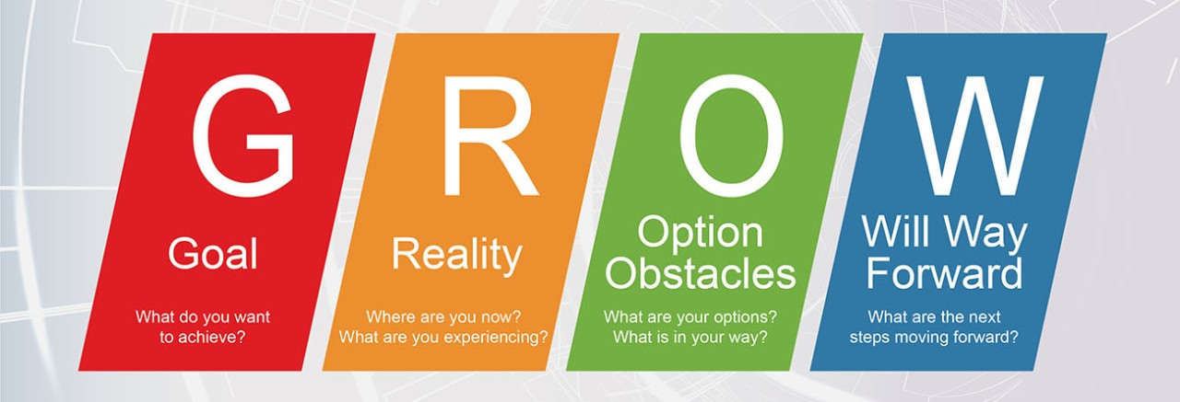
Figure: GROW Model
Source: (Grant, 2020)
Disadvantages of the GROW Model
Lack of Depth: The effortlessness of the GROW model may infrequently be a disadvantage. Its straight method might not sufficiently discourse more complicated psychological rudiments or more profound, fundamental difficulties that have an impression on presentation and goal accomplishment (Smith et al., 2020).
Overemphasis on Action: Setting major goals and organising an achievement strategy may overshadow the implication of investigative psychological and emotional complications that can lead in the way of progression. This may result in a rather mechanical coaching style.
Dependency on Coach Skill: The coach's volume to lead stimulating discussions and pose insightful interrogations is a major influence on the GROW model's effectiveness (Melo et al., 2022). Coaches with little involvement may discover it problematic to apply the perception efficiently, which could confine its encouragement.
Conditions Under Which the GROW Model Is Most Beneficial:
Performance Improvement: When entities or groups must up their game or meet the programmed goal line, the GROW models the whole thing extremely well. Its systematic method simplifies the formation of detailed goals and the expansion of workable programmes to advance presentation.
Career Development: The GROW model proposes a clear outline for background career goals, understanding present encounters, investigating several possibilities, and obligating several action plans for people observing to progress in their careers or make foremost career transmissions (Melo et al., 2022).
Project Management: The GROW model can also be used in circumstances where the operative accomplishment of a project is contingent on having well-defined purposes, practical assessments, and doable movements. It simplifies teams' attentiveness in reaching development objectives and successful challenges.

Mixed Methods Mentoring (MMM) Theory
The MMM Theory on employee development happens when there is the integration of coaching and mentoring (Melo et al., 2022). Specifically, this hybrid method means drawing on the system-driven measurable goal orientation of the coaching process in terms of the immediate. Additionally, practical, as well as the long-term relationship aspect of the mentoring model concerning career development and lifelong learning. The MMM Theory highlights the significance of the stimulus specificity, the constant sharing of knowledge, and the appreciation of change, which establishes a strong approach to reaching immediate goals and lifelong evolution (Grant, 2020)

Reflection on Practical 1: Coaching and Goal Setting

Gibbs Reflective Cycle
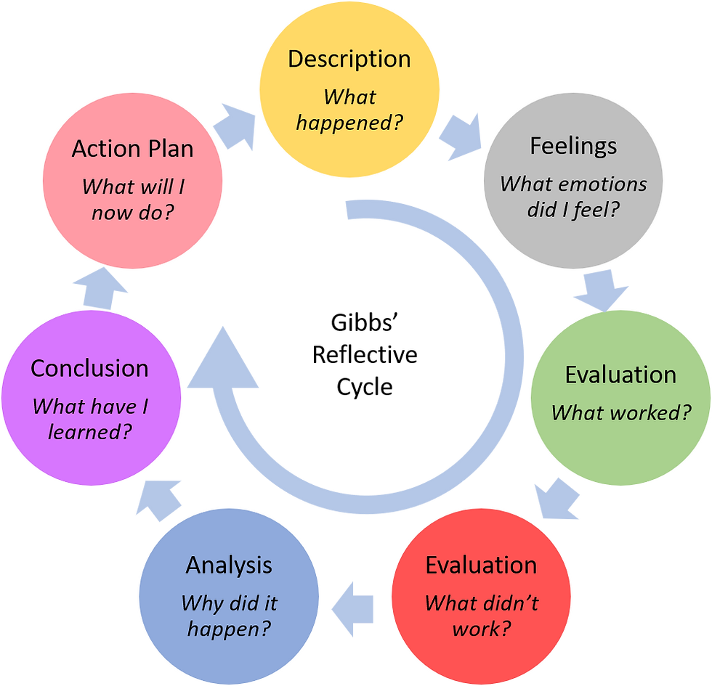
Figure: Gibbs reflective cycle
Source: (Hughes, 2020)
Description:
In Practical 1, I conducted a formal coaching session with the help of the GROW model, within which I defined my professional aims and progressed toward their accomplishment.
Feelings:
At first, I had a certain amount of anxiety and interest, regarding how developmental that can be, received through the means of coaching (Grant, 2020). When I found myself in that coaching session, I felt this kind of fear and pressure although I was happy to explore where I could improve.
Evaluation:
The first question of the coaching session Top Coaching Model was all about the Goal – my clear objective improves presentation skills in the client’s meetings. It was important to set this goal as it offered a clear focus for the discussion and my activities (Zhang et al., 2022). The GROW model was quite useful in structuring the conversation and helped direct the focus towards the skill assessment question highlighting the current level of competency and the obstacles. I used this phase to identify areas where I lacked competency and the circumstances of the environment within which my goal had to be accomplished.
Analysis:
Transferring to the Options phase, my coach urged me to generate multiple tactics and techniques for enhancing my performance in presentation tasks. I found this phase educational as it opened my eyes to the various possibilities with the task that I could adopt, right from practice, to even getting an opinion from my fellow students (Ivey and Dupré, 2022). It also stressed that there should be a variety of approaches in learning taking into account individual styles of learning and the workplace.
Conclusion:
Finally, when in the Will stage, I also mentioned the benchmarks that have to be met to achieve my goal and the steps needed to accomplish them (Hughes et al., 2020). This involved the most important element of time management to ensure the practice sessions were within the set dates and time for feedback sessions from colleagues. I was able to fully commit to these actions to the level I was sure about growth due to the clear goals outlined by the GROW model.
Action Plan:
Therefore, as a manager, I am encouraged to practice the strategies that I was going through during the coaching process. I will ensure that I regularly practice my presentation, and go ahead to seek criticisms to help me fine-tune my delivery (Theobald, 2021). Also, I plan to set time to review my progress to remind myself or fix my gaze on the objective in case I am misled.
Learning:
I was able to identify the role of structured coaching in the type of self and career development (Stoeger et al., 2021). From the case disclosed in this paper, it could be seen that the GROW model did not only provide the framework for setting the goal but also the attention to the strength and development requisite. Hence, in other leadership developmental activities, I will enact this reflective process to master coaching, as well as self-confidence.
Future Goals:
In the future, I desire to expand my understanding of coaching by gradually increasing the number of already approved models and approaches. This has other dimensions as emotional intelligence besides the application of mindfulness techniques in studying the personality of a person as personality suggests a deeper psychological view (Graßmann et al., 2020). Therefore, it was made a personal aim to increase the level of coaching experience that I possess and consequently contribute to the growth and achievement of myself, and the individuals that are assigned to my coaching responsibilities.

Reflection on Practical 2: Mentoring Journey and Feedback Provision
Engagement Description:
Practical 2 is a very important practice that I did where I assigned myself to be a mentor to improve my colleagues on project management, opting to give them constructive criticisms.
Emotional Journey:
First and foremost, for me, it was a combination of work duties and anticipation to foster my colleague’s professional development (Ivey and Dupré, 2022). This is because there was a great honour in being assigned this task, yet at the same time there was pressure in having to give the feedback constructively.
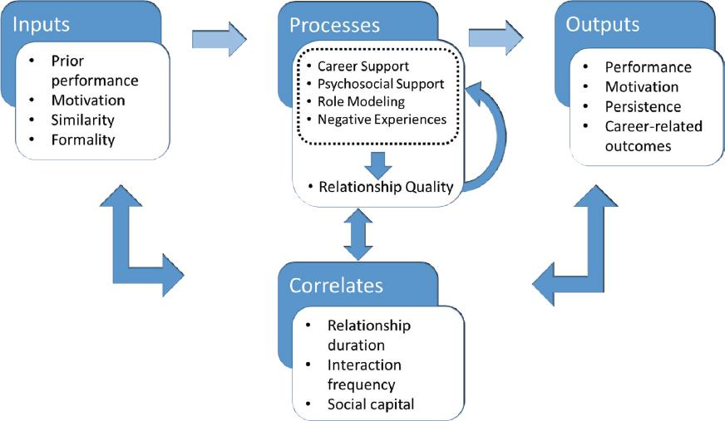
Figure: Assessment and Evaluation
Source: (Stoeger, 2021)
Evaluation of the Mentoring Session:
Probably from the very initial stages, the attitude had to be set up in such a way that everyone would be comfortable to share and be as truthful as possible. Knowing that the workshop’s aim is to create better understanding of coaching and its practical use, I focused on listening and empathy to gain insight into the colleague’s difficulties and goals (Stoeger et al., 2021). This approach I found helpful in establishing the flow of guidance that would respond to their needs to a greater extent.
Analysis of Feedback Provided:
During the session, I ensured I gave my colleague precise strategies that could be used to improve the project management practices (Gan et al., 2021). I endeavoured to make their strong points shine and at the same time, show them the aspects that could be improved to boost their efficiency drastically. This approach was also designed to begin with the process of improvement as well as to urge people to keep on thinking about improvement.
Conclusion and Action Plan:
I was able to understand that at the end of the mentoring session, we should come up with practical goals as well as timelines to achieve our objective (Grant, 2020). This entailed the area of training needs that would be important for the organisation and how the unit could enhance the approaches that would help meet those needs. Further, to enhance the level and to maintain continued growth, we agreed to meet and follow up on the progress, and to make changes where necessary.
Personal Learning and Development:
This made me understand the importance of empathy and constructive communication in building good and productive mentoring relationships (Theobald, 2021). It expanded me more knowledge regarding the application of strategic feedback as a solution in helping professionals to develop their skills besides boosting their confidence levels.
Future Aspirations:
For my future plans, I am eager to expand my knowledge concerning advanced strategies and concepts of mentoring (Zhang et al., 2022). Thus, my personal goal for the future is to remain actively involved in enhancing the positive impact on successful professional experiences of many other people, as well as to sustain the principles of progressive improvement and learning on the level of a particular team, but not only it. I want to use it to build support structures for people to provide opportunities for them to succeed in life.

Conclusion
The report has focused on the major goals, frameworks, and the real-world uses of coaching and mentoring in the effective workplace. The report has also outlined the primary goal line of coaching and mentoring, emphasising their help in managing the goal-setting, behavioural alteration, career progression, material transfer, networking, and the skill improvement. While mentoring emphasises on the long-term career and effective personal development, coaching is frequently utilised for meeting the short-term, goal-oriented responsibilities. After that, it has directed a critical examination of the GROW coaching paradigm, which has mainly been defined as an organised outline that comprises Goal, Reality, Options, and Will. Its several benefits, such as contribution to a clear framework, encouraging self-discovery, and boosting the process of motivation, were encompassed in the analysis. It has complicated reflecting on the preliminary coaching involvement, concentrating on the goal setting, communication, and action scheduling. Additionally, it has complicated reflecting on mentoring, emphasising major feedback establishment, relationship building, and long-term expansion approaches. Overall, this conversation has decorated the important impact coaching and mentoring have on discrete and also meeting organisational growth. The structured method of the coaching, as exemplified by the GROW model and MMM Theory, accompanies the holistic and relationship-focused method of mentoring. By contributing coaching and mentoring to workplace performance, organisations can foster incessant learning, improve employee appointment, and drive complete accomplishment. The analysis has been provided with a comprehensive empathetic understanding of the theoretical fundamentals, practical submissions, and reflective performances indispensable for operative coaching and mentoring in a suitable workplace.

References
De Oliveira, B., (2023). Participatory action research as a research approach: Advantages, limitations and criticisms. Qualitative Research Journal, 23(3), pp.287-297.
Ehrhardt, K. and Ensher, E., (2021). Perceiving a calling, living a calling, and calling outcomes: How mentoring matters. Journal of Counseling Psychology, 68(2), p.168. https://psycnet.apa.org/record/2020-45469-001 [Accessed Date 11 July 2024]
Gan, G.C., Chong, C.W., Yuen, Y.Y., Yen Teoh, W.M. and Rahman, M.S., (2021). Executive coaching effectiveness: Towards sustainable business excellence. Total Quality Management & Business Excellence, 32(13-14), pp.1405-1423. https://www.tandfonline.com/doi/abs/10.1080/14783363.2020.1724507 [Accessed Date 11 July 2024]
Garvey, B., Garvey, R. and Stokes, P., (2021). Coaching and mentoring: Theory and practice. Sage. https://books.google.co.in/books?hl=en&lr=&id=OsxAEAAAQBAJ&oi=fnd&pg=PP1&dq=Define+the+main+purposes+for+which+coaching+and+mentoring+can+be+used+in+the+workplace&ots=Cxxdefhmy0&sig=mN30az0CJ6BjyeK-yR7Ofb5k_x0&redir_esc=y#v=onepage&q=Define%20the%20main%20purposes%20for%20which%20coaching%20and%20mentoring%20can%20be%20used%20in%20the%20workplace&f=false [Accessed Date 11 July 2024]
Grant, A.M., (2020). An integrated model of goal‐focused coaching: an evidence‐based framework for teaching and practice. Coaching researched: A coaching psychology reader, pp.115-139. https://onlinelibrary.wiley.com/doi/abs/10.1002/9781119656913.ch7 [Accessed Date 11 July 2024]
Grant, A.M., (2020). An integrated model of goal‐focused coaching: an evidence‐based framework for teaching and practice. Coaching researched: A coaching psychology reader, pp.115-139. https://onlinelibrary.wiley.com/doi/abs/10.1002/9781119656913.ch7 [Accessed Date 11 July 2024]
Graßmann, C., Schölmerich, F. and Schermuly, C.C., (2020). The relationship between working alliance and client outcomes in coaching: A meta-analysis. Human relations, 73(1), pp.35-58. https://journals.sagepub.com/doi/full/10.1177/0018726718819725 [Accessed Date 11 July 2024]
Hughes, A.M., Zajac, S., Woods, A.L. and Salas, E., (2020). The role of work environment in training sustainment: A meta-analysis. Human factors, 62(1), pp.166-183.
Ivey, G.W. and Dupré, K.E., (2022). Workplace mentorship: A critical review. Journal of Career Development, 49(3), pp.714-729. https://journals.sagepub.com/doi/abs/10.1177/0894845320957737 [Accessed Date 11 July 2024]
Melo, S., Guedes, J. and Mendes, S., (2022). Theory of cumulative disadvantage/advantage. In Encyclopedia of gerontology and population ageing (pp. 5129-5136). Cham: Springer International Publishing.
Mullen, C.A. and Klimaitis, C.C., (2021). Defining mentoring: a literature review of issues, types, and applications. Annals of the New York Academy of Sciences, 1483(1), pp.19-35. https://nyaspubs.onlinelibrary.wiley.com/doi/abs/10.1111/nyas.14176 [Accessed Date 11 July 2024]
Rivaldo, Y. and Nabella, S.D., (2023). Employee performance: Education, training, experience and work discipline. Calitatea, 24(193), pp.182-188. https://www.researchgate.net/profile/Yandra-Rivaldo/publication/369498939_Employee_Performance_Education_Training_Experience_and_Work_Discipline/links/641ddd3092cfd54f8428ace8/Employee-Performance-Education-Training-Experience-and-Work-Discipline.pdf?origin=journalDetail&_tp=eyJwYWdlIjoiam91cm5hbERldGFpbCJ9 [Accessed Date 11 July 2024]
Smith, N.Z., Vasquez, P.J., Emelogu, N.A., Hayes, A.E., Engebretson, J. and Nash, A.J., (2020). The good, the bad, and recovery: Adolescents describe the advantages and disadvantages of alternative peer groups. Substance abuse: research and treatment, 14, p.1178221820909354.
Stoeger, H., Balestrini, D.P. and Ziegler, A., (2021). Key issues in professionalizing mentoring practices. Annals of the New York Academy of Sciences, 1483(1), pp.5-18. https://nyaspubs.onlinelibrary.wiley.com/doi/full/10.1111/nyas.14537 [Accessed Date 11 July 2024]
Theobald, M., (2021). Self-regulated learning training programs enhance university students’ academic performance, self-regulated learning strategies, and motivation: A meta-analysis. Contemporary Educational Psychology, 66, p.101976. https://www.sciencedirect.com/science/article/abs/pii/S0361476X21000357 [Accessed Date 11 July 2024]
Zhang, T., Gao, L., He, C., Zhang, M., Krishnamachari, B. and Avestimehr, A.S., (2022). Federated learning for the internet of things: Applications, challenges, and opportunities. IEEE Internet of Things Magazine, 5(1), pp.24-29. https://ieeexplore.ieee.org/abstract/document/9773116/ [Accessed Date 11 July 2024]

