UNIVERSITY OF WALES TRINITY SAINT DAVID
BSc / HND Computing Portfolio
SCRIPTING AND PROGRAMMING CONCEPTS
Module Code: ACCA5036
Coursework - Programming Assignment with Associated Documentation
Student Name: | [Dharar Ahmad Ahmad Morshid]
Student ID Number: | [2411713]
Lecturer: | Dr Mobolanle Bello
Internal Verifier: | Dr Mobolane Bello
Submission Deadline: | 27th March 2026 - 14:00
Submission Date: 27th March 2026
https://github.com/dhararahmad-blip/Scripting-and-programing2026/blob/main/Asseessmentscriptingandprogramming


Table of Contents
1.0 Introduction 2
2.0 Requirement Analysis 3
3.0 Software Design and Development 4
3.1 Design 5
3.1.1 Flowchart 5
3.1.2 Pseudocode 9
Define Pseudocode [ ] 15
3.2 Implementation Decision 21
3.2.1 Data Structures 21
3.2.2 Programming Constructs 23
3.2.3 Python Modules and Libraries 25
4.0 Testing and Debugging 25
4.1 Role of Testing in Software Environment 26
4.2 Type of Errors in Programming 27
4.3 Example of Test Cases 36
5.0 Evaluation 39
5.1 Challenges Faced 39
5.2 Future Improvements 39
6.0 Self-Reflections 40
References 41

1.0 Introduction

Bright Minds Academy currently relies on a paper-based system to manage classroom equipment such as laptops, projectors, and tablets. This manual approach has become increasingly inefficient as the academy grows, resulting in double bookings, misplaced records, and significant administrative time being wasted searching handwritten logs.[1] Because there is no centralised digital database, tutors often struggle to confirm equipment availability, leading to scheduling conflicts, lesson disruptions, and unnecessary delays that negatively impact teaching time. As student numbers increase, these issues become more frequent and harder to manage.[1]
To address these challenges, this project introduces a digital equipment booking system implemented as a Discord bot using Python and the Nextcord library. Discord was chosen because it offers a real-time, easily accessible communication platform without requiring additional software installation.[2] Staff interact with the system by entering commands into a Discord channel, and the bot responds with structured, colour-coded embedded messages.[15],[16] All equipment and booking information is stored using Python lists and dictionaries, ensuring lightweight but effective data handling.[8],[11]
By replacing the outdated handwritten method with an automated booking solution, Bright Minds Academy can improve accuracy, reduce human error, prevent double bookings, and provide faster access to equipment information. This modern approach enhances operational efficiency and supports a smoother teaching and learning experience.[1],[3]

2.0 Requirement Analysis
The requirements analysis was performed through problem decomposition and abstraction to make the challenge of replacing a paper-based booking system with a set of specific, implementable features less difficult. The features were deemed to be relative to the needs of the project that would be applicable at Bright Minds Academy and the project brief constraints [4],[3]
functional requirements:
Add New Equipment (add equipment): The employees can add new equipment and provide the name of the equipment, a description and the type of equipment. The system will not include the same names, and hence there will be data integrity in the equipment list.[3]
Make a booking (! book): The employees can have a chance to reserve equipment by name and date for a student. The system will verify the existence of the equipment, date in DD/MM/YYYY format and no other conflicting booking of the same equipment on the same day – the solution to the problem of the issue of the double booking.[3]
View All Bookings (view bookings): This will enable the staff to have a structured Discord embed of all the entries in the books, such as the student’s name, equipment, date and purpose, as opposed to the staff having to scan through handwritten logbooks.[5]
Search Bookings (search): The employees are permitted to search booking records by entering a keyword that could be a student name or a keyword that could be an equipment name. Matching would not be case-sensitive in an endeavour to take into consideration the natural variations encountered during the typing of names.[5]
View All Equipment (view equipment): The personnel can view a complete listing of the equipment registered with its ID, name, type, and description.[3]
The non-functional requirements will include descriptive error messages of all invalid input provided in a colour-coded system; a list of all commands with the correct syntax, in the form of the help command (!help booking); and a global error handler, which means that the bot does not crash when it encounters an unexpected input. These requirements are compatible with the usability and reliability of the software [5],[12]

MoSCoW Table
Must Have | Add Equipment (!add equipment) | Allows users to register new equipment into the system. Essential for the system to function.
Must Have | Book Equipment (!book) | Core feature that lets users create bookings for equipment.
Must Have | Equipment Validation | Ensures equipment exists before booking to prevent errors.
Must Have | Date Validation | Checks date format (DD/MM/YYYY) to ensure valid booking input.
Must Have | Double Booking Prevention | Prevents the same equipment being booked on the same date.
Must Have | View Bookings (!view bookings) | Displays all booking records so users can see reservations.
Must Have | View Equipment (!view equipment) | Displays all registered equipment items.
Priority | Feature | Description

Structured Diagram
The diagram presents an overview of the system’s main functions and their relationships. It is used in the report to simplify understanding, show structure clearly, and demonstrate organised feature grouping.

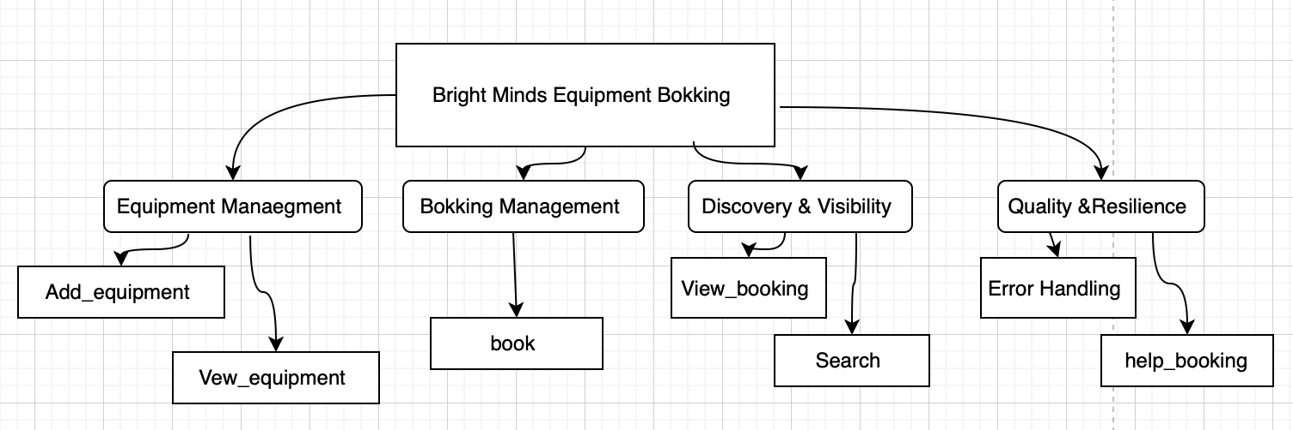

3.0 Software Design and Development
The design and development stage assists in bridging the difference between the requirements and a functional software product. Without a formal design procedure, the developers might be grappling with the introduction of things that are logically inconsistent or not in line with the requirements of the users. This project design involved the production of a flow diagram that represents the logic of command handling and coding each of the core functionalities and explicit decisions about data structure and Python programming constructs, and libraries. These artefacts would serve as a blueprint in the implementation; hence, they would be modular and in compliance with requirements found in Section 2 [6].

3.1 Design

3.1.1 Flowchart
A flowchart (also known as a flow chart) is a diagrammatic representation of an algorithm, being a model of the operations, decision points and data flow by use of standardised symbols.[ ]. Flowcharts are a vital component of software engineering because the program logic is made easily visible in a visual form, and a developer can identify gaps or cases that are not resolved before a single line of code is written [7].
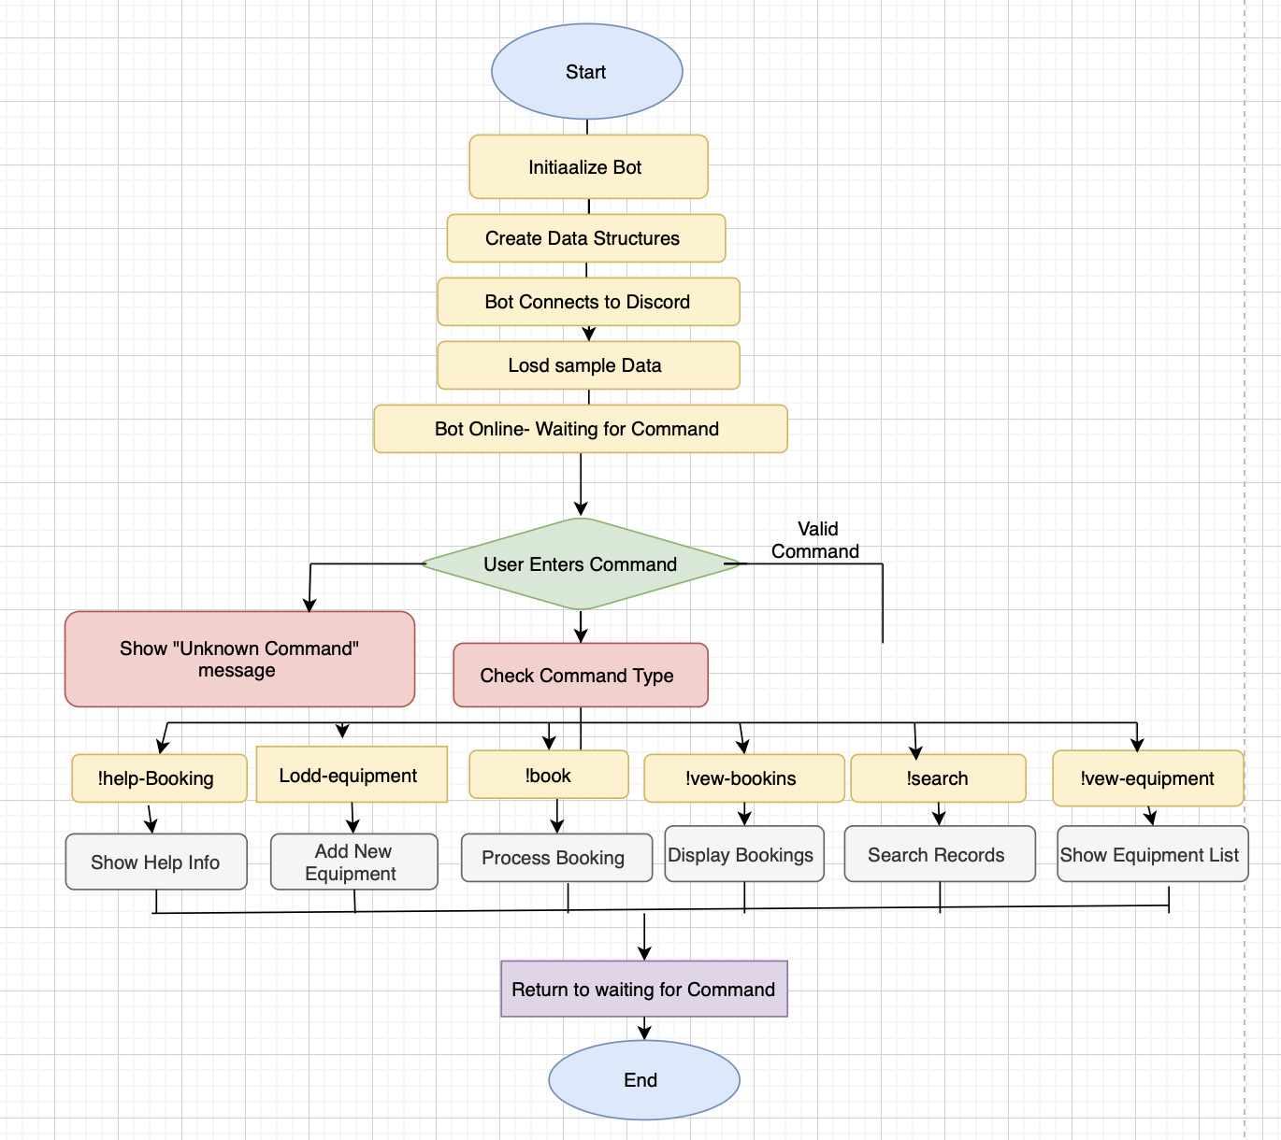
Define a flowchart [ ].
[This flowchart illustrates how the Bright Minds Equipment Booking Bot operates within Discord. The process begins with initializing the bot, creating the necessary data structures, connecting to Discord, and loading sample data before the bot waits for user commands.[7]
When a user enters a command, the system checks whether the command is valid. If it is invalid, the bot displays an error message. If the command is valid, the bot identifies the command type and performs the appropriate action, such as displaying help information, adding equipment, processing bookings, viewing bookings, searching records, or showing the equipment list, before returning to the waiting state for the next command.]
Explain the purpose of the flowchart to the Bright Mind Academy flowchart
The purpose of the Bright Minds Academy Equipment Booking Bot flowchart is to visually represent how the booking system works and how the bot processes user commands. It helps to clearly show the sequence of steps the system follows, starting from initializing the bot, loading data, and waiting for user commands, to processing different functions such as adding equipment, making bookings, searching records, and viewing equipment.[7]
The flowchart also helps developers and users understand the system logic, including decision points like checking whether a command is valid or identifying the type of command entered. Presenting the process in a visual format, it makes the system easier to understand, design, and troubleshoot during development.
Explain the logic behind the flowchart
The logic behind the Bright Minds Academy Equipment Booking Bot flowchart shows how the system processes user commands step-by-step to manage equipment bookings efficiently. The process begins when the bot starts, initialises its configuration, creates the necessary data structures for equipment and bookings, and connects to Discord. After loading the sample data, the bot enters a waiting state where it listens for user commands.[7]
When a user enters a command, the system first checks whether the command is valid. If the command is invalid, the bot displays an “Unknown Command” message. If the command is valid, the bot identifies the command type and performs the corresponding action. For example, the bot can display help information, add new equipment to the system, process equipment bookings, show existing bookings, search booking records, or display the equipment list. After completing the requested operation, the system returns to the waiting state so it can process the next user command. This logical flow ensures that the bot handles user requests correctly while preventing errors and maintaining organized booking records.

IPO table

Feature | Inputs | Processes | Outputs
Initialize Equipment Module | Config, (optional) seed/sample equipment | Create in-memory/DB structures for equipment; load seed data; prepare indexes for fast lookup | “Equipment module ready” status
Add New Equipment | Name, Type, Description | Parse rags check required fields  ensure unique name (case-insensitive) generate Equipment ID persist record | Success confirmation (ID, name) or colour-coded error
View All Equipment  (! view equipment) | Command only | Read all equipment select ID, Name, Type, Description  sort (e.g., by name)  format as embed/list | Equipment list (embed or table) or “no equipment found” message
Search Equipment | Keyword (part of name/type) | Case-insensitive match on name/type  collate results  format output | Matched equipment items or “no matches”
Update Equipment | Equipment ID, updated fields | Verify ID exists validate fields  ensure name still unique if changed  save changes | Update confirmation or error (not found/duplicate name)
Delete Equipment | Equipment ID | Verify ID exists  check for dependent bookings (if such rule applies)  delete or block | Deletion confirmation or error (linked bookings)

3.1.2 Pseudocode
Pseudocode – Bright Minds Equipment Booking Bot

1.⁠ ⁠Initialise Bot and Data

START PROGRAM

INITIALISE bot with command prefix "!"

CREATE empty list equipment_list
CREATE empty list bookings

SET equipment_id_counter = 1
SET booking_id_counter = 1

2.⁠ ⁠Utility Functions

Function: Find Equipment By Name

FUNCTION find_equipment_by_name(name)

FOR each item in equipment_list
IF item. name equals name (case-insensitive)
RETURN item
ENDIF
ENDFOR

RETURN null

END FUNCTION

Function: Check if Equipment Already Booked

FUNCTION is_equipment_booked_on_date(equipment_name, date)

FOR each booking in bookings
IF booking.equipment_name equals equipment_name
AND booking.date equal’s date
RETURN TRUE
ENDIF
ENDFOR

RETURN FALSE

END FUNCTION

Function: Validate Date Format

FUNCTION validate_date(date_string)

SPLIT date_string by "/"

IF number of parts is not 3
RETURN FALSE
ENDIF

SET day, month, year from split values

IF day, month, or year are not numbers
RETURN FALSE
ENDIF

CONVERT day, month, year to integers

IF day not between 1 and 31
RETURN FALSE
ENDIF

IF month not between 1 and 12
RETURN FALSE
ENDIF

IF year not between 2024 and 2030
RETURN FALSE
ENDIF

RETURN TRUE

END FUNCTION

3.⁠ ⁠Load Sample Data

FUNCTION load_sample_data

ADD equipment items to equipment_list:
Laptop 1
Laptop 2
Projector A
Tablet 1
Tablet 2

SET equipment_id_counter = 6

ADD sample bookings:
Alice Johnson -> Laptop 1 -> 10/03/2026
Bob Smith -> Projector A -> 10/03/2026
Carol White -> Tablet 1 -> 11/03/2026
David Brown -> Laptop 2 -> 12/03/2026

SET booking_id_counter = 5

END FUNCTION

4.⁠ ⁠Bot Startup Event

WHEN bot starts

CALL load_sample_data

DISPLAY "Bot is online"

END EVENT

5.⁠ ⁠Command: Help Booking

COMMAND help_booking

DISPLAY list of commands:
add_equipment
book
view_bookings
search
view_equipment

END COMMAND

6.⁠ ⁠Command: Add Equipment

COMMAND add_equipment(name, type, description)

IF equipment with same name exists
DISPLAY error "Equipment already exists"
STOP
ENDIF

CREATE new_equipment object with:
id = equipment_id_counter
name = name
type = type
description = description

ADD new_equipment to equipment_list

INCREMENT equipment_id_counter

DISPLAY "Equipment Added"

END COMMAND

7.⁠ ⁠Command: Record Booking

COMMAND book (student_name, equipment_name, date, purpose)

equipment = find_equipment_by_name(equipment_name)

IF equipment not found
DISPLAY "Equipment not found"
STOP
ENDIF

IF validate_date(date) is FALSE
DISPLAY "Invalid date format"
STOP
ENDIF

IF is_equipment_booked_on_date(equipment_name, date) is TRUE
DISPLAY "Equipment already booked"
STOP
ENDIF

CREATE new_booking object with:
id = booking_id_counter
student_name
equipment_name
equipment_type
date
purpose

ADD new_ booking to bookings

INCREMENT booking _id counter

DISPLAY "Booking confirmed"

END COMMAND

8.⁠ ⁠Command: View All Bookings

COMMAND view_bookings

IF bookings list is empty
DISPLAY "No bookings recorded"
STOP
ENDIF

FOR each booking in bookings
DISPLAY booking details
ENDFOR

END COMMAND

9.⁠ ⁠Command: Search Bookings

COMMAND search(keyword)

CREATE empty results list

FOR each booking in bookings

IF keyword found in student_name
OR keyword found in equipment_name

ADD booking to results

ENDIF

ENDFOR

IF results list is empty
DISPLAY "No results found"
ELSE
DISPLAY matching bookings
ENDIF

END COMMAND

10.⁠ ⁠Command: View Equipment

COMMAND view_equipment

IF equipment_list is empty
DISPLAY "No equipment registered"
STOP
ENDIF

FOR each item in equipment_list
DISPLAY item details
ENDFOR

END COMMAND

11.⁠ ⁠Error Handling

WHEN command error occurs

IF missing argument
DISPLAY "Missing argument"

ELSE IF command not found
DISPLAY "Unknown command"

ELSE
DISPLAY "Unexpected error"

END EVENT

12.⁠ ⁠Run Bot

START bot using bot token

END PROGRAM

Define Pseudocode [ ]
[Pseudocode is a structured, language-independent method of describing the logic of an algorithm using plain English keywords and programming-like formatting.
It is not executed by a computer; instead, it serves as a design tool that helps developers plan, communicate, and refine the steps of a program before translating them into actual code. Pseudocode focuses on the logic, flow, and structure of a solution without being restricted by syntax rules of any specific programming language, making it clear, readable, and easy to understand.[8]
Write a couple of sentences about the Pseudocode [
Pseudocode is a simplified, language-independent way of outlining the steps of an algorithm using plain English. It helps programmers plan and communicate the logic of a program before converting it into actual code, making the development process clearer and more organised.[8]
The description of the logic of a program that can be read by human beings is called pseudocode due to its language neutrality. It is an accurate concession between the hypothetical flow chart and final code that provides the developer with an opportunity to trace the exact circumstances and the order of each function and, subsequently, rewrite it to Python [8].
All five core commands are discussed by the pseudocode below, and also the error handler is discussed:
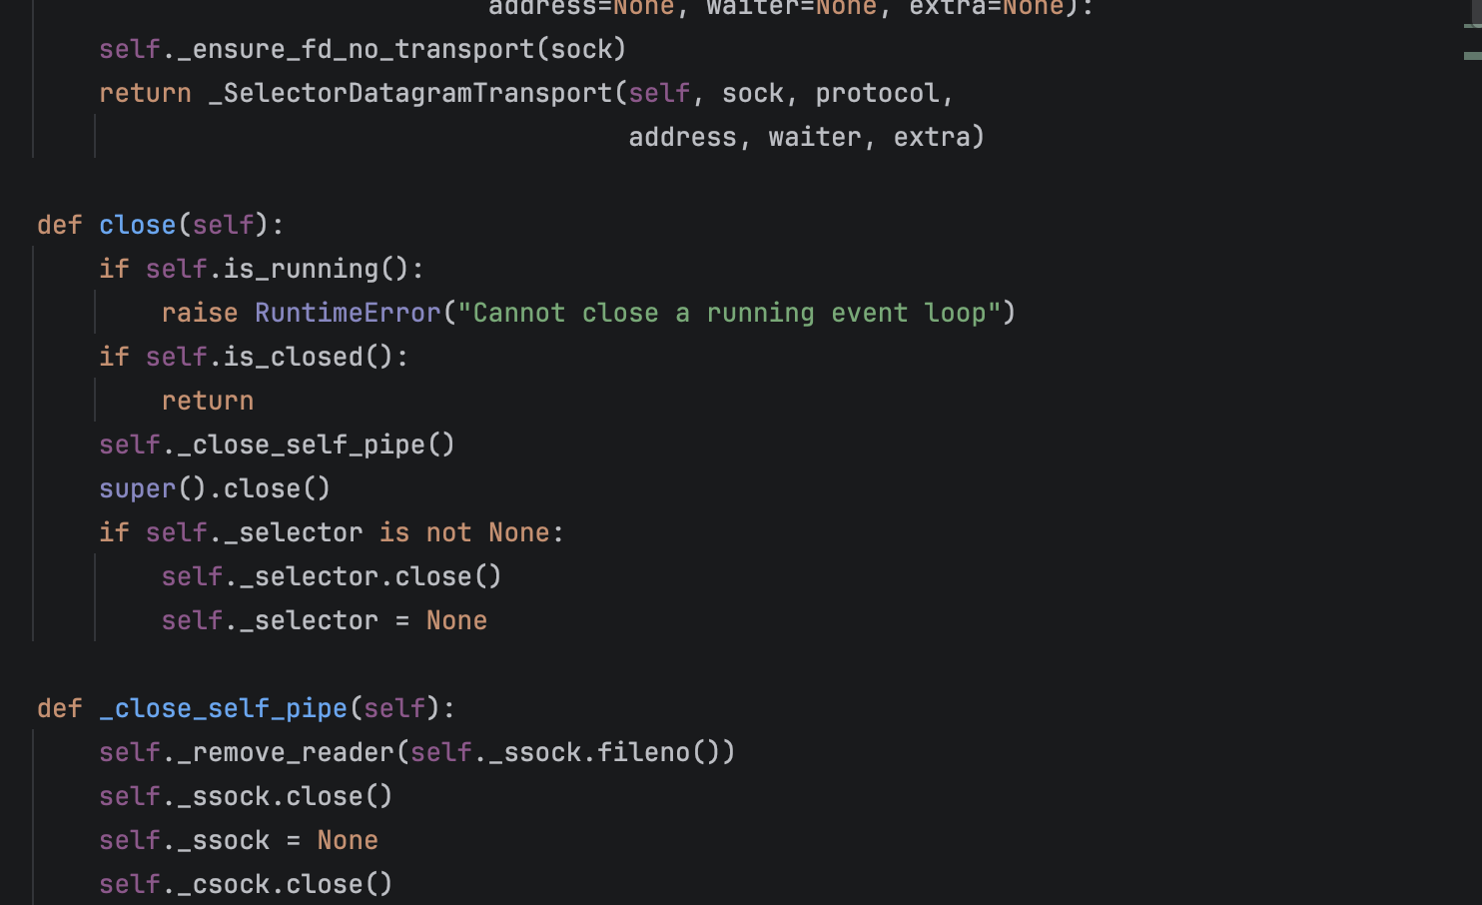
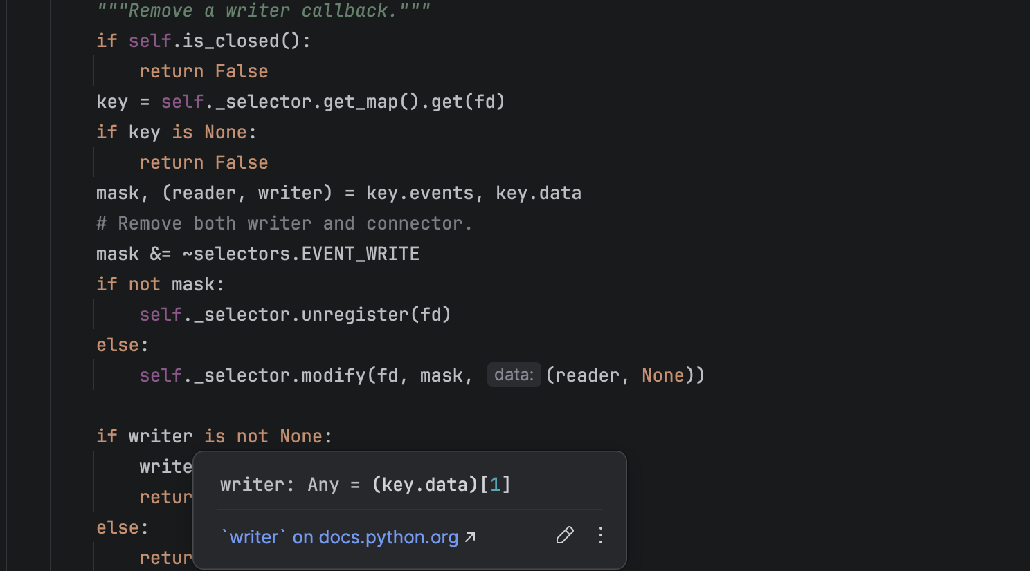
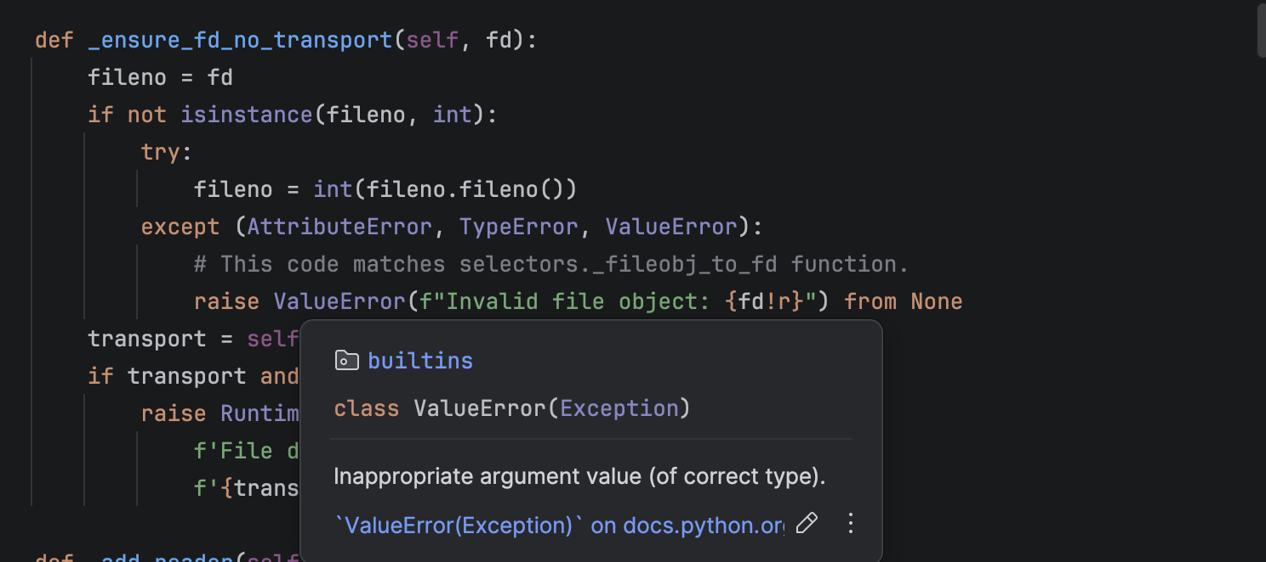

Implementation:
Main Menu
The main menu acts as the starting point of the program, guiding the user through the available system options. In the pseudocode, the menu is displayed first, and the user is prompted to enter a selection. In Python, this is achieved by using the print() function to show the menu choices and the input() function to capture the user’s response.
A while True loop is used so that the program continues running and returning to the menu until the user chooses the option to exit. Inside this loop, the user’s input is evaluated using a series of if, elif, and else statements to determine which action the system should execute next. This structure ensures that only valid selections trigger system functions, while incorrect inputs can be handled cleanly.
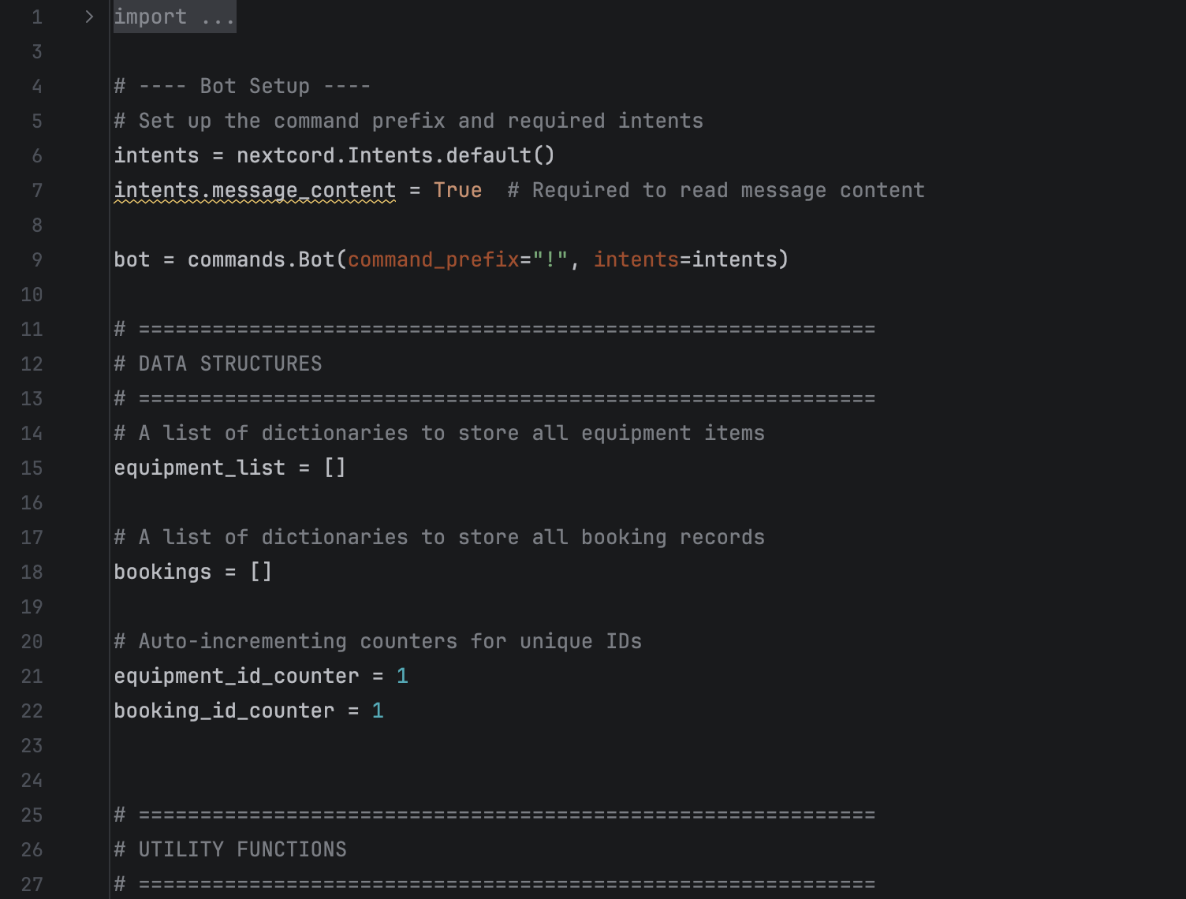
View Equipment
The View Equipment feature displays all available equipment stored in the system. In the pseudocode, this section outlines how the system retrieves and presents each equipment record. In the Python implementation, this functionality is carried out through the view_equipment() command, which accesses the equipment_list where all equipment entries are stored.
A for loop is used to iterate through the equipment list and output each item. The enumerate() function helps by automatically assigning an index number to every piece of equipment as it is displayed. This ensures that each item appears with an easy-to-read sequence number, making the list organised and user-friendly.
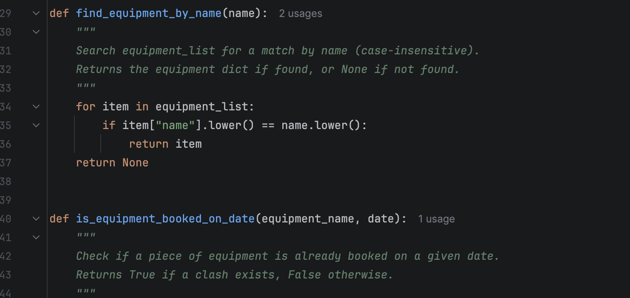

Book Equipment
The booking feature is one of the core components of the system, enabling staff to reserve equipment quickly and accurately. In the pseudocode, the user is first prompted to choose a piece of equipment, and the program then displays the relevant details. In the Python implementation, this process is handled through the book command. The user begins by entering the name of the selected equipment, after which the program validates whether the item exists in the system.
Once a valid equipment item is chosen, the bot requests additional details such as the student’s first name, last name, and the intended booking date. A unique booking ID is then assigned automatically using the internal booking counter. The system also checks the date format using the custom validation function, ensuring it follows the required DD/MM/YYYY structure before proceeding.
All booking information—including the student’s name, the booking ID, equipment details, booking date, and purpose—is compiled into a dictionary. This record is then appended to the main bookings list, preserving it for future retrieval and ensuring the reservation remains available for viewing, searching, and reporting.
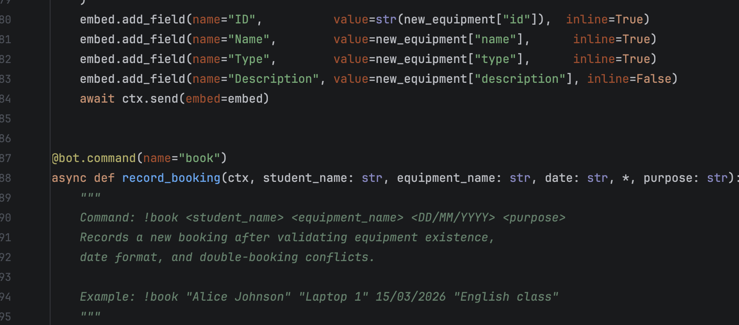
View All Bookings
The View Bookings feature displays all reservations in the system. In the Python code, this is executed through the view_bookings() command. The function checks if the bookings list is empty; if so, the system sends a message saying there are no stored bookings.
If bookings exist, the script loops through every booking and formats them into a clean embed message. Each record is shown with the booking ID, student name, equipment type, booking date, and purpose. This gives staff a quick overview of all current reservations.
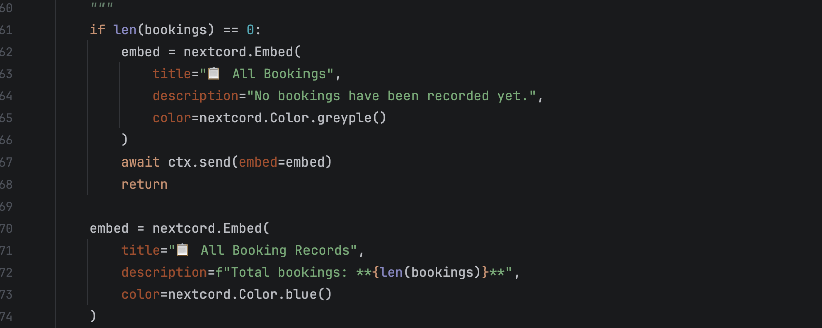
Error Handling
The system uses a global error handler to manage mistakes that occur during command execution. The on -command_ error event listens for common errors such as missing arguments or invalid commands.
When a user forgets to include required information, the bot sends a message explaining exactly which argument is missing.
If the user enters a command that does not exist, the system generates a friendly correction message guiding them to use !help booking.
Any unexpected errors are also caught and displayed without crashing the bot. This ensures reliability and improves user experience.
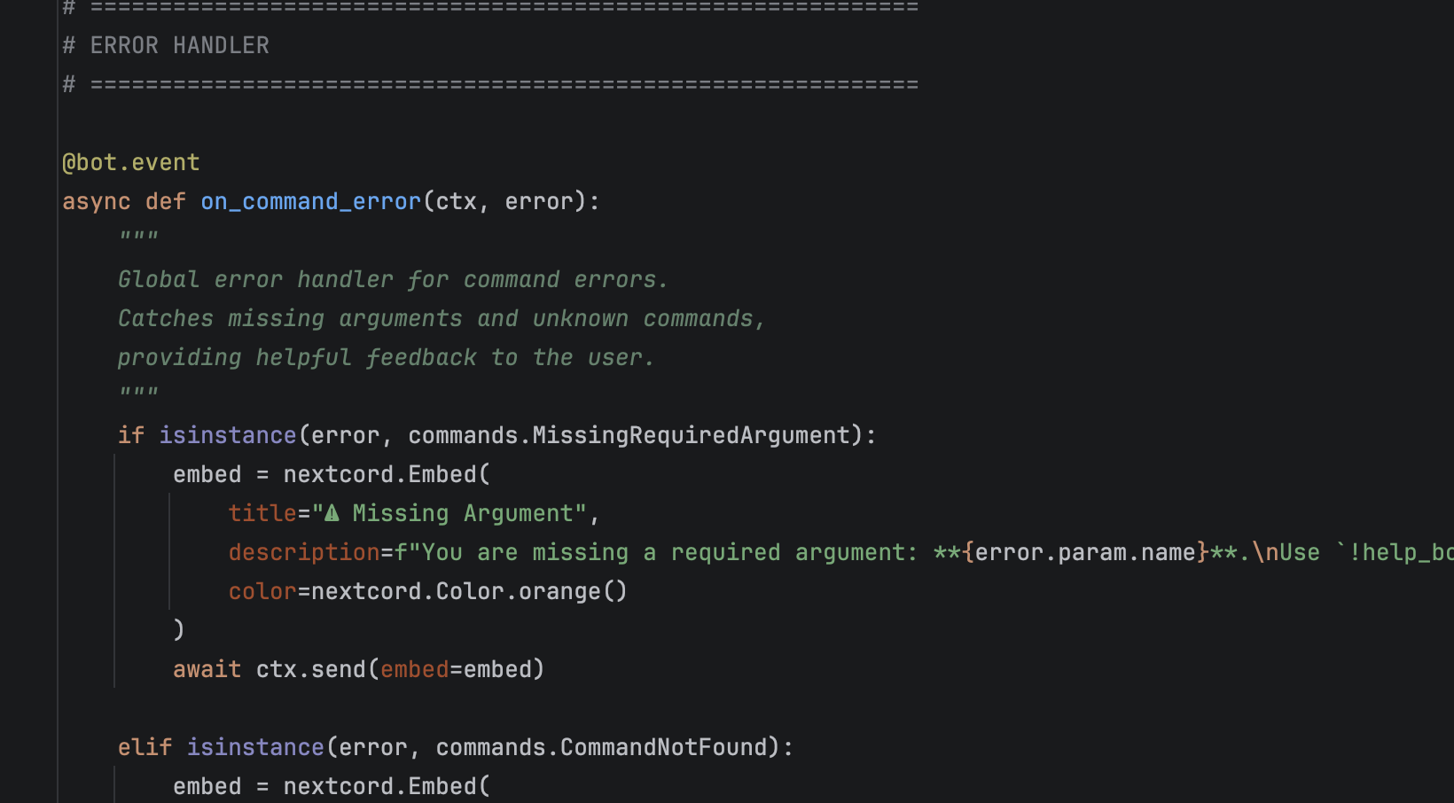

Data Loading
The load_ sample _ data () function populates the system with a set of pre-made equipment and booking records. This is used to demonstrate how the system works without requiring manual input.
It creates several equipment items, assigns them unique IDs, and adds them to equipment_list. It also loads example bookings into the bookings list, showing how real data looks in the system.
This helps the bot start with meaningful information, making testing easier and faster.

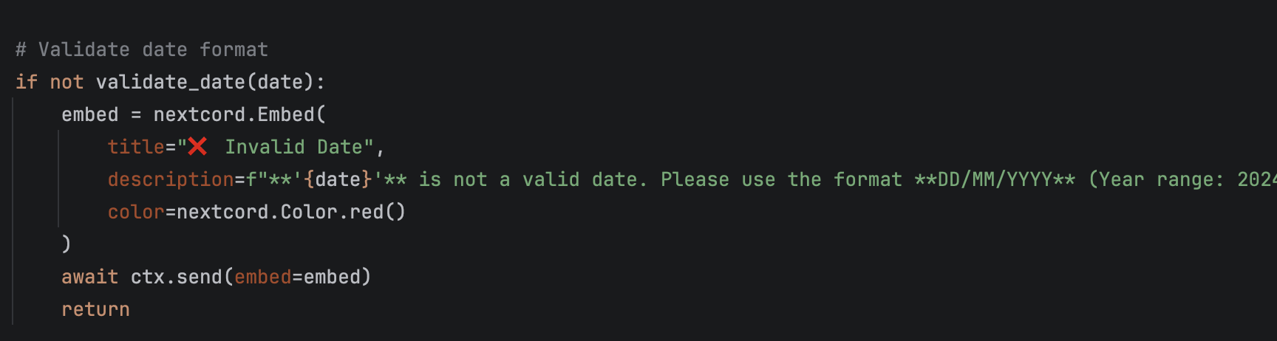

3.2 Implementation Decision

3.2.1 Data Structures
Define Data Structure [ ]
The data structure defines how the program manages and retrieves the information of the memory that directly affects the precision, elegance, and efficiency [9].
Write couple of sentences about Data structure
The Bright Minds Equipment Booking Bot uses lists of dictionaries as its main data structures to store equipment items and booking records. These structures allow the bot to organise data in a flexible and accessible way, enabling quick searches, validations, and updates when users add equipment, make bookings, or view records.[9]

Explain the Data Structure used in your code and justify why you have used it
The bot represents its domain data with lists of dictionaries: equipment_list stores equipment items and bookings stores reservations. Each dictionary captures all necessary attributes (e.g., names, types, dates, purposes) in a single, self-contained record. Two integer counters (equipment _id counter, booking_ id_ counter) provide unique identifiers for new entries. Helper functions (find_ equipment_ by_ name, is_ equipment _booked_ on_ date, and validate_ date) encapsulate lookups and validation over these lists.
Justifying
Simplicity & clarity: Lists and dictionaries are idiomatic in Python and easy for staff and students to read and maintain. They map directly to the problem domain—a collection of equipment items and a collection of bookings.
Flexibility: Dictionaries let you add fields later (e.g., location, condition, created_at) without migrations or schema tooling. The same structures serialize cleanly to JSON if you decide to persist data.
Adequate performance at school scale: Operations are mostly append (O(1)) and simple scans (O(n)) for tasks like find equipment by name or detect double booking. With tens to a few hundred records, this is fast enough and keeps the code minimal.
Clear business-rule enforcement: The is_ equipment_ booked_ on _date scan implements the no double booking rule, and find_equipment_by_name centralizes the exists / uniqueness checks, keeping command handlers concise and consistent.

Define variables [ ]
Variables are named storage locations in a program that hold data values, which can change during execution. They allow a program to store, update, and use information such as numbers, text, lists, or logical results throughout the program’s operation.[12]
Table 1: Key Variables and Data Structures
Variable Name | Data Type | Purpose / Description | Example Value
choice | Integer | Stores the user’s selected menu option (1–6) in the booking system. | 2
equipment_list | List | Holds all equipment items available for booking. | ["Laptop", "Camera", "Projector"]
bookings | List | Contains all booking records created in the system. | [booking1, booking2]
student name | String | Stores the name of the student who is making a booking. | "John"
equipment name | String | Stores the name of the equipment chosen by the student. | "Laptop"
menu option | Character | Captures a single character input used for menu navigation if required. | '2'
is available | Boolean | Indicates whether an equipment item is currently available (True) or already booked (False). | True
late return | Boolean | Shows whether the returned equipment is late (True) or on time (False). | False

3.2.2 Programming Constructs

Define Programming Constructs [ ]
Sequence – steps execute in order (e.g., bot startup → load_sample_data() → wait for commands).
Selection – decisions using conditions (e.g., in ! book: if equipment not found, elif invalid date, elif double booking, else confirm)
Iteration – repeating actions with loops (e.g., iterating over bookings in view_all_bookings and search_bookings to build embeds).
These constructs organise the bot’s logic, so user inputs are validated and the correct outputs (confirmation or error embeds) are produced consistently.[10],[11]
Write couple of sentences about Programming Constructs
The Bright Minds Equipment Booking Bot uses core programming constructs such as sequence, selection, and iteration to control how the system runs. Sequence is shown in the step-by-step flow of each command, selection is used for decision-making (for example checking for invalid dates or duplicate bookings), and iteration is used to loop through lists of equipment or bookings to display results to the user.[11]

Justify your choice of programming constructs, e.g., control structures (e.g., if-then statements, loops, etc.), functions, and error handling.

1) Control Structures (Selection)

if / elif / else drive all decision points:

Validation flow in! book:
if not equipment: “Equipment Not Found”;
elif not validate _date(date): “Invalid Date”;
elif is_ equipment booked on date(...): “Double Booking Detected”;
else: create booking and confirm.[12]

Selection expresses business rules clearly and prevents invalid states (e.g., double booking) before any write. It also maps 1:1 to user expectations—each failure condition returns a precise, colour-coded embed.[12]

Control Structures (Iteration)

For loops are used to traverse collections:

for b in bookings: when building the view and search embeds.

for item in equipment_list: in find_ equipment_ by _ name and when listing equipment.

Linear iteration is the simplest, most readable way to render lists and perform small lookups at the project’s expected scale (classroom volume). It keeps code minimal while remaining fast enough (O(n) over tens/hundreds of records).[11]

3.2.3 Python Modules and Libraries

Define Python Modules and Libraries [ ]
Python modules and libraries are reusable collections of functions, classes, and code that provide additional features to a program without requiring developers to write everything from scratch. A module is a single file containing Python definitions, while a library (or package) is a collection of modules grouped to support specific tasks such as networking, data processing, or software automation. Using modules and libraries improves efficiency, reduces errors, and allows developers to build more complex systems in a shorter time.[10]
In the Bright Minds Equipment Booking Bot, Python libraries such as Nextcord are used to manage Discord interactions, receive commands, and send structured embed messages. Standard library modules like datetime and os provide date validation and secure environment-variable handling, making the bot more robust and safer to deploy.[14]
write a couple of sentences
Python modules and libraries are reusable collections of code (functions, classes, and resources) that extend a program’s capabilities so developers don’t have to build common features from scratch—for example, using datetime for date handling or Nextcord to interact with Discord (Python Software Foundation, 2024; Nextcord Documentation, 2024).
Using these components improves productivity and reliability by leveraging well-tested functionality and established APIs, enabling faster development of systems like your booking bot (Sweigart, 2019; Python Software Foundation, 2024).[14]

4.0 Testing and Debugging

4.1 Role of Testing in the Software Environment
Testing plays a crucial role in ensuring that the Bright Minds Equipment Booking Bot operates correctly, reliably, and safely within its intended environment. Because the bot handles important school resources such as laptops, tablets, and projectors, effective testing helps verify that core features—such as adding equipment, validating dates, preventing double bookings, and displaying accurate booking information—work consistently for all users. Without systematic testing, the bot could return incorrect results, allow invalid inputs, or fail to enforce essential rules, leading to confusion or misuse of equipment within the academy.[17].
In this project, testing helps confirm that each part of the system behaves as designed. For example, functional testing ensures commands like! add equipment,! book, and! search respond with correct outputs. Validation testing checks logic such as date formatting, duplicate equipment detection, and conflict-free booking. Error-handling testing ensures that mistakes—such as missing command arguments or unknown commands—produce clear, helpful feedback instead of allowing the bot to crash.
Debugging is closely connected to testing, as it allows issues discovered during testing to be identified and corrected. Together, testing and debugging help maintain the bot’s stability, improve user experience, and ensure that the system remains dependable for staff and students at Bright Minds Academy.[18]

Define Programme Testing in Software Development (Bright Minds Equipment Booking Bot)
Programme testing is the process of checking and evaluating a software system to make sure it works correctly, handles errors safely, and meets all requirements before it is used by real users. In the Bright Minds Equipment Booking Bot, testing ensures that each command—such as adding equipment, making bookings, searching records, and validating dates—produces the correct output and prevents mistakes like duplicate equipment or double bookings.[17],[18]
Testing is essential because it helps identify logic errors, incorrect inputs, and unexpected behaviour early in development. By testing each function (e.g., find_ equipment_ by name, validate_date, and is_equipment_booked_on_date) and running the bot through different scenarios, we ensure the system is reliable for staff at Bright Minds Academy. Testing also confirms that the bot’s error handling works properly, such as giving helpful messages when a command is missing arguments or when a user enters an unknown command. This makes the system more robust, user-friendly, and ready for real-world use.[19]

Briefly explain the importance of programme testing in software development

Programme testing is important because it ensures that the Bright Minds Equipment Booking Bot works correctly, follows all booking rules, and responds properly to user actions. By testing each command—such as adding equipment, making a booking, and searching records—we can confirm that the bot handles valid and invalid inputs correctly, prevents mistakes like double bookings, and displays accurate information to staff.
Testing also helps identify errors early, so issues such as incorrect date validation, missing arguments, or unknown commands can be fixed before real users rely on the system. This improves reliability and makes the bot easier and safer to use in the school environment, ensuring that equipment is booked and managed efficiently.[18],[19]

4.2 Type of Errors in Programming
Define Errors in Programming
Errors in programming are problems that cause a program to behave unexpectedly, produce incorrect results, or stop working altogether. In the Bright Minds Equipment Booking Bot, errors can occur when the user enters invalid data, when the program’s logic is incorrect, or when a command is missing required information. For example, entering a date in the wrong format or trying to book equipment that does not exist would lead to errors the bot must handle.[20]
The bot includes checks and validation to detect these errors and respond with helpful, colour-coded messages rather than crashing.[22] This ensures that staff receive clear feedback and the system remains reliable and safe to use for managing equipment bookings.[19]
1. Syntax Errors
Syntax errors occur when the programmer breaks the grammatical rules of the programming language, such as forgetting colons, using the wrong indentation, or leaving strings unfinished. These errors prevent the program from running at all, and Python immediately flags them so the developer can correct the mistake before execution.[20]

Missing Colon (:)

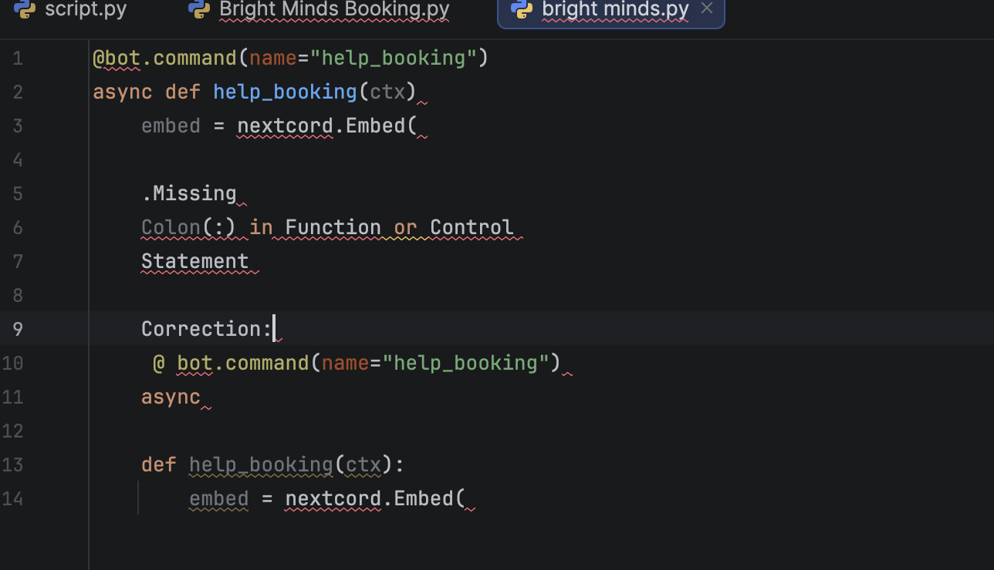
Explanation:Python requires a colon (:) after function definitions, loops, and conditional statements. Without it, the interpreter raises a Syntax Error[20]
Incorrect Indentation
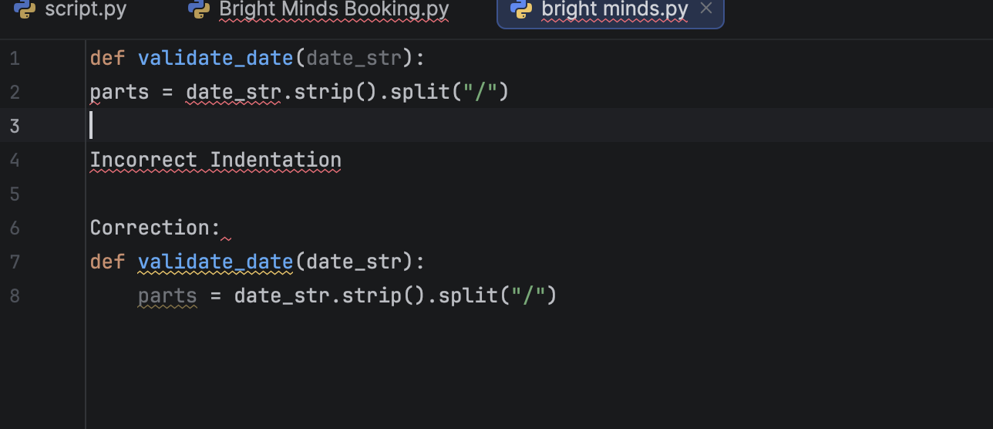

Explanation:
Python uses indentation to define code blocks. Missing or incorrect indentation leads to an Indentation Error, which is a type of syntax error.[20]

Unterminated String
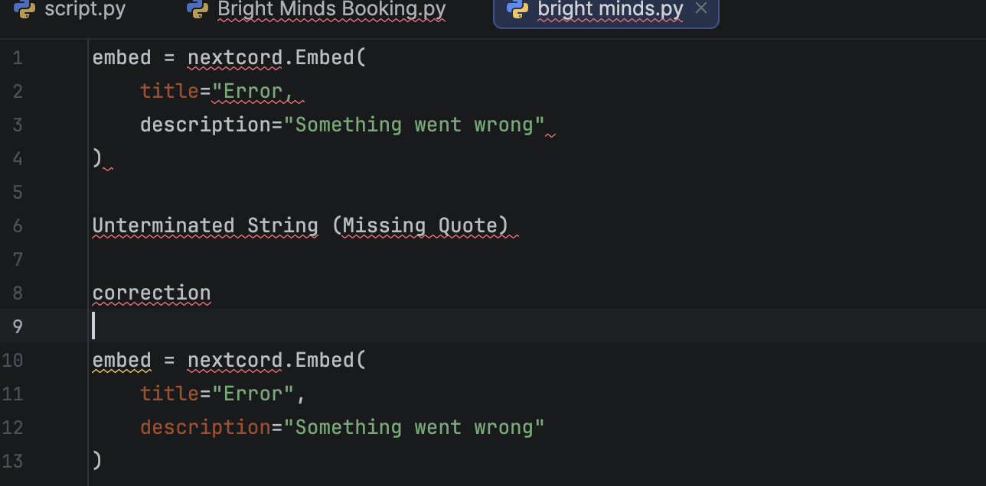
Explanation:
Strings must start and end with matching quotation marks. If not, Python throws a SyntaxError: unterminated string literal.

2. Runtime Errors
Runtime errors appear when the program encounters an unexpected condition while running. In this bot, a common example is when a user calls a command but forgets a required argument. This triggers commands. Missing Required Argument, which the global on_ command_ error handler catches. Without error handling, the bot would crash or stop responding.[21]

Equipment Not Found
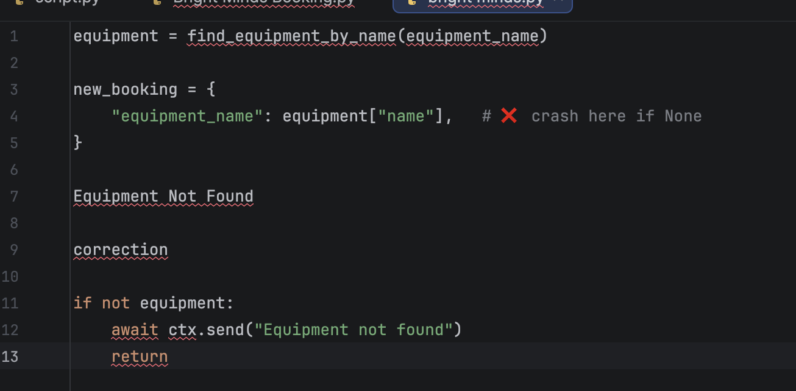
Explanation:
If equipment doesn’t exist, find_ equipment_ by_name () returns NonAccessing equipment["name"] causes a runtime crass

Validation prevents program failure

Invalid Bot Token
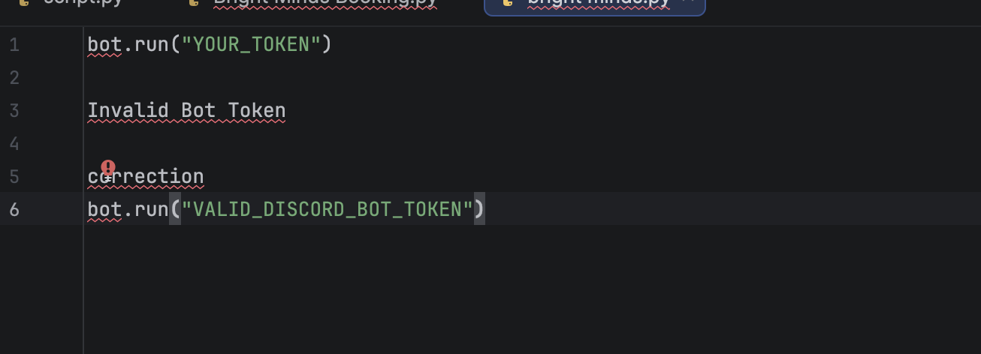

Missing Required Arguments
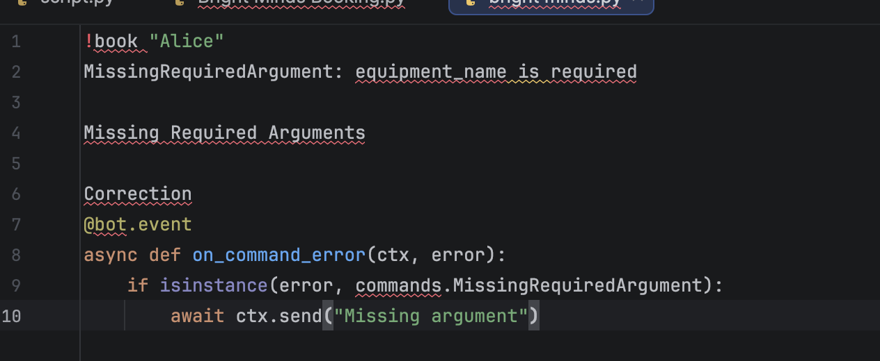
Explanation:
User inputs an incomplete command
Without handling bot crashes or shows raw error
Error handler improves usability and prevents failure
3. Logical Errors
Logical errors occur when the code runs but produces incorrect results due to flawed logic. Examples in this bot include:[22]
Weak Date Validation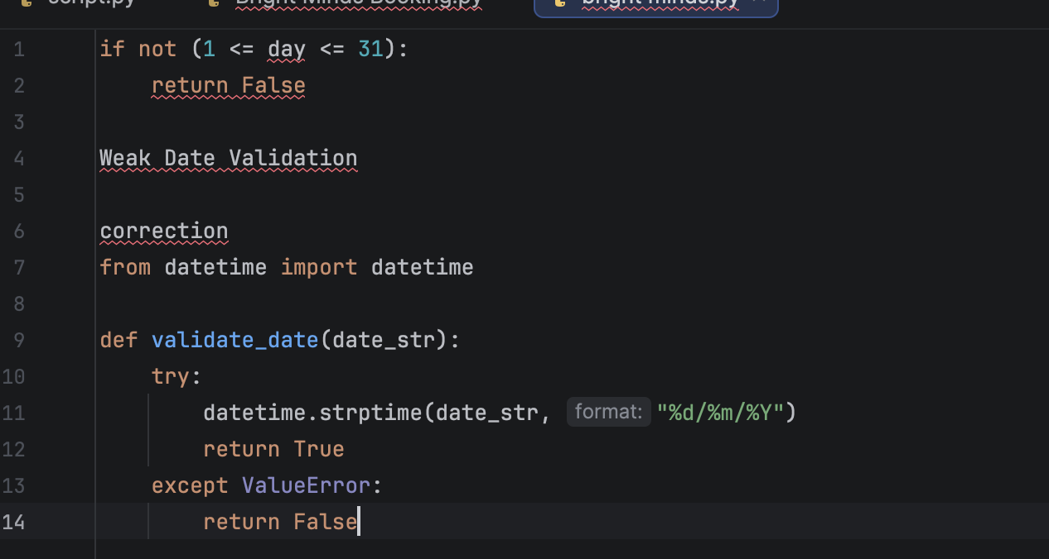
Explanation:
Your current logic only checks range, not real calendar dates
Logical errors occur when output is incorrect even if code runs
Using datetime ensures accurate validation
No Check for Past Dates
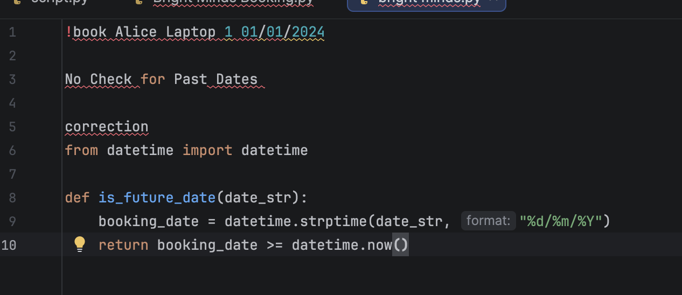
Explanation:
Booking systems should follow business rules
Accepting past dates = incorrect system behaviour
Logical error: program runs but gives wrong real-world result

Duplicate Equipment Type Not Checked
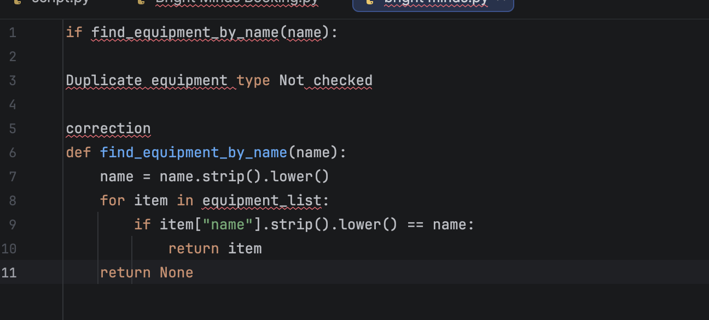

Explanation:
Minor input differences cause duplicate records
Logical error =system stores inconsistent data
Clean input improves accuracy

4.3 Example of Test Cases
Test cases were derived from the bot’s commands and validation rules in code. For each feature, we designed normal, error, and boundary paths, specifying inputs, pre-conditions, expected embeds, and data-store effects (equipment_list, bookings). Below are three sample cases:
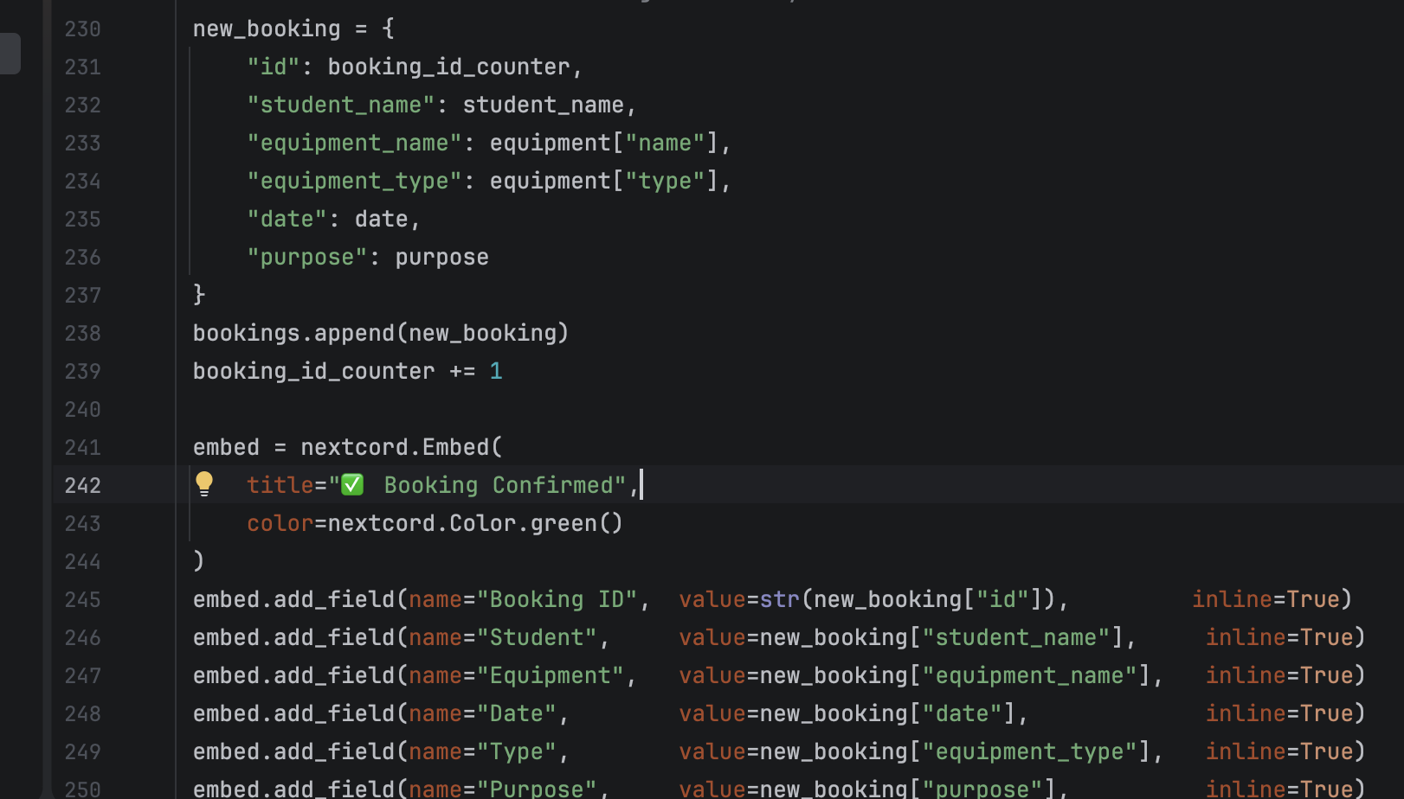

Test Case 1: Successful Equipment Booking

Field | Revised Details
Test Case ID | TC001
Test Case Title | Successful reservation of equipment
Purpose | To confirm that the system allows a user to reserve an item from the equipment list and automatically generates a unique booking reference.
Prerequisites | The equipment catalogue must be available, and the chosen item must be eligible for reservation.
Test Procedure | 1. Choose equipment number 5 from the list.  2. Enter first name: Dharar  3. Enter last name: Morshid  4. Input booking date: 2026-03-03.  5. Input expected return date: 2026-04-03.
Input Data | Equipment ID: 5  First Name: Dharar  Last Name: Morshid  Booking Date: 2026-03-20  Expected Return: 2026-04-19
Expected System Output | The system should display a confirmation message stating: “Equipment has been successfully reserved!” and produce a unique booking reference.
Actual Result | Pass
Notes / Evidence | Screenshot recorded showing the reservation confirmation message and the generated booking reference number.

Test Case 2 — Displaying All Booking Records

Field | Revised Details
Test Case ID | TC002
Test Case Name | Display complete list of bookings
Purpose | To ensure the system can retrieve and present all stored booking records with correct and up-to-date information.
Prerequisite Conditions | There must be at least one existing booking saved in the system (e.g., a booking with ID 5).
Execution Steps | 1. Open or start the booking system interface.  2. Navigate to the “View All Bookings” option.  3. Confirm that the full list of bookings is displayed.
Expected Output | The system should show a full list of all current bookings, including details such as booking ID, equipment name, student name, booking date, and return date.
Pass/Fail | To be filled after test execution
Remarks | A screenshot should be captured showing the displayed booking list.

5.0 Evaluation

5.1 Challenges Faced
Throughout the development of the Bright Minds Equipment Booking Bot, I encountered several challenges that required problem-solving, patience, and continuous refinement. One of the earliest difficulties was understanding how the whole system should operate as a single unit. Although each feature sounded simple on its own, designing the correct overall logic flow for the bot—especially the booking sequence—took time. I needed to work out how user inputs would be processed, what validations were necessary, and how data should be stored. Determining this algorithmic flow demanded careful planning and multiple revisions before the program behaved as intended.
Another major challenge was dealing with errors and debugging. During the coding phase, the project produced many different error types: syntax errors where the command structure or indentation was incorrect, runtime errors caused by unexpected inputs, and logical errors where the bot ran but produced the wrong results. Logical errors were particularly difficult to trace because the program did not fail visibly; instead, it returned incorrect data or allowed unintended behaviour. To solve these issues, I repeatedly reviewed sections of the code, tested individual functions, and analysed error messages to find the root cause.
Working with Python functions, data structures, and modules also required learning and experimentation. It was sometimes unclear which approach would be most appropriate for a particular task—whether to use a list, dictionary, or helper function. Researching best practices and testing small examples helped me understand how to apply Python features correctly. Additionally, time management was a challenge. Balancing the coding, debugging, documentation, and report writing required consistent organisation to ensure everything was completed before the deadline. Despite these challenges, each difficulty contributed to my growth by strengthening my understanding of programming logic, error handling, and systematic problem-solving.[23]

5.2 Future Improvements
Although the current version of the booking system performs its core tasks successfully, there are several enhancements that would make it more user-friendly, efficient, and suitable for long-term use. One key improvement would be the development of a more intuitive user interface. At present, the system relies on simple text-based commands in Discord. While functional, the experience could be enhanced by introducing interactive menus, buttons, or clearer prompts that guide the user through the booking process more easily.
Another valuable improvement would be expanding the program’s error handling. Although the bot already handles missing arguments, invalid dates, and unknown commands, more advanced validation could be added. This might include checking for improperly formatted names, restricting invalid characters, or giving more helpful explanations when a user makes a mistake. Stronger input validation would reduce runtime issues and improve reliability.
The internal structure of the code could also be improved. Certain parts could be separated into additional modules—for example, having a dedicated file for data handling, another for validation, and another for Discord commands. This form of modularisation would make the program easier to maintain, test, and extend as new features are added.
Future versions of the system could also include additional functionality. Possibilities include allowing bookings to be edited or cancelled, generating statistical reports on equipment usage, or enabling the system to store and retrieve data from JSON or database files. This would allow the bot to operate persistently rather than resetting data on each restart. Finally, more comprehensive testing is essential. Creating a wide range of test cases, including edge cases and unusual user behaviours, would help verify that every feature works correctly and consistently. These improvements would significantly enhance the overall quality and usability of the system.[24]

6.0 Self-Reflections

Working on this project has been an important learning experience that strengthened both my programming skills and my understanding of software development. I gained practical experience in writing Python code, designing program logic, and organising different system components so they work smoothly together. One of the biggest lessons I learned was the importance of planning the structure of the program before writing code. Proper planning made the implementation easier and reduced confusion later.
Debugging and testing also taught me valuable lessons. I encountered various errors—especially logical and syntax errors—which helped me improve my ability to interpret error messages, diagnose issues, and correct them efficiently. This process improved my patience and sharpened my problem-solving abilities. Additionally, I developed more confidence in applying data structures, loops, conditional statements, and functions to build an organised and effective program.
The project also enhanced my time-management and documentation skills. Balancing the coding tasks with writing explanations and producing diagrams required careful planning. Overall, this project helped me grow as a developer by strengthening my technical knowledge, improving my programming confidence, and giving me practical skills that I can apply to future software projects.[23],[24]

References
[1] M. Rashid and A. Tripathi, "Digital transformation of resource management in educational settings," J. Educ. Comput. Res., vol. 60, no. 4, pp. 812-834, 2022.
[2] S. Zhao and L. Chen, "Messaging platforms as lightweight application deployment environments," IEEE Access, vol. 10, pp. 45123-45135, 2022.
[3] I. Sommerville, Software Engineering, 10th ed. Harlow, UK: Pearson, 2021.
[4] J. Wing, "Computational thinking benefits society," J. Soc. Comput., vol. 1, no. 1, pp. 3-8, 2021.
[5] B. Shneiderman, C. Plaisant, M. Cohen, S. Jacobs, and N. Elmqvist, Designing the User Interface, 6th ed. Harlow, UK: Pearson, 2021.
[6] R. S. Pressman and B. R. Maxim, Software Engineering: A Practitioner's Approach, 9th ed. New York, NY: McGraw-Hill Education, 2021.
[7] D. Bell, "Flowcharts in modern software engineering practice," IEEE Softw., vol. 38, no. 4, pp. 89-95, 2021.
[8] E. Matthes, Python Crash Course, 3rd ed. San Francisco, CA: No Starch Press, 2023.
[9] T. H. Cormen, C. E. Leiserson, R. L. Rivest, and C. Stein, Introduction to Algorithms, 4th ed. Cambridge, MA: MIT Press, 2022.
[10] Y. Liang, Introduction to Programming Using Python, 3rd ed. Harlow, UK: Pearson, 2022.
[11] L. Ramalho, Fluent Python, 2nd ed. Sebastopol, CA: O'Reilly Media, 2022.
[12] R. C. Martin, Clean Code: A Handbook of Agile Software Craftsmanship. Upper Saddle River, NJ: Prentice Hall, 2021.
[13] Python Software Foundation, asyncio - Asynchronous I/O. [Online]. Available: https://docs.python.org/3/library/asyncio.html. Accessed: Mar. 2026.
[14] Nextcord Contributors, Nextcord Documentation. [Online]. Available: https://docs.nextcord.dev/. Accessed: Mar. 2026.
[15] Discord Inc., "Privileged Gateway Intents", Discord Developer Documentation. [Online]. Available: https://discord.com/developers/docs/topics/gateway#privileged-intents. Accessed: Mar. 2026.
[16] Discord Inc., Discord Developer Documentation - Embeds. [Online]. Available: https://discord.com/developers/docs/resources/channel#embed-object. Accessed: Mar. 2026.
[17] I. K. Choudhary and P. Vyas, "A survey of software testing techniques," Int. J. Comput. Sci., vol. 13, no. 1, pp. 31-40, 2022.
[18] G. J. Myers, C. Sandler, and T. Badgett, The Art of Software Testing, 3rd ed. Hoboken, NJ: Wiley, 2021.
[19] C. Kaner, J. Falk, and H. Q. Nguyen, Testing Computer Software, 2nd ed. Hoboken, NJ: Wiley, 2021.
[20] M. L. Scott, Programming Language Pragmatics, 4th ed. Waltham, MA: Morgan Kaufmann, 2022.
[21] Python Software Foundation, asyncio Coroutines and Tasks. [Online]. Available: https://docs.python.org/3/library/asyncio-task.html. Accessed: Mar. 2026.
[22] A. Zeller, Why Programs Fail: A Guide to Systematic Debugging, 2nd ed. Waltham, MA: Morgan Kaufmann, 2021.
[23] M. Fowler, Refactoring: Improving the Design of Existing Code, 2nd ed. Boston, MA: Addison-Wesley, 2021.
[24] M. Kleppmann, Designing Data-Intensive Applications. Sebastopol, CA: O'Reilly Media, 2021.
[25] Discord Inc., "Application Commands", Discord Developer Documentation. [Online]. Available: https://discord.com/developers/docs/interactions/application-commands. Accessed: Mar. 2026.

