Simon Gwyn Richards (1809846)
UWTSD
Scenic assessment of Gower and Swansea beaches

Contents
1. Introduction
2. Study area
2.1 Site description
2.2 Shoreline management plan
2.3 Designation
2.4 Flora and Fauna
3.0 Methodological assessment
4.0 Results
5.0 SWOT analysis of beaches
6.0 Discussion
7.0 Other methodologies of scenic assessment
8.0 Implications and contrast of different methodologies
9.0 Site management recommendations
10.0 Conclusion
11.0 Reference list

Scenic assessment of Gower and Swansea beaches
1.Introduction
Coastal habitats are dynamic environments where different ecosystems marine, freshwater and land meet. While these ecosystems are vital and fragile, the coastal zone provides outlets for rivers, protection against erosion, transport links and the most favoured environment for tourism, the largest global industry. (Houston, 2002; Lencek, 1998).
The rich biosphere is at great risk of loss of biodiversity with increasing pressure from anthropogenic demands upon the fragile environment. (Beatley, 2008) Infrastructure, buildings, visitors, all require sustainable management to protect the sensitive coastlines and meet economic and human needs. (Phillips, 2006). Climate change is causing additional threat due to sea level rise over 3mm per annum putting pressure on existing shorelines. Rising Waters (nasa.gov) Adaption management to the increasing risks and effects of climate change are necessary (Kron,2008).This demands a holistic approach to sustainable management of our coastline incorporating all stakeholders. (IUCN, 1994 ;Salomons, 1999; Von, 2001). Understanding and applying appropriate weighting to often competing needs of the various stakeholders using the beaches and coastline is important. (Phillips, 2008).The scope of this report is to evaluate six beaches in The Gower and Swansea and recommend sustainable and appropriate management considering physical biological and human impact factors
2.0 Study area
2.1 Site description
Located west of United Kingdom in South Wales on the Bristol channel ,the area studied is between Carmarthen Bay to the west extending to Swansea Bay on the eastern end. Swansea Bay and the Gower(Grid Reference SS495835) has seventeen beaches, most located along a rugged limestone coast. The six beaches in this study west to east are: Rhossili, Mewslade, Oxwich, Caswell, Swansea bay and Aberavon.

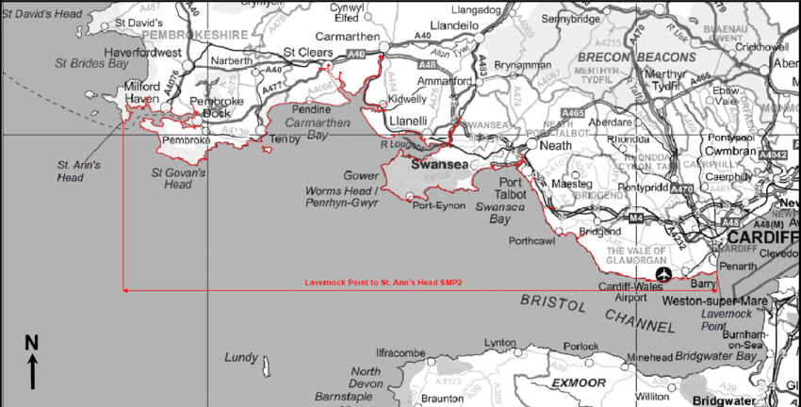

Fig 1. . SMP2 Lavernock Point to St Ann's Head ( image from Griffiths 2019)

2.2 Shoreline Management Plans (SMP) (EA, 2015)
SMPs are in place for all the coastline of the United Kingdom divided into coastal zones. The section extending from St Ann’s Head to Great Orme covers South West Wales and West Wales and has the second highest global tidal range, a mean spring tidal range of 8.1m (Griffiths, 2019). SMPs need regular monitoring and updating with local data from scientific objective analysis as coastal environments constantly change due to pressures from nature and man. Existing legislation is an essential consideration and physical, biological and social factors all need inclusion.
2.3 Designations
The Gower was designated Area of Outstanding Natural Beauty (AONB) in 1956 and is largely owned by The National Trust. (Robinson, 1983) Also designated a Heritage Coast (Swansea.gov.uk 2017) with National Nature Reserves (NNR), sites of Special Scientific Interest (SSSI), Gower Special Area of Conservation (SAC) and Important Plant Area (IPA).The Gower includes Biodiversity Action Plan (BAP) priority habitats of lowland heath, lowland acid and calcareous grassland, sand dunes and maritime cliff . South Gower Coast, Rhossili to Oxwich (swansea.gov.uk, 2019)

2.4 Flora and Fauna
With over 700 species of plants, some rare in the UK, yellow whitlow grass the only site in Britain and burnt tip orchid in Oxwich dunes, the only known site in Wales. (Plantlife 2020).
Many important bird species are found here, Green woodpecker, Chough, Greenshank, Lapwing, Purple sandpiper, Kestrel, Peregrine falcon and Dartford warbler. Discover Gower Birdlife (The Gower society 2020).
3.0 Methodological assessment
Normally site visits would be part of this methodology but due to Covid restraints it has had to be undertaken from photographs which is an accepted methodology. A method of assessment using beach rating checklists (see table 1) was used comparing physical, biological and human use for each beach (Leatherman, 1998). 50 parameters were listed and scored from 1= least favourable to 3 =most favourable. The scores were sub totalled by each category and totalled. All scores had equal weighting and were normalised using function analysis.
Table 1

4.0. Results
Graph 1 Physical scoring with Caswell 51 Oxwich 50 Rhossili 48 Mewslade 47 Aberavon 45 and Swansea bay 40.

Graph 1
Graph 2 Biological scoring Rhossili, Mewslade and Caswell all 30 , Oxwich 27 Swansea 19 and Aberafon 17.

Graph 2.
Graph 3 Human impact Caswell 60 Oxwich 56 Rhossili and Mewslade 55 Swansea 43 and Aberafon 39.

Graph 3.
Graph four Combined results of physical, biological, and human results with Oxwich 144 Caswell 40 Rhossili 133 Mewslade 132 Aberafon 103 and Swansea 100.

Graph 4 Combined results

In graph 5 combined results were normalised to give equal weighting to each. Oxwich 2.94 Caswell 2.85 Rhossili 2.69 Mewslade 2.69 Aberavon 2.10 and Swansea 2.04

Graph 5

5.0 SWOT analysis of the beaches
Rhossili
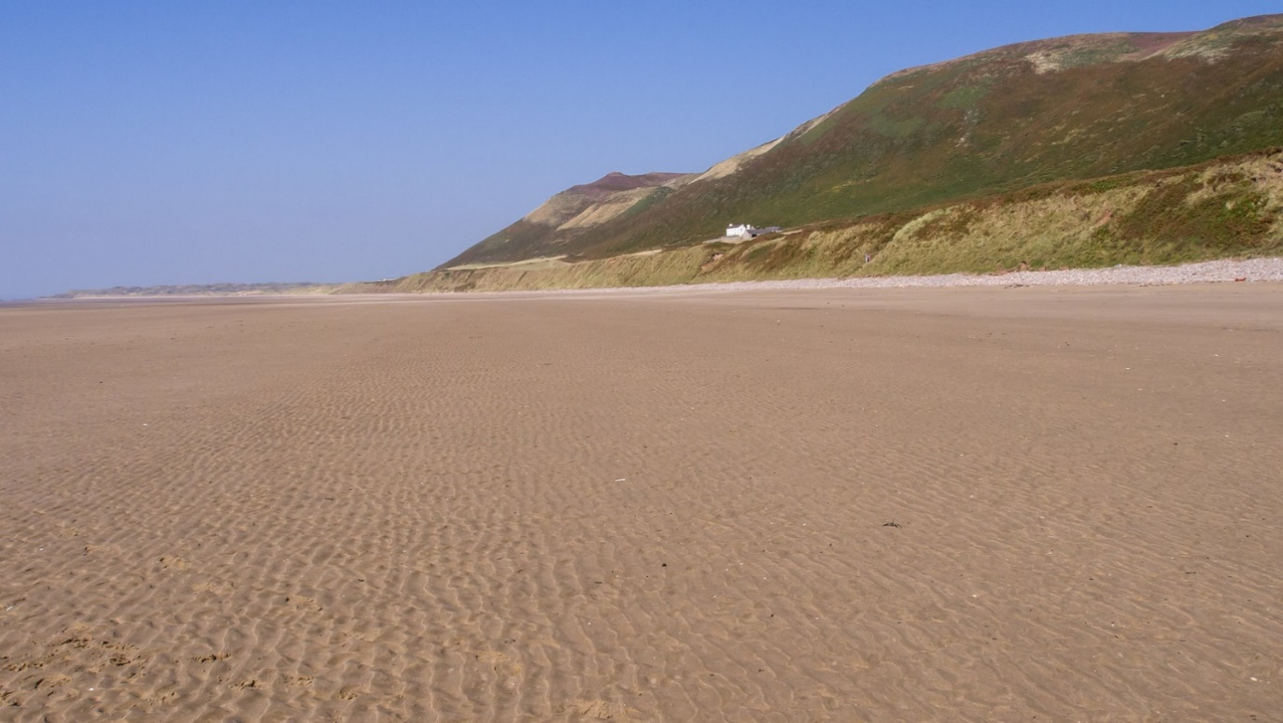

Strengths
Rated excellent by NRW in 2020 for bathing water quality.
Voted Wales best beach 2018 TripAdvisor choice awards.
Area of Outstanding Natural Beauty (AONB)
Large beach area able to accommodate many people
Safe level beach for safe bathing
Weaknesses
B road access provides transport congestion.
Steep access onto the beach reducing accessibility for many.
Opportunities
Use as a promotional beach for improving new tourism to Wales.
Can be a flagship to encourage tourists to holiday at home.
Threats
Increased visitors can put pressure on the fragile habitat with rubbish, path erosion and dog faeces.
Climate change with more violent storms causing erosion of the beach. This long beach facing south westerly prevailing winds has a large expanse of vulnerable coastline.

Mewslade
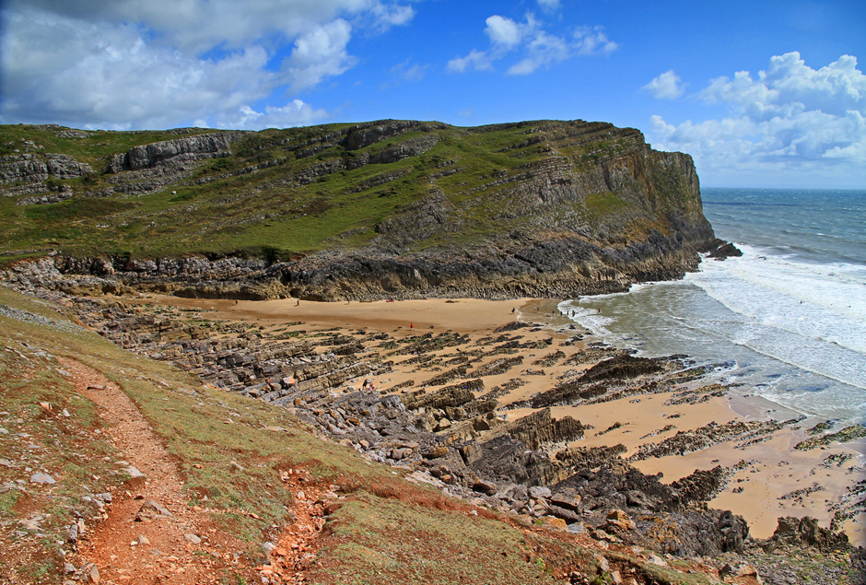
Strengths
Rated excellent by NRW in 2020 for bathing water quality
ANOB
Secluded beach with great waves for surfing
Remote without parking so ideal for visitors wanting quiet.
Weaknesses
Access difficult so not suitable for families with small children, elderly or disabled.
No toilet facilities.
No refreshments.
Tide times need to be observed as the beach disappears at high tide
High waves mean it is unsuitable for general swimming
Opportunities
The location is beautiful and unspoilt, so it is a showpiece beach for wild nature.
It provides great surfing conditions so can be developed for this activity bringing in more visitors to take part or watch this
Threats
Dangerous beach at high tide or in storm conditions so could provide a threat to life.
Increased visitors could provide unacceptable pressure on a small beach area with litter, access difficulties and demands on support services like the coastguard.

Oxwich
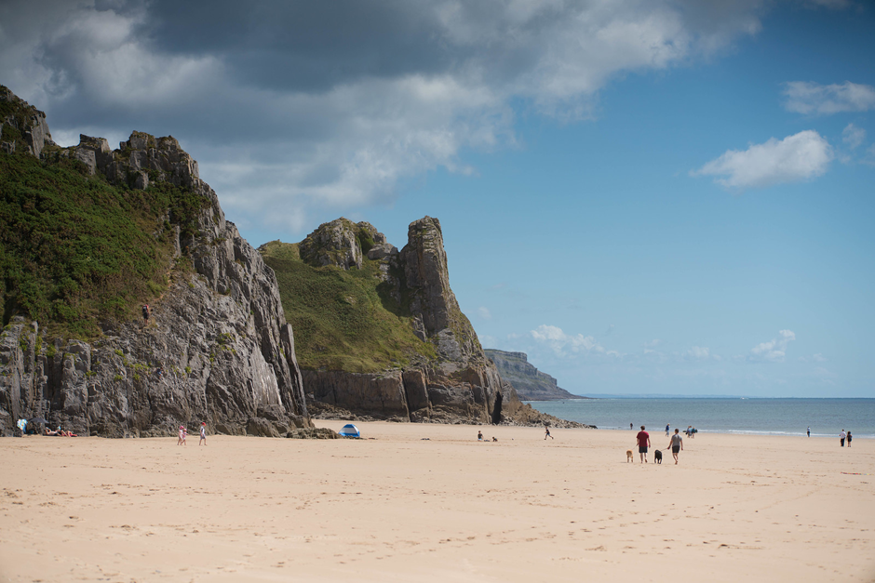
Strengths
Rated excellent by NRW in 2020 for bathing water quality
AONB
Good access so available to most people including disabled and elderly.
Good parking, catering and toilets including disabled facilities
A safe swimming beach
NNR including sand dunes
BAP ancient woodland.
Weaknesses
High levels of seaweed and flotsam on the beach which can become smelly and unattractive, particulary in hot weather.
Opportunities
Possible increased business with catering, retail, and residential businesses through expansion of its visitor numbers.
Threats
Increased visitor numbers place a fragile dune eco system under threat of damage.
The ancient woodland is vulnerable with limited pathways which could result in erosion of existing pathways and damage to a fragile ecosystem.
Although generally a safe bathing beach, further to the east is Three cliffs bay which is has had several recent deaths due to rip tides

Caswell
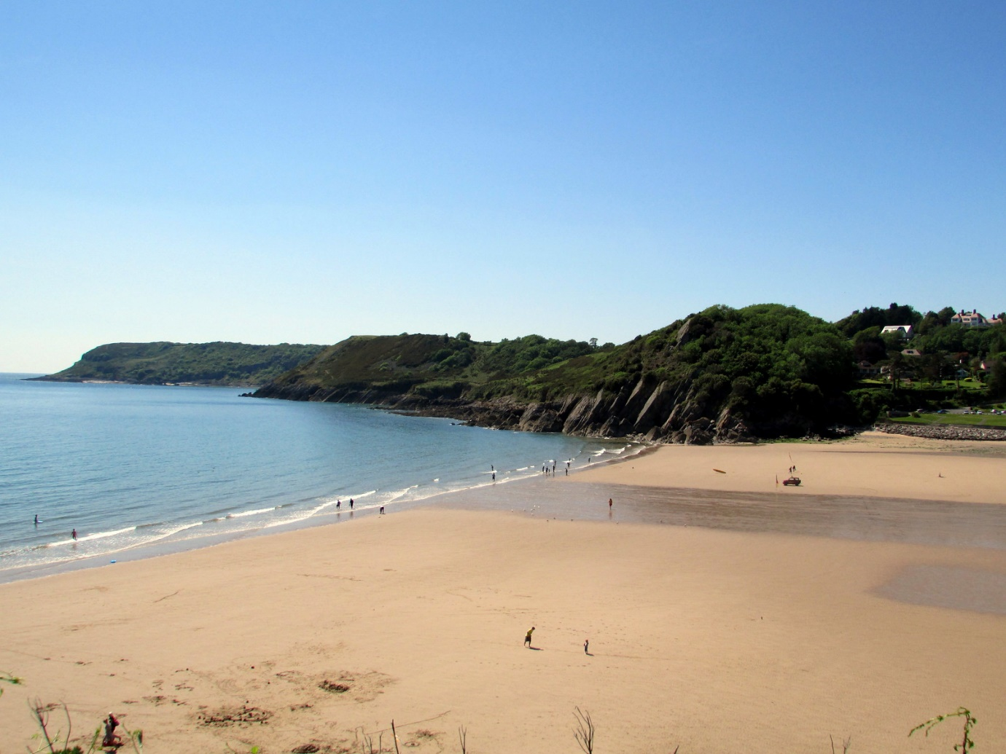
Strengths
Rated excellent by NRW in 2020 for bathing water quality
Good access and parking
Blue Flag so high standards of safety and facilities including lifeguard presence.
Seaside award.
Toilets including disabled facilities.
Floating wheelchairs available free of charge.
No dogs allowed.
Beautiful location with clean water and lovely scenery
Marine conservation location
Public transport
Weaknesses
The B road access causing congestion due to high numbers of visitors in busy periods
River outlet across beach bringing sediment and possible pollution across beach in high rainfall periods
A moderate sized beach that could become overcrowded in high season
Opportunities
A jewel in the crown for Welsh beaches that could encourage more visitors and increased income for local business
Threats
With increased visitor numbers the natural beauty could be spoilt.
Pressure of litter and dog faeces from increased numbers of visitors could negatively impact on the cleanliness and safety of the beach and bathing water

Swansea Bay
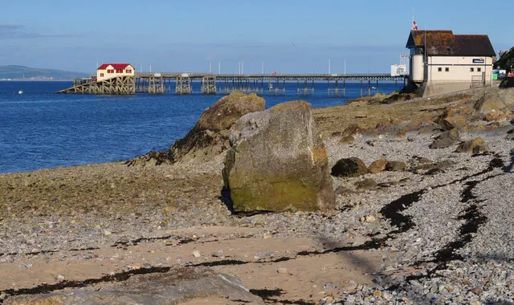
Strengths
A waterfront city beach located beside Swansea city.
Blackpill SSSI with large numbers of wading birds Important intertidal zones (Schans 2001)
Parking is available within 100m of beach with disabled access.
Safe with good parking, catering and toilet facilities.
Lifeguards in summer.
Weaknesses
Rated good by NRW in 2020 for bathing water quality, missing the excellent rating of 80% of Welsh beaches
Hard landscaping unsightly
Misfits ugly
Opportunities
Due to location could become a very popular attraction year-round if facilities and beach quality improved.
Reinstatement of oyster reef improving water quality, enhancing ecosystem, reducing erosion and providing a boost to local economy.
Threats
Coastal erosion of hard landscaping, a small section at West Cross has crumbled twice in recent storms with costs exceeding £1million to reinstate.
Sand motor system erosion with prevailing storm tides from western end.
Sandhills area at increasing risk of flooding
Aberavon 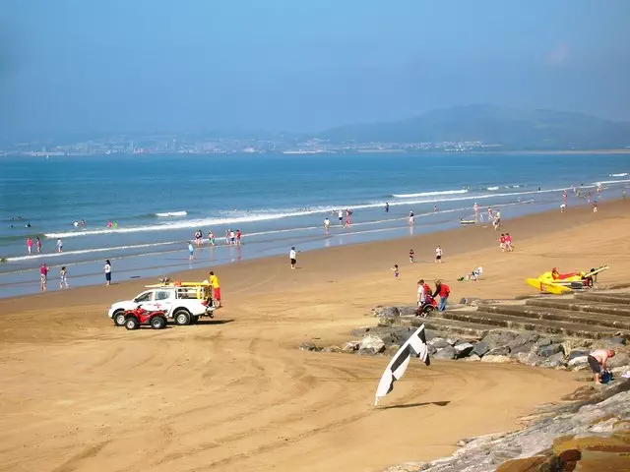
Strengths
Car parking 100m of beach.
Refreshments and toilet facilities available.
Easy access
Lifeguards in summer.
Weaknesses
Rated sufficient by NRW in 2020 for bathing water quality, ranked bottom 6% of Welsh beaches.
Misfits ugly including Hanson cement works, Tata steel and Port Talbot docks.
Hard engineering is unsightly.
Opportunities
Easy access and large population in Port Talbot could be developed into a major resort improving economic activity.
Threats
With bathing water quality standards dropping, rated good in 2019 and downgraded to sufficient in 2020, pollution from the surrounding industry, roads and population could further damage economic future.

6.0. Discussion
The results for Physical were all quite similar across the six beaches. Williams (1986) stated that ‘Aesthetic appeal is based on the behavioural relationship between the environment and the observer’.
Results are open to criticism due to the subjective basis on which the method is based
The human impact showed large differences across the beaches due to the very differing populations and infrastructure.
Biological results show greatest variability in scores with both Aberavon and Swansea scoring well below the other four beaches.
A scoring system of 1 = low/ 2= medium/ 3= high does not allow much differentiation. Using a 1- 5 or 1-7 scale would improve this (Amyot & Grant 2014)
Factors are liable to change throughout the year, so several seasonal checklists would give a more reliable overall assessment. Methodology used is clear and straightforward, Fines (1968) stated, its simplistic and provides a basic measure of the scenic appraisal. This methodology is useful as it is concise giving a useful comparison between different sites.

7.0 Other methodologies of scenic assessment
7.1 The DeCyDe-4-Sustainability method is a spreadsheet methodology (Schumacher, 2018) assessing sustainability across Economics, Social wellbeing, Environmental quality, and Governance assigns scores from 1 to 7 along both the x axis and y axis with 1 being most important to 7 being least important. Weighting is then applied to this data by local stakeholders whose views are taken into consideration by a series of workshops. Consensus must be reached with key decision makers before the agreed score is placed on the two axis. Once the spreadsheet is complete a weighting for all parameters is calculated as shown in Table 1.
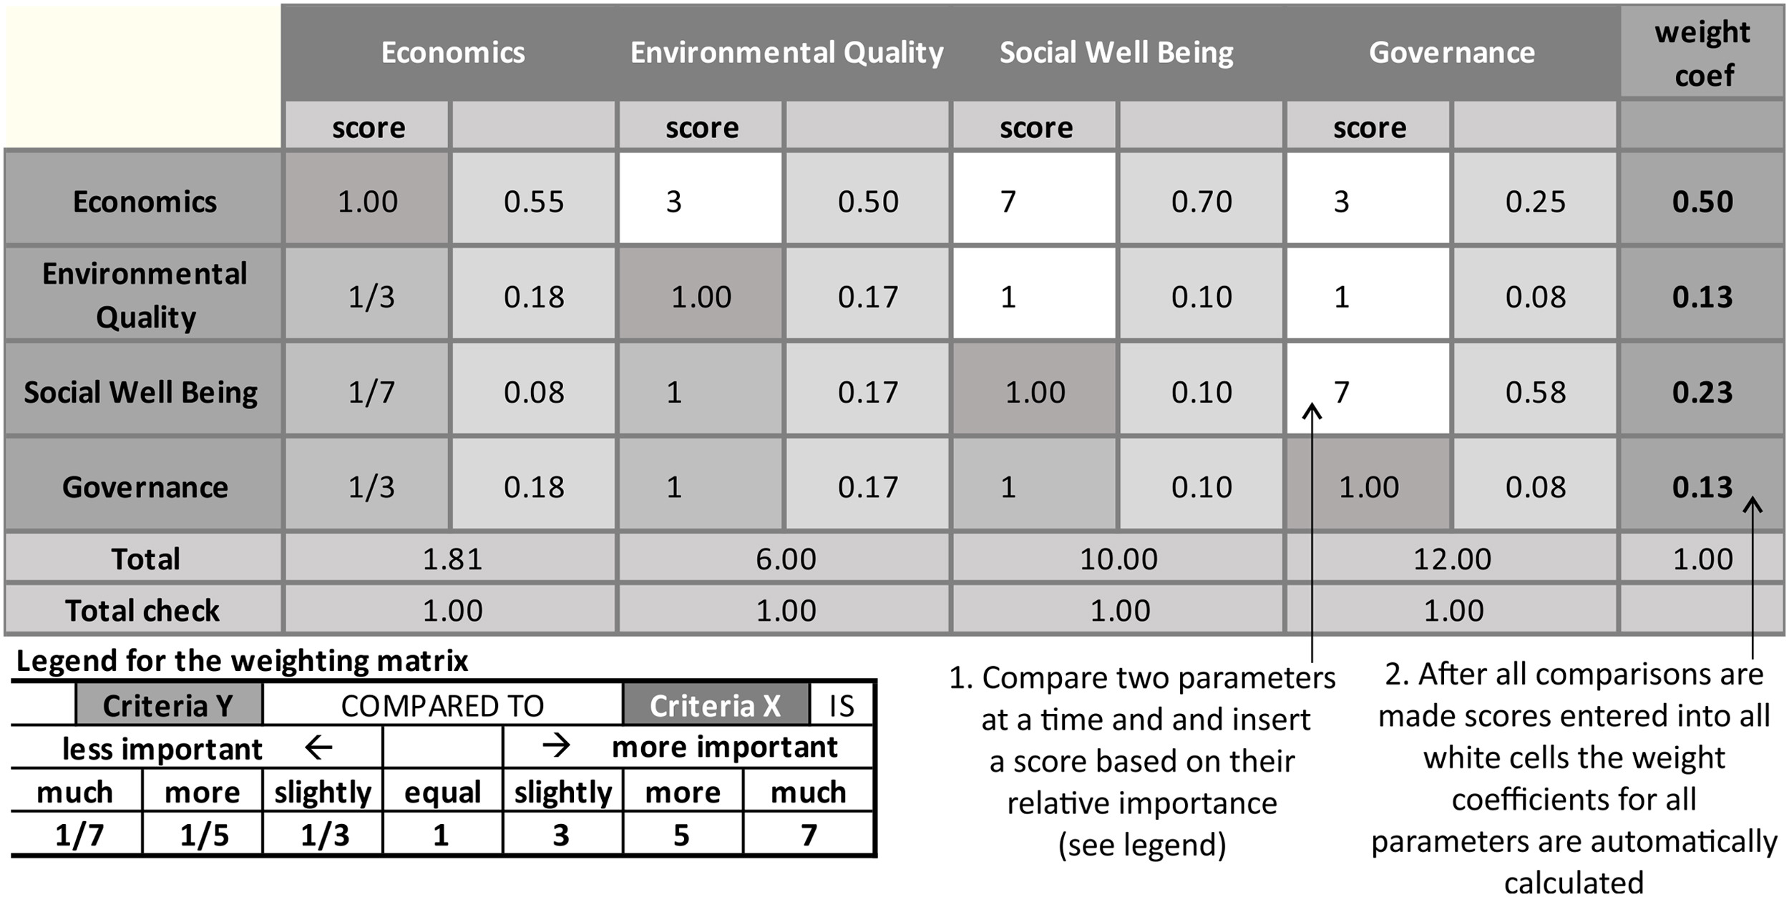
Table 3. Excerpt of DeCyDe-4-Sustainability scoring matrix for comparisons on the sustainability pillar level.(Isotech Ltd)
7.2 Anfuso (2017) used a weighted fuzzy logic checklist for scenic value based on physical and human factors. Beach sites were assessed with 26 physical and human parameters placed on the x axis and categorized into five classes on the y axis and attributed a subsequent value, category 1 a top-grade scenic beach with low anthropogenic influence, category 5 lowest grade scenic beach with high anthropogenic influence. This allowed for management plans to be produced relative to the scenic beauty of each beach. Surveys of beach users were then used to rank these 26 categories from most to least important. This data was then used to provide a weighting to the assessment. This has the advantage of giving an importance weighting to the previously subjective parameters as they are not equal in importance. ( Ergin,2004).
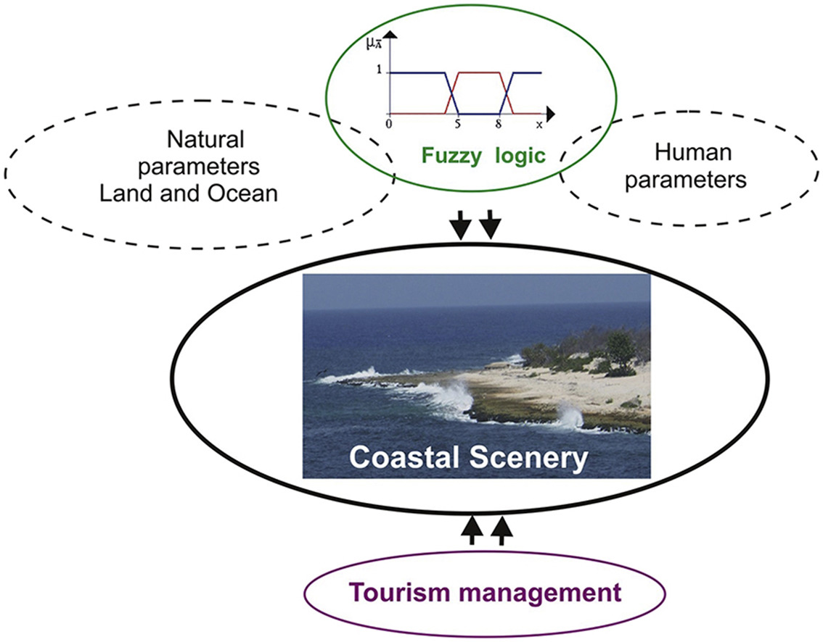
Fig 9.
7.3 Integrated coastal management (ICM) is wide ranging and requires several assessments to get an overall understanding of the various factors involved. The stakeholders need to be involved and consulted.(Schumacher,2018).
This matrix on Table 2 is used as a basis for examination of stakeholder’s interests and boundaries can be defined with factors present and would be easy to use when comparing a large number of sites.
Planning for likely conflict of interest between stakeholders, their values can be allocated and graphed, comparing ecological, economic and social values to examine scale of likely conflict between user groups and mitigation of detrimental effects can be factored into any plan allowing a balance between economic development, human uses of natural resources and ecological needs in an integrated coastal zone management system (cantasano 2014).
This provides a method for sustainable development and is a continuous process.

Table 2

8.0 Wider implications and contrast of different methodologies.
Using the scenic assessment (Leatherman, 1998) is simplistic and clear providing clear ranking that can be a useful guide to management of individual sites. It is subjective with a basic scoring system and involves the observer only so is open to criticism and does not take on the views of stakeholders. All 50 parameters have equal weighting which could be contested.
The Anfuso weighted fuzzy logic checklist for scenic value is using two factors of physical and human factors with a scale of 1-5 ranking. This provides more differentiation than Leatherman.
The results then weighted by a survey of beach users give important emphasis on the various 26 parameters that is lacking from Leatherman methodology. It does not consider the numerous other stakeholders so could still be open to criticism.
The DeCyDe-4-Sustainability methodology uses a scale from 1-7 which allows further differentiation. It then involves a range of stakeholders who have input into the ranking in workshops with key decisionmakers allowing for discussion and consensus providing a sound basis for management planning.

9.0 Site management recommendations
Management plans for the individual beaches must include the coastline and marine environment and all its stakeholders to produce a coordinated strategy . The relevant SMP must form the basis of the management plan incorporating the various legislations the Water framework Directive, Marine and Coastal access act (UK), Marpol and the Urban waste water directive (UK). Local regulations need to be followed. Scientifically based Ecological Value Assessments (EVA) with biodiversity baseline monitoring provide vital information allowing evaluation to better integrate coastal ecosystems and economic needs (Seitz 2014)
Designated and sensitive areas require special management and expert advice should be sought for these.
Visitors put importance on clean and attractive beaches so all integrated coastal areas must be kept in good order. The paths, parking areas, dog faeces bins and litter bins must be emptied regularly, with additional visits according to the season and expected visitor numbers. The refuge bins must be well signed, recyclable materials separated from general waste. Sustainably sourced natural products used for the construction of bins and signage where possible.
Beach cleaning primarily for the removal of litter with no pesticides or chemical cleaners used. Natural debris from seaweeds, dunes and surrounding scrubland left to biodegrade naturally as providing habitat unless deemed to be causing health or accident hazard and then recycled as green waste.
Clear signage for facilities and guidelines for beach use must be provided, on longer beaches at regular intervals. Emergency contact details for support services provided for accidents and pollution incidents. If no Lifeguard presence, public rescue equipment provided must be visible and located at suitable locations.
Toilet facilities need regular inspection, cleaning and restocking dependant on the visitor numbers anticipated, the waste water piped into a designated sewage system.
On beaches where water sports are permitted zoning for swimmers, surfers, windsurfers, and motor craft should be provided by lifeguards or alternately clear signage.
Safe access to beach is essential with good steps with handrails on steep slopes and pedestrian crossings from car parks on busy roads. Parking places should have provision for disabled persons nearest the beach. A potable water source provided near toilet block or at beach entrance protected from animal contamination.
All disabled facilities should comply with the ISO Standard Code for Access wherever possible.

10.0 Conclusion
The coastal zone is an important ecological environment that is also a most favoured area for economic development and human use therefore needs of the fragile and dynamic ecosystems need to be balanced with often-competing requirements of a range of stakeholders.
Many methodologies exist for managing the complexities of this but essential to achieving a sustainable and successful balance it is essential that scientific knowledge is readily available and applied with full stakeholder involvement to support sound decision making. ICM plans needs to be adaptive to changing demands and have to balance factors of physical, biological, and human use using a range of suitable methodologies that rank the numerous parameters in consultation with the stakeholders to achieve the best outcomes for all.

11.0 References
Anfuso, G., Williams, A.T., Martínez, G.C., Botero, C.M., Hernández, J.C. and Pranzini, E., 2017. Evaluation of the scenic value of 100 beaches in Cuba: Implications for coastal tourism management. Ocean & Coastal Management, 142, pp.173-185.
Amyot, J. and Grant, J., 2014. Environmental Function Analysis: A decision support tool for integrated sandy beach planning. Ocean & coastal management, 102, pp.317-327.
Beatley, T., 1991. Protecting biodiversity in coastal environments: introduction and overview. Coastal Management, 19(1), pp.1-19.
Cantasano, N. and Pellicone, G., 2014. Marine and river environments: a pattern of integrated coastal zone management (ICZM) in Calabria (Southern Italy). Ocean & coastal management, 89, pp.71-78.
E.A. (Environment Agency). (2015) Shoreline Management Plan policies – what do they mean? Environment Agency. Available at http://apps.environment-agency.gov.uk/wiyby/134834.aspx (accessed 8th December 2020)
Fines, K. D. 1968. Landscape Evaluation. A research project in East Sussex. Regional Studies, 2: 41–45.
Griffiths, D., House, C., Rangel-Buitrago, N. and Thomas, T., 2019. An assessment of areal and transect-based historic shoreline changes in the context of coastal planning. Journal of Coastal Conservation, 23(2), pp.315-330.
IUCN (International Union for Conservation of Nature). (1994). Parks for life: Action for protected landscapes in Europe. Gland, Switzerland: IUCN.
Kron, W., 2009. Coasts–The riskiest places on Earth. In Coastal Engineering 2008: (In 5 Volumes) (pp. 3-21).
Leatherman, S. P. (1997). Beach rating: a methodological approach. Journal of Coastal Research, 3(1), 253–258.
Leopold, L. B. (1969). Quantitative comparisons of some aesthetics factors among rivers. U.S. Geological Survey Circular, 620, 16.
Phillips, M.R. and House, C., 2009. An evaluation of priorities for beach tourism: Case studies from South Wales, UK. Tourism Management, 30(2), pp.176-183.
Phillips, M. R., & Jones, A. L. (2006). Erosion and tourism infrastructure in the coastal zone: problems, consequences and management. Tourism Management, 27(3), 517–524.
Protecting biodiversity in coastal environments: Timothy Beatley Department of Urban and Environmental , Planning University of Virginia , Charlottesville, VA, 22903
Robinson A, Millward R (1983) The Shell book of the British coast. David & Charles, London, p 496
Sayan, S., Williams, A.T., Johnson, D.E. and Ünal, Ö., 2011. A pilot study for sustainable tourism in the coastal zone of Antalya, Turkey: tourists, turtles or both? Journal of Coastal Research, pp.1806-1810.
Schans, H., Möller, I. and Spencer, T., 2001. Large-scale classification of the East Anglian coastline, UK. In Coastal Dynamics' 01 (pp. 683-692).
Schumacher, J., Schernewski, G., Bielecka, M., Loizides, M.I. and Loizidou, X.I., 2018. Methodologies to support coastal management-A stakeholder preference and planning tool and its application. Marine Policy, 94, pp.150-157.
Seitz, R.D., Wennhage, H., Bergström, U., Lipcius, R.N. and Ysebaert, T., 2014. Ecological value of coastal habitats for commercially and ecologically important species. ICES Journal of Marine Science, 71(3), pp.648-665.
Swansea.gov.uk. (2017). South Gower Coast, Rhossili to Oxwich. Available at: http://www.swansea.gov.uk/article/2729/SouthGower-Coast-Rhossili-to-Oxwich (accessed 13th December 2020)
Von, B. and Turner, R.K., 2001. Science and integrated coastal management. Dahlem University Press, Berlin ISBN, 393, pp.4504-02.
Williams, A.T., 1986. Landscape aesthetics of the river Wye. Landscape Research, 11(2), pp.25-30.
https://www.nasa.gov/specials/sea-level-rise-2020/s
https://www.swansea.gov.uk/southgowercoast
https://www.plantlife.org.uk/uk/nature-reserves-important-plant-areas
https:/www.thegowersociety.org.uk/birds
WTO (World Tourism Organisation). (2001). Leading the world’s largest industry. http://www.world-tourism.org/aboutwto.html. Accessed 24.03.02

