- Krasimir Gadzhev
- 1917134
- The Global Business Environment
- Assessment 2
- Nadeem Mirza

Covid19 and its impact on Tesco Plc

Table of Contents
1. Introduction 2
2. Discussion 2
2.1 Impact of COVID-19 on U.K retail industry 2
2.2 Environmental analysis of Tesco Plc (at the UK and global level) 4
2.2.1 PESTLE 4
2.2.2 Porter five forces 6
2.3 Business lifecycle of Tesco Plc 7
2.4 Changes Tesco Plc made in response to COVID-19 8
2.5 Analysis of Tesco’s changes and innovation strategies 9
3. Conclusion 10
References 11

Impact of COVID-19 on TESCO PLC

1. Introduction
COVID-19 has severely impacted each sector including the retail industry worldwide. But, on other hand, it has created opportunities for retail businesses to come up with innovative tech solutions. This report discusses how COVID-19 has affected TESCO PLC’s operations and how the company has responded to the pandemic by developing effective response strategies.

2. Discussion

2.1 Impact of COVID-19 on U.K retail industry
UK retail industry is considered a significant contributor to the country’s overall economy. The annual sales revenue was reported to be 394 billion pounds before the coronavirus (Retail Economics, 2020). In the early weeks of COVID-19, people created a panic situation and started stockpiling things for daily use rigorously due to which there were long queues of people outside grocery stores and supermarkets, and store shelves had instantly become vacant. The demand for food retail products (particularly flour, yeast, pasta) significantly increased during the lockdown, which resulted in short term shocks to supply chains. However, the demand for non-food products except toilet paper was significantly dropped as non-food retailing was considered non-essential. Due to store closures, retail businesses that have an online presence temporarily switched to online sales and home deliveries. Those retail companies instantly hired temporary workers for smooth operations of digital sales (Sparks, 2020).
But, as online shopping continued to increase in lockdown, click collect slots were becoming scarce or unavailable. It triggered major retailers like Tesco to double down their slots in one month and small retailers to start online operations. During ease of the situation between the first and second wave of COVID-19, major retailers carefully and differentially started opening their stores and supermarkets, such as- by doing restructuring (Sparks, 2020). Overall, it can be said that COVID-19 has made a significant contribution to the growth of internet retailing, which has consequently raised employment levels. Below graph 1 shows the upsurge in internet retail sales value in the crisis period and graph 2 shows most people will permanently change their shopping behaviour in a way that their frequency of shopping online will be significantly increased in the long-term as a result of COVID-19 (Statista, 2020; A&M, 2020).
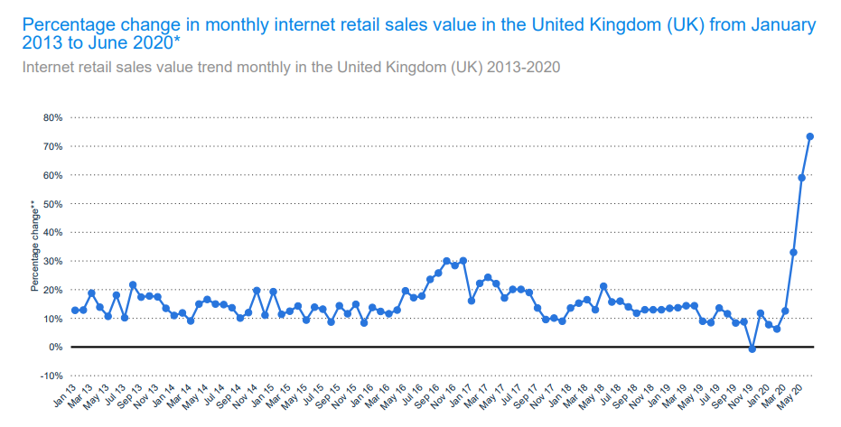
Source: Statista (2020)
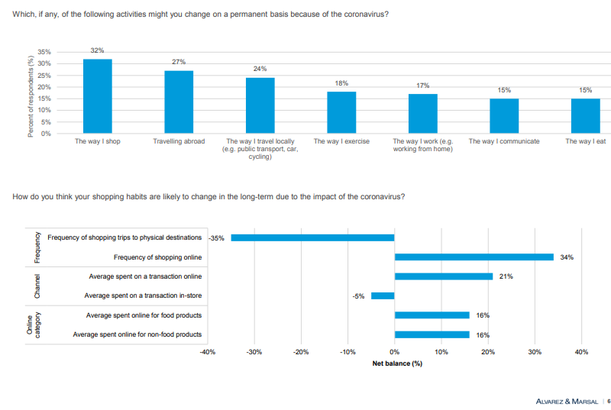
Source: A&M (2020)

2.2 Environmental analysis of Tesco Plc (at the UK and global level)

2.2.1 PESTLE
Political | Economic | Social
1. The first major political concern for UK retail industry is the case of Scottish independence because it can create problems related to pension laws, supply chains, and administration costs that can ultimately raise consumer prices (FXCM, 2020).  2. The second major political concern is the high risk of no-deal Brexit, which can have a severe impact on the UK retail industry as it would lead to tariffs and other trade-related issues (McKevitt and Gaul, 2020).  3. Recently, COVID-19 has become the largest political concern as it has further created political tensions in the UK. The government is facing growing criticism due to mishandling of the pandemic situation (PubAffairs, 2020).  4. COVID-19 has also caused political unrest in developing countries in terms of-worsened labor conditions, increased unemployment, and widened inequality (Dudley, 2020). | 1. COVID-19 has severely impacted the UK economy in comparison to its international counterparts. In the 3rd quarter of the year 2020, the UK economy has declined by 9.7% and in the 2nd quarter, it has significantly reduced by 20.4% (TUC, 2020).  2. In UK, the retail industry contributes 5% to the overall GDP and it is severely affected by COVID-19 (BRC, 2020). But, overall UK economic risk is considered low as the current economic instability is temporary.  3. The crisis has also caused economic instability and increased unemployment levels in developing countries (Dudley, 2020). | 1. COVID-19 has increased health-consciousness among people worldwide due to which most people are changing their shopping habits and moving from physical to online shopping (Skrill, 2020).  2. UK retailers were substantially investing capital in their online operations even before COVID-19. As per estimates, half of UK retail sales will be online by the year 2028 (Butler, 2019).  3. COVID-19 has induced retail businesses to engage more in Corporate Social Responsibility (CSR) activities (Durkee, 2020).
Technological | Legal | Environmental
1. Renowned retailers in the UK are coming up with innovative technological solutions like automated traffic light systems and 3D imaging amid the coronavirus pandemic to improve the in-store shopping experience (RTIH, 2020).  2. Moreover, retailers are increasing the number of online slots because customers are turning to internet shopping. | 1. The current legal environment due to the coronavirus pandemic and Brexit has posed challenges for the UK retail sector (Deloitte, 2020).  2. Overall, the UK has a well-developed and modernized legal system. | 1. Due to lockdowns and the significant slowdown of economic and social activities, water and air pollution has been reduced in many places, so COVID-19 is indirectly positively impacting the overall environment (Rume and Islam, 2020).  2. Due to the coronavirus pandemic, 55 percent of people around the world have become more environmentally-concerned, which has induced major retailers like Tesco to reduce plastic from the Christmas range for environmental sustainability (Nott, 2020; Smithers, 2020).

2.2.2 Porter five forces

2.2.2.1 Bargaining power of suppliers (low)
Tesco has a broad supplier network as it works with 2500 suppliers in the UK and thousands of suppliers in international countries where it operates. The bargaining power of suppliers is low due to Tesco’s strong brand positioning and large market size. In the present pandemic situation, Tesco is shifting to an ‘everyday low pricing’ strategy to compete with budget supermarkets like Aldi and Lidl (BBC News, 2020). For this purpose, it has demanded price cuts (offensive discounts) from suppliers and has pressurized them to agree with it. It indicates that Tesco is in a strong position to easily exercise power in negotiations with suppliers (Nazir, 2020).

2.2.2.2 Bargaining power of buyers (high)
The bargaining power of customers is fairly high and switching cost is low due to intensified competition in the supermarket industry. Major competitors like Asda, Lidl, Sainsbury's, and Aldi, etc. are offering similar products but some of them are offering relatively lower prices than Tesco, so customers can be easily attracted towards such brands. The position of customers has become stronger in the present crisis due to which Tesco is making substantial efforts to reduce prices of items (Tesco PLC, 2020a).

2.2.2.3 Competitive rivalry (high)
Presently, Tesco is facing intense competition from major competitors- Asda, Lidl, Sainsbury's, Waitrose, Morrisons, and Aldi, etc. over mainly prices and promotions. In rural places, retailers like Co-op and Somerfield are attracting some primary customers of Tesco. The increasing competitive rivalry can threaten Tesco’s leadership position in the market and can affect its profit margins (Craft, 2020).

2.2.2.4 Threat of new entrants (moderate)
Although, the threat of new entrants is high in the British retail industry, however, Covid-19 has disrupted the overall industry environment, exerting a mixed effect on the threat of new entrants. On one hand, the prevailing uncertainty has made it challenging for new businesses, and on other hand, it has created new opportunities for the businesses that are coming with innovative ideas to cater to the consumers’ needs in a changing environment.

2.2.2.5 Threat of substitutes (high)
The threat of substitutes in form of e-commerce (e-tailing) has significantly raised, and Covid-19 has further intensified the threat of substitutes, making the business environment highly challenging for the existing market players (Kumar, Sachan and Dutta, 2020).

2.3 Business lifecycle of Tesco Plc
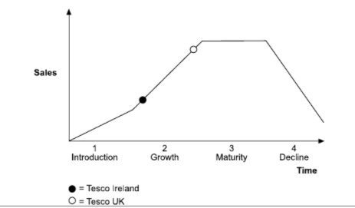
Self-drawn based on industry analysis
Tesco UK has grown significantly due to its competitive pricing and product diversifications. Tesco Ireland is placed at growth stage as but it still needs to strengthen its position in Ireland retail industry and there is high growth potential in Ireland. Tesco UK is placed in between growth and maturity stage but more to maturity stage. It is noted that Tesco UK has managed to retain its position and saved the business from entering into the decline phase due to its substantial focus on diversification strategy as it is now offering non-food items and financial services other than food items (Rosnizam et al. 2020). But, it must continue to focus on a differentiation strategy to strengthen its position at the present stage of the business lifecycle. Recently, COVID-19 has further created opportunities for Tesco UK and Tesco Ireland to escalate the innovation process for long term growth and sustainability (Karpen and Conduit, 2020).

2.4 Changes Tesco Plc made in response to COVID-19
Tesco is considered one of the retail companies that have successfully managed to effectively respond to COVID-19 by bringing innovative technological solutions in business practices and developing effective strategies. In April 2020, the retail giant ‘Tesco’ has been regarded as the first retail business that has fulfilled 1 million online grocery orders in just 1 week amid a pandemic situation. Tesco has introduced priority slots for existing Tesco online customers that are most vulnerable to COVID-19. By assisting the most vulnerable people and delivering them food on a priority basis, it has caught substantial attention from people in the last few months (Beard, 2020). According to Alan Stewart (Tesco’s CFO), company practices have relatively changed in recent months than in the entire last ten years. The key organizational change that Tesco brought at the beginning of the pandemic situation was its shift to remote working because it was already well-equipped with technology. The finance and technology team members have made an important contribution to Tesco’s effective and timely response to COVID-19 because they assisted in the quick implementation of major operational changes. Due to such assistance, Tesco has been able to double its slots for online grocery orders (ICAEW, 2020).
In the critical COVID-19 period, Tesco initially hired 35,000 new temporary staff as they were required to manage the backlog of online orders and to work as delivery drivers and work in distribution centres and shop floor. It effectively brought collaboration among team members and asked them to assist with store shifts to handle extensive pressure and meet increased customers’ demand. As customers were increasingly shifting to online shopping, Tesco later hired an additional 16,000 new staff (including 3000 delivery drivers and10,000 pickers) to support the permanent growth of the company’s digital platform (Coker, 2020a). For e-commerce sustainability, it is investing heavily in new automated urban fulfilment centres as it has recently aimed to build at least 25 urban fulfilment centres (UFCs) to drive its boom in online sales, significantly reduce cost and increase click collect slots (Bowden, 2020). Tesco has recently introduced an automated traffic light system and 3D imaging system across its stores as coronavirus continues to raise. This innovative technological solution greatly helps in queuing of people and it maintains a safe shopping environment. The 3D imaging system is built to track the number of people at stores. The red stop sign is displayed when capacity gets fulfilled and green directional arrows are shown to inform people that they can safely enter (Coker, 2020b).
Tesco has also taken an initiative called ‘Tesco Red Door’ amid pandemic, which is aimed to virtually invite international innovators and technology start-ups to obtain new ideas for products, emerging technology, packaging, robotics, and automation. For this purpose, it has developed a group innovation team (Sillitoe, 2020). Lastly, Tesco has particularly developed a strategy ‘food for all, safety for everyone, supporting our colleagues and supporting our communities’ in response to COVID-19 to show huge concern for its stakeholders (TESCO, 2020b).

2.5 Analysis of Tesco’s changes and innovation strategies
Tesco’s initiatives in response to the pandemic are not only effective in the short-term, but also the long-term. For instance, shift to remote workers, investment in sophisticated technological infrastructure, and integration of flexibility into the organizational structure to quickly implement the operational changes will benefit the organization in the long-term, as consumers are becoming more tech-savvy, and are shifting from traditional to online retailing. Although Tesco has hired 35,000 temporary staff to manage the backlog of online orders, management needs to integrate temporary staff hiring into the existing service delivery model to handle similar situations in the future. The decision to hire an additional 16,000 new staff also supports the company’s permanent growth in the e-retailing area. Investment in automated urban fulfilment centres, 3D imaging system, and the Red Door initiative- all initiatives will accelerate the innovation process and support Tesco in expanding its offline and particularly online operations.

3. Conclusion
To conclude, Tesco PLC has effectively responded in such a critical situation by developing innovative technological solutions and strategies. These innovations would also help in ensuring business long term sustainability. Tesco PLC is suggested to continue developing effective contingency planning so that it could be well pre-prepared for any future uncertain situation.

References

A&M, June, 2020. Uk Chartbook- The shape of retail: Consumers and the new normal. [Online] Alvarez and Marsal. https://www.alvarezandmarsal.com/sites/default/files/uk_appendix_.pdf [Accessed on December 30, 2020]
BBC News, July 03, 2020. Tesco demands supplier price cuts in discount battle. [Online] BBC.com. https://www.bbc.com/news/business-53284788 [Accessed on December 30, 2020]
Beard, J., October 01, 2020. How to get the best online delivery slot for your groceries with the large supermarkets. [Online] The Telegraph. https://www.telegraph.co.uk/money/consumer-affairs/vulnerable-people-priority-home-food-delivery-tesco-sainsburys/ [Accessed on December 30, 2020]
Bowden, G., September 08, 2020. Where are the new battlefields in urban grocery fulfilment? [Online] Retail Week. https://www.retail-week.com/grocery/where-are-the-new-battlefields-in-urban-grocery-fulfilment/7035685.article [Accessed on December 30, 2020]
BRC, 2020. UK Retail: Leading Globally, Serving Globally. [Online] British Retail Consortium. https://d2rpq8wtqka5kg.cloudfront.net/129096/open20120105120000.pdf?Expires=1609339360&Signature=HqMeWR7AocQomsn2vsjJ~9Mz~6MaqZRK2PV8lNAs3YGwa5eOAfY75iylRsauOBkmh9wxH2R2LBLCZ7SP9OFCjSmQ~0r~bNEzGkTU5St4~43fdc5KpVGcOfb9te7MubFBRz~KBpQHHktc06c42-rQkbI~voH61AVVF4HMhQjwOGX5NA1XlWFbLNgrsXz7MxwAzY6~g~BfJF4ExfpdkIf-0me6r13aaZPS3m3KhPAxo57hthyoSYaLFVVRoDZAOAQ9eM1JGXO4e-5~y6~zCObkM5ZLwJCeNlOShfW7uXMKex97FbNeB3l1K6rKmx7ZASWDLjXB-HPJ~0A0B2u70VNmCQ__&Key-Pair-Id=APKAJVGCNMR6FQV6VYIA#:~:text=%E2%80%A2-,The%20retail%20sector%20consistently%20accounts%20for%20around%205%25%20of%20Gross,Added%20in%20the%20UK%20economy.&text=%E2%80%A2-,14%25%20of%20all%20UK%20investment%20made%20by%20large%20non%20financial,is%20made%20by%20large%20retailers.&text=%E2%80%A2-,Retailers%20purchase%20around%20%C2%A3180bn%20worth%20of%20goods%20for%20resale,of%20output%20from%20other%20sectors. [Accessed on December 30, 2020]
Butler, S., July 09, 2019. Half of UK retail sales will be online within 10 years, report predicts. [Online] The Guardian. https://www.theguardian.com/business/2019/jul/09/half-of-uk-retail-sales-will-be-online-within-10-years-report-predicts [Accessed on December 30, 2020]
Coker, J., May 28, 2020b. Covid-19: Tesco introduces 3D imaging to manage customer numbers in stores. [Online] Essential Retail. https://www.essentialretail.com/news/covid-tesco-imaging-manage-customer/ [Accessed on December 30, 2020]
Coker, J., September 16, 2020a. Tesco’s response to sustained eCommerce demand. [Online] Essential Retail. https://www.essentialretail.com/features/tesco-response-sustained-ecommerce/ [Accessed on December 30, 2020]
Craft, 2020. Tesco competitors. [Online] Craft.com. https://craft.co/tesco/competitors [Accessed on December 30, 2020]
Deloitte, October, 2020. Tackling Brexit and COVID-19 together. [Online] Deloitte.com. https://www2.deloitte.com/content/dam/Deloitte/uk/Documents/international-markets/deloitte-uk-tackling-brexit-and-covid-19-together.pdf [Accessed on December 30, 2020]
Dudley, D., June 10, 2020. Coronavirus Crisis Likely To Lead To Surge In Political Unrest, Says Report. [Online] Forbes. https://www.forbes.com/sites/dominicdudley/2020/06/10/coronavirus-crisis-likely-to-lead-to-surge-in-political-unrest-says-report/?sh=6a34b9875723 [Accessed on December 30, 2020]
Durkee, A., July 22, 2020. The Covid Effect On CSR And Marketing. [Online] Forbes. https://www.forbes.com/sites/alliancembs/2020/07/22/the-covid-effect-on-csr-and-marketing/?sh=1fa656105e77 [Accessed on December 30, 2020]
FXCM, 2020. What Effect Would Scottish Independence Have On World Business? [Online] Fxcm.com. https://www.fxcm.com/markets/insights/what-effect-would-scottish-independence-have-on-world-business/ [Accessed on December 30, 2020]
ICAEW, July 17, 2020. Adapting to COVID-19: the Tesco story. [Online] Icaew.com. https://www.icaew.com/insights/interviews-and-profiles/2020/july-2020/adapting-to-covid19-the-tesco-story [Accessed on December 30, 2020]
Karpen, I.O. and Conduit, J., 2020. Engaging in times of COVID-19 and beyond: theorizing customer engagement through different paradigmatic lenses. Journal of Service Management.
Kumar, R., Sachan, A. and Dutta, T., 2020. Examining the Impact of e-Retailing Convenience Dimensions on Behavioral Intention: The Mediating Role of Satisfaction. Journal of Internet Commerce, 19(4), pp.466-494.
McKevitt, F., and Gaul, R., 2020. The impact of Brexit on UK grocery industry and shoppers. [Online] Kantar. https://www.kantar.com/uki/inspiration/retail/the-impact-of-brexit-on-uk-grocery-industry-and-shoppers/ [Accessed on December 30, 2020]
Nazir, S., July 05, 2020. Tesco demands “offensive” discounts from suppliers. [Online] Retail Gazette. https://www.retailgazette.co.uk/blog/2020/07/tesco-demands-offensive-discounts-from-suppliers/ [Accessed on December 30, 2020]
Nott, G., July 06, 2020. Can the sustainable packaging effort survive Covid-19? [Online] The Grocer. https://webcache.googleusercontent.com/search?q=cache:4VbQb5y3otoJ:https://www.thegrocer.co.uk/plastic/can-the-sustainable-packaging-effort-survive-covid-19/646118.article+&cd=2&hl=en&ct=clnk&gl=pk [Accessed on December 30, 2020]
PubAffairs, May 20, 2020. The role of COVID-19 in shaping the UK's political landscape: a new social contract? [Online] Public Affairs Networking. https://www.publicaffairsnetworking.com/news/the-role-of-covid-19-in-shaping-the-uk-s-political-landscape-a-new-social-contract- [Accessed on December 30, 2020]
Retail Economics, 2020. UK RETAIL STATS & FACTS. [Online] Retaileconomics.co.uk. https://www.retaileconomics.co.uk/library-retail-stats-and-facts [Accessed on December 30, 2020]
Rosnizam, M.R.A.B., Kee, D.M.H., Akhir, M.E.H.B.M., Shahqira, M., Yusoff, M.A.H.B.M., Budiman, R.S. and Alajmi, A.M., 2020. Market Opportunities and Challenges: A Case Study of Tesco. Journal of the community development in Asia, 3(2), pp.18-27.
RTIH, 2020. Retailers rapidly embrace digital technologies amid coronavirus pandemic. [Online] Retail Technology Innovation Hub. https://retailtechinnovationhub.com/home/2020/7/8/retailers-rapidly-embrace-digital-technologies-amid-coronavirus-pandemic [Accessed on December 30, 2020]
Rume, T. and Islam, S.D.U., 2020. Environmental effects of COVID-19 pandemic and potential strategies of sustainability. Heliyon, p.e04965.
Sillitoe, B., September 10, 2020. Tesco opens up to new innovation with 'Red Door' disruption programme. [Online] Essential Retail. https://www.essentialretail.com/news/tesco-red-door/ [Accessed on December 30, 2020]
Skrill, September 01, 2020. How online shopping has changed since COVID-19. [Online] Skrill Business. https://www.skrill.com/en/business/skrill-business-news/ecommerce/covid-19-impact-on-business/ [Accessed on December 30, 2020]
Smithers, R., December 09, 2020. Tesco removes 20m items of plastic from Christmas range. [Online] The Guardian. https://www.theguardian.com/business/2020/dec/09/tesco-removes-20m-items-of-plastic-from-christmas-range [Accessed on December 30, 2020]
Sparks, L., November 03, 2020. How is coronavirus affecting the UK’s retail sector? [Online] Economics Observatory. https://www.coronavirusandtheeconomy.com/question/how-coronavirus-affecting-uks-retail-sector [Accessed on December 30, 2020]
Statista, 2020. Coronavirus: impact on the retail industry in the UK. [Online] Statista.com. https://www.statista.com/study/72445/coronavirus-impact-on-the-retail-industry-in-the-uk/ [Accessed on December 30, 2020]
TESCO PLC, 2020b. Together, we can do this. Coronavirus (Covid-19) - see what we’re doing to help colleagues and customers. [Online] tescoplc.com. https://www.tescoplc.com/covid-19/ [Accessed on December 30, 2020]
Tesco PLC, March 05, 2020a. Tesco’s new campaign sees hundreds of prices matched with Aldi. [Online] Tescoplc.com. https://www.tescoplc.com/news/2020/tesco-aldi-price-match/ [Accessed on December 30, 2020]
TUC, 2020. Impact of Covid-19 and Brexit for the UK economy. [Online] Tuc.org.uk. https://www.tuc.org.uk/sites/default/files/2020-12/BrexitBrief.pdf [Accessed on December 30, 2020]

