17/12/2025
University of Wales Trinity Saint Davids
London Campus
Module Name: Computer Architecture and Operating Systems
Module Code: ACCA 4022

Student Name: Guido llanos
Student ID: 2438787
Group: 3

Lecturer’s Name: Koushik Modak
Computer Architecture and Operating Systems.
Assignment 2
Table of Contents
Introduction 2
Main Body 2
Key functions of general Operating Systems 2
Use of Windows OS CLI commands 2
Use of Linux OS CLI commands 2
Use of Windows OS scripts (Batch Scripting) 2
Use of Linux OS scripts (Bash Scripting) 2
Conclusion 2
References 2

Introduction
Operating systems are essential software that manage computer hardware and enable user interaction. This report examines operating systems functions and explores command-line interfaces and scripting in Windows and Linux. Through five sections, it analyses key OS functions, CLI commands for both systems, and practical scripting applications. Each section includes screenshots and academic references, providing references providing comprehensive coverage for IT professionals.

Main Body

Key functions of general Operating Systems

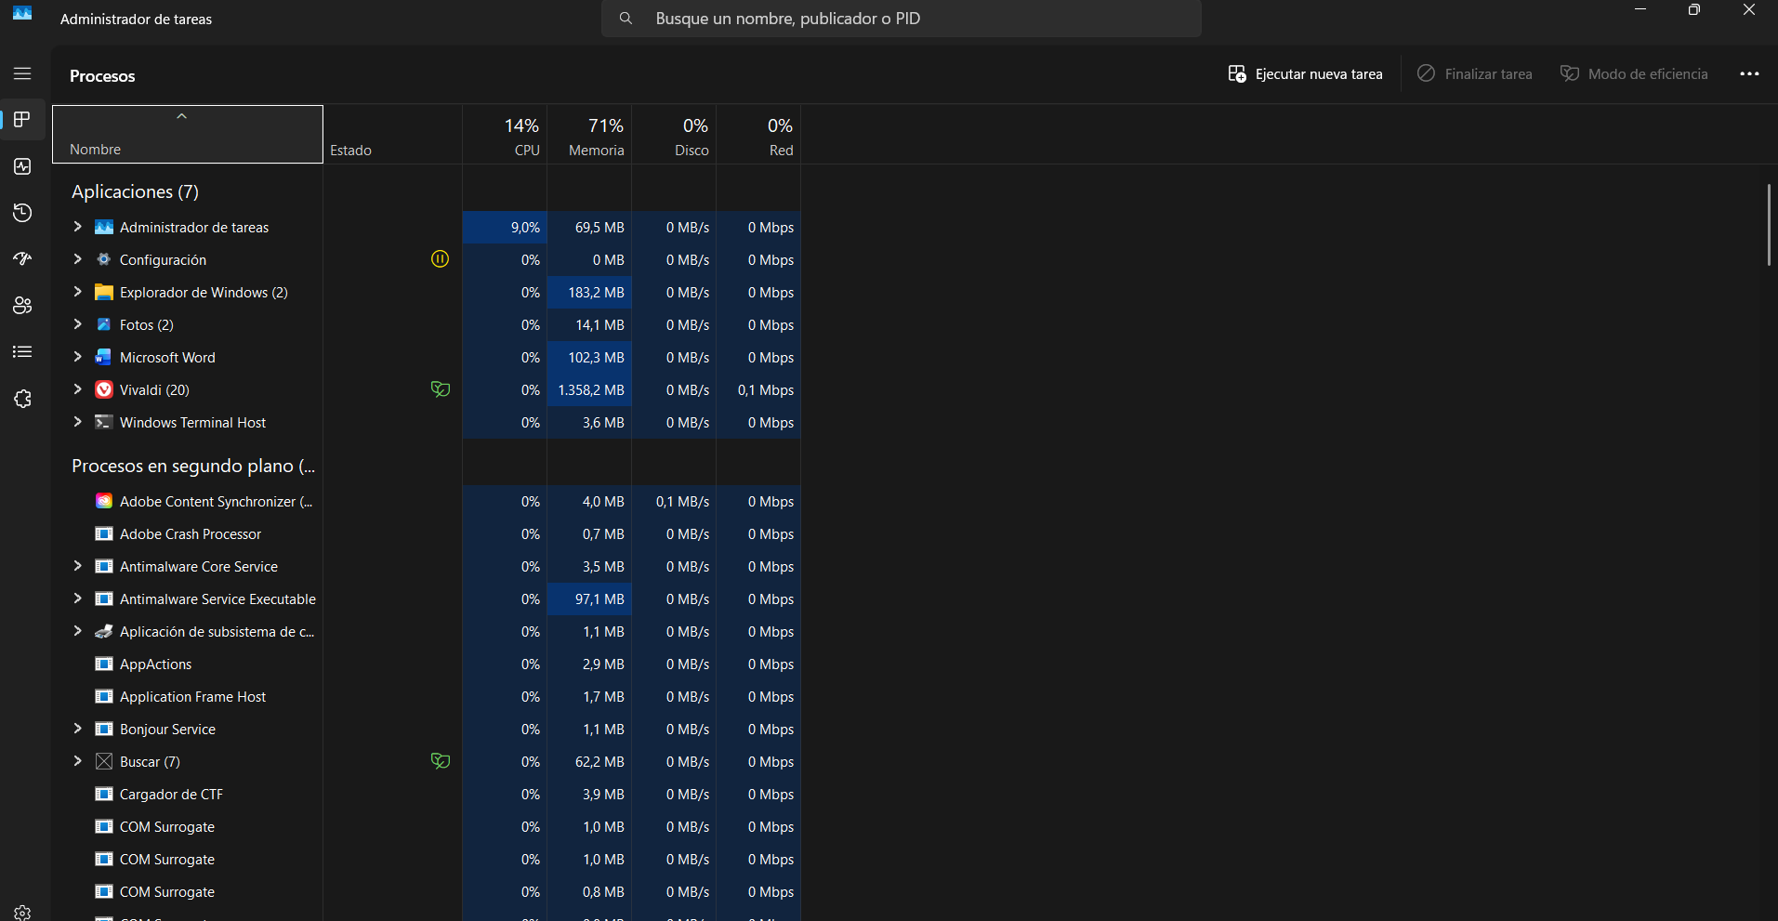

Process management is a fundamental operating system function that handles program execution and resource allocation. The Task Manager utility in windows provides real-time monitoring of running processes, displaying CPU usage, memory consumption, and application performance. This function enables users to identify resource-intensive programs, terminate unresponsive applications, and manage system priorities.
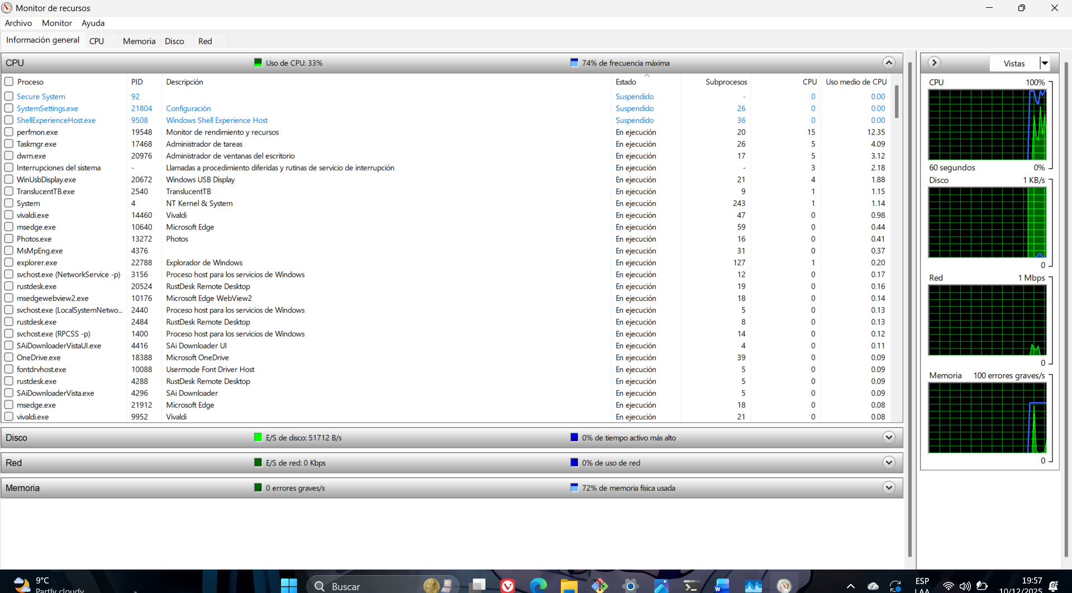
Memory management controls how to operating system allocates and utilizes RAM resource. Windows Resource Monitor offers detailed insights into memory usage patterns, showing which applications consume the most RAM and identifying potential memory leaks. This function ensures efficient memory distribution and prevents systems slowdowns due to insufficient memory resource. 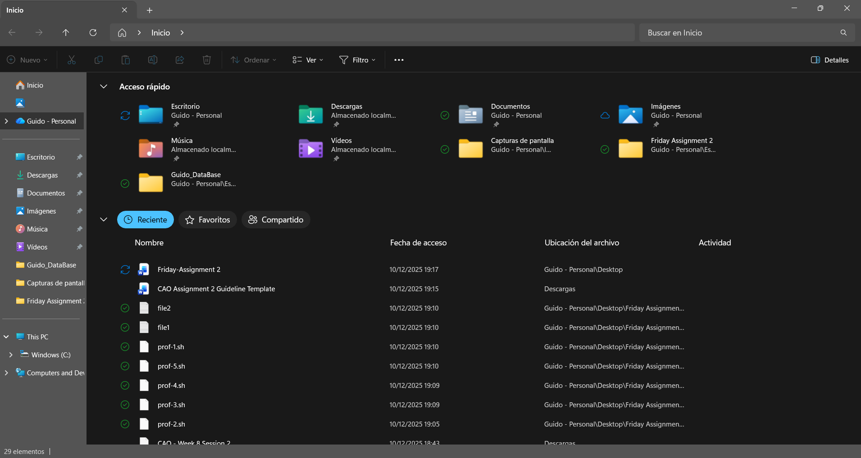
File management organizes and controls data storage through hierarchical directory structures. File Explorer provides graphical interface for creating, deleting, copying, and organizing files and folders. This function implements file permissions, directory navigation, and storage management, allowing users to efficiently manage their digital documental and media.
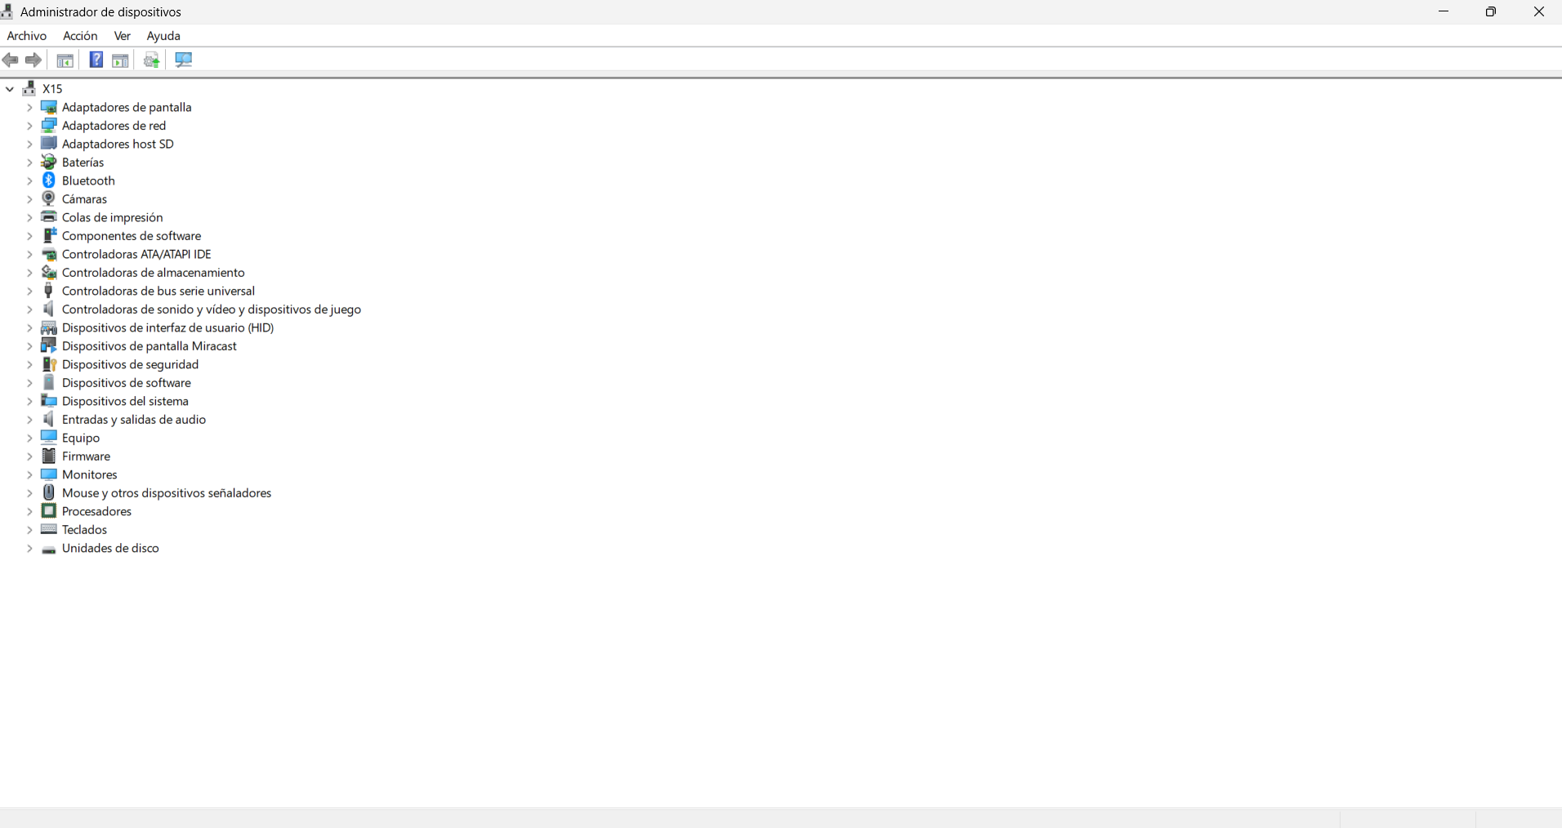
Divice management coordinates hardware components and their drivers. Device Manager displays all connected hardware devices, their driver status, and configuration options. This function enables troubleshooting of hardware issues, drivers updates, and resource allocation for peripherals devices like printers, storage drives, and network adapters.
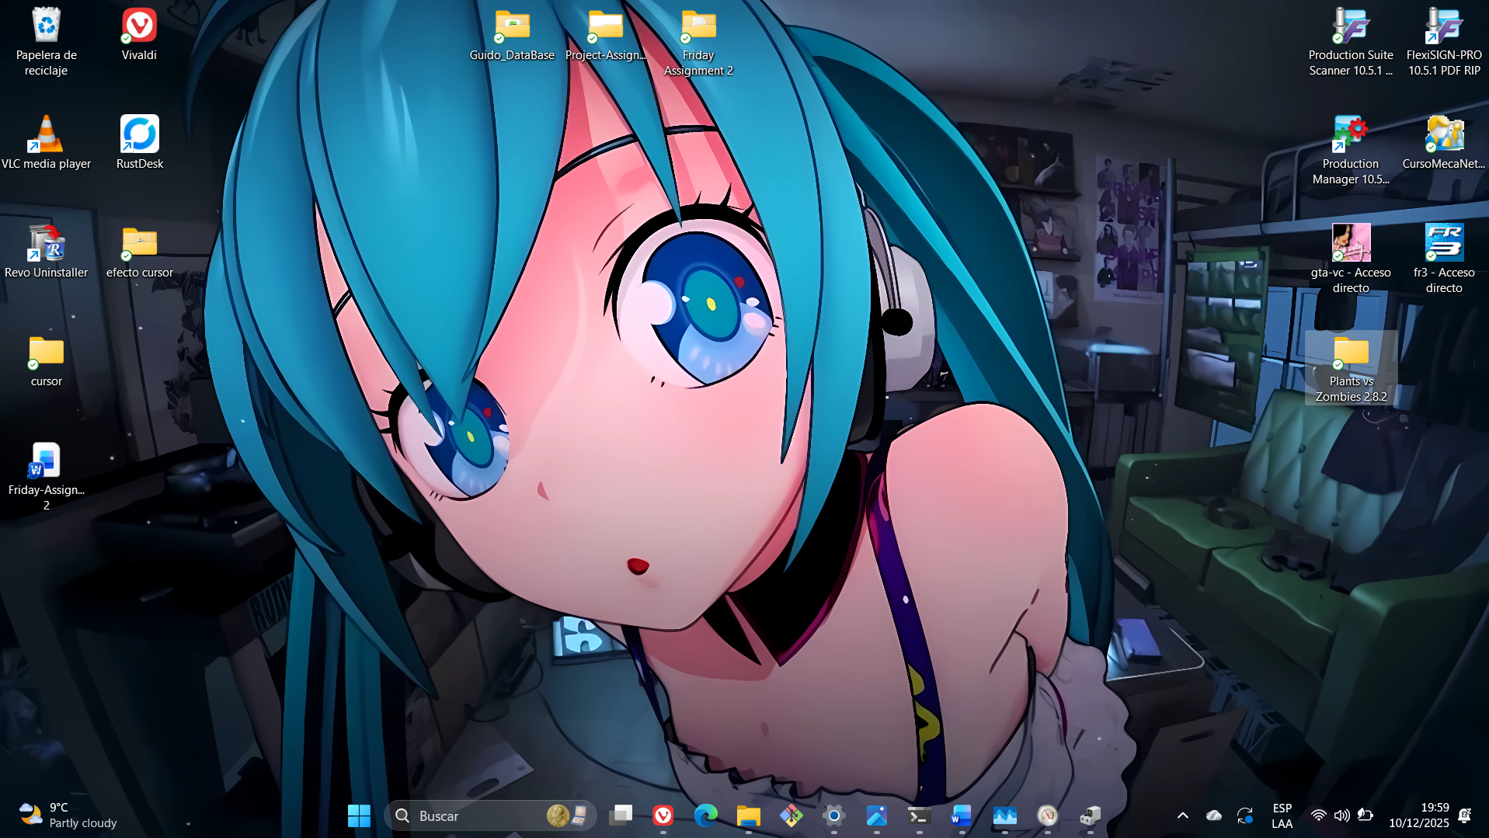
User interface functions provide interaction between users and the computers systems. Modern operating systems like windows offers both graphical user interface (GUI) through the desktop environment and command-line interface (CLI) through PowerShell or Command Prompt. This dual-interface approach accommodates different user preferences and technical requirements.

Use of Windows OS CLI commands
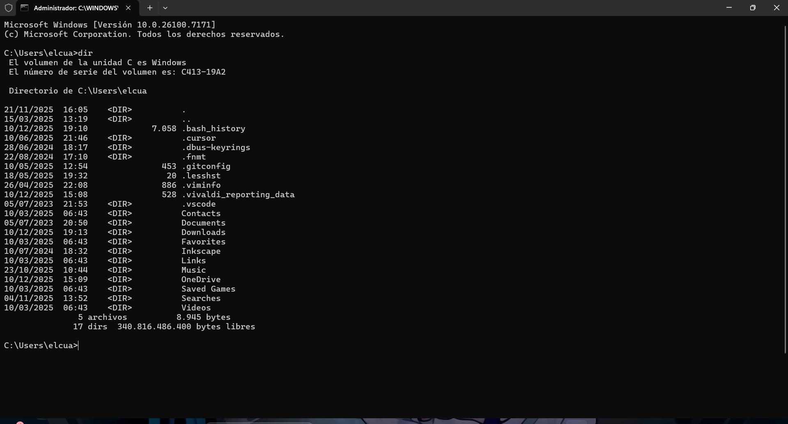
The “dir” command displays directory contents including files and folders. It shows file size, creation dates, and attributes, making it essential for file system navigation and management. This command helps users quickly view directory structures.
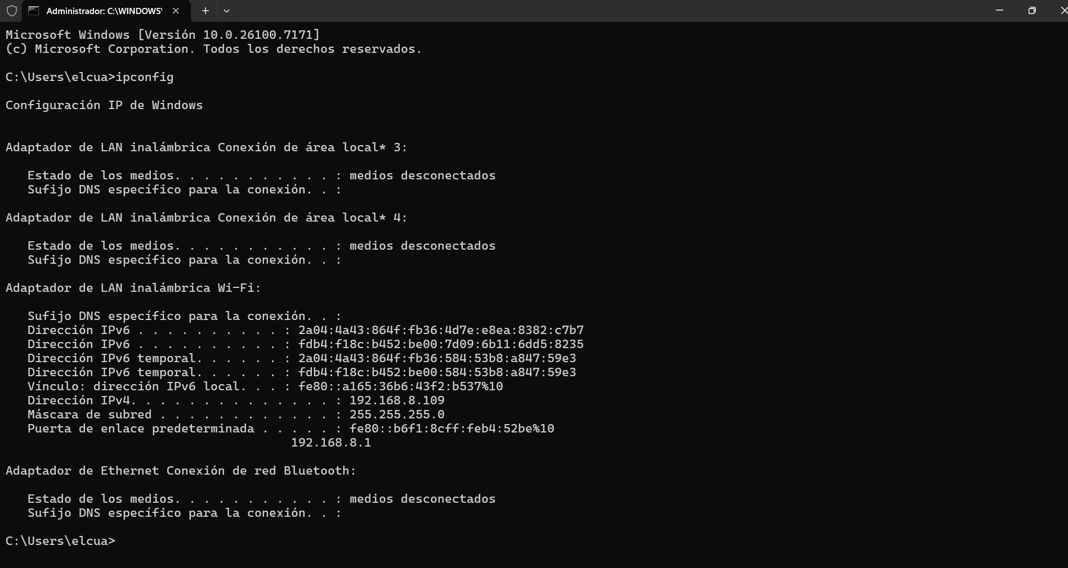
The “ipconfig” command displays network configuration details including IP addresses, subnet mask, and default gateway. This is crucial for network troubleshooting, verifying connectivity settings, and diagnosing internet connection issues.
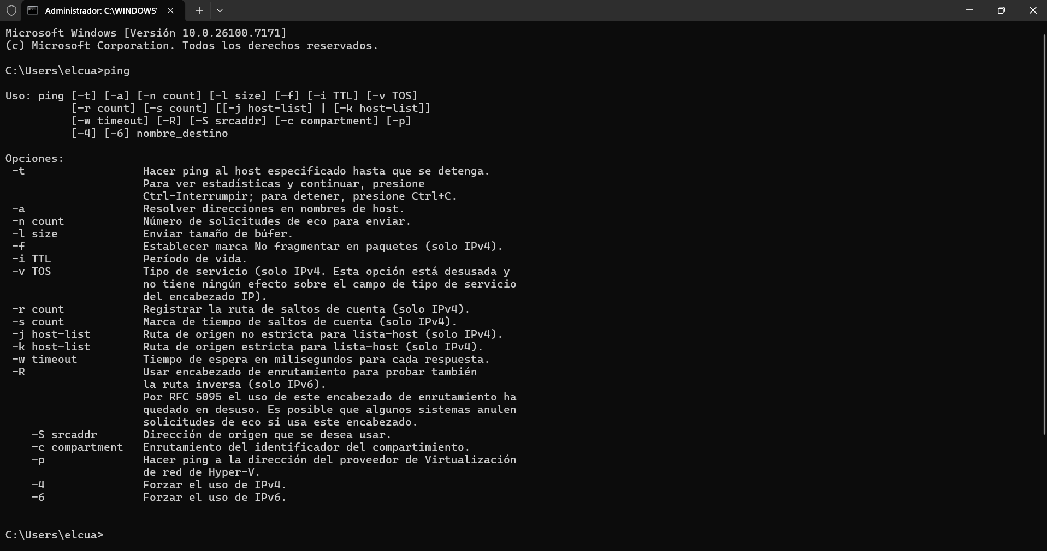
The “ping” command tests network connectivity by sending packets to a specified address. It measures response times and packet loss, helping diagnose network problems and verify server availability.
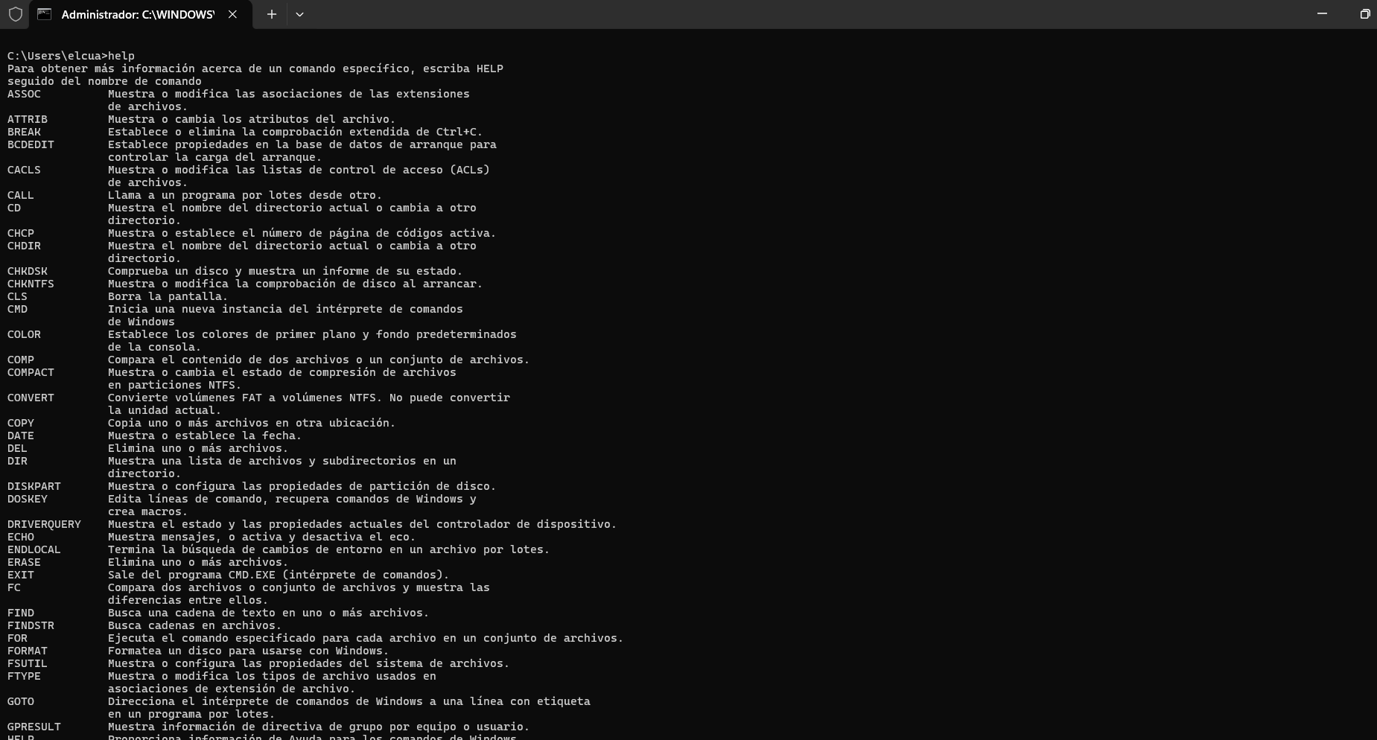
The “help” command provides documentation for other commands. It displays systax, parameters, and usage examples, serving as built-in reference material for learning command functionality.
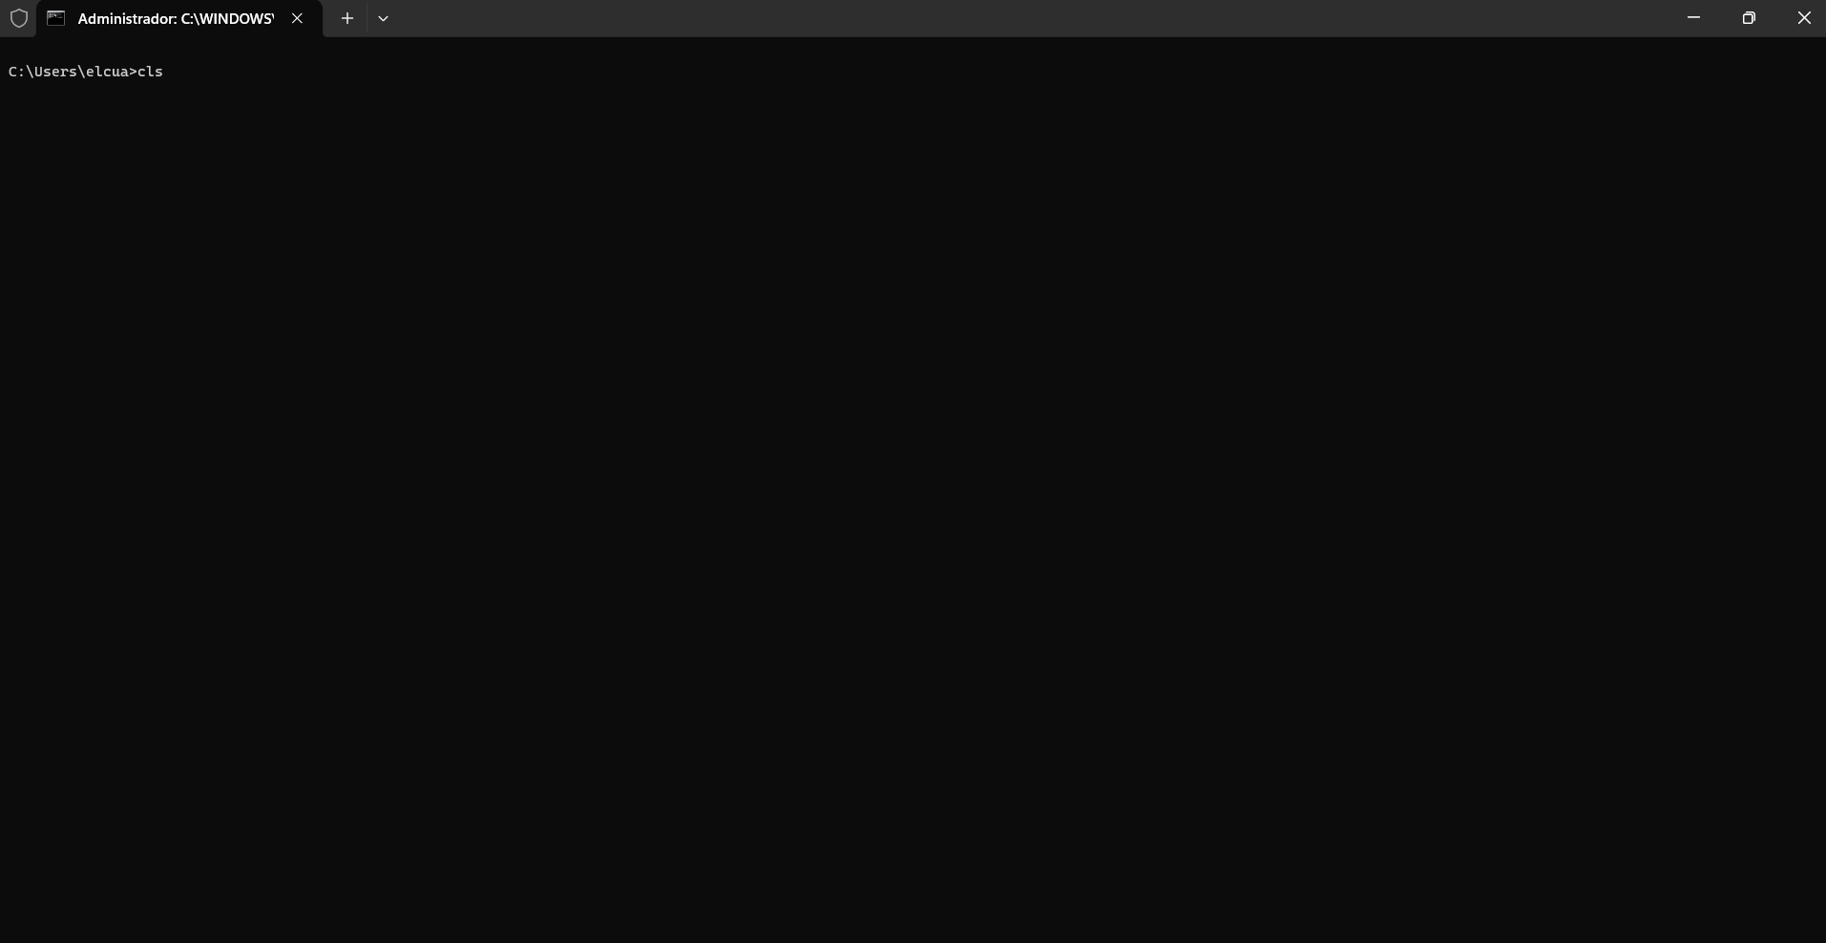
The “cls” command clears all text from the command prompt window. This improves readability during extended sessions by removing previous command output and providing a clean workspace.
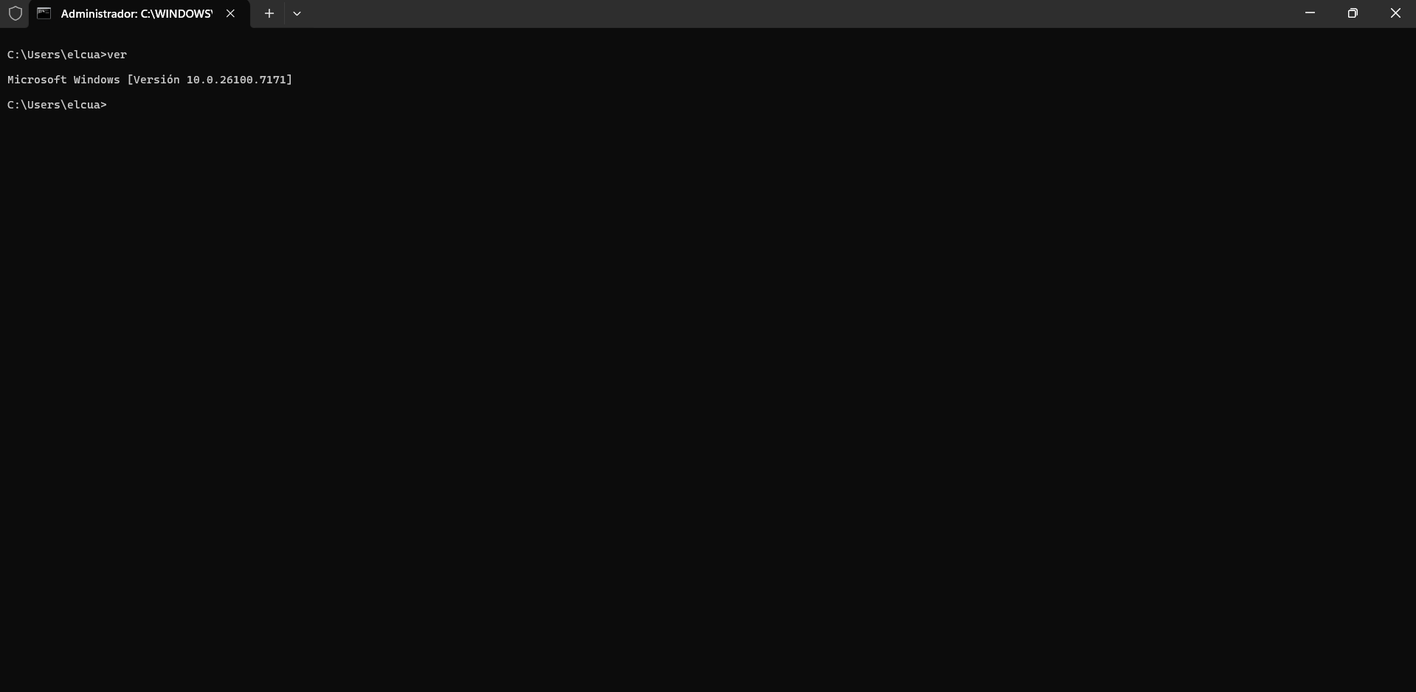
The “ver” command shows windows operating system version and build number. This information is essential for compatibility checking, troubleshooting, and verifying system specifications.
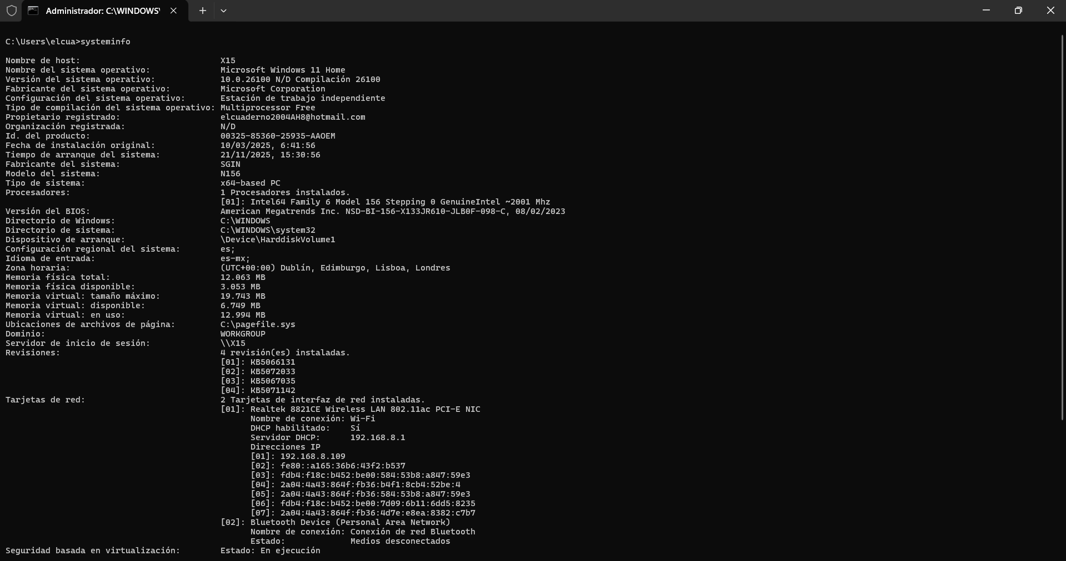
The “systeminfo” command displays comprehensive system information including OS details, hardware configuration, and network setting. Combined with findstr, it filters specific data for quick system analysis and documentation purposes.
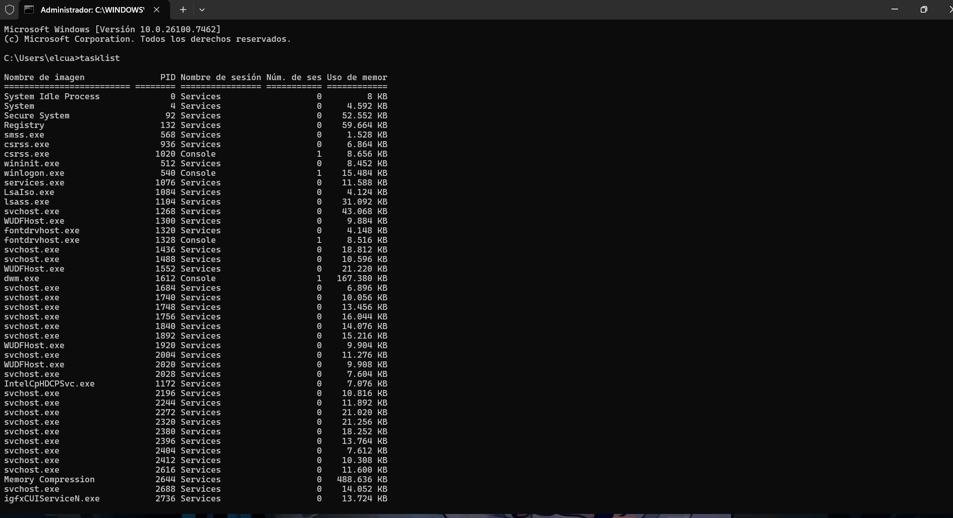
The “tasklist” command shows all running processes with their Process IDs and memory usage. When filtered with find, it displays specific applications, helping monitor resource consumption and identify problematic processes.
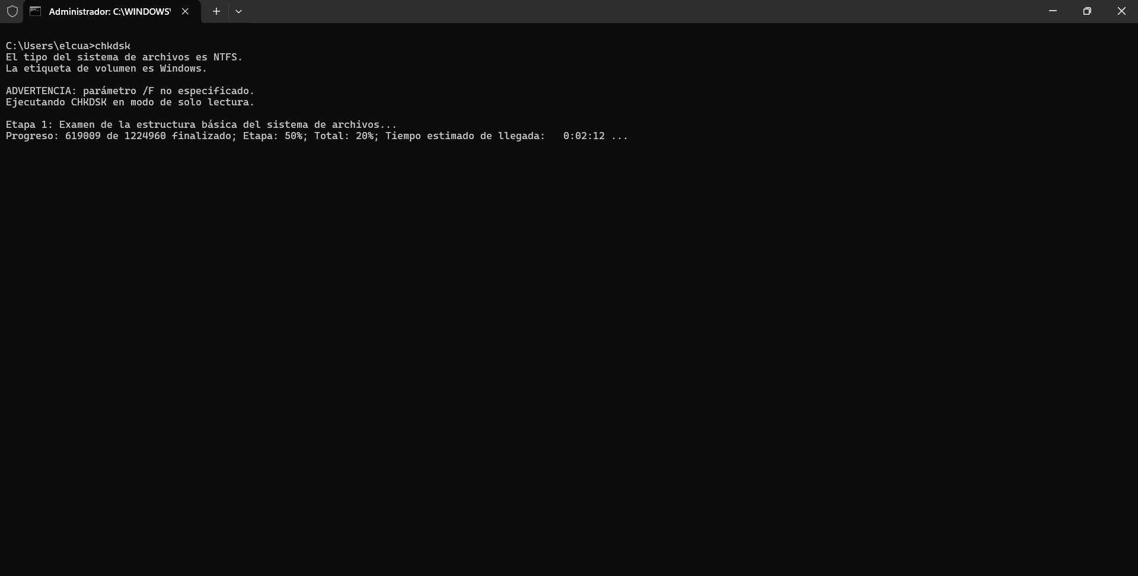
The “chkdsk” command checks disk drives for errors and displays file systems status. It scans for bad sectors and file system inconsistencies, providing vital disk health information for maintenance and troubleshooting.
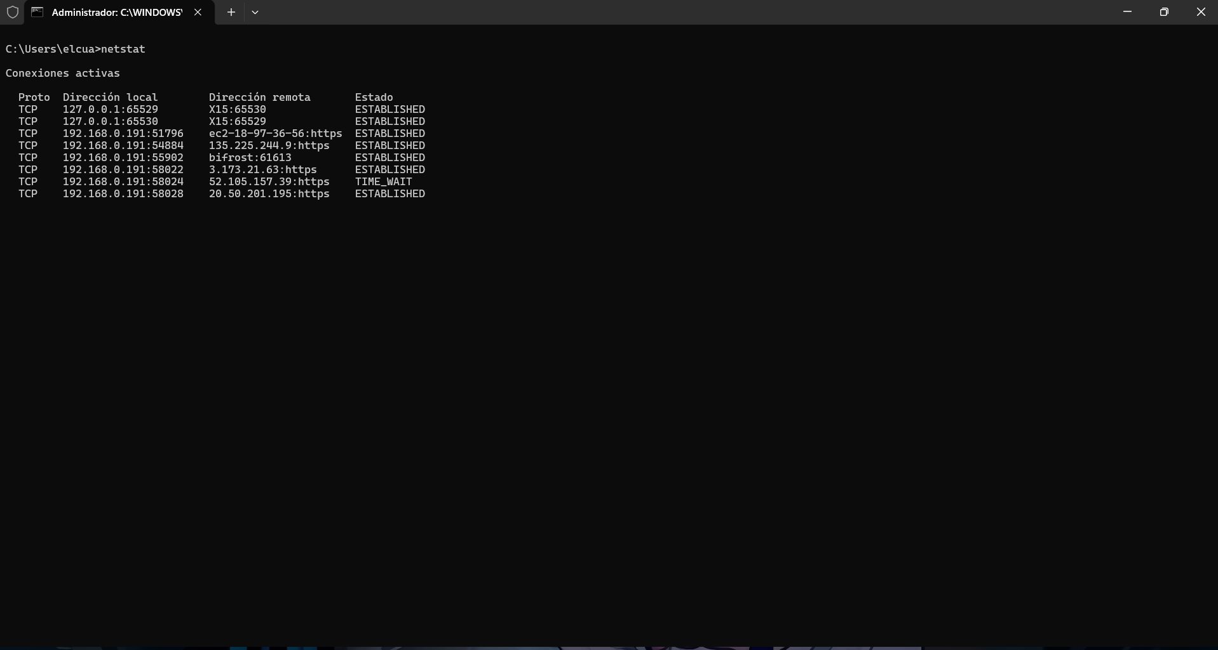
The “netstat” command displays network connections and listening ports. The -an shows all connections numerically, while findstr filters specific ports. This helps monitor network activity and security.

Use of Linux OS CLI commands
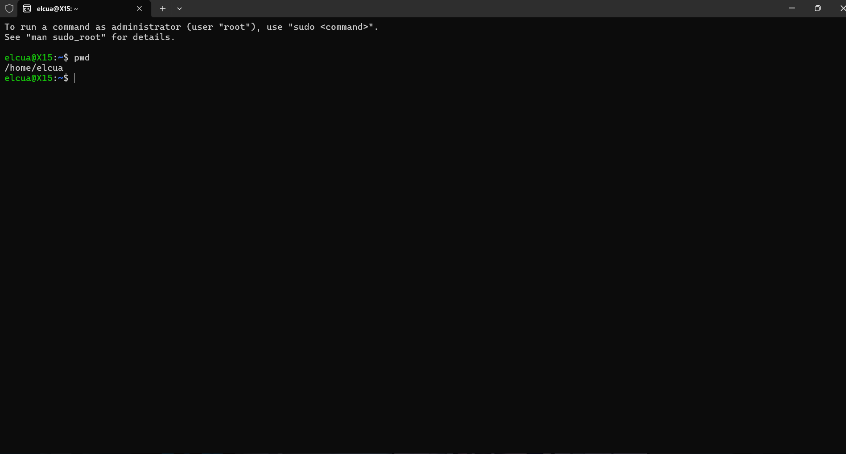
“pwd” (Print Working Directory) shows the absolute path of the current directory. Essential for orientation in the filesystem
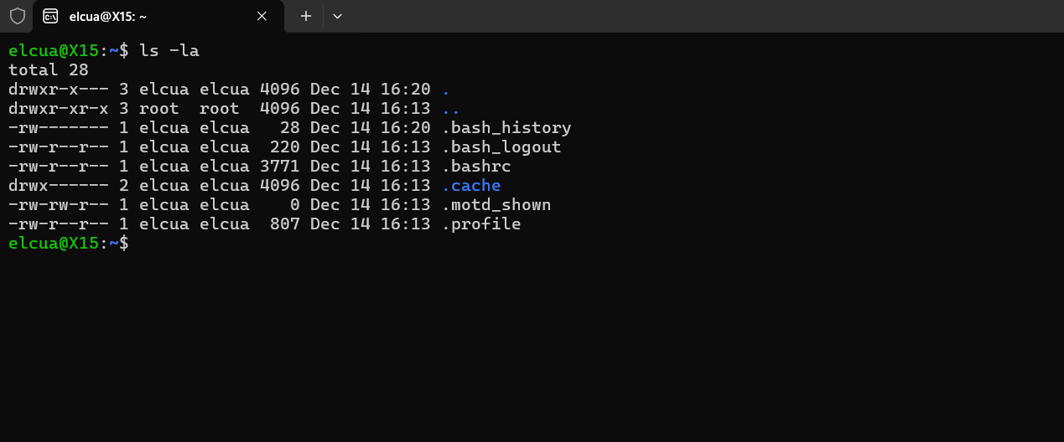
“ ls -la” (List File) Lists all files including hidden one with detailed permission, owner, and size.
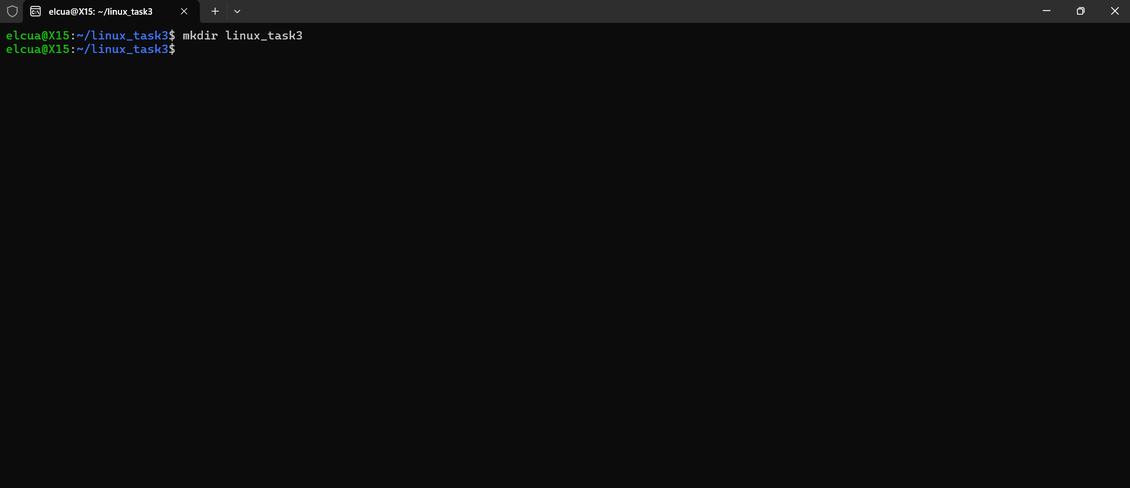
“mkdir” ( Make Directory) Creates a new directory. Used here to make “linux_task3” for organizing task files.
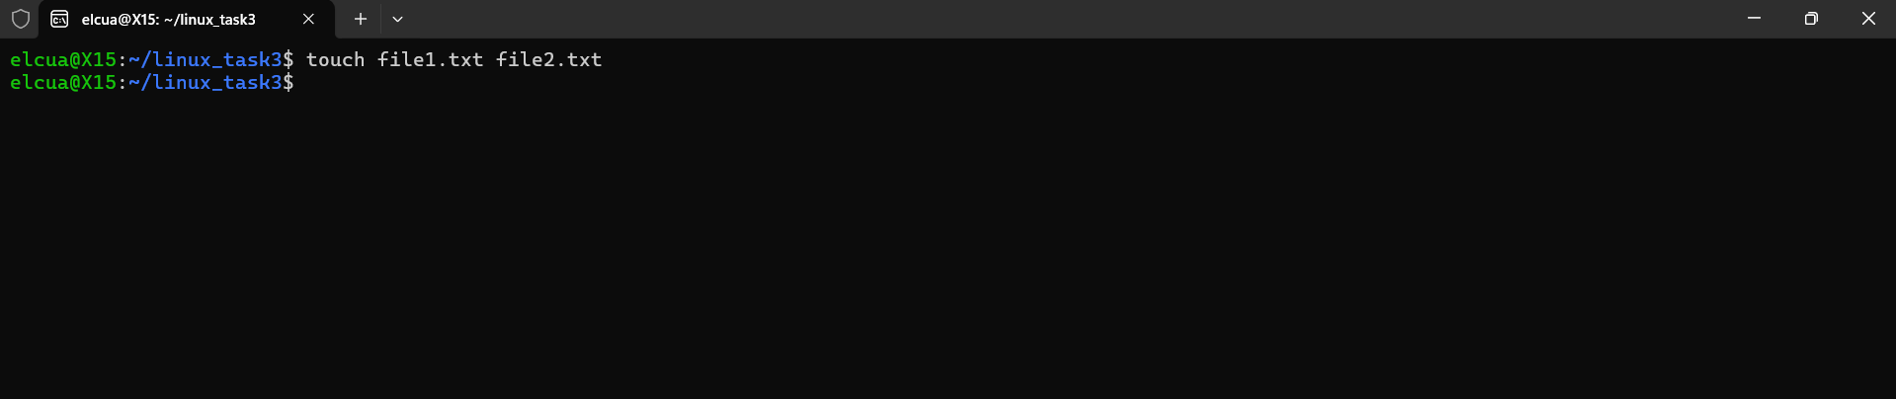
“touch” (Create file) Creates empty files or updates timestamp. Create file1.text and file2.text .
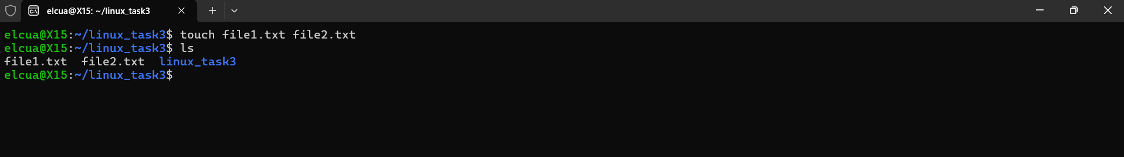
“ls” (List contents) Verifies file creation shows file1.text and file2.text in the directory.
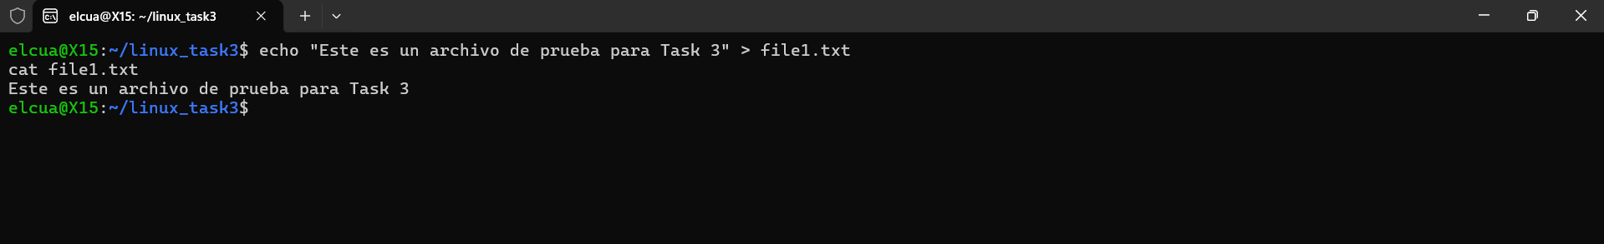
“echo and cat” (write and Read) echo writes the text to a file; cat displays files content. Used to add and view simple text
“cp” ( copy file) copies file1.text to file1_copy.text, demonstrating file duplication for backups.
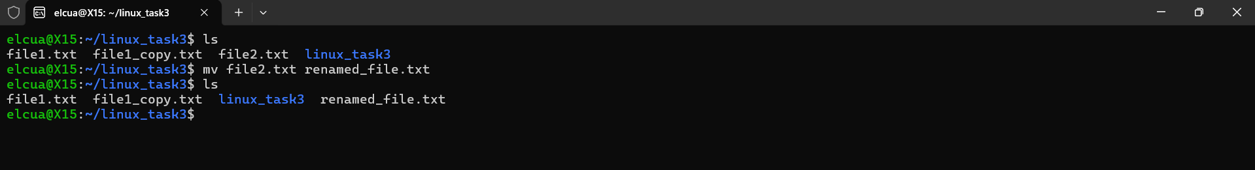”mv” (move/rename) rename file2.text to rename file.text. showing file management.
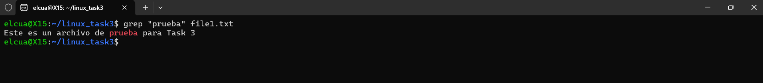
“grep” (search text) searches for the word “prueba” in file1.text, illustrating text filtering.
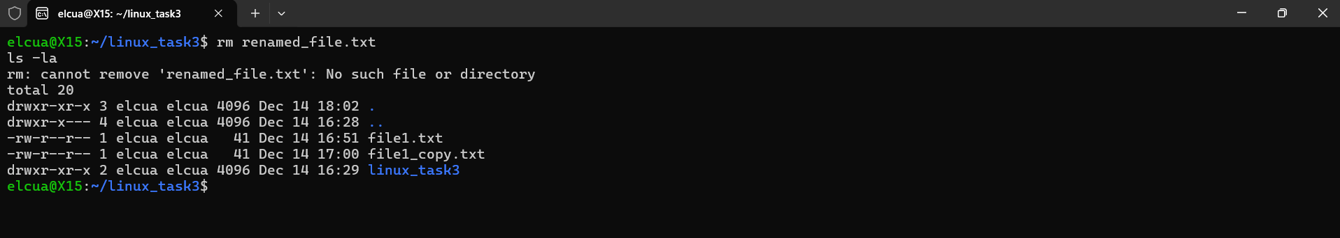
“rm” ( remove file) deletes rename_file.text, cleaning up unnecessary files.

Use of Windows OS scripts

(Batch Scripting)
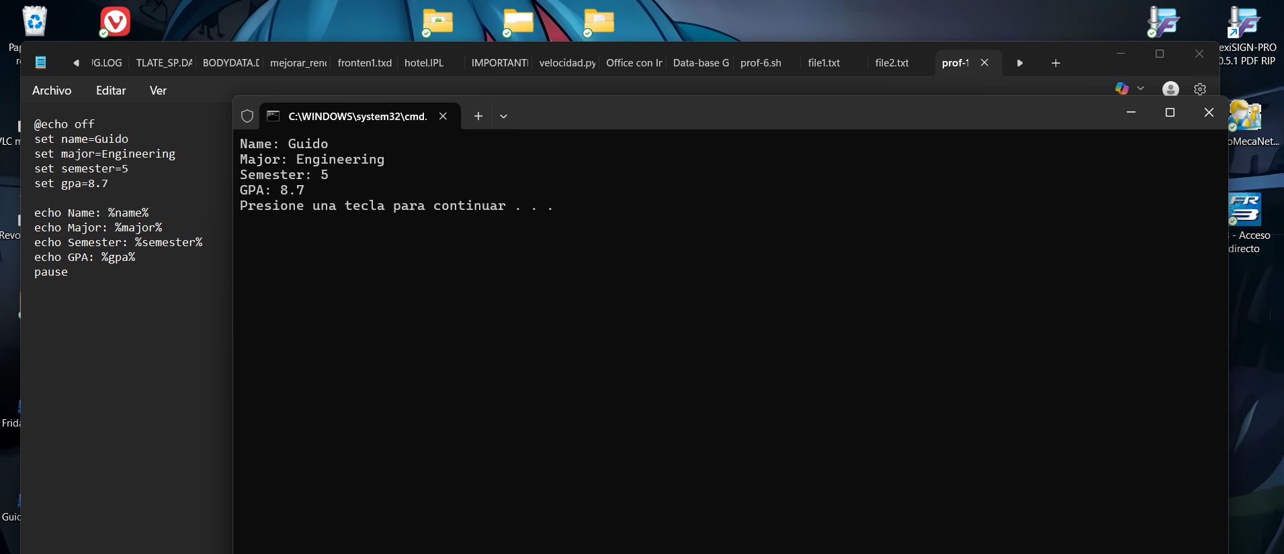
A console windows displaying data for a student named Guido: majoring in Engineering,5th semester, GPA 8.7.The Bath script likely uses set for variables like name and major, then echo to print them. The code has minor syntax inconsistencies, like inconsistent variables call sysntax. 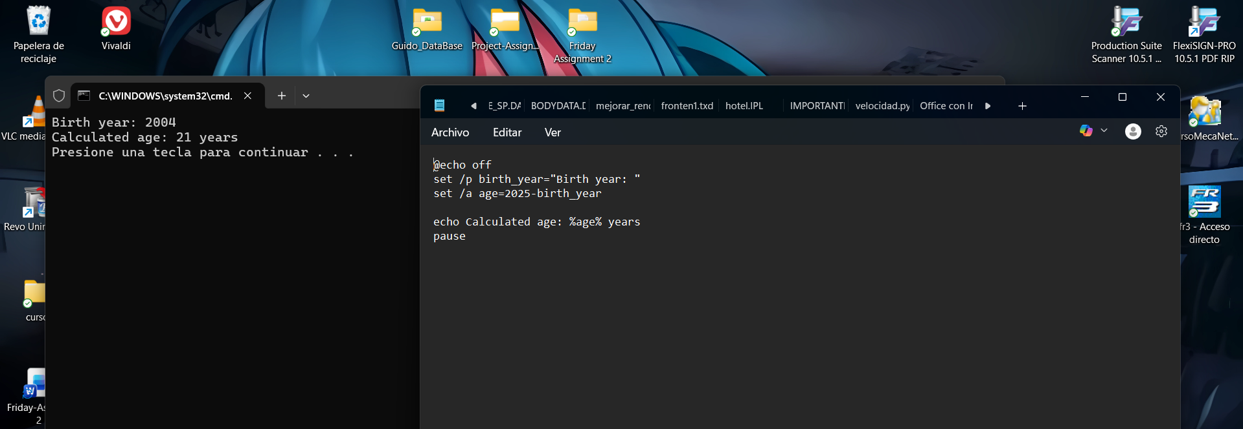
A simple Batch script that asks for a birth year, subtracts it from 2025, and prints the calculated age. The code contains a syntax error in the calculation line ( set /a age=2025-Birth_year”) and a type in the echo command (kagok), typical of manual coding.
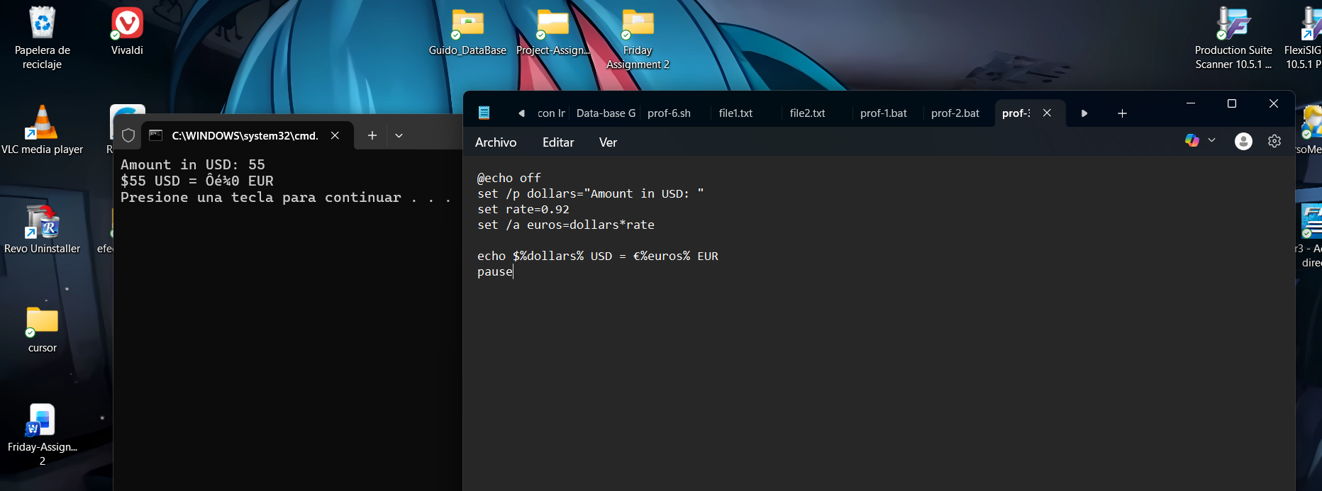
A console program converting USD to Euros. It prompts for an amount, uses a fixed rate (0.92), and outputs the conversion. The visible Batch code has errors in variable sysntax (%dollars$t) and type in the output ( CKenro$%)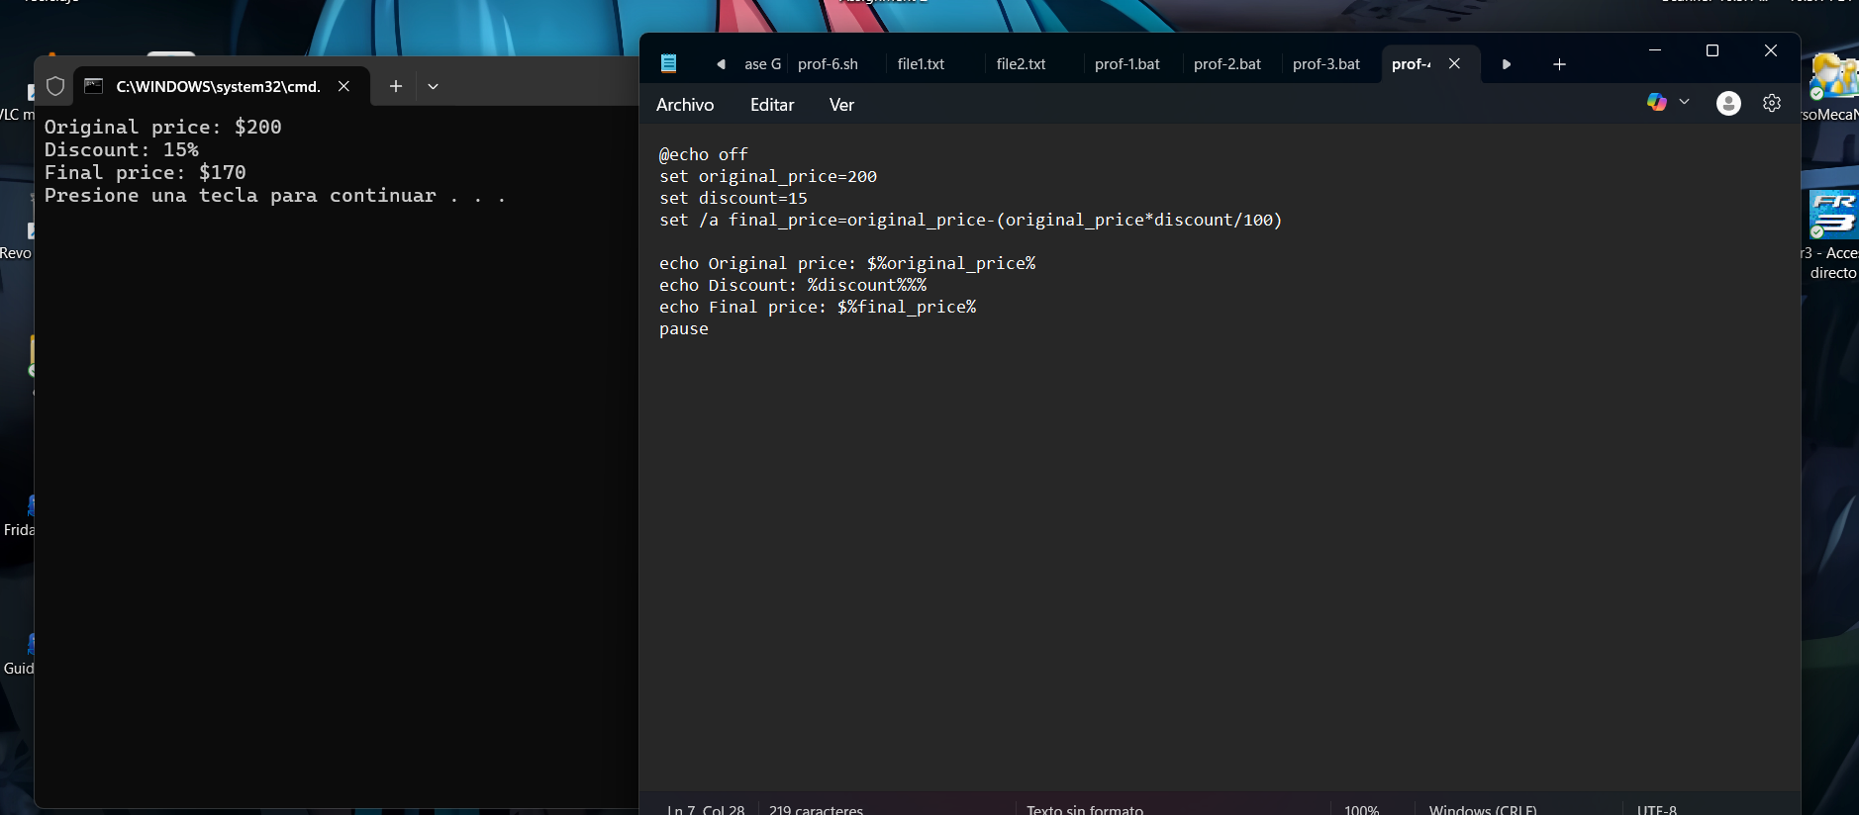
A Batch script calculating a final price after descount. It sets an original price and descount percentage, computes the final price, and desplays all three values. The code has typos like “original price: $&original_price$ instead of proper %variable%
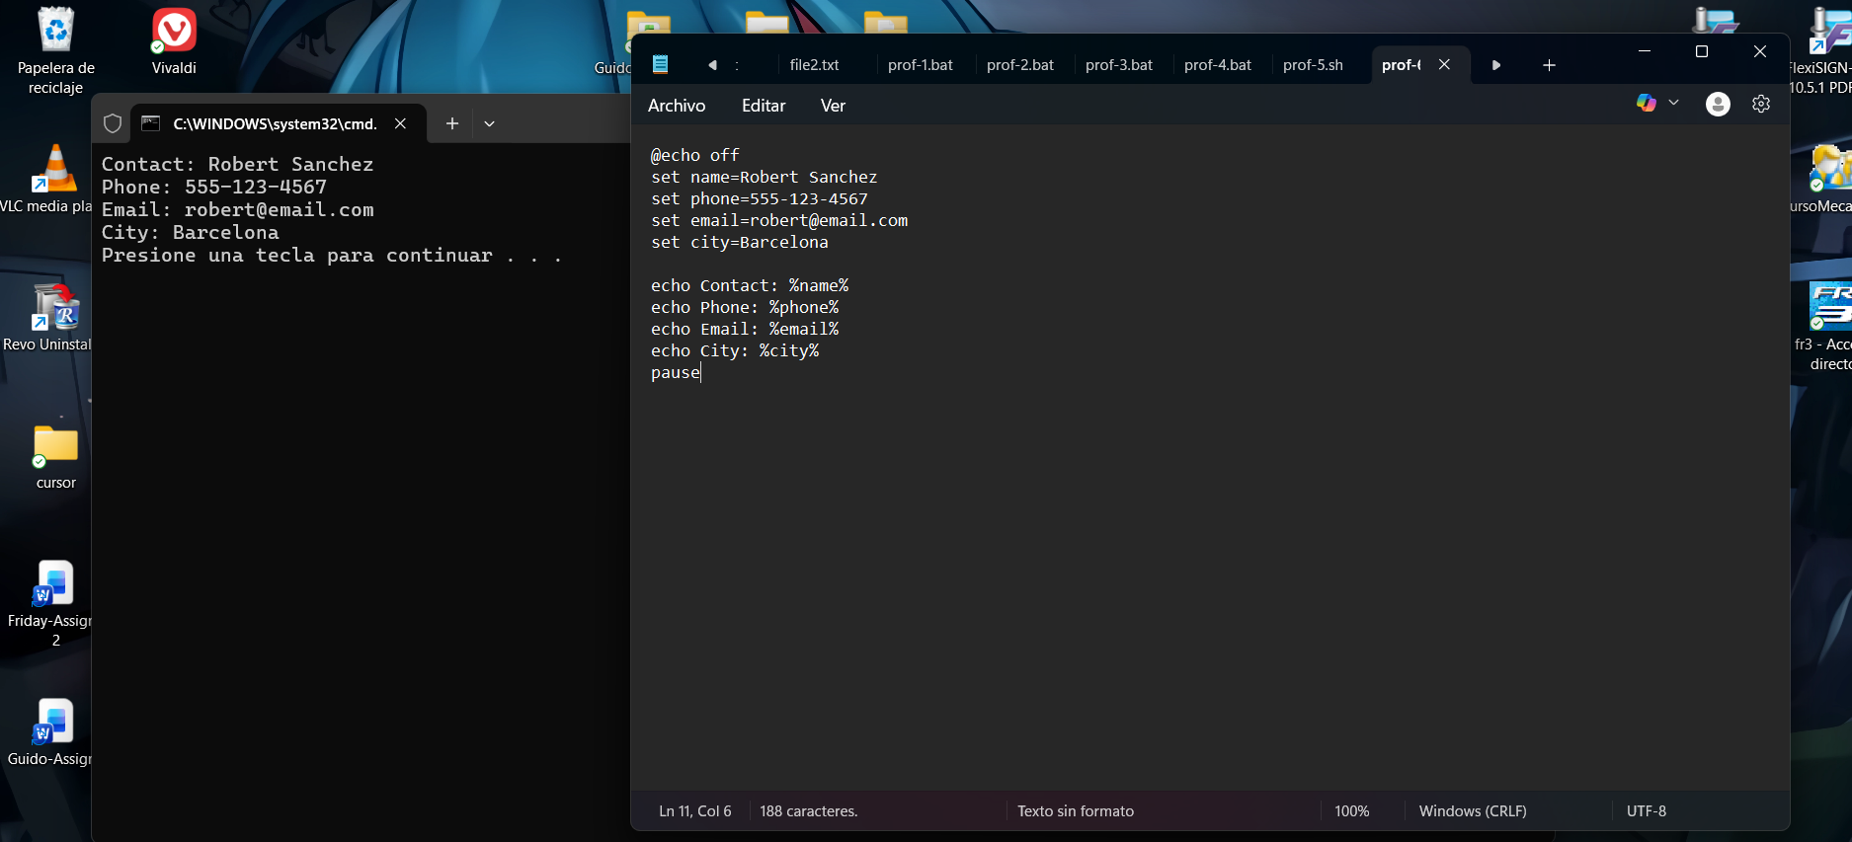
A program showing a contact card with name, phone, email, and city. The Batch script defines variables and prints them. Errors include using XnameX and XphoneX instead of %name% and inconsistent set command syntax ( set phones>555-123-4567

Use of Linux OS scripts (Bash Scripting)
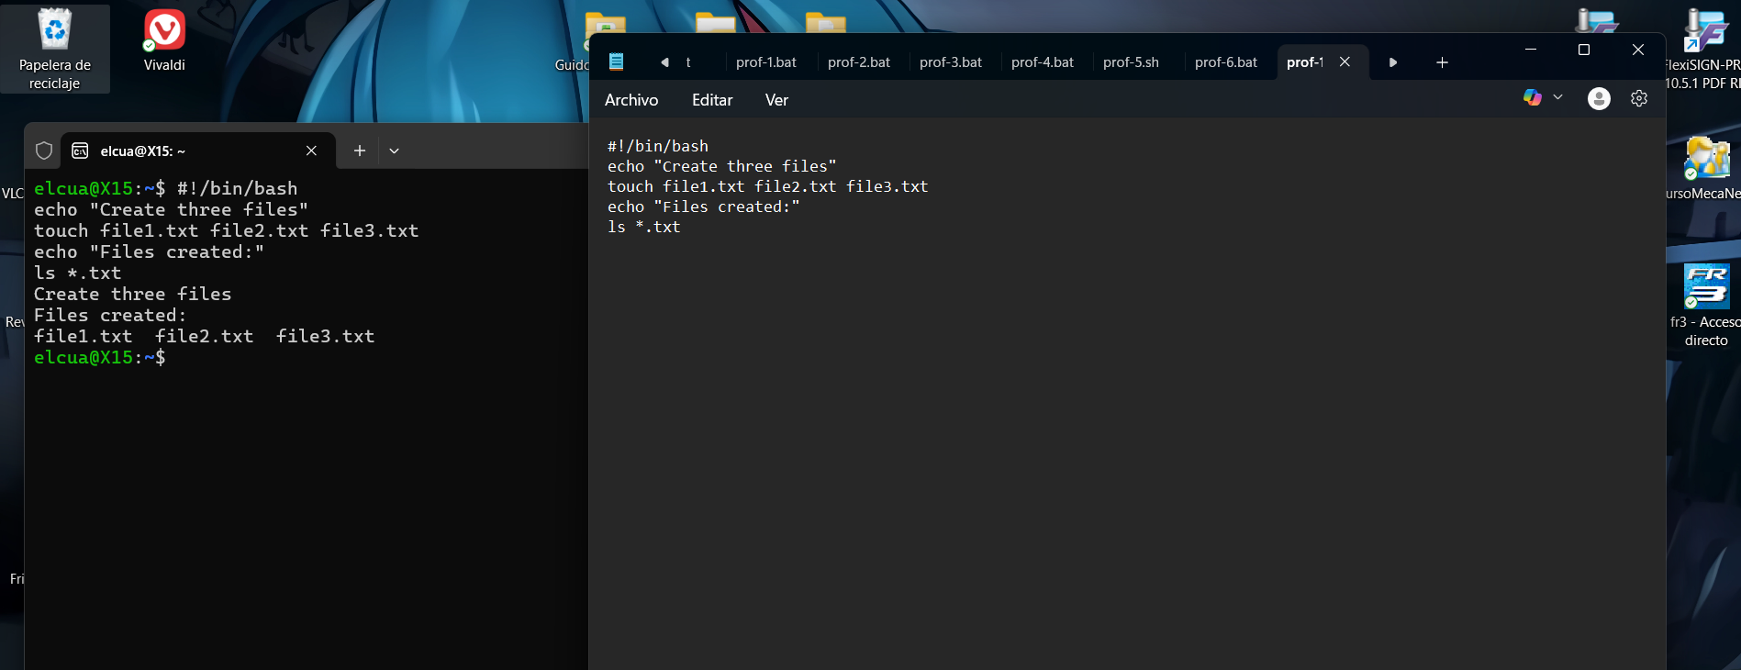
A very short Bash script designed to create three text files ( file1.text, file2.text, file3.txt) and then list them. However, the Ls command is incomplete (is “.txt), which is a common type. This would cause an error when trying to display the created files.
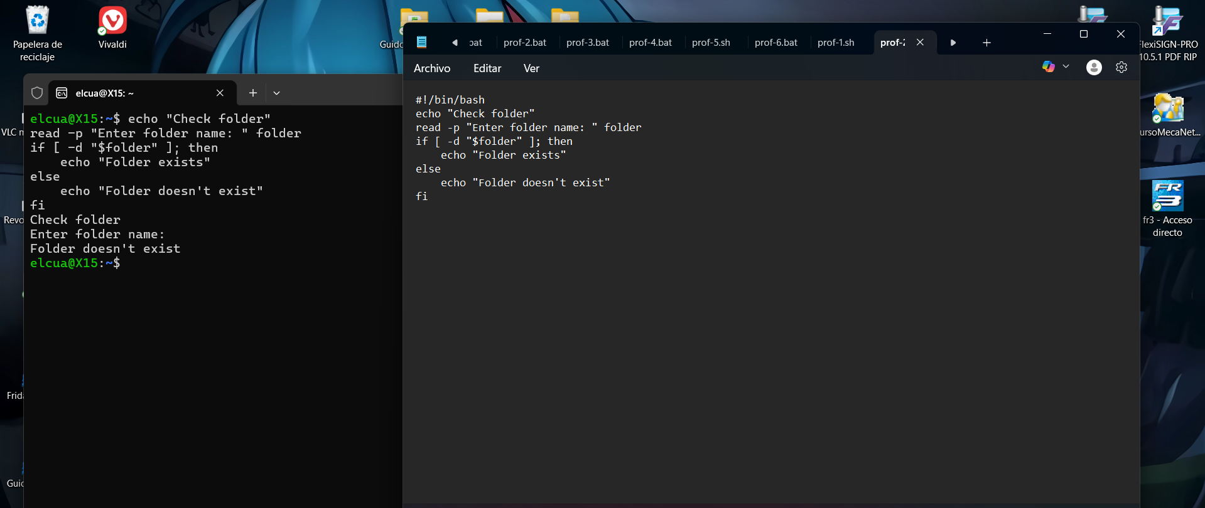
This image shows a Bash script that checks if a folder exists. There is a sysntax arror in the read command (read “p” instead of read -p). The console output shows it runs but always returns “Folder does not exist” due to the input issue, and a list of .bat files is also vasible.
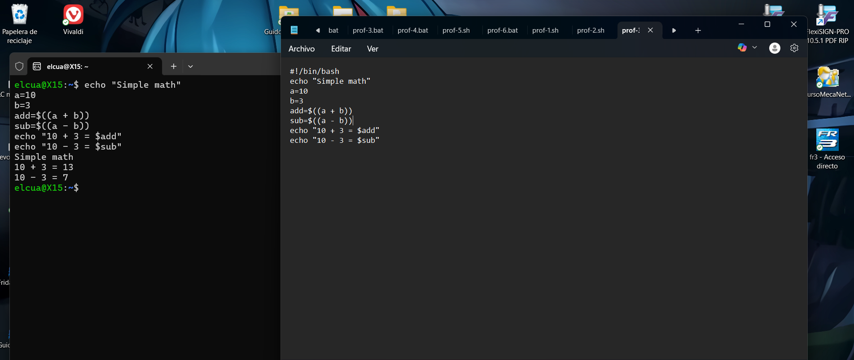
A script performing basic addition and subtraction, but the output message contain mistakes. The script correctly calculates 10+3=13 and 10-3=7, but the echo commands have swapped operators, printing 10-3=13 and 10-3=7. The code below has further typos in the echo strings.
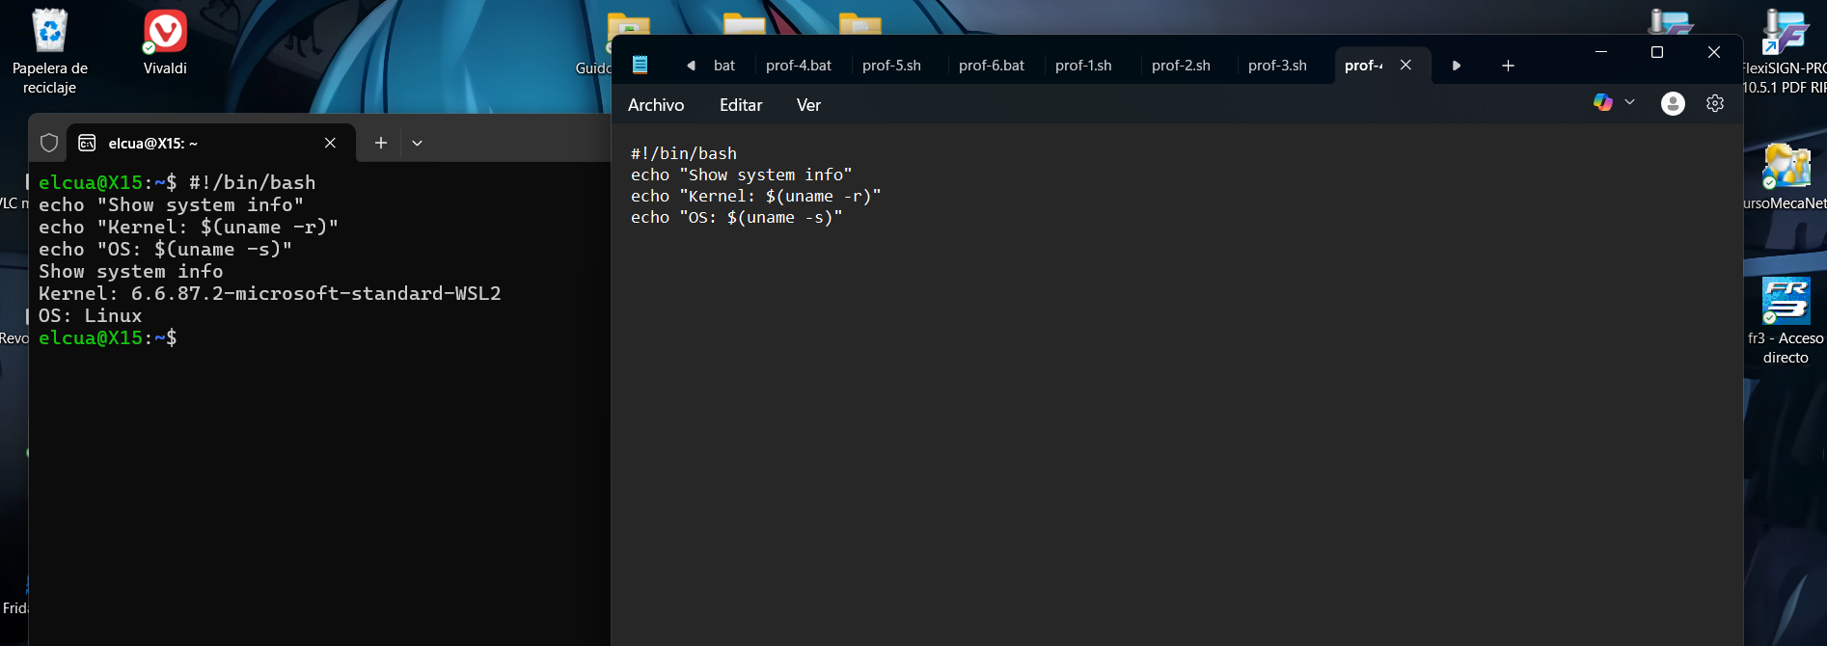
A Bash script meant to desplay system information (Kernel and OS). It has a typo in the first echo ($bbm instead of a clear title). The command substitutions use incorrect syntax (${uname -r} instead of $(uname -r), which would cause errors, but the output below shows it somehow ran, revealing the user is on Linux.
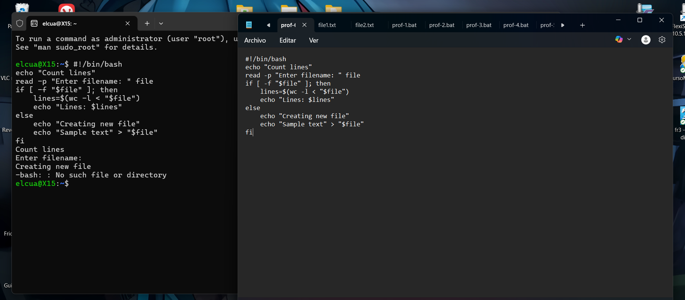
A Bash script intended to count lines in a file or create it if missing. It contains critical syntax errors: a malformed command substitution (wc -l'<) and incorrect variables reference (${lines). When run, it fails to read input correctly and errors on file creation, showing a broken script.

Scripting languages are popular for solving problems in many different domains. Some are general scripting languages such as Perl, Python and Ruby, while others are slightly domain-specific (platform-specific: Bash, PowerShell) or very domain-specific (application-specific: Cfengine, Matlab). (Hjelmås, A Common Framework for Scripting Tutorials, 2011)

Bash Associative arrays where not introduced in Bash before 2009, so it is not included in this tutorial. Similar to the Python tutorial it starts out with a simple example demonstrating syntax followed by an example demonstration scripting features (in this case, “gluing”). (Hjelmås, A Common Framework for Scripting Tutorials, 2011)

Bash (Bourne Again Shell) is a command language interpreter shell that is developed and maintained by GNUs Not Unix (GNU) Projects. GNU Projects is a mass-collaboration open-source software project announced by Richard Stallman in September 27, 1983. (Romanov, 2019)

PowerShell Since command line shells are less of an issue on Windows platforms compared to Unix/Linux platforms, much material in the start of the tutorial is devoted to the use of the PowerShell, before scripting is addressed. Associative arrays are called hash tables and introduced early, followed by control structures and functions, before quickly moving on to windows specific topics. (Hjelmås, A Common Framework for Scripting Tutorials, 2011)

Conclusion
This report has explored the core functions of modern operating systems and demonstrated practical system administration through command-line interface in both Windows and Linux. The tasks illustrate how operating systems manage hardware, software, and user’s interactions via graphical and text-based tools.By executing CLI commands and creating scripts in PowerShell and Bash, the efficiency, automation, and control offered by these environments were confirmed. These skills are essential for IT professionals, enabling effective management, troubleshooting, and automation In real-world computing environments, ultimately supporting career readiness in technology-driven workplace.

References

References
Hjelmås, E. &. (2011). A Common Framework for Scripting Tutorials.
Hjelmås, E. &. (2011). A Common Framework for Scripting Tutorials.
Hjelmås, E. &. (2011). A Common Framework for Scripting Tutorials.
Romanov, M. (2019). Technical automation of Windows platform testing.

