Jac Thomas (2204038)
University of Wales
BMBM4001: Business Model Canvas

Contents
Content Of Assignment 2
Reference List 7

Content Of Assignment

Link to Canvas:
https://next.canvanizer.com/canvas/ru1r7bzL8EkPH

Images of Canvas:
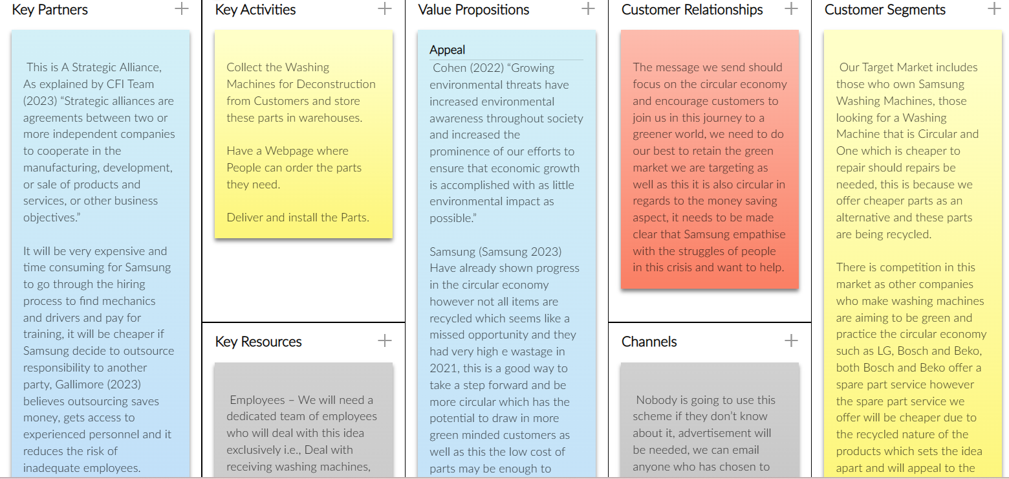
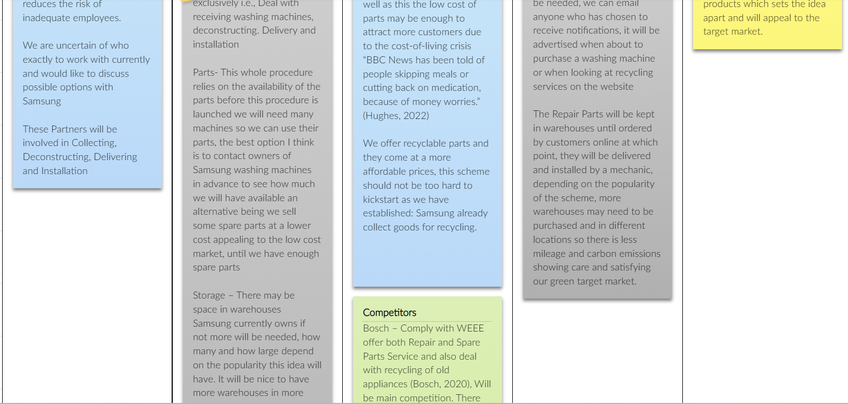
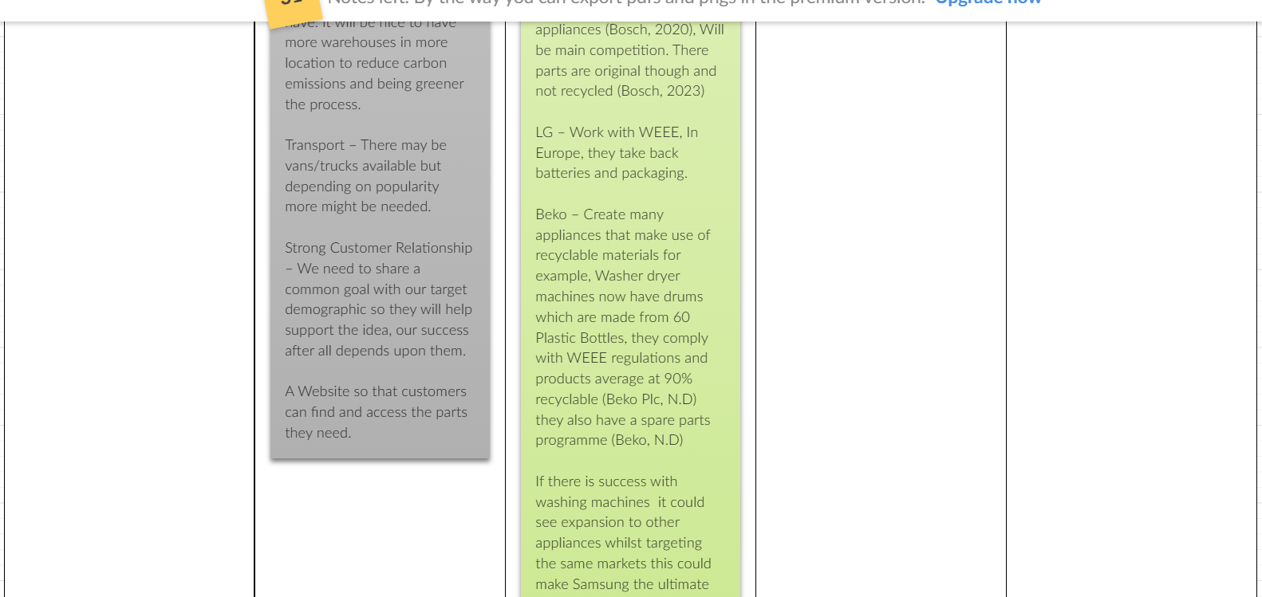
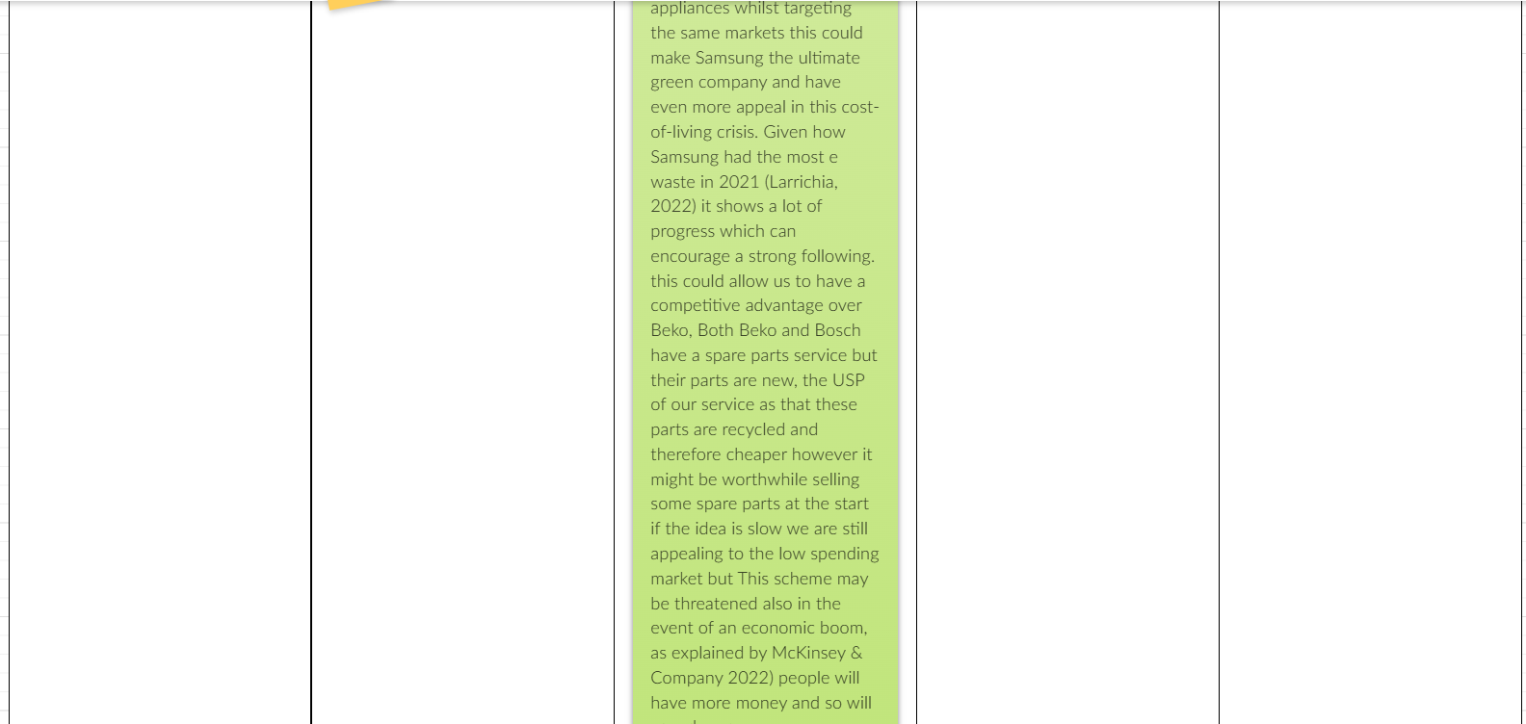
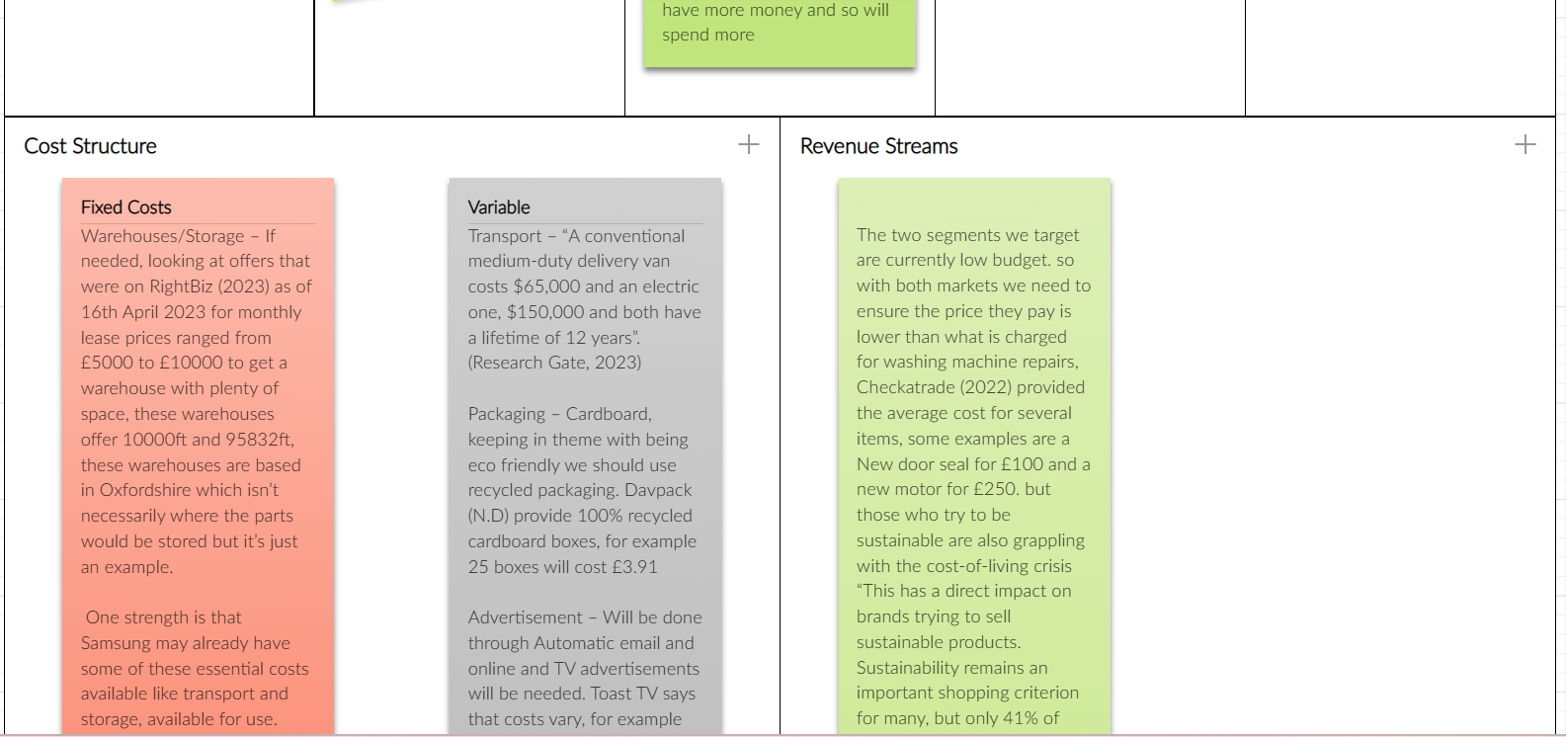
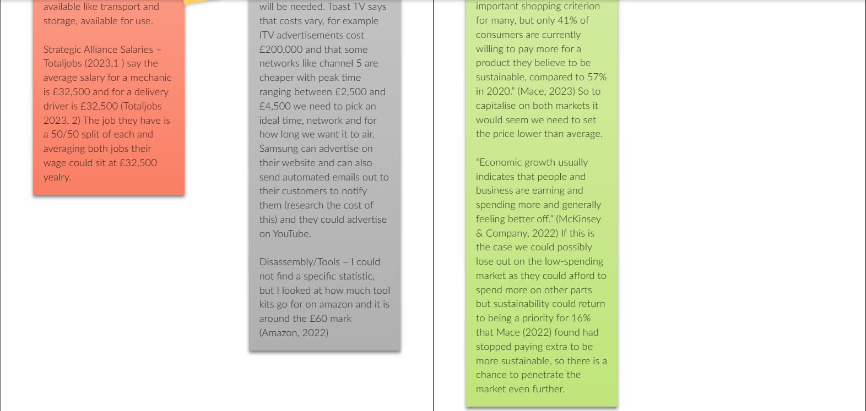

Reference List

The following reference List Includes the references used in the canvas and the accompanying Presentation:

Amazon (2022) “Tools for a Mechanic" Available at: Amazon.co.uk : tools for a mechanic Accessed: 22nd April
Beko (N.D) “Genuine Beko Spares Parts & Accessories” Available at: https://www.beko.co.uk/support/parts-and-accessories Accessed: 31st March 2023
Beko plc (N.D) “Waste and Recycling” Available at: https://www.bekoplc.com/sustainability/waste-and-recycling/ Accessed: 31st March 2023
Bosch (2020) “Recycling and Sustainability” Available at: https://www.bosch-diy.com/gb/en/service/recycling#:~:text=Recycling%20and%20sustainability,are%20taken%20back%20and%20recycled. Accessed 31st March 2023
Bosch (2023) “Spare Parts for Washing Machines” Available at: https://www.bosch-home.co.uk/customer-service/spare-parts-search/washing-machines Accessed: 31st March 2023
Cambridge Dictionary (2023) “target market” Available at: TARGET MARKET definition | Cambridge English Dictionary Accessed: 03/05/2023
Cambridge Dictionary (2023) “value proposition” Available at: VALUE PROPOSITION | English meaning - Cambridge Dictionary Accessed: 03/05/23.
CFI Team (2023) “Strategic Alliances” Available at: Strategic Alliances - Types and Benefits of Strategic Alliances (corporatefinanceinstitute.com) Accessed: 4th April 2023
Checkatrade (2022) “What is the average cost to repair a washing machine in 2023” Available at: https://www.checkatrade.com/blog/cost-guides/washing-machine-repair-cost/ Accessed: 27/04/23
Davpack (N.D) “Recycled Boxes – Single Wall” Available at: https://www.davpack.co.uk/cardboard-boxes/single-wall/recycled-boxes.htm Accessed 16th April.
F. Larrichia (2022) “Waste generated from leading tech companies worldwide in 2021, by company” Available at: https://www.statista.com/statistics/1250749/generated-waste-top-tech-companies-worldwide/ Accessed 20th April
Gallimore D. (2023) “Advantages and disadvantages of outsourcing” Available at: Advantages and disadvantages of outsourcing | Outsource Accelerator Accessed: 31st March 2023
Hughes D. (2022) “Cost of living: Soaring bills damaging people's health, say medics” Available at: Cost of living: Soaring bills damaging people's health, say medics - BBC News
LG (2023) “Take-Back & Recycling Network” Available at: https://www.lg.com/global/sustainability/environment/take-back-recycling/global-network-europe# Accessed 31st March 2023
M. Mace (2023) “Consumers less willing to pay more for sustainable products during cost-of-living crisis”. Available at: https://www.edie.net/consumers-less-willing-to-pay-more-for-sustainable-products-during-cost-of-living-crisis/#:~:text=Sustainability%20remains%20an%20important%20shopping,compared%20to%2057%25%20in%202020. Accessed: 27/04/2023
McKinsey & Company (2022) “What is economic growth?” Available at: https://www.mckinsey.com/featured-insights/mckinsey-explainers/what-is-economic-growth Accessed: 27/04/2023
ResearchGate (2023) “Electric Truck & Bus Grid Integration, Opportunities, Challenges & Recommendations” Available at: https://www.researchgate.net/figure/Medium-duty-delivery-van-costs-savings-analysis_fig2_316562460#:~:text=A%20conventional%20medium%2Dduty%20delivery,a%20lifetime%20of%2012%20years. Accessed: 16th April.
Rightbiz (2023) “Warehouse to let in Oxfordshire for multiple businesses” Available at: https://www.rightbiz.co.uk/commercial/for_sale/1187_oxfordshire.html Accessed: 16th April.
S. Cohen (2022) “The Growing Awareness and Prominence of Environmental Sustainability” Available at: https://news.climate.columbia.edu/2022/09/19/the-growing-awareness-and-prominence-of-environmental-sustainability/ Accessed: 28th March 2023
Samsung (2023) “Samsung WEEE Recycling Services” Available at: https://www.samsung.com/uk/recycling-services/ Accessed: 31st March 2023
Selzy (2023) “How Much Does Email Marketing Cost?” Available at: https://selzy.com/en/blog/how-much-does-email-marketing-cost/ Accessed: 28/04/2023
Toast (2023) “TV Advertising Costs in the UK” Available at: https://www.toasttv.co.uk/tv-advertising-costs/#:~:text=These%20can%20range%20from%20%C2%A3,as%20little%20as%20%C2%A3120K. Accessed 16th April.
Totaljobs (2023) “What is the average salary for Delivery Driver jobs?” Available at: https://www.totaljobs.com/salary-checker/average-delivery-driver-salary Accessed: 16th April.
Totaljobs (2023) “What is the average salary for Mechanic jobs?” Available at: https://www.totaljobs.com/salary-checker/average-mechanic-salary Accessed: 16th April.
V. Kalia (2019) “Strategic Alliance: What is it, Types, Benefits & Why You Need it.” Available at: Strategic Alliance: What is it, Types, Benefits & Why You Need it. | Workspan Accessed: 06/05/2023.

