Student name: Liesbeth Beeckman
Student number: 1709314
Assignment title: Leading the Development of Social Prescribing in the Cardiff South West Cluster
Module number: DSAW7058
Institution name: University of Wales Trinity St David

Contents

Research proposal 4
1. Background 4
2. Research Proposal 4
3. Leadership, change management and service improvement 5
1. Time credit social prescribing pilot 7
Permission to fail 7
1. Introduction 7
2. Rationale 8
3. Proposal 9
4. Ethical approval 10
5. Research questions 10
6. Outcomes 10
7. Learning 12
Innovation management 16
Impact 17
2. Social Prescribing in Mental Health Bid 17
Infrastructure building 17
Complex (adaptive) systems 18
Impact 19
3. The All Wales Social Prescribing Research Network 20
The Legacy 20
The Epiphany 20
4. Y llwyth: Cardiff South West Social Prescribing Tribe 21
Creating synergy 21
Tribal Leadership 21
Impact 23
5. Social Prescribing Cymru 25
The social prescriber community in Wales 25
Impact 25
6. The South East Wales Social Prescribing Community of Practice 26
Impact 27
7. Digital health solutions 29
Conclusion 30
References 31
Appendix 1: The Logic Model for the Innovate to Save time credit social prescribing pilot in the Cardiff South West cluster, August 2017 – January 2018 33
Appendix 2: The research questions (RQ) for the Innovate to Save time credit social prescribing pilot in the Cardiff South West cluster, August 2017 – January 2018 37

Research proposal

Background

Social prescribing, sometimes referred to as community referral, is a means of enabling GPs, nurses and other primary care professionals to refer people to a range of local, non-clinical services (The King’s Fund, 2017).
Social prescribing started in 1998 in Bromley by Bow, London (Stocks-Rankin, Seale and Mead, 2018). By 2017, the vast majority of GPs in the UK are open to social prescribing, with one in five practices regularly referring patients to non-clinical services (Millett, 2017).
Public Health Wales conducted a review of social prescribing and concluded that the evidence base is weak (Price, Hookway and King, 2017). Despite this, social prescribing has high face validity and is supported by policy makers in Wales. For example, it is one of the six priorities of the Future Generations Commissioner for Wales (Future Generations Commissioner for Wales, 2018).

Research Proposal

The Cardiff South West (SW) cluster has obtained an Innovate to Save grant. This programme funds innovative initiatives that improve the quality of Welsh public services whilst generating cashable savings for Welsh Government (Nesta, 2018).
The cluster will use this grant to pilot a time credit social prescribing model in three GP practices with high deprivation scores, in collaboration with Spice. Spice is a social enterprise that provides a corporate network where people can spend “time credits” – rewards for volunteering in Spice’s third sector network (Spice, 2018).
Research has suggested a positive correlation between volunteering and wellbeing (Jenkinson et al., 2013). Spice’s own evaluation has demonstrated improved mental and physical health outcomes among volunteers in their network (Spice, 2016).
The aim of this pilot is to investigate whether a “social prescription” of time credits can incentivise patients to take up volunteering within the Spice network and whether this improves their health and wellbeing.
The learning from this pilot will be used to develop an innovative social prescribing model for the Cardiff SW cluster.
Ethical approval was sought but deemed not necessary as the project qualified as service improvement.

Leadership, change management and service improvement

The project team consists of Dr. Karen Pardy, Cardiff SW cluster lead; Ms Andrea Pace, Cardiff SW cluster project support officer; two managers and a social prescriber from Spice; myself. We are being supported by Nesta (an innovation foundation, www.nesta.org.uk) for innovation management coaching and the University of Cardiff for evaluation.
I will be leading the project at operational level. Based on the discussions during a project team meeting led by Nesta, I have written a Logic Model (see Appendix 1) and Research Questions (see Appendix 2). My further role will be to lead the project team meetings, liaise with Nesta and the University of Cardiff, engage with stakeholders, design and deliver the training pack for primary care staff in the pilot GP practices, manage the project and research governance and audit trail, create the required paperwork for consultations and data collection, collect data, present interim results to the project team and wider stakeholders. Alongside this, I will be trained by Spice to run social prescribing clinics alongside their social prescriber.
The most important stakeholders I will be engaging with are the Cardiff SW cluster, Spice, the three participating GP practices, Public Health Wales, Nesta and the University of Cardiff.
For the purpose of the project, as instructed by Nesta, we will be using innovation management methodology. We have used the Logic Model for planning (see Appendix 1) and we will be writing monthly reflective diaries during the six month pilot. The content of these will be used to update the Logic Model as we hit obstacles and uncover more assumptions, which will inform adjustments in rapid cycles of experimentation (each one month long).
From a leadership perspective, I will investigate which leadership, management and organisational change strategies, models and tools are most effective to achieve the cluster’s objective of developing an innovative and integrated social prescribing model.
As a starting point, in addition to using innovation management principles and tools (theory of change, Logic Model, rapid cycles of experimentation, reflective diaries, double-loop learning), I will also be drawing on the principles of Kotter’s 8-Step Change Model (Kotter and Cohen, 2002). The work to create a climate for change (increasing urgency, building the guiding team, getting the right vision) has been done as part of and by setting up the pilot. Engaging and enabling the organisation (communicate for buy-in, empower action, create short-term wins) will be important actions while running the pilot. Implementing and sustaining change (don’t let up, make it stick) will be the main challenge when the learning of the pilot is used to develop an innovative social prescribing model for the Cardiff SW cluster.

Social prescribing

Social prescribing, sometimes referred to as community referral, is a means of enabling GPs, nurses and other primary care professionals to refer people to a range of local, non-clinical services (The King’s Fund, 2017).
Increasing numbers of patients are presenting to GP practices with non-medical issues - mainly psychosocial and financial. This is currently estimated at 20% of GP appointments, costing the NHS about £400 million per year in the UK (Citizens Advice, 2015). This comes at a time when these GP practices are facing increasing time pressure and challenges of funding and staff retention.
Moreover, it is estimated that “social determinants of health” - social, economic, environmental and lifestyle factors - determine 70% of an individual’s health, thus impacting on the healthcare budget long-term (Schroeder, 2007).
A social prescriber is a non-clinical professional who addresses these non-medical issues, taking pressure off primary care staff. They provide one-to-one support to patients and refer them to appropriate services in the public and third sector.
Social prescribing started in 1998 in Bromley by Bow, London (Stocks-Rankin, Seale and Mead, 2018). By 2017, the vast majority of GPs in the UK are open to social prescribing, with one in five practices regularly referring patients to non-clinical services (Millett, 2017).
Public Health Wales conducted an evidence review for social prescribing and concluded that the evidence base is weak (Price, Hookway and King, 2017). Despite this, social prescribing has high face validity and support at policy level within the UK. It is one of the top 10 high-impact actions to reduce GP appointments in NHS England’s Five Year Forward View (NHS England, 2014). It is also one of the six priorities of the Future Generations Commissioner for Wales (Future Generations Commissioner for Wales, 2018).

Time credit social prescribing pilot

Permission to fail

Background and rationale

The Cardiff South West (SW) cluster consists of 11 GP practices serving a population of approximately 65,000 patients. There are areas of high deprivation within the cluster and a significant elderly population (Lester et al., 2013). In 2016, the cluster spent approximately £319,000 on antidepressants. GP practices are struggling to meet demand for appointments.
In July 2017, the cluster obtained Welsh Government funding under the Innovate to Save scheme to run a time credit social prescribing pilot in collaboration with Spice. Spice is a social enterprise that provides a corporate network where people can spend “time credits” – rewards for volunteering in Spice’s third sector network (Spice, 2018).
Research has suggested a positive correlation between volunteering and wellbeing (Jenkinson et al., 2013). Spice’s own evaluation has demonstrated improved mental and physical health outcomes among volunteers in their network (Fig. 1) (Spice, 2016).

Aim

The aim of this pilot is to investigate whether a “social prescription” of time credits can incentivise patients to take up volunteering within the Spice network and whether this improves their health and wellbeing.

Ethical approval

Ethical approval was applied for with Cardiff and Vale University Health Board Research and Development department. It was deemed not necessary as the project was classified as a service improvement project.

Figure 1: impact of Spice time credits (Spice, 2016)

Research questions

The research questions are included in Appendix 2.

Outcomes

The outcomes are included in Appendix 3.
More than providing answers to the research questions, this pilot revealed a large number of “unknown unknowns” and generated a high number of questions and hypotheses for future research.
A list of these factors is included in Appendix 4. Many of these factors proved to be significant barriers for pilot delivery, not in the least the discovery that time credits are poor drivers for behavioural change in patients who present to primary care.

Innovation management
The Welsh Government’s Innovation Wales strategy defines innovation as: “The successful exploitation of new ideas. Sometimes it is the result of the application of brand new knowledge, but more often it is the result of experimental changes, or new combinations of existing ideas and experience. It can involve the development of new or improved products, of different or better processes for producing goods or services, or the introduction of entirely new services. And these do not have to be for sale; they might also be the way public services are offered or delivered.” (Welsh Government, 2014)
Both Welsh Government and NHS Wales focus on innovation as a way to respond to increasing pressure on services, by transforming those services (Welsh Government, 2014)(NHS Wales Governance, no date). Innovation can be a driving force for prudent healthcare (Martin and Evans, no date). As Cabinet Secretary for Health and Social Care Vaughan Gething repeatedly states at conferences: “More money is not the solution. In the current system, there will never be enough money to deliver everything we want to deliver. We have to transform services instead.”
These words are put into action, for example with Welsh Government programmes like Innovate to Save (Nesta, 2018) and Accelerate (Welsh Government, 2018).
Before and during the Innovate to Save time credit social prescribing pilot, we were supported by innovation foundation Nesta, who had been commissioned by Welsh Government in an academic collaboration with the University of Cardiff. Nesta organised several “bootcamps” where the project team received training in the principles of innovation management and theory of change.
I found this training very useful, both for the pilot and for my leadership development. It helped me to identify what is needed for effective leadership and management for patient focused service improvement.
“Permission to fail” is an important aspect of innovation management. “FAIL stands for First Attempt In Learning” is also a frequently cited phrase. I learned that the willingness to take a risk and accept the possibility of failure is an important condition for deep reflection and true learning. If targets are set too soon, people will use superficial tricks to ensure they achieve the required numbers. I learned that if you really want to understand change, you cannot be precious about the proposed intervention and anticipated result, but have to accept it may go either way.
“Fail fast” and rapid cycles of experimentation are other important aspects of innovation management. I learned that there is no point in theorising for too long – if you want to lead change, you have to test your assumptions in the real world – and again, be prepared to see them all shattered.
Double-loop learning is also a useful change management tool. This prevents pointless superficial cosmetic interventions and troubleshooting, and encourages deep learning by questioning underlying assumptions and beliefs. For example: if receptionists don’t code patients the way I ask them to – is it really a case of just simplifying the codes? Or will it never happen the way I want it, regardless of how simple codes are, because the way I want it is not part of their normal workflow?
Learning to identify and challenge limiting assumptions was also very useful in my leadership development. I learned that it is worth asking why we adhere to certain belief. All too often these turn out to be arbitrary and historical convention rather than naturally set in stone.
I also learned that innovation is an uncomfortable place for most people and teams. It is important to be a brave leader who paints the common vision and inspires trust. It is this vision and trust that is required for teams in order not to disintegrate in the face of potential failure.

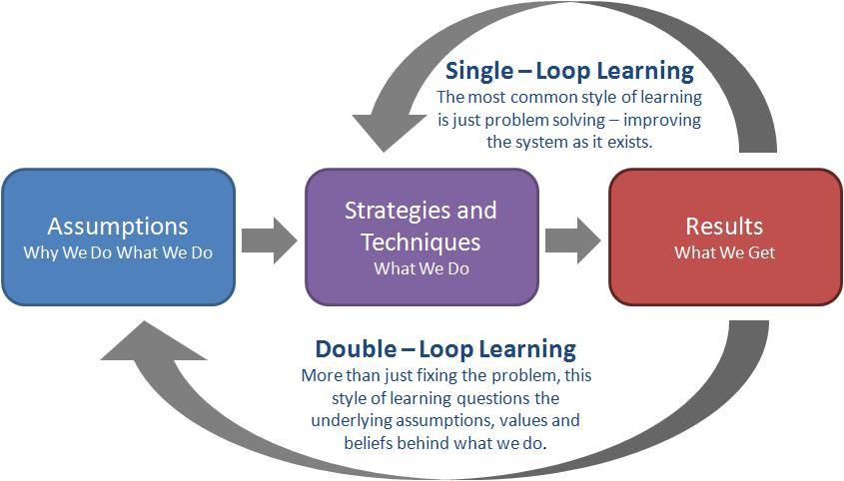
Figure 2: double-loop learning. (Nesta, 2017)

Impact
This pilot acted as a catalyst and accelerated our learning about social prescribing and my leadership development exponentially. I then used this learning to develop a social prescribing model for the Cardiff SW cluster, as further explained below.

Social Prescribing in Mental Health Bid

Infrastructure building

In December 2017, Welsh Government opened the application window for third sector organisations to submit a bid for funding for a social prescribing in mental health pilot.
I took the lead on writing a large collaborative bid between 15 GP clusters in Mid and South Wales, 3 voluntary councils and a number of public services and third sector organisations, with mental health charities Hafal and CAIS as lead applicants.
The proposed model in the bid incorporated all learning from the time credit social prescribing pilot and focused on infrastructure building, based on the concept of complex (adaptive) systems.

Complex (adaptive) systems
Complex systems are systems with many components and interactions. These interactions cause distinct properties like non-linearity, feedback loops and self-organisation. In a complex system, the total is different from the sum of the individual components and the behaviour of the system cannot be predicted from the behaviour of the individual components.
A complex adaptive system is a complex system that maintains an equilibrium. (Figure 3)
Social prescribing is usually structured as a programme that is offered in a certain geographical area for a certain time. It is rarely joined up with existing services, and there is no continuity of provision when the programme stops.
My focal point for the social prescribing model proposed in this bid was not the social prescribing programme itself, but the cluster and the existing components and interactions, conceptualised as a complex adaptive system. I proposed to build an infrastructure of volunteer and professional signposters in every cluster, supported by an IT portal that provides an up to date directory of services. This infrastructure would be based on people, services and resources already in place and thus would be sustainable after the end of the funding period. Social prescribing would not be owned and practiced by those with the job title, but by everybody, and rather than a link worker, the social prescriber would be a highly skilled individual who is a specialist navigator and behavioural change specialist and who deals with the most complex cases and manages the infrastructure.

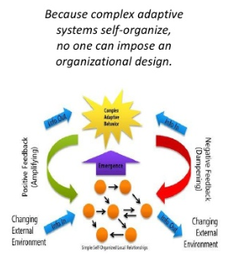
Figure 3: Complex adaptive system. (Hakimi, 2010)

Impact
The bid was not successful, but like the time credit social prescribing pilot, acted as a catalyst, especially in terms of networking and to build momentum with the wider stakeholders. The partnership for this bid was the direct predecessor of the Cardiff SW social prescribing Tribe and Social Prescribing Cymru.

The All Wales Social Prescribing Research Network

The Legacy

In January 2018 I was invited to join the steering group of the All Wales Social Prescribing Research Network, a collaboration of over 150 academics and researchers and 25 third sector organisations, to represent the practitioners’ viewpoint, which I accepted.
The Research Network organised its first event in May 2018, which focused on priority setting via a consensual process (see Appendix 5 for the priorities).
For 2018-2019 the network is planning three regional events (North, Mid and South Wales) that will focus on the research priorities and aim to build academic collaboratives to submit research proposals around these priorities.

The Epiphany
I was honoured to be invited to join the steering group. I did not know the people involved, they had heard about me as someone who was doing good work in Cardiff and trying to establish a social prescribing network practitioner network in Wales, when they were enquiring about practitioners they could invite to the steering group.
I was proud that my name had started travelling after only a few months in post. But at the same time I started to self-doubt. I was obviously doing a good job in establishing a reputation, but what difference was I making for my patients? What would I leave behind at the end of the year?
I did not know it then, but this is the moment that the authors of Tribal Leadership call the epiphany – the moment you start questioning your legacy. (Logan, Fischer-Wright and King, 2008)

Y Llwyth: Cardiff South West Social Prescribing Tribe

Creating synergy

In February 2018 I started building a social prescribing tribe in the Cardiff SW cluster, building on the momentum created by the social prescribing in mental health bid.
The model was largely based on the model that I had built for the social prescribing in mental health bid. The main difference is that the focus has shifted from the infrastructure and the process to the personal relationships between individuals in different organisations. This was caused by reading the book Tribal Leadership. (Logan, Fischer-Wright and King, 2008) I decided to try and apply the principles in that book and to form triadic relationships in the complex system to create synergy based on a common noble cause and value framework.
The model I proposed – a combination of a complex adaptive system and tribal pride – resonated with a lot of people in the cluster and sparked a lot of interest and debate.
At the first meeting in February 2018, 8 people attended. At the second meeting in March 2018, 15 people attended. At the third meeting in May 2018, 45 people attended. By then there were 78 people on our distribution list, spread across primary, secondary and tertiary healthcare, public services and third sector.
On the surface, it looked like this was achieved with minimal input from my side, and mainly by word of mouth. On reflection however, the success is a direct consequence of my leadership behaviour during the social prescribing in mental health bid. I had indeed applied the first six steps of Kotter’s 8-Step Change Model (Kotter and Cohen, 2002): establish a sense of urgency (through the external submission deadline), form a powerful coalition (the collaborative behind the bid), create and communicate a vision (the infrastructure building), empower others to act on the vision (by inviting them all to personally contribute) and planning for and creating short term wins (the prospect of potentially winning a large Welsh Government bid).

Tribal Leadership
In their book Tribal Leadership (Logan, Fischer-Wright and King, 2008), Dave Logan et al. describe five cultural stages in naturally occurring groups. (Figure 4)
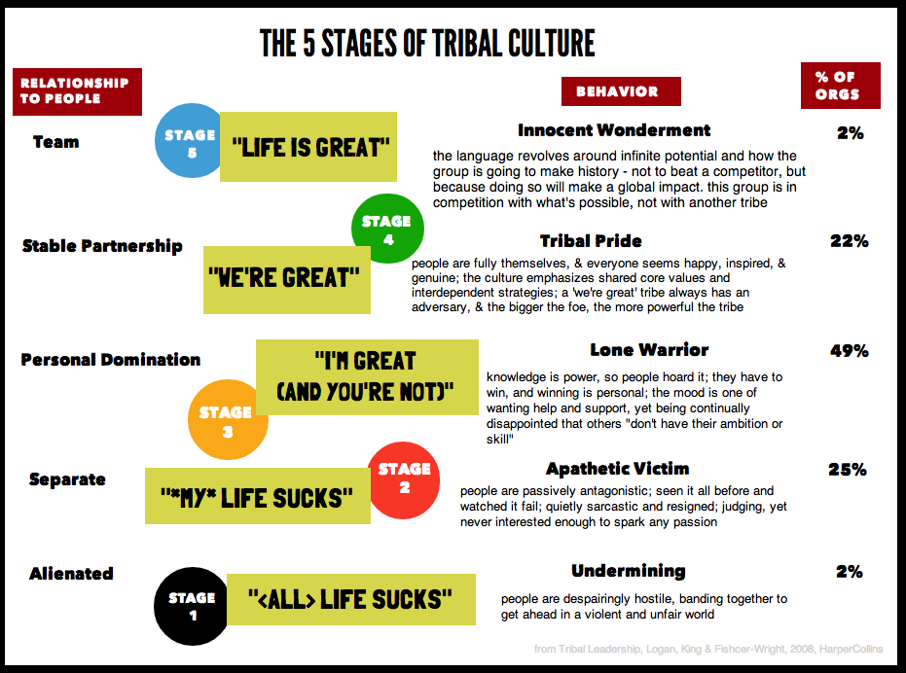
Figure 4: The five stages of tribal culture. (Logan, Fischer-Wright and King, 2008)

The crucial transition is the one between stage 3 (the dominant stage in western society) and stage 4.
Stage 3 is characterised by: "I am great (and you are not)", personal domination, dyadic relationships, hoarding of knowledge, contacts and resources as a source of individual power, competition with other tribe members, and striving for agreement.
Stage 4 is characterised by: "We are great (and they are not)", stable partnership, triadic relationships, sharing of knowledge, contacts and resources within the tribe, collaboration with other tribe members, synergy, competition with an external foe and striving for alignment instead of agreement. Stage 4 tribes have a noble cause, a common value framework, and align their outcomes, assets and behaviours.
Under similar conditions, stage 4 tribes will consistently outperform stage 3 tribes.

At the second Tribe meeting, we discussed our common values. We centred the conversation around two questions:
- What do we want to see?
- Which incentives could be built into the model?

At the third Tribe meeting, we discussed the difference between stage 3 and 4 and the transition between the two stages. We centred the conversation around the following 2 questions:
- What factors can contribute to a group of people / a service remaining a stage 3 tribe?
- What can enable a stage 3 tribe to progress to level 4?
At the end of the meeting we identified two important short-term action points:
- setting up a communication system that allows us to form relationships faster and more effectively
- setting up a core group that can propose a course of action.
I am currently working on both of those action points. Especially communication is a big challenge as the Tribe is now growing faster than the relationships can be formed, reintroducing requests for a directory of services. Rather than doing this, I am committed to investigating how we can accelerate the formation of relationships within the Tribe.

Impact
The impact of the Tribe is difficult to capture and to measure. Via my involvement in the research network, we have a researcher attached to the Tribe who uses a realist review approach to understand the expansion, capture the outcomes and build a theory of change.
Anecdotally we are starting to see more referrals between organisations that previously did not know each other, and work being done on collaborative bids. Two projects I am personally involved in are mental health retreats to coach people with adverse mental health back into work, and social prescribing into participatory theatre for people who don’t respond to coaching and/or counselling.
I often compare the Tribe with an ant farm. Although ants will be ants and behave like ants, it is difficult to predict and impossible to control or set targets for the outcomes of their activity – the owner’s job is merely to create the optimal conditions for the ants to go to work (temperature, humidity, material …). Likewise, my work with the Tribe is focused on building a sense of belonging, ambition and pride, and creating the right atmosphere and support structures for the members, so they can then work on process improvement and better outcomes. Evaluating the impact of this work will always be a challenge.
One concrete direct consequence of the Tribe is that the learning that is derived from it, is now informing a Pacesetter bid to develop health and wellbeing networks in all clusters in Cardiff and Vale.

Social Prescribing Cymru

The social prescriber community in Wales

When I started in my post, the social prescribing landscape in Wales was very fragmented. There was a number of small scale pilots, but no national structures in place. As all the learning from our time credit social prescribing pilot started to emerge, I learned from other pilot projects that they found similar issues. However, there was no national platform to discuss these issues and share learning, and all projects appeared to cycle through the same patterns and replicate each other’s mistakes.
In October 2017 I registered www.socialprescribing.wales, created a simple website with a contact form and started tweeting as the All Wales Social Prescribing Network, hoping to attract the attention of those who wanted to achieve the same. I made contact with social prescribers with similar views on social prescribing as myself (the need for a complex system approach instead of a structured programme) and in view of the All Wales Social Prescribing Research Network being formed, I changed our name to Social Prescribing Cymru and moved the website to www.socialprescribing.cymru. I also applied for CIO status as the social prescribing in mental health bid had highlighted administrative issues caused by lack of a registered status. (This application is still under review by the Charity Commission.)
Social Prescribing Cymru aims to be the social prescriber community in Wales, representing the practitioner viewpoint and offering a platform for shared learning across Wales.

Impact
The first big project of Social Prescribing Cymru is to organise the South East Wales Social Prescribing Community of Practice.

The South East Wales Social Prescribing Community of Practice

Although social prescribing is 20 years old, the social prescriber role is not regulated. There is no accredited training and no professional development, it is not clear what the boundaries of their role are and which background and training they should have. As commissioners and managers often don’t understand the role, they employ young people in low pay grades who are ill equipped to deal with the requirements of their clients. Anecdotally we are starting to notice high rates of burnout.
Coming from a highly regulated profession, I decided quite soon in my fellowship that something needed to be done to support and protect social prescribers, both in terms of training and wellbeing at work.
Early 2018 plans were made to establish a community of practice in North Wales (Betsi Cadwaladr University Health Board), followed by Hywel Dda University Health Board. The combination of no one standing up to do the same in the rest of Wales and my concern about the practitioners being split up in different and geographically isolated groups, prompted me to use Social Prescribing Cymru as the host for a South East Wales Social Prescribing Community of Practice.
I organised the launch on 26 July 2018. The event was fully booked with 90 places and a waiting list. To my surprise, we did not only attract practitioners, but also had many requests from managers, policy makers and commissioners.
Like the research network, we focused our first event on priority setting. We split into three groups that each used consensus techniques to define their top 3 priorities for the Community of Practice (See Appendix 5).
In a facilitated group discussion, we compared our priorities with those of the research network and agreed on the following course of action:
1. to set up an online community for all
2. to set up an online community for practitioners, to discuss wellbeing at work and what support we can put in place
3. to set up a steering group for the community of practice
4. to set up project groups that will examine one priority each and decide on a course of action to address them
I am currently working on the first priority.

Impact
It is very early days to evaluate the impact of the Community of Practice. Like the Tribe, as this is organically growing, it is difficult to predict what the outcomes will be.
As a member of the Research Network steering group, I work in close collaboration with the Research Network, ensuring not to duplicate any of their work. The research network lead attended our launch event, and the PhD student who is researching their network development, is now also researching ours. This will hopefully give us a better understanding of our impact.
One of my big areas of attention, in addition to the priorities defined by the members of the community of practice, is ongoing dialogue with the other two communities of practice in North and West Wales. I send out regular emails and schedule regular phone calls to foster engagement. I hope that in time, there will be a platform for shared learning and an annual joint event between us to stimulate exchange.
Another exciting development occurred early August. A professor in primary care in South Wales forwarded my summary of our launch event to a network of European colleagues in primary care. One day later, her Italian, Catalan, French and Polish colleagues had replied requesting a visit to discuss social prescribing. This professor and myself are now planning to host a European meeting to draw up a cross-working agreement.

Digital health solutions

The Innovator’s DNA course, based on the book with the same name, (Dyer, Gregersen and Christensen, 2011) and the Innovation Ecosystems course, both at MIT in Boston, Massachusetts, inspired me to look at social prescribing in an entire new way and to consider digital health solutions.
After my return I started networking within the Welsh Government digital health ecosystem.
I became interested in gamification in policy making, and I am currently working with a health technology manager at Welsh Government around using gamification to drive behavioural change in healthcare.
I also became interested in virtual conversation agents (chatbots). Based on the example of Woebot, built at the University of Stanford (Woebot - Your charming robot friend who is ready to listen, 24/7, no date), I organised a meeting with different stakeholders to discuss a chatbot for social prescribing. From this meeting, two groups emerged. One group is developing a bid for a social prescribing triage chatbot as a single point of access for wellbeing services in Cardiff and Vale. The other group, in which I am involved, is planning to develop a chatbot to address the communication challenges in the Tribe and the Community of Practice, in collaboration with the University of South Wales.

Conclusion

The time credit social prescribing pilot acted as a catalyst to accelerate my understanding of social prescribing. This learning is now used to inform the development of a tribal model of a social prescribing network in the Cardiff SW Cluster, support the professional development and wellbeing of social prescribers in South East Wales, and support research on an all Wales level. Most of this work involves organically growing networks and complex systems, and outcomes will be long term and difficult to capture. Impact can be seen in terms of development of networks, collaborative bids and national and international recognition.
In terms of my leadership development, I gained knowledge of and applied principles of innovation management, Kotter’s 8-Step Change Model, tribal leadership, complex adaptive systems and network leadership to develop a model for social prescribing in the Cardiff SW cluster as well as benefiting the wider social prescribing community in Wales.

References

Citizens Advice (2015) A very general practice How much time do GPs spend on issues other than health? Available at: https://www.citizensadvice.org.uk/Global/CitizensAdvice/Public services publications/CitizensAdvice_AVeryGeneralPractice_May2015.pdf (Accessed: 13 September 2018).
Dyer, J., Gregersen, H. and Christensen, C. M. (2011) The Innovator’s DNA: Mastering the five skills of disruptive innovators. Boston, Massachusetts: Harvard Business Review Press.
Future Generations Commissioner for Wales (2018) Annual Report and Accounts for the period 1 February 2016 to 31 March 2017. Available at: https://futuregenerations.wales/wp-content/uploads/2017/08/2017-07-18-AR-and-Accounts-FINAL-in-English.pdf (Accessed: 13 September 2018).
Hakimi, A. (2010) The New World of Emergent Architecture and Complex Adaptive Systems. Available at: https://blogs.msdn.microsoft.com/zen/2010/08/10/the-new-world-of-emergent-architecture-and-complex-adaptive-systems/ (Accessed: 3 August 2018).
Jenkinson, C. E. et al. (2013) Is volunteering a public health intervention? A systematic review and meta-analysis of the health and survival of volunteers. doi: 10.1186/1471-2458-13-773.
Kotter, J. P. and Cohen, D. (2002) The Heart of Change: Real-Life Stories of How People Change Their Organizations. Harvard Business Review Press.
Lester, N. et al. (2013) GP Cluster Profiles: Cardiff and Vale UHB. Available at: www.publichealthwalesobservatory.wales.nhs.uk/gpclusterswww.arsyllfaiechydcyhoedduscymru.wales.nhs.uk/clystyrauofeddygonteulu (Accessed: 13 September 2018).
Logan, D., Fischer-Wright, H. and King, J. (2008) Tribal Leadership: leveraging natural groups to build a thriving organization.
Martin, C. and Evans, I. (no date) Innovation – the driving force for prudent healthcare | Making prudent healthcare happen. Available at: http://www.prudenthealthcare.org.uk/innovation/ (Accessed: 14 September 2018).
Millett, D. (2017) Social prescribing used regularly by one in five GPs | GPonline. Available at: https://www.gponline.com/social-prescribing-used-regularly-one-five-gps/article/1438039 (Accessed: 14 September 2018).
Nesta (2018) Innovate to Save. Available at: https://www.nesta.org.uk/project/innovate-save/ (Accessed: 13 September 2018).
NHS England (2014) FIVE YEAR FORWARD VIEW. Available at: https://www.england.nhs.uk/wp-content/uploads/2014/10/5yfv-web.pdf (Accessed: 13 September 2018).
NHS Wales Governance (no date) NHS Wales Governance e-Manual - Standard 21: Research, Development and Innovation. NHS Wales Governance. Available at: http://www.wales.nhs.uk/governance-emanual/standard-21-research-development-and-inn (Accessed: 14 September 2018).
Price, S., Hookway, A. and King, S. (2017) Social prescribing evidence map: summary report. Available at: http://www2.nphs.wales.nhs.uk:8080/PubHObservatoryProjDocs.nsf/0/d8aba77d02cf471c80258148002ad093/$FILE/Social prescribing summary report v1 GROUPWARE.pdf (Accessed: 13 September 2018).
Schroeder, S. A. (2007) We Can Do Better — Improving the Health of the American People, N Engl J Med. Available at: www.nejm.org (Accessed: 13 September 2018).
Social Work Tech (no date) The Stages of Change (Prochaska; DiClemente). Available at: http://socialworktech.com/2012/01/09/stages-of-change-prochaska-diclemente/ (Accessed: 3 August 2018).
Spice (2016) Positive Change in Challenging Times: How Spice Time Credits are creating system change. Available at: http://www.justaddspice.org/wp-content/uploads/2016/06/Final-System-Change-Report_Screen-Version_single.pdf (Accessed: 3 August 2018).
Spice (2018) Spice Time Credits - Transform communities and public services by engaging the many. Available at: http://www.justaddspice.org/ (Accessed: 3 August 2018).
Stocks-Rankin, C.-R., Seale, B. and Mead, N. (2018) Unleashing Healthy Communities Researching the Bromley by Bow model. Available at: https://www.bbbc.org.uk/wp-content/uploads/2018/07/BBBC-UnleashingHealthyCommunities-FullReport-June2018.pdf (Accessed: 14 September 2018).
The King’s Fund (2017) What is social prescribing? Available at: https://www.kingsfund.org.uk/publications/social-prescribing (Accessed: 13 September 2018).
Welsh Government (2014) Innovation Wales. Available at: https://gov.wales/docs/det/publications/140313innovationstrategyen.pdf (Accessed: 14 September 2018).
Welsh Government (2018) £33m for health innovation to boost economy and create jobs. Available at: https://gov.wales/newsroom/health-and-social-services/2018/180613-33-million-for-health-innovation/?lang=en (Accessed: 14 September 2018).
Woebot - Your charming robot friend who is ready to listen, 24/7 (no date). Available at: https://woebot.io/ (Accessed: 3 August 2018).

Appendix 1: The Logic Model for the Innovate to Save time credit social prescribing pilot in the Cardiff South West cluster, August 2017 – January 2018

What is the problem you are trying to solve? | Who is your key audience? | What is your entry point to reaching your audience? | What steps are needed to bring about change? | What is the measurable effect of your work? | What are the wider benefits of your work? | What is the long-term change you see as your goal?
- GP practices are struggling to meet demand for appointments: in surgery and house calls  - on site support is needed to help address the psychosocial problems experienced by patients  - knowledge deficit in relation to community support available | Patients with  - mild to moderate anxiety and depression  on background of  - social isolation  - socio-economic deprivation  in 3 GP practices in Cardiff SW GP cluster | - all primary care staff in GP practices  - Community health practitioners | • Social prescriber role embedded within GP practices  • Training for social prescriber  • Consultation room for social prescriber  • primary care staff engagement  • Referral pathway from primary care staff to social prescriber  • “red flag toolkit” for social prescriber  • Service navigation inventory and referral pathway for social prescriber  • Activation of network  • Removal of barriers to entry  • Robust evaluation | Cashable savings:  • Reduction in patient appointment frequency  • Reduction in prescriptions for antidepressants in newly diagnosed patients  Acceptable and valued:  • Number of patients being offered the social prescribing scheme  • Number of patients being referred to the social prescribing scheme  • Number of referrals attending the Social Prescriber appointment  • Number of prescribed time credits spent  • Number of prescribed time credits earned back  • anxiety and depression/wellbeing scores in attenders and non-attenders of initial social prescriber appointment at fixed points in time  • patient feedback on social prescribing and time credits  Improve quality of life:  • Wellbeing and Time Credit questionnaires/ surveys  • Desktop research of social prescribing evaluations, e.g. Bristol, Rotherham  • Comparative analysis of Time Credits data  Implementation:  • Attitude/expectations/satisfaction of primary care staff  • Comparisons between uptake of Social Prescribing on a GP practice level  • Barrier analysis where uptake is low  Primary care staff:  - measure of work satisfaction or satisfaction with service provided  - measure of administrative load  Patient feedback  Forum / case studies / patient stories / earn a time credit incentive through giving feedback | - reduction in inappropriate booked GP appointments and DNA rate  - improved resilience in patients  - increase in volunteering and community cohesion  - colocation and coproduction  - increased sustainability | • improving health and wellbeing of patients and GPs in Cardiff SW cluster  BY:  - reduced frequency of GP appointments in frequent attenders  - increased capacity of GP appointments  - reduced waiting time to see GP  - reduced ED attendance for minor issues  - chronic patients seeing their allocated GP  - holistic approach to new patients with psychosocial issues, avoiding unnecessary medicalisation whilst offering appropriate support and (re)activating them in the community
Key assumptions | Key assumptions | Key assumptions | Key assumptions | Key assumptions | Key assumptions | Stakeholders
Appropriate community support will reduce number of GP appointments | This is the most likely audience to see an effect within the time period of the R&D phase | • GPs will be able to identify and refer suitable participants within their 10 minute consultation  • Primary care staff will be able to identify suitable participants | - We will be able to appoint suitable candidate for social prescriber role and give them appropriate training  - We will be able to develop workable toolkits  - Network is able to absorb all referrals  - Sufficient resources to remove barriers  - Finding the right evaluation models | • Being able to collect all data  • Finding the right data sets for baseline and comparison  • Being able to show changes within limited time period  • Having recruited the correct patient cohort that will exhibit this change  • Attribution of causality | • Benefits/ savings/ profit will outweigh investments  • Patient cohort showing benefit in GP setting is same as in community with SPICE | • Patients  • GPs and other primary care staff  • SPICE  • Time credit network  • Patient groups  • Public Health Wales  • Local council  • Third sector  • Private sector  • Welsh government  • University of Cardiff – Y Lab  • NESTA

Appendix 2: The research questions (RQ) for the Innovate to Save time credit social prescribing pilot in the Cardiff South West cluster, August 2017 – January 2018

RQ 1 | Can we demonstrate cashable savings for Welsh Government?  Proposed cashable savings are in the following areas: prescription cost, number of GP appointments, number of presentations to secondary care.
RQ 2 | What is patients’ engagement with time credits?
RQ 3 | What is the impact on primary care staff workload and job satisfaction?
RQ 4 | What is the impact on patient health and wellbeing?
RQ 5 | How is social prescribing perceived and valued by primary care staff and patients?
RQ 6 | How many social prescribers do we need to establish a workable social prescribing model across the cluster?
RQ7 | What is the capacity of the SPICE network to absorb social prescribing referrals?

Appendix 3: Outcomes of the Innovate to Save time credit social prescribing pilot in the Cardiff South West cluster, August 2017 – January 2018

- Number of patients: 84
- Number of clinics: 64
- Number of appointments: 273
- Patient non-attendance rate (cancellations and no-shows combined): 45%
- Time credit prescriptions: 49
- Time credits spent: 17. This equates to a maximum of 7 patients using their prescribed time credits (assuming every patient undertook only one activity).
- Time credits earned: 0

Based on these outcomes, the following two research questions can be answered:

RQ2: What is patients’ engagement with time credits:
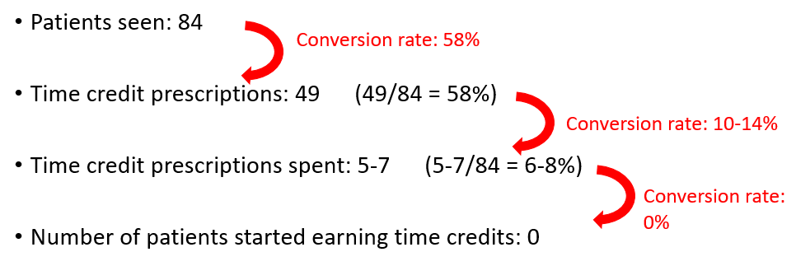
RQ6: How many social prescribers do we need (in full-time equivalents) to cover all of Cardiff SW cluster:
Based on this pilot, we need a minimum of 1 day (2 sessions) per week for a GP practice with 5,000 patients. Assuming the same work pattern and availability as the Spice social prescriber, this means 8 full time social prescribers for the Cardiff SW cluster.

RQ7 (capacity of Spice network to absorb referrals) was irrelevant in view of the low patient engagement with time credits.

Further analysis of data by the University of Cardiff to answer the remaining research questions, is still in progress.

Appendix 4: Uncovered barriers to the Innovate to Save time credit social prescribing pilot in the Cardiff South West cluster, August 2017 – January 2018

  - Factors related to time credits
About half of patients declined time credits.
A small number of patients were offended by the offer of time credits, thinking they were targeted because of their financial situation or employment status.
A significant number of patients were concerned about the repercussions of time credits and volunteering on various benefits and their employment status.
A small number of patients were suspicious of the social prescriber’s relationship with the DWP.
Time credits are a poor driver for behavioural change in primary care. (*)
Even among those patients who accepted time credits, engagement was low. Maximum 7 patients spent time credits, and 0 patients started volunteering.
Patients did not value the time credits, preferring activities that directly addressed their issues instead of Spice spending opportunities.
Being able to spend time credits is a poor external motivator and does not compensate for a lack of internal motivation to start volunteering.
In those patients who expressed an interest in volunteering, the possibility of earning time credits did not provide external motivation to start volunteering for a project that was not aligned with their internal motivation.
Low number of and little choice in Spice spending and earning opportunities.
Significant cost for organisations that want to sign up to the Spice network.
The duration of the social prescribing intervention is likely too short to bring patients to the volunteering stage.
The relationship between volunteering and increased health and wellbeing is insufficiently understood.
  - Factors related to the role of the social prescriber
The role of the social prescriber is incompletely understood.
The required skill set for the social prescriber is incompletely understood.
The conditions for successful engagement with the social prescriber by primary care staff and patients are incompletely understood.
Patients found the name “social prescribing” stigmatising.

  - Factors related to patients
The reasons for the high combined patient cancellation and no-show rate are incompletely understood.
It is incompletely understood which patient group benefits most from social prescribing.

  - Factors related to primary care.
The high demands on GP practices and primary care staff reduce the capacity to engage with social prescribing and support the evaluation.
It is incompletely understood what the best location for social prescribing is: GP practice or community.
It is incompletely understood whether and how data should be shared with primary care staff, especially the referrer.

  - Factors related to the providers.
It is incompletely understood which providers make up an effective social prescribing offer.
It is incompletely understood which stakeholders make up an effective social prescribing network.
The instability of the third sector.
The variable capacity of the third sector to absorb referrals.
The service-centred approach of Spice versus the person-centred approach in prudent healthcare.
The lack of continuity of service provision by Spice.

  - Factors related to the referral pathway.
A single point of referral increases the number of referrals to the social prescribing service.
An open door policy increases the number of referrals to the social prescribing service.
It is incompletely understood how the interface with the third sector should be designed.
It is incompletely understood how to turn anecdotal success into a reliable patient pathway.

  - Factors related to evaluation
Evaluation is challenging due to the heterogeneity of patients seen.
Data collection during consultations was challenging, because of patients’ emotional state, refusal to give consent, risk of patient disengagement, lack of time …
The software currently being used in GP practices is not appropriate to extract outcome data for social prescribing evaluation.

(*) This was the most surprising and unexpected discovery of all.
A possible explanation may be found in the behavioural change cycle.
A significant number of patients in our cohort appeared to be in the (pre-)contemplation stage. A simple incentive as offering time credits upfront appears to be too simplistic as a single intervention in these stages. These patients are likely to need more specialised and intensive behavioural change techniques as part of the social prescribing intervention.

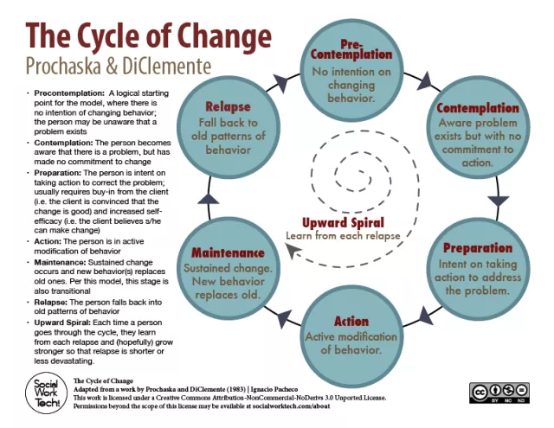
Behavioural change cycle. (Social Work Tech, no date)

Appendix 5: Priorities of the South East Wales Social prescribing Community of practice and the All Wales Social Prescribing Research Network.



