

Student Name: Asma Begum
Student ID: 2503534
Module Name: International Business Concepts
Module Code: LCMB7034
Lecturer’s Name : Akshay Narayanan

Table of Contents
1.Introduction 4
2. Industry and Country Overview 4
a. Introduction to the EV Industry in Vietnam 4
Figure 1: Global Electric Vehicle Sales by Region (2014–2024) 5
Figure 2: Electric Vehicle Adoption in Vietnam (2018–2024) 6
b. Size, Scope and Economic Importance 7
Figure 3: Forecast Growth of Vietnam’s Electric Vehicle Market Size (US$ Million), 2025–2033 7
c. Major domestic and multinational companies in Vietnam’s electric vehicle (EV) industry 8
Figure 4: Positioning map (car industry) 8
3. Porter’s Diamond Model of National Advantage – Vietnam EV Industry 10
Figure-5: Porter’s Diamond Model 10
3.1 Factor Conditions 10
3.2 Demand Conditions 11
3.3: Related and Supporting Industries 12
3.4: Firm Strategy, structure and Rivalry 12
3.5 Government and Chance 13
4. Analysis of Tesla as a Major MNC in Vietnam’s EV Industry 14
Figure 6: 14
Figure-7: PESTEL 15
4.1: Political Factors 15
4.2: Economic Factors 16
4.3: Social and Cultural Factors 16
4.4: Technological Factors 17
4.5: Environmental Factors 17
4.6: Legal Factors 17
4.7: Competitive Landscape 18
4.8: Strategic Implications for Tesla 18
4.9: Summary of Market Attractiveness 19
5. Conclusion 19
6. Reflective Account (Gibbs’ Reflective Cycle) 20
Figure -8: Gibbs Cycle 20
6.1: Description 21
6.2: Feelings 21
6.3: Evaluation 21
6.4: Analysis 22
6.5: Conclusion 22
6.6: Action Plan 23
7. Reference 24

1.Introduction
Global business expansion requires multinational enterprises (MNEs) to strategically adapt to diverse national environments and shifting industrial landscapes (Cavusgil et al., 2014). A key example is the transformation of the global automotive sector, where the shift toward electric vehicles (EVs) is being driven by technological innovation and stringent international carbon reduction policies (International Energy Agency, 2023).
Within this context, Vietnam has emerged as a high-potential market. Supported by consistent GDP growth and a rising middle class with increasing purchasing power, the country is experiencing growing demand for sustainable and efficient mobility solutions (World Bank, 2022). However, despite its attractiveness, Vietnam presents significant entry barriers, including infrastructure limitations and a developing regulatory framework.
This report investigates the feasibility of Tesla’s entry into the Vietnamese EV market. Porter’s Diamond Model (1990) is applied to evaluate national competitiveness, while a PESTEL analysis examines the macro-environmental factors—political, economic, social, technological, environmental, and legal—that influence Tesla’s strategic prospects in this emerging economy.

2. Industry and Country Overview

a. Introduction to the EV Industry in Vietnam

Electric vehicle (EV) industry encompasses the design, production, and distribution of vehicles powered primarily by electric batteries rather than internal combustion engines. In recent years, the global EV market has experienced rapid expansion, driven by increasing environmental concerns, strong government support, and continuous advancements in battery technology and charging infrastructure. The transition toward electric mobility is widely recognised as a critical strategy for reducing greenhouse gas emissions and improving urban air quality (Sierzchula et al., 2014). According to the International Energy Agency, global EV adoption has accelerated significantly due to declining battery costs, favourable policy frameworks, and rising consumer acceptance.

Figure 1: Global Electric Vehicle Sales by Region (2014–2024)

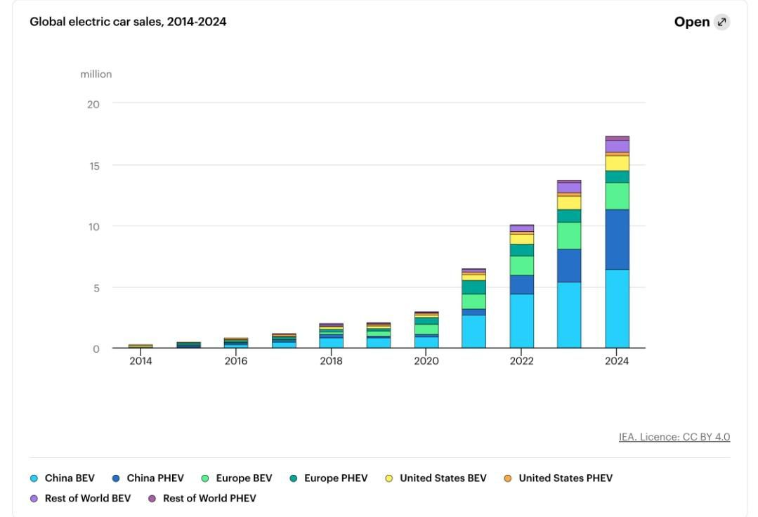
Source: International Energy Agency (2024)
As illustrated in Figure 1, global EV sales have grown exponentially over the past decade, with particularly strong expansion observed in major markets such as China, Europe, and the United States. This trend highlights the increasing competitiveness of EVs relative to conventional vehicles and reflects a broader global shift toward sustainable transportation. Importantly, this global momentum is beginning to extend to emerging markets, including Vietnam, where the EV industry remains in an early but rapidly developing stage.
In Vietnam, the automotive sector is becoming increasingly significant due to sustained economic growth and rapid urbanisation. The country’s GDP per capita reached approximately US$4,717 in 2024, indicating rising household incomes and stronger consumer purchasing power (World Bank, 2024). As of 2024, Vietnam recorded over 7 million registered cars and approximately 78 million motorcycles, underscoring the continued dominance of two-wheeled transport while also signalling gradual growth in private car ownership (Ministry of Transport, 2025).
Motorcycles remain the primary mode of transportation, with around 80% of households owning at least one motorbike. However, increasing concerns regarding traffic congestion, road safety, and environmental degradation are driving demand for alternative mobility solutions. The World Health Organization reports that major urban centres such as Hanoi and Ho Chi Minh City frequently exceed safe PM2.5 air pollution levels, highlighting the urgency of transitioning to cleaner transportation systems.
In response to these challenges, the Vietnamese government has introduced a range of supportive policies, including tax incentives, subsidies for EV adoption, and investments in charging infrastructure. As a result, EV adoption has begun to accelerate, although it remains at an early stage compared to global leaders.

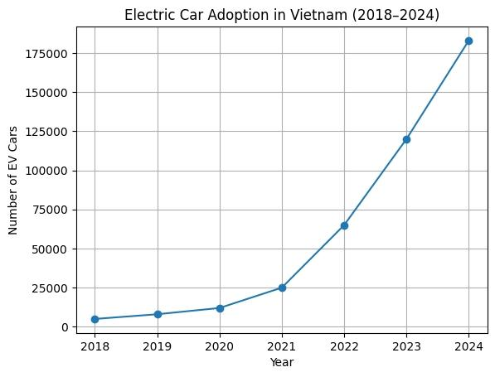
Figure 2: Electric Vehicle Adoption in Vietnam (2018–2024)
Source: Adapted from Bloomberg NEF (2024) and Vietnam Net (2025)
As shown in Figure 2, the number of electric vehicles in Vietnam has increased significantly, particularly after 2021. This rapid growth reflects the combined impact of supportive government policies, rising environmental awareness, and the expansion of domestic EV manufacturers such as VinFast. Despite this progress, the overall level of EV adoption remains relatively low compared to global markets, indicating substantial room for future growth.
Overall, the comparison between global and domestic trends suggests that Vietnam is gradually aligning with the global transition toward electric mobility. While structural challenges such as infrastructure limitations and consumer readiness persist, the country’s strong economic growth, supportive policy environment, and increasing investment in EV production position it as a promising emerging market for the EV industry.

b. Size, Scope and Economic Importance
Vietnam’s electric vehicle (EV) industry remains at an early stage of development compared with more mature markets such as China and Europe; however, it demonstrates substantial long-term growth potential. The country has a population exceeding 100 million, supported by a rapidly expanding middle class projected to grow significantly by 2030 (World Bank, 2022; BCG, 2023). Rising income levels, reflected in GDP per capita of approximately US$4,500–4,700, are increasing consumers’ purchasing power and demand for modern transportation. As a result, vehicle ownership is rising, with over 7 million cars and approximately 78 million motorcycles registered nationwide (Ministry of Transport, 2025). At the same time, EV adoption is gradually increasing as awareness and infrastructure improve.

Figure 3: Forecast Growth of Vietnam’s Electric Vehicle Market Size (US$ Million), 2025–2033
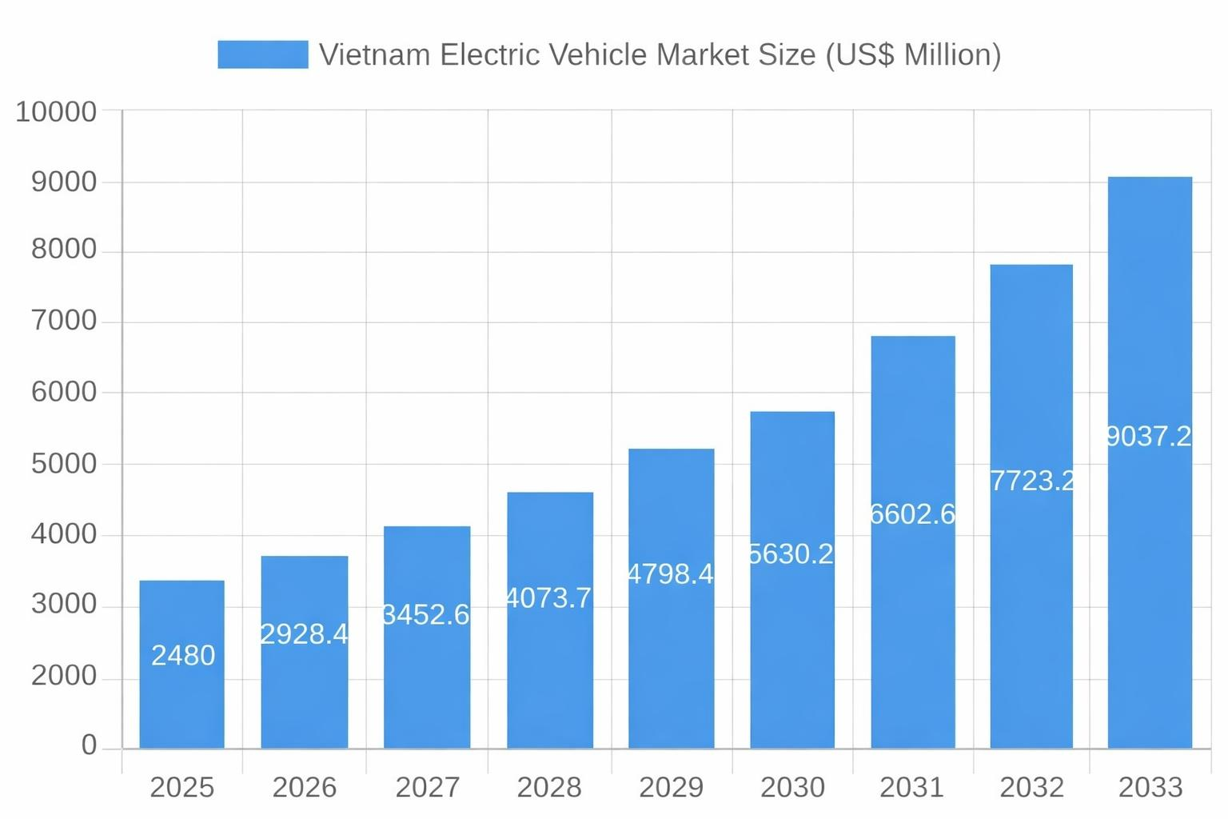
Source: Bloomberg NEF (2024)
As illustrated in Figure 3, Vietnam’s EV market is projected to grow rapidly between 2025 and 2033, highlighting its strong expansion potential and increasing economic significance. Government policy plays a central role in shaping the industry’s growth. Incentives include registration fee exemptions and reduce special consumption tax rates of 1–3% for EVs, compared to significantly higher rates for internal combustion engine vehicles. In addition, investment in charging infrastructure is expanding rapidly, supported by both public initiatives and domestic manufacturers such as VinFast (VinFast, 2024). According to the International Energy Agency (2023), such policy support is a key driver of EV market expansion in emerging economies.
The EV sector contributes to economic development through employment generation in battery production, vehicle assembly, and infrastructure development. For instance, VinFast has invested over US$3.5 billion in its manufacturing complex in Hai Phong, strengthening domestic supply chains and industrial capabilities (VinFast, 2024). By the mid-2020s, Vietnam had more than 180,000 electric vehicles in operation, indicating early but accelerating market penetration (Bloomberg NEF, 2024).
Furthermore, Vietnam’s strategic location in Southeast Asia enhances its role in regional automotive supply chains. The country continues to attract significant foreign direct investment due to its competitive labour costs, young workforce, and supportive investment policies (Wagner and Fischer, 2020). Consequently, the expansion of the EV industry is expected to contribute positively to both economic growth and environmental sustainability.

c. Major domestic and multinational companies in Vietnam’s electric vehicle (EV) industry
The electric vehicle (EV) market in Vietnam is expanding rapidly, driven by government incentives, increasing environmental awareness, and strong urbanisation trends (International Energy Agency (IEA), 2025; McKinsey & Company, 2025). The competitive landscape includes both domestic and multinational firms, which can be understood through differences in pricing and brand positioning, as illustrated in Figure 4.

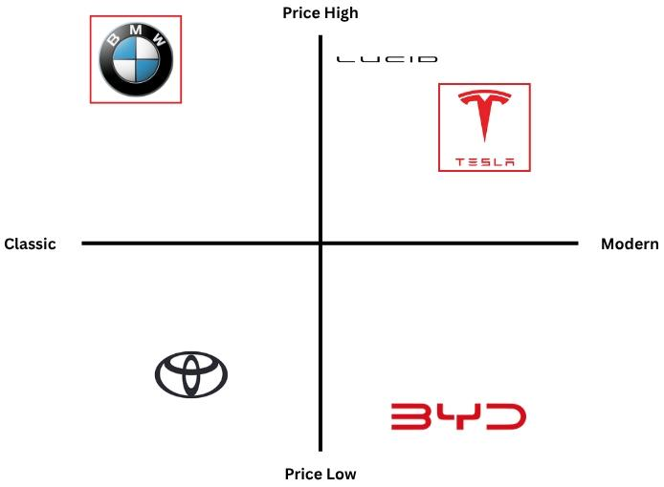
Figure 4: Positioning map (car industry)

Source: Researchgate,2025
The domestic market is currently dominated by VinFast, which has fully transitioned into electric vehicle production. The company follows a mass-market strategy, offering relatively affordable EV models targeted at urban consumers and commercial users. Its competitive advantage lies in local manufacturing capabilities, strong government support, and the rapid expansion of charging infrastructure (Bloomberg NEF, 2025). This positioning places VinFast within the modern and mid-to-low price segment, where it competes closely with other value-oriented EV brands (Statista, 2025).
Among multinational companies, Tesla operates in the high-price, modern segment, supported by its advanced technology, high performance, and strong brand prestige. However, its presence in Vietnam remains limited to private imports due to the absence of official dealerships and a local charging ecosystem, which constrains its market penetration (IEA, 2025). Similarly, Lucid Motors competes within the same premium and innovation-driven segment, reflecting a broader industry trend of luxury EV manufacturers focusing on technological differentiation (McKinsey & Company, 2025).
In contrast, BYD adopts a low-price, modern positioning, reflecting its cost-competitive strategy and extensive portfolio of affordable EV models. This makes it highly competitive in emerging markets such as Vietnam (McKinsey & Company, 2025).
Traditional automotive brands such as BMW and Mercedes-Benz remain positioned in the high-price segment, with a stronger emphasis on brand heritage and luxury. While both companies have introduced electric models, their market perception continues to be associated with premium and traditional automotive values (McKinsey & Company, 2025). Meanwhile, Toyota represents the low-price, more traditional segment, reflecting a gradual transition toward electrification and a continued focus on hybrid technologies (Statista, 2025).
Additionally, Hyundai adopts a mid-market positioning, balancing affordability with modern EV features, placing it between value-oriented and premium competitors (McKinsey & Company, 2025).
Overall, the EV market in Vietnam is clearly segmented by both price and technological positioning. VinFast dominates the domestic mass-market segment through pricing advantages and policy support, while Tesla and Lucid Motors target high-income consumers with premium, technology-driven offerings. BYD competes strongly in the affordable EV segment, whereas traditional automakers such as BMW, Mercedes-Benz, and Toyota maintain their positions through brand heritage and differentiated pricing strategies. This reflects a rapidly evolving market characterised by increasing competition and distinct strategic positioning (Bloomberg NEF, 2025).

3. Porter’s Diamond Model of National Advantage – Vietnam EV Industry
Michael Porter’s Diamond Model of National Advantage provides a comprehensive framework for analysing the determinants of national competitiveness, including factor conditions, demand conditions, related and supporting industries, firm strategy, structure and rivalry, as well as the roles of government and chance (Porter, 1990). Applying this model to Vietnam’s electric vehicle (EV) industry enables a critical evaluation of the country’s competitive advantages and limitations, as well as its attractiveness for foreign entrants such as Tesla.

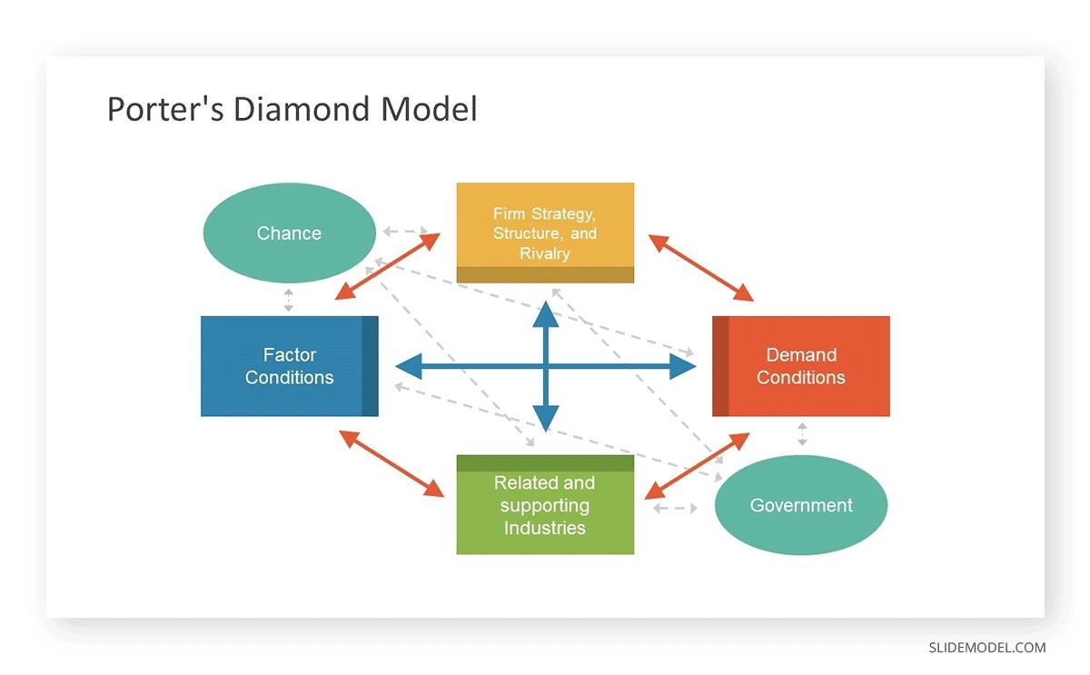
Figure-5: Porter’s Diamond Model

Source: Slide Model.com,2023

3.1 Factor Conditions
Vietnam benefits from favourable factor conditions, particularly a young, cost-competitive, and increasingly skilled workforce, which supports manufacturing efficiency and technological adoption. In 2022, the labour force reached approximately 51.7 million, with a participation rate of 68.5% (World Bank, 2022). The country has developed capabilities in electronics manufacturing and assembly, which are directly relevant to electric vehicle (EV) production. However, limitations remain in high-value areas such as battery research and development and precision component manufacturing, indicating a continued reliance on external expertise and technology (International Energy Agency (IEA), 2025).
Vietnam is heavily dependent on imported high-value components; particularly lithium-ion batteries sourced from countries such as China and South Korea. This reliance constrains technological autonomy and exposes the EV supply chain to potential disruptions. Compared to leading EV markets such as China, which benefit from vertically integrated supply chains and strong domestic battery production, Vietnam remains underdeveloped in upstream industries and advanced manufacturing capabilities (McKinsey & Company, 2025; IEA, 2025).
For Tesla, these conditions suggest that initial market entry may depend on imported components or semi-knocked-down (SKD) assembly. However, this also presents a strategic opportunity to invest in local supply chain development, enhance production capabilities, and facilitate technology transfer, thereby strengthening long-term competitiveness in the Vietnamese market.
Infrastructure remains a significant constraint. Although Vietnam’s transport network has improved in recent years, EV charging infrastructure is still limited and unevenly distributed across the country, which may hinder widespread EV adoption (World Bank, 2023; IEA, 2025). For Tesla, this represents both a barrier to immediate expansion and a strategic opportunity to deploy its proprietary charging network, thereby supporting market growth and reinforcing its competitive advantage.
Overall, Vietnam demonstrates moderate competitiveness in factor conditions. While the country possesses clear strengths in labour availability and manufacturing capacity, it faces notable weaknesses in advanced technology, infrastructure, and supply chain integration. These factors will play a critical role in shaping the market entry strategy and long-term investment decisions of firms such as Tesla.

3.2 Demand Conditions
Domestic demand for electric vehicles (EVs) in Vietnam is gradually increasing, particularly in major urban centres such as Hanoi and Ho Chi Minh City. This growth is driven by rapid urbanisation, rising income levels, and increasing environmental awareness among consumers (International Energy Agency (IEA), 2025; World Bank, 2023). In addition, emerging government incentives, including tax reductions and policy support, are contributing to a more favourable environment for EV adoption.
For Tesla, these trends indicate a developing but still niche market opportunity, particularly among urban middle- and upper-income consumers who are more receptive to premium, technology-driven vehicles. This suggests that demand exists but is concentrated within specific segments rather than the broader population.
However, price sensitivity remains a significant constraint. Despite economic growth, Vietnam’s GDP per capita was approximately $4,100 in 2022, reflecting relatively low purchasing power compared to developed markets (World Bank, 2022). As EVs—particularly those offered by Tesla—are positioned at a premium price point, affordability remains a major barrier to widespread adoption.
Furthermore, limited access to consumer financing and underdeveloped EV infrastructure may further restrict demand growth. As a result, Tesla would likely need to adopt adaptive market entry strategies, such as flexible pricing models, instalment plans, or partnerships with local financial institutions, to improve affordability and stimulate demand.
Overall, while demand conditions in Vietnam are improving, the market remains at an early stage of development. Growth is driven by favourable macroeconomic and policy trends, but constrained by income levels, price sensitivity, and structural limitations, resulting in a moderately attractive but still evolving market for EV manufacturers.

3.3: Related and Supporting Industries
Vietnam’s supporting industries are developing but remain incomplete. Supported by foreign direct investment, the country has a growing electronics manufacturing base, particularly in assembly activities, which contributes indirectly to potential electric vehicle (EV) supply chains (World Bank, 2022; UNCTAD, 2023). In 2024, manufacturing accounted for approximately 24.4% of Vietnam’s GDP, highlighting its importance to the economy (World Bank, 2024).
However, the domestic battery industry remains underdeveloped, with high-capacity batteries largely imported, increasing costs and dependency. Vietnam’s logistics and distribution networks are improving, supporting vehicle delivery and after-sales services, while investment in charging infrastructure is expanding, though still concentrated in urban areas (International Energy Agency, 2024; World Bank, 2022). Tesla’s experience in charging ecosystem development may be relevant in collaboration with local partners. Overall, supporting industries provide partial advantages but continue to limit full EV competitiveness.

3.4: Firm Strategy, structure and Rivalry
Vietnam’s electric vehicle (EV) market is characterised by growing competition between domestic and international firms. VinFast is one of the leading domestic EV manufacturers, supported by government policies, vertical integration, and rapid expansion, which has enabled it to establish a strong position in the local market (World Bank, 2023). Its focus on affordability and localisation has helped it appeal to domestic consumers.
International competitors such as BYD benefit from economies of scale and a highly developed global supply chain, while Toyota continues to compete through hybrid technology and a strong reputation for reliability (International Energy Agency, 2024).
For Tesla, this competitive environment presents both opportunities and challenges. Tesla’s strengths in advanced technology and strong brand positioning support its premium market strategy; however, demand in Vietnam is likely to remain limited to higher-income consumers due to relatively low purchasing power, with GDP per capita at approximately $4,000–$4,300 (World Bank, 2023). This restricts Tesla to a niche segment rather than mass-market penetration. In addition, the absence of local production facilities may increase costs due to tariffs and logistics.
Overall, while competition in Vietnam’s EV sector supports innovation and market development, it also increases pressure on pricing and localisation strategies, requiring firms such as Tesla to adopt carefully differentiated approaches.

3.5 Government and Chance
Government policies play a central role in shaping Vietnam’s electric vehicle (EV) industry. The Vietnamese government has introduced a range of incentives to promote electric mobility, including tax reductions, subsidies, and registration fee exemptions. At one point, registration fees for electric vehicles were reduced by up to 100%, significantly increasing the attractiveness of EV adoption for consumers and investors (International Energy Agency, 2024). These supportive measures help expand market demand and improve conditions for firms entering the sector, including Tesla.
However, government support has also been reported to favour domestic manufacturers, particularly VinFast, which may create barriers for foreign entrants. Regulatory frameworks such as import tariffs and localisation requirements can increase operational costs and complicate market entry for international firms, potentially limiting competitiveness.
In addition to policy factors, external uncertainties also influence Tesla’s strategic position. Global battery price fluctuations, supply chain disruptions, and geopolitical tensions continue to affect production costs and availability of key materials (International Energy Agency, 2023). Furthermore, rapid technological development and evolving consumer preferences add further uncertainty to long-term planning within the EV industry.
Overall, while Vietnam’s policy environment supports the growth of the EV market, preferential treatment of domestic firms and external market uncertainties present significant challenges for Tesla’s entry and expansion.

4. Analysis of Tesla as a Major MNC in Vietnam’s EV Industry
The global transition toward sustainable transportation has positioned the electric vehicle (EV) industry as a major driver of economic and environmental change.

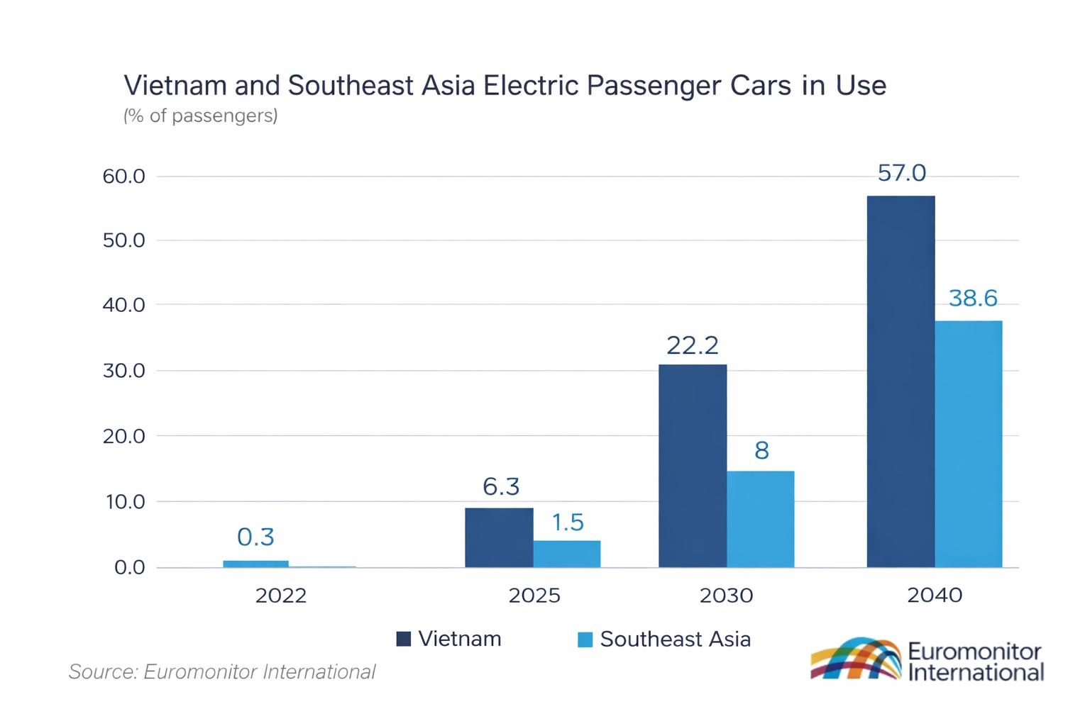
Figure 6:

Vietnam is emerging as one of the most dynamic EV markets in Southeast Asia. Electric passenger vehicle penetration is projected to increase from 0.3% of the national fleet in 2022 to 6.3% by 2025 and over 20% by 2030, supported by government incentives, expanding local production capacity, and growing consumer acceptance of EV technology. By 2040, more than half of all passenger vehicles in Vietnam are expected to be electric. In comparison, EV adoption across Southeast Asia is expected to remain lower, reaching only 1.5% by 2025 and 8% by 2030 (Euromonitor International, 2024).
Within this context, Tesla Inc. Is a leading multinational corporation seeking to expand into Vietnam’s EV market. The company’s global strengths in electric vehicle technology, battery innovation, and autonomous driving systems provide significant competitive advantages. However, its success in Vietnam depends on a range of macro-environmental factors, including regulatory conditions, market structure, and technological developments.

This section critically evaluates these factors using the PESTEL framework and assesses the overall attractiveness of the Vietnamese EV market for Tesla’s expansion.
The PESTLE framework analyses a business’s macro-environment by examining political, economic, social, technological, legal, and environmental factors that influence organisational strategy and performance (Johnson, Scholes and Whittington, 2023).

Figure-7: PESTEL
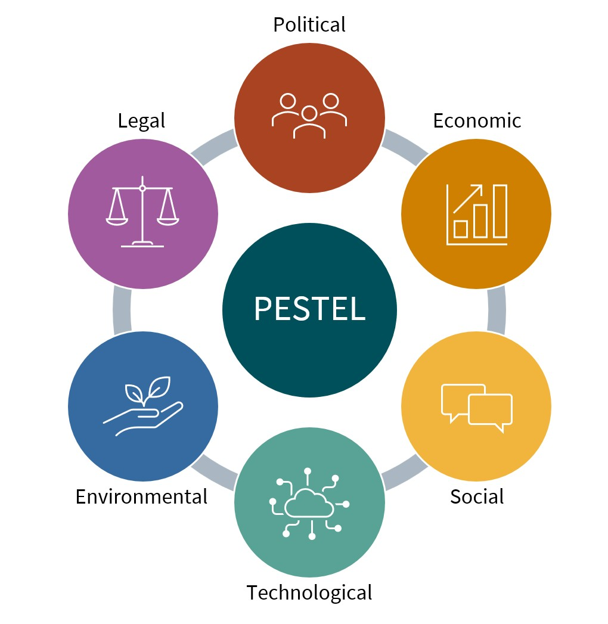
(Source: Compiled by author using Johnson, Johnson, Scholes and Whittington, 2023).

4.1: Political Factors
Vietnam has maintained a stable political environment, which has supported foreign direct investment (FDI) and industrial development (World Bank, 2022). Trade agreements such as the Comprehensive and Progressive Agreement for Trans-Pacific Partnership and the EU–Vietnam Free Trade Agreement have enhanced global integration, making Vietnam attractive for multinational firms. In 2022, Vietnam attracted approximately USD 36.6 billion in registered FDI, with disbursed FDI reaching around USD 22.4 billion (UNCTAD, 2023). Additionally, the EVFTA is expected to eliminate up to 99% of tariffs between Vietnam and the EU over time, significantly boosting trade flows. Vietnam’s total trade volume exceeded USD 730 billion in 2022 (World Bank, 2024)
Government policies increasingly promote electric vehicle (EV) adoption through tax incentives, reduced registration fees, and infrastructure investment (International Energy Agency, 2023). However, the government has also provided strong support for domestic firms such as VinFast, which may increase competitive pressure for foreign entrants. Therefore, while Vietnam’s political stability enhances investment attractiveness, Tesla may need to adopt localisation and government engagement strategies to mitigate potential political and competitive risks.

4.2: Economic Factors
Vietnam’s economy has experienced sustained growth, with GDP expanding by approximately 6–7% annually (World Bank, 2022). Rising incomes and the expansion of the middle class in major cities such as Hanoi and Ho Chi Minh City are increasing demand for private vehicles, including electric vehicles (EVs) (World Bank, 2022).
However, GDP per capita remains relatively low (around $4,100), making Vietnam a highly price-sensitive market (World Bank, 2022). Tesla’s premium pricing strategy therefore restricts its products to a niche, high-income segment.
Additionally, factors such as currency fluctuations, high import duties, and reliance on global supply chains increase Tesla’s cost structure, reducing its price competitiveness (International Monetary Fund, 2023). In contrast, competitors such as BYD offer more affordable EV options, intensifying market competition.
While Vietnam presents strong long-term growth potential, Tesla’s success will depend on its ability to adapt its pricing strategy—potentially through financing schemes, leasing options, or localised production. Without such adjustments, its market penetration is likely to remain limited.

4.3: Social and Cultural Factors
Vietnam has a relatively young population, with a large proportion under the age of 35, contributing to a digitally engaged and increasingly environmentally aware consumer base (World Bank, 2023). Rising levels of air pollution in major urban centres such as Hanoi and Ho Chi Minh City have further increased public concern for sustainable and cleaner transportation options (International Energy Agency, 2022).
Tesla’s brand is strongly associated with innovation, luxury, and sustainability, making it particularly appealing to affluent urban consumers. In addition, cultural preferences in emerging markets for foreign premium brands enhance Tesla’s aspirational positioning.
However, consumer behaviour presents a significant barrier to adoption. Motorcycles remain the dominant mode of transport in Vietnam due to their affordability, flexibility, and suitability for dense urban environments. Furthermore, electric vehicle (EV) adoption is constrained by limited consumer awareness and concerns regarding charging infrastructure (International Energy Agency, 2022).
Although Tesla benefits from a strong global brand image, social and cultural factors indicate that aspirational appeal alone is insufficient to drive widespread adoption. To succeed in the Vietnamese market, Tesla must invest in consumer education, targeted marketing, and experiential engagement strategies to influence purchasing behaviour and reduce perceived risks associated with EV usage.

4.4: Technological Factors
Vietnam’s technological infrastructure is developing rapidly, driven by government investment in digital transformation, industrial modernisation, and smart city initiatives (World Bank, 2023). These developments are gradually strengthening the country’s manufacturing capabilities, particularly in electronics and assembly activities that support the electric vehicle (EV) supply chain. However, Vietnam remains dependent on imports for high-value components such as lithium-ion batteries and advanced semiconductor technologies, limiting domestic value creation (International Energy Agency, 2022).
Tesla holds a strong technological advantage through its leadership in battery efficiency, software integration, artificial intelligence, and autonomous driving systems. In addition, its global Supercharger network helps address infrastructure gaps and reduces consumer concerns related to charging availability and range anxiety.
Despite these strengths, Tesla’s success in Vietnam depends on localisation. Without adaptation in charging infrastructure, regulatory alignment, and supply chain integration, its technological advantages may not fully translate into competitive market performance within Vietnam’s developing EV ecosystem.

4.5: Environmental Factors
Vietnam faces serious environmental challenges, including air pollution and rising carbon emissions due to rapid urbanisation and industrial growth (World Bank, 2022). In major cities such as Hanoi, PM2.5 levels often exceed World Health Organization limits, indicating significant air quality issues (World Health Organization, 2023).
Government policies supporting carbon reduction and sustainable transport encourage EV adoption, aligning with Tesla’s mission. However, environmental concerns related to battery production and disposal may create future regulatory challenges (International Energy Agency, 2022).
Overall, environmental factors favour Tesla’s entry, but long-term success depends on sustainable battery management and clean energy integration.

4.6: Legal Factors
Vietnam’s legal framework for electric vehicles is still developing, particularly in areas such as import regulations, vehicle certification, safety standards, and environmental compliance (World Bank, 2022). This creates several challenges for Tesla, including import duties, regulatory approvals, and compliance with evolving national standards, all of which may increase operational complexity and slow market entry.
In addition, intellectual property protection is an important consideration for technology-driven firms such as Tesla operating in emerging markets. Weak enforcement in some areas may increase the risk of imitation or technology leakage. Therefore, Tesla must maintain strong engagement with regulatory bodies to ensure compliance, reduce uncertainty, and safeguard its technological innovations (World Intellectual Property Organization, 2023; International Trade Administration, 2023).

4.7: Competitive Landscape
Vietnam’s electric vehicle (EV) market is highly competitive, involving both domestic and international manufacturers. VinFast currently holds a strong position due to government support and local production capabilities. BYD competes through cost efficiency and scale advantages in global supply chains, while Toyota focuses on hybrid and low-emission vehicle strategies (International Energy Agency, 2023; Toyota Motor Corporation, 2023).
Tesla maintains several key competitive advantages, including leadership in battery technology, artificial intelligence systems, and continuous software innovation, which enhance vehicle performance and driving range. The company also benefits from a strong global brand reputation and extensive financial resources, enabling sustained investment in research and development (Interbrand, 2023; Statista, 2023). In addition, its integrated Supercharger network strengthens customer convenience and supports EV adoption.
However, Tesla faces disadvantages such as high pricing and the absence of local manufacturing in Vietnam. Competition from VinFast is particularly strong due to localisation advantages and policy support. Therefore, Tesla must rely on innovation, brand strength, and strategic adaptation to remain competitive in the Vietnamese EV market.

4.8: Strategic Implications for Tesla
To succeed in Vietnam, Tesla Inc. Should adopt a gradual and adaptive market entry strategy. Initially, the company should target affluent urban consumers before expanding to a broader customer base, consistent with market segmentation theory (Kotler and Keller, 2016).
Furthermore, forming local partnerships or joint ventures can help reduce operational costs and improve market access by leveraging local expertise, in line with internationalisation theory (Dunning, 1988).
Tesla should also invest in charging infrastructure, particularly its Supercharger network, to address range anxiety and support wider EV adoption (International Energy Agency, 2023). However, this should specifically refer to the Global EV Outlook framework.
To overcome Vietnam’s high price sensitivity, Tesla may introduce flexible pricing models such as leasing or instalment-based payment options, which have been identified as effective strategies for increasing EV adoption (McKinsey & Company, 2022).
Overall, a localisation-focused marketing strategy emphasising sustainability, innovation, and long-term cost savings will strengthen Tesla’s competitive positioning in the Vietnamese market, aligning with Porter’s competitive advantage framework (Porter, 1990).

4.9: Summary of Market Attractiveness
Vietnam represents an emerging but promising market for Tesla Inc., offering both significant opportunities and notable challenges. The country benefits from relative political stability and increasingly supportive trade and investment policies, creating a favourable environment for foreign direct investment (World Bank, 2022). In addition, rapid urbanisation, a growing middle class, and a young, technologically engaged population contribute to rising demand for electric vehicles (BCG (Boston Consulting Group), 2023). Government initiatives promoting sustainability and emissions reduction further strengthen the long-term potential of the EV market (International Energy Agency, 2023).
However, several challenges remain. Tesla’s premium pricing limits accessibility in a highly price-sensitive market, while underdeveloped charging infrastructure restricts widespread adoption of electric vehicles (World Bank, 2022). In addition, increasing competition from domestic manufacturers supported by government policy intensifies market pressure. Supply chain dependencies on imported high-value components further increase cost and operational risk (International Energy Agency, 2023).
Overall, despite these constraints, Tesla’s technological leadership, strong global brand reputation, financial strength, and innovation capabilities position it well to capitalise on Vietnam’s long-term growth in the electric vehicle sector.

5. Conclusion
The analysis of the electric vehicle (EV) industry in Vietnam highlights both significant opportunities and key challenges for multinational firms entering this emerging market. Vietnam’s strong economic growth, expanding middle class, and rapid urbanisation are driving increased demand for modern and sustainable transport solutions. Government policies supporting environmental sustainability, including incentives and infrastructure development, further enhance the long-term potential of the EV sector (World Bank, 2022).
The industry remains in a relatively early stage of development, with growing consumer interest in electric vehicles driven by environmental concerns and urban pollution challenges. However, adoption is constrained by high vehicle costs, limited charging infrastructure, and technological barriers, which may slow market expansion (International Energy Agency, 2023).
An analysis using Porter’s Diamond Model suggests that Vietnam benefits from favourable demand conditions and supportive government policy but still faces limitations in advanced technological capability and dependence on imported EV components. Competition is also intensifying, particularly from domestic manufacturers such as VinFast, which benefit from strong local market understanding and policy support (VinFast, 2023).
Overall, Vietnam represents a promising but challenging market for Tesla Inc. While the company’s technological leadership, strong global brand, and financial strength provide clear advantages, successful entry will depend on localisation strategies, competitive pricing, and infrastructure alignment. Long-term success is likely to require strategic partnerships and sustained investment in the local EV ecosystem.

6. Reflective Account (Gibbs’ Reflective Cycle)
Reflective learning plays a crucial role in academic development, as it enables students to critically examine their experiences, enhance analytical skills, and improve future performance. This reflective account is based on Gibbs’ Reflective Cycle, which consists of six stages: description, feelings, evaluation, analysis, conclusion, and action plan (Gibbs, 1988). By applying this structured model, the process of researching and completing the international industry report can be critically examined in a systematic way.


Figure -8: Gibbs Cycle
Source: TSW, 2024

6.1: Description
The main objective of this report was to analyse the electric vehicle (EV) industry in Vietnam and evaluate how a multinational corporation such as Tesla could enter and succeed in this market. To achieve this, a structured research process was undertaken, involving the collection of data from credible sources, including academic journals, textbooks, and institutional publications such as reports from organisations like the World Bank. Online academic databases and digital libraries were also used to identify relevant literature on international business strategy, emerging markets, and the EV industry.
To ensure the report was logically structured and academically rigorous, several strategic frameworks were applied. Porter’s Diamond Model was used to assess Vietnam’s competitive advantage in the EV sector, while the PESTEL framework was used to examine macro-environmental factors influencing Tesla’s potential market entry. These frameworks are widely recognised in strategic management and provide a strong theoretical foundation for business analysis (Johnson, Scholes and Whittington, 2017). Their application helped structure the report coherently and ensured that all arguments were supported by established academic theory.

6.2: Feelings
At the beginning of the assignment, the research process felt challenging due to the complexity of integrating theoretical frameworks with real-world industry data. Applying models such as Porter’s Diamond Model required considerable time and effort, particularly in understanding how to link abstract theory to the Vietnamese electric vehicle (EV) market. In addition, identifying relevant and credible academic sources was initially difficult, which created some uncertainty about how to structure the report effectively.
However, as the research progressed, confidence gradually improved. Engagement with academic literature helped develop a clearer understanding of how theoretical models are applied in real business contexts. This made the research process more structured and manageable over time. Furthermore, exploring the global EV industry increased interest in sustainable technologies and innovation, particularly in emerging markets such as Vietnam, making the overall experience more engaging and insightful.

6.3: Evaluation
Overall, the research process involved both positive outcomes and several challenges. One of the main strengths of the assignment was the opportunity to apply theoretical frameworks to a real-world industry context. The use of models such as Porter’s Diamond Model and PESTEL enabled a structured and systematic analysis of Vietnam’s electric vehicle (EV) industry and Tesla’s potential market entry strategy. This improved understanding of how strategic tools can be applied in international business analysis.
Another positive aspect was the development of academic research skills. The process of sourcing scholarly articles, assessing the credibility of information, and integrating academic references improved overall research and academic writing ability. The importance of using reliable data and a systematic approach to analysis is widely emphasised in research methodology literature (Creswell and Creswell, 2018), and this assignment reinforced these principles in practice.
Despite these strengths, several challenges were encountered. One key difficulty was synthesising information from multiple sources while maintaining a clear and consistent argument throughout the report. In some cases, balancing descriptive content with critical analysis proved challenging, as it was necessary to move beyond description and compare different perspectives from academic literature and industry reports to develop a more analytical approach.
These challenges, however, highlighted areas for improvement, particularly in developing stronger critical thinking and improving the ability to integrate and evaluate information more effectively.

6.4: Analysis
The research process highlighted the importance of structured methodologies in producing high-quality academic work. Effective research requires careful planning, systematic data collection, and critical evaluation of information (Saunders, Lewis and Thornhill, 2019). Applying these principles enhanced the academic rigour and consistency of the report.
Porter’s Diamond Model provided valuable insights into the strengths and limitations of Vietnam’s electric vehicle (EV) industry. The framework emphasises the role of factor conditions, demand conditions, related and supporting industries, and firm strategy, structure, and rivalry in shaping national competitive advantage. The analysis showed that Vietnam benefits from economic growth, urbanisation, and supportive government policies, all of which encourage EV development. However, limitations such as underdeveloped charging infrastructure and technological constraints remain key barriers.
Similarly, the PESTEL framework enabled a comprehensive evaluation of the external environment influencing Tesla’s potential entry into Vietnam. The analysis identified political stability, economic growth, and increasing environmental awareness as key opportunities for EV adoption. However, regulatory complexity, infrastructure limitations, and high consumer price sensitivity present significant risks. Overall, the combined use of these frameworks provided a balanced and critical understanding of the market environment.

6.5: Conclusion
Reflecting on the overall experience, the assignment provided valuable opportunities for both academic research and strategic analysis. Conducting an in-depth industry analysis and applying theoretical frameworks enhanced understanding of international business strategies and the dynamics of global markets.
Although the process was challenging at certain stages, it contributed significantly to the development of key academic skills, including critical thinking, research methodology, and structured academic writing. These skills are essential for analysing complex business environments and producing high-quality academic work. The experience also reinforced the importance of linking theory with practice, which is a key principle in business education.

6.6: Action Plan
For future research projects, several improvements can be made to enhance both efficiency and quality. Firstly, beginning the literature review earlier would allow more time to explore a wider range of sources and develop a deeper understanding of the topic. Organising sources systematically from the start would also improve synthesis of information and help maintain a clearer argument throughout the work.
In addition, using reference management tools such as EndNote or Zotero would improve the accuracy and consistency of citations, while also save time and reduce referencing errors.
Another key area for improvement is the development of stronger critical analysis skills. Future assignments should place greater emphasis on comparing multiple academic perspectives and evaluating contrasting viewpoints, rather than relying mainly on description. This would support more analytical and insightful academic writing.
Finally, continued practice in applying international business frameworks and research methods will be essential for future development. Strengthening these skills will improve the ability to conduct rigorous academic research and analyse complex global business environments more effectively.

7. Reference
- BCG (Boston Consulting Group) (2023) Vietnam’s rising middle class and consumer growth. Available at: https://www.bcg.com (Accessed: 10 April 2026).
- Bloomberg NEF (2024) Electric vehicle outlook 2024. Available at: https://about.bnef.com/electric-vehicle-outlook (Accessed: 12 April 2026).
- Bloomberg NEF (2025) Global EV market trends and emerging markets analysis. Available at: https://about.bnef.com (Accessed: 14 April 2026).
- Cavusgil, S.T., Knight, G. And Riesenberger, J.R. (2014) International business: The new realities. 3rd edn. Harlow: Pearson. Available at: https://www.pearson.com (Accessed: 5 April 2026).
- Creswell, J.W. and Creswell, J.D. (2018) Research design: Qualitative, quantitative, and mixed methods approach. 5th edn. Thousand Oaks: Sage.
- Dunning, J.H. (1988) ‘The eclectic paradigm of international production’, Journal of International Business Studies, 19(1), pp. 1–31. Available at: https://doi.org/10.1057/palgrave.jibs.8490372 (Accessed: 5 April 2026).
- Euromonitor International (2024) Electric vehicles in Southeast Asia. Available at: https://www.euromonitor.com (Accessed: 11 April 2026).
- Gibbs, G. (1988) Learning by doing: A guide to teaching and learning methods. Oxford: Oxford Polytechnic.
- Interbrand (2023) Best global brands 2023. Available at: https://www.interbrand.com (Accessed: 9 April 2026).
- International Energy Agency (2022) Global EV outlook 2022. Available at: https://www.iea.org/reports/global-ev-outlook-2022 (Accessed: 2 March 2026).
- International Energy Agency (2023) Global EV outlook 2023. Available at: https://www.iea.org/reports/global-ev-outlook-2023 (Accessed: 5 March 2026).
- International Energy Agency (2024) Global EV outlook 2024. Available at: https://www.iea.org/reports/global-ev-outlook-2024 (Accessed: 8 April 2026).
- International Energy Agency (2025) Electric vehicles market report. Available at: https://www.iea.org (Accessed: 14 April 2026).
- International Monetary Fund (2023) World economic outlook database. Available at: https://www.imf.org (Accessed: 7 April 2026).
- International Trade Administration (2023) Vietnam – Country commercial guide: Trade regulations, customs and standards. Available at: https://www.trade.gov/country-commercial-guides/vietnam-trade-regulations-customs-and-standards (Accessed: 7 April 2026).
- Johnson, G., Scholes, K. And Whittington, R. (2017) Exploring corporate strategy. 11th edn. Harlow: Pearson.
- Johnson, G., Scholes, K. And Whittington, R. (2023) Exploring strategy. 13th edn. Harlow: Pearson.
- Kotler, P. And Keller, K.L. (2016) Marketing management. 15th edn. Harlow: Pearson.
- McKinsey & Company (2022) The future of mobility and EV adoption. Available at: https://www.mckinsey.com (Accessed: 3 April 2026).
- McKinsey & Company (2025) Global electric vehicle market trends. Available at: https://www.mckinsey.com (Accessed: 13 April 2026).
- Ministry of Transport (Vietnam) (2025) Vehicle registration statistics. Available at: https://www.mt.gov.vn (Accessed: 12 April 2026).
- Porter, M.E. (1990) The competitive advantage of nations. New York: Free Press.
- Saunders, M., Lewis, P. And Thornhill, A. (2019) Research methods for business students. 8th edn. Harlow: Pearson.
- Sierzchula, W., Bakker, S., Maat, K. And van Wee, B. (2014) ‘The influence of financial incentives and other socio-economic factors on electric vehicle adoption’, Energy Policy, 68, pp. 183–194. Available at: https://doi.org/10.1016/j.enpol.2014.01.043 (Accessed: 4 April 2026).
- Statista (2023) Tesla brand value and global performance. Available at: https://www.statista.com (Accessed: 6 April 2026).
- Statista (2025) Automotive market segmentation and pricing. Available at: https://www.statista.com (Accessed: 13 April 2026).
- Toyota Motor Corporation (2023) Sustainability and electrification strategy. Available at: https://global.toyota (Accessed: 7 April 2026).
- UNCTAD (2023) World investment report 2023. Available at: https://unctad.org (Accessed: 8 April 2026).
- VinFast (2023) Company annual report. Available at: https://vinfastauto.com (Accessed: 10 April 2026).
- VinFast (2024) Investment and production expansion report. Available at: https://vinfastauto.com (Accessed: 12 April 2026).
- Wagner, S.M. and Fischer, A. (2020) ‘Strategic location decisions in emerging markets’, International Journal of Production Economics, 223, 107537. Available at: https://doi.org/10.1016/j.ijpe.2019.09.007 (Accessed: 6 April 2026).
- World Bank (2022) Vietnam development report. Available at: https://www.worldbank.org/en/country/vietnam (Accessed: 1 March 2026).
- World Bank (2023) Vietnam economic update. Available at: https://www.worldbank.org (Accessed: 3 April 2026).
- World Bank (2024) World development indicators. Available at: https://data.worldbank.org (Accessed: 9 April 2026).
- World Health Organization (2023) Air quality guidelines and Vietnam data. Available at: https://www.who.int (Accessed: 11 April 2026).
- World Intellectual Property Organization (2023) IP protection in emerging markets. Available at: https://www.wipo.int (Accessed: 5 April 2026).

