
UNIVERSITY OF WALES TRINITY SAINT DAVID
DISSERTATION TITLE: Profitability, gearing and liquidity of Sports Direct plc (Frasers Group plc), JD Sports Fashion plc comparative financial ratio analyses.
SLAVENA PANAYOTOVA
1906636
SUPERVISOR: PHD. DAVID JENKINS

.

DECLARATATION FORM

I, Slavena Panayotova declare that this dissertation has been composed by myself, that the work contained herein is entirely my own except where explicitly stated otherwise in the text, and that this work has not been submitted for any other degree or qualification, in whole or in part, except as specified.

Signature: Slavena Panayotova

Date: 12.05.2024

ACKNOWLEDGEMENT

I extend my deepest gratitude to my supervisor, PhD David Jenkins for his generous support and guidance throughout this project. I am also profoundly thankful to my Program Manager, Mr Vasilios Tavlaridis and the department staff for their helpful insights and encouragement. Special thanks go to Mur and Lyubka for their endless love and patience and to Arham for her contribution in my personal growth. This dissertation would not have been possible without the collective support and encouragement received from each one of them.

ABSTRACT
This dissertation evaluates and compares the financial performance of Sports Direct plc, now part of Frasers Group plc (SD) and JD Sports Fashion plc (JD) from 2018 to 2023, focusing on key financial metrics such as Profitability, Gearing, and Liquidity ratios. Utilising annual financial reports, the study employs a quantitative analysis through secondary data research. The data from the reports is extracted and used for calculation of financial ratios presented in Excel. Initial findings from combined trend visualisations in Chapter One suggest notable differences in financial health and strategic outcomes between the two companies. Subsequent chapters present a deeper analysis of these metrics and discuss the potential impacts of external factors such as the COVID-19 pandemic and ongoing military conflicts on these firms. The study aims to provide a comprehensive comparative insight into the financial positioning and resilience of these leading retailers in the sports apparel industry.
The findings reveal distinct competitive advantages for each company across different financial metrics. JD Sports exhibited superior revenue growth and maintained a more conservative debt strategy, while Sports Direct demonstrated higher profitability, at the end of the examined period, in terms of both - total profits and returns on capital and assets, suggesting more efficient operational management. In terms of liquidity, neither company showed a clear advantage; JD Sports had higher cash reserves, whereas Sports Direct had better quick ratios, indicating more readily available assets to cover short-term liabilities.
Key words: Profitability, Gearing, Liquidity, financial ratios, financial analysis, GPM, NPM, ROCE, ROA, Debt to Equity, Capital Structure, Cash Ratio, Quick Ratio, Sports Direct, JD Sports Fashion

Table of Contents
I. CHAPTER I: INTRODUCTION 8
1. BACKGROUND 8
2. AIM 8
3. OBJECTIVES 9
4. QUESTIONS 9
5. SIGNIFICANCE 9
6. METHODOLOGY 10
7. STRUCTURE 10
II. CHAPTER II: LITERATURE REVIEW 11
III. CHAPTER III: RESEARCH AND METHODOLOGY 12
1. RESEARCH GOALS 12
2. RESEARCH STRATEGY AND DATA COLLECTION 12
3. FRAMEWORK OF THE ANALYSIS 13
4. STRUCTURE OF THE ANALYSIS 13
5. LIMITATIONS AND CRITICAL LOOK 14
5.1 LIMITATIONS: 14
5.2 CRITICAL REFLECTION 14
IV. CHAPTER IV: FINDINGS 15
1. REVENUE, CoS, OPERATING COST 16
2. PROFITABILITY RATIOS AND METRICS 17
2.1 GROSS PROFIT MARGIN (GPM) 17
2.2 NPM 18
2.3 ROCE 19
2.4 ROA 19
3. GEARING 20
3.1 DEBT TO EQUITY 20
3.2 CAPITAL STRUCTURE 21
4. LIQUIDITY 21
4.1 QUICK RATIO 21
4.2 CASH RATIO 22
4.3 WORKING CAPITAL 22
CHAPTER V: ANALYSIS OF FINDINGS 23
1. REVENUE 23
2. PROFITABILITY RATIOS 24
2.1 GROSS PROFIT MARGIN (GPM) 24
2.2 NET PROFIT AND NPM 26
2.3 ROCE 29
2.4 ROA 31
3. GEARING 33
3.1 DEBT/EQUITY 33
3.2 CAPITAL STRUCTURE 34
4. LIQUIDITY 34
4.1 QUICK RATIO 35
4.2 CASH RATIO 36
4.3 WORKING CAPITAL 37
CHAPTER VI. DISCUSSION OF FINDINGS 38
1. The Prelude: Financial Stance in 2018 38
2. 2019: A Year of Strategic Expansion 38
3. 2020: Plans before Covid 39
4. 2021: Navigating Through Pandemic Challenges 39
5. 2022: Post-Pandemic Recovery. 40
6. 2023: In times of geopolitical military conflicts 40
7. Resemblances in the Performance of Sports Direct and JD Sports (2018-2023) 41
7.1 Starting point 41
7.2 Responsiveness to Economic Conditions: 42
7.3 Focus on Growth and Expansion: 42
7.4 Trends 42
8. Differences in the Performance of Sports Direct and JD Sports (2018-2023) 42
8.1 Risk Tolerance and Financial Strategy: 42
8.2 Degree of Financial Aggressiveness: 42
8.3 Variability in Liquidity Management: 43
8.4 Impact of Strategic Choices on Capital Structure: 43
8.5 Long-term Investment vs. Short-term Gains: 43
8.6 Covid response 43
7. Ending point 2023 44
VII. CHAPTER VII: CONCLUSIONS 44
VIII. REFERENCES 45
IX. APPENDIX 45

I. CHAPTER I: INTRODUCTION

1. BACKGROUND
The UK apparel sector has a strong presence for sports goods retail. JD Sports Fashion plc and Sports Direct plc, now known as Frasers Group plc, are the two leading sportswear retailer brands in the UK market. In fact, SD and JD are rivals for decades and started to compete on a global scale recently as both companies expanded overseas (Hua, H. and Bowden, G., 2022), competing not only over customers' spending, but also to be the first to include new and important product lines from major labels like Nike and Adidas etc., (Hua and 2022, 2022) and to conquer new markets.
As both companies went through acquisition plans to support both local and international growth, this competition has recently expanded internationally and into new categories.
Sports Direct plc (SD) and JD Sports Fashion plc (JD) dominate the UK sports retail brick and mortar market, which suggests that both companies have very successful practises worth comparing. In this dissertation the companies’ financial performance will be examined for a period of six years – from 2018 to 2023. The timeframe is specifically chosen because it contains two globally significant events, and more particularly - the Covid Pandemic and the current geopolitical conflicts, as well as the stages before and between them, and thus allowing to look at the companies pre and during the unusual stress conditions and make judgments on their adaptability, profitability, stability and financial health.
2. AIM
The study aims to provide a comprehensive comparative insight into the financial positioning and resilience of two leading retailers in the sports apparel industry in UK.
3. OBJECTIVES
Examining Profitability, Gearing and Liquidity ratios and their components is crucial for identifying similarities, differences, patterns, trends, and anomalies in the financial performance of the two competitive companies over the six-year period. Moreover, it will be possible to track how these companies responded or were affected by globally significant events such as Covid Pandemic and the ongoing military conflicts. In other words, by identifying the trends over time it will be possible to make comparative performance evaluation and to assess the financial health and potential risks involved with the companies’ debt practices in an uncertain geopolitical and economic environment. Due to word count limitations the focus of this Dissertation falls onto the main ratios from these three groups, as they are strongly related, and they outline some of the most important moments of the company’s trends and performance over the specified period.

4. RESEARCH QUESTIONS
- What are the similarities in the companies’ performance for the examined period?
- What are the differences in the performance of the two companies over the examined period?
- What are the potential impacts of the COVID-19 pandemic and geopolitical tensions over the companies’ Profitability, Gearing and Liquidity?

5. SIGNIFICANCE
Ratio analysis is a crucial financial statement analysis technique. Ratios are useful in understanding the financial status of the organisation. Even if a company performs well overall, bankers, creditors, investors, and management use the ratio analysis to assess the company's effectiveness and pinpoint operational weaknesses. In addition to being used to assess past financial performance, financial ratios can also be used to forecast future trends in the company's financial performance. This research will shed light onto critical insights of the financial strategies in terms of Profitability, Gearing and Liquidity of the two leading sport retailers in the UK market. It will also provide information about the operational efficiency and adaptability of the companies in an uncertain economic and geopolitical environment, that could serve as a foundation for further deeper research of the market dynamics. This research will also highlight the most obvious risks about the financial health of the companies and draw conclusions on their stability.

6. METHODOLOGY
This research was conducted using six annual financial reports of the companies from 2018 to 2023 and inputting the relevant data from them in MS Excel in order to make calculations of financial ratios, and to generate Graphs and tables. The used data was extracted from the Consolidated statements of the Groups and analysed independently for each company, and then compared afterwards to establish the position of each retailer according to a certain metrics or ratio and to rank them on their overall financial performance. Due to word count limitations, the focus on the research falls only on the most important ratios from three groups – Profitability, Gearing and Liquidity, namely: Gross Profit Margin, Net Profit Margin, Return Over Capital Employed, Return Over Assets, Debt to Equity, Capital Structure, Cash Ratio and Quick ratio, as well as their components.

7. STRUCTURE
The research is presented in the following structure:
Chapter II. Literature Review – This chapter presents the used ratios, their formulas, components and explains their significance. It also discusses relevant case studies and articles that provide basis for the analysis.
Chapter III. Methodology – In this part will be described the method used for conducting the analyses.
Chapter IV. Findings – The summarised results of the companies’ financial performance compared to each other will be presented in this chapter setting a scene for an in-dept analysis.
Chapter V. Analysis – This chapter examines each ratio for each company for the whole period, as well as its changes over the years, by breaking it down to its constituent components and suggesting the possible implications or reasons for the changes.
Chapter VI. Discussion – A chronological story of the performance of both company is exposed in this chapter, this time in the context of the global events that took place within the examined period. The main differences and similarities between the competitors are outlined.
Chapter VII. Conclusions – The text in this chapter summarises the findings and draws conclusions based on them.
Chapter VIII. References

II. CHAPTER II: LITERATURE REVIEW
This chapter is dedicated to the review of the used literature to prepare this dissertation. It will cover academic materials related to the methods and metrics used in the performance of the comparative financial analysis of the examined companies. The focus of the review will be articles concerned with financial analysis, Profitability, Gearing, and Liquidity. The review will also include two academic papers with financial analysis.
The preparation for writing this paper started with recapping several books on finance. First, I read “Theoretical Foundations of Corporate Finance”, where the author João Amaro de Matos discusses the Capital Structure, and more specifically the importance and the implications of allowing some debt to compose the Capital structure of a company for gaining leverage and deducting taxes (de Matos, 2018).
The next reviewed book is called “Corporate Finance for Long-Term Value” by D. Schoemaker and W. Schramade. The book provides detailed insights on many aspects of the corporate finances, but those related to this paper are exposed in chapter 17 – Reporting and Investor Relations, where authors dig into the reasons behind financial reporting and the implications of various ratios from Profitability, Leverage and Liquidity groups. This book provided the main definitions of the used ratios below.
Gross Profit Margin (GPM) measures the relationship between the Gross profits and the revenue, calculating the marginal difference between both, and is a crucial indicator of a company's financial health, revealing the percentage of revenue exceeding the cost of goods sold (Schoenmaker and Schramade, 2023).
Net Profit Margin (NPM) assesses overall profitability after accounting for all expenses, taxes, and interests, as a portion of the total sales (revenue) and is the main most universal metrics of profitability (Schoenmaker and Schramade, 2023).
Return Over Capital Employed (ROCE) is one of the most significant ratios, as it calculates how the Operating Profit relates to the employed capital, which is a function of deducting the current liabilities from the total assets.
Return Over Assets (ROA) is a ratio used to describe what is the rate of return of the total assets as represented by denominator of the Net Profits.
The Debt-to-Equity ratio is a fundamental indicator that compares a company’s total liabilities to its shareholder equity, offering a glimpse into the level of financial risk a company is willing to take by using debt to finance its operations (Schoenmaker and Schramade, 2023).
Capital Structure illustrates the percentage of non-current debt of the total assets, as function to measure a company’s reliance on long-term borrowing to fuel its capital.
The Quick Ratio measures a company’s ability to meet its immediate liabilities with its most liquid assets, excluding inventories (Schoenmaker and Schramade, 2023).
Cash Ratio represent the proportion of the long-term debt to the current liabilities and examines the capability of a company to cover its current liabilities only with its cash reserves (Schoenmaker and Schramade, 2023).
In the next stages of preparation and writing of this paper were revied articles and books on structuring and writing a master’s dissertation, as well as two examples of dissertations described in the table below.
At last, I explored relevant to my analysis articles and cited them in text.

Index | Authors | Year | Title | Key themes or keywords
1. | Schoenmaker,Dirk.; Schramade,Willem. | 2023 | Corporate finance for long-term value | Corporate finance, Profitability, Liquidity, Leverage
2. | de Matos, João Amaro, | 2018 | Theoretical Foundations of Corporate Finance | Ratios, profitability,Capital structure
3. | D O'Gorman,Kevin; MacIntosh,Robert | 2015 | Research Methods for Business and Management : A Guide to Writing Your Dissertation | Writing dissertation
4 | Skinner, James; Smith, Aaron C T | 2021 | Introduction: sport and COVID-19: impacts and challenges for the future (Volume 1) | COVID, impact, sports
5 | Goodacre,Alan | 2003 | Operating lease finance in the UK retail sector | balance sheets, long-term debt, retail sector
6 | Chnar,Abdullah Rashid | 2018 | Efficiency of Financial Ratios Analysis for Evaluating Companies’ Liquidity | Evaluation of liquidity, financial ratio analysis
7 | Waal,Antonie Adriaan de; Bootsman,Jacques and Bilstra,Eelco | 2021 | Building the high performance finance function | Financial analysis
8 | Laws,Jason | 2018 | Essentials of financial management | Excel spreadsheets, financial statements
9 | Browne, Clayton | 2010 | Good Benchmark for Profit Margins for a Sporting Goods Store | Profit margins,  Sports retail
10 | Goel, Sandeep | 2015 | Financial ratios | GM, NPM, ROCE, ROA, Cash ratio

III. CHAPTER III: RESEARCH AND METHODOLOGY

1. RESEARCH GOALS
This paper aims to uncover the similarities and the differences in the financial performance of two Groups – Fraser Group plc (formerly known as Sports Direct plc and referred to as SD in this work) and JD Sports Fashion plc (JD), as well as the potential impact of globally significant events such as Covid Pandemic and the ongoing military conflicts over their Profitability, Gearing and Liquidity metrics.

2. RESEARCH STRATEGY AND DATA COLLECTION
The researched is based on secondary data and adopts a quantitative approach to conduct a horizontal and (partially) vertical analysis of the financial performance of two companies: Sports Direct plc (SD) and JD Sports Fashion plc (JD) over six-year period between 2018 and 2023 and compare them using three groups of ratios – Profitability, Gearing and Liquidity, in order to outline the most significant resemblances and differences between the two competitors. The analysed ratios are Gross Profit Margin (GPM), Net Profit Margin (NPM), Return Over Capital Employed (ROCE), Return Over Assets (ROA), Debt to Equity, Capital Structure, Cash Ratio and Quick Ratio. The analysis also includes their components.

3. FRAMEWORK OF THE ANALYSIS
The financial data was extracted from the groups’ annual reports, specifically the Consolidated Profit and Loss statements and Consolidated Statements of Financial Position. Key financial ratios concerning Profitability, Gearing, and Liquidity were calculated using Microsoft Excel. The relevant data from the reports was manually entered in Microsoft Excel, where it was used in various calculations for each company, such as ratios, differences between each year, differences from the beginning to the end of the examined period, and arithmetic averages. Finally, were created visual representations, such as graphs and tables and the analysis was conducted as described below.

4. STRUCTURE OF THE ANALYSIS
The methodology involved the systematic calculation of these ratios followed by a visual analysis of trends through the generated graphically represented data. This structure of the approach facilitated a clear, objective comparison of financial metrics, ensuring a multilevel analysis of each company's financial performance.
Chapter IV, named Findings presents the gathered financial information about the companies in a form of graphs and tables, and presents an overall summary of the analysis by comparing the ratios from the groups Profitability, Gearing and Liquidity for both companies.
Chapter V - Analysis of Findings, focuses on a detailed multilevel analysis of the results from the mentioned above calculations: what are the reasons for changes in the companies’ performance via levels of analysis and breaking down ratios to components, identifying significant differences between the companies by comparing the results.
Chapter VI, called Discussion constructs a chronological financial story of the companies for the six-years period, emphasising on their similarities and differences, in the context of globally significant events that might have affected the companies (brief reference to the economic data).

5. LIMITATIONS AND CRITICAL LOOK
5.1 LIMITATIONS:
Due to word count restrictions and the level of its complexity, the scope of this Dissertation is limited to the main ratios from only three groups – Profitability, Gearing and Liquidity, as they are strongly related, and they outline some of the most important moments of the company’s trends and performance over the specified period. It also relies predominantly on the information provided in the Consolidated financial statements of the Groups, subject of the analysis (Profit and Loss and Statement of Financial Position) for the purpose of the financial calculations. Therefore, this analysis is not exhaustive of the overall financial performance of the examined Groups, but rather sets a foundation for deeper exploration of the two competitors via further analysis of the rest of the metrics in their performance as well as other related information.
5.2 CRITICAL REFLECTION
Looking back, if I had to do this analysis again, I would approach it differently, by extracting the financial data from recognised financial platforms, rather than extracting it from the company’s annual reports manually, calculating it, and checking it multiple times. Nevertheless, by doing so I have much better understanding of the financial metrics as well as the results, even though this data input method took the majority of the time to produce this dissertation.
For reader’s convenience and to avoid confusion, the period between two financial years is named after the late year, as it is the year when the annual report has been issued. As example, whenever it is written “2019” that means the fiscal year, or in other words, the period between 2018 and 2019, that ended in 2019.
Used abbreviations:
Abbreviation | Definition
CE | Capital Employed
CoS | Cost of Sales
GPM | Gross Profit Margin
JD | JD Sports Fashion plc
NPM | Net Profit Margin
OC | Operating Cost
OP | Operating Profit
PBT | Profit Before Tax
ROA | Return Over Assets
ROCE | Return Over Capital Employed
SD | Sports Direct plc (Frasers Group plc)

IV. CHAPTER IV: FINDINGS

This part of the dissertation lays out the basic financial performance in terms of Profitability, Gearing and Liquidity for each company over the period between 2018 and 2023, setting the scene for a deeper analysis of what these figures are result of and what they imply about the business operations and market conditions.
Table 1 Basic Metrics SD and JD

Table 2 Ratios and % difference SD and JD

1. REVENUE, CoS, OPERATING COST
This section systematically details the observed financial data, focusing on the revenue, CoS and Operating Cost trends of Sports Direct plc and JD Sports plc over a six-year period.
At first glance, Sports Direct plc (SD) and JD Sports plc (JD) have similarly increasing trends of the first three metrics of the Profit and Loss statement – Revenue, Cost of Sales (CoS) and Operating Cost (OC) over the six-year period between 2018 and 2023. Nevertheless, looking closely reveals some differences.
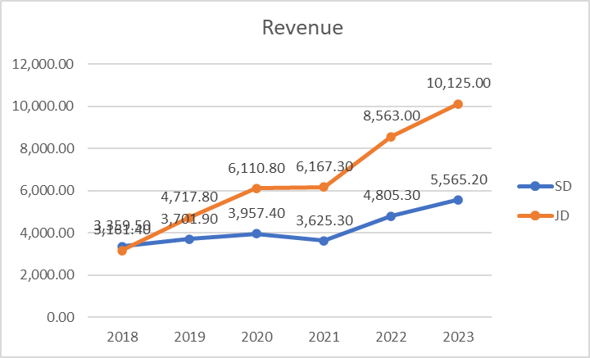
In the beginning of the period both companies had a Revenue (Graph 1) of over £3b in favour of Sports Direct, leading JD Sports in Sales with about £200m. But over the next five years JD Sports’ Sales growth rate overtakes SD and by the end of the examined period JD has almost twice the Revenue (over £10.1b) of its number one competitor (£5.5b).
The trajectories of growth of the CoS (Graph 2) and OC (Graph 3) of both companies repeat the Revenue’s pattern and show the rapid and aggressive growth of JD’s market share, suggesting big expansion of the company, while SD struggles to sustain stable rates of growth and even goes through a small decline in Revenue.
Graph 1 Revenue trends
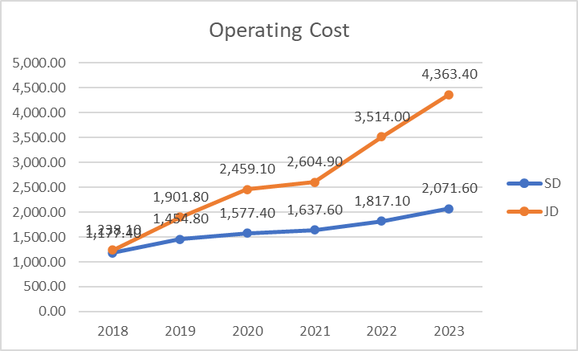
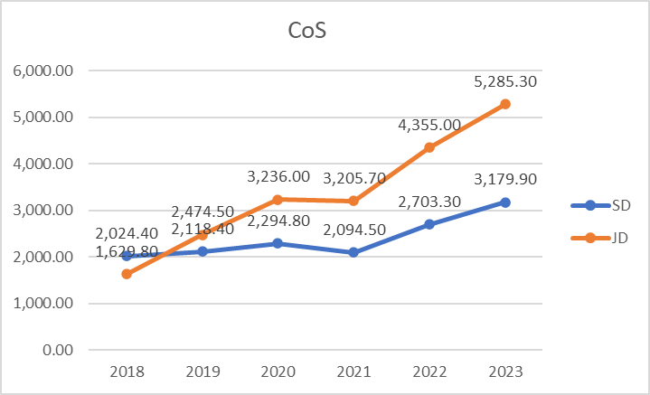
Graph 3 Operating Cost
Graph 2 CoS

2. PROFITABILITY RATIOS AND METRICS

This section presents the results from analysis focused on Sports Direct’s and JD Sports’ Profitability ratios- GPM, NPM, ROCE, ROA for the period 2018 - 2023.
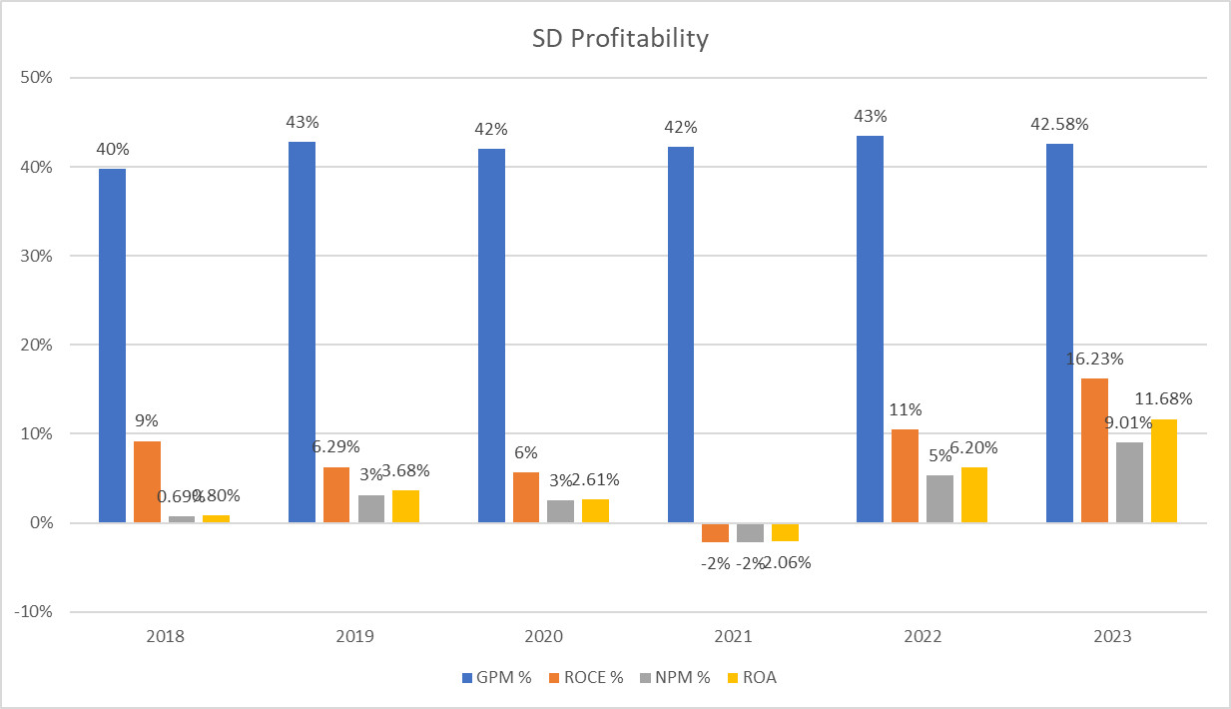
Table 3 SD Profitability
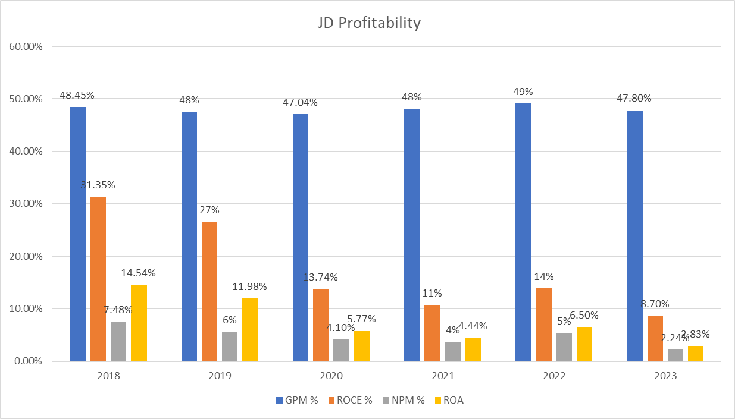
Table 4 JD Profitability

2.1 GROSS PROFIT MARGIN (GPM)

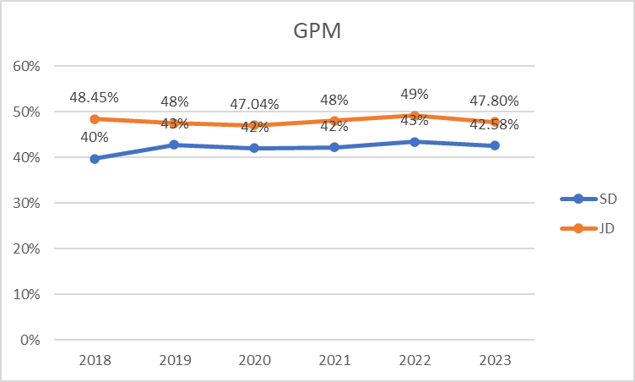
Both companies have almost identical trajectory of Gross Profit Margin (GPM) (Graph 4) over the six-years period. The main differences are in the beginning of the period where SD starts with a small increase, and JD suffers a decrease in the growth rate. JD’s GPM declined insignificantly at the end of the period, while SD’s inclined again insignificantly.
Graph 4 GPM

2.2 NPM
Looking at Net Profit Margin (NPM) this is where the companies’ trajectories start to deviate radically from one another (Graph 5).
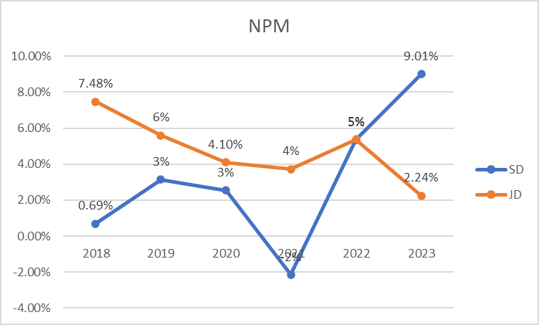
In the beginning of the period JD has a strong performance on its NPM, while SD barely have a margin under 1%, but adjustments in SD’s strategy clearly impacted in a positive way NPM over the last two years, since the company has now higher NPM than its competitor from the beginning. Interestingly, it looks like there is some inverse proportionality between the companies’ NPM trajectories for the past couple of years as they deviate from one another on the same rate.
Graph 5 NPM

2.3 ROCE
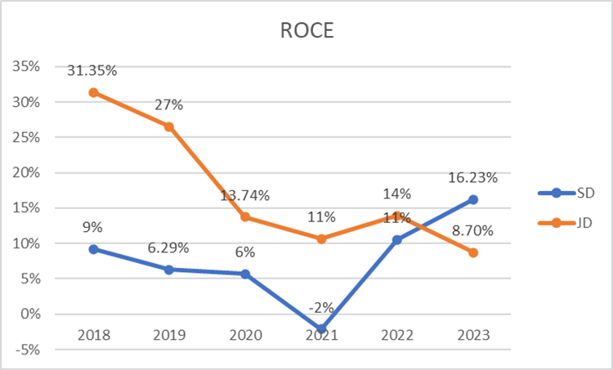
The Return Over Capital Employed (ROCE) ratio on both companies have declining trends for the first four years of the examined period, when JD is leading in employed capital returns, but after 2022 SD’s ratio improved significantly and went ahead of JD’s with almost double rates of return.
Graph 6 ROCE

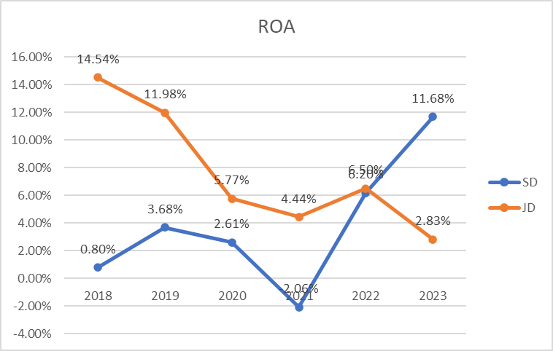
2.4 ROA

The Return Over Assets ratios as expected, repeats the same trajectory of ROCE meaning that both Net Profits and Operating Profits of both companies are proportional moving along with their assets. Again the companies switched places in returns in 2022, when JD had suffered 8% decline, while SD enjoyed 8% rise. The trajectories of both companies suggest further deviation in time, unless one or both companies changes its basic metric.
Graph 7 ROA

3. GEARING
This section presents the results from calculating the Debt to Equity Ratio and Capital Structure ratio for both companies over the examined period.
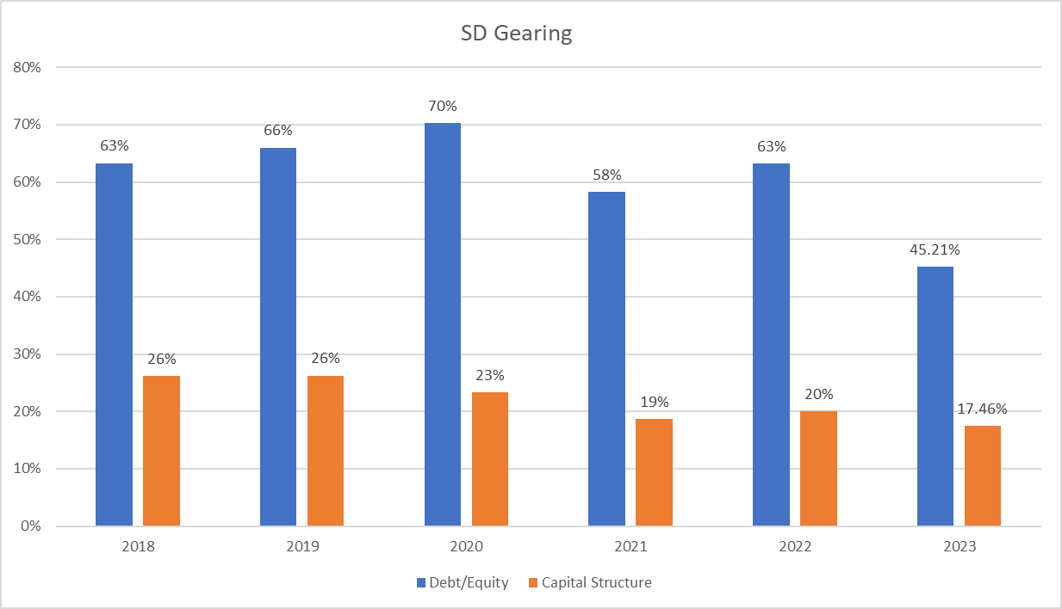
Table 5 SD Gearing ratios
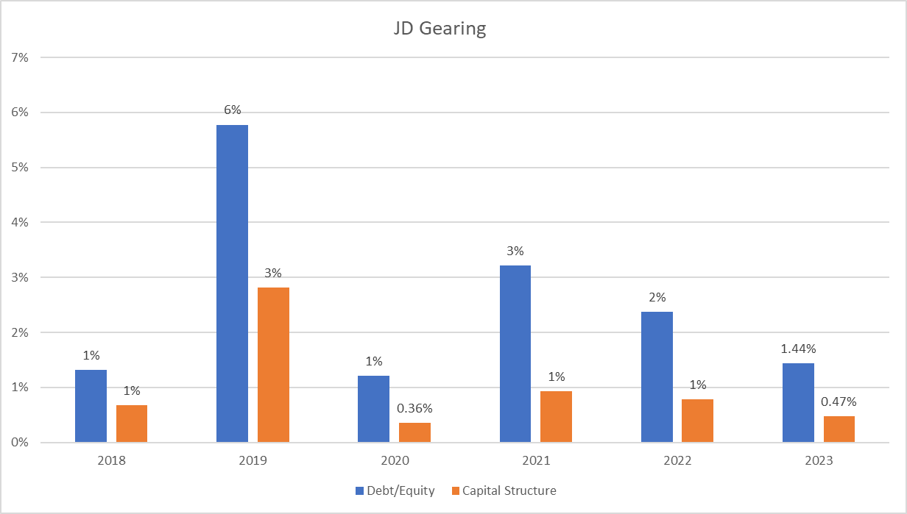
Table 6 JD Gearing ratios
Looking at the examined period, Sports Direct and JD Sports have completely different attitude towards long term debt, despite the fact that both companies maintain a positive working capital. While Sports Direct have more aggressive approach in terms of leverage, characterised by the higher percentage of long-term debt as compared to their equity and total assets, JD Sports is way more conservative keeping those numbers persistently low.

3.1 DEBT TO EQUITY
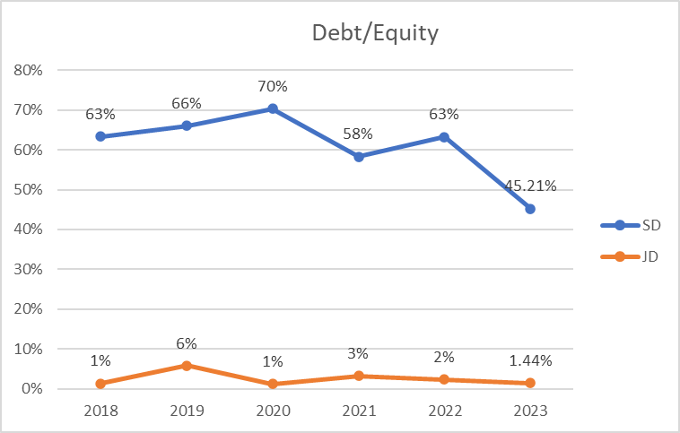
JD consistently demonstrated a conservative approach in its D/E ratio, preferring to rely less on debt and more on equity or retained earnings for financing. This conservative stance underscores a risk-averse strategy aimed at maintaining financial stability and flexibility. A notable, albeit slight, increase in leverage in 2019 suggests a temporary strategic adjustment possibly aimed at exploiting market opportunities that required additional capital, but still marking a very low average of 3%.
Graph 8 Debt to Equity
SD’s approach contrasted notably with JDs, as evidenced by its consistently higher D/E ratios. This indicates a strategic preference for leveraging debt to underpin growth and expansion efforts. The fluctuations in JD's D/E ratios also reflect a dynamic approach to financial management, responding agilely to changes in market conditions or opportunities.

3.2 CAPITAL STRUCTURE

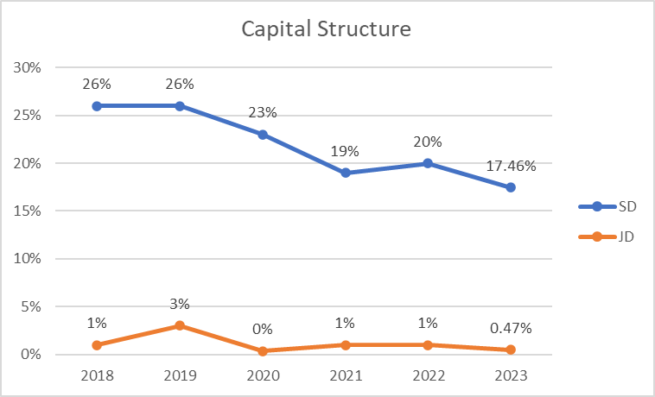
Resembling the Debt to Equity ratio, the Capital Structure of the companies follows similar trajectory. Again, JD presents as very conservative and careful to increase the long term borrowings portion of its capital, while SD does prove to be more risky in the same instance, but also is able to gain more leverage.
Graph 9 Capital Structure

4. LIQUIDITY
This section presents the results from calculating the liquidity ratios for both companies for the period between 2018 and 2023.
As evident from Table 7 and Table 8. Both companies have different liquidity practices. While SD’s liquidity sustain high rates in Current assets (minus inventory), their cash reserves are not enough to cover all of its current liabilities even in half for the last three years. In the case of JD, the liquidity cash rates are much higher meaning that company keeps cash and cash equivalents at its disposal at most times, since its cash ratio could cover above two thirds of its current debt. At the same time JD’s quick ratio has lower rates than SD’s, agai suggesting that their current assets minus the inventory are not enough to pay for their short- term liabilities. Even so, both companies maintain positive working capital on an inclining trend, which is a positive indicator about their liquidity and capital management.
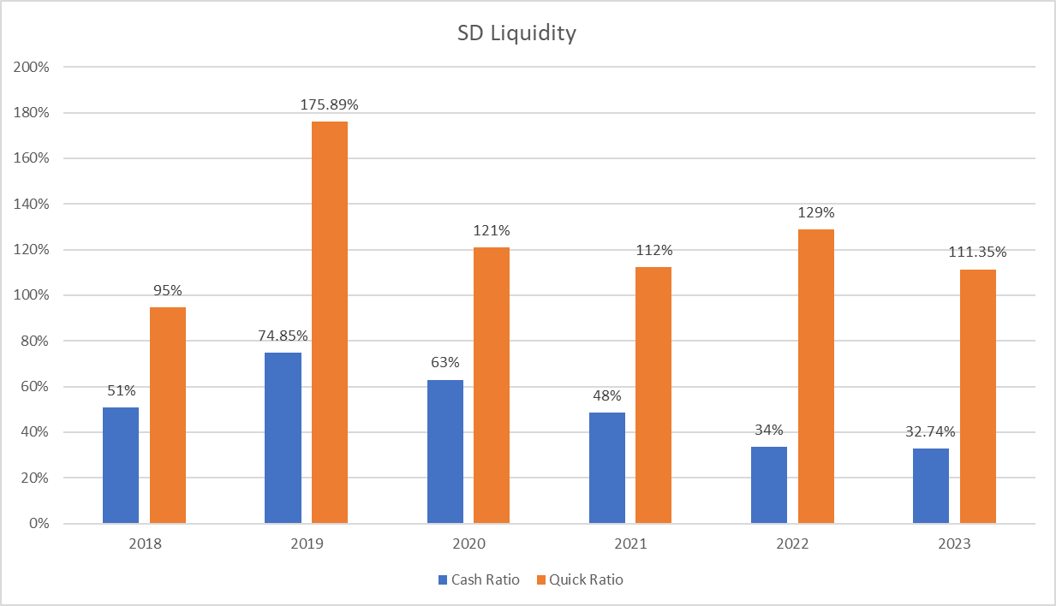
Table 7 SD Liquidity ratios
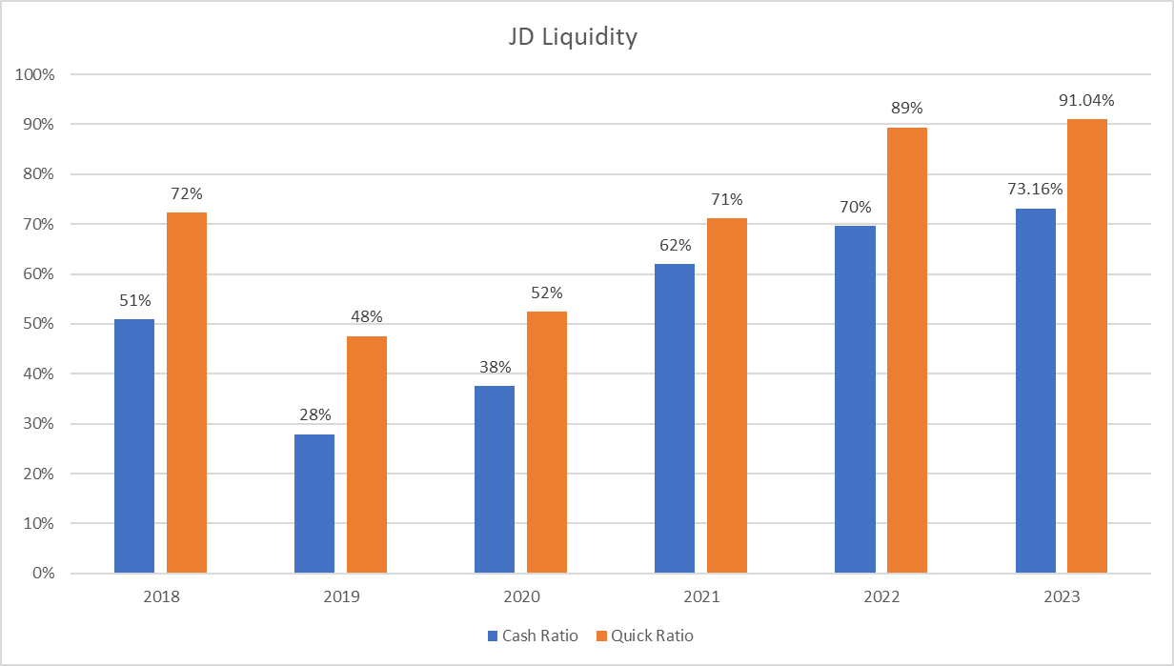
Table 8 JD Liquidity ratios

4.1 QUICK RATIO

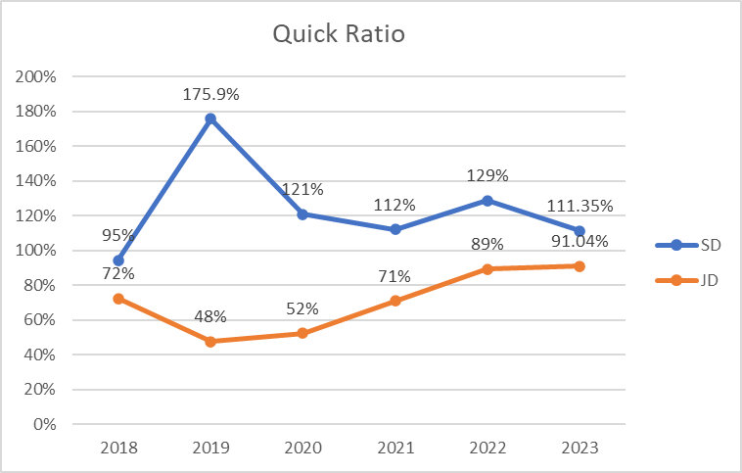
JD's Quick Ratio remained relatively stable, underscoring a consistent strategy to maintain liquidity at a level that safeguards operational stability without necessarily prioritising excessive liquidity. SD's Quick Ratio, though more volatile, was generally higher, pointing towards a strategic preference to keep liquidity on hand, possibly as a defensive measure against the dynamic challenges of rapid expansion and new markets penetration.
Graph 10 Quick Ratio

4.2 CASH RATIO
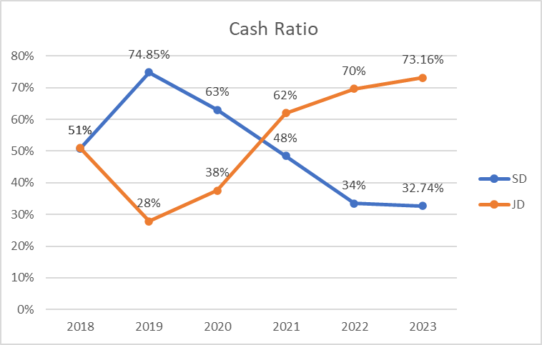
The trajectory of the companies’ Cash ratio is quite interesting with both companies basically mirroring each other for the whole examined period between 2018 and 2023. Again, while JD’s improves on cash reserves, SD’s decline.
Graph 11 Cash Ratio

4.3 WORKING CAPITAL

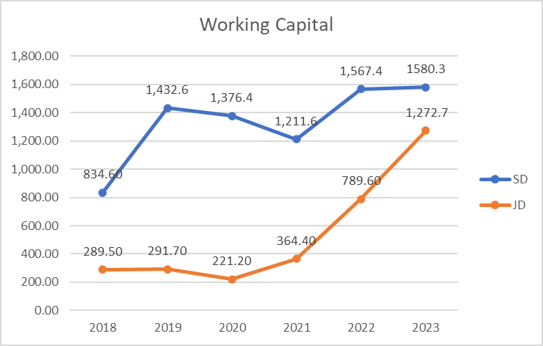
Throughout the analysed period, JD exhibited a pattern of higher fluctuations and tendency to gradually increase its Working Capital (after 2020), as compared to SD, which consistently maintained a more balanced level of Working Capital for the majority of the examined period. This pattern underscores JD's changing attitude towards the use of its operational funds, possibly redirecting them after Covid to fuel growth initiatives, such as opening new stores or expanding into new markets, which requires significant investment in inventory and other short-term assets.
Graph 12 Working Capital
In contrast, SD’s relatively stable and higher levels of Working Capital suggests a strategic emphasis on maintaining constantly liquidity to ensure expansion and smooth business operations. The increase in Working Capital in 2023 for both companies might be indicative of their strategies to invest heavily in long-term assets or possibly to be prepared with cash on hand for disruptions in their sales and operational costs as a result of the ongoing geopolitical conflicts and possibly interrupted supply-distribution channels.

CHAPTER V: ANALYSIS OF FINDINGS

This analysis dives into the reasons behind the financial trends observed in the first part and explores their broader implications. Understanding the dynamics of each company’s ratios and their components is crucial for identifying similarities and differences in their operational and financial approaches.

1. REVENUE
This section systematically details the observed financial data, focusing on the revenue trends of Sports Direct plc and JD Sports Fashion plc over a six-year period.
- SPORTS DIRECT PLC has an average annual Revenue of £4.2b between 2018 and 2023, starting at roughly £3.4b and ending at almost £5.6b from sales, which is 66% increase for the whole period. Nevertheless, the company has inconsistent Revenue growth over the years varying between 7% and 33%, and even a 8.4% decline in 2021. At the same time JD SPORTS PLC shows steady growth of sales in 2019 and 2020 of 49% and 30% with exception in 2021 when the growth rate slows down to 1%. In 2022 another increase of 39% occurred, marking an overall increase of the Revenue over the six-year period with the remarkable 220% from £3.2b in 2018 to £10.1b in 2023 or £6.5b on average.

- SPORTS DIRECT PLC does not have a straightforward trajectory of Revenue Graph…. .growth within the examined period. Between 2018 and 2019 fiscal years the Revenue grows with 10%, while in 2020 that percent is nearly 7% generating close to £4b. The Turnover drops with over 8% in 2021 to £3.6b and in 2022 the company benefits from a strong increase of Revenue with 32.55% compared to the previous year and followed by another increase of 16% in 2023. The overall increase of the Revenue for the period of six years is 62%, starting with £3.4b in 2018 and ending 2023 with £5.4b in sales. This MAY indicate effective marketing strategies and initiatives aimed at expanding the company's reach and enhancing its sales channels. The continued growth, even during varying economic conditions, could suggests a strong consumer demand and effective adaptation to market trends, and possibly a relatively stable management of cost or pricing strategies under varying market conditions.
JD SPORTS PLC shows steady growth of sales in 2019 and 2020 of 49% and 30% then in 2021 the growth has slowed down to 1% until 2022, when another increase of 39% occurred, marking an overall increase of the Revenue Graph….). over the five-year period with the remarkable 171% from £3.2b in 2018 to £10.1b in 2023.

2. PROFITABILITY RATIOS

This part of analysis, will explore the financial trajectories of two companies, SD and JD, using four critical profitability ratios: Gross Profit Margin (GPM), Net Profit Margin (NPM), Return on Capital Employed (ROCE), and Return on Assets (ROA). By examining these ratios from 2018 to 2023, the aim is to understand the companies’ operational efficiency, profitability, asset management, and capital utilisation.

2.1 GROSS PROFIT MARGIN (GPM)
Gross Profit Margin (GPM) Overview

Sports Direct
Between 2018 and 2019 the rise of 3% of the GPM (Graph 4).to almost 43% is due to the unproportional increase of the Revenue as compared to the CoS – the Revenue increased with over 10%, while the CoS grew with only 4.64% for the same period, leading to 18.6% Gross Profit increase, and suggesting that the company is successfully managing and improving the cost of goods sold and/or its pricing policies (Goel, 2016). In the following 2020 the company’s GPM of 42% is slightly lower, impacted by the lower levels of Revenue increase (6.9%), compared to the increased CoS with 8.33% and causing a Gross Profit increase of only 5%. 2021 keeps almost the same GPM of 42% with an insignificant increase of half percent, being a consequence of the proportionally declined Revenue, CoS and Gross Profit with respectively 8.39%, 8.73% and 8% (table3).
In 2022 the higher levels of growth of the Revenue with 33% and slightly lower levels of increase in the Cost of sales with 29% caused over 36% jump in the Gross Profit, and therefore 1% increase of the GPM to 43.47%. The period ends with slightly lower GPM of 42.6% in the fiscal year 2023, which is due to the vaguely higher rate of increase of the CoS (17.63%) compared to the Revenue (13.4%) and reducing the growth rate of the Gross Profit to 13.5%).

JD Sports
JD SPORTS PLC’ shows steady levels of GPM (Graph….) of around 48% on average over the period of six years with insignificant fluctuations.
The persistence of the GPM is a result of keeping similar proportion of growth and relation between the Revenue and the Cos over the years. That suggests that the company is successful in managing the Cost of sales and keeping them at similar levels (Goel, 2016).

The minimal fluctuation in GPM also suggests that both companies possibly have a well-established supply chain and pricing strategy that effectively withstands the market unpredictability.
The fact that both companies share very similar GPM trends and values, could further imply that companies also share similar cost and pricing structures, which could be due to using the same suppliers, for instance. It could also mean that they operate in a mature market segment with standardised operations (Porter, 1985). In any event, close GPM values could mean that there is not much room for improvement of CoS and companies might not be able to gain competitive advantage from pricing when “racing” on the same market (Schoenmaker and Schramade, 2023).

2.2 NET PROFIT AND NPM

SPORTS DIRECT PLC has been very consistent with an average GPM of 42% over the six years period and a 4% increase between 2018 and 2023 ending at 43.48%. The highest growth was 3% in 2019.
JD SPORTS PLC’ shows steady levels of GPM of around 48% on average over the period of six years with insignificant fluctuations.

SPORTS DIRECT PLC:

The impressive growth in Net Profit of 2000% between 2018 and 2023 can be attributed to overall higher revenue growth rates exceeding increases in the Cost of Sales and Operating expenses. Chronologically, between 2018 and 2019 the Net Profit rose with 400% from £23m to £116m, due to the reduced finance and investments costs with 82.6% to less than £28m, and due to investment and finance income of £55m (SPORTS DIRECT PLC, 2019), despite the rise of the Operating Costs with almost 24%, which ultimately resulted in increase in the NPM with 2%. Then the following 2020, the Net Profit dropped with 13% to £101m, accounting for 0.6% drop in NPM to 3%, due to 186% increase of the finance cost and decrease of the finance income with 16%, as well as 8% increase of CoS and Operating Cost, while the Revenue and the Gross Profit increased with lower rates, respectively with 7% and 5%.

In 2021 Net Profit continues to drop but on a much higher rate – with 177% marking a very significant loss of £78m. That is a result of fall the in the Revenue and the Gross Profit, with respectively 8.4% decline and 8%, but mostly to the double amount of taxes which increased from £42.5m to £86.5m, due to non-deductible expenses (p. 94 FG annual report 2021) and £13.6m adjustments from previous period, but also the increase of the Operating cost of 4%. That caused the NPM to drop as well with almost 5% to a -2%.

SPORTS DIRECT PLC marks 2022 with strong return of Net Profits with an increase of 429% and reaching the highest rate of growth for the period amongst both companies, which equals to almost £257m and causing a 7.5% growth in the NPM, reaching for the first time 5%, meaning that on every £1 of sales, the company profits £0.05. The huge jump of the Net Profits, and respectively of the NPM is due to several reasons – the Revenue increased with 33%, while the CoS only with 29%, causing the Gross Profit to increase as well with above 36%, and resulting in Operating Profit to rise with almost 650%, while the Operating cost increased with just 11%, and triggering a Profit Before Tax rise with almost thirty times, while the tax was reduced by 9%.

In 2023 SD continues the growth trend with the almost doubled Net profits as compared to the previous year, reaching above £501m. This is predominantly due to increase of the Operating Profit with 61%, more specifically - Other Operating income of £41m, Profit from Exceptional items bringing to the company £97m, and Profits from property sales accounting for above £95m (SD 23 annual report)) and 114% rise in the Finance income. Both of the above counteracted the effect from the rise of CoS with 2% higher that the Revenue’s growth rate and the doubled taxes, so that the NPM, climbed with almost 4% setting the new highest record at 9%. This rapid growth of profits is hard evidence of adaptable and successful investment and leverage strategies.
JD SPORTS PLC:
-JD SPORTS PLC presents with the less favourable NPM graph out of the two companies.
Starting strong at almost 7.5% in 2018 it gradually declines and loses over 5% for the whole period (Graph…), controversially to its other metrics so far.
Between 2018 and 2019 the Net Profit grew with 12% to £264m, but the NPM dropped with 2%. That was a result of a gap, opened by the higher rate of increase of the CoS (52%),as compared to the Revenue (49%) and the increase of Investments and finance costs with 275% and of tax with 30%. In the following year 2020 Net Profits dropped with 5% to £250m, result of the ten times increase of the Interest and finance costs from £7.5m to just below £80m and the 29% more taxes. That had minor effect on the NPM, which dropped with 1%.
In 2021 the Revenue increased insignificantly with 1%, while the CoS declined with the same amount, but nevertheless the Operating cost increased with 6% from £2.5b to £2.6b, reducing the Operating profit with 10% from £426.6m to £385m and causing the decline in the Net Profit with 9% to £229.2m, but affecting insignificantly the NPM, with less than half percent. In 2022 the company increased their Sales with 39%, on a higher rate than the increase of CoS, and experienced a rise in Other operating income from £13m to £16.6m (JD annual report 2022 page …) driving 87% rise in Operating profit to £721m, and ultimately leading to increase of the Profit after tax with the remarkable 101% to £460m, and respectively the NPM with 2%, reaching above 5%. In 2023 the company’s NPM descended with 3% more to just above 2%, as a consequence of 51% reduced Net Profits from £460m to below £227m, and despite the 18% growth of the Revenue. The drop in the Net Profits could be traced backwards to increase in Tax with 10% leading to decline in PBT with 33%, resulting in decline of Operating Profit with 29% to £510m, which is due to 24% increase in Operating Cost from £3.5b to £4.4b, and finally 21% increase of CoS from £4.4b to £5.3b, which is higher rate of growth, as compared to the Revenue.
For the whole period, the Net profit of JD Sports decreased with 4%. While the Sales increased with 220%, the CoS increased unproportionally with 224%, triggering a decline, which means that at the end of the period it is costing more to realise the same amount from sales, but it also means that the Company has much higher Operational Cost and Investment Cost, possibly due to external factors…and expansion… (…), both of which consume a big part from its Gross profits too.

2.3 ROCE
The analysis of the changes of ROCE during the examined period for each company provides critical insights of their operational efficiencies, and how well the company is succeeding to turn its Capital into profits. These insights are essential for understanding the financial health and strategic direction of SPORTS DIRECT PLC and JD SPORTS FASHION PLC, as they adapt to dynamic market conditions and aim for sustainable growth.

SD: In the beginning of the examined period the company’s ROCE is 9.19% but it drops with 3% in 2019 to 6.3% due to both: 20% decrease of the Operating Profit from £200.5m to £160.5m, and 17% increase in the employed Capital from £2182m to £2550m.
The Operating Profit drops due to 24% increase of Operating Cost, while the change in the Capital Employed is a result of 16% decrease in the Current Liabilities and 9% increase of the Total Assets. The Current Liabilities decreased because of 82% drop in Derivative financial liabilities – from £93m to £16.3m, as well as 11% drop in Trade payables from £606.6m to £541m. The Total Assets increased to £3149m with the 32% rise of the Current Assets: Inventory with 12% from £873.4m to £978.4m, Trade receivables with 48% from £293m to £433m, Derivative financial assets with 509% from £17m to £104m, and finally, Cash and Cash equivalents with 24%, from £360m to £448m.
In 2020 the ratio follows the same declining trajectory and drops with another 0.6% to 5.7%, again as a result of the rise in the employed Capital with 18.4% to £3020m, which is a higher rate of increase than the 7% inclined Operating Profit. The Capital employed changed due to 23% increased Total assets to £3868m, from which £2225m are Current assets, increased with 10%, and £1643.6m are Non-Current Assets, increased with 47%. Within the Current Assets, the ones responsible for the rise are the Inventory jumping with 22% to almost £1200m and Cash and cash equivalents growing with 19% to £534m. The Non-Current assets accountable for the 47% change are Deferred tax assets, increased with 111% from £23.7m to £50m, and Property, plant and equipment, which grew with 64% from £823.2 to £1348m.

SPORTS DIRECT PLC ends 2021 with negative ROCE of -2%, directly affected by the drop of the Operating profit of 135% resulting in £60.3m loss, which is a decline of 8%, while the CE marked only 6% drop for the same year. The negative OP is due to the 8.4% decline in sales from £3957m to £3625m, as well as to an increase of the operating cost with 4%.
The performance of the company in 2022 results in almost 13% rise of ROCE to 10.5%, due to 648% increase of the OP. The increase of the OP is affected by the growth in the Gross Profit with over 36%, which is higher than the growth of the Operating Costs of 11%. The Gross Profit increased to £2088.7m as a result of the higher increasing rates of the Revenue, as compared to the CoS.
ROCE in 2023 rises with close to 6%, setting it at 16.23%, mainly due to 61% growth of the Operating Profit to £532m.
Over the examined period the ROCE of SPORTS DIRECT PLC changed positively with over 7% from 2018 to 2023 and has a growing current trajectory, which has a positive impact on the profitability (…).

JD
In 2018 the ratio was over 31% but it dropped with 5% in 2019 to 26.5% mainly due to the substantial increase in the employed capital of 38% from £944m to £1305m, as compared to the lower increase rate of the OP (17%, from £296m to 346m). Because the Total assets of the company grew on a higher rate (36%) than its Current liabilities (32%), that resulted in the increase in the CE from £943m to £1305m, which leads to a lower ROCE ratio. The Total assets in play are: Intangible assets changed with 87% from £211.00m to £394.30m, Property, plant and equipment changed with 43% from £376.90m to £539.80m, and Other assets – with 19% from £66.50m to £79.10m.

The following year 2020 JD lost another 13% of ROCE dropping to less than 14%, but again that was caused by the drastically increased Total assets with almost 100% - Long-term assets with 185% from 654m to £1013m and Short-term assets with 23% and thus increasing the CE with 138%, while the Operating profit increased only with 23%. Long-term assets with notable effect are Property, plant and equipment, which rose with 348% to £2420m. The Short-term assets worth mentioning are Cash and cash equivalents which were infused with 85% from £251m to roughly £466m.
2021 brings more decline in the ROCE with 3% to the lowest point in the examined period of 10.7%. This time that is due to the decline in the Operating profit of 10%, and to the increased CE with 16%.
In 2022 the Operating profit increased with 37%, while the CE increased with 44%, due to 37% more assets, and therefore causing the ROCE to climb with 3% to almost 14%.The assets responsible for the change are: long-term assets, from which Deferred tax assets with 101% increase, Investments in associates – almost 2000% jump, Property, plant and equipment with 17%, and Intangible Assets – 80% rise; and short-term assets, from which Inventory rose with 22%, Trade Receivables – with 23% and Cash- with 36%.
In 2023 affected by the 30% reduced Operating profit and 13% increased employed Capital, ROCE shrunk with another 5% to just below 9%.
Therefore, the final ROCE at the end of the examined period in 2023 is 23% lower than in the beginning in 2018 with an average of 17.5%.

2.4 ROA
SD: Between 2018 and 2019 company’s ROA increased with almost 3% from 0.8% to 3.7% due to 400% increase in the net profits, as compared to the 9% increase in the Total assets. In 2020 the ratio declined with 1% as a result of 13% decline in Net Profits (due to 186% increase of the finance cost and decrease of the finance income with 16%, as well as 8% increase of CoS and Operating Cost) and 23% increase in Total Assets (Current assets, increased with 10%, and £1.6b are Non-Current Assets, increased with 47%).

In 2021, due to the recorded Net Loss of £78m, the company has a negative ROA of 2%, or 4.6% drop from the previous year. The increase of the Net Profit of 429% to £257m in 2022, boosting the company’s ROA to over 6%, marking 8% increase and starting an increasing trend, which continues in the following year. In 2023 the increase is 5% leaving the ROA at 11.7%, as an outcome of 95% jump in the Net Profits.

JD:
JD Sports has an average ROA of 8% between 2018 and 2022 and experienced a decline from the beginning of the period of 12%, starting at 14.5% and ending at just below 3%.
Between 2018 and 2019 the 3% decline is a result of the 36% increase in total assets (mainly 87% intangible assets, 43% Property, plant and equipment, from the non-current assets, and 60% increase in inventory from the currents assets).

In 2020 ROA dropped with another 6%, again as a result of 97% increase in Total assets and reduced Net Profit. Property, plant and equipment grew with 348% boosting non-current assets with 185% and the 85% rise in cash and cash equivalents led to 23% increase of current assets. At the same time the Net profit dropped with 5%, mostly due to ten times increase in the investment/finance cost from £7.5m to £80m and 30% higher taxes.
In 2021 JD lost another 1.3% of ROA to 4.4% due to a fall in the Net profit of almost 9% and increase in assets of 19%, from which 12% rise in non-current assets of 12% (the most significant one is intangible assets with 98%) and current assets with 31% (mostly affected by the cash and cash equivalents increase of 107%). 2022 marks a growth of ROA with 2%, due to a jump of 101% in Net profit as compared to the lower rate of increase of the total assets. In 2023 the ratio dropped further to 3%, due to the reduced Net Profit in half.

3. GEARING
This analysis highlights the insights from an in-depth analysis of two ratios: Debt to Equity (D/E) and Capital Structure for Sports Direct (SD) and JD Sports (JD) from 2018 to 2023. The purpose is to uncover how these two companies manage their financial leverage and overall capital deployment to fuel their operations and growth, providing a window into their strategic financial decisions and risk management.

3.1 DEBT/EQUITY

SD: Between 2018 and 2019 the ratio climbed with 3%, reaching 66% because of increase in the borrowings with 9%, as compared to the lower rate of increase of the equity with 5%. Between 2019 and 2020 the ratio raised with another 4% to 70%, again as a result of 9% boost of the borrowings from £827m to £900m and only 2% of the shareholder’s equity from £1252m to £1280m. In 2021 SPORTS DIRECT PLC successfully reduced its Long-term debt with 12% reaching 58%, which was a consequence of the 22% drop in the borrowings to £706m, despite the reduced equity with 5%. In 2022 the company increased their borrowing with 17% to £828m and its Total equity with 8% to £1309m, resulting in increase of the debt-to-equity ratio with 5% and reaching the same level from 2018 of 63%. In 2023 the Non-current debt of the company decreased with 9% to £750m, while its Equity inclined with 27%, and pushed the ratio down with above 18% at a little bit over 45%, which is also the lowest within the examined period.
JD:
JD SPORTS PLC keeps on average 3% of long-term debt for the period 2018 - 2023 with no significant change from the beginning of the period. Between 2018 and 2019 the company increased their non-current loans with 465%, which is much greater rate of increase than the 29% rise of the equity, causing the debt-to-equity ratio to increase to 6%. In 2020 the company reduced its long-term loans with 75%, reducing the ratio to 1%. The company increased the non-current debt in 2021, this time with 208%, which caused the 2% increase of the proportion debt to equity, leaving it at 3%. The following two years JD increased the equity thus and reduced the ratio to below 1.5%, which is very close to the initial point.

3.2 CAPITAL STRUCTURE
The Capital Structure ratio provides insights into how the examines companies structure their finances between debt and equity, revealing their long-term financial strategies and risk management philosophy.

SPORTS DIRECT PLC presents with a Capital structure ratio of 22% on average and 9% decline over the six-year period between 2018 and 2023.
Between 2018 and 2019 the Capital Structure was 26% and did not experience a significant change.
Then in 2020 the ratio decreased with 3% to 23%, due to the 9% increase in borrowings and despite the increase of 23% in Total assets until 2021, when it dropped with 5% to 19%. In 2022 the company gained back 1% leaving the ratio at 20%, but in 2023 it dropped with 3% to 17.5%, meaning that 17.5% of the Total assets of the company are gained via long-term debt.
JD: In the case of JD Sports, the Capital structure looks very similar to the debt-to-equity ratio, with only 1% on average of its capital being debt. Despite some small fluctuations between 2018 and 2019, when it rose with 2% the ratio declined to below half percent to 2023.

4. LIQUIDITY
Quick Ratio, Cash Ratio, Working Capital
In this part of the discussion are explored the financial metrics that reflect liquidity and operational efficiency of the two competing retail giants Sports Direct (SD) and JD Sports (JD), from 2018 through 2023. By analysing the Cash Ratio, Quick Ratio, and Working Capital, this paper aims to uncover the nuances of how each company manages its short-term obligations and operational funding to support day-to-day activities and growth strategies.

The comparison between SD and JD in terms of their liquidity ratios and Working Capital management reveals fundamental differences in their financial strategies and operational management.
4.1 QUICK RATIO
SD: In 2019 the company experienced 81% growth in the ratio, reaching 176%, influenced by the increase in the Current assets (without including the inventory), from which the Derivative financial assets jumped with 509% or £87m to £104m, the Cash and cash equivalents with 24% to £448m, the Trade receivables with 48% to £432.5m, and also the 16% decline in the Current Liabilities. The decline in the Current liabilities from £709m to £599m comes from two branches - the declined Derivative financial liabilities from £93m to £16, which is 82%, and Trade payables, which declined with 11% from £606.6m to £541m. The following 2020 the ratio declined with 55% to 121%, due to a 42% increase of the Current Liabilities with almost £250m to £848m (company has new Lease liabilities of £148m, added to the 171% increase in derivative financial liabilities, and to the 11% increase in Trade payables).
In 2021 the Quick Ratio declined with 9% to 112%, caused by increase of the Current liabilities with 11% (tax liabilities rose with 68%, lease increased with 27% and Trade payables with 7%), and decline in some of the Current Assets excluding inventory, 100% decline in Assets held for sale equal to £68m, Trade receivables declined with 4% from £432.5m to £414m, Derivative financial assets declined with 25% from £104m to £78m).
The Company increased the Quick ratio with 17% to 129% in 2022, due to drop in the Cash and cash equivalents with 26% from £ 457m to £337m, from the Current Assets and 6% jump in Current Liabilities (Derivative financial liabilities increased with 458% from £19m to £107m, Trade Payables increased with 13% from £646m to nearly £730m).
In 2023 the Ratio declined with 17.5%, setting it at 111%, due to 100% or £40m decline in Assets held for sale, 14% decline in Trade receivables from £841m to £720m and 32% decline in Derivative financial assets from £116.5m to £79m.
JD: The average Quick ratio of JD over the six examined years is 71% with 19% from the beginning of the period.
Between 2018 and 2019 the ratio declined with 25% from 72% to 48%, as a result of 32% increase of Current Liabilities, and more specifically – borrowings, which inclined with 138%, and trade payables with 30% growth. The following year started gradually increasing trend that continued until the end of the examined period, triggered by increase in Cash and Trade receivables (for 2022 and 2023 only), which was on a higher rate than the increase of Current Liabilities.

4.2 CASH RATIO
SD: The Cash Ratio moves very similarly to the Quick Ratio, following the same trend. Between 2018 and 2019 the ratio increased from 51% to almost 75%, which is a 24% difference, caused by the 24% increase in cash and cash equivalents from £360m to £448m, while reducing the Current Liabilities with 16% from £709m to £599m. The two branches affecting the Current Liabilities are the declined Derivative financial liabilities from £93m to £16, which is 82%, and Trade payables, which declined with 11% from £606.6m to £541m.

In 2020 the company increased their cash and cash equivalents with 19% reaching £534m but increased significantly their Current Liabilities with 42% to £848m, which caused the decline of 12% in the Cash ratio to 63%.
Another decrease of the ratio, this time of 15% followed in 2021, setting it at 48%, due to 14% decline in the cash and cash equivalents 11% decline in Current Liabilities.
In 2022 the Cash ratio followed a second drop of 15% to 34%, inflicted by the drop of cash and cash equivalents of 26% to £337m and 6% increase in the Current liabilities (attributable to 458% rise in Derivative financial liabilities and 13% Trade payables).
In 2023 The ratio declined insignificantly with less than 1%, leaving it at just below 33%.

That means that the company has cash to cover up to 33% of its Current debt and could be seriously affected by unexpected expenses and emergencies (Chnar, 2018).

JD: JD SPORTS PLC has an average cash ratio of 54% between 2018 and 2023, as well as 22% growth for the same period. Starting with 51% in 2018, in 2019 the ratio suffered 23% reduction, due to 28% drop in the cash and cash equivalents from £348m to £251m, while the current liabilities increased with 32% from £682m to £901m. In 2020 the cash and cash equivalents increased with the significant 85% to £466m, while the current liabilities raised with 38% and causing the 10% increase in the cash ratio to 38%. Another increase in the cash and cash equivalents followed in 2021, but this time of 107% to £964m, caused a rise in the cash ratio of 24%, and setting it to 62%. In 2022 the cash and cash equivalent increased with 36% to £964m, while current liabilities increased with 21% to £1.9bm and inflicting further 8% growth of the cash ratio to 70%, meaning that company’s cash only could cover 70% of its debt. Same trend continued to 2023 leaving the ratio at 73%.

4.3 WORKING CAPITAL
Working Capital represents the difference between a company's current assets and current liabilities and is a direct measure of its ability to cover short-term obligations with short-term assets.
SD: SD maintains an average Working Capital of £1.3b between 2018 and 2023, starting at £834m and ending with £1.6b which is 90% growth from the beginning. The company’s available capital varies between 25% and 39% as a portion of its Revenue over the years.
JD: Over the whole examined period, the company maintains positive Working Capital, which varies between 4% and 13% of the Revenue and marks 340% growth from the beginning of the period from £290m to £1.2b. On average the company’s available funds for current expenses are about £540m with rapid growth of 65%, 117% and 61% for the last three years due to increase in Current Assets, this time including Inventory.

VI. CHAPTER VI: DISCUSSION OF FINDINGS
The discussion part of this dissertation aims to chronologically unfold the financial journey of Sports Direct (SD) and JD Sports (JD) from 2018 through 2023, using the information from analysis of the financial ratios to illuminate their strategies, operational efficiencies, and market responses within uncertain geopolitical and economic environment, as well as to outline the similarities and differences in their financial performance. It also points out the importance of adaptive financial management in responding to market dynamics and unforeseen challenges.

The Prelude: Financial Stance in 2018

In 2018, both SD and JD displayed distinctive financial health metrics.
Even though both competitors have very similar Revenues, CoS, OC and GPM at the starting point of the examined period, they strongly differed in NPM, ROCE, ROA, D/E and Capital Structure, as well as in Working Capital.
JD's conservative financial strategies were evident from its moderate but stable liquidity and gearing ratios. The company maintained a lower Gearing ratios compared to SD, reflecting a calculated approach that avoided excessive debt, while its competitor’s Debt to Equity (D/E) ratio and Capital Structure were significantly higher, reflecting SD’s attempt to gain more leverage and subsequently more market share, but in the same time increasing its vulnerability to unexpected turbulences.

2019: A Year of Strategic Expansion
2019 marked an important year for both companies. SD's financial metrics started to deviate even more from its number one competitor. While the company was maintaining almost the same levels of Revenue, CoS, OC and GPM, as compared to the previous year, its OP declined, while JD’s metrics inclined proportionally to its growth. Nevertheless, SD’s NPM was increased, reflecting its double income from investments, while reducing the finance cost, as a contrast to JD’s declining NPM and increasing finance cost. Furthermore, SD saw increase in Liquidity, evident from its growing Cash and Quick ratios, as well as in Working Capital, which puts them in more favourable position, and could be interpreted as a strategic response to ensure financial flexibility against market uncertainties. At the same time JD’s Liquidity ratios declined, but its Working Capital increased, reflecting assets accumulation to support future sales growth and expansion.

2020: Plans before Covid
The strategy of both companies was advantageous during this period including big and bold plans for expansion. The long-term debt of SD increased, as well as its assets, evident from the increase of property, plant and equipment, increased finance cost and D/E ratio, and reduced PBT. Meanwhile JD’s profits before and after tax declined despite the increase of Sales and OP, due to drastically inflated finance cost of more than 10 times, triggering an incline in D/E ratio and a decline in assets return, but that could be result of the growing assets (similarly to SD – property, plant and equipment, again suggesting expansion plans) and the expected delay in their conversion to revenue, evident from decreased Capital Structure.

2021: Navigating Through Pandemic Challenges
The advent of the COVID-19 pandemic in 2020 introduced unprecedented challenges (Orr et al., 2021), prompting both companies to adapt quickly.
SD’s liquidity ratios dipped in 2021 due to decreased revenue and assets, a higher operational cost, consequential of the pandemic disruptions, such as global lock downs and social distancing measures, reduced staff, as well as limited and more difficult transportation of the stock etc (Seong and Seong, 2022). Furthermore, the company recorded a significant Net Loss and paid doubled taxes. JD experienced the disruptions differently – their NPM did not change significantly, in fact their Liquidity improved notably, despite the dip of PBT, which means they were able to capitalise on their assets even during such uncertain period, evident from the increased Working Capital, Revenue, which also saw small increase, as well as a decrease of CoS. That reveals impressive adaptability, as well as CoS and pricing strategies, under such unprecedented market conditions. It could be said that JD showed spectacular resilience in the first year of the Pandemic, where it only experienced reduced growth rates unlike SD, which suffered a record loss.

2022: Post-Pandemic Recovery.
In 2022, both companies began showing signs of recovery.
After finishing 2021 with a severe loss, in 2022 SD saw jump in the Revenue, the Profit before tax and Net Profit. The returns over assets and capital also improved significantly. Furthermore, the company additionally enhanced its Liquidity (while the cash reserves were reduced the rest of the Current assets were increased) and Working Capital metrics. On the other hand, JD’s financial performance also improved on most metrics such as Sales, Operating Profit, PBT, NPM, ROCE and ROA. Even further, the company increased its capability to cover debt with cash and Current assets (minus Inventory) as evident from the Cash and Quick ratios and its double Working Capital, possibly due to optimising its asset for better efficiency.
Therefore, both companies proved resilient to unexpected and severe stress conditions, such as the rapidly changed market operations overnight during the Pandemic, by their signs of recovery the next year.

2023: In times of geopolitical military conflicts
After the recovery from the Pandemic, the world entered a new difficult phase with two ongoing and globally significant military conflicts. The conflicts heavily and negatively impacted the economic relations between some countries and continents, as well as the usual transport routes, and especially energy prices, which increased dramatically for the past two years (Bolton and Stewart, 2024), and which alone are enough to trigger a domino effect of an increase of prices of goods and services (Bubasu and Gareis, 2022). Since both companies operate globally, it is not unlikely to expect that the conflicts would have some effect over the companies’ financial performance.
JD’s slight increase in Liquidity ratios and Working Capital opposes the decline in the same metrics of SD. Even so, JD’s returns, expressed in ROCE and ROA, as well as its profits started to decline rapidly. What is more interesting, at the same time those metrics improved in SD quite notably putting both companies at almost ideal inverse proportionality on those metrics. Furthermore, both companies had an increase in revenues, with JD’s being almost twice as high as SDs, but the amount of the Operating profits are very close. That suggests that while SD is on a growing trend and managing its resources, costs and operations well, JD’s experiences serious struggles to maintain the same amount of profit even from twenty percent higher revenue, and even after increasing its finance income five times, and that its OC is increasing unproportionally. This could possibly be attributed to the acquisitions the concluded within this year (JD annual report 2023). It is also worth mentioning that JD’s Inventory days ratio increased significantly, which further indicates struggles in converting stock into profits, or in other words – it takes JD longer to sell its inventory, while in SD’s performance that ratio declined, outlining possible improvement in sales channels and/or in marketing, and /or in customer service. Last but not least, it could also mean that SD is fulfilling a market gap, that JD could not.
Even though both companies experienced increased costs (CoS and OC) the difference in their profits could not be traced back undoubtedly to the conflicts, without further investigation of their operations in Europe and the rest of the world. There are no unquestionable evidence in their financial statements for the last year that reflect on disruptions of their operations particularly due to the conflicts, nor it is evident from the numbers themselves, within the scope of this analysis, which is not exhaustive of their financial performance as a whole. Therefore, it cannot be concluded that the conflicts directly impacted the operations of both companies, nor it could be rejected entirely, therefore it remains a possibility within the general narrative of disruption of the global economy due to the conflicts and could be explored in further research.
As both companies continue to evolve, their financial strategies will likely continue to diverge, reflecting their core operational philosophies, struggles and market ambitions.

Resemblances in the Performance of Sports Direct and JD Sports (2018-2023)

7.1 Starting point

In the beginning of the examined period in 2018 both companies had similar sales, expenses, GPM and even Cash ratio.

7.2 Responsiveness to Economic Conditions:
Both Sports Direct (SD) and JD Sports (JD) showed responsiveness to broader economic conditions, adjusting their financial strategies according to shifts in the market landscape. They both managed to navigate through the pandemic with strategic adjustments in their liquidity and capital structures to mitigate its impacts.

7.3 Focus on Growth and Expansion:
Both SD and JD displayed a clear focus on growth and expansion, although through different strategies. This is evident from their capital deployment in new long-term assets, reflecting a forward-looking approach in their respective operational strategies.

7.4 Trends
Both groups share similar trends in some of their metrics, such as GPM trends, which are almost parallel to one another and Revenue, CoS and Operating Cost, which follow same direction of the trajectory, but differ in growth rate. The trajectories of the finance costs of both companies also exhibits some similarities, although it strongly differs in the beginning of the period, by the end of it they are almost the same.

Differences in the Performance of Sports Direct and JD Sports (2018-2023)

8.1 Risk Tolerance and Financial Strategy:
SD exhibited a higher risk tolerance, using more aggressive financial strategies evident from the higher gearing ratios and the lower liquidity ratios, while in contrast, JD demonstrated more conservative financial behaviours, focusing on stability and risk aversion, as seen in its more stable and lower gearing ratios, and higher cash reserves.

8.2 Degree of Financial Aggressiveness:
SD's financial metrics showed greater fluctuations, than JD’s indicative of a more aggressive strategy that capitalised on market opportunities. Meanwhile, JD maintained more consistent financial metrics across the years (with notable exception of the last year), which could be part of a strategy for gradual and more sustainable growth.

8.3 Variability in Liquidity Management:
SD maintained higher cash liquidity levels compared to JD, in the beginning of the period, likely to support a responsive and aggressive growth strategy that required rapid capital deployment, but it declined in the second half. Conversely, JD’s liquidity management was more conservative in the second part, likely aiming to minimise financial risks associated with unexpected turbulence. In fact, the trajectories of the Cash ratio of both companies are mirroring each other in almost ideal inverse proportionality, meaning that companies have radically different, if not opposite approach towards Liquidity and more specifically Cash reserves.

8.4 Impact of Strategic Choices on Capital Structure:
SD’s capital structure was more variable, reflecting its utilisation of debt for expansion and its responsive adjustments to the market conditions. JD, on the other hand, showed a preference for a more balanced and lower Capital structure, likely to avoid the dangers of over-leveraging and to maintain steady growth.

8.5 Long-term Investment vs. Short-term Gains:
SD’s approach suggests focusing on maximising short-term gains and market capture, which sometimes led to higher financial volatility. JD’s strategy, on the other hand, leaned towards securing long-term investment stability, opting for financial practices that sustained long-term operational health over immediate gains, sacrificing profits for future growth.

8.6 Covid response
As discussed previously, both companies responded differently to the Covid crisis with JD being affected by slowing down its growth rates to sustain same levels from the previous year, while SD experienced huge Net Loss and significant dips of returns.
These points of resemblance and difference illustrated a detailed comparative picture of how SD and JD have navigated their financial pathways over the past years, particularly in adapting to and recovering from economic challenges. Each company’s unique approach not only reflects its corporate philosophy and strategies to leverage market conditions but also its adaptability to changing market dynamics and economic environments.
7. Ending point 2023
At the end of the period the companies differ in almost every analysed metrics, except in Operating Profit and Finance (Investment) Cost. Furthermore, companies show signs of inverse proportionality on some metrics such as Profit Before Tax, Net Profit, ROCE, ROA and Cash Ratio, and even Tax, visible in the graphs presented in Chapter IV.

VII. CHAPTER VII: CONCLUSIONS
This analysis explored in detail the financial performance of Sports Direct plc (SD) and JD Sports Fashion plc (JD) withing six years between 2018 and 2023, and was based on the annual reports, and more specifically the consolidated statements of financial position and consolidated income statements of the companies. The analysis was conducted within the scope of three financial ratio groups, namely Profitability, Gearing and Liquidity, reviewing the most important ratios from these groups. The examined ratios were Gross Profit Margin (GPM), Net Profit Margin (NPM), ROCE, ROA, Debt to Equity, Capital Structure, Quick Ratio, and Cash ratio.
After performing the analysis, it is evident that each one of them has competitive advantages over the other and that both of them are leaders in different financial criteria.
In terms of Profitability, at the end of the examined period, the company with the highest Revenue and highest increase of Revenue is JD, but the company with highest profits as an amount and as a percentage before and after tax is SD. Similarly, SD is also the company with the better returns over employed capital and assets.
In terms of Gearing, the company with lower gearing rates in both – Debt to Equity and Capital Structure over the whole period and at the end of it is JD, as a result of their very conservative debt philosophy, as a contrast to SD’s bold behaviour. Therefore, at the end of the period, the company with more leverage is SD, which also carries more risks.
And finally, comparing the companies in liquidity resulted in judgment in favour of none of them, as JD has more cash available to cover current financial obligations, visible from the Cash ratio, but has lower Quick ratio, meaning that SD has more disposable current assets, not counting the inventory, to cover its current debt than JD. And to finally reinforce the balance between the companies’ performance – SD and JD have very similar Working Capital.
Ultimately, at the end of the examined period SD shows better metrics, while it was second at its beginning. Nevertheless, JD presented with much better values of most of its metrics over the whole period, and especially during Covid, except for the last year, therefore is the most stable and less risky company overall, despite the drop in profits.
Conclusion: It is not possible at this stage to determine the company with better performance on all metrics and criteria, since both companies have competitive advantage over the other.

VIII. REFERENCES

Akgiray, V. (2019) Good Finance Why We Need a New Concept of Finance Bristol, UK ;: Bristol University Press.
Alam, M.M. and Abdurraheem, I.I. (2023a) 'COVID-19 and the financial crisis in the sports sector around the world', Sport in Society, 26(1), pp. 154-167 Available at: https://doi.org/10.1080/17430437.2021.1979964.
Alam, M.M. and Abdurraheem, I.I. (2023b) 'COVID-19 and the financial crisis in the sports sector around the world', Sport in Society, 26(1), pp. 154-167 Available at: https://doi.org/10.1080/17430437.2021.1979964.
Becker et al. (2022) Sporting goods 2022: The new normal is here | McKinsey. Available at: https://www.mckinsey.com/industries/retail/our-insights/sporting-goods-2022-the-new-normal-is-here#/ (Accessed: Aug 28, 2023).
Blomgren, A. (2011) 'Does corporate social responsibility influence profit margins? a case study of executive perceptions', Corporate Social Responsibility and Environmental Management, 18(5), pp. 263-274 Available at: https://doi.org/10.1002/csr.246.
Bobasu, A. and Gareis, J. (2022) 'The impact of higher energy prices on services and goods consumption in the euro area', ECB Economic Bulletin, (8) Available at: https://www.ecb.europa.eu/press/economic-bulletin/focus/2023/html/ecb.ebbox202208_03~2ca54e2b1b.en.html.
Bolton, P. and Stewart, I. (2024) Domestic energy prices Summary 1 Context: Domestic energy use and spending 2 The energy price cap and the Energy Price Guarantee 3 How have energy prices changed? 4 Variations in prices 5 Why did prices increase so rapidly? 6 How much do people actually spend on energy? 7 How do gas and electricity prices vary across Europe? Reference table.
Browne, C. (2010) 'Good Benchmark for Profit Margins for a Sporting Goods Store', Small Business - Chron.com, .
CARLSON, M., FISHER, A. and GIAMMARINO, R. (2004) 'Corporate Investment and Asset Price Dynamics: Implications for the Cross-section of Returns', The Journal of Finance, 59(6), pp. 2577-2603 Available at: https://doi.org/10.1111/j.1540-6261.2004.00709.x.
Chan, K., Chan, L.K.C., Jegadeesh, N. and Lakonishok, J. (2006) 'Earnings Quality and Stock Returns', The Journal of Business, 79(3), pp. 1041-1082 Available at: https://doi.org/10.1086/500669.
Chnar, A.R. (2018) 'Efficiency of Financial Ratios Analysis for Evaluating Companies’ Liquidity', International Journal of Social Sciences & Educational Studies, 4(4), pp. 110-123 Available at: https://doi.org/10.23918/ijsses.v4i4p110.
D O'Gorman, K. and MacIntosh, R. (2015) Research Methods for Business and Management : A Guide to Writing Your Dissertation Oxford: Goodfellow Publishers, Limited.
de Matos, J.A. (2018) Theoretical Foundations of Corporate Finance Princeton, NJ: Princeton University Press.
Dunn, W. (2018) 'The house of Ashley: How the retail billionaire is defying foes', (5432, 147), 18.
fg-annual-report-2018-web. Available at: https://frasers.group/financials
fg-annual-report-2019-web. Available at: https://frasers.group/financials
fg-annual-report-2020-web. Available at: https://frasers.group/financials
fg-annual-report-2021-web. Available at: https://frasers.group/financials
fg-annual-report-2022-web. Available at: https://frasers.group/financials
fg-annual-report-2023-web. Available at: https://frasers.group/financials
Goel, S. (2015) Financial ratios Business Expert Press.
Goodacre, A. (2003) 'Operating lease finance in the UK retail sector', The International review of retail, distribution and consumer research, 13(1), pp. 99-125 Available at: https://doi.org/10.1080/0959396032000065373.
Happ, E., Scholl-Grissemann, U., Peters, M. and Schnitzer, M. (2021) 'Insights into customer experience in sports retail stores', International journal of sports marketing & sponsorship, 22(2), pp. 312-329 Available at: https://doi.org/10.1108/IJSMS-12-2019-0137.
Heikal, M., Khaddafi, M. and Ummah, A. (2014) 'Influence Analysis of Return on Assets (ROA), Return on Equity (ROE), Net Profit Margin (NPM), Debt To Equity Ratio (DER), and current ratio (CR), Against Corporate Profit Growth In Automotive In Indonesia Stock Exchange', International journal of academic research in business and social sciences, 4(12) Available at: https://doi.org/10.6007/IJARBSS/v4-i12/1331.
Hua, H. and 2022, G.B.A. (2022) 'Data: JD Sports vs Frasers Group two sports retail titans square up', .
JD, 2018-annual-report-v1-compressed. Available at: https://www.jdplc.com/
JD, annual-report-2019-compressed. Available at: https://www.jdplc.com/
JD-group-annual-report-report-2020 Available at: https://www.jdplc.com/
JD-group-annual-report-report-2021 Available at: https://www.jdplc.com/
JD-group-annual-report-report-2022 Available at: https://www.jdplc.com/
JD-group-annual-report-report-2023 Available at: https://www.jdplc.com/
Laws, J. (2018) Essentials of financial management Liverpool: Liverpool University Press.
Mulyadi, D., Sihabudin and Sinaga, O. (2020) 'Analysis of Current Ratio, Net Profit Margin, and Good Corporate Governance against Company Value', Systematic reviews in pharmacy, 11(1), pp. 588-600 Available at: https://doi.org/10.5530/srp.2020.1.74.
Nariswari, T.N. (2020) Profit growth Center for Strategic Studies in Business and Finance SSBFNET, pp. 87-96.
Novy-Marx, R. (2013) 'The other side of value: The gross profitability premium', Journal of Financial Economics, 108(1), pp. 1-28 Available at: https://doi.org/10.1016/j.jfineco.2013.01.003.
Orr, A.M., Gardner, A., Jackson, C. and White, J.T. ADAPTATION OF THE RETAIL INVESTMENT MARKET IN THE UK: changing tenant covenant perceptions and flexibility in the lease model.
Porter, M.E. (1985) Competitive advantage: creating and sustaining superior performance New York: Free Press; London: Collier Macmillan: Free Press ; Collier Macmillan.
Schoenmaker, D. and Schramade, W. (2023) Corporate finance for long-term value. 1st edn. Cham: Springer International Publishing.
Seong, D. and Seong, N. The Negative Effect of COVID 19 Pandemic on Sports Leisure Recreation Retailers, and its Solutions.
Skinner, J. and Smith, A.C.T. (2021) Introduction: sport and COVID-19: impacts and challenges for the future (Volume 1) Informa UK Limited, pp. 323.
Waal, A.A.d., Bootsman, J. and Bilstra, E. (2021) Building the high performance finance function Hershey PA: IGI Global.

IX. APPENDIX

- Screenshots of MS Excel spreadsheets with calculations



