Is there a significant association between gender and university course choices?
Research Methods

Is there a significant association between gender and university course choices?

Abstract

A lot of information says gender is pertinent in what courses in higher education are chosen. It is said that women are likely to choose subjects of the arts and humanistic subjects, while males tend to edge towards the STEM fields. Using readily available secondary data, it has been reported that there is a clear segregation of genders in
Computing and psychology, with males being the dominant gender in the former and females in the latter. This report analyses whether gender plays a significant role in a person’s choice of university course. Based on research for this paper, the hypothesis was that gender would play a significant role in course choice. Thirty-two participants, who were undergraduate students, were asked about their gender and whether they were studying computing or psychology. This information was input anonymously using the Qualtrics programme. Based on the data gathered, it was found that there was no significance and that the initial hypothesis could be rejected.

Introduction

The way many children are introduced to STEM subjects is through media. In movies, video games and television, these subjects are often shown using gender stereotypes. More often than not, that stereotype is a socially awkward male with intense interests who fit the classic ‘nerd’ description (Cheryan et al., 2017). Even now, in television shows such as The Big Bang Theory (Lorre & Prady, 2007-2019), the four main characters are all male scientists. This narrative continues to portray that these subjects are not only mainly for men but that women are just not as capable as men in these fields. Research by Cheryan et al. (2017) found that there was a boom In the ’70s and 80’s of women joining STEM courses in American colleges. This climb peaked in 1984, with 37% per cent of students studying computer science being female, and this number dropped to just 18% in 2018.

A survey taken by SWIFT in Canada of over seven thousand participants found that males were more interested in computer science than females. Over the course of forty years, data was collected to study trends in who was taking computer science courses and why they took them. They found that between 1990 and 2011, there was a significant drop in women studying the field, and in general, the women who did take the course felt much less confident using computers than their male counterparts (Beyer, 2014). According to a report by SIGIS (Strategies of Inclusion: Gender and the information society), these drops in female inclusion have been noticed, and work has been done to counteract this. The importance of engaging girls and women in STEM subjects is now being embedded in all forms of education, both primary and secondary and numerous initiatives have been put forward to counteract the gender imbalance (Lagesen, 2007).

According to Radford and Holdstock (1995), in the last fifty years, computer science has grown from a relatively unknown field into an exciting and hugely informative subject. The research they conducted found that the computer sciences were primarily studied by men. However, computer science has not always been dominated by males. Computer programming, for example, was primarily thought of as ‘women’s work’ as the job itself was rather mundane and mechanical akin to factory or secretary work, making the field predominantly feminine (Romeo, 2021). As computers became more mainstream, more businesses and companies needed people to work computer jobs and salaries within these jobs increased, thus becoming more appealing to men. With women largely having to stay at home to raise families, this could contribute to the low number of women within the field over the years (Rossiter, 2006).

If males dominate computer studies, then why are psychology courses largely taken by females? The British psychology society (2020) states that 80% of psychology undergrads are women. The psychology profession is also female-dominated, with 80% of clinical and educational psychologists being women. This gender balance is concerning, as men who might want to see a male therapist are less likely to have access to one. The office for national statistics (2022) reports that three-quarters of all people who commit suicide in the UK are male, so having access to the appropriate mental health care is extremely important.

Men indeed dominated the initial subject of psychology, with many of the field's significant findings found by men. Freud, Watson, and skinner, to name just a few, but over the years, it has come to be seen as a more feminine subject, perhaps due to the perceived stereotypical caring nature involved in the therapeutic side of psychology (Gross, 2020). Males entering the psychological field have noted feeling out of place in female dominated classrooms, reporting feelings of embarrassment and reluctance to offer opinions due to the lack of diversity; this could be off-putting to future men looking to enter the psychology field (Willyard, 2011).

The increase in segregation has led to many wondering what has caused this and what the far-reaching consequences of this might be. The more the field of psychology became female-led, the curriculum itself slowly but surely changed to suit the people taking the classes. The humanistic side of psychology is far more favoured by women than the clinical side of statistics and research. Also found that at A-level, the humanistic side of psychology is featured more predominantly (Radford & Holdstock, 1995).

Given all of the information, there seems to be a significant association between gender and choice of university subject. The study below has been devised to define if that assumption is correct. The hypothesis is that males prefer computing courses, and females prefer psychology courses.

Method

Participants

This study used thirty-two undergraduate students: 17 female and 15 male. These participants were recruited via opportunity sampling, meaning participants took part during a module workshop – one psychology class and one computing class. Ages ranged between 18 and 43 (M = 25.91, SD = 6.12).

Design

The variables included in this study were categorical, and therefore a chi-square test for independence was used to explore the association between these variables. The first variable was gender (Male or Female), and the second variable included in the study was the current university course (Psychology or Counselling).

Materials

Participants were asked to record their gender, age and indicate which course they studied between Psychology and Computing on Qualtrics.

Procedure

Data collection took place during a module workshop – one psychology module lead introduced the study during a scheduled class, and one module lead from the computing discipline did the same. During the workshop, participants were provided with a brief oral description of what the study would entail. Participants were informed that they would be required to consent and complete the three questions on Qualtrics. Once data collection had taken part in both classes, the researcher summarised the data into one excel document ready to distribute for analysis.

Results

A Chi² for independence was calculated to explore the association between a chosen university course and an individual's gender. The formula used to calculate this is as follows:

X2 (1, N = 32) = 3.14, p > .05.

This calculation reveals no significant association between a chosen university course and an individual's gender. Therefore, the hypothesis that males would favour studying a computing course and females would favour studying a psychology course must be rejected.

Discussion

From reading the literature, it was expected there would be a significant finding that males would prefer computer courses and females would prefer psychology courses. There was plenty of research to support this hypothesis, but from the study that was undertaken, there was no significant association between gender and courses. The Chi² was found to be more than the P= .05 therefore, the initial hypothesis can be rejected.

It has been documented that males are statistically more likely to choose a computing course than females (Radford & Holdstock, 1995). There has been a steady decline of women entering the STEM field since 1984, with female university attendees falling from 34% to 18% in 2018. With the STEM subjects being primarily portrayed by the media as male dominant subjects, it is little wonder that women are put off and with sexism and violence against women still being an issue today, being around many men for an extended period of time might also make women decide against following a career in the STEM field (ONS, 2022).

Females have been found to dominate the more humanistic field of Psychology. This was backed up by research from the BPS, which stated that 80% of students studying psychology were females. This is largely down to the perceived notion that psychology is a soft science, where it carries connotations of sensitivity and tenderness (Reynolds, 2021).

The lack of male psychologists can have dire consequences. Men often feel more comfortable talking to another man about any issues they are facing, so the lack of men in psychology will lead to fewer male psychologists and therapists for them to access. Given the information from the ONS about male suicide rates, it seems steps should be taken to encourage more men to enter the field and fire out ways to make psychology seem less of a feminine subject (ONS, 2022).

With these things in place, creating a longitudinal study to follow trends in these subjects might be beneficial. This would allow variables to be included over the years. For example, age was taken in the questionnaire but disregarded as a variable. Perhaps it should not have been disregarded. It could be a significant factor that could yield further valuable information. Older people with more life experience might be statistically more likely to choose a subject where that life experience would help them understand subjects as technical as psychology and computing. With UCAS reporting a recent surge in Mature students, there would be plenty of available participants (UCAS, 2023).

In conclusion, the results of the study did not support the available literature on gender and university course choice. Further studies should be undertaken, taking further variables into account to try and gain further information into what is a very important and interesting subject. It is important to find a way to bridge the gender gap in university courses as this will ultimately be beneficial to us all.

References

Beyer, S. (2014). Why are women underrepresented in computer science? Gender differences in stereotypes, self-efficacy, values, and interests and predictors of future CS Course-taking and grades. Computer Science Education, 24(2-3), 153–192. https://doi.org/10.1080/08993408.2014.963363
Cheryan, S., Ziegler, S. A., Montoya, A. K., & Jiang, L. (2017). Why are some STEM fields more gender balanced than others? Psychological Bulletin, 143(1), 1–35. https://doi.org/10.1037/bul0000052
Johnson, J., Madill, A., Koutsopolou, G. Z., Brown, C., & Harris, R. (2020, July 24). Tackling gender imbalance in psychology. BPS. Retrieved March 14, 2023, from https://www.bps.org.uk/psychologist/tackling-gender-imbalance-psychology
Lagesen, V. A. (2007). The strength of numbers. Social Studies of Science, 37(1), 67–92. https://doi.org/10.1177/0306312706063788
Lorre, C., & Prady, B. (2007). The Big bang Theory. whole, CBS.
Mature undergraduate students. UCAS. (2023, March 14). Retrieved March 14, 2023, from https://www.ucas.com/undergraduate/applying-university/mature-undergraduate-students
Office for National Statistics (ONS), released 06 September 2022, ONS website, statistical bulletin, Suicides in England and Wales: 2021 registrations.
Office for National Statistics (ONS), released 25 November 2022, ONS website, article, Violence against women and girls research update: November 2022
Radford, J., & Holdstock, L. (1995). Gender differences in higher education aims between computing and psychology students. Research in Science & Technological Education, 13(2), 163–176. https://doi.org/10.1080/0263514950130206
Reynolds, E. (2021, July 20). People tend to believe that psychology is a "feminine" discipline. BPS. Retrieved March 14, 2023, from https://www.bps.org.uk/research-digest/people-tend-believe-psychology-feminine-discipline
Romeo, J. (2021, August 29). How computer science became a boys' club - JSTOR DAILY. JSTOR Daily. Retrieved March 14, 2023, from https://daily.jstor.org/how-computer-science-became-a-boys-club/
Rossiter, M. W. (2006). Women Scientists in America (Vol. 1). JHU Press.
Willyard, C. (2011, January). Men: A growing minority? American Psychological Association. Retrieved March 14, 2023, from https://www.apa.org/gradpsych/2011/01/cover-men

Apendices

1. Table of Results.

Gender | University course |  | Total
 | Computing | Psychology
Male | ₁10 | ₂5 | 15
Female | ₃6 | ₄11 | 17
Total | 16 | 16 | 32

Calculation of results

Formula: - (Row total) x (Column total)
Grand Total

1. 16 x 15 / 32 = 7.5
2. 16 x 15 / 32 = 7.5
3. 16 x 17 / 32 = 8.5
4. 16 x 17 / 32 = 8.5

Observed (O) and expected (E) frequencies table: -

 | Observed | Expected
1 | 10 | 7.5
2 | 5 | 7.5
3 | 6 | 8.5
4 | 11 | 8.5

Calculation of Chi²

Chi² = S (O – E)²
E

1. (10 – 7.5)2 / 7.5 = 2.52 / 7.5 = 6.25 / 7.5 = 0.83
2. (5 – 7.5)2 / 7.5 = -2.52 / 7.5 = 6.25 / 7.5 = 0.83
3. (6 – 8.5)2 / 8.5 = -2.52 / 8.5 = 6.25 / 8.5 = 0.74
4. (11 – 8.5)2 / 8.5 = 2.52 / 8.5 = 6.25 / 8.5 = 0.74

Chi² = 0.83 + 0.83 + 0.74 + 0.74 = 3.14

Chi² = 3.14

Degree of freedom: -

2 x Variables – V1 = Gender and V2 = University course
2 x Categories – Male/Female and Computing/Psychology

DF formula and calculations: -

(V1 – 1) x (V2 – 1) = (2 – 1) x (2 – 1) = 1 x 1 = 1

The degree of freedom = 1

Data table

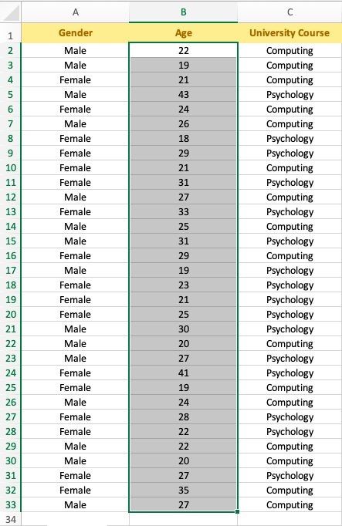

Consent form.
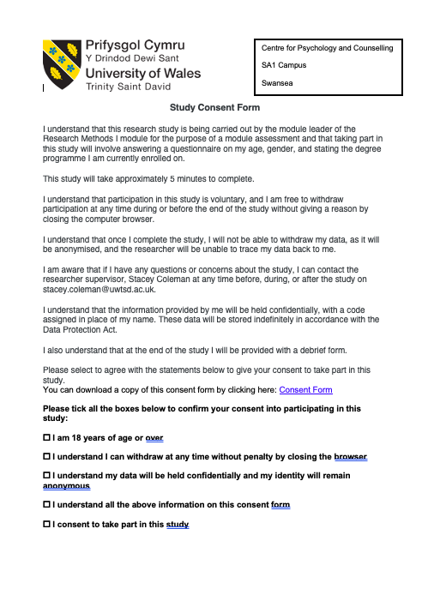

Debrief form.

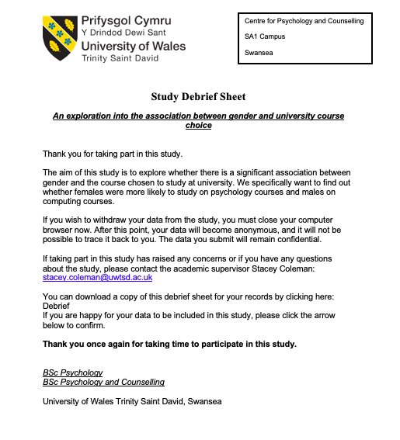

Questionnaire



