Effective TeamWorking for Team Success

Student Name: Adriana-Camelia Grigore
Student ID: 2024754
Module code:
Assignment section:
Lecturer’s name:

Summary
This report aims to analyse and define what a team is all about, significantly what contributes to creating effective teamwork, and how students can develop an efficient and effective team. Also, we will discuss more in detail about the impact effective teamwork can have in a team in order to become successfully, barriers when it comes to teamwork and not last the sorts of parts that are required to form a cohesive and successful group.
A couple of points aligned in order to offer a perspective on the report presented.
• What are the preferences of effective teamwork?
• What can the effect be of ineffectual or poor teamwork?

TABLE OF CONTENT:
Summary/Title page…………………………………………………..…….. 1
Table of Content……………………………………………………………….. 2
Introduction/Overview of Team Working………………………….. 3/4
Case Study ………………………………………………………………..……... 4
Tuckman’s Model……….………………..…………………..…………..……………….. 5/6
Team Roles…………………………………………………………………..........6/7
Action Oriented Roles …………………….………………………………………………….7-8
Thinking Oriented Roles……………………………………….……………………8
People Oriented Roles………………………………………………...…………………9/10
Discussion/Conclusion & Recommendation…………………………… 10
Reference…….………………………………………………………………………11
Bibliography…………………………………………………………………..12-13

‘’Teamworking is drawing on various conventions, which has brought about several distinctive sorts and plans of groups that can meet personal needs.’’
(Muller, 2000)

Introduction
The following report aims to open horizons and understand in a more detailed way how we could bring a group of people and develop into a successful team, including the ways and steps to be followed to developing an excellent team to generate success. This report will also bring countless ways to discuss. We have also called models of team development. First, however, we will talk briefly about the important subject: how and in what terms students can develop in an effective team?
It is a must nowadays to know what is the difference between formal and informal and what and how Tuckman’s model(1965), Wheelan’s Model(1999) and Gersick(1988) can help students in becoming successful and effective team journey.
What is a team? What is the definition of a Team? Human beings tend to come up with different opinions when it comes to defining the difference between a team and a group of people, which is the common interest between them? What makes them different from each other? A crucial aspect is a barrier that stops people in order to become an effective team.
We will analyze all aspects presented in the case study. Furthermore, we will develop in detail the topics related to students from the University of Wales Trinity Saint David, where the background and diversity make a distinct difference in some cases, which can be an advantage and a disadvantage.

‘’Group work is an undeniable route for settling issues for business improvement. It gives the key to higher good target accomplishment and competitive advantage.’’ (Peralta, 2018)

Overview of Team working
Let us have a short overview of what we call 'team'. A team is a number of people who, despite the differences between personalities, have the same goal, to take tasks to a successful end. Each team must designate the roles of each person and set a goal and responsibilities being ready to contribute to that task.
To provide examples of teams, we will think of the space travelers of a space station, a team of analysts, a football team or the team of a boat.
What contribute to effective teamworking?
- Communication
Communication in a team is a crucial aspects when it comes to team success

- Support
When it comes to a task or a challenge a well environment with a supportive staff can become more creative.

- Ideas
Teamwork can become more productive and efficient when everyone comes with ideas and suggestions.

- Willingness of sharing and listen
Effective communication that leads to successful collaboration starts with a companywide willingness to share and listen.

- Solid relationship
Establishing a relationship with other members part of a team, learning about their weaknesses and strength.

- Well organized
Time management is crucial in terms of team success
- Leadership
There is a massive importance in team to have a good leadership. They must be good communicator offering motivation, guidance, encouragement and inspiration.

(Author)

The students from the University of Wales Trinity Saint David, who are working in teams to develop a presentation, might face a challenging path due to diversity, including different experiences, ages, backgrounds, and further. Being an effective team is essential in order to succeed in reaching the target, but to be effective is not that easy. Therefore, a very important question to ask will be: how can an effective team be developed?
In terms of answering this question we need to be aware of the multiple models of team development.
‘’The execution characteristics of a comparable set of groups working with everyday tasks can be accounted for in a formative handle that encounters two progressive constraints or barriers to greatness. The primary may be a frail obstruction through which most teams pass to realize a shared performance standard. On the other hand, the moment may be a solid barrier through which few groups pass.’’
(Rickards, 2002)

According to the case study the most appropriate team development models that can apply is Tuckman’s model.
Because by forming, we can refer to students chosen randomly where they are subjected to collaboration, starting to know the behaviour, skills and personal experiences that might help. Following stage two storming, where the different ideas can lead to conflicts. Easy adding stage three norming where students were chosen to prepare presentations to accept differences and prepare the field. That leads to the last stage, performing, where ideas are putting into practice to become a successful team

Tuckman's model through elaboration is an understanding, a development of skills, creating relationships between people and leader stabilization where the leader shows the changes and coordination of the team.
FORMING
The first part represents forming. Since the team members do not possess the knowledge about other team members, they have the privilege to get to know each other, get along, and build their trust.
Some of them do not have the patience to understand the role when other members already understand the role has been given. As a leader, immediate steps must be taken to restore order and clarify the roles of each.
STORMING
Developing boundaries become challenged, and conflicts happen. To dissatisfaction with the need for an advance is expected. The leader requires guidance.
Team members are more tested at the stage where many team members lose interest in achieving the goal. In contrast, other members can become very stressed trying to reach the task if the leader does not have an excellent relationship to create a balance and encouragement.

NORMING
In this process, team members begin to become calmer, starting to accept differences, thus avoiding conflicts, and showing more respectively, taking into account the rules imposed, the leader. Showing it considered understanding tasks and improving performance

PERFORMING
Once at this stage we can conclude that the team has reached the end of the task, becoming a successful team. The team successfully passing through all the stages of forming an effective team arrive at the point where the understanding between members is a good and lasting

ADJOURNING

This following stage is approximately wrapping up the assignment and the group breaking up. It may be a painful stage for a few group individuals who appreciate the routine, or who have made great fellowships. A leader can offer assistance by working with group individuals to arrange their prospects and what comes another.

STORMING
Conflicts, misunderstanding

PERFORMING
Clear structure of the task

FORMING
Build trust
ADJOURNING
Good feeling
NORMING
Roles and Responsibility

(Author)

TEAM ROLES
‘’The term 'Team Role' alludes to one of nine clusters of behavioural properties, distinguished by Dr Meredith Belbin's investigation at Henley as successful in encouraging group progress. The inquire about shown that the significant successful groups were made up of a different mix of practices. To become a high-performing group, each group needs to get to each of the nine Belbin Group Part practices.’’ (Belbin, 2021)

Belding team roles enable us to understand people preferred behaviour when working with any team. It is essential to realize that we are talking about their behaviour within the team and not their actual personality. There are two parts to consider: What we do and How we do it.
The origins of the module were developed by Meredith Belbin back in the 1970s.
He developed nine roles models. Dr Belbin chose several managers worldwide, and then he studied them to identify their personalities and preferred style. After asking them to complete complex tasks that involve teamwork. From these experiments, three different groups of behaviour were identified

Theory
Belbin accepts that each of us has a design of conduct that characterises one person's behaviour in relationship to another in encouraging the advance of a group. For example, Dr Meredith Belbin characterises a group part as: "An inclination to act, contribute and interrelate with others in a specific way.
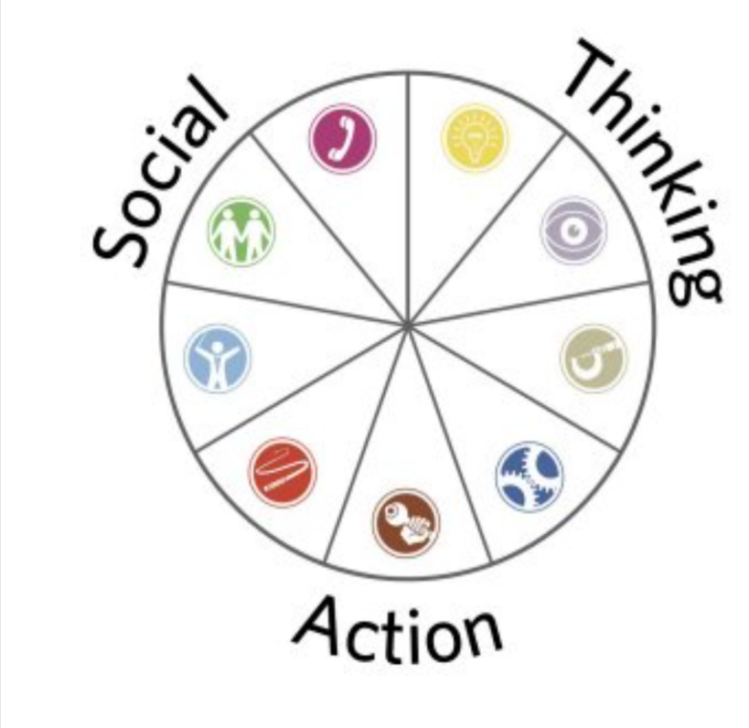

Action Oriented Roles

‘’These action roles are all almost the individuals that get things done. So instead of talking about the procedure and the delicate issues, these are people who need to induce their heads down and wrap up the work.’’
(ExpertProgramManagement, 2017)

Sharper

Strength - Profoundly motivated with a part of apprehensive vitality and an incredible require for achievement
Weaknesses- These people may be to some degree aggressive, annoying and provocative to irritate others.
 Implementer
Strength – In implementer quality is that they like to be organized and not the last, practical. Therefore, they appreciate taking their colleagues’ thoughts and putting them into practice.
Weaknesses- They may be small inflexible, and close-minded at times.
Completer finisher

Strength – In the case shown individuals like to double check every detail to ensure everything is perfect.
Weaknesses- This individuals tent to be considered obsessed

Thinking Oriented Roles

 Plant

Strength – Extraordinary for producing modern propositions and solving complex problems. Innovators and creators – can be exceedingly creative
Weaknesses- They may not play precisely the part assigned to them, and they may come up with new thoughts that are insignificant.

Strength – Being intelligent eyewitnesses, they keep their distinctive thoughts beneath control.
Weaknesses- They may be excessively critical.


Strength – They are known for their information and aptitudes.
Weaknesses- Tend not to be accommodating when their information is not required.

People – Oriented Roles

‘’It ought to continuously be recollected that the tool makes a difference to describe an individuals 'preferred' group parts and is outlined to demonstrate how you would in a perfect world work in a group environment. Quality in one group part is regularly at the expense of what could be seen as a shortcoming in another setting.’’
(UniversityofCambrige, 2016)

Coordinator

Strength – They can be focused on objectives, so they oversee to assign tasks and are idealized as group leaders.
Weaknesses-He can frequently be manipulative, so he can assign his work to other individuals to have less for his part.

Team Worker
Strength – Teamwork makes a difference for the group to work within the best conceivable way, indeed avoiding conflicts.
Weaknesses- Tent to be undecided
Resource Investigator

Strength – The resource examiner is an exploratory and inviting individual.
Weaknesses- They can lose interest in their projects exceptionally quickly.

DISCUSSION
Clarifying the meaning of a team and disseminating different parts and theories is fundamental and considering what kind of effect a team can have in a business.
To start with, having practical cooperation can intentionally bring a valuable part.
To become a successful team, all members must begin to know each other. Working together bring success in the business. They can get and produce more in a shorter time without a conflict
Working together for a long time may bring to getting more experiences
But the option in which a team can become destructive recess to the destruction of the business. Noncommunication leads to an unserious team with people with the necessary skills or team members who can not adapt to changes
On aside, the big problem can be the leader that cannot carry on tasks and delegates lead to confusion where issues will never end. From my own experience working in an individual team, we do not experience any problems because each person knows the process and what to do. The process leads to practical work by reaching the target quickly. In the team, each has its well-established role, but every person is trained to replace in other departments when needed.
CONCLUSION AND RECOMANDATION
In conclusion, to have an effective business, individuals should be arranged, particularly in collaboration. However, as mentioned before, a successful group may be a key to victory, so we ought to work on this viewpoint.
Working full of computing energy and a positive attitude brings only good results being ready for any difficulty or opportunity.

REFERENCE

Belbin, (2021) The Nine Belbin Team Roles [online]
Available at: https://www.belbin.com/about/belbin-team-roles
(Accessed 11TH September 2021)
Belbin, R. M. (2010). Team roles at work (2nd ed.). Routledge. London
Available at :https://librarysearch.uwtsd.ac.uk/discovery/fulldisplay?docid=alma99100107805802421&context=L&vid=44WHELF_UWTSD:44WHELF_UWTSD_VU1&lang=en&search_scope=MyInst_and_CI&adaptor=Local%20Search%20Engine&isFrbr=true&tab=Everything&query=any,contains,belbins%20roles
(Accessed 11TH September 2021)
Anon (2015) Improving team performance: Does Belbin role diversity really matter? [Online] 29 (5), 25–27.
Available at : https://librarysearch.uwtsd.ac.uk/discovery/fulldisplay?docid=cdi_proquest_journals_1696214722&context=PC&vid=44WHELF_UWTSD:44WHELF_UWTSD_VU1&lang=en&search_scope=MyInst_and_CI&adaptor=Primo%20Central&tab=Everything&query=any,contains,belbins%20roles&offset=0
(Accessed 11TH September 2021)
Chapman, A. (2017) Tuckman: Forming, Storming, Norming, Performing model [online]
Available at:https://www.businessballs.com/team-management/tuckman-forming-storming-norming-performing-model/
(Accessed 11TH September 2021)
ExpertProgramManagement, (2017) Belbin Team Roles [online]
Available at: https://expertprogrammanagement.com/2017/06/belbin-team-roles/
(Accessed 07TH September 2021)

BIBLIOGRAPHY

Belbin, (2021) The Nine Belbin Team Roles [online]
Available at: https://www.belbin.com/about/belbin-team-roles
(Accessed 11TH September 2021)
Belbin, R. M. (2010). Team roles at work (2nd ed.). Routledge. London
Available at :https://librarysearch.uwtsd.ac.uk/discovery/fulldisplay?docid=alma99100107805802421&context=L&vid=44WHELF_UWTSD:44WHELF_UWTSD_VU1&lang=en&search_scope=MyInst_and_CI&adaptor=Local%20Search%20Engine&isFrbr=true&tab=Everything&query=any,contains,belbins%20roles
(Accessed 11TH September 2021)
Anon (2015) Improving team performance: Does Belbin role diversity really matter? [Online] 29 (5), 25–27.
Available at : https://librarysearch.uwtsd.ac.uk/discovery/fulldisplay?docid=cdi_proquest_journals_1696214722&context=PC&vid=44WHELF_UWTSD:44WHELF_UWTSD_VU1&lang=en&search_scope=MyInst_and_CI&adaptor=Primo%20Central&tab=Everything&query=any,contains,belbins%20roles&offset=0
(Accessed 11TH September 2021)
Chapman, A. (2017) Tuckman: Forming, Storming, Norming, Performing model [online]
Available at:https://www.businessballs.com/team-management/tuckman-forming-storming-norming-performing-model/
(Accessed 11TH September 2021)
ExpertProgramManagement, (2017) Belbin Team Roles [online]
Available at: https://expertprogrammanagement.com/2017/06/belbin-team-roles/
(Accessed 07TH September 2021)
Nibusinessinfo, (n.d) How to build and manage an effective team [online]
Available at: https://www.nibusinessinfo.co.uk/content/advantages-effective-teamwork
(Accessed 07TH September 2021)
Kimberley, (2017) Benefits of effective team working [online]
Available at: https://www.earlyyearscareers.com/eyc/effective-ways-to-manage-a-team/benefits-of-effective-team-working/#:~:text=%20Benefits%20of%20effective%20team%20working%20%201,to%20work%20together%20%E2%80%93%20Sometimes%20to...%20More%20
(Accessed 07TH September 2021)
Hensley, L. et al. (2017) Bruce W. Tuckman (1938-2016). The Journal of experimental education. [Online] 85 (1), 1–2.
Available at: https://librarysearch.uwtsd.ac.uk/discovery/fulldisplay?docid=cdi_crossref_primary_10_1080_00220973_2017_1236514&context=PC&vid=44WHELF_UWTSD:44WHELF_UWTSD_VU1&lang=en&search_scope=MyInst_and_CI&adaptor=Primo%20Central&tab=Everything&query=any,contains,TUCKMANS&offset=0
(Accessed 07TH September 2021)
Paul, D. et al. (2012) The human touch personal skills for professional success. 1st edition. London: BCS The Chartered Institute for IT.
Available at: https://librarysearch.uwtsd.ac.uk/discovery/fulldisplay?docid=alma99100185159802421&context=L&vid=44WHELF_UWTSD:44WHELF_UWTSD_VU1&lang=en&search_scope=MyInst_and_CI&adaptor=Local%20Search%20Engine&tab=Everything&query=any,contains,TEAM%20WORKING%20AND%20SUCCESS&offset=0
(Accessed 07TH September 2021)

Anon (2008) Working as a Team.
Available at: https://librarysearch.uwtsd.ac.uk/discovery/fulldisplay?docid=alma99100401263802421&context=L&vid=44WHELF_UWTSD:44WHELF_UWTSD_VU1&lang=en&search_scope=MyInst_and_CI&adaptor=Local%20Search%20Engine&tab=Everything&query=any,contains,TEAM%20WORKING%20AND%20SUCCESS&offset=0
(Accessed 07TH September 2021)

