Driving Change and Building Business Cases (BMHR7014)


A critical evaluation of managerial perspectives and knowledge of performance appraisals within Neath Port Talbot Council
Laura Parry CIPD Associate 2240424

1st May 2025

Word Count: 2916

Executive summary

This report critically examines the implementation and perception of performance appraisals within Neath Port Talbot Council (NPTC). Despite having a formal performance appraisal policy accessible via the internal portal, evidence from employee surveys, exit interviews, and management feedback reveals inconsistencies throughout the organisation. Only 49% of employees reported receiving regular appraisals and just 44% confirmed their managers conducted them consistently highlighting a gap between policy and practice.

The research aims to evaluate managerial understanding and undertaking of performance appraisals, identify barriers to effective implementation, and provide recommendations for improvement. By undertaking a literature review, the report looks to better understand the role of line managers in performance management, the barriers to effective use of appraisals and their benefits and limitations.

A mixed-methods approach was adopted, using a 12-question survey distributed to 364-line managers. From the 86 responses, key findings were identified:
- Policy Awareness: 22% of managers did not know where to access the appraisal policy.
- Training: Only 20 respondents had attended performance management training with only 34% feeling adequately trained. Over half expressed interest in further training.
- Process: Many managers viewed the appraisal process as time-consuming and not user-friendly.
- Confidence: While 65 managers reported confidence in conducting appraisals, this was not reflected in the comment on training and policy adherence.
- Understanding of the benefits: Managers perceived appraisals as beneficial but noted that employees often viewed them negatively.

These insights emphasise the need for clearer guidance, enhanced training, and further research to undertake a strategic review of appraisal practices to better align with organisational goals.

Table of contents
- Introduction  - Introduction of Neath Port Talbot Council (NPTC)  - The business case  - Literature  - What are performance reviews?  - What is the importance of line managers involvement in performance reviews?  - What are the advantages and disadvantages of performance reviews?  - Methodology  - Aim and objectives  - Aim  - Objectives  - Research philosophy and approach  - Research methodology and strategy  - Procedures and techniques  - Limitations and ethical considerations  - Research findings  - Conclusion  - Appendices  - Appendix 1 – NPTC’s Performance appraisal policy  - Appendix 2 – Pilot email request and colleague responses  - Appendix 3 – NPTC Employee performance appraisals survey final draft  - Appendix 4 – Email invitation to complete survey  - Appendix 5 – Email reminder to complete survey  - Appendix 6 – Data collected including analysis, tables, graphs and charts  - References | Page  4  4  4  5  5  6  6  7  7  7  7  7  8  9  9  10  17  19  19  44  46  50  52  54  65

- Introduction

1.1. Introduction of Neath Port Talbot Council (NPTC)

NPTC is a local authority based in South Wales serving a population of just over 140,000 residents (NPTC, 2024). NPTC has 5 directorates covering 16 service areas, including schools, with approximately 6,600 employees (NPTC, 2024).

1.2. The business case

NPTC currently has a performance appraisal policy available through their internal portal (appendix 1). It has transpired from exit interviews, staff surveys and management surveys that not all managers are following the policy, and not all staff members are receiving performance appraisals.

NPTC’s 2024-2025 Employee Survey (NPTC, n.d.) highlighted that only 49% of employees agreed they have regular appraisals (Figure 1), which was further supported by data collected from exit interviews, which found only 44% agreed that managers completed regular job appraisals with them (NPTC, n.d.) (Figure 2).

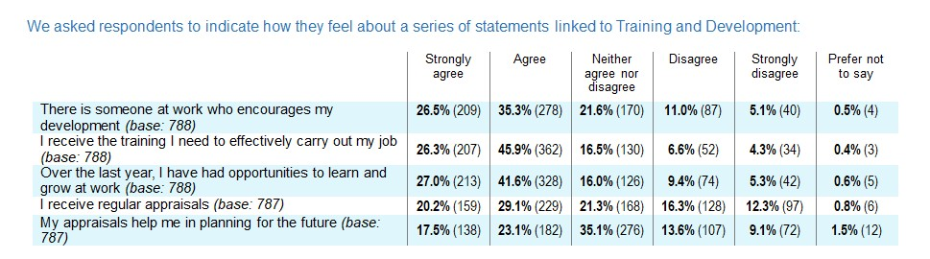
Figure 1. NPT Council Employee Survey 2024-2025 - Report of findings data extract (NPTC, n.d.).
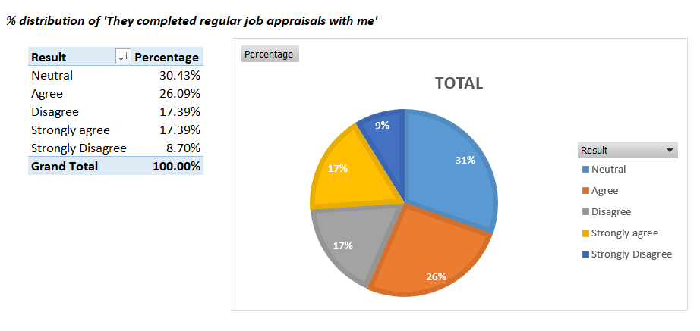

Figure 2. Exit interview 2024/2025 data extract (NPTC, n.d.).

A further 140 employees completed a survey asking what they felt was important in a manager with 121 answering that a manager should co-ordinate regular one to ones/supervision sessions where they can discuss workloads and development needs (Figure 3), which shows employees want managers to conduct appraisals.

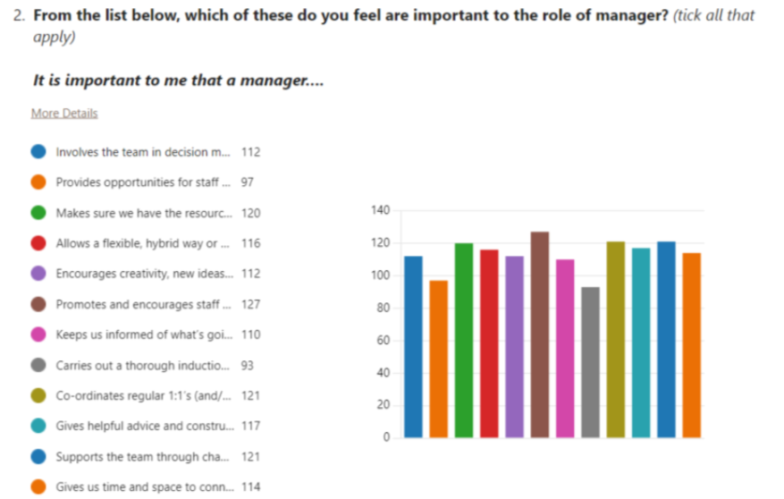

Figure 3. NPTC Leading and managing team staff survey report 2024 data extract (NPTC, n.d.).

The evidence suggests a clear inconsistency between policy and practice alongside the need and demand for performance appraisals. Addressing this issue aligns with NPTC’s broader objectives of improving organisational effectiveness, enhancing employee satisfaction, and fostering a culture of continuous development.

- Literature

2.1. What are performance reviews?

Performance reviews are the ‘formal evaluation of an employee’s job performance to determine the degree to which the employee is performing effectively’ (Ebert and Griffin, 2022, p216). Performance reviews are seen as an opportunity for an employer and employee to discuss work performance (Unison, 2013). The function of performance reviews is a large part of performance management, allowing an employer to make workplace decisions including talent management, training and development along with administrative decisions such as pay, reward and redundancies (CIPD, 2025b). Taylor and Woodhams (2022a) state that although given different names such as job appraisals, performance evaluations and personal development reviews, they have the same common features such as regularity (bi-annually or annually), outcomes are documented, and targets set for employees to achieve by the next review.

2.2. What is the importance of line managers involvement in performance reviews?

Appraisals are mainly undertaken by line managers with the policy set by human resource managers (Woodhams and Taylor, 2022b, p. 154). Line managers play a crucial role in fostering relationships with employees and influence their performance and conduct by the way they implement policies (Hutchinson, 2013; Purcell and Hutchinson, 2007). Hutchinson (2013) highlights that line managers are critical to the outcomes of performance reviews and employee perceptions of performance reviews. Howe (2023) states that well-executed appraisals contribute directly to the development of high-performing teams and the achievement of organisational objectives.

It is reported that line managers may not have the skills, experience or training to manage performance appraisals efficiently in a culture where the benefits of appraisals are not understood and therefore managers just ‘go through the motions (Chubb, Reilly and Brown, 2011). Gratton and Ghoshal (2002) state that it is essential that line managers lead by example and promote honest discussion with feedback to encourage development and improvement. Line managers need to ensure that the ‘golden thread’ runs through performance appraisals linking them back to the organisational strategy and objectives so that employees are aware of how they fit into the strategy (Improvement and Development Agency, 2004).

2.3. What are the advantages and disadvantages of performance reviews?

Performance appraisals are believed to be a tool to drive performance and productivity through social comparison theory (Festinger, 1954, pp. 117-140), equity theory (Adams, 1965; Walster et al., 1978) and feedback intervention theory (Kluger and DeNisi, 1996). Bloom, Sadun and Reenen (2012) found that organisations that had formal performance management practices, such as performance reviews, were 23% more productive with Barends et al. (2016) stating that the consensus was that performance appraisals have a positive impact on a range of organisational outcomes. Taylor and Woodhams (2022b, pp. 154-155) highlight that advantages include raising morale, reinforcing hierarchy and clarification of roles, expectations and alignment with organisational goals.

Redman and Wilkinson (2009) found no correlation between performance appraisals and financial success in organisations with Murphy (2019) arguing that complex performance reviews are not required to identify talent as ‘stars’ are easy to spot. Murphy (2019) further suggests that the measures adopted in performance reviews are rarely trustworthy or dependable and are subjective. The CIPD (2025b) agrees that some roles are better suited to performance measures than others and that not all performance measures are based on outcome with employees’ behaviours and values being harder to measure. The CIPD (2025b) also note a high risk of bias from line managers’ personalities and employees’ behaviours.

Further studies found that performance reviews varied between having positive or negative impact on employees depending on the employee’s autonomy orientation (Kuvaas, 2007) with Adler et al., (2016) and Murphy (2019) finding that performance reviews had a negative effect on performance.

The primary research was necessary to identify the views and understanding managers at NPTC have of performance appraisals. To ensure consistency and application of the performance appraisal policy, more information is needed on whether and how managers are currently conducting appraisals and what barriers they may have to conducting them efficiently.

- Methodology

3.1. Aim and objectives

3.1.1 Aim

The aim of this report was to undertake a critical evaluation of managerial perspectives and knowledge of performance appraisals within NPTC.

3.1.2 Objectives
- Explore the literature relating to performance appraisals
- Conduct primary research through the use of questionnaires to establish managers understanding, use and perspectives on performance appraisals
- Analyse the findings from primary and secondary data in relation to advantages and best practice in performance appraisals
- To make recommendations to ensure performance appraisals are consistent across the authority
3.2. Research philosophy and approach
Research philosophy is described by Saunders, Lewis and Thornhill (2023) as the development of knowledge created through the researcher’s beliefs and assumptions. The research onion model, as shown in figure 4, was used as a guide for the methodology. By working through the outer layers of the philosophy and assumptions through to the core of the analysis techniques and data collection, which ensures cohesion with the aim and give credibility to the research by explaining the rationale behind each decision (Saunders, Lewis and Thornhill, 2009).
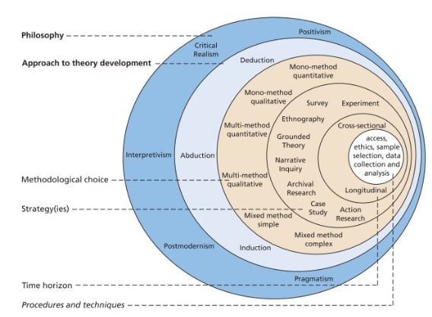
Figure 4. Research Onion (Saunders, Lewis and Thornhill, 2023).

Research philosophy consists of ontology (assumptions of the reality), epistemology (assumptions of knowledge) and axiology (impact of ethics and values). The aim of the research in its nature was to understand managers perspectives of performance appraisals, and as such an interpretivism approach was applied to consider the varied views and experiences of line managers (Crotty, 1998; Ryan, 2018). A pragmatic approach was also used to incorporate a broader data collection, consider the problem raised by the data and consider suitable recommendations (Creswell and Creswell, 2023). Working on an inductive approach whereby the data collected would help form a theory of line managers application and understanding of performance appraisals (Saunders, Lewis and Thornhill, 2023).
3.3. Research methodology and strategy
A mixed method approach to primary data collection was used to consider quantitative and qualitative giving a broader and wider understanding of perspectives incorporating the ‘what’ and the ‘why’ (Bell, Bryman and Harley, 2022; Saunders, Lewis and Thornhill, 2023; Taylor and Woohams, 2022b). To collect both types of data in parallel, a survey was used via Microsoft Forms incorporating closed questions and open-ended questions. A survey was seen as beneficial as it is cost effective, can be sent with ease via email to many line managers and promotes anonymity for responses, which was essential in collecting unbiased data (Taylor and Woohams, 2022b). It was also structed and detached from the researcher enhancing ease of completion, not time consuming for participants and is removed from the researcher encouraging honestly in the answers (Anderson and Fontinha, 2024).

Analysing the data from surveys is time consuming and it is important that participants were representative, the questions used were well designed and piloted to increase the likelihood of success (Teijlingen and Hundley, 2002; Saunders, Lewis and Thornhill, 2023). The option of interviews or focus groups was disregarded due to time constraints and logistical issues for participants along with the concern of face-to-face communication impacting bias and honesty. The time horizon for the survey was cross-sectional and collected over a period of 14 days.
3.4. Procedures and techniques
The time horizon for this survey will be cross-sectional and will be collected over a period of 14 days.

The survey was designed using Microsoft Forms, as NPTC’s preferred survey mechanism. The survey incorporated a confidentiality statement with options to agree or disagree to complete the survey and an open text box to allow for a reason if they disagree. This was followed by 12 questions with a mixture of response styles. The survey was sent as a pilot to 3 colleagues in the people management team in order form them to provide feedback (Appendix 2). Feedback was positive, however, one colleague suggested including a question about managers confidence in providing negative feedback in performance appraisals and as such this a question incorporating this was added to the final survey draft (Appendix 3).

The survey was sent via email with the body of the email explaining the reasons for the survey, advising that results would be shared and inviting the recipient to complete the survey within 2 weeks (appendix 4). Participants were selected from our internal system who were identified as line managers and as such would have line management responsibilities over employees. A list of 364 line manager internal email addresses was obtained from across NPTC and the Bcc function on Microsoft outlook was used to ensure confidentially.

A reminder email was sent after 7 days to encourage further participants to complete the survey (appendix 5). Responses are collected automatically via Microsoft Forms with the raw data then being transferred to Microsoft Excel for analysing (Appendix 6).
3.5. Limitations and ethical considerations
The researcher was a member of the people management team in NPTC and therefore there was a risk of response bias, which is very difficult to mitigate or identify (McGrath, Mitchell, Kim and Hough, 2010). Participants were assured in the email invite and the consent at the top of the survey that responses were confidential and that no identifiable information was asked or collected in order to mitigate any bias. For added assurance, only the researcher was able to access the raw data collected from the responses and the only information seen by others would be collated data with no identifiable indicators.
To ensure participants were providing informed consent to the research, a statement explain the reasons for the research was provided in the email invitation and at the top of the questionnaire stating that by completing the questionnaire they are providing consent. To ensure participants were actively providing consent the first question of the survey requested that they agree or disagree to participate followed by question 2 asking for the to explain their reasons if they did not agree (UK Research and Innovation, 2024).

- Research findings

Eighty-six responses were collected and analysed using pivot tables in Microsoft Excel, which generated it diagrammatic graphs, tables, and charts (Appendix 7). The data revealed inconsistencies in how line managers apply NPTC’s performance appraisal policy. Although annual appraisals are expected, 14% of respondents reported not conducting them (Figure 5), and only 66 confirmed they do so annually (Figure 6). A statistical test found no trends by directorate.

The CIPD (2025a) emphasise that HR practice implementation depends heavily on line managers, who are best placed to apply policies. NPTC promotes managerial autonomy, yet Hewett et al. (2023) found that autonomy can reduce policy adherence unless managers feel accountable and competent. Purcell and Hutchinson (2007) similarly note a gap between formal expectations and actual practice, often influenced by leadership style and motivation.

Figure 5.

Figure 6.

Further data showed that 22% of respondents did not know where to access the appraisal policy (Figure 7). Comments included “not easy to find on the intranet” and “not aware of where the policy documents can be found.” This lack of awareness may contribute to inconsistent application. Clear communication and support from the people management team are essential (CIPD, 2025c; Whitehouse, 2019), and updates must be well communicated (CIPD, 2025a).

Figure 7.

Trullen, Stirpe, Bonache and Valverde (2016) argue that policies are only effective when supported by training. Although NPTC offers performance management training, only 20 respondents had attended (Figure 8). Just 34% felt they had received adequate training (Figure 9), while 51% expressed interest in further training (Figure 10).
The UK has a poor culture of promoting ‘accidental managers’—those excelling in prior roles but lacking management competencies with the Chartered Management Institute (2023) calling for a change in management culture to one where ‘accidental managers’ are replaced with well-trained, skilled and confident managers. Unison (2019) state that line managers lack training and time to fulfil their people management tasks and therefore they endeavour to promote a culture where employers ensure managers have the necessary training (Trades Union Congress, 2019; CIPD, 2023).

Figure 8.

Figure 9.

Figure 10.

Brown (2024) found that 40% of managers felt undertrained, and 79% would benefit from further development. The CMI’s Better Managers report revealed that 82% of new managers received no formal training, with 52% of experienced managers reporting the same (Mayne, 2023). The CIPD (2023) echoed these concerns, noting that only 53% of line managers felt adequately supported.

One respondent stated they had never received training or knew appraisals were required, adding they needed more support from the people management team. The CIPD (2023) emphasise that support must go beyond training, including robust systems and time allocation to enable managers to fulfil their roles effectively

Time constraints were a recurring theme. Thirty-two respondents viewed appraisals as too time-consuming (Figure 11), and 18 cited time allocation and the process not being user-friendly when asked about drawbacks (Figure 12). Cespedes (2022) reports widespread dissatisfaction with the appraisal process among managers and employees.

Figure 11.

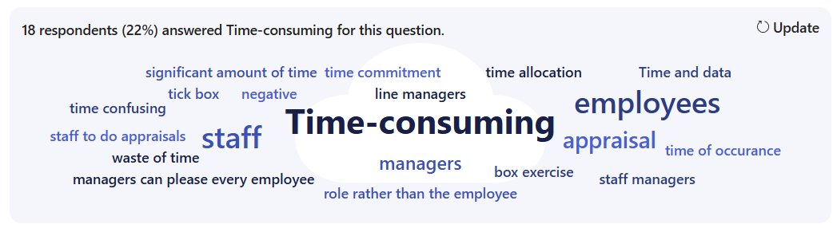
Figure 12. Word chart showing responded to question 13, What do you perceive are the draw backs to conducting performance appraisals?

Respondents also criticised the process and documentation as lengthy, unstructured, and inconsistent across the authority. Only 29% found the policy user-friendly (Figure 13). Barends, Rousseau, Wietrak, Gifford and Young (2022) argue that effective performance reviews require multiple measures and raters. The CIPD (2025b) recommend benchmarking against comparable organisations to improve practice.

Figure 13.

Despite these findings, 65 respondents expressed confidence in conducting appraisals, with an average self-rating of 7.84 out of 10 (Figure 14). Research indicates that many managers experience discomfort when tasked with monitoring, evaluating, and delivering feedback (Murphy and Cleveland, 1995) with those managers being more lenient towards employees to avoid providing negative feedback and ‘difficult conversations’ (Barnett, 2024).

Figure 14.

The survey also revealed a perception issue. Many managers described appraisals as a ‘box-ticking exercise’. While most saw them as beneficial (Figures 15 and 16), they felt employees did not share this view (Figure 17), with appraisals described as ‘negative’, ‘pointless’, or ‘a waste of time’.

Figure 15.

Figure 16.

Figure 17.

- Conclusion

From the research completed, areas of improvement and requirements for change have been identified in relation to the performance appraisals process in NPTC. It is clear from the data collected that managers feel they have not received adequate training, if any, in conducting performance appraisals and that the current training that is in place is not being completed and/or is not sufficient to ensure managers have the correct skills and confidence. It is essential for managers to have the correct skills and knowledge to carry out the people management duties required of them assisting NPTC to meet its organisational objectives (Bosley and Gifford, 2023; CIPD, 2025c). The Chartered Management Institute (2023) reported that 83% of managers who had received training felt more confidence in their people management skills, had more trust in their team and where better equipped to identify and manage poor performance.

The research further identified that managers have not seen, are not familiar with or do not know where to access the performance appraisal policy. This was surprising as all policies are available on the employee intranet and can be found using the search function. Concerningly, this could be interpreted that managers are not aware that polices are available via the intranet, which could be a broader issue in relation to policy adherence across the organisation. CIPD (2025a) state that for policies to be actioned it is essential that people management teams communicate the policies and their expectations clearly and take into consideration the organisational culture when deciding the best way to manage communications.

A repeated theme throughout the research was that the performance appraisal process was not fit for purpose and needed to be re-considered. It was reported that managers and employees feel it is too time consuming, was not user friendly and seen as a ‘box ticking exercise’ rather than being a beneficial and worthwhile exercise. Further research may be required to gain further insight into managers and employees views and identify best practice across similar organisations.

- Appendices

Appendix 1

NPTC’s Performance appraisal policy



Performance Appraisals Afarniadau Perfformiad

Afarniadau Perfformiad
Performance Appraisals
Os hoffech dderbyn gohebiaeth mewn perthynas â’ch cyflogaeth yn Gymraeg, cysylltwch â’ch Swyddog AD dynodedig.

Version | Date | Action
1 | January 2016 | New Document
2 | September 2018 | Review and Amendment
3 | September 2019 | Review and Amendment
4 | September 2021 | Review

1. INTRODUCTION

This guide is for all Neath Port Talbot Council employees and provides the information and tools you need to make the most of the performance appraisal discussion. Each section focuses on a different stage of the performance appraisal.

2. WHAT IS A PERFORMANCE APPRAISAL?

Performance appraisal is a two-way discussion; when carried out well, it actively involves employees, helping them to understand what is expected of them. By setting agreed objectives and regularly reviewing progress, employees become responsible for their own performance.

The appraisal forms have been developed following feedback from managers and employees. The forms;

- Focus on the discussions between managers and employees during the appraisal meeting, rather than just the completion of the form
- Focus mainly on the previous year’s achievements and
- Enable the recording of future objectives and goals outcomes and development needs, including any personal career plans.

There are two appraisal forms: ‘Performance Appraisal Review Form’ (Appendix B) and ‘Appraisal Form with Limited Objectives’ (Appendix C).

If the nature of the employee’s job role does not suit the more detailed form, ‘Performance Appraisal Review Form’, the manager can choose to complete the shorter form with ‘limited objectives’. For example, the employee might work for a few hours a day or might carry out a more generic role, in which case, it might be more appropriate to set fewer objectives. Further guidance on using this form is provided in section 4.

3. WHO SHOULD HAVE A PERFORMANCE APPRAISAL?

Every Neath Port Talbot employee with a permanent or temporary contract should receive a performance appraisal.

With the increase in partnership working and other forms of work, some team members may not be Council employees (e.g. agency or staff on secondment from another organisation). Performance should still be reviewed regularly for these individuals and feedback given to the individual (and their employing agency if appropriate).

4. ROLES WITH LIMITED OBJECTIVES

Where managers/supervisors wish to use the shorter form at Appendix C, the following process should be followed.

The manager/supervisor should give adequate notice of the appraisal meeting to the employee and also, provide a copy of the job description and person specification in order to prepare for the appraisal discussion.

At the appraisal meeting, the manager/supervisor and employee discuss the contents of the appraisal form together and complete it, as appropriate.

The meeting involves assessing the employee’s performance over the past year. It also provides the opportunity for the manager and employee to identify any training/ development and any personal or work-related issues. If the employee wishes, he/she can also discuss any longer-term career development plans.

The factors shown on the form at Appendix C can be changed by the manager/ supervisor, if it is felt that more relevant factors should be assessed.

5. ROLE OF THE EMPLOYEE DURING THE PERFORMANCE
APPRAISAL PROCESS

To get the best out of an appraisal meeting, both the manager and employee need to prepare. Remember an appraisal meeting is:

- A two-way discussion
- An ongoing process, not an annual event. Managers and employees both have responsibilities for ensuring that appraisals are successful. Providing feedback is critical to improving performance.

Successful appraisals are the outcome of ongoing, regular two-way discussions between the manager and employee during the year.
As the employee you are expected to:

- Take ownership of your development and performance by:
  - Working towards meeting agreed objectives and standards
  - Actively monitoring your own progress against targets and keeping your manager informed of difficulties you may be facing
  - Listening to constructive feedback and acting on it
  - Participating fully in development activities and assessing the impact they have had on your performance

- Prepare for and participate fully in performance appraisal discussions by:
- Gathering evidence about your performance
- Generating ideas for service improvement
- Completing the section on the appraisal form (‘End of Year Review’ at section 2), in advance of the appraisal meeting and providing a copy to your manager
- Reviewing your own training and development needs and if you choose, any longer term career plans.

Employee preparation

In order to prepare for your performance appraisal, you should:-

- Gather evidence about your performance by seeking feedback from colleagues and customers and reviewing your own supervision/one-to-one notes
- Complete the ‘End of Year Review’ prior to the appraisal meeting and also, consider your training and development needs for the year ahead. You might also wish to include any personal career plans during the appraisal discussion

Completing the ‘End of Year Review’ (Section 2 – Looking Back)

You should complete this section before your appraisal meeting as this will help both you and your manager to start thinking about your achievements, key learning points and identify any training and development needs.

Try to clearly identify what your strengths are, what you have improved on and what you need to develop. During your performance appraisal meeting, your manager will refer to the ‘End of Year Review’ section and give you feedback on your performance throughout the year.

Sources of evidence

There are several sources of evidence you can use to help you make an objective assessment of performance. Some options are:

- Work samples – such as reports, project plans
- Observations – noted during the years
- Colleagues
- Customers – collected from a range of sources

Training and Development Opportunities

This section enables you to discuss any future training and development opportunities for the year ahead and also, any personal career plans.
You will need to consider what you wish to discuss with your manager prior to the appraisal meeting. Preparation will give you time to consider what opportunities could support you in achieving your work objectives and what you think could help improve your performance during the year ahead. You might also wish to discuss your longer-term development and any career plans you may have.

Planning your development

You need to consider what training and development activities you think will support you in your role over the forthcoming year, what you think might help you improve your current performance and use this as the basis for discussions with your manager about your development plan.
In addition, you might choose to discuss your longer-term development such as your career plans, what you might wish to achieve and how you think your manager can support you. It is important that you are aware of your development needs and consider how they can be met.

The development plan identifies opportunities that support your training and development needs over the year ahead and includes:

- The agreed training and development activity that you and your manager have identified during your discussion
- What support you require from your manager to plan for the activity
- The desired outcome from the development activity i.e. how performance could be improved

You might also wish to discuss your personal career plans and include these in the development plan.

6. ROLE OF THE MANAGER DURING THE PERFORMANCE APPRAISAL PROCESS

To get the best out of an appraisal meeting, both the manager and employee need to prepare. Remember an appraisal meeting is:
  - A two-way discussion
  - An ongoing process, not an annual event. Managers and employees both have responsibilities for ensuring that appraisals are successful. Providing feedback is critical to improving performance.

Successful appraisals are the outcome of ongoing, regular two-way discussions between the manager and employee during the year.

As the manager, you are expected to:
1. Lead individual performance appraisal discussions with employees who you directly manage.
The discussions must include:
- Review of past performance
- An agreed work plan with smart objectives which will contribute to the delivery of your service area’s business plan and the overall council plan
- An opportunity for the employee to respond to feedback and raise points
- A written record of the discussion (using the appropriate appraisal form) which is signed by the manager, the employee and the Head of Service /reviewing manager.

2. Regularly review performance and progress by:
- Revising and updating objectives, if necessary
- Using formal supervision/one-to-one meetings to discuss development activity planned or undertaken

3. Give positive and/or constructive feedback:
- In team meetings
- During supervision/one-to-one meetings
- Informally, as part of day-to-day working

4. Tackle under-performance constructively and promptly:
  - By giving feedback, setting targets for improvement and providing support and development

5. Support agreed training and development activities ( and any personal career plans, if relevant) by:
- Allocating time for the activities to be undertaken
- Evaluating the impact on performance of individual development activities, bearing in mind that the effect may not be immediate

6. Ensure that the process is applied consistently and fairly by :
  - Ensuring that issues of equalities and diversity are considered throughout the work objective setting and development planning process
  - Sensitivity and judgment when using the appraisal process to meet individual and service needs

7. Confirm appraisals have been completed by:
  - Ensuring that the date of the performance appraisal has been recorded on the appraisal form
  - Providing a copy of the completed appraisal form to the Head of Service /reviewing manager

Manager preparation

As a manager, you are expected to:-

  - Gather evidence to ensure a fair assessment
  - Consider what objectives, competencies and development should be set
  - Review the information provided to you by the employee in the ‘End of Year Review’ section.
  - Set a date for the appraisal meeting

And if employees are under-performing?

The most effective way to tackle underperformance is to approach the individual as soon as the situation arises. Constructive feedback should be used to highlight the area of concern, and include suggestions on how the situation can be better handled next time.

A record of the discussion should be kept, along with the agreed actions to be taken to improve. You should monitor improvement, and discuss with the employee, as necessary. Discussions about under-performance should not be left until the annual appraisal meeting. The appraisal discussion should contain no surprises or feel uncomfortable for you or your team member.

Where performance or conduct continues to be an issue, it may be necessary to take formal action. Consult the Managing Performance policy/procedure for further guidance.

Planning Development Opportunities

The discussion should be focussed on supporting the employee to achieve his/her personal work objectives. Such opportunities could include providing training to meet statutory requirements or regulatory requirements, specific to the job role.
It could also include identifying opportunities that would help the employee to develop any competencies needed for the job role.
The employee might also choose to discuss their longer-term development and /or personal career plan.
Examples of training and development opportunities could include:
- Attending a short course
- Shadowing
- Completing an e learning course
- Secondment opportunities
- Attending a seminar or conference
- Acting as a mentor

Supporting personal career plans

You might also wish to discuss your personal career plans and include these in the development plan.
In supporting long-term career goals, consider the following:

- What could be learnt or developed in the employee’s current role that could contribute to their aspirations?
- Could shadowing in another directorate/service help the employee?
- Could voluntary work be useful in contributing to long-term goals?
- How could the development activities benefit the service/organisation in the long-term?

By the end of the discussion, the manager and employee should be able to establish what actions both you and your employee will take in order to work towards those plans. Identifying and achieving any personal career plans remains the responsibility of the employee, but should be supported by managers, where possible.

Evaluation

Following the completion of a development activity, the manager should discuss the impact it has had on the employee’s performance during subsequent supervision/one-to-one meetings. Whether the expected outcome has been achieved also needs to be noted on the appraisal form.

7. ROLE OF THE REVIEWING MANAGER DURING THE
PERFORMANCE APPRAISAL PROCESS

As the reviewing manager, you are responsible for:

- Reviewing the completed performance appraisal forms your managers have completed. With each form, you should ensure that:
  - Suitable objectives have been set
  - Performance has been assessed fairly, using evidence
  - The appraisal outcomes will effectively contribute to improving performance
  - The process is being carried out and used fairly and consistently; and that equality and diversity issues are considered when setting work objectives and in planning development activity.

- Feeding identified training and development needs into the planning for your service.

8. SETTING SMART OBJECTIVES

The objectives set should reflect the Council’s corporate objectives and the Service’s business plan. The objectives set should be agreed using the SMART criteria.

SMART stands for Specific, Measurable, Achievable, Realistic and Resourced and Time-bound.

Specific

You will know if it is specific enough if:

  - Everyone who is involved knows that it includes them specifically
  - Everyone involved understands their role
  - The objective is jargon free
  - You have a clear terms of reference

Measurable

How will you know you have achieved your objective? How will you measure success? Remember, in appraisals you need to make an end of year assessment on whether each work objective has been met. To do this successfully, ongoing observation and documentation is required.

Achievable

There is no point starting a job you know you can’t finish. Decide if it is achievable by knowing if:

- It is measurable
- Others have done it successfully before you or elsewhere
- It is theoretically possible
- It fits in with your existing role and commitments

Resourced

Is about ensuring the necessary resources (people /time /money /opportunity) are available to complete the objective. Think about:

- Has this objective been sponsored by the appropriate authority?
- Have you and others responsible committed to achieving this objective?
- Do you and all involved have the required skills to achieve the objective?
- Are all the other resources money, time & opportunity in place?

Time-bound

Is all about setting deadlines, without it you would find it difficult to measure progress against your objectives. If the objective cannot be time-bound, think about:

- Can the objective be broken down further, or
- A success criteria be set for the end of year appraisal relevant to the continuing activity

9. WHAT SHOULD BE DISCUSSED AT THE MEETING?

Setting Objectives

Effective objective setting is crucial to the performance appraisal process. This part of the discussion clarifies to employees exactly what is expected from them in the year ahead. It also provides the opportunity to agree what support managers need to provide in order to help the employee achieve their objectives.

How many objectives?

For senior officers (e.g. Principal Officers and Heads of Service) the appropriate number of objectives is open ended.

For others, up to five objectives can be set for employees.

Fewer objectives may be set and the ‘Appraisal Form for Limited Objectives’ used.

Using this form might be appropriate when employees are:
- Employed on a casual contract or work part- time hours
- Part of a team where there are several others fulfilling the same role
- Not office-based

It may be appropriate to set the objectives for these employees in advance of the appraisal meeting, especially if there are a number of employees fulfilling the same role.

Objectives should:
  - Be in line with Neath Port Talbot’s corporate objectives
  - Contribute to the delivery of the service area’s business plan
  - Be SMART (Specific, Measurable, Achievable, Realistic and Resourced, Time-bound)
  - Be tailored so that they consider an individual’s abilities, experience and aspirations
  - Be stretching/challenging so that the individual has an opportunity to develop new skills and experiences (this refers to the quality of the work not quantity)
  - Be supported by the individual’s development plan
  - Be reviewed regularly in supervision meetings throughout the appraisal year
  - Be amended if circumstances arise that affect the business objectives, e.g. new policies/priorities, changing customer needs

10. TRAINING AND DEVELOPMENT OPPORTUNITIES

Neath Port Talbot Council takes the view that investing in the training and development of all its employees is a priority, and should be planned, implemented and evaluated to ensure it is effective. Training and development planning is a key component of performance appraisal, as it provides the opportunity to discuss the support an individual needs to meet their objectives.

11. ASSESSING PERFORMANCE

Consider some of these questions when assessing performance:

  - Has the employee met the work objective?
- How have you measured this and is the employee aware of how achievement is measured?
- Have you monitored success and reviewed them in one-to-ones?
- What was the impact of not meeting the objective (for internal and external customers)?
- How can the employee help themselves to do better?
- How can you support the employee in improving performance?
- What can the organisation do to support the employee? Can this be linked to their or your development objectives?

Underperformance can be caused by many factors. When addressing underperformance, consider the following:
- Did you give/offer the employee adequate training/development opportunities?
- Does the employee have the skill and competencies necessary for the job? If not, how can these be developed?
- Does the employee understand what is expected of them?
- Have you provided the employee with adequate tools and resources?
- Are there any processes or systems in place that make it difficult for the employee to achieve their objectives?
- Has anything changed in the employee’s work situation or environment?
- Has anything happened in the employee’s personal life that could be affecting his or her work?

Once you have gathered the evidence, you need to make a fair and objective assessment of the employee’s performance:

12. PROVIDING FEEDBACK

Performance should be managed throughout the year. Regular and meaningful feedback ensures that the manager and employee engage in two-way communication throughout the appraisal year and helps the individual understand how well they are performing in their role. It is also, a means of identifying any individual training and development needs that could support the employee in achieving their work objectives.

Regular discussions help to identify any performance problems encountered during the year, so support can be put in place to address them.

Regular feedback can be provided in formal supervision meeting (one-to- one) meetings, team meetings and informally as part of daily management.

Supervision (one-to-one) meetings should be held with each employee every 4 – 6 weeks. These meetings can be used to assess the employee’s performance throughout the year against the personal objectives agreed at the start of the appraisal year.

Supervision records can be used to support the performance appraisal process.

Regular supervision meetings help to:
- Assess individual performance standards
- Identify any areas of strengths and/or weaknesses
- Identify any areas of improvement
- Discuss successes and identify areas of concern or issues that may affect performance
- Identify and training and development needs and opportunities that focus on improving performance and achieving the objectives of the role.

As part of daily management, performance is also managed informally. Initial conversations about performance issues will take place but, if the same issue/s continue, these might need to be raised formally during supervision meeti

Appendix A - The Appraisal Cycle

1. Preparing for the annual performance appraisal
Manager and employee prepare by reflecting on the previous year’s performance and thinking ahead to the coming year’s objectives and development needs

Budget & Business Planning

2. The annual performance appraisal -
A conversation where the manager and employee:

• Review the previous year’s performance
• Review whether objectives have been met
• Agree on the work objectives and competencies to be developed
• Agree any support required and complete the appraisal form

3. Regular one-to-one / supervision meetings
To monitor progress and deal with day-to-day issues as they arise, and to recognise progress and achievements

Performance Appraisal Review Form  Human Resources |   Appendix B

TO BE COMPLETED IN ELECTRONIC FORMAT AND PRINTED FOR SIGNATURE PURPOSES
THIS DOCUMENT IS ALSO AVAILABLE IN WELSH
Performance Appraisal Review Form
Employee Name

Job Title

Department

Payroll Number

Review Period

Line Manager

Section 1 – Looking Back
Employee’s objectives for the last 12 months
(To be completed by the manager in advance of the appraisal meeting and emailed/handed to the employee)
Managers to complete with the objectives from the previous year’s appraisal – if applicable. If no appraisal was undertaken in the previous year, either leave blank and go to Section 5 or include details of tasks undertaken during the period)
Objectives
1.

2.

3.

4.

5.

Section 2- Looking Back
End of Year Review
Employee to complete in advance of the appraisal meeting – summary of achievements against objectives identified in Section 1

Objective Number  1.  2.  3.  4.  5. | Outcome |  |  | Objective Met  Yes/No  Mgr to complete)
Outcome of Discussion at meeting (to be completed by manager)

Section 3 –Looking Back
Manager/Employee review of previous year
To be completed by the manager in the appraisal meeting.

- What areas of work over the past year have you delivered well?

Employee Comments |  |  | Manager Comments
- What areas of work over the past year could have been delivered differently/performed better?
Explain why this is the case

Employee Comments |  |  | Manager Comments
- What areas of your work do you think have improved over the past year?
Why do you think this?

Employee Comments |  |  | Manager Comments
- What contribution have you made to your team and service over the past year?

Employee Comments |  |  | Manager Comments

- What training and development opportunities were planned for the past 12 months. List here and discuss the outcomes (e.g. improvements shown, needs more support etc.)

Employee Comments |  |  |  | Manager Comments
Section 4 – Job Description (to be completed by employee)

Do the current duties and responsibilities of your post match your agreed job description? |  |  | Yes |  |  |  |  | No
If no, please outline what duties / tasks you have been undertaking which are not included or any duties/tasks you no longer undertake
Section 5 – Looking Forward
Employee’s Objectives for the next 12 months
Manager and employee to discuss and complete at appraisal meeting

Objectives
1.

2.

3.

4.

5.

N.B. These objectives will move to Section 1 of the form for next year’s appraisal.

Section 6 – Looking Forward
Training and Development Opportunities planned for the forthcoming year.
Include mandatory training - VAWDASV, GDPR, Information Governance, Digital Skills,
Modern Slavery, Cyber Awareness, WRAP
To be completed at meeting
(Please include here any personal career plans)

Training and Development Activity  (What needs to be learned?) |  | What support is required from line manager? |  |  |  |  | What are the expected outcomes?
Section 7 – Looking Forward
Do you have any issues, personal or work-related, that may be affecting your well-being that you would like to discuss?
(Manager to note agreed supportive measures/actions with timescales – only document the issues the employee is happy with – check with employee at the meeting)
Measures/Actions

Signatures

Signed  (Employee) |  |  |  |  |  | Date
Signed  (Manager) |  |  |  |  |  | Date
Signed  (Reviewing Manager) |  |  |  |  |  | Date

Os hoffech dderbyn gohebiaeth mewn perthynas â’ch cyflogaeth yn Gymraeg, cysylltwch â’ch Swyddog AD dynodedig

Appraisal Form for Roles with Limited Objectives  Human Resources | Appendix C

For some roles, the full Performance Appraisal may not be suitable.

This is only likely to be in roles where there are limited objectives.

Whilst managers retain discretion in relation to which form to use, this simplified appraisal is not designed to support roles:

• With managerial responsibilities

• With professional registration requirements

• Where there is a need to regularly review caseloads, assignments or projects

APPRAISAL FORM FOR ROLES WITH LIMITED OBJECTIVES

Employee Name

Payroll Number

Job Title

Department

Length of Time in Post

Date of Appraisal

- JOB DESCRIPTION
(AMENDMENTS TO BE AGREED WITH THE EMPLOYEE AND RECORDED)
2. ASSESSMENT OF PERFORMANCE
(TICK AS APPROPRIATE)
 | Supervisors Comments |  | A  Well Ahead of Standard |  | B  More than satisfactory – slightly above job requirements |  | C  Less than satisfactory – needs slight improvement |  | D  Unsatisfactory – below the standard reasonably expected
Volume of work  How does the amount of work done compare with the job requirements? |  |  | Exceptionally high output |  | Output is usually above average |  | Output is occasionally unsatisfactory |  | Insufficient – improvement needed
Job knowledge  Does the employee have the knowledge to do the job properly? |  |  | Exceptionally thorough knowledge of own and related work |  | Good knowledge of own job and related work aspect |  | Lack of job knowledge sometimes hinders progress |  | Inadequate knowledge of own work
Safety awareness  Consider in regard to safe working practices |  |  | Highly motivated towards safety. Always insists on safe working practices |  | A good attitude to safety and encourages others likewise |  | Sometimes has to be reminded of safety precautions at work |  | Disregards basic safety precautions
Dependability  How well does the employee follow procedures? |  |  | Always thoroughly reliable |  | Little supervision required |  | Requires more frequent checks than normal |  | Requires constant supervision
Teamwork  How well does the employee work with others to accomplish the goals of the job and work group? |  |  | Works extremely well with others and responds enthusiastically to new challenges |  | Co-operative and flexible |  | Usually gets along reasonably well but occasionally unhelpful |  | Uncooperative, resists change
Work planning  Consider employee’s success in planning own work |  |  | Displays excellent planning ability |  | Organises work well |  | Needs to improve some aspects of work planning |  | Does not plan effectively
Communication  How effective is the employee at verbal and written communication? |  |  | Exceptionally effective in all written and verbal communication |  | Usually a good communicator |  | Some difficulties with written and/or verbal communication |  | Does not communicate effectively
Overall marking |  |  | Well ahead of standard performance |  | More than satisfactory – slightly above job requirements |  | Less than satisfactory – needs slight improvement |  | Unsatisfactory – below the standard reasonably expected
GENERAL COMMENTS BY SUPERVISOR ON THIS ASSESSMENT
Signed |  |  |  |  |  | Date
COMMENTS BY EMPLOYEE / SUPERVISOR
( INCLUDING ANY PERSONAL OR WORK-RELATED ISSUES THAT MAY BE AFFECTING THE EMPLOYEE’S WELL-BEING THAT THEY WOULD LIKE TO DISCUSS - Supervisor to note any supportive measures/actions agreed with timescales – only note the issues the employee is happy with – check with employee at the meeting)

Signed |  |  |  |  |  | Date
GENERAL COMMENTS BY SUPERVISOR’S MANAGER

Signed |  |  |  |  |  | Date
ACTION PLANS
ACTION PLAN AGREED TO DEVELOP EMPLOYEE AND/OR THE JOB
Training Requirements
Career development – possible steps in career development
Agreed action plan – job and development objectives – timescale
Os hoffech dderbyn gohebiaeth mewn perthynas â’ch cyflogaeth yn Gymraeg, cysylltwch â’ch Swyddog AD dynodedig

Appendix 2

Pilot email request and colleague responses

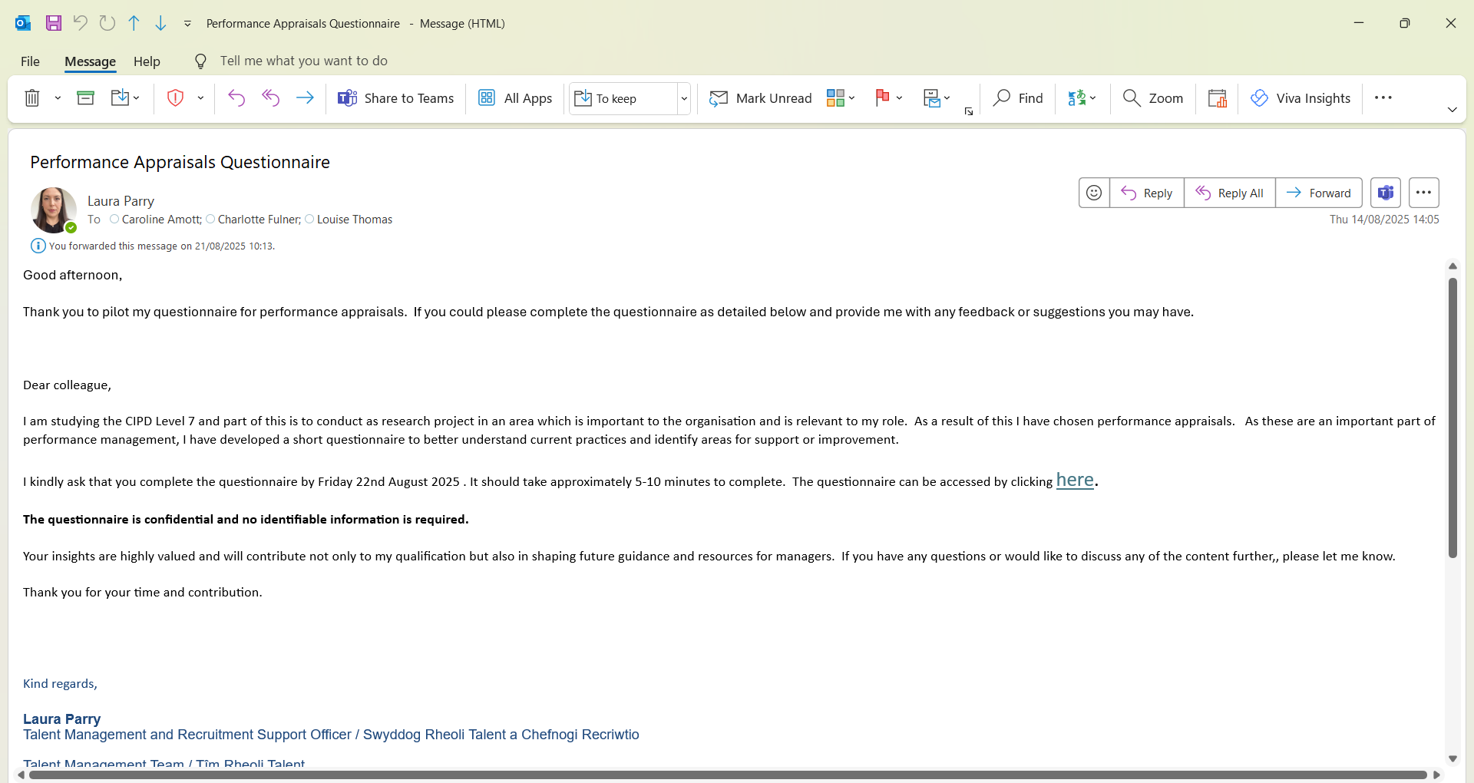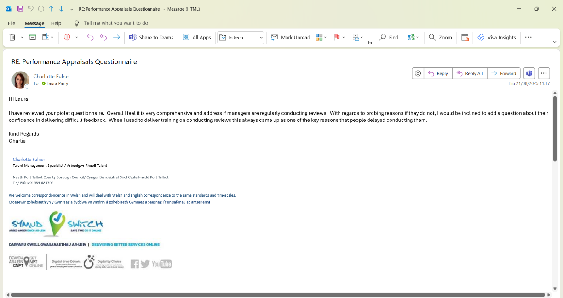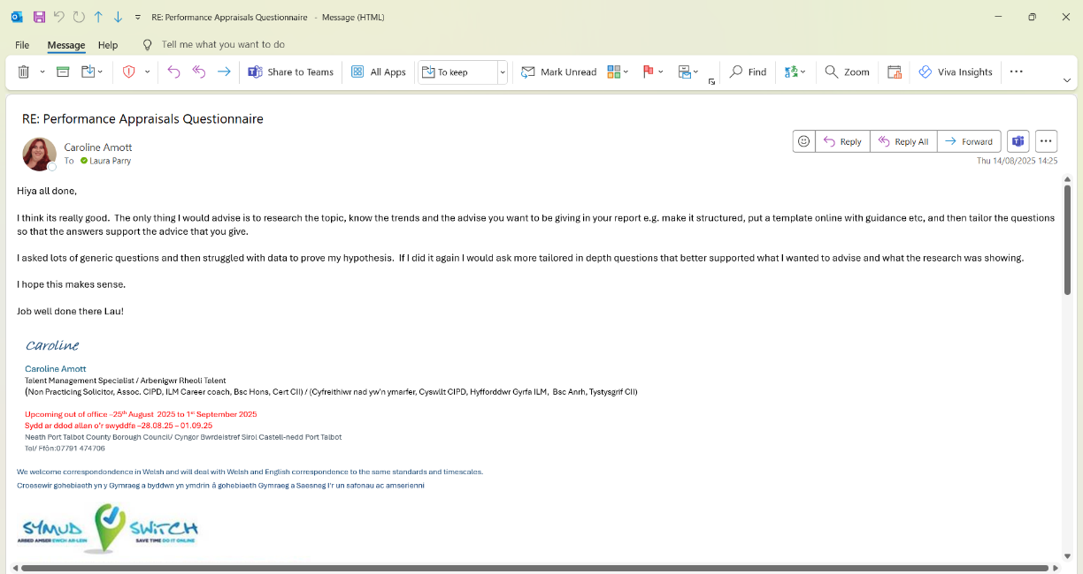

Appendix 3

NPTC Employee Performance Appraisals survey final draft

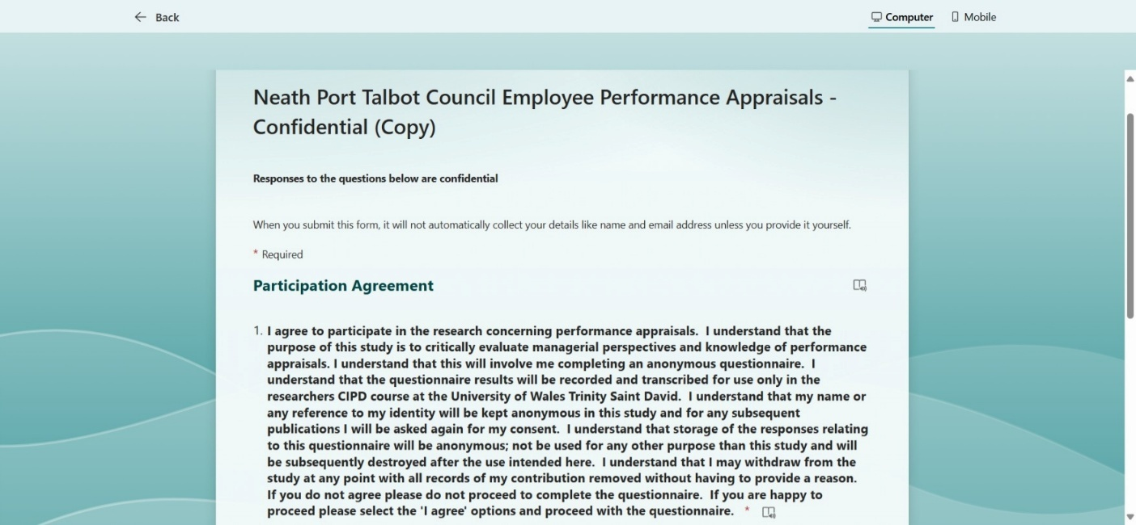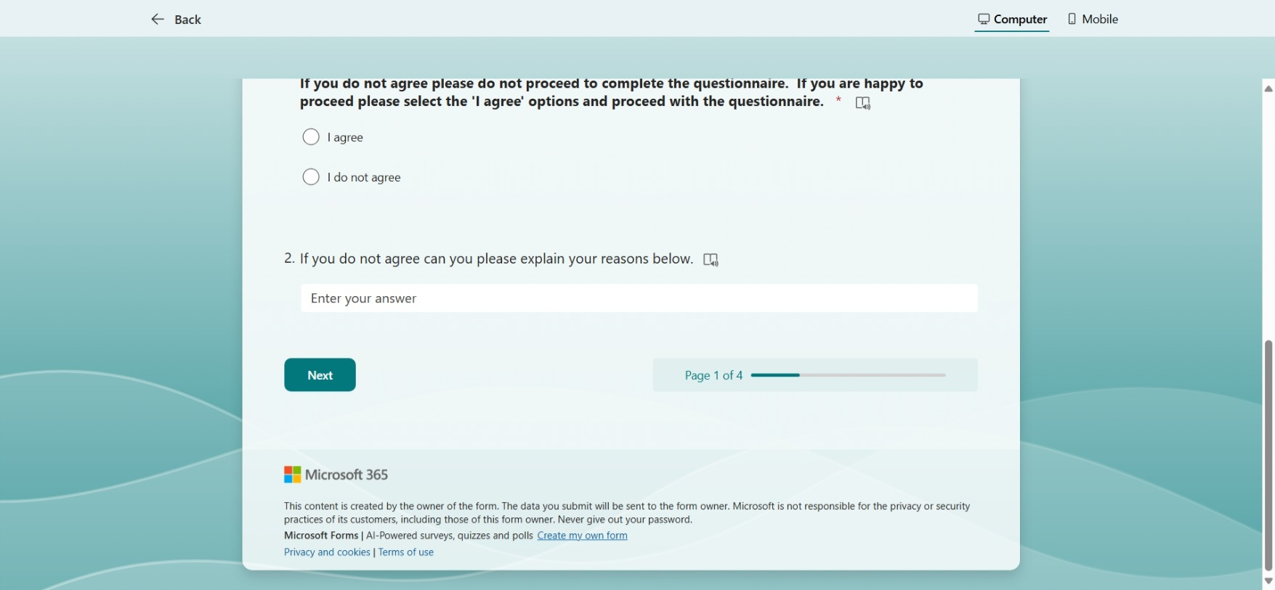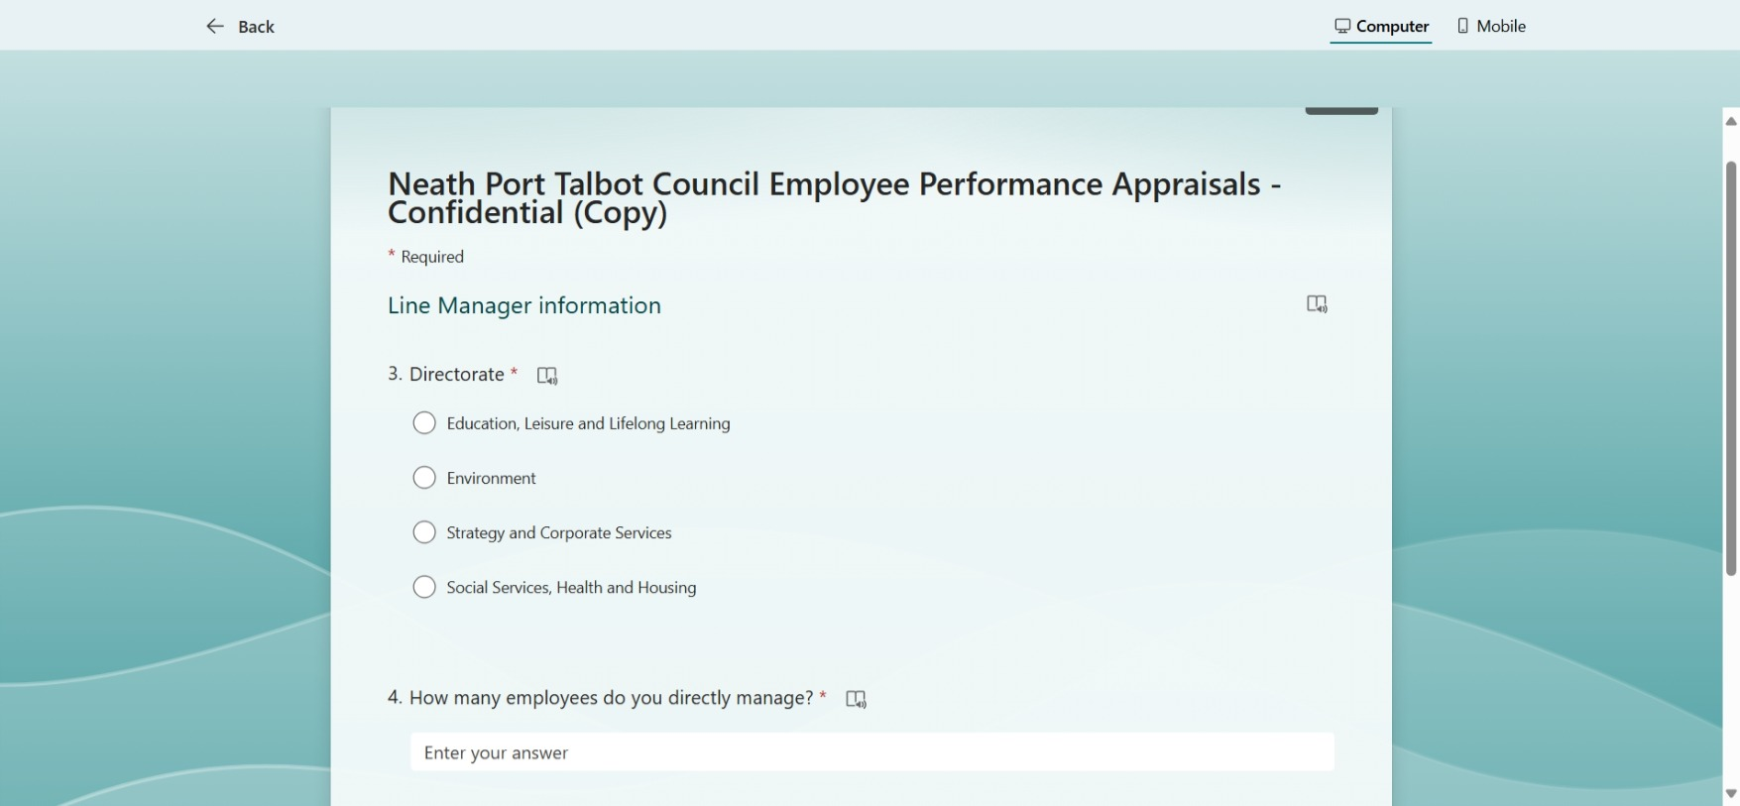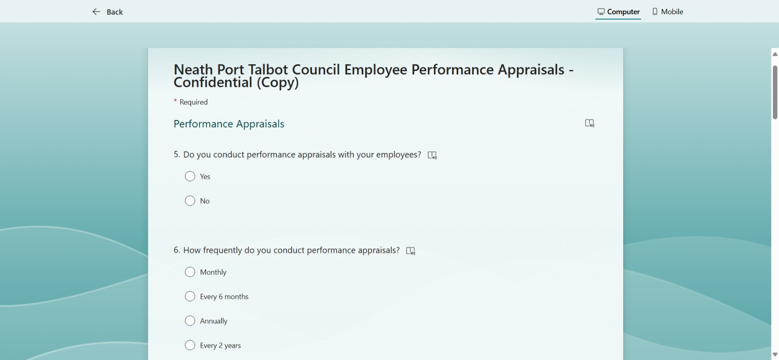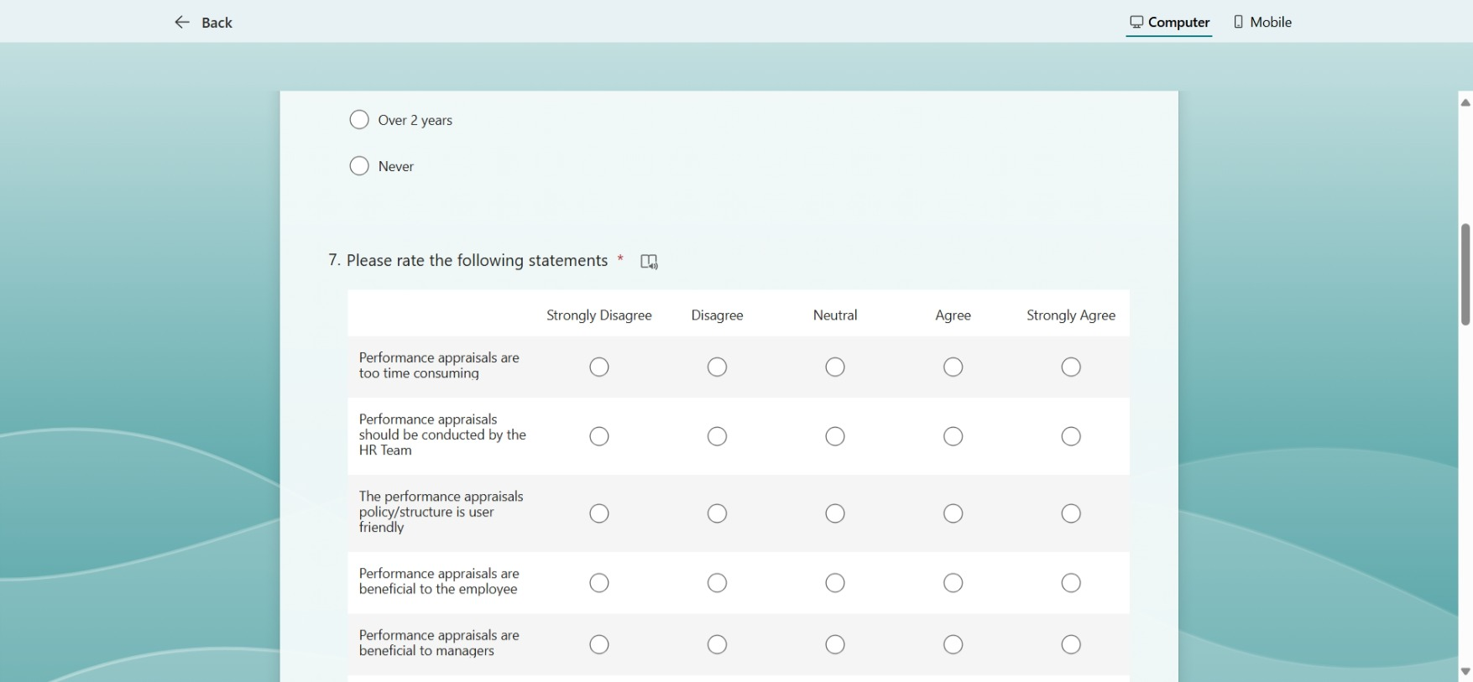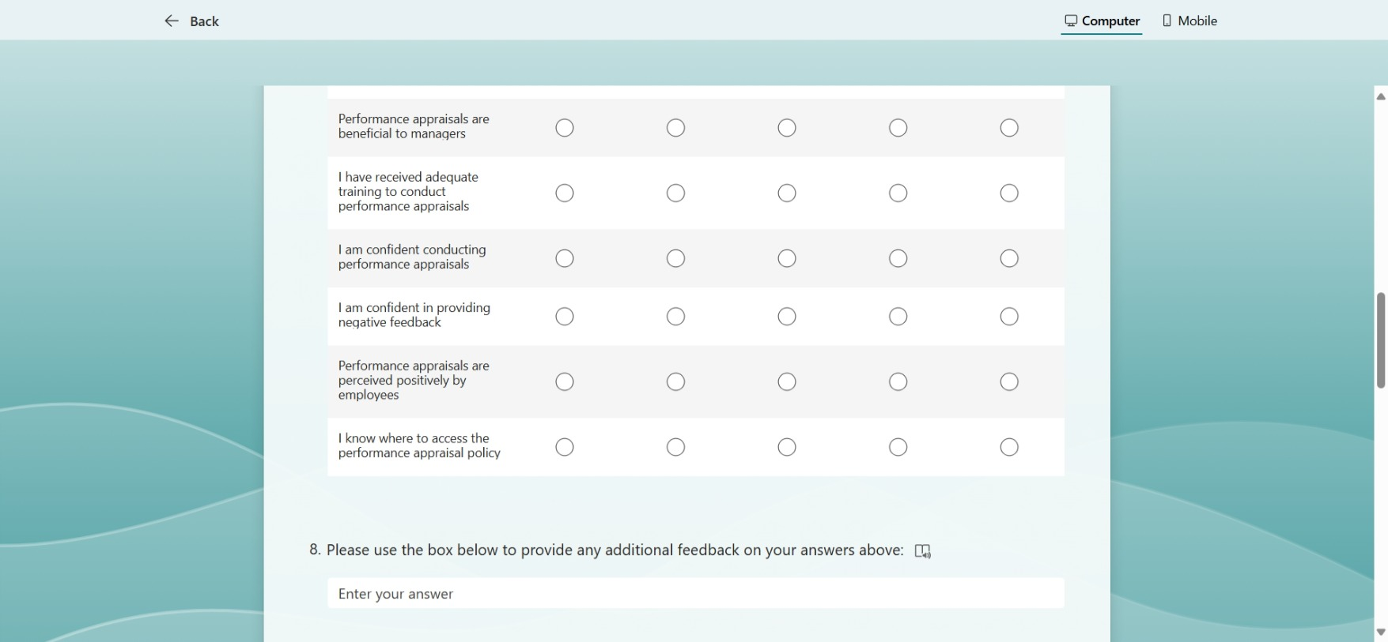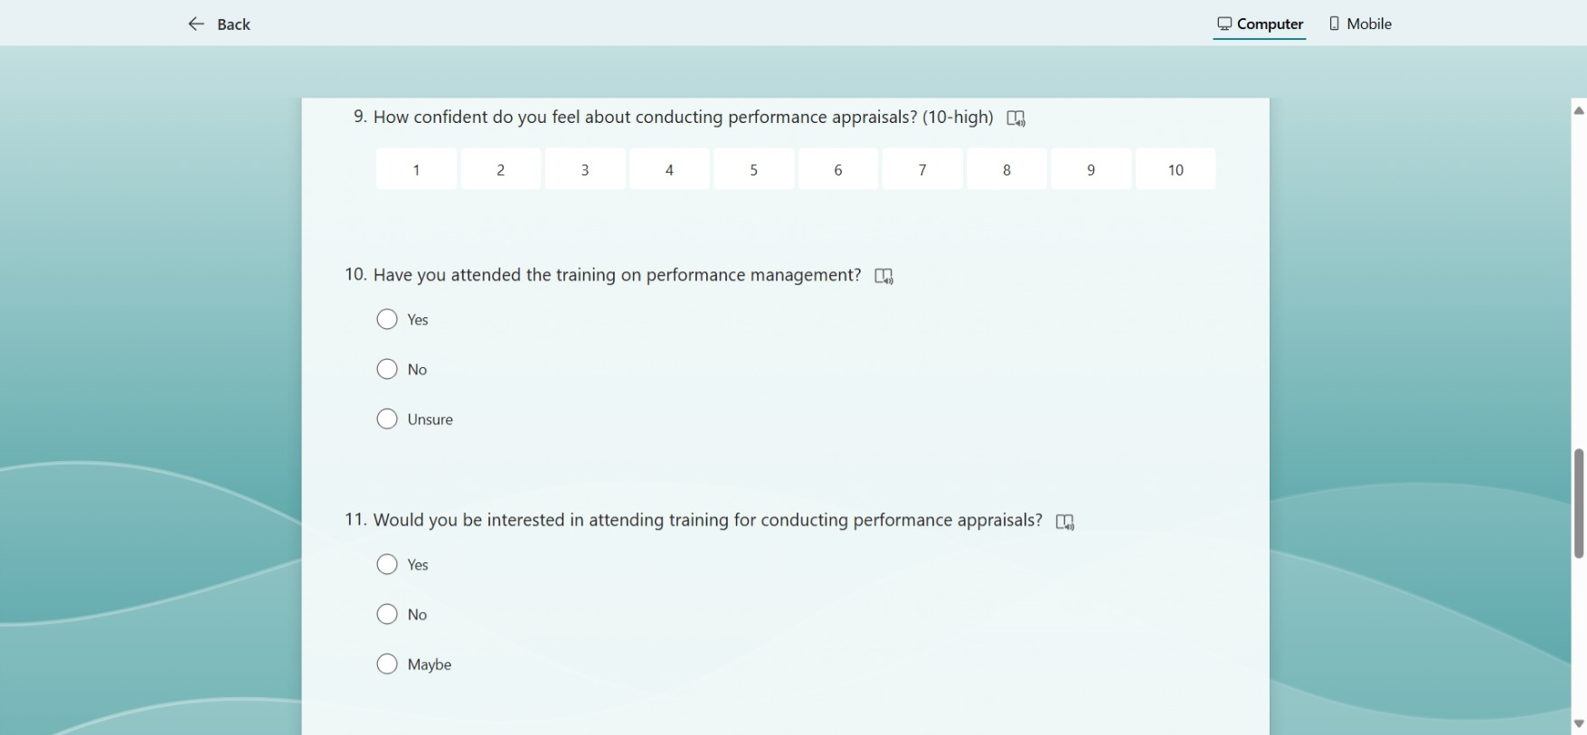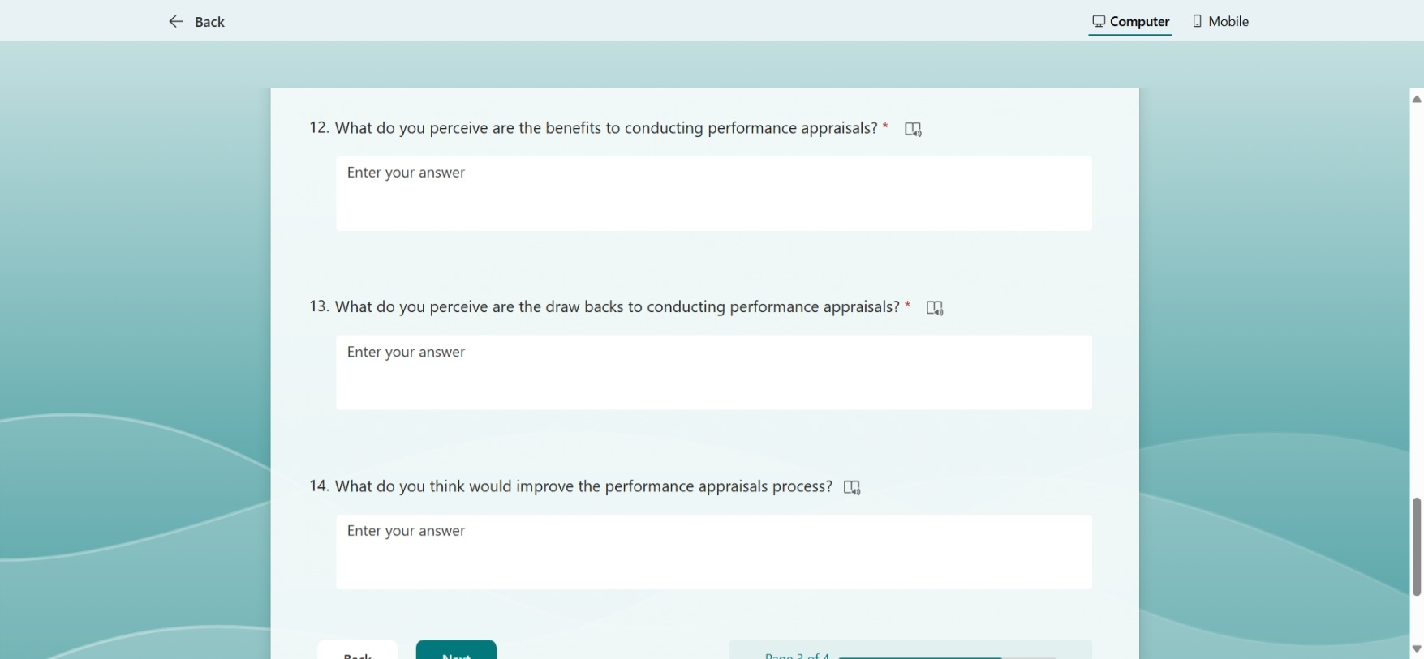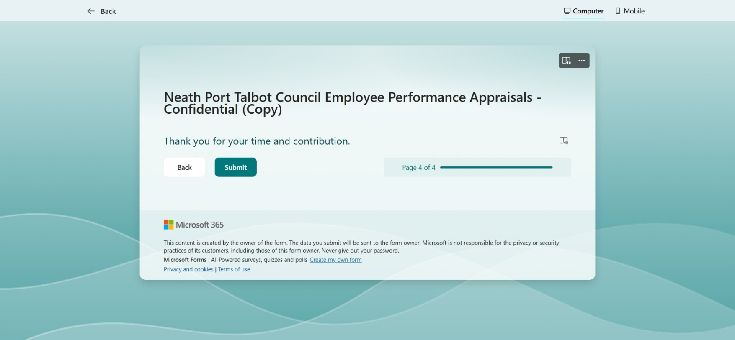

Appendix 4

Email invitation to complete survey

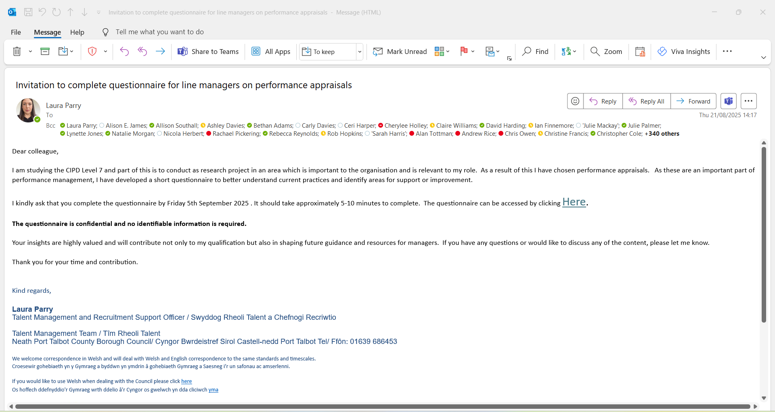

Appendix 5

Email reminder to complete survey

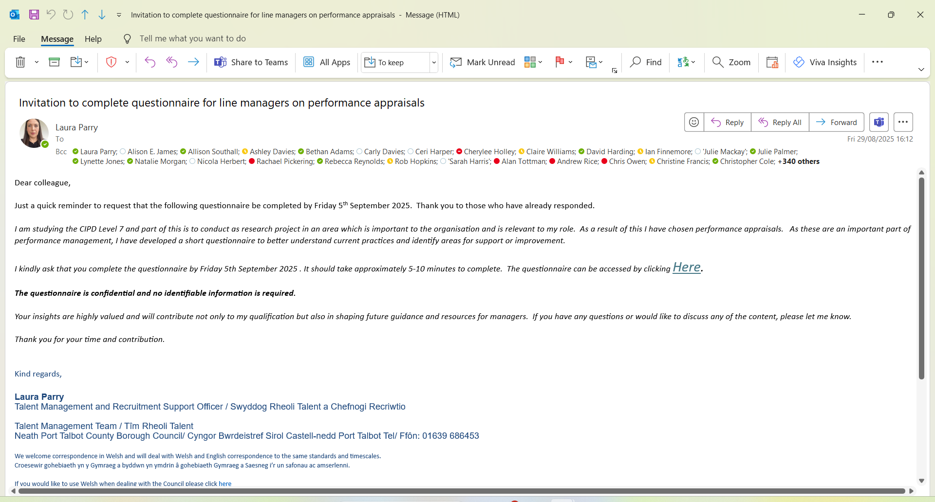

Appendix 6

Data collected including analysis
Tables, graphs and charts

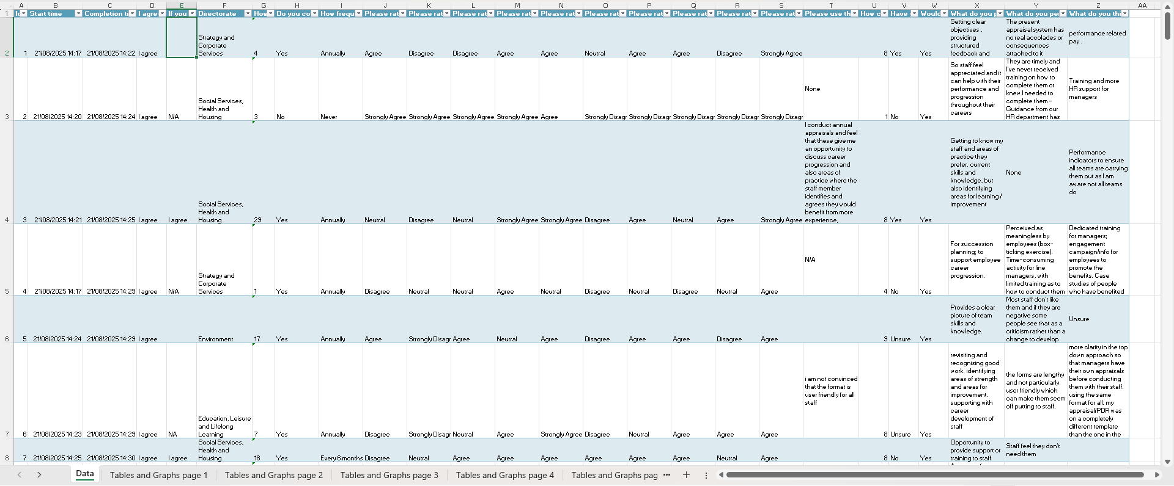

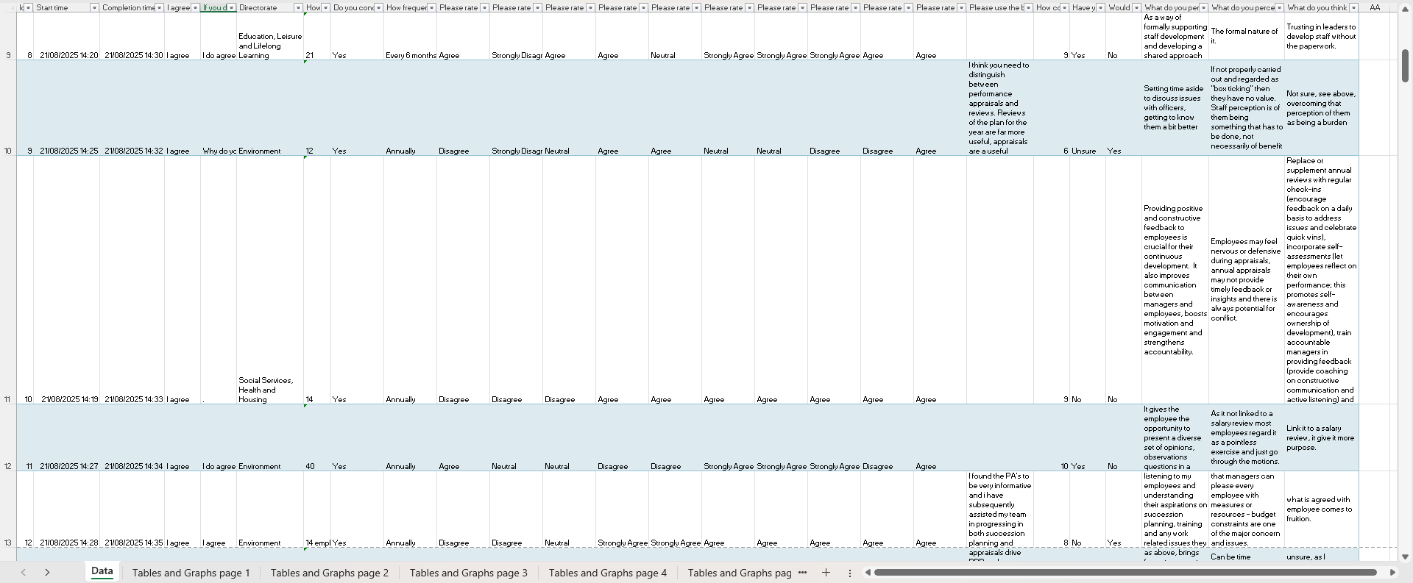

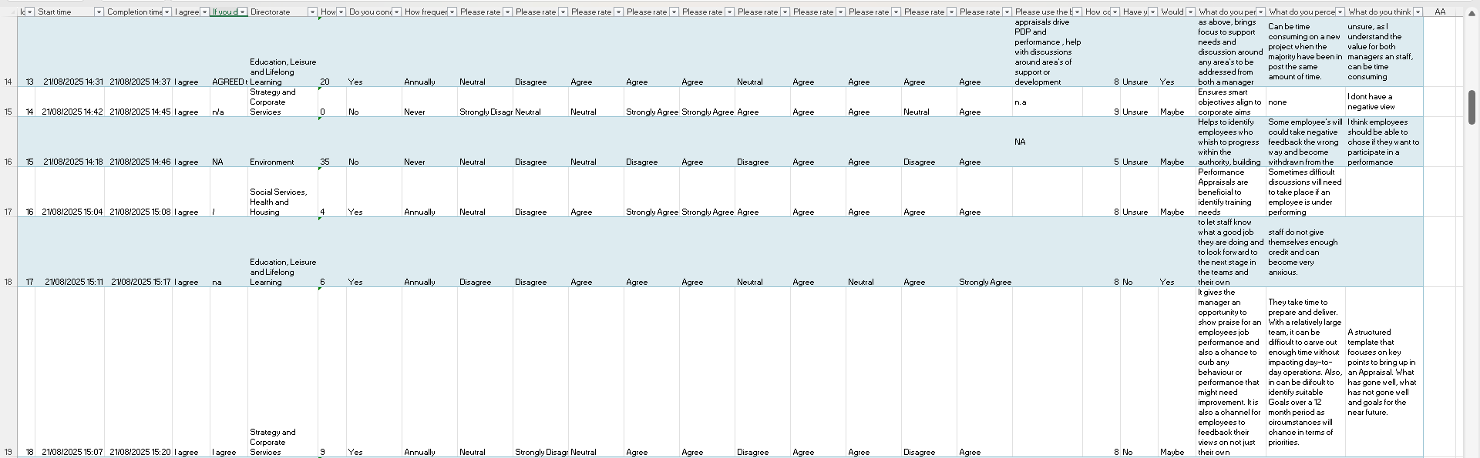

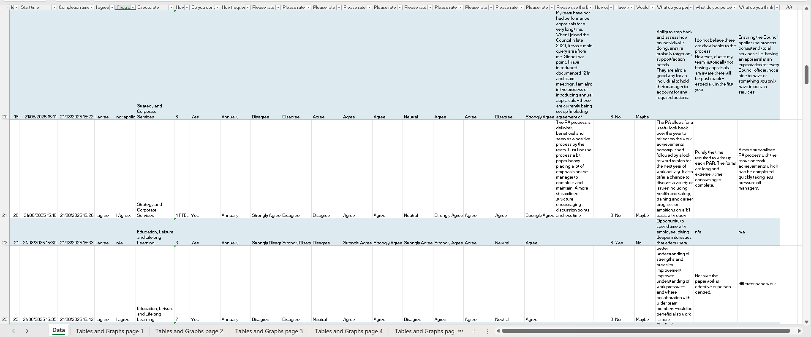

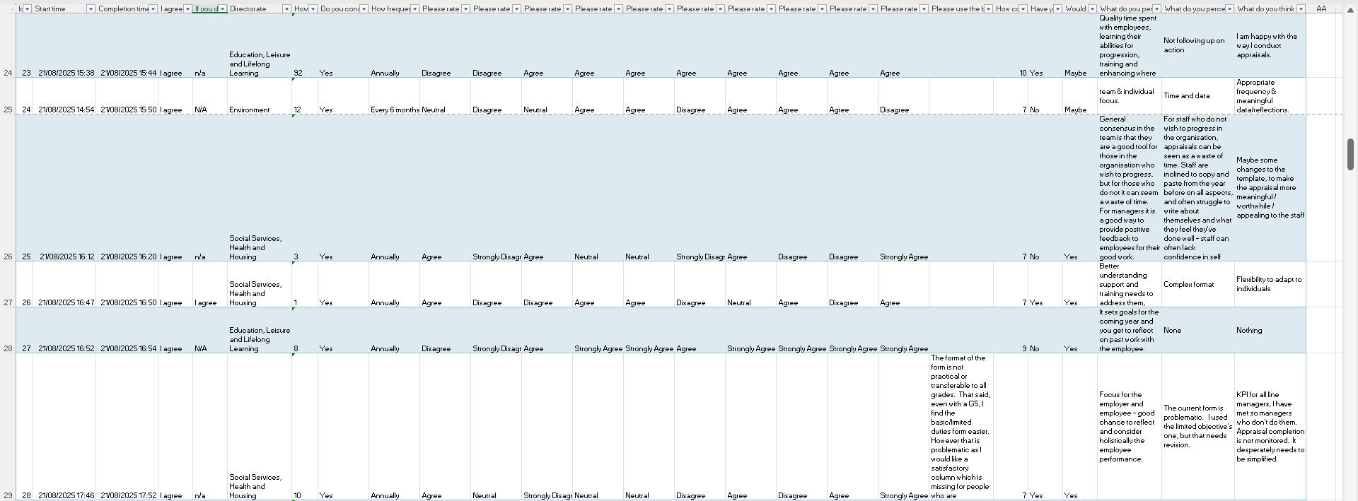

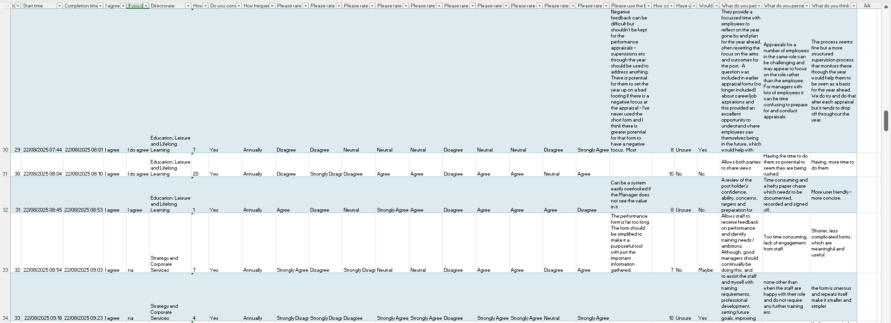

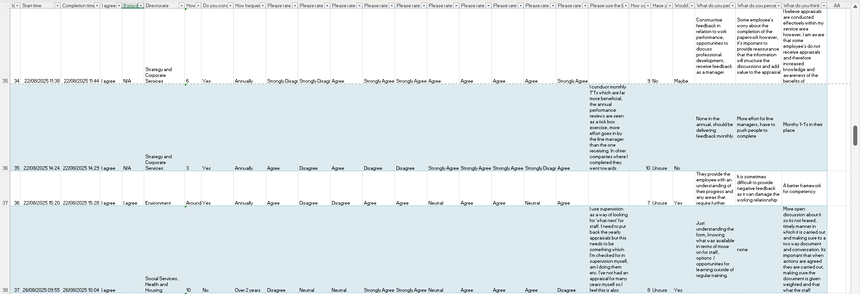

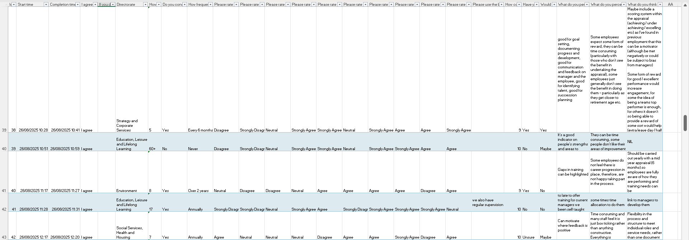

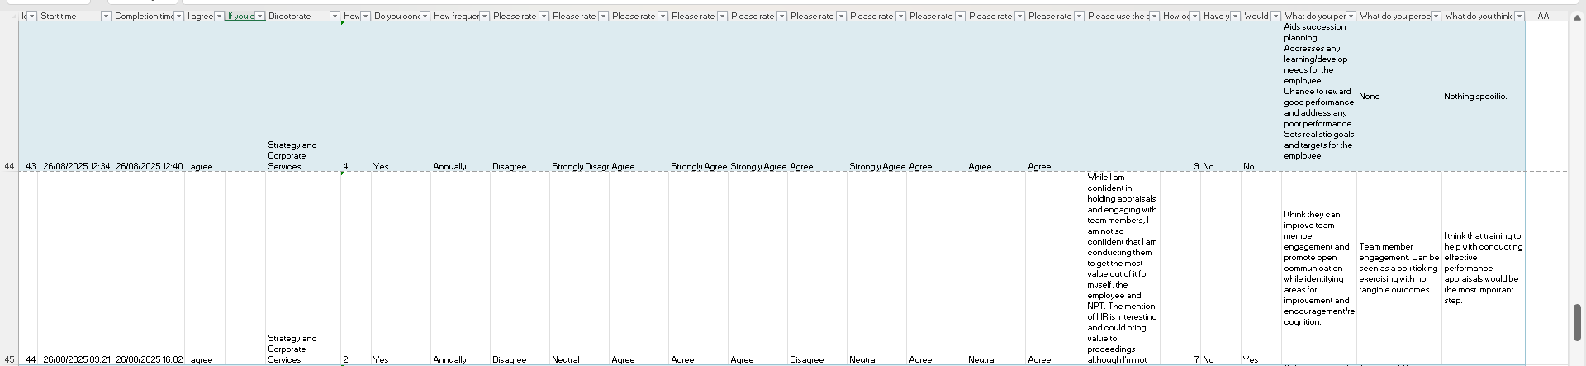

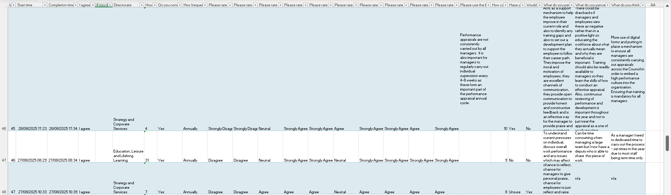

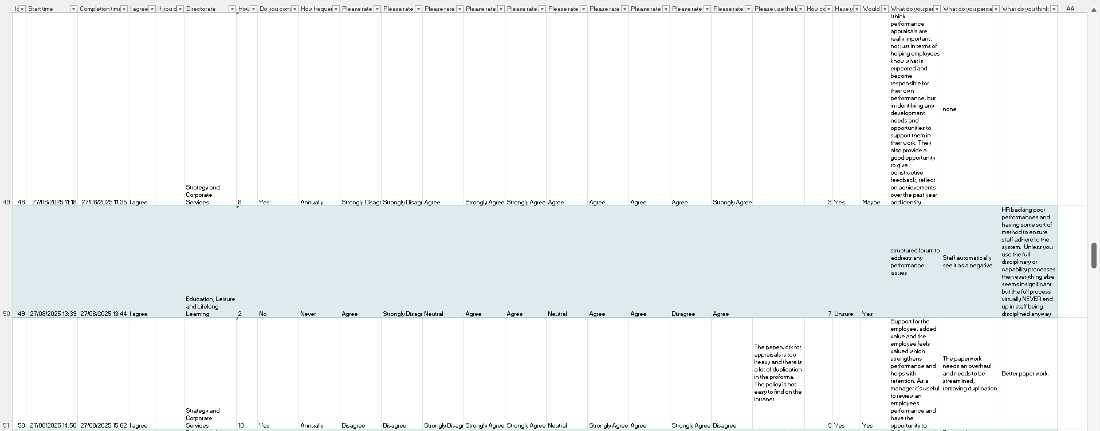

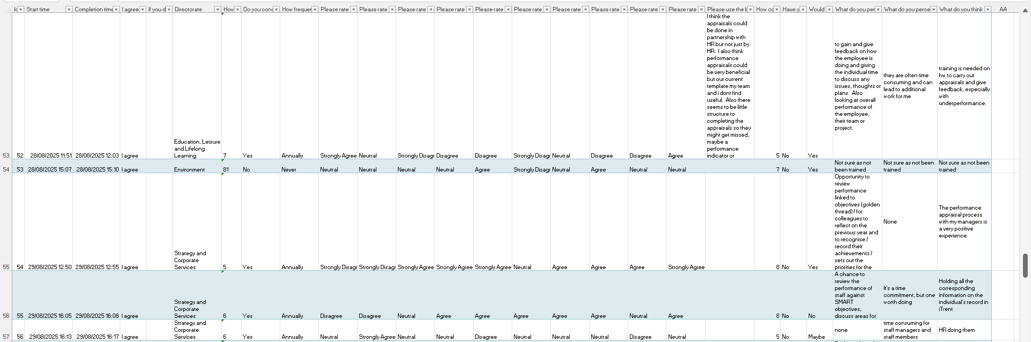

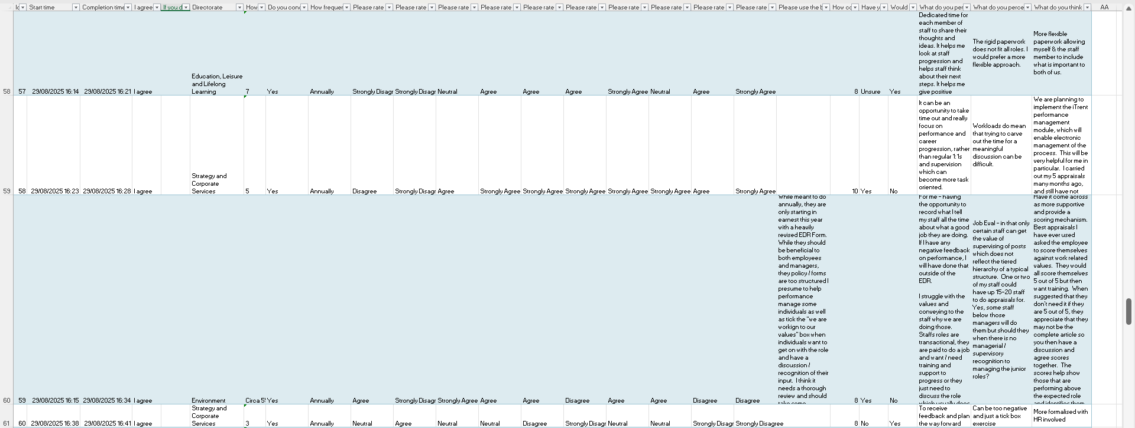

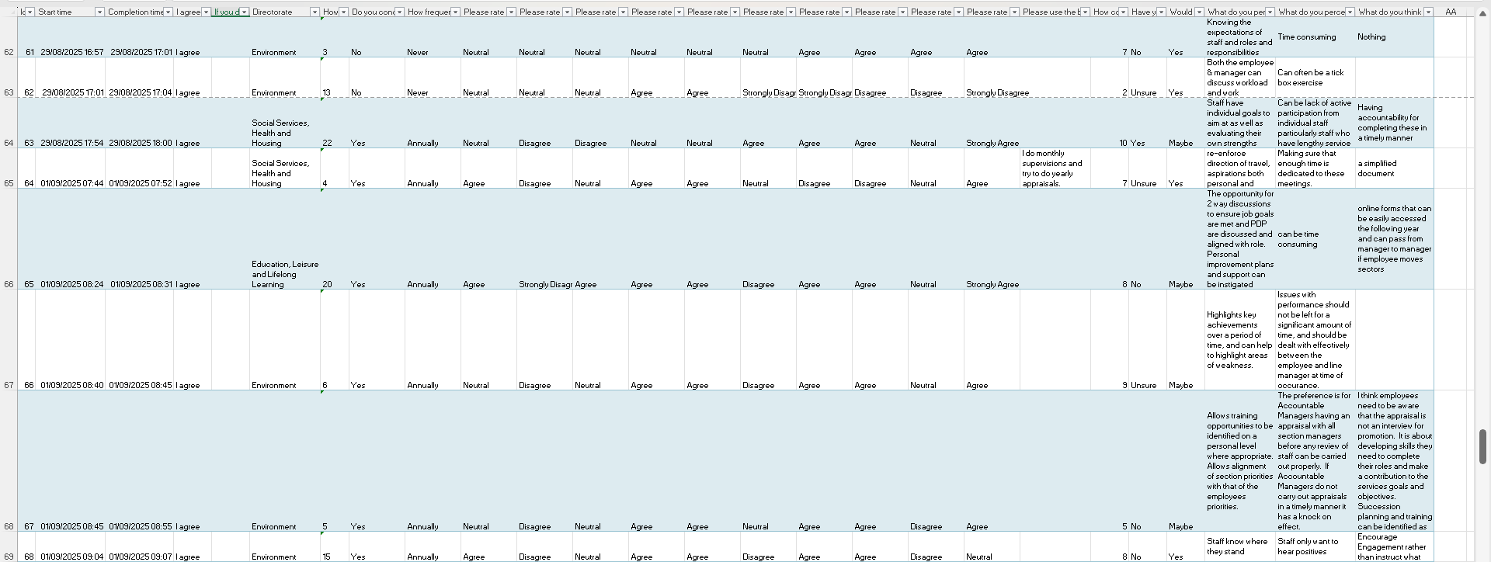

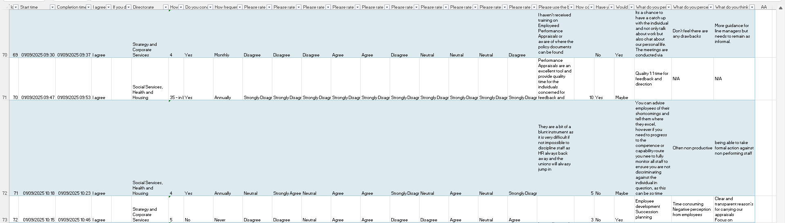

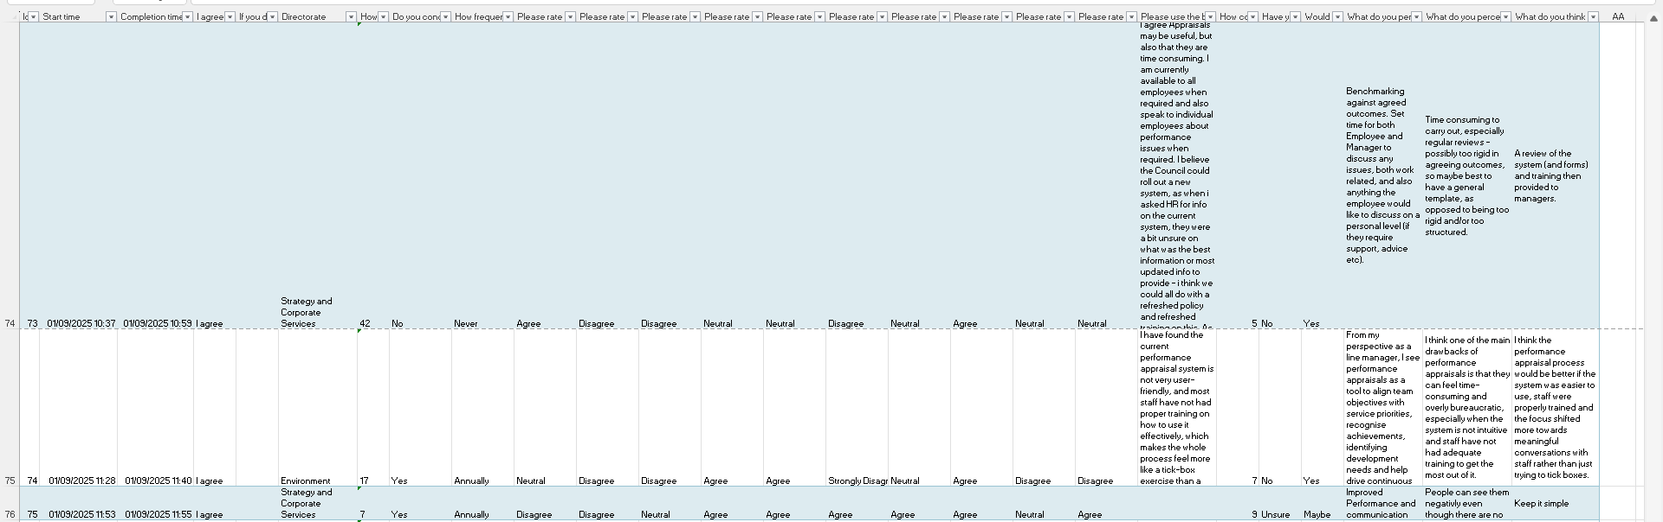

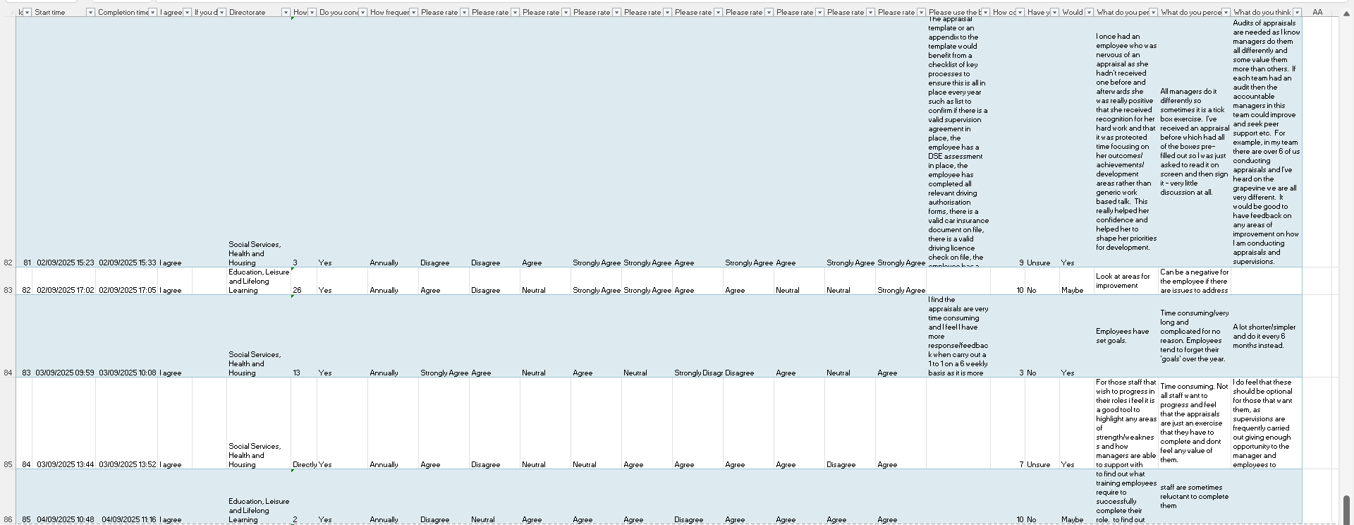

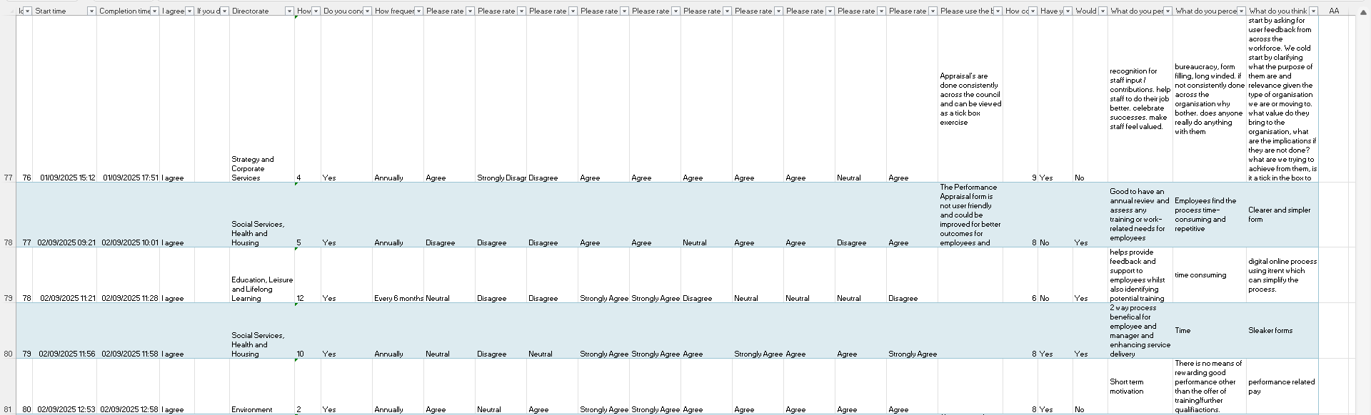

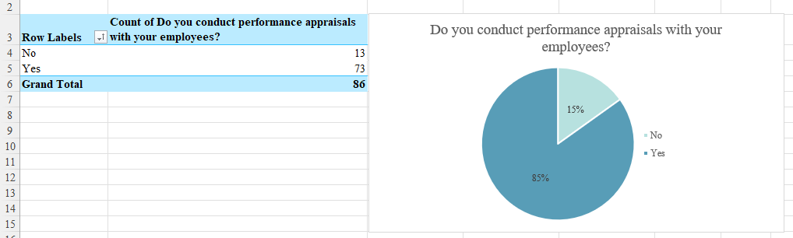

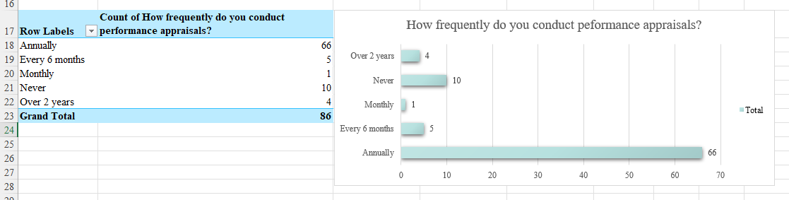

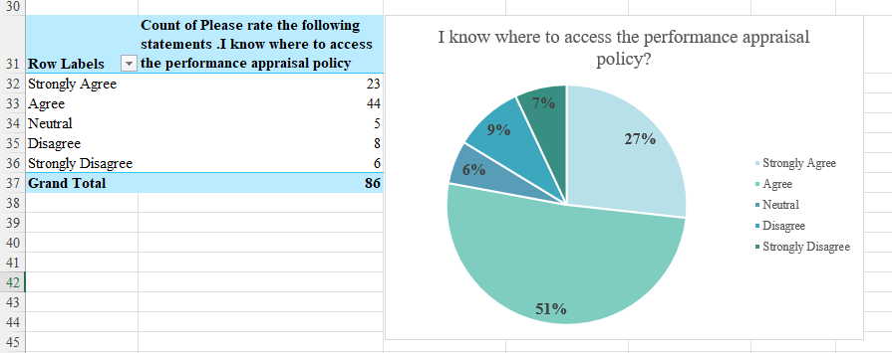

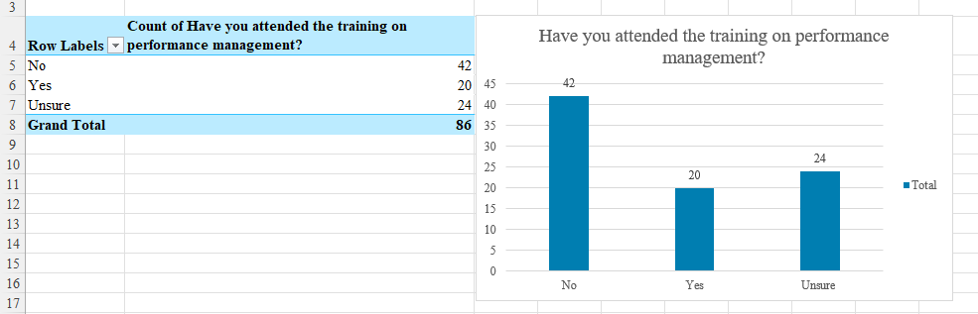

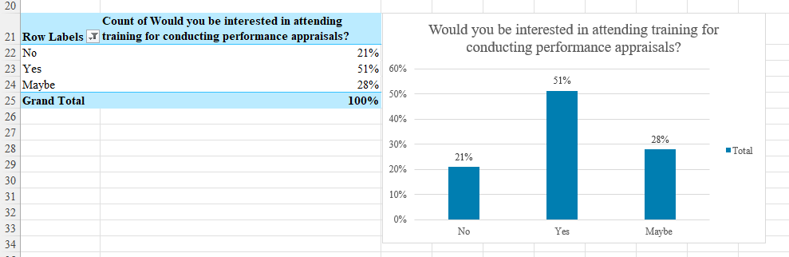

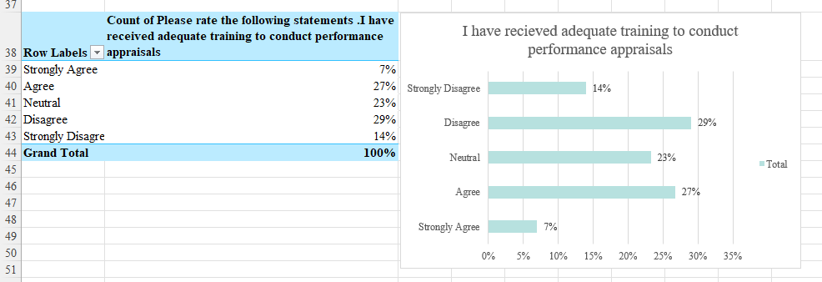

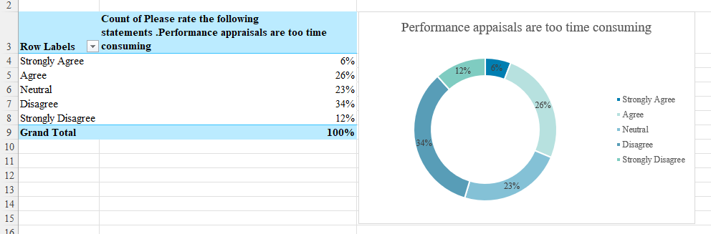

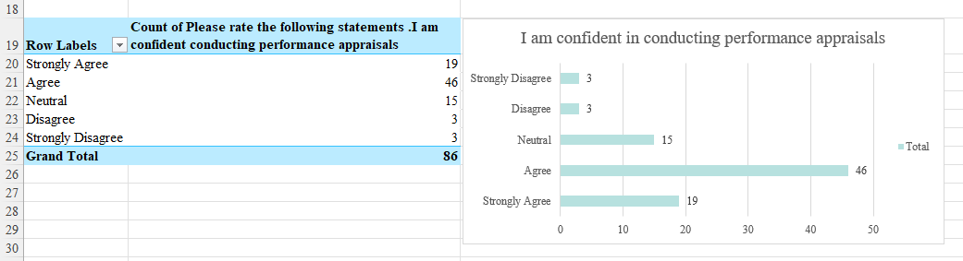

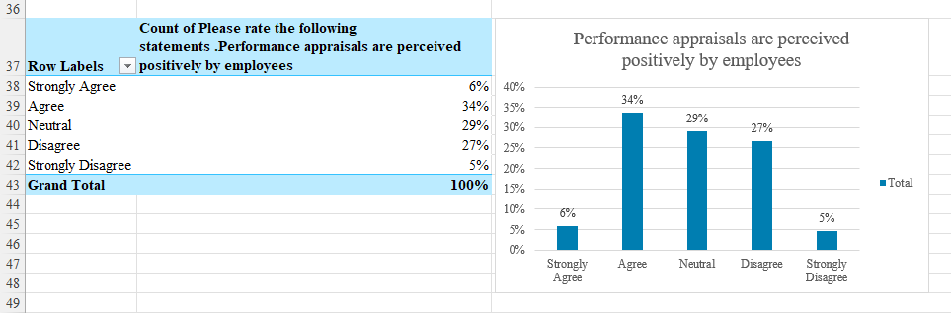

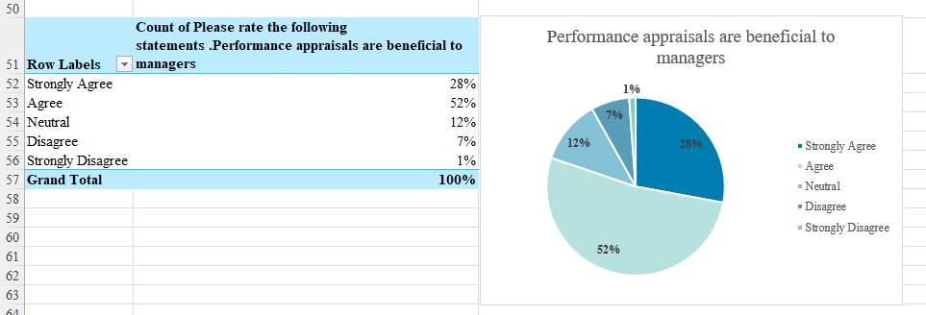

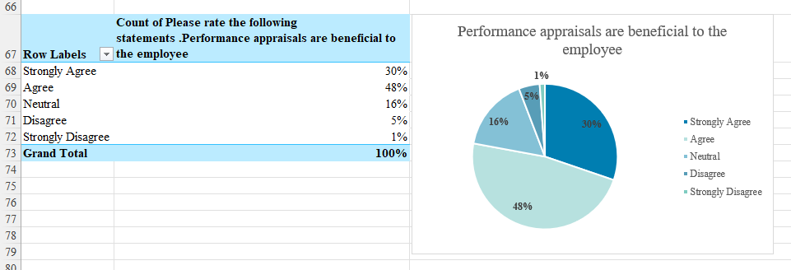

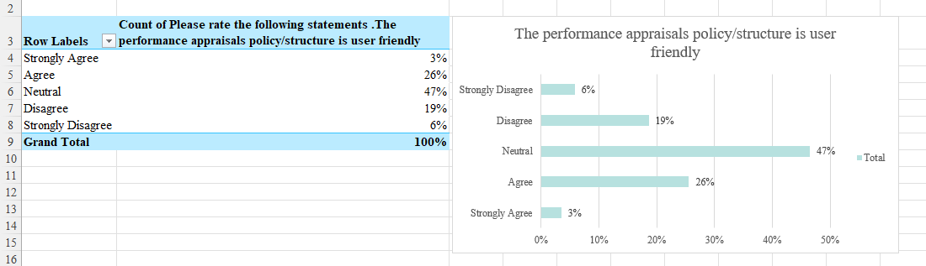

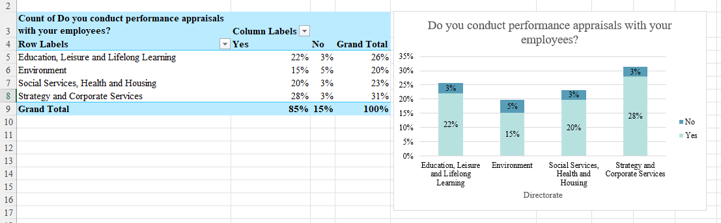

- References

Adams, J.S. (1965) ‘Inequity in Social Exchange’, Advances in Experimental Social Psychology, 2(1), pp.267–299. Available at: https://doi.org/10.1016/S0065-2601(08)60108-2.
Adler, S., Campion, M., Colquitt, A., Grubb, A., Murphy, K., Ollander-Krane, R. and Pulakos, E.D. (2016) ‘Getting Rid of Performance Ratings: Genius or Folly? A Debate’, Industrial and Organizational Psychology, 9(2), pp.219–252. Available at: https://www.cambridge.org/core/journals/industrial-and-organizational-psychology/article/getting-rid-of-performance-ratings-genius-or-folly-a-debate/215B47ABDD0DEE3B55BE747B87FFDCBC (Accessed: 4 August 2025).
Anderson, V. and Fontinha, R. (2024) Research Methods in Human Resource Management. 5th ed. London:Kogan Page.
Barends, E., Janssen, B., Marenco, P., Briner, R. and Rousseau, D. (2016) Rapid evidence assessment of the research literature on the effect of performance appraisal on workplace performance Technical report. Available at: https://www.cipd.org/globalassets/media/knowledge/knowledge-hub/reports/rapid-evidence-assessment-of-the-research-literature-on-the-effect-of-performance-appraisal-on-workplace-performance_tcm18-16902.pdf (Accessed: 4 August 2025).
Barends, E., Rousseau, D., Wietrak, E., Gifford, J. and Young, J. (2022) People performance definitions and measures: an evidence review. Available at: https://www.cipd.org/globalassets/media/knowledge/knowledge-hub/evidence-reviews/people-performance-definitions-measures-scientific-summary_tcm18-109855.pdf (Accessed: 10 September 2025).
Barnett, A. (2024) Why L&D needs to focus on helping managers with difficult conversations. Available at: https://www.peoplemanagement.co.uk/article/1900624/why-l-d-needs-focus-helping-managers-difficult-conversations (Accessed: 10 September 2025).
Bell, E., Bryman, A. and Harley, B. (2022) Business Research Methods. 6th ed. Oxford:Oxford University Press.
Bloom, N., Sadun, R. and Reenen, J.V. (2012) Does Management Really Work? Available at: https://hbr.org/2012/11/does-management-really-work (Accessed: 4 August 2025).
Bosley, A. and Gifford, J. (2023) Effective people managers at Work 2022 An evidence review. Available at: https://www.cipd.org/globalassets/media/knowledge/knowledge-hub/evidence-reviews/2023-pdfs/8424-effective-people-managers-practice-summary.pdf (Accessed: 11 September 2025).
Brown, L. (2024) Two in five employees do not think their manager is trained enough, survey finds. Available at: https://www.peoplemanagement.co.uk/article/1887801/two-five-employees-not-think-manager-trained-enough-survey-finds (Accessed: 10 September 2025).
Cespedes, F. (2022) How to Conduct a Great Performance Review. Available at: https://hbr.org/2022/07/how-to-conduct-a-great-performance-review (Accessed: 11 September 2025).
Chartered Management Institute (2023) Taking Responsibility – Why UK PLC Needs Better Managers. Available at: https://www.managers.org.uk/wp-content/uploads/2023/10/CMI_BMB_GoodManagment_Report.pdf (Accessed: 10 September 2025).
Chubb, C., Reilly, P. and Brown, D. (2011) Performance Management Literature Review. Available at: https://www.employment-studies.co.uk/system/files/resources/files/mp90.pdf (Accessed: 18 September 2025).
CIPD (2023) Survey report The importance of people management Analysis of its impact on employees. Available at: https://www.cipd.org/globalassets/media/knowledge/knowledge-hub/reports/2023-pdfs/2023-report-importance-of-people-management-8329-may23.pdf (Accessed: 10 September 2025).
CIPD (2025a) CIPD HR Policies Factsheets. Available at: https://www.cipd.org/uk/knowledge/factsheets/hr-policies-factsheet/ (Accessed: 10 September 2025).
CIPD (2025b) CIPD Performance Reviews Factsheets. Available at: https://www.cipd.org/uk/knowledge/factsheets/appraisals-factsheet/ (Accessed: 4 August 2025).
CIPD (2025c) Line Managers’ Role in Supporting the People Profession Factsheets. Available at: https://www.cipd.org/uk/knowledge/factsheets/line-managers-factsheet/ (Accessed: 8 September 2025).
Creswell, J.W. and Creswell, J.D. (2023) Research design: Qualitative, quantitative, and mixed methods approaches. 6th ed. London:SAGE Publications.
Crotty, M. (1998) The Foundations of Social Research: Meaning and Perspective in the Research Process. The Foundations of Social research: Meaning and Perspective in the Research Process. London: Sage Publications.
Ebert, R.J. and Griffin, R.W. (2022). Business essentials. Upper Saddle River, Nj: Pearson.
Festinger, L. (1954) ‘A theory of social comparison processes’, Human Relations, 7(2), pp.117–140. Available at: https://doi.org/10.1177/001872675400700202.
Gratton, L. and Ghoshal, S. (2002) ‘Improving the Quality of Conversations’, Organizational Dynamics, 31(3), pp.209–223. Available at: https://doi.org/10.1016/s0090-2616(02)00110-9.
Hewett, R., Sikora, D., Brees, J.R. and Moelijker, R. (2023) ‘Answerable for what? The role of accountability focus in line manager HR implementation’, Human Resource Management, 63(2). Available at: https://doi.org/10.1002/hrm.22189.
Howe, J. (2023) Mastering effective appraisals. Available at: https://www.peoplemanagement.co.uk/article/1832460/mastering-effective-appraisals (Accessed: 11 September 2025).
Hutchinson, S. (2013) Performance Management. London: Chartered Institute of Personnel and Development.
Improvement and Development Agency (2004). Performance management: the people dimension. Ref: IDEA035 ed. Improvement and Development Agency.
Kluger, A.N. and DeNisi, A. (1996) ‘The effects of feedback interventions on performance: A historical review, a meta-analysis, and a preliminary feedback intervention theory’, Psychological Bulletin, 119(2), pp.254–284. Available at: https://doi.org/10.1037/0033-2909.119.2.254.
Kuvaas, B. (2007) ‘Different relationships between perceptions of developmental performance appraisal and work performance’, Personnel Review, 36(3), pp.378–397. Available at: https://doi.org/10.1108/00483480710731338.
Mayne, M. (2023)‘Accidental managers’ without proper leadership training contributing to almost one in three workers walking out, research finds. Available at: https://www.peoplemanagement.co.uk/article/1844443/accidental-managers-without-proper-leadership-training-contributing-almost-one-three-workers-walking-out-research-finds (Accessed: 10 September 2025).
McGrath, R.E., Mitchell, M., Kim, B.H. and Hough, L. (2010) ‘Evidence for response bias as a source of error variance in applied assessment’, Psychological Bulletin, 136(3), pp.450–470. Available at: https://doi.org/10.1037/a0019216.
Murphy, K.R. (2019) ‘Performance evaluation will not die, but it should’, Human Resource Management Journal, 30(1), pp.13–31. Available at: https://doi.org/10.1111/1748-8583.12259.
Murphy, K.R. and Cleveland, J.N. (1995) Understanding performance appraisal social, organizational, and goal-based perspectives. 1st ed. London: Sage Publications.
Neath Port Talbot Council (2024) Corporate Strategy 2025-2028 - Neath Port Talbot Council. Available at: https://www.npt.gov.uk/council/strategies-plans-and-policies/priorities-and-performance/corporate-strategy-2025-2028/ (Accessed: 25 Sepember 2025).
Neath Port Talbot Council (n.d.) ‘Employee Exit Interview/Survey’. NPTC. Unpublished.
Neath Port Talbot Council (n.d.) ‘Employee Survey 2024-2025’. NPTC. Unpublished.
Purcell, J. and Hutchinson, S. (2007) ‘Front-line managers as agents in the HRM-performance causal chain: theory, analysis and evidence’, Human Resource Management Journal, 17(1), pp.3–20. Available at: https://doi.org/10.1111/j.1748-8583.2007.00022.x.
Redman, T. and Wilkinson, A. (2009) Contemporary human resource management: Text and cases. Harlow, England; New York: Financial Times/Prentice Hall.
Ryan, G. (2018) ‘Introduction to positivism, Interpretivism and Critical Theory’, Nurse Researcher, 25(4), pp.41–49. Available at: https://doi.org/10.7748/nr.2018.e1466.
Saunders, M., Lewis, P. and Thornhill, A. (2009) Understanding Research Philosophies and Approaches. Available at: https://www.researchgate.net/publication/309102603_Understanding_research_philosophies_and_approaches (Accessed: 26 August 2025).
Saunders, M., Lewis, P. and Thornhill, A. (2023). Research Methods for Business Students. 9th ed. London:Pearson.
Taylor, S. and Woodhams, C. (2022a) Human resource management: people and organisations. 3rd ed. London: Kogan Page.
Taylor, S. and Woodhams, C. (2022b) Studying Human Resource Management: a Guide to the study, Context and Practice of hr. 3rd ed. London: Kogan Page.
Teijlingen, E.V. and Hundley, V. (2002) ‘The importance of pilot studies’, Nursing Standard, 16(40), pp.33–36. Available at: https://doi.org/10.7748/ns2002.06.16.40.33.c3214.
Trades Union Congress (2019) Improving line management: Why better line management will help improve work for everyone. Available at: https://www.tuc.org.uk/sites/default/files/Improving%20line%20management.pdf (Accessed: 18 September 2025).
Trullen, J., Stirpe, L., Bonache, J. and Valverde, M. (2016) ‘The HR department’s contribution to line managers’ effective implementation of HR practices’, Human Resource Management Journal, 26(4), pp.449–470. Available at: https://doi.org/10.1111/1748-8583.12116.
UK Research and Innovation (2024) Consent. Available at: https://www.ukri.org/councils/esrc/guidance-for-applicants/research-ethics-guidance/consent/ (Accessed: 11 September 2025).
Unison (2013) Unison terminating suspending job appraisal. Available at: https://www.unison.org.uk/get-help/knowledge/terminating-suspending-job/appraisal/ (Accessed: 4 August 2025).
Unison (2019) UNISON Health Conference 2019 Conference agenda and guide. Available at: https://www.unison.org.uk/content/uploads/2019/03/2019-Health-Conference-Guide-and-Agenda.pdf (Accessed: 18 September 2025).
Walster, E.H., Walster, G.W., Berscheid, E., Austin, W., Traupmann, J. and Utne, M.K. (1978) Equity: theory and research. Boston: Allyn And Bacon, Cop.
Whitehouse, E. (2019) Will we ever build better line managers? Available at: https://www.peoplemanagement.co.uk/article/1742219/will-we-ever-build-better-line-managers (Accessed: 8 September 2025).

Academic poster content – Word Count: 788

A critical evaluation of managerial perspectives and knowledge of performance appraisals within Neath Port Talbot Council

Introduction
Neath Port Talbot Council (NPTC) is a local authority in South Wales serving approximately 140,000 residents (NPTC, 2024b). It has 5 directorates, 16 service areas and over 6,500 employees (NPTC, 2024c).

The business case
Despite having a performance appraisal policy, data collected from employee surveys and exit interviews report inconsistent implementation across the organisation, with under half of staff receiving regular performance appraisals (NPTC, n.d.)

Literature
Performance reviews are formal evaluations of employee performance, often used to inform decisions on development, pay, and organisational strategy (Ebert and Griffin, 2022; CIPD, 2025). Typically conducted by line managers, they influence employee perceptions and workplace outcomes (Woodhams and Taylor, 2022; Hutchinson, 2013). Reviews can enhance morale, clarify expectations, and align goals (Taylor and Woodhams, 2022), but may also be biased or subjective (Murphy, 2019; CIPD, 2025). While some studies show productivity gains (Bloom et al., 2012), others question their reliability and impact (Redman and Wilkinson, 2009). Effectiveness often depends on employee autonomy and managerial execution (Kuvaas, 2007; Howe, 2023).

Methodology
Aim and Objectives
This report critically evaluates managerial perspectives and understanding of performance appraisals within Neath Port Talbot Council (NPTC). Its objectives include reviewing relevant literature, conducting primary research via questionnaires, analysing findings, and recommending improvements for consistent appraisal practices across the authority.
Research Philosophy and Approach
Guided by Saunders, Lewis and Thornhill’s (2023) research onion model, the study adopts an interpretivist and pragmatic philosophy to explore varied managerial experiences (Crotty, 1998; Ryan, 2018; Creswell and Creswell, 2023). An inductive approach supports theory development based on collected data (Saunders et al., 2023).
Methodology and Strategy
A mixed-methods strategy was employed using Microsoft Forms to gather quantitative and qualitative data simultaneously (Bell et al., 2022; Taylor and Woodhams, 2022b). Surveys were chosen for their cost-effectiveness, anonymity, and ease of distribution, enhancing honest responses (Anderson and Fontinha, 2024). Interviews were excluded due to time and bias concerns.
Procedures and Techniques
The survey ran for 14 days, targeting 364-line managers via email. It included consent statements and piloting feedback, which led to the inclusion of a question on delivering negative feedback.
Limitations and Ethics
Potential bias was mitigated through anonymised data handling and clear consent procedures (McGrath et al., 2010; UKRI, 2024). Only the researcher accessed raw data, ensuring confidentiality

Results
Survey data revealed that 22% of respondents did not know where they could access NPTC’s performance appraisal policy, suggesting inconsistent implementation (Figure 1). Comments indicated difficulty locating the policy on the intranet, with some unaware of its existence. Clear communication and accessibility of HR policies are essential for consistency and compliance (CIPD, 2025a). Line managers must be supported by both senior leadership and the people management team to effectively carry out their responsibilities (CIPD, 2025b; Whitehouse, 2019). Without proper guidance and visibility of key documents, performance management practices risk becoming fragmented and ineffective across the organisation.

Trullen et al. (2016) argue that policies are only effective when implemented by well-supported line managers. At NPTC, only 20 of 86 respondents had attended performance management training, with just 34% feeling adequately trained (Figure 2). Over half expressed interest in further training (Figure 3). Nationally, 82% of new managers lack formal training (CMI, 2023; Mayne, 2023), and 53% feel under-supported (CIPD, 2023). One NPTC respondent admitted to never receiving appraisal training or knowing it was required. Time constraints and usability issues were cited as barriers, echoing broader dissatisfaction with appraisal processes (Cespedes, 2022; Brown, 2024; CIPD, 2023).

Survey responses revealed concerns about NPTC’s performance appraisal process being overly time-consuming, lengthy, and inconsistent, with only 29% finding it user-friendly (Figure 4). Barends et al. (2022) argue that effective appraisals require multiple rater’s and diverse performance measures.

Benchmarking against other organisations can improve structure and clarity (CIPD, 2025a). Managers often feel discomfort when delivering feedback, leading to avoidance of difficult conversations (Murphy and Cleveland, 1995; Barnett, 2024). Appraisals were frequently described as a “box ticking exercise,” with managers valuing them more than employees, who viewed them as negative or pointless, highlighting a disconnect in perceived value and purpose.

Conclusion
Research at NPTC revealed key issues in the performance appraisal process, including inadequate training and poor policy awareness among managers. Only a minority felt confident in conducting appraisals, despite training being available (Bosley and Gifford, 2023; CIPD, 2025c). The Chartered Management Institute (2023) found that trained managers reported greater confidence and effectiveness. Many managers were unaware of how to access appraisal policies, suggesting wider communication gaps (CIPD, 2025a). Appraisals were often viewed as time-consuming and ineffective, described as a “box ticking exercise.” These findings indicate the need for clearer communication, improved training, and a review of appraisal practices to ensure organisational alignment.

