4/28/2026
Assessment
Portfolio Report on Contemporary Software Applications for Business


Student Name: Ena Joselin Galo Nunez
Student ID:2530051

Module NaMe: Software solutions for business
Module Code: ACCA 4026
Lecturer: Amitave Banik
Trinity saint david University of Wales (London Campus)

Table of Contents
Introduction 2
Main Body 2
Task 1 2
e-Commerce Website builders/software solutions 2
Task 2 4
Mind-map of Contemporary Software Applications 4
Task 3 6
Office Applications for Creating, Storing, Presenting, and Analysing Data 6
a. 6
b. 7
Task 4 13
Communication and Collaboration applications 13
a. 13
b. 13
Conclusion 13
References Task 1 13
References Task 1 14
Appendices 15

Introduction

In today’s digital world, businesses depend heavily on different types of software to operate efficiently and stay competitive. From selling products online to managing data and communicating within teams, technology plays an important role in almost every part of an organisation. Because of this, it is important to understand how different software applications are used in real business environments.
This assignment explores four key areas of modern business software. Firstly, it looks at e-commerce website builders and how businesses use them to create online stores. Secondly, it examines mind-mapping tools and their benefits for organising ideas and supporting business operations. Thirdly, it focuses on office applications such as word processing, spreadsheets, and presentation tools, explaining how they are used to create, store, and analyse information. Finally, it analyses communication and collaboration applications, which are essential for teamwork, especially in remote or digital workplaces.
Overall, this assignment aims to provide both theoretical knowledge and practical understanding by analysing the features, benefits, and limitations of different tools, and by demonstrating real-world use through screenshots and examples.

Task 1

e-Commerce Website builders/software solutions
Name several e-Commerce website builders/software solutions most popularly used and give a description of 2 contemporary e-Commerce website builders/software solutions based on their major features, benefits, and limitations (approx. 2/3 sources).

HAPPY BAKERIES
Happy Bakeries is a small family-run bakery that provides excellent customer service. They are in a very good area of the city, which has helped them for many years.
Because being in a strategic location, their bakery has worked well. However, now they want to improve their competitiveness and adapt to the new demands of the market.
For this reason, they have had the great idea of introducing a digital platform known as SHOPIFY to offer a better service to their customers.
With this platform, they will be able to have online sales, reach a new market, and become known outside their city. In addition, they will be able to accept card payments, which caused them to lose many customers in the past because they only accepted cash; nowadays, card payments are more commonly used. They will also be able to have better control of their raw materials and therefore provide a better service, as they will know in advance when they need to restock. They will also have better information about their profits and whether they are having losses.
The platform will help them to have better control of their sales and therefore have more growth opportunities, for example, opening another bakery, since this would make managing their business easier.
In summary, the advantages will be:
- Easier management of the bakery.
- Card and online payment facilities.
- Inventory management.
- Ease of use
- Better customer service.

Advantages of Shopify: Ease of use. You don't need to code; it's all on one platform.
Hosting, security, payments, inventory, reporting. You don't have to worry about installing anything extra. It accepts many payment methods, has a good professional design, works 24/7, you can keep good control of your business, and is scalable and is a platform for both small businesses and large businesses.
The disadvantages are few; one of them would be that it has a monthly cost, and you must pay a commission if you don't use Shopify payments. You must always have internet if not, it doesn't work [1]

ISABEAUTY
Isabella is a small entrepreneur who is trying to grow her online store selling natural beauty products. They business is located at her house, and she has been running it for 2 years. Currently she serves her customers personally through orders by phone calls or WhatsApp messages. The local deliveries are done by her and for shipments she uses a small delivery company near her house. Payments are made by bank transfer, and she does her own inventory every month so that nothing is missing for her customers.
Now this way of working generates many messages at all hours that are impossible to answer, and it is very difficult for her to check every transfer that arrives to her phone. For this reason, she needs a website platform that makes her work easier, where all her customers can be satisfied and can know her history and understand why her products are better because they are natural.
For this reason, she chose a digital platform called WIX.COM, which will help her to solve her problems because, for a monthly payment, she will not have to worry about answering messages, since customers will be able to see her products on her website under the name ISABEAUTY and buy directly from there. In the same way, she will be able to receive online payments without complications, because the platform automatically makes the charges and gives the details of each order so that the deliveries to her customers are faster.
Now she has:
- A platform easier to use.
- Better customer service.
- Better visibility of her business.
- Secure payments.
- Better control of her inventory.

Wix.com is a platform widely used by small businesses and students because it is extremely easy to use, it is a free plan, it has modern designs, it is all in one, for example, it includes hosting, payment domain, and security. It is perfect for small businesses like small shops, entrepreneurs, portfolios, and services. One of its disadvantages is that you cannot change the pavilion. If you choose a design, you must create the website again, which is a little slower.
You must pay for several options, such as removing advertising, using your own domain and to be able to sell online, you need a premium plan. It is not the best choice for businesses that want to scale a lot [2]

The internet has had a great impact on society; companies can improve their services and provide better customer service.
There is no geographical barrier that stops the internet, as it has become the means par excellence to communicate.
Electronic commerce refers to financial and information transactions made electronically between an organisation and a third party with which it has dealings.

Task 2

Mind-map of Contemporary Software Applications
- Describe mind mapping and explain the benefits of using mind mapping in business operations (approx. 2/3 sources).

Mind mapping is a technique for organizing ideas visually using a diagram. The central topic is placed in the middle, with related ideas branching out around it. Each branch typically contains keywords, brief phrases, or images that clarify the topic.
One key advantage of mind mapping in business is its ability to stimulate idea generation. During meetings or brainstorming sessions, it facilitates sharing ideas and exploring various solutions [3].
Additionally, mind maps help structure information. Given that businesses often handle numerous tasks and responsibilities, a mind map helps managers and employees see key points and priorities clearly.
Mind mapping also promotes teamwork. When team members collaborate on a mind map, everyone can contribute ideas, fostering better communication and cooperation.
Benefits of mind mapping in business operations [4].
- Improves idea generation.
Help teams brainstorm more ideas quickly. By visually connecting concepts, employees can think more creatively and explore new solutions to business problems.
- Better organization of information.
Businesses often deal with large amounts of information. Mind maps help structure and categorize information, making it easier to analyze projects, strategies, and workflows.
- Enhances team collaboration.
Mind maps are useful during meetings because they allow teams to share ideas and contributions from everyone in one place, improving communication and teamwork.
- Supports decision making.
Managers can use a mind map to compare options, identify risks, and evaluate strategies, helping them make decisions.
- Improves project planning.
Can help break down complex projects into tasks, timelines, and responsibilities, which improves efficiency and project management.
- Increases productivity.
Because information is organized visually, employees can understand tasks faster and focus on priorities, saving time and increasing productivity [5].

- Create a mind map of contemporary software applications that are used to support day-today business/Organisation operations.

Mind Map Link: https://mm.tt/map/3958783999?t=2jjh00DaqN
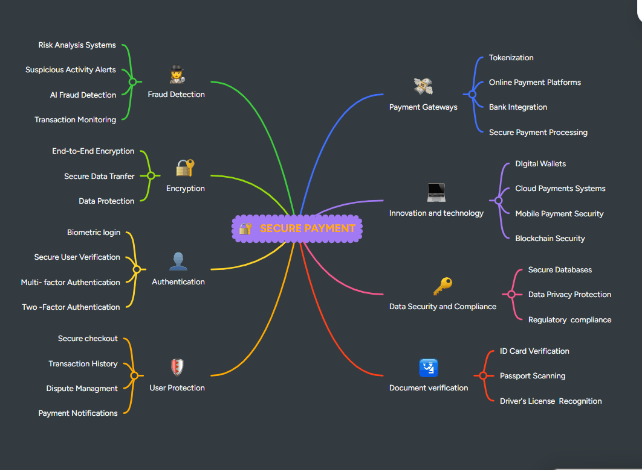

Task 3

Office Applications for Creating, Storing, Presenting, and Analysing Data

a. Explain four office (MS Word, MS PowerPoint, MS Excel, and MS Access), highlighting their major features, benefits, and limitations (if there are any). You can use some images in addition to text (approx. 4/5 sources).

Microsoft Word is mainly used for creating and editing documents. It offers features such as formatting tools, templates, and spelling and grammar checks that help users produce clear, professional work. For example, a company can use Word to write reports, letters, or contracts.
One of the main benefits of Word is that it is quite easy to use, even for people who are not very experienced with technology. It also allows users to work together by using comments and tracking changes, which is useful when several people are editing the same document. In my opinion, this makes it very practical in workplaces where teamwork is important [6].
However, Word is not perfect. Sometimes the formatting can change without warning, especially when the document is opened on a different computer. This can be frustrating and take extra time to fix. Also, it is not suitable for working with numbers or data, as it is mainly designed for text.

Basic and important steps of Microsoft Word [7].
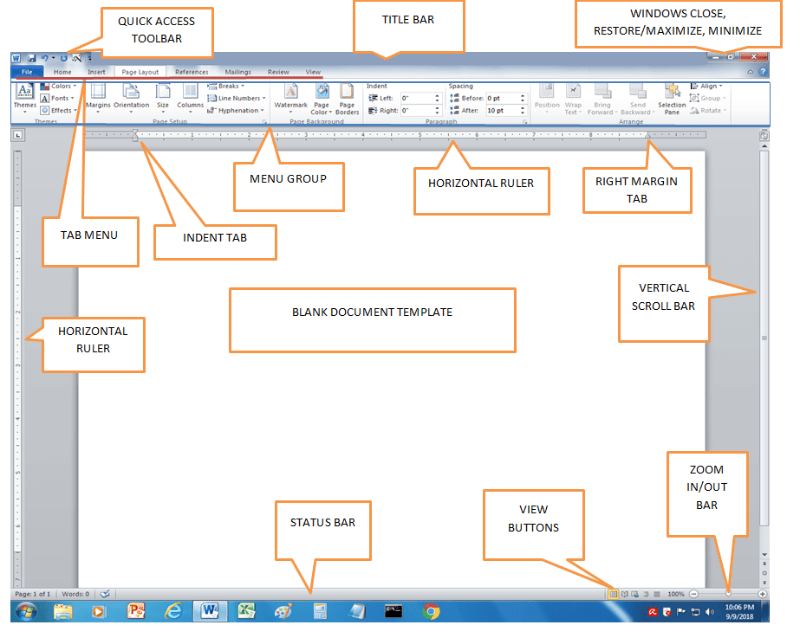

A very important feature is that Mail Merge is also called Mail Merge, and it is a very useful tool for businesses because it allows you to send personalised communications at scale without writing each message manually.
It basically works by combining two elements. Base document and database, as a base document, we have a letter, email, or invoice. As a database, a list of customers with names, emails, or addresses. The system automatically replaces fields, such as the name, with each person's real data.
In business, it is used to send mass campaigns with a personal touch: emails with the customer's name and specific offers based on their history.
Time and cost savings: avoid repetitive manual tasks. Instead of writing many emails, you can do it in minutes and reduce human error.
It is very useful for generating invoices and documents automatically using each client's data. Companies use it for internal communication, for example, employee notifications and personalised letters from human resources [8].

MAIL MERGE [9].
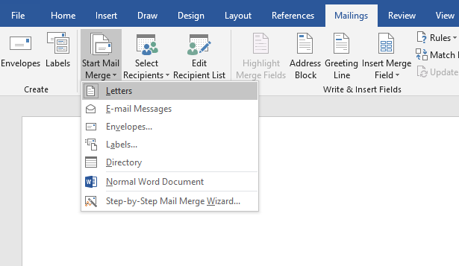

Another function is references, especially in IEEE; they are not only an academic requirement but also have practical applications in the business world.
Evidence-based decision-making allows proposals to be supported with reliable sources. Market research, technical reports, and scientific data. This makes your decisions more credible and reliable. In professional reports, IEEE references make them look more formal, building greater confidence among clients and investors. Compliance and transparency. Citing correctly prevents plagiarism, protects intellectual capacity, and improves business reputation
REFERENCES IEEE [10].
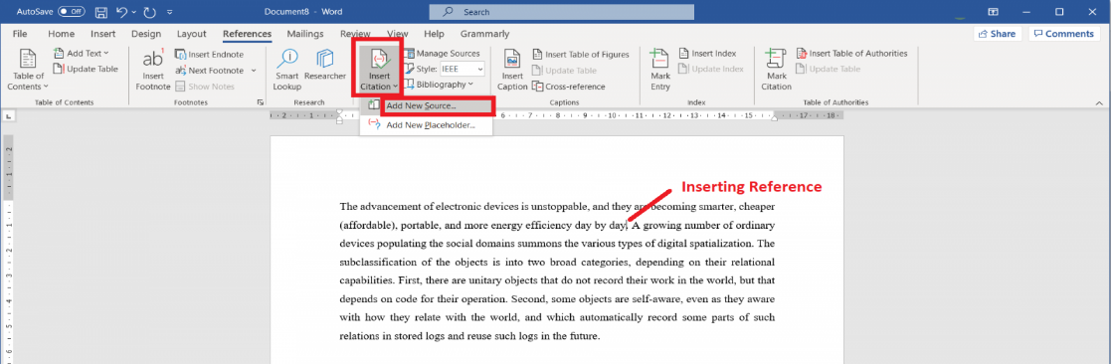

Microsoft Excel
Microsoft Excel is a powerful spreadsheet application used for organizing, analysing, and storing data. One of its key characteristics is the use of formulas and functions, which allow users to perform calculations automatically. Excel also includes tools such as charts and graphs that help present data visually. Another important feature is the use of pivot tables, which enable users to summarise and analyse large amounts of data quickly. These features make Excel a valuable tool for businesses that need to manage financial information or track performance.
The benefits of Excel are particularly important in decision-making processes. It allows users to work with large datasets efficiently and identify trends or patterns. This can help businesses make more informed decisions based on accurate data. Excel is also widely used across industries, including finance, marketing, and management, demonstrating its versatility. Additionally, it can save time by automating repetitive calculations and tasks.
Despite its advantages, Excel also has several limitations. For beginners, it can be difficult to understand how to use formulas and advanced features correctly. Even small errors in formulas can lead to incorrect results, which may affect business decisions. Another limitation is that very large spreadsheets can become slow and difficult to manage. Collaboration can also be challenging when multiple users edit the same file simultaneously, especially without proper version control [11].

Basic tools of ECXEL in business [12].
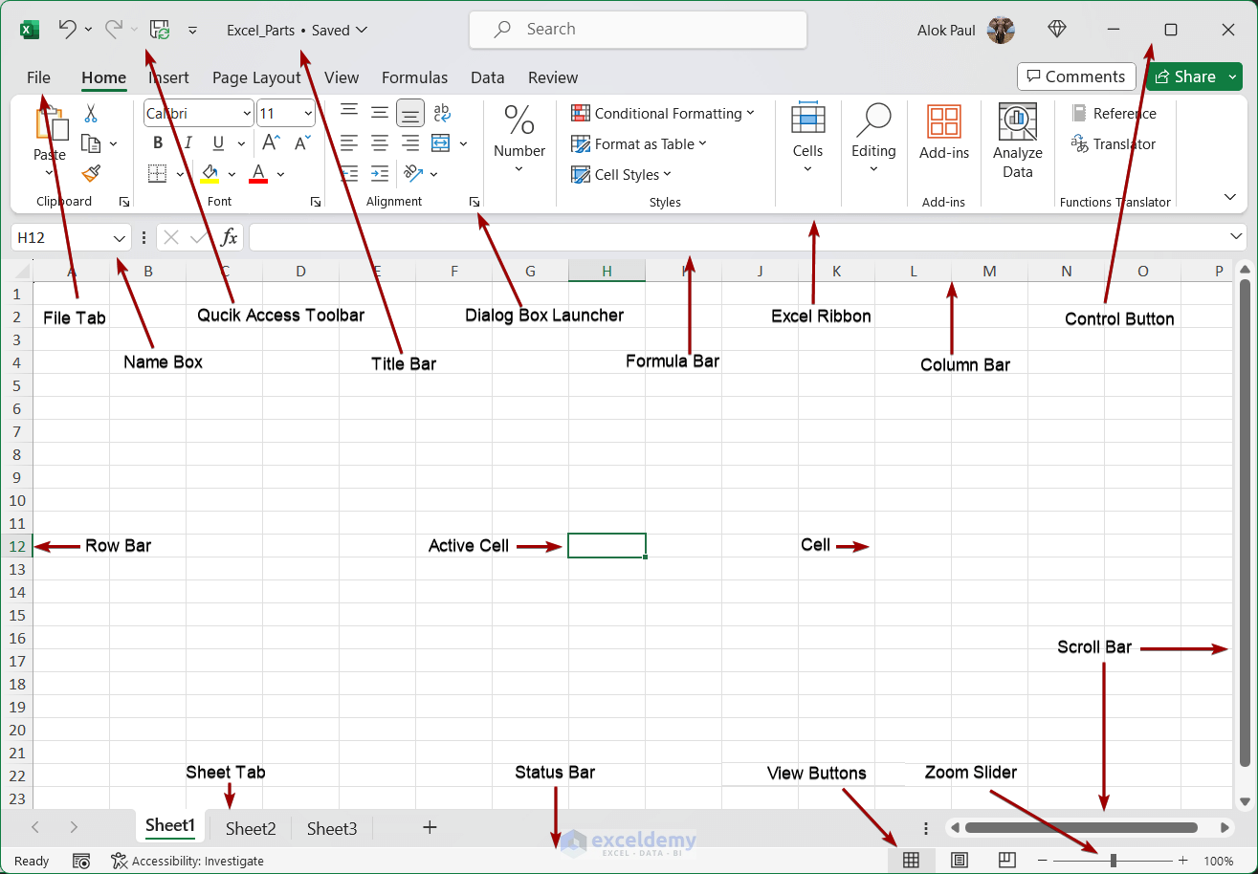

One of its most important functions is the IF function and the IFS function, which basically serve to make decisions automatically. The IF function is used when there is only one condition, and the IFS function when there are many. In business, they can be used in these ways. In a company, everything works with rules, such as, for example, if a customer buys a lot, it is important. IF it serves to make a simple decision: yes or no.
IFS is used to make several decisions based on different cases; in the business realm, it automates rules and saves time.

Example of the IF function [13].
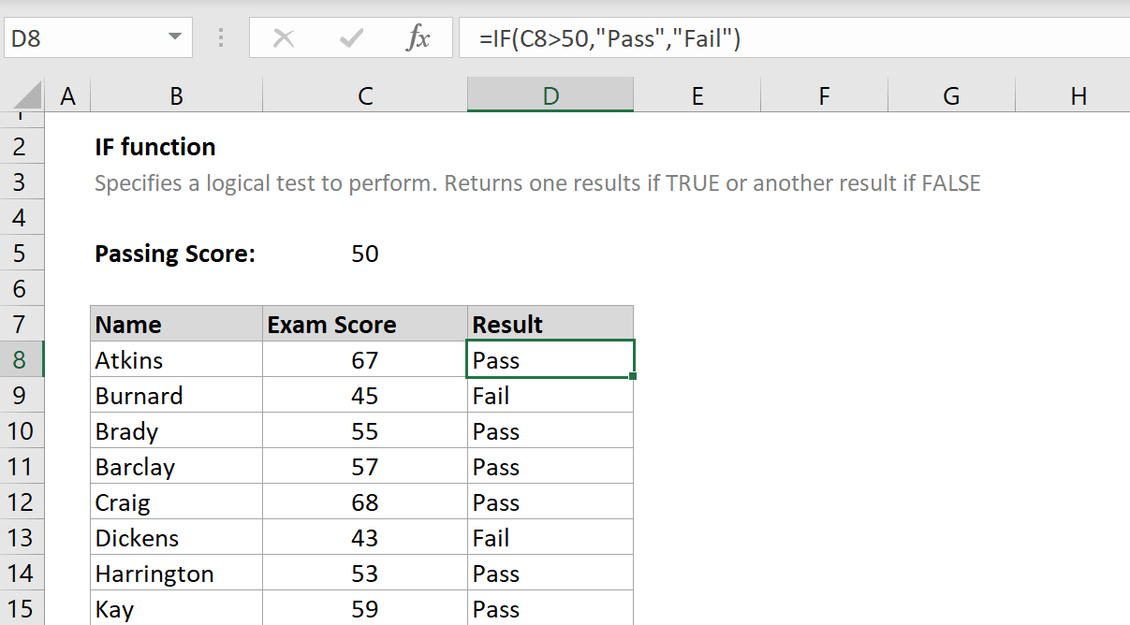

Example of the IFS function.
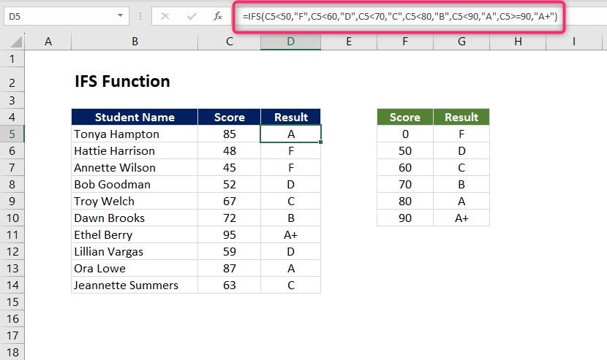

Another important feature is the PIVOT TABLE: it is a tool that summarises and organises large amounts of data easily. It's like making an automatic summary of a lot of information; Group and add the data without you having to calculate everything. In business, we can use it to see sales by product, analyse customers, review revenues, control inventory, and it is very important because it allows us to save time, analyse data quickly, find important information, and make decisions [14].

Examples of the PIVOT TABLE
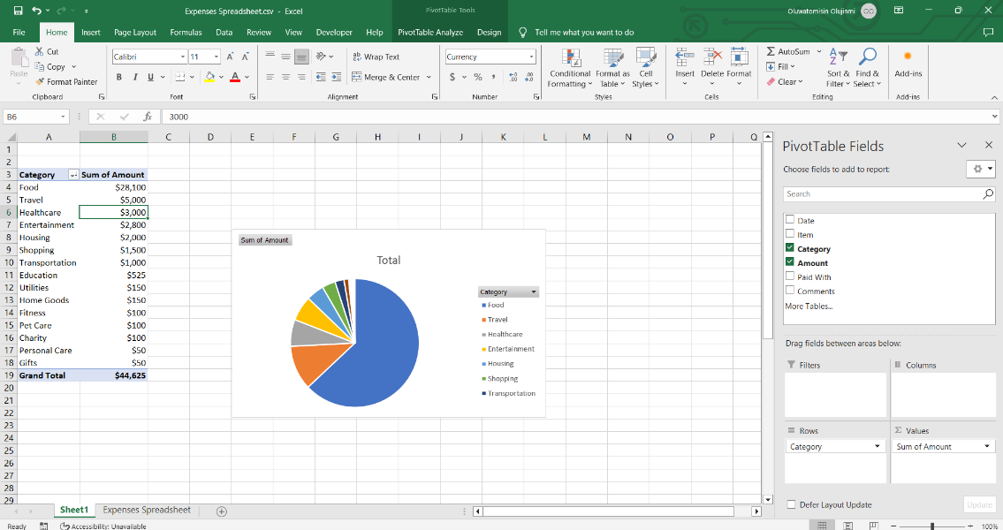

Microsoft PowerPoint
Microsoft PowerPoint is a presentation tool designed to help users communicate ideas visually. It allows users to create slides that include text, images, charts, videos, and animations. One of its main characteristics is the availability of design templates, which make it easier to create professional-looking presentations. PowerPoint also includes transitions and animation effects that can make presentations more engaging for the audience.
The main benefit of PowerPoint is that it simplifies complex information and presents it in a clear, structured way. This makes it particularly useful in business meetings, training sessions, and educational settings. Visual elements such as images and charts can help the audience understand the content more easily. Another advantage is that it allows presenters to organise their ideas logically and present them step by step.
However, PowerPoint also has its limitations. One common problem is that users often include too much text on slides, making presentations difficult to follow. Overusing animations and transitions can also distract the audience rather than support the message. Additionally, PowerPoint is not ideal for explaining very detailed or complex topics, as it is designed to summarise information rather than provide in-depth explanations [15].

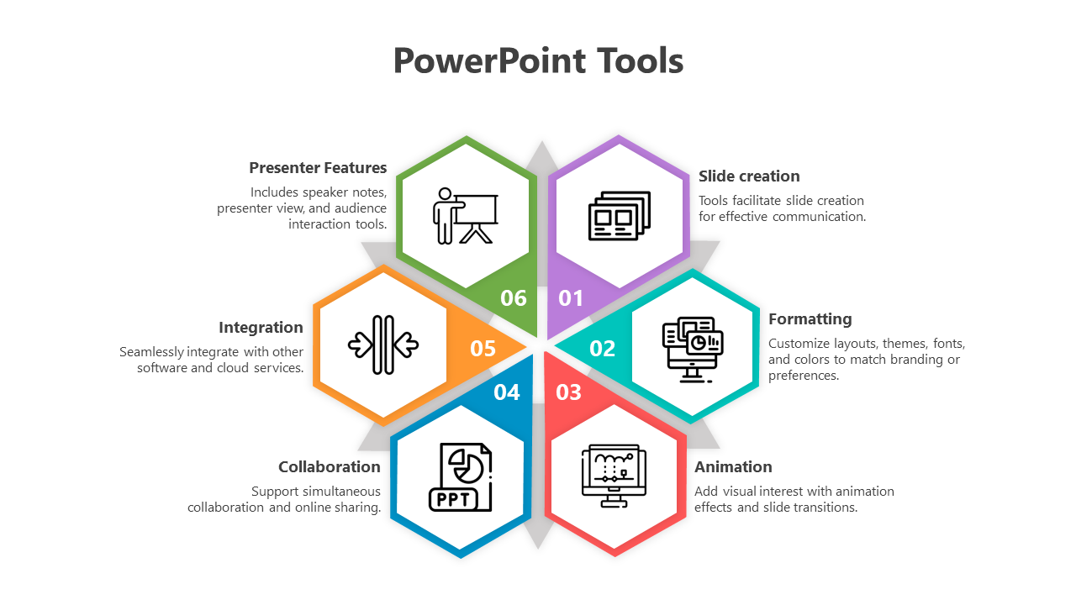

Basic tools of the PowerPoint in business.
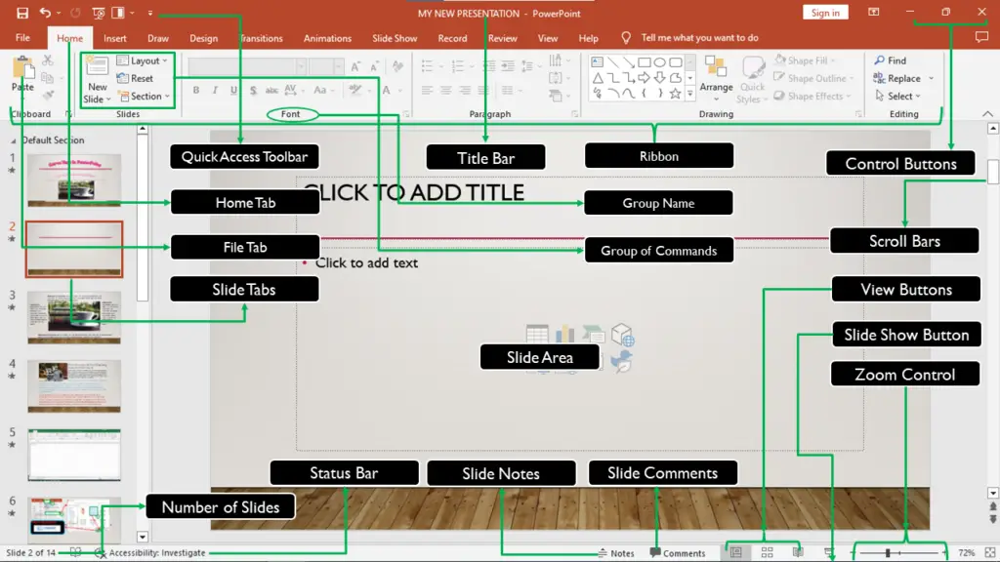

Microsoft Access
Microsoft Access is a database management system used to store, organise, and manage large amounts of structured information. One of its main characteristics is the ability to create databases that include tables, queries, forms, and reports. These tools allow users to store data efficiently and retrieve it when needed. Access also supports relationships between different data sets, which improves organisation and data accuracy.
The benefits of Microsoft Access are particularly useful for small and medium-sized businesses. It helps organisations manage customer information, inventory, and other important data in a structured way. Another advantage is that it integrates well with other Microsoft Office applications, making it easier to share and use data across different platforms. Access can also improve efficiency by automating data management tasks.
On the other hand, Access has some limitations. It can be difficult for beginners to learn because it requires an understanding of database concepts. It is also not suitable for very large organisations, as it has limitations in handling extremely large datasets compared to more advanced database systems. Additionally, compatibility issues may arise when working with other database software, creating challenges in some business environments [16].

Basic tools of Microsoft Access.

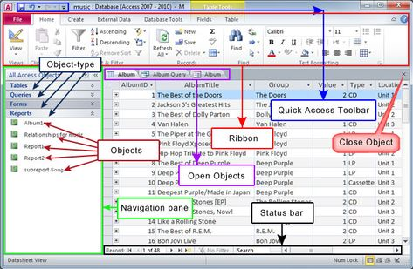

b. Test some (Two different functions/tools from two different software applications. Show the process step by step through screenshots) business-related features of Office Applications (e.g., Mail merge, IF Function, VLOOKUP, Pivot Table, Goal Seek, Database concept using MS Access) and document several screenshots with accompanying description to provide evidence of practical use.

MAIL MERGE
Step-by-step process.
Step 1: Go to the Mailings section.
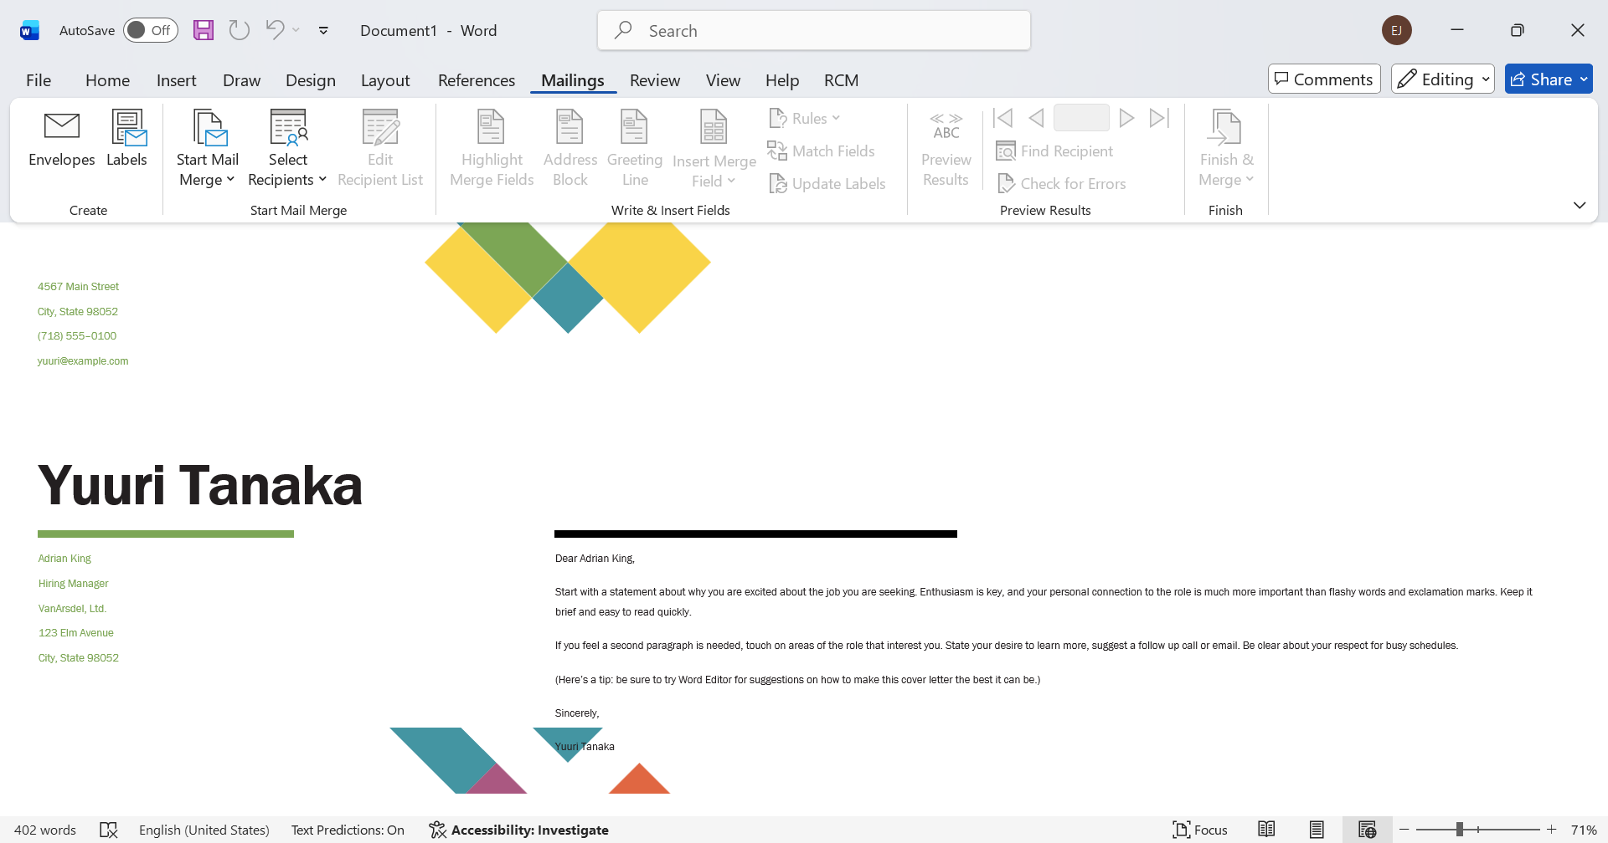

Step 2: Go to the star mail merge section and select letters.
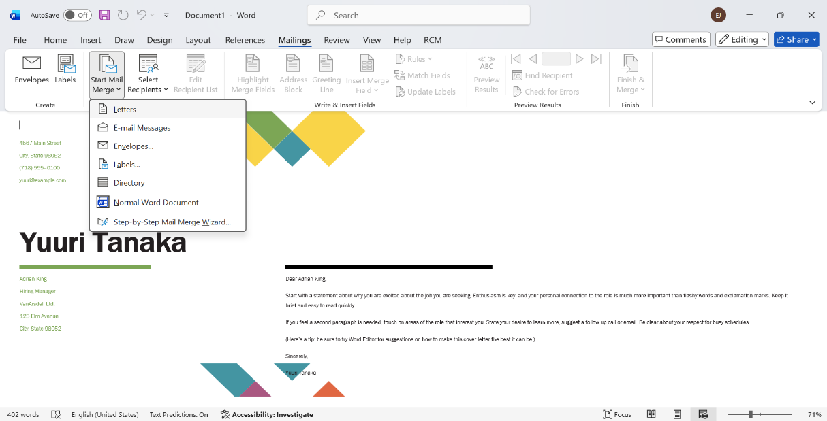

Step 3: After having selected the letter, which is what we will work on, we will now add the containers to the list where it says select recipients and we will go to the first box that says type a new list.
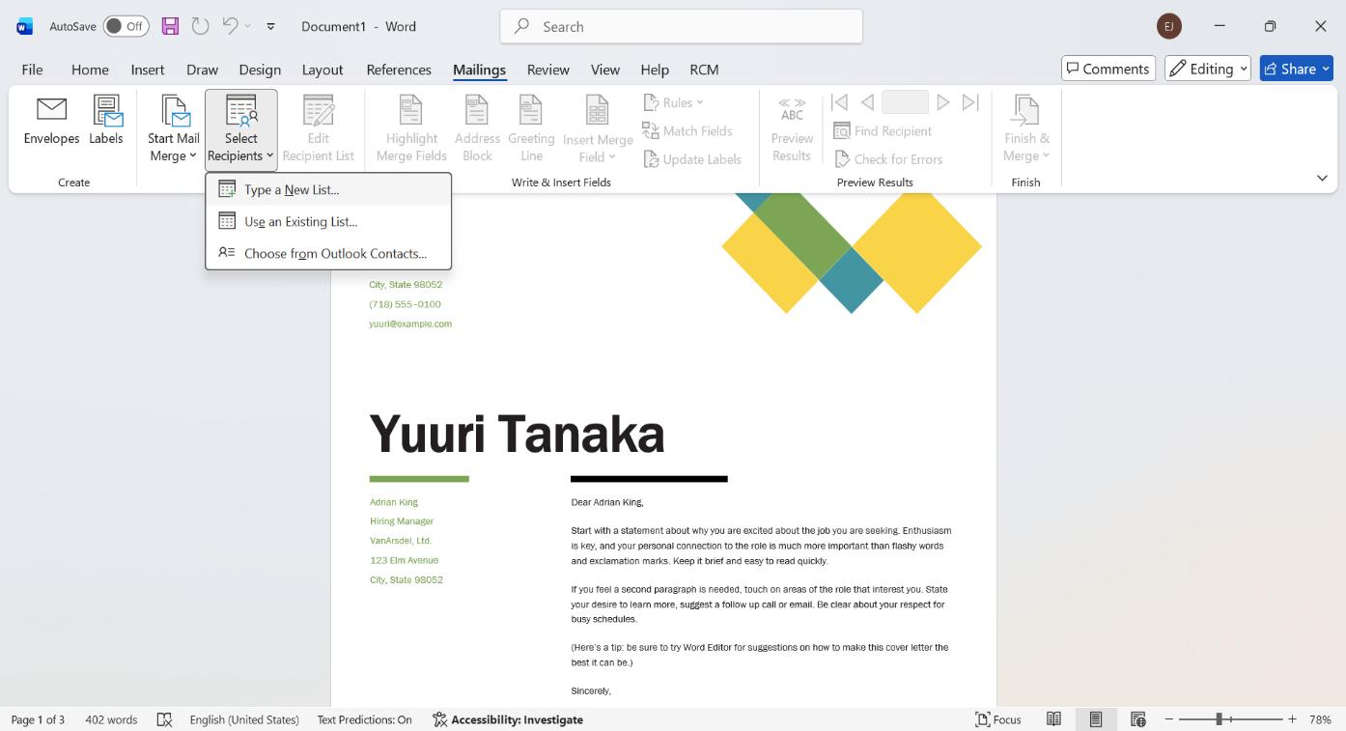

Step 4: we must start adding the information of the people we want in our list.
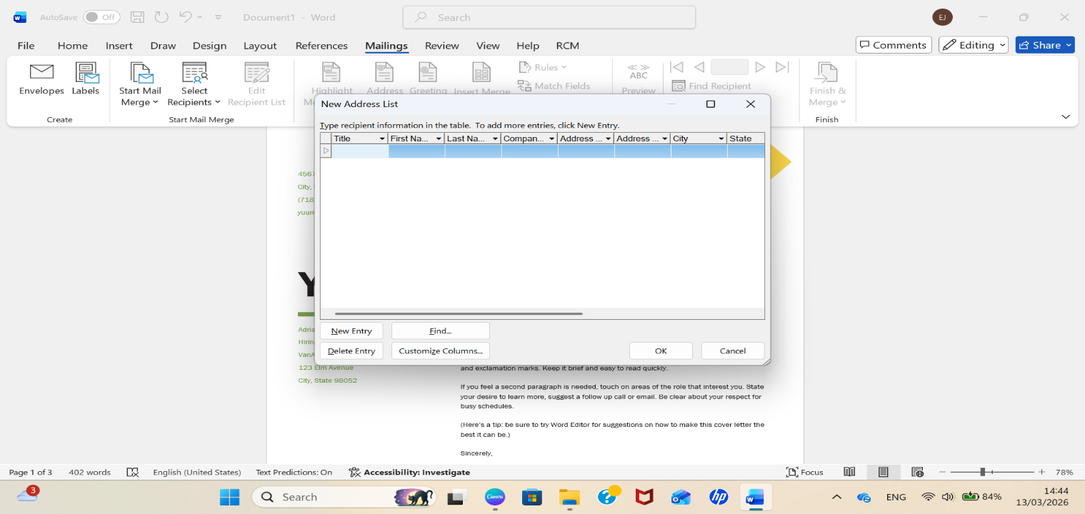

Step 5: Choose the information we need and delete what we don't need, for example, we will remove the company name, address line 2, state, home phone, work phone, and email address. Then we price ok and start adding the information we want.
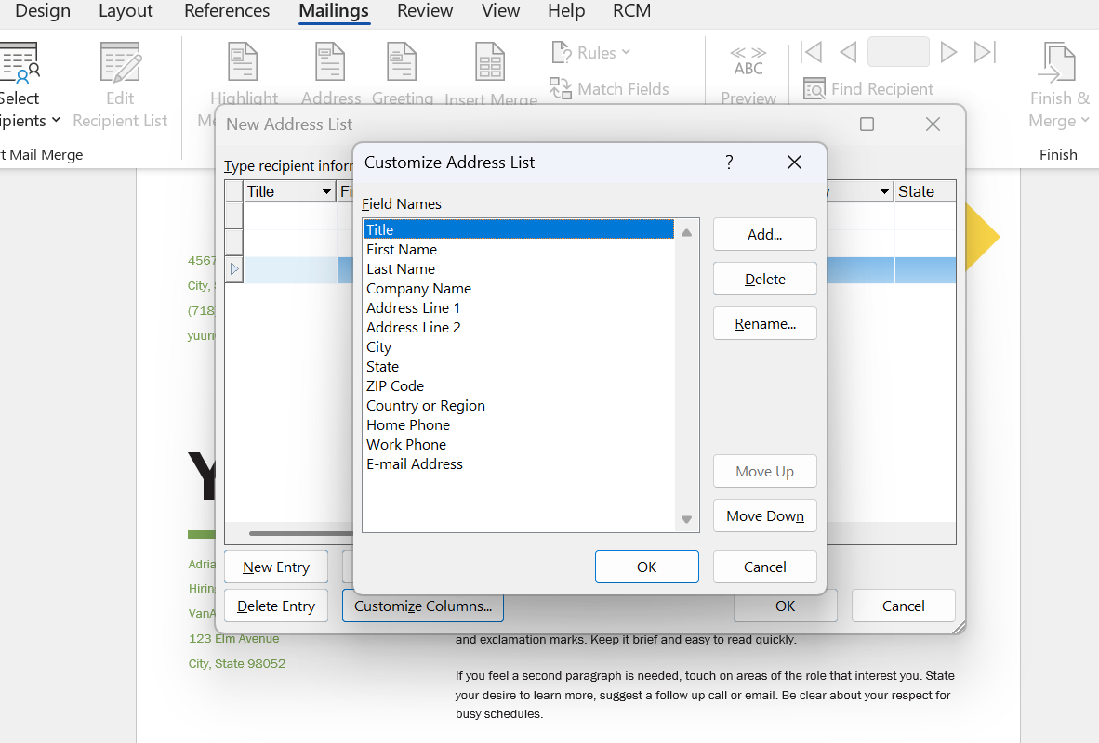

Step 6: We already added the information in total. There were 3 addresses, press ok to save the list.
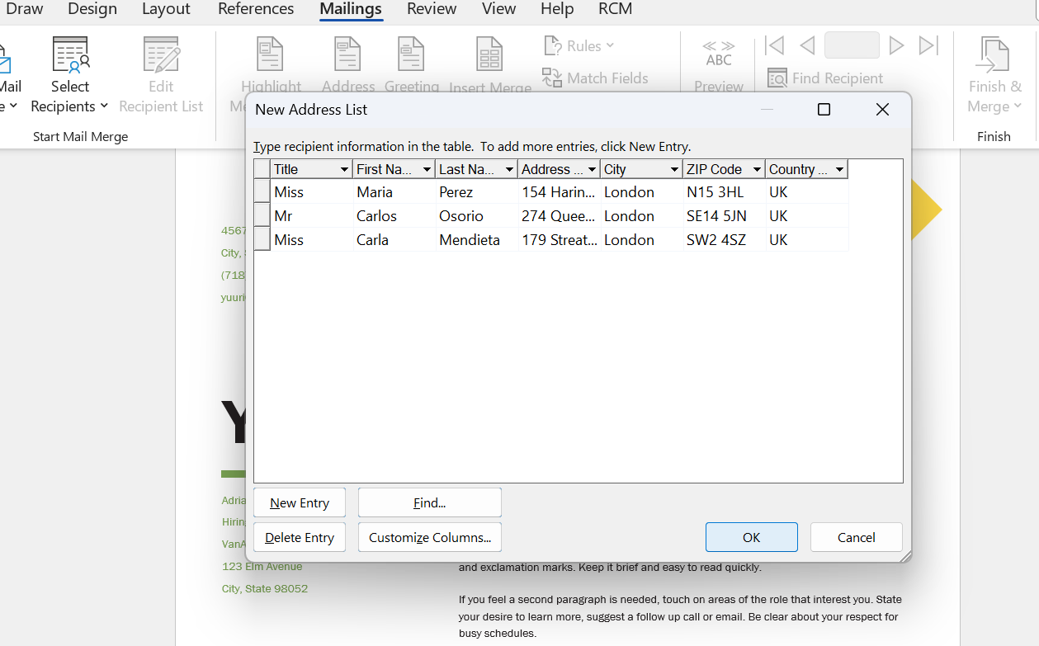

Step 7: We save the list in our archives so that we can select it later.
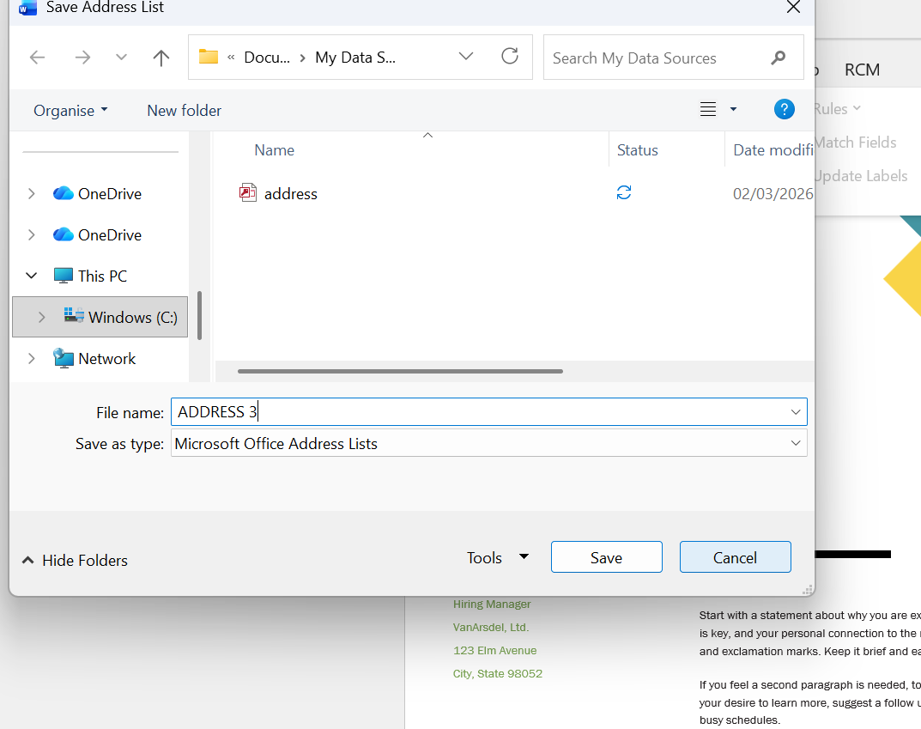

Step 8: we are going to insert merge field and press 1 by one the options to insert the information in our letter.
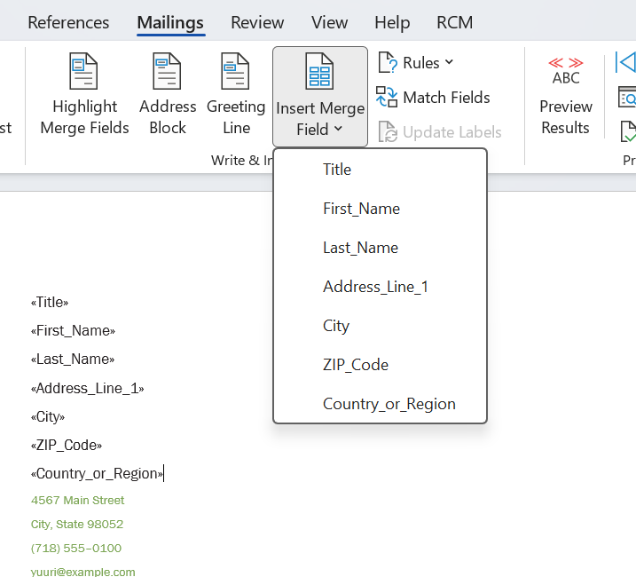

Step 9: Preview results and the first address automatically appear on the chart.
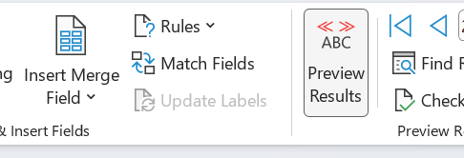

Step 10: This is the first address.
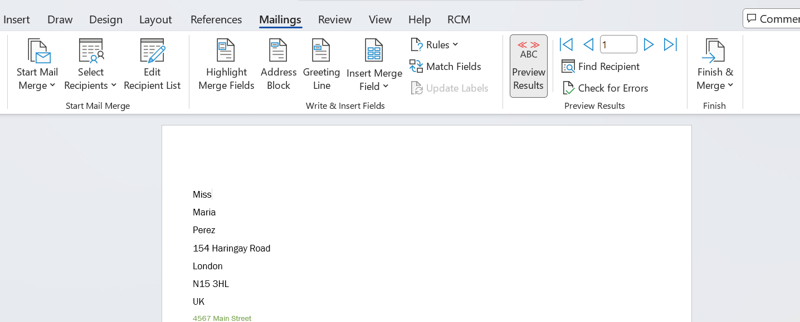

Step 11: this is the second address.
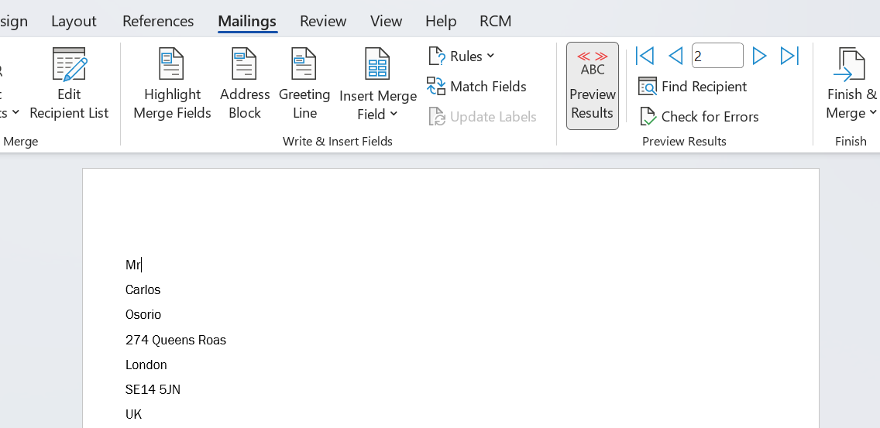
Step 12: In the last step, we click the blue arrow to change the recipient.

Pivot Table Function.
It is an Excel feature that allows you to easily summarise and organise large volumes of data.
Step 1: In Excel, we will create a table containing the information we want to summarise automatically.
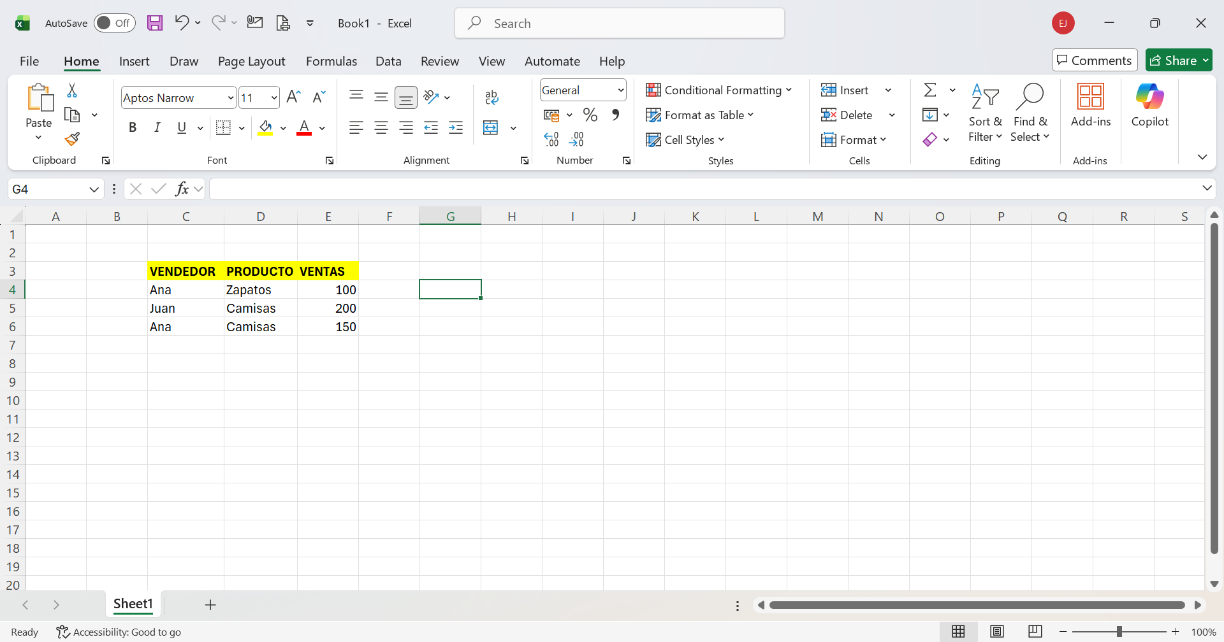

Step 2: We will select the Insert option.
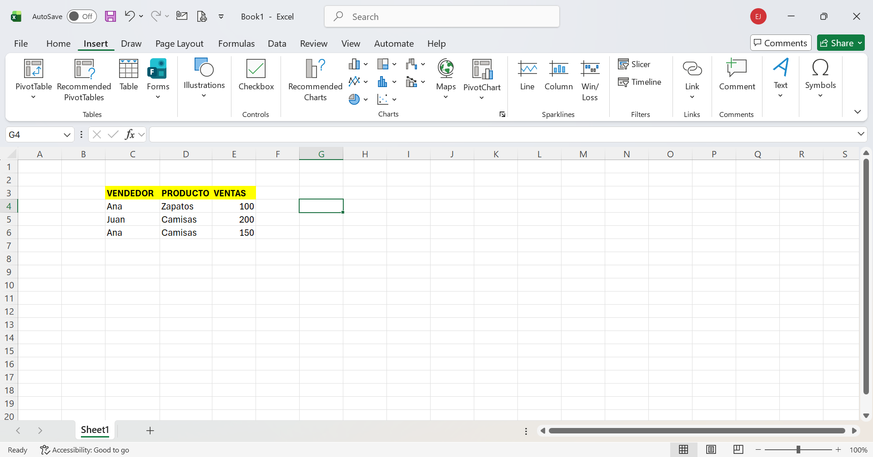

Step 3: We will select the entire table and then select the pivot table option.
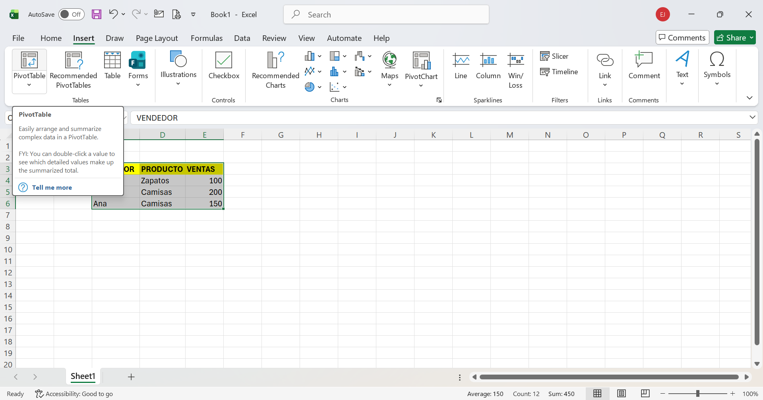

Step 4: When selecting the pivot table option, this box will appear, where the selected table ranges are shown. We will press OK to select.
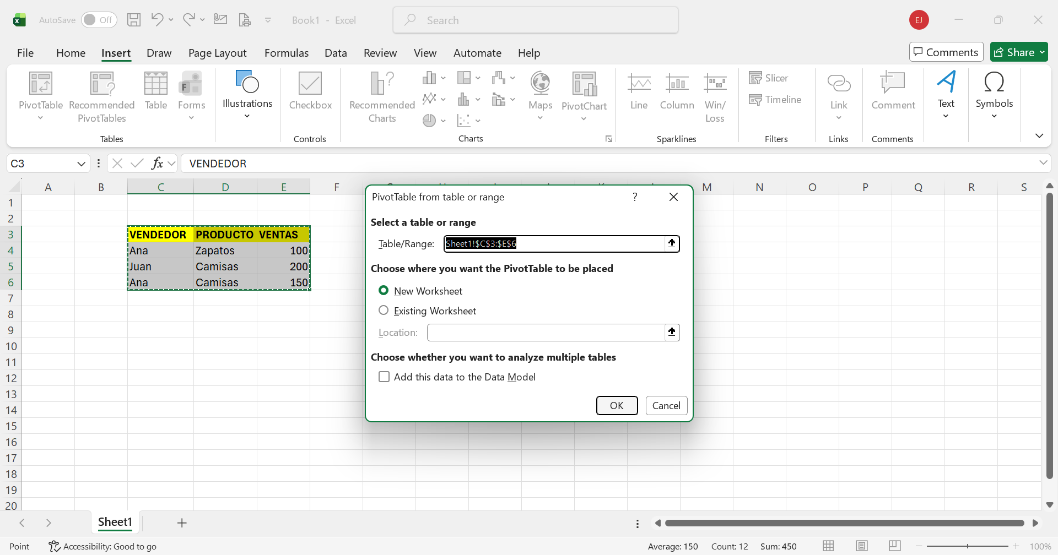

Step 5: Now the function is applied, now we must select the information we want to see, for example, if we want to see the products we have or the total sales. In this case, in my table, I select all of them.
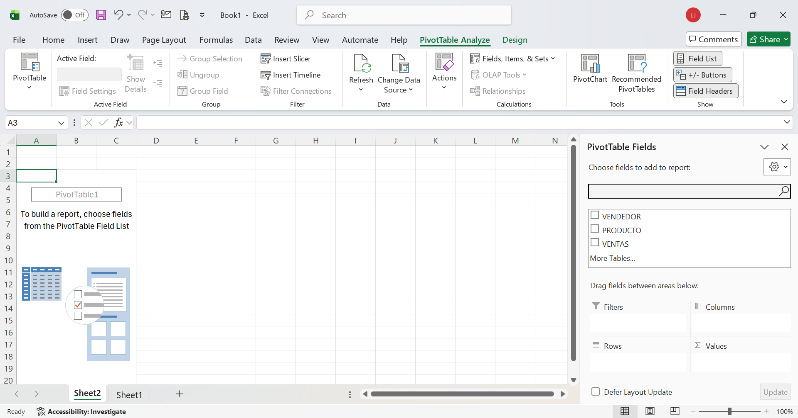

Step 6: It will look like this, and we will automatically see the total for the sale and organise each seller's sales.
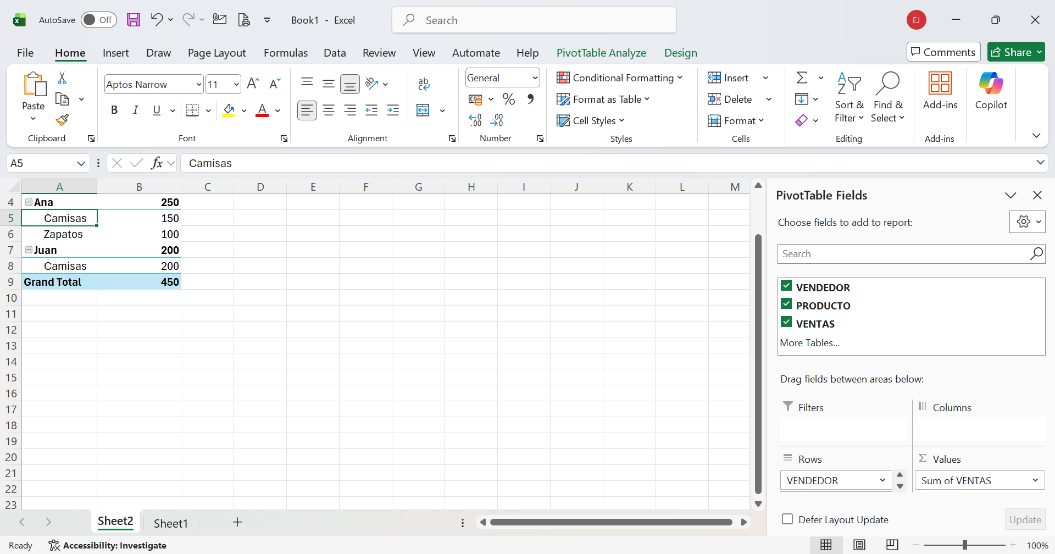

Task 4

Communication and Collaboration applications
a.Analyse one contemporary Communication (Email, MS Teams etc.) and one Collaboration (SharePoint, One Drive etc.) applications/tools used frequently in modern business world and document a summary of their key features, benefits and limitations using written text with some images and relevant citations. (approx. 2/3 sources)

Communication and Collaboration Applications
In today’s business world, companies use a range of apps to communicate and collaborate. These tools help employees share ideas, send messages, and complete tasks more easily. In this report, I will discuss one communication app, Microsoft Teams, and one collaboration app, SharePoint [17].

Microsoft Teams (Communication Application)
Microsoft Teams is a communication tool used by many businesses. It allows people to send messages, make calls, and hold online meetings.
One important feature is chat, which allows users to send messages to individuals or groups. Another feature is video calls, which are useful for meetings, especially when people are working from home. Teams also allows users to share files and collaborate on documents during conversations.
There are several benefits to using Microsoft Teams. First, it speeds up communication because people can send instant messages instead of emails. Second, it helps teams stay connected, even when they are in different places. Third, everything is in one app, which makes work more organised.
However, there are also some limitations. Sometimes there are too many messages, which can be confusing. It also needs a good internet connection to work properly. Some features are not free, and new users might find it a bit difficult at first [18].

SharePoint (Collaboration Application)
SharePoint is a tool used for collaboration. It helps people store and share files in one place, so everyone on a team can access them.
One key feature is file storage, which allows users to upload and save documents online. Another feature is sharing, which enables team members to work on the same file together. SharePoint also has a version history, so users can see changes and revert to older versions if needed.
The benefits of SharePoint are clear. It helps teams work together more easily because everyone can access the same files. It also keeps documents safe and organised. This makes it easier to find information when needed.
On the other hand, SharePoint has some disadvantages. It can be hard to use at first, especially for beginners. It may also require training to understand all its features. Like Teams, some functions are only available with a paid plan.
To conclude, Microsoft Teams and SharePoint are very useful tools in modern businesses. Teams helps people communicate quickly, while SharePoint helps them work together by sharing files. Even though both apps have some disadvantages, they are still very helpful for improving teamwork and productivity [19].

b. Test some features of a freely available Communication (1) and Collaboration (1) application and document several screenshots with brief accompanying descriptions to provide evidence of practical use.
Microsoft Teams.
1 This screenshot shows a chat in Microsoft Teams. I sent a message to test the communication feature. This shows how users can communicate instantly instead of using email, making communication faster.
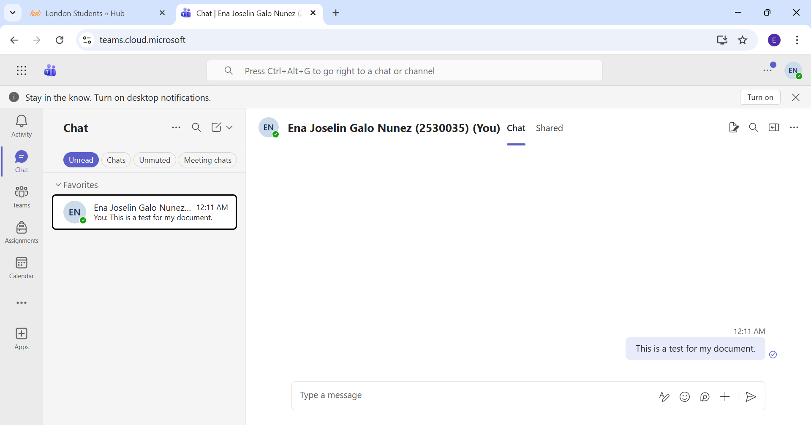

2 This screenshot shows a meeting in Microsoft Teams. This feature allows users to have online meetings, which is useful for remote work and team communication.
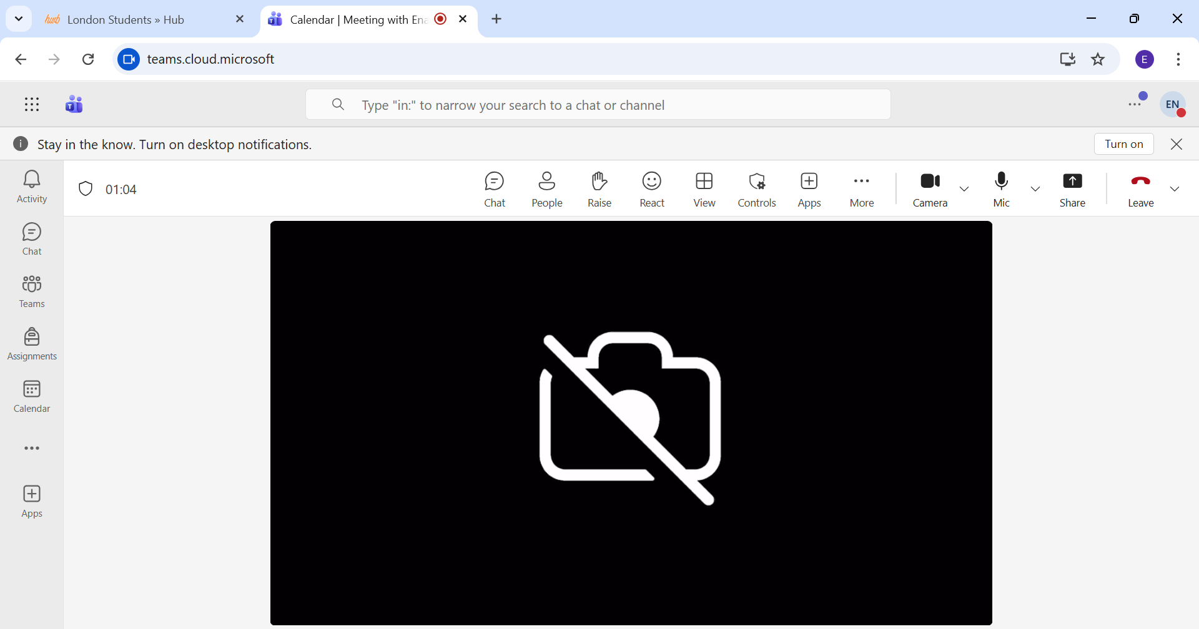
Google Drive.
1 This screenshot shows a file uploaded to Google Drive. This feature allows users to store files online and access them from any device.
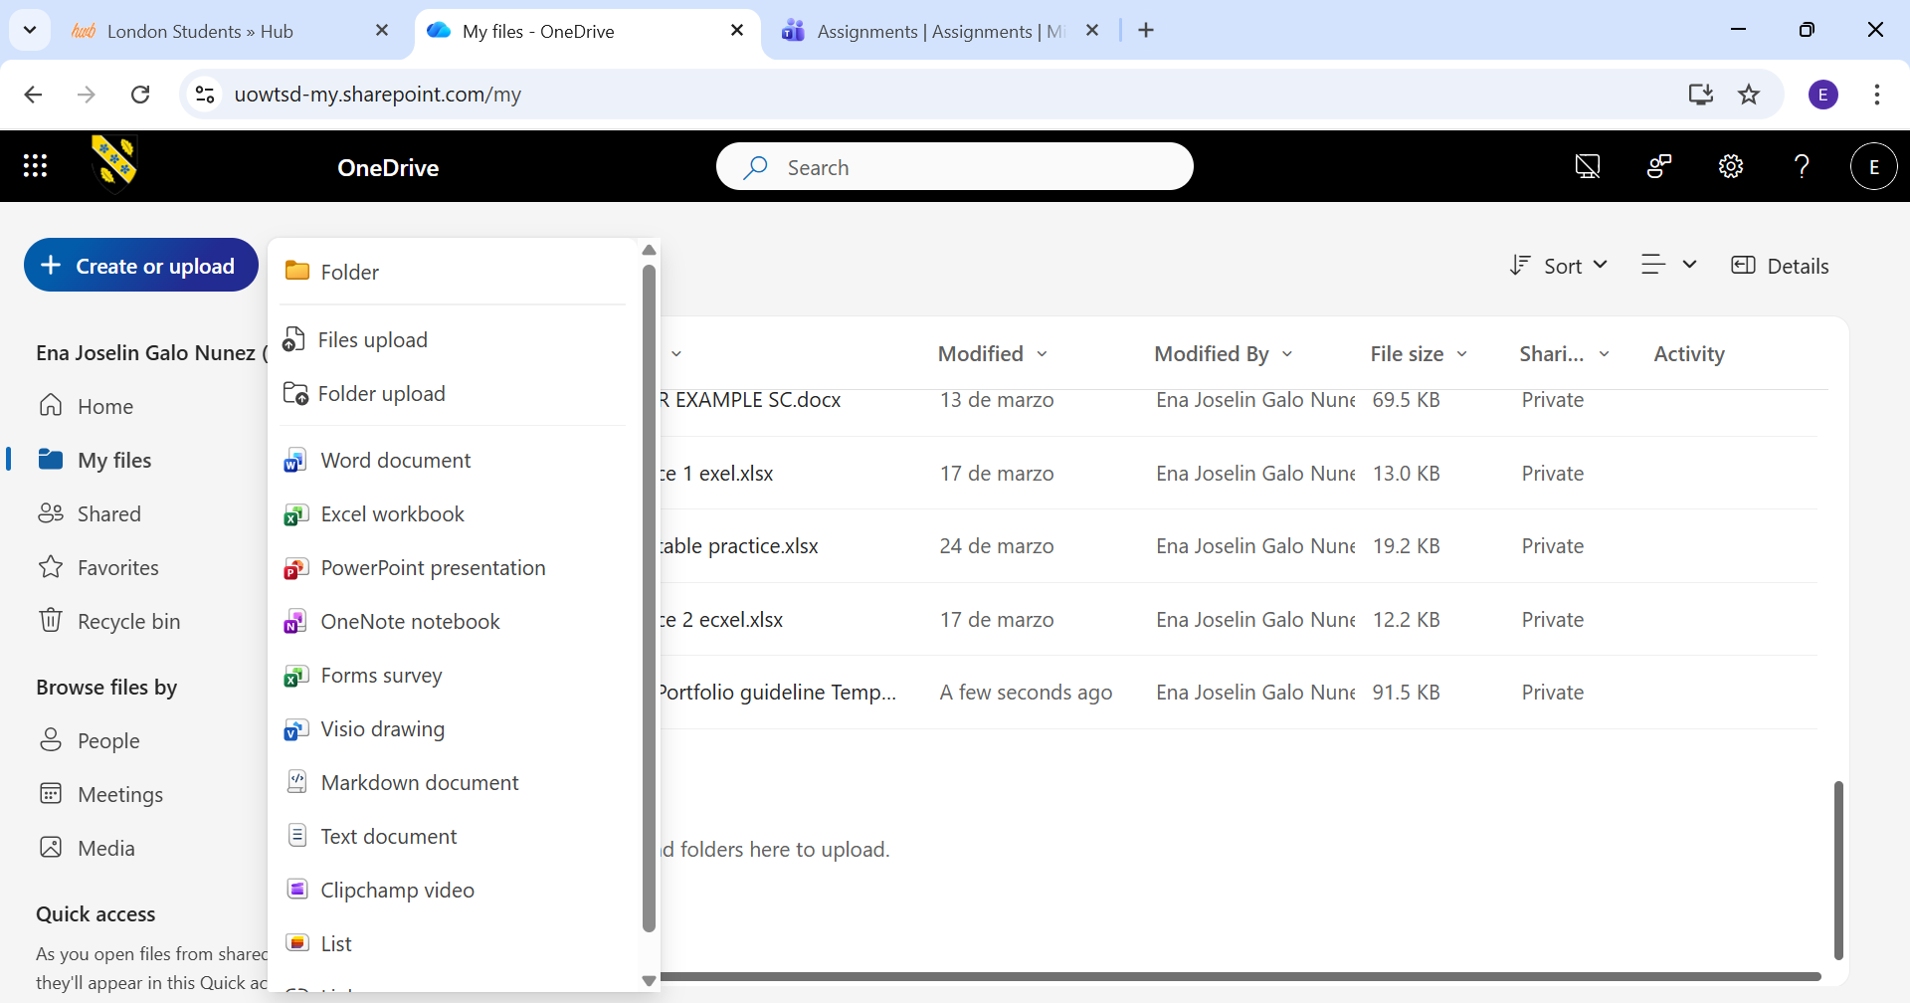
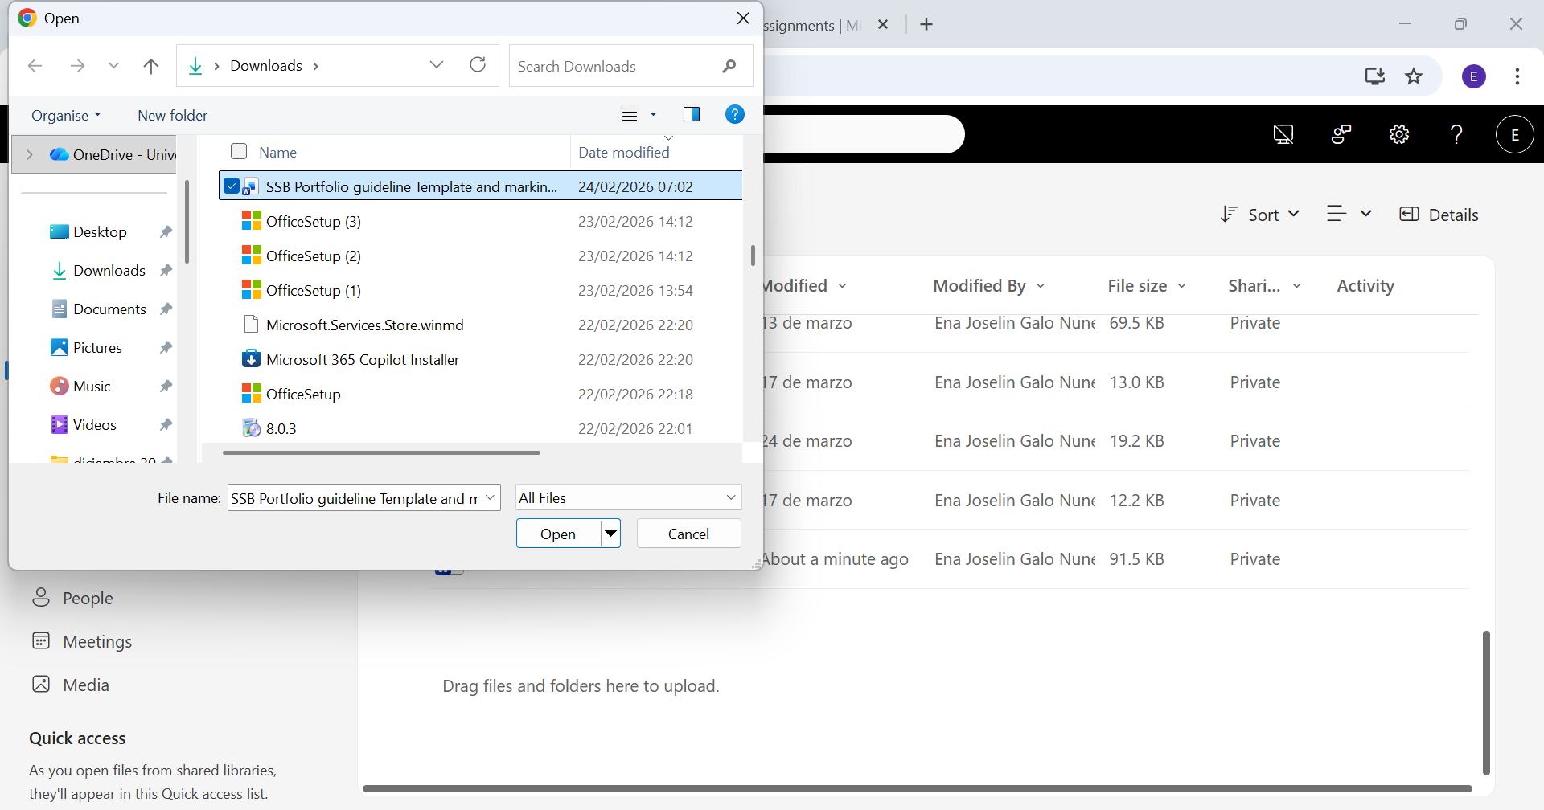

2 This screenshot shows the sharing option in Google Drive. It allows users to share files with others so they can work together easily.
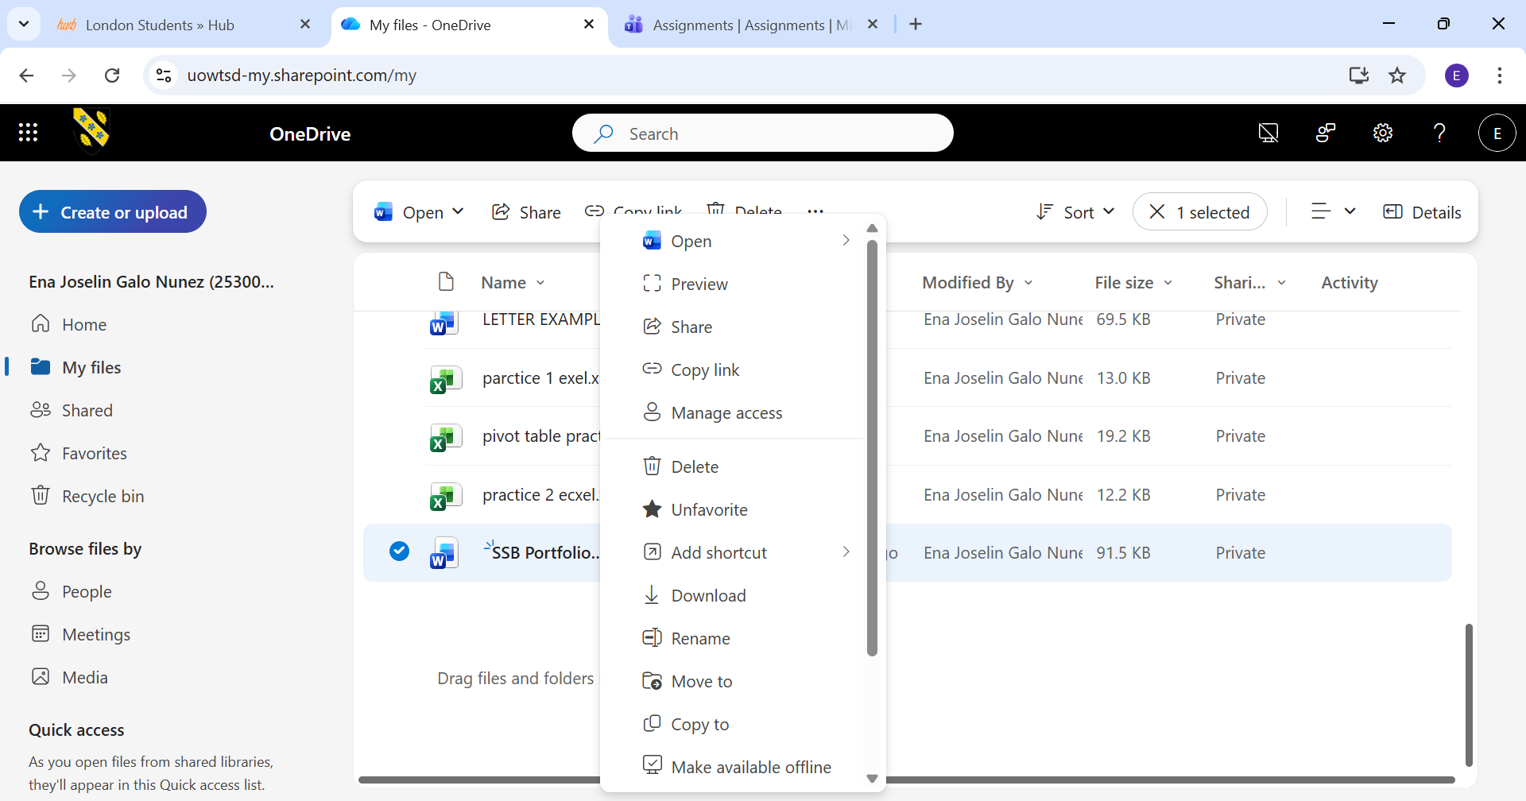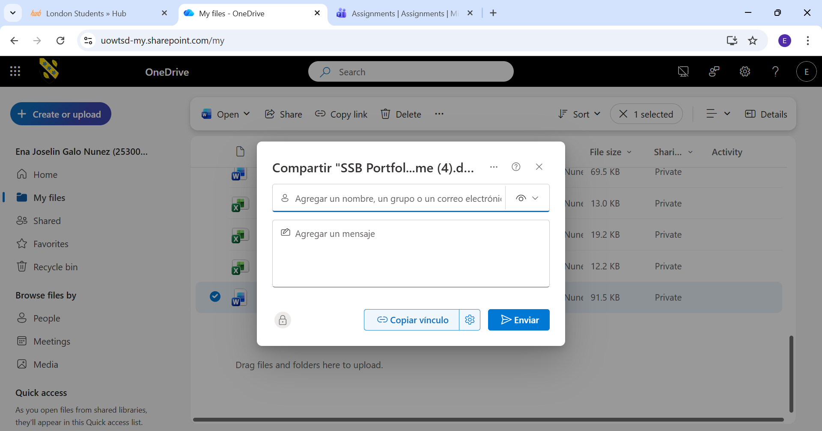

References

[1] | O. Gonzalez, “Digital transformation,” Future of people, 2021.
[2] | R. Boleso, “What are the advantages and disadvantages of Wix?,” Kendin.es, 7 4 2025.
[3] | H. Susilo, “Mind Mapping in Learning Models: A Tool to Improve Student Metacognitive Skills,” Learntechlib, vol. 15, 2020.
[4] | T. Buzan, Mind Maps for Business, Pearson UK: publishing corporation , 2013.
[5] | A. Buran, “Mind Mapping Technique in Language Learning,” Elsevier, vol. 206, pp. 215-218, 2015.
[6] | A. Jalil, “Exploration of FeaturesMicrosoft Word,” in Abdul Jalil, Copyright:© 2024by the authors, 2024, pp. 28-32.
[7] | Image, “Basic and important steps of Microsoft Word,” [Online]. Available: https://uk.images.search.yahoo.com/search/images;_ylt=AwrEt5CIQNppzA8B8mpNBQx.;_ylu=c2VjA3NlYXJjaARzbGsDYnV0dG9u;_ylc=X1MDMjExNDcxNzAwNQRfcgMyBGZyA21jYWZlZQRmcjIDcDpzLHY6aSxtOnNiLXRvcARncHJpZANETlJLY1gyMlF4ZUN2U0xJOV9ULmtBBG5fcnNsdAMwBG5fc3VnZwMxMARvcmlna.
[8] | J. A. E. Swope, “FRIC,” 01 02 1998. [Online]. Available: https://files.eric.ed.gov/fulltext/ED416400.pdf#page=63. [Accessed 21 02 1998].
[9] | Image, “Mail Merge example,” [Online]. Available: https://uk.images.search.yahoo.com/search/images;_ylt=AwrFYzMeX.5p7bQDv5lNBQx.;_ylu=c2VjA3NlYXJjaARzbGsDYnV0dG9u;_ylc=X1MDMjExNDcxNzAwNQRfcgMyBGZyA21jYWZlZQRmcjIDcDpzLHY6aSxtOnNiLXRvcARncHJpZANjT1A0Z1V1WFRBZUsuRnZ0NWRfeUpBBG5fcnNsdAMwBG5fc3VnZwM3BG9yaWdpb.
[10] | Image, “References IEEE example,” [Online]. Available: https://uk.images.search.yahoo.com/search/images;_ylt=AwrFYzPKYO5psncETppNBQx.;_ylu=c2VjA3NlYXJjaARzbGsDYnV0dG9u;_ylc=X1MDMjExNDcxNzAwNQRfcgMyBGZyA21jYWZlZQRmcjIDcDpzLHY6aSxtOnNiLXRvcARncHJpZANFZmZ1QlA4YlNJR0p3bmFKUS51MUpBBG5fcnNsdAMwBG5fc3VnZwMxBG9yaWdpb.
[11] | R. C. Fuller, “ADVANTAGES AND HAZARDS OF USING MICROSOFT EXCEL™ TO,” 13 APRIL 2011. [Online]. Available: https://bpb-us-e1.wpmucdn.com/sites.gatech.edu/dist/6/3466/files/2023/06/6.1.3Fuller.pdf.
[12] | Image, “Basic tools of ECXEL in business,” [Online]. Available: https://uk.images.search.yahoo.com/search/images;_ylt=AwrijD2IQ9ppq.A46QtNBQx.;_ylu=c2VjA3NlYXJjaARzbGsDYnV0dG9u;_ylc=X1MDMjExNDcxNzAwNQRfcgMyBGZyA21jYWZlZQRmcjIDcDpzLHY6aSxtOnNiLXRvcARncHJpZANNcGdRSmFsY1RMdU9hN0h1eWhsblRBBG5fcnNsdAMwBG5fc3VnZwM5BG9yaWdpb.
[13] | Image, “Example of the IF funtion in Ecxel,” [Online]. Available: https://uk.images.search.yahoo.com/search/images;_ylt=AwrFGouORNpp9ew4r_5NBQx.;_ylu=c2VjA3NlYXJjaARzbGsDYnV0dG9u;_ylc=X1MDMjExNDcxNzAwNQRfcgMyBGZyA21jYWZlZQRmcjIDcDpzLHY6aSxtOnNiLXRvcARncHJpZAM4dEVoWFAzdVFtS2dwWXpsZkxBWmFBBG5fcnNsdAMwBG5fc3VnZwMwBG9yaWdpb.
[14] | M. A. B Jelen, Pivot Table Data Crunching: Microsoft Excel 2010, 2010, pp. 3-25.
[15] | S. H. Webb, “The Journal of Research in Business Education,” 2013. [Online]. Available: file:///C:/Users/galoe/Downloads/USING+OFFICE+MIX+IN+ONLINE+BUSINESS+2017.pdf.
[16] | M. A. o. Alishov, “THE POSITIVE IMPACT OF MICROSOFT ACCESS IN EDUCATION,” European Journal of Education Studies, vol. 13, no. 1, pp. 1-10, 2026.
[17] | C. Maican, A study on academic staff personality and technology acceptance: The case of communication and collaboration applications, TRANSILVANIA, 2019, pp. 113-131.
[18] | B. Ilag, Understanding Microsoft Teams Administration, Apress Berkeley, CA, 2020, pp. 1-36.
[19] | P. Tucke, SharePoint Architect's Planning Guide: Create reusable architecture, Birmingham: packt publishing LTD. , 2022.

Conclusion

In conclusion, this assignment has shown the importance of different types of software applications in modern business operations. Each task focused on a different area, but together they highlight how technology supports efficiency, communication, and decision-making in organisations.
The e-commerce tools discussed demonstrate how businesses can easily create and manage online stores, enabling them to reach customers globally. Mind mapping tools were shown to be useful for organising ideas and improving planning, which is important in business environments. Office applications such as Word, Excel, and PowerPoint play a key role in handling data, creating documents, and presenting information clearly. In addition, communication and collaboration tools like Microsoft Teams and Google Drive help teams work together more effectively, especially when working remotely.
Although each application has its own limitations, such as complexity or the need for internet access, the overall benefits are much greater. These tools improve productivity, save time, and make business processes more organised.
By completing this assignment, I have also gained practical experience by testing features and capturing screenshots, which has helped me better understand how these applications are used in real-world situations. This knowledge will be useful in both academic work and future professional environments.

