LEADING AND IMPLEMENTING WORKPLACE CHANGE
Module 6103
Lecturer: Samuel Ofori

Student Name: Elvis Liviu Nassiri Basti
Student id:2112789

Executive Summary
This report evaluates Barclays' strategic change initiatives based on the response to regulatory pressures and the need for sustainability in the financial sector. Thus, it focuses on issuing green bonds and financing renewable energy projects, and Barclay aims to collaborate its business objectives based on environmental goals. Using Lewin’s Three-Stage Model, the report outlines a structured change management plan emphasising stakeholder engagement, communication, and evaluation. The active role of HR in fostering a sustainability-focused culture has been discussed, as well as ensuring these initiatives are integrated into the organisation’s core identity. Digital disruption and economic uncertainty in the UK have been influential in Barclays' business. It has created some uncertainty and challenging situations in managing the new change management process in the company. The level of new initiation followed by the change management process, which includes green bonds and renewable energy projects by Barclays, investment plans, and loan repayment procedures, have been influenced by these factors of the external environment. On the other hand, cultural aspects have also influenced the company and its change management process.

Table of Contents
A. Introduction 4
B. Current state of the company 4
C. Recent history of the organisation 5
D. Impact of changed external environment followed by digital disruption and economic uncertainty on the company 6
E. Issues related to strategic change in the company 11
F. Managing the change and appropriate leadership used 13
G. Impact of organisational culture on the change management programme 14
H. Suitable change management plan 15
I. Conclusion 18
Reference 19

A. Introduction
In recent years, Barclays has been facing developing regulatory pressures and market volatility, as there is an urgent need for sustainable practices in the financial sector. The company's commitment to addressing these challenges has been focused on strategic change initiatives, focusing specifically on sustainability. The issuance of green bonds and the expansion of financing for renewable energy projects highlight Barclays' dedication to collaborating with its business goals as environmental stewardship. Thus, it adapts to these changes, and Barclays aims to comply with regulatory demands by positioning itself based on the leader by corporate responsibility. Effective change management has been influential in successfully adopting these initiatives, necessitating a structured approach involving stakeholder engagement, clear communication, and robust evaluation mechanisms. Utilising frameworks like Lewin’s Three-Stage Model of Change, Barclays can navigate the complexities of transformation and foster a culture of sustainability that will improve its operational resilience and market competitiveness.

B. Current state of the company
It is stated that Barclays is currently operating in a transformative phase, strategically identifying the complex challenges based on the modern financial landscape. The bank has been focused on responding to significant regulatory pressures, rapid digital transformation, and a growing emphasis on sustainability (Barclays, 2024). Thus, it can recognize the volatile and unpredictable nature based on today's markets; Barclays has developed a robust change management framework to ensure its resilience and long-term success.
After that, it is observed that the cornerstone of this strategy is the bank's commitment to sustainability by its recent initiatives, like the issuance of green bonds. This move aims to support environmentally friendly projects to develop Barclays’ reputation as a responsible financial institution (Barclays, 2024). These initiatives have been addressing pressing environmental concerns as position Barclays favourably has been an increasingly competitive market as consumers have providing the prioritizing sustainable practices.
On the other hand, Barclays has actively embraced digital transformation, improving its technological capabilities by meeting evolving needs based on its customers. The integration of advanced technologies has been essential for developing operational efficiency and providing innovative financial solutions and is crucial in maintaining a competitive edge in the banking sector (Barclays, 2024). It is considered that major drivers of organisational change, such as technology, government, and globalization, have been influencing Barclays' strategic direction.

C. Recent history of the organization
Nowadays, Barclays has undergone significant transformations driven by regulatory changes, digital innovation, and sustainability commitments. Therefore, in the global financial crisis of 2008, the bank faced intense scrutiny by leading substantial regulatory reforms aimed at developing transparency and accountability (Flesch, 2024).
On the other hand, in 2016, Barclays announced, based on a strategic shift, that it would sell its African operations by concentrating on the core UK and US markets. This decision was part of a broader strategy that was simplified based on its business model to improve operational efficiency (Flesch, 2024). In 2018, Barclays launched a mobile banking app, which has achieved millions of users, demonstrating by bank's commitment to providing innovative financial services.
After that, Barclays made significant strides based on sustainability, issuing its first green bond in 2020 based on the finance of renewable energy projects. The bank's strategy has expanded its financing for green initiatives by targeting net-zero carbon emissions by 2050 (Monasterolo et al., 2024). This financial performance underscores the focus on effectiveness by its strategic initiatives and resilience in implementing a dynamic marketplace (Ajayiand Pollitt, 2024).
SWOT analysis
Strengths:
- Strong Financial Performance: Barclay focuses on the largest financial institutions in the UK, with a solid revenue base. In 2022, Barclays reported revenues as £24.96 billion, based on the financial resilience (Alexakis, 2024).
- Sustainability Commitment: The bank has evaluated leadership in sustainable finance, as issuance of over £1.25 billion based on green bonds and a commitment to facilitating £100 billion in green financing by 2030.
- Digital Transformation: Barclays has invested heavily in fintech as well as digital platforms, allocating £900 million in 2022 for developing mobile banking by online services and building competition based on the digital banking space (Dogan and Lemmen, 2023).
Weaknesses:
- Fossil Fuel Financing Exposure: Based on its commitment to sustainability, Barclays has been criticized for financing fossil fuel projects up to $5.7 billion in 2022 (Mager and Schultz, 2024).
- Regulatory Fines: Barclays has been facing £26 million based on fines from the Financial Conduct Authority in 2021 for operational failures, highlighting challenges by regulatory compliance and risk management.
Opportunities:
- Growing Sustainable Finance Market: The global sustainable finance market has been developing at a Compound Annual Growth Rate (CAGR) of 14.5% by providing Barclays with an opportunity to capitalize on the demand for Environmental, Social and Governance (ESG) investments as well as green financing (Bank, 2024).
- Technological Innovation: Continued investment has been focused on AI as well as blockchain by developing improved operational efficiency, customer experience, as well as transparency, specifically in sustainable finance.
Threats:
- Regulatory Pressures: Developing UK government regulations based on ESG disclosures and climate-related financial risks can raise compliance costs by exposing Barclays to fines based on non-compliance.
- Market Volatility: The UK economy has been facing inflation based on 6.7% and recession risks by decreasing consumer spending and borrowing, affecting Barclays’ profitability (Townsend, 2024).

D. Impact of changed external environment followed by digital disruption and economic uncertainty on the company
Overview of Digital Disruption
The digital disruption factor in the UK context has been identified towards the rise of vintage and Artificial Intelligence in the technology of financial services. In the year 2023, it has been evidenced that about £13.3 billion investment has been made by the UK fintech sector, where robust growth and innovative strategies are evident (Almarzoqi and Mathis, 2024). On the other hand, factors of customer expectation changes and evaluation regarding the digital experience they have found in their service sector have been some evident factors in the digital description.
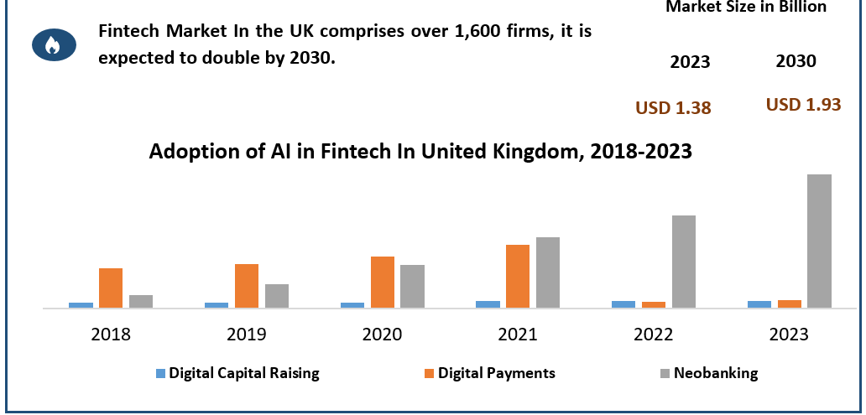
Figure 1: Fintech market of the UK
(Source: Puschmann and Michael, 2024)
In this case, the customers have demanded personalised services and greater transparency, and the stage of the post-pandemic situation has been the evident factor. Over 60% of UK consumers have been observed to prefer online banking services rather than the manual process (Ofori-Okyere et al., 2023). In this case, the agility and flexibility of the digital financing of the company Barclays have been found to follow some more Agile and flexible Change management processes regarding its green bonds and financial investment.
Impact on the company
It has been evident that the quick response to this digital disruption into the context of the UK financial sector, the shifting of the digital transformation in the banking companies, has been found. Integrating the agile process regarding the digital disruption method is also responsible for changing market demand and customer demand (Ofori-Okyere et al., 2023). This digital destruction process in the financial sector of the UK is done with the establishment of cross-functional teams where the prospects of product development and iteration of the changing demand of customers have been found (Papathomas and Konteos, 2024). In the year 2023, the report of Barclays found that 25% of increased revenue was found from the digital banking platform (Hakizimana et al., 2023). This factor is a significant associating feature of the UK's external environment, where the implementation of some comprehensive training programs and digital skill development processes is emerging. In the year 2022, Barclays Company made an investment of about £120 million in training and development.
Impact on company’s change management
Following the process of digital disruption, the company Barclay has prioritised its Sustainable Finance. The installation and initiation of the green Bond Framework has been done by the company Barclay following its financial projects that have been a contribution towards the environmental responsibility of the UK (Shirai, 2023). Following the process of digital disruption, it has been evident that in 2023, the Green Bond Association of Barclay has been projected to value £1 in the UK, where the commitment to renewable energy projects has also been implemented (Dragomir et al. 2023). Following this, the company Barclays has projected the collaboration of some renewable energy companies and the transition towards the low-carbon economy.
Overview of economic uncertainty
The inflation of Brexit and the global economic shift are the factors that cause economic uncertainty in the context of the UK. In this case, the role of the COVID-19 outbreaks and some regular and particular Change management processes in the context of UK business is evident. In this case, this factor is the inflation rising rate of 6.7% in the year 2023 of September, which has impacted both the customers and business aspects of the UK (Morgan et al. 2023).
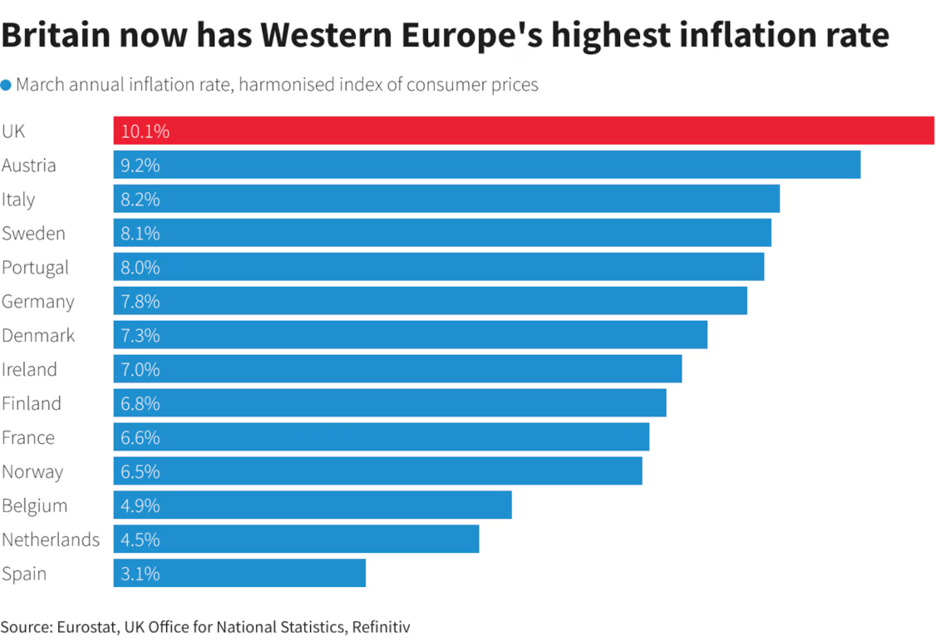
Figure 2: Inflation rise rate of the UK
(Source: Bruce, 2023)
Impact on the company
Following the impact of this economic uncertainty in the UK, the business perspective of Barclays has been found to be evident in the decreased borrowing factor. In the case of Barclays, it has been found that the management of credit risk assessment and the availability and potential of managing such loan and debt-related factors have been effective (Siering, 2023). Following these, it has been evident that in October of 2023, the base rate of the England Bank was found to be 5.25%, which has been impactful towards the increased rate of existing loans and demand of the new loan from the business perspectives of Barclays (Le et al. 2023). In the case of managing the investment power and Wealth Management divisions of Barclays, the rate of lower transition is reduced following the advisory fees of this company (van der Heide, 2023).
Impact on change management
Following the economic uncertainty in the UK, Barclay has faced challenges regarding its green bond issuance following its change man instrument process. It has been evidenced that the effective environment and consciousness regarding the investor's engagement towards the project this economic down from has been effective there (Manjengwa et al. 2023).
Political Factors
Barclays, as a UK bank, has been facing ongoing regulatory challenges. The UK government has ramped up based on regulatory oversight by financial institutions, specifically regarding “environmental, social, and governance (ESG) practices”. The Bank of England's “Climate Biennial Exploratory Scenario (CBES)” in the year 2021 has required banks to assess their exposure to climate risks, placing developing scrutiny on Barclays has been demonstrating a commitment to sustainability. In the year 2021, the UK government committed to decreasing carbon emissions by 78% by 2035, as influenced by Barclays based on the issue of green bonds (Griffith and Nicholls, 2024). Barclays has issued over £1.25 billion based on its green bonds as part of its sustainable financing strategy, positioning itself as the leader in green finance. It is observed that the “Financial Conduct Authority (FCA)” has been introducing post-Brexit rules by adding complexity to Barclays' compliance costs, projected to develop by 5-10% cause of dual regulatory standards among the UK and the EU.
Economic Factors
The UK economy has faced significant challenges recently, including the aftermath of Brexit, the COVID-19 pandemic, and inflationary pressures. As of 2023, UK inflation reached 6.7%, as interest rates rose to 5.25%, based on Barclays' lending operations. In 2021, the global sustainable finance market has been valued at $35.3 trillion. It is expected to develop 15-20% annually, providing Barclays with growth opportunities based on its green bond programs and ESG-focused investments. Barclays has also pledged to facilitate £100 billion in green financing by 2030, collaborating with its long-term strategy to capitalize on the growing demand for sustainable investment products (Gutterman, 2024). The UK economy contracted by 0.2% in the third quarter of 2023 as a developing potential recession, further decreasing Barclays' revenue streams by corporate lending and investment banking.
Social Factors
Public demand for ethical banking, as well as sustainable practices, has surged. The survey conducted by Deloitte found that 57% of UK consumers prefer engaging with companies that demonstrate a commitment to sustainability. It is observed that 77% of millennials prefer mobile banking, driving Barclays ' investment in digital transformation (Gbadamosi, 2024). In 2022, Barclays allocated £900 million to developing digital services, focusing on mobile banking apps by online platforms, as the tech-savvy, sustainability-conscious customer base.
Technological Factors
Barclays has been facing developing competition from fintech firms, based on the UK-based fintech companies rising over £11.6 billion as funding in 2021 alone. It is focused on remaining competitive. Barclays has invested heavily in technology, specifically sustainable finance platforms. It is observed that Barclays, launching its Green Innovation Fund, has been investing £175 million in digital technologies supporting climate change mitigation efforts (Arnold-Dwyer, 2024). Technological advancements have included artificial intelligence (AI) and blockchain, which have reshaped the financial industry. Moreover, leveraging these technologies, Barclays aims to develop a position in the sustainable finance sector, a market expected to develop a compound annual growth rate (CAGR) of 14.5% over the next decade.
Legal Factors
Barclays has been focused on complying with many legal requirements around sustainability reporting. The UK Green Finance Strategy, updated in 2023, mandates that all large companies disclose based on their climate-related financial risks under by Task Force on “Climate-related Financial Disclosures (TCFD)” framework (Gebhardt et al. 2024). Barclays has been actively involved in collaborating with these requirements, reporting its exposure to high-carbon sectors and pledging to decrease financed emissions by 30% by 2030. Non-compliance, such as regulations, has led to severe financial penalties. In the year 2021, the FCA fined Barclays £26 million for operational control failures.
Environmental Factors
Barclays has made significant strides in identifying environmental concerns through its sustainable finance efforts. The bank issued £1.25 billion in green bonds in 2022 by focusing on renewable energy, clean transportation, and waste management. These initiatives support the UK’s transition based on the low-carbon economy and the government's net-zero by 2050 goals (van der Zwan and van der Heide, 2024). The bank has been criticised for its exposure to fossil fuel financing, totalling $5.7 billion in 2022. Thus, it is considered that Barclays has committed to decreasing its financed emissions and developing investments in renewable energy sectors, targeting a 30% decrease in oil and gas financing by 2030.

E. Issues related to strategic change in the company
Barclays, a leading global financial services provider, has faced numerous strategic challenges and issues for years that necessitate substantial change. The dynamic landscape of banking, characterised by regulatory pressures, digital transformation, and sustainability imperatives, has compelled the bank to implement a proactive approach to strategic change.
1. Regulatory Pressures by Compliance Challenges
In the aftermath of the 2008 financial crisis, regulatory bodies have been adopting stringent measures by developing stability as well as transparency based on financial institutions. Barclays has had to navigate by complex regulatory environment, as has often been a double-edged sword. Moreover, these regulations are effective for restoring public trust; as they pose challenges related to compliance costs as well as operational adjustments (Olawale et al. 2024). The need to collaborate with regulations like Basel III has necessitated significant changes based on capital management strategies and risk assessment frameworks.
2. Digital Transformation and Technological Innovation
The rapid pace of digital transformation has compelled Barclays has focus on innovating continually. The rise of fintech companies has been focused on intensified competition in the banking sector, by leading based on the needs of banks by developing their technological capabilities to meet evolving customer expectations (Papathomas and Konteos, 2024). It observed that Barclays has made strides based on this area, including by launching its mobile banking app and investing in AI-driven solutions, as banks face challenges in integrating these technologies effectively.
3. Cultural Resistance to Change
A significant challenge in adapting strategic change at Barclays has been focused on organizational culture. It is stated that when building financial institutions, employees can resist change, specifically in perceiving new initiatives as threats to job security as traditional work practices. This cultural inertia has hindered based on the successful adaptation of new strategies as well as technologies (Onesi-Ozigagun et al. 2024). Moreover, cultivating this mindset has required comprehensive change management strategies, including effective communication, training, and incentives for encouraging staff buy-in.
4. Sustainability Initiatives and Environmental Challenges
Barclays has considered that the execution of these sustainability initiatives is without challenges to achieve meaningful results by leading to accusations of “greenwashing”, as perceived as exaggerating their environmental commitments and avoiding substantial impact (Ertürk, 2024). Therefore, collaborating with sustainability goals with core business objectives requires a delicate balance while expanding financing for renewable projects has been beneficial, Barclays ensures that these initiatives are financially viable based on the compromised profitability.
5. Globalization and Market Competition
The global nature of Barclays’ operations has presented both opportunities and challenges. It observed that banks seeking to expand their footprint in emerging markets face intense competition from local banks and fintech disruptors (Maside‐Sanfiz et al. 2024). Barclays implements a nuanced approach to globalization based on its strategies adaptable to diverse market conditions by addressing local regulatory and cultural differences.
6. Financial Performance and Economic Uncertainty
Despite Barclays’ financial successes, the bank has been operating in a volatile economic environment that poses ongoing risks. It is analysed that inflation, rising interest rates, and geopolitical tensions can affect lending practices based on overall profitability (Syed, 2024). Strategic change initiatives, specifically the context of growth as well as investment, as an account of economic realities.

F. Managing the change and appropriate leadership used
It is observed that effectively managing change has ensured its success; organisations must integrate leadership development approaches by emphasising core values like honesty, integrity, and strong moral principles.
Leadership Development Approaches
Leadership development has focused on addressing individuals by demonstrating core values and equipping them with the skills necessary to lead effectively. This involves a systematic process that addresses potential leaders, providing training and development opportunities through mentoring as desired behaviour (Ajayi and Pollitt, 2024).
- Identifying Potential Leaders: Organizations should adapt processes by assessing employees based on leadership potential. It involved performance evaluations, peer feedback, as well as self-assessments by focusing on integrity as well as moral reasoning.
- Training and Development: It is observed that potential leaders are identified, and organizations invest in tailored training programs that emphasize ethical leadership, decision-making, and emotional intelligence (Flesch, 2024).
- Mentoring and Coaching: Mentors can provide guidance, by sharing their experiences, as well as help mentees navigate complex challenges by staying true to their values.
Leadership Process Cycle
The Leadership Process Cycle provides a structured approach to understanding the execution of effective leadership during change initiatives. This cycle includes several key phases:
- Setting Direction: This involves communicating based on the reasons for the change, with the benefits it will bring, as well as the expected outcomes, by inspiring confidence and motivating employees with the change process.
- Engaging Others: Successful leaders actively involve employees based on the change process. This is achieved by open communication, soliciting feedback, by building opportunities as collaboration (Snelling et al. 2024).
- Adapting Change: Leaders have been providing guidance to teams during the adaptions phase, ensuring that change is executed effectively. This requires a hands-on approach, as actively involved in overcoming obstacles by identifying challenges that arise.
- Monitoring by Evaluating: After adaptions, leaders need to monitor the progress of the change initiative to evaluate its impact. This involves collecting data and analysing results by building necessary adjustments and collaborating by vision (Adesola et al. 2024).
- Sustaining Change: It is observed that for change to be effective in the long term, leaders ensure based on new practices as well as behaviours are sustained. Thus, it is achieved by continuous reinforcement, recognition of achievements, and ongoing training.
Core Leadership Skills
- Communication: Effective leaders communicate persuasively, ensuring that based on their vision, expectations are understood by all stakeholders.
- Emotional Intelligence: This skill is vital for identifying employees' concerns and anxieties during times of change.
- Decision-Making: Leaders have implemented this by building informed decisions quickly, particularly in dynamic environments, as they weigh the potential consequences of different options (Godfrey, 2024).
- Adaptability: The ability to pivot has been adjusting strategies to new information or circumstances and has effectively navigated challenges.

G. Impact of organisational culture on the change management programme
It has been evident that the cultural aspects of Barclays have been included with sustainability leadership and, in some cases, the strong decision-making aspects followed by employee engagement. Following these, Barclays's sustainability culture has been found to be influential regarding the employees and management perceiving the implementation of change followed by green bonds and renewable energy projects (Papathomas and Konteos, 2024). It has been the culture that the main responsibility to prioritise environmental responsibility was the acceptance of the new projects following The Change management in Barclays, which are green bonds and renewable energy are found to be involved (Shirai, 2023).
VUCA analysis
Volatility:
Barclays has been operating in a volatile environment influenced by regulatory changes, market fluctuations, and evolving stakeholder expectations for sustainability. Therefore, it is focused on a culture of adaptability, demonstrating that investing in digital transformation and green finance has allowed it to weather volatility (Yawson et al. 2024).
Uncertainty:
The rapid shift towards sustainable finance has been introducing uncertainty, particularly regarding based on the long-term impact of ESG initiatives as profitability. Barclays’ culture, traditionally risk-averse as well as hierarchical, has been facing resistance to implementing innovative practices, building uncertainty in executing change management programs effectively (Biloslavo et al. 2024).
Complexity:
Barclays’ global operations and diverse stakeholder interests have been building its change management complex. Balancing short-term financial goals based on long-term sustainability objectives requires an inclusive, transparent culture. The bank’s organizational culture has promoted collaboration across departments to handle complexities and drive successful change (Yawson et al. 2024).
Ambiguity:
The ambiguity has been focused on the regulatory frameworks based on future market trends as “green finance regulations” presenting a challenge for change management. It is considered that a culture of open communication and continuous learning plays a Barclays in decreasing ambiguity by collaborating with a workforce as a strategic change initiative (Biloslavo et al. 2024). The inclusive culture of Barclays following its new business operations is influential in managing the encouragement of employees and their motivational factor in fostering a sense of ownership and accountability in managing this new Project (Papathomas and Konteos, 2024).

H. Suitable change management plan
It is observed that a change management plan for Barclays should be developed by focusing on sustainability initiatives and applying Lewin’s Three-Stage Model of Change: Unfreeze, Change, and Refreeze.

Figure 3: Lewin’s Three-Stage Model
(Source: McMahon et al. 2024)
Proposed Change
The primary change is taking initiatives involving development to Barclays’ sustainability efforts based on expanding financing as renewable energy projects as well as issuing green bonds. This is collaborating with regulatory pressures and developing corporate responsibility in the financial sector (McMahon et al. 2024).
Change Management Plan
1. Unfreeze
- Objective: Preparing the organization for change by building awareness based on the need for sustainability initiatives.
- Assessment: Analyse current sustainability practices by addressing gaps such as regulatory requirements, market trends, and stakeholder expectations (McMahon et al., 2024).
- Communication: Using multiple channels such as emails, meetings, and newsletters based on disseminate information about upcoming changes, their benefits, as well as the need for collective action (ELLIS, 2023).
2. Change
Objective: Adapting the new sustainability initiatives.
Financial Plan:
- Budgeting: Allocating funds based on new projects has been related to renewable energy and green bonds by including investment in technology with infrastructure improvements.
- Partnerships: Building partnerships with renewable energy firms and NGOs to leverage expertise with resources (Vrcelj, 2023).
- Incentives: Improving incentive programs for employees as actively contributing to sustainability goals. This could include recognition programs with financial bonuses linked with project outcomes.
Implementation:
- Roll out training programs among employees to ensure they understand their roles in the new initiatives;
- Building cross-functional teams to oversee the execution based on the projects, ensuring diverse perspectives as well as expertise are included;
- Monitoring the progress of new initiatives and adjusting strategies based on performance metrics needs with employee feedback (Vrcelj, 2023).
3. Refreeze
Objective: Reinforce as well as institutionalize the changes.
Evaluation Plan:
- Metrics: Building key performance indicators to measure the success based on sustainability initiatives, like the amount of renewable energy financed, based on the number of green bonds issued, and employee engagement levels (ELLIS, 2023).
- Feedback Mechanism: Adapting a feedback system for employees based on their voices and opinions based on the changes.
Sustainability Culture:
- Promoting a culture of sustainability within Barclays has been integrated based on the company’s core values as well as practices;
- Recognise as well as celebrate milestones by achievements related to sustainability as reinforce commitment across based organisations (McMahon et al. 2024);
HR’s Role in Change Management
- Change Agents: HR can act based on change agents by driving the communication strategy to ensure employees understand the rationale behind change by their roles in the process (FitzGibbon and Pohl, 2023).
- Training and Development: HR should develop and adapt training programs to equip employees with the necessary skills and knowledge and support sustainability initiatives.
- Performance Management: HR can integrate sustainability goals based on performance management systems, as employees are evaluated by financial outcomes based on their contributions to sustainability efforts (Vrcelj, 2023).

I. Conclusion
It can be concluded that strategic change by taking initiatives at Barclays, specifically those focusing on sustainability, reflects a proactive approach to navigating an evolving business landscape characterised based on regulatory demands and societal expectations. Thus, it is analysed that by embracing sustainability through issuing green bonds and financing renewable energy projects, Barclays positions itself as a compliant organization and an innovative leader in the financial services sector. Effective change management has been effective for the success of these initiatives, as well as the application of “Lewin’s Three-Stage Model”, providing a clear framework for adoptions.
After that, engaging employees in building financial plans and reinforcing the changes through evaluation and feedback mechanisms are essential steps in this process. Therefore, the active role of HR in fostering a culture of sustainability ensures that taking the initiative is a temporary measure integral to the organisation’s addressing. As Barclays navigates these changes, its ability to achieve operational efficiency is based on solidifying its reputation as a responsible as well and forward-thinking institution committed based on sustainable growth.

Reference
Adesola, E., Salamzadey, Y. and Ramkissoon, H., (2024). Investigating And Ranking the Main Barriers and Enablers of Digital Leadership in The Manufacturing Industry of UK: A Case Study.
Ajayi, V. and Pollitt, M.G., (2024). Green growth and net zero policy in the UK: some conceptual and measurement issues. Energy Strategy Reviews, 55, p.101506.
Alexakis, P., (2024). The Link Between ESG, Corporate. The Political Economy of Evaluation in Greece: Interdisciplinary Perspectives for an Inclusive and Forward-Looking Evaluation, p.371.
Almarzoqi, R.M. and Mathis, F.J., (2024). Innovation and Economic Development. Taylor & Francis.
Arnold-Dwyer, F., (2024). Insurance, Climate Change and the Law. Taylor & Francis.
Bank, I.F., (2024). Building a sustainable franchise.
Barclays, (2024), 7th October, [online] Available at: https://home.barclays/ (accessed on: 07/10/2024)
Biloslavo, R., Edgar, D., Aydin, E. and Bulut, C., (2024). Artificial intelligence (AI) and strategic planning process within VUCA environments: a research agenda and guidelines. Management Decision.
Bruce, A., (2023). Why is UK inflation so high?. Available at: https://www.reuters.com/markets/europe/why-is-uk-inflation-so-high-2023-04-19/ [Accessed on: 07.10.2024]
Dogan, O.F. and Lemmen, J.J.G., (2023). Green Bonds vs. Conventional Bonds.
Dragomir, V.D., Dumitru, M. and Perevoznic, F.M., (2023). Carbon reduction and energy transition targets of the largest European companies: An empirical study based on institutional theory. Cleaner Production Letters, 4, p.100039.
ELLIS, P., (2023). Managing change--the Lewin model 3: refreeze. Wounds UK, 19(4).
Ertürk, I., (2024). Money and a green economy: financialised solutions to the environmental problems. In Understanding Green Finance (pp. 33-45). Edward Elgar Publishing.
FitzGibbon, A.R. and Pohl, N., (2023). Unraveling the Complexity Puzzle: Evaluating the Relevance of Traditional Change Management Models in a Complex Environment.
Flesch, D., (2024). The Web of Financial Regulation: Banking Crises, Symbiotic Rules, and Holistic Reform. Symbiotic Rules, and Holistic Reform (April 19, 2024).
Gbadamosi, A., (2024). Consumer Behaviour and Digital Transformation. Taylor & Francis.
Gebhardt, M., Schneider, A., Siedler, F., Ottenstein, P. and Zülch, H., (2024). Climate reporting in the fast lane? The impact of corporate governance on the disclosure of climate‐related risks and opportunities. Business strategy and the environment.
Godfrey, P., (2024). Building a technical leadership model. INSIGHT, 27(3), pp.8-15.
Griffith, R. and Nicholls, M., (2024). Financing UK place-based climate action: from Westminster to Cumberland.
Gutterman, A.S., (2024). Investing for Impact: A Guide for Impact Investors and Sustainable Entrepreneurs. Available at SSRN.
Hakizimana, S., Wairimu, M.M.C. and Stephen, M., (2023). Digital Banking Transformation and Performance-Where Do We Stand?. International Journal of Management Research and Emerging Sciences, 13(1).
Le, T.N.L., Nasir, M.A. and Huynh, T.L.D., (2023). Capital requirements and banks performance under Basel-III: A comparative analysis of Australian and British banks. The Quarterly Review of Economics and Finance, 87, pp.146-157.
Mager, F. and Schultz, A., (2024). Climate betrayal.
Manjengwa, E.R., Dorfling, C. and Tadie, M., (2023). Development of a conceptual framework to evaluate factors that affect drivers for stakeholder engagement in mine waste management. Resources Policy, 81, p.103280.
Maside‐Sanfiz, J.M., Iglesias‐Casal, A., Mazahreh, Q.A.S. and López‐Penabad, M.C., (2024). The impact of competition on environmental and social performance in the MENA banking sector. Corporate Social Responsibility and Environmental Management.
McMahon, K., Mugge, R. and Hultink, E.J., (2024). Overcoming barriers to circularity for internal ICT management in organizations: A change management approach. Resources, Conservation and Recycling, 205, p.107568.
Monasterolo, I., Mandel, A., Battiston, S., Mazzocchetti, A., Oppermann, K., Coony, J., Stretton, S., Stewart, F. and Dunz, N., (2024). The role of green financial sector initiatives in the low-carbon transition: A theory of change. Global Environmental Change, 89, p.102915.
Morgan, J., Chu, C.M. and Haines-Doran, T., (2023). Competent retrofitting policy and inflation resilience: The cheapest energy is that which you don't use. Energy Economics, 121, p.106648.
Ofori-Okyere, I., Edghiem, F. and Kumah, S.P., (2023). Marketing inclusive banking services to financially vulnerable consumers: a service design approach. Journal of Services Marketing, 37(2), pp.232-247.
Olawale, O., Ajayi, F.A., Udeh, C.A. and Odejide, O.A., (2024). RegTech innovations streamlining compliance, reducing costs in the financial sector. GSC Advanced Research and Reviews, 19(1), pp.114-131.
Onesi-Ozigagun, O., Ololade, Y.J., Eyo-Udo, N.L. and Ogundipe, D.O., (2024). Leading digital transformation in non-digital sectors: a strategic review. International Journal of Management & Entrepreneurship Research, 6(4), pp.1157-1175.
Papathomas, A. and Konteos, G., (2024). Financial institutions digital transformation: the stages of the journey and business metrics to follow. Journal of Financial Services Marketing, 29(2), pp.590-606.
Papathomas, A. and Konteos, G., (2024). Financial institutions digital transformation: the stages of the journey and business metrics to follow. Journal of Financial Services Marketing, 29(2), pp.590-606.
Puschmann, T. and Michael, P., (2024). Financial System 2030. Springer Nature.
Shirai, S., (2023). Global climate challenges, innovative finance, and green central banking. Asian Development Bank.
Siering, M., (2023). Peer-to-peer (P2P) lending risk management: Assessing credit risk on social lending platforms using textual factors. ACM Transactions on Management Information Systems, 14(3), pp.1-19.
Snelling, I., Brown, H., Hardy, L., Somerset, L., Bosence, S. and Thurlow, J., (2024). UK trainees’ perceptions of leadership and leadership development. BMJ leader, 8(3).
Syed, A.A., (2024). Economic policy uncertainty and Indian banking stability: the mediating role of regulation and supervision. Journal of Financial Regulation and Compliance, 32(1), pp.47-60.
Townsend, A.R., (2024). The Impact of Recession: On Industry, Employment and the Regions, 1976–1981. Taylor & Francis.
van der Heide, A., (2023). De-Risking Pensions, Managing Assets. In Dealing in Uncertainty (pp. 145-160). Bristol University Press.
Van der Zwan, N. and van der Heide, A., (2024). Investors as members in transnational sustainable finance initiatives: Collectors, mediators and performers. Competition & Change, p.10245294241242258.
Vrcelj, N., (2023). TOWARDS SUCCESSFUL ORGANIZATIONAL CHANGE MANAGEMENT-NEW PROCESS MODEL IDENTIFICATION. Journal of process management and new technologies, 11(3-4), pp.1-15.
Yawson, R., Osafo, E. and Yawson, A.M., (2024). Role of Strategic Flexibility Analysis in Organizational Adaptation to VUCA. Authorea Preprints.

